# [***82 FR 53568***](https://advance.lexis.com/api/document?collection=administrative-codes&id=urn:contentItem:5PYV-R2Y0-006W-81N6-00000-00&context=)

Vol. 82, No. 220, Part II, Thursday, November 16, 2017

Rules and Regulations

**Reporter**

82 FR 53568 *

***Federal Register* > *2017* > *November* > *Thursday, November 16, 2017* > *Rules and Regulations* > *DEPARTMENT OF HEALTH AND HUMAN SERVICES (HHS) -- Centers for Medicare & Medicaid Services (CMS)***

**Title:** **Medicare Program; CY 2018 Updates to the Quality Payment Program; and Quality Payment Program: Extreme and Uncontrollable Circumstance Policy for the Transition Year**

**Action:**  Final rule with comment period and interim final rule with comment period.

**Agency**

DEPARTMENT OF HEALTH AND HUMAN SERVICES (HHS) > Centers for Medicare & Medicaid Services (CMS)

**Identifier:** **[CMS-5522-FC and IFC]** > **RIN 0938-AT13**

**Administrative Code Citation**

**42 CFR Part 414**

**Synopsis**

**SUMMARY:** The Medicare Access and CHIP Reauthorization Act of 2015 (MACRA) established the Quality Payment Program for eligible clinicians. Under the Quality Payment Program, eligible clinicians can participate via one of two tracks: Advanced Alternative Payment Models (APMs); or the Merit-based Incentive Payment System (MIPS). We began implementing the Quality Payment Program through rulemaking for calendar year (CY) 2017. This final rule with comment period provides updates for the second and future years of the Quality Payment Program.

In addition, we also are issuing an interim final rule with comment period (IFC) that addresses extreme and uncontrollable circumstances MIPS eligible clinicians may face as a result of widespread catastrophic events affecting a region or locale in CY 2017, such as Hurricanes Irma, Harvey and Maria.

**Editorial Note:** The following appendix will not appear in the Code of Federal ***Regulations***.

**Appendix**

**Note:** For previously finalized MIPS quality measures, we refer readers to Table A in the Appendix of the CY 2017 Quality Payment Program final rule [*(81 FR 77558).*](https://advance.lexis.com/api/document?collection=administrative-codes&id=urn:contentItem:5M3D-MP10-006W-80MT-00000-00&context=) For previously finalized MIPS specialty measure sets, we refer readers to Table E in the Appendix of the CY 2017 Quality Payment Program final rule [*(81 FR 77686).*](https://advance.lexis.com/api/document?collection=administrative-codes&id=urn:contentItem:5M3D-MP10-006W-80MT-00000-00&context=) Except as otherwise proposed in the CY 2018 Quality Payment Program proposed rule [*(82 FR 30260)*](https://advance.lexis.com/api/document?collection=administrative-codes&id=urn:contentItem:5NX6-6BS0-006W-83PD-00000-00&context=) and finalized in this final rule, previously finalized measures and specialty measure sets will continue to apply for the Quality Payment Program year 2 and future years. **[*53966]**

**[*53967]**

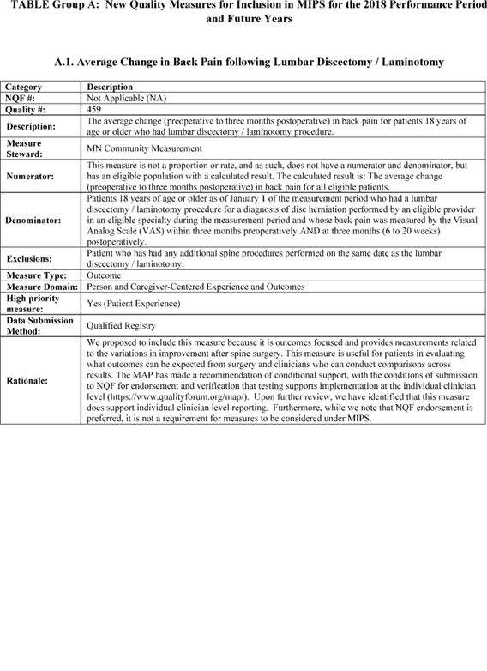

**[*53967]**



**[*53968]**

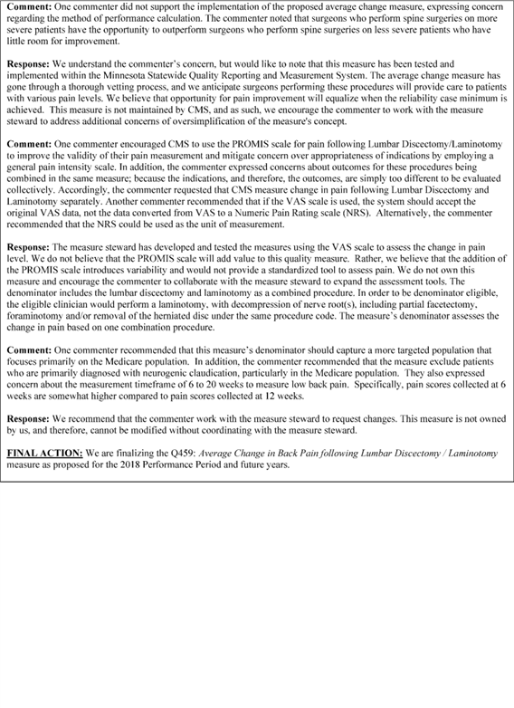

**[*53968]**



**[*53969]**

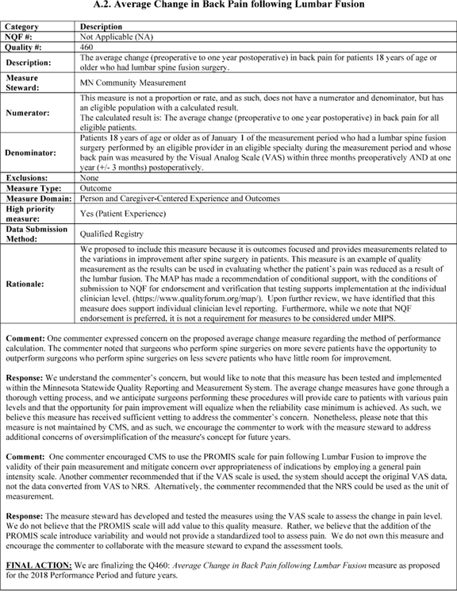

**[*53969]**



**[*53970]**

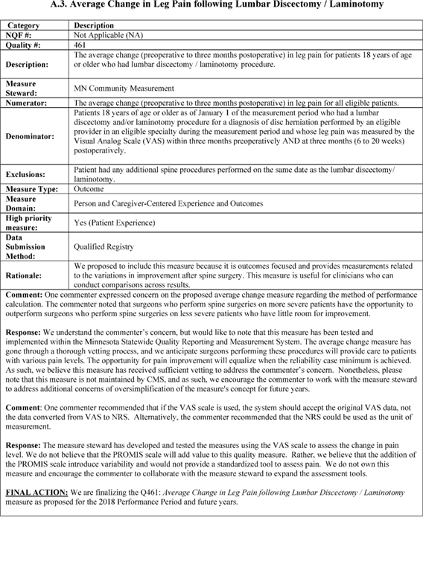

**[*53970]**



**[*53971]**

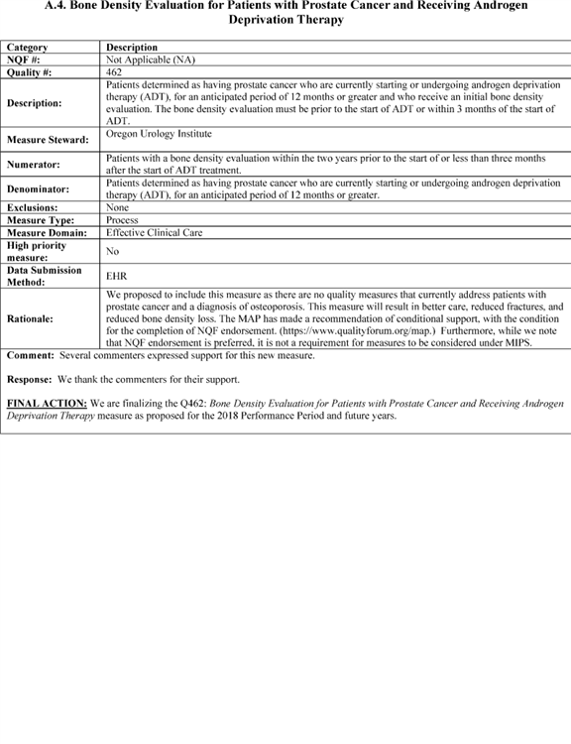

**[*53971]**



**[*53972]**

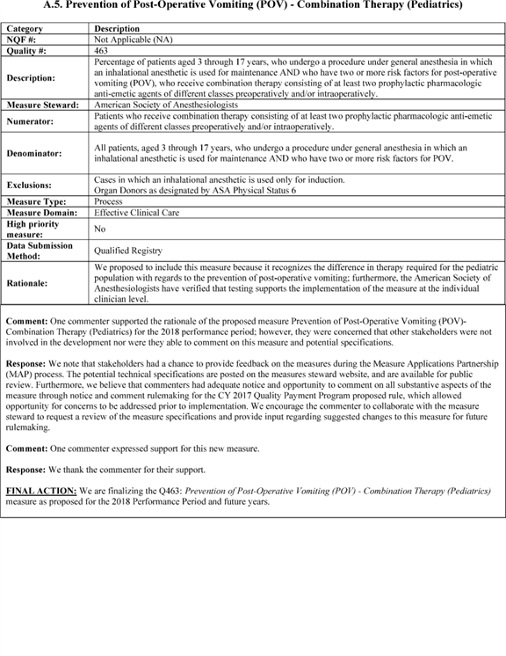

**[*53972]**



**[*53973]**

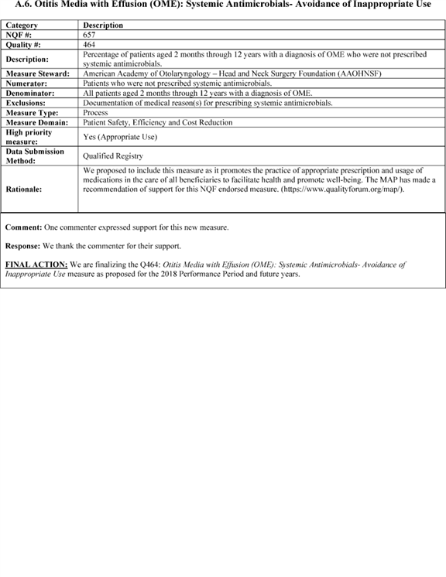

**[*53973]**



**[*53974]**

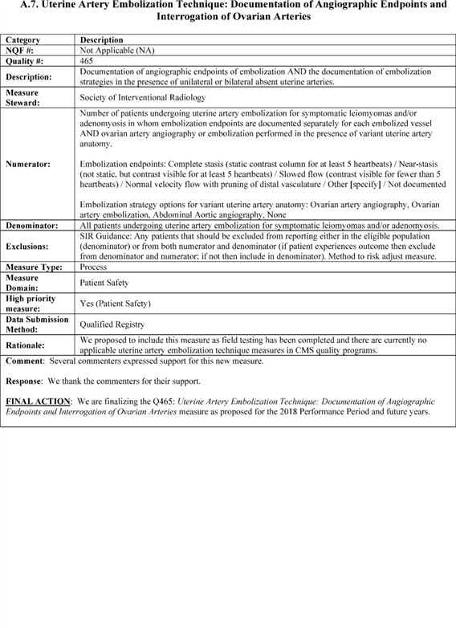

**[*53974]**



**[*53975]**

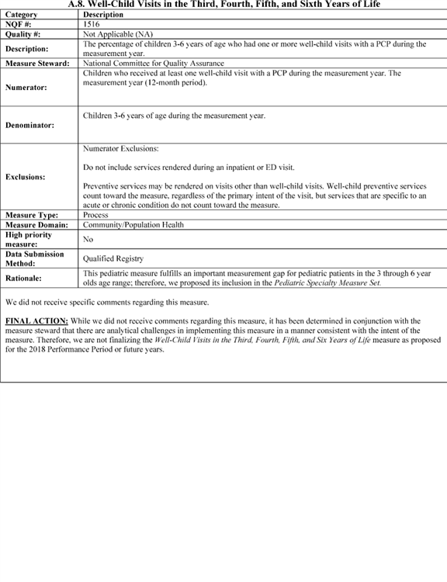

**[*53975]**



**[*53976]**

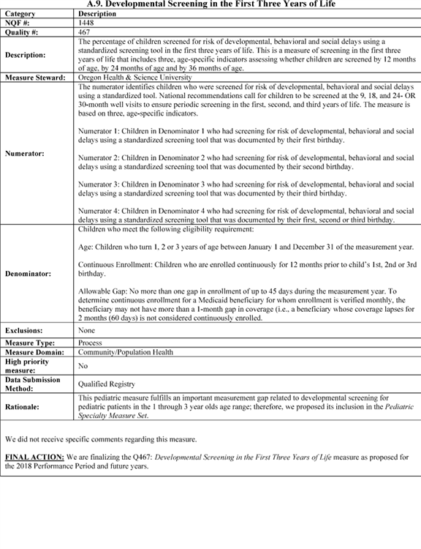

**[*53976]**



**[*53977]**

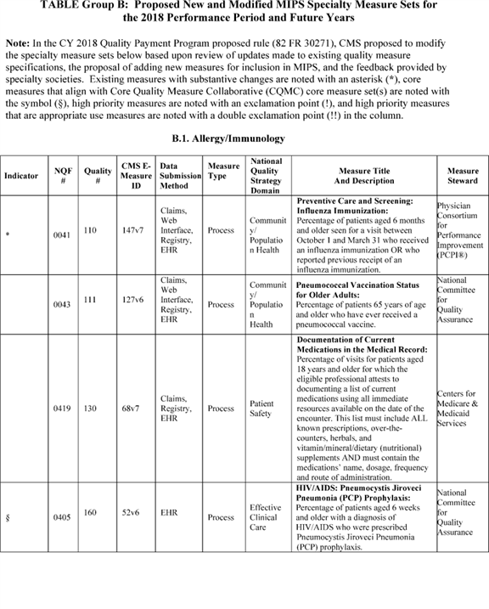

**[*53977]**



**[*53978]**

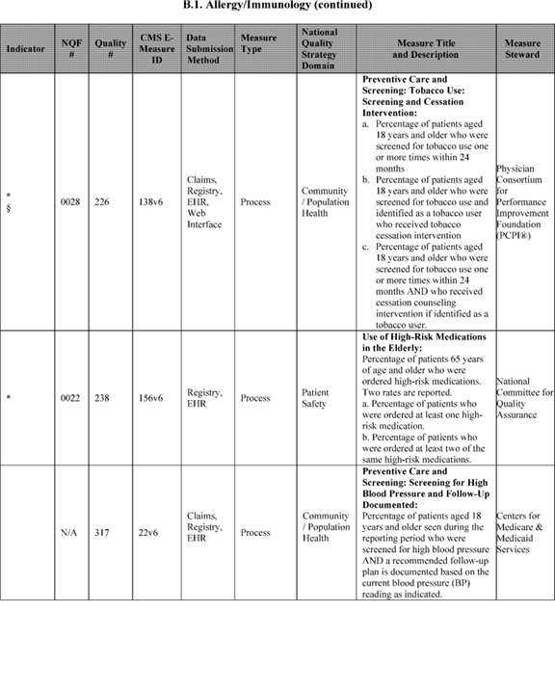

**[*53978]**



**[*53979]**

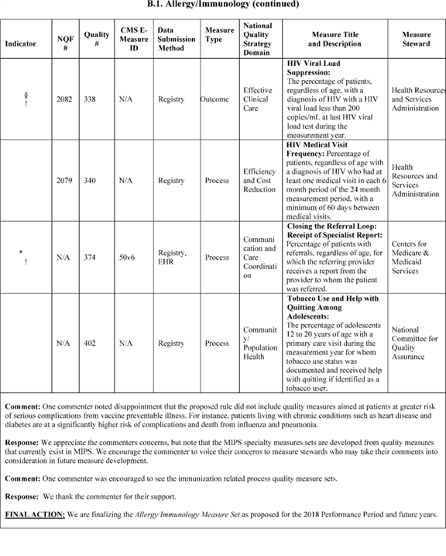

**[*53979]**



**[*53980]**

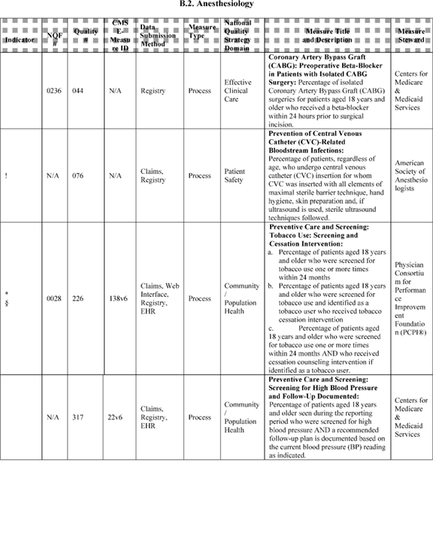

**[*53980]**



**[*53981]**

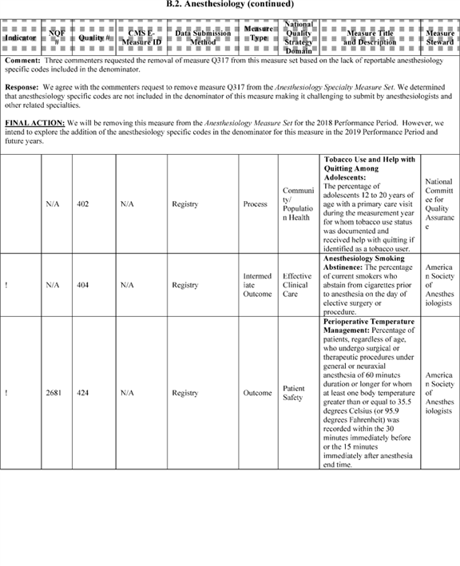

**[*53981]**



**[*53982]**

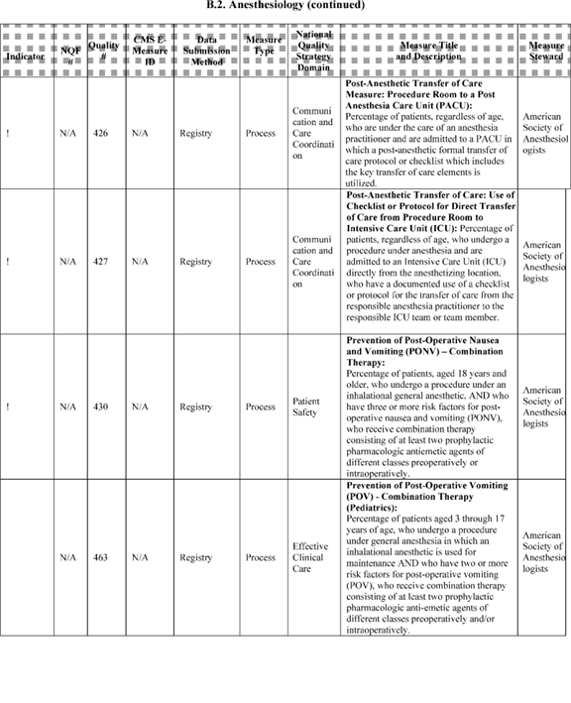

**[*53982]**



**[*53983]**

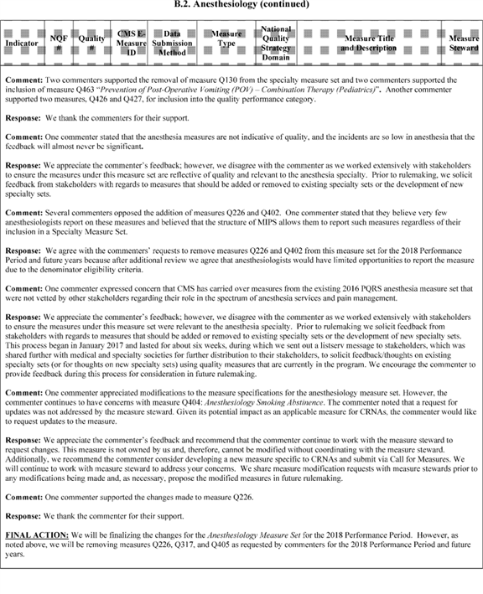

**[*53983]**



**[*53984]**

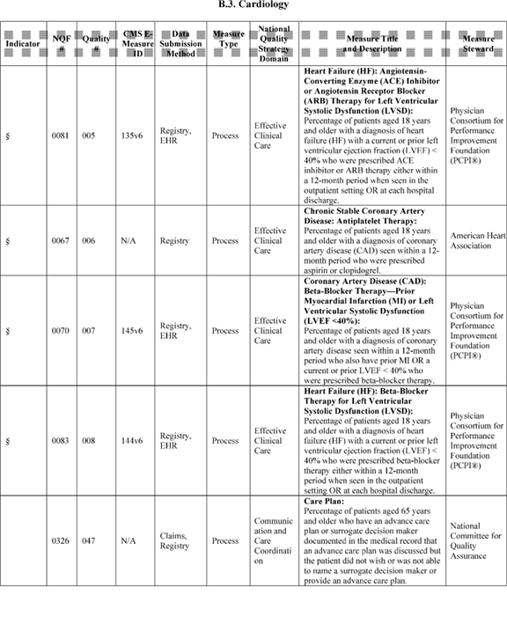

**[*53984]**



**[*53985]**

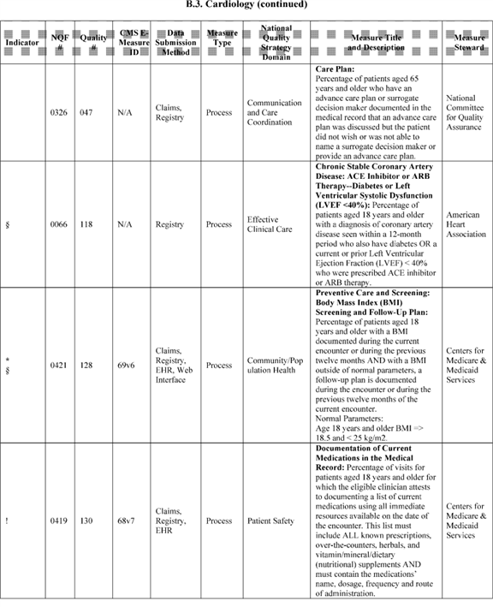

**[*53985]**



**[*53986]**

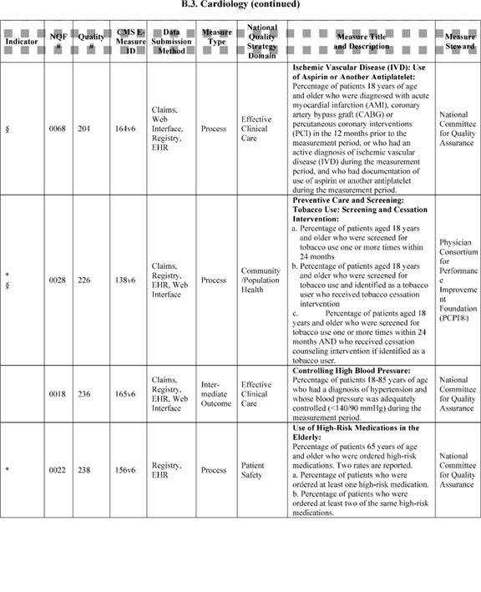

**[*53986]**



**[*53987]**

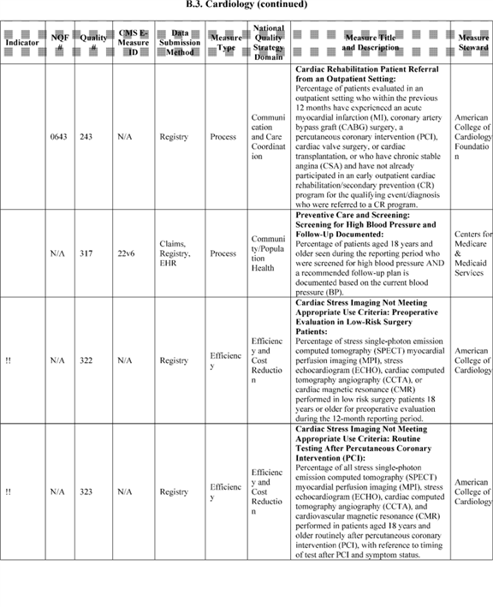

**[*53987]**



**[*53988]**

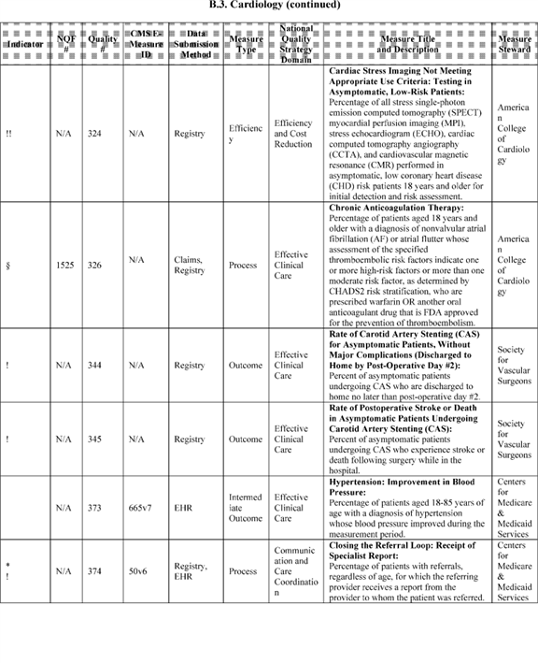

**[*53988]**



**[*53989]**

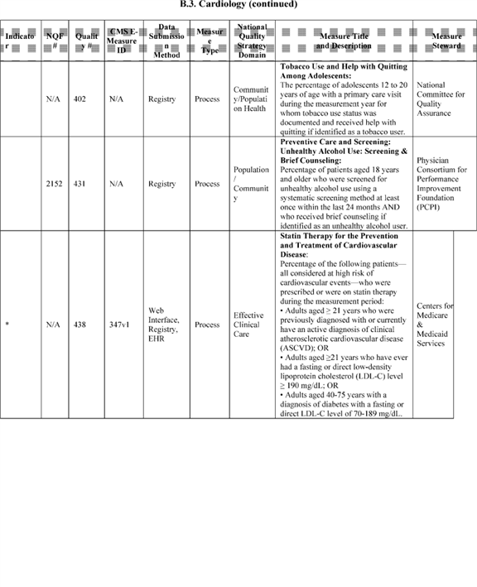

**[*53989]**



**[*53990]**

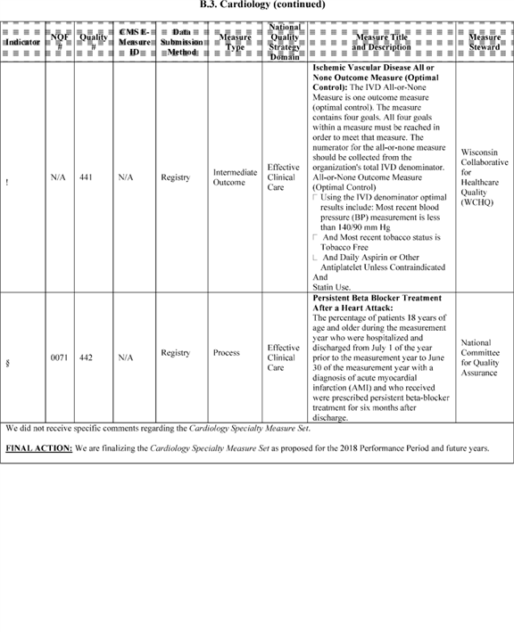

**[*53990]**



**[*53991]**



**[*53991]**



**[*53992]**

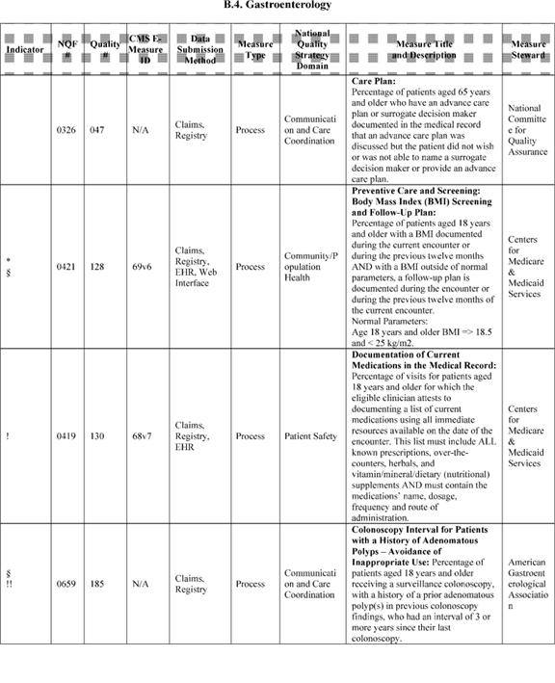

**[*53992]**



**[*53993]**

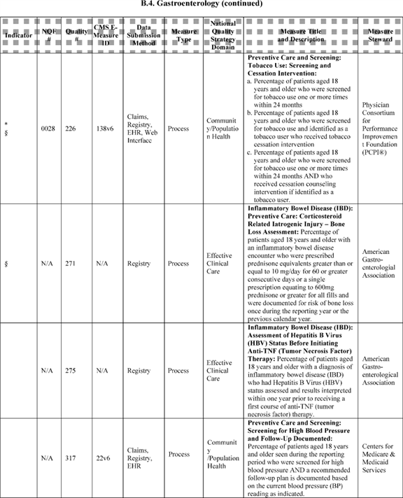

**[*53993]**



**[*53994]**

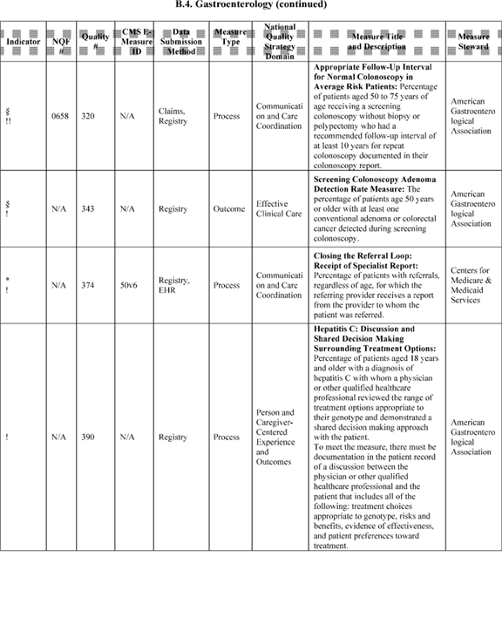

**[*53994]**



**[*53995]**

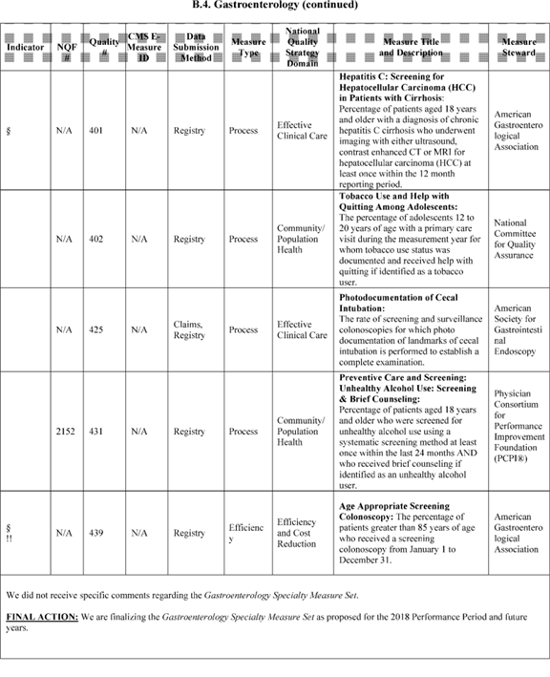

**[*53995]**



**[*53996]**

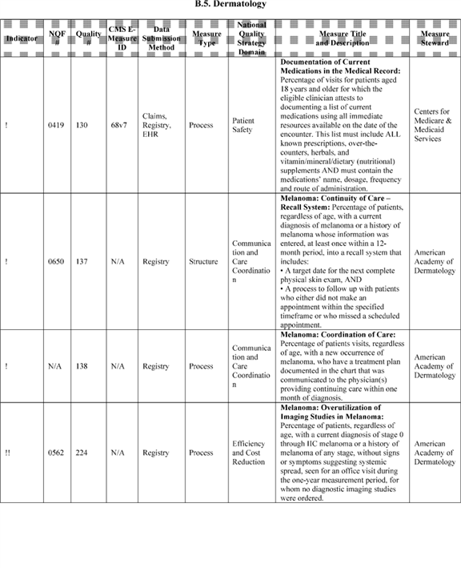

**[*53996]**



**[*53997]**

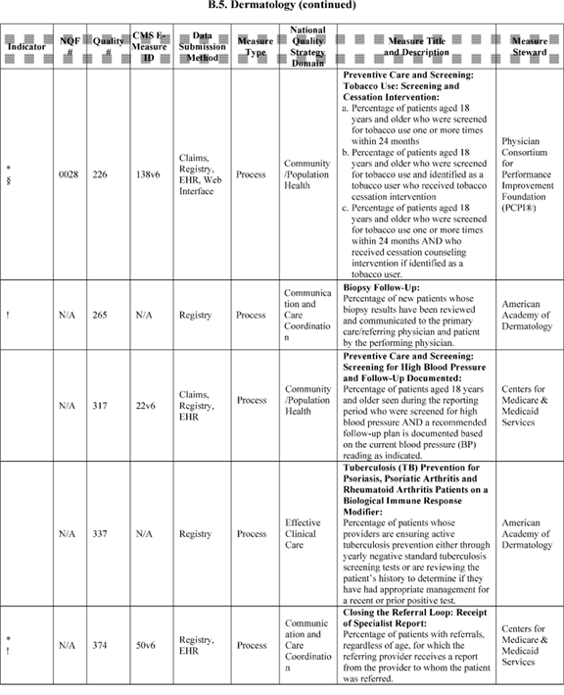

**[*53997]**



**[*53998]**

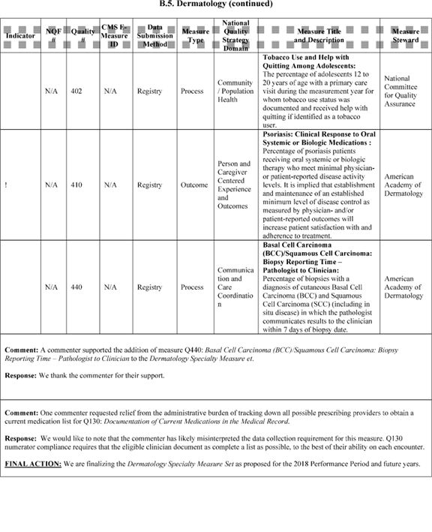

**[*53998]**



**[*53999]**

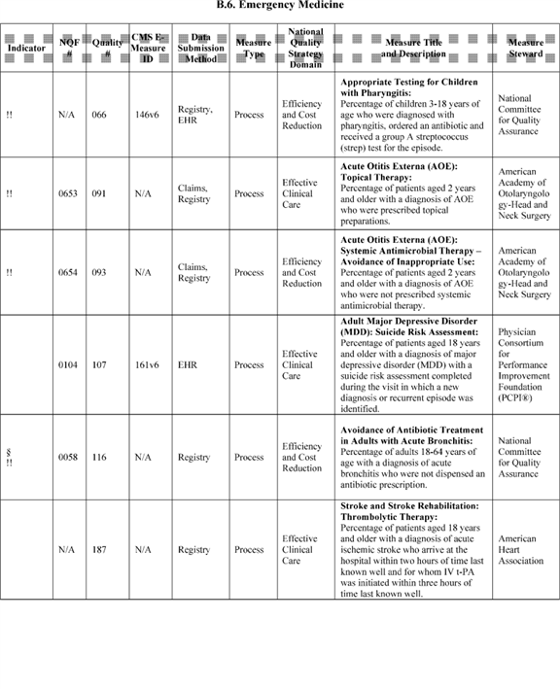

**[*53999]**



**[*54000]**

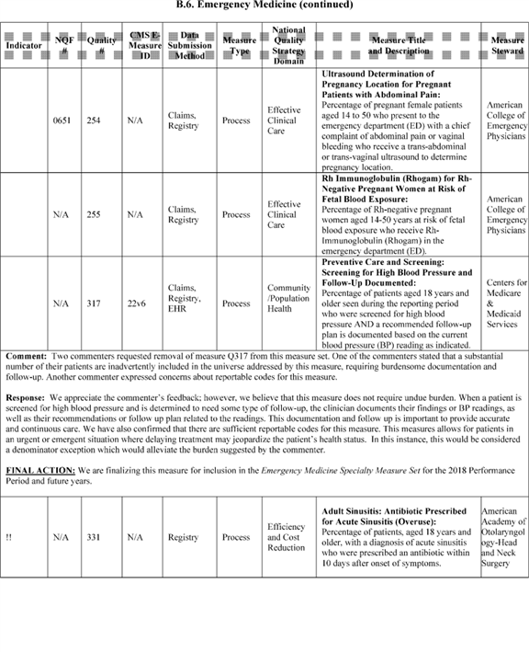

**[*54000]**



**[*54001]**

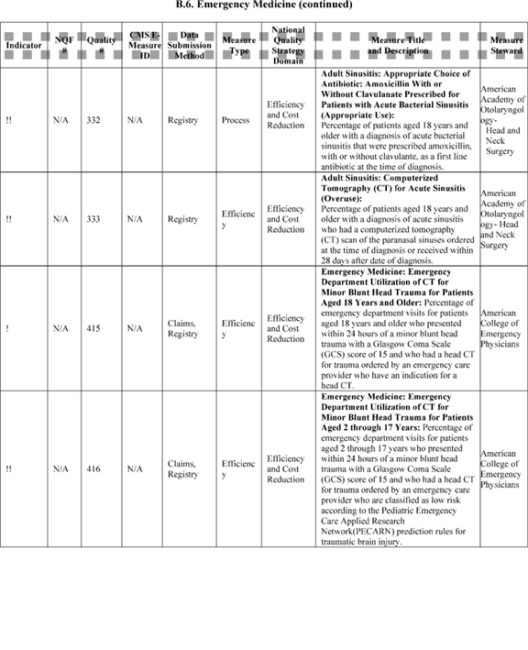

**[*54001]**



**[*54002]**

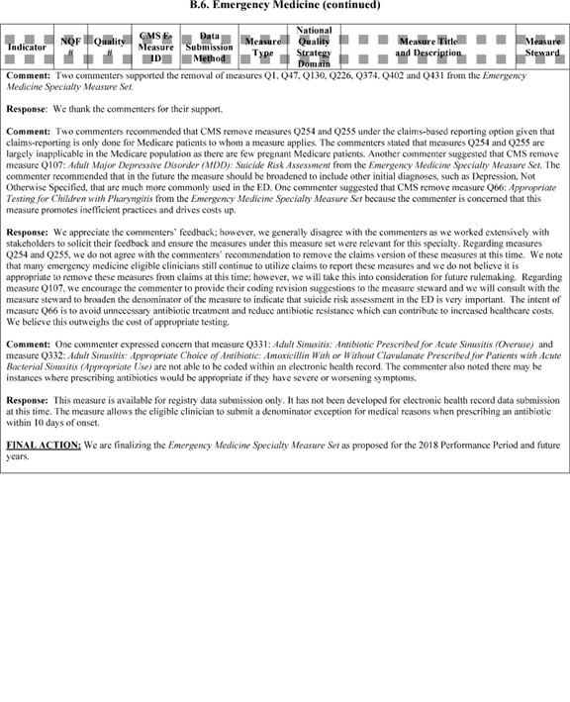

**[*54002]**



**[*54003]**

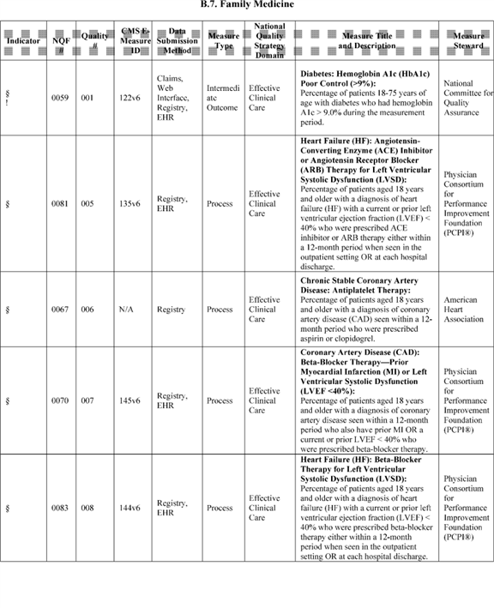

**[*54003]**



**[*54004]**

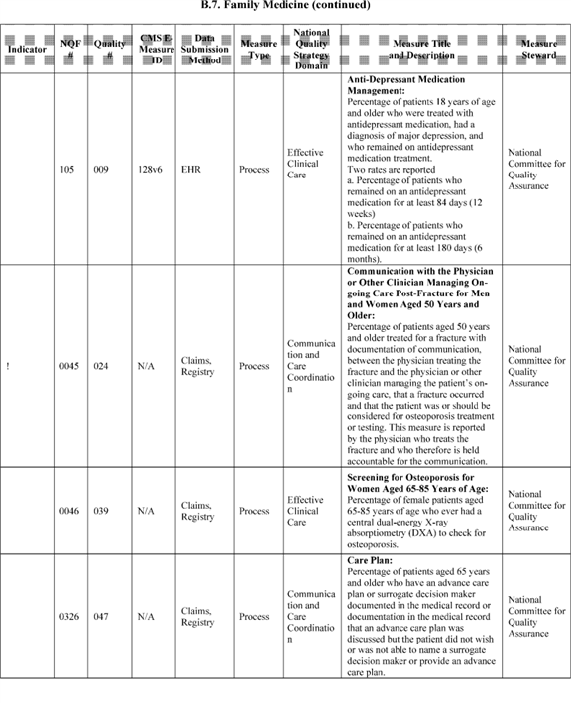

**[*54004]**



**[*54005]**

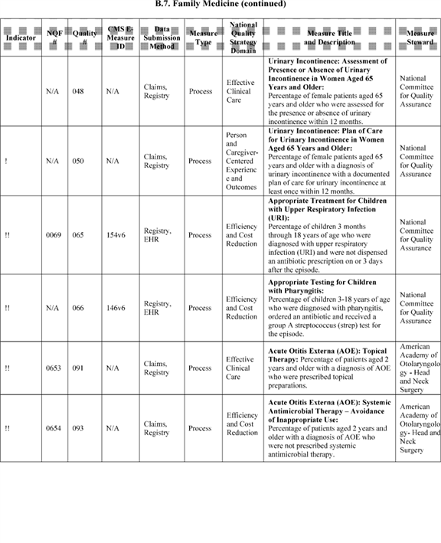

**[*54005]**



**[*54006]**

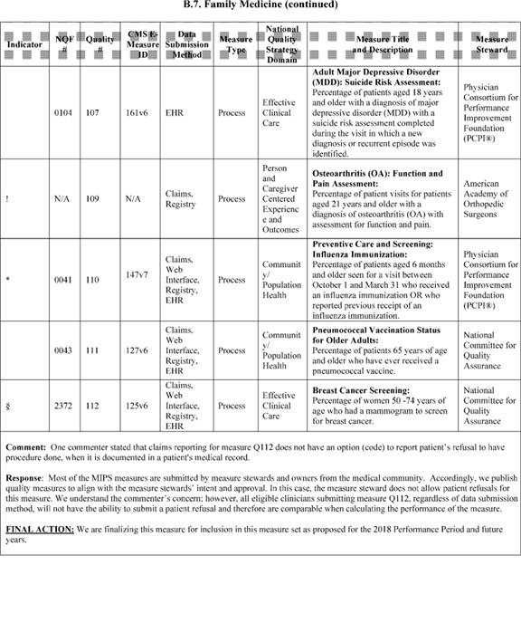

**[*54006]**



**[*54007]**

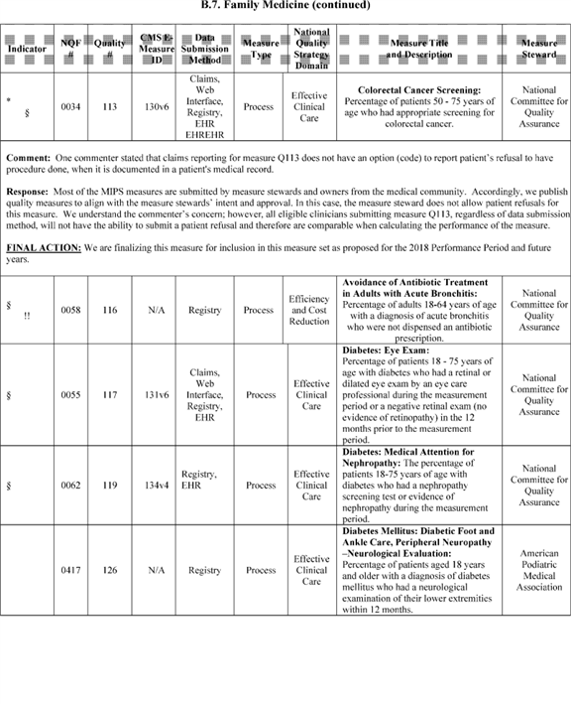

**[*54007]**



**[*54008]**

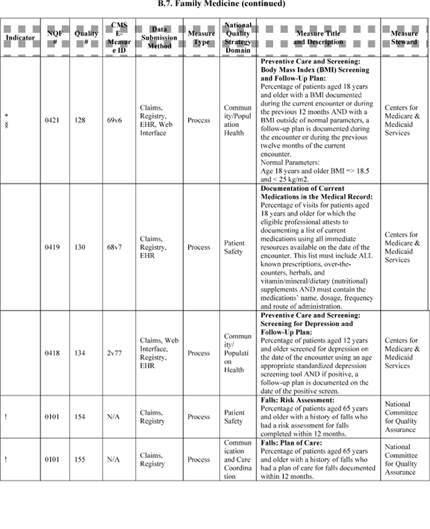

**[*54008]**



**[*54009]**

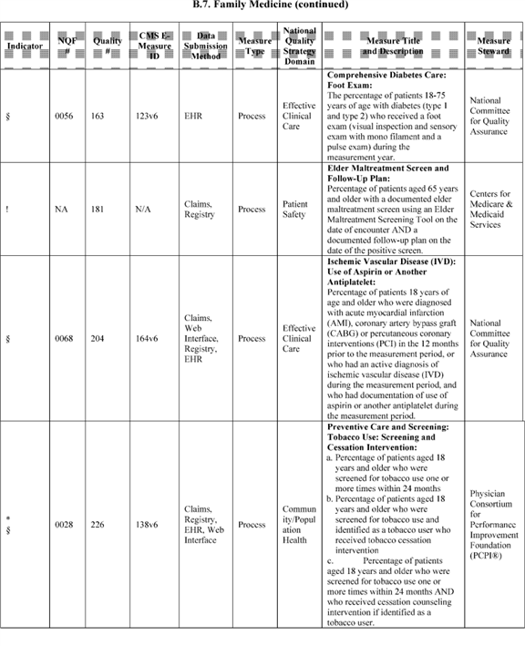

**[*54009]**



**[*54010]**

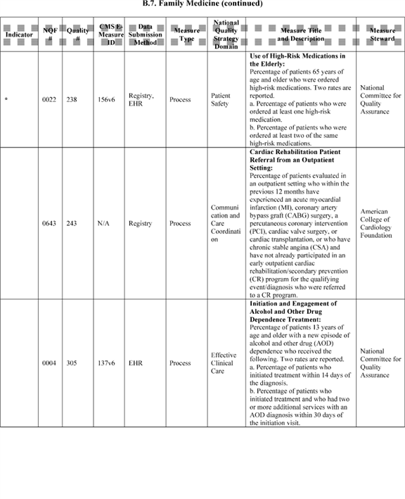

**[*54010]**



**[*54011]**

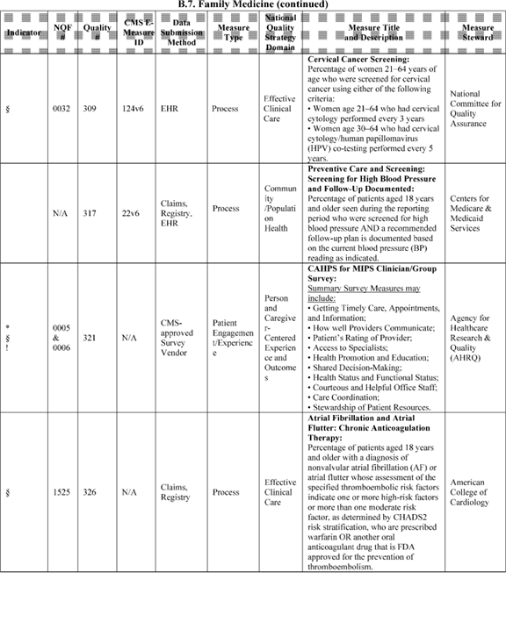

**[*54011]**



**[*54012]**

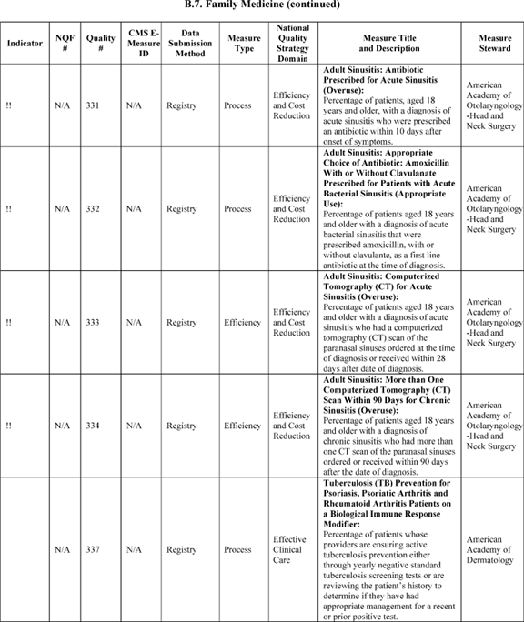

**[*54012]**



**[*54013]**

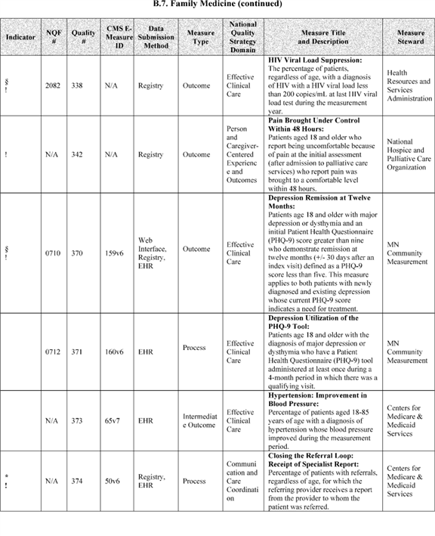

**[*54013]**



**[*54014]**

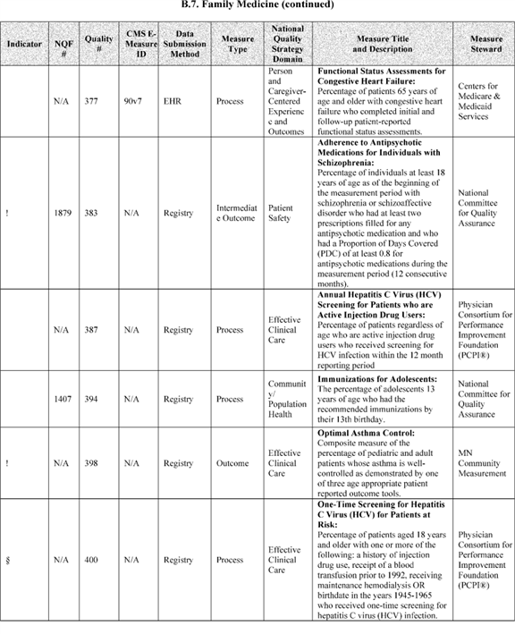

**[*54014]**



**[*54015]**

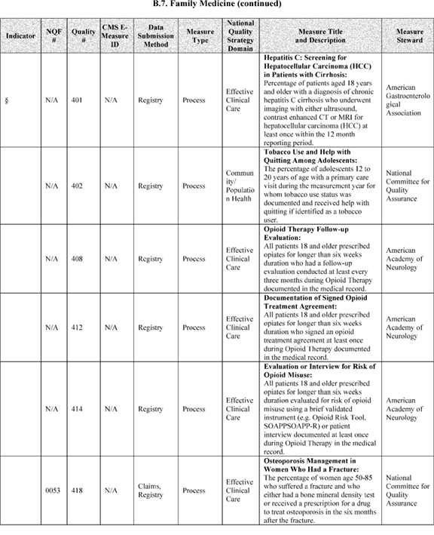

**[*54015]**



**[*54016]**

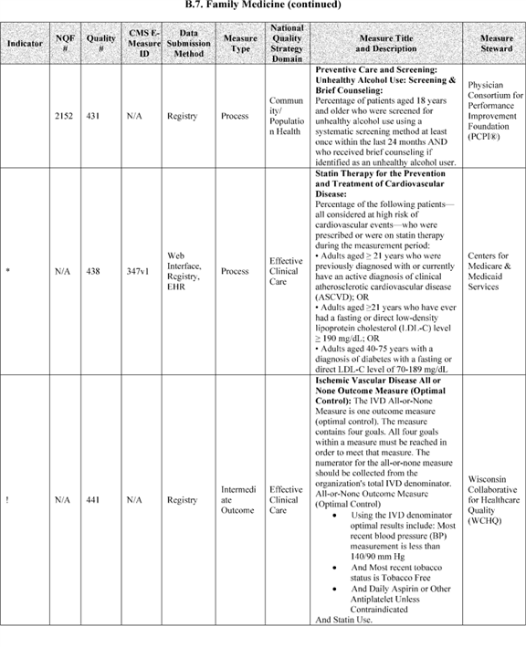

**[*54016]**



**[*54017]**

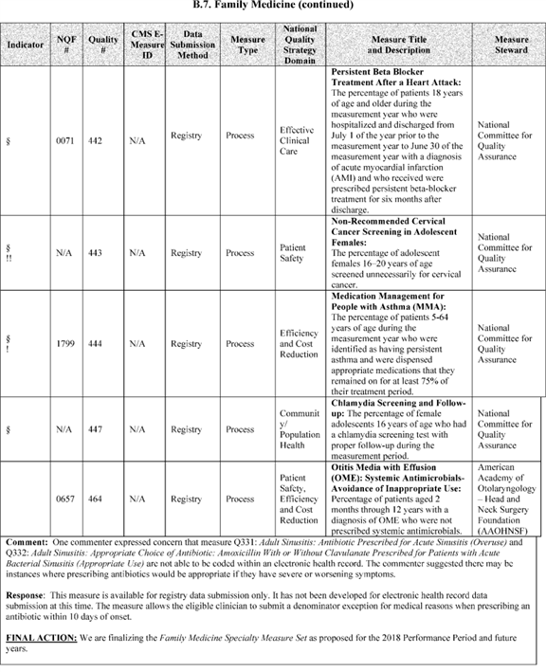

**[*54017]**



**[*54018]**

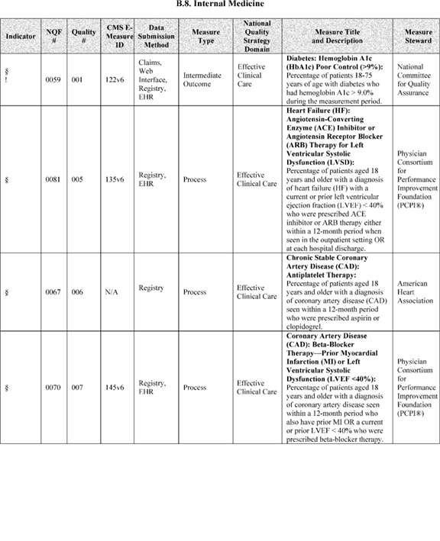

**[*54018]**



**[*54019]**

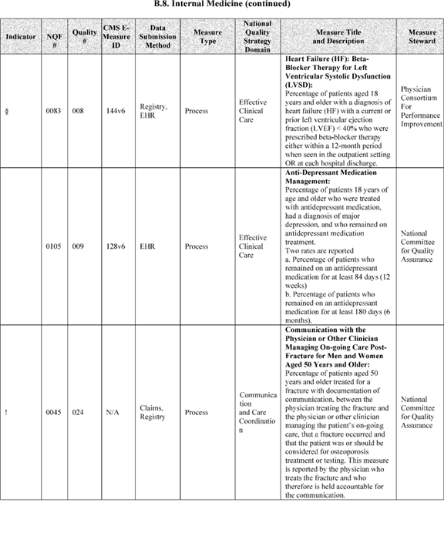

**[*54019]**



**[*54020]**

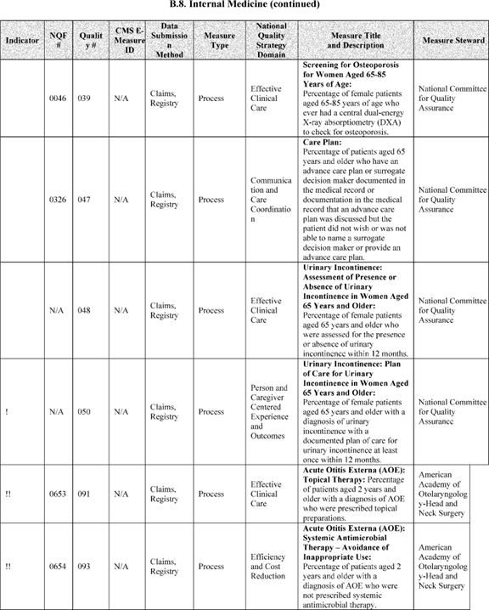

**[*54020]**



**[*54021]**

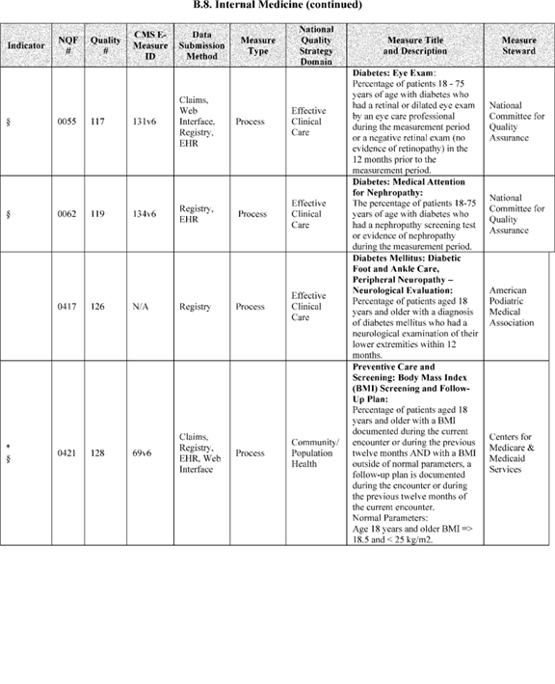

**[*54021]**



**[*54022]**

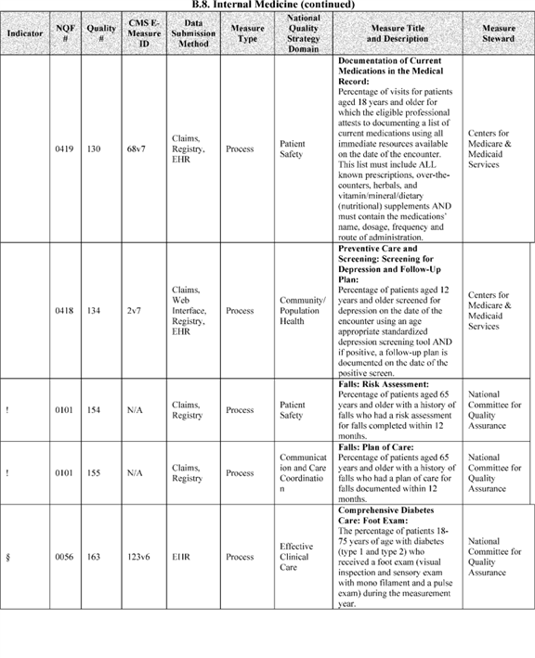

**[*54022]**



**[*54023]**

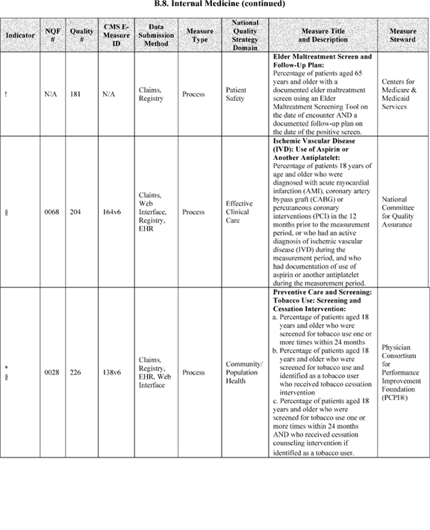

**[*54023]**



**[*54024]**

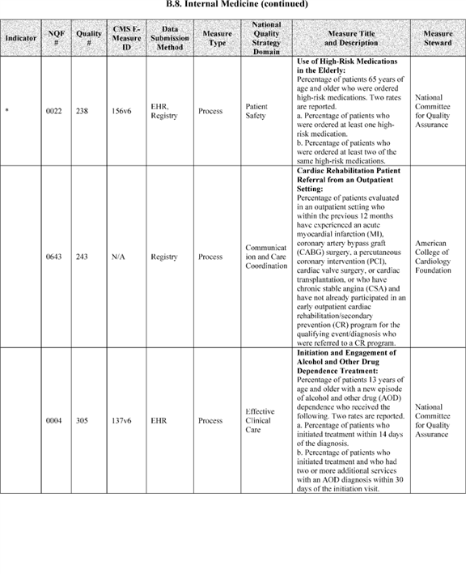

**[*54024]**



**[*54025]**

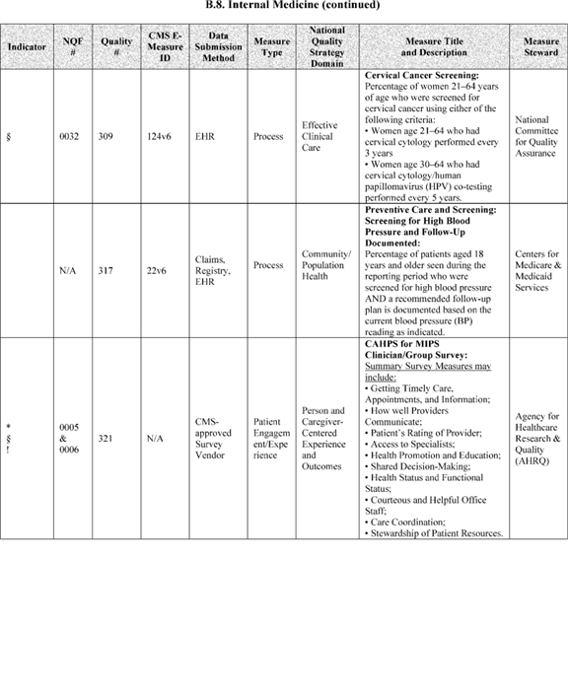

**[*54025]**



**[*54026]**

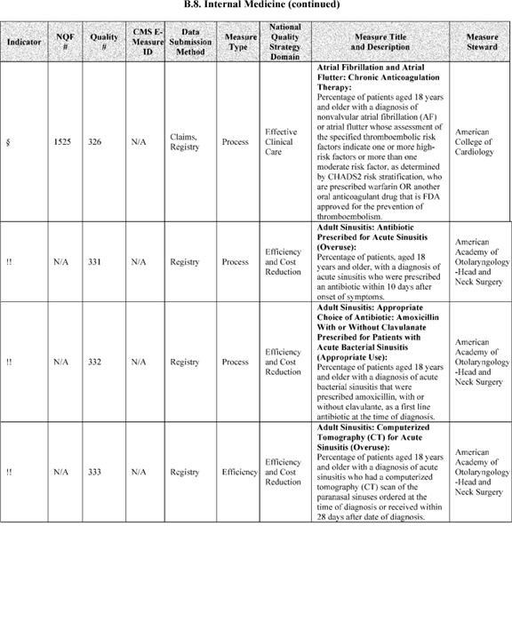

**[*54026]**



**[*54027]**

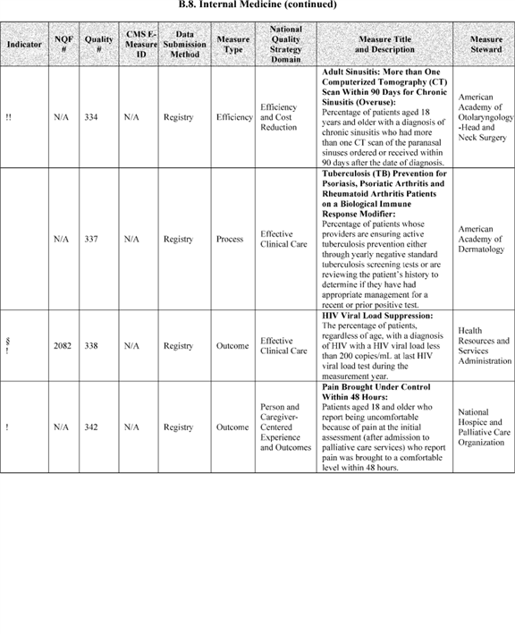

**[*54027]**



**[*54028]**

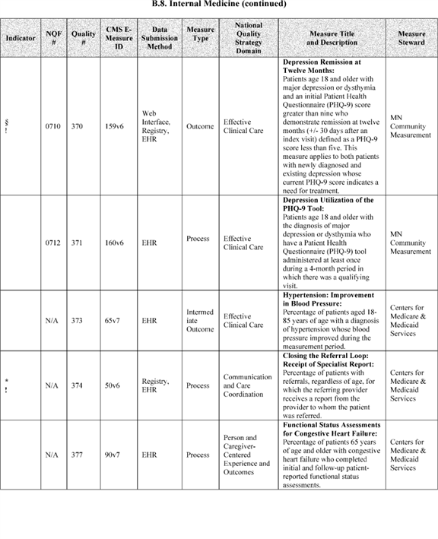

**[*54028]**



**[*54029]**

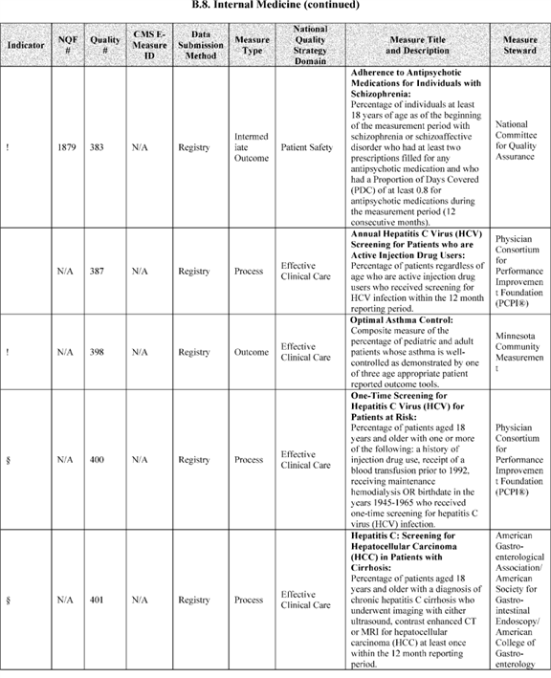

**[*54029]**



**[*54030]**

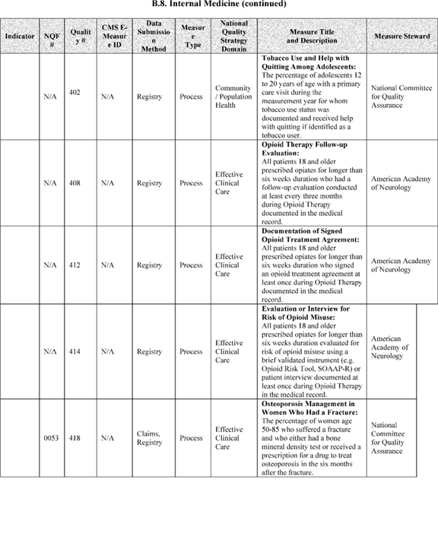

**[*54030]**



**[*54031]**

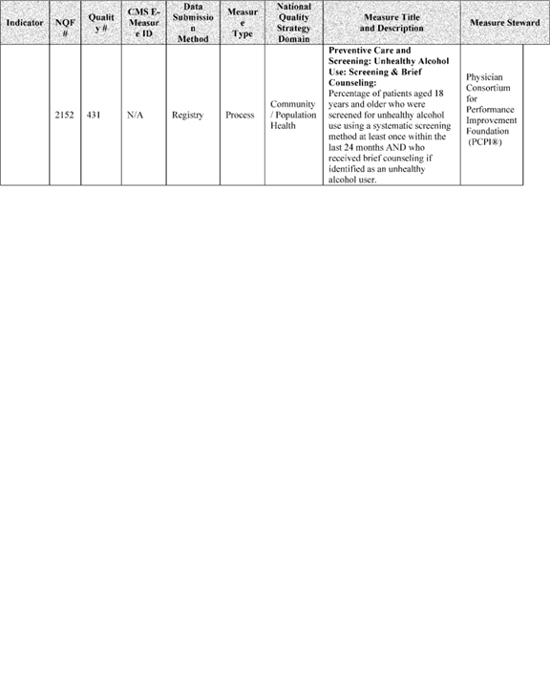

**[*54031]**



**[*54032]**

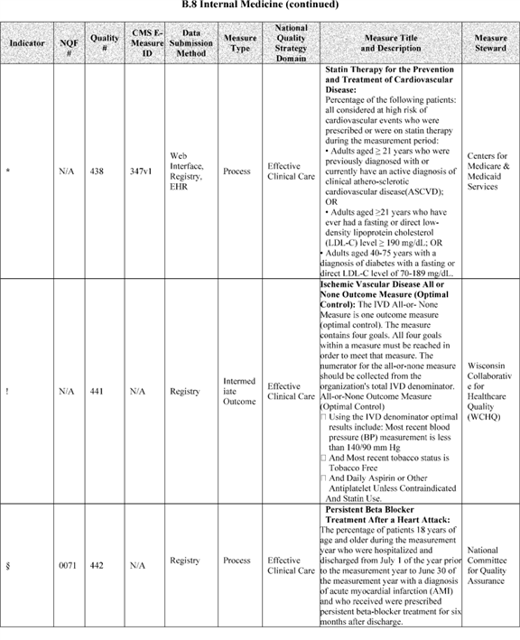

**[*54032]**



**[*54033]**

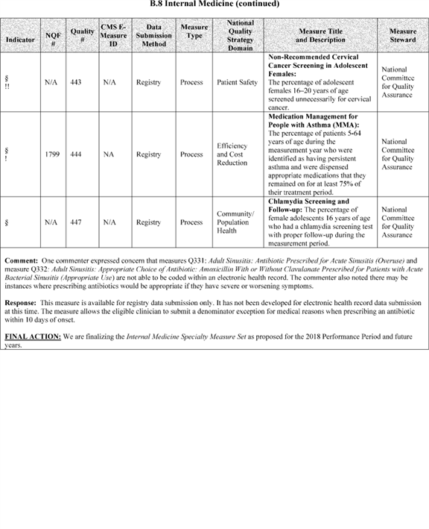

**[*54033]**



**[*54034]**

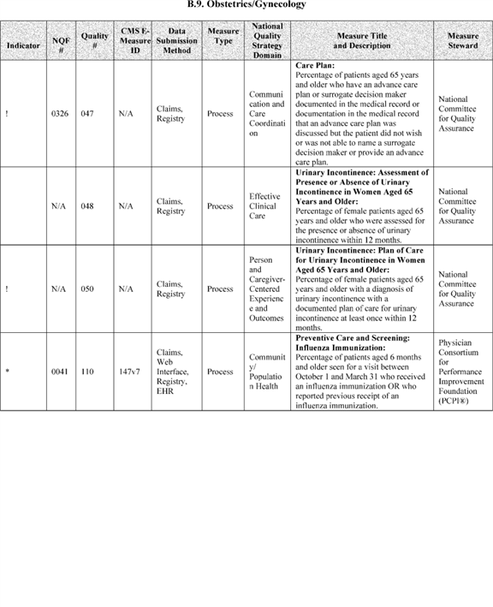

**[*54034]**



**[*54035]**

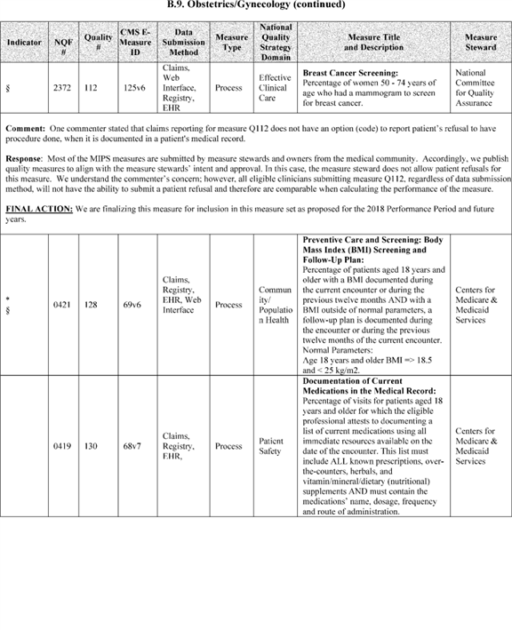

**[*54035]**



**[*54036]**

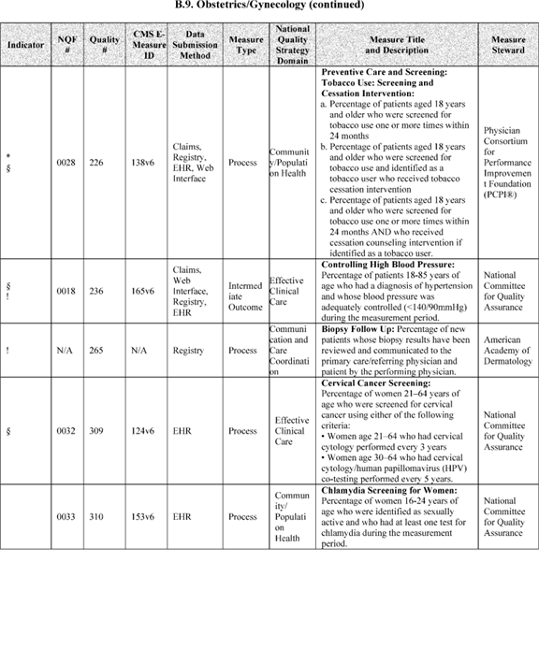

**[*54036]**



**[*54037]**

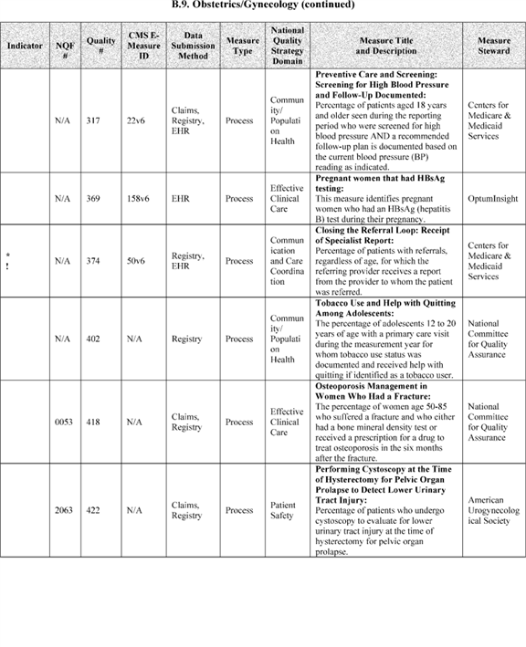

**[*54037]**



**[*54038]**

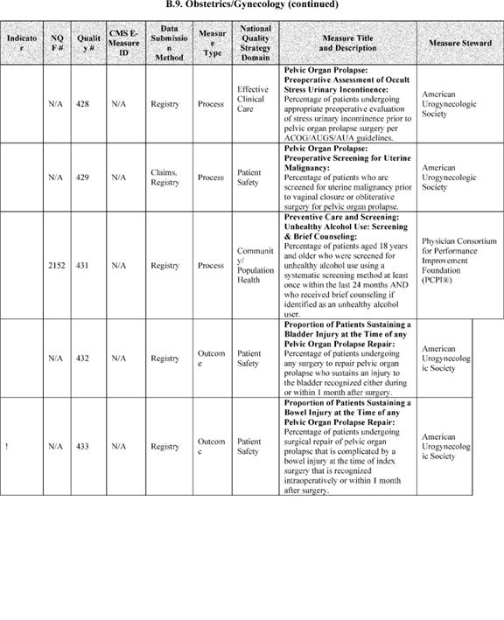

**[*54038]**



**[*54039]**

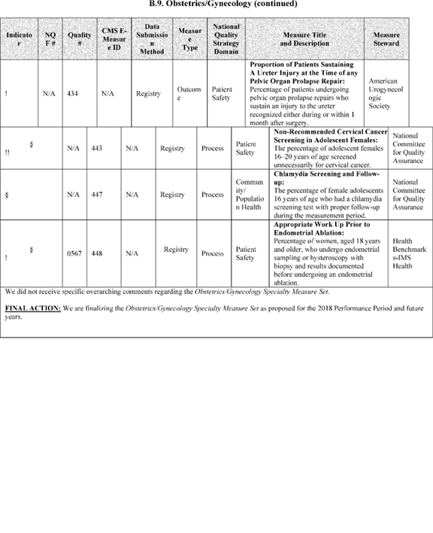

**[*54039]**



**[*54040]**

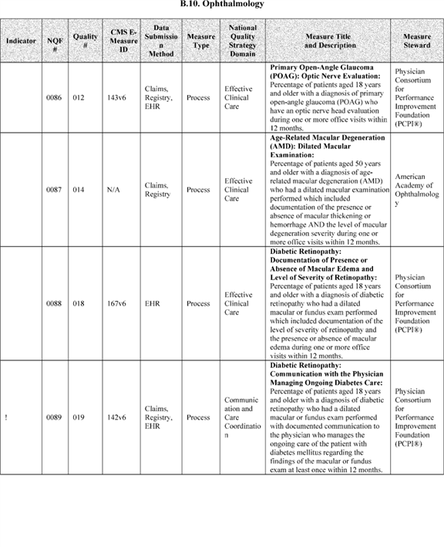

**[*54040]**



**[*54041]**

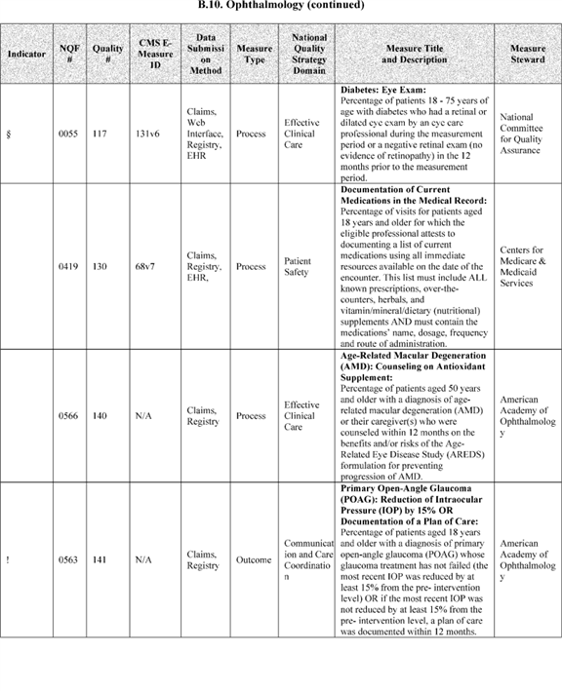

**[*54041]**



**[*54042]**

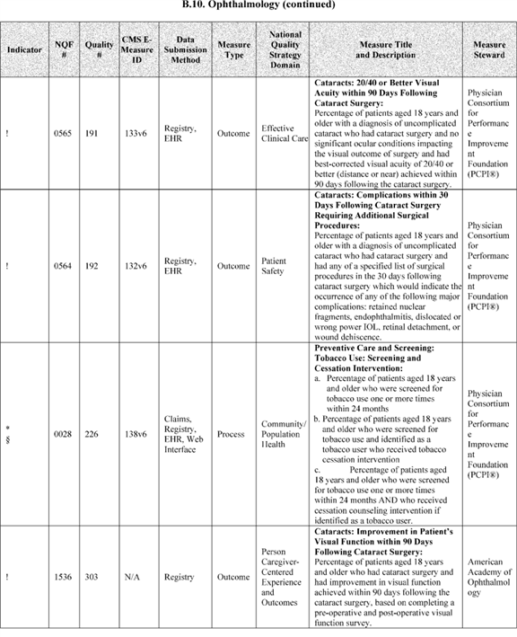

**[*54042]**



**[*54043]**

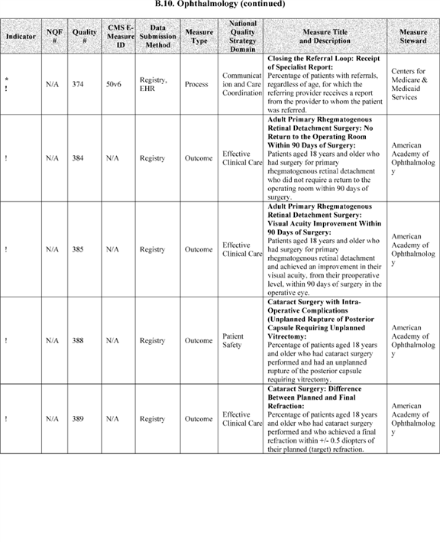

**[*54043]**



**[*54044]**

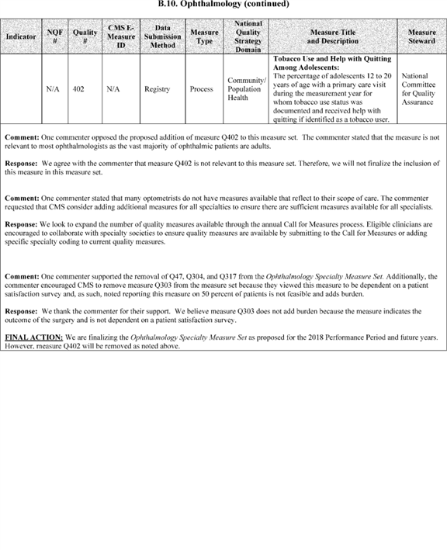

**[*54044]**



**[*54045]**

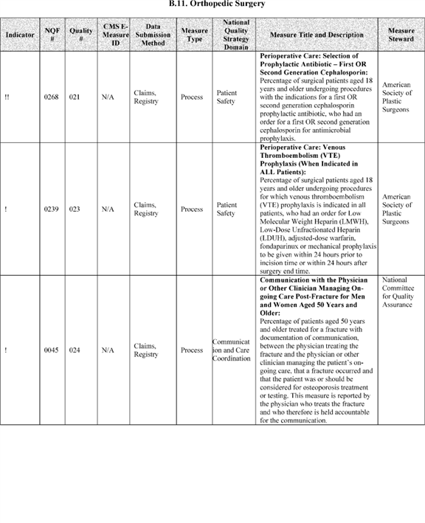

**[*54045]**



**[*54046]**

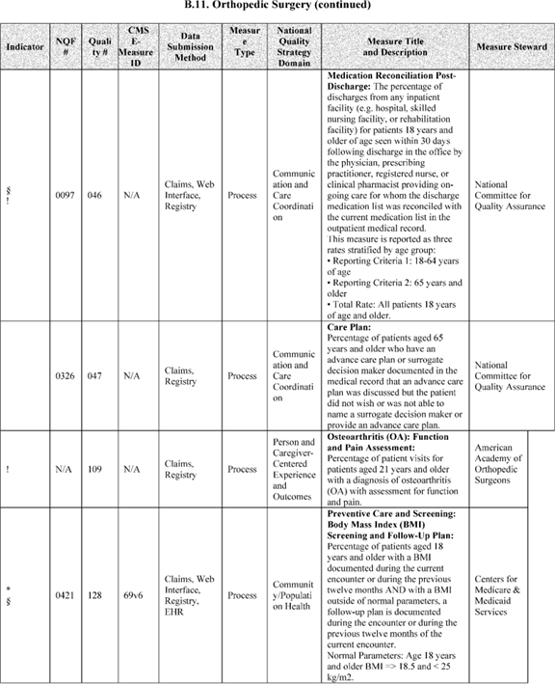

**[*54046]**



**[*54047]**

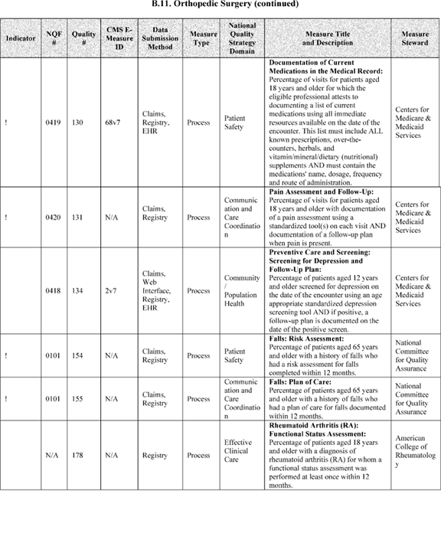

**[*54047]**



**[*54048]**

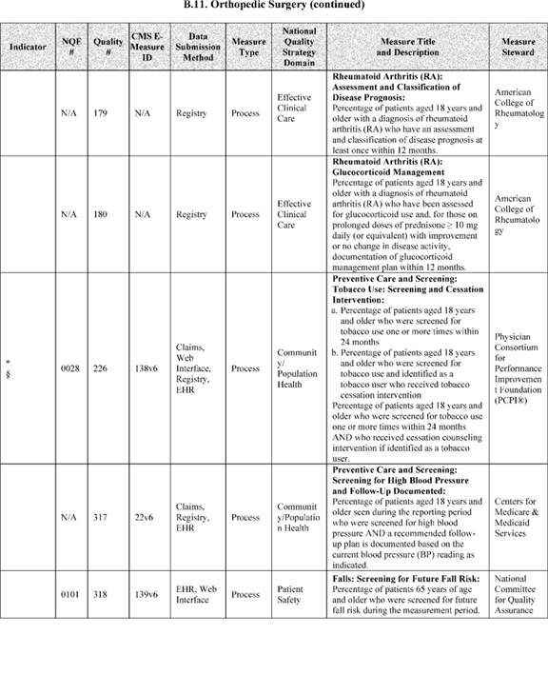

**[*54048]**



**[*54049]**

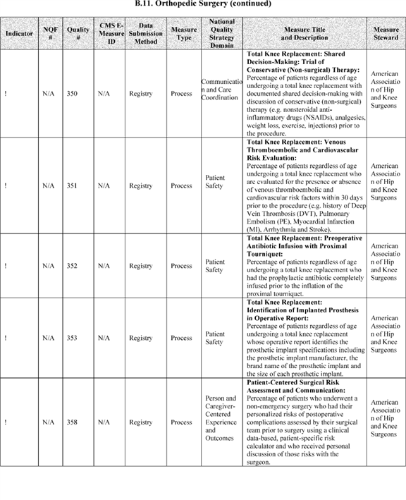

**[*54049]**



**[*54050]**

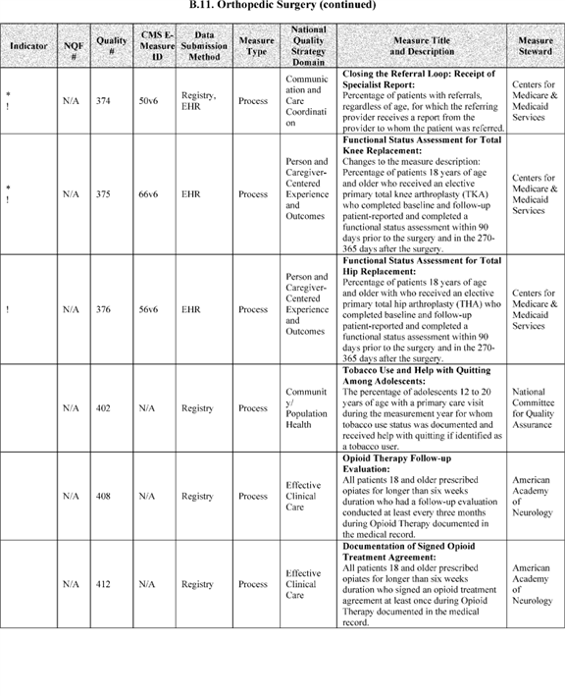

**[*54050]**



**[*54051]**

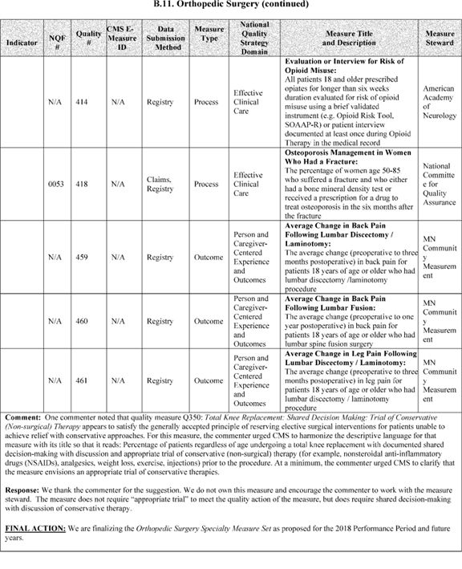

**[*54051]**



**[*54052]**

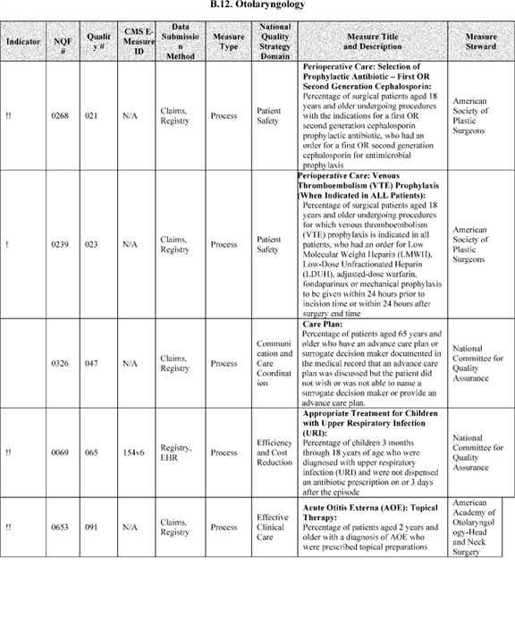

**[*54052]**



**[*54053]**

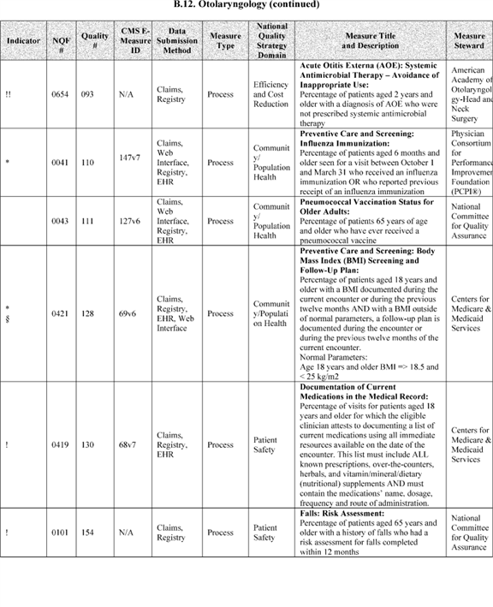

**[*54053]**



**[*54054]**

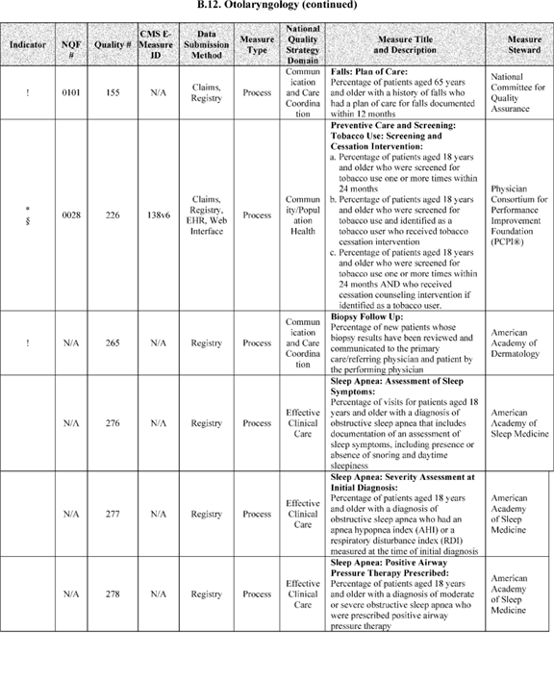

**[*54054]**



**[*54055]**

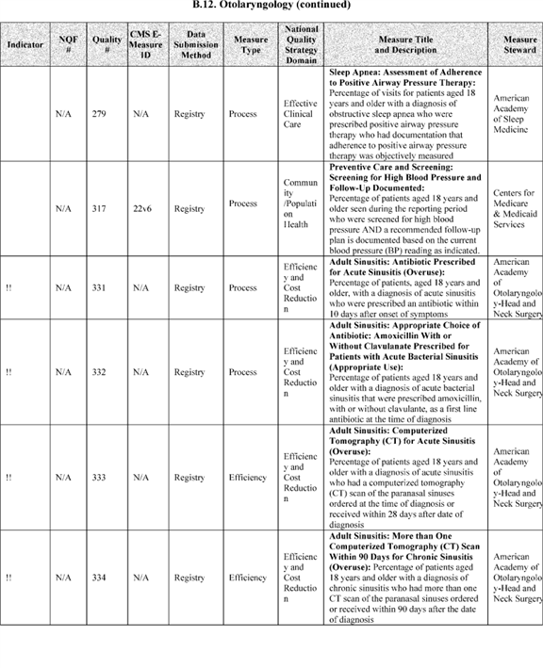

**[*54055]**



**[*54056]**

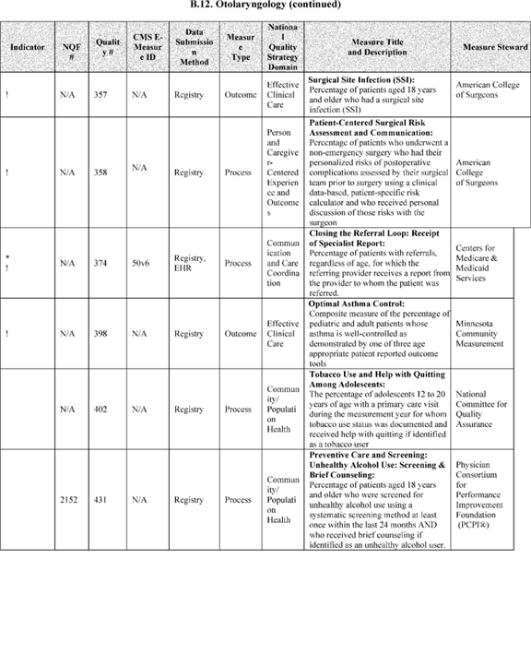

**[*54056]**



**[*54057]**

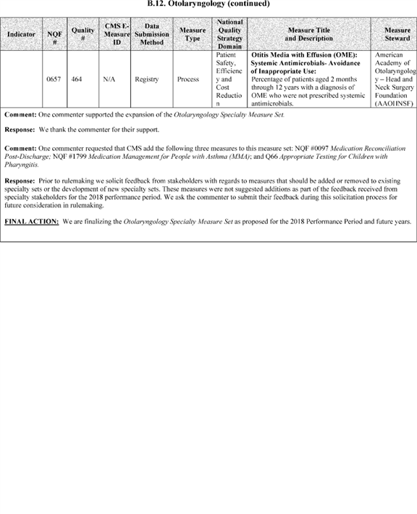

**[*54057]**



**[*54058]**

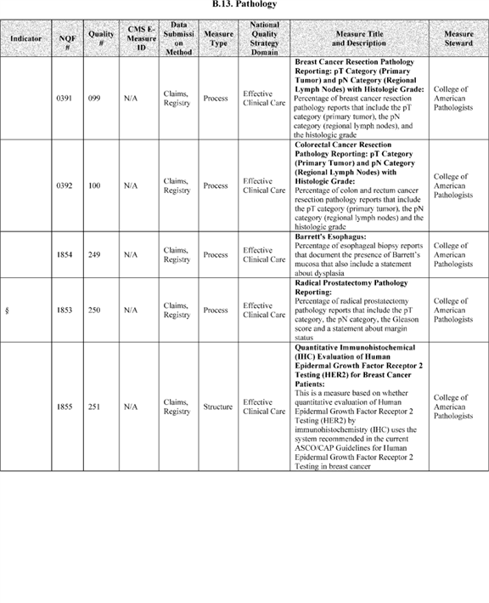

**[*54058]**



**[*54059]**



**[*54059]**



**[*54060]**

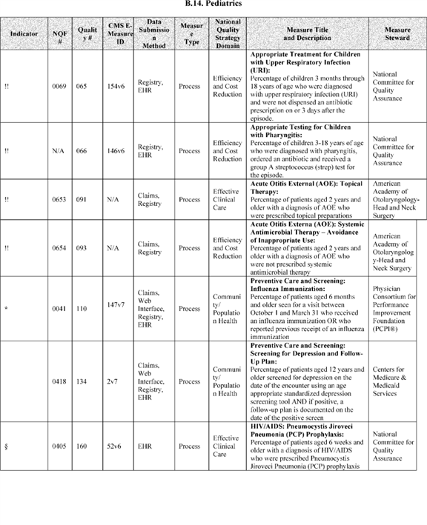

**[*54060]**



**[*54061]**

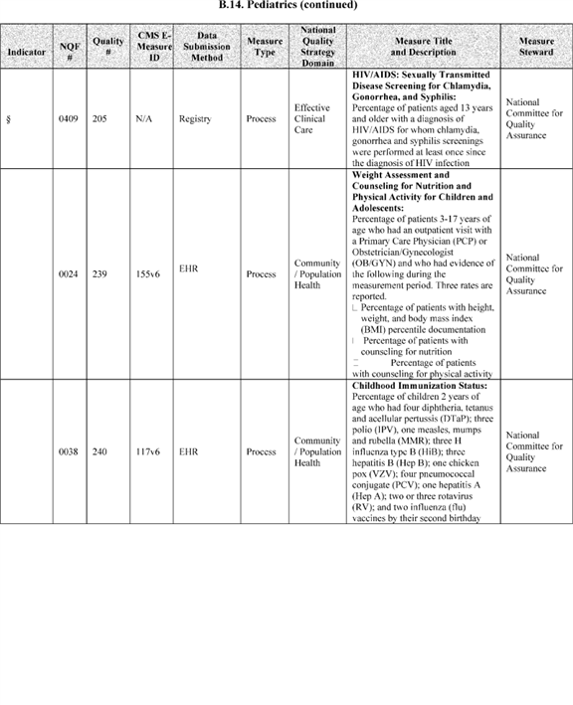

**[*54061]**



**[*54062]**

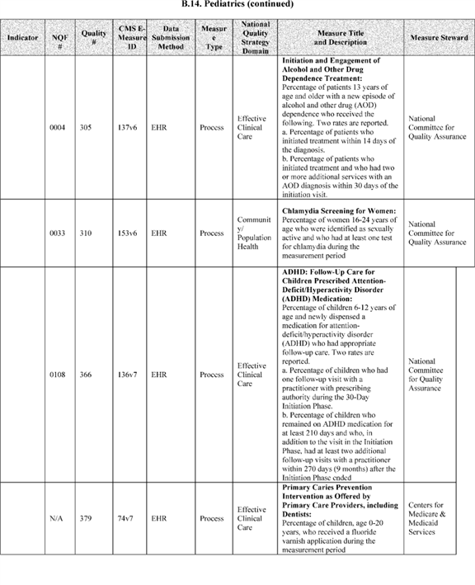

**[*54062]**



**[*54063]**

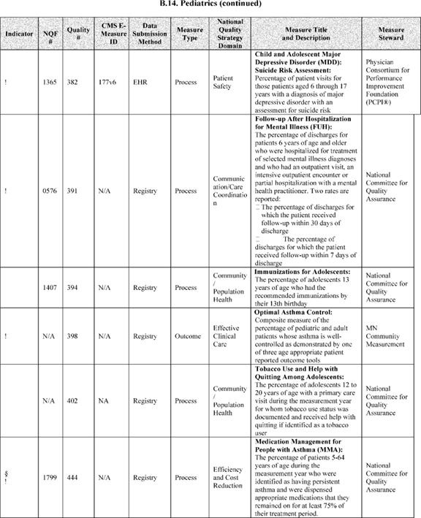

**[*54063]**



**[*54064]**

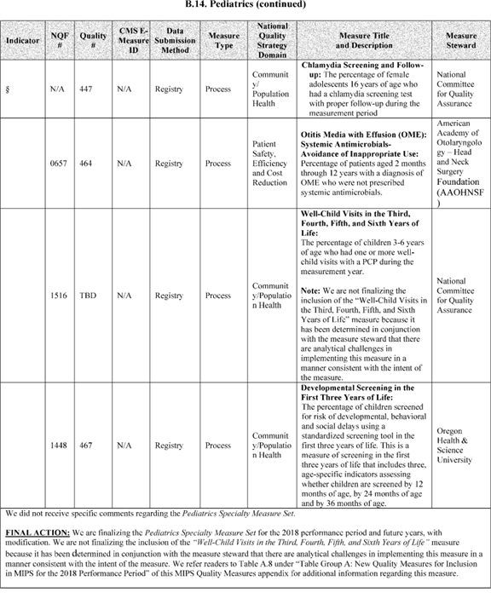

**[*54064]**



**[*54065]**

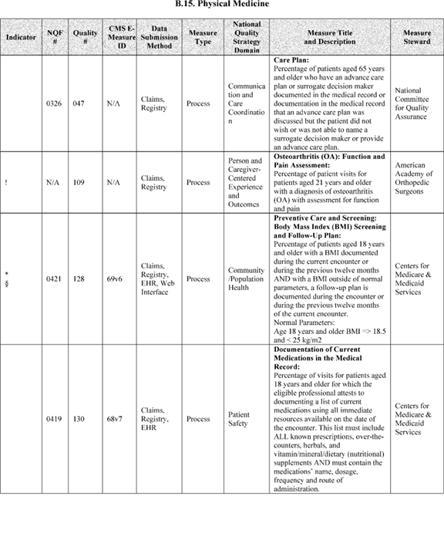

**[*54065]**



**[*54066]**

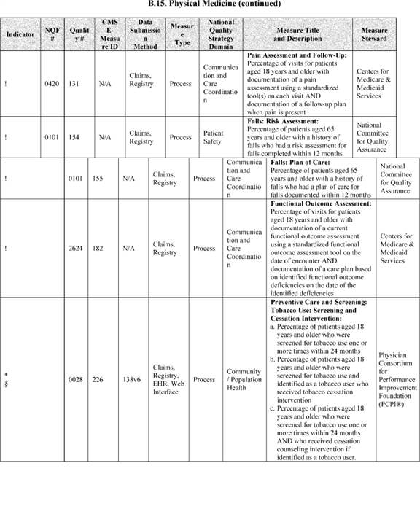

**[*54066]**



**[*54067]**

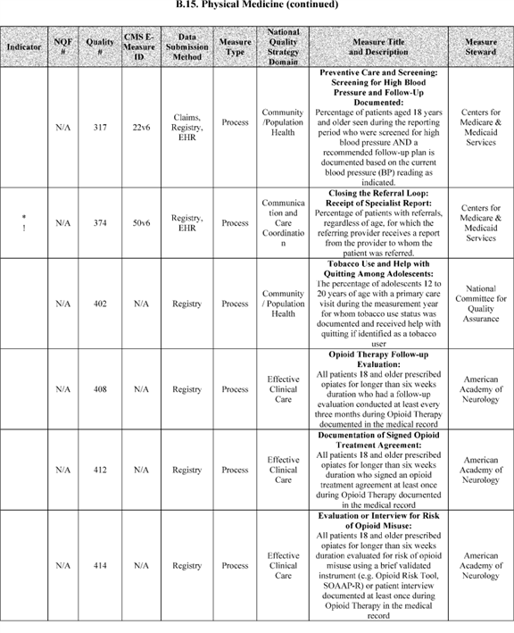

**[*54067]**



**[*54068]**

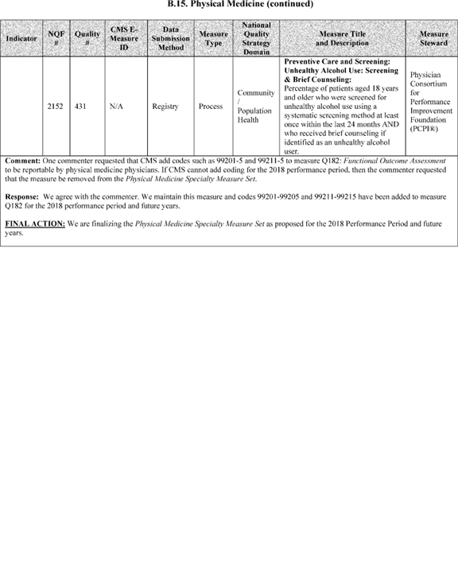

**[*54068]**



**[*54069]**

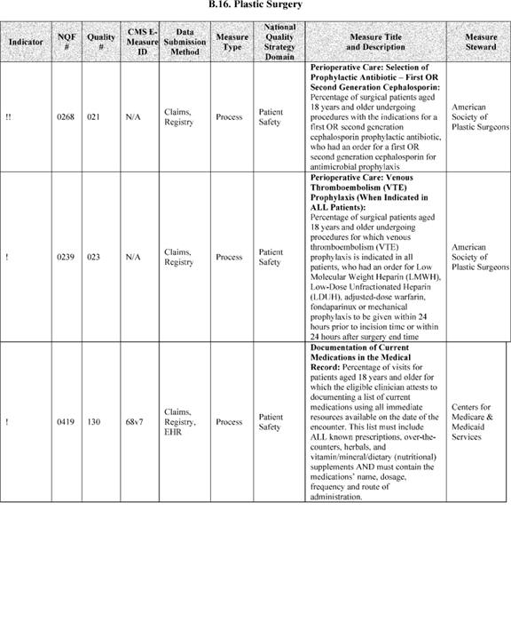

**[*54069]**



**[*54070]**

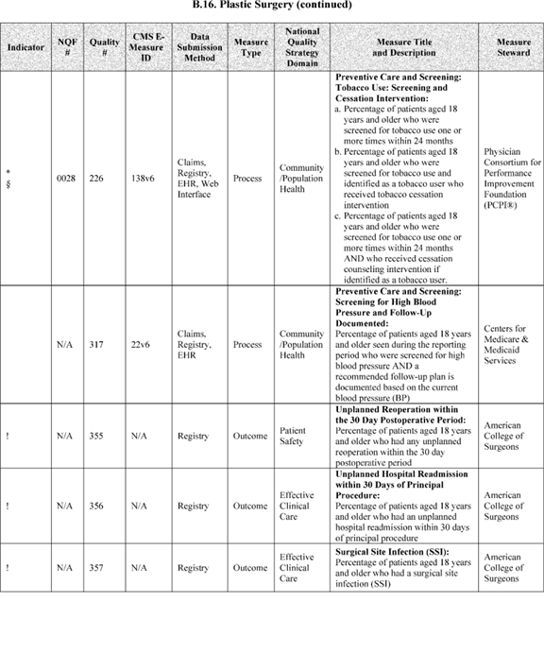

**[*54070]**



**[*54071]**

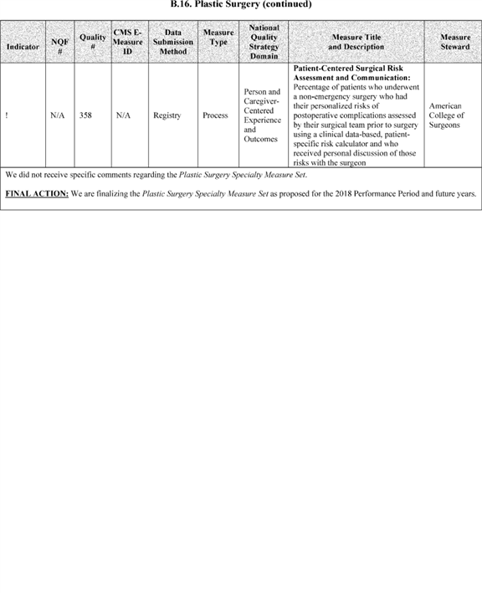

**[*54071]**



**[*54072]**

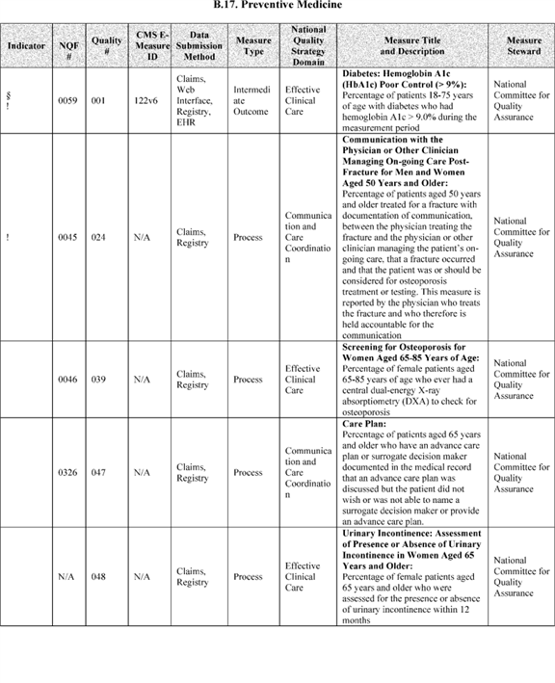

**[*54072]**



**[*54073]**

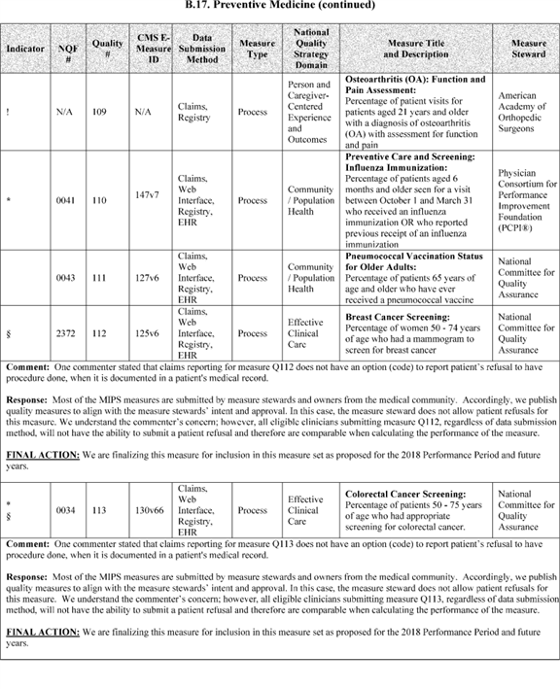

**[*54073]**



**[*54074]**

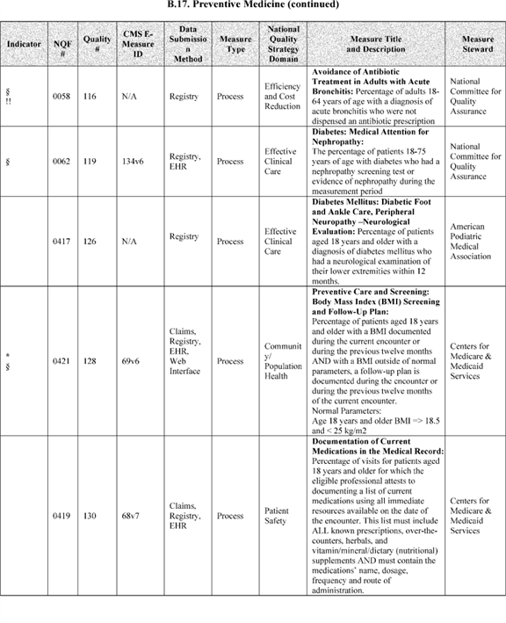

**[*54074]**



**[*54075]**

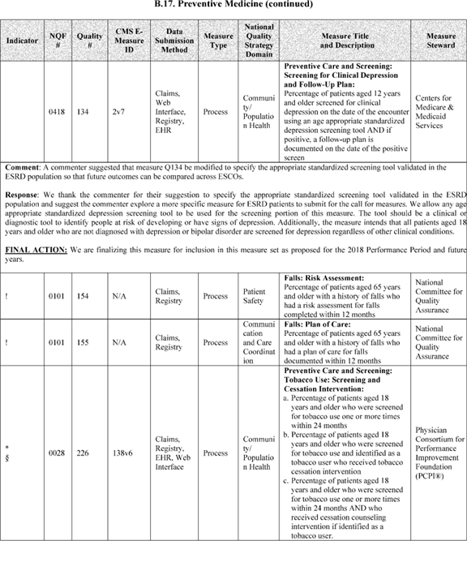

**[*54075]**



**[*54076]**

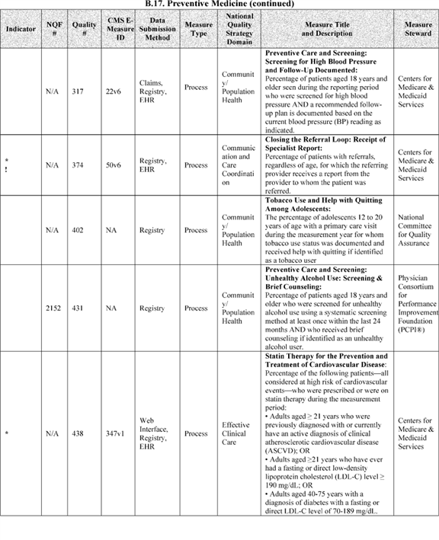

**[*54076]**



**[*54077]**

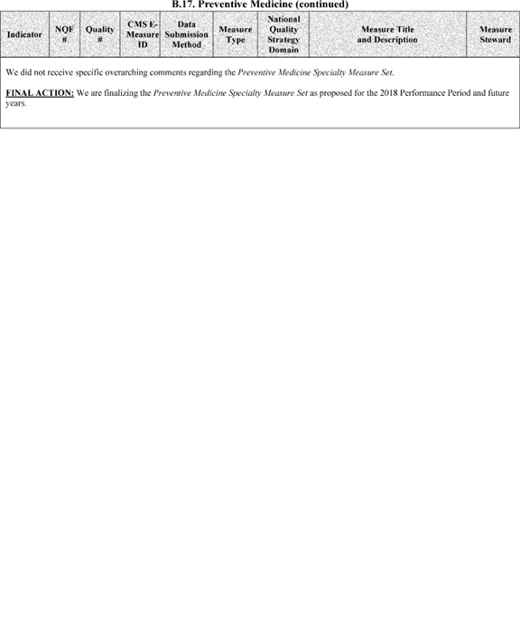

**[*54077]**



**[*54078]**

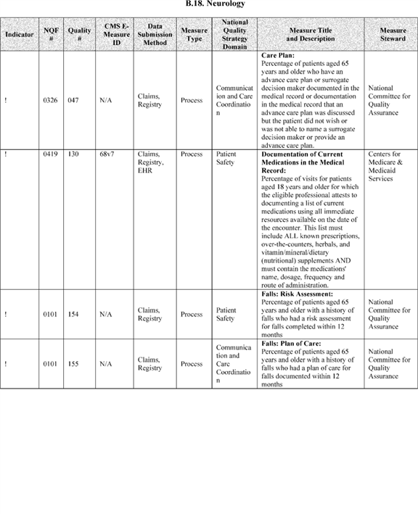

**[*54078]**



**[*54079]**

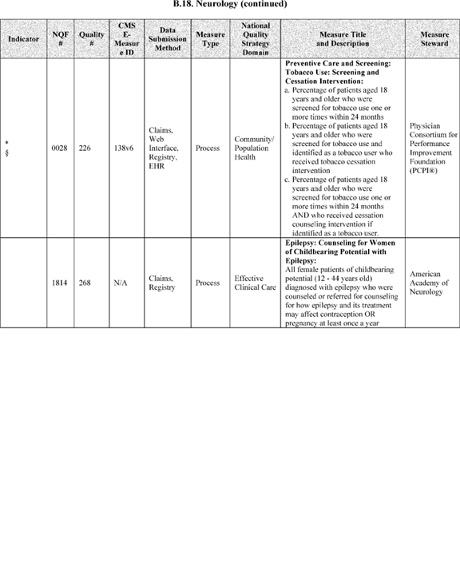

**[*54079]**



**[*54080]**

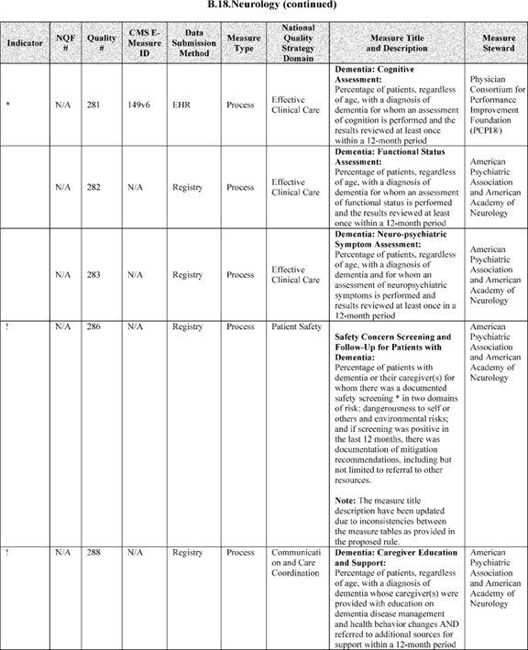

**[*54080]**



**[*54081]**

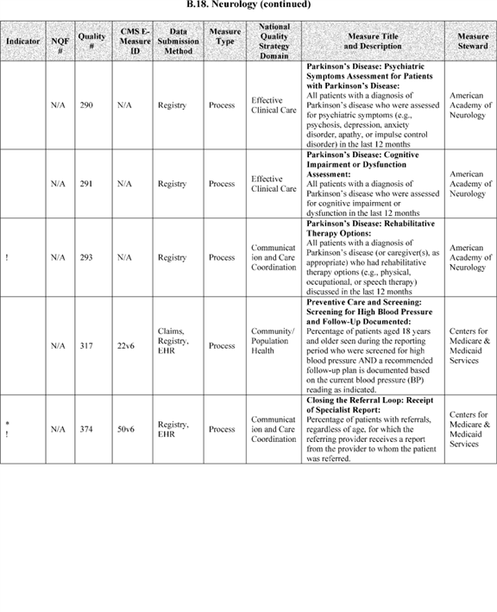

**[*54081]**



**[*54082]**

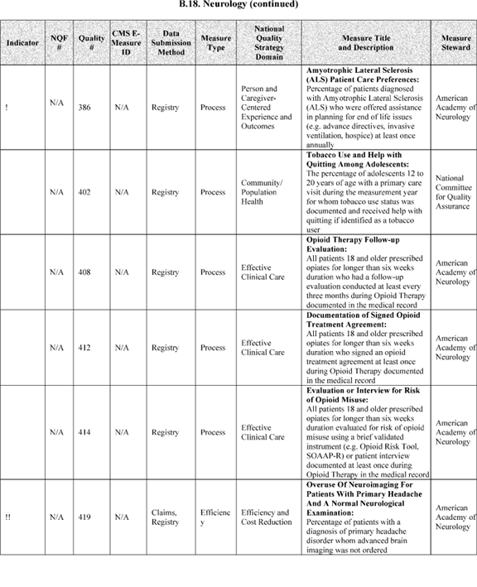

**[*54082]**



**[*54083]**

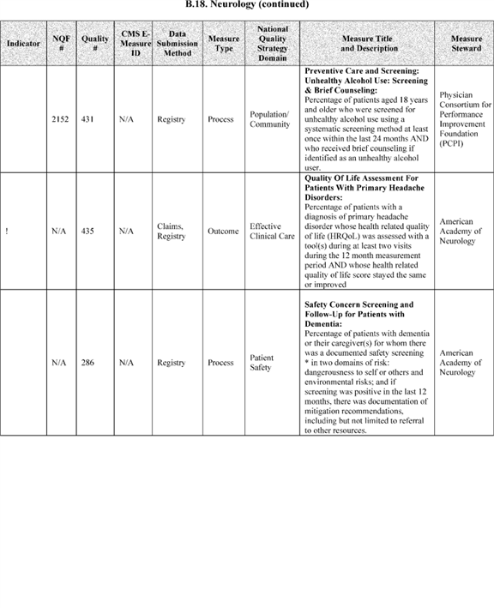

**[*54083]**



**[*54084]**

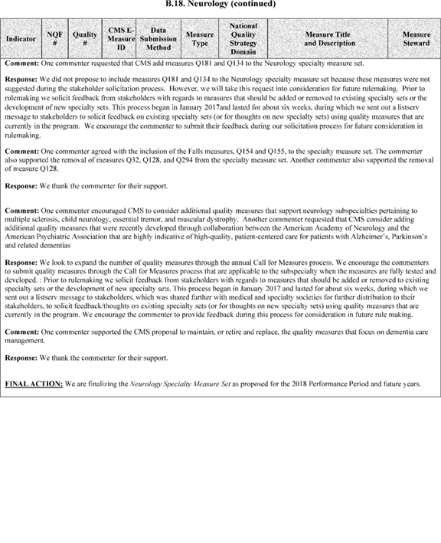

**[*54084]**



**[*54085]**

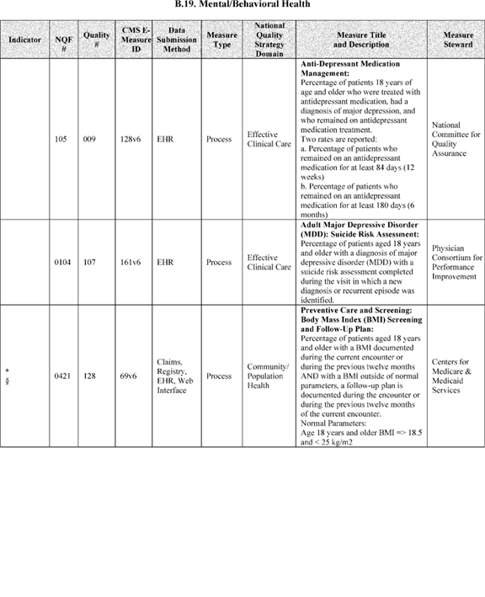

**[*54085]**



**[*54086]**

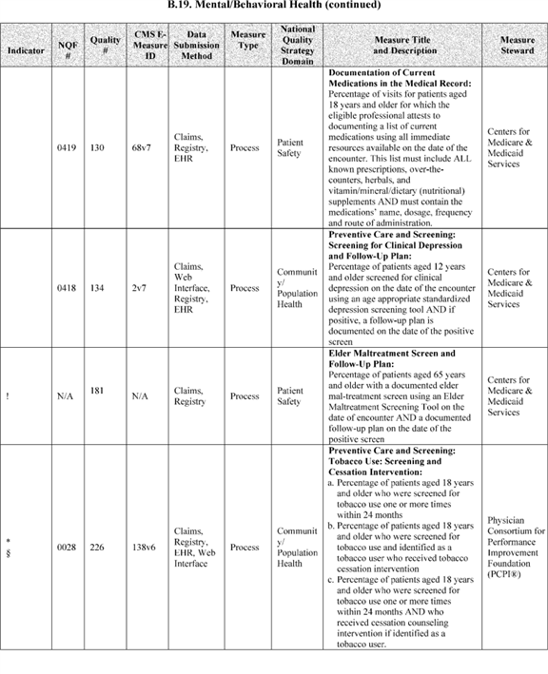

**[*54086]**



**[*54087]**

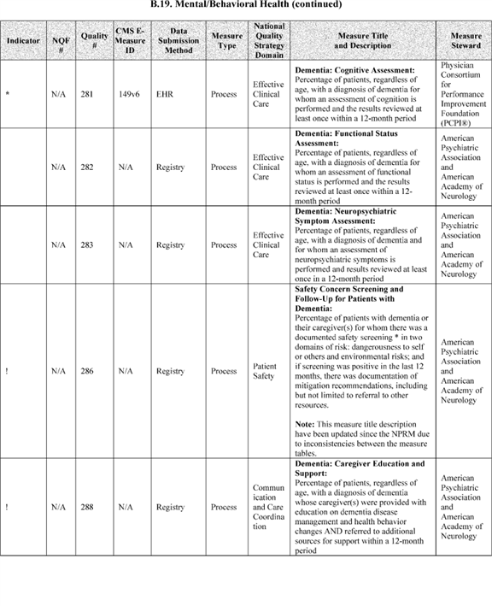

**[*54087]**



**[*54088]**

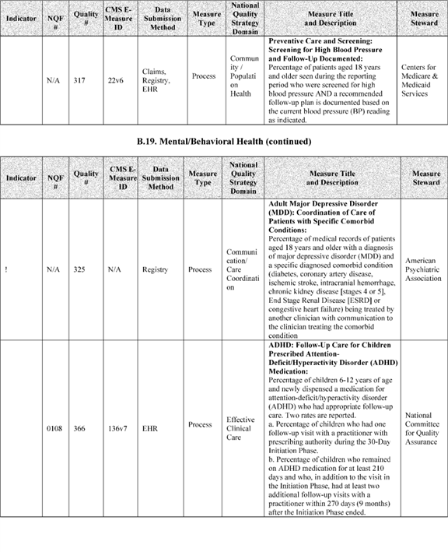

**[*54088]**



**[*54089]**

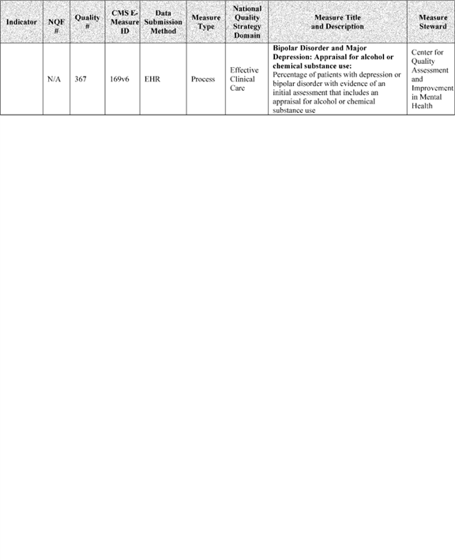

**[*54089]**



**[*54090]**

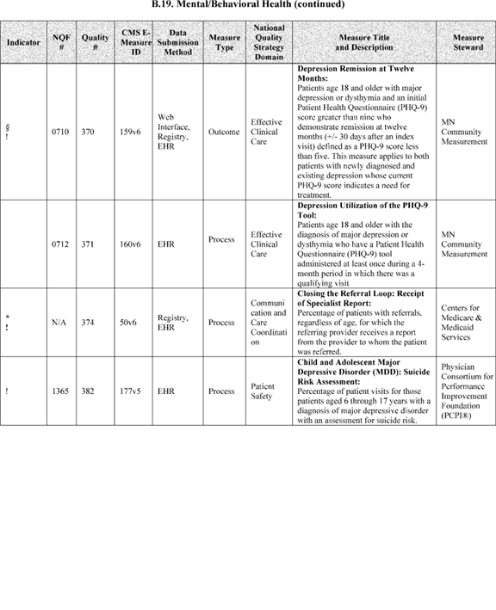

**[*54090]**



**[*54091]**

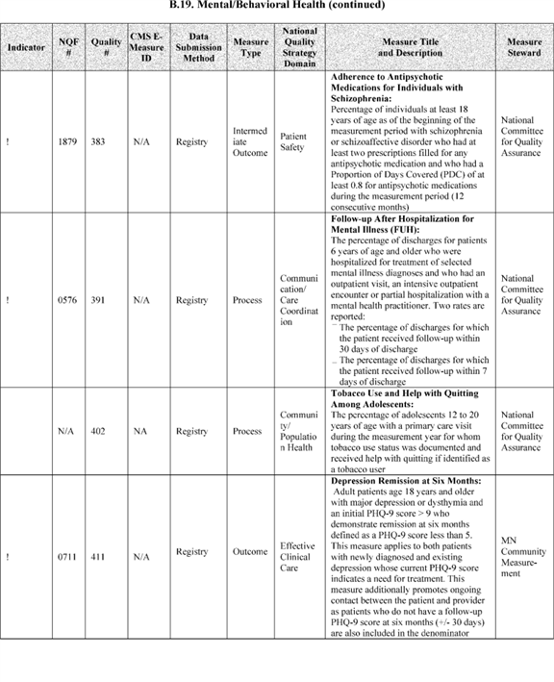

**[*54091]**



**[*54092]**

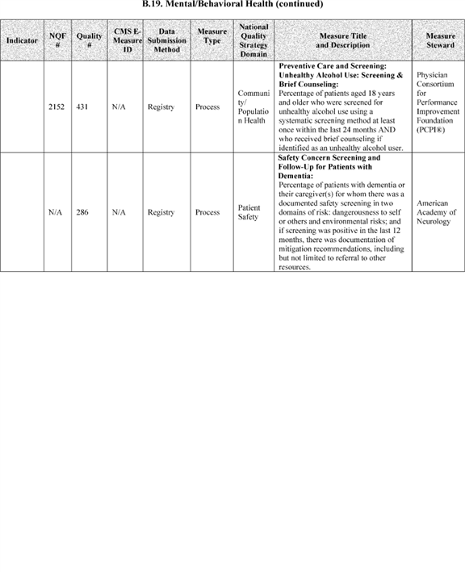

**[*54092]**



**[*54093]**

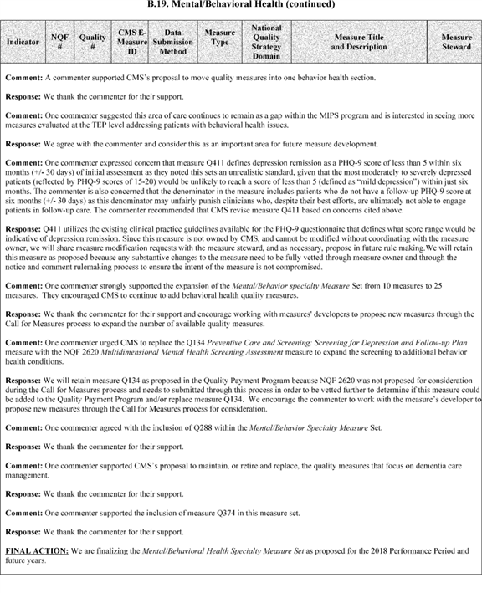

**[*54093]**



**[*54094]**

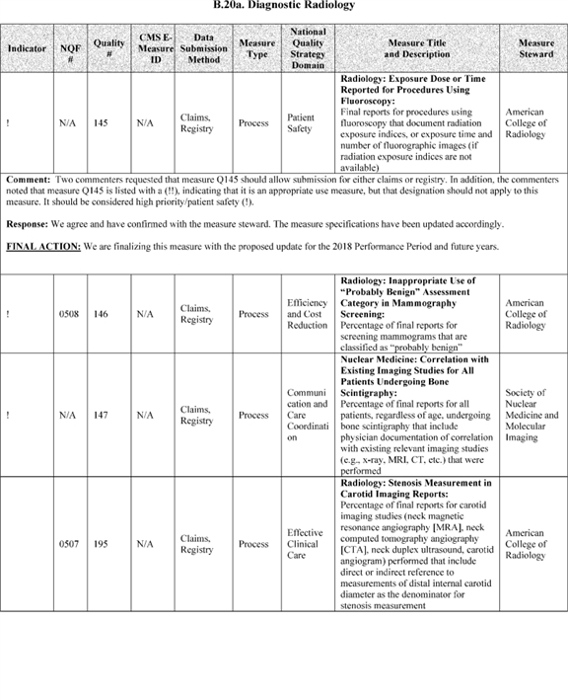

**[*54094]**



**[*54095]**

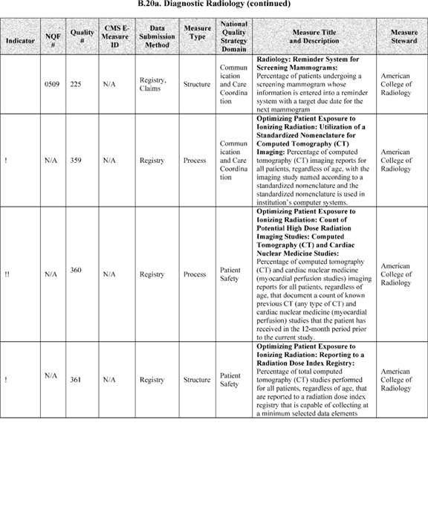

**[*54095]**



**[*54096]**

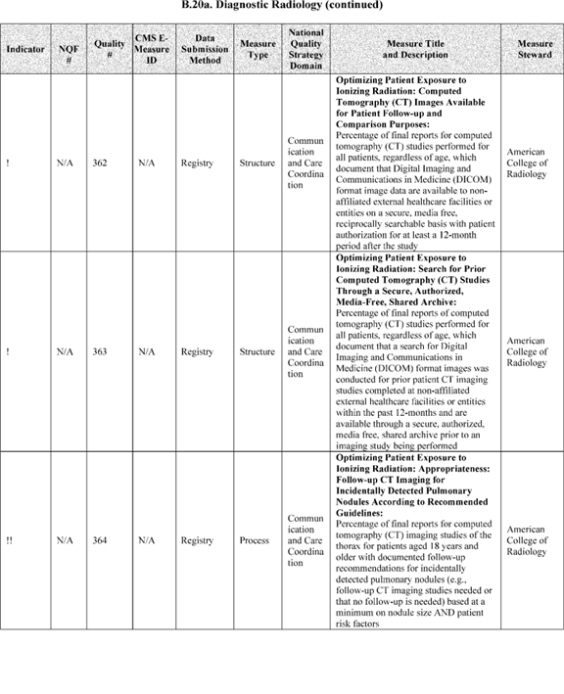

**[*54096]**



**[*54097]**

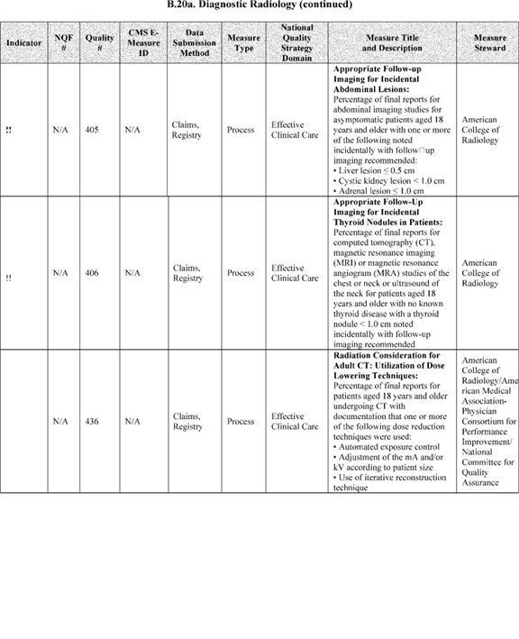

**[*54097]**



**[*54098]**



**[*54098]**



**[*54099]**

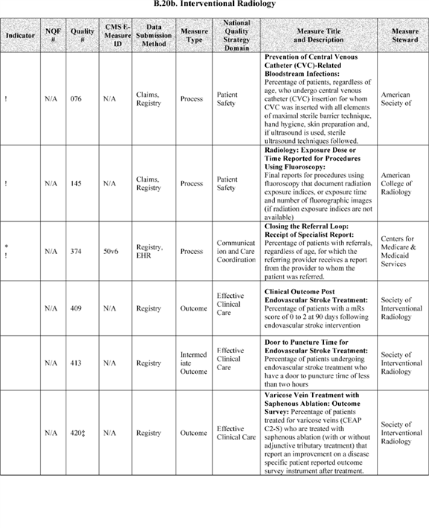

**[*54099]**



**[*54100]**

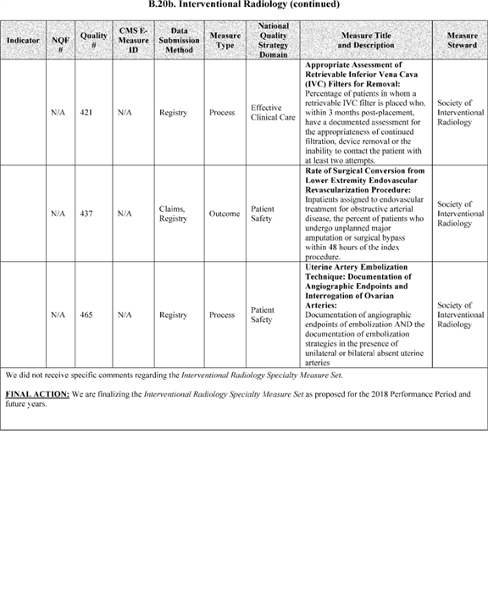

**[*54100]**



**[*54101]**

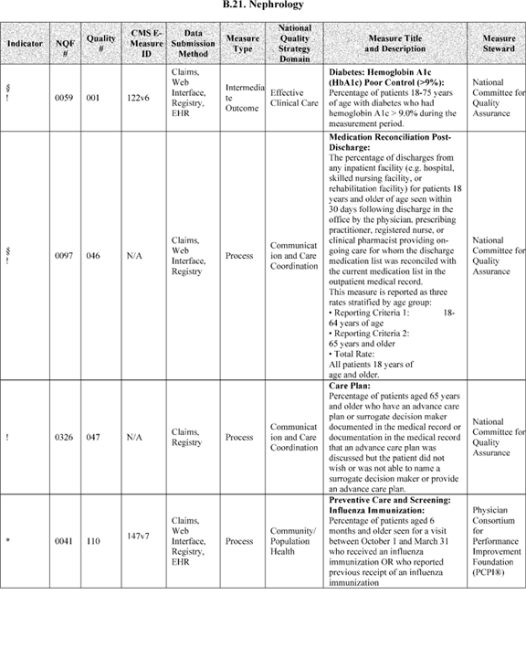

**[*54101]**



**[*54102]**

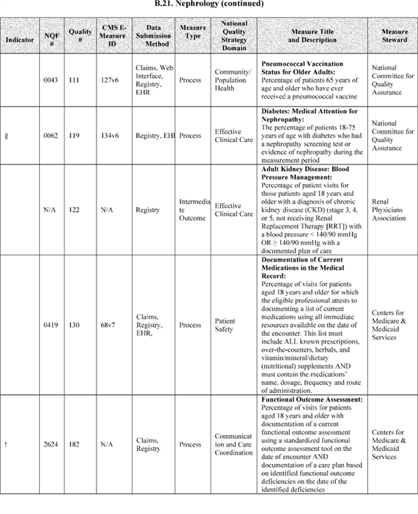

**[*54102]**



**[*54103]**

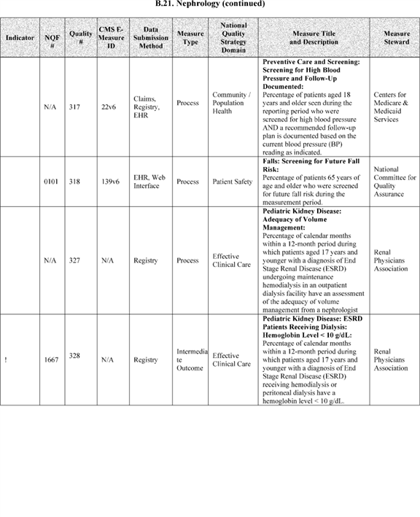

**[*54103]**



**[*54104]**

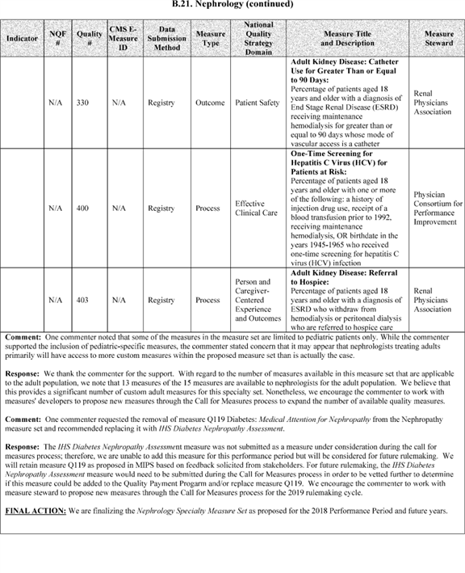

**[*54104]**



**[*54105]**

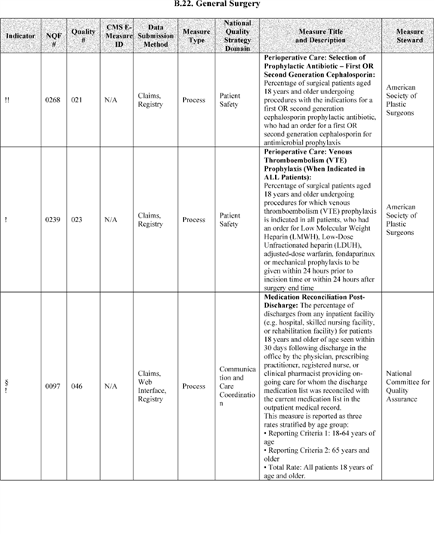

**[*54105]**



**[*54106]**

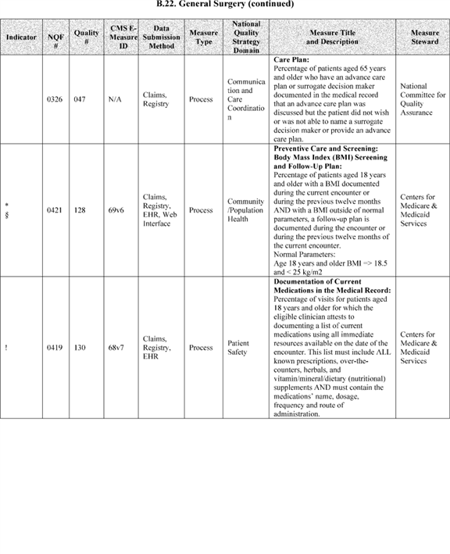

**[*54106]**



**[*54107]**

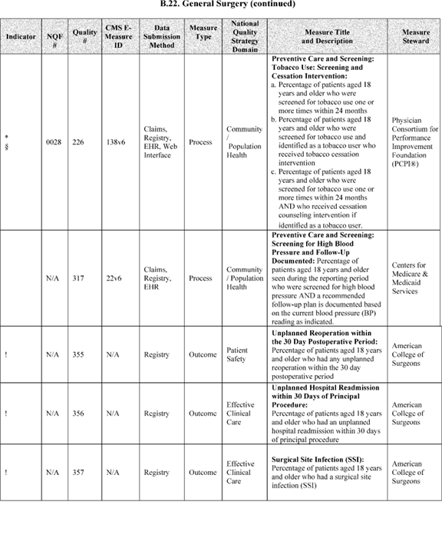

**[*54107]**



**[*54108]**

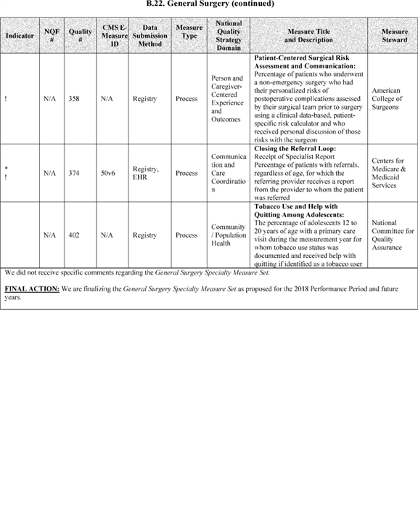

**[*54108]**



**[*54109]**

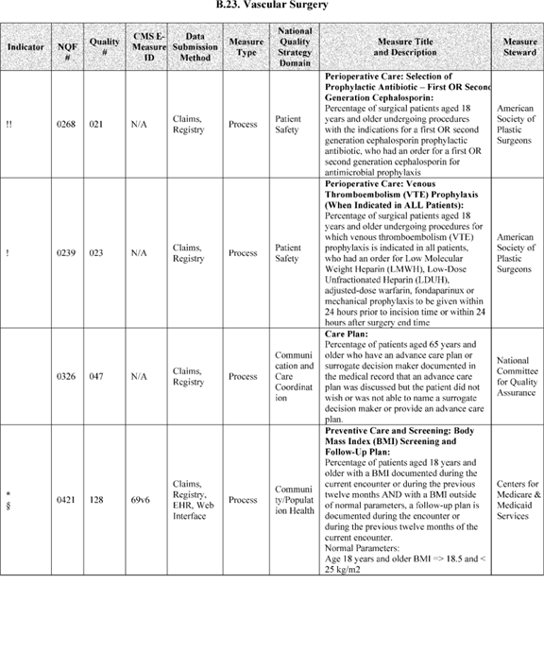

**[*54109]**



**[*54110]**

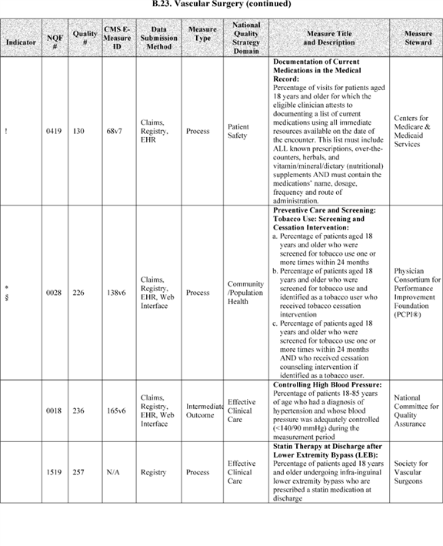

**[*54110]**



**[*54111]**

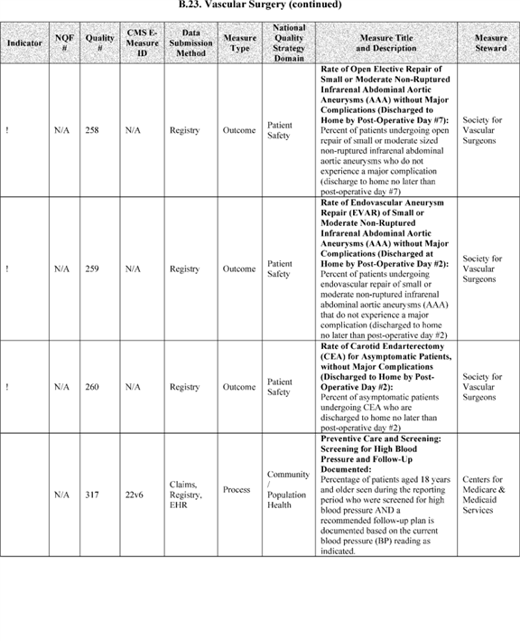

**[*54111]**



**[*54112]**

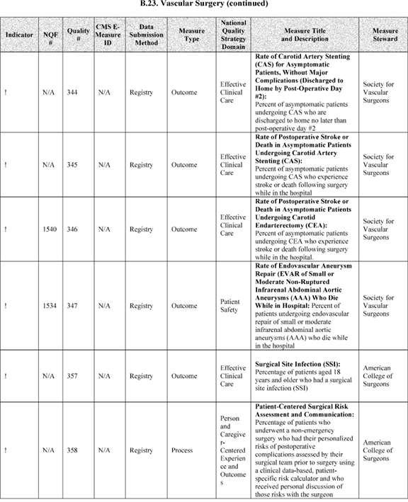

**[*54112]**



**[*54113]**

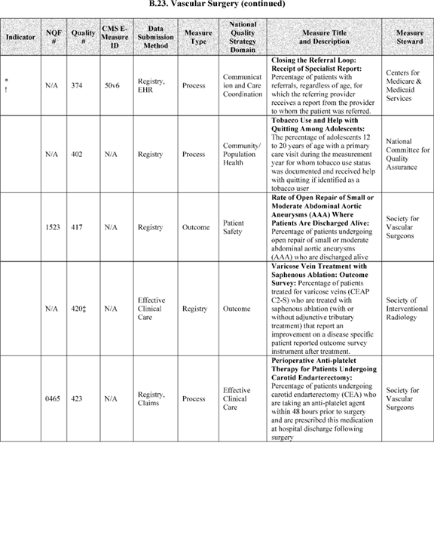

**[*54113]**



**[*54114]**

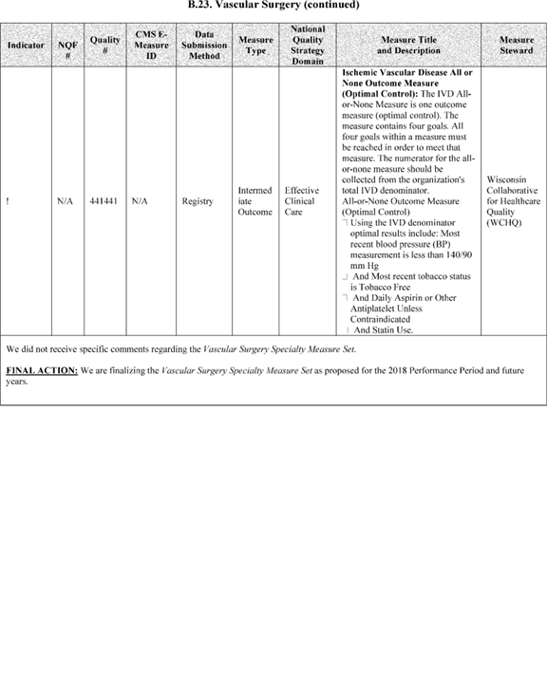

**[*54114]**



**[*54115]**

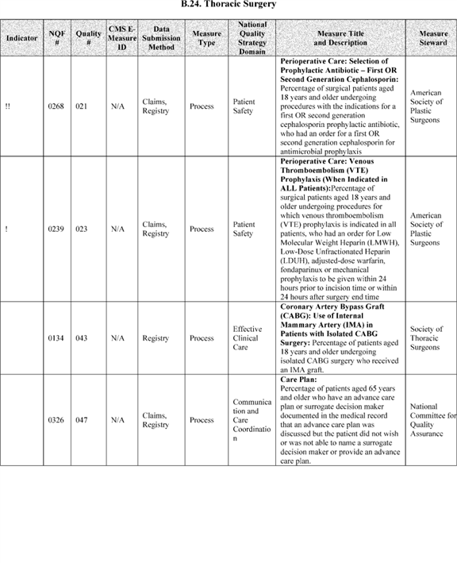

**[*54115]**



**[*54116]**

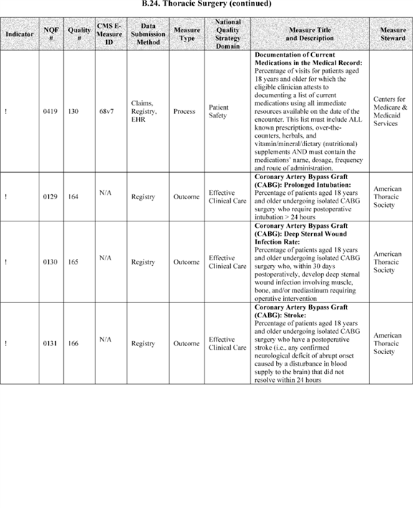

**[*54116]**



**[*54117]**

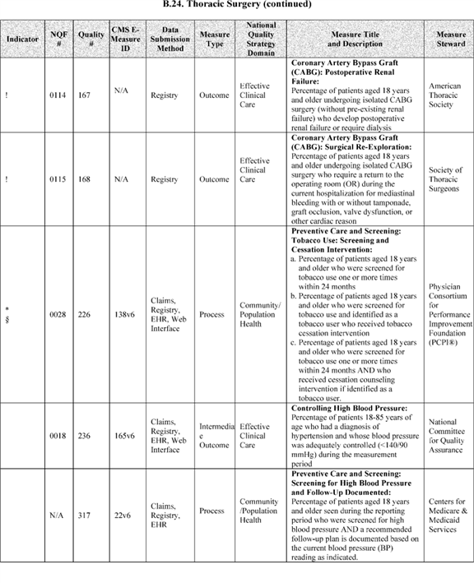

**[*54117]**



**[*54118]**

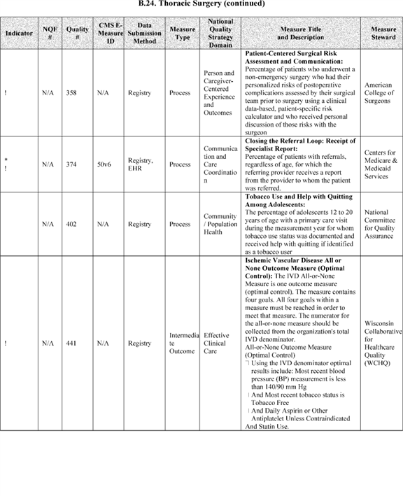

**[*54118]**



**[*54119]**

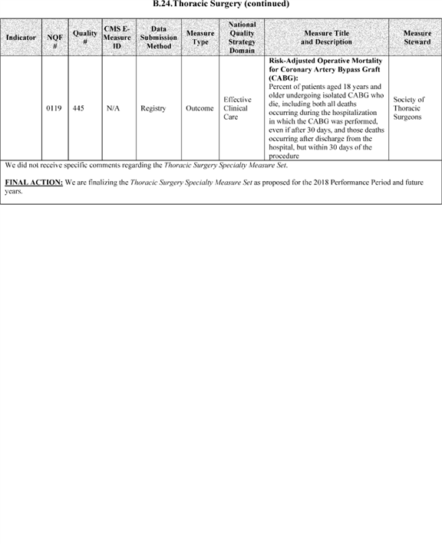

**[*54119]**



**[*54120]**

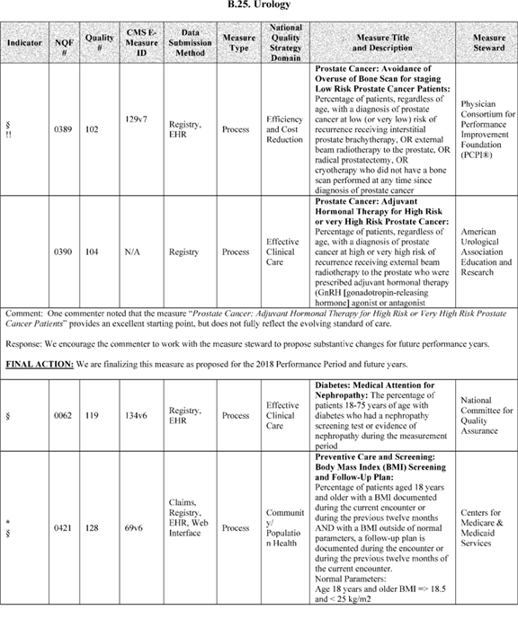

**[*54120]**



**[*54121]**

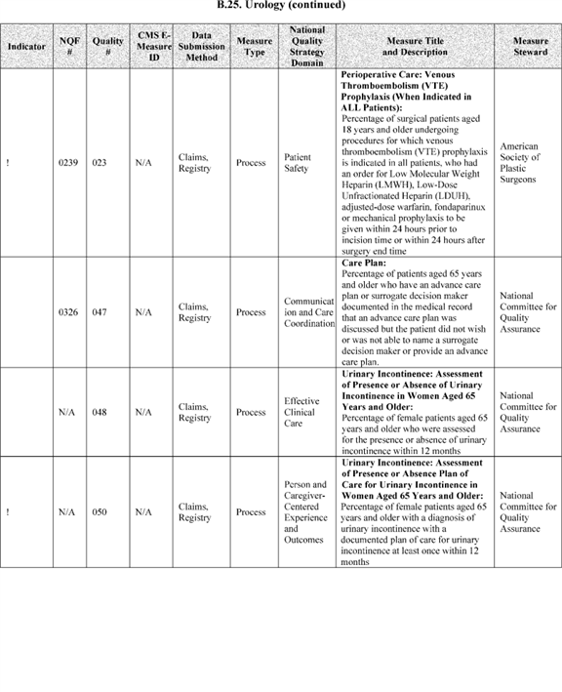

**[*54121]**



**[*54122]**

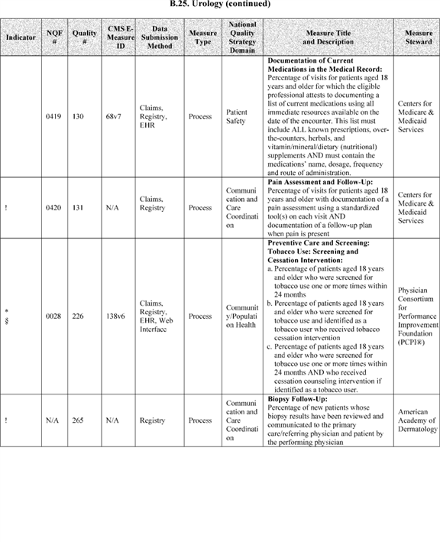

**[*54122]**



**[*54123]**

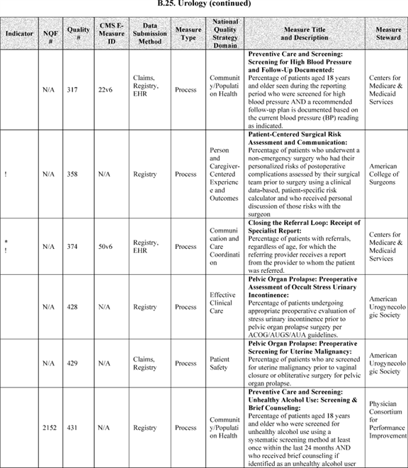

**[*54123]**



**[*54124]**

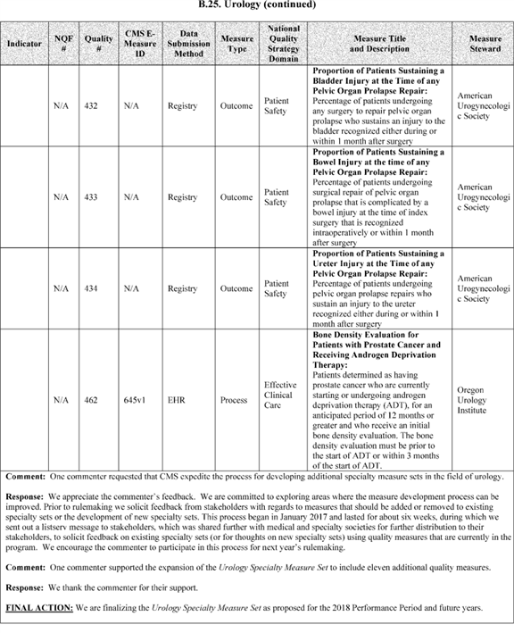

**[*54124]**



**[*54125]**

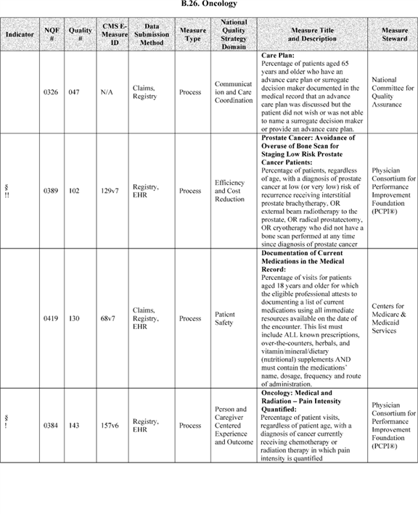

**[*54125]**



**[*54126]**

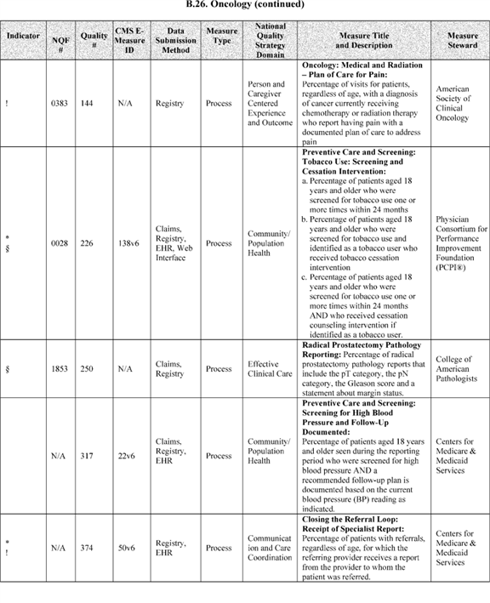

**[*54126]**



**[*54127]**

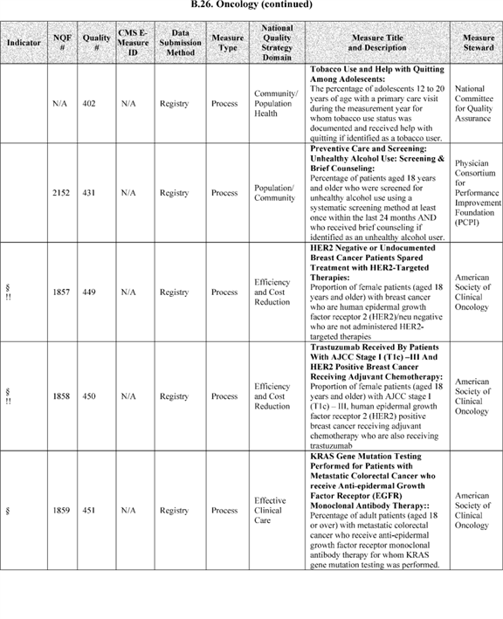

**[*54127]**



**[*54128]**

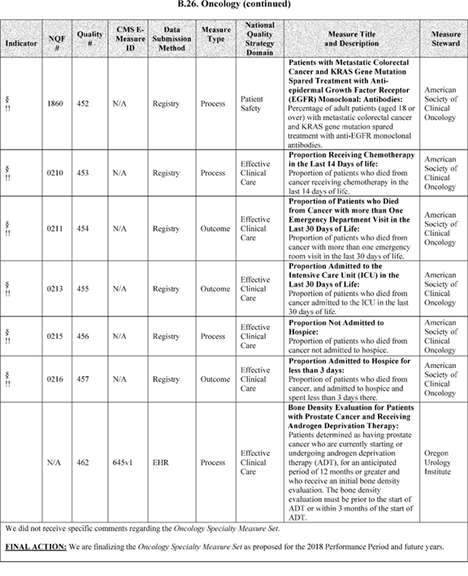

**[*54128]**



**[*54129]**

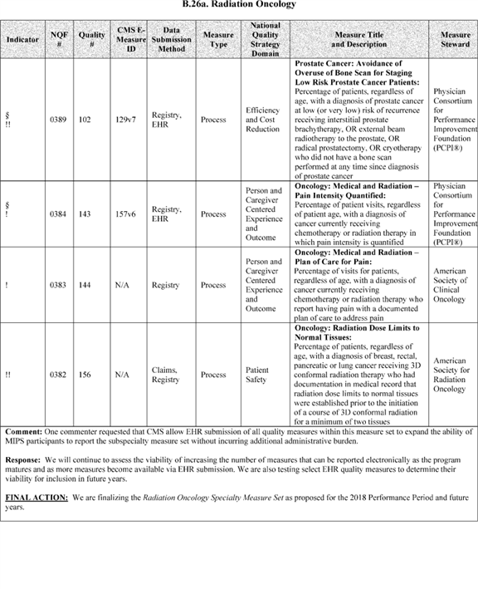

**[*54129]**



**[*54130]**

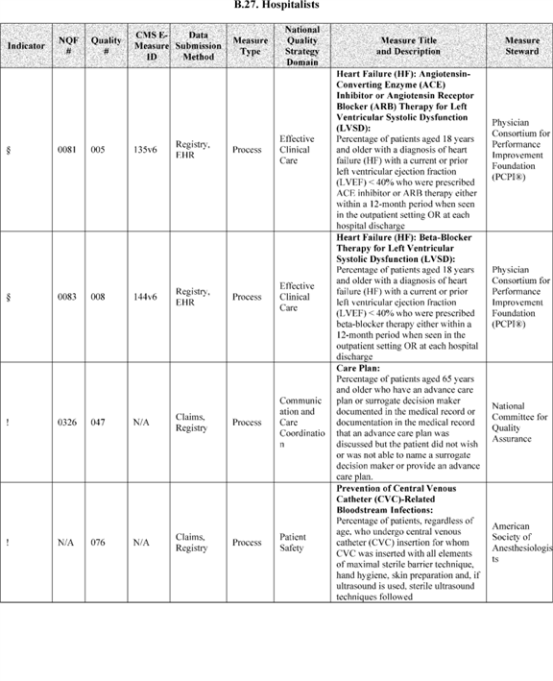

**[*54130]**



**[*54131]**

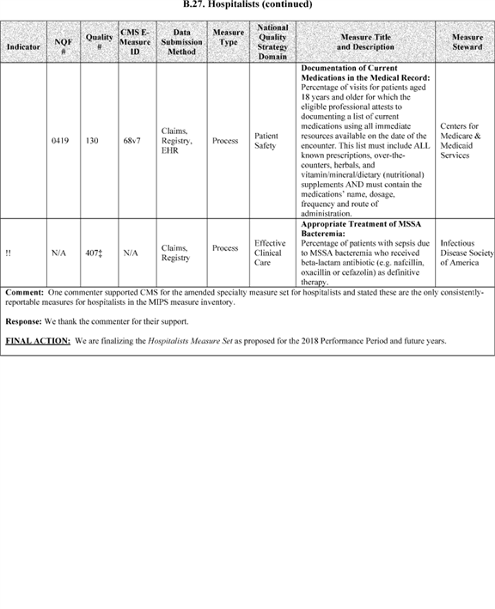

**[*54131]**



**[*54132]**

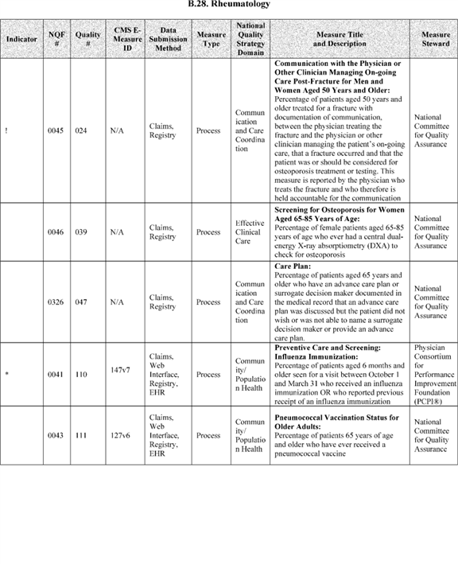

**[*54132]**



**[*54133]**

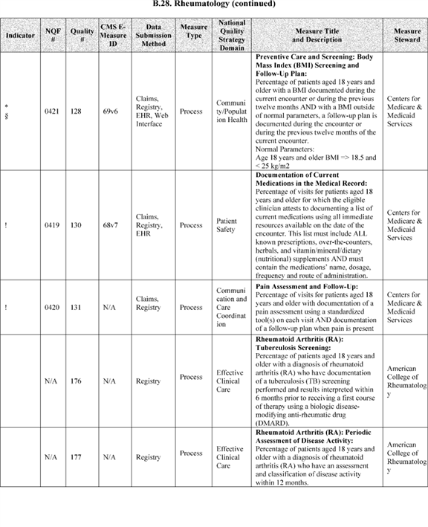

**[*54133]**



**[*54134]**

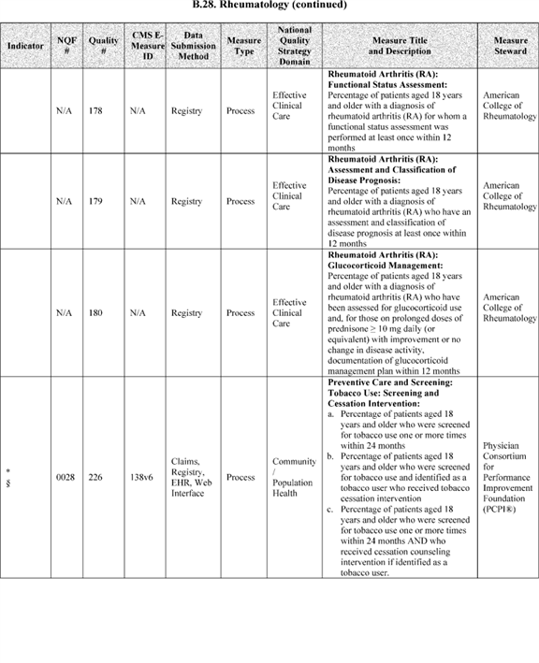

**[*54134]**



**[*54135]**

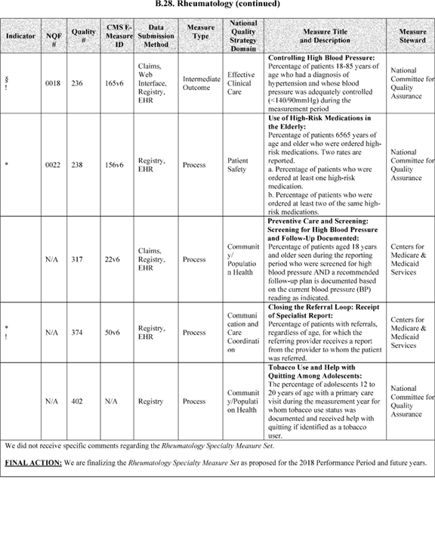

**[*54135]**



**[*54136]**

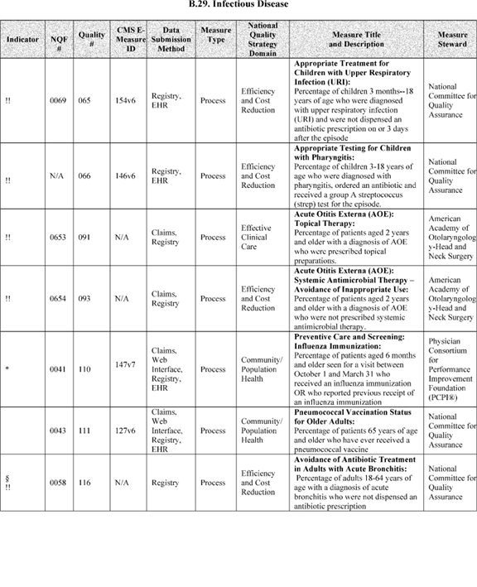

**[*54136]**



**[*54137]**

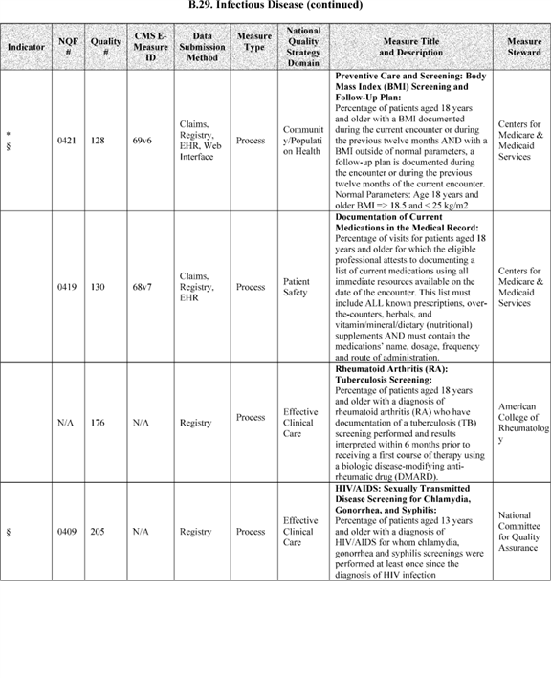

**[*54137]**



**[*54138]**

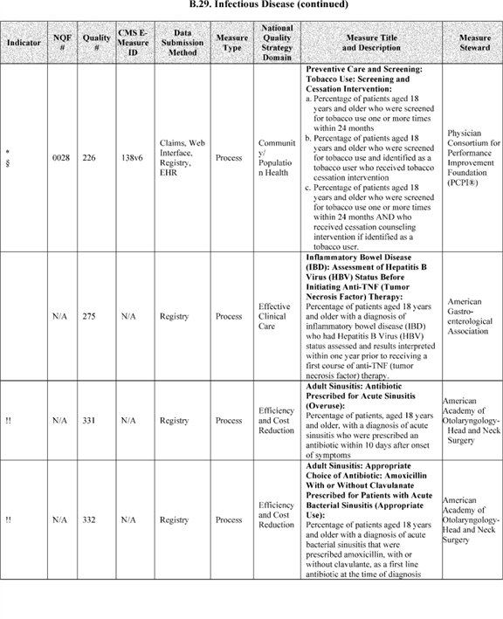

**[*54138]**



**[*54139]**

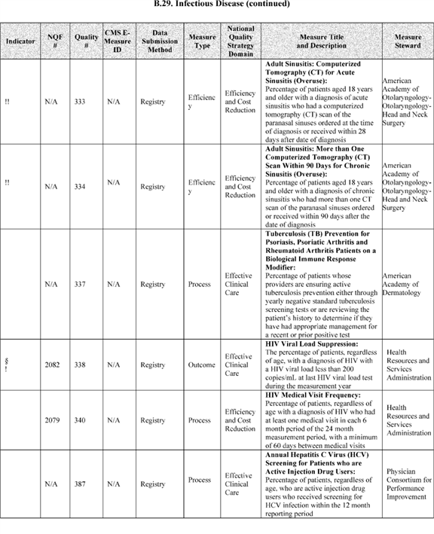

**[*54139]**



**[*54140]**

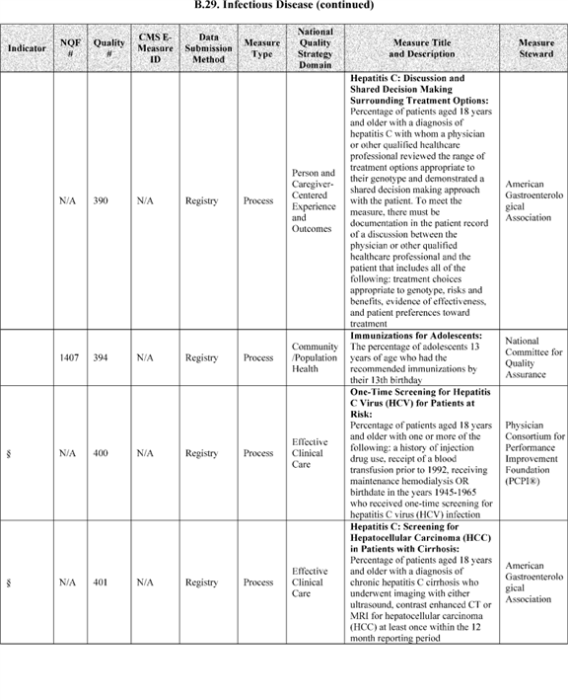

**[*54140]**



**[*54141]**

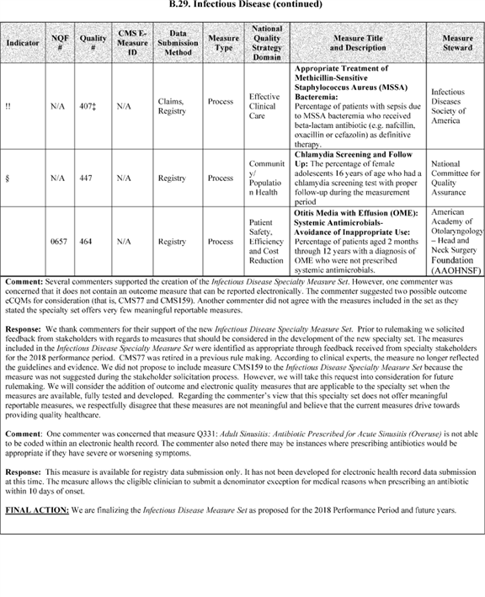

**[*54141]**



**[*54142]**

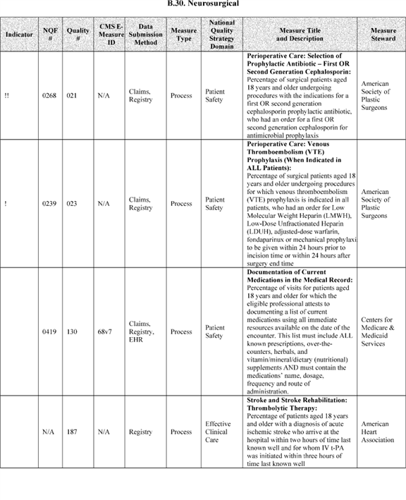

**[*54142]**



**[*54143]**

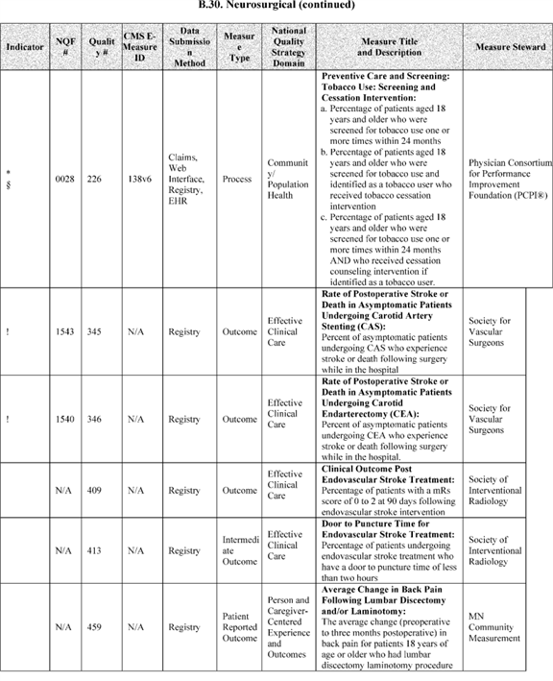

**[*54143]**



**[*54144]**

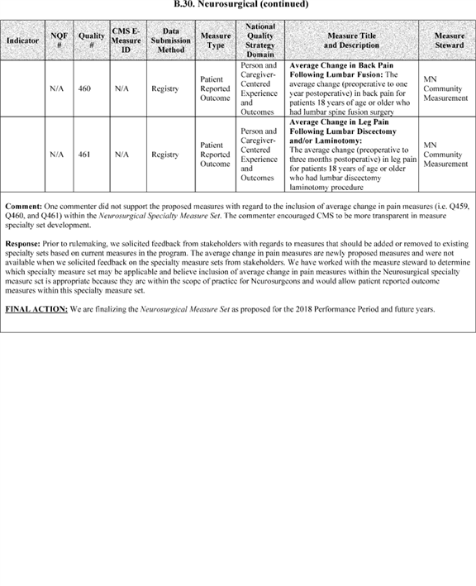

**[*54144]**



**[*54145]**

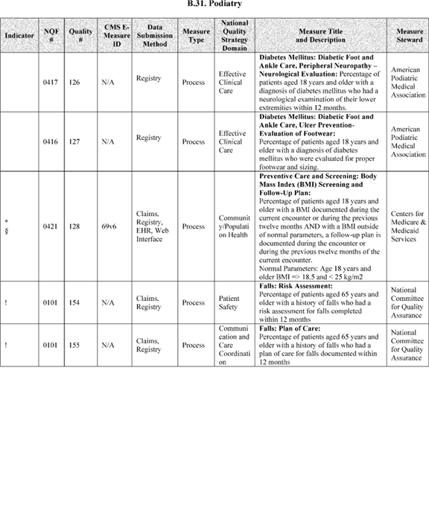

**[*54145]**



**[*54146]**

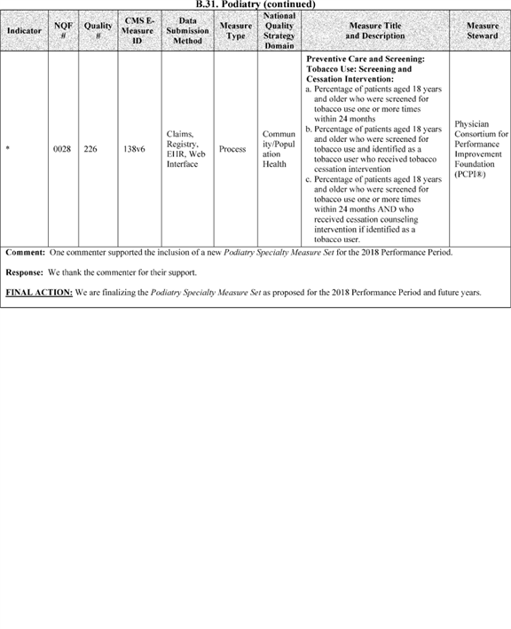

**[*54146]**



**[*54147]**

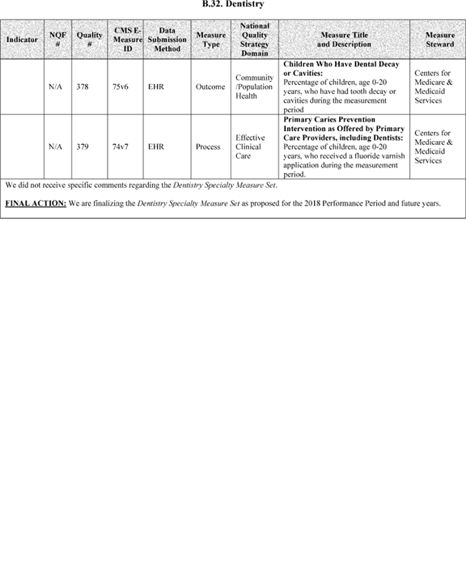

**[*54147]**



**[*54148]**

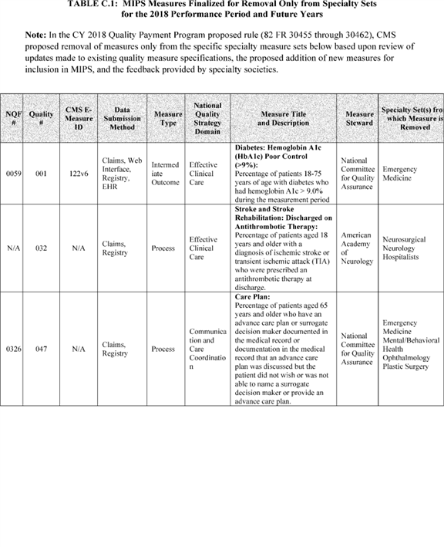

**[*54148]**



**[*54149]**

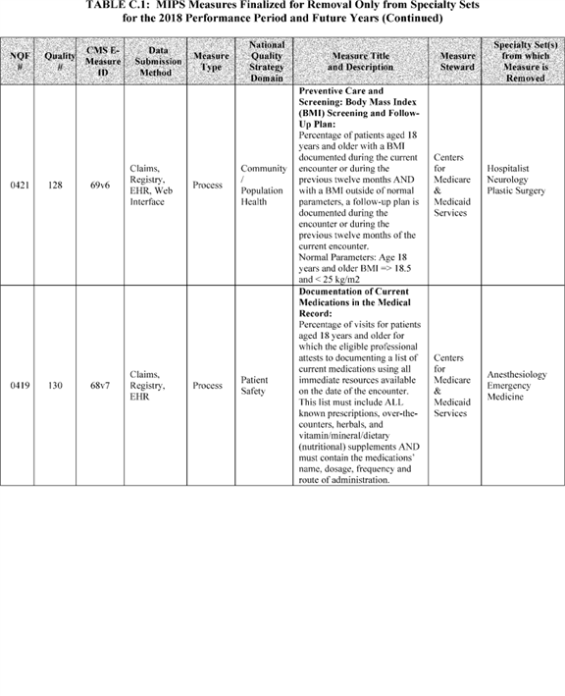

**[*54149]**



**[*54150]**

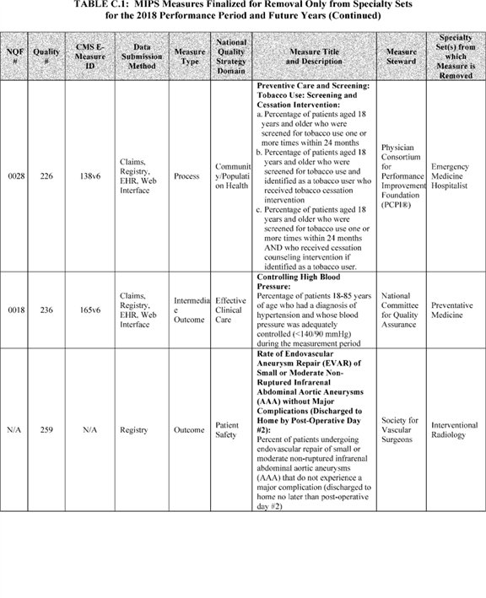

**[*54150]**



**[*54151]**

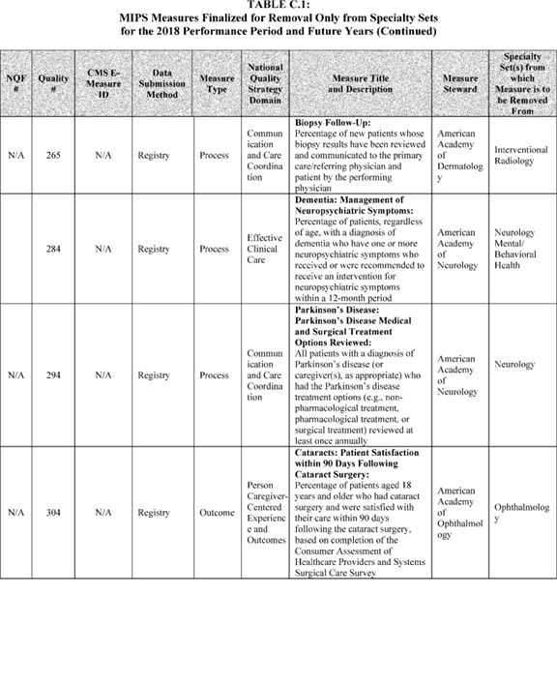

**[*54151]**



**[*54152]**

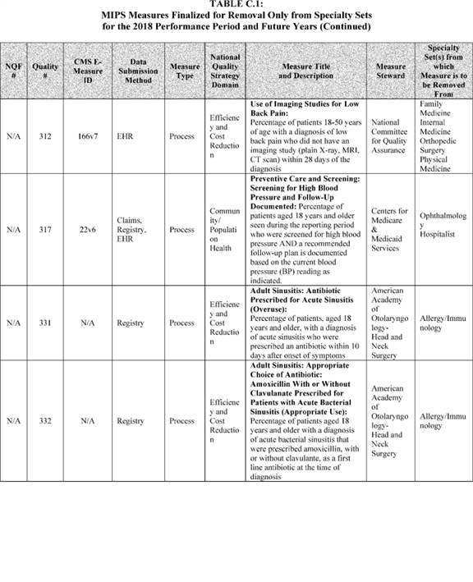

**[*54152]**



**[*54153]**

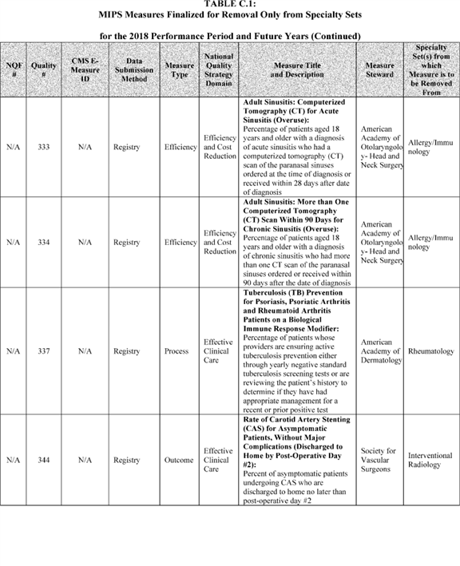

**[*54153]**



**[*54154]**

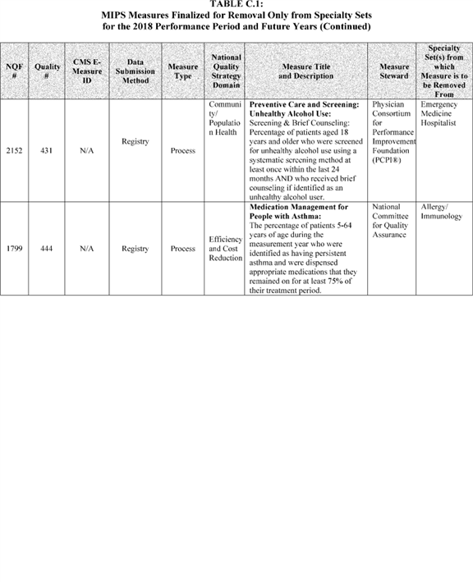

**[*54154]**



**[*54155]**

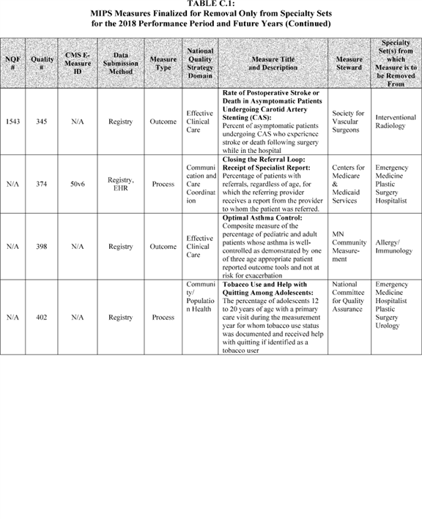

**[*54155]**



**[*54156]**

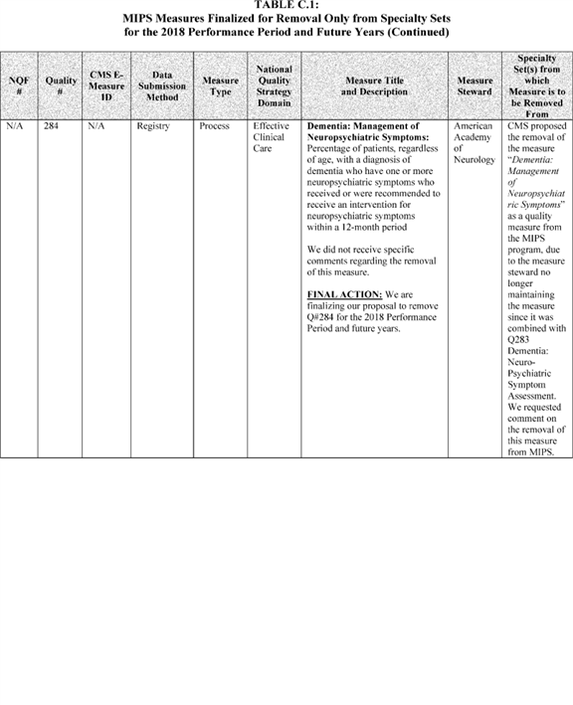

**[*54156]**



**[*54157]**

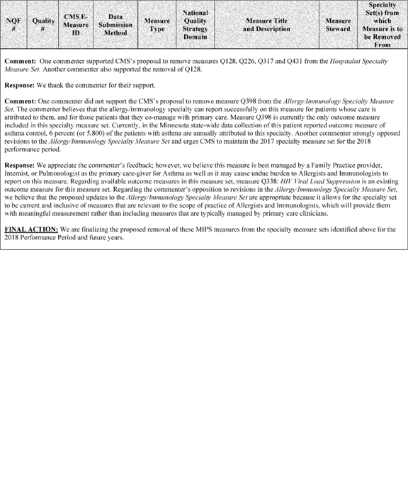

**[*54157]**



**[*54158]**

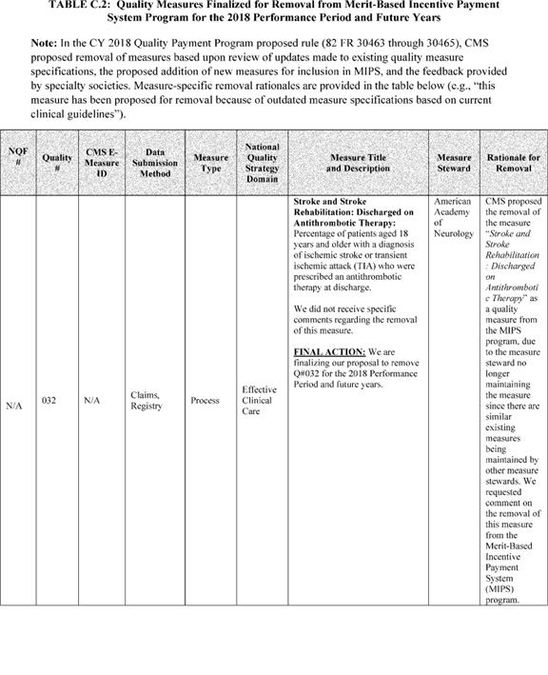

**[*54158]**



**[*54159]**

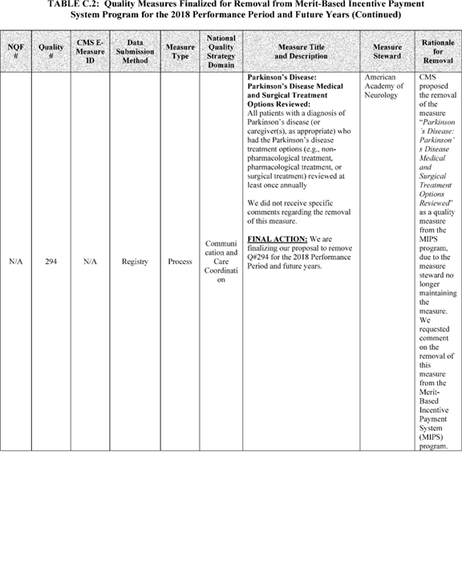

**[*54159]**



**[*54160]**

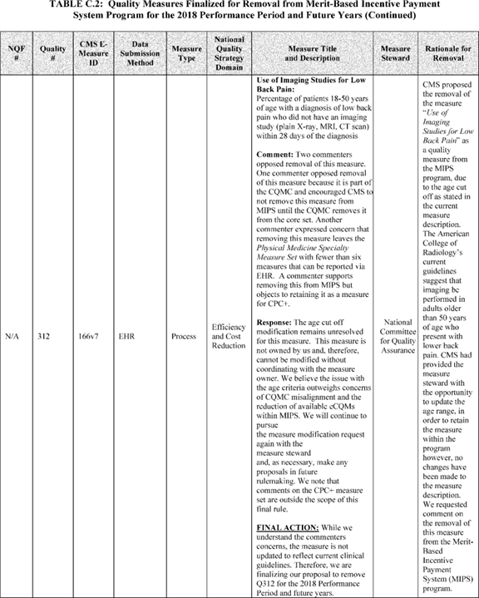

**[*54160]**



**[*54161]**

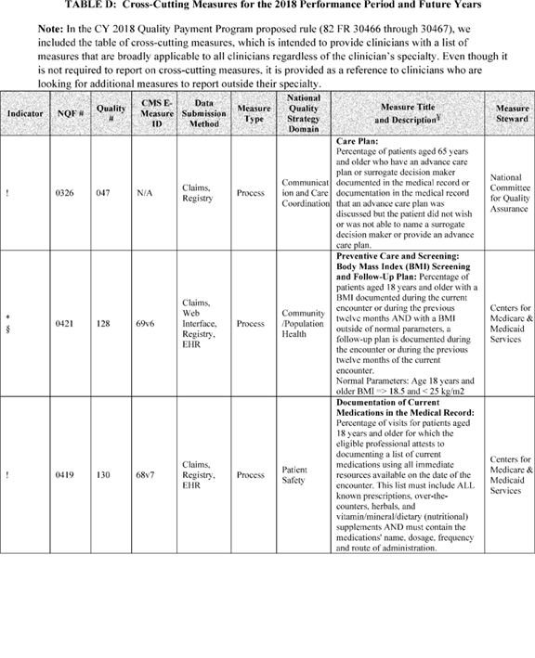

**[*54161]**



**[*54162]**

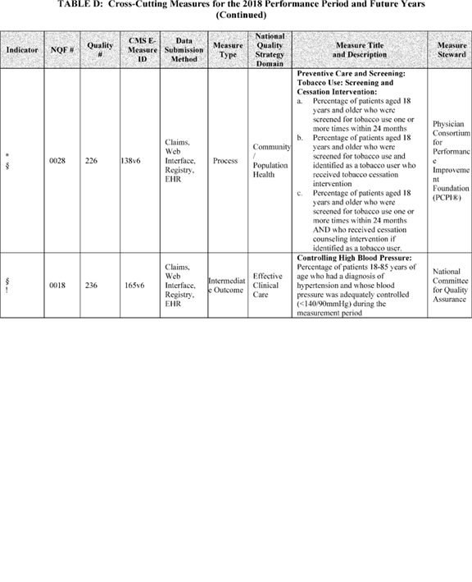

**[*54162]**



**[*54163]**

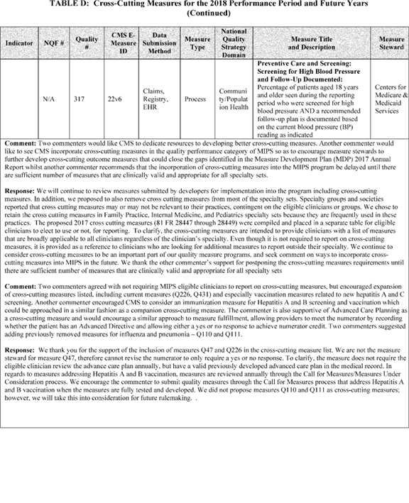

**[*54163]**



**[*54164]**

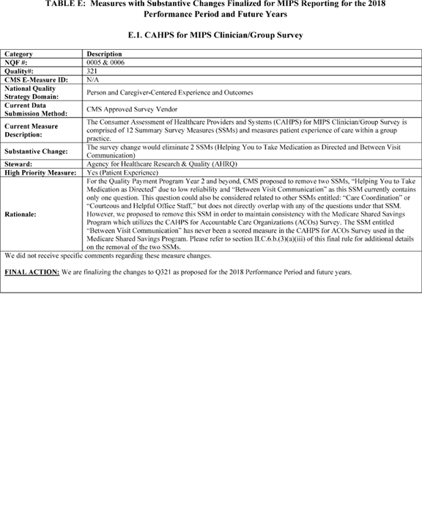

**[*54164]**



**[*54165]**

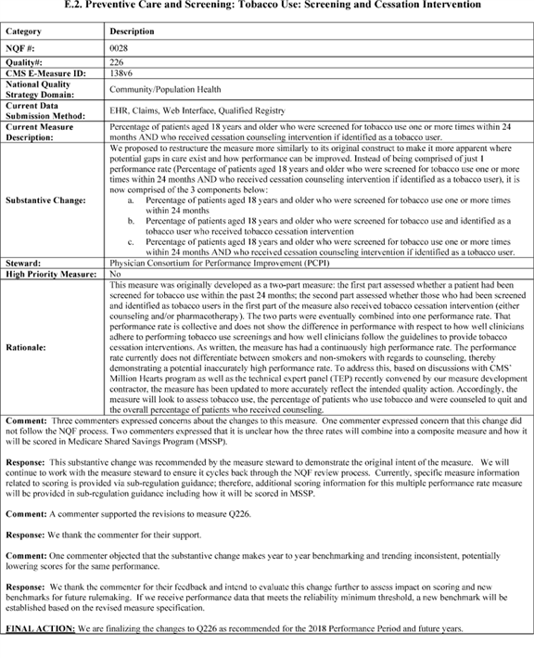

**[*54165]**



**[*54166]**

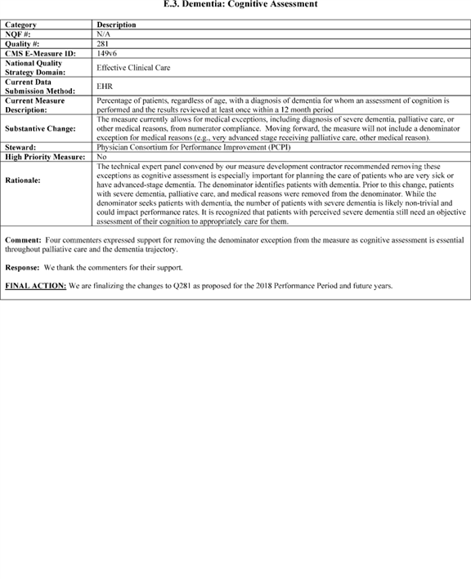

**[*54166]**



**[*54167]**

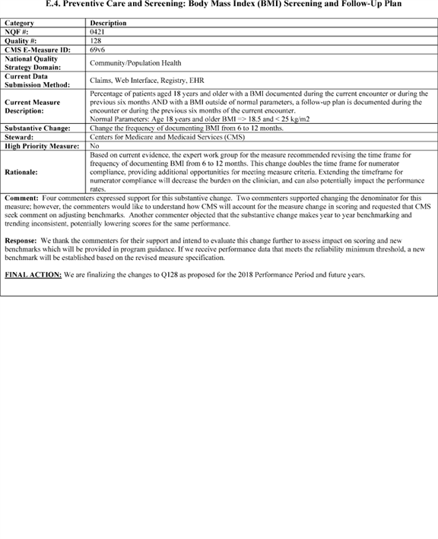

**[*54167]**



**[*54168]**

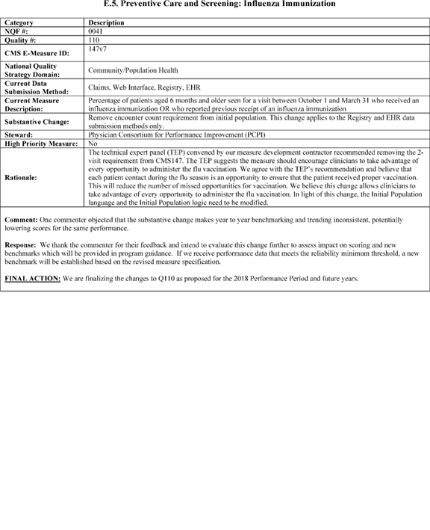

**[*54168]**



**[*54169]**

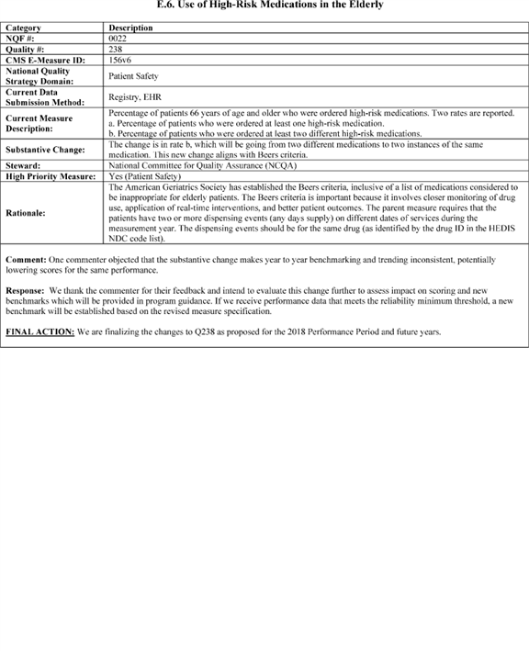

**[*54169]**



**[*54170]**

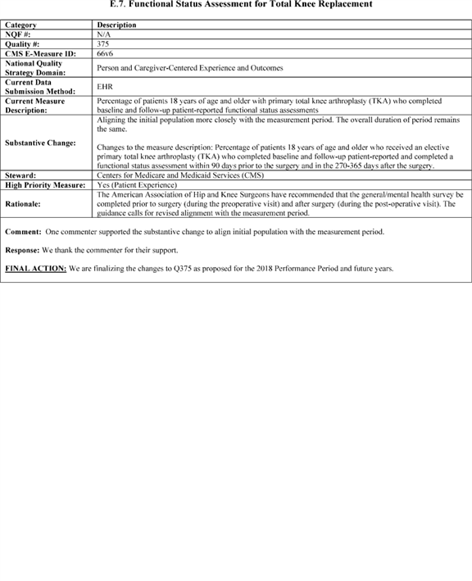

**[*54170]**



**[*54171]**

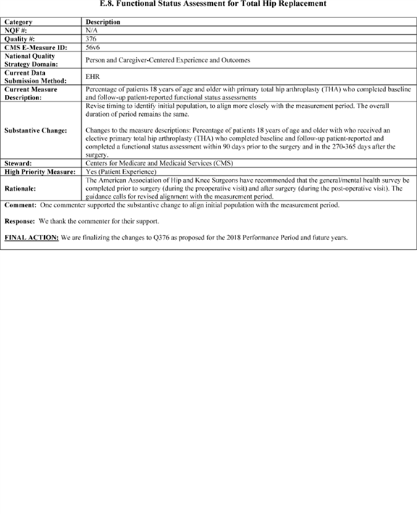

**[*54171]**



**[*54172]**

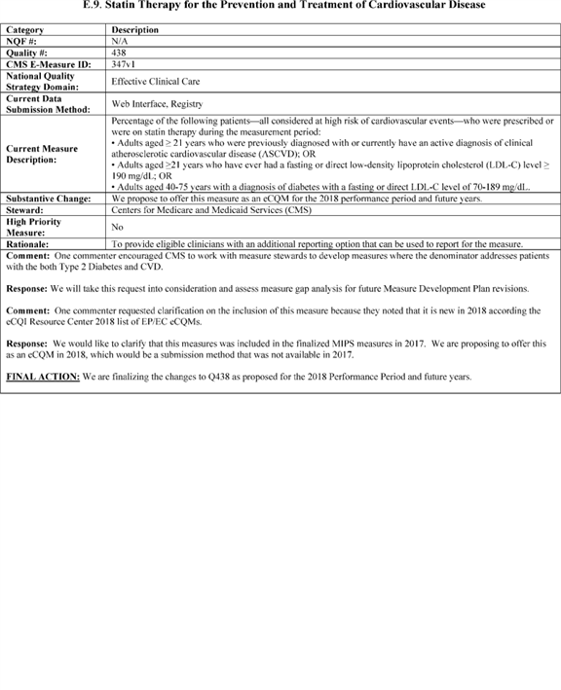

**[*54172]**



**[*54173]**

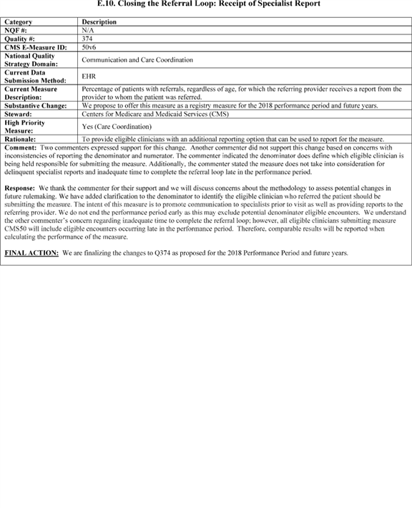

**[*54173]**



**[*54174]**

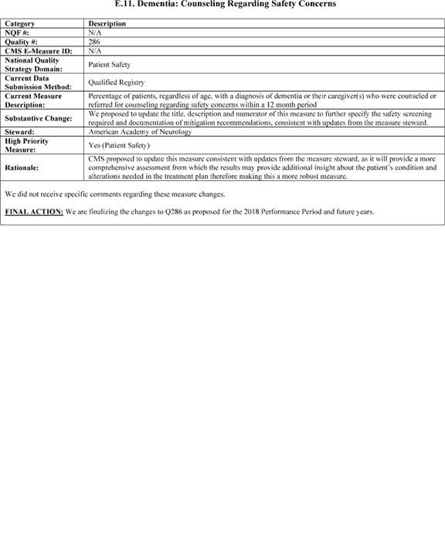

**[*54174]**



**[*54175]**

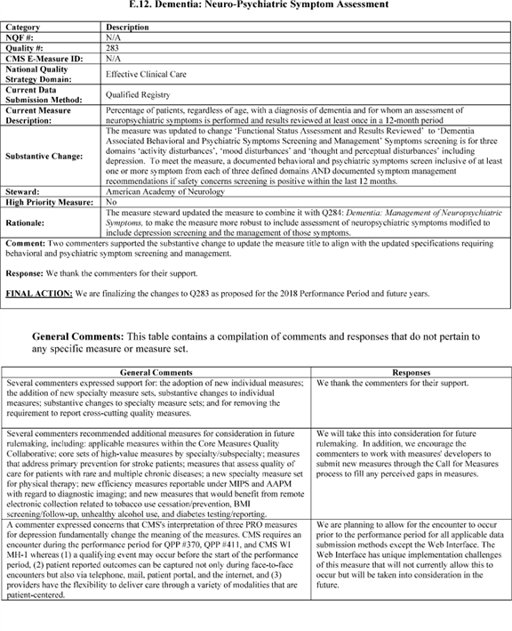

**[*54175]**



**[*54176]**

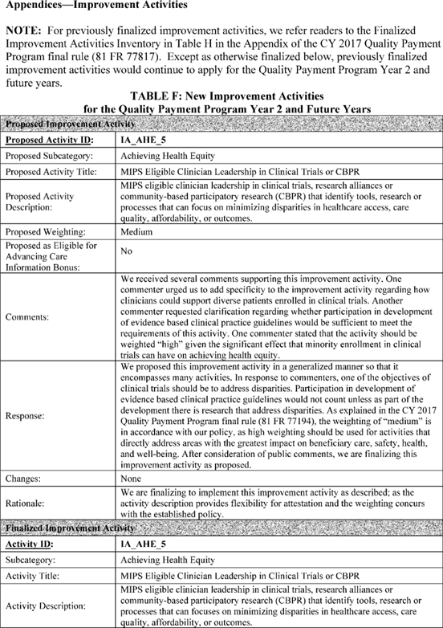

**[*54176]**



**[*54177]**

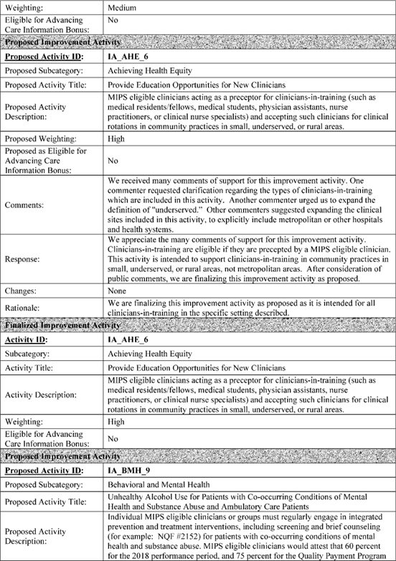

**[*54177]**



**[*54178]**

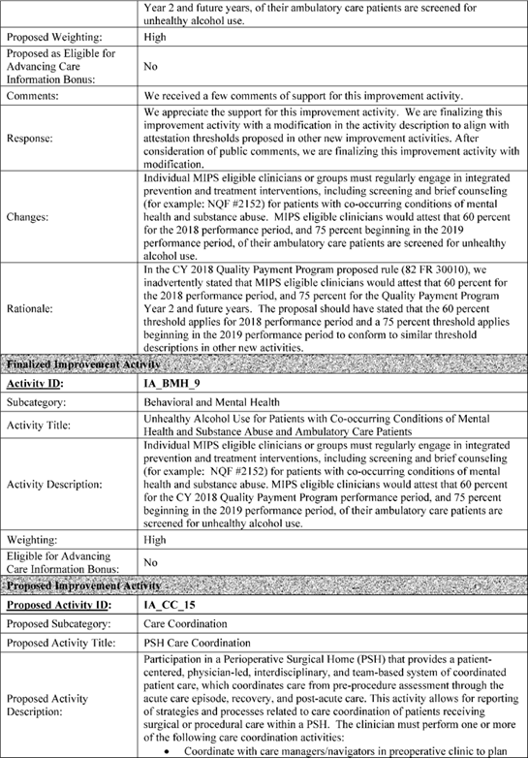

**[*54178]**



**[*54179]**

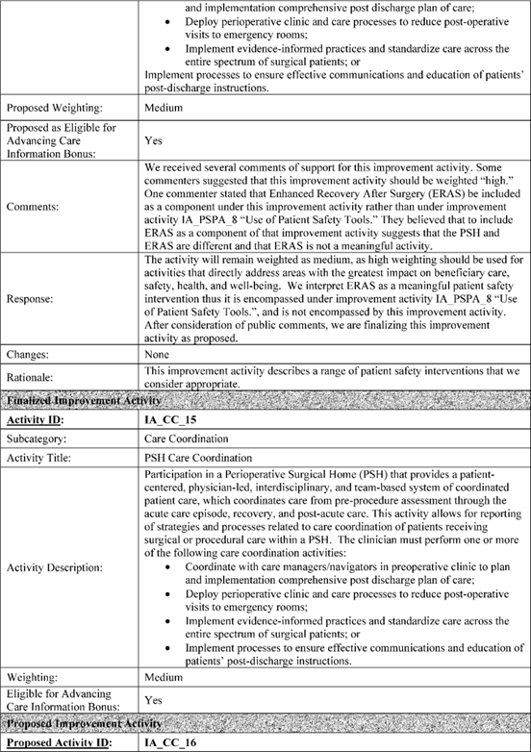

**[*54179]**



**[*54180]**

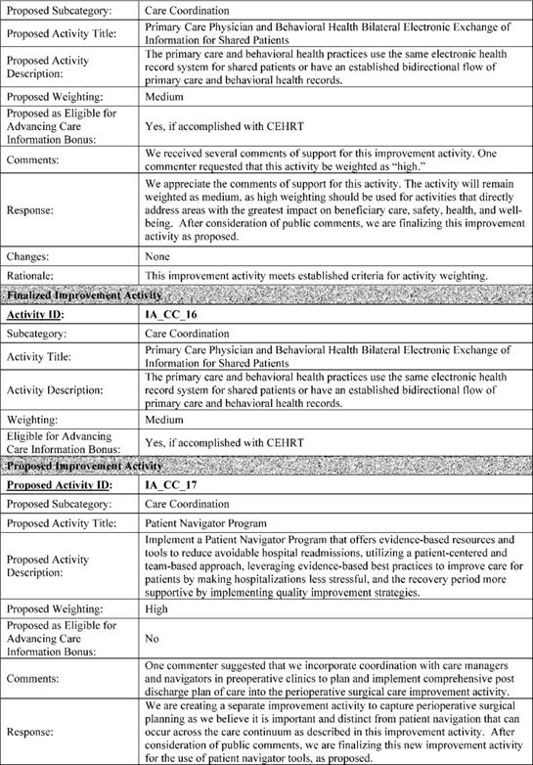

**[*54180]**



**[*54181]**

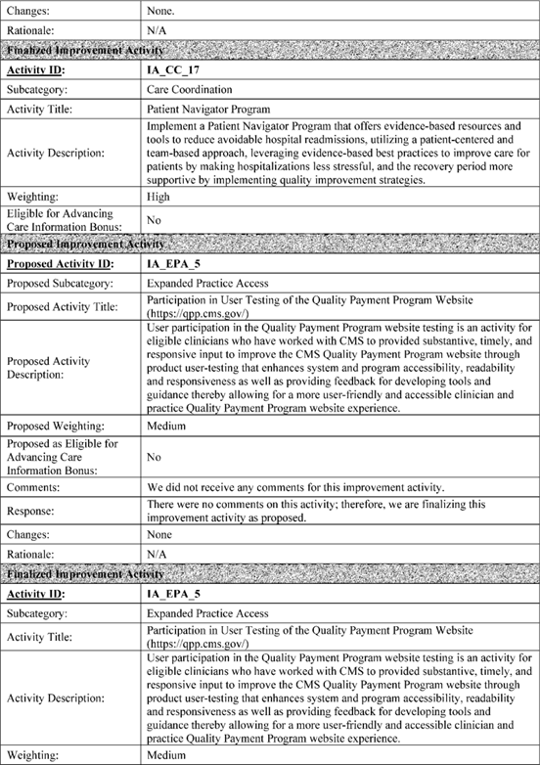

**[*54181]**



**[*54182]**

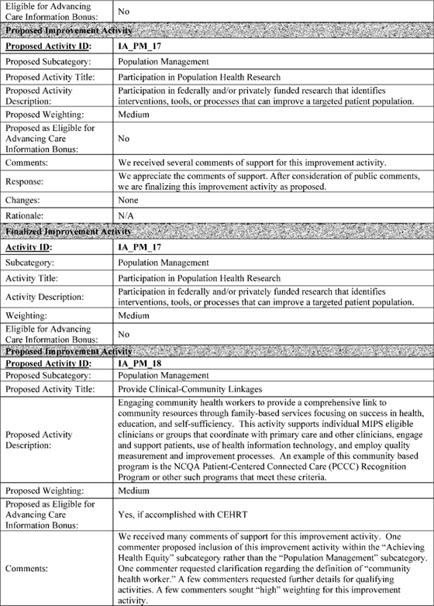

**[*54182]**



**[*54183]**

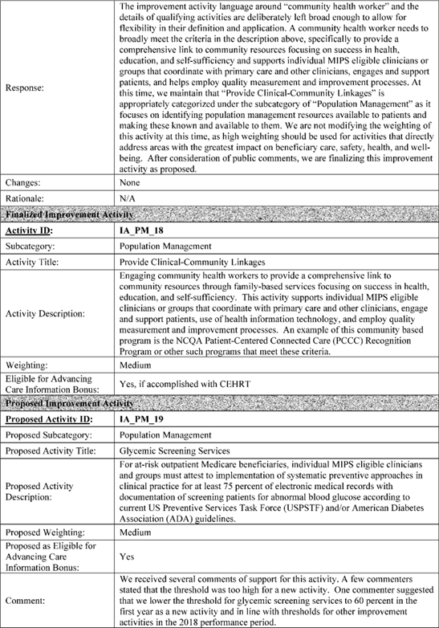

**[*54183]**



**[*54184]**

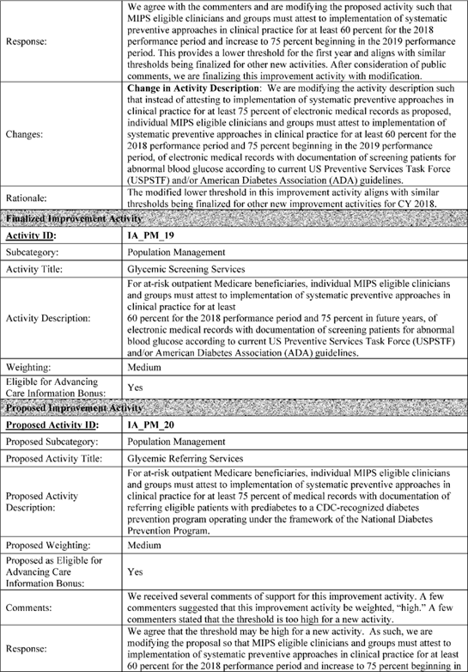

**[*54184]**



**[*54185]**

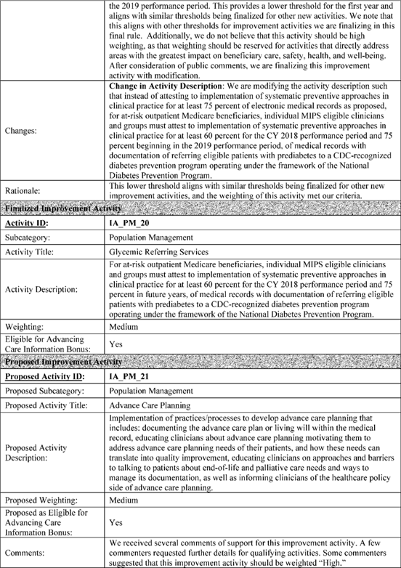

**[*54185]**



**[*54186]**

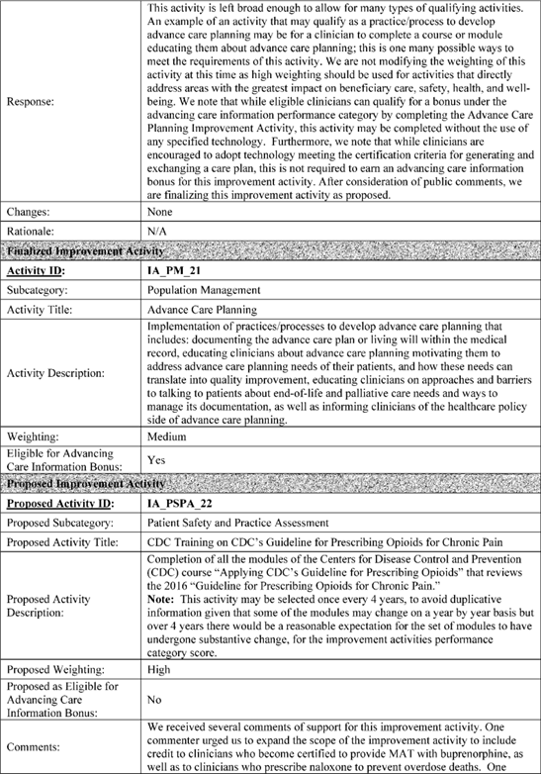

**[*54186]**



**[*54187]**

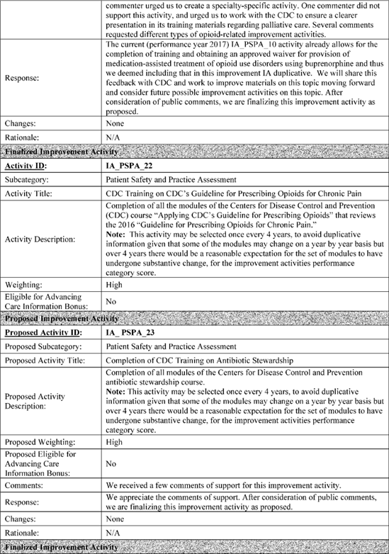

**[*54187]**



**[*54188]**

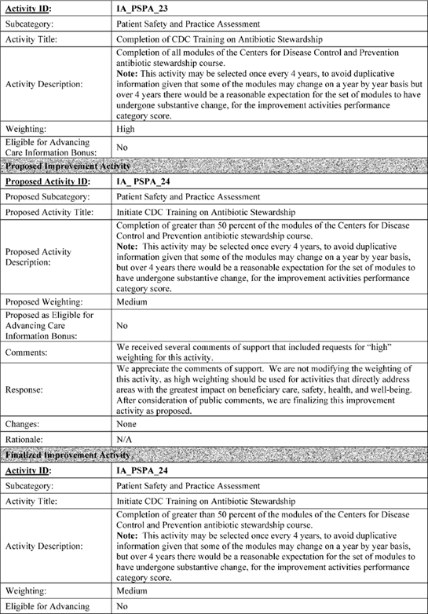

**[*54188]**



**[*54189]**

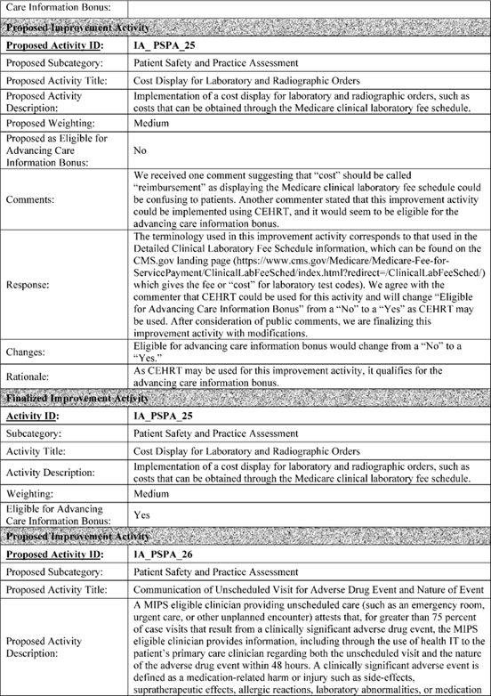

**[*54189]**



**[*54190]**

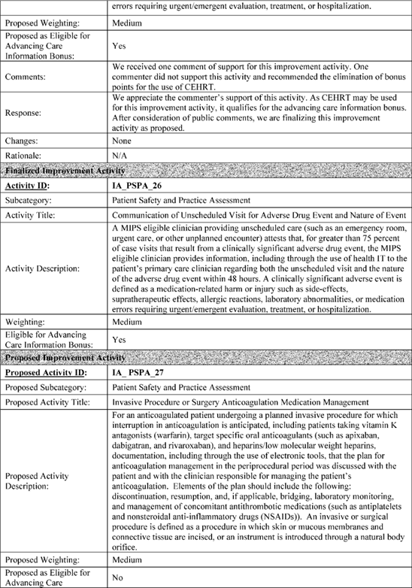

**[*54190]**



**[*54191]**

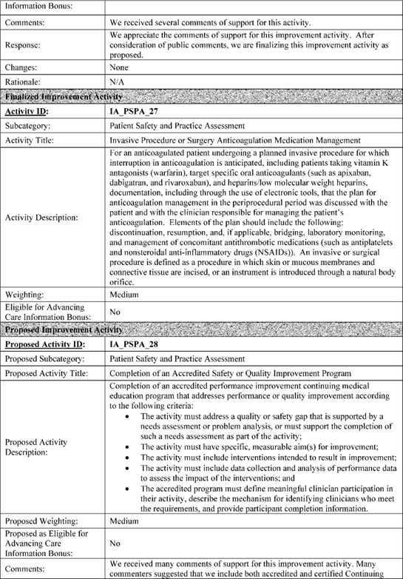

**[*54191]**



**[*54192]**

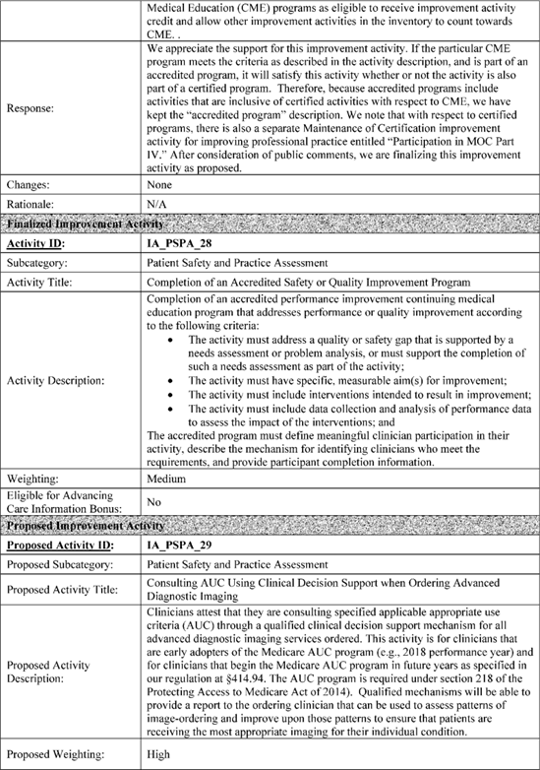

**[*54192]**



**[*54193]**

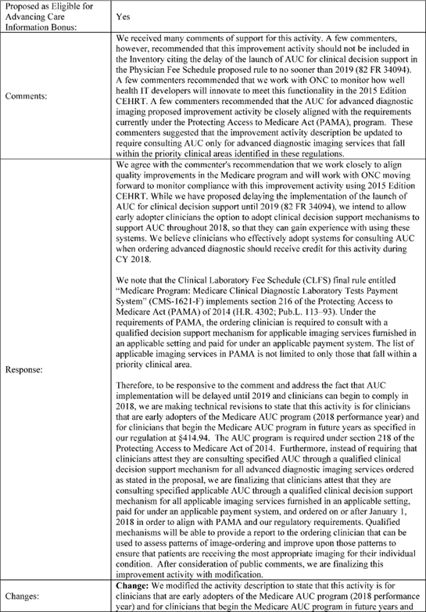

**[*54193]**



**[*54194]**

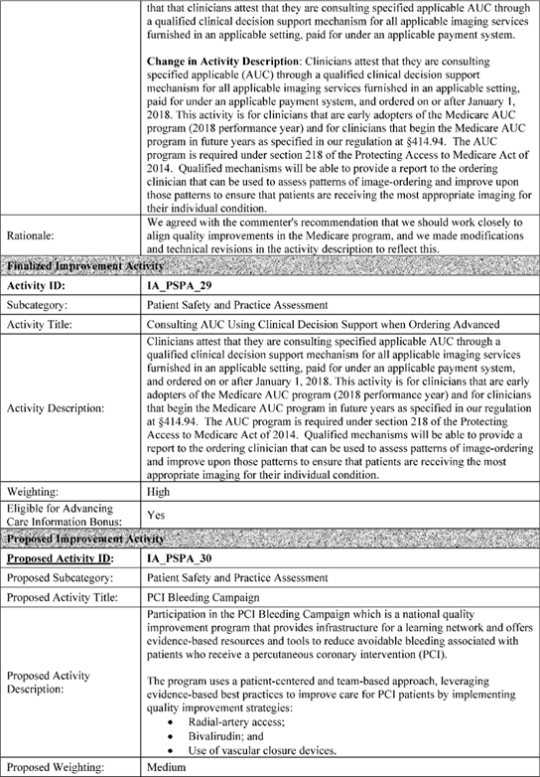

**[*54194]**

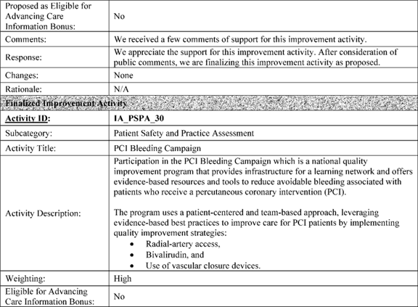

**Text**

**SUPPLEMENTARY INFORMATION:**

**Table of Contents**

I. Executive Summary and Background

A. Overview

B. Quality Payment Program Strategic Objectives

C. One Quality Payment Program

D. Summary of the Major Provisions

1. Quality Payment Program Year 2

2. Small Practices

3. Summary of Major Provisions for Advanced Alternative Payment Models (Advanced APMs)

4. Summary of Major Provisions for the Merit-Based Incentive Payment System (MIPS)

E. Payment Adjustments

F. Benefits and Costs of the Final Rule With Comment Period

G. Automatic Extreme and Uncontrollable Circumstance Policy Interim Final Rule With Comment Period

H. Stakeholder Input

II. Summary of the Provisions of the Proposed ***Regulations***, and Analysis of and Responses to Public Comments

A. Introduction

B. Definitions

C. MIPS Program Details

1. MIPS Eligible Clinicians

2. Exclusions

3. Group Reporting

4. Virtual Groups

5. MIPS Performance Period

6. MIPS Category Measures and Activities

7. MIPS Final Score Methodology

8. MIPS Payment Adjustments

9. Review and Correction of MIPS Final Score

10. Third Party Data Submission

11. Public Reporting on Physician Compare

D. Overview of the APM Incentive

1. Overview

2. Terms and Definitions

3. ***Regulation*** Text Changes

4. Advanced APMs

5. Qualifying APM Participant (QP) and Partial QP Determinations

6. All-Payer Combination Option

7. Physician-Focused Payment Models (PFPMs)

III. Quality Payment Program: Extreme and Uncontrollable Circumstances Policy for the Transition Year Interim Final Rule With Comment Period

A. Background

B. Changes to the Extreme and Uncontrollable Circumstances Policies for the MIPS Transition Year

C. Changes to the Final Score and Policies for Redistributing the Performance Category Weights for the Transition Year

D. Changes to the APM Scoring Standard for MIPS Eligible Clinicians in MIPS APMs for the Transition Year

E. Waiver of Proposed Rulemaking for Provisions Related to Extreme and Uncontrollable Circumstances

IV. Collection of Information Requirements

A. Wage Estimates

B. Framework for Understanding the Burden of MIPS Data Submission **[*53569]**

C. ICR Regarding Burden for Virtual Group Election (§ 414.1315)

D. ICR Regarding Burden for Election of Facility-Based Measurement (§ 414.1380(e))

E. ICRs Regarding Burden for Third-Party Reporting (§ 414.1400)

F. ICRs Regarding the Quality Performance Category (§§ 414.1330 and 414.1335)

G. ICRs Regarding Burden Estimate for Advancing Care Information Data (§ 414.1375)

H. ICR Regarding Burden for Improvement Activities Submission (§ 414.1355)

I. ICR Regarding Burden for Nomination of Improvement Activities (§ 414.1360)

J. ICRs Regarding Burden for Cost (§ 414.1350)

K. ICR Regarding Partial QP Elections (§ 414.1430)

L. ICRs Regarding Other Payer Advanced APM Determinations: Payer-Initiated Process (§ 414.1440) and Medicaid Specific Eligible Clinician Initiated Process (§ 414.1445)

M. ICRs Regarding Burden for Voluntary Participants To Elect Opt Out of Performance Data Display on Physician Compare (§ 414.1395)

N. Summary of Annual Burden Estimates

O. Submission of PRA-Related Comments

P. Collection of Information Requirements for the Interim Final Rule With Comment Period: Medicare Program; Quality Payment Program: Extreme and Uncontrollable Circumstances Policy for the Transition Year

V. Response to Comments

VI. Regulatory Impact Analysis

A. Statement of Need

B. Overall Impact

C. Changes in Medicare Payments

D. Impact on Beneficiaries

E. Regulatory Review Costs

F. Accounting Statement

G. Regulatory Impact Statement for Interim Final Rule With Comment Period: Medicare Program; Quality Payment Program: Extreme and Uncontrollable Circumstance Policy for the Transition Year

**Acronyms**

Because of the many terms to which we refer by acronym in this rule, we are listing the acronyms used and their corresponding meanings in alphabetical order below:

ABC(TM) Achievable Benchmark of Care

ACO Accountable Care Organization

API Application Programming Interface

APM Alternative Payment Model

APRN Advanced Practice Registered Nurse

ASC Ambulatory Surgical Center

ASPE HHS' Office of the Assistant Secretary for Planning and Evaluation

BPCI Bundled Payments for Care Improvement

CAH Critical Access Hospital

CAHPS Consumer Assessment of Healthcare Providers and Systems

CBSA Core Based Statistical Area

CEHRT Certified EHR Technology

CFR Code of Federal ***Regulations***

CHIP Children's Health Insurance Program

CJR Comprehensive Care for Joint Replacement

COI Collection of Information

CPR Customary, Prevailing, and Reasonable

CPS Composite Performance Score

CPT Current Procedural Terminology

CQM Clinical Quality Measure

CY Calendar Year

eCQM Electronic Clinical Quality Measure

ED Emergency Department

EHR Electronic Health Record

EP Eligible Professional

ESRD End-Stage Renal Disease

FFS Fee-for-Service

FR Federal Register

FQHC Federally Qualified Health Center

GAO Government Accountability Office

HCC Hierarchical Condition Category

HIE Health Information Exchange

HIPAA Health Insurance Portability and Accountability Act of 1996

HITECH Health Information Technology for Economic and Clinical Health

HPSA Health Professional Shortage Area

HHS Department of Health & Human Services

HRSA Health Resources and Services Administration

IHS Indian Health Service

IT Information Technology

LDO Large Dialysis Organization

MACRA Medicare Access and CHIP Reauthorization Act of 2015

MEI Medicare Economic Index

MIPAA Medicare Improvements for Patients and Providers Act of 2008

MIPS Merit-based Incentive Payment System

MLR Minimum Loss Rate

MSPB Medicare Spending per Beneficiary

MSR Minimum Savings Rate

MUA Medically Underserved Area

NPI National Provider Identifier

OCM Oncology Care Model

ONC Office of the National Coordinator for Health Information Technology

PECOS Medicare Provider Enrollment, Chain, and Ownership System

PFPMs Physician-Focused Payment Models

PFS Physician Fee Schedule

PHI Protected Health Information

PHS Public Health Service

PQRS Physician Quality Reporting System

PTAC Physician-Focused Payment Model Technical Advisory Committee

QCDR Qualified Clinical Data Registry

QP Qualifying APM Participant

QRDA Quality Reporting Document Architecture

QRUR Quality and Resource Use Reports

RBRVS Resource-Based Relative Value Scale

RFI Request for Information

RHC Rural Health Clinic

RIA Regulatory Impact Analysis

RVU Relative Value Unit

SGR Sustainable Growth Rate

TCPI Transforming Clinical Practice Initiative

TIN Tax Identification Number

VBP Value-Based Purchasing

VM Value-Based Payment Modifier

VPS Volume Performance Standard

**I. Executive Summary and Background**

*A. Overview*

This final rule with comment period makes payment and policy changes to the Quality Payment Program. The Medicare Access and CHIP Reauthorization Act of 2015 (MACRA) (*Pub. L. 114-10*, enacted April 16, 2015) amended Title XVIII of the Social Security Act (the Act) to repeal the Medicare sustainable growth rate (SGR) formula, to reauthorize the Children's Health Insurance Program (CHIP), and to strengthen Medicare access by improving physician and other clinician payments and making other improvements. The MACRA advances a forward-looking, coordinated framework for clinicians to successfully take part in the Quality Payment Program that rewards value and outcomes in one of two ways:

* Advanced Alternative Payment Models (Advanced APMs).

1. Merit-based Incentive Payment System (MIPS).

Our goal is to support patients and clinicians in making their own decisions about health care using data driven insights, increasingly aligned and meaningful quality measures, and innovative technology. To implement this vision, the Quality Payment Program emphasizes high-value care and patient outcomes while minimizing burden on eligible clinicians. The Quality Payment Program is also designed to be flexible, transparent, and structured to improve over time with input from clinicians, patients, and other stakeholders.

In today's health care system, we often pay doctors and other clinicians based on the number of services they perform rather than patient health outcomes. The good work that clinicians do is not limited to conducting tests or writing prescriptions, but also taking the time to have a conversation with a patient about test results, being available to a patient through telehealth or expanded hours, coordinating medicine and treatments to avoid confusion or errors, and developing care plans.

The Quality Payment Program takes a comprehensive approach to payment by basing consideration of quality on a set of evidenced-based measures that were primarily developed by clinicians, thus encouraging improvement in clinical practice and supporting by advances in technology that allow for the easy exchange of information. The Quality Payment Program also offers special incentives for those participating in certain innovative models of care that **[*53570]** provide an alternative to fee-for-service payment.

We have sought and will continue to seek feedback from the health care community through various public avenues such as rulemaking, listening sessions and stakeholder engagement. We understand that technology, infrastructure, physician support systems, and clinical practices will change over the next few years and are committed to refine our policies for the Quality Payment Program with those factors in mind.

We are aware of the diversity among clinician practices in their experience with quality-based payments and expect the Quality Payment Program to evolve over multiple years. The groundwork has been laid for expansion toward an innovative, patient-centered, health system that is both outcome focused and resource effective. A system that leverages health information technology to support clinicians and patients and builds collaboration across care settings. The Quality Payment Program: (1) Supports care improvement by focusing on better outcomes for patients, and preserving the independent clinical practice; (2) promotes the adoption of APMs that align incentives for high-quality, low-cost care across healthcare stakeholders; and (3) advances existing delivery system reform efforts, including ensuring a smooth transition to a healthcare system that promotes high-value, efficient care through unification of CMS legacy programs.

In the Merit-based Incentive Payment System (MIPS) and Alternative Payment Model (APM) Incentive under the Physician Fee Schedule, and Criteria for Physician-Focused Payment Models final rule with comment period [*(81 FR 77008,*](https://advance.lexis.com/api/document?collection=administrative-codes&id=urn:contentItem:5M3D-MP10-006W-80MT-00000-00&context=) November 4, 2016), referred to as the "CY 2017 Quality Payment Program final rule," we established incentives for participation in Advanced APMs, supporting the goals of transitioning from fee-for-service (FFS) payments to payments for quality and value. The CY 2017 Quality Payment Program final rule included definitions and processes to determine Qualifying APM Participants (QPs) in Advanced APMs. The CY 2017 Quality Payment Program final rule also established the criteria for use by the Physician-Focused Payment Model Technical Advisory Committee (PTAC) in making comments and recommendations to the Secretary on proposals for physician-focused payment models (PFPMs).

The CY 2017 Quality Payment Program final rule also established policies to implement MIPS, which consolidated certain aspects of the Physician Quality Reporting System (PQRS), the Physician Value-based Payment Modifier (VM), and the Medicare Electronic Health Record (EHR) Incentive Program for Eligible Professionals (EPs) and made CY 2017 the transition year for clinicians under the Quality Payment Program. As prescribed by MACRA, MIPS focuses on the following: (1) Quality--including a set of evidence-based, specialty-specific standards; (2) cost; (3) practice-based improvement activities; and (4) use of certified electronic health record (EHR) technology (CEHRT) to support interoperability and advanced quality objectives in a single, cohesive program that avoids redundancies.

This CY 2018 final rule with comment period continues to build and improve upon our transition year policies, as well as, address elements of MACRA that were not included in the first year of the program, including virtual groups, beginning with the CY 2019 performance period facility-based measurement, and improvement scoring. This final rule with comment period implements policies for "Quality Payment Program Year 2," some of which will continue into subsequent years of the Quality Payment Program.

We have also included an interim final rule with comment period to establish an automatic extreme and uncontrollable circumstance policy for the 2017 MIPS performance period that recognizes recent hurricanes (Harvey, Irma, and Maria) and other natural disasters can effectively impede a MIPS eligible clinician's ability to participate in MIPS.

*B. Quality Payment Program Strategic Objectives*

After extensive outreach with clinicians, patients and other stakeholders, we created 7 strategic objectives to drive continued progress and improvement. These objectives help guide our final policies and future rulemaking in order to design, implement, and advance a Quality Payment Program that aims to improve health outcomes, promote efficiency, minimize burden of participation, and provide fairness and transparency in operations.

These strategic objectives are as follows: (1) To improve beneficiary outcomes and engage patients through patient-centered Advanced APM and MIPS policies; (2) to enhance clinician experience through flexible and transparent program design and interactions with easy-to-use program tools; (3) to increase the availability and adoption of robust Advanced APMs; (4) to promote program understanding and maximize participation through customized communication, education, outreach and support that meet the needs of the diversity of physician practices and patients, especially the unique needs of small practices; (5) to improve data and information sharing on program performance to provide accurate, timely, and actionable feedback to clinicians and other stakeholders; (6) to deliver IT systems capabilities that meet the needs of users for data submission, reporting, and improvement and are seamless, efficient and valuable on the front and back-end; and (7) to ensure operation excellence in program implementation and ongoing development; and to design the program in a manner that allows smaller independent and rural practices to be successful. More information on these objectives and the Quality Payment Program can be found at *qpp.cms.gov*.

Stakeholder feedback is the hallmark of the Quality Payment Program. We solicited and reviewed nearly 1,300 comments and had over 100,000 physicians and other stakeholders attend our outreach sessions to help inform our policies for Quality Payment Program Year 2. We have set ambitious yet achievable goals for those clinicians interested in APMs, as they are a vital part of bending the Medicare cost curve by encouraging the delivery of high-quality, low-cost care. To allow this program to work for all stakeholders, we further recognize that we must provide ongoing education, support, and technical assistance so that clinicians can understand program requirements, use available tools to enhance their practices, and improve quality and progress toward participation in APMs if that is the best choice for their practice. Finally, we understand that we must achieve excellence in program management, focusing on customer needs while also promoting problem-solving, teamwork, and leadership to provide continuous improvements in the Quality Payment Program.

*C. One Quality Payment Program*

Clinicians have told us that they do not separate their patient care into domains, and that the Quality Payment Program needs to reflect typical clinical workflows in order to achieve its goal of better patient care. Advanced APMs, the focus of one pathway of the Quality Payment Program, contribute to better care and smarter spending by allowing physicians and other clinicians to deliver coordinated, customized, high-value care to their patients in a streamlined and cost-effective manner. Within MIPS, the second pathway of the Quality Payment Program, we believe that integration into typical clinical **[*53571]** workflows can best be accomplished by making connections across the four statutory pillars of the MIPS incentive structure. Those four pillars are: (1) Quality; (2) clinical practice improvement activities (referred to as "improvement activities"); (3) meaningful use of CEHRT (referred to as "advancing care information"); and (4) resource use (referred to as "cost").

Although there are two separate pathways within the Quality Payment Program, Advanced APMs and MIPS both contribute toward the goal of seamless integration of the Quality Payment Program into clinical practice workflows. Advanced APMs promote this seamless integration by way of payment methodology and design that incentivize care coordination. The MIPS builds the capacity of eligible clinicians across the four pillars of MIPS to prepare them for participation in APMs in later years of the Quality Payment Program. Indeed, the bedrock of the Quality Payment Program is high-value, patient-centered care, informed by useful feedback, in a continuous cycle of improvement. The principal way that MIPS measures quality of care is through a set of clinical quality measures (CQMs) from which MIPS eligible clinicians can select. The CQMs are evidence-based, and the vast majority are created or supported by clinicians. Over time, the portfolio of quality measures will grow and develop, driving towards outcomes that are of the greatest importance to patients and clinicians and away from process, or "check the box" type measures.

Through MIPS, we have the opportunity to measure clinical and patient outcomes, not only through evidence-based quality measures, but also by accounting for activities that clinicians and patients themselves identify: Namely, practice-driven quality improvement. MIPS also requires us to assess whether CEHRT is used in a meaningful way and based on significant feedback, this area was simplified to support the exchange of patient information, engagement of patients in their own care through technology, and the way technology specifically supports the quality goals selected by the practice. And lastly, MIPS requires us to measure the cost of services provided through the cost performance category, which will contribute to a MIPS eligible clinician's final score beginning in the second year of the MIPS.

We realize the Quality Payment Program is a big change. In this final rule with comment period, we continue the slow ramp-up of the Quality Payment Program by establishing special policies for MIPS Year 2 aimed at encouraging successful participation in the program while reducing burden, reducing the number of clinicians required to participate, and preparing clinicians for the CY 2019 performance period (CY 2021 payment year). Our hope is for the program to evolve to the point where all the clinical activities captured in MIPS across the four performance categories reflect the single, unified goal of quality improvement.

*D. Summary of the Major Provisions*

1. Quality Payment Program Year 2

We believe the second year of the Quality Payment Program should build upon the foundation that has been established which provides a trajectory for clinicians to value-based care. A second year to ramp-up the program will continue to help build upon the iterative learning and development of year 1 in preparation for a robust program in year 3.

2. Small Practices

The support of small, independent practices remains an important thematic objective for the implementation of the Quality Payment Program and is expected to be carried throughout future rulemaking. Many small practices did not have to participate in MIPS during the transition year due to the low-volume threshold, which was set for the CY 2017 performance period at less than or equal to $ 30,000 in Medicare Part B allowed charges or less than or equal to 100 Medicare Part B patients. We have heard feedback that many small practices still face challenges in their ability to participate in the program. We are implementing additional flexibilities for Year 2 including: Implementing the virtual groups provisions; increasing the low-volume threshold to less than or equal to $ 90,000 in Medicare Part B allowed charges or less than or equal to 200 Medicare Part B patients; adding a significant hardship exception from the advancing care information performance category for MIPS eligible clinicians in small practices; providing 3 points even if small practices submit quality measures below data completeness standards; and providing bonus points that are added to the final scores of MIPS eligible clinicians who are in small practices. We believe that these additional flexibilities and reduction in barriers will further enhance the ability of small practices to participate successfully in the Quality Payment Program.

In keeping with the objectives to provide education about the Quality Payment Program and maximize participation, and as mandated by the statute, during a period of 5 years, $ 100 million in funding was provided for technical assistance to be available to provide guidance and assistance to MIPS eligible clinicians in small practices through contracts with regional health collaboratives, and others. Guidance and assistance on the MIPS performance categories or the transition to APM participation will be available to MIPS eligible clinicians in practices of 15 or fewer clinicians with priority given to practices located in rural areas or medically underserved areas (MUAs), and practices with low MIPS final scores. More information on the technical assistance support available to small practices can be found at [*https://qpp.cms.gov/docs/QPP_Support_for_Small_Practices.pdf*](https://qpp.cms.gov/docs/QPP_Support_for_Small_Practices.pdf).

We have also performed an updated regulatory impact analysis, accounting for flexibilities, many of which are continuing into the Quality Payment Program Year 2, that have been created to ease the burden for small and solo practices.

3. Summary of Major Provisions for Advanced Alternative Payment Models (Advanced APMs)

a. Overview

APMs represent an important step forward in our efforts to move our healthcare system from volume-based to value-based care. Our existing APM policies provide opportunities that support state flexibility, local leadership, regulatory relief, and innovative approaches to improve quality, accessibility, and affordability.

APMs that meet the criteria to be Advanced APMs provide the pathway through which eligible clinicians, many of whom who would otherwise fall under the MIPS, can become Qualifying APM Participants (QPs), thereby earning incentives for their Advanced APM participation. In the CY 2017 Quality Payment Program final rule, we estimated that 70,000 to 120,000 eligible clinicians would be QPs for payment year 2019 based on Advanced APM participation in performance year 2017 [*(81 FR 77516).*](https://advance.lexis.com/api/document?collection=administrative-codes&id=urn:contentItem:5M3D-MP10-006W-80MT-00000-00&context=) With new Advanced APMs expected to be available for participation in 2018, including the Medicare ACO Track 1 Plus (1+) Model, and the addition of new participants for some current Advanced APMs, such as the Next Generation ACO Model and Comprehensive Primary Care Plus (CPC+) Model, we anticipate higher numbers of QPs in subsequent years of the program. We currently estimate that approximately 185,000 to 250,000 **[*53572]** eligible clinicians may become QPs for payment year 2020 based on Advanced APM participation in performance year 2018.

b. Advanced APMs

In the CY 2017 Quality Payment Program final rule, to be considered an Advanced APM, we finalized that an APM must meet all three of the following criteria, as required under section 1833(z)(3)(D) of the Act: (1) The APM must require participants to use CEHRT; (2) The APM must provide for payment for covered professional services based on quality measures comparable to those in the quality performance category under MIPS; and (3) The APM must either require that participating APM Entities bear risk for monetary losses of a more than nominal amount under the APM, or be a Medical Home Model expanded under section 1115A(c) of the Act [*(81 FR 77408).*](https://advance.lexis.com/api/document?collection=administrative-codes&id=urn:contentItem:5M3D-MP10-006W-80MT-00000-00&context=)

We are maintaining the generally applicable revenue-based nominal amount standard at 8 percent for QP Performance Periods 2019 and 2020. We are exempting participants in Round 1 of the CPC+ Model as of January 1, 2017 from the 50 eligible clinician limit as proposed. We are also finalizing a more gradual ramp-up in percentages of revenue for the Medical Home Model nominal amount standard over the next several years.

c. Qualifying APM Participant (QP) and Partial QP Determinations

QPs are eligible clinicians in an Advanced APM who have met a threshold percentage of their patients or payments through an Advanced APM or, beginning in performance year 2019, attain QP status through the All-Payer Combination Option. Eligible clinicians who are QPs for a year are excluded from the MIPS reporting requirements and payment adjustment for the year, and receive a 5 percent APM Incentive Payment for the year in years from 2019 through 2024. The statute sets thresholds for the level of participation in Advanced APMs required for an eligible clinician to become a QP for a year.

We are finalizing that for Advanced APMs that start or end during the QP Performance Period and operate continuously for a minimum of 60 days during the QP Performance Period for the year, we are making QP determinations using payment or patient data only for the dates that APM Entities were able to participate in the Advanced APM per the terms of the Advanced APM, not for the full QP Performance Period.

Eligible clinicians who participate in Advanced APMs but do not meet the QP or Partial QP thresholds are subject to MIPS reporting requirements and payment adjustments unless they are otherwise excluded from MIPS.

d. All-Payer Combination Option

The All-Payer Combination Option, which uses a calculation based on an eligible clinician's participation in both Advanced APMs and Other Payer Advanced APMs to make QP determinations, is applicable beginning in performance year 2019. To become a QP through the All-Payer Combination Option, an eligible clinician must participate in an Advanced APM with CMS as well as an Other Payer Advanced APM. We determine whether other payer arrangements are Other Payer Advanced APMs based on information submitted to us by eligible clinicians, APM Entities, and in some cases by payers, including states and Medicare Advantage Organizations. In addition, the eligible clinician or the APM Entity must submit information to CMS so that we can determine whether the eligible clinician meets the requisite QP threshold of participation.

To be an Other Payer Advanced APM, as set forth in section 1833(z)(2)(B)(ii) and (C)(ii) of the Act and implemented in the CY 2017 Quality Payment Program final rule, a payment arrangement with a payer (for example, payment arrangements authorized under Title XIX, Medicare Health Plan payment arrangements, and payment arrangements in CMS Multi-Payer Models) must meet all three of the following criteria: (1) CEHRT is used; (2) the payment arrangement must require the use of quality measures comparable to those in the quality performance category under MIPS; and (3) the payment arrangement must either require the APM Entities to bear more than nominal financial risk if actual aggregate expenditures exceed expected aggregate expenditures, or be a Medicaid Medical Home Model that meets criteria comparable to Medical Home Models expanded under section 1115A(c) of the Act.

In this final rule with comment period, we are finalizing policies that provide more detail about how the All-Payer Combination Option will operate. We are finalizing that an other payer arrangement would meet the generally applicable revenue-based nominal amount standard we proposed if, under the terms of the other payer arrangement, the total amount that an APM Entity potentially owes the payer or foregoes is equal to at least: For the 2019 and 2020 QP Performance Periods, 8 percent of the total combined revenues from the payer of providers and suppliers in participating APM Entities only for arrangements that are expressly defined in terms of revenue. We are also finalizing a more gradual ramp-up in percentages of revenue for the Medicaid Medical Home Model nominal amount standard over the next several years.

We are finalizing the Payer Initiated and Eligible Clinician Other Payer Advanced APM determination processes to allow payers, APM Entities, or eligible clinicians to request that we determine whether other payer arrangements meet the Other Payer Advanced APM criteria. We have also finalized requirements pertaining to the submission of information.

We are finalizing certain modifications to how we calculate Threshold Scores and make QP determinations under the All-Payer Combination Option. We are retaining the QP Performance Period for the All-Payer Combination Option from January 1 through August 31 of each year as finalized in the CY 2017 Quality Payment Program final rule.

e. Physician-Focused Payment Models (PFPMs)

The PTAC is an 11-member federal advisory committee that is an important avenue for the creation of innovative payment models. The PTAC is charged with reviewing stakeholders' proposed PFPMs, and making comments and recommendations to the Secretary regarding whether they meet the PFPM criteria established by the Secretary through rulemaking in the CY 2017 Quality Payment Program final rule. The Secretary is required to review the comments and recommendations submitted by the PTAC and post a detailed response to these recommendations on the CMS Web site.

We sought comments on broadening the definition of PFPM to include payment arrangements that involve Medicaid or the Children's Health Insurance Program (CHIP) as a payer even if Medicare is not included as a payer. We are maintaining the current definition of a PFPM to include only payment arrangements with Medicare as a payer. We believe this definition retains focus on APMs and Advanced APMs, which would be proposals that the Secretary has more direct authority to implement, while maintaining consistency for PTAC's review while they are still refining their processes. In addition, we sought comment on the Secretary's criteria and stakeholders' needs in developing PFPM proposals aimed at meeting the criteria. **[*53573]**

4. Summary of Major Provisions for the Merit-Based Incentive Payment System (MIPS)

For Quality Payment Program Year 2, which is the second year of the MIPS and includes the 2018 performance period and the 2020 MIPS payment year, as well as the following:

a. Quality

We previously finalized that the quality performance category would comprise 60 percent of the final score for the transition year and 50 percent of the final score for the 2020 MIPS payment year [*(81 FR 77100).*](https://advance.lexis.com/api/document?collection=administrative-codes&id=urn:contentItem:5M3D-MP10-006W-80MT-00000-00&context=) While we proposed to maintain a 60 percent weight for the quality performance category for the 2020 MIPS payment year, we are not finalizing this proposal and will be keeping our previously finalized policy to weight the quality performance category at 50 percent for the 2020 MIPS payment year. We are also finalizing that for purposes of the 2021 MIPS payment year, the performance period for the quality and cost performance categories is CY 2019 (January 1, 2019 through December 31, 2019). We note that we had previously finalized that for the purposes of the 2020 MIPS payment year the performance period for the quality and cost performance categories is CY 2018 (January 1, 2018 through December 31, 2018). We did not make proposals to modify this time frame in the CY 2018 Quality Payment Program proposed rule and are therefore unable to modify this performance period.

Quality measures are selected annually through a call for quality measures under consideration, with a final list of quality measures being published in the **Federal Register** by November 1 of each year. We are finalizing for the CAHPS for MIPS survey for the Quality Payment Program Year 2 and future years that the survey administration period will, at a minimum, span over 8 weeks and, at a maximum, 17 weeks and will end no later than February 28th following the applicable performance period. In addition, we are finalizing for the Quality Payment Program Year 2 and future years to remove two Summary Survey Modules (SSMs), specifically, "Helping You to Take Medication as Directed" and "Between Visit Communication" from the CAHPS for MIPS survey.

For the 2018 MIPS performance period, we previously finalized that the data completeness threshold would increase to 60 percent for data submitted on quality measures using QCDRs, qualified registries, via EHR, or Medicare Part B claims. While we proposed to maintain a 50 percent data completeness threshold for the 2018 MIPS performance period, we are not finalizing this proposal and will be keeping our previously finalized data completeness threshold of 60 percent for data submitted on quality measures using QCDRs, qualified registries, EHR, or Medicare Part B claims for the 2018 MIPS performance period. We also proposed to have the data completeness threshold for the 2021 MIPS payment year (2019 performance period) to 60 percent for data submitted on quality measures using QCDRs, qualified registries, EHR, or Medicare Part B claims. We are also finalizing this proposal. We anticipate that as MIPS eligible clinicians gain experience with the MIPS we will propose to further increase these thresholds over time.

b. Improvement Activities

Improvement activities are those that improve clinical practice or care delivery and that, when effectively executed, are likely to result in improved outcomes. We believe improvement activities support broad aims within healthcare delivery, including care coordination, beneficiary engagement, population management, and health equity. For the 2020 MIPS payment year, we previously finalized that the improvement activities performance category would comprise 15 percent of the final score [*(81 FR 77179).*](https://advance.lexis.com/api/document?collection=administrative-codes&id=urn:contentItem:5M3D-MP10-006W-80MT-00000-00&context=) There are no changes in improvement activities scoring for Quality Payment Program Year 2 (2018 MIPS performance period) as discussed in section II.C.7.a.(5) of this final rule with comment period. However, in this final rule, we are finalizing our proposal to no longer require self-identifications for non-patient facing MIPS eligible clinicians, small practices, practices located in rural areas or geographic HPSAs, or any combination thereof, beginning with the 2018 MIPS performance period and for future years.

We are finalizing that for Quality Payment Program Year 2 and future years (2018 MIPS performance period and future years), MIPS eligible clinicians or groups must submit data on improvement activities in one of the following manners: Via qualified registries, EHR submission mechanisms, QCDR, CMS Web Interface, or attestation; and that for activities that are performed for at least a continuous 90 days during the performance period, MIPS eligible clinicians must submit a yes response for activities within the Improvement Activities Inventory.

In this final rule with comment period, we are finalizing updates to the Improvement Activities Inventory. Specifically, as discussed in the appendices (Tables F and G) of this final rule with comment period, we are finalizing 21 new improvement activities (some with modification) and changes to 27 previously adopted improvement activities (some with modification and including 1 removal) for the Quality Payment Program Year 2 and future years (2018 MIPS performance period and future years) Improvement Activities Inventory. These activities were recommended by clinicians, patients and other stakeholders interested in advancing quality improvement and innovations in healthcare. We will continue to seek new improvement activities as the program evolves. Additionally, we are finalizing several policies related to submission of improvement activities. In particular, we are formalizing the annual call for activities process for Quality Payment Program Year 3 and future years. We are finalizing with modification, for the Quality Payment Program Year 3 and future years, that stakeholders should apply one or more of the criteria when submitting improvement activities in response to the Annual Call for Activities. In addition to the criteria listed in the proposed rule for nominating new improvement activities for the Annual Call for Activities policy, we are modifying and expanding the proposed criteria list to also include: (1) Improvement activities that focus on meaningful actions from the person and family's point of view, and (2) improvement activities that support the patient's family or personal caregiver. In addition, we are finalizing to: (1) Accept submissions for prospective improvement activities at any time during the performance period for the Annual Call for Activities and create an Improvement Activities Under Review (IAUR) list; (2) only consider prospective activities submitted by March 1 for inclusion in the Improvement Activities Inventory for the performance periods occurring in the following calendar year; and (3) add new improvement activities and subcategories through notice-and-comment rulemaking in future years of the Quality Payment Program.

Additionally, we are finalizing that for purposes of the 2021 MIPS payment year, the performance period for the improvement activities performance category is a minimum of a continuous 90-day period within CY 2019, up to and including the full CY 2019 (January 1, 2019 through December 31, 2019).

In this final rule with comment period, we are also expanding our **[*53574]** definition of how we will recognize an individual MIPS eligible clinician or group as being a certified patient-centered medical home or comparable specialty practice. We are finalizing our proposal, with clarification, that at least 50 percent of the practice sites within the TIN must be recognized as a patient-centered medical home or comparable specialty practice to receive full credit as a certified or recognized patient-centered medical home or comparable specialty practice for the 2020 MIPS payment year and future years. We are clarifying that a practice site as is the physical location where services are delivered. We proposed in section II.C.6.e.(3)(b) of the proposed rule [*(82 FR 30054)*](https://advance.lexis.com/api/document?collection=administrative-codes&id=urn:contentItem:5NX6-6BS0-006W-83PD-00000-00&context=) that eligible clinicians in practices that have been randomized to the control group in the CPC+ model would also receive full credit as a Medical Home Model. We are not finalizing this proposal, however, because CMMI has not randomized any practices into a control group in CPC+ Round 2.

We are also finalizing changes to the study, including modifying the name to the "CMS Study on Burdens Associated with Reporting Quality Measures," increasing the sample size for 2018, and updating requirements.

Furthermore, in recognition of improvement activities as supporting the central mission of a unified Quality Payment Program, we are finalizing in section II.C.6.e.(3)(a) of this final rule with comment period to continue to designate activities in the Improvement Activities Inventory that will also qualify for the advancing care information bonus score. This is consistent with our desire to recognize that CEHRT is often deployed to improve care in ways that our programs should recognize.

c. Advancing Care Information

For the Quality Payment Program Year 2, the advancing care information performance category is 25 percent of the final score. However, if a MIPS eligible clinician is participating in a MIPS APM the advancing care information performance category may be 30 percent or 75 percent of the final score depending on the availability of APM quality data for reporting. We are finalizing that for purposes of the 2021 MIPS payment year, the performance period for advancing care information performance category is a minimum of a continuous 90-day period within CY 2019, up to and including the full CY 2019 (January 1, 2019 through December 31, 2019).

Objectives and measures in the advancing care information performance category focus on the secure exchange of health information and the use of CEHRT to support patient engagement and improved healthcare quality. While we continue to recommend that physicians and clinicians migrate to the implementation and use of EHR technology certified to the 2015 Edition so they may take advantage of improved functionalities, including care coordination and technical advancements such as application programming interfaces, or APIs, we recognize that some practices may have challenges in adopting new certified health IT. Therefore, we are finalizing that MIPS eligible clinicians may continue to use EHR technology certified to the 2014 Edition for the performance period in CY 2018. Clinicians may also choose to use the 2015 Edition CEHRT or a combination of the two. Clinicians will earn a bonus for using only 2015 CEHRT in 2018.

For the 2018 performance period, MIPS eligible clinicians will have the option to report the Advancing Care Information Transition Objectives and Measures using 2014 Edition CEHRT, 2015 Edition CEHRT, or a combination of 2014 and 2015 Edition CEHRT, as long as the EHR technology they possess can support the objectives and measures to which they plan to attest. Similarly, MIPS eligible clinicians will have the option to attest to the Advancing Care Information Objectives and Measures using 2015 Edition CEHRT or a combination of 2014 and 2015 Edition CEHRT, as long as their EHR technology can support the objectives and measures to which they plan to attest.

We are finalizing exclusions for the e-Prescribing and Health Information Exchange Objectives beginning with the 2017 performance period. We are also finalizing that eligible clinicians can earn 10 percentage points in their performance score for reporting to any single public health agency or clinical data registry to meet any of the measures associated with the Public Health and Clinical Data Registry Reporting objective (or any of the measures associated with the Public Health Reporting Objective of the 2018 Advancing Care Information Transition Objectives and Measures, for clinicians who choose to report on those measures) and, and will award an additional 5 percentage point bonus for reporting to more than one. We are implementing several provisions of the 21st Century Cures Act ([*Pub. L. 114-255*](https://advance.lexis.com/api/document?collection=statutes-legislation&id=urn:contentItem:5RS1-97W0-0019-T373-00000-00&context=), enacted on December 13, 2016) pertaining to hospital-based MIPS eligible clinicians, ambulatory surgical center-based MIPS eligible clinicians, MIPS eligible clinicians using decertified EHR technology, and significant hardship exceptions under the MIPS. We are also finalizing a significant hardship exception for MIPS eligible clinicians in small practices. For clinicians requesting a reweighting of the advancing care information performance category, we are changing the deadline for submission of this application to December 31 of the performance period. Lastly, we are finalizing additional improvement activities that are eligible for a 10 percent bonus under the advancing care information performance category if they are completed using CEHRT.

d. Cost

We previously finalized that the cost performance category would comprise zero percent of the final score for the transition year and 10 percent of the final score for the 2020 MIPS payment year [*(81 FR 77165).*](https://advance.lexis.com/api/document?collection=administrative-codes&id=urn:contentItem:5M3D-MP10-006W-80MT-00000-00&context=) For the 2020 MIPS payment year, we proposed to change the weight of the cost performance category from 10 percent to zero percent [*(82 FR 30047).*](https://advance.lexis.com/api/document?collection=administrative-codes&id=urn:contentItem:5NX6-6BS0-006W-83PD-00000-00&context=) For the 2020 MIPS payment year, we are finalizing a 10 percent weight for the cost performance category in the final score in order to ease the transition to a 30 percent weight for the cost performance category in the 2021 MIPS payment year. For the 2018 MIPS performance period, we are adopting the total per capita costs for all attributed beneficiaries measure and the Medicare Spending per Beneficiary (MSPB) measure that were adopted for the 2017 MIPS performance period, and we will not use the 10 episode-based measures that were adopted for the 2017 MIPS performance period. Although data on the episode-based measures has been made available to clinicians in the past, we are in the process of developing new episode-based measures with significant clinician input and believe it would be more prudent to introduce these new measures over time. We will continue to offer performance feedback on episode-based measures prior to potential inclusion of these measures in MIPS to increase clinician familiarity with the concept as well as specific episode-based measures. Specifically, we are providing feedback on these new episode-based cost measures for informational purposes only. We intend to provide performance feedback on the MSPB and total per capita cost measures by July 1, 2018, consistent with section 1848(q)(12) of the Act. In addition, we intend to offer feedback on newly developed episode-based cost measures in 2018 as well. **[*53575]**

e. Submission Mechanisms

We are finalizing additional flexibility for submitting data through multiple submission mechanisms. Due to operational reasons and to allow additional time to communicate how this policy intersects with our measure applicability policies, this policy will not be implemented for the 2018 performance period but will be implemented instead for the 2019 performance period of the Quality Payment Program. Individual MIPS eligible clinicians or groups will be able to submit measures and activities, as available and applicable, via as many mechanisms as necessary to meet the requirements of the quality, improvement activities, or advancing care information performance categories for the 2019 performance period. This option will provide clinicians the ability to select the measures most meaningful to them, regardless of the submission mechanism.

Also, given stakeholder concerns regarding CMS' multiple submissions mechanism policy, we want to clarify that under the validation process for Year 3, MIPS eligible clinicians who submit via claims or registry submission only or a combination of claims and registry submissions would not be required to submit measures through other mechanisms to meet the quality performance category criteria; rather, it is an option available to MIPS eligible clinicians which may increase their quality performance category score. We expect that MIPS eligible clinicians would choose the submission mechanism that would give them 6 measures to report. Our intention is to offer multiple submission mechanisms to increase flexibility for MIPS individual clinicians and groups. We are not requiring that MIPS individual clinicians and groups submit via additional submission mechanisms; however, through this policy the option would be available for those that have applicable measures and/or activities available to them.

f. Virtual Groups

Virtual groups are a new way to participate in MIPS starting with the 2018 MIPS performance period. For the 2018 performance period, clinicians can participate in MIPS as an individual, as a group, as an APM Entity in a MIPS APM, or as a virtual group.

For the implementation of virtual groups as a participation option under MIPS, we are establishing the following policies. We are defining a virtual group as a combination of two or more TINs assigned to one or more solo practitioners or one or more groups consisting of 10 or fewer eligible clinicians that elect to form a virtual group for a performance period for a year. In order for solo practitioners or such groups to be eligible to join a virtual group, the solo practitioners and the groups would need to exceed the low-volume threshold. A solo practitioner or a group that does not exceed the low-volume threshold could not participate in a virtual group, and it is not permissible under the statute to apply the low-volume threshold at the virtual group level. Also, we are finalizing our virtual group policies to clearly delineate those group-related policies that apply to virtual groups versus policies that only apply to virtual groups.

Virtual groups are required to make an election to participate in MIPS as a virtual group prior to the start of an applicable performance period. We are also finalizing a two-stage virtual group election process for the applicable 2018 and 2019 performance periods. The first stage is the optional eligibility stage, but for practices that do not choose to participate in stage 1 of the election process, we will make an eligibility determination during stage 2 of the election process. The second stage is the virtual group formation stage. We are also finalizing that virtual groups must have a formal written agreement among each party of a virtual group. The election deadline will be December 31.

To provide support and reduce burden, we intend to make technical assistance (TA) available, to the extent feasible and appropriate, to support clinicians who choose to come together as a virtual group for the first 2 years of virtual group implementation applicable to the 2018 and 2019 performance years. Clinicians already receiving technical assistance may continue to do so for virtual groups support; otherwise, the Quality Payment Service Center is available to assist and connect virtual groups with a technical assistance representative. For year 2, we believe that we have created an election process that is simple and straightforward. For Quality Payment Program Year 3, we intend to provide an electronic election process, if technically feasible.

Virtual groups are required to meet the requirements for each performance category and responsible for aggregating data for their measures and activities across the virtual group, for example, across their TINs. In future years, we intend to examine how we define "group" under MIPS with respect to flexibility in composition and reporting.

g. MIPS APMs

MIPS eligible clinicians who participate in MIPS APMs are scored using the APM scoring standard instead of the generally applicable MIPS scoring standard. For the 2018 performance period, we are finalizing modifications to the quality performance category reporting requirements and scoring for MIPS eligible clinicians in MIPS APMs, and other modifications to the APM scoring standard. For purposes of the APM scoring standard, we are adding a fourth snapshot date that would be used only to identify eligible clinicians in APM Entity groups participating in those MIPS APMs that require full TIN participation. This snapshot date will not be used to make QP determinations. Along with the other APM Entity groups, these APM Entity groups would be used for the purposes of reporting and scoring under the APM scoring standard described in the CY 2017 Quality Payment Program final rule [*(81 FR 77246).*](https://advance.lexis.com/api/document?collection=administrative-codes&id=urn:contentItem:5M3D-MP10-006W-80MT-00000-00&context=)

h. Facility-Based Measurement

We solicited comments on implementing facility-based measurement for the 2018 MIPS performance period and future performance periods to add more flexibility for clinicians to be assessed in the context of the facilities at which they work. We described facility-based measures policies related to applicable measures, applicability to facility-based measurement, group participation, and facility attribution. For clinicians whose primary professional responsibilities are in a healthcare facility we presented a method to assess performance in the quality and cost performance categories of MIPS based on the performance of that facility in another value-based purchasing program.

After much consideration, we are finalizing our proposal to allow clinicians to use facility-based measurement in year 3 (2019) of the Quality Payment Program. We will use the 2018 year to ensure that clinicians better understand the opportunity and ensure operational readiness to offer facility-based measurement.

i. Scoring

In the transition year of the Quality Payment Program, we finalized a unified scoring system to determine a final score across the 4 performance categories [*(81 FR 77273*](https://advance.lexis.com/api/document?collection=administrative-codes&id=urn:contentItem:5M3D-MP10-006W-80MT-00000-00&context=) through 77276). For the 2018 MIPS performance period, we will build on the scoring methodology we finalized for the transition year, focusing on encouraging **[*53576]** MIPS eligible clinicians to meet data completeness requirements.

For quality performance category scoring, we are finalizing to extend some of the transition year policies to the 2018 MIPS performance period and also finalizing several modifications to existing policy. Quality measures that can be scored against a benchmark that meet data completeness standards, and meet the minimum case size requirements will continue to receive between 3 and 10 points as measure achievement points. Measures that do not have a benchmark or meet the case minimum requirement will continue to receive 3 points.

For quality data submitted via EHR, QCDR, or qualified registry, we are lowering the number of points available for measures that do not meet the data completeness criteria to 1 point, except for a measure submitted by a small practice, which we will continue to assign 3 points.

We are finalizing a timeline to identify and propose to remove topped out quality measures through future rulemaking. We are evaluating additional considerations needed to maintain measures for important aspects of care, such as patient safety and high reliability, and will address this in future rulemaking. We are finalizing a policy of applying a scoring cap to identified topped out measures with measure benchmarks that have been topped out for at least 2 consecutive years; however, based on feedback, we will award up to 7 points for topped out measures rather than the 6 points originally proposed. We are finalizing the special scoring policy for the 6 measures identified for the 2018 performance period with a 7-point scoring cap.

We are also excluding CMS Web Interface measures from topped out scoring, but we will continue to monitor differences between CMS Web Interface and other submission options. We intend to address CAHPS through future rulemaking.

Beginning with the 2018 MIPS performance period, we are finalizing measuring improvement scoring at the performance category level for the quality performance category, but we will monitor this approach and revisit as needed through future rule making. We are finalizing measuring improvement scoring at the measure level for the cost performance category.

For the 2018 MIPS performance period, the quality, improvement activities, cost and advancing care information performance category scores will be given weight in the final score, or be reweighted if a performance category score is not available.

We are also finalizing small practice and complex patient bonuses only for the 2020 MIPS payment year. The small practice bonus of 5 points will be applied to the final score for MIPS eligible clinicians in groups, virtual groups, or APM Entities that have 15 or fewer clinicians and that submit data on at least one performance category in the 2018 performance period. We will also apply a complex patient bonus capped at 5 points using the dual eligibility ratio and average HCC risk score. We increased the complex patients bonus from 3 points as proposed in part to align with the small practice bonus. The final score will be compared against the MIPS performance threshold of 15 points for the 2020 MIPS payment year, a modest increase from 3 points in the transition year. A 15-point final score equal to the performance threshold can be achieved via multiple pathways and continues the gradual transition into MIPS. The additional performance threshold for exceptional performance will remain at 70 points, the same as for the transition year.

We are finalizing a policy of applying the MIPS payment adjustment to the Medicare paid amount.

j. Performance Feedback

We proposed and are finalizing the policy to provide Quality Payment Program performance feedback to eligible clinicians and groups. Initially, we will provide performance feedback on an annual basis. In future years, we aim to provide performance feedback on a more frequent basis, which is in line with clinician requests for timely, actionable feedback that they can use to improve care.

k. Third Party Intermediaries

In the CY 2017 Quality Payment Program final rule [*(81 FR 77362),*](https://advance.lexis.com/api/document?collection=administrative-codes&id=urn:contentItem:5M3D-MP10-006W-80MT-00000-00&context=) we finalized that qualified registries, QCDRs, health IT vendors, and CMS-approved survey vendors will have the ability to act as intermediaries on behalf of individual MIPS eligible clinicians and groups for submission of data to CMS across the quality, improvement activities, and advancing care information performance categories.

Regarding QCDRs and qualified registries, we are finalizing our proposal to eliminate the self-nomination submission method of email and require that QCDRs and qualified registries submit their self-nomination applications via a web-based tool for future program years beginning with the 2018 performance period. Beginning with the 2019 performance period, we are finalizing the use of a simplified self-nomination process for previously approved QCDRs and qualified registries in good standing.

In addition, regarding information a QCDR specifically must provide to us at the time of self-nomination, we are making a number of clarifications, finalized that the term "QCDR measures" will replace the existing term of "non-MIPS measures", and sought public input on requiring full development and testing of QCDR measures by submission. We have also made a few clarifications to existing criteria as they pertain to qualified registries.

We are not making any changes to the health IT vendors that obtain data from CEHRT requirements. Regarding CMS-approved survey vendors, we are finalizing that for the Quality Payment Program year 2 and for future years, that the vendor application deadline be January 31st of the applicable performance year or a later date specified by CMS. Lastly, based on comments we received on the 10-year record retention period and our interest in reducing financial and time burdens under this program and having consistent policies across this program, we are aligning our record retention period across the program by modifying our proposal for third parties from 10 years to finalize a 6-year retention period. Therefore, we are finalizing that entities must retain all data submitted to us for purposes of MIPS for a 6 years from the end of the MIPS performance period.

l. Public Reporting

As discussed in section II.C.11. of this final rule with comment period, we proposed and are finalizing public reporting of certain eligible clinician and group Quality Payment Program information, including MIPS and APM data in an easily understandable format as required under the MACRA.

m. Eligibility and Exclusion Provisions of the MIPS Program

We are modifying the definition of a non-patient facing MIPS eligible clinician to apply to virtual groups. In addition, we are finalizing our proposal to specify that groups considered to be non-patient facing (more than 75 percent of the NPIs billing under the group's TIN meet the definition of a non-patient facing individual MIPS eligible clinician) during the non-patient facing determination period would automatically have their advancing care information performance category reweighted to zero. **[*53577]**

Additionally, we are finalizing our proposal to increase the low-volume threshold to less than or equal to $ 90,000 in Medicare Part B allowed charges or 200 or fewer Part-B enrolled Medicare beneficiaries to further decrease burden on MIPS eligible clinicians that practice in rural areas or are part of a small practice or are solo practitioners. We are not finalizing our proposal to provide clinicians the ability to opt-in to MIPS if they meet or exceed one, but not all, of the low-volume threshold determinations, including as defined by dollar amount, beneficiary count or, if established, items and services. We intend to revisit this policy in future rulemaking and are seeking comment on methods to implement this policy in a low burden manner.

*E. Payment Adjustments*

For the 2020 payment year based on Advanced APM participation in 2018 performance period, we estimated that approximately 185,000 to 250,000 clinicians will become QPs, and therefore, be excluded from the MIPS reporting requirements and payment adjustment, and qualify for a lump sum APM incentive payment equal to 5 percent of their estimated aggregate payment amounts for covered professional services in the preceding year. We estimate that the total lump sum APM incentive payments will be between approximately $ 675 million and $ 900 million for the 2020 Quality Payment Program payment year. This expected growth in QPs between the first and second year of the program is due in part to reopening of CPC+ and Next Generation ACO for 2018, and the Medicare ACO Track 1+ Model which is projected to have a large number of participants, with a large majority reaching QP status.

Under the policies in this final rule with comment period, and for purposes of the Regulatory Impact Analysis, we estimate that approximately 622,000 eligible clinicians will be subject to MIPS reporting requirements and payment adjustments in the 2018 MIPS performance period. However, this number may vary depending on the number of eligible clinicians excluded from MIPS based on their status as QPs or Partial QPs. After restricting the population to eligible clinician types who are not newly enrolled, we believe the increase in the low-volume threshold is expected to exclude 540,000 clinicians who do not exceed the low-volume threshold. In the 2020 MIPS payment year, MIPS payment adjustments will be applied based on MIPS eligible clinicians' performance on specified measures and activities within four integrated performance categories.

Assuming that 90 percent of MIPS eligible clinicians of all practice sizes participate in MIPS, we estimate that MIPS payment adjustments will be approximately equally distributed between negative MIPS payment adjustments of $ 118 million and positive MIPS payment adjustments of $ 118 million to MIPS eligible clinicians, as required by the statute to ensure budget neutrality. Positive MIPS payment adjustments will also include up to an additional $ 500 million for exceptional performance to MIPS eligible clinicians whose final score meets or exceeds the additional performance threshold of 70 points. These MIPS payment adjustments are expected to drive quality improvement in the provision of MIPS eligible clinicians' care to Medicare beneficiaries and to all patients in the health care system. However, the distribution will change based on the final population of MIPS eligible clinicians for CY 2020 and the distribution of scores under the program. We believe that starting with these modest initial MIPS payment adjustments is in the long-term best interest of maximizing participation and starting the Quality Payment Program off on the right foot, even if it limits the magnitude of MIPS positive adjustments during the 2018 MIPS performance period. The increased availability of Advanced APM opportunities, including through Medical Home models, also provides earlier avenues to earn APM incentive payments for those eligible clinicians who choose to participate.

*F. Benefits and Costs of the Final Rule With Comment Period*

We quantify several costs associated with this rule. We estimate that this final rule with comment period will result in approximately $ 694 million in collection of information-related burden. We estimate that the incremental collection of information-related burden associated with this final rule with comment period is a reduction of approximately $ 13.9 million relative to the estimated burden of continuing the policies the CY 2017 Quality Payment Program final rule, which is $ 708 million. We also estimate regulatory review costs of $ 2.2 million for this final rule with comment period. We estimate that federal expenditures will include $ 118 million in revenue neutral payment adjustments and $ 500 million for exceptional performance payments. Additional federal expenditures include approximately $ 675-$ 900 million in APM incentive payments to QPs.

*G. Automatic Extreme and Uncontrollable Circumstance Policy Interim Final Rule With Comment Period*

In order to account for Hurricanes Harvey, Irma, and Maria and other disasters that have occurred or might occur during the 2017 MIPS performance period, we are establishing in an interim final rule with comment period an automatic extreme and uncontrollable circumstance policy for the quality, improvement activities, and advancing care information performance categories for the 2017 MIPS performance period. We believe the automatic extreme and uncontrollable circumstance policy will reduce clinician burden during a catastrophic time and will also align with Medicare policies in other programs such as the Hospital IQR Program. Under this policy, we will apply the extreme and uncontrollable circumstance policies for the MIPS performance categories to individual MIPS eligible clinicians for the 2017 MIPS performance period without requiring a MIPS eligible clinician to submit an application when we determine a triggering event, such as a hurricane, has occurred and the clinician is in an affected area. We will automatically weight the quality, improvement activities, and advancing care information performance categories at zero percent of the final score, resulting in a final score equal to the performance threshold, unless the MIPS eligible clinician submits MIPS data which we would then score on a performance-category-by-performance-category-basis, like all other MIPS eligible clinicians. We are not making any changes to the APM scoring standard policies that apply in 2017 for participants in MIPS APMs. We are waiving notice and comment and adopting this policy on an interim final basis due to the urgency of providing relief for MIPS eligible clinicians impacted by recent natural disasters during the 2017 MIPS performance period.

*H. Stakeholder Input*

In developing this final rule with comment period, we sought feedback from stakeholders and the public throughout the process, including in the CY 2018 Quality Payment Program proposed rule, CY 2017 Quality Payment Program final rule with comment period, listening sessions, webinars, and other listening venues. We received a high degree of interest **[*53578]** from a broad spectrum of stakeholders. We thank our many commenters and acknowledge their valued input throughout the rulemaking process. We summarize and respond to comments on our proposals in the appropriate sections of this final rule with comment period, though we are not able to address all comments or all issues that all commenters raised due to the volume of comments and feedback. Specifically, due to the volume of comments we have not summarized feedback from commenters on items we solicited feedback on for future rulemaking purposes. However, in general, commenters continue to be supportive as we continue implementation of the Quality Payment Program and maintain optimism as we move from FFS Medicare payment towards a payment structure focused on the quality and value of care. Public support for our proposed approach and policies in the proposed rule, which many were finalized, focused on the potential for improving the quality of care delivered to beneficiaries and increasing value to the public--while rewarding eligible clinicians for their efforts. Additionally we note that we received a number of comments from stakeholders in regards to the application of MIPS to certain Part B drugs. Additional guidance on the applicability of MIPS to Part B drugs can be found on our Web site at *qpp.cms.gov*.

We thank stakeholders again for their responses throughout our process, in various venues, including comments on the Request for Information Regarding Implementation of the Merit-based Incentive Payment System, Promotion of Alternative Payment Models, and Incentive Payments for Participation in Eligible Alternative Payment Models (herein referred to as the MIPS and APMs RFI) [*(80 FR 59102*](https://advance.lexis.com/api/document?collection=administrative-codes&id=urn:contentItem:5H24-D010-006W-835C-00000-00&context=) through 59113) and the CY 2017 Quality Payment Program final rule [*(81 FR 77008*](https://advance.lexis.com/api/document?collection=administrative-codes&id=urn:contentItem:5M3D-MP10-006W-80MT-00000-00&context=) through 77831). We intend to continue open communication with stakeholders, including consultation with tribes and tribal officials, on an ongoing basis as we develop the Quality Payment Program in future years.

We will continue to offer help so clinicians can be successful in the program and make informed decisions about how to participate. You can find out more about the help that's available at *qpp.cms.gov*, which has many free and customized resources, or by calling 1-866-288-8292. As with the policy decisions, stakeholder feedback is essential to the development of educational resources as well. We look forward to your feedback on existing or the need for new resources.

**II. Provisions of the Proposed *Regulations*, and Analysis of and Responses to Comments**

The following is a summary of the proposed provisions in the "Medicare Program; CY 2018 Updates to the Quality Payment Program" proposed rule [*(82 FR 30010-30500)*](https://advance.lexis.com/api/document?collection=administrative-codes&id=urn:contentItem:5NX6-6BS0-006W-83PD-00000-00&context=) (hereinafter referred to as the "CY 2018 Quality Payment Program proposed rule." In this section, we also provide summaries of the public comments and our responses.

*A. Introduction*

The Quality Payment Program, authorized by the Medicare Access and CHIP Reauthorization Act of 2015 (MACRA) is a new approach for reforming care across the health care delivery system for eligible clinicians. Under the Quality Payment Program, eligible clinicians can participate via one of two pathways: Advanced Alternative Payment Models (APMs); or the Merit-based Incentive Payment System (MIPS). We began implementing the Quality Payment Program through rulemaking for calendar year (CY) 2017. This rule provides updates for the second and future years of the Quality Payment Program.

*B. Definitions*

At § 414.1305, subpart O, we define the following terms:

. Ambulatory Surgical Center (ASC)-based MIPS eligible clinician.

. CMS Multi-Payer Model.

. Facility-based MIPS eligible clinician.

. Full TIN APM.

. Improvement Scoring.

. Other MIPS APM.

. Solo practitioner.

. Virtual group.

We revise the definitions of the following terms:

. Affiliated practitioner.

. APM Entity.

. Attributed beneficiary.

. Certified Electronic Health Record Technology (CEHRT).

. Final Score.

. Hospital-based MIPS eligible clinician.

. Low-volume threshold.

. Medicaid APM.

. Non-patient facing MIPS eligible clinician.

. Other Payer Advanced APM.

. Rural areas.

. Small practice.

We remove the following terms:

. Advanced APM Entity.

These terms and definitions are discussed in detail in relevant sections of this final rule with comment period.

*C. MIPS Program Details*

1. MIPS Eligible Clinicians

a. Definition of a MIPS Eligible Clinician

In the CY 2017 Quality Payment Program final rule (81 FR77040 through 77041), we defined at § 414.1305 a MIPS eligible clinician, as identified by a unique billing TIN and NPI combination used to assess performance, as any of the following (excluding those identified at § 414.1310(b)): A physician (as defined in section 1861(r) of the Act), a physician assistant, nurse practitioner, and clinical nurse specialist (as such terms are defined in section 1861(aa)(5) of the Act), a certified registered nurse anesthetist (as defined in section 1861(bb)(2) of the Act), and a group that includes such clinicians. We established at § 414.1310(b) and (c) that the following are excluded from this definition per the statutory exclusions defined in section 1848(q)(1)(C)(ii) and (v) of the Act: (1) QPs; (2) Partial QPs who choose not to report on applicable measures and activities that are required to be reported under MIPS for any given performance period in a year; (3) low-volume threshold eligible clinicians; and (4) new Medicare-enrolled eligible clinicians. In accordance with sections 1848(q)(1)(A) and (q)(1)(C)(vi) of the Act, we established at § 414.1310(b)(2) that eligible clinicians (as defined at § 414.1305) who are not MIPS eligible clinicians have the option to voluntarily report measures and activities for MIPS. Additionally, we established at § 414.1310(d) that in no case will a MIPS payment adjustment apply to the items and services furnished during a year by eligible clinicians who are not MIPS eligible clinicians, as described in § 414.1310(b) and (c), including those who voluntarily report on applicable measures and activities specified under MIPS.

In the CY 2017 Quality Payment Program final rule [*(81 FR 77340),*](https://advance.lexis.com/api/document?collection=administrative-codes&id=urn:contentItem:5M3D-MP10-006W-80MT-00000-00&context=) we noted that the MIPS payment adjustment applies only to the amount otherwise paid under Part B with respect to items and services furnished by a MIPS eligible clinician during a year, in which we will apply the MIPS payment adjustment at the TIN/NPI level. We have received requests for additional clarifications on which specific Part B services are subject to the MIPS payment adjustment, as well as which Part B services are included for eligibility determinations. We note that **[*53579]** when Part B items or services are furnished by suppliers that are also MIPS eligible clinicians, there may be circumstances in which it is not operationally feasible for us to attribute those items or services to a MIPS eligible clinician at an NPI level in order to include them for purposes of applying the MIPS payment adjustment or making eligibility determinations.

To further clarify, there are circumstances that involve Part B prescription drugs and durable medical equipment (DME) where the supplier may also be a MIPS eligible clinician. In the case of a MIPS eligible clinician who furnishes a Part B covered item or service, such as prescribing Part B drugs that are dispensed, administered, and billed by a supplier that is a MIPS eligible clinician, or ordering DME that is administered and billed by a supplier that is a MIPS eligible clinician, it is not operationally feasible for us at this time to associate those billed allowed charges with a MIPS eligible clinician at an NPI level in order to include them for purposes of applying the MIPS payment adjustment or making eligibility determinations. To the extent that it is not operationally feasible for us to do so, such items or services would not be included for purposes of applying the MIPS payment adjustment or making eligibility determinations. However, for those billed Medicare Part B allowed charges that we are able to associate with a MIPS eligible clinician at an NPI level, such items and services would be included for purposes of applying the MIPS payment adjustment or making eligibility determinations.

b. Groups

As discussed in the CY 2017 Quality Payment Program final rule [*(81 FR 77088*](https://advance.lexis.com/api/document?collection=administrative-codes&id=urn:contentItem:5M3D-MP10-006W-80MT-00000-00&context=) through 77831), we indicated that we will assess performance either for individual MIPS eligible clinicians or for groups. We defined a group at § 414.1305 as a single Taxpayer Identification Number (TIN) with two or more eligible clinicians (including at least one MIPS eligible clinician), as identified by their individual NPI, who have reassigned their Medicare billing rights to the TIN. We recognize that MIPS eligible clinicians participating in MIPS may be part of a TIN that has one portion of its NPIs participating in MIPS according to the generally applicable scoring criteria while the remaining portion of its NPIs is participating in a MIPS APM or an Advanced APM according to the MIPS APM scoring standard. In the CY 2017 Quality Payment Program final rule [*(81 FR 77058),*](https://advance.lexis.com/api/document?collection=administrative-codes&id=urn:contentItem:5M3D-MP10-006W-80MT-00000-00&context=) we noted that except for groups containing APM participants, we are not permitting groups to "split" TINs if they choose to participate in MIPS as a group. Thus, we would like to clarify that we consider a group to be either an entire single TIN or portion of a TIN that: (1) Is participating in MIPS according to the generally applicable scoring criteria while the remaining portion of the TIN is participating in a MIPS APM or an Advanced APM according to the MIPS APM scoring standard; and (2) chooses to participate in MIPS at the group level. We also defined an APM Entity group at § 414.1305 as a group of eligible clinicians participating in an APM Entity, as identified by a combination of the APM identifier, APM Entity identifier, TIN, and NPI for each participating eligible clinician.

c. Small Practices

In the CY 2017 Quality Payment Program final rule [*(81 FR 77188),*](https://advance.lexis.com/api/document?collection=administrative-codes&id=urn:contentItem:5M3D-MP10-006W-80MT-00000-00&context=) we defined the term small practices at § 414.1305 as practices consisting of 15 or fewer clinicians and solo practitioners. However, it has come to our attention that there is inconsistency between the proposed definition of a solo practitioner discussed in section II.C.4.b. of this final rule with comment period and the established definition of a small practice. Therefore, to resolve this inconsistency and ensure greater consistency with established MIPS terminology, we are modifying the definition of a small practice at § 414.1305 to mean a practice consisting of 15 or fewer eligible clinicians. This modification is not intended to substantively change the definition of a small practice. In section II.C.4.d. of this final rule with comment period, we discuss how small practice status would apply to virtual groups. Also, in the final rule with comment period, we noted that we would not make an eligibility determination regarding the size of small practices, but indicated that small practices would attest to the size of their group practice [*(81 FR 77057).*](https://advance.lexis.com/api/document?collection=administrative-codes&id=urn:contentItem:5M3D-MP10-006W-80MT-00000-00&context=) However, we have since realized that our system needs to account for small practice size in advance of a performance period for operational purposes relating to assessing and scoring the improvement activities performance category, determining hardship exceptions for small practices, calculating the small practice bonus for the final score, and identifying small practices eligible for technical assistance. As a result, we believe it is critical to modify the way in which small practice size would be determined. To make eligibility determinations regarding the size of small practices for performance periods occurring in 2018 and future years, we proposed that we would determine the size of small practices as described in this section of the final rule with comment period [*(82 FR 30020).*](https://advance.lexis.com/api/document?collection=administrative-codes&id=urn:contentItem:5NX6-6BS0-006W-83PD-00000-00&context=) As noted in the CY 2017 Quality Payment Program final rule, the size of a group (including a small practice) would be determined before exclusions are applied [*(81 FR 77057).*](https://advance.lexis.com/api/document?collection=administrative-codes&id=urn:contentItem:5M3D-MP10-006W-80MT-00000-00&context=) We note that group size determinations are based on the number of NPIs associated with a TIN, which would include eligible clinicians (NPIs) who may be excluded from MIPS participation and do not meet the definition of a MIPS eligible clinician.

To make eligibility determinations regarding the size of small practices for performance periods occurring in 2018 and future years, we proposed that we would determine the size of small practices by utilizing claims data [*(82 FR 30020).*](https://advance.lexis.com/api/document?collection=administrative-codes&id=urn:contentItem:5NX6-6BS0-006W-83PD-00000-00&context=) For purposes of this section, we are coining the term "small practice size determination period" to mean a 12-month assessment period, which consists of an analysis of claims data that spans from the last 4 months of a calendar year 2 years prior to the performance period followed by the first 8 months of the next calendar year and includes a 30-day claims run out. This would allow us to inform small practices of their status near the beginning of the performance period as it pertains to eligibility relating to technical assistance, applicable improvement activities criteria, the proposed hardship exception for small practices under the advancing care information performance category, and the proposed small practice bonus for the final score.

Thus, for purposes of performance periods occurring in 2018 and the 2020 MIPS payment year, we would identify small practices based on 12 months of data starting from September 1, 2016 to August 31, 2017. We would not change an eligibility determination regarding the size of a small practice once the determination is made for a given performance period and MIPS payment year. We recognize that there may be circumstances in which the small practice size determinations made do not reflect the real-time size of such practices. We considered two options that could address such potential discrepancies. One option would include an expansion of the proposed small practice size determination period to 24 months with two 12-month segments of data analysis (before and during the performance period), in which we would conduct a second analysis of claims data during the performance period. Such an expanded **[*53580]** determination period may better capture the real-time size of small practices, but determinations made during the performance period prevent our system from being able to account for the assessment and scoring of the improvement activities performance category and identification of small practices eligible for technical assistance prior to the performance period. Specifically, our system needs to capture small practice determinations in advance of the performance period in order for the system to reflect the applicable requirements for the improvement activities performance category and when a small practice bonus would be applied. A second option would include an attestation component, in which a small practice that was not identified as a small practice during the small practice size determination period would be able to attest to the size of their group practice prior to the performance period. However, this second option would require us to develop several operational improvements, such as a manual process or system that would provide an attestation mechanism for small practices, and a verification process to ensure that only small practices are identified as eligible for technical assistance. Since individual MIPS eligible clinicians and groups are not required to register to participate in MIPS (except for groups utilizing the CMS Web Interface for the Quality Payment Program or administering the CAHPS for MIPS survey), requiring small practices to attest to the size of their group practice prior to the performance period could increase burden on individual MIPS eligible clinicians and groups that are not already utilizing the CMS Web Interface for the Quality Payment Program or administering the CAHPS for MIPS survey. We solicited public comment on the proposal regarding how we would determine small practice size.

The following is a summary of the public comments received on the "Small Practices" proposal and our responses:

*Comment:* Several commenters supported using historical claims data to make a small practice size determination. One commenter also noted support for the definition of a small practice using the number of NPIs associated with a TIN.

*Response:* We are finalizing that we will utilize a 12-month assessment period, which consists of an analysis of claims data that spans from the last 4 months of a calendar year 2 years prior to the performance period followed by the first 8 months of the next calendar year and includes a 30-day claims run out for the small practice size determination.

*Comment:* Several commenters supported the proposal to notify small practices of their status near the beginning of the performance period so that practices can plan accordingly.

*Response:* We are finalizing that we will utilize a 12-month assessment period, which consists of an analysis of claims data that spans from the last 4 months of a calendar year 2 years prior to the performance period followed by the first 8 months of the next calendar year and includes a 30-day claims run out for the small practice size determination. We anticipate providing MIPS eligible clinicians with their small practice size determination by Spring 2018, for the applicable 2018 performance period.

*Comment:* Several commenters recommended that practices be allowed to attest the size of their practice if they are not identified during the small practice size determination period. Specifically, a few commenters expressed concern that utilizing claims data will result in practices learning of their small practice status too close to the start of the performance period. A few commenters recommended that we should rely on attestation alone, and expressed concern that claims data will not provide a reliable, real-time determination of practice size. Another commenter specifically recommended that practices be required to attest 180 days before the close of the performance period so that practices can accurately predict their status. One commenter recommended that we validate practice size for groups attesting as small using recent claims data. One commenter recommended utilizing a claims determination process as well as attestation, and using whichever method yields a smaller practice size.

*Response:* Regarding the various commenters that provided different methods for validating practice size, including: Attesting as small using recent claims data; utilizing an 180 days attestation period; or utilizing a claims determination process as well as attestation, we have considered various approaches and have determined that the most straightforward approach which provides the lowest burden to MIPS eligible clinicians is the utilization of claims data. By utilizing claims data, we can apply the status of a small practice accurately without requiring clinicians to take a separate action and attest to being a small practice. Therefore, we are finalizing that we will utilize a 12-month assessment period, which consists of an analysis of claims data that spans from the last 4 months of a calendar year 2 years prior to the performance period followed by the first 8 months of the next calendar year and includes a 30-day claims run out for the small practice size determination. We anticipate providing MIPS eligible clinicians with their small practice size determination by Spring 2018, for the applicable 2018 performance period.

As discussed in the CY 2018 Quality Payment Program proposed rule [*(82 FR 30020),*](https://advance.lexis.com/api/document?collection=administrative-codes&id=urn:contentItem:5NX6-6BS0-006W-83PD-00000-00&context=) there are operational barriers with allowing groups to attest to their size. Specifically, since individual MIPS eligible clinicians and groups are not required to register to participate in MIPS (except for groups utilizing the CMS Web Interface for the Quality Payment Program or administering the CAHPS for MIPS survey), requiring small practices to attest to the size of their group practice prior to the performance period could increase burden on individual MIPS eligible clinicians and groups. In addition, attestation would require us to develop several operational improvements, such as a manual process or system that would provide an attestation mechanism for small practices, and a verification process to ensure that only small practices are identified as eligible for technical assistance. We believe utilizing claims data will support most eligibility determinations because we consider it a reliable source of how a MIPS eligible clinician or group interacts with Medicare.

*Comment:* One commenter expressed concern that using performance period data or an attestation portal as a second step in the small practice identification process does not provide practices with adequate advanced notice of their practice size determination and could limit their ability to access small practice support services.

*Response:* We are finalizing that we will utilize a 12-month assessment period, which consists of an analysis of claims data that spans from the last 4 months of a calendar year 2 years prior to the performance period followed by the first 8 months of the next calendar year and includes a 30-day claims run out for the small practice size determination. This proposed modification of the claims run out period from 60 days to 30 days increases the speed of delivery for communication and creation of the file using claims data. In addition, using the 30-day claims run out allows us to inform small practices of their determination as soon as technically possible, as it pertains to eligibility relating to technical assistance, applicable improvement **[*53581]** activities criteria, the proposed hardship exception for small practices under the advancing care information performance category, and the proposed small practice bonus for the final score. As a result, we do not believe clinicians' ability to access small practice support services will be limited.

*Comment:* A few commenters recommended that we should not allow practices to attest that they are small practices. Specifically, one commenter expressed concern that practices may mistakenly expect to be identified as small based on their number of MIPS eligible clinicians and attest incorrectly.

*Response:* We acknowledge and agree with the commenters' concern. We have considered various approaches and have determined that the most straightforward and best representation of small practice size determination is the utilization of claims data. Therefore, we are finalizing that we will utilize a 12-month assessment period, which consists of an analysis of claims data that spans from the last 4 months of a calendar year 2 years prior to the performance period followed by the first 8 months of the next calendar year and includes a 30-day claims run out for the small practice size determination.

*Comment:* Several commenters did not support the previously finalized definition of small practices as practices consisting of 15 or fewer clinicians and solo practitioners. One commenter recommended that we modify the definition of small practices to include those that are similar in challenges and structure, but that may include more than 15 clinicians. The commenter noted that several small practices may be loosely tied together under the same TIN but may function as small practices without the benefit of shared organizational and administrative resources. The commenter recommended that we assess the number of clinicians at a physical practice site to determine small practice status and ability to join a virtual group. Several commenters believed that we should define small practices based on the number of MIPS eligible clinicians, not eligible clinicians. A few commenters supported defining small practices based on the number of full-time equivalent employees, arguing that rural and HPSAs use different staffing arrangements to fully staff their practices.

*Response:* Section 1848(q)(2)(B)(iii) of the Act defines small practices as consisting of 15 or fewer professionals. We previously defined small practices at § 414.1305 as practices consisting of 15 or fewer clinicians and solo practitioners in order to include both MIPS eligible clinicians and eligible clinicians, such as those in APMs. As discussed above, we are modifying the definition of a small practice at § 414.1305 to mean a practice consisting of 15 or fewer eligible clinicians. This modification is not intended to substantively change the definition of a small practice. In response to the suggestions that we assess the number of clinicians at a physical practice site to determine small practice status, or make the small practice assessment based on the number of full-time equivalent employees, we acknowledge that some practices may be structured in this manner; however, we do not currently have a reliable method of making a determination that does not require a separate action from such practices, such as attestation or submission of supporting documentation to verify these statuses. Rather, we believe the approach of simply counting the NPIs (clinicians) that are associated with a TIN provides a simple method for all stakeholders to understand.

*Final Action:* After consideration of the public comments, we are finalizing that we will utilize a 12-month assessment period, which consists of an analysis of claims data that spans from the last 4 months of a calendar year 2 years prior to the performance period followed by the first 8 months of the next calendar year and includes a 30-day claims run out for the small practice size determination. In addition, as discussed above, we are modifying the definition of a small practice at § 414.1305 to mean a practice consisting of 15 or fewer eligible clinicians. This modification is not intended to substantively change the definition of a small practice. Finally, we refer readers to section II.C.4.b. of this final rule with comment period for a discussion of the definition of a solo practitioner.

d. Rural Area and Health Professional Shortage Area Practices

In the CY 2017 Quality Payment Program final rule, we defined rural areas at § 414.1305 as clinicians in ZIP codes designated as rural, using the most recent Health Resources and Services Administration (HRSA) Area Health Resource File data set available; and Health Professional Shortage Areas (HPSAs) at § 414.1305 as areas designated under section 332(a)(1)(A) of the Public Health Service Act. For technical accuracy purposes, we proposed to remove the language "clinicians in" as clinicians are not technically part of a ZIP code and modify the definition of a rural areas at § 414.1305 as ZIP codes designated as rural, using the most recent Health Resources and Services Administration (HRSA) Area Health Resource File data set available.

We recognize that there are cases in which an individual MIPS eligible clinician (including a solo practitioner) or a group may have multiple practice sites associated with its TIN and as a result, it is critical for us to outline the application of rural area and HPSA practice designations to such practices. For performance periods occurring in 2017, we consider an individual MIPS eligible clinician or a group with at least one practice site under its TIN in a ZIP code designated as a rural area or HPSA to be a rural area or HPSA practice. For performance periods occurring in 2018 and future years, we believe that a higher threshold than one practice within a TIN is necessary to designate an individual MIPS eligible clinician, a group, or a virtual group as a rural or HPSA practice. We recognize that the establishment of a higher threshold starting in 2018 would more appropriately identify groups and virtual groups with multiple practices under a group's TIN or TINs that are part of a virtual group as rural or HPSA practice and ensure that groups and virtual groups are assessed and scored according to requirements that are applicable and appropriate. We note that in the CY 2017 Quality Payment Program final rule [*(81 FR 77048*](https://advance.lexis.com/api/document?collection=administrative-codes&id=urn:contentItem:5M3D-MP10-006W-80MT-00000-00&context=) through 77049), we defined a non-patient facing MIPS eligible clinician at § 414.1305 as including a group provided that more than 75 percent of the NPIs billing under the group's TIN meet the definition of a non-patient facing individual MIPS eligible clinician during the non-patient facing determination period. We refer readers to section II.C.1.e. of this final rule with comment period for our policy to modify the definition of a non-patient facing MIPS eligible clinician. We believe that using a similar threshold for applying the rural and HPSA designation to an individual MIPS eligible clinician, a group, or virtual group with multiple practices under its TIN or TINs within a virtual group will add consistency for such practices across the MIPS as it pertains to groups and virtual groups obtaining such statuses. We also believe that establishing a 75 percent threshold renders an adequate representation of a group or virtual group where a significant portion of a group or a virtual group is identified as having such status. Therefore, for performance periods occurring in 2018 and future years, we proposed that an individual **[*53582]** MIPS eligible clinician, a group, or a virtual group with multiple practices under its TIN or TINs within a virtual group would be designated as a rural or HPSA practice if more than 75 percent of NPIs billing under the individual MIPS eligible clinician or group's TIN or within a virtual group, as applicable, are designated in a ZIP code as a rural area or HPSA [*(82 FR 30020*](https://advance.lexis.com/api/document?collection=administrative-codes&id=urn:contentItem:5NX6-6BS0-006W-83PD-00000-00&context=) through 30021).

The following is a summary of the public comments received on the "Rural Area and Health Professional Shortage Area Practices" proposals and our responses:

*Comment:* Several commenters supported the proposals to modify the definition of rural areas as ZIP codes designated as rural and a rural group when more than 75 percent of NPIs billing under the individual MIPS eligible clinician or group's TIN or within a virtual group, as applicable, are designated in a ZIP code as a rural area or HPSA. Another commenter recommended that we conduct further analysis on those clinicians who thought they qualified as a rural area or HPSA practice but did not meet the 75 percent threshold.

*Response:* We are finalizing that the definition of a rural areas at § 414.1305 as ZIP codes designated as rural, using the most recent Health Resources and Services Administration (HRSA) Area Health Resource File data set available. In addition, we are finalizing that for performance periods occurring in 2018 and future years, that an individual MIPS eligible clinician, a group, or a virtual group with multiple practices under its TIN or TINs within a virtual group would be designated as a rural or HPSA practice if more than 75 percent of NPIs billing under the individual MIPS eligible clinician or group's TIN or within a virtual group, as applicable, are designated in a ZIP code as a rural area or HPSA. In regard to the suggestion that we conduct further analysis on those clinicians who thought they qualified as a rural area or HPSA practice but did not meet the 75 percent threshold, we would encourage those stakeholders to contact our Quality Payment Program Service Center which may be reached at 1-866-288-8292 (TTY 1-877-715-6222), available Monday through Friday, 8:00 a.m.-8:00 p.m. Eastern Time or via email at [*QPP@cms.hhs.gov*](mailto:QPP@cms.hhs.gov).

*Comment:* One commenter recommended we further analyze the characteristics of practices currently defined as rural or HPSA to identify practices that may be inappropriately classified.

*Response:* We believe that establishing a 75 percent threshold more appropriately identifies groups and virtual groups with multiple practices under a group's TIN or TINs that are part of a virtual group as rural or HPSA practices and ensure that groups and virtual groups are assessed and scored according to requirements that are applicable and appropriate. We will take the suggestions for further analysis on the characteristics of practices currently defined as rural or HPSA to identify practices that may be inappropriately classified into consideration in future rulemaking as necessary.

*Comment:* Several commenters did not support the proposed definition of rural areas and did not support the proposed group definition of rural and HPSA practice. One commenter did not support the use of ZIP codes as a reliable indicator of rural status as some clinicians have multiple sites inside and outside of rural areas. A few commenters recommended that we not adopt the policy that a group be considered rural if more than 75 percent of NPIs billing under the TIN are designated in a ZIP code as rural or HPSA because it would overly limit the number of rural group practices. Of these commenters, two recommended using 50 percent as a threshold, and one commenter recommended a gradual transition using the 2017 threshold for the 2018 MIPS performance period and thresholds of 25 percent, 50 percent, and 75 percent in performance periods occurring in 2019, 2020, and 2021, respectively. A few commenters believed that expanding the number of clinicians in rural or HPSA groups would hamper the ability of those practices to participate fully in the transition to value-based care and increase disparities between urban and rural care. One commenter stated that the status of rural or HPSA should be assigned to an individual but not be assigned to a group.

*Response:* We are finalizing that an individual MIPS eligible clinician, a group, or a virtual group with multiple practices under its TIN or TINs within a virtual group would be designated as a rural or HPSA practice if more than 75 percent of NPIs billing under the individual MIPS eligible clinician or group's TIN or within a virtual group, as applicable, are designated in a ZIP code as a rural area or HPSA. We do not believe establishing a 75 percent threshold would overly limit the number of rural group practices, nor hamper their ability to participate fully in the transition to value-based care, or increase disparities between urban and rural care. In response to the various threshold recommendations, we believe that the 75 percent threshold provides adequate representation of the group, and it also aligns with our definition of a non-patient facing group, which provides consistency across the program. We believe rural and HPSA status should be assigned to groups because we believe those clinicians that are in a rural or HPSA area and choose to participate in MIPS as part of a group, should receive the benefit of those statuses, regardless of their chosen participation mechanism. In regards to the commenter who did not support the use of ZIP codes as a reliable indicator of rural status due to clinicians practicing at multiple sites, we disagree. We believe that utilizing ZIP codes designated as rural is an appropriate indicator of rural status. We further note that if a clinician practices at multiple sites that have different TINs, each TIN would have a separate rural analysis applied for that particular site (TIN).

*Final Action:* After consideration of the public comments, we are finalizing the definition of rural areas at § 414.1305 as ZIP codes designated as rural, using the most recent Health Resources and Services Administration (HRSA) Area Health Resource File data set available. In addition, we are finalizing that for performance periods occurring in 2018 and future years, that an individual MIPS eligible clinician, a group, or a virtual group with multiple practices under its TIN or TINs within a virtual group would be designated as a rural or HPSA practice if more than 75 percent of NPIs billing under the individual MIPS eligible clinician or group's TIN or within a virtual group, as applicable, are designated in a ZIP code as a rural area or HPSA.

e. Non-Patient Facing MIPS Eligible Clinicians

Section 1848(q)(2)(C)(iv) of the Act requires the Secretary, in specifying measures and activities for a performance category, to give consideration to the circumstances of professional types (or subcategories of those types determined by practice characteristics) who typically furnish services that do not involve face-to-face interaction with a patient. To the extent feasible and appropriate, the Secretary may take those circumstances into account and apply alternative measures or activities that fulfill the goals of the applicable performance category to such non-patient facing MIPS eligible clinicians. In carrying out these provisions, we are required to consult with non-patient facing MIPS eligible clinicians.

In addition, section 1848(q)(5)(F) of the Act allows the Secretary to re-weight **[*53583]** MIPS performance categories if there are not sufficient measures and activities applicable and available to each type of MIPS eligible clinician. We assume many non-patient facing MIPS eligible clinicians will not have sufficient measures and activities applicable and available to report under the performance categories under MIPS. We refer readers to section II.C.6.f. of this final rule with comment period for the discussion regarding how we address performance category weighting for MIPS eligible clinicians for whom no measures or activities are applicable and available in a given performance category.

In the CY 2017 Quality Payment Program final rule [*(81 FR 77048*](https://advance.lexis.com/api/document?collection=administrative-codes&id=urn:contentItem:5M3D-MP10-006W-80MT-00000-00&context=) through 77049), we defined a non-patient facing MIPS eligible clinician for MIPS at § 414.1305 as an individual MIPS eligible clinician that bills 100 or fewer patient-facing encounters (including Medicare telehealth services defined in section 1834(m) of the Act) during the non-patient facing determination period, and a group provided that more than 75 percent of the NPIs billing under the group's TIN meet the definition of a non-patient facing individual MIPS eligible clinician during the non-patient facing determination period. In order to account for the formation of virtual groups starting in the 2018 performance year and how non-patient facing determinations would apply to virtual groups, we need to modify the definition of a non-patient facing MIPS eligible clinician. Therefore, for performance periods occurring in 2018 and future years, we proposed to modify the definition of a non-patient facing MIPS eligible clinician at § 414.1305 to mean an individual MIPS eligible clinician that bills 100 or fewer patient-facing encounters (including Medicare telehealth services defined in section 1834(m) of the Act) during the non-patient facing determination period, and a group or virtual group provided that more than 75 percent of the NPIs billing under the group's TIN or within a virtual group, as applicable, meet the definition of a non-patient facing individual MIPS eligible clinician during the non-patient facing determination period [*(82 FR 30021).*](https://advance.lexis.com/api/document?collection=administrative-codes&id=urn:contentItem:5NX6-6BS0-006W-83PD-00000-00&context=)

We considered a patient-facing encounter to be an instance in which the individual MIPS eligible clinician or group billed for items and services furnished such as general office visits, outpatient visits, and procedure codes under the PFS. We published the list of patient-facing encounter codes for performance periods occurring in 2017 at *qpp.cms.gov/resources/education*. We intend to publish the list of patient-facing encounter codes for performance periods occurring in 2018 at *qpp.cms.gov* by the end of 2017. The list of patient-facing encounter codes is used to determine the non-patient facing status of MIPS eligible clinicians.

The list of patient-facing encounter codes includes two general categories of codes: Evaluation and Management (E&M) codes; and Surgical and Procedural codes. E&M codes capture clinician-patient encounters that occur in a variety of care settings, including office or other outpatient settings, hospital inpatient settings, emergency departments, and nursing facilities, in which clinicians utilize information provided by patients regarding history, present illness, and symptoms to determine the type of assessments to conduct. Assessments are conducted on the affected body area(s) or organ system(s) for clinicians to make medical decisions that establish a diagnosis or select a management option(s).

Surgical and Procedural codes capture clinician-patient encounters that involve procedures, surgeries, and other medical services conducted by clinicians to treat medical conditions. In the case of many of these services, evaluation and management work is included in the payment for the single code instead of separately reported. Patient-facing encounter codes from both of these categories describe direct services furnished by eligible clinicians with impact on patient safety, quality of care, and health outcomes.

For purposes of the non-patient facing policies under MIPS, the utilization of E&M codes and Surgical and Procedural codes allows for accurate identification of patient-facing encounters, and thus, accurate eligibility determinations regarding non-patient facing status. As a result, MIPS eligible clinicians considered non-patient facing are able to prepare to meet requirements applicable to non-patient facing MIPS eligible clinicians. We proposed to continue applying these policies for purposes of the 2020 MIPS payment year and future years [*(82 FR 30021).*](https://advance.lexis.com/api/document?collection=administrative-codes&id=urn:contentItem:5NX6-6BS0-006W-83PD-00000-00&context=)

As described in the CY 2017 Quality Payment Program final rule, we established the non-patient facing determination period for purposes of identifying non-patient facing MIPS eligible clinicians in advance of the performance period and during the performance period using historical and performance period claims data. This eligibility determination process allows us to begin identifying non-patient facing MIPS eligible clinicians prior to or shortly after the start of the performance period. The non-patient facing determination period is a 24-month assessment period, which includes a two-segment analysis of claims data regarding patient-facing encounters during an initial 12-month period prior to the performance period followed by another 12-month period during the performance period. The initial 12-month segment of the non-patient facing determination period spans from the last 4 months of a calendar year 2 years prior to the performance period followed by the first 8 months of the next calendar year and includes a 60-day claims run out, which allows us to inform individual MIPS eligible clinicians and groups of their non-patient facing status during the month (December) prior to the start of the performance period. The second 12-month segment of the non-patient facing determination period spans from the last 4 months of a calendar year 1 year prior to the performance period followed by the first 8 months of the performance period in the next calendar year and includes a 60-day claims run out, which will allow us to inform additional individual MIPS eligible clinicians and groups of their non-patient status during the performance period.

However, based on our analysis of data from the initial segment of the non-patient facing determination period for performance periods occurring in 2017 (that is, data spanning from September 1, 2015 to August 31, 2016), we found that it may not be necessary to include a 60-day claims run out since we could achieve a similar outcome for such eligibility determinations by utilizing a 30-day claims run out. In our comparison of data analysis results utilizing a 60-day claims run out versus a 30-day claims run out, there was a 1 percent decrease in data completeness (see Table 1 for data completeness regarding comparative analysis of a 60-day and 30-day claims run out). The small decrease in data completeness would not negatively impact individual MIPS eligible clinicians or groups regarding non-patient facing determinations. We believe that a 30-day claims run out would allow us to complete the analysis and provide such determinations in a more timely manner. **[*53584]**

| **Table 1--Percentages of Data Completeness for 60-Day and 30-Day Claims Run** | | |
| --- | --- | --- |
| **Out** | | |
|  |  |  |
| **Incurred year** | **30-Day** | **60-Day** |
|  | **claims** | **claims** |
|  | **run out \*** | **run out \*** |
| 2015 | 97.1% | 98.4% |

* Note: Completion rates are estimated and averaged at aggregated service categories and may not be applicable to subsets of these totals. For example, completion rates can vary by clinician due to claim processing practices, service mix, and post payment review activity. Completion rates vary from subsections of a calendar year; later portions of a given calendar year will be less complete than earlier ones. Completion rates vary due to variance in loading patterns due to technical, seasonal, policy, and legislative factors. Completion rates are a function of the incurred date used to process claims, and these factors will need to be updated if claims are processed on a claim from date or other methodology.

For performance periods occurring in 2018 and future years, we proposed a modification to the non-patient facing determination period, in which the initial 12-month segment of the non-patient facing determination period would span from the last 4 months of a calendar year 2 years prior to the performance period followed by the first 8 months of the next calendar year and include a 30-day claims run out; and the second 12-month segment of the non-patient facing determination period would span from the last 4 months of a calendar year 1 year prior to the performance period followed by the first 8 months of the performance period in the next calendar year and include a 30-day claims run out [*(82 FR 30022).*](https://advance.lexis.com/api/document?collection=administrative-codes&id=urn:contentItem:5NX6-6BS0-006W-83PD-00000-00&context=) The proposal would only change the duration of the claims run out, not the 12-month timeframes used for the first and second segments of data analysis.

For purposes of the 2020 MIPS payment year, we would initially identify individual MIPS eligible clinicians and groups who are considered non-patient facing MIPS eligible clinicians based on 12 months of data starting from September 1, 2016, to August 31, 2017. To account for the identification of additional individual MIPS eligible clinicians and groups that may qualify as non-patient facing during performance periods occurring in 2018, we would conduct another eligibility determination analysis based on 12 months of data starting from September 1, 2017, to August 31, 2018.

Similarly, for future years, we would conduct an initial eligibility determination analysis based on 12 months of data (consisting of the last 4 months of the calendar year 2 years prior to the performance period and the first 8 months of the calendar year prior to the performance period) to determine the non-patient facing status of individual MIPS eligible clinicians and groups, and conduct another eligibility determination analysis based on 12 months of data (consisting of the last 4 months of the calendar year prior to the performance period and the first 8 months of the performance period) to determine the non-patient facing status of additional individual MIPS eligible clinicians and groups. We would not change the non-patient facing status of any individual MIPS eligible clinician or group identified as non-patient facing during the first eligibility determination analysis based on the second eligibility determination analysis. Thus, an individual MIPS eligible clinician or group that is identified as non-patient facing during the first eligibility determination analysis would continue to be considered non-patient facing for the duration of the performance period and MIPS payment year regardless of the results of the second eligibility determination analysis. We would conduct the second eligibility determination analysis to account for the identification of additional, previously unidentified individual MIPS eligible clinicians and groups that are considered non-patient facing.

Additionally, in the CY 2017 Quality Payment Program final rule [*(81 FR 77241),*](https://advance.lexis.com/api/document?collection=administrative-codes&id=urn:contentItem:5M3D-MP10-006W-80MT-00000-00&context=) we established a policy regarding the re-weighting of the advancing care information performance category for non-patient facing MIPS eligible clinicians. Specifically, MIPS eligible clinicians who are considered to be non-patient facing will have their advancing care information performance category automatically reweighted to zero [*(81 FR 77241).*](https://advance.lexis.com/api/document?collection=administrative-codes&id=urn:contentItem:5M3D-MP10-006W-80MT-00000-00&context=) For groups that are considered to be non-patient facing (that is, more than 75 percent of the NPIs billing under the group's TIN meet the definition of a non-patient facing individual MIPS eligible clinician) during the non-patient facing determination period, we are finalizing in section II.C.7.b.(3) of this final rule with comment period to automatically reweight their advancing care information performance category to zero. We proposed to continue applying these policies for purposes of the 2020 MIPS payment year and future years.

The following is a summary of the public comments received on the "Non-Patient Facing MIPS Eligible Clinicians" proposals and our responses:

*Comment:* Several commenters supported the policy to define non-patient facing clinicians as individual eligible clinicians billing 100 or fewer encounters, and group or virtual groups to be defined as non-patient facing if more than 75 percent of eligible clinicians billing under the group meets the individual clinician definition. One commenter appreciated the flexibility we are demonstrating in considering the use of telehealth. Another commenter recommended we implement the same thresholds for rural and HPSA practices.

*Response:* We are finalizing for performance periods occurring in 2018 and future years that at § 414.1305 non-patient facing MIPS eligible clinician means an individual MIPS eligible clinician that bills 100 or fewer patient-facing encounters (including Medicare telehealth services defined in section 1834(m) of the Act) during the non-patient facing determination period, and a group or virtual group provided that more than 75 percent of the NPIs billing under the group's TIN or within a virtual group, as applicable, meet the definition of a non-patient facing individual MIPS eligible clinician during the non-patient facing determination period.

*Comment:* Several commenters did not support the proposed definition of non-patient facing as an individual MIPS eligible clinician that bills 100 or fewer patient-facing encounters during the non-patient facing determination period, and a group provided that more than 75 percent of the NPIs billing under the group's TIN meet the definition of a non-patient facing individual MIPS eligible clinician during the non-patient facing determination period. One commenter recommended that the definition of a non-patient facing clinician be defined at the individual clinician level and not be applied at a group level. Another commenter did not support applying the non-patient facing definition to pathologists using PECOS, but rather believed all pathologists should be automatically identified as non-patient facing.

*Response:* We do not agree with the commenters who did not support the proposed definition of a non-patient facing MIPS eligible clinician at the individual or group level. We weighed several options when considering the appropriate definition of non-patient facing MIPS eligible clinicians and believe we have established an appropriate threshold that provides the most appropriate representation of a non-patient facing MIPS eligible clinician. The definition of a non-patient facing MIPS eligible clinician is based on a methodology that would allow us to more accurately identify MIPS eligible clinicians who are non-patient facing by applying a threshold to recognize that a MIPS eligible clinician who furnishes almost exclusively non- **[*53585]** patient facing services should be treated as a non-patient facing MIPS eligible clinician despite furnishing a small number of patient-facing services. This approach also allows us to determine if an individual clinician or a group of clinicians is non-patient facing. We believe that having the determination of non-patient facing available at the individual and group level provides further flexibilities for MIPS eligible clinicians on the options available to them for participation within the program. Our methodology used to identify non-patient facing MIPS eligible clinicians included a quantitative, comparative analysis of claims and HCPCS code data. We refer commenters to CY 2017 Quality Payment Program Final Rule [*(81 FR 77041*](https://advance.lexis.com/api/document?collection=administrative-codes&id=urn:contentItem:5M3D-MP10-006W-80MT-00000-00&context=) through 77049) for a full discussion on the logic for which clinicians are eligible to be non-patient facing MIPS eligible clinicians. We agree and intend to provide the non-patient facing determination prior to the performance period following the non-patient facing determination period as discussed in section II.C.1.e. of this final rule with comment period. Regarding the comment disagreeing with applying the non-patient facing definition to pathologists using PECOS, we note that we are not utilizing PECOS for the non-patient facing determination, rather we utilize Part B claims data.

*Comment:* Two commenters recommended that we release all patient-facing codes through formal notice-and-comment rulemaking rather than subregulatory guidance.

*Response:* In the CY 2018 Quality Payment Program proposed rule [*(82 FR 30021),*](https://advance.lexis.com/api/document?collection=administrative-codes&id=urn:contentItem:5NX6-6BS0-006W-83PD-00000-00&context=) we noted that we consider a patient-facing encounter to be an instance in which the individual MIPS eligible clinician or group billed for items and services furnished such as general office visits, outpatient visits, and procedure codes under the PFS, and we described in detail two general categories of codes included in this list of codes, specifically, E&M codes and Surgical and Procedural codes, and our rationale for including these codes, which we proposed to continue applying for purposes of the 2020 MIPS payment year and future years. Therefore, we do not believe it is necessary to specify each individual code in notice-and-comment rulemaking. Moreover, we are unable to provide the patient-facing codes through the notice-and-comment rulemaking as the final list of Current Procedural Terminology (CPT) codes used to determine patient facing encounters are often not available in conjunction with the proposed and final rulemaking timelines. However, we intend to publish the patient-facing codes as close to when the final rule with comment period is issued as possible and prior to the start of the performance period. We will adopt any changes to this policy through future rulemaking as necessary.

*Comment:* Several commenters supported the proposed policy on determination periods. The commenters agreed with the proposed policy to use 2 determination periods. A few commenters recommended that we notify MIPS eligible clinicians and groups prior to the start of the performance period by either including such information in the MIPS eligibility notifications sent to eligible clinicians or responding to MIPS eligible clinician or group requests for information. Two commenters recommended that we allow an appeal process or attestation by MIPS eligible clinicians for the non-patient facing designation.

*Response:* We agree with the commenters regarding the non-patient facing determination period and that MIPS eligible clinicians should be notified prior to the performance period regarding their eligibility status. In the CY 2017 Quality Payment Program final rule [*(81 FR 77043*](https://advance.lexis.com/api/document?collection=administrative-codes&id=urn:contentItem:5M3D-MP10-006W-80MT-00000-00&context=) through 77048), we established the non-patient facing determination period for purposes of identifying non-patient facing MIPS eligible clinicians in advance of the performance period and during the performance period using historical and performance period claims data. In addition, we would like to note that MIPS eligible clinicians may access the Quality Payment Program Web site at [*www.qpp.cms.gov*](http://www.qpp.cms.gov) and check if they are required to submit data to MIPS by entering their NPI into the online tool. In response to the comment regarding appeals for non-patient facing status, if a MIPS eligible clinician disagrees with the non-patient facing determination, we note that clinicians can contact the Quality Payment Program Service Center which may be reached at 1-866-288-8292 (TTY 1-877-715-6222), available Monday through Friday, 8:00 a.m.-8:00 p.m. Eastern Time or via email at [*QPP@cms.hhs.gov*](mailto:QPP@cms.hhs.gov). If an error in the non-patient facing determination is discovered, we will update the MIPS eligible clinicians' status accordingly.

*Final Action:* After consideration of the public comments, we are finalizing for performance periods occurring in 2018 and future years that at § 414.1305 non-patient facing MIPS eligible clinician means an individual MIPS eligible clinician that bills 100 or fewer patient-facing encounters (including Medicare telehealth services defined in section 1834(m) of the Act) during the non-patient facing determination period, and a group or virtual group provided that more than 75 percent of the NPIs billing under the group's TIN or within a virtual group, as applicable, meet the definition of a non-patient facing individual MIPS eligible clinician during the non-patient facing determination period. In addition, we are finalizing that for performance periods occurring in 2018 and future years that for purposes of non-patient facing MIPS eligible clinicians, we will utilize E&M codes and Surgical and Procedural codes for accurate identification of patient-facing encounters, and thus, accurate eligibility determinations regarding non-patient facing status. Further, we are finalizing that a patient-facing encounter is considered to be an instance in which the individual MIPS eligible clinician or group billed for items and services furnished such as general office visits, outpatient visits, and procedure codes under the PFS. Finally, we are finalizing that for performance periods occurring in 2018 and future years, that for the non-patient facing determination period, in which the initial 12-month segment of the non-patient facing determination period would span from the last 4 months of a calendar year 2 years prior to the performance period followed by the first 8 months of the next calendar year and include a 30-day claims run out; and the second 12-month segment of the non-patient facing determination period would span from the last 4 months of a calendar year 1 year prior to the performance period followed by the first 8 months of the performance period in the next calendar year and include a 30-day claims run out.

f. MIPS Eligible Clinicians Who Practice in Critical Access Hospitals Billing Under Method II (Method II CAHs)

In the CY 2017 Quality Payment Program final rule [*(81 FR 77049),*](https://advance.lexis.com/api/document?collection=administrative-codes&id=urn:contentItem:5M3D-MP10-006W-80MT-00000-00&context=) we noted that MIPS eligible clinicians who practice in CAHs that bill under Method I (Method I CAHs), the MIPS payment adjustment would apply to payments made for items and services billed by MIPS eligible clinicians, but it would not apply to the facility payment to the CAH itself. For MIPS eligible clinicians who practice in Method II CAHs and have not assigned their billing rights to the CAH, the MIPS payment adjustment would apply in the same manner as for MIPS eligible clinicians who bill for items and services in Method I CAHs. As established in the CY 2017 Quality Payment Program final rule [*(81 FR 77051),*](https://advance.lexis.com/api/document?collection=administrative-codes&id=urn:contentItem:5M3D-MP10-006W-80MT-00000-00&context=) the MIPS payment adjustment will apply to Method II CAH payments **[*53586]** under section 1834(g)(2)(B) of the Act when MIPS eligible clinicians who practice in Method II CAHs have assigned their billing rights to the CAH.

We refer readers to the CY 2017 Quality Payment Program final rule [*(81 FR 77049*](https://advance.lexis.com/api/document?collection=administrative-codes&id=urn:contentItem:5M3D-MP10-006W-80MT-00000-00&context=) through 77051) for our discussion of MIPS eligible clinicians who practice in Method II CAHs.

g. MIPS Eligible Clinicians Who Practice in Rural Health Clinics (RHCs) or Federally Qualified Health Centers (FQHCs)

As established in the CY 2017 Quality Payment Program final rule [*(81 FR 77051*](https://advance.lexis.com/api/document?collection=administrative-codes&id=urn:contentItem:5M3D-MP10-006W-80MT-00000-00&context=) through 77053), services furnished by an eligible clinician under the RHC or FQHC methodology, will not be subject to the MIPS payments adjustments. As noted, these eligible clinicians have the option to voluntarily report on applicable measures and activities for MIPS, in which the data received will not be used to assess their performance for the purpose of the MIPS payment adjustment.

We refer readers to the CY 2017 Quality Payment Program final rule [*(81 FR 77051*](https://advance.lexis.com/api/document?collection=administrative-codes&id=urn:contentItem:5M3D-MP10-006W-80MT-00000-00&context=) through 77053) for our discussion of MIPS eligible clinicians who practice in RHCs or FQHCs.

h. MIPS Eligible Clinicians Who Practice in Ambulatory Surgical Centers (ASCs), Home Health Agencies (HHAs), Hospice, and Hospital Outpatient Departments (HOPDs)

Section 1848(q)(6)(E) of the Act provides that the MIPS payment adjustment is applied to the amount otherwise paid under Part B with respect to the items and services furnished by a MIPS eligible clinician during a year. Some eligible clinicians may not receive MIPS payment adjustments due to their billing methodologies. If a MIPS eligible clinician furnishes items and services in an ASC, HHA, Hospice, and/or HOPD and the facility bills for those items and services (including prescription drugs) under the facility's all-inclusive payment methodology or prospective payment system methodology, the MIPS adjustment would not apply to the facility payment itself. However, if a MIPS eligible clinician furnishes other items and services in an ASC, HHA, Hospice, and/or HOPD and bills for those items and services separately, such as under the PFS, the MIPS adjustment would apply to payments made for such items and services. Such items and services would also be considered for purposes of applying the low-volume threshold. Therefore, we proposed that services furnished by an eligible clinician that are payable under the ASC, HHA, Hospice, or HOPD methodology would not be subject to the MIPS payments adjustments [*(82 FR 30023).*](https://advance.lexis.com/api/document?collection=administrative-codes&id=urn:contentItem:5NX6-6BS0-006W-83PD-00000-00&context=) However, these eligible clinicians have the option to voluntarily report on applicable measures and activities for MIPS, in which case the data received would not be used to assess their performance for the purpose of the MIPS payment adjustment. We note that eligible clinicians who bill under both the PFS and one of these other billing methodologies (ASC, HHA, Hospice, and/or HOPD) may be required to participate in MIPS if they exceed the low-volume threshold and are otherwise eligible clinicians; in such case, the data reported would be used to determine their MIPS payment adjustment.

The following is a summary of the public comments received on the "MIPS Eligible Clinicians Who Practice in ASCs, HHAs, HOPDs" proposal and our responses:

*Comment:* A few commenters agreed with the proposal that services furnished by an eligible clinician that are payable under the ASC, HHA, Hospice, or Outpatient payment methodology would not be subject to the MIPS payment adjustments.

*Response:* We appreciate the commenters' support. We are finalizing that services furnished by an eligible clinician that are payable under the ASC, HHA, Hospice, or HOPD methodology will not be subject to the MIPS payments adjustments and that such data will not be utilized for MIPS eligibility purposes.

*Final Action:* After consideration of the public comments, we are finalizing that services furnished by an eligible clinician that are payable under the ASC, HHA, Hospice, or HOPD methodology will not be subject to the MIPS payments adjustments and that such data will not be utilized for MIPS eligibility purposes, as proposed.

i. MIPS Eligible Clinician Identifiers

As described in the CY 2017 Quality Payment Program final rule [*(81 FR 77057),*](https://advance.lexis.com/api/document?collection=administrative-codes&id=urn:contentItem:5M3D-MP10-006W-80MT-00000-00&context=) we established the use of multiple identifiers that allow MIPS eligible clinicians to be measured as an individual or collectively through a group's performance and that the same identifier be used for all four performance categories. While we have multiple identifiers for participation and performance, we established the use of a single identifier, TIN/NPI, for applying the MIPS payment adjustment, regardless of how the MIPS eligible clinician is assessed.

(1) Individual Identifiers

As established in the CY 2017 Quality Payment Program final rule [*(81 FR 77058),*](https://advance.lexis.com/api/document?collection=administrative-codes&id=urn:contentItem:5M3D-MP10-006W-80MT-00000-00&context=) we define a MIPS eligible clinician at § 414.1305 to mean the use of a combination of unique billing TIN and NPI combination as the identifier to assess performance of an individual MIPS eligible clinician. Each unique TIN/NPI combination is considered a different MIPS eligible clinician, and MIPS performance is assessed separately for each TIN under which an individual bills.

(2) Group Identifiers for Performance

As established in the CY 2017 Quality Payment Program final rule [*(81 FR 77059),*](https://advance.lexis.com/api/document?collection=administrative-codes&id=urn:contentItem:5M3D-MP10-006W-80MT-00000-00&context=) we codified the definition of a group at § 414.1305 to mean a group that consists of a single TIN with two or more eligible clinicians (including at least one MIPS eligible clinician), as identified by their individual NPI, who have reassigned their billing rights to the TIN.

(3) APM Entity Group Identifiers for Performance

As described in the CY 2017 Quality Payment Program final rule [*(81 FR 77060),*](https://advance.lexis.com/api/document?collection=administrative-codes&id=urn:contentItem:5M3D-MP10-006W-80MT-00000-00&context=) we established that each eligible clinician who is a participant of an APM Entity is identified by a unique APM participant identifier. The unique APM participant identifier is a combination of four identifiers: (1) APM Identifier (established by CMS; for example, XXXXXX); (2) APM Entity identifier (established under the APM by CMS; for example, AA00001111); (3) TIN(s) (9 numeric characters; for example, XXXXXXXXX); (4) EP NPI (10 numeric characters; for example, 1111111111). We codified the definition of an APM Entity group at § 414.1305 to mean a group of eligible clinicians participating in an APM Entity, as identified by a combination of the APM identifier, APM Entity identifier, TIN, and NPI for each participating eligible clinician.

2. Exclusions

a. New Medicare-Enrolled Eligible Clinician

As established in the CY 2017 Quality Payment Program final rule [*(81 FR 77061*](https://advance.lexis.com/api/document?collection=administrative-codes&id=urn:contentItem:5M3D-MP10-006W-80MT-00000-00&context=) through 77062), we defined a new Medicare-enrolled eligible clinician at § 414.1305 as a professional who first becomes a Medicare-enrolled eligible clinician within the PECOS during the performance period for a year and had not previously submitted claims under Medicare such as an individual, an entity, or a part of a clinician group or under a different billing number or tax identifier. Additionally, we established **[*53587]** at § 414.1310(c) that these eligible clinicians will not be treated as a MIPS eligible clinician until the subsequent year and the performance period for such subsequent year. We established at § 414.1310(d) that in no case would a MIPS payment adjustment apply to the items and services furnished during a year by new Medicare-enrolled eligible clinicians for the applicable performance period.

We used the term "new Medicare-enrolled eligible clinician determination period" to refer to the 12 months of a calendar year applicable to the performance period. During the new Medicare-enrolled eligible clinician determination period, we conduct eligibility determinations on a quarterly basis to the extent that is technically feasible to identify new Medicare-enrolled eligible clinicians that would be excluded from the requirement to participate in MIPS for the applicable performance period.

b. Qualifying APM Participant (QP) and Partial Qualifying APM Participant (Partial QP)

In the CY 2017 Quality Payment Program final rule [*(81 FR 77062),*](https://advance.lexis.com/api/document?collection=administrative-codes&id=urn:contentItem:5M3D-MP10-006W-80MT-00000-00&context=) we established at § 414.1305 that a QP (as defined at § 414.1305) is not a MIPS eligible clinician, and therefore, is excluded from MIPS. Also, we established that a Partial QP (as defined at § 414.1305) who does not report on applicable measures and activities that are required to be reported under MIPS for any given performance period in a year is not a MIPS eligible clinician, and therefore, is excluded from MIPS.

c. Low-Volume Threshold

Section 1848(q)(1)(C)(ii)(III) of the Act provides that the definition of a MIPS eligible clinician does not include eligible clinicians who are below the low-volume threshold selected by the Secretary under section 1848(q)(1)(C)(iv) of the Act for a given year. Section 1848(q)(1)(C)(iv) of the Act requires the Secretary to select a low-volume threshold to apply for the purposes of this exclusion which may include one or more of the following: (1) The minimum number, as determined by the Secretary, of Part B-enrolled individuals who are treated by the eligible clinician for a particular performance period; (2) the minimum number, as determined by the Secretary, of items and services furnished to Part B-enrolled individuals by the eligible clinician for a particular performance period; and (3) the minimum amount, as determined by the Secretary, of allowed charges billed by the eligible clinician for a particular performance period.

In the CY 2017 Quality Payment Program final rule [*(81 FR 77069*](https://advance.lexis.com/api/document?collection=administrative-codes&id=urn:contentItem:5M3D-MP10-006W-80MT-00000-00&context=) through 77070), we defined MIPS eligible clinicians or groups who do not exceed the low-volume threshold at § 414.1305 as an individual MIPS eligible clinician or group who, during the low-volume threshold determination period, has Medicare Part B allowed charges less than or equal to $ 30,000 or provides care for 100 or fewer Part B-enrolled Medicare beneficiaries. We established at § 414.1310(b) that for a year, eligible clinicians who do not exceed the low-volume threshold (as defined at § 414.1305) are excluded from MIPS for the performance period for a given calendar year.

In the CY 2017 Quality Payment Program final rule [*(81 FR 77069*](https://advance.lexis.com/api/document?collection=administrative-codes&id=urn:contentItem:5M3D-MP10-006W-80MT-00000-00&context=) through 77070), we defined the low-volume threshold determination period to mean a 24-month assessment period, which includes a two-segment analysis of claims data during an initial 12-month period prior to the performance period followed by another 12-month period during the performance period. The initial 12-month segment of the low-volume threshold determination period spans from the last 4 months of a calendar year 2 years prior to the performance period followed by the first 8 months of the next calendar year and includes a 60-day claims run out, which allows us to inform eligible clinicians and groups of their low-volume status during the month (December) prior to the start of the performance period. The second 12-month segment of the low-volume threshold determination period spans from the last 4 months of a calendar year 1 year prior to the performance period followed by the first 8 months of the performance period in the next calendar year and includes a 60-day claims run out, which allows us to inform additional eligible clinicians and groups of their low-volume status during the performance period.

We recognize that individual MIPS eligible clinicians and groups that are small practices or practicing in designated rural areas face unique dynamics and challenges such as fiscal limitations and workforce shortages, but serve as a critical access point for care and provide a safety net for vulnerable populations. Claims data shows that approximately 15 percent of individual MIPS eligible clinicians (TIN/NPIs) are considered to be practicing in rural areas after applying all exclusions. Also, we have heard from stakeholders that MIPS eligible clinicians practicing in small practices and designated rural areas tend to have a patient population with a higher proportion of older adults, as well as higher rates of poor health outcomes, co-morbidities, chronic conditions, and other social risk factors, which can result in the costs of providing care and services being significantly higher compared to non-rural areas. We also have heard from many solo practitioners and small practices that still face challenges and additional resource burden in participating in the MIPS.

In the CY 2017 Quality Payment Program final rule, we did not establish an adjustment for social risk factors in assessing and scoring performance. In response to the CY 2017 Quality Payment Program final rule, we received public comments indicating that individual MIPS eligible clinicians and groups practicing in designated rural areas would be negatively impacted and at a disadvantage if assessment and scoring methodology did not adjust for social risk factors. Additionally, commenters expressed concern that such individual MIPS eligible clinicians and groups may be disproportionately more susceptible to lower performance scores across all performance categories and negative MIPS payments adjustments, and as a result, such outcomes may further strain already limited fiscal resources and workforce shortages, and negatively impact access to care (reduction and/or elimination of available services).

After the consideration of stakeholder feedback, we proposed to modify the low-volume threshold policy established in the CY 2017 Quality Payment Program final rule [*(82 FR 30024).*](https://advance.lexis.com/api/document?collection=administrative-codes&id=urn:contentItem:5NX6-6BS0-006W-83PD-00000-00&context=) We stated that we believe that increasing the dollar amount and beneficiary count of the low-volume threshold would further reduce the number of eligible clinicians that are required to participate in the MIPS, which would reduce the burden on individual MIPS eligible clinicians and groups practicing in small practices and designated rural areas. Based on our analysis of claims data, we found that increasing the low-volume threshold to exclude individual eligible clinicians or groups that have Medicare Part B allowed charges less than or equal to $ 90,000 or that provide care for 200 or fewer Part B-enrolled Medicare beneficiaries will exclude approximately 134,000 additional clinicians from MIPS from the approximately 700,000 clinicians that would have been eligible based on the low-volume threshold that was finalized in the CY 2017 Quality Payment Program final rule. Almost half of the additionally excluded clinicians are in small practices, and approximately 17 percent are clinicians from practices in designated rural areas. Applying this **[*53588]** criterion decreases the percentage of the MIPS eligible clinicians that come from small practices. For example, prior to any exclusions, clinicians in small practices represent 35 percent of all clinicians billing Part B services. After applying the eligibility criteria for the CY 2017 Quality Payment Program final rule, MIPS eligible clinicians in small practices represent approximately 27 percent of the clinicians eligible for MIPS; however, with the increased low-volume threshold, approximately 22 percent of the clinicians eligible for MIPS are from small practices. In our analysis, the proposed changes to the low-volume threshold showed little impact on MIPS eligible clinicians from practices in designated rural areas. MIPS eligible clinicians from practices in designated rural areas account for15 to 16 percent of the total MIPS eligible clinician population. We note that, due to data limitations, we assessed rural status based on the status of individual TIN/NPI and did not model any group definition for practices in designated rural areas.

We believe that increasing the number of such individual eligible clinicians and groups excluded from MIPS participation would reduce burden and mitigate, to the extent feasible, the issue surrounding confounding variables impacting performance under the MIPS. Therefore, beginning with the 2018 MIPS performance period, we proposed to increase the low-volume threshold. Specifically, at § 414.1305, we proposed to define an individual MIPS eligible clinician or group who does not exceed the low-volume threshold as an individual MIPS eligible clinician or group who, during the low-volume threshold determination period, has Medicare Part B allowed charges less than or equal to $ 90,000 or provides care for 200 or fewer Part B-enrolled Medicare beneficiaries. This would mean that approximately 37 percent of individual eligible clinicians and groups would be eligible for MIPS based on the low-volume threshold exclusion (and the other exclusions). However, approximately 65 percent of Medicare payments would still be captured under MIPS as compared to 72.2 percent of Medicare payments under the CY 2017 Quality Payment Program final rule.

We recognize that increasing the dollar amount and beneficiary count of the low-volume threshold would increase the number of individual eligible clinicians and groups excluded from MIPS. We assessed various levels of increases and found that $ 90,000 as the dollar amount and 200 as the beneficiary count balances the need to account for individual eligible clinicians and groups who face additional participation burden while not excluding a significant portion of the clinician population.

Eligible clinicians who do not exceed the low-volume threshold (as defined at § 414.1305) are excluded from MIPS for the performance period with respect to a year. The low-volume threshold also applies to eligible clinicians who practice in APMs under the APM scoring standard at the APM Entity level, in which APM Entities do not exceed the low-volume threshold. In such cases, the eligible clinicians participating in the MIPS APM Entity would be excluded from the MIPS requirements for the applicable performance period and not subject to a MIPS payment adjustment for the applicable year. Such an exclusion would not affect an APM Entity's QP determination if the APM Entity is an Advanced APM.

In the CY 2017 Quality Payment Program final rule, we established the low-volume threshold determination period to refer to the timeframe used to assess claims data for making eligibility determinations for the low-volume threshold exclusion [*(81 FR 77069*](https://advance.lexis.com/api/document?collection=administrative-codes&id=urn:contentItem:5M3D-MP10-006W-80MT-00000-00&context=) through 77070). We defined the low-volume threshold determination period to mean a 24-month assessment period, which includes a two-segment analysis of claims data during an initial 12-month period prior to the performance period followed by another 12-month period during the performance period. Based on our analysis of data from the initial segment of the low-volume threshold determination period for performance periods occurring in 2017 (that is, data spanning from September 1, 2015 to August 31, 2016), we found that it may not be necessary to include a 60-day claims run out since we could achieve a similar outcome for such eligibility determinations by utilizing a 30-day claims run out.

In our comparison of data analysis results utilizing a 60-day claims run out versus a 30-day claims run out, there was a 1 percent decrease in data completeness. The small decrease in data completeness would not substantially impact individual MIPS eligible clinicians or groups regarding low-volume threshold determinations. We believe that a 30-day claims run out would allow us to complete the analysis and provide such determinations in a more timely manner. For performance periods occurring in 2018 and future years, we proposed a modification to the low-volume threshold determination period, in which the initial 12-month segment of the low-volume threshold determination period would span from the last 4 months of a calendar year 2 years prior to the performance period followed by the first 8 months of the next calendar year and include a 30-day claims run out; and the second 12-month segment of the low-volume threshold determination period would span from the last 4 months of a calendar year 1 year prior to the performance period followed by the first 8 months of the performance period in the next calendar year and include a 30-day claims run out [*(82 FR 30025).*](https://advance.lexis.com/api/document?collection=administrative-codes&id=urn:contentItem:5NX6-6BS0-006W-83PD-00000-00&context=) We stated that the proposal would only change the duration of the claims run out, not the 12-month timeframes used for the first and second segments of data analysis.

For purposes of the 2020 MIPS payment year, we would initially identify individual eligible clinicians and groups that do not exceed the low-volume threshold based on 12 months of data starting from September 1, 2016 to August 31, 2017. To account for the identification of additional individual eligible clinicians and groups that do not exceed the low-volume threshold during performance periods occurring in 2018, we would conduct another eligibility determination analysis based on 12 months of data starting from September 1, 2017 to August 31, 2018. We would not change the low-volume status of any individual eligible clinician or group identified as not exceeding the low-volume threshold during the first eligibility determination analysis based on the second eligibility determination analysis. Thus, an individual eligible clinician or group that is identified as not exceeding the low-volume threshold during the first eligibility determination analysis would continue to be excluded from MIPS for the duration of the performance period regardless of the results of the second eligibility determination analysis. We established our policy to include two eligibility determination analyses in order to prevent any potential confusion for an individual eligible clinician or group to know whether or not participate in MIPS; also, such policy makes it clear from the onset as to which individual eligible clinicians and groups would be required to participate in MIPS. We would conduct the second eligibility determination analysis to account for the identification of additional, previously unidentified individual eligible clinicians and groups who do not exceed the low-volume threshold. We note that low-volume threshold determinations are made at the individual and group level, and not at the virtual group level.

As noted above, section 1848(q)(1)(C)(iv) of the Act requires the **[*53589]** Secretary to select a low-volume threshold to apply for the purposes of this exclusion which may include one or more of the following: (1) The minimum number, as determined by the Secretary, of Part B-enrolled individuals who are treated by the eligible clinician for a particular performance period; (2) the minimum number, as determined by the Secretary, of items and services furnished to Part B-enrolled individuals by the eligible clinician for a particular performance period; and (3) the minimum amount, as determined by the Secretary, of allowed charges billed by the eligible clinician for a particular performance period. We have established a low-volume threshold that accounts for the minimum number of Part-B enrolled individuals who are treated by an eligible clinician and that accounts for the minimum amount of allowed charges billed by an eligible clinician. We did not make proposals specific to a minimum number of items and service furnished to Part-B enrolled individuals by an eligible clinician.

In order to expand the ways in which claims data could be analyzed for purposes of determining a more comprehensive assessment of the low-volume threshold, we have assessed the option of establishing a low-volume threshold for items and services furnished to Part-B enrolled individuals by an eligible clinician. We have considered defining items and services by using the number of patient encounters or procedures associated with a clinician. Defining items and services by patient encounters would assess each patient per visit or encounter with the eligible clinician. We believe that defining items and services by using the number of patient encounters or procedures is a simple and straightforward approach for stakeholders to understand. However, we are concerned that using this unit of analysis could incentivize clinicians to focus on volume of services rather than the value of services provided to patients. Defining items and services by procedure would tie a specific clinical procedure furnished to a patient to a clinician. We solicited public comment on the methods of defining items and services furnished by clinicians described in this paragraph above and alternate methods of defining items and services [*(82 FR 30025*](https://advance.lexis.com/api/document?collection=administrative-codes&id=urn:contentItem:5NX6-6BS0-006W-83PD-00000-00&context=) through 30026).

For the individual eligible clinicians and groups that would be excluded from MIPS participation as a result of an increased low-volume threshold, we believe that in future years it would be beneficial to provide, to the extent feasible, such individual eligible clinicians and groups with the option to opt-in to MIPS participation if they might otherwise be excluded under the low-volume threshold, such as where they only meet one of the threshold determinations (including a third determination based on Part B items and services, if established). For example, if a clinician meets the low-volume threshold of $ 90,000 in allowed charges, but does not meet the threshold of 200 patients or, if established, the threshold pertaining to Part B items and services, we believe the clinician should, to the extent feasible, have the opportunity to choose whether or not to participate in the MIPS and be subject to MIPS payment adjustments. We recognize that this choice would present additional complexity to clinicians in understanding all of their available options and may impose additional burden on clinicians by requiring them to notify us of their decision. Because of these concerns and our desire to establish options in a way that is a low-burden and user-focused experience for all MIPS eligible clinicians, we would not be able to offer this additional flexibility until performance periods occurring in 2019. Therefore, as a means of expanding options for clinicians and offering them the ability to participate in MIPS if they otherwise would not be included, for the purposes of the 2021 MIPS payment year, we proposed to provide clinicians the ability to opt-in to the MIPS if they meet or exceed one, but not all, of the low-volume threshold determinations, including as defined by dollar amount, beneficiary count or, if established, items and services [*(82 FR 30026).*](https://advance.lexis.com/api/document?collection=administrative-codes&id=urn:contentItem:5NX6-6BS0-006W-83PD-00000-00&context=)

We note that there may be additional considerations we should address for scenarios in which an individual eligible clinician or a group does not exceed the low-volume threshold and opts-in to participate in MIPS. We therefore sought comment on any additional considerations we should address when establishing this opt-in policy. Additionally, we note that there is the potential with this opt-in policy for there to be an impact on our ability to create quality benchmarks that meet our sample size requirements. For example, if particularly small practices or solo practitioners with low Part B beneficiary volumes opt-in, such clinicians may lack sufficient sample size to be scored on many quality measures, especially measures that do not apply to all of a MIPS eligible clinician's patients. We therefore sought comment on how to address any potential impact on our ability to create quality benchmarks that meet our sample size requirements [*(82 FR 30026).*](https://advance.lexis.com/api/document?collection=administrative-codes&id=urn:contentItem:5NX6-6BS0-006W-83PD-00000-00&context=)

The following is a summary of the public comments received on the "Low-Volume Threshold" proposals and our responses:

*Comment:* Many commenters supported raising the low-volume threshold to exclude an individual MIPS eligible clinician or group who, during the low-volume threshold determination period, has Medicare Part B allowed charges less than or equal to $ 90,000 or provides care for 200 or fewer Part B-enrolled Medicare beneficiaries. Several commenters further suggested that we retroactively apply the threshold to the 2017 MIPS performance period because changing the low-volume threshold for the 2018 MIPS performance period would create confusion, complicate operational and strategic planning for eligible clinicians, and create inefficiencies for clinicians. One commenter noted that we has not yet issued the required second round of reports notifying MIPS eligible clinicians whether they are below the low-volume threshold, so it would be technically feasible to implement the lower threshold before the end of the CY 2017 reporting period. A few commenters supported the proposal but recommended that we maintain the current, lower low-volume threshold for at least 2, 3, or more years to allow for planning and investment by clinicians in the program.

*Response:* We appreciate the support from commenters who supported raising the low-volume threshold. We are finalizing our proposal to define at § 414.1305 an individual eligible clinician or group that does not exceed the low-volume threshold as an individual eligible clinician or group that, during the low-volume threshold determination period, has Medicare Part B allowed charges less than or equal to $ 90,000 or provides care for 200 or fewer Part B-enrolled Medicare beneficiaries. We do not believe that we have the flexibility to retroactively apply the revised low-volume threshold to the 2017 MIPS performance period threshold. We are aware that by finalizing this policy, some MIPS eligible clinicians who were eligible to participate in MIPS for Year 1 will be excluded for Year 2. However, we would like to note that those MIPS eligible clinicians may still participate in Year 1. Finally, we agree with the commenter that there are benefits of maintaining the same low-volume threshold for several years and will take this into consideration in future years.

*Comment:* Several commenters did not support the proposed low-volume threshold because the commenters believed the low-volume threshold **[*53590]** should be raised further to exclude more clinicians. Several of those commenters specifically recommended that we set the threshold no lower than $ 100,000 in Medicare Part B charges and to only apply to practices with 10 or fewer eligible clinicians.

*Response:* We disagree with the commenters regarding raising the low-volume threshold further. Based on our data analysis, applying the proposed criterion decreases the percentage of MIPS eligible clinicians that come from small practices. We note that from our updated data models we found that the revised low-volume threshold will exclude approximately 123,000 additional clinicians from MIPS from the approximately 744,000 clinicians that would have been eligible based on the low-volume threshold that was finalized in the CY 2017 Quality Payment Program final rule. We believe that if we were to raise the low-volume threshold further, we may prevent medium size practices that wish to participate from the opportunity to receive an upward adjustment and would have fewer clinicians engaged in value-based care. We believe the finalized low-volume threshold strikes the appropriate balance with the need to account for individual MIPS eligible clinicians and groups who face additional participation burden while not excluding a significant portion of the clinician population. We are finalizing the low-volume threshold to exclude an individual eligible clinician or group that, during the low-volume threshold determination period, has Medicare Part B allowed charges less than or equal to $ 90,000 or provides care for 200 or fewer Part B-enrolled Medicare beneficiaries.

*Comment:* Many commenters did not support raising the low-volume threshold for the 2018 MIPS performance period because they believed it would be unfair to clinicians who were already participating or planned to participate in MIPS in future years. The commenters noted that clinicians may have already invested in MIPS participation. Many commenters did not support the proposed low-volume threshold because they believed that raising the low-volume threshold would reduce payment and incentives for excluded clinicians to participate in value-based care, which would create additional quality and reimbursement disparities for the beneficiaries seen by the excluded clinicians, creating a 2-tiered system of clinicians and related beneficiaries that are participating in value-based care. The commenters noted that raising the low-volume threshold would signal to the industry that we are not focused on transitioning to value-based payment and care. A few commenters expressed concern that raising the low-volume threshold would create further disparities in quality between urban and rural clinicians based on the reduced incentives for rural clinicians to participate in value-based purchasing programs. One of these commenters strongly recommended that we study the impact on the rural health industry prior to implementing the increased low-volume threshold. Many commenters noted that excluding more clinicians would risk dismantling the EHR infrastructure that has developed over recent years as additional practices opt-out of participation in programs designed to increase adoption and use of EHRs, wasting the billions of dollars we have invested to date in EHRs. The commenters believed that reduction in use of EHRs will affect participating clinicians as well by hampering connectivity and information sharing between excluded clinicians and participating clinicians. Some commenters also stated that decreased investment in EHRs by excluded clinicians will drive greater disparities in care quality between clinicians who are engaged in value-based purchasing and those who are not. One commenter strongly recommended that we delay implementation of the proposed low-volume threshold. Another commenter recommended that, rather than exclude clinicians from MIPS, we should allow clinicians to continue the pick-your-pace approach and continue participating in MIPS.

*Response:* We acknowledge there will be MIPS eligible clinicians who were eligible for Year 1 of MIPS that are no longer eligible for Year 2 of MIPS. However, from our analyses, the MIPS eligible clinicians affected are mainly smaller practices and practices in rural areas, many of which have raised concerns regarding their ability to participate in MIPS. We want to encourage all clinicians to participate in value-based care within the MIPS; however, we have continued to hear from practices that challenges to participation in the Quality Payment Program still exist. Therefore, we believe it is appropriate to raise the low-volume threshold to not require these practices to participate in the program. However, we will review the impacts of this policy to determine if it should remain. We do not believe that raising the low-volume threshold will cause quality disparities between urban and rural practices. With the increased low-volume threshold, additional practices will not be required to participate in the Quality Payment Program; however, we still encourage all clinicians to provide high-value care to their patients. The goal of raising the low-volume threshold is to reduce burden on small practices, and we do not believe it will create a 2-tiered system. We appreciate the suggestion to study the impact on the rural health industry before finalizing this policy. We do not believe a study is necessary prior to finalizing this policy; rather, we believe that there is sufficient evidence from stakeholder feedback to reflect the value of increasing the low-volume threshold at this time. We do not agree that this policy would risk dismantling the EHR infrastructure. We believe that the low-volume threshold in Year 2 provides MIPS eligible clinicians and groups, particularly those in smaller practices and rural areas, that do not exceed the low-volume threshold with additional time to further invest in their EHR infrastructure to gain experience in implementing and utilizing an EHR infrastructure to meet their needs and prepare for their potential participation in MIPS in future years while not being subject to the possibility of a negative payment adjustment. We believe that clinicians and patients benefit from the utilization and capabilities of an EHR infrastructure and would continue to utilize this technology. In addition, we do not believe we should delay implementation of this policy as it reduces the burden on individual MIPS eligible clinicians and those in small practices and in some rural areas. The intention of the Year 1 pick-your-pace policies were to set the foundation for MIPS to support long-term, high quality patient care through feedback by lowering the barriers to participation. Year 2 continues this transition as we are providing a gradual ramp-up of the program and of the performance thresholds. For the low-volume threshold, we are finalizing our proposal to increase the threshold, which excludes more eligible clinicians from MIPS. Specifically, we are finalizing our proposal to exclude an individual eligible clinician or group that, during the low-volume threshold determination period, has Medicare Part B allowed charges less than or equal to $ 90,000 or provides care for 200 or fewer Part B-enrolled Medicare beneficiaries.

*Comment:* Many commenters did not support the proposed low-volume threshold because it is based on the amount of Medicare billings from clinicians or number of beneficiaries. Instead, the commenters offered **[*53591]** recommendations for alternative ways of applying the low-volume threshold. Many commenters recommended that we exclude all practices with 15 or fewer clinicians. Several commenters recommended redefining the low-volume threshold so that it would mirror the policy for non-patient facing eligible clinicians by excluding a group from MIPS if 75 percent or more of its eligible clinicians individually fall below the low-volume threshold or if the group's average Medicare allowed charges or Medicare patient population falls below the threshold. The commenters noted that this would align status determinations across the Quality Payment Program and reduce complexity and burden. One commenter recommended excluding: Practices with less than $ 100,000 per clinician in Medicare charges not including Part B drug costs; practices with 10 or fewer clinicians; and rural clinicians practicing in an area with fewer than 100 clinicians per 100,000 population. The commenter further encouraged us to consider excluding specialists who practice in ZIP codes or other geographic areas with low per capita numbers of clinicians in their specialty per population. One commenter recommended that we establish 2 different low-volume thresholds for primary care and specialty care clinicians. Another commenter recommended using a percentage of Medicare charges to total charges and a percentage of Medicare patients to total patients as opposed to the use of claims and patients. One commenter noted that the low-volume threshold's inclusion of beneficiaries creates an incentive for clinicians to turn away Medicare beneficiaries in order to fall below the low-volume threshold. Another commenter recommended that we exclude all clinicians who have elected to have non-participation status for Medicare. As an alternative to raising the low-volume threshold, one commenter recommended that we reduce the reporting requirement for small practices or for those practices between the previous threshold of $ 30,000 and 100 beneficiaries to $ 90,000 and 200 beneficiaries. Several commenters specifically did not support that a group could meet the low-volume threshold based on services provided by a small percentage of the clinicians in the group. A few commenters recommended that we exclude individuals who do not meet the low-volume threshold, even if the group practice otherwise met the low-volume threshold.

*Response:* We note that some of the suggestions provided are not compliant with the statute, specifically, the suggestions on basing the low-volume threshold exclusion on practice size, practice location and specialty characteristics. We note that section 1848(q)(1)(C)(iv) of the Act requires the Secretary to select a low-volume threshold to apply for the purposes of this exclusion which may include one or more of the following: (1) The minimum number, as determined by the Secretary, of Part B-enrolled individuals who are treated by the eligible clinician for a particular performance period; (2) the minimum number, as determined by the Secretary, of items and services furnished to Part B-enrolled individuals by the eligible clinician for a particular performance period; and (3) the minimum amount, as determined by the Secretary, of allowed charges billed by the eligible clinician for a particular performance period. We do not believe the statute provides discretion in establishing exclusions other than the three exclusions specified above. Additionally, for the commenters suggestion to use a percentage of Medicare charges to total charges and a percentage of Medicare patients to total patients as opposed to the use of a minimum number of claims and patients, we will take this suggestion under consideration for future rulemaking. In regards to the commenters suggestion to exclude all clinicians from MIPS that have non-participation status within Medicare, we note that these clinicians may still fall within the definition of a MIPS eligible clinician at § 414.1305. However, as provided in § 414.1310(d), in no case will a MIPS payment adjustment apply to the items and services furnished during a year by clinicians who are not MIPS eligible clinicians.

We note that the low-volume threshold is different from the other exclusions in that it is not determined solely based on the individual NPI status, it is based on both the TIN/NPI (to determine an exclusion at the individual level) and TIN (to determine an exclusion at the group level) status. In regard to group-level reporting, the group, as a whole, is assessed to determine if the group (TIN) exceeds the low-volume threshold. Thus, eligible clinicians (TIN/NPI) who do not exceed the low-volume threshold at the individual reporting level and would otherwise be excluded from MIPS participation at the individual level, would be required to participate in MIPS at the group level if such eligible clinicians are part of a group reporting at the group level that exceeds the low-volume threshold. In the CY 2017 Quality Payment Program final rule [*(82 FR 77071)*](https://advance.lexis.com/api/document?collection=administrative-codes&id=urn:contentItem:5R90-7FM0-006W-80HS-00000-00&context=) we considered aligning how MIPS exclusions would be applied at the group level. We recognized that alignment would provide a uniform application across exclusions and offer simplicity, but we also believed that it is critical to ensure that there are opportunities encouraging coordination, teamwork, and shared responsibility within groups. In order to encourage coordination, teamwork, and shared responsibility at the group level, we finalized that we would assess the low-volume threshold so that all clinicians within the group have the same status: all clinicians collectively exceed the low-volume threshold or they do not exceed the low-volume threshold. We appreciate the other concerns and recommendations provided by the commenters. We received a range of suggestions and considered the various options. We are finalizing our proposal to exclude an individual MIPS eligible clinician or group that, during the low-volume threshold determination period, has Medicare Part B allowed charges less than or equal to $ 90,000 or provides care for 200 or fewer Part B-enrolled Medicare beneficiaries. In this final rule with comment period, we are requesting additional comments regarding the application of low-volume threshold at the group level.

*Comment:* Many commenters supported the proposed policy to provide clinicians the ability to opt-in to the MIPS if they meet or exceed one, but not all, of the low-volume threshold determinations, including as defined by dollar amount, beneficiary count, or, if established, items and services beginning with the 2019 MIPS performance period. Other commenters supported applying the opt-in based on the Medicare Part B charges criterion, but not the Medicare beneficiary criterion. Several commenters supported the proposal to allow opt-in but requested that the policy be retroactively applied to the 2017 MIPS performance period. A few commenters supported the proposed opt-in option but recommended that we establish separate performance benchmarks for excluded individuals or groups that opt-in. Other commenters recommended that we shield opt-in clinicians so that they can avoid a negative payment adjustment or other disadvantages of participation.

*Response:* We appreciate the support of the proposed policy to provide clinicians the ability to opt-in to the MIPS if they meet or exceed one, but not all, of the low-volume threshold **[*53592]** determinations, including as defined by dollar amount, beneficiary count, or, if established, items and services beginning with the 2019 MIPS performance period. However, we are not finalizing this proposal for the 2019 MIPS performance period. We are concerned that we will not be able to operationalize this policy in a low-burden manner to MIPS eligible clinicians as currently proposed. Specifically, our goal is to implement a process whereby a clinician can be made aware of their low-volume threshold status and make an informed decision on whether they will participate in MIPS or not. We believe it is critical to implement a process that provides the least burden to clinicians in communicating this decision to us. Therefore, in this final rule with comment period, we are seeking additional comments on the best approach of implementing a low-volume threshold opt-in policy. As we plan to revisit this policy in the 2018 notice-and-comment rulemaking cycle. This additional time and additional public comments will give us the opportunity to explore how best to implement this policy and to perform additional analyses. We do not agree that we should allow any MIPS eligible clinicians that meet the low-volume threshold exclusion from any criterion to opt-in to MIPS, as it may impact our ability to create quality performance benchmarks that meet our sample size requirements. For example, if particularly small practices or solo practitioners with low Part B beneficiary volumes opt-in, such clinician's may lack sufficient sample size to be scored on many quality measures, especially measures that do not apply to all of a MIPS eligible clinician's patients. In addition, we do not believe MIPS eligible clinicians who opt-in should have different performance benchmarks nor avoid a negative payment adjustment. If the MIPS eligible clinician decides to opt-in, then they are committing to participating in the entire program, which would include being assessed on the same criteria as other MIPS eligible clinicians.

*Comment:* A few commenters opposed the proposed policy to provide clinicians the ability to opt-in to the MIPS if they meet or exceed one, but not all, of the low-volume threshold determinations, including as defined by dollar amount, beneficiary count, or, if established, items and services beginning with the 2019 MIPS performance period. One commenter believed that an opt-in policy would complicate the program's ability to accurately evaluate clinician performance, which may result in unequal outcomes based on clinician participation at the individual- or group-level and specialty types. The commenter recommended that we fully evaluate the effect of the opt-in policy prior to implementing any changes.

*Response:* We agree with the commenters' concerns and acknowledge that allowing an opt-in option may present additional complexity and could inadvertantly create a model where only high-performers opt-in. Therefore, we are not finalizing this proposal for the 2019 MIPS performance period. Rather, we are seeking further comment on the best approach to implementing the low-volume opt-in policy. This additional time will give us the opportunity to perform additional analyses. We intend to revisit this policy in the 2018 notice-and-comment rulemaking cycle.

*Comment:* Several commenters supported the current low-volume threshold assessment period and proposal to use a 30-day claims run out. One commenter agreed with retaining the low-volume threshold status if triggered during the first 12-month determination period regardless of the status resulting from the second 12-month determination period. Another commenter did not support the use of a determination period for low-volume threshold that is outside of the performance period and believed that only data overlapping the performance period should be used to determine low-volume threshold status.

*Response:* We appreciate the commenters' support of the low-volume threshold determination period and the proposed use of a 30-day claims run out. We believe that it is beneficial for MIPS eligible clinicians to know whether they are excluded under the low-volume threshold prior to the start of the performance period. In order to identify these MIPS eligible clinicians prior to the start of the performance period, we must use historical data that is outside of the performance period. We refer commenters to the CY 2017 Quality Payment Program final rule [*(82 FR 77069*](https://advance.lexis.com/api/document?collection=administrative-codes&id=urn:contentItem:5R90-7FM0-006W-80HS-00000-00&context=) through 77070) for a full discussion of this policy.

*Final Action:* After consideration of the public comments, we are finalizing our proposal to define at § 414.1305 an individual eligible clinician or group that does not exceed the low-volume threshold as an individual eligible clinician or group that, during the low-volume threshold determination period, has Medicare Part B allowed charges less than or equal to $ 90,000 or provides care for 200 or fewer Part B-enrolled Medicare beneficiaries. In addition, for performance periods occurring in 2018 and future years, we are finalizing a modification to the low-volume threshold determination period, in which the initial 12-month segment of the low-volume threshold determination period would span from the last 4 months of a calendar year 2 years prior to the performance period followed by the first 8 months of the next calendar year and include a 30-day claims run out; and the second 12-month segment of the low-volume threshold determination period would span from the last 4 months of a calendar year, 1 year prior to the performance period followed by the first 8 months of the performance period in the next calendar year and include a 30-day claims run out. In addition, in this final rule with comment period, we are seeking further comment on the best approach to implementing a low-volume threshold opt-in policy. We welcome suggestions on ways to implement the low-volume threshold opt-in that does not add additional burden to clinicians. We also are interested in receiving feedback on ways to mitigate our concern that only high-performers will choose to opt-in. We also are soliciting comment on whether our current application of the low-volume threshold to groups is still appropriate. We refer readers to the CY 2017 Quality Payment Program final rule [*(81 FR 77062*](https://advance.lexis.com/api/document?collection=administrative-codes&id=urn:contentItem:5M3D-MP10-006W-80MT-00000-00&context=) through 77070) for a discussion on how the low-volume threshold is currently applied to groups.

3. Group Reporting

a. Background

As discussed in the CY 2017 Quality Payment Program final rule, we established the following requirements for groups [*(81 FR 77072):*](https://advance.lexis.com/api/document?collection=administrative-codes&id=urn:contentItem:5M3D-MP10-006W-80MT-00000-00&context=)

* Individual eligible clinicians and individual MIPS eligible clinicians will have their performance assessed as a group as part of a single TIN associated with two or more eligible clinicians (including at least one MIPS eligible clinician), as identified by an NPI, who have reassigned their Medicare billing rights to the TIN (at § 414.1310(e)(1)).

1. A group must meet the definition of a group at all times during the performance period for the MIPS payment year in order to have its performance assessed as a group (at § 414.1310(e)(2)).
2. Individual eligible clinicians and individual MIPS eligible clinicians within a group must aggregate their performance data across the TIN to have their performance assessed as a group (at § 414.1310(e)(3)). **[*53593]**
3. A group that elects to have its performance assessed as a group will be assessed as a group across all four MIPS performance categories (at § 414.1310(e)(4)).

We stated in the CY 2017 Quality Payment Program final rule that groups attest to their group size for purpose of using the CMS Web Interface or identifying as a small practice [*(81 FR 77057).*](https://advance.lexis.com/api/document?collection=administrative-codes&id=urn:contentItem:5M3D-MP10-006W-80MT-00000-00&context=) In section II.C.1.c. of this final rule with comment period, we are finalizing our proposal to modify the way in which we determine small practice size by establishing a process under which CMS would utilize claims data to make small practice size determinations. In addition, in section II.C.4.e. of this final rule comment period, we are finalizing our proposal to establish a policy under which CMS would utilize claims data to determine group size for groups of 10 or fewer eligible clinicians seeking to form or join a virtual group.

As noted in the CY 2017 Quality Payment Program final rule, group size would be determined before exclusions are applied [*(81 FR 77057).*](https://advance.lexis.com/api/document?collection=administrative-codes&id=urn:contentItem:5M3D-MP10-006W-80MT-00000-00&context=) We note that group size determinations are based on the number of NPIs associated with a TIN, which would include individual eligible clinicians (NPIs) who may be excluded from MIPS participation and do not meet the definition of a MIPS eligible clinician.

b. Registration

As discussed in the CY 2017 Quality Payment Program final rule [*(81 FR 77072*](https://advance.lexis.com/api/document?collection=administrative-codes&id=urn:contentItem:5M3D-MP10-006W-80MT-00000-00&context=) through 77073), we established the following policies:

* A group must adhere to an election process established and required by CMS (§ 414.1310(e)(5)), which includes:

++ Groups will not be required to register to have their performance assessed as a group except for groups submitting data on performance measures via participation in the CMS Web Interface or groups electing to report the CAHPS for MIPS survey for the quality performance category. For all other data submission mechanisms, groups must work with appropriate third party intermediaries as necessary to ensure the data submitted clearly indicates that the data represent a group submission rather than an individual submission.

++ In order for groups to elect participation via the CMS Web Interface or administration of the CAHPS for MIPS survey, such groups must register by June 30 of the applicable performance period (that is, June 30, 2018, for performance periods occurring in 2018). We note that groups participating in APMs that require APM Entities to report using the CMS Web Interface are not required to register for the CMS Web Interface or administer the CAHPS for MIPS survey separately from the APM.

When groups submit data utilizing third party intermediaries, such as a qualified registry, QCDR, or EHR, we are able to obtain group information from the third party intermediary and discern whether the data submitted represents group submission or individual submission once the data are submitted.

In the CY 2017 Quality Payment Program final rule [*(81 FR 77072*](https://advance.lexis.com/api/document?collection=administrative-codes&id=urn:contentItem:5M3D-MP10-006W-80MT-00000-00&context=) through 77073), we discussed the implementation of a voluntary registration process if technically feasible. Since the publication of the CY 2017 Quality Payment Program final rule, we have determined that it is not technically feasible to develop and build a voluntary registration process. Until further notice, we are not implementing a voluntary registration process.

Also, in the CY 2017 Quality Payment Program final rule [*(81 FR 77075),*](https://advance.lexis.com/api/document?collection=administrative-codes&id=urn:contentItem:5M3D-MP10-006W-80MT-00000-00&context=) we expressed our commitment to pursue the active engagement of stakeholders throughout the process of establishing and implementing virtual groups. Please refer to the CY 2018 Quality Payment Program proposed rule [*(82 FR 30027)*](https://advance.lexis.com/api/document?collection=administrative-codes&id=urn:contentItem:5NX6-6BS0-006W-83PD-00000-00&context=) for a full discussion of the public comments and additional stakeholder feedback we received in response to the CY 2017 Quality Payment Program final rule and additional stakeholder feedback gathered through hosting several virtual group listening sessions and convening user groups.

As discussed in the CY 2018 Quality Payment Program proposed rule [*(82 FR 30027),*](https://advance.lexis.com/api/document?collection=administrative-codes&id=urn:contentItem:5NX6-6BS0-006W-83PD-00000-00&context=) one of the overarching themes we have heard is that we make an option available to groups that would allow a portion of a group to report as a separate subgroup on measures and activities that are more applicable to the subgroup and be assessed and scored accordingly based on the performance of the subgroup. In future rulemaking, we intend to explore the feasibility of establishing group-related policies that would permit participation in MIPS at a subgroup level and create such functionality through a new identifier. Therefore, we solicited public comment on the ways in which participation in MIPS at the subgroup level could be established. In addition, in this final rule with comment period, we are seeking comment on additional ways to define a group, not solely based on a TIN. For example, redefining a group to allow for practice sites to be reflected and/or for specialties within a TIN to create groups.

We received several comments on subgroup level policies and will take them into consideration for future rulemaking.

4. Virtual Groups

a. Background

There are generally three ways to participate in MIPS: (1) Individual-level reporting; (2) group-level reporting; and (3) virtual group-level reporting. In the CY 2018 Quality Payment Program proposed rule [*(82 FR 30027*](https://advance.lexis.com/api/document?collection=administrative-codes&id=urn:contentItem:5NX6-6BS0-006W-83PD-00000-00&context=) through 30034), we proposed to establish requirements for MIPS participation at the virtual group level.

Section 1848(q)(5)(I) of the Act provides for the use of voluntary virtual groups for certain assessment purposes, including the election of certain practices to be a virtual group and the requirements for the election process. Section 1848(q)(5)(I)(i) of the Act provides that MIPS eligible clinicians electing to be a virtual group must: (1) Have their performance assessed for the quality and cost performance categories in a manner that applies the combined performance of all the MIPS eligible clinicians in the virtual group to each MIPS eligible clinician in the virtual group for the applicable performance period; and (2) be scored for the quality and cost performance categories based on such assessment for the applicable performance period. Section 1848(q)(5)(I)(ii) of the Act requires the Secretary to establish and implement, in accordance with section 1848(q)(5)(I)(iii) of the Act, a process that allows an individual MIPS eligible clinician or a group consisting of not more than 10 MIPS eligible clinicians to elect, for a performance period, to be a virtual group with at least one other such individual MIPS eligible clinician or group. Virtual groups may be based on appropriate classifications of providers, such as by geographic areas or by provider specialties defined by nationally recognized specialty boards of certification or equivalent certification boards.

Section 1848(q)(5)(I)(iii) of the Act provides that the virtual group election process must include the following requirements: (1) An individual MIPS eligible clinician or group electing to be in a virtual group must make their election prior to the start of the applicable performance period and cannot change their election during the performance period; (2) an individual MIPS eligible clinician or group may elect to be in no more than one virtual group for a performance period, and, in the case of a group, the election applies to all MIPS eligible clinicians in the **[*53594]** group; (3) a virtual group is a combination of TINs; (4) requirements providing for formal written agreements among individual MIPS eligible clinicians and groups electing to be a virtual group; and (5) such other requirements as the Secretary determines appropriate.

b. Definition of a Virtual Group

(1) Generally

As noted above, section 1848(q)(5)(I)(ii) of the Act requires the Secretary to establish and implement, in accordance with section 1848(q)(5)(I)(iii) of the Act, a process that allows an individual MIPS eligible clinician or group consisting of not more than 10 MIPS eligible clinicians to elect, for a performance period, to be a virtual group with at least one other such individual MIPS eligible clinician or group. Given that section 1848(q)(5)(I)(iii)(III) of the Act provides that a virtual group is a combination of TINs, we interpreted the references to an "individual" MIPS eligible clinician in section 1848(q)(5)(I)(ii) of the Act to mean a solo practitioner, which, for purposes of section 1848(q)(5)(I) of the Act, we proposed to define as a MIPS eligible clinician (as defined at § 414.1305) who bills under a TIN with no other NPIs billing under such TIN [*(82 FR 30027).*](https://advance.lexis.com/api/document?collection=administrative-codes&id=urn:contentItem:5NX6-6BS0-006W-83PD-00000-00&context=)

Also, we recognized that a group (TIN) may include not only NPIs who meet the definition of a MIPS eligible clinician, but also NPIs who do not meet the definition of a MIPS eligible clinician at § 414.1305 or who are excluded from the definition of a MIPS eligible clinician under § 414.1310(b) or (c). Thus, we interpreted the references to a group "consisting of not more than 10" MIPS eligible clinicians in section 1848(q)(5)(I)(ii) of the Act to mean a group with 10 or fewer eligible clinicians (as such terms are defined at § 414.1305) [*(82 FR 30027).*](https://advance.lexis.com/api/document?collection=administrative-codes&id=urn:contentItem:5NX6-6BS0-006W-83PD-00000-00&context=) Under § 414.1310(d), the MIPS payment adjustment would apply only to NPIs in the virtual group who meet the definition of a MIPS eligible clinician at § 414.1305 and who are not excluded from the definition of a MIPS eligible clinician under § 414.1310(b) or (c). We noted that groups must include at least one MIPS eligible clinician in order to meet the definition of a group at § 414.1305 and thus be eligible to form or join a virtual group.

We proposed to define a virtual group at § 414.1305 as a combination of two or more TINs composed of a solo practitioner (that is, a MIPS eligible clinician (as defined at § 414.1305) who bills under a TIN with no other NPIs billing under such TIN) or a group with 10 or fewer eligible clinicians (as such terms are defined at § 414.1305) under the TIN that elects to form a virtual group with at least one other such solo practitioner or group for a performance period for a year [*(82 FR 30027*](https://advance.lexis.com/api/document?collection=administrative-codes&id=urn:contentItem:5NX6-6BS0-006W-83PD-00000-00&context=) through 30028).

With regard to the low-volume threshold, we recognized that such determinations are made at the individual and group level, but not at the virtual group level [*(82 FR 30031).*](https://advance.lexis.com/api/document?collection=administrative-codes&id=urn:contentItem:5NX6-6BS0-006W-83PD-00000-00&context=) For example, if an individual MIPS eligible clinician is part of a practice that is participating in MIPS (that is, reporting) at the individual level, then the low-volume threshold determination is made at the individual level. Whereas, if an individual MIPS eligible clinician is part of a practice that is participating in MIPS (that is, reporting) at the group level, then the low-volume threshold determination is made at the group level and would be applicable to such MIPS eligible clinician regardless of the low-volume threshold determination made at the individual level. Similarly, if a solo practitioner or a group with 10 or fewer eligible clinicians seeks to participate in MIPS (that is, report) at the virtual group level, then the low-volume threshold determination made at the individual or group level, respectively, would be applicable to such solo practitioner or group. Thus, solo practitioners or groups with 10 or fewer eligible clinicians that are determined not to exceed the low-volume threshold at the individual or group level, respectively, would not be eligible to participate in MIPS as an individual, group, or virtual group, as applicable.

Given that a virtual group must be a combination of TINs, we recognized that the composition of a virtual group could include, for example, one solo practitioner (NPI) who is practicing under multiple TINs (TIN A and TIN B), in which the solo practitioner would be able to form a virtual group with his or her own self based on each TIN assigned to the solo practitioner (TIN A/NPI and TIN B/NPI) [*(82 FR 30032).*](https://advance.lexis.com/api/document?collection=administrative-codes&id=urn:contentItem:5NX6-6BS0-006W-83PD-00000-00&context=) As discussed in section II.C.4.b.(3) of this final rule with comment period, we did not propose to establish a limit on the number of TINs that may form a virtual group at this time.

Lastly, we noted that qualification as a virtual group for purposes of MIPS does not change the application of the physician self-referral law to a financial relationship between a physician and an entity furnishing designated health services, nor does it change the need for such a financial relationship to comply with the physician self-referral law [*(82 FR 30028).*](https://advance.lexis.com/api/document?collection=administrative-codes&id=urn:contentItem:5NX6-6BS0-006W-83PD-00000-00&context=)

We refer readers to section II.C.4.b.(3) of this final rule with comment period for a summary of the public comments we received on these proposals and our responses.

(2) Application to Groups Containing Participants in a MIPS APM or an Advanced APM

Additionally, we recognized that there are circumstances in which a TIN may have one portion of its NPIs participating under the generally applicable MIPS scoring criteria while the remaining portion of NPIs under the TIN is participating in a MIPS APM or an Advanced APM under the MIPS APM scoring standard [*(82 FR 30028).*](https://advance.lexis.com/api/document?collection=administrative-codes&id=urn:contentItem:5NX6-6BS0-006W-83PD-00000-00&context=) To clarify, for all groups, including those containing participants in a MIPS APM or an Advanced APM, the group's performance assessment will be based on the performance of the entire TIN. Generally, for groups other than those containing participants in a MIPS APM or an Advanced APM, each MIPS eligible clinician under the TIN (TIN/NPI) receives a MIPS adjustment based on the entire group's performance assessment (entire TIN). For groups containing participants in a MIPS APM or an Advanced APM, only the portion of the TIN that is being scored for MIPS according to the generally applicable scoring criteria (TIN/NPI) receives a MIPS adjustment based on the entire group's performance assessment (entire TIN). The remaining portion of the TIN that is being scored according to the APM scoring standard (TIN/NPI) receives a MIPS adjustment based on that standard. We noted that such participants may be excluded from MIPS if they achieve QP or Partial QP status. For more information, we refer readers to the CY 2017 Quality Payment Program final rule [*(81 FR 77058, 77330*](https://advance.lexis.com/api/document?collection=administrative-codes&id=urn:contentItem:5M3D-MP10-006W-80MT-00000-00&context=) through 77331).

We proposed to apply a similar policy to groups, including those containing participants in a MIPS APM or an Advanced APM, that are participating in MIPS as part of a virtual group [*(82 FR 30028).*](https://advance.lexis.com/api/document?collection=administrative-codes&id=urn:contentItem:5NX6-6BS0-006W-83PD-00000-00&context=) Specifically, for groups other than those containing participants in a MIPS APM or an Advanced APM, each MIPS eligible clinician under the TIN (TIN/NPI) would receive a MIPS adjustment based on the virtual group's combined performance assessment (combination of TINs). For groups containing participants in a MIPS APM or an Advanced APM, only the portion of the TIN that is being scored for MIPS according to the generally applicable scoring criteria (TIN/NPI) would receive a MIPS adjustment based on the virtual **[*53595]** group's combined performance assessment (combination of TINs). As discussed in section II.C.6.g. of this final rule with comment period, we proposed to use waiver authority to ensure that the remaining portion of the TIN that is being scored according to the APM scoring standard (TIN/NPI) would receive a MIPS adjustment based on that standard. We noted that such participants may be excluded from MIPS if they achieve QP or Partial QP status.

We refer readers to section II.C.4.b.(3) of this final rule with comment period for a summary of the public comments we received on these proposals and our responses.

(3) Appropriate Classifications

As noted above, the statute provides the Secretary with discretion to establish appropriate classifications regarding the composition of virtual groups, such as by geographic area or by specialty. We recognized that virtual groups would each have unique characteristics and varying patient populations. However, we believe it is important for virtual groups to have the flexibility to determine their own composition at this time, and, as a result, we did not propose to establish any such classifications regarding virtual group composition [*(82 FR 30028).*](https://advance.lexis.com/api/document?collection=administrative-codes&id=urn:contentItem:5NX6-6BS0-006W-83PD-00000-00&context=)

We further noted that the statute does not limit the number of TINs that may form a virtual group, and we did not propose to establish such a limit at this time [*(82 FR 30028).*](https://advance.lexis.com/api/document?collection=administrative-codes&id=urn:contentItem:5NX6-6BS0-006W-83PD-00000-00&context=) We did consider proposing to establish such a limit, such as 50 or 100 participants. In particular, we were concerned that virtual groups of too substantial a size (for example, 10 percent of all MIPS eligible clinicians in a given specialty or sub-specialty) may make it difficult to compare performance between and among clinicians. We believe that limiting the number of virtual group participants could eventually assist virtual groups as they aggregate their performance data across the virtual group. However, we believe that as we initially implement virtual groups, it is important for virtual groups to have the flexibility to determine their own size, and thus, the better approach is not to place such a limit on virtual group size. We will monitor the ways in which solo practitioners and groups with 10 or fewer eligible clinicians form virtual groups and may propose to establish appropriate classifications regarding virtual group composition or a limit on the number of TINs that may form a virtual group in future rulemaking as necessary.

We solicited public comment on these proposals, as well as our approach of not establishing appropriate classifications (such as by geographic area or by specialty) regarding virtual group composition or a limit on the number of TINs that may form a virtual group at this time.

We noted that we received public comments in response to the CY 2017 Quality Payment Program final rule and additional stakeholder feedback by hosting several virtual group listening sessions and convening user groups [*(82 FR 30028).*](https://advance.lexis.com/api/document?collection=administrative-codes&id=urn:contentItem:5NX6-6BS0-006W-83PD-00000-00&context=) We refer readers to the CY 2018 Quality Payment Program proposed rule [*(82 FR 30027)*](https://advance.lexis.com/api/document?collection=administrative-codes&id=urn:contentItem:5NX6-6BS0-006W-83PD-00000-00&context=) for a summary of these comments and our response.

The following is a summary of the public comments received regarding our proposals, as well as our approach of not establishing appropriate classifications (such as by geographic area or by specialty) regarding virtual group composition or a limit on the number of TINs that may form a virtual group at this time.

*Comment:* A majority of commenters supported the concept of virtual groups, as defined, as a participation option available under MIPS.

*Response:* We appreciate the support from the commenters.

*Comment:* Several commenters did not support virtual groups being limited to groups consisting of not more than 10 eligible clinicians and requested that CMS expand virtual group participation to groups with more than 10 eligible clinicians.

*Response:* As noted above, we interpreted the references to a group "consisting of not more than 10" MIPS eligible clinicians in section 1848(q)(5)(I)(ii) of the Act to mean a group with 10 or fewer eligible clinicians (as such terms are defined at § 414.1305) [*(82 FR 30027).*](https://advance.lexis.com/api/document?collection=administrative-codes&id=urn:contentItem:5NX6-6BS0-006W-83PD-00000-00&context=) We do not have discretion to expand virtual group participation to groups with more than 10 MIPS eligible clinicians.

*Comment:* One commenter recommended that CMS seek a technical amendment to section 1848(q)(5)(I) of the Act to replace the group eligibility threshold of 10 or fewer MIPS eligible clinicians with a patient population requirement of at least 5,000 to improve the validity of the reporting of virtual groups.

*Response:* We appreciate the feedback from the commenter and will take the commenter's recommendation into consideration.

*Comment:* A few commenters recommended that CMS allow a large, multispecialty group under one TIN to split into clinically relevant reporting groups, or allow multiple TINs within a health care delivery system to report as a virtual group.

*Response:* In the CY 2017 Quality Payment Program final rule [*(81 FR 77058),*](https://advance.lexis.com/api/document?collection=administrative-codes&id=urn:contentItem:5M3D-MP10-006W-80MT-00000-00&context=) we noted that except for groups containing APM participants, we do not permit groups to "split" TINs if they choose to participate in MIPS as a group. As we considered the option of permitting groups to split TINs, we identified several issues that would make it challenging and cumbersome to implement a split TIN option such as the administrative burden of groups having to monitor and track which NPIs are reporting under which portion of a split TIN and the identification of appropriate criteria to be used for determining the ways in which groups would be able to split TINs (for example, based on specialty, practice site, location, health IT systems, or other factors). However, we recognize that there are certain advantages for allowing TINs to split, such as those the identified by the commenter. We intend to explore the option of permitting groups to split TINs, and any changes would be proposed in future rulemaking. Thus, we consider a group to mean an entire single TIN that elects to participate in MIPS at the group or virtual group level. However, for multiple TINs that are within a health care delivery system, such TINs would be able to form a virtual group provided that each TIN has 10 or fewer eligible clinicians.

*Comment:* A significant portion of commenters expressed concern regarding the ineligibility of virtual group participation for solo practitioners and groups that do not exceed the low-volume threshold. The commenters noted that such solo practitioners and groups would not be able to benefit from participating as part of a virtual group and noted that the purpose of virtual group formation was to provide such solo practitioners and groups, which are otherwise unable to participate on their own, with an opportunity to join with other such entities and collectively become eligible to participate in MIPS as part of a virtual group. A few commenters recommended that the low-volume threshold be conducted at the virtual group level.

*Response:* In regard to stakeholder concerns pertaining to the low-volume threshold eligibility determinations made at the individual and group level that would prevent certain solo practitioners and groups from being eligible to form a virtual group, we believe there are statutory constraints that do not allow us to establish a low- **[*53596]** volume threshold at the virtual group level. The statute includes specific references to "MIPS eligible clinicians" throughout the virtual group provisions, and we believe that such references were intended to limit virtual group participation to "MIPS eligible clinicians", that is, eligible clinicians who meet the definition of a MIPS eligible clinician and are not excluded under the low-volume threshold or any other statutory exclusion. As a result, we do not believe we are able to establish a low-volume threshold at the virtual group level because a solo practitioner or group would need to be considered eligible to participate in MIPS to form or join a virtual group.

*Comment:* Many commenters supported the flexibility provided for virtual group composition, such as to not have parameters pertaining to geographic area, specialty, size, or other factors, while other commenters had concerns that such flexibility could circumvent bona fide clinical reasons for collaboration, incentivize practice consolidation, and cause an increase in costs without improving quality and health outcomes.

*Response:* We appreciate the support from the commenters regarding the flexibility we are providing to virtual groups pertaining to composition. In regard to concerns from other commenters regarding such flexibility, we note that TINs vary in size, clinician composition, patient population, resources, technological capabilities, geographic area, and other characteristics, and may join or form virtual groups for various reasons, and we do not want to inhibit virtual group formation due to parameters. At this juncture of virtual group implementation, we believe that virtual groups should have the flexibility to determine their composition and size, and thus we do not want to limit the ways in which virtual groups are composed. However, we encourage TINs within virtual groups to assess means for promoting and enhancing the coordination of care and improving the quality of care and health outcomes. We will monitor the ways in which solo practitioners and groups with 10 or fewer eligible clinicians form virtual groups and may propose to establish appropriate classifications regarding virtual group composition or a limit on the number of TINs that may form a virtual group in future rulemaking as necessary.

*Comment:* One commenter requested that CMS continue to examine the formation and implementation of virtual groups, ensuring equity and taking into account variability in patient case-mix and practice needs.

*Response:* We appreciate the feedback from the commenter and will take the commenter's recommendation into consideration.

*Comment:* One commenter indicated that the Quality Payment Program encourages eligible clinicians to aggregate data, share financial risk, and work together as virtual groups, which promotes joint accountability and creates delivery systems that are better able to improve the cost, quality, and experience of care. As a result, the commenter recommended that CMS issue detailed guidance and develop tools, resources, technical assistance, and other materials for guidance as to how clinicians can form virtual groups.

*Response:* We appreciate the feedback from the commenter and note that we intend to publish a virtual group toolkit that provides information pertaining to requirements and outlines the steps a virtual group would pursue during the election process, which can be accessed on the CMS Web site at [*https://www.cms.gov/Medicare/Quality-Initiatives-Patient-Assessment-Instruments/Value-Based-Programs/MACRA-MIPS-and-APMs/MACRA-MIPS-and-APMs.html*](https://www.cms.gov/Medicare/Quality-Initiatives-Patient-Assessment-Instruments/Value-Based-Programs/MACRA-MIPS-and-APMs/MACRA-MIPS-and-APMs.html).

*Comment:* A few commenters recommended that only MIPS eligible clinicians be considered as part of a virtual group as written in the statute. The commenters indicated that CMS continues to include all eligible clinicians versus only MIPS eligible clinicians in the count to determine TIN size and requested that CMS instead rely on the "not more than 10 MIPS eligible clinicians" language in the statute, which would allow more groups to take advantage of the virtual group reporting option and focus more directly on the number of clinicians who are participating in and contributing to MIPS rather than clinicians who are excluded.

*Response:* We note that our proposed definition of a virtual group reflects the statutory premise of virtual group participation pertaining to MIPS eligible clinicians. In the CY 2017 final rule [*(81 FR 77539),*](https://advance.lexis.com/api/document?collection=administrative-codes&id=urn:contentItem:5M3D-MP10-006W-80MT-00000-00&context=) we define a MIPS eligible clinician (identified by a unique billing TIN and NPI combination used to assess performance) at § 414.1305 to mean any of the following (excluding those identified at § 414.1310(b)): (1) A physician as defined in section 1861(r) of the Act; (2) a physician assistant, a nurse practitioner, and clinical nurse specialist as such terms are defined in section 1861(aa)(5) of the Act; (3) a certified registered nurse anesthetist as defined in section 1861(bb)(2) of the Act; and (4) a group that includes such clinicians. The definition of a MIPS eligible clinician includes a group and we define a group at § 414.1305 to mean a single TIN with two or more eligible clinicians (including at least one MIPS eligible clinician), as identified by their individual NPI, who have reassigned their billing rights to the TIN. Since a group is included under the definition of a MIPS eligible clinician, which would include two or more eligible clinicians (including at least one MIPS eligible clinician), our definition of a virtual group is consistent with statute.

In regard to determining TIN size for purposes of virtual group eligibility, we count each NPI associated with a TIN in order to determine whether or not a TIN exceeds the threshold of 10 NPIs, which is an approach that we believe provides continuity over time if the definition of a MIPS eligible clinician is expanded in future years under section 1848(q)(1)(C)(i)(II) of the Act to include other eligible clinicians. We considered an alternative approach for determining TIN size, which would determine TIN size for virtual group eligibility based on NPIs who are MIPS eligible clinicians. However, as we conducted a comparative assessment of the application of such alternative approach with the current definition of a MIPS eligible clinician (as defined at § 414.1305) and a potential expanded definition of a MIPS eligible clinician, we found that such an approach could create confusion as to which factors determine virtual group eligibility and cause the pool of virtual group eligible TINs to significantly be reduced once the definition of a MIPS eligible clinician would be expanded, which may impact a larger portion of virtual groups that intend to participate in MIPS as a virtual group for consecutive performance periods. Such impact would be the result of the current definition of a MIPS eligible clinician being narrower than the potential expanded definition of a MIPS eligible clinician. For example, under the recommended approach, a TIN with a total of 15 NPIs (10 MIPS eligible clinicians and 5 eligible clinicians) would not exceed the threshold of 10 MIPS eligible clinicians and would be eligible to participate in MIPS as a virtual group for the 2018 performance period; however, if the definition of a MIPS eligible clinician were expanded through rulemaking for the 2019 performance period, such TIN, with no change in TIN size (15 NPIs), would exceed the threshold of 10 MIPS eligible clinicians if 1 or more of the 5 eligible clinicians met the expanded definition **[*53597]** of a MIPS eligible clinician and no longer eligible to participate in MIPS as part of a virtual group. We did not pursue such an approach given that it did not align with our objective of establishing virtual group eligibility policies that are simplistic in understanding and provide continuity.

*Final Action:* After consideration of the public comments received, we are finalizing with modification our proposal to define a solo practitioner at § 414.1305 as a practice consisting of one eligible clinician (who is also a MIPS eligible clinician). We are also finalizing with modification our proposal to define a virtual group at § 414.1305 as a combination of two or more TINs assigned to one or more solo practitioners or one or more groups consisting of 10 or fewer eligible clinicians, or both, that elect to form a virtual group for a performance period for a year. We are modifying the definition (i) to remove the redundant phrases "with at least one other such solo practitioner or group" and unnecessary parenthetical cross references; (ii) to accurately characterize TINs as being "assigned to" (rather than "composed of") a solo practitioner or group; and (iii) to clearly indicate that a virtual group can be composed of "one or more" solo practitioners or groups of 10 or fewer eligible clinicians. We note that we are modifying our proposed definitions for greater clarity and consistency with established MIPS terminology.

We are also finalizing our proposal that for groups (TINs) that participate in MIPS as part of a virtual group and do not contain participants in a MIPS APM or an Advanced APM, each MIPS eligible clinician under the TIN (each TIN/NPI) will receive a MIPS payment adjustment based on the virtual group's combined performance assessment (combination of TINs). For groups (TINs) that participate in MIPS as part of a virtual group and contain participants in a MIPS APM or an Advanced APM, only the portion of the TIN that is being scored for MIPS according to the generally applicable scoring criteria will receive a MIPS adjustment based on the virtual group's combined performance assessment (combination of TINs). As discussed in section II.C.6.g. of this final rule with comment period, the remaining portion of the TIN that is being scored according to the APM scoring standard will receive a MIPS payment adjustment based on that standard. We note that such participants may be excluded from MIPS if they achieve QP or Partial QP status.

At this juncture, we are not establishing additional classifications (such as by geographic area or by specialty) regarding virtual group composition or a limit on the number of TINs that may form a virtual group.

c. Virtual Group Identifier for Performance

To ensure that we have accurately captured all of the MIPS eligible clinicians participating in a virtual group, we proposed that each MIPS eligible clinician who is part of a virtual group would be identified by a unique virtual group participant identifier [*(82 FR 30028*](https://advance.lexis.com/api/document?collection=administrative-codes&id=urn:contentItem:5NX6-6BS0-006W-83PD-00000-00&context=) through 30029). The unique virtual group participant identifier would be a combination of three identifiers: (1) Virtual group identifier (established by CMS; for example, XXXXXX); (2) TIN (9 numeric characters; for example, XXXXXXXXX); and (3) NPI (10 numeric characters; for example, 1111111111). For example, a virtual participant identifier could be VG-XXXXXX, TIN-XXXXXXXXX, NPI-11111111111. We solicited public comment on this proposal.

The following is a summary of the public comments received regarding our proposal.

*Comment:* A majority of commenters expressed support for our proposal.

*Response:* We appreciate the support from the commenters.

*Comment:* One commenter indicated that a virtual group identifier would lead to administrative simplification and more accurate identification of MIPS eligible clinicians caring for Medicare beneficiaries, which could be used in recognizing and eliminating redundancies in the payer system.

*Response:* We appreciate the support from the commenter. We believe that our proposed virtual group identifier will accurately identify each MIPS eligible clinician participating in a virtual group and be easily implemented by virtual groups.

*Comment:* One commenter thanked CMS for not requiring virtual groups to form new TINs, which would add to the administrative burden for entities electing to become virtual groups, while another commenter requested clarification regarding whether or not members of a virtual group would need to submit a Reassignment of Benefits Form (CMS-855R) to the MAC and reassign their billing rights to the elected virtual group.

*Response:* We note that a virtual group is recognized as an official collective entity for reporting purposes, but is not a distinct legal entity for billing purposes. As a result, a virtual group does not need to establish a new TIN for purposes of participation in MIPS, nor does any eligible clinician in the virtual group need to reassign their billing rights to a new or different TIN.

*Comment:* A few commenters indicated that EHR developers need to know the specifications for the virtual group identifier as soon as technically feasible in order for such specifications to be included in their development efforts and implemented early in 2018. One commenter indicated that qualified registries submit data at the TIN level for group reporting and that individual NPI data is effectively obscured, and requested clarification regarding the type of information qualified registries would report for virtual groups, such as the virtual group identifier alone (VG-XXXXXX) or the combination of all three identifiers (VG-XXXXXX, TIN-XXXXXXXXX, NPI-11111111111).

*Response:* For a virtual groups that are determined to have met the virtual group formation criteria and approved to participate in MIPS as an identified official virtual group, we will notify official designated virtual group representatives of their official virtual group status and issue a virtual group identifier. We intend to notify virtual groups of their official status as close to the start of the performance period as technically feasible. Virtual groups will need to provide their virtual group identifiers to the third party intermediaries that will be submitting their performance data, such as qualified registries, QCDRs, and/or EHRs. Qualified registries, QCDRs, and EHRs will include the virtual group identifier alone (VG-XXXXXX) in the file submissions. For virtual groups that elect to participate in MIPS via the CMS Web Interface or administer the CAHPS for MIPS survey, they will register via the CMS Web Interface and include the virtual group identifier alone (VG-XXXXXX) during registration. We intend to update submission specifications prior to the start of the applicable submission period.

*Comment:* One commenter expressed concerns regarding the burden of using a virtual group identifier and the added administrative complexity to the claims process of using layered identifiers and modifiers. The commenter requested that CMS simplify the reporting process for MIPS eligible clinicians, groups, and virtual groups rather than increase the administrative burden.

*Response:* We appreciate the feedback from the commenter. We do not believe that the virtual group identifier would be burdensome for virtual groups to implement. We believe that our proposed virtual group identifier is the most appropriate and simple approach, **[*53598]** which will allow for the accurate identification of each MIPS eligible clinician participating in a virtual group and be easily implemented by virtual groups.

*Final Action:* After consideration of the public comments received, we are finalizing our proposal that each MIPS eligible clinician who is part of a virtual group will be identified by a unique virtual group participant identifier, which will be a combination of three identifiers: (1) Virtual group identifier (established by CMS; for example, XXXXXX); (2) TIN (9 numeric characters; for example, XXXXXXXXX); and (3) NPI (10 numeric characters; for example, 1111111111). For example, a virtual group participant identifier could be VG-XXXXXX, TIN-XXXXXXXXX, NPI-11111111111.

d. Application of Group-Related Policies to Virtual Groups

(1) Generally

In the CY 2017 Quality Payment Program final rule [*(81 FR 77070*](https://advance.lexis.com/api/document?collection=administrative-codes&id=urn:contentItem:5M3D-MP10-006W-80MT-00000-00&context=) through 77072), we finalized various requirements for groups under MIPS at § 414.1310(e), under which groups electing to report at the group level are assessed and scored across the TIN for all four performance categories. In the CY 2018 Quality Payment Program proposed rule [*(82 FR 30029),*](https://advance.lexis.com/api/document?collection=administrative-codes&id=urn:contentItem:5NX6-6BS0-006W-83PD-00000-00&context=) we proposed to apply our previously finalized and proposed group-related policies to virtual groups, unless otherwise specified. We recognized that there are instances in which we may need to clarify or modify the application of certain previously finalized or proposed group-related policies to virtual groups, such as the definition of a non-patient facing MIPS eligible clinician; small practice, rural area and HPSA designations; and groups that contain participants in a MIPS APM or an Advanced APM (see section II.C.4.b. of this final rule with comment period). More generally, such policies may include, but are not limited to, those that require a calculation of the number of NPIs across a TIN (given that a virtual group is a combination of TINs), the application of any virtual group participant's status or designation to the entire virtual group, and the applicability and availability of certain measures and activities to any virtual group participant and to the entire virtual group.

We refer readers to section II.C.4.d.(5) of this final rule with comment period for a summary of the public comments we received on these proposals and our responses.

(2) Application of Non-Patient Facing Status to Virtual Groups

With regard to the applicability of the non-patient facing MIPS eligible clinician-related policies to virtual groups, in the CY 2017 Quality Payment Program final rule [*(81 FR 77048*](https://advance.lexis.com/api/document?collection=administrative-codes&id=urn:contentItem:5M3D-MP10-006W-80MT-00000-00&context=) through 77049), we defined the term non-patient facing MIPS eligible clinician at § 414.1305 as an individual MIPS eligible clinician that bills 100 or fewer patient facing encounters (including Medicare telehealth services defined in section 1834(m) of the Act) during the non-patient facing determination period, and a group provided that more than 75 percent of the NPIs billing under the group's TIN meet the definition of a non-patient facing individual MIPS eligible clinician during the non-patient facing determination period. In the CY 2018 Quality Payment Program proposed rule [*(82 FR 30021, 30029),*](https://advance.lexis.com/api/document?collection=administrative-codes&id=urn:contentItem:5NX6-6BS0-006W-83PD-00000-00&context=) we proposed to modify the definition of a non-patient facing MIPS eligible clinician to include clinicians in a virtual group, provided that more than 75 percent of the NPIs billing under the virtual group's TINs meet the definition of a non-patient facing individual MIPS eligible clinician during the non-patient facing determination period. We noted that other policies previously established and proposed in the proposed rule for non-patient facing groups would apply to virtual groups [*(82 FR 30029).*](https://advance.lexis.com/api/document?collection=administrative-codes&id=urn:contentItem:5NX6-6BS0-006W-83PD-00000-00&context=) For example, as discussed in section II.C.1.e. of this final rule with comment period, virtual groups determined to be non-patient facing would have their advancing care information performance category automatically reweighted to zero.

We refer readers to section II.C.4.d.(5) of this final rule with comment period for a summary of the public comments we received on these proposals and our responses.

(3) Application of Small Practice Status to Virtual Groups

With regard to the application of small practice status to virtual groups, in the CY 2017 Quality Payment Program final rule [*(81 FR 77188),*](https://advance.lexis.com/api/document?collection=administrative-codes&id=urn:contentItem:5M3D-MP10-006W-80MT-00000-00&context=) we defined the term small practices at § 414.1305 as practices consisting of 15 or fewer clinicians and solo practitioners. In the CY 2018 Quality Payment Program proposed rule [*(82 FR 30019, 30029),*](https://advance.lexis.com/api/document?collection=administrative-codes&id=urn:contentItem:5NX6-6BS0-006W-83PD-00000-00&context=) we proposed that a virtual group would be identified as a small practice if the virtual group does not have 16 or more eligible clinicians. In addition, we proposed for performance periods occurring in 2018 and future years to identify small practices by utilizing claims data; for performance periods occurring in 2018, we would identify small practices based on 12 months of data starting from September 1, 2016 to August 31, 2017 [*(82 FR 30019*](https://advance.lexis.com/api/document?collection=administrative-codes&id=urn:contentItem:5NX6-6BS0-006W-83PD-00000-00&context=) through 30020). We refer readers to section II.C.1.c. of this final rule with comment period for the discussion of our proposal to identify small practices by utilizing claims data. We refer readers to section II.C.4.d.(3) of this final rule with comment period for the discussion regarding how small practice status would apply to virtual groups for scoring under MIPS.

We refer readers to section II.C.4.d.(5) of this final rule with comment period for a summary of the public comments we received on our proposal to apply small practice status to virtual groups and our responses.

(4) Application of Rural Area and HSPA Practice Status to Virtual Groups

In the CY 2018 Quality Payment Program proposed rule [*(82 FR 30020*](https://advance.lexis.com/api/document?collection=administrative-codes&id=urn:contentItem:5NX6-6BS0-006W-83PD-00000-00&context=) through 30021), we proposed to determine rural area and HPSA practice designations at the individual, group, and virtual group level. Specifically, for performance periods occurring in 2018 and future years, we proposed that an individual MIPS eligible clinician, a group, or a virtual group with multiple practices under its TIN or TINs within a virtual group would be designated as a rural area or HPSA practice if more than 75 percent of NPIs billing under the individual MIPS eligible clinician or group's TIN or within a virtual group, as applicable, are designated in a ZIP code as a rural area or HPSA. We noted that other policies previously established and proposed in the proposed rule for rural area and HPSA groups would apply to virtual groups [*(82 FR 30029).*](https://advance.lexis.com/api/document?collection=administrative-codes&id=urn:contentItem:5NX6-6BS0-006W-83PD-00000-00&context=) We note that in section II.C.7.b.(1)(b) of this final rule with comment period, we describe our scoring proposals for practices that are in a rural area.

We refer readers to section II.C.4.d.(5) of this final rule with comment period for a summary of the public comments we received on these proposals and our responses.

(5) Applicability and Availability of Measures and Activities to Virtual Groups

As noted above, we proposed to apply our previously finalized and proposed group-related policies to virtual groups, unless otherwise specified [*(82 FR 30029).*](https://advance.lexis.com/api/document?collection=administrative-codes&id=urn:contentItem:5NX6-6BS0-006W-83PD-00000-00&context=) In particular, we recognized that the measures and activities applicable and available to groups would also be applicable and available to virtual groups. Virtual groups would be required to meet the reporting **[*53599]** requirements for each measure and activity, and the virtual group would be responsible for ensuring that their measure and activity data are aggregated across the virtual group (for example, across their TINs). We noted that other previously finalized and proposed group-related policies pertaining to the four performance categories would apply to virtual groups.

The following is a summary of the public comments received regarding our proposals.

*Comment:* Many commenters supported our proposal to generally apply MIPS group-related policies to virtual groups, unless otherwise specified. The commenters indicated that such alignment would ease undue administrative and reporting burden.

*Response:* We appreciate the support from the commenters.

*Comment:* Several commenters supported our proposal to modify the definition of a non-patient facing MIPS eligible clinician to include clinicians in a virtual group provided that more than 75 percent of the NPIs billing under the virtual group's TINs meet the definition of a non-patient facing individual MIPS eligible clinician.

*Response:* We appreciate the support from the commenters.

*Comment:* One commenter expressed support for our proposal that a virtual group would be identified as a small practice if the virtual group does not have 16 or more eligible clinicians, while another commenter expressed support for our proposal that a virtual group with more than 75 percent of the NPIs billing under the virtual group's TINs are in a ZIP code designated as a rural area or HPSA would be designated as a rural area or HPSA practice at the virtual group level.

*Response:* We appreciate the support from the commenters regarding our proposals.

*Comment:* Several commenters did not support our proposal that a virtual group would be identified as a small practice if the virtual group does not have 16 or more eligible clinicians. The commenters expressed concerns that the benefits of forming a virtual group could be outweighed by the loss of the proposed small practice bonus points for virtual groups with more than 15 eligible clinicians, and that the elimination of small practice bonus points for such virtual groups would undermine the establishment of small practice policies afforded to such entities in statute. The commenters indicated that the formation of virtual groups would involve substantial administrative burdens for small practices, and that each TIN within a virtual group would otherwise qualify as a small practice and should not lose the accommodations to which they would otherwise be entitled. The commenters suggested that any virtual group, regardless of size, be considered a small practice. The commenters further stated that small practices that just slightly exceed the low-volume threshold may have the most challenges and difficulty succeeding in the Quality Payment Program.

*Response:* We note that virtual groups with 15 or fewer eligible clinicians will continue to be considered a small practice as a collective entity. The small practice status is applied based on the collective entity as a whole and not based on the small practice status of each TIN within a virtual group. If a virtual group has 16 or more eligible clinicians, it would not be considered to have a small practice status as a collective whole. We believe that our approach is consistent with statute and not unfair to small practices that are a part of virtual groups with 16 or more eligible clinicians. Section 1848(q)(2)(B)(iii) of the Act specifically refers to small practices of 15 or fewer clinicians, and we do not believe it is appropriate to apply such designation to a virtual group as a collective single entity when a virtual group has 16 or more eligible clinicians. We encourage small practices to weigh the benefit of the special provisions specific to small practices against the benefits of virtual group participation when considering whether to form a virtual group that has 16 or more eligible clinicians. We refer readers to section II.C.7.b.(1)(c) of this final rule with comment for the discussion regarding the scoring of small practices. We want to ensure that small practices have the ability to determine the most appropriate means for participating in MIPS, whether it be as individuals, as a group or part of a virtual group. The formation of virtual groups provides for a comprehensive measurement of performance, shared responsibility, and an opportunity to effectively and efficiently coordinate resources to achieve requirements under each performance category. A small practice may elect to join a virtual group in order to potentially increase their performance under MIPS or elect to participate in MIPS as a group and take advantage of other flexibilities and benefits afforded to small practices. We note that if a virtual group has 16 or more eligible clinicians, it will not be considered a small practice.

*Comment:* A few commenters did not support our proposal that a virtual group with more than 75 percent of the NPIs billing under the virtual group's TINs are in a ZIP code designated as a rural area or HPSA would be designated as a rural area or HPSA practice at the virtual group level. The commenters requested that CMS reduce the threshold pertaining to rural area and HPSA practice status for virtual groups and recommended that a virtual group with more than 50 percent of the NPIs billing under a virtual group's TINs are in a ZIP code designated as a rural area or HPSA would be designated as a rural area or HPSA practice at the virtual group level.

*Response:* We disagree with the recommendation from the commenters. In order for a virtual group to be designated as a rural area or HPSA practice, we believe that a significant portion of a virtual group's NPIs would need to be in a ZIP code designated as a rural area or HPSA. Our proposal provides a balance between requiring more than half of a virtual group's NPIs to have such designations and requiring all NPIs within a virtual group to have such designations. Also, our proposed threshold pertaining to rural area and HPSA practice status for virtual groups aligns with other group-related and virtual group policies, which creates continuity among policies and makes virtual group implementation easier for TINs forming virtual groups.

*Comment:* One commenter urged CMS to eliminate the all-cause hospital readmission measure from the quality performance category score for virtual groups with 16 or more eligible clinicians. The commenter noted that virtual groups would be newly formed and unlikely to have the same infrastructure and care coordination functionality that established groups under a single TIN may have in place, and that factoring the all-cause hospital readmission measure into their score would be inappropriate.

*Response:* We recognize that small practices, including solo practitioners, would not be assessed on the all-cause hospital readmission measure as individual TINs. However, we believe that the all-cause hospital readmission measure is an appropriate measure, when applicable, to assess performance under the quality performance category of virtual groups with 16 or more eligible clinicians that meet the case volume of 200 cases. For virtual groups that do not meet the minimum case volume of 200, the all-cause hospital readmission measure would not be scored. Also, we believe that our approach for assessing performance based on the all-cause hospital readmission measure for virtual groups with 16 or more eligible clinicians is appropriate because it reflects the same **[*53600]** policy for groups, which was developed as a requirement to reduce burden (such measure is based on administrative claims data and does not require a separate submission of data) and ensure that we do not unfairly penalize MIPS eligible clinicians or groups that did not have adequate time to prepare adequately to succeed in the program while still rewarding high performers.

*Comment:* One commenter supported our proposal to generally apply our group-related policies to virtual groups, specifically with regard to the improvement activities performance category requirements, under which groups and virtual groups would receive credit for an improvement activity as long as one NPI under the group's TIN or virtual group's TINs performs an improvement activity for a continuous 90-day period.

*Response:* We appreciate the support from the commenter.

*Comment:* One commenter requested clarification regarding how the proposed group-related policy that at least 50 percent of the practice sites within a TIN must be certified or recognized as a patient-centered medical home or comparable specialty practice in order to receive full credit in the improvement activities performance category applies to virtual groups. Another commenter recommended that a virtual group receive full credit for the improvement activities performance category if at least 50 percent of its eligible clinicians are certified or recognized as a patient-centered medical home or comparable specialty practice.

*Response:* As discussed in section II.C.7.a.(5)(c) of this final rule with comment period, in order for a group to receive full credit as a certified or recognized patient-centered medical home or comparable specialty practice under the improvement activities performance category, at least 50 percent of the practice sites within the TIN must be recognized as a patient-centered medical home or comparable specialty practice. In order for a virtual group to receive full credit as a certified or recognized patient-centered medical home or comparable specialty practice under the improvement activities performance category, at least 50 percent of the practice sites within the TINs that are part of a virtual group must be certified or recognized as a patient-centered medical home or comparable specialty practice.

*Comment:* One commenter requested that CMS clarify how a virtual group would be expected to meet the advancing care information performance category requirements and whether all TINs within a virtual group would be required to have certified EHR technology.

*Response:* In general and unless stated otherwise, for purposes of the advancing care information performance category, the policies pertaining to groups will apply to virtual groups. We refer readers to section II.C.6.f. of this final rule with comment period for more information on the generally applicable policies for the advancing care information performance category.

We note that as with virtual group reporting for the other MIPS performance categories, to report as a virtual group, the virtual group will need to aggregate data for all of the individual MIPS eligible clinicians within the virtual group for which its TINs have data in CEHRT. For solo practitioners and groups that choose to report as a virtual group, performance on the advancing care information performance category objectives and measures will be reported and evaluated at the virtual group level. The virtual group will submit the data that its TINs have utilizing CEHRT and exclude data not collected from a non-certified EHR system. While we do not expect that every MIPS eligible clinician in a virtual group will have access to CEHRT, or that every measure will apply to every clinician in the virtual group, only those data contained in CEHRT should be reported for the advancing care information performance category.

For example, the virtual group calculation of the numerators and denominators for each measure must reflect all of the data from the individual MIPS eligible clinicians (unless a clinician can be excluded) that have been captured in CEHRT for the given advancing care information performance category measure. If the groups (not including solo practitioners) that are part of a virtual group have CEHRT that is capable of supporting group level reporting, the virtual group would submit the aggregated data across the TINs produced by the CEHRT. If a group (TIN) that is part of a virtual group does not have CEHRT that is capable of supporting group level reporting, such group would aggregate the data by adding together the numerators and denominators for each MIPS eligible clinician within the group for whom the group has data captured in CEHRT. If an individual MIPS eligible clinician meets the criteria to exclude a measure, their data can be excluded from the calculation of that particular measure only.

We recognize that it can be difficult to identify unique patients across a virtual group for the purposes of aggregating data on the advancing care information performance category measures, particularly when TINs within a virtual group may be using multiple CEHRT systems. For the 2018 performance period, TINs within virtual groups may be using systems which are certified to different CEHRT Editions. We consider "unique patients" to be individual patients treated by a TIN within a virtual group who would typically be counted as one patient in the denominator of an advancing care information performance category measure. This patient may see multiple MIPS eligible clinicians within a TIN that is part of a virtual group, or may see MIPS eligible clinicians at multiple practice sites of a TIN that is part of a virtual group. When aggregating performance on advancing care information measures for virtual group level reporting, we do not require that a virtual group determines that a patient seen by one MIPS eligible clinician (or at one location in the case of TINs working with multiple CEHRT systems) is not also seen by another MIPS eligible clinician in the TIN that is part of the virtual group or captured in a different CEHRT system. Virtual groups are provided with some flexibility as to the method for counting unique patients in the denominators to accommodate such scenarios where aggregation may be hindered by systems capabilities across multiple CEHRT platforms. We refer readers to section II.C.6.f.(4) of this final rule with comment for the discussion regarding certification requirements.

*Comment:* One commenter requested that CMS require that a majority of eligible clinicians within a virtual group participate in activities to which the virtual group attests in the improvement activities and advancing care information performance categories in order for the virtual group to receive credit for those activities.

*Response:* We note that a virtual group would need to meet the group-related requirements under each performance category. For the improvement activities performance category, a virtual group would meet the reporting requirements if at least one NPI within the virtual group completed an improvement activity for a minimum of a continuous 90-day period within CY 2018. In regard to the advancing care information performance category, a virtual group would need to fulfill the required base score measures for a minimum of 90 days in order to earn points for the advancing care information performance category. Additionally, virtual groups are able to submit performance score measures and bonus score measures in order to **[*53601]** increase the number of points earned under the advancing care information performance category.

*Comment:* A few commenters requested that virtual groups have the same flexibility afforded to groups regarding the ability to report on different measures and utilize multiple submission mechanisms under each performance category.

*Response:* We note that virtual groups will have the same flexibility as groups to report on measures and activities that are applicable and available to them. As discussed in section II.C.6.a.(1) of this final rule with comment period, the submission mechanisms available to groups under each performance category will also be available to virtual groups. Similarly, virtual groups will also have the same option as groups to utilize multiple submission mechanisms, but only one submission mechanism per performance category for the 2018 performance period. However, starting with the 2019 performance period, groups and virtual groups will be able to utilize multiple submission mechanisms for each performance category.

*Comment:* A few commenters recommended that CMS establish performance feedback for virtual groups and each TIN within a virtual group that includes complete performance data for each performance category. One commenter requested that CMS provide instructions regarding the appeal and audit process for virtual groups and TINs within a virtual group.

*Response:* We note that performance feedback for virtual groups will be similar to feedback reports for groups, which is based on the performance of the entire group for each performance category. We note that virtual groups are required to aggregate their data across the virtual group, and will be assessed and scored at the virtual group level. Each TIN within the virtual group will receive feedback on their performance based on participation in MIPS as a virtual group, in which each TIN under the virtual group will have the same performance feedback applicable to the four performance categories. At this juncture, it is not technically feasible nor do we believe it is appropriate for us to de-aggregate data at the virtual group level and reassess performance data at the TIN or TIN/NPI level without requiring TINs and/or TIN/NPIs to submit data separately. We refer readers to section II.C.9.a. of this final rule with comment period for the discussion pertaining to performance feedback.

Moreover, we note that virtual groups will have an opportunity to request a targeted review of their MIPS payment adjustment factor(s) for a performance period. In regard to an audit process, virtual groups would be subject to the MIPS data validation and auditing requirements as described in section II.C.9.c. of this final rule with comment period.

*Final Action:* After consideration of public comments received, we are finalizing our proposal to apply our previously finalized and proposed group-related policies to virtual groups, unless otherwise specified.

We are also finalizing our proposal to modify the definition of a non-patient facing MIPS eligible clinician at § 414.1305 to include a virtual group, provided that more than 75 percent of the NPIs billing under the virtual group's TINs meet the definition of a non-patient facing individual MIPS eligible clinician during the non-patient facing determination period. Other previously finalized and proposed policies related to non-patient facing MIPS eligible clinicians would apply to such virtual groups.

We are also finalizing our proposal that a virtual group will be considered a small practice if a virtual group consists of 15 or fewer eligible clinicians. Other previously finalized and proposed policies related to small practices would apply to such virtual groups.

We are also finalizing our proposal that a virtual group will be designated as a rural area or HPSA practice if more than 75 percent of NPIs billing under the virtual group's TINs are designated in a ZIP code as a rural area or HPSA, the virtual group's TINs are designated as rural areas or HPSA practices. Other previously finalized and proposed policies related to rural area or HPSA practices would apply to such virtual groups.

In response to public comments, we are also finalizing that a virtual group will be considered a certified or recognized patient-centered medical home or comparable specialty practice under § 414.1380(b)(3)(iv) if at least 50 percent of the practices sites within the TINs are certified or recognized as a patient-centered medical home or comparable specialty practice.

e. Virtual Group Election Process

(1) Generally

As noted in section II.C.4.a. of this final rule with comment period, section 1848(q)(5)(I)(iii)(I) and (II) of the Act provides that the virtual group election process must include certain requirements, including that: (1) An individual MIPS eligible clinician or group electing to be in a virtual group must make their election prior to the start of the applicable performance period and cannot change their election during the performance period; and (2) an individual MIPS eligible clinician or group may elect to be in no more than one virtual group for a performance period, and, in the case of a group, the election applies to all MIPS eligible clinicians in the group. Accordingly, we proposed to codify at § 414.1315(a) that a solo practitioner (as defined at § 414.1305) or group consisting of 10 or fewer eligible clinicians (as such terms are defined at § 414.1305) electing to be in a virtual group must make their election prior to the start of the applicable performance period and cannot change their election during the performance period [*(82 FR 30029*](https://advance.lexis.com/api/document?collection=administrative-codes&id=urn:contentItem:5NX6-6BS0-006W-83PD-00000-00&context=) through 30030). Virtual group participants may elect to be in no more than one virtual group for a performance period, and, in the case of a group, the election applies to all MIPS eligible clinicians in the group.

We noted that in the case of a TIN within a virtual group being acquired or merged with another TIN, or no longer operating as a TIN (for example, a group practice closes), during a performance period, such solo practitioner's or group's performance data would continue to be attributed to the virtual group [*(82 FR 30032).*](https://advance.lexis.com/api/document?collection=administrative-codes&id=urn:contentItem:5NX6-6BS0-006W-83PD-00000-00&context=) The remaining parties to the virtual group would continue to be part of the virtual group even if only one solo practitioner or group remains. We consider a TIN that is acquired or merged with another TIN, or no longer operating as a TIN (for example, a group practice closes), to mean a TIN that no longer exists or operates under the auspices of such TIN during a performance period.

In order to provide support and reduce burden, we intend to make technical assistance (TA) available, to the extent feasible and appropriate, to support clinicians who choose to come together as a virtual group. Clinicians can access the TA infrastructure and resources that they may already be utilizing. For Quality Payment Program year 3, we intend to provide an electronic election process if technically feasible. We proposed that clinicians who do not elect to contact their designated TA representative would still have the option of contacting the Quality Payment Program Service Center to obtain information pertaining to virtual groups [*(82 FR 30030).*](https://advance.lexis.com/api/document?collection=administrative-codes&id=urn:contentItem:5NX6-6BS0-006W-83PD-00000-00&context=)

We refer readers to section II.C.4.e.(3) of this final rule with comment period for a summary of the public comments we received on these proposals and our responses. **[*53602]**

(2) Virtual Group Election Deadline

For performance periods occurring in 2018 future years, we proposed to establish a virtual group election period [*(82 FR 30030).*](https://advance.lexis.com/api/document?collection=administrative-codes&id=urn:contentItem:5NX6-6BS0-006W-83PD-00000-00&context=) Specifically, we proposed to codify at § 414.1315(a) that a solo practitioner (as defined at § 414.1305) or group consisting of 10 or fewer eligible clinicians (as such terms are defined at § 414.1305) electing to be in a virtual group must make their election by December 1 of the calendar year preceding the applicable performance period. A virtual group representative would be required to make the election, on behalf of the members of a virtual group, regarding the formation of a virtual group for the applicable performance period, by the election deadline. For example, a virtual group representative would need to make an election, on behalf of the members of a virtual group, by December 1, 2017 for the members of the virtual group to participate in MIPS as a virtual group during the CY 2018 performance period. We intend to publish the beginning date of the virtual group election period applicable to performance periods occurring in 2018 and future years in subregulatory guidance.

We refer readers to section II.C.4.e.(3) of this final rule with comment period for a summary of the public comments we received on these proposals and our responses.

(3) Virtual Group Eligibility Determinations and Formation

We proposed to codify at § 414.1315(c) a two-stage virtual group election process, stage 1 of which is optional, for performance periods occurring in 2018 and 2019 [*(82 FR 30030*](https://advance.lexis.com/api/document?collection=administrative-codes&id=urn:contentItem:5NX6-6BS0-006W-83PD-00000-00&context=) through 30032). Stage 1 pertains to virtual group eligibility determinations, and stage 2 pertains to virtual group formation. We noted that activity involved in stage 1 is not required, but a resource available to solo practitioners and groups with 10 or fewer eligible clinicians. Solo practitioners and groups that engage in stage 1 and are determined eligible for virtual group participation would proceed to stage 2; otherwise, solo practitioners and groups that do not engage in any activity during stage 1 would begin the election process at stage 2. Engaging in stage 1 would provide solo practitioners and groups with the option to confirm whether or not they are eligible to join or form a virtual group before going to the lengths of executing formal written agreements, submitting a formal election registration, allocating resources for virtual group implementation, and other related activities; whereas, by engaging directly in stage 2 as an initial step, solo practitioners and groups might conduct all such efforts to only have their election registration be rejected with no recourse or remaining time to amend and resubmit.

In stage 1, solo practitioners and groups with 10 or fewer eligible clinicians interested in forming or joining a virtual group would have the option to contact their designated TA representative in order to obtain information pertaining to virtual groups and/or determine whether or not they are eligible, as it relates to the practice size requirement of a solo practitioner or a group of 10 or fewer eligible clinicians, to participate in MIPS as a virtual group (§ 414.1315(c)(1)(i)). During stage 1 of the virtual group election process, we would determine whether or not a TIN is eligible to form or join a virtual group. In order for a solo practitioner to be eligible to form or join a virtual group, the solo practitioner would need to meet the definition of a solo practitioner at § 414.1305 and not be excluded from MIPS under § 414.1310(b) or (c). In order for a group to be eligible to form or join a virtual group, a group would need to meet the definition of a group at § 414.1305, have a TIN size that does not exceed 10 eligible clinicians, and not be excluded from MIPS under § 414.1310(b) or (c). For purposes of determining TIN size for virtual group participation eligibility, we coined the term "virtual group eligibility determination period" and defined it to mean an analysis of claims data during an assessment period of up to 5 months that would begin on July 1 and end as late as November 30 of the calendar year prior to the applicable performance period and includes a 30-day claims run out.

To capture a real-time representation of TIN size, we proposed to analyze up to 5 months of claims data on a rolling basis, in which virtual group eligibility determinations for each TIN would be updated and made available monthly [*(82 FR 30030).*](https://advance.lexis.com/api/document?collection=administrative-codes&id=urn:contentItem:5NX6-6BS0-006W-83PD-00000-00&context=) We noted that an eligibility determination regarding TIN size is based on a relative point in time within the 5-month virtual group eligibility determination period, and not made at the end of such 5-month determination period.

If at any time a TIN is determined to be eligible to participate in MIPS as part of a virtual group, the TIN would retain that status for the duration of the election period and the applicable performance period. TINs could determine their status by contacting their designated TA representative; otherwise, the TIN's status would be determined at the time that the TIN's virtual group election is submitted. For example, if a group contacted their designated TA representative on October 20, 2017, the claims data analysis would include the months of July through September of 2017, and, if determined not to exceed 10 eligible clinicians, the TIN's size would be determined at such time, and the TIN's eligibility status would be retained for the duration of the election period and the CY 2018 performance period. If another group contacted their designated TA representative on November 20, 2017, the claims data analysis would include the months of July through October of 2017, and, if determined not to exceed 10 eligible clinicians, the TIN's size would be determined at such time, and the TIN's eligibility status would be retained for the duration of the election period and the CY 2018 performance period.

We believe such a virtual group determination period process provides a relative representation of real-time TIN size for purposes of virtual group eligibility and allows solo practitioners and groups to know their real-time eligibility status immediately and plan accordingly for virtual group implementation. It is anticipated that starting in September of each calendar year prior to the applicable performance period, solo practitioners and groups would be able to contact their designated TA representative and inquire about virtual group participation eligibility. We noted that TIN size determinations are based on the number of NPIs associated with a TIN, which would include clinicians (NPIs) who do not meet the definition of a MIPS eligible clinician at § 414.1305 or who are excluded from MIPS under § 414.1310(b) or (c).

For groups that do not choose to participate in stage 1 of the election process (that is, the group does not request an eligibility determination), we will make an eligibility determination during stage 2 of the election process. If a group began the election process at stage 2 and if its TIN size is determined not to exceed 10 eligible clinicians and not excluded based on the low-volume threshold exclusion at the group level, the group is determined eligible to participate in MIPS as part of a virtual group, and such virtual group eligibility determination status would be retained for the duration of the election period and applicable performance period. Stage 2 pertains to virtual group formation. For stage two, we proposed the following [*(82 FR 30031):*](https://advance.lexis.com/api/document?collection=administrative-codes&id=urn:contentItem:5NX6-6BS0-006W-83PD-00000-00&context=) **[*53603]**

* TINs comprising a virtual group must establish a written formal agreement between each member of a virtual group prior to an election (§ 414.1315(c)(2)(i)).

1. On behalf of a virtual group, the official designated virtual group representative must submit an election by December 1 of the calendar year prior to the start of the applicable performance period (§ 414.1315(c)(2)(ii)). Such election will occur via email to the Quality Payment Program Service Center using the following email address for the 2018 and 2019 performance periods: [*MIPS_VirtualGroups@cms.hhs.gov*](mailto:MIPS_VirtualGroups@cms.hhs.gov).
2. The submission of a virtual group election must include, at a minimum, information pertaining to each TIN and NPI associated with the virtual group and contact information for the virtual group representative (§ 414.1315(c)(2)(iii)). A virtual group representative would submit the following type of information: Each TIN associated with the virtual group; each NPI associated with a TIN that is part of the virtual group; name of the virtual group representative; affiliation of the virtual group representative to the virtual group; contact information for the virtual group representative; and confirmation through acknowledgment that a formal written agreement has been established between each member of the virtual group (solo practitioner or group) prior to election and each eligible clinician in the virtual group is aware of participating in MIPS as a virtual group for an applicable performance period. Each party to the virtual group agreement must retain a copy of the virtual group's written agreement. We noted that the virtual group agreement is subject to the MIPS data validation and auditing requirements as described in section II.C.9.c. of this final rule with comment period.
3. Once an election is made, the virtual group representative must contact their designated CMS contact to update any election information that changed during an applicable performance period at least one time prior to the start of an applicable submission period (§ 414.1315(c)(2)(iv)). Virtual groups will use the Quality Payment Program Service Center as their designated CMS contact; however, we will define this further in subregulatory guidance.

For stage 2 of the election process, we would review all submitted election information; confirm whether or not each TIN within a virtual group is eligible to participate in MIPS as part of a virtual group; identify the NPIs within each TIN participating in a virtual group that are excluded from MIPS in order to ensure that such NPIs would not receive a MIPS payment adjustment or, when applicable and when information is available, would receive a payment adjustment based on a MIPS APM scoring standard; calculate the low-volume threshold at the individual and group levels in order to determine whether or not a solo practitioner or group is eligible to participate in MIPS as part of a virtual group; and notify virtual groups as to whether or not they are considered official virtual groups for the applicable performance period. For virtual groups that are determined to have met the virtual group formation criteria and identified as an official virtual group participating in MIPS for an applicable performance period, we would contact the official designated virtual group representative via email notifying the virtual group of its official virtual group status and issuing a virtual group identifier for performance (as described in section II.C.4.c. of this final rule with comment period) that would accompany the virtual group's submission of performance data during the submission period.

As we engaged in various discussions with stakeholders during the rulemaking process through listening sessions and user groups, stakeholders indicated that many solo practitioners and small groups have limited resources and technical capacities, which may make it difficult for the entities to form virtual groups without sufficient time and technical assistance. Depending on the resources and technical capacities of the entities, stakeholders conveyed that it may take entities 3 to 18 months to prepare to participate in MIPS as a virtual group. The majority of stakeholders indicated that virtual groups would need at least 6 to 12 months prior to the start of the CY 2018 performance period to form virtual groups, prepare health IT systems, and train staff to be ready for the implementation of virtual group related activities by January 1, 2018.

We recognized that for the first year of virtual group formation and implementation prior to the start of the CY 2018 performance period, the timeframe for virtual groups to make an election by registering would be relatively short, particularly from the date we issue the publication of a final rule toward the end of the 2017 calendar year. To provide solo practitioners and groups with 10 or fewer eligible clinicians with additional time to assemble and coordinate resources, and form a virtual group prior to the start of the CY 2018 performance period, we provided virtual groups with an opportunity to make an election prior to the publication of our final rule. On October 11, 2017, the election period began and we issued information pertaining to the start date of the election process via subregulatory guidance, which can be accessed on the CMS Web site at [*https://www.cms.gov/Medicare/Quality-Initiatives-Patient-Assessment-Instruments/Value-Based-Programs/MACRA-MIPS-and-APMs/MACRA-MIPS-and-APMs.html*](https://www.cms.gov/Medicare/Quality-Initiatives-Patient-Assessment-Instruments/Value-Based-Programs/MACRA-MIPS-and-APMs/MACRA-MIPS-and-APMs.html). As discussed in section II.C.4.e. of this final rule with comment period, we are extending the virtual group election. Virtual groups would have from October 11, 2017 to December 31, 2017 to make an election for the 2018 performance year. However, any MIPS eligible clinicians applying to be a virtual group that does not meet all finalized virtual group requirements would not be permitted to participate in MIPS as a virtual group.

As previously noted, solo practitioners and groups participating in a virtual group would have the size of their TIN determined for eligibility purposes. We recognized that the size of a TIN may fluctuate during a performance period with eligible clinicians and/or MIPS eligible clinicians joining or leaving a group. For solo practitioners and groups that are determined eligible to form or join a virtual group based on the one-time determination per applicable performance period, any new eligible clinicians or MIPS eligible clinicians that join the TIN during the performance period would participate in MIPS as part of the virtual group. In such cases, we recognized that a solo practitioner or group may exceed 1 eligible clinician or 10 eligible clinicians, as applicable, associated with its TIN during an applicable performance period, but such solo practitioner or group would have been determined eligible to form or join a virtual group given that the TIN did not have more than 1 eligible clinician or 10 eligible clinicians, as applicable, associated with its TIN at the time of election. As previously noted, the virtual group representative would need to contact the Quality Payment Program Service Center to update the virtual group's information that was provided during the election period if any information changed during an applicable performance period at least one time prior to the start of an applicable submission period (for example, include new NPIs who joined a TIN that is part of a virtual group). **[*53604]** Virtual groups must re-register before each performance period.

The following is a summary of the public comments received regarding our proposed election process for virtual groups.

*Comment:* Generally, all commenters expressed support for the technical assistance infrastructure and two-stage election process.

*Response:* We appreciate the support from commenters.

*Comment:* A majority of commenters expressed concern regarding the election deadline of December 1, while several commenters recommended that an election deadline be established during the performance period in order for virtual groups to have the adequate and necessary time to prepare for the implementation of virtual groups, including the establishment and execution of formal written agreements and coordination within virtual groups to address issues pertaining to interoperability, measure selection, data collection and aggregation, measure specifications, workflows, resources, and other related items. A few commenters recommended an election deadline of June 30 to align with the election deadline for groups and virtual groups to register to use the CMS Web Interface and/or administer the CAHPS for MIPS survey.

*Response:* We appreciate the feedback from commenters regarding the election deadline of December 1 and note that section 1848(q)(5)(I)(iii)(I) of the Act provides that the virtual group election process must require an individual MIPS eligible clinician or group electing to be in a virtual group to make their election prior to the start of the applicable performance period. Given that the CY performance period for the quality and cost performance categories begins on January 1, a solo practitioner or group electing to be in a virtual group would need to make their election prior to January 1. As a result, we are modifying our proposed election deadline by extending it to December 31 of the calendar year preceding the applicable performance period. We note that our proposed election deadline of December 1 was intended to allow us to notify virtual groups of their official status prior to the start of the performance period. With the modification we are finalizing for the election deadline of December 31, it is not operationally feasible for us to notify virtual groups of their official virtual group status prior to the start of the performance period. However, we intend to notify virtual groups of their official status as close to the start of the performance period as technically feasible.

*Comment:* A few commenters indicated that solo practitioners and groups should have the option of leaving a virtual group during the performance period or allow a virtual group to remove a solo practitioner or group for non-compliance or low performance.

*Response:* We note that the statute specifies that a virtual group election cannot be changed during the performance period, and such election would remain for the duration of the performance period.

*Comment:* A few commenters requested that CMS allow virtual group agreements to be executed during the performance period in order to provide the virtual group parties with time to establish goals and objectives, build relationships with each other, and identify additional agreement provisions that may be necessary to include in order to meet program requirements.

*Response:* We note that section 1848(q)(5)(I)(iii)(I) and (IV) of the Act provides that the virtual group election process must require an individual MIPS eligible clinician or group electing to be in a virtual group to make their election prior to the start of the applicable performance period, and include requirements providing for formal written agreements among individual MIPS eligible clinicians and groups electing to be a virtual group. Thus, we are not authorized to establish an agreement deadline during the performance period. However, we note that the parties to a virtual group agreement would not be precluded from amending their agreement during the performance period, which enables them to incorporate any additional agreement provisions that they later identify as necessary. A virtual group representative would notify CMS of the implementation and execution of an amended virtual group agreement.

*Final Action:* After consideration of the public comments received, we are finalizing the following policies. We are codifying at § 414.1315(a) that a solo practitioner or a group of 10 or fewer eligible clinicians must make their election to participate in MIPS as a virtual group prior to the start of the applicable performance period and cannot change their election during the performance period; and codifying at § 414.1315(c) a two-stage virtual group election process, stage 1 of which is optional, for the applicable 2018 and 2019 performance periods. We are finalizing a modification to our proposed election period deadline by codifying at § 414.1315(b) that, beginning with performance periods occurring in 2018, a solo practitioner, or group of 10 or fewer eligible clinicians electing to be in a virtual group must make their election by December 31 of the calendar year preceding the applicable performance period.

f. Virtual Group Agreements

As noted in section II.C.4.a. of this final rule with comment period, section 1848(q)(5)(I)(iii)(IV) of the Act provides that the virtual group election process must provide for formal written agreements among individual MIPS eligible clinicians (solo practitioners) and groups electing to be a virtual group. We proposed that each virtual group member (that is, each solo practitioner or group) would be required to execute formal written agreements with each other virtual group member to ensure that requirements and expectations of participation in MIPS are clearly articulated, understood, and agreed upon [*(82 FR 30032*](https://advance.lexis.com/api/document?collection=administrative-codes&id=urn:contentItem:5NX6-6BS0-006W-83PD-00000-00&context=) through 30033). We noted that a virtual group may not include a solo practitioner or group as part of the virtual group unless an authorized person of the TIN has executed a formal written agreement. During the election process and submission of a virtual group election, a designated virtual group representative would be required to confirm through acknowledgement that an agreement is in place between each member of the virtual group. An agreement would be executed for at least one performance period. If an NPI joins or leaves a TIN, or a change is made to a TIN that impacts the agreement itself, such as a legal business name change, during the applicable performance period, a virtual group would be required to update the agreement to reflect such changes and submit changes to CMS via the Quality Payment Program Service Center.

We proposed, at § 414.1315(c)(3), that a formal written agreement between each member of a virtual group must include the following elements:

* Expressly state the only parties to the agreement are the TINs and NPIs of the virtual group (at § 414.1315(c)(3)(i)). For example, the agreement may not be between a virtual group and another entity, such as an independent practice association (IPA) or management company that in turn has an agreement with one or more TINs within the virtual group. Similarly, virtual groups should not use existing contracts between TINs that include third parties.

1. Be executed on behalf of the TINs and the NPIs by individuals who are authorized to bind the TINs and the **[*53605]** NPIs, respectively at § 414.1315(c)(3)(ii)).
2. Expressly require each member of the virtual group (including each NPI under each TIN) to agree to participate in MIPS as a virtual group and comply with the requirements of the MIPS and all other applicable laws and ***regulations*** (including, but not limited to, federal criminal law, False Claims Act, anti-kickback statute, civil monetary penalties law, the Health Insurance Portability and Accountability Act of 1996, and physician self-referral law) (at § 414.1315(c)(3)(iii)).
3. Require each TIN within a virtual group to notify all NPIs associated with the TIN of their participation in the MIPS as a virtual group (at § 414.1315(c)(3)(iv)).
4. Set forth the NPI's rights and obligations in, and representation by, the virtual group, including without limitation, the reporting requirements and how participation in MIPS as a virtual group affects the ability of the NPI to participate in the MIPS outside of the virtual group (at § 414.1315(c)(3)(v)).
5. Describe how the opportunity to receive payment adjustments will encourage each member of the virtual group (including each NPI under each TIN) to adhere to quality assurance and improvement (at § 414.1315(c)(3)(vi)).
6. Require each member of the virtual group to update its Medicare enrollment information, including the addition and deletion of NPIs billing through a TIN that is part of a virtual group, on a timely basis in accordance with Medicare program requirements and to notify the virtual group of any such changes within 30 days after the change (at § 414.1315(c)(3)(vii)).
7. Be for a term of at least one performance period as specified in the formal written agreement (at § 414.1315(c)(3)(viii)).
8. Require completion of a close-out process upon termination or expiration of the agreement that requires the TIN (group part of the virtual group) or NPI (solo practitioner part of the virtual group) to furnish, in accordance with applicable privacy and security laws, all data necessary in order for the virtual group to aggregate its data across the virtual group (at § 414.1315(c)(3)(ix)).

On August 18, 2017, we published a 30-day **Federal Register** notice [*(82 FR 39440)*](https://advance.lexis.com/api/document?collection=administrative-codes&id=urn:contentItem:5P8M-94R0-006W-82Y8-00000-00&context=) announcing our formal submission of the information collection request (ICR) for the virtual group election process to OMB, which included a model formal written agreement, and informing the public on its additional opportunity to review the ICR and submit comments by September 18, 2017. OMB approved the ICR on September 27, 2017 (OMB control number 0938-1343). The model formal written agreement is not required, but serves as a template that virtual groups could utilize in establishing an agreement with each member of a virtual group. Such agreement template will be made available via subregulatory guidance. Each prospective virtual group member should consult their own legal and other appropriate counsel as necessary in establishing the agreement.

We want to ensure that all eligible clinicians who bill through the TINs that are components of a virtual group are aware of their participation in a virtual group. We want to implement an approach that considers a balance between the need to ensure that all eligible clinicians in a group are aware of their participation in a virtual group and the minimization of administration burden.

We solicited public comment on these proposals and on approaches for virtual groups to ensure that all eligible clinicians in a group are aware of their participation in a virtual group.

The following is a summary of the public comments received regarding our proposal to require formal written agreement between each member of a virtual group.

*Comment:* Several commenters expressed support for the proposed provisions that virtual groups would need to include as part of the formal written agreement establishing a virtual group.

*Response:* We appreciate the support from commenters.

*Comment:* A few commenters expressed concern regarding the burden associated with the agreements required for virtual group implementation and execution. One commenter indicated that the formal written agreement process, while essential to allow for data capture, poses administrative burden and other complexities when utilizing multiple submission mechanisms.

*Response:* We note that section 1848(q)(5)(I)(iii)(IV) of the Act provides that the virtual group election process must provide for "formal written agreements among MIPS eligible professionals" (that is, individual MIPS eligible clinicians and groups) that elect to be a virtual group. As such, we do not believe that our proposal to require a written agreement governing the virtual group is excessively burdensome. However, although we believe the agreements should identify each eligible clinician billing under the TIN of a practice within the virtual group, we have concluded that it would be unnecessarily burdensome to require each such eligible clinician to be a party to the virtual group agreement. In addition, we agree that it is unnecessarily burdensome to require each solo practitioner or group that wishes to be part of a virtual group to have a separate agreement with every other solo practitioner or group that wishes to be part of the same virtual group. We do not believe the statute compels such a requirement; a single agreement among all solo practitioners and groups forming a virtual group is sufficient to implement the statutory requirement. Accordingly, we have revised the ***regulation*** text at § 414.1315(c)(3) to clarify that the parties to a formal written virtual group agreement must be only the groups and solo practitioners (as identified by name of party, TIN, and NPI) that compose the virtual group. We note that we are modifying our proposals for greater clarity.

We recognize that our proposals regarding virtual group agreements as well as other virtual group matters used the term "member of a virtual group" inconsistently. In some places, we used the term to refer only to the components of the virtual group (that is, the solo practitioners and groups that can form a virtual group), while in other places we used the term to mean both the components of the virtual group and the eligible clinicians billing through a TIN that is a component of the virtual group. We believe that some of the perceived burden of the requirement for a virtual group agreement was due to the ambiguous use of this terminology. Wherever possible, we modified our proposals to ensure that they appropriately distinguishes between the components of a virtual group and the eligible clinicians billing through a TIN that is a component of a virtual group.

*Comment:* One commenter expressed support for the proposed agreement provision that would require the parties to a virtual group agreement to be only solo practitioners and groups (not third parties), while another commenter did not support such provision and indicated that many small practices have joined IPAs to provide centralized support for quality improvement training, health technology support, reporting, and analytics needed for success under payment reform programs such as the Quality Payment Program. The commenter also indicated that IPAs could serve as the administrator of a virtual group by collecting and submitting data on behalf of the virtual group and requested that CMS eliminate the requirement for all members of a virtual group to execute a single joint agreement and expand the allowable **[*53606]** scope of the agreements by permitting IPAs to sign a virtual group agreement with each member of a virtual group.

*Response:* For purposes of participation in MIPS as a virtual group, we note that eligible clinicians within a virtual group are collectively assessed and scored across each performance category based on applicable measures and activities that pertain to the performance of all TINs and NPIs within a virtual group. Each TIN and NPI within a virtual group has an integral role in improving quality of care and health outcomes, and increasing care coordination. As such, we believe it is appropriate prohibit third parties from becoming parties to a virtual group agreement. However, we note that virtual groups are not precluded from utilizing, or executing separate agreements with, third parties to provide support for virtual group implementation.

*Comment:* To minimize the administrative burden, one commenter suggested that CMS not require all agreement requirements to be met in freestanding agreements. The commenter noted that the agreement could be an addendum to existing contracts to eliminate the need to draft an independent agreement, unless necessary.

*Response:* We consider an "existing" contract to mean a contract that was established and executed prior to the formation of a virtual group. Depending on the parties to an existing contract, freestanding virtual group agreements may not be necessary. For example, if an existing contract was established between two or more TINs prior to the formation of a virtual group and such TINs formed a virtual group among themselves, the required provisions of a virtual group agreement could be included in the existing contract as an addendum as long as the parties to the existing contract include each TIN within the virtual group and all other requirements are satisfied prior to the applicable performance period. However, if the existing contract is with a third party intermediary or does not include each TIN within the virtual group, the virtual group agreement could not be effectuated as an addendum to the existing contract.

We recognize that including virtual group agreement provisions as an addendum to an existing contract may reduce administrative burden and in certain circumstances such an addendum can be incorporated to an existing contract. However, we do believe it is critical that the inclusion of such provisions as an addendum does not limit or restrict the responsibility of each party to collectively meet the program requirements under MIPS. We reiterate that the statute requires formal written agreements to between each solo practitioner and group forming the virtual group. Individuals billing under the TIN of a party to a virtual group are collectively assessed and scored across each performance category based on applicable measures and activities that pertain to the performance of all TINs and NPIs within a virtual group. Each TIN and NPI within a virtual group has an integral role in improving quality of care and health outcomes, and increasing care coordination. As such, we believe it is appropriate to require agreements to only be between solo practitioners and groups and not include third parties. However, we note that virtual groups are not precluded from utilizing, or executing separate agreements with, third parties to provide support for virtual group implementation.

*Comment:* One commenter requested that CMS clarify the parameters surrounding the proposed agreement provision that requires agreements to be executed on behalf of the TINs and the NPIs by individuals who are authorized to bind the TINs and the NPIs, and how CMS would evaluate the criterion in such provision when reviewing written agreements.

*Response:* If a solo practitioner (or his or her professional corporation) is a party to a virtual group agreement, the solo practitioner could execute the agreement individually or on behalf of his or her professional corporation. We recognize that groups (TINs) have varying administrative and operational infrastructures. In general, one or more officers, agents, or other authorized individuals of a group would have the authority to legally bind the group. The parties to a virtual group agreement should ensure that the agreement is executed only by appropriately authorized individuals.

*Comment:* One commenter expressed support for the proposed agreement provision that would require NPIs billing under a TIN in a virtual group to agree to participate in MIPS as a virtual group, and urged CMS to notify, by a means of direct communication, each NPI regarding his or her participation in MIPS as part of a virtual group prior to the performance period.

*Response:* We appreciate the support from the commenter. We believe that it is critical for each eligible clinician in a virtual group to be aware of his or her participation in MIPS as part of a virtual group. Based on our experience under the Medicare Shared Savings Program, we found that NPIs continued to be unaware of their participation in a Medicare Shared Savings Program ACO regardless of the ACO's obligation to notify each NPI via direct communication. We considered directly notifying all NPIs regarding their participation in MIPS as part of a virtual group, but based on our experience under the Medicare Shared Savings Program, we do not believe that such action would be an effective way of ensuring that each NPI is aware of his or her TIN being part of a virtual group. We believe that communication within a TIN is imperative and the crux of ensuring that each NPI is aware of his or her participation in MIPS as part of a virtual group. As part of the virtual group election process, we will notify each virtual group representative regarding the official status of the virtual group. We will also require each TIN within a virtual group to notify all NPIs associated with the TIN of their participation in the MIPS as a virtual group.

*Comment:* One commenter expressed support for one of the proposed agreement provisions that would set forth the NPI's rights and obligations in, and representation by, the virtual group. As part of the process for establishing an agreement, the commenter, as well as other commenters, requested that CMS allow virtual groups to discuss with all participants in the virtual group the ways in which the virtual group would meet the requirements for each performance category, the type of submission mechanism(s) the virtual group intends to utilize, the timelines for aggregating data across the TINs within the virtual group and for data submission, and the assessment and scoring of performance and application of the MIPS payment adjustment. Another commenter requested that the agreements include other elements such as requiring participation in improvement activities, use of EHR, and data sharing workflows, and suggested that CMS provide guidance on specific efficiencies and improvement goals that a virtual group could support and encourage virtual groups to create a plan for achieving those goals as a virtual group. A commenter suggested that the model agreement include provisions related to a mutual interest in quality performance, shared responsibility in decision making, a meaningful way to effectively use data to drive performance, and a mechanism to share best practices within the virtual group. Another commenter requested for CMS to develop a checklist for interested TINs to assist them in understanding the **[*53607]** requirements pertaining a virtual group agreement.

*Response:* For the successful implementation of virtual groups, we believe that it is critical for everyone participating in a virtual group (including the individuals billing under the TIN of a group) to understand their rights and obligations in a virtual group. We believe that virtual groups should have the flexibility to identify additional requirements that would facilitate and guide a virtual group as it works to achieve its goals and meet program requirements. We note that the model agreement serves as a template that virtual groups could utilize in establishing a virtual group agreement, and could include other elements that would meet the needs of the virtual group to ensure that each TIN and NPI within a virtual group are collectively and collaboratively working together. We encourage the parties to a virtual group agreement to actively engage in discussions with eligible clinicians to develop a strategic plan, identify resources and needs, and establish processes, workflows, and other tools as they prepare for virtual group reporting. To support the efforts of solo practitioners and groups with 10 or fewer eligible clinicians in virtual group implementation, we intend to publish a virtual group toolkit that provides information pertaining to requirements and outlines the steps a virtual group would pursue during an the election process.

*Comment:* One commenter requested that the agreement be a 1-year term and renewable thereafter.

*Response:* We note that an agreement will need to be executed for at least one performance period. However, with virtual groups being required to be assessed and scored across all four performance categories, and the quality and cost performance categories having a calendar year performance period (at § 414.1320), we clarify that a virtual group agreement would need to be executed for least a 1-year term. Virtual groups have the flexibility to establish a new agreement or renew the execution of an existing agreement for the preceding applicable performance period.

*Comment:* One commenter requested that the virtual group agreements clearly specify the repercussions of an eligible clinician or group within a virtual group who fails to report as part of the virtual group.

*Response:* We believe that the proposed provisions of a virtual group agreement provide a foundation that sets forth the responsibilities and obligations of each party for a performance period. Virtual groups have the flexibility to include other elements in an agreement. Each virtual group will be unique, and as a result, we encourage virtual groups to establish and execute an agreement that guides how a virtual group would meet its goals and objectives, and program requirements. Some virtual groups may elect to include a provision that outlines the implications of a solo practitioner or group failing to meet the elements of an agreement. We will also require such agreements to describe how the opportunity to receive payment adjustments will encourage each member of the virtual group (and each NPI under each TIN in the virtual group) to adhere to quality assurance and improvement.

*Comment:* One commenter recommended that virtual group agreements contain similar elements used in agreements by the private sector, which would address factors pertaining to health IT and administrative and operationalization components such as: Requiring the establishment of a plan for integrating each virtual group component's health IT (for example, EHRs, patient registries, and practice management systems), including a timeline to work with health IT vendors on such integration, if applicable; requiring component of a virtual group to serve a common patient population and provide a list of hospitals and/or facilities with which they have an affiliation and a list of counties in which they would be active; and determining how a virtual group would be staffed and governed by identifying staff allocations to organizational leadership, clinical leadership, practice consultants, and IT resources.

*Response:* We recognize that different sectors may have established agreements with various elements to facilitate and assure attainment of program goals and objectives, which may serve as a useful tool to virtual groups. We encourage virtual groups to assess whether or not their agreement should include other elements in addition to our proposed agreement provisions. Virtual groups have the flexibility to identify other elements that would be critical to include in an agreement specific to their particular virtual group. We believe it is essential to continue to provide virtual groups with the flexibility to establish agreements that will most appropriately reflect the unique characteristics of a virtual group.

Also, we note that different TINs, particularly small practices, may have access to different resources, which makes it difficult to identify specific requirements pertaining to the inclusion of administration and operationalization of health IT components in a virtual group agreement that would be universally applicable to any virtual group composition, while maintaining the flexibility and discretion afforded to virtual groups in establishing additional elements for their agreements that meet the needs of virtual groups. We recognize that each TIN within a virtual group will need to coordinate within the virtual group to address issues pertaining to interoperability, data collection, measure specifications, workflows, resources, and other related items, and believe that a virtual group is the most appropriate entity to determine how it will prepare, implement, and execute the functions of the virtual group to meet the requirements for each performance category. We believe that our proposed agreement elements provide a critical foundation for virtual group implementation, which establishes a clear responsibility and obligation of each NPI to the virtual group for the duration of an applicable performance period.

*Comment:* Many commenters expressed concern regarding the timeframe virtual groups would have to make an election and establish agreements. The commenters indicated that the election period is very restrictive and does not provide interested solo practitioners and groups with sufficient time to meet and execute the required elements of an agreement and work through all of the necessary details in forming and implementing a virtual group. The commenters also noted that contractual agreements between NPIs and TINs often take several months, at least, to negotiate and finalize. A few commenters indicated that interested solo practitioners and groups would not have adequate time to make informed decisions regarding virtual group participation. The commenters noted that it would be helpful to have the virtual group agreement template available for review and comment in advance. One commenter indicated that the lack of virtual group requirements at this early stage of the Quality Payment Program causes a lack of clarity and stability for eligible clinicians and/or groups interested in forming virtual groups.

*Response:* In order to provide support and reduce burden, we intend to make TA available, to the extent feasible and appropriate, to support clinicians who choose to come together as a virtual group. Clinicians can access the TA infrastructure and resources that they **[*53608]** may already be utilizing. In section II.C.4.e. of this final rule with comment period, we establish a two-stage virtual group election process, stage 1 of which is optional, for performance periods occurring in 2018 and 2019 [*(82 FR 30030*](https://advance.lexis.com/api/document?collection=administrative-codes&id=urn:contentItem:5NX6-6BS0-006W-83PD-00000-00&context=) through 30032). Stage 1 pertains to virtual group eligibility determinations, and stage 2 pertains to virtual group formation. During stage 1, solo practitioners and groups have the option to contact their designated TA representative in order to obtain information pertaining to virtual groups and/or determine whether or not they are eligible, as it relates to the practice size requirement. Clinicians who do not elect to contact their designated TA representative would still have the option of contacting the Quality Payment Program Service Center to obtain information pertaining to virtual groups.

We recognize that the election period, including the timeframe virtual groups would have to establish and implement the virtual group agreement, and the timeline for establishing virtual group policies in this final rule with comment period is short and imposes certain potential barriers for virtual group formation and limitations for the first year of virtual group implementation that we are not able to eliminate due to statutory constraints, such as the requirement for virtual groups to make an election made prior to an applicable performance period. In order to mitigate some of the challenges, we developed a model agreement to serve as a template that could be utilized by virtual groups as they prepare for the implementation of virtual groups and are finalizing a modification to the election period deadline by extending it to December 31, which can be accessed on the CMS Web site at [*https://www.cms.gov/Medicare/Quality-Initiatives-Patient-Assessment-Instruments/Value-Based-Programs/MACRA-MIPS-and-APMs/MACRA-MIPS-and-APMs.html*](https://www.cms.gov/Medicare/Quality-Initiatives-Patient-Assessment-Instruments/Value-Based-Programs/MACRA-MIPS-and-APMs/MACRA-MIPS-and-APMs.html). In this final rule with comment period, we are establishing virtual group policies for the 2018 and 2019 performance periods. Solo practitioners and groups with 10 or fewer eligible clinicians that are not able to form virtual groups for the 2018 performance period should have sufficient time to prepare and implement requirements applicable to virtual groups for the 2019 performance period.

*Comment:* A majority of commenters indicated that virtual group formation involves preparing health IT systems, training staff to be ready for implementation, sharing and aggregating data, and coordinating workflows. The commenters expressed concern that while such steps are necessary to ensure the success of virtual groups, such steps could raise issues regarding compliance with certain fraud and abuse laws, particularly the physician self-referral law (section 1877 of the Act) and the anti-kickback statute (section 1128B(b) of the Act). The commenters requested that CMS assess the potential risks virtual groups may have under the physician self-referral law and whether or not a regulatory exception would be necessary to successfully implement and maximize the advantages of the virtual group option. One commenter noted that parties to a virtual group agreement may want to enter into financial arrangements with each other to maximize the benefit of the virtual group (for example, pay for one party to organize and submit all measures on behalf of all the virtual group parties) and that such an arrangement may result in some eligible clinicians being unable to refer patients to other participants in the virtual group without running afoul of the physician self-referral law, unless CMS established an exception for virtual groups. A few commenters requested that the Secretary exercise prosecutorial discretion by not enforcing the anti-kickback statute and the physician self-referral law for activities involving the development and operation of a virtual group.

Many commenters expressed concerns regarding the lack of information and clarity pertaining to the interaction between virtual groups and the physician self-referral law, anti-kickback statute, and ***antitrust*** law. The commenters requested that CMS clarify the program integrity obligations of virtual groups, issue safe harbors, and publish guidance outlining how the physician self-referral law, anti-kickback statute, and ***antitrust*** law apply to virtual groups. The commenters asserted that this was needed in order for solo practitioners and groups to maintain safeguards against fraud and abuse while soliciting partners to form a virtual group and working toward common MIPS goals.

*Response:* Nothing in this final rule with comment period changes the application of the physician self-referral law, anti-kickback statute, or ***anti-trust*** laws. We note that a "group practice" as defined for purposes of the physician self-referral law is separate and distinct from a "virtual group" as defined in this final rule. A virtual group may, but is not required, to include a "group practice" as defined for purposes of the physician self-referral law. Whether an entity that is assigned a TIN and is included in a virtual group should be a "group practice" (as defined for purposes of the physician self-referral law) is a separate legal issue that is not governed by this final rule with comment period. We recognize that a virtual group may include multiple clinician practices and that the clinicians in one practice may refer patients for services that will be furnished by other practices in the virtual group. However, we believe that the virtual group arrangement can be structured in a manner that both complies with an existing physician self-referral law exception and does not violate the anti-kickback statute. We note that the issuance of guidance, exceptions, or safe harbors regarding the physician self-referral law or the anti-kickback statute is beyond the scope of this rulemaking, and MACRA does not authorize the Secretary to waive any fraud and abuse laws for MIPS. Finally, HHS is not authorized to interpret or provide guidance regarding the ***anti-trust*** laws.

*Comment:* Several commenters supported the development of a model agreement. One commenter indicated that the model agreement lacked the details necessary to enable virtual groups to cover all required criteria and urged CMS to supply a template that is inclusive of needed detail and instructions.

*Response:* We appreciate the support from commenters. In regard to the model agreement, we established such a template in order to reduce the burden of virtual groups having to develop an agreement. On August 18, 2017, we published a 30-day **Federal Register** notice [*(82 FR 39440)*](https://advance.lexis.com/api/document?collection=administrative-codes&id=urn:contentItem:5P8M-94R0-006W-82Y8-00000-00&context=) announcing our formal submission of the ICR for the virtual group election process to OMB, which included a model formal written agreement, and informing the public on its additional opportunity to review the information collection request and submit comments by September 18, 2017. OMB approved the ICR on September 27, 2017 (OMB control number 0938-1343). The utilization of our model agreement is not required, but serves as a tool that can be utilized by virtual groups. Each prospective party to a virtual group agreement should consult their own legal and other appropriate counsel as necessary in establishing the agreement. We note that the received comments pertaining to the content of the model agreement are out of scope for this final rule with comment period.

*Final Action:* After consideration of public comments received, we are finalizing with modification our proposal at § 414.1315(c)(3) regarding virtual group agreements. This final rule **[*53609]** with comment period requires a formal written agreement between each solo practitioner and group that composes a virtual group; the revised ***regulation*** text makes it clear the formal written virtual group agreement must identify, but need not include as parties to the agreement, all eligible clinicians who bill under the TINs that are components of the virtual group. The requirement to execute a formal written virtual group agreement ensures that requirements and expectations of participation in MIPS are clearly articulated, understood, and agreed upon. We are finalizing our proposal that a virtual group agreement must be executed on behalf of a party to the agreement by an individual who is authorized to bind the party. For greater clarity, we are finalizing with modification our proposals at § 414.1315(c)(3) that a formal written agreement between each member of a virtual group must include the following elements:

* Identifies the parties to the agreement by name of party, TIN, and NPI, and includes as parties to the agreement only the groups and solo practitioners that compose the virtual group (at § 414.1315(c)(3)(i)).

1. Is executed on behalf of each party by an individual who is authorized to bind the party (at § 414.1315(c)(3)(ii)).
2. Expressly requires each member of the virtual group (and each NPI under each TIN in the virtual group) to participate in MIPS as a virtual group and comply with the requirements of the MIPS and all other applicable laws and ***regulations*** (including, but not limited to, federal criminal law, False Claims Act, anti-kickback statute, civil monetary penalties law, the Health Insurance Portability and Accountability Act of 1996, and physician self-referral law) (at § 414.1315(c)(3)(iii)).
3. Identifies each NPI under each TIN in the virtual group and requires each TIN within a virtual group to notify all NPIs associated with the TIN of their participation in the MIPS as a virtual group (at § 414.1315(c)(3)(iv)).
4. Sets forth the NPI's rights and obligations in, and representation by, the virtual group, including without limitation, the reporting requirements and how participation in MIPS as a virtual group affects the ability of the NPI to participate in the MIPS outside of the virtual group (at § 414.1315(c)(3)(v)).
5. Describes how the opportunity to receive payment adjustments will encourage each member of the virtual group (and each NPI under each TIN in the virtual group) to adhere to quality assurance and improvement (at § 414.1315(c)(3)(vi)).
6. Requires each party to the agreement to update its Medicare enrollment information, including the addition and deletion of NPIs billing through its TIN, on a timely basis in accordance with Medicare program requirements and to notify the virtual group of any such changes within 30 days after the change (at § 414.1315(c)(3)(vii)).
7. Is for a term of at least one performance period as specified in the formal written agreement (at § 414.1315(c)(3)(viii)).
8. Requires completion of a close-out process upon termination or expiration of the agreement that requires each party to the virtual group agreement to furnish, in accordance with applicable privacy and security laws, all data necessary in order for the virtual group to aggregate its data across the virtual group (at § 414.1315(c)(3)(ix)).

During the election process and submission of a virtual group election, a designated virtual group representative will be required to confirm through acknowledgement that an agreement is in place between all solo practitioners and groups that compose the virtual group. An agreement will be executed for at least one performance period. If a NPI joins or leaves a TIN, or a change is made to a TIN that impacts the agreement itself, such as a legal business name change, during the applicable performance period, a virtual group will be required to update the agreement to reflect such changes and submit changes to CMS via the Quality Payment Program Service Center.

g. Virtual Group Reporting Requirements

As discussed in section II.C.4.d. of this final rule with comment period, we believe virtual groups should generally be treated under the MIPS as groups. Therefore, for MIPS eligible clinicians participating at the virtual group level, we proposed at § 414.1315(d) the following requirements [*(82 FR 30033):*](https://advance.lexis.com/api/document?collection=administrative-codes&id=urn:contentItem:5NX6-6BS0-006W-83PD-00000-00&context=)

* Individual eligible clinicians and individual MIPS eligible clinicians who are part of a TIN participating in MIPS at the virtual group level would have their performance assessed as a virtual group (at § 414.1315(d)(1)).

1. Individual eligible clinicians and individual MIPS eligible clinicians who are part of a TIN participating in MIPS at the virtual group level would need to meet the definition of a virtual group at all times during the performance period for the MIPS payment year (at § 414.1315(d)(2)).
2. Individual eligible clinicians and individual MIPS eligible clinicians who are part of a TIN participating in MIPS at the virtual group level must aggregate their performance data across multiple TINs in order for their performance to be assessed as a virtual group (at § 414.1315(d)(3)).
3. MIPS eligible clinicians that elect to participate in MIPS at the virtual group level would have their performance assessed at the virtual group level across all four MIPS performance categories (at § 414.1315(d)(4)).
4. Virtual groups would need to adhere to an election process established and required by CMS (at § 414.1315(d)(5)).

The following is a summary of the public comments received regarding our proposed virtual group reporting requirements.

*Comment:* Many commenters generally supported our proposed reporting requirements for virtual groups.

*Response:* We appreciate the support from the commenters.

*Comment:* One commenter expressed support of our proposed virtual group reporting requirements and indicated that a majority of practicing vascular surgeons are part of private practices, including groups of 10 or fewer eligible clinicians, and would benefit from participating in MIPS as part of a virtual group. The commenter noted that the implementation of virtual groups would ease burdens on small practices and eligible clinicians by allowing them to report data together for each performance category, and be assessed and scored as a virtual group. Another commenter supported our proposal that allows small practices to aggregate their data at the virtual group level, which would allow them to have a larger denominator to spread risk and mitigate the impact of adverse outlier situations.

*Response:* We appreciate the support from the comment regarding our proposed virtual group reporting requirements.

*Comment:* One commenter indicated that the reporting of performance data for all NPIs under a TIN participating in a virtual group, particularly non-MIPS eligible clinicians who are excluded from MIPS participation, would be a regulatory burden to virtual groups.

*Response:* We do not believe that requiring virtual groups to report on data for all NPIs under a TIN participating in a virtual group would be burdensome to virtual groups. Based on previous feedback from stakeholders regarding group reporting under PQRS, we believe that it would be more burdensome for virtual groups to **[*53610]** determine which clinicians are MIPS eligible versus not MIPS eligible and remove performance data for non-MIPS eligible clinicians when reporting as a virtual group. While entire TINs participate in a virtual group, including each NPI under a TIN, and are assessed and scored collectively as a virtual group, we note that only NPIs that meet the definition of a MIPS eligible clinician would be subject to a MIPS payment adjustment.

*Comment:* A majority of commenters did not support our proposal to require all eligible clinicians who are part of a TIN participating in MIPS at the virtual group level to aggregate their performance data across multiple TINs in order for their performance to be assessed and scored as a virtual group. The commenters expressed concerns that it would be burdensome for rural and small practices and prohibitive for virtual groups to perform data aggregation and requested that CMS aggregate data for virtual groups. The commenters indicated that the requirement for virtual groups to aggregate data across the virtual group could be a potential barrier for virtual group participation and would be unlikely to occur without error. One commenter requested that CMS further define data aggregation and clarify whether or not individual reports from each NPI within a virtual group could simply be added together for all NPIs in the virtual group or if each NPI's data could be pulled from each TIN's QRDA file.

*Response:* We appreciate the feedback from the commenters and recognize that data aggregation across multiple TINs within a virtual group may pose varying challenges. At this juncture, it is not technically feasible for us to aggregate the data for virtual groups, but will consider such option in future years. In order to support the implementation of virtual groups as a participation option under MIPS, we intend to issue subregulatory guidance pertaining to data aggregation for virtual groups.

*Comment:* A few commenters recommended that for the first year of virtual group implementation, CMS hold virtual groups and registries that support virtual groups harmless from penalties if they encounter technical challenges related to data aggregation. The commenters noted that the potential penalty for technical challenges in data aggregation is a severe 5 percent for TINs that are already operating on small margins and expressed concerns that registries supporting virtual group reporting would be opening themselves to potential disqualification for the aforementioned challenges in data aggregation.

*Response:* We appreciate the feedback from commenters and note that statute requires virtual groups to be assessed and scored, and subject to a MIPS payment adjustment as a result of TINs participating in a virtual group under MIPS. The statute does not authorize us to establish additional exclusions that are not otherwise identified in statute. If a virtual group encounters technical challenges regarding data aggregation and are not able to report on measures and activities via QCDRs, qualified registries, or EHRs, virtual groups would have the option of reporting via the CMS Web Interface (for virtual groups of 25 or more eligible clinicians), a CMS-approved survey vendor for the CAHPS for MIPS survey, and administrative claims (if applicable) for the quality and cost performance categories, and via attestation for the improvement activities and advancing care information performance categories. The administrative claims submission mechanism does not require virtual groups to submit data for purposes of the quality and cost performance categories but the calculation of performance data is conducted by CMS.

We note that the measure reporting requirements applicable to groups are also generally applicable to virtual groups. However, we note that the requirements for calculating measures and activities when reporting via QCDRs, qualified registries, EHRs, and attestation differ in their application to virtual groups. Specifically, these requirements apply cumulatively across all TINs in a virtual group. Thus, virtual groups will aggregate data for each NPI under each TIN within the virtual group by adding together the numerators and denominators and then cumulatively collate to report one measure ratio at the virtual group level. Moreover, if each MIPS eligible clinician within a virtual group faces a significant hardship or has EHR technology that has been decertified, the virtual group can apply for an exception to have its advancing care information performance category reweighted. If such exception application is approved, the virtual group's advancing care information performance category is reweighted to zero percent and applied to the quality performance category increasing the quality performance weight from 50 percent to 75 percent.

Additionally, the data submission criteria applicable to groups are also generally applicable to virtual groups. However, we note that data completeness and sampling requirements for the CMS Web Interface and CAHPS for MIPS survey differ in their application to virtual groups. Specifically, data completeness for virtual groups applies cumulatively across all TINs in a virtual group. Thus, we note that there may be a case when a virtual group has one TIN that falls below the 60 percent data completeness threshold, which is an acceptable case as long as the virtual group cumulatively exceeds such threshold. In regard to the CMS Web Interface and CAHPS for MIPS survey, sampling requirements pertain to Medicare Part B patients with respect to all TINs in a virtual group, where the sampling methodology would be conducted for each TIN within the virtual group and then cumulatively aggregated across the virtual group. A virtual group would need to meet the beneficiary sampling threshold cumulatively as a virtual group.

*Comment:* A few commenters urged CMS to set clear expectations as to how virtual groups should submit data across performance categories and from multiple systems while ensuring their information is aggregated and reported correctly to maximize the virtual group's final score and requested that CMS provide clarity regarding virtual group reporting. One commenter indicated that virtual group reporting can be completed through QCDRs, in which multiple eligible clinicians in a virtual group could report to one place on the quality of care furnished to their respective patients. The commenter noted that the commitments from CMS and ONC regarding interoperability and electronic data sharing would continue to further the feasibility of virtual group reporting through EHRs in the future. However, a few commenters requested clarification regarding how data can and should be submitted for virtual groups, and whether or not QCDRs and other clinical outcomes data registries would be able to assist virtual groups by sharing in the responsibility for aggregating data. The commenters noted that the aggregation of data across various TINs and health IT systems may be logistically difficult and complex, as groups and health IT systems have different ways of collecting and storing data and stated that data aggregation across various systems for measures and activities under each performance category may not be possible if qualified registries do not have the option to assist virtual groups.

*Response:* We appreciate the feedback from commenters and recognize that commenters seek clarification regarding submission requirements for third party intermediaries such as QCDRs, qualified registries, and EHRs. We note that third **[*53611]** party intermediaries would need to meet the same requirements established at § 414.1400 and form and manner per submission mechanism when submitting data on behalf of virtual groups. We intend to issue subregulatory guidance for virtual groups and third party intermediaries pertaining to data aggregation and the collection and submission of data.

*Comment:* One commenter requested clarification regarding the submission of data for virtual groups via EHRs. The commenter indicated that while groups may already be familiar with the reporting of quality measures via EHRs, the addition of the improvement activities and advancing care information performance categories adds a new level of complexity. Also, the commenter requested clarification regarding whether or not CMS has an established mechanism that would accept multiple QRDA III submissions for a single virtual group pertaining to the improvement activities and advancing care information performance categories. The commenter indicated that standards do not exist to combine files pertaining to the improvement activities and advancing care information performance categories from disparate vendors and requested clarification regarding whether or not combined files would be needed for virtual groups and for CMS to issue guidance to vendors at least 18 months in advance regarding development and implementation.

*Response:* We appreciate the feedback from the commenter and note that we intend to issue additional subregulatory guidance for third party intermediaries pertaining to the collection and submission of data for all performance categories. In regard to the submission of multiple QRDA III files, our system is not built to allow for the submission of multiple QRDA III files. Groups and virtual groups are required to submit one QRDA III file for each performance category. Given that virtual groups are required to aggregate their data at the virtual level and submit one file of data per performance category, there may be circumstances that would require a virtual group to combine their files in order to meet the submission requirements. However, it should be noted that all other measures and activities requirements would also need to be met in order for virtual groups to meeting reporting and submission requirements.

*Comment:* One commenter requested that CMS allow QCDRs and other clinical outcomes data registries to support virtual groups in aggregating measures and activities for reporting.

*Response:* We note that virtual groups are not precluded from utilizing third party intermediaries such as QCDRs and qualified registries to support virtual groups in meeting virtual group reporting requirements. We intend to issue subregulatory guidance for virtual groups and third party intermediaries pertaining to data aggregation and the collection and submission of data.

*Comment:* A few commenters expressed concern that the submission mechanisms available to virtual groups involve multiple layers of legal and operational complexity. The commenters indicated that certain registries have internal data governance standards, including patient safety organization requirements, that they must follow when contracting with single TIN participants, such that legal agreements made between solo practitioners and small groups within a virtual group may complicate the registries' ability to comply with those requirements. The commenters recommended that CMS provide guidance to registries on how to handle data sharing among virtual groups with respect to patient safety organization requirements. One commenter expressed concern regarding how registries would be able to meet virtual group requirements to report a sufficient number of measures given that some registries may have made a variety of measures available for individual eligible clinicians to report, but may need to increase the available measures to report in order to support virtual group reporting. The commenter requested that CMS provide guidance regarding the expectations for registries supporting virtual group reporting, particularly when considering the role of specialty registries and the quality performance category.

*Response:* We recognize that certain registries may have internal governance standards complicating how they would support virtual groups, but note that by definition, a virtual group is a combination of TINs. We appreciate the feedback from commenters and note that we intend to issue additional subregulatory guidance for third party intermediaries such as qualified registries.

*Comment:* One commenter expressed concern regarding how quality data would be collected, aggregated and displayed for solo practitioners and groups composing the virtual group. The commenter requested clarification regarding whether or not solo practitioners and groups composing the virtual group would be allowed to view the quality data of other solo practitioners and groups in the virtual group. Also, the commenter indicated that it is not clear what responsibility a qualified registry would have, if any, to verify if a virtual group reporting through a registry has all the appropriate legal agreements in place prior to their participation in the registry.

*Response:* We appreciate the commenter expressing such concern and note that we intend to issue subregulatory guidance for virtual groups and third party intermediaries pertaining to data aggregation and the collection and submission of data. We note that the measure reporting requirements applicable to groups are also generally applicable to virtual groups. However, we note that the requirements for calculating measures and activities when reporting via QCDRs, qualified registries, EHRs, and attestation differ in their application to virtual groups. Specifically, these requirements apply cumulatively across all TINs in a virtual group. Thus, virtual groups will aggregate data for each NPI under each TIN within the virtual group by adding together the numerators and denominators and then cumulatively collate to report one measure ratio at the virtual group level. Moreover, if each MIPS eligible clinician within a virtual group faces a significant hardship or has EHR technology that has been decertified, the virtual group can apply for an exception to have its advancing care information performance category reweighted. If such exception application is approved, the virtual group's advancing care information performance category is reweighted to zero percent and applied to the quality performance category increasing the quality performance weight from 50 percent to 75 percent.

Additionally, the data submission criteria applicable to groups are also generally applicable to virtual groups. However, we note that data completeness and sampling requirements for the CMS Web Interface and CAHPS for MIPS survey differ in their application to virtual groups. Specifically, data completeness for virtual groups applies cumulatively across all TINs in a virtual group. Thus, we note that there may be a case when a virtual group has one TIN that falls below the 60 percent data completeness threshold, which is an acceptable case as long as the virtual group cumulatively exceeds such threshold. In regard to the CMS Web Interface and CAHPS for MIPS survey, sampling requirements pertain to Medicare Part B patients with respect to all TINs in a virtual group, where the sampling methodology would be conducted for **[*53612]** each TIN within the virtual group and then cumulatively aggregated across the virtual group. A virtual group would need to meet the beneficiary sampling threshold cumulatively as a virtual group. In regard to the comment requesting clarification on whether or not solo practitioners and groups composing a virtual group would be allowed to view quality data of other solo practitioners and groups in the virtual group, we note that virtual groups have the flexibility to determine if, how, and when solo practitioners and groups in the virtual group would be able to view quality data and/or data pertaining to the other three performance categories, in which such permissibility could be established as a provision under the virtual group agreement. Moreover, the establishment and execution of a virtual group agreement is the responsibility of the parties electing to participate in MIPS as part of a virtual group. Health IT vendors or third party intermediaries are not required to verify that each virtual group has established and executed a prior virtual group agreement.

*Comment:* One commenter indicated that there would be added technical challenges for a virtual group representative when submitting on behalf of their virtual group given that he or she may face errors or warnings during submission and, due to the possibility that individual files could come from various EHR vendors, that representative would not have authority or the ability to work directly with another TIN's vendor.

*Response:* We note that virtual groups have the flexibility to determine how they would complete reporting under MIPS. We believe that virtual groups would need to address operational elements to ensure that it would meet the reporting requirements for each performance category. Virtual groups are able to utilize the same multiple submission mechanisms that are available to groups. For the 2018 performance period, groups and virtual groups can utilize multiple submission mechanism, but only use one submission mechanism per performance category. Starting with the 2019 performance period, groups and virtual groups will be able to utilize multiple submission mechanisms for each performance category.

*Comment:* One commenter recommended that the virtual group infrastructure be defined and tested prior to implementation and noted that virtual group implementation does not appear to be ready for CY 2018. Another commenter suggested that the virtual group reporting option have a transition year for the CY 2018 and CY 2019 performance periods in order for solo practitioners and groups to become familiar with implementing the virtual group reporting option as well as the election process and executing agreements. The commenter requested that virtual groups have the "pick your pace" options that were established for the CY 2017 performance period for the CY 2018 performance period in order to test the virtual group option, whereby the virtual group would only need to report one quality measure or one improvement activity to avoid a negative MIPS payment adjustment.

*Response:* We note that it is not permissible for virtual groups to meet the requirements established for the 2017 performance period given that such requirements are not applicable to the 2018 performance period. Moreover, the "pick your pace" options were based on the lower performance threshold established for the CY 2017 performance period. As discussed in section II.C.8.c. of this final rule with comment period, we are finalizing a higher performance threshold for the CY 2018 performance period, and the statute requires the establishment of one performance threshold for a performance period, which is the same for all MIPS eligible clinicians regardless of how or when they participate in MIPS. Year 2 requirements for virtual groups are defined throughout this final rule with comment period.

*Comment:* One commenter requested that CMS require virtual groups to report a plan prior to the start of the performance period regarding how members of the virtual group (solo practitioners and groups) would share data internally, including how they would identify the measures that the virtual group would report, and share NPI-level performance data on those measures with each other during the performance period to facilitate performance improvement.

*Response:* We appreciate the commenter recommending requirements for virtual groups, but disagree with the recommendation that would require virtual groups to submit a report to us prior to the start of the performance period outlining how the virtual group would share data internally, how the virtual group would identify the measures and activities to report, and share NPI-level performance data on those measures with each other during the performance period to facilitate performance improvement. We believe that the submission of such report prior to the start of the performance period would increase administrative burden for virtual groups. However, we encourage virtual groups to actively engage in discussions with its members to develop a strategic plan, select measures and activities to report, identify resources and needs, and establish processes, workflows, and other tools as they prepare for virtual group reporting. Virtual groups have the flexibility to identify other elements, in addition to our proposed agreement provisions, that would be critical to include in an agreement specific to their particular virtual group. We believe that virtual groups should have the flexibility to identify additional requirements that would facilitate and guide a virtual group as it works to achieve its goals and meet program requirements.

*Comment:* One commenter recommended that CMS require all eligible clinicians within a virtual group to report on the same measure set. The commenter indicated that unifying measures would allow CMS to aggregate numerators and denominators more easily when calculating performance against measures.

*Response:* For virtual groups that report via the CMS Web Interface, they would report on all measures within the CMS Web Interface. For virtual groups that report via other submission mechanisms, they would report on the same 6 measures for the quality performance category. We encourage virtual groups to assess the types of measures and measure sets to report to ensure that they would meet the reporting requirements for the applicable performance categories.

*Comment:* One commenter recommended that CMS develop a web-based portal that would streamline reporting requirements for virtual groups. For example, CMS could model, to the extent possible and appropriate, a virtual group web-based portal on the CMS Web Interface. The availability of a web-based portal would relieve a substantial burden for solo practitioners and small groups who do not have the same level of resources as larger groups to purchase and maintain the infrastructure necessary for MIPS reporting. Moreover, the commenter indicated that a single reporting portal would ease data collection burden on CMS, enabling the Agency to collect and pull data from a single source under a single submission mechanism rather than engaging in a more cumbersome process that could require multiple data collection and submission mechanisms.

*Response:* We have developed a web-based portal submission system that streamlines and simplifies the **[*53613]** submission of data at the individual, group, and virtual group level, including the utilization of multiple submission mechanisms (one submission mechanism per performance category), for each performance category. We will be issuing guidance at *qpp.cms.gov* pertaining to the utilization and functionality of such portal.

*Comment:* Several commenters requested that CMS clarify whether or not data should be de-duplicated for virtual group reporting. The commenters indicated that TINs already have an issue of not being able to de-duplicate patient data across different health IT systems/multiple EHRs. The commenters indicated that virtual groups need clear guidelines regarding how to achieve accurate reporting and suggested that CMS may want to consider delaying implementation of the virtual group reporting option until all related logistics issues and solutions are identified.

*Response:* We interpret the commenter's reference to "de-duplicate" to mean the identification of unique patients across a virtual group. We recognize that it may be difficult to identify unique patients across a virtual group for the purposes of aggregating performance on the advancing care information measures, particularly when a virtual group is using multiple CEHRT systems. For 2018, virtual groups may be using systems which are certified to different CEHRT editions further adding to this challenge. We consider "unique patients" to be individual patients treated by a TIN within a virtual group who would typically be counted as one patient in the denominator of an advancing care information measure. This patient may see multiple MIPS eligible clinicians within a TIN that is part of a virtual group, or may see MIPS eligible clinicians at multiple practice sites of a TIN that is part of a virtual group. When aggregating performance on advancing care information measures for virtual group level reporting, we do not require that a virtual group determine that a patient seen by one MIPS eligible clinician (or at one location in the case of TINs working with multiple CEHRT systems) is not also seen by another MIPS eligible clinician in the TIN that is part of the virtual group or captured in a different CEHRT system.

In regard to the suggestion provided by the commenter regarding the delay of the implementation of virtual groups, we are not able to further postpone the implementation of virtual groups. We recognize that there are various elements and factors that virtual groups would need to address prior to the execution of virtual groups. Also, we recognize that certain solo practitioners and groups may not be ready to form virtual groups for the 2018 performance period.

*Comment:* One commenter expressed concern regarding how a health IT vendor would support a virtual group regardless of submission mechanism, CEHRT, registry, and/or billing claims. The commenter indicated that having multiple health IT vendors and products to support within a single virtual group would complicate the ability to aggregate data for a final score, affect the productivity of the health IT vendor in its effort to support the virtual groups, and increase coding and billing errors.

*Response:* We note that virtual groups may elect to utilize health IT vendors and/or third party intermediaries for the collection and submission of data on behalf of virtual groups. As discussed in section II.C.6.a.(1) of this final rule with comment period, the submission mechanisms available to groups under each performance category will also be available to virtual groups. Similarly, virtual groups will also have the same option as groups to utilize multiple submission mechanisms, but only one submission mechanism per performance category for the 2018 performance period. However, starting with the 2019 performance period, groups and virtual groups will be able to utilize multiple submission mechanisms for each performance category. We believe that our policies pertaining to the availability and utilization of multiple submission mechanisms increases flexibility and reduces burden. However, we recognize that data aggregation across at the virtual group level may pose varying challenges.

We note that the measure reporting requirements applicable to groups are also generally applicable to virtual groups. However, we note that the requirements for calculating measures and activities when reporting via QCDRs, qualified registries, EHRs, and attestation differ in their application to virtual groups. Specifically, these requirements apply cumulatively across all TINs in a virtual group. Thus, virtual groups will aggregate data for each NPI under each TIN within the virtual group by adding together the numerators and denominators and then cumulatively collate to report one measure ratio at the virtual group level. Moreover, if each MIPS eligible clinician within a virtual group faces a significant hardship or has EHR technology that has been decertified, the virtual group can apply for an exception to have its advancing care information performance category reweighted. If such exception application is approved, the virtual group's advancing care information performance category is reweighted to zero percent and applied to the quality performance category increasing the quality performance weight from 50 percent to 75 percent.

Additionally, the data submission criteria applicable to groups are also generally applicable to virtual groups. However, we note that data completeness and sampling requirements for the CMS Web Interface and CAHPS for MIPS survey differ in their application to virtual groups. Specifically, data completeness for virtual groups applies cumulatively across all TINs in a virtual group. Thus, we note that there may be a case when a virtual group has one TIN that falls below the 60 percent data completeness threshold, which is an acceptable case as long as the virtual group cumulatively exceeds such threshold. In regard to the CMS Web Interface and CAHPS for MIPS survey, sampling requirements pertain to Medicare Part B patients with respect to all TINs in a virtual group, where the sampling methodology would be conducted for each TIN within the virtual group and then cumulatively aggregated across the virtual group. A virtual group would need to meet the beneficiary sampling threshold cumulatively as a virtual group.

*Final Action:* After consideration of the public comments received, we are finalizing the following virtual group reporting requirements:

* Individual eligible clinicians and individual MIPS eligible clinicians who are part of a TIN participating in MIPS at the virtual group level will have their performance assessed as a virtual group at § 414.1315(d)(1).

1. Individual eligible clinicians and individual MIPS eligible clinicians who are part of a TIN participating in MIPS at the virtual group level will need to meet the definition of a virtual group at all times during the performance period for the MIPS payment year (at § 414.1315(d)(2)).
2. Individual eligible clinicians and individual MIPS eligible clinicians who are part of a TIN participating in MIPS at the virtual group level must aggregate their performance data across multiple TINs in order for their performance to be assessed as a virtual group (at § 414.1315(d)(3)).
3. MIPS eligible clinicians that elect to participate in MIPS at the virtual group level will have their performance assessed at the virtual group level across all four MIPS performance categories (at § 414.1315(d)(4)). **[*53614]**
4. Virtual groups will need to adhere to an election process established and required by CMS (at § 414.1315(d)(5)).

h. Virtual Group Assessment and Scoring

As noted in section II.C.4.a. of this final rule with comment period, section 1848(q)(5)(I)(i) of the Act provides that MIPS eligible clinicians electing to be a virtual group must: (1) Have their performance assessed for the quality and cost performance categories in a manner that applies the combined performance of all the MIPS eligible clinicians in the virtual group to each MIPS eligible clinician in the virtual group for the applicable performance period; and (2) be scored for the quality and cost performance categories based on such assessment for the applicable performance period. We believe it is critical for virtual groups to be assessed and scored at the virtual group level for all performance categories, as it eliminates the burden of virtual group components having to report as a virtual group and separately outside of a virtual group. Additionally, we believe that the assessment and scoring at the virtual group level provides for a comprehensive measurement of performance, shared responsibility, and an opportunity to effectively and efficiently coordinate resources to also achieve performance under the improvement activities and the advancing care information performance categories. Therefore, we proposed at § 414.1315(d)(4) that virtual groups would be assessed and scored across all four MIPS performance categories at the virtual group level for a performance period for a year [*(82 FR 30033*](https://advance.lexis.com/api/document?collection=administrative-codes&id=urn:contentItem:5NX6-6BS0-006W-83PD-00000-00&context=) through 30034).

In the CY 2017 Quality Payment Program final rule [*(81 FR 77319*](https://advance.lexis.com/api/document?collection=administrative-codes&id=urn:contentItem:5M3D-MP10-006W-80MT-00000-00&context=) through 77329), we established the MIPS final score methodology at § 414.1380, which would apply to virtual groups. We refer readers to sections II.C.4.h. and II.C.6.g. of this final rule with comment period for scoring policies that would apply to virtual groups.

As noted in section II.C.4.g. of this final rule with comment period, we proposed to allow solo practitioners and groups with 10 or fewer eligible clinicians that have elected to be part of a virtual group to have their performance measured and aggregated at the virtual group level across all four performance categories; however, we would apply payment adjustments at the individual TIN/NPI level. Each TIN/NPI would receive a final score based on the virtual group performance, but the payment adjustment would still be applied at the TIN/NPI level. We would assign the virtual group score to all TIN/NPIs billing under a TIN in the virtual group during the performance period.

During the performance period, we recognized that NPIs in a TIN that has joined a virtual group may also be participants in an APM. The TIN, as part of the virtual group, would be required to submit performance data for all eligible clinicians associated with the TIN, including those participating in APMs, to ensure that all eligible clinicians associated with the TIN are being measured under MIPS.

APMs seek to deliver better care at lower cost and to test new ways of paying for care and measuring and assessing performance. In the CY 2017 Quality Payment Program final rule, we established policies to the address concerns we have expressed in regard to the application of certain MIPS policies to MIPS eligible clinicians in MIPS APMs [*(81 FR 77246*](https://advance.lexis.com/api/document?collection=administrative-codes&id=urn:contentItem:5M3D-MP10-006W-80MT-00000-00&context=) through 77269). In the CY 2018 Quality Payment Program proposed rule, we reiterated those concerns and proposed additional policies for the APM scoring standard [*(82 FR 30080*](https://advance.lexis.com/api/document?collection=administrative-codes&id=urn:contentItem:5NX6-6BS0-006W-83PD-00000-00&context=) through 30091). We believe it is important to consistently apply the APM scoring standard under MIPS for eligible clinicians participating in MIPS APMs in order to avoid potential misalignments between the evaluation of performance under the terms of the MIPS APM and evaluation of performance on measures and activities under MIPS, and to preserve the integrity of the initiatives we are testing. Therefore, we believe it is necessary to waive the requirement to only use the virtual group scores under section 1848(q)(5)(I)(i)(II) of the Act, and instead to apply the score under the APM scoring standard for eligible clinicians in virtual groups who are also in an APM Entity participating in an APM.

Specifically, for participants in MIPS APMs, we proposed to use our authority under section 1115A(d)(1) of the Act for MIPS APMs authorized under section 1115A of the Act, and under section 1899(f) of the Act for the Shared Savings Program, to waive the requirement under section 1848(q)(2)(5)(I)(i)(II) of the Act that requires performance category scores from virtual group reporting to be used to generate the final score upon which the MIPS payment adjustment is based for all TIN/NPIs in the virtual group. Instead, we would use the score assigned to the MIPS eligible clinician based on the applicable APM Entity score to determine MIPS payment adjustments for all MIPS eligible clinicians that are part of an APM Entity participating in a MIPS APM, in accordance with § 414.1370, instead of determining MIPS payment adjustments for these MIPS eligible clinicians using the final score of their virtual group.

We noted that MIPS eligible clinicians who are participants in both a virtual group and a MIPS APM would be assessed under MIPS as part of the virtual group and under the APM scoring standard as part of an APM Entity group, but would receive their payment adjustment based only on the APM Entity score. In the case of an eligible clinician participating in both a virtual group and an Advanced APM who has achieved QP status, the clinician would be assessed under MIPS as part of the virtual group, but would still be excluded from the MIPS payment adjustment as a result of his or her QP status. We refer readers to section II.C.6.g. of this final rule with comment period for further discussion regarding the waiver.

The following is a summary of the public comments received regarding our proposals.

*Comment:* Many commenters supported our proposals regarding the assessment and scoring of virtual group performance and the application of the MIPS payment adjustment to MIPS eligible clinicians based on the virtual group's final score.

*Response:* We appreciate the support from the commenters.

*Comment:* One commenter supported our proposal to assess and score virtual groups at the virtual group level and indicated that such an approach would provide comprehensive measurement, shared responsibility and coordination of resources, and reduce burden. Another commenter expressed support for requiring the aggregation of data across the TINs within a virtual group, including the performance data of APM participants, to assess the performance of a virtual group given that it would be difficult for TINs to separate and exclude data for some NPIs. One commenter supported our proposal to utilize waiver authority, which allows MIPS eligible clinicians within a virtual group to receive their MIPS payment adjustment based on the virtual group score while allowing APM participants who are also a part of a virtual group to receive their MIPS payment adjustment based on their APM Entity score under the APM scoring standard.

*Response:* We appreciate the support from the commenters regarding our proposals.

*Comment:* One commenter requested clarification regarding whether or not the MIPS payment adjustment would only apply to MIPS eligible clinicians within a virtual group. **[*53615]**

*Response:* We note that each eligible clinician in a virtual group will receive a virtual group score that is reflective of the combined performance of a virtual group; however, only MIPS eligible clinicians will receive a MIPS payment adjustment based on the virtual group final score. In the case of an eligible clinician participating in both a virtual group and an Advanced APM who has achieved QP status, such eligible clinician will be assessed under MIPS as part of the virtual group, but will still be excluded from the MIPS payment adjustment as a result of his or her QP status. Conversely, in the case of an eligible clinician participating in both a virtual group and an Advanced APM who has achieved Partial QP status, it is recognized that such eligible clinician would be excluded from the MIPS payment adjustment unless such eligible clinician elects to report under MIPS. We note that affirmatively agreeing to participate in MIPS as part of a virtual group prior to the start of the applicable performance period would constitute an explicit election to report under MIPS. Thus, eligible clinicians who participate in a virtual group and achieve Partial QP status would remain subject to the MIPS payment adjustment due to their election to report under MIPS. New Medicare-enrolled eligible clinicians and clinician types not included in the definition of a MIPS eligible clinician who are associated with a TIN that is part of a virtual group would receive a virtual group score, but would not receive a MIPS payment adjustment. MIPS eligible clinicians who are participants in both a virtual group and a MIPS APM will be assessed under MIPS as part of the virtual group and under the APM scoring standard as part of an APM Entity group, but will receive their payment adjustment based only on the APM Entity score.

*Comment:* In order to increase virtual group participation and incentivize solo practitioners and groups (including rural and small practices) to form virtual groups and move toward joint accountability, many commenters recommended that CMS provide bonus points to TINs that elect to form virtual groups given that virtual groups would face administrative and operational challenges, such as identifying reliable partners, aggregating and sharing data, and coordinating workflow across multiple TINs and NPIs. One commenter recommended that CMS consider granting virtual groups (of any size) special reporting and/or scoring accommodations similar to the previously finalized and proposed policies for small practices (for example, attesting to only one to two improvement activities) in order to account for the short timeframe (a few months) TINs have to form and implement virtual groups in preparation for the CY 2018 performance period.

*Response:* We appreciate the recommendations from commenters. We believe that the ability for solo practitioners and groups to form and/or join virtual groups is an advantage and provides flexibility. We note that virtual groups are generally able to take advantage and benefit from all scoring incentives and bonuses that are currently provided under MIPS. We will take into consideration the development of additional incentives, and any changes would be proposed in future rulemaking.

*Comment:* One commenter requested that CMS consider scoring virtual groups by weighting each individual group category score by the number of clinicians. The commenter indicated that the requirement to consolidate scoring for each performance category would limit the ability of TINs to take advantage of the virtual group option, particularly with regard to the advancing care information performance category, where the use of different EHR vendors may make finding viable partners difficult and preclude easy reporting. Another commenter indicated that our proposal to require virtual groups to be scored across all performance categories may cause unintended consequences, such as virtual groups being dissuaded from admitting TINs that do have EHR technology certified to the 2014 Edition in order for virtual groups' advancing care information performance category scores not to be impacted.

*Response:* We believe it is important for TINs participating in MIPS as part of a virtual group to be assessed and scored at the virtual group level across each performance category. We believe it provides continuity in assessment and allows virtual groups to share and coordinate resources pertaining to each performance category. We recognize that there may be challenges pertaining to aligning EHR technology and the ways in which EHR technology captures data, but believe that virtual groups have the opportunity to coordinate and identify means to align elements of EHR technology that would benefit the virtual group. In order for virtual groups to accurately have their performance assessed and scored as a collective entity and identify areas to improve care coordination, quality of care, and health outcomes, we believe that each eligible clinician in a virtual group should be assessed and scored across all four performance categories at the virtual group level.

*Comment:* One commenter suggested that CMS explore the development of a test to determine, in advance, if a virtual group would have sufficient numbers for valid measurement.

*Response:* We interpret the commenter's reference to "sufficient numbers for valid measurement" to mean sufficient numerator and denominator data to enable the data to accurately reflect the virtual group's performance on specific measures and activities. As virtual groups are implemented, we will take this recommendation into consideration.

*Comment:* One commenter expressed concern that virtual groups would have the ability to skew benchmark scoring standards to the disadvantage of MIPS eligible clinicians who choose not to participate in MIPS as part of a virtual group.

*Response:* We disagree with the commenter and do not believe that virtual groups would skew benchmark scoring standards to the disadvantage of MIPS eligible clinicians participating in MIPS at the individual or group level as a result of how benchmarks are calculated, which is based on the composite of available data for all MIPS eligible clinicians. MIPS eligible clinicians that are participating in MIPS as part of a virtual group would already be eligible and able to participate in MIPS at the individual or group level; therefore, the benchmark scoring standards would not be skewed regardless of such MIPS eligible clinicians participating in MIPS at the individual, group, or virtual group level. Also, we believe that solo practitioners and groups with 10 or fewer eligible clinicians that form virtual groups would increase their performance by joining together.

*Comment:* One commenter urged CMS to address risk adjustment mechanisms for virtual groups and develop methodologies to account for the unique nature of virtual groups and noted that appropriate risk adjustment is critical for virtual groups because of the heterogeneous make-up of virtual groups (for example, geographic and specialty diversity).

*Response:* We appreciate the recommendation from the commenter. Under the Improving Medicare Post-Acute Transformation (IMPACT) Act of 2014, the Office of the Assistant Secretary for Planning and Evaluation (ASPE) has been conducting studies on the issue of risk adjustment for sociodemographic factors on quality measures and cost, as well as other strategies for including social **[*53616]** determinants of health status evaluation in CMS programs. We will closely examine the ASPE studies when they are available and incorporate findings as feasible and appropriate through future rulemaking. Also, we will monitor outcomes of beneficiaries with social risk factors, as well as the performance of the MIPS eligible clinicians who care for them to assess for potential unintended consequences such as penalties for factors outside the control of clinicians.

*Comment:* One commenter requested clarification regarding how compliance would be implemented for the quality and improvement activities performance categories at the virtual group level and whether or not a virtual group would be able to achieve the highest possible score for the improvement activities performance category if only one NPI within the virtual group meets the requirements regardless of the total number of NPIs participating in the virtual group. Also, the commenter requested clarification regarding whether or not a virtual group would meet the requirements under the quality performance category if the virtual group included a TIN that reported a specialty measures set that is not applicable to other eligible clinicians in the virtual group.

*Response:* As discussed in section II.C.4.d. of this final rule with comment period, we are generally applying our previously finalized and proposed group policies to virtual groups, unless specified. Thus, in order for virtual groups to meet the requirements for the quality and improvement activities performance categories, they would need to meet the same requirements established for groups and meet virtual group reporting requirements. Virtual groups will have their performance assessed and scored for the quality and improvement activities performance categories based submitting the minimum number of measures and activities. Generally, virtual groups reporting quality measures are required to select at least 6 measures, one of which must be an outcome measure, or if an outcome measure is not available a high priority measure to collectively report for the performance period of CY 2018. Virtual groups are encouraged to select the quality measures that are most appropriate to the TINs and NPIs within their virtual group and patient population.

For the 2018 performance period, virtual groups submitting data on quality measures using QCDRs, qualified registries, or via EHR must report on at least 60 percent of the virtual group's patients that meet the measure's denominator criteria, regardless of payer for the performance period. We expect to receive quality data for both Medicare and non-Medicare patients under these submission mechanisms. Virtual groups submitting quality measures data using the CMS Web Interface or a CMS-approved survey vendor to report the CAHPS for MIPS survey must meet the data submission requirements on the sample of the Medicare Part B patients CMS provides. We note that the measure reporting requirements applicable to groups are also generally applicable to virtual groups. However, we note that the requirements for calculating measures and activities when reporting via QCDRs, qualified registries, EHRs, and attestation differ in their application to virtual groups. Specifically, these requirements apply cumulatively across all TINs in a virtual group. Thus, virtual groups will aggregate data for each NPI under each TIN within the virtual group by adding together the numerators and denominators and then cumulatively collate to report one measure ratio at the virtual group level. Moreover, if each MIPS eligible clinician within a virtual group faces a significant hardship or has EHR technology that has been decertified, the virtual group can apply for an exception to have its advancing care information performance category reweighted. If such exception application is approved, the virtual group's advancing care information performance category is reweighted to zero percent and applied to the quality performance category increasing the quality performance weight from 50 percent to 75 percent.

Additionally, the data submission criteria applicable to groups are also generally applicable to virtual groups. However, we note that data completeness and sampling requirements for the CMS Web Interface and CAHPS for MIPS survey differ in their application to virtual groups. Specifically, data completeness for virtual groups applies cumulatively across all TINs in a virtual group. Thus, we note that there may be a case when a virtual group has one TIN that falls below the 60 percent data completeness threshold, which is an acceptable case as long as the virtual group cumulatively exceeds such threshold. In regard to the CMS Web Interface and CAHPS for MIPS survey, sampling requirements pertain to Medicare Part B patients with respect to all TINs in a virtual group, where the sampling methodology would be conducted for each TIN within the virtual group and then cumulatively aggregated across the virtual group. A virtual group would need to meet the beneficiary sampling threshold cumulatively as a virtual group.

In regard to performance under the improvement activities performance category, we clarified in the CY 2017 Quality Payment Program final rule [*(81 FR 77181)*](https://advance.lexis.com/api/document?collection=administrative-codes&id=urn:contentItem:5M3D-MP10-006W-80MT-00000-00&context=) that if one MIPS eligible clinician (NPI) in a group completed an improvement activity, the entire group (TIN) would receive credit for that activity. In addition, we specified that all MIPS eligible clinicians reporting as a group would receive the same score for the improvement activities performance category if at least one clinician within the group is performing the activity for a continuous 90 days in the performance period. As discussed in section II.C.4.d. of this final rule with comment period, we are finalizing our proposal to generally apply our previously finalized and proposed group policies to virtual groups, unless otherwise specified. Thus, if one MIPS eligible clinician (NPI) in a virtual group completed an improvement activity, the entire virtual group would receive credit for that activity and receive the same score for the improvement activities performance category if at least one clinician within the virtual group is performing the activity for a minimum of a continuous 90-day period in CY 2018. In order for virtual groups to achieve full credit under the improvement activities performance category for the 2018 performance period, they would need to submit four medium-weighted or two high-weighted activities that were for a minimum of a continuous 90-day period in CY 2018. Virtual groups that are considered to be non-patient facing or small practices, or designated as rural or HPSA practices will receive full credit by submitting one high-weighted improvement activity or two medium-weighted improvement activities that were conducted for a minimum of a continuous 90-day period in CY 2018.

In regard to compliance with quality and improvement activities performance category requirements, virtual groups would meet the same performance category requirements applicable to groups. In section II.C.4.g. of this final rule with comment period, we outline virtual group reporting requirements. Virtual groups are required to adhere to the requirements established for each performance category. Performance data submitted to CMS on behalf of virtual groups must be meet form and manner requirements for each submission mechanism. **[*53617]**

*Final Action:* After consideration of the public comments received, we are finalizing the following proposals. Solo practitioners and groups with 10 or fewer eligible clinicians that have elected to be part of a virtual group will have their performance measured and aggregated at the virtual group level across all four performance categories. We will apply payment adjustments at the individual TIN/NPI level. Each TIN/NPI will receive a final score based on the virtual group performance, but the payment adjustment would still be applied at the TIN/NPI level. We will assign the virtual group score to all TIN/NPIs billing under a TIN in the virtual group during the performance period.

For participants in MIPS APMs, we will use our authority under section 1115A(d)(1) for MIPS APM authorized under section 1115A of the Act, and under section 1899(f) for the Shared Savings Program, to waive the requirement under section 1848 (q)(2)(5)(I)(i)(II) of the Act that requires performance category scores from virtual group reporting to be used to generate the final score upon which the MIPS payment adjustment is based for all TIN/NPIs in the virtual group. We will use the score assigned to the MIPS eligible clinician based on the applicable APM Entity score to determine MIPS payment adjustments for all MIPS eligible clinicians that are part of an APM Entity participating in a MIPS APM, in accordance with § 414.1370, instead of determining MIPS payment adjustments for these MIPS eligible clinicians using the final score of their virtual group.

5. MIPS Performance Period

In the CY 2017 Quality Payment Program final rule [*(81 FR 77085),*](https://advance.lexis.com/api/document?collection=administrative-codes&id=urn:contentItem:5M3D-MP10-006W-80MT-00000-00&context=) we finalized at § 414.1320(b)(1) that for purposes of the 2020 MIPS payment year, the performance period for the quality and cost performance categories is CY 2018 (January 1, 2018 through December 31, 2018). We finalized at § 414.1320(b)(2) that for purposes of the 2020 MIPS payment year, the performance period for the improvement activities and advancing care information performance categories is a minimum of a continuous 90-day period within CY 2018, up to and including the full CY 2018 (January 1, 2018, through December 31, 2018). We did not propose any changes to these policies.

We also finalized at § 414.1325(f)(2) that for Medicare Part B claims, data must be submitted on claims with dates of service during the performance period that must be processed no later than 60 days following the close of the performance period. In this final rule with comment period, we are finalizing three policies (small practice size determination, non-patient facing determination, and low-volume threshold determination) that utilize a 30-day claims run out. We refer readers to sections II.C.l.c., II.C.l.e., and II.C.2.c. of this final rule with comment period for details on these three policies. Lastly, we finalized that individual MIPS eligible clinicians or groups who report less than 12 months of data (due to family leave, etc.) are required to report all performance data available from the applicable performance period (for example, CY 2018 or a minimum of a continuous 90-day period within CY 2018).

We proposed at § 414.1320(c)(1) that for purposes of the 2021 MIPS payment year and future years, the performance period for the quality and cost performance categories would be the full calendar year (January 1 through December 31) that occurs 2 years prior to the applicable payment year. For example, for the 2021 MIPS payment year, the performance period would be CY 2019 (January 1, 2019 through December 31, 2019), and for the 2022 MIPS payment year, the performance period would be CY 2020 (January 1, 2020 through December 31, 2020).

We proposed at § 414.1320(d)(1) that for purposes of the 2021 MIPS payment year, the performance period for the improvement activities and advancing care information performance categories would be a minimum of a continuous 90-day period within CY 2019, up to and including the full CY 2019 (January 1, 2019 through December 31, 2019).

The following is a summary of the public comments received on the "MIPS Performance Period" proposals and our responses:

*Comment:* Many commenters did not support our proposal that beginning with the 2021 MIPS payment year, the performance period for the quality and cost performance categories would be the full calendar year that occurs 2 years prior to the applicable payment year. The commenters believed that MIPS eligible clinicians are not prepared to move from "pick your pace" flexibility to a full calendar year performance period and that the proposal would create significant administrative burden and confusion for MIPS eligible clinicians. A few commenters noted that a full calendar year of data does not necessarily improve the validity of the data. Many commenters recommended that CMS continue "pick your pace" flexibility with respect to the performance period, while several commenters expressed an interest in CMS allowing clinicians to choose the length of their performance period. One commenter recommended that CMS provide bonus points to clinicians who report for a performance period that is longer than 90 days. A few commenters recommended that CMS analyze the quality and cost performance data to determine the appropriate length of the performance period, taking into consideration whether there are any unintended consequences for practices of a particular size or specialty. One commenter suggested that CMS work with physicians to develop options and a specific plan to provide accommodations where possible, such as providing clinicians multiple different performance periods to choose from. A few commenters noted that a 90-day performance period may eliminate issues for clinicians that either switch or update their EHR system during the performance period. Furthermore, a few commenters noted that since the QCDR self-nominations are not due until November 1, 2017, CMS would need to review and approve QCDR measures within less than 2 months, for clinicians to have QCDR measures to report at the start of the CY 2018 performance period. One commenter noted that a 90-day performance period is preferable as clinicians will need time to update their systems and train staff after QCDR measures have been approved.

*Response:* We understand the commenters' concerns. However, we believe that it would not be in the best interest of MIPS eligible clinicians to have less than a full calendar year performance period for the quality and cost performance categories beginning with the 2021 MIPS payment year, as we previously finalized at § 414.1320(b)(1) a full calendar year performance period for the quality and cost performance categories for the 2020 MIPS payment year, which will occur during CY 2018. By finalizing a full calendar year performance period for the quality and cost performance categories for the 2021 MIPS payment year, we are maintaining consistency with the performance period for the 2020 MIPS payment year. We believe this will be less burdensome and confusing for MIPS eligible clinicians. We also would like to note that a longer performance period for the quality and cost performance categories will likely include more patient encounters, which will increase the denominator of the quality and cost measures. Statistically, larger sample sizes provide more accurate and actionable information. Additionally, the longer performance **[*53618]** period (a year) is consistent with how many of the measures used in our program were designed to be reported and performed, such as Quality #303 (Cataracts: Improvement in Patient's Visual Function within 90 Days Following Cataract Surgery) and Quality #304 (Cataracts: Patient Satisfaction within 90 Days Following Cataract Surgery). Finally, some of the measures do not allow for a 90-day performance period (such as those looking at complications after certain surgeries or improvement in certain conditions after treatment). In regards to the recommendation of providing bonus points to MIPS eligible clinicians that report for a performance period longer than 90 days, we believe a more appropriate incentive is for MIPS eligible clinicians to perform on a full year so that they have the ability to improve their performance due to having a larger sample size, etc. We also understand the commenters' preference of a 90-day performance period, so that there is adequate time to update systems and train staff. We agree that adequate time is needed to update systems, workflows and train staff. However, we note that the quality measures are finalized as part of this final rule, and the specifications are published on our Web site by no later than December 31 prior to the performance period. While we strongly encourage all clinicians to review the current performance period's measure specifications, we note that the overwhelming majority of MIPS quality measures are maintained year over year with only minor code set updates. Further, for quality, we have a 60 percent data completeness threshold, which provides a buffer for clinicians if they are not able to implement their selected measures immediately at the start of the performance period. Finally, we would like to clarify that many registries, QCDRs, and EHRs have the ability to accept historical data so that once the EHR system is switched or updated, the MIPS eligible clinician can report their information. With regard to the suggestion that we work with physicians to develop options and a specific plan to provide accommodations where possible, such as providing clinicians multiple different performance periods to choose from, we will consider this suggestion for future rulemaking as necessary.

*Comment:* While we did not propose any changes to the previously finalized performance periods for the 2020 MIPS payment year, many commenters did not support a full calendar year performance period for the quality performance category for the 2020 MIPS payment year. The commenters noted that MIPS eligible clinicians are not prepared to move from "pick your pace" flexibility to a full calendar year performance period and that this policy will create significant administrative burden and confusion for MIPS eligible clinicians.

*Response:* We understand the commenters' concerns in regards to the full calendar year MIPS performance period for the quality performance category for the 2020 MIPS payment year. We would like to note that the MIPS performance period for the 2020 MIPS payment year was finalized in the CY 2017 Quality Payment Program final rule, and we made no new proposals for the MIPS performance period for the 2020 MIPS payment year. Therefore, we are unable to modify the MIPS performance period for the quality performance category for the 2020 MIPS payment year.

*Comment:* Several commenters supported the proposal to increase the performance period for the 2021 MIPS payment year and future payment years to 12 months occurring 2 years prior because the longer performance period provides a more accurate picture of eligible clinicians' performance. A few commenters noted that their support was contingent on CMS approving 2018 QCDR measure specifications by December 1, 2017. One commenter noted that a 90-day performance period is insufficient to thoroughly assess performance. One commenter noted that the full year will ensure continuity in the quality of care delivered to beneficiaries. One commenter noted that a TIN participating in Track 1 of the Shared Savings Program is automatically required to report for the full year, so requiring all MIPS eligible clinicians to participate for a full year would be fairer now that scores are reflected on Physician Compare.

*Response:* We thank the commenters for their support. We would also like to note that in the CY 2017 Quality Payment Program final rule [*(81 FR 77158),*](https://advance.lexis.com/api/document?collection=administrative-codes&id=urn:contentItem:5M3D-MP10-006W-80MT-00000-00&context=) we stated that we would post the approved QCDR measures through the qualified posting by no later than January 1, 2018.

*Comment:* A few commenters did not support the proposed performance periods because the quality and cost performance categories would not be aligned with the improvement activities and advancing care information performance categories. The commenters believed it would be confusing to clinicians. One commenter recommended that all performance categories have a 12-month performance period.

*Response:* We understand the commenters' concerns that the proposed performance periods for quality and cost would not be consistent with the improvement activities and advancing care information performance categories. For the improvement activities performance category, a minimum of a continuous 90-day performance period provides MIPS eligible clinicians more flexibility as some improvement activities may be ongoing, while others may be episodic. For the advancing care information performance category, a minimum of a continuous 90-day period performance period provides MIPS eligible clinicians more flexibility and time to adopt and implement 2015 Edition CEHRT. As for the quality and cost performance categories, we believe that a full calendar year performance period is most appropriate. Additionally, submitting only 90 days of performance data may create challenges for specific measures. Finally, with respect to the cost performance category, we would like to note that no data submission is required, as this performance category is calculated utilizing Part B claim data.

*Comment:* Many commenters supported the proposed 90-day performance period for the improvement activities and advancing care information performance categories. A few commenters requested that CMS adopt a 90-day performance period for the improvement activities and advancing care information performance categories for the 2022 MIPS payment year and future years.

*Response:* We thank the commenters for their support and will consider the commenters' recommendation for future rulemaking.

*Comment:* A few commenters did not support the length of time between the proposed performance period and the applicable payment year because the commenters believed it would not allow practices time to make necessary adjustments before the next performance period begins. One commenter recommended that, as the program matures, one consideration for shortening this timeframe could be a quarterly rolling annual performance period with a three- to 6-month validation period prior to any payment adjustment. Another commenter recommended that we consider staggered performance periods; for example payment adjustments for 2021, would ideally be based on a performance period running from July 1, 2019 through June 30, 2020.

*Response:* We understand the commenters' concerns regarding the length of time between the proposed **[*53619]** performance period and the applicable payment year and appreciate the commenters' suggestions for shortening this timeframe. While a shortened timeframe between performance period and payment year may be desirable, there are operational challenges with this approach that we do not anticipate can be resolved in the near future. Specifically, we need to allow time for the post submission processes of calculating MIPS eligible clinicians' final scores, establishing budget neutrality, issuing the payment adjustment factors, and allowing for a targeted review period to occur prior to the application of the MIPS payment adjustment to MIPS eligible clinicians' claims. However, we are continuing to look for opportunities to shorten the timeframe between the end of the performance period and when payment adjustments are applied.

*Comment:* One commenter recommended a 2-year performance period for clinicians who have patient volume insufficient for statistical analysis so that the clinician has a sufficient sample size to analyze.

*Response:* We thank the commenter for their suggestion and will consider it for future rulemaking. We would like to note that in this final rule with comment period, we are only finalizing the performance period for the 2021 MIPS payment year, not future years, so that we can continue to monitor and assess whether changes to the performance period through future rulemaking would be beneficial.

*Comment:* One commenter encouraged CMS to implement the MIPS program as soon as possible. This commenter noted that a transition period could discourage eligible clinicians from participating in the program.

*Response:* We appreciate the commenter's recommendation to implement the MIPS program as soon as possible; however, we disagree that a transition period will discourage participation. We believe that a transition period will reduce barriers from participation that existed in the legacy programs.

*Final Action:* After consideration of the public comments, we are finalizing at § 414.1320(c)(1) that for purposes of the 2021 MIPS payment year, the performance period for the quality and cost performance categories is CY 2019 (January 1, 2019 through December 31, 2019). We are not finalizing the proposed performance period for the quality and cost performance categories for purposes of the 2022 MIPS payment year and future years. We are also redesignating proposed § 414.1320(d)(1) and finalizing at § 414.1320(c)(2) that for purposes of the 2021 MIPS payment year, the performance period for the advancing care information and improvement activities performance categories is a minimum of a continuous 90-day period within CY 2019, up to and including the full CY 2019 (January 1, 2019 through December 31, 2019).

6. MIPS Performance Category Measures and Activities

a. Performance Category Measures and Reporting

(1) Submission Mechanisms

We finalized in the CY 2017 Quality Payment Program final rule [*(81 FR 77094)*](https://advance.lexis.com/api/document?collection=administrative-codes&id=urn:contentItem:5M3D-MP10-006W-80MT-00000-00&context=) at § 414.1325(a) that individual MIPS eligible clinicians and groups must submit measures and activities, as applicable, for the quality, improvement activities, and advancing care information performance categories. For the cost performance category, we finalized that each individual MIPS eligible clinician's and group's cost performance would be calculated using administrative claims data. As a result, individual MIPS eligible clinicians and groups are not required to submit any additional information for the cost performance category. We finalized in the CY 2017 Quality Payment Program final rule [*(81 FR 77094*](https://advance.lexis.com/api/document?collection=administrative-codes&id=urn:contentItem:5M3D-MP10-006W-80MT-00000-00&context=) through 77095) multiple data submission mechanisms for MIPS, which provide individual MIPS eligible clinicians and groups with the flexibility to submit their MIPS measures and activities in a manner that best accommodates the characteristics of their practice, as indicated in Tables 2 and 3. Table 2 summarizes the data submission mechanisms for individual MIPS eligible clinicians that we finalized at § 414.1325(b) and (e). Table 3 summarizes the data submission mechanisms for groups that are not reporting through an APM that we finalized at § 414.1325(c) and (e).

| **Table 2--Data Submission Mechanisms for MIPS Eligible Clinicians Reporting** | |
| --- | --- |
| **Individually** | |
| **[TIN/NPI]** | |
|  |  |
| **Performance** | **Individual reporting data submission mechanisms** |
| **category/submission** |  |
| **combinations accepted** |  |
| Quality | Claims. |
|  | QCDR. |
|  | Qualified registry. |
|  | EHR. |
| Cost | Administrative claims.(1M) |
| Advancing Care | Attestation. |
| Information |  |
|  | QCDR. |
|  | Qualified registry. |
|  | EHR. |
| Improvement Activities | Attestation. |
|  | QCDR. |
|  | Qualified registry. |
|  | EHR. |

| **Table 3--Data Submission Mechanisms for MIPS Eligible Clinicians Reporting as** | |
| --- | --- |
| **Groups** | |
| **[TIN]** | |
|  |  |
| **Performance** | **Group reporting data submission mechanisms** |
| **category/submission** |  |
| **combinations accepted** |  |
| Quality | QCDR. |
|  | Qualified registry. |
|  | EHR. |
|  | CMS Web Interface (groups of 25 or more). |
|  | CMS-approved survey vendor for CAHPS for MIPS |
|  | (must be reported in conjunction with another data |
|  | submission mechanism). |
|  | and |
|  | Administrative claims (for all-cause hospital |
|  | readmission measure; no submission required). |
| Cost | Administrative claims.(1M) |
| Advancing Care | Attestation. |
| Information |  |
|  | QCDR. |
|  | Qualified registry. |
|  | EHR. |
|  | CMS Web Interface (groups of 25 or more). |
| Improvement Activities | Attestation. |
|  | QCDR. |
|  | Qualified registry. |
|  | EHR. |
|  | CMS Web Interface (groups of 25 or more). |

We finalized at § 414.1325(d) that individual MIPS eligible clinicians and groups may elect to submit information via multiple mechanisms; however, they must use the same identifier for all performance categories, and they may only use one submission mechanism per performance category.

n1 Requires no separate data submission to CMS: Measures are calculated based on data available from MIPS eligible clinicians' billings on Medicare Part B claims. **Note:** Claims differ from administrative claims as they require MIPS eligible clinicians to append certain billing codes to denominator eligible claims to indicate the required quality action or exclusion occurred.

We proposed to revise § 414.1325(d) for purposes of the 2020 MIPS payment year and future years, beginning with performance periods occurring in 2018, to allow individual MIPS eligible clinicians and groups to submit data on measures and activities, as applicable and available, via multiple data submission mechanisms for a single performance category (specifically, the quality, improvement activities, or advancing care information performance category) [*(82 FR 30035).*](https://advance.lexis.com/api/document?collection=administrative-codes&id=urn:contentItem:5NX6-6BS0-006W-83PD-00000-00&context=) Under this proposal, individual MIPS eligible clinicians and groups that have fewer than the required number of measures and activities applicable and available under one submission mechanism could submit data on additional measures and activities via one or more additional submission mechanisms, as necessary, to receive a potential maximum number of points under a performance category.

If an individual MIPS eligible clinician or group submits the same measure through two different mechanisms, each submission would be calculated and scored separately. We do not have the ability to aggregate data on the same measure across submission mechanisms. We would only count the submission that gives the clinician the higher score, thereby avoiding the double count. We refer readers to section II.C.7.a.(2) of this final rule with comment period, which further outlines how we proposed to score measures and activities regardless of submission mechanism.

We believe that this flexible approach would help individual MIPS eligible clinicians and groups with reporting, as it provides more options for the submission of data for the applicable performance categories. We believe that by providing this flexibility, we would be allowing MIPS eligible clinicians to choose the measures and activities that are most meaningful to them, regardless of the submission mechanism. We are aware that this proposal for increased flexibility in data submission mechanisms may increase complexity and in some instances necessitate additional costs for clinicians, as they may need to establish relationships with additional data submission mechanism vendors in order to report additional measures and/or activities for any given performance category. We clarified that the requirements for the performance categories remain the same, regardless of the number of submission mechanisms used. It is also important to note that for the improvement activities and advancing care information performance categories, that using multiple data submission mechanisms may limit our ability to provide real-time feedback. While we strive to provide flexibility to individual MIPS eligible clinicians and groups, we noted that our goal within the MIPS program is to minimize complexity and administrative burden to individual MIPS eligible clinicians and groups.

As discussed in section II.C.4 of this final rule with comment period, we proposed to generally apply our previously finalized and proposed group policies to virtual groups. With respect to data submission mechanisms, we proposed that virtual groups would be able to use a different submission mechanism for each performance category, and would be able to utilize multiple submission mechanisms for the quality performance category, beginning with performance periods occurring in 2018 [*(82 FR 30036).*](https://advance.lexis.com/api/document?collection=administrative-codes&id=urn:contentItem:5NX6-6BS0-006W-83PD-00000-00&context=) However, virtual groups would be required to utilize the same submission mechanism for the improvement activities and the advancing care information performance categories.

For those MIPS eligible clinicians participating in a MIPS APM, who are on an APM Participant List on at least one of the three snapshot dates as finalized in the CY 2017 Quality Payment Program Final Rule [*(81 FR 77444*](https://advance.lexis.com/api/document?collection=administrative-codes&id=urn:contentItem:5M3D-MP10-006W-80MT-00000-00&context=) through 77445), or for MIPS eligible clinicians participating in a full TIN MIPS APM, who are on an APM Participant List on at least one of the four snapshot dates as discussed in section II.C.6.g.(2) of this final rule with comment period, the APM scoring standard applies. We refer readers to § 414.1370 and the CY 2017 Quality Payment Program final rule [*(81 FR 77246),*](https://advance.lexis.com/api/document?collection=administrative-codes&id=urn:contentItem:5M3D-MP10-006W-80MT-00000-00&context=) which describes how MIPS eligible clinicians participating in APM entities submit data to MIPS in the form and manner required, including separate approaches to the quality and cost performance categories applicable to MIPS APMs. We did not propose any changes to how APM entities in MIPS APMs and their participating MIPS eligible clinicians submit data to MIPS. **[*53621]**

The following is a summary of the public comments received on the "Performance Category Measures and Reporting: Submission Mechanisms" proposal and our responses:

*Comment:* Many commenters supported the proposal to allow MIPS eligible clinicians and groups to submit measures and activities via multiple submission mechanisms. Several commenters noted it will help ease reporting and administrative burden. Several commenters also noted it will provide greater flexibility, including increasing the number of measures available. Several commenters stated it will allow clinicians to report the measures that are most meaningful and applicable to them. Several commenters also stated it will help MIPS eligible clinicians and groups successfully report required measures and meet MIPS reporting requirements. A few commenters specifically supported the policy to allow reporting of quality measures across multiple data submission mechanisms because 6 clinically-applicable quality measures may not always be available using one submission mechanism; it will provide clinicians who belong to multi-specialty groups more ease in reporting quality measures they may be already reporting to qualified vendors, versus forcing different specialties to find a common reporting platform that causes much more administrative, and often financial burden; it will allow greater flexibility in measure selection and will particularly benefit specialists who may want to report one or 2 eCQMs but will need to use a registry to report the rest of their measure set; and it is especially helpful for those who want to report via EHR to the extent possible even though not all measures can be submitted via that mechanism. One commenter asked if specialists who would have used a specialty measure set would be required to use multiple submission methods to meet the 6-measure requirement.

*Response:* We appreciate the commenters support for our proposal. Due to operational feasibility concerns, we are not finalizing this proposal beginning with the CY 2018 performance period as proposed, but instead beginning with the CY 2019 performance period. Moreover, we are not requiring that MIPS individual clinicians and groups submit via additional submission mechanisms; however, through this proposal the option would be available for those that have applicable measures and/or activities available to them. As discussed in section II.C.7.a.(2)(e) of this final rule with comment period, beginning with the CY 2019 performance period, we will apply our validation process to determine if other measures are available and applicable only with respect to the data submission mechanism(s) that a MIPS eligible clinician utilizes for the quality performance category for a performance period. With regard to a specialty measure set, specialists who report on a speciality measure set are only required to report on the measures within that set, even if it is less than the required 6 measures. If the specialty set includes measures that are available through multiple submission mechanisms, then through this policy, beginning with the 2019 performance period, the option to report additional measures would be available for those that have applicable measures and/or activities available to them, which may potentially increase their score, but they are not required to utilize multiple submission methods to meet the 6 measure requirement. In addition, for MIPS eligible clinicians reporting on a specialty measure set via claims or registry, we will apply our validation process to determine if other measures are available and applicable within the specialty measure set only with respect to the data submission mechanism(s) that a MIPS eligible clinician utilizes for the quality performance category for a performance period.

*Comment:* A few commenters stated this proposal will allow MIPS eligible clinicians to determine which method is most appropriate for the different MIPS categories. Several commenters noted it will encourage MIPS participation. Many commenters stated it will encourage the reporting of measures through new submission methods such as QCDRs and EHRs. A few commenters stated it will reduce burden on clinicians and EHR vendors by allowing large groups that report under different EHRs to report using multiple EHRs.

*Response:* In the CY 2017 Quality Payment Program final rule, we finalized that for the quality performance category, an individual MIPS eligible clinician or group that submits data on quality measures via EHR, QCDR, qualified registry, claims, or a CMS-approved survey vendor for the CAHPS for MIPS survey will be assigned measure achievement points for 6 measures (1 outcome, or if an outcome measure is not available, another high priority measure and the next 5 highest scoring measures) as available and applicable, and we will receive applicable measure bonus points for all measures submitted that meet the bonus criteria [*(81 FR 77282*](https://advance.lexis.com/api/document?collection=administrative-codes&id=urn:contentItem:5M3D-MP10-006W-80MT-00000-00&context=) through 77301). Consistent with this policy, we would like to clarify that for performance periods beginning in 2019, if a MIPS eligible clinician or group reports for the quality performance category by using multiple instances of the same data submission mechanism (for example, multiple EHRs) then all the submissions would be scored, and the 6 quality measures with the highest performance (that is, the greatest number of measure achievement points) would be utilized for the quality performance category score. As noted above, if an individual MIPS eligible clinician or group submits the same measure through two different mechanisms, each submission would be calculated and scored separately. We do not have the ability to aggregate data on the same measure across multiple submission mechanisms. We would only count the submission that gives the clinician the higher score, thereby avoiding the double count. For example, if a MIPS eligible clinician submits performance data for Quality Measure 236, Controlling High Blood Pressure, using a registry and also through an EHR, these two submissions would be scored separately, and we would apply the submission with the higher score towards the quality performance score. We would not aggregate the score of the registry and EHR submission of the same measure. This approach decreases the likelihood of cumulative overcounting in the event that the submissions may have time or patient overlaps that may not be readily identifiable.

*Comment:* One commenter supported that virtual groups would be able to use multiple submission mechanisms for quality reporting but would have to use the same submission mechanism for the improvement activities and advancing care information performance categories. A few commenters suggested that both groups and virtual groups have the same submission requirements. Another commenter suggested that we reconsider multiple submission mechanisms due to the complexity it will place on clinicians.

*Response:* We are not finalizing our proposal that virtual groups would be required to utilize the same submission mechanism for the improvement activities and the advancing care information performance categories because we believe that virtual groups should have the same reporting capabilities as groups. Thus, groups and virtual groups have the same submission requirements, which for the CY 2018 performance period, includes the utilization of multiple submission mechanisms with the caveat that only one submission mechanism must be used per performance category. Starting **[*53622]** with the CY 2019 performance period, groups and virtual groups will be able to utilize multiple submission mechanisms for each performance category. As noted above, due to operational feasibility concerns, we are not finalizing this proposal beginning with the CY 2018 performance period as proposed, but instead beginning with the CY 2019 performance period.

*Comment:* A few commenters stated this proposal would help clinicians and groups receive the maximum number of points available. One commenter noted it will ease the path for small and rural practice clinicians to participate in MIPS. One commenter stated it will support reporting the highest quality data available. One commenter noted it may allow clinicians to complete more activities. One commenter noted it will provide EHR and registry vendors flexibility in submitting data on behalf of their customers. One commenter stated that while it may add some burdens to reporting quality measures because MIPS eligible clinicians will be required to report on 6 quality measures instead of only the number available via a given submission mechanism, they stated that they believe it will ultimately drive adoption of more robust measures based on clinical data and outcomes.

*Response:* We note that under this policy, individual MIPS eligible clinicians and groups are not required to, but may use multiple data submission mechanisms to report on six quality measures in order to potentially achieve the maximum score for the quality performance category beginning with the 2019 performance period. Individual MIPS eligible clinicians and groups could report on additional measures and/or activities using multiple data submission mechanisms for the Quality, Advancing Care Information, and Improvement Activities performance categories should applicable measures and/or activities be available to them. We agree that this policy provides small and rural practice clinicians with additional flexibility to participate in MIPS by not limiting them to the use of one submission mechanism per performance category. We believe that MIPS eligible clinicians and groups should select and report on measures that provide meaningful measurement within the scope of their practice that should include a focus on more outcomes-based measurement.

*Comment:* One commenter who supported the proposal expressed concern that the flexibility may create more complexity and confusion, as well as burden on CMS. Another commenter stated that while there could be some burdens with requiring clinicians to use multiple submission mechanisms, if they have fewer than the required number of measures and activities applicable and available under one submission mechanism, as the requirements for the performance categories remain the same regardless of the number of submission mechanisms used. A commenter expressed concern with making multiple submissions part of the measure validation process for the review of whether 6 measures are available for reporting.

*Response:* We appreciate the commenters support for our proposal. Due to operational feasibility concerns, we are not finalizing this proposal beginning with the CY 2018 performance period as proposed, but instead beginning with the CY 2019 performance period. Moreover, we are not requiring that MIPS individual clinicians and groups submit via additional submission mechanisms; however, through this proposal the option would be available for those that have applicable measures and/or activities available to them. As discussed in section II.C.7.a.(2)(e) of this final rule with comment period, beginning with the CY 2019 performance period, we will apply our validation process to determine if other measures are available and applicable only with respect to the data submission mechanism(s) that a MIPS eligible clinician utilizes for the quality performance category for a performance period. With regard to a specialty measure set, specialists who report on a speciality measure set are only required to report on the measures within that set, even if it is less than the required 6 measures. If the specialty set includes measures that are available through multiple submission mechanisms, then through this policy, beginning with the 2019 performance period, the option to report additional measures would be available for those that have applicable measures and/or activities available to them, which may potentially increase their score, but they are not required to utilize multiple submission methods to meet the 6 measure requirement. In addition, for MIPS eligible clinicians reporting on a specialty measure set via claims or registry, we will apply our validation process to determine if other measures are available and applicable within the specialty measure set only with respect to the data submission mechanism(s) that a MIPS eligible clinician utilizes for the quality performance category for a performance period.

*Comment:* A few commenters offered additional recommendations including: That CMS eventually require a MIPS eligible clinician or group to submit all data on measures and activities across a single data submission mechanism of their choosing to ensure that reliable, trustworthy, comparative data can be extracted from the MIPS eligible clinician and/or group's MIPS performance information and to alleviate the resource intensity associated with retaining all data across the multiple submission mechanisms for auditing purposes; and that claims-only reporting for the quality performance category be phased-out due to difficulty with clinically abstracting meaningful quality data.

*Response:* We thank the commenter for their recommendations regarding using a single data submission mechanism and phasing out claims-only reporting for the quality performance category, and will take their recommendations into consideration for future rulemaking. We refer readers to section II.C.9.c of this final rule with comment period for a discussion of our data validation and auditing policies.

*Comment:* Commenters requested that CMS continue to look for ways to increase flexibility in the Quality Payment Program and believed the best way to ensure participating clinicians can meet the requirements of each performance category is to increase the number of meaningful measures available. For clinicians who do not want to manage multiple submission mechanisms an alternative solution would be for each specialty within a group to create their own TINs and report as subgroups, because the commenter stated that allowing all MIPS eligible groups to report unique sets of measures via a single mechanism or multiple mechanisms promotes the ability for all clinicians to have a meaningful impact on overall MIPS performance, although the commenter recognized that this subgroup approach could create challenges with the current MIPS group scoring methodology.

*Response:* We agree that reporting on quality measures should be meaningful for clinicians, and note that measures are taken into consideration on an annual basis prior to rule-making and we encourage stakeholders to communicate their concerns regarding gaps in measure development to measure stewards. We thank commenters for their suggestions regarding an alternative approach to submission mechanisms. We would like to clarify that each newly created TIN would be considered a new group, and as discussed in the CY 2018 Quality Payment Program proposed rule [*(82 FR 30027),*](https://advance.lexis.com/api/document?collection=administrative-codes&id=urn:contentItem:5NX6-6BS0-006W-83PD-00000-00&context=) we intend to explore the **[*53623]** feasibility of establishing group-related policies that would permit participation in MIPS at a subgroup level through future rulemaking. We refer readers section II.C.3. of this final rule with comment period for additional information regarding group reporting.

*Comment:* Commenters suggested that CMS ensure that entire specialty specific measure sets can be reported through a single submission mechanism of their choice, specifically expressing concern for the measures within the radiation oncology subspecialty measure set.

*Response:* We would like to note that a majority of the measures in the specialty measure sets are available through registry reporting, and that specifically to the commenters concern, that all the measures within the radiation oncology subspecialty measure set are available through registry reporting. A majority of the quality measures in the MIPS program are not owned by CMS, but rather are developed and maintained by third party measure stewards. As a part of measure development and maintenance, measure stewards conduct feasibility testing of adding a new submission mechanism as a reporting option for their measure. We will share this recommendation with the measure stewards for future consideration.

*Comment:* One commenter suggested that CMS retroactively provide similar flexibility for the CY 2017 MIPS performance period.

*Response:* For operational and feasibility reasons, we believe that it would not be possible to retroactively allow MIPS individual eligible clinicians and groups to submit data through multiple submission mechanisms for the CY 2017 MIPS performance period.

*Comment:* Some commenters suggested that CMS not overly rely on claims-based measures to drive quality improvement and scoring in future program years, that CMS develop a transition plan toward only accepting data from electronic systems that have demonstrated abilities to produce valid measurement, such as those EHRs that have achieved NCQA eMeasure Certification; and that CMS create educational programs to help clinicians and groups understand the multiple submission option. A few commenters recommended making more quality measures available under each of the submission mechanisms so MIPS eligible clinicians have sufficient measures within a single submission mechanism. One commenter stated it would inadvertently advantage large practices that may be better equipped to track measures. One commenter asked for clarification to distinguish between the scenarios where a clinician is required to submit under both EHR and registry because their EHR is not certified for enough measures and when a clinician is required to submit under both EHR and registry because CMS has not created enough electronic measures for the clinician's specialty.

*Response:* We appreciate the suggestions, and will take them into consideration for future rulemaking. As indicated in the CY 2017 Quality Payment Program final rule [*(81 FR 77090),*](https://advance.lexis.com/api/document?collection=administrative-codes&id=urn:contentItem:5M3D-MP10-006W-80MT-00000-00&context=) we intend to reduce the number of claims-based measures in the future as more measures are available through health IT mechanisms that produce valid measurement such as registries, QCDRs, and health IT vendors. We plan to continuously work with MIPS eligible clinicians and other stakeholders to continue to improve the submission mechanisms available for MIPS. We agree that there is value to EHR based reporting; however, we recognize that there are relatively fewer measures available via EHR reporting and we generally want to retain solutions that are low burden unless and until we identify viable alternatives. As indicated in the quality measures appendices in this final rule with comment period, we are finalizing 54 out of the 275 quality measures available through EHR reporting for the CY 2018 performance period. MIPS eligible clinicians should evaluate the options available to them and choose which available submission mechanism and measures they believe will provide meaningful measurement for their scope of practice. We intend to provide stakeholders with additional education with regards to the use of multiple submission mechanisms by the implementation of this policy for the CY 2019 performance period. We plan to continuously work with MIPS eligible clinicians and other stakeholders to continue to improve the submission mechanisms available for MIPS. It is not our intent to provide larger practices an advantage over smaller practices, rather our intention is to provide all MIPS eligible clinicians and groups the opportunity to submit data on measures that are available and applicable to their scope of practice. We are not requiring that MIPS individual clinicians and groups submit via additional submission mechanisms; however, through this proposal the option would be available for those that have applicable measures and/or activities available to them. As discussed in section II.C.7.a.(2)(e) of this final rule with comment period, beginning with the CY 2019 performance period, we will apply our validation process to determine if other measures are available and applicable only with respect to the data submission mechanism(s) that a MIPS eligible clinician utilizes for the quality performance category for a performance period. With regard to a specialty measure set, specialists who report on a speciality measure set are only required to report on the measures within that set, even if it is less than the required 6 measures. If the specialty set includes measures that are available through multiple submission mechanisms, then through this policy, beginning with the 2019 performance period, the option to report additional measures would be available for those that have applicable measures and/or activities available to them, which may potentially increase their score, but they are not required to utilize multiple submission methods to meet the 6 measure requirement. In addition, for MIPS eligible clinicians reporting on a specialty measure set via claims or registry, we will apply our validation process to determine if other measures are available and applicable within the specialty measure set only with respect to the data submission mechanism(s) that a MIPS eligible clinician utilizes for the quality performance category for a performance period.

*Comment:* Several commenters recommended that CMS make multiple submission mechanisms optional only. A few commenters expressed concern that a requirement to report via multiple mechanisms to meet the required 6 measures in the quality performance category would increase burden on MIPS eligible clinicians and groups that are unable to meet the minimum requirement using one submission mechanism. A few commenters stated that MIPS eligible clinicians and groups should not be required to contract with vendors and pay to report data on additional quality measures that are not reportable through their preferred method or be penalized for failing to report additional measures via a second submission mechanism and that CMS should only review the measures available to a clinician or group given their chosen submission mechanism--claims, registry, EHR or QCDR--to determine if they could have reported on additional measures. A few commenters recommended that CMS only offer multiple submission mechanisms as an option that could earn a clinician bonus points to recognize investment in an additional submission mechanism. One commenter **[*53624]** recommended that reporting using more than one submission mechanism be required for a given performance period only if the MIPS eligible clinician or group already has an additional submission mechanism in place that could be utilized to submit additional measures.

*Response:* We are not requiring that MIPS individual clinicians and groups submit via additional submission mechanisms; however, through this proposal the option would be available for those that have applicable measures and/or activities available to them. As discussed in section II.C.7.a.(2)(e) of this final rule with comment period, beginning with the CY 2019 performance period, we will apply our validation process to determine if other measures are available and applicable only with respect to the data submission mechanism(s) that a MIPS eligible clinician utilizes for the quality performance category for a performance period. With regard to a specialty measure set, specialists who report on a speciality measure set are only required to report on the measures within that set, even if it is less than the required 6 measures. If the specialty set includes measures that are available through multiple submission mechanisms, then through this policy, beginning with the 2019 performance period, the option to report additional measures would be available for those that have applicable measures and/or activities available to them, which may potentially increase their score, but they are not required to utilize multiple submission methods to meet the 6 measure requirement. In addition, for MIPS eligible clinicians reporting on a specialty measure set via claims or registry, we will apply our validation process to determine if other measures are available and applicable within the specialty measure set only with respect to the data submission mechanism(s) that a MIPS eligible clinician utilizes for the quality performance category for a performance period.

*Comment:* Many commenters did not support our proposal to allow submission of measures via multiple submission mechanisms or expressed concerns with the proposal. Several commenters expressed concern that it would add burden, confusion, and complexity for MIPS eligible clinicians and groups, as well as vendors, possibly requiring them to track measures across mechanisms based on varying benchmarks and to review measures and tools to determine if there are additional applicable measures.

*Response:* We understand the commenters concerns with regards to burden and complexity around the use of multiple submission mechanisms. we are not requiring that MIPS individual clinicians and groups submit via additional submission mechanisms; however, through this proposal the option would be available for those that have applicable measures and/or activities available to them. As discussed in section II.C.7.a.(2)(e) of this final rule with comment period, beginning with the CY 2019 performance period, we will apply our validation process to determine if other measures are available and applicable only with respect to the data submission mechanism(s) that a MIPS eligible clinician utilizes for the quality performance category for a performance period. With regard to a specialty measure set, specialists who report on a speciality measure set are only required to report on the measures within that set, even if it is less than the required 6 measures. If the specialty set includes measures that are available through multiple submission mechanisms, then through this policy, beginning with the 2019 performance period, the option to report additional measures would be available for those that have applicable measures and/or activities available to them, which may potentially increase their score, but they are not required to utilize multiple submission methods to meet the 6 measure requirement. In addition, for MIPS eligible clinicians reporting on a specialty measure set via claims or registry, we will apply our validation process to determine if other measures are available and applicable within the specialty measure set only with respect to the data submission mechanism(s) that a MIPS eligible clinician utilizes for the quality performance category for a performance period.

*Comment:* A few commenters expressed concern that this policy could substantially increase costs and burden for MIPS eligible clinicians, as it may require a MIPS eligible clinician or group practice to purchase an additional data submission mechanism in order to report 6 measures, and another commenter expressed concern for financial impact on small and solo practices. A few commenters stated that it would increase costs to vendors, which would be passed on to customers and patients. One commenter expressed concern regarding decreased productivity, and increased opportunity for coding errors. A few commenters expressed concern that they may be required to report on measures that are potentially not clinically relevant. One commenter noted that requiring the clinician to use multiple submission mechanisms would penalize them for something out of their control, specifically development of specialty-specific eCQMs, noting that even with software certified to all 64 eCQMs, fewer than 6 have a positive denominator. A few commenters expressed concern with how this proposal would interact with the measure validation process to determine whether a clinician could have reported additional measures, specifically expressing concern that it would require eligible clinicians to look across multiple mechanisms to fulfill the 6-measure requirement and that MIPS eligible clinicians should not be held accountable to meet more measures or look across submission mechanisms, and potentially invest in multiple mechanisms, because CMS is making additional submission mechanisms available.

*Response:* We are not requiring that MIPS individual clinicians and groups submit via additional submission mechanisms; however, through this proposal the option would be available for those that have applicable measures and/or activities available to them. As discussed in section II.C.7.a.(2)(e) of this final rule with comment period, beginning with the CY 2019 performance period, we will apply our validation process to determine if other measures are available and applicable only with respect to the data submission mechanism(s) that a MIPS eligible clinician utilizes for the quality performance category for a performance period. With regard to a specialty measure set, specialists who report on a speciality measure set are only required to report on the measures within that set, even if it is less than the required 6 measures. If the specialty set includes measures that are available through multiple submission mechanisms, then through this policy, beginning with the 2019 performance period, the option to report additional measures would be available for those that have applicable measures and/or activities available to them, which may potentially increase their score, but they are not required to utilize multiple submission methods to meet the 6 measure requirement. In addition, for MIPS eligible clinicians reporting on a specialty measure set via claims or registry, we will apply our validation process to determine if other measures are available and applicable within the specialty measure set only with respect to the data submission mechanism(s) that a MIPS eligible clinician utilizes for the quality **[*53625]** performance category for a performance period.

*Comment:* One commenter recommended that CMS withhold the option for submission through multiple mechanisms in the quality category for future implementation, or until CMS has become comfortable with the data received in year 1 of the program.

*Response:* We agree with the commenter and due to operational feasibility concerns, we have determined that this proposal will be implemented beginning with the CY 2019 performance period. By the time this proposal is implemented for the CY 2019 performance period, we will have greater familiarity with which the way data is submitted to CMS based off submissions from the CY 2017 performance period.

*Comment:* One commenter asked that CMS confirm that a MIPS eligible clinician would be allowed to submit data using multiple QCDRs under the same TIN/NPI or TIN because allowing submission via multiple QCDRs in single TIN could serve as a pathway forward for greater specialist participation within multispecialty groups.

*Response:* A MIPS individual eligible clinician or group would be able to submit data using multiple QCDRs if they are able to find measures supported by other QCDRs that would provide meaningful measurement for the clinicians, and those measures are applicable. Consistent with the policy finalized in the CY 2017 Quality Payment Program final rule [*(81 FR 77282*](https://advance.lexis.com/api/document?collection=administrative-codes&id=urn:contentItem:5M3D-MP10-006W-80MT-00000-00&context=) through 77301), we would like to clarify that beginning with the CY 2019 performance period, if a MIPS eligible clinician or group reports for the quality performance category by using multiple instances of the same submission mechanism (for example, multiple QCDRs), then all the submissions would be scored, and the 6 quality measures with the highest performance (that is, the greatest number of measure achievement points) would be utilized for the quality performance category score. As noted above, if an individual MIPS eligible clinician or group submits the same measure through two different submission mechanisms, each submission would be calculated and scored separately. We do not have the ability to aggregate data on the same measure across submission mechanisms. Similarly, data completeness cannot be combined for the same measure that is reported through multiple submission mechanisms, but data completeness would need to be achieved for each measure and associated submission mechanism.

*Comment:* One commenter requested clarification on how the data completeness will be determined if reporting the same quality measures via multiple submission mechanisms, for example, if a clinician utilized two submission mechanisms to report the same measure, would 50 percent data completeness need to be achieved for each submission mechanism or for the combined data submitted. Another commenter asked how CMS will take into consideration data that is submitted using the same submission mechanism, but using two different products or services, specifically data submitted from two different certified EHRs in a single performance period when clinicians switch EHRs mid-performance year.

*Response:* In the CY 2017 Quality Payment Program final rule, we finalized that for the quality performance category, an individual MIPS eligible clinician or group that submits data on quality measures via EHR, QCDR, qualified registry, claims, or a CMS-approved survey vendor for the CAHPS for MIPS survey will be assigned measure achievement points for 6 measures (1 outcome, or if an outcome measure is not available, another high priority measure and the next 5 highest scoring measures) as available and applicable, and we will receive applicable measure bonus points for all measures submitted that meet the bonus criteria [*(81 FR 77282*](https://advance.lexis.com/api/document?collection=administrative-codes&id=urn:contentItem:5M3D-MP10-006W-80MT-00000-00&context=) through 77301). Consistent with this policy, we would like to clarify that for performance periods beginning in 2019, if a MIPS eligible clinician or group reports for the quality performance category by using multiple instances of the same data submission mechanism (for example, multiple EHRs) then all the submissions would be scored, and the 6 quality measures with the highest performance (that is, the greatest number of measure achievement points) would be utilized for the quality performance category score. As noted above, if an individual MIPS eligible clinician or group submits the same measure through two different mechanisms, each submission would be calculated and scored separately. We do not have the ability to aggregate data on the same measure across multiple submission mechanisms. We would only count the submission that gives the clinician the higher score, thereby avoiding the double count. For example, if a MIPS eligible clinician submits performance data for Quality Measure 236, Controlling High Blood Pressure, using a registry and also through an EHR, these two submissions would be scored separately, and we would apply the submission with the higher score towards the quality performance score; we would not aggregated the score of the registry and EHR submission of the same measure. This approach decreases the likelihood of cumulative overcounting in the event that the submissions may have time or patient overlaps that may not be readily identifiable.

*Final Action:* After consideration of the public comments received, we are finalizing our proposal at § 414.1325(d) with modification. Specifically, due to operational reasons, and to allow for additional time to communicate how this policy intersects with out measure applicability policies, we are not finalizing this policy for the CY 2019 performance period. For the CY 2018 performance period, we intend to continue implementing the submission mechanisms policies as finalized in the CY 2017 Quality Payment Program final rule [*(81 FR 77094)*](https://advance.lexis.com/api/document?collection=administrative-codes&id=urn:contentItem:5M3D-MP10-006W-80MT-00000-00&context=) that individual MIPS eligible clinicians and groups may elect to submit information via multiple submission mechanisms; however, they must use one submission mechanism per performance category. We are, however, finalizing our proposal beginning with the CY 2019 performance period. Thus, for purposes of the 2021 MIPS payment year and future years, beginning with performance periods occurring in 2019, individual MIPS eligible clinicians, groups, and virtual groups may submit data on measures and activities, as applicable, via multiple data submission mechanisms for a single performance category (specifically, the quality, improvement activities, or advancing care information performance category). Individual MIPS eligible clinicians and groups that have fewer than the required number of measures and activities applicable and available under one submission mechanism may submit data on additional measures and activities via one or more additional submission mechanisms, as necessary, provided that such measures and activities are applicable and available to them.

We are finalizing our proposal with modification. Specifically, we are not finalizing our proposal for the CY 2018 performance period, and our previously finalized policies continue to apply for the CY 2018 performance period. Thus, for the CY 2018 performance period, virtual groups may elect to submit information via multiple submission mechanisms; however, they must use the same identifier for all practice categories, and they may only use one submission mechanism per performance **[*53626]** category. We are, however, finalizing our proposal beginning with the CY 2019 performance period. Thus, beginning with the CY 2019 performance period, virtual groups will be able to use multiple submission mechanisms for each performance category.

(2) Submission Deadlines

In the CY 2017 Quality Payment Program final rule [*(81 FR 77097),*](https://advance.lexis.com/api/document?collection=administrative-codes&id=urn:contentItem:5M3D-MP10-006W-80MT-00000-00&context=) we finalized submission deadlines by which all associated data for all performance categories must be submitted for the submission mechanisms described in this rule.

As specified at § 414.1325(f)(1), the data submission deadline for the qualified registry, QCDR, EHR, and attestation submission mechanisms is March 31 following the close of the performance period. The submission period will begin prior to January 2 following the close of the performance period, if technically feasible. For example, for performance periods occurring in 2018, the data submission period will occur prior to January 2, 2019, if technically feasible, through March 31, 2019. If it is not technically feasible to allow the submission period to begin prior to January 2 following the close of the performance period, the submission period will occur from January 2 through March 31 following the close of the performance period. In any case, the final deadline will remain March 31, 2019.

At § 414.1325(f)(2), we specified that for the Medicare Part B claims submission mechanism, data must be submitted on claims with dates of service during the performance period that must be processed no later than 60 days following the close of the performance period. Lastly, for the CMS Web Interface submission mechanism, at § 414.1325(f)(3), we specified that the data must be submitted during an 8-week period following the close of the performance period that will begin no earlier than January 2, and end no later than March 31. For example, the CMS Web Interface submission period could span an 8-week timeframe beginning January 16 and ending March 13. The specific deadline during this timeframe will be published on the CMS Web site. We did not propose any changes to the submission deadlines in the CY 2018 Quality Payment Program proposed rule.

b. Quality Performance Criteria

(1) Background

Sections 1848(q)(1)(A)(i) and (ii) of the Act require the Secretary to develop a methodology for assessing the total performance of each MIPS eligible clinician according to performance standards and, using that methodology, to provide for a final score for each MIPS eligible clinician. Section 1848(q)(2)(A)(i) of the Act requires us to use the quality performance category in determining each MIPS eligible clinician's final score, and section 1848(q)(2)(B)(i) of the Act describes the measures and activities that must be specified under the quality performance category.

The statute does not specify the number of quality measures on which a MIPS eligible clinician must report, nor does it specify the amount or type of information that a MIPS eligible clinician must report on each quality measure. However, section 1848(q)(2)(C)(i) of the Act requires the Secretary, as feasible, to emphasize the application of outcomes-based measures.

Sections 1848(q)(1)(E) of the Act requires the Secretary to encourage the use of QCDRs, and section 1848(q)(5)(B)(ii)(I) of the Act requires the Secretary to encourage the use of CEHRT and QCDRs for reporting measures under the quality performance category under the final score methodology, but the statute does not limit the Secretary's discretion to establish other reporting mechanisms.

Section 1848(q)(2)(C)(iv) of the Act generally requires the Secretary to give consideration to the circumstances of non-patient facing MIPS eligible clinicians and allows the Secretary, to the extent feasible and appropriate, to apply alternative measures or activities to such clinicians.

As discussed in the CY 2017 Quality Payment Program final rule [*(81 FR 77098*](https://advance.lexis.com/api/document?collection=administrative-codes&id=urn:contentItem:5M3D-MP10-006W-80MT-00000-00&context=) through 77099), we finalized MIPS quality criteria that focus on measures that are important to beneficiaries and maintain some of the flexibility from PQRS, while addressing several of the comments we received in response to the CY 2017 Quality Payment Program proposed rule and the MIPS and APMs RFI.

* To encourage meaningful measurement, we finalized allowing individual MIPS eligible clinicians and groups the flexibility to determine the most meaningful measures and data submission mechanisms for their practice.

1. To simplify the reporting criteria, we aligned the submission criteria for several of the data submission mechanisms.
2. To reduce administrative burden and focus on measures that matter, we lowered the required number of the measures for several of the data submission mechanisms, yet still required that certain types of measures, particularly outcome measures, be reported.
3. To create alignment with other payers and reduce burden on MIPS eligible clinicians, we incorporated measures that align with other national payers.
4. To create a more comprehensive picture of a practice's performance, we also finalized the use of all-payer data where possible.

As beneficiary health is always our top priority, we finalized criteria to continue encouraging the reporting of certain measures such as outcome, appropriate use, patient safety, efficiency, care coordination, or patient experience measures. However, as discussed in the CY 2017 Quality Payment Program final rule [*(81 FR 77098),*](https://advance.lexis.com/api/document?collection=administrative-codes&id=urn:contentItem:5M3D-MP10-006W-80MT-00000-00&context=) we removed the requirement for measures to span across multiple domains of the NQS. While we do not require that MIPS eligible clinicians select measures across multiple domains, we encourage them to do so.

(2) Contribution to Final Score

For MIPS payment year 2019, the quality performance category will account for 60 percent of the final score, subject to the Secretary's authority to assign different scoring weights under section 1848(q)(5)(F) of the Act. Section 1848(q)(2)(E)(i)(I)(aa) of the Act states that the quality performance category will account for 30 percent of the final score for MIPS. However, section 1848(q)(2)(E)(i)(I)(bb) of the Act stipulates that for the first and second years for which MIPS applies to payments, the percentage of the final score applicable for the quality performance category will be increased so that the total percentage points of the increase equals the total number of percentage points by which the percentage applied for the cost performance category is less than 30 percent. Section 1848(q)(2)(E)(i)(II)(bb) of the Act requires that, for the transition year for which MIPS applies to payments, not more than 10 percent of the final score shall be based on the cost performance category. Furthermore, section 1848(q)(2)(E)(i)(II)(bb) of the Act states that, for the second year for which MIPS applies to payments, not more than 15 percent of the final score shall be based on the cost performance category.

In the CY 2017 Quality Payment Program final rule [*(81 FR 77100),*](https://advance.lexis.com/api/document?collection=administrative-codes&id=urn:contentItem:5M3D-MP10-006W-80MT-00000-00&context=) we finalized at § 414.1330(b) that, for MIPS payment years 2019 and 2020, 60 percent and 50 percent, respectively, of **[*53627]** the MIPS final score will be based on the quality performance category. For the third and future years, 30 percent of the MIPS final score will be based on the quality performance category.

As discussed in section II.C.6.d. of this final rule with comment period, we are not finalizing our proposal to weight the cost performance category at zero percent for the second MIPS payment year (2020) and are instead retaining the previously finalized cost performance category weight of 10 percent for that year. In accordance with section 1848(q)(5)(E)(i)(I)(bb) of the Act, for the first 2 years, the percentage of the MIPS final score that would otherwise be based on the quality performance category (that is, 30 percent) must be increased by the same number of percentage points by which the percentage based on the cost performance category is less than 30 percent. We proposed to modify § 414.1330(b)(2) to reweight the percentage of the MIPS final score based on the quality performance category for MIPS payment year 2020 as may be necessary to account for any reweighting of the cost performance category, if finalized [*(82 FR 30037).*](https://advance.lexis.com/api/document?collection=administrative-codes&id=urn:contentItem:5NX6-6BS0-006W-83PD-00000-00&context=) Thus, since we are not finalizing our proposal to reweight the cost performance category to zero percent for MIPS payment year 2020, we are not finalizing our proposal to modify § 414.1330(b)(2), as the performance in the quality performance category currently comprises 50 percent of a MIPS eligible clinician's final score for MIPS payment year 2020, and no reweighting is necessary to account for the previously finalized cost performance category weight. We refer readers to section II.C.6.d. of this final rule with comment period for more information on the cost performance category.

Section 1848(q)(5)(B)(i) of the Act requires the Secretary to treat any MIPS eligible clinician who fails to report on a required measure or activity as achieving the lowest potential score applicable to the measure or activity. Specifically, under our finalized scoring policies, an individual MIPS eligible clinician or group that reports on all required measures and activities could potentially obtain the highest score possible within the performance category, assuming they perform well on the measures and activities they report. An individual MIPS eligible clinician or group who does not submit data on a required measure or activity would receive a zero score for the unreported items in the performance category (in accordance with section 1848(q)(5)(B)(i) of the Act). The individual MIPS eligible clinician or group could still obtain a relatively good score by performing very well on the remaining items, but a zero score would prevent the individual MIPS eligible clinician or group from obtaining the highest possible score within the performance category.

The following is a summary of the public comments received on the "Contribution to Final Score" proposal and our responses:

*Comment:* Many commenters supported the policy to weight the quality performance category at 60 percent of the final score for the 2020 MIPS payment year. One commenter expressed appreciation for the proposal because it maintains consistency within the program, which facilitates easier implementation for upcoming years.

*Response:* We appreciate the commenters' support. However, as noted above, we are not finalizing our proposal at § 414.1330(b)(2) to provide that performance in the quality performance category will comprise 60 percent of a MIPS eligible clinician's final score for MIPS payment year 2020. We believe that by keeping our current policy to weight the quality performance period at 50 percent and the cost performance category at 10 percent will help ease the transition so that MIPS eligible clinicians can understand how they will be scored in future years under MIPS generally and the cost performance category in particular, as the cost performance category will be weighted at 30 percent beginning with MIPS payment year 2021.

*Comment:* One commenter did not support the policy to weight the quality performance category at 60 percent of the final score for the 2020 MIPS payment year. Instead, the commenter recommended that CMS retain the previously finalized weighting for the quality performance category of 50 percent for the 2020 MIPS payment year. The commenter explained that since the 2021 MIPS payment year will require a cost performance category weighting of 30 percent, they recommended that CMS not retreat from progressing toward that amount in the intervening year.

*Response:* We appreciate the commenter's recommendation and note that we are not finalizing the cost performance category weighting at zero percent toward the final score for the 2020 MIPS payment year. Further, the percentage of the MIPS final score based on the quality performance category for MIPS payment year 2020 will be 50 percent in accordance with section 1848(q)(5)(E)(i)(I)(bb) of the Act. We refer readers to section II.C.6.d. of this final rule with comment period for more information on the cost performance category.

*Comment:* One commenter requested clarification on the policy to weight the quality performance category at 60 percent of the final score for the 2020 MIPS payment year instead of 50 percent. The commenter requested clarification as to which performance category the 10 percent difference would apply if the quality performance category was weighted at 50 percent in the 2020 MIPS payment year.

*Response:* As previously noted in this final rule with comment period, for the 2020 MIPS payment year, the quality performance category will be weighted at 50 percent. The 10 percent difference will be applied to the cost performance category.

*Comment:* A few commenters urged CMS to reconsider the proposal to weight the quality performance category at 60 percent of the final score for the 2020 MIPS payment year for non-patient facing MIPS eligible clinicians. One commenter noted that the quality performance category accounts for 85 percent of the total score for pathologists, and placing this much weight on the quality performance category puts pathologists at an unfair disadvantage given the lack of reportable measures. The commenter recommended that the improvement activity performance category be weighted more heavily at a 50 percent weight and that the quality performance category receive a 50 percent weight. Another commenter indicated that it was not possible for non-patient facing MIPS eligible clinicians to achieve a score higher than 40 percent, in the quality performance category, given a lack of measures and given that those measures that are applicable are only worth 3 points. While this score allows them to avoid a penalty, the commenter noted it precludes them from achieving a bonus. Thus, the commenter recommended that CMS reweight the quality performance category for non-patient facing MIPS eligible clinicians so that they can receive a score of 70 percent or higher. This would give non-patient facing MIPS eligible clinicians motivation for improvement as well as encourage them to continue to participate in the Quality Payment Program should it become voluntary.

*Response:* As previously noted in this final rule with comment period, we are not finalizing our proposal to reweight the quality performance to 60 percent of the final score or the cost performance category to zero percent of the final score for the 2020 MIPS payment year. **[*53628]** Therefore, we are keeping our previously finalized policy to weight the quality performance category at 50 percent and the cost performance category at 10 percent for the 2020 MIPS payment year. It is important to note that for the 2021 MIPS payment year that the quality performance category will be 30 percent of the final score, and the cost performance category will be 30 percent of the final score as required by statute. We cannot weight the improvement activities performance category more heavily as suggested because section 1848(q)(5)(E)(i)(III) of the Act specifies that the improvement activities performance category will account for 15 percent of the final score and was codified as such at § 414.1355. Regarding the comment on applicable measures being worth less points, we note that non-patient facing MIPS eligible clinicians may report on a specialty-specific measure set (which may have fewer than the required six measures) or may report through a QCDR that can report QCDR measures in order to earn the full points in the quality performance category.

*Final Action:* After consideration of the public comments, we are not finalizing our proposal at § 414.1330(b)(2) to provide that performance in the quality performance category will comprise 60 percent of a MIPS eligible clinician's final score for MIPS payment year 2020. Rather we will be maintaining our previously finalized policy at § 414.1330(b)(2) to provide that the performance in the quality performance category will comprise 50 percent of a MIPS eligible clinician's final score for MIPS payment year 2020.

(3) Quality Data Submission Criteria

(a) Submission Criteria

(i) Submission Criteria for Quality Measures Excluding Groups Reporting via the CMS Web Interface and the CAHPS for MIPS Survey

In the CY 2017 Quality Payment Program final rule [*(81 FR 77114),*](https://advance.lexis.com/api/document?collection=administrative-codes&id=urn:contentItem:5M3D-MP10-006W-80MT-00000-00&context=) we finalized at § 414.1335(a)(1) that individual MIPS eligible clinicians submitting data via claims and individual MIPS eligible clinicians and groups submitting data via all mechanisms (excluding the CMS Web Interface and the CAHPS for MIPS survey) are required to meet the following submission criteria. For the applicable period during the performance period, the individual MIPS eligible clinician or group will report at least six measures, including at least one outcome measure. If an applicable outcome measure is not available, the individual MIPS eligible clinician or group will be required to report one other high priority measure (appropriate use, patient safety, efficiency, patient experience, and care coordination measures) in lieu of an outcome measure. If fewer than six measures apply to the individual MIPS eligible clinician or group, then the individual MIPS eligible clinician or group would be required to report on each measure that is applicable. We defined "applicable" to mean measures relevant to a particular MIPS eligible clinician's services or care rendered. As discussed in section II.C.7.a.(2) of this final rule with comment period, we will only make determinations as to whether a sufficient number of measures are applicable for claims-based and registry submission mechanisms; we will not make this determination for EHR and QCDR submission mechanisms, for example.

Alternatively, the individual MIPS eligible clinician or group will report one specialty measure set, or the measure set defined at the subspecialty level, if applicable. If the measure set contains fewer than six measures, MIPS eligible clinicians will be required to report all available measures within the set. If the measure set contains six or more measures, MIPS eligible clinicians will be required to report at least six measures within the set. Regardless of the number of measures that are contained in the measure set, MIPS eligible clinicians reporting on a measure set will be required to report at least one outcome measure or, if no outcome measures are available in the measure set, the MIPS eligible clinician will report another high priority measure (appropriate use, patient safety, efficiency, patient experience, and care coordination measures) within the measure set in lieu of an outcome measure. MIPS eligible clinicians may choose to report measures in addition to those contained in the specialty measure set and will not be penalized for doing so, provided that such MIPS eligible clinicians follow all requirements discussed here.

In accordance with § 414.1335(a)(1)(ii), individual MIPS eligible clinicians and groups will select their measures from either the set of all MIPS measures listed or referenced in Table A of the Appendix in this final rule with comment period or one of the specialty measure sets listed in Table B of the Appendix in this final rule with comment period. We note that some specialty measure sets include measures grouped by subspecialty; in these cases, the measure set is defined at the subspecialty level. Previously finalized quality measures may be found in the CY 2017 Quality Payment Program final rule [*(81 FR 77558*](https://advance.lexis.com/api/document?collection=administrative-codes&id=urn:contentItem:5M3D-MP10-006W-80MT-00000-00&context=) through 77816).

We also finalized the definition of a high priority measure at § 414.1305 to mean an outcome, appropriate use, patient safety, efficiency, patient experience, or care coordination quality measure. Except as discussed in section II.C.6.b.(3)(a) of this final rule with comment period with regard to the CMS Web Interface and the CAHPS for MIPS survey, we did not propose any changes to the submission criteria or definitions established for measures in the proposed rule.

In the CY 2017 Quality Payment Program final rule [*(81 FR 77114),*](https://advance.lexis.com/api/document?collection=administrative-codes&id=urn:contentItem:5M3D-MP10-006W-80MT-00000-00&context=) we solicited comments regarding adding a requirement to our finalized policy that patient-facing MIPS eligible clinicians would be required to report at least one cross-cutting measure in addition to the high priority measure requirement for further consideration for the Quality Payment Program Year 2 and future years. For clarification, we consider a cross-cutting measure to be any measure that is broadly applicable across multiple clinical settings and individual MIPS eligible clinicians or groups within a variety of specialties. We specifically requested feedback on how we could construct a cross-cutting measure requirement that would be most meaningful to MIPS eligible clinicians from different specialties and that would have the greatest impact on improving the health of populations. We refer readers to the CY 2018 Quality Payment Program proposed rule [*(82 FR 30038*](https://advance.lexis.com/api/document?collection=administrative-codes&id=urn:contentItem:5NX6-6BS0-006W-83PD-00000-00&context=) through 30039) for a full discussion of the comments received and responses provided.

Except as discussed in section II.C.6.b.(3)(a)(iii) of this final rule with comment period with regard to the CAHPS for MIPS survey, we did not propose any changes to the submission criteria for quality measures. We solicited additional feedback on meaningful ways to incorporate cross-cutting measurement into MIPS and the Quality Payment Program generally. We received several comments regarding incorporating cross-cutting measurements into the Quality Payment Program and will take them into consideration in future rulemaking.

(ii) Submission Criteria for Quality Measures for Groups Reporting via the CMS Web Interface

In the CY 2017 Quality Payment Program final rule [*(81 FR 77116),*](https://advance.lexis.com/api/document?collection=administrative-codes&id=urn:contentItem:5M3D-MP10-006W-80MT-00000-00&context=) we finalized at § 414.1335(a)(2) the following criteria for the submission of data on quality measures by registered groups of 25 or more eligible clinicians **[*53629]** who want to report via the CMS Web Interface. For the applicable 12-month performance period, the group would be required to report on all measures included in the CMS Web Interface completely, accurately, and timely by populating data fields for the first 248 consecutively ranked and assigned Medicare beneficiaries in the order in which they appear in the group's sample for each module or measure. If the sample of eligible assigned beneficiaries is less than 248, then the group would report on 100 percent of assigned beneficiaries. A group would be required to report on at least one measure for which there is Medicare patient data. Groups reporting via the CMS Web Interface are required to report on all of the measures in the set. Any measures not reported would be considered zero performance for that measure in our scoring algorithm. Specifically, we proposed to revise § 414.1335(a)(2) to clarify that the CMS Web Interface criteria applies only to groups of 25 or more eligible clinicians [*(82 FR 30039).*](https://advance.lexis.com/api/document?collection=administrative-codes&id=urn:contentItem:5NX6-6BS0-006W-83PD-00000-00&context=) As previously finalized at § 414.1335(a)(2)(i), groups using the CMS Web Interface must report on all measures included in the CMS Web Interface and report on the first 248 consecutively ranked beneficiaries in the sample for each measure or module.

In the CY 2017 Quality Payment Program final rule [*(81 FR 77116),*](https://advance.lexis.com/api/document?collection=administrative-codes&id=urn:contentItem:5M3D-MP10-006W-80MT-00000-00&context=) we finalized to continue to align the 2019 CMS Web Interface beneficiary assignment methodology with the attribution methodology for two of the measures that were formerly in the VM: the acute and chronic composite measures of Agency for Healthcare Research and Quality (AHRQ) Prevention Quality Indicators (PQIs) discussed in the CY 2017 Quality Payment Program proposed rule [*(81 FR 28192)*](https://advance.lexis.com/api/document?collection=administrative-codes&id=urn:contentItem:5JR6-TD50-006W-8163-00000-00&context=) and total per capita cost for all attributed beneficiaries discussed in the CY 2017 Quality Payment Program proposed rule [*(81 FR 28196).*](https://advance.lexis.com/api/document?collection=administrative-codes&id=urn:contentItem:5JR6-TD50-006W-8163-00000-00&context=) When establishing MIPS, we also finalized a modified attribution process to update the definition of primary care services and to adapt the attribution to different identifiers used in MIPS. These changes are discussed in the CY 2017 Quality Payment Program proposed rule [*(81 FR 28196).*](https://advance.lexis.com/api/document?collection=administrative-codes&id=urn:contentItem:5JR6-TD50-006W-8163-00000-00&context=)

We clarify that the attribution methodology for the CMS Web Interface implemented under MIPS is similar to the attribution methodology implemented under the Physician Quality Reporting System (PQRS) Group Practice Reporting Option (GPRO) Web Interface, which utilizes a two-step attribution process to associate beneficiaries with TINs during the period in which performance is assessed. The process attributes a beneficiary to a TIN that bills the plurality of primary care services for that beneficiary. In order to conduct attribution for the CMS Web Interface, we utilize retrospective assignment to identify beneficiaries eligible for sampling and identify the beneficiary claims that will be utilized for the calculations of cost. Beneficiary assignment for groups is based on a 10-month period (between January and October) and determined retrospectively after the month of October for the applicable performance period. We note that it is not operationally feasible for us to utilize a period longer than 10 months, to assess claims data for beneficiary assignment for a performance period.

Lastly, we note that groups reporting via the CMS Web Interface may also report the CAHPS for MIPS survey and receive bonus points for submitting that measure. We did not propose any changes to the submission criteria for quality measures for groups reporting via the CMS Web Interface in the proposed rule.

The following is a summary of the public comments received on the "Submission Criteria for Quality Measures for Groups Reporting via the CMS Web Interface" proposal and our responses:

*Comment:* One commenter suggested that CMS allow groups with fewer than 25 eligible clinicians (such as 2 or more eligible clinicians in a group) to use CMS Web Interface reporting. The commenter was concerned that the Quality Payment Program is more limiting than PQRS with regard to available submission mechanisms.

*Response:* The CMS Web Interface has been limited to groups of 25 or more eligible clinicians because smaller groups have not been able to meet the data submission requirements on the sample of the Medicare Part B patients we provide. We would like to clarify that we have made available the same submission mechanisms for the Quality Payment Program that were available for PQRS. In addition, we are finalizing our proposal to revise § 414.1325(d) for purposes of the 2021 MIPS payment year and future years to allow individual MIPS eligible clinicians and groups to submit measures and activities, as applicable, via as many submission mechanisms as necessary to meet the requirements of the quality, improvement activities, or advancing care information performance categories. We refer readers to section II.C.6.a.(1) of this final rule with comment period for more information on submission mechanisms.

*Final Action:* After consideration of the public comments, we are finalizing our proposal at § 414.1335(a)(2) to clarify that the CMS Web Interface criteria applies only to group of 25 or more eligible clinicians. As previously finalized at § 414.1335(a)(2)(i), the group must report on the first 248 consecutively ranked beneficiaries in the sample for each measure or module.

(iii) Performance Criteria for Quality Measures for Groups Electing To Report Consumer Assessment of Healthcare Providers and Systems (CAHPS) for MIPS Survey

In the CY 2017 Quality Payment Program final rule [*(81 FR 77100),*](https://advance.lexis.com/api/document?collection=administrative-codes&id=urn:contentItem:5M3D-MP10-006W-80MT-00000-00&context=) we finalized at § 414.1335(a)(3) the following criteria for the submission of data on the CAHPS for MIPS survey by registered groups via CMS-approved survey vendor: For the applicable 12-month performance period, a group that wishes to voluntarily elect to participate in the CAHPS for MIPS survey measure must use a survey vendor that is approved by CMS for a particular performance period to transmit survey measures data to CMS. The CAHPS for MIPS survey counts for one measure towards the MIPS quality performance category and, as a patient experience measure, also fulfills the requirement to report at least one high priority measure in the absence of an applicable outcome measure. In addition, groups that elect this data submission mechanism must select an additional group data submission mechanism (that is, qualified registries, QCDRs, EHR, etc.) in order to meet the data submission criteria for the MIPS quality performance category. The CAHPS for MIPS survey will count as one patient experience measure, and the group will be required to submit at least five other measures through one other data submission mechanism. A group may report any five measures within MIPS plus the CAHPS for MIPS survey to achieve the six measures threshold. We did not propose any changes to the performance criteria for quality measures for groups electing to report the CAHPS for MIPS survey in the proposed rule.

In the CY 2017 Quality Payment Program final rule (see [*81 FR 77120),*](https://advance.lexis.com/api/document?collection=administrative-codes&id=urn:contentItem:5M3D-MP10-006W-80MT-00000-00&context=) we finalized retaining the CAHPS for MIPS survey administration period that was utilized for PQRS of November to February. However, this survey administration period has become operationally problematic for the administration of MIPS. In order to compute scoring, we must have the **[*53630]** CAHPS for MIPS survey data earlier than the current survey administration period deadline allows. Therefore, we proposed for the Quality Payment Program Year 2 and future years that the survey administration period would, at a minimum, span over 8 weeks and would end no later than February 28th following the applicable performance period [*(82 FR 30040).*](https://advance.lexis.com/api/document?collection=administrative-codes&id=urn:contentItem:5NX6-6BS0-006W-83PD-00000-00&context=) In addition, we proposed to further specify the start and end timeframes of the survey administration period through our normal communication channels.

In addition, as discussed in the CY 2017 Quality Payment Program final rule [*(81 FR 77116),*](https://advance.lexis.com/api/document?collection=administrative-codes&id=urn:contentItem:5M3D-MP10-006W-80MT-00000-00&context=) we anticipated exploring the possibility of updating the CAHPS for MIPS survey under MIPS, specifically not finalizing all of the proposed Summary Survey Measures (SSMs). The CAHPS for MIPS survey currently consists of the core CAHPS Clinician & Group (CG-CAHPS) Survey developed by the Agency for Healthcare Research and Quality (AHRQ), plus additional survey questions to meet CMS's program needs. We proposed for the Quality Payment Program Year 2 and future years to remove two SSMs, specifically, "Helping You to Take Medication as Directed" and "Between Visit Communication" from the CAHPS for MIPS survey [*(82 FR 30040).*](https://advance.lexis.com/api/document?collection=administrative-codes&id=urn:contentItem:5NX6-6BS0-006W-83PD-00000-00&context=) We proposed to remove the SSM entitled "Helping You to Take Medication as Directed" due to low reliability. In 2014 and 2015, the majority of groups had very low reliability on this SSM. Furthermore, based on analyses conducted of SSMs in an attempt to improve their reliability, removing questions from this SSM did not result in any improvements in reliability. The SSM, "Helping You to Take Medication as Directed," has also never been a scored measure with the Medicare Shared Savings Program CAHPS for Accountable Care Organizations (ACOs) Survey. We refer readers to the CY 2014 Physician Fee Schedule final rule for a discussion on the CAHPS for ACOs survey scoring [*(79 FR 67909*](https://advance.lexis.com/api/document?collection=administrative-codes&id=urn:contentItem:5DKG-59V0-006W-84FN-00000-00&context=) through 67910) and measure tables [*(79 FR 67916*](https://advance.lexis.com/api/document?collection=administrative-codes&id=urn:contentItem:5DKG-59V0-006W-84FN-00000-00&context=) through 67917). The SSM entitled "Between Visit Communication" currently contains only one question. This question could also be considered related to other SSMs entitled: "Care Coordination" or "Courteous and Helpful Office Staff," but does not directly overlap with any of the questions under that SSM. However, we proposed to remove this SSM in order to maintain consistency with the Medicare Shared Savings Program which, utilizes the CAHPS for ACOs Survey. The SSM entitled "Between Visit Communication" has never been a scored measure with the Medicare Shared Savings Program CAHPS for ACOs Survey. We refer readers to section II.C.6.g. for the discussion of the CAHPS for ACOs survey.

In addition to public comments we received, we also took into consideration analysis we conducted before finalizing this provision. Specifically, we reviewed the findings of the CAHPS for ACOs survey pilot, which was administered from November 2016 through February 2017. The CAHPS for ACOs survey pilot utilized a survey instrument which did not contain the two SSMs that we proposed for removal from the CAHPS for MIPS survey. For more information on the other SSMs within the CAHPS for MIPS survey, please see the explanation of the CAHPS for PQRS survey in the CY 2016 PFS final rule with comment period [*(80 FR 71142*](https://advance.lexis.com/api/document?collection=administrative-codes&id=urn:contentItem:5HCY-PC70-006W-831M-00000-00&context=) through 71143).

| **Table 4--Summary Survey Measures (SSMs) Included in the CAHPS for MIPS Survey** |
| --- |
| Getting Timely Care, Appointments, and Information. |
| How Well Providers Communicate. |
| Patient's Rating of Provider. |
| Access to Specialists. |
| Health Promotion and Education. |
| Shared Decision-Making. |
| Health Status and Functional Status. |
| Courteous and Helpful Office Staff. |
| Care Coordination. |
| Stewardship of Patient Resources. |

We sought comment on expanding the patient experience data available for the CAHPS for MIPS survey [*(82 FR 30040*](https://advance.lexis.com/api/document?collection=administrative-codes&id=urn:contentItem:5NX6-6BS0-006W-83PD-00000-00&context=) through 30401). Currently, the CAHPS for MIPS survey is available for groups to report under the MIPS. The patient experience survey data that is available on Physician Compare is highly valued by patients and their caregivers as they evaluate their health care options. However, in user testing with patients and caregivers in regard to the Physician Compare Web site, the users regularly request more information from patients like them in their own words. Patients regularly request that we include narrative reviews of individual clinicians and groups on the Web site. AHRQ is fielding a beta version of the CAHPS Patient Narrative Elicitation Protocol ([*https://www.ahrq.gov/cahps/surveys-guidance/item-sets/elicitation/index.html*](https://www.ahrq.gov/cahps/surveys-guidance/item-sets/elicitation/index.html)). This includes five open-ended questions designed to be added to the CG CAHPS survey, after which the CAHPS for MIPS survey is modeled. These five questions have been developed and tested in order to capture patient narratives in a scientifically grounded and rigorous way, setting it apart from other patient narratives collected by various health systems and patient rating sites. More scientifically rigorous patient narrative data would not only greatly benefit patients in their decision for healthcare, but it would also greatly aid individual MIPS eligible clinicians and groups as they assess how their patients experience care. We sought comment on adding these five open-ended questions to the CAHPS for MIPS survey in future rulemaking. Beta testing is an ongoing process, and we anticipate reviewing the results of that testing in collaboration with AHRQ before proposing changes to the CAHPS for MIPS survey.

We are requiring, where possible, all-payer data for all reporting mechanisms, yet certain reporting mechanisms are limited to Medicare Part B data. Specifically, the CAHPS for MIPS survey currently relies on sampling protocols based on Medicare Part B billing; therefore, only Medicare Part B beneficiaries are sampled through that methodology. We requested comments on ways to modify the methodology to assign and sample patients using data from other payers for reporting mechanisms that are currently limited to Medicare Part B data [*(82 FR 30041).*](https://advance.lexis.com/api/document?collection=administrative-codes&id=urn:contentItem:5NX6-6BS0-006W-83PD-00000-00&context=) In particular, we sought comment on the ability of groups to provide information on the patients to whom they provide care during a calendar year, whether it would be possible to identify a list of patients seen by individual clinicians in the group, and what type of patient contact information groups would be able to provide. Further, we sought comment on the challenges groups may anticipate in trying to provide this type of information, especially for vulnerable beneficiary populations, such as those lacking stable housing. We also sought comment on EHR vendors' ability to provide information on the patients who receive care from their client groups.

The following is a summary of the public comments received on the "Performance Criteria for Quality Measures for Groups Electing to Report the CAHPS for MIPS Survey" proposals and our responses:

*Comment:* A few commenters supported removing the 2 SSMs, "Helping You to Take Medication as Directed" and "Between Visit Communication" from CAHPS for MIPS for the 2018 MIPS performance period and future MIPS performance periods. The commenters recommended that CMS communicate all changes made to the CAHPS for MIPS survey well in advance of the annual registration **[*53631]** deadline. While supportive of CMS' proposal to remove these 2 SSMs, one commenter urged CMS to replace the "Helping You to Take Medication as Directed" module with a reliable way to measure patient experience for patients as part of understanding their medications. Finally, one commenter urged CMS to make the survey even shorter, stating that it is still significantly too long to gain a large enough adoption rate among patients and needs to be reduced further to increase completion rates.

*Response:* We thank the commenters for their support and will make every effort to continue to communicate changes to the CAHPS for MIPS survey. We also appreciate the commenters' suggestion to replace the "Helping You to Take Medication as Directed" SSM with a reliable way to measure patients' understanding of their medications, as well as the suggestion to reduce the number of questions in the CAHPS for MIPS survey, and will consider these suggestions for future years of the CAHPS for MIPS survey. We are finalizing for the Quality Payment Program Year 2 and future years to remove two SSMs, specifically, "Helping You to Take Medication as Directed" and "Between Visit Communication" from the CAHPS for MIPS survey.

*Comment:* Several commenters did not support the proposal to remove the 2 SSMs without alternative domains or better patient experience or patient-reported outcomes measures to replace them and urged us to leave these SSMs in the survey at this time. Commenters noted that although the "Between Visit Communication" measure is related to 2 other SSMs ("Care Coordination" and "Courteous and Helpful Office Staff"), these measures do not entirely overlap, and poor communication between visits can have serious consequences. The commenters also expressed concern that the "Helping You to Take Medication as Directed" SSM is needed to continue to capture safe and appropriate medication use as a domain of the CAHPS for MIPS survey. One commenter expressed concern that removal of the SSM is premature and encouraged us to improve this SSM instead of removing it entirely, urging us to retain the SSM and capture this information within both the CAHPS for MIPS and the CAHPS for ACOs surveys if necessary. Another commenter recommended that CMS keep the current CAHPS format which they noted provides important feedback on key areas such as timely appointments, easy access to information, and good communication with healthcare providers.

*Response:* We acknowledge the commenters' concerns with respect to removing the "Between Visit Communication" and "Helping You to Take Medication as Directed" SSMs. We would like to note that the Shared Savings Program piloted tested a revised CAHPS survey that did not include these two SSMs, and we have reviewed the results of that survey. Results from the pilot study suggest that administration of the shortened version of the survey (that is, the pilot survey) is likely to result in improvements in overall response rates. Findings show that the response rate to the pilot survey was 3.4 percentage points higher than the response rate to the Reporting Year (RY) 2016 CAHPS for ACOs survey among ACOs participating in the pilot study. Increases in response rates tended to be larger among ACOs that had lower response rates in the prior year. In addition, after accounting for survey questions that were removed from the pilot survey, the average survey responses for ACOs who participated in the pilot study were mostly similar across the two survey versions (pilot and RY 2016). Based on results of the piloted CAHPS survey, we recommend the removal of the two SSMs "Between Visit Communication" and "Helping You to Take Medications as Directed". Further, the SSM, "Between Visit Communication," currently contains only one question. This question could also be considered related to other SSMs entitled: "Care Coordination" or "Courteous and Helpful Office Staff," but does not directly overlap with any of the questions under that SSM. As for the SSM, "Helping You to Take Medication as Directed," this SSM has had low reliability. However, we will continue to look at ways to further improve the CAHPS for MIPS survey including exploring new questions and domains of patient experience. We are finalizing for the Quality Payment Program Year 2 and future years to remove two SSMs, specifically, "Helping You to Take Medication as Directed" and "Between Visit Communication" from the CAHPS for MIPS survey.

*Comment:* A few commenters supported the proposal to reduce the minimum fielding period for CAHPS for MIPS from 4 months to 2 months in the 2018 MIPS performance period to allow CMS to have adequate time to collect the data needed to administer the MIPS program. One commenter urged CMS to explore additional ways to improve the survey in terms of the survey administration time frame, frequency of results, and the length of the survey and its administration, which is often well after the patient's visit.

*Response:* We plan to consider additional ways to improve the survey in regards to the timeframe for administering the survey, frequency of the results, as well as the survey instrument and its administration. We are finalizing that for the Quality Payment Program Year 2 and future years the survey administration period would span over a minimum of 8 weeks to a maximum of 17 weeks and would end no later than February 28th following the applicable performance period. In addition, we are finalizing to further specify the start and end timeframes of the survey administration period through our normal communication channels.

*Comment:* A few commenters did not support the proposal to change the minimum fielding period for CAHPS for MIPS, expressing concern that 2 months of data is inadequate for a meaningful assessment of the patient experience. One commenter expressed concern that the cost to engage a survey vendor for a relatively short period and for potentially low returns may limit the value of participation, especially if the cost is in addition to costs for the mechanisms to support the other 5 quality measures. Commenters encouraged CMS to field the CAHPS for MIPS survey for at least 10 to 14 weeks--or to select 12 weeks in alignment with existing CAHPS guidelines--in order to improve the patient response rate and avoid unintentionally excluding patients who have a more difficult time responding within the shortened response period.

*Response:* We appreciate the commenters' concern that 2 months of data is inadequate for a meaningful assessment of patient experience and the recommendation to field the CAHPS for MIPS survey for at least 10 to 14 weeks. We would like to clarify that the proposal was for the survey administration, at a minimum, to span over 8 weeks. We believe that an 8 week minimum is adequate for the meaningful assessment of the patient experience because it provides sufficient time for the beneficiaries to respond to the survey. With respect to the 2018 CAHPS for MIPS survey, we anticipate that the survey administration period will be longer than the minimum 8 weeks and note that we will specify the start and end timeframes of the survey administration period through our normal communication channels. Further, this policy will allow us the flexibility to adjust the survey administration period to meet future operational needs, as well **[*53632]** as any newly identified adjustments to the survey administration period that would result in improvements, such as response rates. We are finalizing that for the Quality Payment Program Year 2 and future years the survey administration period would, span over a minimum of 8 weeks to a maximum of 17 weeks and end no later than February 28th following the applicable performance period. We refer readers to section II.C.6.a. of this final rule with comment period for more information on submission mechanisms.

*Final Action:* After consideration of the public comments, we are finalizing that for the Quality Payment Program Year 2 and future years the survey administration period would span over a minimum of 8 weeks to a maximum of 17 weeks and would end no later than February 28th following the applicable performance period. In addition, we are finalizing to further specify the start and end timeframes of the survey administration period through our normal communication channels. Further, we are finalizing for the Quality Payment Program Year 2 and future years to remove two SSMs, specifically, "Helping You to Take Medication as Directed" and "Between Visit Communication" from the CAHPS for MIPS survey.

(b) Data Completeness Criteria

In the CY 2017 Quality Payment Program final rule [*(81 FR 77125),*](https://advance.lexis.com/api/document?collection=administrative-codes&id=urn:contentItem:5M3D-MP10-006W-80MT-00000-00&context=) we finalized data completeness criteria for the transition year and MIPS payment year 2020. We finalized at § 414.1340 the data completeness criteria that follows for performance periods occurring in 2017.

* Individual MIPS eligible clinicians or groups submitting data on quality measures using QCDRs, qualified registries, or via EHR must report on at least 50 percent of the individual MIPS eligible clinician or group's patients that meet the measure's denominator criteria, regardless of payer, for the performance period. In other words, for these submission mechanisms, we expect to receive quality data for both Medicare and non-Medicare patients. For the transition year, MIPS eligible clinicians whose measures fall below the data completeness threshold of 50 percent would receive 3 points for submitting the measure.

1. Individual MIPS eligible clinicians submitting data on quality measures data using Medicare Part B claims, would report on at least 50 percent of the Medicare Part B patients seen during the performance period to which the measure applies. For the transition year, MIPS eligible clinicians whose measures fall below the data completeness threshold of 50 percent would receive 3 points for submitting the measure.
2. Groups submitting quality measures data using the CMS Web Interface or a CMS-approved survey vendor to report the CAHPS for MIPS survey must meet the data submission requirements on the sample of the Medicare Part B patients that CMS provides.

In addition, we finalized an increased data completeness threshold of 60 percent for MIPS for performance periods occurring in 2018 for data submitted on quality measures using QCDRs, qualified registries, via EHR, or Medicare Part B claims. We noted that we anticipate we will propose to increase these thresholds for data submitted on quality measures using QCDRs, qualified registries, via EHR, or Medicare Part B claims for performance periods occurring in 2019 and onward.

We proposed to modify the previously established data completeness criteria for MIPS payment year 2020 [*(82 FR 30041*](https://advance.lexis.com/api/document?collection=administrative-codes&id=urn:contentItem:5NX6-6BS0-006W-83PD-00000-00&context=) through 30042). Specifically, we proposed to provide an additional year for individual MIPS eligible clinicians and groups to gain experience with MIPS before increasing the data completeness thresholds for data submitted on quality measures using QCDRs, qualified registries, via EHR, or Medicare Part B claims. We noted concerns about the unintended consequences of accelerating the data completeness threshold so quickly, which may jeopardize MIPS eligible clinicians' ability to participate and perform well under the MIPS, particularly those clinicians who are least experienced with MIPS quality measure data submission. We wanted to ensure that an appropriate yet achievable level of data completeness is applied to all MIPS eligible clinicians. We continue to believe it is important to incorporate higher data completeness thresholds in future years to ensure a more accurate assessment of a MIPS eligible clinician's performance on quality measures and to avoid any selection bias. Therefore, we proposed a 60 percent data completeness threshold for MIPS payment year 2021. We strongly encouraged all MIPS eligible clinicians to perform the quality actions associated with the quality measures on their patients. The data submitted for each measure is expected to be representative of the individual MIPS eligible clinician's or group's overall performance for that measure. The data completeness threshold of less than 100 percent is intended to reduce burden and accommodate operational issues that may arise during data collection during the initial years of the program. We provided this notice to MIPS eligible clinicians so that they can take the necessary steps to prepare for higher data completeness thresholds in future years.

Therefore, we proposed to revise the data completeness criteria for the quality performance category at § 414.1340(a)(2) to provide that MIPS eligible clinicians and groups submitting quality measures data using the QCDR, qualified registry, or EHR submission mechanism must submit data on at least 50 percent of the individual MIPS eligible clinician's or group's patients that meet the measure's denominator criteria, regardless of payer, for MIPS payment year 2020. We also proposed to revise the data completeness criteria for the quality performance category at § 414.1340(b)(2) to provide that MIPS eligible clinicians and groups submitting quality measures data using Medicare Part B claims, must submit data on at least 50 percent of the applicable Medicare Part B patients seen during the performance period to which the measure applies for MIPS payment year 2020. We further proposed at § 414.1340(a)(3), that MIPS eligible clinicians and groups submitting quality measures data using the QCDR, qualified registry, or EHR submission mechanism must submit data on at least 60 percent of the individual MIPS eligible clinician or group's patients that meet the measure's denominator criteria, regardless of payer, for MIPS payment year 2021. We also proposed at § 414.1340(b)(3), that MIPS eligible clinicians and groups submitting quality measures data using Medicare Part B claims, must submit data on at least 60 percent of the applicable Medicare Part B patients seen during the performance period to which the measure applies for MIPS payment year 2021. We noted that we anticipate for future MIPS payment years we will propose to increase the data completeness threshold for data submitted using QCDRs, qualified registries, EHR submission mechanisms, or Medicare Part B claims. As MIPS eligible clinicians gain experience with the MIPS, we would propose to steadily increase these thresholds for future years through rulemaking. In addition, we sought comment on what data completeness threshold should be established for future years.

In the CY 2017 Quality Payment Program final rule [*(81 FR 77125*](https://advance.lexis.com/api/document?collection=administrative-codes&id=urn:contentItem:5M3D-MP10-006W-80MT-00000-00&context=) through 77126), we finalized our approach of including all-payer data for the QCDR, qualified registry, and EHR submission mechanisms because we believed this approach provides a more complete picture of each MIPS eligible clinician's **[*53633]** scope of practice and provides more access to data about specialties and subspecialties not currently captured in PQRS. In addition, those clinicians who utilize the QCDR, qualified registry, or EHR data submission methods must contain a minimum of one quality measure for at least one Medicare patient. We did not propose any changes to these policies. As noted in the CY 2017 Quality Payment Program final rule, those MIPS eligible clinicians who fall below the data completeness thresholds will receive 3 points for the specific measures that fall below the data completeness threshold in the transition year of MIPS only. For the Quality Payment Program Year 2, we proposed that MIPS eligible clinicians would receive 1 point for measures that fall below the data completeness threshold, with an exception for small practices, which would still receive 3 points for measures that fail data completeness. We refer readers to section II.C.6.b.(3) of this final rule with comment period for our finalized policies on instances when MIPS eligible clinicians' measures fall below the data completeness threshold.

The following is a summary of the public comments received on the "Data Completeness Criteria" proposals and our responses:

*Comment:* Several commenters expressed support for our proposal to increase the data completeness threshold to 60 percent for the 2021 MIPS payment year.

*Response:* We appreciate the commenters' support and are finalizing this proposal.

*Comment:* Several commenters urged CMS to not finalize an increase in the data completeness threshold for the 2021 MIPS payment year or future payment years. Commenters noted that constant changing in reporting requirements creates administrative challenges for eligible clinicians and their staff. Other commenters observed that a higher threshold of data completeness requires a significant amount of technical and administrative coordination which can take several months to properly validate, both for MIPS eligible clinicians in larger practices and those in small and rural practices.

*Response:* We understand the commenters' concerns but believe it is important to incorporate higher thresholds to ensure a more accurate assessment of a MIPS eligible clinician's performance on the quality measures and to avoid any selection bias. Therefore, we are not finalizing our proposal to decrease the data completeness threshold to 50 percent for the 2020 MIPS payment year and are instead retaining the previously finalized data completeness threshold of 60 percent that year. In addition, we are finalizing our proposal to increase the data completeness threshold to 60 percent for MIPS payment year 2021.

*Comment:* Many commenters supported the proposal to apply the data completeness criteria that was previously finalized for the CY 2017 performance period to the CY 2018 performance period because they believed that it would help create stability within the quality performance category, would enable MIPS eligible clinicians and groups to gain additional experience reporting on quality measures and make improvements, and would enhance the ability of MIPS eligible clinicians and groups to perform well in the program. Several commenters noted that taking a slower approach to increasing the data completeness criteria is the best way to ensure reliable and accurate data is submitted so that CMS has a complete and accurate reflection of MIPS eligible clinician performance.

*Response:* While we understand the commenters' desire to take a more gradual approach, we must balance this with need to ensure that we have a complete an accurate reflection of MIPS eligible clinician performance. As such, we are not finalizing our proposal to decrease the data completeness threshold to 50 percent for the 2020 MIPS payment year and are instead retaining the previously finalized data completeness threshold of 60 percent for that year. In addition, we are finalizing our proposal to increase the data completeness threshold to 60 percent for MIPS payment year 2021.

*Comment:* A few commenters did not support our proposal to delay moving to a higher data completeness threshold until the 2019 MIPS performance period and 2021 MIPS payment year, expressing concern that a delay would encourage MIPS eligible clinicians and groups to avoid the selection of population-based measures that would more easily meet any higher completeness requirements that we might set; would negatively impact the ability of high performers to receive a substantial payment increase in the 2020 MIPS payment year; and would not prepare MIPS eligible clinicians and groups for a more rigorous program in future years. A few commenters suggested that 50 percent of available data is insufficient and that a larger patient sample provides a more reliable and valid representation of true performance and will better support clinician groups in internal benchmarking for quality improvement. One commenter noted that a delay would continue to create a misalignment between the MIPS and Advanced APM tracks. One commenter disagreed with the 50 percent threshold itself, expressing concern that this standard may motivate MIPS eligible clinicians and groups to "cherry pick" the cases that make up the denominator for reporting. This commenter suggested that for any reporting mechanism for which a MIPS eligible clinician could attest to a formal, auditable representative sampling, we should exempt the MIPS eligible clinician from the data completeness standard.

*Response:* We agree that a larger sample reduces the likelihood of selection bias and provides a more reliable and valid representation of true performance. As a result, we are not finalizing our proposal to decrease the data completeness threshold to 50 percent for the 2020 MIPS payment year and are instead retaining the previously finalized data completeness threshold of 60 percent for that year. In addition, we are finalizing our proposal to increase the data completeness threshold to 60 percent for MIPS payment year 2021.

*Final Action:* After consideration of the public comments, we are not finalizing our proposal regarding the data completeness criteria for MIPS payment year 2020. Instead, we are retaining our previously finalized requirements at:

* § 414.1340(a)(2) that MIPS eligible clinicians and groups submitting quality measures data using the QCDR, qualified registry, or EHR submission mechanism must submit data on at least 60 percent of the MIPS eligible clinician or group's patients that meet the measure's denominator criteria, regardless of payer for MIPS payment year 2020; and

1. § 414.1340(b)(2) that MIPS eligible clinicians submitting quality measures data using Medicare Part B claims, must submit data on at least 60 percent of the applicable Medicare Part B patients seen during the performance period to which the measure applies for MIPS payment years 2020.

We are, however, finalizing our proposal regarding the data completeness criteria for MIPS payment year 2021. Specifically, we are finalizing at:

* § 414.1340(a)(2) that MIPS eligible clinicians and groups submitting quality measures data using the QCDR, qualified registry, or EHR submission mechanism must submit data on at least 60 percent of the MIPS eligible clinician or group's patients that meet the measure's denominator criteria, **[*53634]** regardless of payer for MIPS payment year 2021; and

1. § 414.1340(b)(2) that MIPS eligible clinicians submitting quality measures data using Medicare Part B claims, must submit data on at least 60 percent of the applicable Medicare Part B patients seen during the performance period to which the measure applies for MIPS payment years 2021.

(c) Summary of Data Submission Criteria

Table 5 reflects our final quality data submission criteria for MIPS payment years 2020 and 2021 via Medicare Part B claims, QCDR, qualified registry, EHR, CMS Web Interface, and the CAHPS for MIPS survey. It is important to note that while we finalized at § 414.1325(d) in the CY 2017 Quality Payment Program final rule that individual MIPS eligible clinicians and groups may only use one submission mechanism per performance category, in section II.C.6.a.(1) of this final rule with comment period, we are finalizing to revise § 414.1325(d) for purposes of the 2021 MIPS payment year and future years to allow individual MIPS eligible clinicians and groups to submit measures and activities, as applicable, via as many submission mechanisms as necessary to meet the requirements of the quality, improvement activities, or advancing care information performance categories. We refer readers to section II.C.6.a.(1) of this final rule with comment period for further discussion of this policy.

| **TABLE 5--Summary of Final Quality Data Submission Criteria for MIPS Payment** | | | | |
| --- | --- | --- | --- | --- |
| **Year 2020 and 2021 via Part B Claims, QCDR, Qualified Registry, EHR, CMS Web** | | | | |
| **Interface, and the CAHPS for MIPS Survey** | | | | |
|  |  |  |  |  |
| **Performance** | **Clinician type** | **Submission** | **Submission** | **Data** |
| **period** |  | **mechanism** | **criteria** | **completeness** |
| Jan 1-Dec 31 | Individual | Part B Claims | Report at least | 60 percent of |
|  | MIPS eligible |  | six measures | individual |
|  | clinicians |  | including one | MIPS eligible |
|  |  |  | outcome measure, | clinician's |
|  |  |  | or if an outcome | Medicare Part |
|  |  |  | measure is not | B patients for |
|  |  |  | available report | the |
|  |  |  | another high | performance |
|  |  |  | priority measure; | period. |
|  |  |  | if less than six |  |
|  |  |  | measures apply |  |
|  |  |  | then report on |  |
|  |  |  | each measure that |  |
|  |  |  | is applicable. |  |
|  |  |  | Individual MIPS |  |
|  |  |  | eligible |  |
|  |  |  | clinicians would |  |
|  |  |  | have to select |  |
|  |  |  | their measures |  |
|  |  |  | from either the |  |
|  |  |  | set of all MIPS |  |
|  |  |  | measures listed |  |
|  |  |  | or referenced, or |  |
|  |  |  | one of the |  |
|  |  |  | specialty measure |  |
|  |  |  | sets listed in, |  |
|  |  |  | the applicable |  |
|  |  |  | final rule |  |
| Jan 1-Dec 31 | Individual | QCDR, | Report at least | 60 percent of |
|  | MIPS eligible | Qualified | six measures | individual |
|  | clinicians, | Registry, & | including one | MIPS eligible |
|  | groups | EHR | outcome measure, | clinician's, |
|  |  |  | or if an outcome | or group's |
|  |  |  | measure is not | patients |
|  |  |  | available report | across all |
|  |  |  | another high | payers for the |
|  |  |  | priority measure; | performance |
|  |  |  | if less than six | period. |
|  |  |  | measures apply |  |
|  |  |  | then report on |  |
|  |  |  | each measure that |  |
|  |  |  | is applicable. |  |
|  |  |  | Individual MIPS |  |
|  |  |  | eligible |  |
|  |  |  | clinicians, or |  |
|  |  |  | groups would have |  |
|  |  |  | to select their |  |
|  |  |  | measures from |  |
|  |  |  | either the set of |  |
|  |  |  | all MIPS measures |  |
|  |  |  | listed or |  |
|  |  |  | referenced, or |  |
|  |  |  | one of the |  |
|  |  |  | specialty measure |  |
|  |  |  | sets listed in, |  |
|  |  |  | the applicable |  |
|  |  |  | final rule |  |
| Jan 1-Dec 31 | Groups | CMS Web | Report on all | Sampling |
|  |  | Interface | measures included | requirements |
|  |  |  | in the CMS Web | for the |
|  |  |  | Interface; AND | group's |
|  |  |  | populate data | Medicare Part |
|  |  |  | fields for the | B patients. |
|  |  |  | first 248 |  |
|  |  |  | consecutively |  |
|  |  |  | ranked and |  |
|  |  |  | assigned Medicare |  |
|  |  |  | beneficiaries in |  |
|  |  |  | the order in |  |
|  |  |  | which they appear |  |
|  |  |  | in the group's |  |
|  |  |  | sample for each |  |
|  |  |  | module/measure. |  |
|  |  |  | If the pool of |  |
|  |  |  | eligible assigned |  |
|  |  |  | beneficiaries is |  |
|  |  |  | less than 248, |  |
|  |  |  | then the group |  |
|  |  |  | would report on |  |
|  |  |  | 100 percent of |  |
|  |  |  | assigned |  |
|  |  |  | beneficiaries |  |
| Jan 1-Dec 31 | Groups | CAHPS for MIPS | CMS-approved | Sampling |
|  |  | Survey | survey vendor | requirements |
|  |  |  | would need to be | for the |
|  |  |  | paired with | group's |
|  |  |  | another reporting | Medicare Part |
|  |  |  | mechanism to | B patients. |
|  |  |  | ensure the |  |
|  |  |  | minimum number of |  |
|  |  |  | measures is |  |
|  |  |  | reported. CAHPS |  |
|  |  |  | for MIPS survey |  |
|  |  |  | would fulfill the |  |
|  |  |  | requirement for |  |
|  |  |  | one patient |  |
|  |  |  | experience |  |
|  |  |  | measure towards |  |
|  |  |  | the MIPS quality |  |
|  |  |  | data submission |  |
|  |  |  | criteria. CAHPS |  |
|  |  |  | for MIPS survey |  |
|  |  |  | would only count |  |
|  |  |  | for one measure |  |
|  |  |  | under the quality |  |
|  |  |  | performance |  |
|  |  |  | category |  |

We note that the measure reporting requirements applicable to groups are also generally applicable to virtual groups. However, we note that the requirements for calculating measures and activities when reporting via QCDRs, qualified registries, EHRs, and attestation differ in their application to virtual groups. Specifically, these requirements apply cumulatively across all TINs in a virtual group. Thus, virtual groups will aggregate data for each NPI under each TIN within the virtual group by adding together the numerators and denominators and then cumulatively collate to report one measure ratio at the virtual group level. Moreover, if each MIPS eligible clinician within a virtual group faces a significant hardship or has EHR technology that has been decertified, the virtual group can apply for an exception to have its advancing care information performance category reweighted. If such exception application is approved, the virtual group's advancing care information performance category is reweighted to zero percent and applied to the quality performance category increasing the quality performance weight from 50 percent to 75 percent.

Additionally, the data submission criteria applicable to groups are also generally applicable to virtual groups. However, we note that data completeness and sampling requirements for the CMS Web Interface and CAHPS for MIPS survey differ in their application to virtual groups. Specifically, data completeness for virtual groups applies cumulatively across all TINs in a virtual group. Thus, we note that there may be a case when a virtual group has one TIN that falls below the 60 percent data completeness threshold, which is an acceptable case as long as the virtual group cumulatively exceeds such threshold. In regard to the CMS Web Interface and CAHPS for MIPS survey, sampling requirements pertain to Medicare Part B patients with respect to all TINs in a virtual group, where the sampling methodology would be conducted for **[*53635]** each TIN within the virtual group and then cumulatively aggregated across the virtual group. A virtual group would need to meet the beneficiary sampling threshold cumulatively as a virtual group.

(4) Application of Quality Measures to Non-Patient Facing MIPS Eligible Clinicians

In the CY 2017 Quality Payment Program final rule [*(81 FR 77127),*](https://advance.lexis.com/api/document?collection=administrative-codes&id=urn:contentItem:5M3D-MP10-006W-80MT-00000-00&context=) we finalized at § 414.1335 that non-patient facing MIPS eligible clinicians would be required to meet the applicable submission criteria that apply for all MIPS eligible clinicians for the quality performance category. We did not propose any changes to this policy in the proposed rule.

(5) Application of Facility-Based Measures

Section 1848(q)(2)(C)(ii) of the Act provides that the Secretary may use measures used for payment systems other than for physicians, such as measures used for inpatient hospitals, for purposes of the quality and cost performance categories. However, the Secretary may not use measures for hospital outpatient departments, except in the case of items and services furnished by emergency physicians, radiologists, and anesthesiologists. We refer readers to section II.C.7.a.(4) of this final rule with comment period for a full discussion of the finalized policies regarding the application of facility-based measures.

(6) Global and Population-Based Measures

In the CY 2017 Quality Payment Program final rule [*(81 FR 77136),*](https://advance.lexis.com/api/document?collection=administrative-codes&id=urn:contentItem:5M3D-MP10-006W-80MT-00000-00&context=) we did not finalize all of our proposals on global and population-based measures as part of the quality score. Specifically, we did not finalize our proposal to use the acute and chronic composite measures of the AHRQ Prevention Quality Indicators (PQIs). We agreed with commenters that additional enhancements, including the addition of risk adjustment, needed to be made to these measures prior to inclusion in MIPS. We did, however, calculate these measures at the TIN level, and provided the measure data through the QRURs released in September 2016, and this data can be used by MIPS eligible clinicians for informational purposes.

We did finalize the all-cause hospital readmissions (ACR) measure from the VM Program as part of the annual list of quality measures for the MIPS quality performance category. We finalized this measure with the following modifications. We did not apply the ACR measure to solo practices or small groups (groups of 15 or less). We did apply the ACR measure to groups of 16 or more who meet the case volume of 200 cases. A group will be scored on the ACR measure even if it did not submit any quality measures, if it submitted in other performance categories. Otherwise, the group will not be scored on the readmission measure if it did not submit data in any of the performance categories. In our transition year policies, the readmission measure alone would not produce a neutral to positive MIPS payment adjustment since in order to achieve a neutral to positive MIPS payment adjustment, an individual MIPS eligible clinician or group must submit information in one of the three performance categories as discussed in the CY 2017 Quality Payment Program final rule [*(81 FR 77329).*](https://advance.lexis.com/api/document?collection=administrative-codes&id=urn:contentItem:5M3D-MP10-006W-80MT-00000-00&context=) However, for MIPS eligible clinicians who did not meet the minimum case requirements, the ACR measure was not applicable. In the CY 2018 Quality Payment Program proposed rule, we did not propose to remove this measure from the list of quality measures for the MIPS quality performance category. Nor did we propose any changes for the ACR measure in the proposed rule. As discussed in section II.C.4.d. of this final rule with comment period, we are finalizing our proposal to generally apply our finalized group policies to virtual groups.

c. Selection of MIPS Quality Measures for Individual MIPS Eligible Clinicians and Groups Under the Annual List of Quality Measures Available for MIPS Assessment

(1) Background and Policies for the Call for Measures and Measure Selection Process

Under section 1848(q)(2)(D)(i) of the Act, the Secretary, through notice and comment rulemaking, must establish an annual list of MIPS quality measures from which MIPS eligible clinicians may choose for purposes of assessment for a performance period. The annual list of MIPS quality measures must be published in the **Federal Register** no later than November 1 of the year prior to the first day of a performance period. Updates to the annual list of MIPS quality measures must be published in the **Federal Register** no later than November 1 of the year prior to the first day of each subsequent performance period. Updates may include the addition of new MIPS quality measures, substantive changes to MIPS quality measures, and removal of MIPS quality measures. We refer readers to the CY 2018 Quality Payment Program proposed rule [*(82 FR 30043 and 30044)*](https://advance.lexis.com/api/document?collection=administrative-codes&id=urn:contentItem:5NX6-6BS0-006W-83PD-00000-00&context=) for additional information regarding eCQM reporting and the Measure Development Plan that serves as a strategic framework for the future of the clinician quality measure development to support MIPS and APMs. We encourage stakeholders to develop additional quality measures for MIPS that would address the gaps.

Under section 1848(q)(2)(D)(ii) of the Act, the Secretary must solicit a "Call for Quality Measures Under Consideration" each year. Specifically, the Secretary must request that eligible clinician organizations and other relevant stakeholders identify and submit quality measures to be considered for selection in the annual list of MIPS quality measures, as well as updates to the measures. Under section 1848(q)(2)(D)(ii) of the Act, eligible clinician organizations are professional organizations as defined by nationally recognized specialty boards of certification or equivalent certification boards. However, we do not believe there needs to be any special restrictions on the type or make-up of the organizations that submit measures for consideration through the call for measures. Any such restriction would limit the type of quality measures and the scope and utility of the quality measures that may be considered for inclusion under the MIPS.

As we described previously in the CY 2017 Quality Payment Program final rule [*(81 FR 77137),*](https://advance.lexis.com/api/document?collection=administrative-codes&id=urn:contentItem:5M3D-MP10-006W-80MT-00000-00&context=) we will accept quality measures submissions at any time, but only measures submitted during the timeframe provided by us through the pre-rulemaking process of each year will be considered for inclusion in the annual list of MIPS quality measures for the performance period beginning 2 years after the measure is submitted. This process is consistent with the pre-rulemaking process and the annual call for measures, which are further described at ([*https://www.cms.gov/Medicare/Quality-Initiatives-Patient-Assessment-Instruments/QualityMeasures/Pre-Rule-Making.html*](https://www.cms.gov/Medicare/Quality-Initiatives-Patient-Assessment-Instruments/QualityMeasures/Pre-Rule-Making.html)).

Submission of potential quality measures, regardless of whether they were previously published in a proposed rule or endorsed by an entity with a contract under section 1890(a) of the Act, which is currently the National Quality Forum, is encouraged. The annual Call for Measures process allows eligible clinician organizations and other relevant stakeholder organizations to identify and submit quality measures for consideration. Presumably, stakeholders would not submit **[*53636]** measures for consideration unless they believe that the measure is applicable to clinicians and can be reliably and validly measured at the individual clinician level. The NQF-convened Measure Application Partnership (MAP) provides an additional opportunity for stakeholders to provide input on whether or not they believe the measures are applicable to clinicians as well as feasible, scientifically acceptable, and reliable and valid at the clinician level. Furthermore, we must go through notice and comment rulemaking to establish the annual list of quality measures, which gives stakeholders an additional opportunity to review the measures and provide input on whether or not they believe the measures are applicable to clinicians, as well as feasible, scientifically acceptable, and reliable and valid at the clinician level. Additionally, we are required by statute to submit new measures to an applicable specialty- appropriate, peer-reviewed journal.

As previously noted, we encourage the submission of potential quality measures regardless of whether such measures were previously published in a proposed rule or endorsed by an entity with a contract under section 1890(a) of the Act. However, we proposed to request that stakeholders apply the following considerations when submitting quality measures for possible inclusion in MIPS:

* Measures that are not duplicative of an existing or proposed measure.

1. Measures that are beyond the measure concept phase of development and have started testing, at a minimum, with strong encouragement and preference for measures that have completed or are near completion of reliability and validity testing.
2. Measures that include a data submission method beyond claims-based data submission.
3. Measures that are outcome-based rather than clinical process measures.
4. Measures that address patient safety and adverse events.
5. Measures that identify appropriate use of diagnosis and therapeutics.
6. Measures that address the domain for care coordination.
7. Measures that address the domain for patient and caregiver experience.
8. Measures that address efficiency, cost, and resource use.
9. Measures that address significant variation in performance.

We will apply these considerations when considering quality measures for possible inclusion in MIPS.

In addition, we note that we are likely to reject measures that do not provide substantial evidence of variation in performance; for example, if a measure developer submits data showing a small variation in performance among a group already composed of high performers, such evidence would not be substantial enough to assure us that sufficient variation in performance exists. We also noted that we are likely to reject measures that are not outcome-based measures, unless: (1) There is substantial documented and peer reviewed evidence that the clinical process measured varies directly with the outcome of interest; and (2) it is not possible to measure the outcome of interest in a reasonable timeframe.

We also noted that retired measures that were in one of CMS's previous quality programs, such as the Physician Quality Reporting System (PQRS) program, will likely be rejected if proposed for inclusion. This includes measures that were retired due to being topped out, as defined below. For example, measures may be retired due to attaining topped out status because of high performance, or measures that are retired due to a change in the evidence supporting their use.

In the CY 2017 Quality Payment Program final rule [*(81 FR 77153),*](https://advance.lexis.com/api/document?collection=administrative-codes&id=urn:contentItem:5M3D-MP10-006W-80MT-00000-00&context=) we established that we will categorize measures into the six NQS domains (patient safety, person- and caregiver-centered experience and outcomes, communication and care coordination, effective clinical care, community/population health, and efficiency and cost reduction). We intend to submit future MIPS quality measures to the NQF-convened Measure Application Partnership's (MAP), as appropriate, and we intend to consider the MAP's recommendations as part of the comprehensive assessment of each measure considered for inclusion under MIPS.

In the CY 2017 Quality Payment Program final rule [*(81 FR 77155),*](https://advance.lexis.com/api/document?collection=administrative-codes&id=urn:contentItem:5M3D-MP10-006W-80MT-00000-00&context=) we established that we use the Call for Quality Measures process as a forum to gather the information necessary to draft the journal articles for submission from measure developers, measure owners and measure stewards. The submission of this information does not preclude us from conducting our own research using Medicare claims data, Medicare survey results, and other data sources that we possess. We submit new measures for publication in applicable specialty-appropriate, peer-reviewed journals before including such measures in the final annual list of quality measures.

In the CY 2017 Quality Payment Program final rule [*(81 FR 77158),*](https://advance.lexis.com/api/document?collection=administrative-codes&id=urn:contentItem:5M3D-MP10-006W-80MT-00000-00&context=) we established at § 414.1330(a)(2) that for purposes of assessing performance of MIPS eligible clinicians in the quality performance category, we use quality measures developed by QCDRs. In the circumstances where a QCDR wants to use a QCDR measure for inclusion in the MIPS program for reporting, those measures go through a CMS approval process during the QCDR self-nomination period. We also established that we post the quality measures for use by QCDRs by no later than January 1 for performance periods occurring in 2018 and future years.

Previously finalized MIPS quality measures can be found in the CY 2017 Quality Payment Program final rule [*(81 FR 77558*](https://advance.lexis.com/api/document?collection=administrative-codes&id=urn:contentItem:5M3D-MP10-006W-80MT-00000-00&context=) through 77675). Updates may include the addition of proposed new MIPS quality measures, including measures selected 2 years ago during the Call for Measures process. The new MIPS quality measures proposed for inclusion in MIPS for the 2018 performance period and future years were found in Table A of the CY 2018 Quality Payment Program proposed rule [*(82 FR 30261*](https://advance.lexis.com/api/document?collection=administrative-codes&id=urn:contentItem:5NX6-6BS0-006W-83PD-00000-00&context=) through 30270). The proposed new and modified MIPS specialty sets for the 2018 performance period and future years were listed in Table B of the CY 2018 Quality Payment Program proposed rule [*(82 FR 30271*](https://advance.lexis.com/api/document?collection=administrative-codes&id=urn:contentItem:5NX6-6BS0-006W-83PD-00000-00&context=) through 30454), and included existing measures that were proposed with modifications, new measures, and measures finalized in the CY 2017 Quality Payment Program final rule. We noted that the modifications made to the specialty sets may include the removal of certain quality measures that were previously finalized. The specialty measure sets should be used as a guide for eligible clinicians to choose measures applicable to their specialty. To clarify, some of the MIPS specialty sets have further defined subspecialty sets, each of which is effectively a separate specialty set. In instances where an individual MIPS eligible clinician or group reports on a specialty or subspecialty set, if the set has less than six measures, that is all the clinician is required to report. MIPS eligible clinicians are not required to report on the specialty measure sets, but they are suggested measures for specific specialties. Throughout measure utilization, measure maintenance should be a continuous process done by the measure owners, to include environmental scans of scientific literature about the measure. New information gathered during this ongoing review may trigger an ad hoc review. Please note that these specialty specific measure sets are not all inclusive of every specialty or subspecialty. On January 25, 2017, we announced that we would be accepting **[*53637]** recommendations for potential new specialty measure sets for year 2 of MIPS under the Quality Payment Program. These recommendations were based on the MIPS quality measures finalized in the CY 2017 Quality Payment Program final rule, and include recommendations to add or remove the current MIPS quality measures from the specialty measure sets. The current specialty measure sets can be found on the Quality Payment Program Web site at [*https://qpp.cms.gov/measures/quality*](https://qpp.cms.gov/measures/quality). All specialty measure sets submitted for consideration were assessed to ensure that they met the needs of the Quality Payment Program.

As a result, we proposed [*(82 FR 30045)*](https://advance.lexis.com/api/document?collection=administrative-codes&id=urn:contentItem:5NX6-6BS0-006W-83PD-00000-00&context=) to add new quality measures to MIPS (Table A in the proposed rule [*(82 FR 30261*](https://advance.lexis.com/api/document?collection=administrative-codes&id=urn:contentItem:5NX6-6BS0-006W-83PD-00000-00&context=) through 30270)), revise the specialty measure sets in MIPS (Table B in the proposed rule [*(82 FR 30271*](https://advance.lexis.com/api/document?collection=administrative-codes&id=urn:contentItem:5NX6-6BS0-006W-83PD-00000-00&context=) through 30454)), remove specific MIPS quality measures only from specialty sets (Table C.1 in the proposed rule [*(82 FR 30455*](https://advance.lexis.com/api/document?collection=administrative-codes&id=urn:contentItem:5NX6-6BS0-006W-83PD-00000-00&context=) through 30462)), and proposed to remove specific MIPS quality measures from the MIPS program for the 2018 performance period (Table C.2 in the proposed rule [*(82 FR 30463*](https://advance.lexis.com/api/document?collection=administrative-codes&id=urn:contentItem:5NX6-6BS0-006W-83PD-00000-00&context=) through 30465)). In addition, we proposed to also remove cross cutting measures from most of the specialty sets. Specialty groups and societies reported that cross cutting measures may or may not be relevant to their practices, contingent on the eligible clinicians or groups. We chose to retain the cross cutting measures in Family Practice, Internal Medicine, and Pediatrics specialty sets because they are frequently used in these practices. The proposed 2017 cross cutting measures [*(81 FR 28447*](https://advance.lexis.com/api/document?collection=administrative-codes&id=urn:contentItem:5JR6-TD50-006W-8163-00000-00&context=) through 28449) were compiled and placed in a separate table for eligible clinicians to elect to use or not, for reporting. To clarify, the cross-cutting measures are intended to provide clinicians with a list of measures that are broadly applicable to all clinicians regardless of the clinician's specialty. Even though it is not required to report on cross-cutting measures, it is provided as a reference to clinicians who are looking for additional measures to report outside their specialty. We continue to consider cross-cutting measures to be an important part of our quality measure programs, and seek comment on ways to incorporate cross-cutting measures into MIPS in the future. The Table of Cross-Cutting Measures can be found in Table D of the Appendix in the CY 2018 Quality Payment Program proposed rule [*(82 FR 30466*](https://advance.lexis.com/api/document?collection=administrative-codes&id=urn:contentItem:5NX6-6BS0-006W-83PD-00000-00&context=) through 30467).

For MIPS quality measures that are undergoing substantive changes, we proposed to identify measures including, but not limited to measures that have had measure specification, measure title, and domain changes. MIPS quality measures with proposed substantive changes can be found at Table E of the Appendix in the CY 2018 Quality Payment Program proposed rule [*(82 FR 30468*](https://advance.lexis.com/api/document?collection=administrative-codes&id=urn:contentItem:5NX6-6BS0-006W-83PD-00000-00&context=) through 30478).

The measures that would be used for the APM scoring standard and our authority for waiving certain measure requirements are described in section II.C.6.g.(3)(b)(ii) of this final rule with comment period, and the measures that would be used to calculate a quality score for the APM scoring standard are proposed in Tables 14, 15, and 16 of the CY 2018 Quality Payment Program proposed rule [*(82 FR 30091*](https://advance.lexis.com/api/document?collection=administrative-codes&id=urn:contentItem:5NX6-6BS0-006W-83PD-00000-00&context=) through 30095).

We also sought comment on whether there are any MIPS quality measures that commenters believe should be classified in a different NQS domain than what is being proposed, or that should be classified as a different measure type (for example, process vs. outcome) than what we proposed [*(82 FR 30045).*](https://advance.lexis.com/api/document?collection=administrative-codes&id=urn:contentItem:5NX6-6BS0-006W-83PD-00000-00&context=) We did not receive any public comments in response to this solicitation.

The following is a summary of the public comments received on the "Background and Policies for the Call for Measures and Measure Selection Process proposals and our responses:

*Comment:* A few commenters supported the proposal to remove cross-cutting measures from most specialty sets. One commenter agreed that cross-cutting measures may or may not be relevant to certain practices.

*Response:* We appreciate the commenters support.

*Comment:* One commenter recommended that CMS retain cross-cutting measures in specialty sets with fewer than six measures because the commenter believed it would allow parity in quality measure reporting across all clinicians and provide incentives for all specialties to develop quality measures.

*Response:* We did not retain the cross-cutting measures in all the specialty sets, including those sets with less than six measures, because we believe that cross-cutting measures are not necessarily reflective of all specialty groups' scope of their practice. One goal of the MIPS program is to ensure that meaningful measurement occurs, and CMS chose to retain the cross cutting measures in Family Practice, Internal Medicine, and Pediatrics specialty sets because they are frequently used in these practices. The cross-cutting measures are intended to provide clinicians with a list of measures that are broadly applicable to all clinicians regardless of the clinician's specialty. Even though MIPS eligible clinicians are not required to report on cross-cutting measures, they are provided as a reference to clinicians who are looking for additional measures to report outside their specialty.

*Final Action:* After consideration of the public comments received, we refer readers to the appendix of this final rule with comment period for the finalized list of new quality measures available for reporting in MIPS for the 2018 performance period and future years (Table A); the finalized specialty measure sets available for reporting in MIPS for the 2018 performance period and future years (Table B); the MIPS quality measures removed only from specialty sets for the 2018 performance period and future years (Table C.1); the MIPS quality measures removed from the MIPS program for the 2018 performance period and future years (Table C.2); the cross-cutting measures available for the 2018 MIPS performance period and future years (Table D); and the MIPS quality measures finalized with substantive changes for the 2018 performance period and future years (Table E).

(2) Topped Out Measures

As defined in the CY 2017 Quality Payment Program final rule at [*(81 FR 77136),*](https://advance.lexis.com/api/document?collection=administrative-codes&id=urn:contentItem:5M3D-MP10-006W-80MT-00000-00&context=) a measure may be considered topped out if measure performance is so high and unvarying that meaningful distinctions and improvement in performance can no longer be made. Topped out measures could have a disproportionate impact on the scores for certain MIPS eligible clinicians, and provide little room for improvement for the majority of MIPS eligible clinicians. We refer readers to section II.C.7.a.(2)(c) of this final rule with comment period for additional information regarding the scoring of topped out measures.

Although we proposed a 3-year timeline to identify and propose to remove (through future rulemaking) topped out measures [*(82 FR 30046).*](https://advance.lexis.com/api/document?collection=administrative-codes&id=urn:contentItem:5NX6-6BS0-006W-83PD-00000-00&context=) We would like to clarify that the proposed timeline is more accurately described as a 4-year timeline. After a measure has been identified as topped out for 3 consecutive years, we may propose to remove the measure through notice-and-comment rulemaking for the 4th year. Therefore, in the 4th year, if finalized through rulemaking, the measure would be removed and would no longer be available for reporting during the performance period. This proposal would provide a path toward removing topped out measures over time, and will **[*53638]** apply to the MIPS quality measures. QCDR measures that consistently are identified as topped out according to the same timeline as proposed below, would not be approved for use in year 4 during the QCDR self-nomination review process. These identified QCDR measures would not be removed through the notice-and-comment and rulemaking process described below.

We proposed to phase in this policy starting with a select set of six highly topped out measures identified in section II.C.7.a.(2)(c) of this final rule with comment period. We also proposed to phase in special scoring for measures identified as topped out in the published benchmarks for 2 consecutive performance periods, starting with the select set of highly topped out measures for the 2018 MIPS performance period. An example illustrating the proposed timeline for the removal and special scoring of topped out measures, as it would be applied to the select set of highly topped out measures identified in section II.C.7.a.(2)(c) of this final rule with comment period, is as follows:

* *Year 1:* Measures are identified as topped out in the benchmarks published for the 2017 MIPS performance Period. The 2017 benchmarks are posted on the Quality Payment Program Web site: [*https://qpp.cms.gov/resources/education*](https://qpp.cms.gov/resources/education).

1. *Year 2:* Measures are identified as topped out in the benchmarks published for the 2018 MIPS performance period. We refer readers to section II.C.7.a.(2)(c) of this final rule with comment period for additional information regarding the scoring of topped out measures.
2. *Year 3:* Measures are identified as topped out in the benchmarks published for the 2019 MIPS performance period. The measures identified as topped out in the benchmarks published for the 2019 MIPS performance period and the previous two consecutive performance periods would continue to have special scoring applied for the 2019 MIPS performance period and would be considered, through notice-and-comment rulemaking, for removal for the 2020 MIPS performance period.
3. *Year 4:* Topped out measures that are finalized for removal are no longer available for reporting. For example, the measures in the set of highly topped out measures identified as topped out for the 2017, 2018 and 2019 MIPS performance periods, and if subsequently finalized for removal will not be available on the list of measures for the 2020 MIPS performance period and future years.

For all other measures, the timeline would apply starting with the benchmarks for the 2018 MIPS performance period. Thus, the first year any other topped out measure could be proposed for removal would be in rulemaking for the 2021 MIPS performance period, based on the benchmarks being topped out in the 2018, 2019, and 2020 MIPS performance periods. If the measure benchmark is not topped out during one of the 3 MIPS performance periods, then the lifecycle would stop and start again at year 1 the next time the measure benchmark is topped out.

We sought comment on the proposed timeline; specifically, regarding the number of years before a topped out measure is identified and considered for removal, and under what circumstances we should remove topped out measures once they reach that point [*(82 FR 30046).*](https://advance.lexis.com/api/document?collection=administrative-codes&id=urn:contentItem:5NX6-6BS0-006W-83PD-00000-00&context=) We also noted that if for some reason a measure benchmark is topped out for only one submission mechanism benchmark, then we would remove that measure from the submission mechanism, but not remove the measure from other submission mechanisms available for submitting that measure. The comments we received and our responses are discussed further below.

We also sought comment on whether topped out Summary Survey Measures (SSMs), if topped out, should be considered for removal from the Consumer Assessment of Healthcare Providers and Systems (CAHPS) for MIPS Clinician or Group Survey measure due to high, unvarying performance within the SSM, or whether there is another alternative policy that could be applied for topped out SSMs within the CAHPS for MIPS Clinician or Group Survey measure [*(82 FR 30046).*](https://advance.lexis.com/api/document?collection=administrative-codes&id=urn:contentItem:5NX6-6BS0-006W-83PD-00000-00&context=) We received a comment on this item and appreciate the input received. As this was a request for comment only, we will take the feedback provided into consideration for future rulemaking.

In the CY 2017 Quality Payment Program final rule, we stated that we do not believe it would be appropriate to remove topped out measures from the CMS Web Interface for the Quality Payment Program because the CMS Web Interface measures are used in MIPS and in APMs, such as the Shared Savings Program. Removing topped out measures from the CMS Web Interface would not be appropriate because we have aligned policies where possible, with the Shared Savings Program, such as using the Shared Savings Program benchmarks for the CMS Web Interface measures [*(81 FR 77285).*](https://advance.lexis.com/api/document?collection=administrative-codes&id=urn:contentItem:5M3D-MP10-006W-80MT-00000-00&context=) In the CY 2017 Quality Payment Program final rule, we also finalized that MIPS eligible clinicians reporting via the CMS Web Interface must report all measures included in the CMS Web Interface [*(81 FR 77116).*](https://advance.lexis.com/api/document?collection=administrative-codes&id=urn:contentItem:5M3D-MP10-006W-80MT-00000-00&context=) Thus, if a CMS Web Interface measure is topped out, the CMS Web Interface reporter cannot select other measures. We refer readers to section II.C.7.a.(2) of this final rule with comment period for information on scoring policies with regards to topped out measures from the CMS Web Interface for the Quality Payment Program. We did not propose to include CMS Web Interface measures in our proposal on removing topped out measures.

The following is a summary of the public comments received on the "Topped Out Measures" proposals and our responses:

*Comment:* Many commenters supported the proposed timeline for identification and removal of topped out measures because the process relies on multiple years of data and the lifecycle permits enough time to avoid disadvantaging certain clinicians who may report these measures. The commenters supported the lifecycle over multiple years to find a trend in high performance, providing time for consideration of replacement measures to sustain the focus on clinical areas where improvement opportunities exist. A few commenters supported the timeline and encouraged CMS to develop a more comprehensive approach to identifying topped out measures, to ensure that voluntary reporting on a menu of quality measures does not allow eligible clinicians to 'cherry pick' measures. One commenter supported not applying the topped out measure policies to measures in the CMS Web Interface to align with measures used in APMs such as the Shared Savings Program for the CMS Web Interface submission mechanism for the Quality Payment Program.

*Response:* We agree that by identifying and removing topped out measures, we may greatly reduce eligible clinicians' ability to "cherry pick" measures. We believe that the benchmarks will help us identify those measures that meet our definition of topped out measures.

*Comment:* Many commenters did not support removal of the measures, because they noted: Benchmarks published for the 2017 performance period were not derived from MIPS reported data; criteria to identify topped out measures did not include consideration of important clinical considerations including patient safety and the ability to accurately measure and motivate high quality care; and removal of measures may disproportionately impact one submission mechanism or clinicians **[*53639]** based on medical specialty, practice size or regional variation. Several commenters indicated that identification of topped out measures is challenging because measures are voluntarily selected with limited reporting on each measure, and thus benchmarks may appear to be topped out when in fact there is still the room for improvement. A few commenters cautioned against removing measures because this may lead to "back sliding" due to a shift in resources from support of current practices yielding high performance to new practices to support a new measure. Several commenters indicated that the criteria for selection of topped out measures should be expanded to consider the clinical importance of measures, and a few commenters recommended the identification of measures that are essential for high quality care such as patient safety, public health or patient experience that should never be removed from the list of measures. Many commenters voiced concern over the potential number of measures that may be topped out which they believed would leave eligible clinicians, particularly specialists with few relevant measures to submit. Many commenters recommended only removing topped out measures if there are adequate replacement measures added to the measures list. A few commenters indicated that topped out measures could be incorporated into composite measures reflecting multiple, important aspects of care. A few commenters recommended that prior to the removal of a measure, CMS evaluate the topped out measure across submission mechanisms to determine if the measure is harmonized across submission mechanisms.

*Response:* The benchmarks for the 2017 performance period are derived from the measure's historical performance data which helps us trend the measure's anticipated performance in the future. Topped out measures are considered topped out if the measure performance is so high and unvarying that meaningful differences and improvement in performance can no longer be seen. Retaining topped out measures could have a disproportionate impact on the scores for certain MIPS eligible clinicians. We note that topped out measures must be consecutively identified for 3 years (in MIPS) as topped out before it is proposed for removal in the 4th year through rulemaking and comment period. As a part of the topped out measure timeline, we will take into consideration other factors such as clinical relevance and the availability of other relevant specialty measures prior to deciding whether or not to remove the measure from the program. Through the Call for Measures process and annual approval of QCDR measures, we anticipate that MIPS eligible clinicians and groups will have measures that provide meaningful measurement and are reflective of their current scope of practice. We believe that through the annual Call for Measures and QCDR self-nomination processes additional quality measures will be developed and implemented in the program, that will provide eligible clinicians and groups with a continuously growing selection of measures to choose from that will allow for meaningful measurement. We recognize that there are certain types of high value measures such as patient safety and patient experience, but we disagree that such measures should be designated as never to be removed from the list of available quality measures. We thank the commenters for their suggestion to remove topped out measures if there are adequate replacement measures added to the measures list, and we will take this into consideration, while encouraging measure stewards to submit measures to us through the Call for Measures process. We would like to note that this policy creates a standard timeline for us to consider which measures are topped out and may need to be removed. Each removal would need to be proposed and finalized through rulemaking, and we would have the discretion to retain any particular measure that, after consideration of public comments and other factors, may be determined to be inappropriate for removal.

*Comment:* Several commenters did not support the removal of topped out measures from QCDR submissions because commenters believed this would reduce the ability of specialists to develop and strengthen new measures. A few commenters believed that not including QCDR measures in the topped out measure policy would ensure that eligible clinicians, including anesthesia clinicians, have measures of merit during the transition to full implementation of MIPS. One commenter urged CMS not to remove QCDR topped out measures but rather allow topped out measures as controls for new and developing measures by which true statistical validity and reliability can be assessed. One commenter voiced concern over potential removal of QCDR topped out measures without going through the notice-and-comment rulemaking process. One commenter indicated that EHR measures used by QCDRs are less likely to be topped out because QCDRs led by specialty societies have significant expertise in quality measure development, measurement, and implementation, and are uniquely poised to develop and test meaningful measures. The commenter indicated that specialty registries can continue to monitor vital topped out measures, even if the measures are removed from MIPS reporting. A few commenters noted that many topped out process measures are important to monitor and to provide feedback to clinicians because less than very high performance is concerning and should be flagged.

*Response:* We disagree that the removal of topped out QCDR measures would reduce the ability of specialists to develop and strengthen new measures. Rather, we believe that QCDRs can develop QCDR measures that would address areas in which there is a known performance gap and in which there is need for improvement. We also disagree that the removal of QCDR measures should occur through the notice-and-comment rulemaking process, as QCDR measures are not approved for use in the program through rulemaking. We refer readers to section 1848(q)(2)(D)(vi) of the Act, which expressly provides that QCDR measures are not subject to the notice-and-comment rulemaking requirements described in section 1848(q)(2)(D)(i) of the Act that apply to other MIPS measures, and that the Secretary is only required to publish the list of QCDR measures on the CMS Web site. We appreciate the QCDRs expertise in given areas of specialty, but as previously indicated, we will utilize benchmarks for all submission mechanisms to appropriately identify measures as topped out, and will consider performance in all submission mechanisms before indicating that a given measure is topped out. QCDR measures should also be removed from MIPS through a similar timeline when QCDR measures meet the definition of a topped out measure. We understand the importance of monitoring high performance among clinicians, but we also believe that topped out QCDR measures may inadvertently penalize clinicians who are considered high performers when they are compared to other high performer clinicians, as described in the CY 2017 Quality Payment Program final rule [*(81 FR 77286).*](https://advance.lexis.com/api/document?collection=administrative-codes&id=urn:contentItem:5M3D-MP10-006W-80MT-00000-00&context=) For example, a clinician who performs at the 90th percentile, when compared to another high performing clinician who scored in the 98th percentile, could potentially receive a lower score based on the cohort in **[*53640]** which they are compared. QCDR measures, their performance data, and clinical relevance are reviewed extensively as QCDRs self-nominate and submit their QCDR measures for consideration on an annual basis. We agree that specialty registries can continue to monitor their data submission of topped out measures for purposes of monitoring performance and improvement, even after the measures are removed from MIPS. Additional data provided by QCDRs or discussions about their QCDR measures is taken into consideration during the review process.

*Comment:* A few commenters encouraged CMS to have a transparent process using multiple communication processes to indicate which measures are topped out and which measures will have the scoring cap to ensure MIPS eligible clinicians have the necessary time to alter their reporting under the quality performance category before topped-out measures are finalized for removal. Some commenters recommended that CMS provide detailed information on the measures considered to be topped-out, including the number and type of clinicians or groups reporting the measure each year, the number and type of clinicians or groups consistently reporting the measure, the range of performance scores and any statistical testing information. Other commenters suggested that CMS announce the status of a topped out measure in a draft proposed rule with at least a 45-day comment period. One commenter urged CMS to announce topped out measures at a consistent time each year.

*Response:* We intend to indicate which measures are topped out through the benchmarks that will be published on the Quality Payment Program Web site annually, as feasible prior to the beginning of each performance period. We intend to consider, and as appropriate, propose removal of topped out measures in future notice-and-comment rulemaking in accordance with the proposed timeline. We thank commenters for their suggestions as to what information should be available on measures considered topped out and will provide additional data elements, as technically feasible and appropriate.

*Comment:* A few commenters did not support the proposed lifecycle and made suggestions regarding the delay of the initiation of the lifecycle or extension to the timeline, to allow more time to adjust and continue to demonstrate improvement over time within MIPS. A few commenters recommended lengthening the lifecycle by 1 year, allowing the measure to be scored for 2 years after the measure is identified as topped out. The commenters indicated this will support MIPS eligible clinicians in incorporating appropriate measures into EHR systems and updating clinical practice. Several commenters recommended a delay in the start of the lifecycle to allow benchmarks to be developed from MIPS data and a more representative sample, while giving time for MIPS eligible clinicians to experience the program. One commenter requested a delay in the initiation of the lifecycle for measures without a benchmark to allow additional submissions in future years which may lead to the development of benchmarks.

*Response:* We note that the topped out measure lifecycle has built in a 4-year timeline, which would be triggered when topped out measures are identified through the benchmarks as topped out. We believe the 4-year timeline would provide MIPS eligible clinicians, groups, and third-party intermediaries with a sufficient amount of time to adjust to the removal of identified topped out measures. Topped out measures are identified through the benchmarks, and cannot be identified as topped out until the benchmark is established. We would like to note that this policy creates a standard timeline for us to consider which measures are topped out and may need to be removed. Each removal would need to be proposed and finalized through rulemaking, and we would have the discretion to retain any particular measure that, after consideration of public comments and other factors may be determined to be inappropriate for removal. We believe that the 4-year timeline will provide MIPS eligible clinicians with sufficient time to incorporate measures into their EHR systems and to update their clinical practice.

*Comment:* A few commenters did not support the proposed topped out measure removal timeline, noting that the proposal would delay the retirement of topped out measures and selection and use of different quality measures. One commenter believed that allowing performance to be supported by the selection of topped out measures will not provide sufficient incentive for eligible clinicians to select the more challenging and difficult measures available.

*Response:* We believe that the topped out measure timeline reflects a sufficient amount of time in which we are able to clearly distinguish topped out measures through their performance in the benchmarks. The timing will allow us to take into consideration any variances in the benchmarks, and provide sufficient timing to request public comment on the proposed removal of topped out measures. There are a variety of quality and QCDR measures to choose from in the MIPS program, and we encourage MIPS individual eligible clinicians and groups to select measures that provide meaningful measurement for them.

*Final Action:* After consideration of the public comments received and since topped out measures may provide little room for improvement for the majority of MIPS eligible clinicians, and a disproportionate impact on the scores for certain MIPS eligible clinicians, we are finalizing our proposed 4-year timeline to identify topped out measures, after which we may propose to remove the measures through future rule making topped out measures. After a measure has been identified as topped out for 3 consecutive years, we may propose to remove the measure through notice and comment rulemaking for the 4th year. Therefore, in the 4th year, if finalized through rulemaking, the measure would be removed and would no longer be available for reporting during the performance period. This policy provides a path toward removing topped out MIPS quality measures over time. QCDR measures that consistently are identified as topped out according to the same timeline would not be approved for use in year 4 during the QCDR self-nomination review process. Removal of these QCDR measures would not go through the comment and rulemaking process as MIPS quality measures would.

(3) Non-Outcome Measures

In the CY 2017 Quality Payment Program final rule, we sought comment on whether we should remove non-outcomes measures for which performance cannot reliably be scored against a benchmark (for example, measures that do not have 20 reporters with 20 cases that meet the data completeness standard) for 3 years in a row [*(81 FR 77288).*](https://advance.lexis.com/api/document?collection=administrative-codes&id=urn:contentItem:5M3D-MP10-006W-80MT-00000-00&context=)

Based on the need for CMS to further assess this issue, we did not propose to remove non-outcome measures. However, we sought comment on what the best timeline for removing both non-outcome and outcome measures that cannot be reliably scored against a benchmark for 3 years [*(82 FR 30047).*](https://advance.lexis.com/api/document?collection=administrative-codes&id=urn:contentItem:5NX6-6BS0-006W-83PD-00000-00&context=) We received a number of comments on this item and appreciate the input received. As this was a request for comment only, we will take the feedback provided into consideration for future rulemaking. **[*53641]**

(4) Quality Measures Determined To Be Outcome Measures

Under the MIPS, individual MIPS eligible clinicians are generally required to submit at least one outcome measure, or, if no outcome measure is available, one high priority measure. As such, our determinations as to whether a measure is an outcome measure is of importance to stakeholders. We did not make any proposals on how quality measures are determined to be outcome measures, and refer readers to the CY 2018 Quality Payment Program proposed rule [*(82 FR 30047)*](https://advance.lexis.com/api/document?collection=administrative-codes&id=urn:contentItem:5NX6-6BS0-006W-83PD-00000-00&context=) for the criteria utilized in determining if a measure is considered an outcome measure. We sought comment on the criteria and process outlined in the proposed rule on how we designate outcome measures [*(82 FR 30047).*](https://advance.lexis.com/api/document?collection=administrative-codes&id=urn:contentItem:5NX6-6BS0-006W-83PD-00000-00&context=) We received a number of comments on this item and appreciate the input received. As this was a request for comment only, we will take the feedback provided into consideration for future rulemaking.

d. Cost Performance Category

(1) Background

(a) General Overview

Measuring cost is an integral part of measuring value as part of MIPS. In implementing the cost performance category for the transition year (2017 MIPS performance period/2019 MIPS payment year), we started with measures that had been used in previous programs (mainly the VM) but noted our intent to move towards episode-based measurement as soon as possible, consistent with the statute and the feedback from the clinician community. Specifically, we adopted 2 measures that had been used in the VM: The total per capita costs for all attributed beneficiaries measure (referred to as the total per capita cost measure); and the MSPB measure [*(81 FR 77166*](https://advance.lexis.com/api/document?collection=administrative-codes&id=urn:contentItem:5M3D-MP10-006W-80MT-00000-00&context=) through 77168). We also adopted 10 episode-based measures that had previously been included in the Supplemental Quality and Resource Use Reports (sQRURs) [*(81 FR 77171*](https://advance.lexis.com/api/document?collection=administrative-codes&id=urn:contentItem:5M3D-MP10-006W-80MT-00000-00&context=) through 77174).

At § 414.1325(e), we finalized that all measures used under the cost performance category would be derived from Medicare administrative claims data and, thus, participation would not require additional data submission. We finalized a reliability threshold of 0.4 for measures in the cost performance category [*(81 FR 77170).*](https://advance.lexis.com/api/document?collection=administrative-codes&id=urn:contentItem:5M3D-MP10-006W-80MT-00000-00&context=) We also finalized a case minimum of 35 for the MSPB measure [*(81 FR 77171) and 20*](https://advance.lexis.com/api/document?collection=administrative-codes&id=urn:contentItem:5M3D-MP10-006W-80MT-00000-00&context=) for the total per capita cost measure [*(81 FR 77170)*](https://advance.lexis.com/api/document?collection=administrative-codes&id=urn:contentItem:5M3D-MP10-006W-80MT-00000-00&context=) and each of the 10 episode-based measures [*(81 FR 77175)*](https://advance.lexis.com/api/document?collection=administrative-codes&id=urn:contentItem:5M3D-MP10-006W-80MT-00000-00&context=) in the cost performance category to ensure the reliability threshold is met.

For the transition year, we finalized a policy to weight the cost performance category at zero percent of the final score in order to give clinicians more opportunity to understand the attribution and scoring methodologies and gain more familiarity with the measures through performance feedback so that clinicians may take action to improve their performance [*(81 FR 77165*](https://advance.lexis.com/api/document?collection=administrative-codes&id=urn:contentItem:5M3D-MP10-006W-80MT-00000-00&context=) through 77166). In the CY 2017 Quality Payment Program final rule, we finalized a cost performance category weight of 10 percent for the 2020 MIPS payment year [*(81 FR 77165).*](https://advance.lexis.com/api/document?collection=administrative-codes&id=urn:contentItem:5M3D-MP10-006W-80MT-00000-00&context=) For the 2021 MIPS payment year and beyond, the cost performance category will have a weight of 30 percent of the final score as required by section 1848(q)(5)(E)(i)(II)(aa) of the Act.

For descriptions of the statutory basis and our existing policies for the cost performance category, we refer readers to the CY 2017 Quality Payment Program final rule [*(81 FR 77162*](https://advance.lexis.com/api/document?collection=administrative-codes&id=urn:contentItem:5M3D-MP10-006W-80MT-00000-00&context=) through 77177).

As finalized at § 414.1370(g)(2), the cost performance category is weighted at zero percent for MIPS eligible clinicians scored under the MIPS APM scoring standard because many MIPS APMs incorporate cost measurement in other ways. For more on the APM scoring standard, see II.C.6.g. of this final rule with comment period.

(2) Weighting in the Final Score

We proposed at § 414.1350(b)(2) to change the weight of the cost performance category from 10 percent to zero percent for the 2020 MIPS payment year. We noted that we continue to have concerns about the level of familiarity with and understanding of cost measures among clinicians. We noted that we could use the additional year where the cost performance category would not affect the final score to increase understanding of the measures so that clinicians would be more comfortable with their role in reducing costs for their patients. In addition, we could use this additional year to develop and refine episode-based cost measures, which are cost measures that are focused on clinical conditions or procedures. We intend to propose in future rulemaking policies to adopt episode-based measures currently in development.

Although we believed that reducing this weight could be appropriate given the level of understanding of the measures and the scoring standards, we noted that section 1848(q)(5)(E)(i)(II)(aa) of the Act requires the cost performance category to be assigned a weight of 30 percent of the MIPS final score beginning in the 2021 MIPS payment year. We recognized that assigning a zero percent weight to the cost performance category for the 2020 MIPS payment year may not provide a smooth enough transition for integrating cost measures into MIPS and may not provide enough encouragement to clinicians to review their performance on cost measures. Therefore, we sought comment on keeping the weight of the cost performance category at 10 percent for the 2020 MIPS payment year [*(82 FR 30048).*](https://advance.lexis.com/api/document?collection=administrative-codes&id=urn:contentItem:5NX6-6BS0-006W-83PD-00000-00&context=)

We invited public comments on this proposal of a zero percent weighting for the cost performance category and the alternative option of a 10 percent weighting for the cost performance category for the 2020 MIPS payment year [*(82 FR 30048).*](https://advance.lexis.com/api/document?collection=administrative-codes&id=urn:contentItem:5NX6-6BS0-006W-83PD-00000-00&context=)

The following is a summary of the public comments received on these proposals and our responses:

*Comment:* Many commenters supported our alternative option to keep the weight of the cost performance category at 10 percent for the 2020 MIPS payment year, as we previously finalized in the CY 2017 Quality Payment Program final rule. The commenters expressed concern that the statutorily mandated 30 percent weight of the cost performance category in the 2021 MIPS payment year would be too steep an increase from zero percent, and MIPS eligible clinicians would be unprepared. Some commenters indicated that they believed that cost measures are intrinsic measures of value and that clinicians can demonstrate value through lower costs. One commenter recommended that the cost performance category be weighted at 15 percent for the 2020 MIPS payment year.

*Response:* We share the commenters' concerns about the increase in the weight of the cost performance category from zero percent in the 2020 MIPS payment year to 30 percent in the 2021 MIPS payment year, which is statutorily required. We agree with the commenters that cost measures are an important component of value, and that weighting the cost category at 10 percent will help to provide a smoother transition for clinicians by giving them more time to experience cost measurement with the cost category having a lower relative weight of 10 percent. Furthermore, moving forward with a lower relative weight in anticipation of the requirement to go to 30 percent in the 2021 MIPS payment year will allow more time for the development of episode-based cost measures, which are being developed with substantial **[*53642]** clinician input. We are therefore adopting our alternative option to maintain the 10 percent weight for the cost performance category for the 2020 MIPS payment year, as we finalized in the CY 2017 Quality Payment Program final rule [*(81 FR 77165).*](https://advance.lexis.com/api/document?collection=administrative-codes&id=urn:contentItem:5M3D-MP10-006W-80MT-00000-00&context=)

*Comment:* Many commenters supported our proposal to weight the cost performance category at zero percent of the final score for the 2020 MIPS payment year. The commenters stated that MIPS eligible clinicians are still gaining familiarity with the scoring methodology and the cost measures and would appreciate additional time to review feedback reports. Some commenters supported the proposal because episode-based measures were not yet included and therefore many clinicians would not be measured in the cost performance category. Some commenters suggested that CMS use the additional time to continue to improve risk adjustment, attribution, and other components of cost measures.

*Response:* We will continue to work to make clinicians more familiar with the measures and continue to refine the measures. However, we are concerned that not assigning any weight to the cost performance category when the weight is required to be at 30 percent in the third MIPS payment year will result in too dramatic a transition in a single year. We also agree with commenters that new episode-based cost measures will be an important part of the cost category, and intend to make future proposals about implementing episode-based measures as soon as they are developed.

*Comment:* Several commenters stated that although the statute requires the cost performance category to be weighted at 30 percent of the final score in the third MIPS payment year, we should use flexibility in the statute to weight the cost performance category at zero percent or a percentage lower than 30 percent for the third MIPS payment year and for additional years in the future either by determining that there are no applicable measures in the cost performance category or using broader flexibility to reweight the performance categories. These commenters supported the zero percent weight for the 2020 MIPS payment year but believed that the cost performance category should not count towards the final score until clinicians have gained more experience with this category, episode-based measures are more developed, and risk adjustment models are more robust.

*Response:* While we understand the concerns of commenters, section 1848(q)(5)(E) of the Act requires the cost performance category to be weighted at 30 percent of the final score beginning in the third MIPS payment year. We do not believe the statute affords us flexibility to adjust this prescribed weight, unless we determine there are not sufficient cost measures applicable and available to MIPS eligible clinicians under section 1848(q)(5)(F) of the Act. We believe that a clinician's influence on the costs borne by both patients and the Medicare program is an important component of measuring value as envisioned by the creation of the MIPS program. In addition, because of our concerns about the dramatic transition between the cost performance category being weighed at zero percent for a year and 30 percent for the next year, we are adopting our alternative to maintain the 10 percent weight for the cost performance category for the 2020 MIPS payment year. We continue to work with clinicians to better understand the cost measures as they prepare for the category to be weighted at 30 percent of the final score. We are seeking extensive input from clinicians on the development of episode-based measures and technical updates to existing measures in addition to providing feedback reports so that clinicians can better understand the measures.

*Comment:* Several commenters recommended that the cost performance category be weighted at 10 percent in the 2020 MIPS payment year only for those clinicians who volunteer to be measured on cost. Other commenters expressed their support for a zero percent weighting but requested that clinicians be given information on how they would have scored under cost measurement.

*Response:* We do not have the statutory authority to score cost measures on a voluntary basis under MIPS. Because the MIPS cost measures are calculated based on Medicare claims data and do not require additional reporting by clinicians, we are able to provide outreach and model scoring scenarios without clinicians volunteering to complete any actions. We are planning to provide feedback on both individual measures as well as the cost performance category to increase understanding and familiarity going into future years.

*Comment:* Many commenters requested that CMS provide extensive feedback on cost measures and the cost performance category score to ensure that clinicians are best positioned for the cost performance category to be weighted at 30 percent of the final score for the 2021 MIPS payment year.

*Response:* We discuss in section II.C.9.a of this final rule with comment period our plans to provide performance feedback, including on cost measures. As noted there, we will also be providing information on newly developed episode-based measures which may become a part of the MIPS cost performance category in future years.

*Comment:* A few commenters recommended that the cost performance category be weighted at zero percent for certain specialties or types of clinicians for an indefinite period of time because not enough measures are available for them. One commenter suggested that if at least one episode-based measure cannot be calculated for a clinician or group that they not be scored in the cost performance category.

*Response:* We recognize that not every clinician will have cost measures attributed to them in the initial years of MIPS and therefore may not receive a cost performance category score. However, we do not believe that it is appropriate to exclude certain clinicians from cost measurement on the basis of their specialty if they are attributed a sufficient number of cases to meet the case minimum for the cost measure. We did not propose any episode-based measures for the 2018 MIPS performance period. We address MIPS cost performance category scoring policies in section II.C.7.a.(3) of this final rule with comment period, but we did not propose any changes related to the minimum number of measures required to receive a cost performance category score. A MIPS eligible clinician must be attributed a sufficient number of cases for at least one cost measure, and that cost measure must have a benchmark, in order for the clinician to receive a cost performance category score [*(81 FR 77322*](https://advance.lexis.com/api/document?collection=administrative-codes&id=urn:contentItem:5M3D-MP10-006W-80MT-00000-00&context=) through 77323).

*Comment:* One commenter recommended that small practices (defined as 15 or fewer clinicians) not have the cost performance category contribute to the weight of their final score, at least until more valid and reliable measures are developed.

*Response:* While we have a strong commitment to ensuring that small practices are able to participate in MIPS, we do not have the statutory authority to exempt small practices from the cost performance category. We have offered additional flexibility for small practices in a number of areas, including a small practice bonus that will be added to the final score for the 2020 MIPS payment year (see section II.C.7.b.(1)(c) of this final rule with comment period). Many of these policies are intended to recognize the different level of administrative or other support a small practice might have in comparison to a larger entity. Because the MIPS cost **[*53643]** measures do not require reporting of data by clinicians other than the usual submission of claims, there is no additional administrative burden associated with being a small practice in the cost performance category. Furthermore, it is possible that some small practices will not have any cost measures applicable and available to them because they may not meet the case minimums for any of the cost measures. Other small practices may have a considerable volume of patients and wish to be rewarded for their commitment to reducing the cost of care.

*Comment:* A few commenters recommended that the cost performance category be weighted at a percentage higher than zero percent but lower than 10 percent so that the cost performance category would have a limited contribution to the final score.

*Response:* We are adopting our alternative of maintaining the cost performance category weight at 10 percent of the final score for the 2020 MIPS payment year. We are doing so because we are concerned about the dramatic transition between a zero percent weight and the 30 percent weight mandated for the 2021 MIPS payment year. We did receive many comments in favor of the 10 percent weight and do not believe that a weight below 10 percent will provide an easier transition to the 30 percent weight for the 2021 MIPS payment year.

*Comment:* Some commenters expressed general concern about our approach to measuring the cost performance category. Some suggested that cost measures should not be included if there are not quality measures for the same group of patients. A few commenters suggested that cost measures should only consider services that were personally provided or ordered by a clinician.

*Response:* We have designed the Quality Payment Program to be flexible and allow clinicians to select quality measures that reflect their practice. We expect that most clinicians and groups will select measures based on the types of patients they typically see. Because the measures for the cost performance category are calculated based on Medicare claims submitted, we believe they will also reflect a clinician's practice. While we are finalizing cost measures that do not directly correspond to quality measures, we note that each performance category is weighted and combined to determine the final score. In that sense, we believe that we are measuring value by rewarding performance in quality while keeping down costs. We also believe that clinicians can influence the cost of services that they do not personally perform by improving care management with other clinicians and avoiding unnecessary services.

*Final Action:* After consideration of the public comments, we are not finalizing our proposal to weight the cost performance category at zero percent of the final score for the 2020 MIPS payment year. We are instead adopting our alternative option to maintain the weight of the cost performance category at 10 percent of the final score for the 2020 MIPS payment year as we finalized in the CY 2017 Quality Payment Program final rule [*(81 FR 77165).*](https://advance.lexis.com/api/document?collection=administrative-codes&id=urn:contentItem:5M3D-MP10-006W-80MT-00000-00&context=)

(3) Cost Criteria

(a) Measures Proposed for the MIPS Cost Performance Category

(i) Background

Under § 414.1350(a), we specify cost measures for a performance period to assess the performance of MIPS eligible clinicians on the cost performance category. For the 2017 MIPS performance period, we will utilize 12 cost measures that are derived from Medicare administrative claims data. Two of these measures, the MSPB measure and total per capita cost measure, have been used in the VM [*(81 FR 77166*](https://advance.lexis.com/api/document?collection=administrative-codes&id=urn:contentItem:5M3D-MP10-006W-80MT-00000-00&context=) through 77168), and the remaining 10 are episode-based measures that were included in the sQRURs in 2014 and 2015 [*(81 FR 77171*](https://advance.lexis.com/api/document?collection=administrative-codes&id=urn:contentItem:5M3D-MP10-006W-80MT-00000-00&context=) through 77174).

Section 1848(r) of the Act specifies a series of steps and activities for the Secretary to undertake to involve the physician, practitioner, and other stakeholder communities in enhancing the infrastructure for cost measurement, including for purposes of MIPS, which we summarized in detail in the CY 2018 Quality Payment Program proposed rule [*(82 FR 30048).*](https://advance.lexis.com/api/document?collection=administrative-codes&id=urn:contentItem:5NX6-6BS0-006W-83PD-00000-00&context=)

(ii) Total Per Capita Cost and MSPB Measures

For the 2018 MIPS performance period and future performance periods, we proposed to include in the cost performance category the total per capita cost measure and the MSPB measure as finalized for the 2017 MIPS performance period [*(82 FR 30048*](https://advance.lexis.com/api/document?collection=administrative-codes&id=urn:contentItem:5NX6-6BS0-006W-83PD-00000-00&context=) through 30049). We referred readers to the description of these measures in the CY 2017 Quality Payment Program final rule [*(81 FR 77164*](https://advance.lexis.com/api/document?collection=administrative-codes&id=urn:contentItem:5M3D-MP10-006W-80MT-00000-00&context=) through 77171). We proposed to include the total per capita cost measure because it is a global measure of all Medicare Part A and Part B costs during the performance period. MIPS eligible clinicians are familiar with the total per capita cost measure because the measure has been used in the VM since the 2015 payment adjustment period and performance feedback has been provided through the annual QRUR since 2013 for a subset of groups that had 20 or more eligible professionals) and to all groups in the annual QRUR since 2014 and mid-year QRUR since 2015. We proposed to use the MSPB measure because many MIPS eligible clinicians will be familiar with the measure from the VM, where it has been included since the 2016 payment adjustment period and in annual QRUR since 2014 and the mid-year QRUR since 2015, or its hospital-specified version, which has been a part of the Hospital VBP Program since 2015. In addition to familiarity, these two measures cover a large number of patients and provide an important measurement of clinician contribution to the overall population that a clinician encounters.

We did not propose any changes to the methodologies for payment standardization, risk adjustment, and specialty adjustment for these measures and refer readers to the CY 2017 Quality Payment Program final rule [*(81 FR 77164*](https://advance.lexis.com/api/document?collection=administrative-codes&id=urn:contentItem:5M3D-MP10-006W-80MT-00000-00&context=) through 77171) for more information about these methodologies.

We noted that we will continue to evaluate cost measures that are included in MIPS on a regular basis and anticipate that measures could be added or removed, subject to rulemaking under applicable law, as measure development continues. We will also maintain the measures that are used in the cost performance category by updating specifications, risk adjustment, and attribution as appropriate. We anticipate including a list of cost measures for a given performance period in annual rulemaking.

The following is a summary of the public comments received on these proposals and our responses:

*Comment:* Many commenters opposed the inclusion of the total per capita cost measure and the MSPB measure as cost measures for the 2018 MIPS performance period and future performance periods. Commenters expressed concern that these measures did not differentiate between services or circumstances that clinicians could control from those that they could not. The commenters stated that the MSPB measure had been developed for the hospital setting and had not been endorsed for use for clinician accountability by the NQF. The commenters stated that the total per capita cost measure had not been endorsed by the NQF. Some commenters recommended that these **[*53644]** measures be eliminated when episode-based measures are made part of the program because episode-based measures are more focused on certain conditions.

*Response:* Both the total per capita cost and MSPB measures were included in the QRURs and used in the VM for many years before the implementation of MIPS. These two measures cover a large number of patients and provide an important measurement of clinician contribution to the overall population that a clinician encounters. Like all of the cost measures that we have developed, we continue to refine these measures for improvement. If we find that episode-based measures would be an appropriate replacement for both of these measures, we would address that issue in future rulemaking. At this time, we believe that the total per capita and MSPB measures are tested and reliable for Medicare populations and are therefore the best measures available for the cost performance category. We are concurrently developing new episode-based cost measures with substantial clinician input, that we will consider for proposals in future rulemaking.

*Comment:* Several commenters supported our proposal to include the total per capita cost measure and MSPB measure as cost measures for the 2018 MIPS performance period. These commenters stated that these measures had been used in the legacy VM and would be applicable to many clinicians.

*Response:* We appreciate the commenters for their support.

*Comment:* A few commenters recommended that Part B drugs be excluded from the cost measures because Part D drugs are excluded. They suggested that including Part B drugs is unfair because it would penalize clinicians for prescribing or providing appropriate care.

*Response:* We believe that clinicians play a key role in prescribing drugs for their patients and that the costs associated with drugs can be a significant contributor to the overall cost of caring for a patient. We do not believe it would be appropriate to remove the cost of Medicare Part B drugs from the cost measures, when other services that are ordered but not performed by clinicians, such as laboratory tests or diagnostic imaging, are included. Clinicians play a similar role in prescribing Part D drugs, and Part D drugs can also be a significant contributor to the overall cost of care. However, there are technical challenges that would need to be addressed to integrate Part D drug costs. Section 1848(q)(2)(B)(ii) of the Act requires CMS, to the extent feasible and applicable, to account for the cost of drugs under Medicare Part D as part of cost measurement under MIPS, and we will continue to explore the addition of this data in cost measures.

*Final Action:* After consideration of the public comments, we are finalizing our proposal to include the total per capita cost and MSPB measures in the cost performance category for the 2018 MIPS performance period and future performance periods.

(iii) Episode-Based Measures

Episode-based measures differ from the total per capita cost measure and MSPB measure because their specifications only include services that are related to the episode of care for a clinical condition or procedure (as defined by procedure and diagnosis codes), as opposed to including all services that are provided to a patient over a given period of time. For the 2018 MIPS performance period, we did not propose to include in the cost performance category the 10 episode-based measures that we adopted for the 2017 MIPS performance period in the CY 2017 Quality Payment Program final rule [*(81 FR 77171*](https://advance.lexis.com/api/document?collection=administrative-codes&id=urn:contentItem:5M3D-MP10-006W-80MT-00000-00&context=) through 77174). We instead will work to develop new episode-based measures, with significant clinician input, for future performance periods.

We received extensive comments on our proposal to include 41 of these episode-based measures for the 2017 MIPS performance period, which we responded to in the CY 2017 Quality Payment Program final rule [*(81 FR 77171*](https://advance.lexis.com/api/document?collection=administrative-codes&id=urn:contentItem:5M3D-MP10-006W-80MT-00000-00&context=) through 77174). We also received additional comments after publication of that final rule with comment period about the decision to include 10 episode-based measures for the 2017 MIPS performance period. Although comments were generally in favor of the inclusion of episode-based measures in the future, there was also overwhelming stakeholder interest in more clinician involvement in the development of these episode-based measures as required by section 1848(r)(2) of the Act. Although there was an opportunity for clinician involvement in the development of some of the episode-based measures included for the 2017 MIPS performance period, it was not as extensive as the process we are currently using to develop episode-based measures. We believe that the new episode-based measures, which we intend to propose in future rulemaking to include in the cost performance category for the 2019 MIPS performance period, will be substantially improved by more extensive stakeholder feedback and involvement in the process.

A draft list of care episodes and patient condition groups that could become episode-based measures used in the Quality Payment Program, along with trigger codes that would indicate the beginning of the episode, was posted for comment in December 2016 ([*https://www.cms.gov/Medicare/Quality-Initiatives-Patient-Assessment-Instruments/Value-Based-Programs/MACRA-MIPS-and-APMs/Episode-Based-Cost-Measure-Development-for-the-Quality-Payment-Program.pdf*](https://www.cms.gov/Medicare/Quality-Initiatives-Patient-Assessment-Instruments/Value-Based-Programs/MACRA-MIPS-and-APMs/Episode-Based-Cost-Measure-Development-for-the-Quality-Payment-Program.pdf)). This material was informed by engagement with clinicians from over 50 clinician specialty societies through a Clinical Committee formed to participate in cost measure development. Subsequently, Clinical Subcomittees have been formed to provide input from a diverse array of clinicians on identifying conditions and procedures for episode groups. For the first set of episode-based cost measures being developed, the Clinical Subcommittees have nearly 150 clinicians affiliated with nearly 100 national specialty societies, recommending which services or claims would be counted in episode costs. This will ensure that cost measures in development are directly informed by a substantial number of clinicians and members of specialty societies.

In addition, a technical expert panel has met to provide oversight and guidance for our development of episode-based cost measures. The technical expert panel has offered recommendations for defining an episode group, assigning costs to the group, attributing episode groups to clinicians, risk adjusting episodes, and aligning cost and quality. This expert feedback has been built into the current cost measure development process.

As this process continues, we are continuing to seek input from clinicians. We believe that episode-based measures will benefit from this comprehensive approach to development. In addition, because it is possible that the new episode-based measures under development could address similar conditions as those in the episode-based measures finalized for the 2017 MIPS performance period, we believe that it would be better to focus attention on the new episode-based measures, so that clinicians would not receive feedback or scores from two measures for the same patient condition or procedure. We will endeavor to have as many episode-based measures available as possible for the 2019 MIPS performance period but will continue to develop measures for potential consideration in the more distant future.

Although we did not propose to include any episode-based measures in **[*53645]** calculating the cost performance category score for the 2020 MIPS payment year, we noted that we do plan to continue to provide confidential performance feedback to clinicians on their performance on episode-based measures developed under the processes required by section 1848(r)(2) of the Act as appropriate in order to increase familiarity with the concept of episode-based measurement as well as the specific episodes that could be included in determining the cost performance category score in the future. We recently provided an initial opportunity for clinicians to review their performance based on the new episode-based measures, as the measures are developed and as the information is available. We note that this feedback will be specific to the new episode-based measures that are developed under the process described above and may be presented in a different format than MIPS eligible clinicians' performance feedback as described in section II.C.9.a. of this final rule with comment period. However, our intention is to align the feedback as much as possible to ensure clinicians receive opportunities to review their performance on potential new episode-based measures for the cost performance category prior to the 2019 MIPS performance period. We are concerned that continuing to provide feedback on the older episode-based measures along with feedback on new episode-based measures will be confusing and a poor use of resources. Because we are focusing on development of new episode-based measures, our feedback on episode-based measures that were previously developed will discontinue after 2017, as these measures would no longer be maintained or reflect changes in diagnostic and procedural coding. We intend to provide feedback on newly developed episode-based measures as they become available in a new format around summer 2018. We noted that the feedback provided in the summer of 2018 will go to those MIPS eligible clinicians for whom we are able to calculate the episode-based measures, which means it would be possible a clinician may not receive feedback on episode-based measures in both the fall of 2017 and the summer of 2018. We believe that receiving feedback on the new episode-based measures will support clinicians in their readiness for the 2019 MIPS performance period.

As previously finalized in the in the CY 2017 Quality Payment Program final rule [*(81 FR 77173),*](https://advance.lexis.com/api/document?collection=administrative-codes&id=urn:contentItem:5M3D-MP10-006W-80MT-00000-00&context=) the 10 episode-based measures (which we did not propose for the 2018 MIPS performance period) will be used for determining the cost performance category score for the 2019 MIPS payment year in conjunction with the MSPB measure and the total per capita cost measure, although the cost performance category score will be weighted at zero percent in that year.

The following is a summary of the public comments received and our responses:

*Comment:* Many commenters supported our decision not to propose for the 2018 MIPS performance period the 10 episode-based measures that will be used for the 2017 MIPS performance period. These commenters stated that they supported the focus on the development of new episode-based measures that are currently being developed under section 1848(r)(2) of the Act and agreed that there would be confusion if multiple versions of episode-based measures existed.

*Response:* We appreciate the commenters for their support.

*Comment:* Many commenters expressed support for episode-based measurement but concern about our stated plan to introduce new episode-based measures to be used in the cost performance category beginning in next year's proposed rule. Many commenters expressed support for the process that had prioritized clinician involvement but were concerned that the measures would not be able to be tested or understood by clinicians prior to their introduction in the MIPS program. Some commenters recommended that episode-based measures be made available for feedback for at least a year before contributing to the cost performance category percent score. Some commenters recommended that cost measures not be included unless they were endorsed by the NQF or recommended by the MAP.

*Response:* As part of our episode-based measure development, we are completing an extensive outreach initiative in the fall of 2017 to share performance information with many clinicians on the newly developed episode-based measures as part of field testing, a part of measure development. We believe these efforts go beyond the typical testing associated with many performance measures and should reveal issues that were not clear during the development, which also included many clinician experts. We did not make any specific proposals related to the inclusion of episode-based measures in future years, but this development work is intended to develop measures that could be used in the MIPS cost performance category. All measures that will be included in the program would be included in a future proposed rule, and we would discuss the assessment and testing of the measures at the time of their proposal. Although CMS is conducting a rigorous process to ensure that any new measure is rigorously reviewed before implementation, we believe it is in the interest of MIPS participants, particularly certain specialists, to have access to new episode based measures. We will consider the opportunity to submit measures that have been or may be adopted for the cost performance category for NQF endorsement and to the MAP review process in the future.

*Comment:* A few commenters recommended specific clinical topics for episode-based measures, including oncology care, chronic care, care of the frail elderly, and rare disease. One commenter recommended that CMS consider a measure that focuses on adherence to clinical pathways, rather than using costs of care, because clinical pathways would differentiate care that is appropriate from care that is not.

*Response:* We appreciate the suggestions for future development of episode-based measures and other measures. We will continue to endeavor to develop measures that capture the cost of care for as many different types of patients and clinicians as possible. We would also review potential different methodologies as appropriate.

*Comment:* Several commenters recommended that episode-based measures be developed so that all drugs costs are considered in the same manner, rather than Medicare Part B drugs being included and Medicare Part D drugs being excluded. These commenters suggested the clinical interchangeability of these types of drugs and expressed concern that they would be considered differently in determining cost measures.

*Response:* Section 1848(q)(2)(B)(ii) of the Act requires CMS, to the extent feasible and applicable, to account for the cost of drugs under Medicare Part D as part of cost measurement under MIPS. As stated in the CY 2017 Quality Payment Program final rule, we will continue to explore methods to add Part D drug costs into cost measures in the future. We believe that Part D drugs are a significant contributor to costs for both patients and the Medicare program and should be measured when technically feasible. Episode-based measures may include Part B drug costs if clinically appropriate as we believe these are an important component of health spending.

*Comment:* One commenter requested that CMS develop a process to allow stakeholders to develop their own cost measures, rather than only relying on **[*53646]** the CMS episode-based measure development. This commenter suggested that this would allow for more leadership from relevant specialties of medicine.

*Response:* Although we continue to develop episode-based measures, we are open to considering other types of measures for use in the cost performance category. If an episode-based measure or cost measure were to be created by an external stakeholder, we may consider it for inclusion in the program along the same criteria that we have used to develop and refine other cost measures.

*Comment:* A few commenters opposed the decision to not propose the inclusion of the 10 episode-based measures as cost performance category measures for the 2018 MIPS performance period and for future performance periods. These commenters suggested that clinicians would benefit from having these measures as part of their score even as new episode-based measures are developed.

*Response:* Many of the 10 episode-based measures that are included for the 2019 MIPS payment year have similar topics to those in the new list of episode-based measures we are currently developing. We believe that continuing to use these measures would create confusion. Furthermore, we want to potentially include episode-based cost measures that have significant clinician input, which is a cornerstone of the new episode-based cost measures currently being developed.

*Comment:* A few commenters recommended that, in addition to episode-based measures, we include condition-specific total per capita cost measures that were used in the VM.

*Response:* We are currently focusing on the development of episode-based measures. We continue to believe that the total per capita cost measure we have adopted is inclusive of the four condition-specific total per capita cost measures that have been used under the VM (chronic obstructive pulmonary disease, congestive heart failure, coronary artery disease, and diabetes mellitus).

*Final Action:* After consideration of the public comments, for the 2018 MIPS performance period, we will not include in the cost performance category the 10 episode-based measures that we adopted for the 2017 performance period, and we do not anticipate proposing to include these measures in future performance periods. We will continue to work on development and outreach for new episode-based measures, such as those that are undergoing field testing in October 2017, and may propose to include them in MIPS as appropriate in future rulemaking.

(iv) Attribution

In the CY 2017 Quality Payment Program final rule, we changed the list of primary care services that had been used to determine attribution for the total per capita cost measure by adding transitional care management (CPT codes 99495 and 99496) codes and a chronic care management code (CPT code 99490) [*(81 FR 77169).*](https://advance.lexis.com/api/document?collection=administrative-codes&id=urn:contentItem:5M3D-MP10-006W-80MT-00000-00&context=) In the CY 2017 Physician Fee Schedule final rule, we changed the payment status for two existing CPT codes (CPT codes 99487 and 99489) that could be used to describe care management from B (bundled) to A (active) meaning that the services would be paid under the Physician Fee Schedule [*(81 FR 80349).*](https://advance.lexis.com/api/document?collection=administrative-codes&id=urn:contentItem:5M5S-DW80-006W-81H2-00000-00&context=) The services described by these codes are substantially similar to those described by the chronic care management code that we added to the list of primary care services beginning with the 2017 performance period. We therefore proposed to add CPT codes 99487 and 99489, both describing complex chronic care management, to the list of primary care services used to attribute patients under the total per capita cost measure [*(82 FR 30050).*](https://advance.lexis.com/api/document?collection=administrative-codes&id=urn:contentItem:5NX6-6BS0-006W-83PD-00000-00&context=)

We did not propose any changes to the attribution methods for the MSPB measure and referred readers to the CY 2017 Quality Payment Program final rule [*(81 FR 77168*](https://advance.lexis.com/api/document?collection=administrative-codes&id=urn:contentItem:5M3D-MP10-006W-80MT-00000-00&context=) through 77169) for more information.

The following is a summary of the public comments received on these proposals and our responses:

*Comment:* Some commenters supported the proposal to add CPT codes 99487 and 99489 to the list of primary care services used to attribute patients under the total per capita cost measure, noting the similarity of these codes to other codes defined as primary care services for this purpose.

*Response:* We appreciate the commenters for their support.

*Comment:* Some commenters expressed concern that cost measures were being attributed to clinicians before patient relationship codes were being reported by clinicians. Some commenters recommended that cost measures not be used before the patient relationship codes are implemented and studied.

*Response:* To facilitate the attribution of patients and episodes to one or more clinicians, section 1848(r)(3) of the Act requires the development of patient relationship categories and codes that define and distinguish the relationship and responsibility of a physician or applicable practitioner with a patient at the time of furnishing an item or service. In the CY 2018 Physician Fee Schedule proposed rule [*(82 FR 34129),*](https://advance.lexis.com/api/document?collection=administrative-codes&id=urn:contentItem:5P2N-1R50-006W-80D3-00000-00&context=) we proposed to use certain HCPCS modifiers as the patient relationship codes. Section 1848(r)(4) of the Act requires claims submitted for items and services furnished by a physician or applicable practitioner on or after January 1, 2018, shall, as determined appropriate by the Secretary, include the applicable patient relationship code, in addition to other information. We proposed [*(82 FR 34129)*](https://advance.lexis.com/api/document?collection=administrative-codes&id=urn:contentItem:5P2N-1R50-006W-80D3-00000-00&context=) that for at least an initial period while clinicians gain familiarity, reporting the HCPCS modifiers on claims would be voluntary, and the use and selection of the modifiers would not be a condition of payment. The statute requires us to include the cost performance category in the MIPS program, and thus, we cannot delay the use of cost measures in MIPS until after the patient relationship codes have been implemented, as recommended by the commenters. However, we may consider future changes to our attribution methods for cost measures based on the patient relationship codes that will be reported on claims.

*Comment:* One commenter recommended that services provided in a nursing facility (POS 32) not be included for purposes of attribution under the total per capita cost measure. One commenter recommended that services provided in a skilled nursing home facility (POS 31) continue to be excluded for purposes of attribution under the total per capita cost measure.

*Response:* Patients in a skilled nursing home facility (SNF) (POS 31) require more frequent practitioner visits--often from 1 to 3 times a week. In contrast, patients in nursing facilities (NFs) (POS 32) are almost always permanent residents and generally receive their primary care services in the facility for the duration of their life. On the other hand, patients in an NF (POS 32) are usually seen every 30 to 60 days unless medical necessity dictates otherwise. We believe this distinction is important enough to treat these sites of service differently in terms of attribution for the total per capita cost measure. Services provided in POS 31 are not included in the definition of primary care services used for the total per capita cost measure, but services provided in POS 32 are. We will continue to evaluate attribution methods as part of measure development and maintenance.

*Comment:* One commenter opposed the addition of complex chronic care management codes because palliative **[*53647]** care physicians often bill for the services, but serve in a consulting role as opposed to serving as a primary care clinician.

*Response:* We believe that the attribution model that assigns patients on the basis of a plurality of services would not assign patients for the purposes of the total per capita cost measure on the basis of a single visit, unless that patient had also not seen a primary care clinician during the year. We believe these codes are consistent with other services typically provided by primary care clinicians.

*Comment:* Many commenters expressed general concerns about attribution methods, stating that they were not well understood, were not properly tested, and were unfair. These commenters encouraged CMS to improve or perfect attribution methods.

*Response:* We will continue to work to improve attribution methods as we develop the measures and methods that are part of the cost performance category. We do not use a single attribution method--instead the attribution method is linked to a measure and attempts to best identify the clinician who may have influenced the spending for a patient, whether it be all spending in a year or a more narrow set of spending in a defined period. As we continue our work to develop episode-based measures and refine the two cost measures included for the 2018 MIPS performance period, we will work to explain the methodology for attribution and how it works in relation to the measure and the scoring methodology.

*Final Action:* After consideration of the public comments, we are finalizing our proposal to add CPT codes 99487 and 99489 to the list of primary care services used to attribute patients under the total per capita cost measure.

(v) Reliability

In the CY 2017 Quality Payment Program final rule [*(81 FR 77169*](https://advance.lexis.com/api/document?collection=administrative-codes&id=urn:contentItem:5M3D-MP10-006W-80MT-00000-00&context=) through 77170), we finalized a reliability threshold of 0.4 for measures in the cost performance category. Reliability is an important evaluation for cost measures to ensure that differences in performance are not the result of random variation. In the proposed rule, we provided a summary of the importance of reliability in measurement and how high reliability must be balanced with other goals, such as measuring where there is significant variation and ensuring that cost measurement is not limited to large groups with large case volume [*(82 FR 30050).*](https://advance.lexis.com/api/document?collection=administrative-codes&id=urn:contentItem:5NX6-6BS0-006W-83PD-00000-00&context=) Although we did not propose any adjustments to our reliability policies, we did receive a number of comments on issues related to reliability which we will consider as part of future rulemaking. We will continue to evaluate reliability as we develop new measures and to ensure that our measures meet an appropriate standard.

(b) Attribution for Individuals and Groups

We did not propose any changes for how we attribute cost measures to individual and group reporters. We refer readers to the CY 2017 Quality Payment Program final rule for more information [*(81 FR 77175*](https://advance.lexis.com/api/document?collection=administrative-codes&id=urn:contentItem:5M3D-MP10-006W-80MT-00000-00&context=) through 77176). Although we did not propose any adjustments to our attribution policies, we did receive a number of comments on issues related to attribution which we will consider as part of future rulemaking.

(c) Incorporation of Cost Measures With SES or Risk Adjustment

Both measures proposed for inclusion in the cost performance category for the 2018 MIPS performance period are risk adjusted at the measure level. Although the risk adjustment of the 2 measures is not identical, in both cases it is used to recognize the higher risk associated with demographic factors (such as age) or certain clinical conditions. We recognize that the risks accounted for with this adjustment are not the only potential attributes that could lead to a higher cost patient. Stakeholders have pointed to many other factors such as income level, race, and geography that they believe contribute to increased costs. These issues and our plans for attempting to address them are discussed in length in section II.C.7.b.(1)(a) of this final rule with comment period. While we did not propose any changes to address risk adjustment for cost measures in this rule, we continue to believe that this is an important issue and it will be considered carefully in the development of future cost measures and for the overall cost performance category. Although we did not propose any adjustments to our policies on incorporating cost measures with SES or risk adjustment, we did receive a number of comments which we will consider as part of future rulemaking.

(d) Incorporation of Cost Measures With ICD-10 Impacts

In the CY 2018 Quality Payment Program proposed rule [*(82 FR 30098),*](https://advance.lexis.com/api/document?collection=administrative-codes&id=urn:contentItem:5NX6-6BS0-006W-83PD-00000-00&context=) we discussed our proposal to assess performance on any measures impacted by ICD-10 updates based only on the first 9 months of the 12-month performance period. Because the total per capita cost and MSPB measures include costs from all Medicare Part A and B services, regardless of the specific ICD-10 codes that are used on claims, and do not assign patients based on ICD-10, we do not anticipate that any measures for the cost performance category would be affected by this ICD-10 issue during the 2018 MIPS performance period. However, as we continue our plans to expand cost measures to incorporate episode-based measures, ICD-10 changes could become important. Episode-based measures may be opened (triggered) by and may assign services based on ICD-10 codes. Therefore, a change to ICD-10 coding could have a significant effect on an episode-based measure. Changes to ICD-10 codes will be incorporated into the measure specifications on a regular basis through the measure maintenance process. Please refer to section II.C.7.a.(1)(c) of this final rule with comment period for a summary of the comments and our response on this issue.

(e) Application of Measures to Non-Patient Facing MIPS Eligible Clinicians

We did not propose changes to the policy we finalized in the CY 2017 Quality Payment Program final rule [*(81 FR 77176)*](https://advance.lexis.com/api/document?collection=administrative-codes&id=urn:contentItem:5M3D-MP10-006W-80MT-00000-00&context=) that we will attribute cost measures to non-patient facing MIPS eligible clinicians who have sufficient case volume, in accordance with the attribution methodology. Although we did not propose any adjustments to our attribution of cost measures to non-patient facing MIPS eligible clinicians with sufficient case volume policies, we did receive a few comments which we will consider as part of future rulemaking.

Section 1848(q)(2)(C)(iv) of the Act requires the Secretary to consider the circumstances of professional types who typically furnish services without patient facing interaction (non-patient facing) when determining the application of measures and activities. In addition, this section allows the Secretary to apply alternative measures or activities to non-patient facing MIPS eligible clinicians that fulfill the goals of a performance category. Section 1848(q)(5)(F) of the Act allows the Secretary to re-weight MIPS performance categories if there are not sufficient measures and activities applicable and available to each type of MIPS eligible clinician involved.

We believe that non-patient facing clinicians are an integral part of the care team and that their services do contribute to the overall costs but at this time we believe it better to focus on the development of a comprehensive system of episode-based measures which focus **[*53648]** on the role of patient-facing clinicians. Accordingly, for the 2018 MIPS performance period, we did not propose alternative cost measures for non-patient facing MIPS eligible clinicians or groups. This means that non-patient facing MIPS eligible clinicians or groups are unlikely to be attributed any cost measures that are generally attributed to clinicians who have patient-facing encounters with patients. Therefore, we anticipate that, similar to MIPS eligible clinicians or groups that do not meet the required case minimums for any cost measures, many non-patient facing MIPS eligible clinicians may not have sufficient cost measures applicable and available to them and would not be scored on the cost performance category under MIPS.

We will continue to explore methods to incorporate non-patient facing clinicians into the cost performance category in the future.

(f) Facility-Based Measurement as It Relates to the Cost Performance Category

In the CY 2018 Quality Payment Program proposed rule [*(82 FR 30123),*](https://advance.lexis.com/api/document?collection=administrative-codes&id=urn:contentItem:5NX6-6BS0-006W-83PD-00000-00&context=) we discussed our proposal to implement section 1848(q)(2)(C)(ii) of the Act by assessing clinicians who meet certain requirements and elect participation based on the performance of their associated hospital in the Hospital VBP Program. We refer readers to section II.C.7.a.(4) of this final rule with comment period for full details on the final policies related to facility-based measurement, including the measures and how the measures are scored, for the cost performance category.

e. Improvement Activity Criteria

(1) Background

Section 1848(q)(2)(C)(v)(III) of the Act defines an improvement activity as an activity that relevant eligible clinician organizations and other relevant stakeholders identify as improving clinical practice or care delivery, and that the Secretary determines, when effectively executed, is likely to result in improved outcomes. Section 1848(q)(2)(B)(iii) of the Act requires the Secretary to specify improvement activities under subcategories for the performance period, which must include at least the subcategories specified in section 1848(q)(2)(B)(iii)(I) through (VI) of the Act, and in doing so to give consideration to the circumstances of small practices, and practices located in rural areas and geographic health professional shortage areas (HPSAs).

Section 1848(q)(2)(C)(iv) of the Act generally requires the Secretary to give consideration to the circumstances of non-patient facing individual MIPS eligible clinicians or groups and allows the Secretary, to the extent feasible and appropriate, to apply alternative measures and activities to such individual MIPS eligible clinicians and groups.

Section 1848(q)(2)(C)(v) of the Act required the Secretary to use a request for information (RFI) to solicit recommendations from stakeholders to identify improvement activities and specify criteria for such improvement activities, and provides that the Secretary may contract with entities to assist in identifying activities, specifying criteria for the activities, and determining whether individual MIPS eligible clinicians or groups meet the criteria set. For a detailed discussion of the feedback received from the MIPS and APMs RFI, see the CY 2017 Quality Payment Program 2017 final rule [*(81 FR 77177).*](https://advance.lexis.com/api/document?collection=administrative-codes&id=urn:contentItem:5M3D-MP10-006W-80MT-00000-00&context=)

In the CY 2017 Quality Payment Program final rule [*(81 FR 77178),*](https://advance.lexis.com/api/document?collection=administrative-codes&id=urn:contentItem:5M3D-MP10-006W-80MT-00000-00&context=) we defined improvement activities at § 414.1305 as an activity that relevant MIPS eligible clinicians, organizations and other relevant stakeholders identify as improving clinical practice or care delivery and that the Secretary determines, when effectively executed, is likely to result in improved outcomes.

In the CY 2017 Quality Payment Program final rule [*(81 FR 77199),*](https://advance.lexis.com/api/document?collection=administrative-codes&id=urn:contentItem:5M3D-MP10-006W-80MT-00000-00&context=) we solicited comments on activities that would advance the usage of health IT to support improvement activities for future consideration. Please refer to the CY 2018 Quality Payment Program proposed rule [*(82 FR 30052)*](https://advance.lexis.com/api/document?collection=administrative-codes&id=urn:contentItem:5NX6-6BS0-006W-83PD-00000-00&context=) for a full discussion of the public comments we received in response to the CY 2017 Quality Payment Program final rule and our responses provided on activities that would advance the usage of health IT to support improvement activities.

In the CY 2018 Quality Payment Program proposed rule [*(82 FR 30052),*](https://advance.lexis.com/api/document?collection=administrative-codes&id=urn:contentItem:5NX6-6BS0-006W-83PD-00000-00&context=) we sought comment on how we might provide flexibility for MIPS eligible clinicians to effectively demonstrate improvement through health IT usage while also measuring such improvement for future consideration. We received many comments on this topic and will take them into consideration for future rulemaking.

(2) Contribution to the Final Score

(i) Patient-Centered Medical Home

In the CY 2017 Quality Payment Program final rule [*(81 FR 77179*](https://advance.lexis.com/api/document?collection=administrative-codes&id=urn:contentItem:5M3D-MP10-006W-80MT-00000-00&context=) through 77180), we finalized at § 414.1355 that the improvement activities performance category would account for 15 percent of the final score. We also finalized at § 414.1380(b)(3)(iv) criteria for recognition as a certified patient-centered medical home or comparable specialty practice. Since then, it has come to our attention that the common terminology utilized in the general medical community for "certified" patient-centered medical home is "recognized" patient-centered medical home.

Therefore, in order to provide clarity, in the CY 2018 Quality Payment Program proposed rule [*(82 FR 30052),*](https://advance.lexis.com/api/document?collection=administrative-codes&id=urn:contentItem:5NX6-6BS0-006W-83PD-00000-00&context=) we proposed that the term "recognized" be accepted as equivalent to the term "certified" when referring to the requirements for a patient-centered medical home to receive full credit for the improvement activities performance category for MIPS. Specifically, we proposed to revise § 414.1380(b)(3)(iv) to provide that a MIPS eligible clinician or group in a practice that is certified or recognized as a patient-centered medical home or comparable specialty practice, as determined by the Secretary, receives full credit for performance on the improvement activities performance category. A practice is certified or recognized as a patient-centered medical home if it meets any of the criteria specified under § 414.1380(b)(3)(iv).

We invited public comment on this proposal.

*Comment:* A few commenters supported the proposed expansion of the patient-centered medical home definition, to include both medical homes that are "certified" and those that are "recognized." These commenters noted that inclusion of both terms aligns with the terminology used by various organizations and states that have patient-centered medical home programs that may be eligible for full credit in the improvement activities performance category.

*Response:* We thank the commenters for their support.

*Comment:* One commenter stated that in the CY 2017 Quality Payment Program final rule, the documented recognition as a patient-centered medical home from an accredited body combined with continual improvements was listed as already receiving credit in the improvement activity performance category.

*Response:* We believe the commenter is referring to our discussion in the CY 2017 Quality Payment Program final rule [*(81 FR 77179*](https://advance.lexis.com/api/document?collection=administrative-codes&id=urn:contentItem:5M3D-MP10-006W-80MT-00000-00&context=) through 77180), where we finalized at § 414.1380 an expanded definition of what is acceptable for recognition as a certified- **[*53649]** patient centered medical home or comparable specialty practice. We recognized a MIPS eligible clinician or group as being a certified patient-centered medical home or comparable specialty practice if they have achieved certification or accreditation as such from a national program, or they have achieved certification or accreditation as such from a regional or state program, private payer or other body that certifies at least 500 or more practices for patient-centered medical home accreditation or comparable specialty practice certification. In the CY 2018 Quality Payment Program proposed rule, we did not propose any substantive changes to that definition. However, for the sake of clarity we proposed that we will accept the designation of "recognized" as equivalent to the designation of "certified" when referring to the requirements for a patient-centered medical home or comparable specialty practice to receive full credit for the improvement activities performance category for MIPS and also to update § 414.1380(b)(3)(iv) to reflect this. Our intention behind this proposal was to reflect common terminology utilized in the general medical community--that "certified" patient-centered medical home is equivalent to "recognized" patient-centered medical home. A practice is certified or recognized as a patient-centered medical home if it meets any of the criteria specified under § 414.1380(b)(3)(iv).

*Comment:* Several commenters provided comments that were not related to our proposal to accept the designation of "recognized" as equivalent to the designation of "certified" when referring to the requirements for a patient-centered medical home or comparable specialty practice to receive full credit for the improvement activities performance category for MIPS. They are summarized here. Some commenters recommended that CMS consider other models as patient-centered medical homes for full credit in this performance category. These commenters suggested that CMS consider full credit to those MIPS eligible clinicians and groups participating in models such as a Patient Centered Medical Neighborhood (PCMN), participation in a Certified Community Behavioral Health Clinic (CCBHC) or a Medicaid Section 2703 Health Home, or Blue Distinction(R) Total Care. Other commenters suggested that CMS establish a policy to offer full auto-credit to any practice that achieves National Committee for Quality Assurance (NCQA) recognition by December 31st of a given performance year, since NCQA requires that practices seeking patient-centered medical home and patient-centered specialty practice (PCSP) recognition perform the appropriate activities for a minimum of 90 days. Further, these commenters recommended that this policy should extend to any other approved patient-centered medical home programs that use a 90-day look-back period.

*Response:* We acknowledge the commenter's suggestions that we consider additional models as patient-centered medical homes for full credit in this performance category. In the CY 2017 Quality Payment Program final rule [*(81 FR 77180),*](https://advance.lexis.com/api/document?collection=administrative-codes&id=urn:contentItem:5M3D-MP10-006W-80MT-00000-00&context=) we previously stated that we recognize a MIPS eligible clinician or group as being a certified patient-centered medical home or comparable specialty practice if they have achieved certification or accreditation as such from a national program, or they have achieved certification or accreditation as such from a regional or state program, private payer or other body that certifies at least 500 or more practices for patient-centered medical home accreditation or comparable specialty practice certification. We went on to state that examples of nationally recognized accredited patient-centered medical homes are: (1) The Accreditation Association for Ambulatory Health Care; (2) the National Committee for Quality Assurance (NCQA) Patient-Centered Medical Home; (3) The Joint Commission Designation; or (4) the Utilization Review Accreditation Commission (URAC) [*(81 FR 77180).*](https://advance.lexis.com/api/document?collection=administrative-codes&id=urn:contentItem:5M3D-MP10-006W-80MT-00000-00&context=) We finalized that the criteria for being a nationally recognized accredited patient-centered medical home are that it must be national in scope and must have evidence of being used by a large number of medical organizations as the model for their patient-centered medical home [*(81 FR 77180).*](https://advance.lexis.com/api/document?collection=administrative-codes&id=urn:contentItem:5M3D-MP10-006W-80MT-00000-00&context=) We also stated that we will also provide full credit for the improvement activities performance category for a MIPS eligible clinician or group that has received certification or accreditation as a patient-centered medical home or comparable specialty practice from a national program or from a regional or state program, private payer, or other body that administers patient-centered medical home accreditation and certifies 500 or more practices for patient-centered medical home accreditation or comparable specialty practice certification [*(81 FR 77180).*](https://advance.lexis.com/api/document?collection=administrative-codes&id=urn:contentItem:5M3D-MP10-006W-80MT-00000-00&context=) We note, however, that in the CY 2018 Quality Payment Program proposed rule we did not propose any changes to the definition of what is acceptable for recognition as a certified patient-centered medical home or comparable specialty practice that we finalized in the CY 2017 Quality Payment Program final rule [*(81 FR 77180)*](https://advance.lexis.com/api/document?collection=administrative-codes&id=urn:contentItem:5M3D-MP10-006W-80MT-00000-00&context=) and codified under § 414.1380(b)(3)(iv). Without more information, we cannot provide information as to whether the suggested entities fall within our previously established definition above. Furthermore, while we are not considering any changes to this definition and criteria for the CY 2018 performance period, we may consider commenters' suggestions as we craft policy for future rulemaking. Moreover, we would like to make clear that credit is not automatically granted; MIPS eligible clinicians and groups must attest in order to receive the credit [*(81 FR 77181)*](https://advance.lexis.com/api/document?collection=administrative-codes&id=urn:contentItem:5M3D-MP10-006W-80MT-00000-00&context=) which is codified at § 414.1360.

*Final Action:* After consideration of the public comments received, we are finalizing, as proposed, our proposals: (1) That the term "recognized" be accepted as equivalent to the term "certified" when referring to the requirements for a patient-centered medical home to receive full credit for the improvement activities performance category for MIPS; and (2) to update § 414.1380(b)(3)(iv) to reflect this change.

(ii) Weighting of Improvement Activities

As previously explained in the CY 2017 Quality Payment Program final rule [*(81 FR 77194),*](https://advance.lexis.com/api/document?collection=administrative-codes&id=urn:contentItem:5M3D-MP10-006W-80MT-00000-00&context=) we believe that high weighting should be used for activities that directly address areas with the greatest impact on beneficiary care, safety, health, and well-being. In the CY 2017 Quality Payment Program final rule [*(81 FR 77198),*](https://advance.lexis.com/api/document?collection=administrative-codes&id=urn:contentItem:5M3D-MP10-006W-80MT-00000-00&context=) we requested commenters' specific suggestions for additional activities or activities that may merit additional points beyond the "high" level for future consideration.

*Comment:* Several commenters urged CMS to increase the overall number of high-weighted activities in this performance category. Some commenters recommended additional criteria for designating high-weighted activities, such as an improvement activity's impact on population health, medication adherence, and shared decision-making tools, and encouraged CMS to be more transparent in our weighting decisions. Several commenters recommended that CMS weight registry-related activities as high, and suggested that we award individual MIPS eligible clinicians and groups in APMs full credit in this performance category. The commenters also offered many recommendations for changing **[*53650]** current medium-weighted activities to high and offered many specific suggestions for new high-weighted improvement activities.

*Response:* After review and consideration of comments in the CY 2017 Quality Payment Program final rule, while we did not propose changes to our approach for weighting improvement activities in the CY 2018 Quality Payment Program proposed rule [*(82 FR 30052),*](https://advance.lexis.com/api/document?collection=administrative-codes&id=urn:contentItem:5NX6-6BS0-006W-83PD-00000-00&context=) we will take the additional criteria suggested by commenters for designating high-weighted activities into consideration in future rulemaking. We did however, propose new, high-weighted as well as new medium weighted activities, in Table F in the Appendix of the proposed rule. We refer readers to Table F in the Appendix of this final rule with comment period where we are finalizing new activites, and Table G in the same Appendix where we are finalizing changes to existing improvement activities.

For MIPS eligible clinicians participating in MIPS APMs, in the CY 2017 Quality Payment Program final rule [*(81 FR 77185)*](https://advance.lexis.com/api/document?collection=administrative-codes&id=urn:contentItem:5M3D-MP10-006W-80MT-00000-00&context=) we finalized a policy to reduce reporting burden through the APM scoring standard for this performance category to recognize improvement activities work performed through participation in MIPS APMs. This policy is codified at § 414.1370(g)(3), and we refer readers to the CY 2017 Quality Payment Program final rule for further details on reporting and scoring this performance category under the APM Scoring Standard [*(81 FR 77259*](https://advance.lexis.com/api/document?collection=administrative-codes&id=urn:contentItem:5M3D-MP10-006W-80MT-00000-00&context=) through 77260). In the CY 2018 Quality Payment Program proposed rule, we did not propose any changes to these policies.

We received many comments on this topic and will take them into consideration for future rulemaking.

(3) Improvement Activities Data Submission Criteria

(a) Submission Mechanisms

(i) Generally

In the CY 2017 Quality Payment Program final rule [*(81 FR 77180),*](https://advance.lexis.com/api/document?collection=administrative-codes&id=urn:contentItem:5M3D-MP10-006W-80MT-00000-00&context=) we discussed that for the transition year of MIPS, we would allow for submission of data for the improvement activities performance category using the qualified registry, EHR, QCDR, CMS Web Interface, and attestation data submission mechanisms through attestation. Specifically, in the CY 2017 Quality Payment Program final rule [*(81 FR 77180),*](https://advance.lexis.com/api/document?collection=administrative-codes&id=urn:contentItem:5M3D-MP10-006W-80MT-00000-00&context=) we finalized a policy that regardless of the data submission method, with the exception of MIPS eligible clinicians in MIPS APMs, all individual MIPS eligible clinicians or groups must select activities from the Improvement Activities Inventory. In addition, we codified at § 414.1360, that for the transition year of MIPS, all individual MIPS eligible clinicians or groups, or third party intermediaries such as health IT vendors, QCDRs and qualified registries that submit on behalf of an individual MIPS eligible clinician or group, must designate a "yes" response for activities on the Improvement Activities Inventory. We also codified at § 414.1360 that in the case where an individual MIPS eligible clinician or group is using a health IT vendor, QCDR, or qualified registry for their data submission, the individual MIPS eligible clinician or group will validate the improvement activities that were performed, and the health IT vendor, QCDR, or qualified registry would submit on their behalf.

We would like to maintain stability in the Quality Payment Program and continue these policies into future years. In the CY 2018 Quality Payment proposed rule [*(82 FR 30053),*](https://advance.lexis.com/api/document?collection=administrative-codes&id=urn:contentItem:5NX6-6BS0-006W-83PD-00000-00&context=) we proposed to update § 414.1360 for the transition year of MIPS and future years, to reflect that all individual MIPS eligible clinicians or groups, or third party intermediaries such as health IT vendors, QCDRs and qualified registries that submit on behalf of an individual MIPS eligible clinician or group, must designate a "yes" response for activities on the Improvement Activities Inventory. We note that these are the same requirements as previously codified for the transition year; requirements for the transition year remain unchanged. We merely proposed to extend the same policies for future years.

In addition, in the case where an individual MIPS eligible clinician or group is using a health IT vendor, QCDR, or qualified registry for their data submission, we proposed that the MIPS eligible clinician or group will certify all improvement activities were performed and the health IT vendor, QCDR, or qualified registry would submit on their behalf [*(82 FR 30053).*](https://advance.lexis.com/api/document?collection=administrative-codes&id=urn:contentItem:5NX6-6BS0-006W-83PD-00000-00&context=) In summary, we proposed to continue our previously established policies for future years and to generally apply our group policies to virtual groups. Furthermore, we refer readers to the CY 2018 Quality Payment Program proposed rule at [*(82 FR 30029)*](https://advance.lexis.com/api/document?collection=administrative-codes&id=urn:contentItem:5NX6-6BS0-006W-83PD-00000-00&context=) and section II.C.4.d. of this final rule, where we are finalizing to generally apply our group policies to virtual groups.

While we previously codified at § 414.1325(d) in the CY 2017 Quality Payment Program final rule that individual MIPS eligible clinicians and groups may only use one submission mechanism per performance category, [*(81 FR 77275),*](https://advance.lexis.com/api/document?collection=administrative-codes&id=urn:contentItem:5M3D-MP10-006W-80MT-00000-00&context=) in section II.C.6.a.(1) of this final rule with comment period, we are finalizing our proposal, with modification, to revise § 414.1325(d) for purposes of the 2021 MIPS payment year and future years to allow individual MIPS eligible clinicians and groups to submit measures and activities, as applicable, via as many submission mechanisms as necessary to meet the requirements of the quality, improvement activities, or advancing care information performance categories. We refer readers to section II.C.6.a.(1) of this final rule with comment period for discussion of this proposal as finalized.

We also included a designation column in the Improvement Activities Inventory at Table H in the Appendix of the CY 2017 Quality Payment Program final rule [*(81 FR 77817)*](https://advance.lexis.com/api/document?collection=administrative-codes&id=urn:contentItem:5M3D-MP10-006W-80MT-00000-00&context=) that indicated which activities qualified for the advancing care information bonus codified at § 414.1380. In future updates to the Improvement Activities Inventory, we intend to continue to indicate which activities qualify for the advancing care information performance category bonus.

We invited public comment on our proposals.

*Comment:* A few commenters expressed support for our proposal that for the transition year of MIPS and future years, all individual MIPS eligible clinicians or groups, or third party intermediaries such as health IT vendors, QCDRs, and qualified registries that submit on behalf of an individual MIPS eligible clinician or group, must designate a "yes" response for activities on the Improvement Activities Inventory, and that where an individual MIPS eligible clinician or group is using a health IT vendor, QCDR, or qualified registry for their data submission, the MIPS eligible clinician or group must certify all improvement activities were performed and the health IT vendor, QCDR, or qualified registry would submit on their behalf.

*Response:* We thank the commenters for their support. We realize the way the proposal was worded may have caused some potential confusion. Therefore, we are clarifying here that our proposal merely extends the same requirements, as previously codified for the transition year, to future years; requirements for the transition year remain unchanged.

*Comment:* One commenter urged CMS to refer to registries more broadly, rather than using the term "QCDR," noting that many qualified registries are in use by clinicians, even though these may not have received official QCDR **[*53651]** status for one reason or another. Another commenter requested that CMS consider allowing other third parties that may be collecting information that is indicative of completion of an improvement activity to submit data to CMS, suggesting that for example, an organization that awards continuing medical education (CME) credits that qualify as improvement activities could submit a list of MIPS eligible clinicians who received qualifying CME credit directly to CMS.

*Response:* We note that the terms "qualified registry" and "QCDR" are defined terms for the purposes of MIPS, as codified at § 414.1400. We refer readers to section II.C.10. of this final rule with comment period for a detailed discussion of third party intermediaries. While we recognize that there are other registries that are not considered MIPS qualified registry or QCDRs, those registries have the option to become a MIPS QCDR using the process finalized in the CY 2017 Quality Payment Program final rule [*(81 FR 77365),*](https://advance.lexis.com/api/document?collection=administrative-codes&id=urn:contentItem:5M3D-MP10-006W-80MT-00000-00&context=) or qualify as a MIPS registry using the process finalized at [*81 FR 77383*](https://advance.lexis.com/api/document?collection=administrative-codes&id=urn:contentItem:5M3D-MP10-006W-80MT-00000-00&context=) in that same final rule. If an organization becomes a MIPS qualified registry or QCDR then they could submit MIPS data to us.

*Final Action:* After consideration of the public comments we received, we are finalizing our proposals, with clarification, to continue our previously established policies for future years. Specifically: (1) For purposes of MIPS Year 2 and future years, MIPS eligible clinicians or groups must submit data on MIPS improvement activities in one of the following manners: Via qualified registries; EHR submission mechanisms; QCDR, CMS Web Interface; or attestation. Our proposal language may have potentially caused some confusion, because it included the transition year; however, we are clarifying here that policies were previously established for that year and remain unchanged. We are also finalizing, as proposed: (2) For activities that are performed for at least a continuous 90 days during the performance period, MIPS eligible clinicians must submit a yes response for activities within the Improvement Activities Inventory; and (3) that § 414.1360 will be updated to reflect these changes.

(ii) Group Reporting

In the CY 2017 Quality Payment Program final rule [*(81 FR 77181),*](https://advance.lexis.com/api/document?collection=administrative-codes&id=urn:contentItem:5M3D-MP10-006W-80MT-00000-00&context=) we clarified that if one MIPS eligible clinician (NPI) in a group completed an improvement activity, the entire group (TIN) would receive credit for that activity. In addition, we specified that all MIPS eligible clinicians reporting as a group would receive the same score for the improvement activities performance category if at least one clinician within the group is performing the activity for a continuous 90 days in the performance period. We refer readers to section II.C.4.d. of this final rule with comment period, where we are finalizing to generally apply our group policies to virtual groups. We did not propose any changes to our group reporting policies in the proposed rule. However, in the CY 2017 Quality Payment Program proposed rule [*(82 FR 30053),*](https://advance.lexis.com/api/document?collection=administrative-codes&id=urn:contentItem:5NX6-6BS0-006W-83PD-00000-00&context=) we requested comment for future consideration on whether we should establish a minimum threshold (for example, 50 percent) of the clinicians (NPIs) that must complete an improvement activity in order for the entire group (TIN) to receive credit in the improvement activities performance category in future years. In addition, we requested comments for future consideration on recommended minimum threshold percentages and whether we should establish different thresholds based on the size of the group. In the proposed rule, [*(82 FR 30053),*](https://advance.lexis.com/api/document?collection=administrative-codes&id=urn:contentItem:5NX6-6BS0-006W-83PD-00000-00&context=) we noted that we are concerned that while establishing any specific threshold for the percentage of NPIs in a TIN that must participate in an improvement activity for credit will incentivize some groups to move closer to the threshold, it may have the unintended consequence of incentivizing groups who are exceeding the threshold to gravitate back toward the threshold. Therefore, we requested comments for future consideration on how to set this threshold while maintaining the goal of promoting greater participation in an improvement activity.

Additionally, we noted in the CY 2017 Quality Payment Program final rule [*(81 FR 77197)*](https://advance.lexis.com/api/document?collection=administrative-codes&id=urn:contentItem:5M3D-MP10-006W-80MT-00000-00&context=) that we intended, in future years, to score the improvement activities performance category based on performance and improvement, rather than simple attestation. In the CY 2018 Quality Payment Program proposed rule [*(82 FR 30053),*](https://advance.lexis.com/api/document?collection=administrative-codes&id=urn:contentItem:5NX6-6BS0-006W-83PD-00000-00&context=) we sought comment on how we could measure performance and improvement for future consideration; we were especially interested in ways to measure performance without imposing additional burden on eligible clinicians, such as by using data captured in eligible clinicians' daily work.

We received many comments on these topics and will take them into consideration as we craft for future policies.

(b) Submission Criteria

(i) Background

In the CY 2017 Quality Payment Program final rule [*(81 FR 77185),*](https://advance.lexis.com/api/document?collection=administrative-codes&id=urn:contentItem:5M3D-MP10-006W-80MT-00000-00&context=) we finalized at § 414.1380 to set the improvement activities submission criteria under MIPS, to achieve the highest potential score, at two high-weighted improvement activities or four medium-weighted improvement activities, or some combination of high and medium-weighted improvement activities. While the minimum reporting period for one improvement activity is 90 days, the maximum frequency with which an improvement activity may be reported would be once during the 12-month performance period [*(81 FR 77185).*](https://advance.lexis.com/api/document?collection=administrative-codes&id=urn:contentItem:5M3D-MP10-006W-80MT-00000-00&context=) In addition, we refer readers to section II.C.4.d. of this final rule with comment period, where we are finalizing to generally apply group policies to virtual groups.

In the CY 2017 Quality Payment Program final rule [*(81 FR 77185),*](https://advance.lexis.com/api/document?collection=administrative-codes&id=urn:contentItem:5M3D-MP10-006W-80MT-00000-00&context=) we established exceptions to the above for: Small practices; practices located in rural areas; practices located in geographic HPSAs; non-patient facing individual MIPS eligible clinicians or groups; and individual MIPS eligible clinicians and groups that participate in a MIPS APM or a patient-centered medical home submitting in MIPS. Specifically, for individual MIPS eligible clinicians and groups that are small practices, practices located in rural areas or geographic HPSAs, or non-patient facing individual MIPS eligible clinicians or groups, to achieve the highest score, one high-weighted or two medium-weighted improvement activities are required [*(81 FR 77185).*](https://advance.lexis.com/api/document?collection=administrative-codes&id=urn:contentItem:5M3D-MP10-006W-80MT-00000-00&context=) For these individual MIPS eligible clinicians and groups, in order to achieve one-half of the highest score, one medium-weighted improvement activity is required [*(81 FR 77185).*](https://advance.lexis.com/api/document?collection=administrative-codes&id=urn:contentItem:5M3D-MP10-006W-80MT-00000-00&context=)

In the CY 2017 Quality Payment Program final rule [*(81 FR 77185),*](https://advance.lexis.com/api/document?collection=administrative-codes&id=urn:contentItem:5M3D-MP10-006W-80MT-00000-00&context=) we finalized that under the APM scoring standard, all clinicians identified on the Participation List of an APM receive at least one-half of the highest score applicable to the MIPS APM. To develop the improvement activities score assigned to each MIPS APM, we compare the requirements of the specific MIPS APM with the list of activities in the Improvement Activities Inventory and score those activities in the same manner that they are otherwise scored for MIPS eligible clinicians [*(81 FR 77185).*](https://advance.lexis.com/api/document?collection=administrative-codes&id=urn:contentItem:5M3D-MP10-006W-80MT-00000-00&context=) If by our assessment the MIPS APM does not receive the maximum improvement activities performance category score then the APM entity can submit additional **[*53652]** improvement activities [*(81 FR 77185).*](https://advance.lexis.com/api/document?collection=administrative-codes&id=urn:contentItem:5M3D-MP10-006W-80MT-00000-00&context=) All other individual MIPS eligible clinicians or groups that we identify as participating in APMs that are not MIPS APMs will need to select additional improvement activities to achieve the improvement activities highest score [*(81 FR 77185).*](https://advance.lexis.com/api/document?collection=administrative-codes&id=urn:contentItem:5M3D-MP10-006W-80MT-00000-00&context=) We did not propose any changes to these policies; we refer readers to section II.C.6.g. of this final rule with comment period for further discussion of the APM scoring standard.

We received many comments on this topic and will take them into consideration for future rulemaking.

(ii) Patient-Centered Medical Homes or Comparable Specialty Practices

In the CY 2017 Quality Payment Program final rule [*(81 FR 77185),*](https://advance.lexis.com/api/document?collection=administrative-codes&id=urn:contentItem:5M3D-MP10-006W-80MT-00000-00&context=) we finalized at § 414.1380(b)(3)(iv) to provide full credit for the improvement activities performance category, as required by law, for an individual MIPS eligible clinician or group that has received certification or accreditation as a patient-centered medical home or comparable specialty practice from a national program or from a regional or state program, private payer or other body that administers patient-centered medical home accreditation and certifies 500 or more practices for patient-centered medical home accreditation or comparable specialty practice certification, or for an individual MIPS eligible clinician or group that is a participant in a medical home model. We noted in the CY 2017 Quality Payment Program final rule [*(81 FR 77178)*](https://advance.lexis.com/api/document?collection=administrative-codes&id=urn:contentItem:5M3D-MP10-006W-80MT-00000-00&context=) that practices may receive this designation at a practice level and that TINs may be comprised of both undesignated practices and designated practices. We finalized at § 414.1380(b)(3)(viii) that to receive full credit as a certified patient-centered medical home or comparable specialty practice, a TIN that is reporting must include at least one practice site which is a certified patient-centered medical home or comparable specialty practice [*(81 FR 77178).*](https://advance.lexis.com/api/document?collection=administrative-codes&id=urn:contentItem:5M3D-MP10-006W-80MT-00000-00&context=) We also indicated that we would continue to have more stringent requirements in future years, and would lay the groundwork for expansion towards continuous improvement over time [*(81 FR 77189).*](https://advance.lexis.com/api/document?collection=administrative-codes&id=urn:contentItem:5M3D-MP10-006W-80MT-00000-00&context=)

We received many comments on the CY 2017 Quality Payment Program final rule regarding our transition year policy that only one practice site within a TIN needs to be certified as a patient-centered medical home for the entire TIN to receive full credit in the improvement activities performance category. While several commenters supported our transition year policy, others disagreed and suggested to move to a more stringent requirement in future years while still offering some flexibility. We refer readers to the CY 2017 Quality Payment Program final rule [*(81 FR 77180*](https://advance.lexis.com/api/document?collection=administrative-codes&id=urn:contentItem:5M3D-MP10-006W-80MT-00000-00&context=) through 77182) for the details of those comments and our responses. In response to these comments, in the CY 2018 Quality Payment Program proposed rule [*(82 FR 30054),*](https://advance.lexis.com/api/document?collection=administrative-codes&id=urn:contentItem:5NX6-6BS0-006W-83PD-00000-00&context=) we proposed to revise § 414.1380(b)(3)(x) to provide that for the 2020 MIPS payment year and future years, to receive full credit as a certified or recognized patient-centered medical home or comparable specialty practice, at least 50 percent of the practice sites within the TIN must be recognized as a patient-centered medical home or comparable specialty practice. This is an increase to the previously established requirement codified at § 414.1380(b)(3) in the CY 2017 Quality Payment Program final rule [*(81 FR 77178)*](https://advance.lexis.com/api/document?collection=administrative-codes&id=urn:contentItem:5M3D-MP10-006W-80MT-00000-00&context=) that only one practice site within a TIN needs to be certified as a patient-centered medical home. We chose not to propose to require that every site be certified, because that could potentially be overly restrictive given that some sites within a TIN may be in the process of being certified as patient-centered medical homes. We believe a 50 percent threshold is achievable, and is supported by a study of physician-owned primary care groups in a recent Annals of Family Medicine article (Casalino, et al., 2016) [*http://www.annfammed.org/content/14/1/16.full*](http://www.annfammed.org/content/14/1/16.full). For nearly all groups in this study (sampled with variation in size and geographic area), at least 50 percent of the practice sites within the group had a medical home designation. n2 If the group is unable to meet the 50 percent threshold, then the individual MIPS eligible clinician may choose to receive full credit as a certified patient-centered medical home or comparable specialty practice by reporting as an individual for all performance categories. In addition, we refer readers to section II.C.4.d. of this final rule with comment period, where we are finalizing to generally apply our group policies to virtual groups. Further, in the proposed rule, we welcomed suggestions on an appropriate threshold for the number of NPIs within the TIN that must be recognized as a certified patient-centered medical home or comparable specialty practice to receive full credit in the improvement activities performance category.

n2 Casalino LP, Chen MA, Staub CT, Press MJ, Mendelsohn JL, Lynch JT, Miranda Y. Large independent primary care medical groups. Ann Fam Med. 2016;14(1):16-25.

In the CY 2018 QPP proposed rule [*(82 FR 30054*](https://advance.lexis.com/api/document?collection=administrative-codes&id=urn:contentItem:5NX6-6BS0-006W-83PD-00000-00&context=) through 55) we invited public comments on our proposals to revise § 414.1380(b)(3)(x) to provide that for the 2020 MIPS payment year and future years, to receive full credit as a certified or recognized patient-centered medical home or comparable specialty practice, at least 50 percent of the practice sites within the TIN must be recognized as a patient-centered medical home or comparable specialty practice. However, we are correcting here that we intended to add § 414.1380(b)(3)(x) as a new provision, not revise it. This was an inadvertent typographical error. The following is a summary of the public comments received and our responses.

*Comment:* Several commenters supported CMS's proposal to raise the threshold to 50 percent for the number of practice sites that must be recognized within a TIN to receive full credit in this performance category as a patient-centered medical home or comparable specialty. These commenters noted that the proposal strikes an appropriate balance between requiring a TIN to show substantial accomplishment before receiving full credit in this performance category and acknowledging that it may be infeasible for every practice site within a TIN to achieve this recognition. One commenter urged CMS to accept data feeds from accrediting bodies so that we can move to requiring 100 percent of practice sites within a TIN to achieve recognition in order to receive full credit in this performance category.

*Response:* We appreciate the support and agree that establishing a 50 percent threshold strikes an appropriate balance. In addition, we appreciate the comment regarding accepting data feeds from accrediting bodies and will explore this idea, including whether it is technically feasible, as we craft future policy.

*Comment:* Another commenter supported the proposal, but suggested that it would be most logical to define the threshold as 50 percent of the primary care sites for TINs with both specialty and primary care, and for groups with both primary care and specialty only sites, the denominator for the threshold should be the number of primary care.

*Response:* It is important to note that our criteria for patient-centered medical homes include specialty sites as well, not just primary care. We do not believe it is appropriate to restrict patient-centered medical home designation to primary care sites only. Based on a survey of patient-centered medical homes accrediting organizations, named in the Annals of Family Medicine article **[*53653]** 2017 (Casalino, et al., 2016) cited above in our proposal, only one specifically requires that practices be primary care, and another offers specialty-specific patient-centered medical homes recognition. Therefore, it is reasonable to assume that specialty practices could attain patient-centered medical homes recognition through multiple accrediting organizations along with their primary care sites if they choose to. Overall, we believe that setting the patient-centered medical home group threshold at 50 percent of the group is achievable and it is our goal to encourage TINs to have more practice sites undergo transformation.

*Comment:* Several commenters opposed CMS's proposal to raise the threshold to 50 percent for the number of practice sites that must be recognized within a TIN to receive full credit in this performance category as a patient-centered medical home or comparable specialty, expressing concern that it is a significant change from the first year of the program, and urging CMS to continue to provide flexibility in this area or gradually increase the threshold in future years.

Several commenters expressed concern that the proposed threshold is premature and may interfere with their ability to report participation in an improvement activity that may be unique to their specialty group or discourage participation by some clinicians in the medical home models altogether.

Other commenters expressed concern that CMS's proposed policy fails to account for the effort and investment required to achieve this designation, and fails to account for how the work of those sites that do achieve such recognition impacts specialty clinics within a TIN by ensuring coordinated primary care for patients as those practice sites refer patients needing specialized care who cannot be managed by primary care. Some commenters recommended that CMS consider alternatives to our proposal. A few commenters recommended a threshold of 2 or more practice sites, or beginning with a lower threshold, such as 33 percent. One commenter suggested that CMS instead consider awarding prorated credit for the entire TIN that is in proportion to the percentage of the TIN that is a patient-centered medical home or comparable specialty. For example, for one practice site that is a patient-centered medical home out of five sites under the same TIN, this practice would receive 20 percent of the 100 percent credit for the performance category score, and eligible clinicians in the other four sites within the TIN would need to demonstrate other improvement activities. Although MIPS eligible clinicians may choose to receive full credit by reporting as an individual clinician, one commenter noted that this is not a reasonable alternative due to the complexity and burden required to do so as part of a large multi-specialty group. This commenter suggested that before proceeding with this policy, CMS should determine an alternative that allows a portion of a group under one TIN to report as a separate subgroup on measures and activities that are more applicable to that subgroup. This commenter suggested that alternatively, CMS could incorporate thresholds into improvement activities, consider a variety of thresholds (for example, clinicians participating, target population included, entire practice included, etc.) and adjust the thresholds based on the type of improvement activity. Another commenter suggested that CMS equate this threshold with the credit received, giving the example that if 70 percent of NPIs within a TIN are performing an improvement activity, then that group should get 70 percent credit toward that improvement activity score. Commenters suggested that this addresses the possibility of a decline in further improvement once the set threshold is achieved.

*Response:* We disagree with the commenters who oppose increasing the threshold to 50 percent of the group practice sites to receive patient-centered medical home designation. Currently, only one practice site in a TIN with multiple practice sites is required for full credit as a patient-centered medical home. We recognized that the transition year was the first time MIPS eligible clinicians or groups would be measured on the quality improvement work on a national scale. Therefore, we approached the improvement activities performance category with these principles in mind along with the overarching principle for the MIPS program that we are building a process that will have increasingly more stringent requirements over time. We noted in the CY 2017 Quality Payment Program final rule [*(81 FR 77188*](https://advance.lexis.com/api/document?collection=administrative-codes&id=urn:contentItem:5M3D-MP10-006W-80MT-00000-00&context=) through 77189) that the baseline requirements that would continue to have more stringent requirements in future years, and that we were laying the groundwork for expansion towards continuous improvement over time. We recognized that quality improvement is a critical aspect of improving the health of individuals and the health care delivery system overall. We have provided great flexibility during the transition year and believe it is time to increase this threshold to encourage TINs to increase their number of patient-centered medical homes. We do not believe that only one MIPS eligible clinician should represent the entire group going forward; and accordingly, do not believe one MIPS eligible clinician's patient-centered medical home status should qualify the entire group to receive the maximum improvement activity performance category score (15 points) toward their final score beyond the transition year. In addition, as discussed in our proposal above, we determined that a 50 percent threshold would be appropriate, because we believe it is an achievable goal and it is supported by a study of physician-owned primary care groups in a recent Annals of Family Medicine article, in which nearly all groups of varying sizes in this study (sampled with variation in size and geographic area) have 50 percent or more of the practice sites within a group being an NCQA patient-centered medical home.

In response to the commenters who believed that the proposed threshold may interfere with their ability to report participation in an improvement activity that may be unique to their specialty group, if those specialty groups decided to use patient-centered medical home recognition as their credit for the improvement activities performance category, those specialty groups would not be able to report on improvement activities unique to their specialties. We refer commenters to our proposal above where we state that if the group is unable to meet the 50 percent threshold, then the individual MIPS eligible clinicians may choose to receive full credit as a recognized or certified patient-centered medical home, or comparable specialty practice, as an individual for all performance categories [*(82 FR 30054).*](https://advance.lexis.com/api/document?collection=administrative-codes&id=urn:contentItem:5NX6-6BS0-006W-83PD-00000-00&context=) To emphasize this point, specialty clinicians could either be recognized as a comparable specialty practice under the patient-centered medical home designation, which would reflect the specialty care they provide, or they could report on improvement activities that may be unique to their specialty group as individual reporters. Therefore, we do not believe that setting the patient-centered medical home threshold at 50 percent would interfere with a group's ability to report other specialty specific improvement activities. We believe that the suggestion that we use a threshold of 2 or more practice sites, instead of 50 percent might discourage large medical groups from investing in patient-centered medical home transformation more broadly, because many large **[*53654]** medical groups may have ten practice sites, and having only 2 sites recognized as patient-centered medical homes would mean a very different investment for a practice with 3 sites than it would for a practice with 30 sites. We also disagree that a threshold of 33 percent is appropriate, because the literature (Casalino, et al., 2016), as cited in our proposal, demonstrated that a 50 percent target is achievable and we have seen a subset of large, multi-specialty medical groups from across the country that have already surpassed this target. We also believe that finalizing a proportion lower than 50 percent of practice sites would unfairly discredit practices that have greater integration and required a significant investment. In addition, using a pro-rated approach as suggested by a commenter brings significant added complexity and burden, for which we do not believe outweighs the benefits.

*Comment:* Several commenters indicated that large multispecialty practices, such as academic medical centers, have a large number of specialists; therefore, it is unlikely that 50 percent of the practice sites under their TIN would be recognized as medical homes. Commenters cautioned that excluding these medical homes from getting credit while other practices get full credit is likely to discourage practice locations from seeking this designation.

*Response:* Regarding commenters who suggested that large multispecialty practices, such as academic medical centers with a large number of specialists would be unlikely to have 50 percent of the practice sites under their TIN recognized as medical homes, we want to raise the threshold to encourage greater transition such that there a meaningful investment in transforming their practice sites. Having 50 percent of their sites being recognized as patient-centered medical homes represents a significant investment toward practice transformation that is achievable and supported by the literature. As cited in our proposal (Casalino, et al., 2016), studies have demonstrated that a 50 percent target is achievable and we have seen a subset of large, multi-specialty medical groups from across the country that have already surpassed this target. In addition, if an academic medical center has numerous sites, and only one is a patient-centered medical home, we do not believe that represent the same degree of investment in practice transformation as a TIN with 50 percent or more of the practice sites being recognized medical homes, because because having only 2 sites recognized as patient-centered medical homes would mean a very different investment for a practice with 3 sites than it would for a practice with 30 sites.

*Comment:* Another commenter suggested that CMS use the CMS Study on Burden Associated with Quality Reporting that is discussed in section II.C.6.e.(9) of this final rule with comment period to solicit input from stakeholders about how to assess thresholds of participation, score practices on performance, and assess improvement.

*Response:* As discussed in the CY 2017 Quality Payment Program final rule [*(81 FR 77195)*](https://advance.lexis.com/api/document?collection=administrative-codes&id=urn:contentItem:5M3D-MP10-006W-80MT-00000-00&context=) the CMS Study on Burden Associated with Quality Reporting goals are to see whether there will be improved outcomes, reduced burden in reporting, and enhancements in clinical care by selected MIPS eligible clinicians desiring:

* A more data driven approach to quality measurement.

1. Measure selection unconstrained by a CEHRT program or system.
2. Improving data quality submitted to CMS.
3. Enabling CMS get data more frequently and provide feedback more often.

We do not believe the CMS Study on Burden Associated with Quality Reporting is the appropriate vehicle to assess thresholds of participation, score practices on performance, and assess improvement. We will, however, take these comments into consideration as we craft future policies.

*Comment:* One commenter requested that CMS more clearly define the term "practice" used in the CY 2018 Quality Payment proposed rule [*(82 FR 30054)*](https://advance.lexis.com/api/document?collection=administrative-codes&id=urn:contentItem:5NX6-6BS0-006W-83PD-00000-00&context=) and clarify, for example, whether "practice" means a physical location where services are delivered or the administrative address, among other things, and urged CMS to define this term in a way that includes as many individual MIPS eligible clinicians as possible.

*Response:* In the CY 2018 Quality Payment Program proposed rule [*(82 FR 30054),*](https://advance.lexis.com/api/document?collection=administrative-codes&id=urn:contentItem:5NX6-6BS0-006W-83PD-00000-00&context=) we proposed to revise § 414.1380(b)(3)(x) to provide that for the 2020 MIPS payment year and future years, to receive full credit as a certified or recognized patient-centered medical home or comparable specialty practice, at least 50 percent of the practice sites within the TIN must be recognized as a patient-centered medical home or comparable specialty practice. However, we note again that we intended to add § 414.1380(b)(3)(x) as a new provision, not revise it. This was an inadvertent typographical error. We interpret commenter to be referring to our use of the term "practice sites" and we agree with the commenter that defining this term will reduce ambiguity. In response, we are clarifying in this final rule that a practice site is the physical location where services are delivered. We are operationalizing this definition by using the practice address field within the Provider Enrollment, Chain and Ownership System (PECOS). We believe this definition is generally acceptable in the medical community as a whole, because physical practice locations are a common way for primary care to be organized.

*Comment:* One commenter stated that the intent of MACRA was to give all practices recognized as a patient-centered medical home or comparable specialty full credit in the improvement activities performance category and that the proposed threshold is not consistent with the intent of Congress.

*Response:* We disagree with the commenter that our proposal is contrary to the intent of Congress. Section 1848(q)(5)(C)(i) of the Act specifies that a MIPS eligible clinician or group that is certified or recognized as a patient-centered medical home or comparable specialty practice, as determined by the Secretary, must be given the highest potential score for the improvement activities performance category for the performance period. We believe the statute gives the Secretary discretion to determine what qualifies as a certified or recognized patient-centered medical home or comparable specialty practice. We have provided the utmost flexibility by allowing any undesignated practices to receive full credit simply by virtue of being in a TIN with one designated practice. As discussed in the CY 2017 Quality Payment Program final rule [*(81 FR 30054)*](https://advance.lexis.com/api/document?collection=administrative-codes&id=urn:contentItem:5JS3-NJ20-006W-81VR-00000-00&context=) for the transition year, that practices may receive a patient-centered medical home designation at a practice level, and that individual TINs may be composed of both undesignated practices and practices that have received a designation as a patient-centered medical home (for example, only one practice site has received patient-centered medical home designation in a TIN that includes five practice sites). In addition, we finalized an expanded definition of what is acceptable for recognition as a certified patient-centered medical home or comparable specialty practice [*(81 FR 77180).*](https://advance.lexis.com/api/document?collection=administrative-codes&id=urn:contentItem:5M3D-MP10-006W-80MT-00000-00&context=) We refer readers to § 414.1380(3)(iv) for details. We recognized a MIPS eligible clinician or group as being a certified patient-centered medical home or comparable specialty practice if they have achieved certification or accreditation as such from a national program, or they have achieved certification or accreditation as **[*53655]** such from a regional or state program, private payer or other body that certifies at least 500 or more practices for patient-centered medical home accreditation or comparable specialty practice certification [*(81 FR 77180).*](https://advance.lexis.com/api/document?collection=administrative-codes&id=urn:contentItem:5M3D-MP10-006W-80MT-00000-00&context=) Examples of nationally recognized accredited patient-centered medical homes are: (1) The Accreditation Association for Ambulatory Health Care; (2) the National Committee for Quality Assurance (NCQA) Patient-Centered Medical Home; (3) The Joint Commission Designation; or (4) the Utilization Review Accreditation Commission (URAC) [*(81 FR 77180).*](https://advance.lexis.com/api/document?collection=administrative-codes&id=urn:contentItem:5M3D-MP10-006W-80MT-00000-00&context=) We finalized that the criteria for being a nationally recognized accredited patient-centered medical home are that it must be national in scope and must have evidence of being used by a large number of medical organizations as the model for their patient-centered medical home [*(81 FR 77180).*](https://advance.lexis.com/api/document?collection=administrative-codes&id=urn:contentItem:5M3D-MP10-006W-80MT-00000-00&context=) We also provided full credit for the improvement activities performance category for a MIPS eligible clinician or group that has received certification or accreditation as a patient-centered medical home or comparable specialty practice from a national program or from a regional or state program, private payer or other body that administers patient-centered medical home accreditation and certifies 500 or more practices for patient-centered medical home accreditation or comparable specialty practice certification [*(81 FR 77180).*](https://advance.lexis.com/api/document?collection=administrative-codes&id=urn:contentItem:5M3D-MP10-006W-80MT-00000-00&context=) Once a MIPS eligible clinician or group is certified or recognized as a patient-centered medical home or comparable specialty practice, those clinicians or groups are given the full improvement activities score (for example, 40 points) [*(81 FR 77180).*](https://advance.lexis.com/api/document?collection=administrative-codes&id=urn:contentItem:5M3D-MP10-006W-80MT-00000-00&context=) This policy specifically applies to MIPS eligible groups; individual MIPS eligible clinicians may still attest that their practice is part of a patient-centered medical home or comparable specialty practice as established for the transition year in the CY 2017 Quality Payment Program final rule [*(81 FR 77189).*](https://advance.lexis.com/api/document?collection=administrative-codes&id=urn:contentItem:5M3D-MP10-006W-80MT-00000-00&context=)

*Final Action:* After consideration of the public comments received, we are finalizing our proposals with clarification. Specifically, we are finalizing that for the 2020 MIPS payment year and future years, to receive full credit as a certified or recognized patient-centered medical home or comparable specialty practice, at least 50 percent of the practice sites within the TIN must be recognized as a patient-centered medical home or comparable specialty practice. We are clarifying that a practice site as is the physical location where services are delivered. We are also finalizing to add § 414.1380(b)(3)(x) to reflect these changes.

(A) CPC+

In the CY 2018 Quality Payment Program proposed rule [*(82 FR 30054)*](https://advance.lexis.com/api/document?collection=administrative-codes&id=urn:contentItem:5NX6-6BS0-006W-83PD-00000-00&context=) we stated that we have determined that the Comprehensive Primary Care Plus (CPC+) APM design satisfies the requirements to be designated as a medical home model, as defined in § 414.1305; and therefore, as defined at [*81 FR 77178*](https://advance.lexis.com/api/document?collection=administrative-codes&id=urn:contentItem:5M3D-MP10-006W-80MT-00000-00&context=) that states that patient-centered medical homes will be recognized if it is a nationally recognized accredited patient-centered medical home, a Medicaid Medical Home Model, or a Medical Home Model, CPC+ APM is also a certified or recognized patient-centered medical home for purposes of the improvement activities performance category. We have also determined that the CPC+ APM meets the criteria to be an Advanced APM. We refer readers to [*https://qpp.cms.gov/docs/QPP_Advanced_APMs_in_2017.pdf*](https://qpp.cms.gov/docs/QPP_Advanced_APMs_in_2017.pdf) for more information. Participating CPC+ practices in the Model must adopt, at a minimum, the certified health IT needed to meet the certified EHR technology (CEHRT) definition at § 414.1305. In addition, participating CPC+ practices receive payments for covered professional services based on quality measures comparable to those used in the quality performance category of MIPS, and they bear more than a nominal amount of financial risk for monetary losses as described at § 414.1415.

We recognized the possibility that certain practices that applied to participate in Round 2 of the CPC+ APM, but were not chosen to participate in the model, could potentially be randomized into a CPC+ control group. The control group practices would meet all of the same eligibility requirements as the CPC+ participating practices (also known as the "intervention group") but the control group would not "participate" in the APM (for example, undertake the CPC+ care delivery activities such as providing 24/7 clinician access, or empanel attributed Medicare beneficiaries) or receive any of the CPC+ payments. In the CY 2018 Quality Payment Program proposed rule [*(82 FR 30015),*](https://advance.lexis.com/api/document?collection=administrative-codes&id=urn:contentItem:5NX6-6BS0-006W-83PD-00000-00&context=) we discussed that we believe MIPS eligible clinicians, who are participating in the CPC+ APM, whether actively in the intervention group or as part of the control group, should therefore receive full credit for the improvement activities performance category.

Accordingly, in the CY 2018 Quality Payment Program proposed rule [*(82 FR 30054*](https://advance.lexis.com/api/document?collection=administrative-codes&id=urn:contentItem:5NX6-6BS0-006W-83PD-00000-00&context=) through 30055), we proposed that MIPS eligible clinicians in practices randomized to the control group in the CPC+ APM would receive full credit as a medical home model, and therefore, a certified patient-centered medical home, for the improvement activities performance category. In other words, MIPS eligible clinicians who attest that they are in practices that have been randomized to the control group in the CPC+ APM would receive full credit for the improvement activities performance category for each performance period in which they are on the Practitioner Roster, the official list of eligible clinicians participating in a practice in the CPC+ control group [*(82 FR 30054*](https://advance.lexis.com/api/document?collection=administrative-codes&id=urn:contentItem:5NX6-6BS0-006W-83PD-00000-00&context=) through 30055).

We invited public comment on our proposal. The following is a summary of public comments received on this proposal and our response.

*Comment:* Several commenters stated that they support recognizing CPC+ control group participants as participating in a medical home model and receiving full credit for the improvement activities performance category. The commenters noted that the focus of these practices should be on developing a balance in primary care and specialty care focused high-weight improvement activities. One commenter stated that the requirements of CPC+ are such that there would be a guarantee that participants are carrying out true practice improvement activities focused on patient-centered care.

*Response:* We thank commenters for their support. As an update, CMS has not randomized any practices that will begin participation in CPC+ in 2018 into a control group. Because we have not randomized any practices into a control group in CPC+ Round 2, we are not finalizing our proposal.

*Final Action:* After consideration of the public comments we received and developments in the CPC+ Model, we are not finalizing our proposal as discussed above.

(c) Required Period of Time for Performing an Activity

In the CY 2017 Quality Payment Program final rule [*(81 FR 77186),*](https://advance.lexis.com/api/document?collection=administrative-codes&id=urn:contentItem:5M3D-MP10-006W-80MT-00000-00&context=) we specified at § 414.1360 that MIPS eligible clinicians or groups must perform improvement activities for at least 90 consecutive days during the performance period for improvement activities performance category credit. Activities, where applicable, may be continuing (that is, could have started prior to the performance period and are continuing) or be adopted in the **[*53656]** performance period as long as an activity is being performed for at least 90 days during the performance period. In the CY 2018 Quality Payment Program proposed rule [*(82 FR 30055),*](https://advance.lexis.com/api/document?collection=administrative-codes&id=urn:contentItem:5NX6-6BS0-006W-83PD-00000-00&context=) we did not propose any changes to the required period of time for performing an activity for the improvement activities performance category in the proposed rule. We also refer readers to section II.C.4.d. of this final rule with comment period, where we are finalizing to generally apply our group policies to virtual groups.

We received many comments on this topic and will take them into consideration for future rulemaking.

(4) Application of Improvement Activities to Non-Patient Facing Individual MIPS Eligible Clinicians and Groups

In the CY 2017 Quality Payment Program final rule [*(81 FR 77187),*](https://advance.lexis.com/api/document?collection=administrative-codes&id=urn:contentItem:5M3D-MP10-006W-80MT-00000-00&context=) we specified at § 414.1380(b)(3)(vii) that for non-patient facing individual MIPS eligible clinicians or groups, to achieve the highest score one high-weighted or two medium-weighted improvement activities are required. For these individual MIPS eligible clinicians and groups, in order to achieve one-half of the highest score, one medium-weighted improvement activity is required [*(81 FR 77187).*](https://advance.lexis.com/api/document?collection=administrative-codes&id=urn:contentItem:5M3D-MP10-006W-80MT-00000-00&context=) In the CY 2018 Quality Payment Program proposed rule [*(82 FR 30055),*](https://advance.lexis.com/api/document?collection=administrative-codes&id=urn:contentItem:5NX6-6BS0-006W-83PD-00000-00&context=) we did not propose any changes to the application of improvement activities to non-patient facing individual MIPS eligible clinicians and groups for the improvement activities performance category.

We received a few comments on this topic and will take them into consideration for future rulemaking.

(5) Special Consideration for Small, Rural, or Health Professional Shortage Areas Practices

In the CY 2017 Quality Payment Program final rule [*(81 FR 77188),*](https://advance.lexis.com/api/document?collection=administrative-codes&id=urn:contentItem:5M3D-MP10-006W-80MT-00000-00&context=) we finalized at § 414.1380(b)(3)(vii) that one high-weighted or two medium-weighted improvement activities are required for individual MIPS eligible clinicians and groups that are small practices or located in rural areas, or geographic HPSAs, to achieve full credit. In addition, we specified at § 414.1305 that a rural area means ZIP codes designated as rural, using the most recent HRSA Area Health Resource File data set available [*(81 FR 77012).*](https://advance.lexis.com/api/document?collection=administrative-codes&id=urn:contentItem:5M3D-MP10-006W-80MT-00000-00&context=) Lastly, in the CY 2017 Quality Payment Program final rule [*(81 FR 77539*](https://advance.lexis.com/api/document?collection=administrative-codes&id=urn:contentItem:5M3D-MP10-006W-80MT-00000-00&context=) through 77540), we codified the following definitions at § 414.1305: (1) Small practices is defined to mean practices consisting of 15 or eligible clinicians; and (2) Health Professional Shortage Areas (HPSA) refers to areas as designated under section 332(a)(1)(A) of the Public Health Service Act. In the CY 2018 Quality Payment Program proposed rule [*(82 FR 30055),*](https://advance.lexis.com/api/document?collection=administrative-codes&id=urn:contentItem:5NX6-6BS0-006W-83PD-00000-00&context=) we did not propose any changes to the special consideration for small, rural, or health professional shortage areas practices for the improvement activities performance category in the proposed rule.

We received many comments on this topic and will take them into consideration for future rulemaking.

(6) Improvement Activities Subcategories

In the CY 2017 Quality Payment Program final rule [*(81 FR 77190),*](https://advance.lexis.com/api/document?collection=administrative-codes&id=urn:contentItem:5M3D-MP10-006W-80MT-00000-00&context=) we finalized at § 414.1365 that the improvement activities performance category will include the subcategories of activities provided at section 1848(q)(2)(B)(iii) of the Act. In addition, we finalized [*(81 FR 77190)*](https://advance.lexis.com/api/document?collection=administrative-codes&id=urn:contentItem:5M3D-MP10-006W-80MT-00000-00&context=) at § 414.1365 the following additional subcategories: Achieving Health Equity; Integrated Behavioral and Mental Health; and Emergency Preparedness and Response. In the CY 2018 Quality Payment Program proposed rule [*(82 FR 30055),*](https://advance.lexis.com/api/document?collection=administrative-codes&id=urn:contentItem:5NX6-6BS0-006W-83PD-00000-00&context=) we did not propose any changes to the improvement activities subcategories for the improvement activities performance category in the proposed rule.

We received a few comments on this topic and will take them into consideration for future rulemaking.

(7) Improvement Activities Inventory

We refer readers to Table H in the Appendix of the CY 2017 Quality Payment Program final rule [*(81 FR 77817)*](https://advance.lexis.com/api/document?collection=administrative-codes&id=urn:contentItem:5M3D-MP10-006W-80MT-00000-00&context=) for our previously finalized Improvement Activities Inventory for the transition year of MIPS and future years. In this final rule with comment period, we are finalizing updates to the Improvement Activities Inventory, formalizing the process for adding new improvement activities to the Improvement Activities Inventory, and finalizing the criteria for nominating new improvement activities. These are discussed in detail below.

(a) Annual Call for Activities Process for Adding New Activities

(i) Transition Year

As discussed in the CY 2017 Quality Payment Program final rule [*(81 FR 77190),*](https://advance.lexis.com/api/document?collection=administrative-codes&id=urn:contentItem:5M3D-MP10-006W-80MT-00000-00&context=) for the transition year of MIPS, we implemented the initial Improvement Activities Inventory and took several steps to ensure it was inclusive of activities in line with statutory and program requirements. Prior to selecting the improvement activities, we conducted background research. We interviewed high performing organizations of all sizes, conducted an environmental scan to identify existing models, activities, or measures that met all or part of the improvement activities performance category requirements, including the patient-centered medical homes, the Transforming Clinical Practice Initiative (TCPI), CAHPS surveys, and AHRQ's Patient Safety Organizations [*(81 FR 77190).*](https://advance.lexis.com/api/document?collection=administrative-codes&id=urn:contentItem:5M3D-MP10-006W-80MT-00000-00&context=) In addition, we reviewed comments from the CY 2016 PFS final rule with comment period [*(80 FR 70886),*](https://advance.lexis.com/api/document?collection=administrative-codes&id=urn:contentItem:5HCY-PC70-006W-831M-00000-00&context=) and those received in response to the MIPS and APMs RFI published in the October 1, 2015 **Federal Register** [*(80 FR 59102, 59106*](https://advance.lexis.com/api/document?collection=administrative-codes&id=urn:contentItem:5H24-D010-006W-835C-00000-00&context=) through 59107) regarding the improvement activities performance category. The Improvement Activities Inventory finalized in the CY 2017 Quality Payment Program final rule [*(81 FR 77817*](https://advance.lexis.com/api/document?collection=administrative-codes&id=urn:contentItem:5M3D-MP10-006W-80MT-00000-00&context=) through 77831) in Table H of the Appendix, for the transition year and future years, was compiled as a result of the stakeholder input, an environmental scan, the MIPS and APMs RFI comments, and subsequent working sessions with AHRQ and ONC and additional communications with CDC, SAMHSA, and HRSA.

(ii) Year 2

For the Quality Payment Program Year 2, we provided an informal process for submitting new improvement activities for potential inclusion in the comprehensive Improvement Activities Inventory for the Quality Payment Program Year 2 and future years through subregulatory guidance ([*https://www.cms.gov/Medicare/Quality-Initiatives-Patient-Assessment-Instruments/MMS/Downloads/Annual-Call-for-Measures-and-Activities-for-MIPS_Overview-Factsheet.pdf*](https://www.cms.gov/Medicare/Quality-Initiatives-Patient-Assessment-Instruments/MMS/Downloads/Annual-Call-for-Measures-and-Activities-for-MIPS_Overview-Factsheet.pdf)). As part of this informal process, we solicited and received input from various MIPS eligible clinicians and organizations suggesting possible new activities via a nomination form that was posted on the CMS Web site at [*https://www.cms.gov/Medicare/Quality-Initiatives-Patient-Assessment-Instruments/MMS/Downloads/CallForMeasures.html*](https://www.cms.gov/Medicare/Quality-Initiatives-Patient-Assessment-Instruments/MMS/Downloads/CallForMeasures.html). These nominations were vetted by an internal CMS review panel that conferred with other federal partners. New activities or modifications to existing activities were proposed in the CY 2018 Quality Payment Program proposed rule [*(82 FR 30479*](https://advance.lexis.com/api/document?collection=administrative-codes&id=urn:contentItem:5NX6-6BS0-006W-83PD-00000-00&context=) through 30500) Improvement Activities Inventory in Tables F and G of the Appendix for Year 2 of the MIPS program. We refer readers to the CY 2017 Quality Payment Program final rule [*(81 FR 77817*](https://advance.lexis.com/api/document?collection=administrative-codes&id=urn:contentItem:5M3D-MP10-006W-80MT-00000-00&context=) through 77831) in **[*53657]** Table H of the Appendix, for the transition year and future years and Tables F and G of the Appendix of this final rule with comment period for our finalized Improvement Activities Inventory for Year 2 and future years of MIPS.

(iii) Year 3 and Future Years

For the Quality Payment Program Year 3 and future years, in the CY 2018 Quality Payment Program proposed rule [*(82 FR 30055),*](https://advance.lexis.com/api/document?collection=administrative-codes&id=urn:contentItem:5NX6-6BS0-006W-83PD-00000-00&context=) we proposed to formalize an Annual Call for Activities process for adding possible new activities or providing modifications to the current activities in the Improvement Activities Inventory. We believe this is a way to engage eligible clinician organizations and other relevant stakeholders, including beneficiaries, in the identification and submission of improvement activities for consideration. Specifically, we proposed that individual MIPS eligible clinicians or groups and other relevant stakeholders may recommend activities for potential inclusion in the Improvement Activities Inventory via a similar nomination form that was utilized in the Year 2 of MIPS informal Annual Call for Activities found on the Quality Payment Program Web site at [*www.qpp.cms.gov*](http://www.qpp.cms.gov), as discussed above. As part of this formalized process, individual MIPS eligible clinicians, groups, and other relevant stakeholders would be able to nominate new improvement activities that we may consider adding to the Improvement Activities Inventory. Individual MIPS eligible clinicians and groups and relevant stakeholders would be required to provide an explanation, via the nomination form, of how the improvement activity meets all the relevant criteria proposed in the CY 2018 Quality Payment Program proposed rule [*(82 FR 30055*](https://advance.lexis.com/api/document?collection=administrative-codes&id=urn:contentItem:5NX6-6BS0-006W-83PD-00000-00&context=) through 30056) and finalized below in section II.C.6.e.(7)(b) of this final rule with comment period.

We refer readers to the Improvement Activities Inventory in Tables F and G of the Appendix of this final rule with comment period where we are finalizing new activities and changes to existing activities, some with modification. We invited public comment on our proposal to formalize the Annual Call for Activities process for the Quality Payment Program Year 3 and future years.

*Comment:* Several commenters supported the proposal to formalize an Annual Call for Activities process to facilitate the solicitation of new improvement activities. The commenters supported CMS's criteria for improvement activities that continue to follow the priorities of the National Quality Strategy. In addition, other commenters noted that the addition of new improvement activities creates more opportunity for clinicians to select a suite of activities that further a particular improvement goal, rather than choosing several discrete activities, which together may not move the practice toward transformation. Several commenters supported the inclusion of improvement activities that demonstrate the delivery of patient and family centered care.

*Response:* We thank the commenters for their support.

*Comment:* One commenter suggested that quality and practice transformation standards such as the National Committee for Quality Assurance (NCQA) patient-centered medical home recognition should be the basis for reporting and validating improvement activities.

*Response:* We are considering the standards for reporting and validation, given that each national accrediting organization has different reporting requirements and utilizes different standards to evaluate their respective patient-centered medical home recognition programs. Although the AHRQ patient-centered medical home definition ([*https://pcmh.ahrq.gov/page/defining-pcmh*](https://pcmh.ahrq.gov/page/defining-pcmh)) identified national accrediting organizations' patient-centered medical home models which align around recognized functions, their standards and activities for evaluation of each element may be different. Likewise, the data collected and maintained by each accrediting organization may be updated during different time frames and assess or evaluate performance elements using different methodologies, presenting challenges to standardizing validation that would need to be addressed through further research. We are evaluating the technical feasibility of having an external entity report and potentially validate improvement activities in the future. We refer readers to the Quality Payment Program Web site Resource Library at [*https://qpp.cms.gov/*](https://qpp.cms.gov/) (MIPS Data Validation Criteria), which provides the current expected data validation information.

*Comment:* Some commenters also encouraged CMS to ensure that accepted improvement activities are aligned with measures for the other performance categories.

*Response:* We agree that it is important to create a program in which the performance categories are aligned as much as possible. We will continue to identify those improvement activities that are also eligible for the advancing care information performance category in the Improvement Activities Inventory. We encourage stakeholders to submit new improvement activities and modifications to existing improvement activities that help to align performance categories through the Annual Call for Activities.

*Comment:* Commenters also encouraged CMS to ensure that the process is transparent, urged CMS to continue to be flexible and include as many proposed improvement activities on the final list as possible, and urged CMS to create more explicit inclusion criteria, which would further streamline the process of hospitals identifying the broader activity to which the discrete activity belongs. A few commenters expressed concern that improvement activities that were submitted were not accepted and urged CMS to be more transparent in the manner in which they make decisions about: (1) Which improvement activities are included and not included in the inventory, and (2) the weighting of improvement activities. In addition, they urged CMS to provide additional rationale to submitters when their recommended improvement activities are not accepted and engage specialists and non-specialists equally to select improvement activities for inclusion in the Inventory.

*Response:* As we have developed the Improvement Activity Inventory, we have strived to be flexible and have accepted as many improvement activities as possible that are appropriate. As we work to further develop the Annual Call for Activities process, we intend to be as transparent as feasible. In the CY 2017 Quality Payment final rule [*(81 FR 77190),*](https://advance.lexis.com/api/document?collection=administrative-codes&id=urn:contentItem:5M3D-MP10-006W-80MT-00000-00&context=) we discussed some guidelines by which improvement activities are selected based on a set of criteria. We note that the Annual Call for Activities that was held in Year 2 for improvement activities that will be applicable for the 2018 performance period, was an informal process. We formally proposed criteria in the CY 2018 QPP proposed rule [*(82 FR 30055*](https://advance.lexis.com/api/document?collection=administrative-codes&id=urn:contentItem:5NX6-6BS0-006W-83PD-00000-00&context=) through 30056) and are finalizing them in section II.C.6.e.(7)(b) of this final rule with comment period. We refer readers to section II.C.6.e.(7)(b) of this final rule with comment period.

We will take the commenters' feedback into consideration as we work to refine the Annual Call for Activities process for future years.

*Comment:* Another commenter recommended that CMS prioritize additional modifications to existing improvement activities and adopt new **[*53658]** improvement activities on a more gradual basis.

*Response:* We do not disagree that we should prioritize modifications to the current improvement activities over new improvement activities as we believe they are both valuable. We must balance burden with including a sufficient number and variety of improvement activities in the Inventory so that all MIPS eligible clinician and groups have relevant activities to select. However, we are mindful of adopting new activities gradually; the Improvement Activities Inventory has not grown by more than 20 percent for the 2018 performance period.

*Comment:* Several commenters supported the addition of improvement activities for hospitals, but recommended that CMS work with partners, clinicians, researchers, and other stakeholders to develop a broad set of activities to fill existing gaps in the program. Some commenters expressed concern that the Inventory is too heavily focused on primary care and urged us to work closely with specialty societies to solicit and develop additional improvement activities.

*Response:* We consistently engage a variety of groups within different specialties via webinars and listening sessions to get improvement activity feedback. We do not agree that the Improvement Activities Inventory is primary care focused as there are many activities specialists may perform. As discussed in the CY 2017 Quality Payment Program final rule [*(82 FR 77190),*](https://advance.lexis.com/api/document?collection=administrative-codes&id=urn:contentItem:5R90-7FM0-006W-80HS-00000-00&context=) we wanted to create a broad list of activities that can be used by multiple practice types to demonstrate improvement activities and activities that may lend themselves to being measured for improvement in future years. We took several steps to ensure the initial improvement activities inventory is inclusive of activities in line with the statutory language. We had numerous interviews with highly performing organizations of all sizes, conducted an environmental scan to identify existing models, activities, or measures that met all or part of the improvement activities performance category. We also encourage specialties to submit new improvement activities and modifications to existing improvement activities through the Annual Call for Activities.

*Comment:* Several commenters noted that it would make more sense to reorganize and augment the Improvement Activities Inventory to align explicitly with the requirements in MIPS, and for APMs. Several commenters believed that improvement activities should be developed and added that would support a practice's capacity to analyze its own quality data and be prepared to share downside risk in order to participate in an APM. The commenters encouraged CMS to align the thresholds and reporting requirements across performance categories for any of these overlapping activities, in order to reduce burden.

*Response:* Section 1848(q)(2)(B)(iii) of the Act specified subcategories improvement activities. However, we are working to ensure that improvement activities align across the performance categories and must balance burden with including a sufficient number and variety of improvement activities in the Inventory so that all MIPS eligible clinician and groups have relevant activities to select, and in particular for clinicians who do not participate in APMs as we do not want to the Inventory to be exclusive to any one group. We encourage stakeholders to submit new improvement activities and modifications to existing improvement activities through the Annual Call for Activities.

*Comment:* One commenter encouraged CMS to specify improvement activities for which a participant can use application programming interfaces (APIs) to receive another advancing care information bonus point. The commenter noted that doing so would further incentivize clinicians to utilize the API functionality for health information sharing with beneficiaries as part of patient engagement and care coordination activities.

*Response:* We will take the commenter's suggestions for specifying improvement activities that are eligible for a bonus in the advancing care information performance category into consideration in future rulemaking. We note that in the CY 2017 Quality Payment Program final rule [*(81 FR 77182),*](https://advance.lexis.com/api/document?collection=administrative-codes&id=urn:contentItem:5M3D-MP10-006W-80MT-00000-00&context=) we finalized a policy to allow MIPS eligible clinicians to achieve a bonus in the advancing care information performance category when they use functions included in CEHRT to complete eligible activities from the improvement activities inventory, and codified at § 414.1380 that we would provide a designation indicating which activities qualify for the advancing care information bonus finalized. In addition, we refer readers to section II.E.5.g. of this final rule with comment period for details on how improvement activities using CEHRT relate to the objectives and measures of the advancing care information and improvement activities performance categories. We acknowledge the commenters additional suggestions and note that in addition to those functions included under the CEHRT definition, we advised in the CY 2017 Quality Payment Program final rule [*(81 FR 77199)*](https://advance.lexis.com/api/document?collection=administrative-codes&id=urn:contentItem:5M3D-MP10-006W-80MT-00000-00&context=) that we may consider including additional ONC certified health IT capabilities as part of activities within the improvement activities inventory in future years. However, we are not making any changes to our current approach for allowing MIPS eligible clinicians to achieve a bonus in the advancing care performance category in this final rule with comment period.

*Comment:* Some commenters encouraged CMS to consider the role of digital technologies in improving care and including related activities as part of continual improvement activities for future consideration. Some commenters supported the inclusion of telehealth-related improvement activities in the Inventory and suggested that these be high-weighted activities. A few commenters recommended that improvement activities that are registry-focused be assigned a high-weight, or alternatively, that CMS allow eligible clinicians who participate in a registry and meet certain basic requirements to receive the maximum score in this performance category.

*Response:* We acknowledge commenters' suggestions for considering digital technologies and telehealth in improvement activities and their weighting in the Improvement Activities Inventory. We note that we have reserved high weighting for activities that directly address areas with the greatest impact on beneficiary care, safety, health, and well-being, as explained in the CY 2017 Quality Payment Program final rule [*(81 FR 77194).*](https://advance.lexis.com/api/document?collection=administrative-codes&id=urn:contentItem:5M3D-MP10-006W-80MT-00000-00&context=) We are not making any changes to this approach in this final rule with comment period; however, we will take these commenters' suggestions into consideration for future rulemaking. We also encourage stakeholders to submit activities for consideration during our formal Annual Call for Activities finalized in this final rule with comment period, as suggestions regarding improvement activity type, and content will be taken into consideration as part of that process. Finally, we do not agree that clinicians who participate in a registry and meet certain basic requirements should receive the maximum improvement activities score at this time, as we do not have sufficient data to determine what basic requirements might be sufficient to merit full credit, or what impact such an approach would have across MIPS eligible clinicians and groups.

*Comment:* One commenter noted that some of the proposed activities exclude **[*53659]** clinicians who are not physicians from participation, and advised us to be mindful of this going forward.

*Response:* We believe that this comprehensive Improvement Activities Inventory includes a broad range of activities that can be used by multiple clinician and practice types to demonstrate improvement activities and activities that may lend themselves to being measured for improvement in future years. We will take this concern into consideration, however, as we craft future policy, and we encourage stakeholders to submit new activities or suggestions for modifications to existing activities for consideration during our Annual Call for Activities.

*Comment:* One commenter urged CMS to accept input from stakeholders regarding the weighting of several activities already included in the inventory that are resource intensive and currently have a medium weighting, and reconsider the weighting of these activities.

*Response:* We refer the commenter and readers to Tables F and G in the Appendices of this final rule with comment period where we received public input on the weighting of a number of existing improvement activities. We previously stated that we believe high weighting should be used for activities that directly address areas with the greatest impact on beneficiary care, safety, health, and well-being, as explained in the CY 2017 Quality Payment Program final rule [*(81 FR 77194).*](https://advance.lexis.com/api/document?collection=administrative-codes&id=urn:contentItem:5M3D-MP10-006W-80MT-00000-00&context=) While we are not making any changes to this approach in this final rule with comment period, we will take the commenter's suggestions into consideration for future rulemaking. We also encourage commenter to submit new improvement activities, or recommendations for modifications to existing activities (including weighting) to us for consideration during the Annual Call for Activities.

*Comment:* Several commenters proposed additional concepts for improvement activities for the Quality Payment Program Year 2, including improvement activities that address participation in self-assessment or ongoing learning activities; improving access to care; engaging patients and families in practice governance; using telehealth for patient interactions; and collaborating and data-sharing with Regional Health Improvement Networks. Several comments were received requesting various new improvement activities for inclusion in the Improvement Activities Inventory.

*Response:* We thank the commenters for their suggestions. While the informal process for the nominating improvement activities for MIPS Year 2 is now closed, we encourage stakeholders to submit new improvement activities and modifications to existing improvement activities through the upcoming Annual Call for Activities.

*Final Action:* After consideration of the public comments we received, we are finalizing our proposal, as proposed, to formalize the Annual Call for Activities process for Quality Payment Program Year 3 and future years, as discussed in this final rule with comment period.

(b) Criteria for Nominating New Improvement Activities for the Annual Call for Activities

In the CY 2017 Quality Payment final rule [*(81 FR 77190),*](https://advance.lexis.com/api/document?collection=administrative-codes&id=urn:contentItem:5M3D-MP10-006W-80MT-00000-00&context=) we discussed guidelines for the selection of improvement activities. In the CY 2018 Quality Payment Program proposed rule [*(82 FR 30055 and 30485),*](https://advance.lexis.com/api/document?collection=administrative-codes&id=urn:contentItem:5NX6-6BS0-006W-83PD-00000-00&context=) we formally proposed that for the Quality Payment Program Year 3 and future years, that stakeholders would apply one or more of the following criteria when submitting improvement activities in response to the proposed formal Annual Call for Activities. We intend to also use these criteria in selecting improvement activities for inclusion in the program.

* Relevance to an existing improvement activities subcategory (or a proposed new subcategory);

1. Importance of an activity toward achieving improved beneficiary health outcome;
2. Importance of an activity that could lead to improvement in practice to reduce health care disparities;
3. Aligned with patient-centered medical homes;
4. Activities that may be considered for an advancing care information bonus;
5. Representative of activities that multiple individual MIPS eligible clinicians or groups could perform (for example, primary care, specialty care);
6. Feasible to implement, recognizing importance in minimizing burden, especially for small practices, practices in rural areas, or in areas designated as geographic HPSAs by HRSA;
7. Evidence supports that an activity has a high probability of contributing to improved beneficiary health outcomes; or
8. CMS is able to validate the activity.

We also noted in our proposal that in future rulemaking, activities that overlap with other performance categories may be proposed to be included if such activities support the key goals of the program.

We invited public comment on our proposal. The following is a summary of the public comments received on the "Criteria for Nominating New Improvement Activities for the Annual Call for Activities" proposals and our responses.

*Comment:* Several commenters provided suggested additional selection criteria: (1) Improvement activities should focus on meaningful activities from the person and family's point of view, not structural processes that do not improve clinical care; and (2) there should be consideration for adding new activities that focus on identifying and supporting the patient's family or personal caregiver. A few commenters requested that CMS expand the definition of eligible activities to include "actions that reduce barriers to care," and to include interpretation and transportation services explicitly.

*Response:* We acknowledge commenters' suggestions for additional criteria, and in response to these comments, we are expanding the proposed criteria to also include: (1) Improvement activities that focus on meaningful actions from the person and family's point of view; and (2) improvement activities that support the patient's family or personal caregiver. We believe these are appropriate to add, because they closely align with one of our MIPS strategic goals, to use a patient-centered approach to program development that leads to better, smarter, and healthier care.

In addition, we currently include several activities in the Improvement Activities Inventory that address barriers to care, such as IA_CC_16, Primary Care Physician and Behavioral Health Bilateral Electronic Exchange of Information for Shared Patients, which rewards primary care and behavioral health practices using the same electronic health record system for shared patients or for exchanging information bilaterally and IA_PM_18 Provide Clinical-Community Linkages, which rewards MIPS eligible clinicians engaging community health workers to provide a comprehensive link to community resources through family-based services focusing on success in health, education, and self-sufficiency. However, we will consider criteria that address "actions that reduce barriers to care" and those that identify interpretation and transportation services as we craft future policies.

*Final Action:* After consideration of the public comments received, we are finalizing with modification, for the Quality Payment Program Year 3 and future years, that stakeholders should apply one or more of the criteria when **[*53660]** submitting improvement activities in response to the Annual Call for Activities. In addition to the criteria listed in the proposed rule for nominating new improvement activities for the Annual Call for Activities policy we are modifying and expanding the proposed criteria list to also include: (1) Improvement activities that focus on meaningful actions from the person and family's point of view, and (2) improvement activities that support the patient's family or personal caregiver. The finalized list of criteria for submitting improvement activities in response to the Annual Call for Activities is as follows:

* Relevance to an existing improvement activities subcategory (or a proposed new subcategory);

1. Importance of an activity toward achieving improved beneficiary health outcome;
2. Importance of an activity that could lead to improvement in practice to reduce health care disparities;
3. Aligned with patient-centered medical homes;
4. Focus on meaningful actions from the person and family's point of view;
5. Support the patient's family or personal caregiver;
6. Activities that may be considered for an advancing care information bonus;
7. Representative of activities that multiple individual MIPS eligible clinicians or groups could perform (for example, primary care, specialty care);
8. Feasible to implement, recognizing importance in minimizing burden, especially for small practices, practices in rural areas, or in areas designated as geographic HPSAs by HRSA;
9. Evidence supports that an activity has a high probability of contributing to improved beneficiary health outcomes; or
10. CMS is able to validate the activity.

(c) Submission Timeline for Nominating New Improvement Activities for the Annual Call for Activities

During the informal process, we accepted nominations from February 16 through Febuary 28, 2017. For the Quality Payment Program Year 2, we provided an informal process for submitting new improvement activities for potential inclusion in the comprehensive Improvement Activities Inventory for the Quality Payment Program Year 2 and future years through subregulatory guidance ([*https://www.cms.gov/Medicare/Quality-Initiatives-Patient-Assessment-Instruments/MMS/Downloads/Annual-Call-for-Measures-and-Activities-for-MIPS_Overview-Factsheet.pdf*](https://www.cms.gov/Medicare/Quality-Initiatives-Patient-Assessment-Instruments/MMS/Downloads/Annual-Call-for-Measures-and-Activities-for-MIPS_Overview-Factsheet.pdf)). As part of this informal process, we solicited and received input from various MIPS eligible clinicians and organizations suggesting possible new activities via a nomination form that was posted on the CMS Web site at [*https://www.cms.gov/Medicare/Quality-Initiatives-Patient-Assessment-Instruments/MMS/Downloads/CallForMeasures.html*](https://www.cms.gov/Medicare/Quality-Initiatives-Patient-Assessment-Instruments/MMS/Downloads/CallForMeasures.html).

It is our intention that the nomination and acceptance process for improvement activities, to the best extent possible, parallel the Annual Call for Measures process that is already conducted for MIPS quality measures. We refer readers to the CY 2017 Quality Payment Program final rule [*(81 FR 77147*](https://advance.lexis.com/api/document?collection=administrative-codes&id=urn:contentItem:5M3D-MP10-006W-80MT-00000-00&context=) through 77153) and section II.C.6.c.(1) of this final rule with comment period for more information. Therefore, aligned with this process, in the CY 2018 Quality Payment Program proposed rule [*(82 FR 30056),*](https://advance.lexis.com/api/document?collection=administrative-codes&id=urn:contentItem:5NX6-6BS0-006W-83PD-00000-00&context=) we proposed to accept submissions for prospective improvement activities at any time during the performance period for the Annual Call for Activities and create an Improvement Activities Under Review (IAUR) list which will be displayed on a CMS Web site. For example, the CY 2019 performance period spans January 1, 2019 through December 31, 2019, therefore, the submission period for CY 2019 prospective improvement activities would be March 2, 2017 through March 1, 2018. When submissions are received after the March 1 deadline then that submission will be included in the next performance period activities cycle. We will consider the IAUR list we make decisions on which improvement activities to include in a future Improvement Activities Inventory. We will analyze the IAUR list while considering the criteria for inclusion of improvement activities as finalized in section II.C.6.e.(7)(b) of this final rule with comment period.

In addition, in the CY 2018 Quality Payment Program proposed rule [*(82 FR 30056),*](https://advance.lexis.com/api/document?collection=administrative-codes&id=urn:contentItem:5NX6-6BS0-006W-83PD-00000-00&context=) we proposed that for the formal Annual Call for Activities, only activities submitted by March 1 would be considered for inclusion in the Improvement Activities Inventory for the performance periods occurring in the following calendar year. In other words, we will accept improvement activities at any time throughout the year, however, we will only consider those improvement activities that are received by the March 1 deadline for the following performance period. This proposal was slightly different than the Call for Measures timeline. The Annual Call for Measures requires a 2-year implementation timeline, because the measures being considered for inclusion in MIPS undergo the pre-rulemaking process with review by the Measures Application Partnership (MAP) [*(81 FR 77153).*](https://advance.lexis.com/api/document?collection=administrative-codes&id=urn:contentItem:5M3D-MP10-006W-80MT-00000-00&context=) In order to decrease the timeframe for activity implementation, we did not propose that improvement activities also undergo MAP review. Our intention is that while we we will accept improvement activities at any time throughout the year, we will close the Annual Call for Activities submissions by March 1 before the applicable performance period, which would enable us to propose the new improvement activities for adoption in the same year's rulemaking cycle for implementation in the following year. When submissions are received after the March 1 deadline then that submission will be included in the next performance period activities cycle. For example, an improvement activity submitted to the IAUR prior to March 1, 2018 could be considered for performance periods beginning in 2019. If an improvement activity submission is submitted April 1, 2018 then the submission could be considered for performance periods beginning in 2020.

In addition, in the CY 2018 Quality Payment Program proposed rule [*(82 FR 30056),*](https://advance.lexis.com/api/document?collection=administrative-codes&id=urn:contentItem:5NX6-6BS0-006W-83PD-00000-00&context=) we proposed that we would add new improvement activities to the inventory through notice-and-comment rulemaking.

We invited public comment on our proposals.

*Final Action:* We did not receive any public comments on these proposals. Therefore, we are finalizing our proposals, as proposed, to: (1) Accept submissions for prospective improvement activities at any time during the performance period for the Annual Call for Activities and create an Improvement Activities under Review (IAUR) list; (2) only consider prospective activities submitted by March 1 for inclusion in the Improvement Activities Inventory for the performance periods occurring in the following calendar year; and (3) add new improvement activities to the inventory through notice-and-comment rulemaking.

(8) Removal of Improvement Activities

In future years, we anticipate developing a process and establishing criteria for identifying activities for removal from the Improvement Activities Inventory through the Annual Call for Activities process. We anticipate proposing these requirements in the future through notice-and-comment rulemaking. In the CY 2018 Quality Payment Program proposed rule [*(82 FR 30056),*](https://advance.lexis.com/api/document?collection=administrative-codes&id=urn:contentItem:5NX6-6BS0-006W-83PD-00000-00&context=) we invited public comments on what criteria should be **[*53661]** used to identify improvement activities for removal from the Improvement Activities Inventory.

We received a few comments on this topic and will take them into consideration for future rulemaking.

(9) Approach for Adding New Subcategories

In the CY 2017 Quality Payment Program final rule [*(81 FR 77197),*](https://advance.lexis.com/api/document?collection=administrative-codes&id=urn:contentItem:5M3D-MP10-006W-80MT-00000-00&context=) we finalized the following criteria for adding a new subcategory to the improvement activities performance category:

* The new subcategory represents an area that could highlight improved beneficiary health outcomes, patient engagement and safety based on evidence.

1. The new subcategory has a designated number of activities that meet the criteria for an improvement activity and cannot be classified under the existing subcategories.
2. Newly identified subcategories would contribute to improvement in patient care practices or improvement in performance on quality measures and cost performance categories.

In the CY 2018 Quality Payment Program proposed rule at [*(82 FR 30056),*](https://advance.lexis.com/api/document?collection=administrative-codes&id=urn:contentItem:5NX6-6BS0-006W-83PD-00000-00&context=) while we did not propose any changes to the approach for adding new subcategories for the improvement activities performance category, we did propose that in future years of the Quality Payment Program, we would add new improvement activities subcategories through notice-and-comment rulemaking. We did not receive any comments on this proposal and are finalizing, as proposed, that in future years of the Quality Payment Program, we will add new improvement activities subcategories through notice-and-comment rulemaking.

In the CY 2018 Quality Payment Program proposed rule at [*(82 FR 30056),*](https://advance.lexis.com/api/document?collection=administrative-codes&id=urn:contentItem:5NX6-6BS0-006W-83PD-00000-00&context=) we also sought comments on new improvement activities subcategories for future consideration. In particular, in the CY 2017 Quality Payment Program final rule [*(81 FR 77194),*](https://advance.lexis.com/api/document?collection=administrative-codes&id=urn:contentItem:5M3D-MP10-006W-80MT-00000-00&context=) several stakeholders have suggested that a separate subcategory for improvement activities specifically related to health IT would make it easier for MIPS eligible clinicians and vendors to understand and earn points toward their final score through the use of health IT. Such a health IT subcategory could include only improvement activities that are specifically related to the advancing care information performance category measures and allow MIPS eligible clinicians to earn credit in the improvement activities performance category, while receiving a bonus in the advancing care information performance category as well. In the CY 2018 Quality Payment Program proposed rule [*(82 FR 30056),*](https://advance.lexis.com/api/document?collection=administrative-codes&id=urn:contentItem:5NX6-6BS0-006W-83PD-00000-00&context=) we sought suggestions on how a health IT subcategory within the improvement activities performance category could be structured to provide MIPS eligible clinicians with flexible opportunities to gain experience in using CEHRT and other health IT to improve their practice.

We received many comments on this topic and will take these into consideration for future rulemaking.

(10) CMS Study on Burdens Associated With Reporting Quality Measures

(a) Background

In the CY 2017 Quality Payment Program final rule [*(81 FR 77195),*](https://advance.lexis.com/api/document?collection=administrative-codes&id=urn:contentItem:5M3D-MP10-006W-80MT-00000-00&context=) we finalized specifics regarding the CMS Study on Improvement Activities and Measurement including the study purpose, study participation credit and requirements, and the study procedure. In the CY 2018 Quality Payment Program proposed rule [*(82 FR 30056),*](https://advance.lexis.com/api/document?collection=administrative-codes&id=urn:contentItem:5NX6-6BS0-006W-83PD-00000-00&context=) we proposed to modify the name of the study to the "CMS Study on Burdens Associated with Reporting Quality Measures" to more accurately reflect the purpose of the study. The study assesses clinician burden and data submission errors associated with the collection and submission of clinician quality measures for MIPS, enrolling groups of different sizes and individuals in both rural and non-rural settings and also different specialties. We previously finalized that study participants receive full credit in the improvement activities performance category if they successfully elect, participate, and submit data to CMS for the full calendar year [*(81 FR 77196).*](https://advance.lexis.com/api/document?collection=administrative-codes&id=urn:contentItem:5M3D-MP10-006W-80MT-00000-00&context=) In the CY 2017 final rule [*(81 FR 77195*](https://advance.lexis.com/api/document?collection=administrative-codes&id=urn:contentItem:5M3D-MP10-006W-80MT-00000-00&context=) through 77197), we requested comments on the study and received generally supportive feedback for the study.

In the CY 2018 Quality Payment Program proposed rule [*(82 FR 30056*](https://advance.lexis.com/api/document?collection=administrative-codes&id=urn:contentItem:5NX6-6BS0-006W-83PD-00000-00&context=) through 30057), we did not propose any changes to the study purpose. However, we proposed changes to the study participation credit and requirements for sample size, how the study sample is categorized into groups, and the study procedures for the frequency of surveys, focus groups, and quality data submission. These proposals are discussed in more detail below.

(b) Sample Size

In addition to performing descriptive statistics to compare the trends in errors and burden between study years 2017 and 2018 as previously finalized in the [*(81 FR 77196),*](https://advance.lexis.com/api/document?collection=administrative-codes&id=urn:contentItem:5M3D-MP10-006W-80MT-00000-00&context=) we would like to perform a more rigorous statistical analysis with the 2018 data, which will require a larger sample size. Therefore, in the CY 2018 Quality Payment Program proposed rule [*(82 FR 30056),*](https://advance.lexis.com/api/document?collection=administrative-codes&id=urn:contentItem:5NX6-6BS0-006W-83PD-00000-00&context=) we proposed increasing the sample size for CY 2018 and beyond to provide the minimum sample needed to get a significant result with adequate power; that is, we proposed increasing the number of the study participants to provide the minimum needed to make a meaningful and factual conclusion out of the study. This is described in more detail below. The sample size, as finalized in the CY 2017 Quality Payment Program final rule [*(81 FR 77196),*](https://advance.lexis.com/api/document?collection=administrative-codes&id=urn:contentItem:5M3D-MP10-006W-80MT-00000-00&context=) for performance periods occurring in CY 2017 consisted of 42 MIPS groups as stated by MIPS criteria from the following seven categories:

* 10 urban individual or groups of < 3 eligible clinicians.

1. 10 rural individual or groups of < 3 eligible clinicians.
2. 10 groups of 3-8 eligible clinicians.
3. 5 groups of 8-20 eligible clinicians.
4. 3 groups of 20-100 eligible clinicians.
5. 2 groups of 100 or greater eligible clinicians.
6. 2 specialty groups.

In the CY 2018 Quality Payment Program proposed rule [*(82 FR 30057),*](https://advance.lexis.com/api/document?collection=administrative-codes&id=urn:contentItem:5NX6-6BS0-006W-83PD-00000-00&context=) we proposed to increase the sample size for the performance periods occurring in CY 2018 to a minimum of:

* 20 urban individual or groups of < 3 eligible clinicians,--(broken down into 10 individuals and 10 groups).

1. 20 rural individual or groups of < 3 eligible clinicians--(broken down into 10 individuals and 10 groups).
2. 10 groups of 3-8 eligible clinicians.
3. 10 groups of 8-20 eligible clinicians.
4. 10 groups of 20-100 eligible clinicians.
5. 10 groups of 100 or greater eligible clinicians.
6. 6 groups of >20 eligible clinicians reporting as individuals--(broken down into 3 urban and 3 rural).
7. 6 specialty groups--(broken down into 3 reporting individually and 3 reporting as a group).
8. Up to 10 non-MIPS eligible clinicians reporting as a group or individual (any number of individuals and any group size).

(c) Study Procedures

(i) Frequency of Survey and Focus Group

In the CY 2018 Quality Payment Program proposed rule [*(82 FR 30057),*](https://advance.lexis.com/api/document?collection=administrative-codes&id=urn:contentItem:5NX6-6BS0-006W-83PD-00000-00&context=) we also proposed changes to the study procedures. In the CY 2017 Quality **[*53662]** Payment Program final rule [*(81 FR 77196),*](https://advance.lexis.com/api/document?collection=administrative-codes&id=urn:contentItem:5M3D-MP10-006W-80MT-00000-00&context=) we finalized that for transition year of MIPS, study participants were required to attend a monthly focus group to share lessons learned in submitting quality data along with providing survey feedback to monitor effectiveness. However, an individual MIPS eligible clinician or group who chooses to report all 6 measures within a period of 90 days may not need to be a part of all of the focus groups and survey sessions after their first focus group and survey following the measurement data submission [*(81 FR 77196).*](https://advance.lexis.com/api/document?collection=administrative-codes&id=urn:contentItem:5M3D-MP10-006W-80MT-00000-00&context=) This is because they may have nothing new to contribute in terms of discussion of errors or clinician burdens [*(81 FR 77196).*](https://advance.lexis.com/api/document?collection=administrative-codes&id=urn:contentItem:5M3D-MP10-006W-80MT-00000-00&context=) This also applied to MIPS eligible clinicians that submitted only three MIPS measures within the performance period, if all three measures within the 90-day period or at one submission [*(81 FR 77196).*](https://advance.lexis.com/api/document?collection=administrative-codes&id=urn:contentItem:5M3D-MP10-006W-80MT-00000-00&context=) We finalized that all study participants would participate in surveys and focus group meetings at least once after each measures data submission [*(81 FR 77196).*](https://advance.lexis.com/api/document?collection=administrative-codes&id=urn:contentItem:5M3D-MP10-006W-80MT-00000-00&context=) For those who elect to report data for a 90-day period, we made further engagement optional [*(81 FR 77196).*](https://advance.lexis.com/api/document?collection=administrative-codes&id=urn:contentItem:5M3D-MP10-006W-80MT-00000-00&context=)

In order to prevent or reduce study participants from incurring any more significant additional administrative work as compared to other MIPS eligible clinicians not participating in the study, in the CY 2018 Quality Payment Program proposed rule [*(82 FR 30057),*](https://advance.lexis.com/api/document?collection=administrative-codes&id=urn:contentItem:5NX6-6BS0-006W-83PD-00000-00&context=) we proposed that for Quality Payment Program Year 2 and future years, that study participants would be required to attend as frequently as four monthly surveys and focus group sessions throughout the year, but certain study participants would be able to attend less frequently. In other words, study participants would be required to attend a maximum of four surveys and focus group sessions throughout the year.

(ii) Data Submission

We previously required study measurement data to be collected at baseline and then at every 3 months (quarterly basis) afterwards for the duration of the calendar year [*(81 FR 77196).*](https://advance.lexis.com/api/document?collection=administrative-codes&id=urn:contentItem:5M3D-MP10-006W-80MT-00000-00&context=) We also finalized a minimum requirement of three MIPS quality measures, four times within the year [*(81 FR 77196).*](https://advance.lexis.com/api/document?collection=administrative-codes&id=urn:contentItem:5M3D-MP10-006W-80MT-00000-00&context=) We stated that we believe this is inconsistent with clinicians reporting a full year's data, as we believe some study participants may choose to submit data for all measures at one time, or alternatively, may choose to submit data up to six times during the 1-year period [*(82 FR 30057).*](https://advance.lexis.com/api/document?collection=administrative-codes&id=urn:contentItem:5NX6-6BS0-006W-83PD-00000-00&context=)

As a result, in the CY 2018 Quality Payment Program proposed rule [*(82 FR 30057),*](https://advance.lexis.com/api/document?collection=administrative-codes&id=urn:contentItem:5NX6-6BS0-006W-83PD-00000-00&context=) we proposed, for the Quality Payment Program Year 2 and future years, to offer study participants flexibility in their submissions such that they could submit all their quality measures data at once, as allowed in the MIPS program, and participate in study surveys and focus groups, while still earning improvement activities credit.

We invited public comments on our proposals.

*Comment:* A few commenters supported the proposal to examine the challenges and costs of reporting quality measures by expanding, and aptly renaming the "CMS Study on Burdens Associated with Reporting Quality Measures."

*Response:* We thank the commenters for their support.

*Comment:* A few commenters encouraged CMS to automate the process to reduce administrative burden and publicly share the survey results.

*Response:* We note the suggestion to automate the process (that is, the measure data submission process) to reduce administrative burden, and will take this into consideration as we craft future policies. We also note that the current study survey and focus group have open ended questions that ask study participants about their recommendations and opinions on the ease and complexities of technology on the process. Furthermore, we intend to make the results of the study public immediately after the end of the study year CY 2018 (summer 2019) to all study participants, relevant stakeholders, and on the CMS Web site.

*Comment:* A few commenters suggested that CMS consider additional study inclusion factors, such as: Practices and clinicians located in both urban and rural HPSAs and clinicians who serve a high proportion of low-income patients and patients of color.

*Response:* The study selection criteria already includes; but is not limited to, rural, urban and geographical location (based on demographic characteristics) [*(81 FR 77195).*](https://advance.lexis.com/api/document?collection=administrative-codes&id=urn:contentItem:5M3D-MP10-006W-80MT-00000-00&context=) For study years CY 2017 and CY 2018, we are able to analyze and compare clinicians who serve at both rural and urban HPSAs, based on participant's zip codes collected during recruitment. Additionally, we will consider for future rulemaking further efforts to include proportionate HPSAs and minority patients in the recruitment and screening of the study participants.

*Final Action:* After consideration of the public comments we received, we are finalizing our proposals for the CY 2018 and beyond as proposed, to: (1) Modify the name of the study to the "CMS Study on Burdens Associated with Reporting Quality Measures;" (2) increase the sample size for CY 2018 and beyond as discussed previously in this final rule with comment period; (3) require study participants to attend as frequently as four monthly surveys and focus group sessions throughout the year; and (4) for the Quality Payment Program Year 2 and future years, offer study participants flexibility in their submissions such that they can submit all their quality measures data at once and participate in study surveys and focus groups while still earning improvement activities credit.

It must be noted that although the aforementioned activities constitute an information collection request as defined in the implementing ***regulations*** of the Paperwork Reduction Act (PRA) of 1995 (5 CFR 1320), the associated burden is exempt from application of the Paperwork Reduction Act. Specifically, section 1848(s)(7) of the Act, as added by section 102 of the MACRA (*Pub. L. 114-10*) states that Chapter 35 of title 44, United States Code, shall not apply to the collection of information for the development of quality measures. Our goals for new measures are to develop new high quality, low cost measures that are meaningful, easily understandable and operable, that also, reliably and validly measure what they purport. This study shall inform us on the root causes of clinicians' performance measure data collection and data submission burdens and challenges that hinders accurate and timely quality measurement activities. In addition, this study will inform us on the characteristic attributes that our new measures must possess to be able to accurately capture and measure the priorities and gaps MACRA aims for, as described in the Quality Measures Development Plan.<2> This study, therefore, serves as the initial stage of developing new measures and also adapting existing measures. We believe that understanding clinician's challenges and skepticisms, and especially, understanding the factors that undermine the optimal functioning and effectiveness of quality measures are requisites of developing measures that are not only measuring what it purports but also that are user friendly and understandable for frontline clinicians--our main stakeholders in measure development. This will lead to the creation of practice-derived, tested measures that reduces burden and create a culture of continuous improvement in measure development. **[*53663]**

f. Advancing Care Information Performance Category

(1) Background

Section 1848(q)(2)(A) of the Act includes the meaningful use of CEHRT as a performance category under the MIPS. We refer to this performance category as the advancing care information performance category, and it is reported by MIPS eligible clinicians as part of the overall MIPS program. As required by sections 1848(q)(2) and (5) of the Act, the four performance categories of the MIPS shall be used in determining the MIPS final score for each MIPS eligible clinician. In general, MIPS eligible clinicians will be evaluated under all four of the MIPS performance categories, including the advancing care information performance category.

(2) Scoring

Section 1848(q)(5)(E)(i)(IV) of the Act states that 25 percent of the MIPS final score shall be based on performance for the advancing care information performance category. We established at § 414.1380(b)(4) that the score for the advancing care information performance category would be comprised of a base score, performance score, and potential bonus points for reporting on certain measures and activities. For further explanation of our scoring policies for the advancing care information performance category, we refer readers to [*81 FR 77216-77227.*](https://advance.lexis.com/api/document?collection=administrative-codes&id=urn:contentItem:5M3D-MP10-006W-80MT-00000-00&context=)

(a) Base Score

For the CY 2018 performance period, we did not propose any changes to the base score methodology as established in the CY 2017 Quality Payment Program final rule [*(81 FR 77217-77223).*](https://advance.lexis.com/api/document?collection=administrative-codes&id=urn:contentItem:5M3D-MP10-006W-80MT-00000-00&context=)

(b) Performance Score

In the CY 2017 Quality Payment Program final rule [*(81 FR 77223*](https://advance.lexis.com/api/document?collection=administrative-codes&id=urn:contentItem:5M3D-MP10-006W-80MT-00000-00&context=) through 77226), we finalized that MIPS eligible clinicians can earn 10 percentage points in the performance score for meeting the Immunization Registry Reporting Measure. We proposed to modify our policy for scoring the Public Health and Clinical Data Registry Reporting Objective beginning with the performance period in CY 2018 because we have learned that there are areas of the country where immunization registries are not available, and we did not intend to disadvantage MIPS eligible clinicians practicing in those areas. We proposed if a MIPS eligible clinician fulfills the Immunization Registry Reporting Measure, the MIPS eligible clinician would earn 10 percentage points in the performance score. If a MIPS eligible clinician cannot fulfill the Immunization Registry Reporting Measure, we proposed that the MIPS eligible clinician could earn 5 percentage points in the performance score for each public health agency or clinical data registry to which the clinician reports for the following measures, up to a maximum of 10 percentage points: Syndromic Surveillance Reporting; Electronic Case Reporting; Public Health Registry Reporting; and Clinical Data Registry Reporting. A MIPS eligible clinician who chooses to report to more than one public health agency or clinical data registry may receive credit in the performance score for the submission to more than one agency or registry; however, the MIPS eligible clinician would not earn more than a total of 10 percentage points for such reporting.

We further proposed similar flexibility for MIPS eligible clinicians who choose to report the measures specified for the Public Health Reporting Objective of the 2018 Advancing Care Information Transition Objective and Measure set. (In section II.C.6.f.(6)(b) of the proposed rule, we proposed to allow MIPS eligible clinicians to report using the 2018 Advancing Care Information Transition Objectives and Measures in 2018.) We proposed if a MIPS eligible clinician fulfills the Immunization Registry Reporting Measure, the MIPS eligible clinician would earn 10 percentage points in the performance score. If a MIPS eligible clinician cannot fulfill the Immunization Registry Reporting Measure, we proposed that the MIPS eligible clinician could earn 5 percentage points in the performance score for each public health agency or specialized registry to which the clinician reports for the following measures, up to a maximum of 10 percentage points: Syndromic Surveillance Reporting; Specialized Registry Reporting. A MIPS eligible clinician who chooses to report to more than one specialized registry or public health agency to submit syndromic surveillance data may earn 5 percentage points in the performance score for reporting to each one, up to a maximum of 10 percentage points.

The following is a summary of the public comments received on these proposals and our responses:

*Comment:* Commenters supported the flexibility that we proposed to complete the objective and earn points in the performance score. Other commenters stated that they appreciate the options for earning a performance score. Most commenters appreciated our intent not to disadvantage those clinicians without access to immunization registries; however, they stated our proposal to award 5 percentage points for reporting to each additional public health agency or clinical data registry minimized the value of reporting to other types of public health information beyond immunization information. Commenters suggested that we award 10 percentage points in the performance score for reporting to a single agency or registry.

*Response:* We appreciate the suggestion and did not intend to disadvantage MIPS eligible clinicians who lack access to immunization registries or do not administer immunizations. The Public Health and Clinical Data Registry Reporting Objective focuses on the importance of the ongoing lines of communication that should exist between MIPS eligible clinicians and public health agencies and clinical data registries, and we want to encourage reporting to them. These registries play an important part in monitoring the health status of patients and some, for example syndromic surveillance registries, help in the early detection of outbreaks, which is critical to public health overall. For these reasons, we are finalizing our proposal with modification so that a MIPS eligible clinician may earn 10 percentage points in the performance score for reporting to any single public health agency or clinical data registry, regardless of whether an immunization registry is available to the clinician.

*Comment:* One commenter requested that we clarify that the exclusion for Immunization Registry Reporting is still available to those who do not routinely provide vaccinations.

*Response:* No exclusion is available for the Immunization Registry Reporting Measure for the advancing care information performance category. The Immunization Registry Reporting Measure is part of the performance score in which clinicians can select which measures they wish to report. If they do not provide vaccinations, then they would not report on the Immunization Registry Reporting Measure. The final policy we are adopting should provide flexibility for clinicians who do not administer immunizations by allowing them to earn performance score points for public health reporting that is not related to immunizations.

*Final Action:* After consideration of the public comments and for the reasons noted above, we are finalizing our proposal with modification. Rather than awarding 5 percentage points in the performance score for each public health agency or clinical data registry that a MIPS eligible clinician reports to (for a maximum of 10 percentage **[*53664]** points), we are finalizing that a MIPS eligible clinician may earn 10 percentage points in the performance score for reporting to any single public health agency or clinical data registry to meet any of the measures associated with the Public Health and Clinical Data Registry Reporting Objective (or any of the measures associated with the Public Health Reporting Objective of the 2018 Advancing Care Information Transition Objectives and Measures, for clinicians who choose to report on those measures), regardless of whether an immunization registry is available to the clinician. A MIPS eligible clinician can earn only 10 percentage points in the performance score under this policy, no matter how many agencies or registries they report to. This policy will apply beginning with the 2018 performance period.

(c) Bonus Score

In the CY 2017 Quality Payment Program final rule [*(81 FR 77220*](https://advance.lexis.com/api/document?collection=administrative-codes&id=urn:contentItem:5M3D-MP10-006W-80MT-00000-00&context=) through 77226), for the Public Health and Clinical Data Registry Reporting Objective and the Public Health Reporting Objective, we finalized that MIPS eligible clinicians who report to one or more public health agencies or clinical data registries beyond the Immunization Registry Reporting Measure will earn a bonus score of 5 percentage points in the advancing care information performance category. Based on our proposals discussed above to allow MIPS eligible clinicians who cannot fulfill the Immunization Registry Reporting Measure to earn additional points in the performance score, we proposed to modify this policy so that MIPS eligible clinicians cannot earn points in both the performance score and bonus score for reporting to the same public health agency or clinical data registry. We proposed to modify our policy beginning with the performance period in CY 2018. We proposed that a MIPS eligible clinician may earn the bonus score of 5 percentage points for reporting to at least one additional public health agency or clinical data registry that is different from the agency/agencies or registry/or registries to which the MIPS eligible clinician reports to earn a performance score. A MIPS eligible clinician would not receive credit under both the performance score and bonus score for reporting to the same agency or registry.

We proposed that for the Advancing Care Information Objectives and Measures, a bonus of 5 percentage points would be awarded if the MIPS eligible clinician reports "yes" for any one of the following measures associated with the Public Health and Clinical Data Registry Reporting Objective: Syndromic Surveillance Reporting; Electronic Case Reporting; Public Health Registry Reporting; or Clinical Data Registry Reporting. We proposed that for the 2018 Advancing Care Information Transition Objectives and Measures, a bonus of 5 percent would be awarded if the MIPS eligible clinician reports "yes" for any one of the following measures associated with the Public Health Reporting Objective: Syndromic Surveillance Reporting or Specialized Registry Reporting. We proposed that to earn the bonus score, the MIPS eligible clinician must be in active engagement with one or more additional public health agencies or clinical data registries that is/are different from the agency or registry that they identified to earn a performance score.

The following is a summary of the public comments received on these proposals and our responses:

*Comment:* Commenters supported the awarding of bonus points for reporting to an additional agency or registry. A commenter supported providing bonus points for registry reporting rather than mandating registry reporting.

*Response:* We appreciate the support for our proposal.

*Comment:* One commenter requested that we make it explicitly clear that MIPS eligible clinicians cannot earn a bonus score for reporting to the same agency or registry that they identified for the purposes of earning a performance score.

*Response:* Under our final policy discussed above, MIPS eligible clinicians may report to a single public health or clinical data registry and earn 10 percentage points in the performance score. Reporting to a different public health or clinical data registry may earn the MIPS eligible clinician five percentage points in the bonus score. In order to earn the bonus score, the MIPS eligible clinician must be in active engagement with a different public health agency or clinical data registry than the one to which they reported to earn the 10 percentage points for the performance score. We expect to engage in education and outreach efforts to ensure MIPS eligible clinicians are aware of the policies adopted in this final rule with comment period including the policy for earning bonus points for the advancing care information performance category.

*Comment:* One commenter supported closing the loophole so that a MIPS eligible clinician cannot receive double credit under both the performance score and bonus score for reporting to the same agency or registry.

*Response:* We appreciate the support for our proposal. As we proposed, MIPS eligible clinician cannot receive credit under both the performance score and bonus score for reporting to the same public health agency or registry.

*Final Action:* After consideration of the public comments that we received, we are adopting our proposal as proposed and updating the ***regulation*** text at § 414.1380(b)(4)(C)(1).

(d) Improvement Activities Bonus Score under the Advancing Care Information Performance Category

In the CY 2017 Quality Payment Program final rule [*(81 FR 77202),*](https://advance.lexis.com/api/document?collection=administrative-codes&id=urn:contentItem:5M3D-MP10-006W-80MT-00000-00&context=) we discussed our approach to the measurement of the use of health IT to allow MIPS eligible clinicians and groups the flexibility to implement health IT in a way that supports their clinical needs. Toward that end, we adopted a policy to award a bonus score to MIPS eligible clinicians who use CEHRT to complete certain activities in the improvement activities performance category based on our belief that the use of CEHRT in carrying out these activities could further the outcomes of clinical practice improvement.

We adopted a final policy to award a 10 percent bonus for the advancing care information performance category if a MIPS eligible clinician attests to completing at least one of the improvement activities we have specified using CEHRT [*(81 FR 77209).*](https://advance.lexis.com/api/document?collection=administrative-codes&id=urn:contentItem:5M3D-MP10-006W-80MT-00000-00&context=) We referred readers to Table 8 in the CY 2017 Quality Payment Program final rule [*(81 FR 77202-77209)*](https://advance.lexis.com/api/document?collection=administrative-codes&id=urn:contentItem:5M3D-MP10-006W-80MT-00000-00&context=) for a list of the improvement activities eligible for the advancing care information performance category bonus. We proposed to expand this policy beginning with the CY 2018 performance period by identifying additional improvement activities in Table 6 [*(82 FR 30060-30063)*](https://advance.lexis.com/api/document?collection=administrative-codes&id=urn:contentItem:5NX6-6BS0-006W-83PD-00000-00&context=) that would be eligible for the advancing care information performance category bonus score if they are completed using CEHRT functionality.

The following is a summary of the public comments received on this proposal and our responses:

*Comment:* One commenter supported rewarding clinicians who used CEHRT to perform improvement activities. Other commenters appreciated the proposed additions to the list of improvement activities using CEHRT that would be eligible for the bonus.

*Response:* We appreciate the support as we continue to believe that offering this bonus will encourage MIPS eligible clinicians to use CEHRT not only to **[*53665]** document patient care, but also to improve their clinical practices by using CEHRT in a meaningful manner that supports clinical practice improvement. We refer readers to Table 6 which lists all improvement activities eligible for the advancing care information performance category improvement activity bonus in 2018.

*Comment:* One commenter recommended that MIPS eligible clinicians and groups that attest to completing one or more of the improvement activities using CEHRT should not only earn improvement activity credit but also automatically earn the base score for the advancing care information performance category, amounting to 50 percent of the advancing care information performance category.

*Response:* We appreciate the commenter's input and continue to be interested in options for incentivizing clinicians to use CEHRT in the completion of improvement activities. We will take this comment under consideration for future rulemaking on this topic.

*Final Action:* After consideration of the public comments, we are finalizing with modifications the list of improvement activities shown in Table 6 that will be eligible for the advancing care information performance category bonus score beginning with the 2018 performance period if they are completed using CEHRT. We refer readers to Table F: New Improvement Activities for the Quality Payment Program Year 2 and Future Years and Table G: Improvement Activities with Changes for the Quality Payment Program Year 2 and Future Years for more information on modifications to the Improvement Activities that were proposed.

| **Table 6--Improvement Activities Eligible for the Advancing Care Information** | | | | |
| --- | --- | --- | --- | --- |
| **Performance Category Bonus Beginning With the 2018 Performance Period** | | | | |
|  |  |  |  |  |
| **Improvement** | **Activity name** | **Activity** | **Improvement** | **Related** |
| **activity** |  |  | **activity** | **advancing care** |
| **performance** |  |  | **performance** | **information** |
| **category** |  |  | **category** | **measure(s) \*** |
| **subcategory** |  |  | **weight** |  |
| Expanded | Provide 24/7 | Provide 24/7 | Medium | Provide |
| Practice | access to | access to MIPS |  | Patient |
| Access | eligible | eligible |  | Access. |
|  | clinicians or | clinicians, |  | Secure |
|  | groups who | groups, or care |  | Messaging. |
|  | have real-time | teams for advice |  | Send A Summary |
|  | access to | about urgent and |  | of Care. |
|  | patient's | emergent care |  | Request/Accept |
|  | medical record | (for example, |  | Summary of |
|  |  | MIPS eligible |  | Care. |
|  |  | clinician and |  |  |
|  |  | care team access |  |  |
|  |  | to CEHRT, cross- |  |  |
|  |  | coverage with |  |  |
|  |  | access to CEHRT, |  |  |
|  |  | or protocol- |  |  |
|  |  | driven nurse line |  |  |
|  |  | with access to |  |  |
|  |  | CEHRT) that could |  |  |
|  |  | include one or |  |  |
|  |  | more of the |  |  |
|  |  | following: |  |  |
|  |  | . Expanded hours |  |  |
|  |  | in evenings and |  |  |
|  |  | weekends with |  |  |
|  |  | access to the |  |  |
|  |  | patient medical |  |  |
|  |  | record (for |  |  |
|  |  | example, |  |  |
|  |  | coordinate with |  |  |
|  |  | small practices |  |  |
|  |  | to provide |  |  |
|  |  | alternate hour |  |  |
|  |  | office visits and |  |  |
|  |  | urgent care); |  |  |
|  |  | . Use of |  |  |
|  |  | alternatives to |  |  |
|  |  | increase access |  |  |
|  |  | to care team by |  |  |
|  |  | MIPS eligible |  |  |
|  |  | clinicians and |  |  |
|  |  | groups, such as |  |  |
|  |  | e-visits, phone |  |  |
|  |  | visits, group |  |  |
|  |  | visits, home |  |  |
|  |  | visits and |  |  |
|  |  | alternate |  |  |
|  |  | locations (for |  |  |
|  |  | example, senior |  |  |
|  |  | centers and |  |  |
|  |  | assisted living |  |  |
|  |  | centers); and/or |  |  |
|  |  | . Provision of |  |  |
|  |  | same-day or next- |  |  |
|  |  | day access to a |  |  |
|  |  | consistent MIPS |  |  |
|  |  | eligible |  |  |
|  |  | clinician, group |  |  |
|  |  | or care team when |  |  |
|  |  | needed for urgent |  |  |
|  |  | care or |  |  |
|  |  | transition |  |  |
|  |  | management. |  |  |
| Patient Safety | Communication | A MIPS eligible | Medium | Secure |
| and Practice | of Unscheduled | clinician |  | Messaging. |
| Assessment | Visit for | providing |  | Send A Summary |
|  | Adverse Drug | unscheduled care |  | of Care. |
|  | Event and | (such as an |  | Request/Accept |
|  | Nature of | emergency room, |  | Summary of |
|  | Event | urgent care, or |  | Care. |
|  |  | other unplanned |  |  |
|  |  | encounter) |  |  |
|  |  | attests that, for |  |  |
|  |  | greater than 75 |  |  |
|  |  | percent of case |  |  |
|  |  | visits that |  |  |
|  |  | result from a |  |  |
|  |  | clinically |  |  |
|  |  | significant |  |  |
|  |  | adverse drug |  |  |
|  |  | event, the MIPS |  |  |
|  |  | eligible |  |  |
|  |  | clinician |  |  |
|  |  | transmits |  |  |
|  |  | information, |  |  |
|  |  | including through |  |  |
|  |  | the use of CEHRT |  |  |
|  |  | to the patient's |  |  |
|  |  | primary care |  |  |
|  |  | clinician |  |  |
|  |  | regarding both |  |  |
|  |  | the unscheduled |  |  |
|  |  | visit and the |  |  |
|  |  | nature of the |  |  |
|  |  | adverse drug |  |  |
|  |  | event within 48 |  |  |
|  |  | hours. A |  |  |
|  |  | clinically |  |  |
|  |  | significant |  |  |
|  |  | adverse event is |  |  |
|  |  | defined as a |  |  |
|  |  | medication- |  |  |
|  |  | related harm or |  |  |
|  |  | injury such as |  |  |
|  |  | side-effects, |  |  |
|  |  | supratherapeutic |  |  |
|  |  | effects, allergic |  |  |
|  |  | reactions, |  |  |
|  |  | laboratory |  |  |
|  |  | abnormalities, or |  |  |
|  |  | medication errors |  |  |
|  |  | requiring |  |  |
|  |  | urgent/emergent |  |  |
|  |  | evaluation, |  |  |
|  |  | treatment, or |  |  |
|  |  | hospitalization |  |  |
| Patient Safety | Consulting AUC | Clinicians attest | High | Clinical |
| and Practice | using clinical | that they are |  | Decision |
| Assessment | decision | consulting |  | Support (CEHRT |
|  | support when | specified |  | function |
|  | ordering | applicable AUC |  | only). |
|  | advanced | through a |  |  |
|  | diagnostic | qualified |  |  |
|  | imaging | clinical decision |  |  |
|  |  | support mechanism |  |  |
|  |  | for all |  |  |
|  |  | applicable |  |  |
|  |  | imaging services |  |  |
|  |  | furnished in an |  |  |
|  |  | applicable |  |  |
|  |  | setting, paid for |  |  |
|  |  | under an |  |  |
|  |  | applicable |  |  |
|  |  | payment system, |  |  |
|  |  | and ordered on or |  |  |
|  |  | after January 1, |  |  |
|  |  | 2018. This |  |  |
|  |  | activity is for |  |  |
|  |  | clinicians that |  |  |
|  |  | are early |  |  |
|  |  | adopters of the |  |  |
|  |  | Medicare AUC |  |  |
|  |  | program (2018 |  |  |
|  |  | performance year) |  |  |
|  |  | and for |  |  |
|  |  | clinicians that |  |  |
|  |  | begin the |  |  |
|  |  | Medicare AUC |  |  |
|  |  | program in future |  |  |
|  |  | years as |  |  |
|  |  | specified in our |  |  |
|  |  | ***regulation*** at § |  |  |
|  |  | 414.94. The AUC |  |  |
|  |  | program is |  |  |
|  |  | required under |  |  |
|  |  | section 218 of |  |  |
|  |  | the Protecting |  |  |
|  |  | Access to |  |  |
|  |  | Medicare Act of |  |  |
|  |  | 2014. Qualified |  |  |
|  |  | mechanisms will |  |  |
|  |  | be able to |  |  |
|  |  | provide a report |  |  |
|  |  | to the ordering |  |  |
|  |  | clinician that |  |  |
|  |  | can be used to |  |  |
|  |  | assess patterns |  |  |
|  |  | of image-ordering |  |  |
|  |  | and improve upon |  |  |
|  |  | those patterns to |  |  |
|  |  | ensure that |  |  |
|  |  | patients are |  |  |
|  |  | receiving the |  |  |
|  |  | most appropriate |  |  |
|  |  | imaging for their |  |  |
|  |  | individual |  |  |
|  |  | condition |  |  |
| Patient Safety | Cost Display | Implementation of | Medium | Clinical |
| and Practice | for Laboratory | a cost display |  | Decision |
| Assessment | and | for laboratory |  | Support (CEHRT |
|  | Radiographic | and radiographic |  | function |
|  | Orders | orders, such as |  | only). |
|  |  | costs that can be |  |  |
|  |  | obtained through |  |  |
|  |  | the Medicare |  |  |
|  |  | clinical |  |  |
|  |  | laboratory fee |  |  |
|  |  | schedule |  |  |
| Population | Glycemic | For at-risk | Medium | Patient- |
| Management | Screening | outpatient |  | Specific |
|  | Services | Medicare |  | Education. |
|  |  | beneficiaries, |  | Patient |
|  |  | individual MIPS |  | Generated |
|  |  | eligible |  | Health Data or |
|  |  | clinicians and |  | Data from Non- |
|  |  | groups must |  | clinical |
|  |  | attest to |  | Settings. |
|  |  | implementation of |  |  |
|  |  | systematic |  |  |
|  |  | preventive |  |  |
|  |  | approaches in |  |  |
|  |  | clinical practice |  |  |
|  |  | for at least 60 |  |  |
|  |  | percent for the |  |  |
|  |  | 2018 performance |  |  |
|  |  | period and 75 |  |  |
|  |  | percent in future |  |  |
|  |  | years, of CEHRT |  |  |
|  |  | with |  |  |
|  |  | documentation of |  |  |
|  |  | screening |  |  |
|  |  | patients for |  |  |
|  |  | abnormal blood |  |  |
|  |  | glucose according |  |  |
|  |  | to current U.S. |  |  |
|  |  | Preventive |  |  |
|  |  | Services Task |  |  |
|  |  | Force (USPSTF) |  |  |
|  |  | and/or American |  |  |
|  |  | Diabetes |  |  |
|  |  | Association (ADA) |  |  |
|  |  | guidelines |  |  |
| Population | Glycemic | For outpatient | High | Patient |
| Management | management | Medicare |  | Generated |
|  | services | beneficiaries |  | Health Data. |
|  |  | with diabetes and |  | Clinical |
|  |  | who are |  | Information |
|  |  | prescribed |  | Reconciliation |
|  |  | antidiabetic |  | . |
|  |  | agents (for |  | Clinical |
|  |  | example, insulin, |  | Decision |
|  |  | sulfonylureas), |  | Support, CCDS, |
|  |  | MIPS eligible |  | Family Health |
|  |  | clinicians and |  | History (CEHRT |
|  |  | groups must |  | functions |
|  |  | attest to having: |  | only). |
|  |  | For the first |  |  |
|  |  | performance |  |  |
|  |  | period, at least |  |  |
|  |  | 60 percent of |  |  |
|  |  | medical records |  |  |
|  |  | with |  |  |
|  |  | documentation of |  |  |
|  |  | an individualized |  |  |
|  |  | glycemic |  |  |
|  |  | treatment goal |  |  |
|  |  | that: |  |  |
|  |  | . Takes into |  |  |
|  |  | account patient- |  |  |
|  |  | specific factors, |  |  |
|  |  | including, at |  |  |
|  |  | least fn1 age, |  |  |
|  |  | fn2 |  |  |
|  |  | comorbidities, |  |  |
|  |  | and fn3 risk for |  |  |
|  |  | hypoglycemia, and |  |  |
|  |  | . Is reassessed |  |  |
|  |  | at least annually |  |  |
|  |  | The performance |  |  |
|  |  | threshold will |  |  |
|  |  | increase to 75 |  |  |
|  |  | percent for the |  |  |
|  |  | second |  |  |
|  |  | performance |  |  |
|  |  | period and onward |  |  |
|  |  | Clinicians would |  |  |
|  |  | attest that, 60 |  |  |
|  |  | percent for first |  |  |
|  |  | year, or 75 |  |  |
|  |  | percent for the |  |  |
|  |  | second year, of |  |  |
|  |  | their medical |  |  |
|  |  | records that |  |  |
|  |  | document |  |  |
|  |  | individualized |  |  |
|  |  | glycemic |  |  |
|  |  | treatment |  |  |
|  |  | represent |  |  |
|  |  | patients who are |  |  |
|  |  | being treated for |  |  |
|  |  | at least 90 days |  |  |
|  |  | during the |  |  |
|  |  | performance |  |  |
|  |  | period |  |  |
| Population | Glycemic | For at-risk | Medium | Patient- |
| Management | Referring | outpatient |  | Specific |
|  | Services | Medicare |  | Education. |
|  |  | beneficiaries, |  | Patient |
|  |  | individual MIPS |  | Generated |
|  |  | eligible |  | Health Data or |
|  |  | clinicians and |  | Data from Non- |
|  |  | groups must |  | clinical |
|  |  | attest to |  | Settings. |
|  |  | implementation of |  |  |
|  |  | systematic |  |  |
|  |  | preventive |  |  |
|  |  | approaches in |  |  |
|  |  | clinical practice |  |  |
|  |  | for at least 60 |  |  |
|  |  | percent for the |  |  |
|  |  | CY 2018 |  |  |
|  |  | performance |  |  |
|  |  | period and 75 |  |  |
|  |  | percent in future |  |  |
|  |  | years, of CEHRT |  |  |
|  |  | with |  |  |
|  |  | documentation of |  |  |
|  |  | referring |  |  |
|  |  | eligible patients |  |  |
|  |  | with prediabetes |  |  |
|  |  | to a CDC- |  |  |
|  |  | recognized |  |  |
|  |  | diabetes |  |  |
|  |  | prevention |  |  |
|  |  | program operating |  |  |
|  |  | under the |  |  |
|  |  | framework of the |  |  |
|  |  | National Diabetes |  |  |
|  |  | Prevention |  |  |
|  |  | Program |  |  |
| Population | Anticoagulant | Individual MIPS | High | Provide |
| Management | management | eligible |  | Patient |
|  | improvements | clinicians and |  | Access. |
|  |  | groups who |  | Patient- |
|  |  | prescribe oral |  | Specific |
|  |  | Vitamin K |  | Education. |
|  |  | antagonist |  | View, |
|  |  | therapy |  | Download, |
|  |  | (warfarin) must |  | Transmit. |
|  |  | attest that, for |  | Secure |
|  |  | 60 percent of |  | Messaging. |
|  |  | practice patients |  | Patient |
|  |  | in the transition |  | Generated |
|  |  | year and 75 |  | Health Data or |
|  |  | percent of |  | Data from Non- |
|  |  | practice patients |  | Clinical |
|  |  | in Quality |  | Setting. |
|  |  | Payment Program |  | Send a Summary |
|  |  | Year 2 and future |  | of Care. |
|  |  | years, their |  | Request/Accept |
|  |  | ambulatory care |  | Summary of |
|  |  | patients |  | Care. |
|  |  | receiving |  | Clinical |
|  |  | warfarin are |  | Information |
|  |  | being managed by |  | Reconciliation |
|  |  | one or more of |  | Exchange. |
|  |  | the following |  | Clinical |
|  |  | improvement |  | Decision |
|  |  | activities; |  | Support (CEHRT |
|  |  | . Patients are |  | Function |
|  |  | being managed by |  | Only). |
|  |  | an anticoagulant |  |  |
|  |  | management |  |  |
|  |  | service, that |  |  |
|  |  | involves |  |  |
|  |  | systematic and |  |  |
|  |  | coordinated care, |  |  |
|  |  | incorporating |  |  |
|  |  | comprehensive |  |  |
|  |  | patient |  |  |
|  |  | education, |  |  |
|  |  | systematic |  |  |
|  |  | prothrombin time |  |  |
|  |  | (PT-INR) testing, |  |  |
|  |  | tracking, follow- |  |  |
|  |  | up, and patient |  |  |
|  |  | communication of |  |  |
|  |  | results and |  |  |
|  |  | dosing decisions; |  |  |
|  |  | . Patients are |  |  |
|  |  | being managed |  |  |
|  |  | according to |  |  |
|  |  | validated |  |  |
|  |  | electronic |  |  |
|  |  | decision support |  |  |
|  |  | and clinical |  |  |
|  |  | management tools |  |  |
|  |  | that involve |  |  |
|  |  | systematic and |  |  |
|  |  | coordinated care, |  |  |
|  |  | incorporating |  |  |
|  |  | comprehensive |  |  |
|  |  | patient |  |  |
|  |  | education, |  |  |
|  |  | systematic PT-INR |  |  |
|  |  | testing, |  |  |
|  |  | tracking, follow- |  |  |
|  |  | up, and patient |  |  |
|  |  | communication of |  |  |
|  |  | results and |  |  |
|  |  | dosing decisions; |  |  |
|  |  | . For rural or |  |  |
|  |  | remote patients, |  |  |
|  |  | patients are |  |  |
|  |  | managed using |  |  |
|  |  | remote monitoring |  |  |
|  |  | or telehealth |  |  |
|  |  | options that |  |  |
|  |  | involve |  |  |
|  |  | systematic and |  |  |
|  |  | coordinated care, |  |  |
|  |  | incorporating |  |  |
|  |  | comprehensive |  |  |
|  |  | patient |  |  |
|  |  | education, |  |  |
|  |  | systematic PT-INR |  |  |
|  |  | testing, |  |  |
|  |  | tracking, follow- |  |  |
|  |  | up, and patient |  |  |
|  |  | communication of |  |  |
|  |  | results and |  |  |
|  |  | dosing decisions; |  |  |
|  |  | and/or |  |  |
|  |  | . For patients |  |  |
|  |  | who demonstrate |  |  |
|  |  | motivation, |  |  |
|  |  | ***competency***, and |  |  |
|  |  | adherence, |  |  |
|  |  | patients are |  |  |
|  |  | managed using |  |  |
|  |  | either a patient |  |  |
|  |  | self-testing |  |  |
|  |  | (PST) or patient- |  |  |
|  |  | self-management |  |  |
|  |  | (PSM) program. |  |  |
| Population | Provide | Engaging | Medium | Provide |
| Management | Clinical- | community health |  | Patient |
|  | Community | workers to |  | Access. |
|  | Linkages | provide a |  | Patient- |
|  |  | comprehensive |  | Specific |
|  |  | link to community |  | Education. |
|  |  | resources through |  | Patient- |
|  |  | family-based |  | Generated |
|  |  | services focusing |  | Health Data. |
|  |  | on success in |  |  |
|  |  | health, |  |  |
|  |  | education, and |  |  |
|  |  | self-sufficiency. |  |  |
|  |  | This activity |  |  |
|  |  | supports |  |  |
|  |  | individual MIPS |  |  |
|  |  | eligible |  |  |
|  |  | clinicians or |  |  |
|  |  | groups that |  |  |
|  |  | coordinate with |  |  |
|  |  | primary care and |  |  |
|  |  | other clinicians, |  |  |
|  |  | engage and |  |  |
|  |  | support patients, |  |  |
|  |  | use of CEHRT, and |  |  |
|  |  | employ quality |  |  |
|  |  | measurement and |  |  |
|  |  | improvement |  |  |
|  |  | processes. An |  |  |
|  |  | example of this |  |  |
|  |  | community based |  |  |
|  |  | program is the |  |  |
|  |  | NCQA Patient- |  |  |
|  |  | Centered |  |  |
|  |  | Connected Care |  |  |
|  |  | (PCCC) |  |  |
|  |  | Recognition |  |  |
|  |  | Program or other |  |  |
|  |  | such programs |  |  |
|  |  | that meet these |  |  |
|  |  | criteria |  |  |
| Population | Advance Care | Implementation of | Medium | Patient- |
| Management | Planning | practices/process |  | Specific |
|  |  | es to develop |  | Education. |
|  |  | advance care |  | Patient- |
|  |  | planning that |  | Generated |
|  |  | includes: |  | Health Data. |
|  |  | Documenting the |  |  |
|  |  | advance care plan |  |  |
|  |  | or living will |  |  |
|  |  | within CEHRT, |  |  |
|  |  | educating |  |  |
|  |  | clinicians about |  |  |
|  |  | advance care |  |  |
|  |  | planning |  |  |
|  |  | motivating them |  |  |
|  |  | to address |  |  |
|  |  | advance care |  |  |
|  |  | planning needs of |  |  |
|  |  | their patients, |  |  |
|  |  | and how these |  |  |
|  |  | needs can |  |  |
|  |  | translate into |  |  |
|  |  | quality |  |  |
|  |  | improvement, |  |  |
|  |  | educating |  |  |
|  |  | clinicians on |  |  |
|  |  | approaches and |  |  |
|  |  | barriers to |  |  |
|  |  | talking to |  |  |
|  |  | patients about |  |  |
|  |  | end-of-life and |  |  |
|  |  | palliative care |  |  |
|  |  | needs and ways to |  |  |
|  |  | manage its |  |  |
|  |  | documentation, as |  |  |
|  |  | well as informing |  |  |
|  |  | clinicians of the |  |  |
|  |  | healthcare policy |  |  |
|  |  | side of advance |  |  |
|  |  | care planning |  |  |
| Population | Chronic care | Proactively | Medium | Provide |
| Management | and | manage chronic |  | Patient |
|  | preventative | and preventive |  | Access. |
|  | care | care for |  | Patient- |
|  | management for | empanelled |  | Specific |
|  | empanelled | patients that |  | Education. |
|  | patients | could include one |  | View, |
|  |  | or more of the |  | Download, |
|  |  | following: |  | Transmit. |
|  |  | . Provide |  | Secure |
|  |  | patients annually |  | Messaging. |
|  |  | with an |  | Patient |
|  |  | opportunity for |  | Generated |
|  |  | development |  | Health Data or |
|  |  | and/or adjustment |  | Data from Non- |
|  |  | of an |  | Clinical |
|  |  | individualized |  | Setting. |
|  |  | plan of care as |  | Send A Summary |
|  |  | appropriate to |  | of Care. |
|  |  | age and health |  | Request/Accept |
|  |  | status, including |  | Summary of |
|  |  | health risk |  | Care. |
|  |  | appraisal; |  | Clinical |
|  |  | gender, age and |  | Information |
|  |  | condition- |  | Reconciliation |
|  |  | specific |  | . |
|  |  | preventive care |  | Clinical |
|  |  | services; plan of |  | Decision |
|  |  | care for chronic |  | Support, |
|  |  | conditions; and |  | Family Health |
|  |  | advance care |  | History (CEHRT |
|  |  | planning; |  | functions |
|  |  | . Use condition- |  | only). |
|  |  | specific pathways |  |  |
|  |  | for care of |  |  |
|  |  | chronic |  |  |
|  |  | conditions (for |  |  |
|  |  | example, |  |  |
|  |  | hypertension, |  |  |
|  |  | diabetes, |  |  |
|  |  | depression, |  |  |
|  |  | asthma and heart |  |  |
|  |  | failure) with |  |  |
|  |  | evidence-based |  |  |
|  |  | protocols to |  |  |
|  |  | guide treatment |  |  |
|  |  | to target; |  |  |
|  |  | . Use pre-visit |  |  |
|  |  | planning to |  |  |
|  |  | optimize |  |  |
|  |  | preventive care |  |  |
|  |  | and team |  |  |
|  |  | management of |  |  |
|  |  | patients with |  |  |
|  |  | chronic |  |  |
|  |  | conditions; |  |  |
|  |  | . Use panel |  |  |
|  |  | support tools |  |  |
|  |  | (registry |  |  |
|  |  | functionality) to |  |  |
|  |  | identify services |  |  |
|  |  | due; |  |  |
|  |  | . Use reminders |  |  |
|  |  | and outreach (for |  |  |
|  |  | example, phone |  |  |
|  |  | calls, emails, |  |  |
|  |  | postcards, |  |  |
|  |  | patient portals |  |  |
|  |  | and community |  |  |
|  |  | health workers |  |  |
|  |  | where available) |  |  |
|  |  | to alert and |  |  |
|  |  | educate patients |  |  |
|  |  | about services |  |  |
|  |  | due; and/or |  |  |
|  |  | . Routine |  |  |
|  |  | medication |  |  |
|  |  | reconciliation |  |  |
| Population | Implementation | Provide | Medium | Provide |
| Management | of | longitudinal care |  | Patient |
|  | methodologies | management to |  | Access. |
|  | for | patients at high |  | Patient- |
|  | improvements | risk for adverse |  | Specific |
|  | in | health outcome or |  | Education. |
|  | longitudinal | harm that could |  | Patient |
|  | care | include one or |  | Generated |
|  | management for | more of the |  | Health Data or |
|  | high risk | following: |  | Data from Non- |
|  | patients | . Use a |  | clinical |
|  |  | consistent method |  | Settings. |
|  |  | to assign and |  | Send A Summary |
|  |  | adjust global |  | of Care. |
|  |  | risk status for |  | Request/Accept |
|  |  | all empaneled |  | Summary of |
|  |  | patients to allow |  | Care. |
|  |  | risk |  | Clinical |
|  |  | stratification |  | information |
|  |  | into actionable |  | reconciliation |
|  |  | risk cohorts. |  | . |
|  |  | Monitor the risk- |  | Clinical |
|  |  | stratification |  | Decision |
|  |  | method and refine |  | Support, CCDS, |
|  |  | as necessary to |  | Family Health |
|  |  | improve accuracy |  | History, |
|  |  | of risk status |  | Patient List |
|  |  | identification; |  | (CEHRT |
|  |  | . Use a |  | functions |
|  |  | personalized plan |  | only). |
|  |  | of care for |  |  |
|  |  | patients at high |  |  |
|  |  | risk for adverse |  |  |
|  |  | health outcome or |  |  |
|  |  | harm, integrating |  |  |
|  |  | patient goals, |  |  |
|  |  | values and |  |  |
|  |  | priorities; |  |  |
|  |  | and/or |  |  |
|  |  | . Use on-site |  |  |
|  |  | practice-based or |  |  |
|  |  | shared care |  |  |
|  |  | managers to |  |  |
|  |  | proactively |  |  |
|  |  | monitor and |  |  |
|  |  | coordinate care |  |  |
|  |  | for the highest |  |  |
|  |  | risk cohort of |  |  |
|  |  | patients. |  |  |
| Population | Implementation | Provide episodic | Medium | Send A Summary |
| Management | of episodic | care management, |  | of Care. |
|  | care | including |  | Request/Accept |
|  | management | management across |  | Summary of |
|  | practice | transitions and |  | Care. |
|  |  | referrals that |  | Clinical |
|  |  | could include one |  | Information |
|  |  | or more of the |  | Reconciliation |
|  |  | following: |  | . |
|  |  | . Routine and |  |  |
|  |  | timely follow-up |  |  |
|  |  | to |  |  |
|  |  | hospitalizations, |  |  |
|  |  | ED visits and |  |  |
|  |  | stays in other |  |  |
|  |  | institutional |  |  |
|  |  | settings, |  |  |
|  |  | including symptom |  |  |
|  |  | and disease |  |  |
|  |  | management, and |  |  |
|  |  | medication |  |  |
|  |  | reconciliation |  |  |
|  |  | and management; |  |  |
|  |  | and/or |  |  |
|  |  | . Managing care |  |  |
|  |  | intensively |  |  |
|  |  | through new |  |  |
|  |  | diagnoses, |  |  |
|  |  | injuries and |  |  |
|  |  | exacerbations of |  |  |
|  |  | illness. |  |  |
| Population | Implementation | Manage | Medium | Clinical |
| Management | of medication | medications to |  | Information |
|  | management | maximize |  | Reconciliation |
|  | practice | efficiency, |  | . |
|  | improvements | effectiveness and |  | Clinical |
|  |  | safety that could |  | Decision |
|  |  | include one or |  | Support, |
|  |  | more of the |  | Computerized |
|  |  | following: |  | Physician |
|  |  | . Reconcile and |  | Order Entry |
|  |  | coordinate |  | Electronic |
|  |  | medications and |  | Prescribing |
|  |  | provide |  | (CEHRT |
|  |  | medication |  | functions |
|  |  | management across |  | only). |
|  |  | transitions of |  |  |
|  |  | care settings and |  |  |
|  |  | eligible |  |  |
|  |  | clinicians or |  |  |
|  |  | groups; |  |  |
|  |  | . Integrate a |  |  |
|  |  | pharmacist into |  |  |
|  |  | the care team; |  |  |
|  |  | and/or |  |  |
|  |  | . Conduct |  |  |
|  |  | periodic, |  |  |
|  |  | structured |  |  |
|  |  | medication |  |  |
|  |  | reviews. |  |  |
| Achieving | Promote use of | Demonstrate | High | Public Health |
| Health Equity | patient- | performance of |  | Registry |
|  | reported | activities for |  | Reporting. |
|  | outcome tools | employing |  | Clinical Data |
|  |  | patient-reported |  | Registry |
|  |  | outcome (PRO) |  | Reporting. |
|  |  | tools and |  | Patient- |
|  |  | corresponding |  | Generated |
|  |  | collection of PRO |  | Health Data. |
|  |  | data (e.g., use |  |  |
|  |  | of PQH-2 or PHQ-9 |  |  |
|  |  | and PROMIS |  |  |
|  |  | instruments) such |  |  |
|  |  | as patient |  |  |
|  |  | reported Wound |  |  |
|  |  | Quality of Life |  |  |
|  |  | (QoL), patient |  |  |
|  |  | reported Wound |  |  |
|  |  | Outcome, and |  |  |
|  |  | patient reported |  |  |
|  |  | Nutritional |  |  |
|  |  | Screening |  |  |
| Care | Practice | Develop pathways | Medium | Send a Summary |
| Coordination | Improvements | to |  | of Care. |
|  | that Engage | neighborhood/comm |  | Request/Accept |
|  | Community | unity-based |  | Summary of |
|  | Resources to | resources to |  | Care. |
|  | Support | support patient |  | Patient- |
|  | Patient Health | health goals that |  | Generated |
|  | Goals | could include one |  | Health Data. |
|  |  | or more of the |  |  |
|  |  | following: |  |  |
|  |  | . Maintain |  |  |
|  |  | formal (referral) |  |  |
|  |  | links to |  |  |
|  |  | community-based |  |  |
|  |  | chronic disease |  |  |
|  |  | self-management |  |  |
|  |  | support programs, |  |  |
|  |  | exercise programs |  |  |
|  |  | and other |  |  |
|  |  | wellness |  |  |
|  |  | resources with |  |  |
|  |  | the potential for |  |  |
|  |  | bidirectional |  |  |
|  |  | flow of |  |  |
|  |  | information and |  |  |
|  |  | provide a guide |  |  |
|  |  | to available |  |  |
|  |  | community |  |  |
|  |  | resources. |  |  |
|  |  | . Including |  |  |
|  |  | through the use |  |  |
|  |  | of tools that |  |  |
|  |  | facilitate |  |  |
|  |  | electronic |  |  |
|  |  | communication |  |  |
|  |  | between settings; |  |  |
|  |  | . Screen patients |  |  |
|  |  | for health- |  |  |
|  |  | harming legal |  |  |
|  |  | needs; |  |  |
|  |  | . Screen and |  |  |
|  |  | assess patients |  |  |
|  |  | for social needs |  |  |
|  |  | using tools that |  |  |
|  |  | are CEHRT enabled |  |  |
|  |  | and that include |  |  |
|  |  | to any extent |  |  |
|  |  | standards-based, |  |  |
|  |  | coded |  |  |
|  |  | question/field |  |  |
|  |  | for the capture |  |  |
|  |  | of data as is |  |  |
|  |  | feasible and |  |  |
|  |  | available as part |  |  |
|  |  | of such tool; |  |  |
|  |  | and/or |  |  |
|  |  | . Provide a guide |  |  |
|  |  | to available |  |  |
|  |  | community |  |  |
|  |  | resources. |  |  |
| Care | Primary Care | The primary care | Medium | Send a Summary |
| Coordination | Physician and | and behavioral |  | of Care. |
|  | Behavioral | health practices |  | Request/Accept |
|  | Health | use the same |  | Summary of |
|  | Bilateral | CEHRT system for |  | Care. |
|  | Electronic | shared patients |  |  |
|  | Exchange of | or have an |  |  |
|  | Information | established |  |  |
|  | for Shared | bidirectional |  |  |
|  | Patients | flow of primary |  |  |
|  |  | care and |  |  |
|  |  | behavioral health |  |  |
|  |  | records |  |  |
| Care | PSH Care | Participation in | Medium | Send a Summary |
| Coordination | Coordination | a Perioperative |  | of Care. |
|  |  | Surgical Home |  | Request/Accept |
|  |  | (PSH) that |  | Summary of |
|  |  | provides a |  | Care. |
|  |  | patient-centered, |  | Clinical |
|  |  | physician-led, |  | Information |
|  |  | interdisciplinary |  | Reconciliation |
|  |  | , and team-based |  | . |
|  |  | system of |  | Health |
|  |  | coordinated |  | Information |
|  |  | patient care, |  | Exchange. |
|  |  | which coordinates |  |  |
|  |  | care from pre- |  |  |
|  |  | procedure |  |  |
|  |  | assessment |  |  |
|  |  | through the acute |  |  |
|  |  | care episode, |  |  |
|  |  | recovery, and |  |  |
|  |  | post-acute care. |  |  |
|  |  | This activity |  |  |
|  |  | allows for |  |  |
|  |  | reporting of |  |  |
|  |  | strategies and |  |  |
|  |  | processes related |  |  |
|  |  | to care |  |  |
|  |  | coordination of |  |  |
|  |  | patients |  |  |
|  |  | receiving |  |  |
|  |  | surgical or |  |  |
|  |  | procedural care |  |  |
|  |  | within a PSH. The |  |  |
|  |  | clinician must |  |  |
|  |  | perform one or |  |  |
|  |  | more of the |  |  |
|  |  | following care |  |  |
|  |  | coordination |  |  |
|  |  | activities: |  |  |
|  |  | . Coordinate with |  |  |
|  |  | care |  |  |
|  |  | managers/navigato |  |  |
|  |  | rs in |  |  |
|  |  | preoperative |  |  |
|  |  | clinic to plan |  |  |
|  |  | and |  |  |
|  |  | implementation |  |  |
|  |  | comprehensive |  |  |
|  |  | post discharge |  |  |
|  |  | plan of care; |  |  |
|  |  | . Deploy |  |  |
|  |  | perioperative |  |  |
|  |  | clinic and care |  |  |
|  |  | processes to |  |  |
|  |  | reduce post- |  |  |
|  |  | operative visits |  |  |
|  |  | to emergency |  |  |
|  |  | rooms; |  |  |
|  |  | . Implement |  |  |
|  |  | evidence-informed |  |  |
|  |  | practices and |  |  |
|  |  | standardize care |  |  |
|  |  | across the entire |  |  |
|  |  | spectrum of |  |  |
|  |  | surgical |  |  |
|  |  | patients; or |  |  |
|  |  | . Implement |  |  |
|  |  | processes to |  |  |
|  |  | ensure effective |  |  |
|  |  | communications |  |  |
|  |  | and education of |  |  |
|  |  | patients' post- |  |  |
|  |  | discharge |  |  |
|  |  | instructions |  |  |
| Care | Implementation | Performance of | Medium | Send A Summary |
| Coordination | of use of | regular practices |  | of Care. |
|  | specialist | that include |  | Request/Accept |
|  | reports back | providing |  | Summary of |
|  | to referring | specialist |  | Care. |
|  | clinician or | reports back to |  | Clinical |
|  | group to close | the referring |  | Information |
|  | referral loop | MIPS eligible |  | Reconciliation |
|  |  | clinician or |  | . |
|  |  | group to close |  |  |
|  |  | the referral loop |  |  |
|  |  | or where the |  |  |
|  |  | referring MIPS |  |  |
|  |  | eligible |  |  |
|  |  | clinician or |  |  |
|  |  | group initiates |  |  |
|  |  | regular inquiries |  |  |
|  |  | to specialist for |  |  |
|  |  | specialist |  |  |
|  |  | reports which |  |  |
|  |  | could be |  |  |
|  |  | documented or |  |  |
|  |  | noted in the |  |  |
|  |  | CEHRT. |  |  |
| Care | Implementation | Implementation of | Medium | Secure |
| Coordination | of | practices/process |  | Messaging. |
|  | documentation | es, including a |  | Send A Summary |
|  | improvements | discussion on |  | of Care. |
|  | for developing | care, to develop |  | Request/Accept |
|  | regular | regularly updated |  | Summary of |
|  | individual | individual care |  | Care. |
|  | care plans | plans for at-risk |  | Clinical |
|  |  | patients that are |  | Information |
|  |  | shared with the |  | Reconciliation |
|  |  | beneficiary or |  | . |
|  |  | caregiver(s). |  |  |
|  |  | Individual care |  |  |
|  |  | plans should |  |  |
|  |  | include |  |  |
|  |  | consideration of |  |  |
|  |  | a patient's goals |  |  |
|  |  | and priorities, |  |  |
|  |  | as well as |  |  |
|  |  | desired outcomes |  |  |
|  |  | of care |  |  |
| Care | Implementation | Implementation of | Medium | Provide |
| Coordination | of | practices/process |  | Patient Access |
|  | practices/proc | es to develop |  | (formerly |
|  | esses for | regularly updated |  | Patient |
|  | developing | individual care |  | Access). |
|  | regular | plans for at-risk |  | View, |
|  | individual | patients that are |  | Download, |
|  | care plans | shared with the |  | Transmit. |
|  |  | beneficiary or |  | Secure |
|  |  | caregiver(s) |  | Messaging. |
|  |  |  |  | Patient |
|  |  |  |  | Generated |
|  |  |  |  | Health Data or |
|  |  |  |  | Data from Non- |
|  |  |  |  | Clinical |
|  |  |  |  | Setting. |
| Care | Practice | Ensure that there | Medium | Send A Summary |
| Coordination | improvements | is bilateral |  | of Care. |
|  | for bilateral | exchange of |  | Request/Accept |
|  | exchange of | necessary patient |  | Summary of |
|  | patient | information to |  | Care. |
|  | information | guide patient |  | Clinical |
|  |  | care, such as |  | Information |
|  |  | Open Notes, that |  | Reconciliation |
|  |  | could include one |  | . |
|  |  | or more of the |  |  |
|  |  | following: |  |  |
|  |  | . Participate in |  |  |
|  |  | a Health |  |  |
|  |  | Information |  |  |
|  |  | Exchange if |  |  |
|  |  | available; and/or |  |  |
|  |  | . Use structured |  |  |
|  |  | referral notes |  |  |
| Beneficiary | Engage | Engage patients | High | Patient- |
| Engagement | Patients and | and families to |  | Generated |
|  | Families to | guide improvement |  | Health Data. |
|  | Guide | in the system of |  | Provide |
|  | Improvement in | care by |  | Patient |
|  | the System of | leveraging |  | Access. |
|  | Care | digital tools for |  | View, |
|  |  | ongoing guidance |  | Download, or |
|  |  | and assessments |  | Transmit. |
|  |  | outside the |  |  |
|  |  | encounter, |  |  |
|  |  | including the |  |  |
|  |  | collection and |  |  |
|  |  | use of patient |  |  |
|  |  | data for return- |  |  |
|  |  | to-work and |  |  |
|  |  | patient quality |  |  |
|  |  | of life |  |  |
|  |  | improvement. |  |  |
|  |  | Platforms and |  |  |
|  |  | devices that |  |  |
|  |  | collect patient- |  |  |
|  |  | generated health |  |  |
|  |  | data (PGHD) must |  |  |
|  |  | do so with an |  |  |
|  |  | active feedback |  |  |
|  |  | loop, either |  |  |
|  |  | providing PGHD in |  |  |
|  |  | real or near-real |  |  |
|  |  | time to the care |  |  |
|  |  | team, or |  |  |
|  |  | generating |  |  |
|  |  | clinically |  |  |
|  |  | endorsed real or |  |  |
|  |  | near-real time |  |  |
|  |  | automated |  |  |
|  |  | feedback to the |  |  |
|  |  | patient. Includes |  |  |
|  |  | patient reported |  |  |
|  |  | outcomes (PROs). |  |  |
|  |  | Examples include |  |  |
|  |  | patient |  |  |
|  |  | engagement and |  |  |
|  |  | outcomes tracking |  |  |
|  |  | platforms, |  |  |
|  |  | cellular or web- |  |  |
|  |  | enabled bi- |  |  |
|  |  | directional |  |  |
|  |  | systems, and |  |  |
|  |  | other devices |  |  |
|  |  | that transmit |  |  |
|  |  | clinically valid |  |  |
|  |  | objective and |  |  |
|  |  | subjective data |  |  |
|  |  | back to care |  |  |
|  |  | teams |  |  |
|  |  | Because many |  |  |
|  |  | consumer-grade |  |  |
|  |  | devices capture |  |  |
|  |  | PGHD (for |  |  |
|  |  | example, wellness |  |  |
|  |  | devices), |  |  |
|  |  | platforms or |  |  |
|  |  | devices eligible |  |  |
|  |  | for this |  |  |
|  |  | improvement |  |  |
|  |  | activity must be, |  |  |
|  |  | at a minimum, |  |  |
|  |  | endorsed and |  |  |
|  |  | offered |  |  |
|  |  | clinically by |  |  |
|  |  | care teams to |  |  |
|  |  | patients to |  |  |
|  |  | automatically |  |  |
|  |  | send ongoing |  |  |
|  |  | guidance (one |  |  |
|  |  | way). Platforms |  |  |
|  |  | and devices that |  |  |
|  |  | additionally |  |  |
|  |  | collect PGHD must |  |  |
|  |  | do so with an |  |  |
|  |  | active feedback |  |  |
|  |  | loop, either |  |  |
|  |  | providing PGHD in |  |  |
|  |  | real or near-real |  |  |
|  |  | time to the care |  |  |
|  |  | team, or |  |  |
|  |  | generating |  |  |
|  |  | clinically |  |  |
|  |  | endorsed real or |  |  |
|  |  | near-real time |  |  |
|  |  | automated |  |  |
|  |  | feedback to the |  |  |
|  |  | patient (e.g. |  |  |
|  |  | automated |  |  |
|  |  | patient-facing |  |  |
|  |  | instructions |  |  |
|  |  | based on |  |  |
|  |  | glucometer |  |  |
|  |  | readings). |  |  |
|  |  | Therefore, unlike |  |  |
|  |  | passive platforms |  |  |
|  |  | or devices that |  |  |
|  |  | may collect but |  |  |
|  |  | do not transmit |  |  |
|  |  | PGHD in real or |  |  |
|  |  | near-real time to |  |  |
|  |  | clinical care |  |  |
|  |  | teams, active |  |  |
|  |  | devices and |  |  |
|  |  | platforms can |  |  |
|  |  | inform the |  |  |
|  |  | patient or the |  |  |
|  |  | clinical care |  |  |
|  |  | team in a timely |  |  |
|  |  | manner of |  |  |
|  |  | important |  |  |
|  |  | parameters |  |  |
|  |  | regarding a |  |  |
|  |  | patient's status, |  |  |
|  |  | adherence, |  |  |
|  |  | comprehension, |  |  |
|  |  | and indicators of |  |  |
|  |  | clinical concern |  |  |
| Beneficiary | Use of CEHRT | In support of | Medium | Provide |
| Engagement | to capture | improving patient |  | Patient |
|  | patient | access, |  | Access. |
|  | reported | performing |  | Patient- |
|  | outcomes | additional |  | Specific |
|  |  | activities that |  | Education. |
|  |  | enable capture of |  | Care |
|  |  | patient reported |  | Coordination |
|  |  | outcomes (for |  | through |
|  |  | example, home |  | Patient |
|  |  | blood pressure, |  | Engagement. |
|  |  | blood glucose |  |  |
|  |  | logs, food |  |  |
|  |  | diaries, at-risk |  |  |
|  |  | health factors |  |  |
|  |  | such as tobacco |  |  |
|  |  | or alcohol use, |  |  |
|  |  | etc.) or patient |  |  |
|  |  | activation |  |  |
|  |  | measures through |  |  |
|  |  | use of CEHRT, |  |  |
|  |  | containing this |  |  |
|  |  | data in a |  |  |
|  |  | separate queue |  |  |
|  |  | for clinician |  |  |
|  |  | recognition and |  |  |
|  |  | review |  |  |
| Beneficiary | Engagement of | Access to an | Medium | Provide |
| Engagement | patients | enhanced patient |  | Patient |
|  | through | portal that |  | Access. |
|  | implementation | provides up to |  | Patient- |
|  |  | date information |  | Specific |
|  |  | related to |  | Education. |
|  |  | relevant chronic |  |  |
|  |  | disease health or |  |  |
|  |  | blood pressure |  |  |
|  |  | control, and |  |  |
|  |  | includes |  |  |
|  |  | interactive |  |  |
|  |  | features allowing |  |  |
|  |  | patients to enter |  |  |
|  |  | health |  |  |
|  |  | information |  |  |
|  |  | and/or enables |  |  |
|  |  | bidirectional |  |  |
|  |  | communication |  |  |
|  |  | about medication |  |  |
|  |  | changes and |  |  |
|  |  | adherence |  |  |
| Beneficiary | Engagement of | Engage patients, | Medium | Provide |
| Engagement | patients, | family and |  | Patient |
|  | family and | caregivers in |  | Access. |
|  | caregivers in | developing a plan |  | Patient- |
|  | developing a | of care and |  | specific |
|  | plan of care | prioritizing |  | Education. |
|  |  | their goals for |  | View, |
|  |  | action, |  | Download, |
|  |  | documented in the |  | Transmit |
|  |  | CEHRT |  | (Patient |
|  |  |  |  | Action). |
|  |  |  |  | Secure |
|  |  |  |  | Messaging. |
| Patient Safety | Use of | Use decision | Medium | Clinical |
| and Practice | decision | support and |  | Decision |
|  | support and | protocols to |  | Support (CEHRT |
|  | standardized | manage workflow |  | function |
|  | treatment | in the team to |  | only). |
|  | protocols | meet patient |  |  |
|  |  | needs |  |  |
| Achieving | Promote Use of | Demonstrate | Medium | Patient |
| Health Equity | Patient- | performance of |  | Generated |
|  | Reported | activities for |  | Health Data or |
|  | Outcome Tools | employing |  | Data from a |
|  |  | patient-reported |  | Non-Clinical |
|  |  | outcome (PRO) |  | Setting. |
|  |  | tools and |  | Public Health |
|  |  | corresponding |  | and Clinical |
|  |  | collection of PRO |  | Data Registry |
|  |  | data such as the |  | Reporting. |
|  |  | use of PQH-2 or |  |  |
|  |  | PHQ-9, PROMIS |  |  |
|  |  | instruments, |  |  |
|  |  | patient reported |  |  |
|  |  | Wound Quality of |  |  |
|  |  | Life (QoL), |  |  |
|  |  | patient reported |  |  |
|  |  | Wound Outcome, |  |  |
|  |  | and patient |  |  |
|  |  | reported |  |  |
|  |  | Nutritional |  |  |
|  |  | Screening |  |  |
| Behavioral and | Implementation | Offer integrated | High | Provide |
| Mental Health | of integrated | behavioral health |  | Patient |
|  | Patient | services to |  | Access. |
|  | Centered | support patients |  | Patient- |
|  | Behavioral | with behavioral |  | Specific |
|  | Health (PCBH) | health needs, |  | Education. |
|  | model | dementia, and |  | View, |
|  |  | poorly controlled |  | Download, |
|  |  | chronic |  | Transmit. |
|  |  | conditions. The |  | Secure |
|  |  | services could |  | Messaging. |
|  |  | include one or |  | Patient |
|  |  | more of the |  | Generated |
|  |  | following: |  | Health Data or |
|  |  | . Use evidence- |  | Data from Non- |
|  |  | based treatment |  | Clinical |
|  |  | protocols and |  | Setting. |
|  |  | treatment to goal |  | Care |
|  |  | where |  | coordination |
|  |  | appropriate; |  | through |
|  |  | . Use evidence- |  | Patient |
|  |  | based screening |  | Engagement. |
|  |  | and case finding |  | Send A Summary |
|  |  | strategies to |  | of Care. |
|  |  | identify |  |  |
|  |  | individuals at |  |  |
|  |  | risk and in need |  |  |
|  |  | of services; |  |  |
|  |  | . Ensure regular |  |  |
|  |  | communication and |  |  |
|  |  | coordinated |  |  |
|  |  | workflows between |  |  |
|  |  | eligible |  |  |
|  |  | clinicians in |  |  |
|  |  | primary care and |  |  |
|  |  | behavioral |  |  |
|  |  | health; |  |  |
|  |  | . Conduct |  |  |
|  |  | regular case |  |  |
|  |  | reviews for at- |  |  |
|  |  | risk or unstable |  |  |
|  |  | patients and |  |  |
|  |  | those who are not |  |  |
|  |  | responding to |  |  |
|  |  | treatment; |  |  |
|  |  | . Use of a |  |  |
|  |  | registry or |  |  |
|  |  | certified health |  |  |
|  |  | information |  |  |
|  |  | technology |  |  |
|  |  | functionality to |  |  |
|  |  | support active |  |  |
|  |  | care management |  |  |
|  |  | and outreach to |  |  |
|  |  | patients in |  |  |
|  |  | treatment; and/or |  |  |
|  |  | . Integrate |  | Request/Accept |
|  |  | behavioral health |  | Summary of |
|  |  | and medical care |  | Care. |
|  |  | plans and |  |  |
|  |  | facilitate |  |  |
|  |  | integration |  |  |
|  |  | through co- |  |  |
|  |  | location of |  |  |
|  |  | services when |  |  |
|  |  | feasible; and/or |  |  |
|  |  | . Participate in |  |  |
|  |  | the National |  |  |
|  |  | Partnership to |  |  |
|  |  | Improve Dementia |  |  |
|  |  | Care Initiative, |  |  |
|  |  | which promotes a |  |  |
|  |  | multidimensional |  |  |
|  |  | approach that |  |  |
|  |  | includes public |  |  |
|  |  | reporting, state- |  |  |
|  |  | based coalitions, |  |  |
|  |  | research, |  |  |
|  |  | training, and |  |  |
|  |  | revised surveyor |  |  |
|  |  | guidance |  |  |
| Behavioral and | Electronic | Enhancements to | Medium | Patient |
| Mental Health | Health Record | CEHRT to capture |  | Generated |
|  | Enhancements | additional data |  | Health Data or |
|  | for BH data | on behavioral |  | Data from Non- |
|  | capture | health (BH) |  | Clinical |
|  |  | populations and |  | Setting. |
|  |  | use that data for |  | Send A Summary |
|  |  | additional |  | of Care. |
|  |  | decision-making |  | Request/Accept |
|  |  | purposes (for |  | Summary of |
|  |  | example, capture |  | Care. |
|  |  | of additional BH |  | Clinical |
|  |  | data results in |  | Information |
|  |  | additional |  | Reconciliation |
|  |  | depression |  | . |
|  |  | screening for at- |  |  |
|  |  | risk patient not |  |  |
|  |  | previously |  |  |
|  |  | identified) |  |  |

(3) Performance Periods for the Advancing Care Information Performance Category

In the CY 2017 Quality Payment Program final rule [*(81 FR 77210*](https://advance.lexis.com/api/document?collection=administrative-codes&id=urn:contentItem:5M3D-MP10-006W-80MT-00000-00&context=) through 77211), we established a performance period for the advancing care information performance category to align with the overall MIPS performance period of one full year to ensure all four performance categories are measured and scored based on the same period of time. We stated for the first and second performance periods of MIPS (CYs 2017 and 2018), we will accept a minimum of 90 consecutive days of data and encourage MIPS eligible clinicians to report data for the full year performance period. We proposed the same policy for the advancing care information performance category for the performance period in CY 2019, Quality Payment Program Year 3, and would accept a minimum of 90 consecutive days of data in CY 2019.

*Comment:* Commenters supported the continuation of a performance period of a minimum of 90 consecutive days of data in CY 2019. Some stated that maintaining the 90-day performance period for the first 3 years of MIPS is important to add stability for the reporting on the performance category. One commenter requested that we maintain the 90-day performance period for the advancing care information performance category in perpetuity as a shorter period enables physicians to adopt innovative uses of technology and permits flexibility to test new health IT solutions.

*Response:* While we believe a 90-day performance period is appropriate for advancing care information for the 2017, 2018 and 2019 performance periods, we believe it is premature to establish the performance periods for any additional years at this time. We will consider creating a 90-day performance period for 2020 and beyond and may address this issue in future rulemaking.

*Comment:* A few commenters expressed their disappointment that we proposed another 90-day performance period for 2019 and urged us to move to full calendar year reporting as soon as possible. They stated that patients and families should be able to experience the benefits of health IT--getting questions answered through secure email, or having summary of care records incorporated into new providers' health records -any day of the year, rather than a particular three-month period.

*Response:* Although we proposed that the MIPS performance period for the advancing care information performance category would be a minimum of 90 consecutive days, MIPS eligible clinicians have the option to submit data for longer periods up to a full calendar year. Furthermore, we believe **[*53671]** that once the functionality in the 2015 Edition CEHRT is implemented, MIPS eligible clinicians will use it all the time.

*Final Action:* After consideration of the public comments, we are adopting our policy as proposed. We will accept a minimum of 90 consecutive days of data in CY 2019 and are revising § 414.1320(d)(1).

(4) Certification Requirements

In the CY 2017 Quality Payment Program final rule [*(81 FR 77211*](https://advance.lexis.com/api/document?collection=administrative-codes&id=urn:contentItem:5M3D-MP10-006W-80MT-00000-00&context=) through 77213), we outlined the requirements for MIPS eligible clinicians using CEHRT during the CY 2017 performance period for the advancing care information performance category as it relates to the objectives and measures they select to report, and also outlined requirements for the CY 2018 performance period. We additionally adopted a definition of CEHRT at § 414.1305 for MIPS eligible clinicians that is based on the definition that applies in the EHR Incentive Programs under § 495.4.

For the CY 2017 performance period, we adopted a policy by which MIPS eligible clinicians may use EHR technology certified to either the 2014 or 2015 Edition certification criteria, or a combination of the two. For the CY 2018 performance period, we previously stated that MIPS eligible clinicians must use EHR technology certified to the 2015 Edition to meet the objectives and measures specified for the advancing care information performance category. We received significant comments from the CY 2017 Quality Payment Program final rule and feedback from stakeholders through meetings and listening sessions requesting that we extend the use of 2014 Edition CEHRT beyond CY 2017 into CY 2018. Many commenters expressed concern over the lack of products certified to the 2015 Edition. Other commenters stated that switching from the 2014 Edition to the 2015 Edition requires a large amount of time and planning and if it is rushed there is a potential risk to patient health. Also, our experience with the transition from EHR technology certified to the 2011 Edition to EHR technology certified to the 2014 Edition did make us aware of the many issues associated with the adoption of EHR technology certified to a new Edition. These include the time that will be necessary to effectively deploy EHR technology certified to the 2015 Edition standards and certification criteria and to make the necessary patient safety, staff training, and workflow investments to be prepared to report for the advancing care information performance category for 2018. Thus, we proposed that MIPS eligible clinicians may use EHR technology certified to either the 2014 or 2015 Edition certification criteria, or a combination of the two for the CY 2018 performance period. We proposed to amend § 414.1305 to reflect this change.

We further noted, that to encourage new participants to adopt certified health IT and to incentivize participants to upgrade their technology to 2015 Edition products which better support interoperability across the care continuum, we proposed to offer a bonus of 10 percentage points under the advancing care information performance category for MIPS eligible clinicians who report the Advancing Care Information Objectives and Measures for the performance period in CY 2018 using only 2015 Edition CEHRT. We proposed to amend § 414.1380(b)(4)C)(3) to reflect this change. We proposed this one-time bonus for CY 2018 to support and recognize MIPS eligible clinicians and groups that invest in implementing certified EHR technology in their practice. We sought comment on the proposed bonus, the proposed amount of percentage points for the bonus, and whether the bonus should be limited to new participants in MIPS and small practices.

The following is a summary of the public comments received on these proposals and our responses:

*Comment:* Most commenters supported our proposal to allow the use of 2014 Edition or 2015 Edition CEHRT or a combination for the 2018 performance period. One stated that allowing flexibility allows clinicians more time to fully evaluate their EHR optimization in a meaningful way that ensures EHR systems are in place, tested thoroughly and operating as intended. Many stated that an additional transition year would be very helpful in allowing physicians to plan for the required upgrades, which can be costly and time-consuming. A few commenters supported our proposal because they believed it would delay the requirement to report on the Advancing Care Information Objectives and Measures derived from meaningful use Stage 3 in 2018.

*Response:* We thank commenters for their feedback and support of CEHRT flexibility in 2018. We hope that allowing MIPS eligible clinicians to use 2014 Edition or 2015 Edition CEHRT or a combination of the two in 2018 will allow for a smooth transition to 2015 Edition CEHRT.

*Comment:* One commenter requested that we affirm that 2015 Edition CEHRT will be required for the 2019 performance period so that they can plan accordingly.

*Response:* Under our current policy as reflected in § 414.1305, 2015 Edition CEHRT will be required in the performance period in 2019. We believe that there are many benefits for MIPS eligible clinicians and their patients implementing the 2015 Edition of CEHRT. These include enabling health information exchange through new and enhanced certification criteria standards, as well as through implementation specifications for interoperability. The 2015 Edition also incorporates changes that are designed to spur innovation and provide more choices to health care providers and patients for the exchange of electronic health information, including new Application Programming Interface (API) certification criteria.

*Comment:* Several commenters stated their disappointment with the proposed delayed transition to 2015 Edition CEHRT as they believe that it includes significant patient-facing technologies and new functionalities to support patient engagement and improve interoperability.

*Response:* While we understand the concern, we believe that it is important to provide MIPS eligible clinicians with flexibility and more time to adopt and implement 2015 CEHRT We recognize there is burden associated with the development and deployment of each new version of CEHRT, which may be labor intensive and expensive for clinicians so we believe the additional time will be welcomed. In addition if MIPS eligible clinicians are ready to report using the 2015 Edition, we encourage them to do so.

*Comment:* Most commenters supported our proposal to award a 10 percentage point bonus for using 2015 Edition CEHRT exclusively in 2018.

*Response:* We appreciate the support for this proposal and believe the bonus will incentivize MIPS eligible clinicians to work to implement 2015 Edition CEHRT by 2018.

*Comment:* Some commenters suggested that we offer a bonus to those MIPS eligible clinicians who use a combination of 2014 Edition and 2015 Edition CEHRT in 2018. Others suggested that the bonus be available not only in 2018 but also in 2019. Other commenters requested that the bonus be available to all MIPS eligible clinicians regardless of whether they are new to the MIPS program or not. Other commenters believed that CMS has struck an appropriate balance of minimizing the regulatory burden on clinicians not yet prepared to transition to 2015 Edition CEHRT, while **[*53672]** incentivizing those clinicians who have transitioned to 2015 Edition CEHRT.

*Response:* We believe it is appropriate to award the bonus only to those MIPS eligible clinicians who are able to use only the 2015 Edition of CEHRT in 2018. We understand that it is challenging to transition from the 2014 Edition to the 2015 Edition of CEHRT and wish to incentivize clinicians to complete the transition. We believe this bonus will help to incentivize participants to continue the process of upgrading from 2014 Edition to 2015 Edition, especially small practices where the investment in updated workflows and implementation may present unique challenges. We agree with commenters that the bonus should be available to all MIPS eligible clinicians who use 2015 Edition CEHRT exclusively in 2018. In addition, we intend this bonus to support and recognize the efforts to report on the Advancing Care Information Measures using EHR technology certified to the 2015 Edition, which include more robust measures using updated standards and functions which support interoperability.

*Comment:* Several commenters requested that the bonus points available for using 2015 Edition CEHRT be raised from 10 percentage points to 20 percentage points because it would provide stronger incentive for clinicians to upgrade to and implement 2015 Edition CEHRT for use in 2018, thereby expanding the availability of 2015 Edition enhancements, such as the new open APIs. A few commenters recommended that we provide a bonus of 15 percentage points. Commenters expressed concern that adding only 10 percentage points to the score for the use of 2015 Edition CEHRT is too trivial an incentive and would do little to offset the work participants must do to prepare to participate in the Quality Payment Program.

*Response:* We disagree and believe that a 10 percentage point bonus provides an adequate incentive for MIPS eligible clinicians to use 2015 Edition CEHRT exclusively for a minimum of a 90-day performance period in 2018. Additionally, the addition of this 10 percentage point bonus would bring the total bonus points available under the advancing care information performance category to 25 percentage points. We remind readers that a MIPS eligible clinician may earn a maximum score of 165 percentage points (including the 2015 Edition CEHRT bonus) for the advancing care information performance category, but all scores of 100 percentage points and higher will receive full credit for the category (25 percentage points) in the final score.

*Comment:* One commenter did not support bonus points for clinicians that adopt 2015 Edition CEHRT in 2018 because they do not agree that 2015 Edition CEHRT enhances a physician's ability to provide higher quality care. Another commenter indicated that providing bonus points may disadvantage clinicians who have prior experience with CEHRT but are unable to fully implement the 2015 Edition due to vendor issues beyond their control.

*Response:* While we appreciate these concerns, we believe that the availability of the bonus is appropriate and we wish to incentivize clinicians to complete the transition to 2015 Edition CEHRT in 2018.

*Final Action:* After consideration of the public comments, we are adopting as proposed our proposal to allow the use of 2014 Edition or 2015 Edition CEHRT, or a combination of the two Editions, for the performance period in 2018. We will offer a one-time bonus of 10 percentage points under the advancing care information performance category for MIPS eligible clinicians who report the Advancing Care Information Objectives and Measures for the performance period in CY 2018 using only 2015 Edition CEHRT. We will not limit the bonus to new participants. We are revising §§ 414.1305 and 414.1380(b)(4) of the ***regulation*** text to reflect this policy.

(5) Scoring Methodology Considerations

Section 1848(q)(5)(E)(i)(IV) of the Act states that 25 percent of the MIPS final score shall be based on performance for the advancing care information performance category. Further, section 1848(q)(5)(E)(ii) of the Act, provides that in any year in which the Secretary estimates that the proportion of eligible professionals (as defined in section 1848(o)(5) of the Act) who are meaningful EHR users (as determined under section 1848(o)(2) of the Act) is 75 percent or greater, the Secretary may reduce the applicable percentage weight of the advancing care information performance category in the MIPS final score, but not below 15 percent, and increase the weightings of the other performance categories such that the total percentage points of the increase equals the total percentage points of the reduction. We noted that section 1848(o)(5) of the Act defines an eligible professional as a physician, as defined in section 1861(r) of the Act.

In CY 2017 Quality Payment Program final rule [*(81 FR 77226-77227),*](https://advance.lexis.com/api/document?collection=administrative-codes&id=urn:contentItem:5M3D-MP10-006W-80MT-00000-00&context=) we established a final policy, for purposes of applying section 1848(q)(5)(E)(ii) of the Act, to estimate the proportion of physicians as defined in section 1861(r) of the Act who are meaningful EHR users, as those physician MIPS eligible clinicians who earn an advancing care information performance category score of at least 75 percent for a performance period. We established that we will base this estimation on data from the relevant performance period, if we have sufficient data available from that period. We stated that we will not include in the estimation physicians for whom the advancing care information performance category is weighted at zero percent under section 1848(q)(5)(F) of the Act, which we relied on in the CY 2017 Quality Payment Program final rule [*(81 FR 77226*](https://advance.lexis.com/api/document?collection=administrative-codes&id=urn:contentItem:5M3D-MP10-006W-80MT-00000-00&context=) through 77227) to establish policies under which we would weigh the advancing care information performance category at zero percent of the final score. In addition, we proposed not to include in the estimation physicians for whom the advancing care information performance category would be weighted at zero percent under the proposal in section II.C.6.f.(7) of the proposed rule to implement certain provisions of the 21st Century Cures Act (that is, physicians who are determined hospital-based or ambulatory surgical center-based, or who are granted an exception based on significant hardship or decertified EHR technology).

We stated that we were considering modifications to the policy we established in last year's rulemaking to base our estimation of physicians who are meaningful EHR users for a MIPS payment year (for example, 2019) on data from the relevant performance period (for example, 2017). We stated our concern that if in future rulemaking we decide to propose to change the weight of the advancing care information performance category based on our estimation, such a change may cause confusion to MIPS eligible clinicians who are adjusting to the MIPS program and believe this performance category will make up 25 percent of the final score for the 2019 MIPS payment year. We noted the earliest we would be able to make our estimation based on 2017 data and propose in future rulemaking to change the weight of the advancing care information performance category for the 2019 MIPS payment year would be in mid-2018, as the deadline for data submission is March 31, 2018. We requested public comments on whether this timeframe is sufficient, or whether a more extended timeframe would be preferable. We proposed to modify our existing policy such that we would base our estimation **[*53673]** of physicians who are meaningful EHR users for a MIPS payment year on data from the performance period that occurs 4 years before the MIPS payment year.

The following is a summary of the public comments received on these proposals and our responses:

*Comment:* Some commenters supported our proposal because they believed it was appropriate to allow additional time to ensure that clinicians are aware of the percentage weighting of each MIPS performance category. A few commenters stated that more certainty and advance notice will offer MIPS eligible clinicians more time to prepare and focus resources on areas of most significance.

*Response:* We thank commenters for their support and agree that additional time to determine whether the advancing care information category weight should be reduced is necessary. Once we make a determination we will communicate such a change to the percentage weighting of each of the MIPS performance categories to MIPS eligible clinicians.

*Comment:* Some commenters stated that the timeline that we proposed was not sufficient. Commenters stated that a proposal to change the weight would not be finalized until late in 2018 and would be applied to the 2019 MIPS performance period/2021 payment year which does not give clinicians sufficient time to be educated and respond to the changes in the category weights. Other commenters stated that any change to the MIPS program, specifically the possibility of a change in the weight of the advancing care information performance category, will have a domino effect on various aspects of the program, as well as within the health IT space. Based on updated category weight allocation, which would change the overall computation of a MIPS score, health IT developers will need to make adjustments to their products and software accordingly. In turn, those products must be implemented by clinicians. For product lifecycles, there needs to be at least 12 months' notice given for all parties to adequately plan and execute these changes. The proposed timeline that CMS has outlined (for performance period 2017/payment year 2019, the earliest feedback would be in mid-2018 that would in turn effect the weight of performance period 2019/payment year 2021) would allow for notification of less than a year, and is therefore not sufficient.

*Response:* While we understand these concerns, we previously finalized our policy to base our estimation of physicians who are meaningful EHR users for a MIPS payment year on data from the relevant performance period for the MIPS payment year. For example, for the 2019 MIPS payment year, the performance period is two years prior to the payment year, in 2017. We proposed to extend the look-back period to the performance period that occurs 4 years before the MIPS payment year, which would give additional time for MIPS eligible clinicians and health IT developers to adjust to the new weighting prior to the start of the actual performance period for the MIPS payment year. We continue to believe that this timeframe is sufficient.

*Comment:* Some commenters expressed concern with the proposal to base CMS' estimation of meaningful EHR users on data from the performance period that occurs 4 years before the MIPS payment year. According to the commenters, the 4-year look-back period is unreasonably long given the rapid pace of technology, especially given continued delays in adopting 2015 Edition technology. Commenters encouraged CMS to shorten this look-back period. Prematurely reducing the advancing care information performance category's weight could impair progress towards robust, person-centered uses of health IT.

*Response:* While we appreciate these concerns, we also believe that it is important to give MIPS eligible clinicians sufficient notice before we change the weighting of a category so that they can plan appropriately. We note that the earliest data we can use to calculate the proportion of physicians who are meaningful EHR users will be the data from the 2017 performance period, which will not be available until 2018. Under our current policy, 2018 is the earliest we would be able to propose in rulemaking to reduce and redistribute the weight of the advancing care information performance category for the 2019 MIPS payment year, based on the proportion of physicians who were meaningful EHR users during the performance period in 2017. As previously stated, we believe it is important for MIPS eligible clinicians to be aware of this reweighting prior to the relevant performance period during which they would be measured for the MIPS payment year, which is why we believe the proposed 4-year timeline is more appropriate.

*Comment:* Some commenters recommended keeping the advancing care information performance category as 25 percent of the MIPS final score in years in which 75 percent or more of physicians are meaningful EHR users. Other commenters recommended that if the weight of the advancing care information performance category is reduced, it should not all be redistributed to the quality category. Many commenters suggested that it be redistributed to quality and improvement activities performance categories particularly for physicians for whom there are not the required number of meaningful quality measures.

*Response:* We appreciate this input. We intend to make our decision about whether to change the performance category weight based on data from the performance period that is 4 years prior to the MIPS payment year. We have not yet proposed a new weight for the advancing care information performance category or to which category or categories the points would be distributed.

*Comment:* A few commenters stated that it is too early to consider reweighting a category before any data has been received or analyzed. When reweighting is implemented, they urged CMS to ensure that clinicians are informed of the reweighting prior to the performance period. Changing the weight of a performance category retrospectively would add confusion to an already complex program.

*Response:* We have not yet proposed to reduce the weight of the performance category. We are simply establishing the timeframe for when we would decide whether to reduce and redistribute the weight.

*Comment:* Several commenters suggested that any proposed changes to the weight of the advancing care information performance category resulting from an assessment of the proportion of clinicians who are meaningful EHR users, for example, those who achieve an advancing care information performance category score of at least 75 percent, should be based on at least two to three MIPS performance periods worth of data to ensure an accurate baseline.

*Response:* We agree that this decision should be made with consideration for the reliability and validity of data, however, we disagree that it would require multiple performance periods to obtain the necessary data to make this determination. We also note that we are not proposing to base this decision on any particular year at this point in time, we are only addressing the timeframe relationship between when the data is reported and when the reweighting would take place. For example, should the data show that 75 percent or more physicians are considered meaningful users based on data submitted for the 2017 performance period, we would propose to reweight the advancing care information performance category weight in 2021 instead of 2019. We **[*53674]** believe this policy would allow adequate time for MIPS eligible clincians, EHR vendors and other stakeholders to adjust to the new scoring structure prior to submitting data for the effected payment year.

*Final Action:* Based on the public comments and for the reasons discussed in the proposed rule, we are adopting our proposal as proposed. Our ability to implement this policy will be dependent on the availability of data from the performance period that occurs 4 years before the MIPS payment year.

(6) Objectives and Measures

(a) Advancing Care Information Objectives and Measures Specifications

We proposed to maintain for the CY 2018 performance period the Advancing Care Information Objectives and Measures as finalized in the CY 2017 Quality Payment Program final rule [*(81 FR 77227*](https://advance.lexis.com/api/document?collection=administrative-codes&id=urn:contentItem:5M3D-MP10-006W-80MT-00000-00&context=) through 77229). We proposed the following modifications to certain objectives and measures.

*Provide Patient Access Measure:* For at least one unique patient seen by the MIPS eligible clinician: (1) The patient (or the patient-authorized representative) is provided timely access to view online, download, and transmit his or her health information; and (2) The MIPS eligible clinician ensures the patient's health information is available for the patient (or patient-authorized representative) to access using any application of their choice that is configured to meet the technical specifications of the Application Programing Interface (API) in the MIPS eligible clinician's CEHRT.

*Proposed definition of timely:* Beginning with the 2018 performance period, we proposed to define "timely" as within 4 business days of the information being available to the MIPS eligible clinician. This definition of timely is the same as we adopted under the EHR Incentive Programs [*(80 FR 62815).*](https://advance.lexis.com/api/document?collection=administrative-codes&id=urn:contentItem:5H5B-72Y0-006W-851V-00000-00&context=)

*Proposed change to the View, Download, Transmit (VDT) Measure:* During the performance period, at least one unique patient (or patient-authorized representatives) seen by the MIPS eligible clinician actively engages with the EHR made accessible by the MIPS eligible clinician by either (1) viewing, downloading or transmitting to a third party their health information; or (2) accessing their health information through the use of an API that can be used by applications chosen by the patient and configured to the API in the MIPS eligible clinician's CEHRT; or (3) a combination of (1) and (2). We proposed this change because we erroneously described the actions in the measure (viewing, downloading or transmitting; or accessing through an API) as being taken by the MIPS eligible clinician rather than the patient or the patient-authorized representatives. We proposed this change would apply beginning with the performance period in 2017.

*Objective:* Health Information Exchange.

*Objective:* The MIPS eligible clinician provides a summary of care record when transitioning or referring their patient to another setting of care, receives or retrieves a summary of care record upon the receipt of a transition or referral or upon the first patient encounter with a new patient, and incorporates summary of care information from other health care clinician into their EHR using the functions of CEHRT.

*Proposed change to the Objective:* The MIPS eligible clinician provides a summary of care record when transitioning or referring their patient to another setting of care, receives or retrieves a summary of care record upon the receipt of a transition or referral or upon the first patient encounter with a new patient, and incorporates summary of care information from other health care providers into their EHR using the functions of CEHRT.

We inadvertently used the term "health care clinician" and proposed to replace it with the more appropriate term "health care provider". We proposed this change would apply beginning with the performance period in 2017.

*Send a Summary of Care Measure:* For at least one transition of care or referral, the MIPS eligible clinician that transitions or refers their patient to another setting of care or health care clinician (1) creates a summary of care record using CEHRT; and (2) electronically exchanges the summary of care record.

*Proposed Change to the Send a Summary of Care Measure:* For at least one transition of care or referral, the MIPS eligible clinician that transitions or refers their patient to another setting of care or health care provider (1) creates a summary of care record using CEHRT; and (2) electronically exchanges the summary of care record.

We inadvertently used the term "health care clinician" and proposed to replace it with the more appropriate term "health care provider". We proposed this change would apply beginning with the 2017 performance period.

*Syndromic Surveillance Reporting Measure:* The MIPS eligible clinician is in active engagement with a public health agency to submit syndromic surveillance data from a non-urgent care ambulatory setting where the jurisdiction accepts syndromic data from such settings and the standards are clearly defined.

*Proposed change to the Syndromic Surveillance Reporting Measure:* The MIPS eligible clinician is in active engagement with a public health agency to submit syndromic surveillance data.

We proposed this change because we inadvertently finalized the measure description that we had proposed for Stage 3 of the EHR Incentive Program [*(80 FR 62866)*](https://advance.lexis.com/api/document?collection=administrative-codes&id=urn:contentItem:5H5B-72Y0-006W-851V-00000-00&context=) and not the measure description that we finalized [*(80 FR 62970).*](https://advance.lexis.com/api/document?collection=administrative-codes&id=urn:contentItem:5H5B-72Y0-006W-851W-00000-00&context=) We are modifying the proposed change so that it does align with the measure description finalized for Stage 3 by adding the phrase "from an urgent care setting" to the end of the measure description.

In the proposed rule, we noted that we have split the Specialized Registry Reporting Measure that we adopted under the 2017 Advancing Care Information Transition Objectives and Measures into two separate measures, Public Health Registry Reporting and Clinical Data Registry Reporting, to better define the registries available for reporting. We proposed to allow MIPS eligible clinicians and groups to continue to count active engagement in electronic public health reporting with specialized registries. We proposed to allow these registries to be counted for purposes of reporting the Public Health Registry Reporting Measure or the Clinical Data Registry Reporting Measure beginning with the 2018 performance period. A MIPS eligible clinician may count a specialized registry if the MIPS eligible clinician achieved the phase of active engagement as described under "active engagement option 3: production" in the 2015 EHR Incentive Programs final rule with comment period [*(80 FR 62862*](https://advance.lexis.com/api/document?collection=administrative-codes&id=urn:contentItem:5H5B-72Y0-006W-851V-00000-00&context=) through 62865), meaning the clinician has completed testing and validation of the electronic submission and is electronically submitting production data to the public health agency or clinical data registry.

(b) 2017 and 2018 Advancing Care Information Transition Objectives and Measures Specifications

In the CY 2017 Quality Payment Program final rule [*(81 FR 77229*](https://advance.lexis.com/api/document?collection=administrative-codes&id=urn:contentItem:5M3D-MP10-006W-80MT-00000-00&context=) through 77237), we finalized the 2017 Advancing Care Information Transition Objectives and Measures for MIPS eligible clinicians using EHR technology certified to the 2014 Edition. Because we proposed in section II.C.6.f.(4) of the **[*53675]** proposed rule to continue to allow the use of EHR technology certified to the 2014 Edition in the 2018 performance period, we also proposed to allow MIPS eligible clinicians to report the 2017 Advancing Care Information Transition Objectives and Measures in 2018. We proposed to make several modifications identified and described below to the 2017 Advancing Care Information Transition Objectives and Measures for the advancing care information performance category of MIPS for the 2017 and 2018 performance periods.

*Objective:* Patient Electronic Access.

*Objective:* The MIPS eligible clinician provides patients (or patient-authorized representative) with timely electronic access to their health information and patient-specific education.

*Proposed Change to the Objective*.

We proposed to modify this objective beginning with the 2017 performance period by removing the word "electronic" from the description of timely access as it was erroneously included in the final rule [*(81 FR 77228).*](https://advance.lexis.com/api/document?collection=administrative-codes&id=urn:contentItem:5M3D-MP10-006W-80MT-00000-00&context=)

*Objective:* Patient-Specific Education.

*Objective:* The MIPS eligible clinician provides patients (or patient authorized representative) with timely electronic access to their health information and patient-specific education.

*Proposed Change to the Objective:* The MIPS eligible clinician uses clinically relevant information from CEHRT to identify patient-specific educational resources and provide those resources to the patient. We inadvertently finalized the description of the Patient Electronic Access Objective for the Patient-Specific Education Objective, so that the Patient-Specific Education Objective had the wrong description. We proposed to correct this error by adopting the description of the Patient-Specific Education Objective adopted under modified Stage 2 in the 2015 EHR Incentive Programs final rule [*(80 FR 62809*](https://advance.lexis.com/api/document?collection=administrative-codes&id=urn:contentItem:5H5B-72Y0-006W-851V-00000-00&context=) and [*80 FR 62815).*](https://advance.lexis.com/api/document?collection=administrative-codes&id=urn:contentItem:5H5B-72Y0-006W-851V-00000-00&context=) We proposed this change would apply beginning with the performance period in 2017.

*Objective:* Health Information Exchange.

*Objective:* The MIPS eligible clinician provides a summary of care record when transitioning or referring their patient to another setting of care, receives or retrieves a summary of care record upon the receipt of a transition or referral or upon the first patient encounter with a new patient, and incorporates summary of care information from other health care clinicians into their EHR using the functions of CEHRT.

*Proposed change to the Objective:* The MIPS eligible clinician provides a summary of care record when transitioning or referring their patient to another setting of care, receives or retrieves a summary of care record upon the receipt of a transition or referral or upon the first patient encounter with a new patient, and incorporates summary of care information from other health care providers into their EHR using the functions of CEHRT.

We inadvertently used the term "health care clinician" and proposed to replace it with the more appropriate term "health care provider". We proposed this change would apply beginning with the performance period in 2017.

*Health Information Exchange Measure:* The MIPS eligible clinician that transitions or refers their patient to another setting of care or health care clinician (1) uses CEHRT to create a summary of care record; and (2) electronically transmits such summary to a receiving health care clinician for at least one transition of care or referral.

*Proposed change to the measure:* The MIPS eligible clinician that transitions or refers their patient to another setting of care or health care provider (1) uses CEHRT to create a summary of care record; and (2) electronically transmits such summary to a receiving health care provider for at least one transition of care or referral.

We inadvertently used the term "health care clinician" and proposed to replace it with the more appropriate term "health care provider". We proposed this change would apply beginning with the performance period in 2017.

*Denominator:* Number of transitions of care and referrals during the performance period for which the EP was the transferring or referring health care clinician.

*Proposed change to the denominator:* Number of transitions of care and referrals during the performance period for which the MIPS eligible clinician was the transferring or referring health care provider. This change reflects the change proposed to the Health Information Exchange Measure replacing "health care clinician" with "health care provider." We also inadvertently referred to the EP in the description and are replacing "EP" with "MIPS eligible clinician." We proposed this change would apply beginning with the performance period in 2017.

*Objective:* Medication Reconciliation.

*Proposed Objective:* We proposed to add a description of the Medication Reconciliation Objective beginning with the CY 2017 performance period, which we inadvertently omitted from the CY 2017 Quality Payment Program proposed and final rules, as follows:

*Proposed Objective:* The MIPS eligible clinician who receives a patient from another setting of care or provider of care or believes an encounter is relevant performs medication reconciliation. This description aligns with the objective adopted for Modified Stage 2 at [*80 FR 62811.*](https://advance.lexis.com/api/document?collection=administrative-codes&id=urn:contentItem:5H5B-72Y0-006W-851V-00000-00&context=)

*Medication Reconciliation Measure:* The MIPS eligible clinician performs medication reconciliation for at least one transition of care in which the patient is transitioned into the care of the MIPS eligible clinician.

* *Numerator:* The number of transitions of care or referrals in the denominator where the following three clinical information reconciliations were performed: Medication list, Medication allergy list, and current problem list.

*Proposed Modification to the Numerator*.

*Proposed Numerator:* The number of transitions of care or referrals in the denominator where medication reconciliation was performed.

We proposed to modify the numerator by removing medication list, medication allergy list, and current problem list. These three criteria were adopted for Stage 3 [*(80 FR 62862)*](https://advance.lexis.com/api/document?collection=administrative-codes&id=urn:contentItem:5H5B-72Y0-006W-851V-00000-00&context=) but not for Modified Stage 2 [*(80 FR 62811).*](https://advance.lexis.com/api/document?collection=administrative-codes&id=urn:contentItem:5H5B-72Y0-006W-851V-00000-00&context=) We proposed this change would apply beginning with the performance period in 2017.

The following is a summary of the public comments received on the "Advancing Care Information Objectives and Measures" and the "2017 and 2018 Advancing Care Information Transition Objectives and Measures" proposals and our responses:

*Comment:* Several commenters were confused by our proposal related to specialized registries and active engagement option 3, production, believing that the only way to receive credit for the Public Health Agency and Clinical Data Registry Reporting Objective is through the production option.

*Response:* MIPS eligible clinicians may fulfill the Public Health Agency and Clinical Data Registry Reporting Objective or the Public Health Reporting Objective through any of the active engagement options as described at [*80 FR 62818-62819:*](https://advance.lexis.com/api/document?collection=administrative-codes&id=urn:contentItem:5H5B-72Y0-006W-851V-00000-00&context=) completed registration to submit data; testing and validation; or production. Our proposal pertained to MIPS eligible clinicians who choose to use option 3, production, for specialized registries.

*Comment:* Several commenters supported the proposed definition of timely for the Patient Electronic Access **[*53676]** Measure. One stated that the proposed definition supports practice workflows where patient information may become available prior to a weekend or holiday. This proposal would allow the necessary time for an eligible clinician to review and ensure accurate information is made available to patients.

*Response:* We appreciate the support for our proposal. We sought to give MIPS eligible clinicians sufficient time to make information available. We specified 4 business days so as not to include holidays and weekends.

*Comment:* In the interest of reducing administrative burden, a commenter encouraged the alignment of the definition of "timely" for the "Provide Patient Access Measure" in the Medicaid EHR Incentive Program and the Quality Payment Program. For both programs, they supported defining "timely" as follows: Providing access to health information within 4 business days of the information being available to the MIPS eligible clinician, as opposed to the 48 hour standard in Stage 3 of the Medicaid EHR Incentive Program.

*Response:* We understand that there are two different definitions of timely. We proposed 4 business days for MIPS because we believe it provides an adequate timeframe for a new program and the clinicians who may not have previously participated in the Medicare and Medicaid EHR Incentive Programs. We may consider aligning the Medicaid EHR Incentive Program definition in the future.

*Comment:* One commenter disagreed with our proposal related to the Patient Electronic Access Objective and suggested that the definition of timely access under the Health Insurance Portability and Accountability Act (HIPAA) is appropriate. The commenter stated that under the HIPAA Privacy Rule, a covered entity must act on an individual's request for access no later than 30 calendar days after receipt of the request.

*Response:* We disagree and believe that 4 business days will provide MIPS eligible clinicians with an adequate amount of time to provide their patients with electronic access to their health information. We further note that the HIPAA timeframe relates to an individual's request for their information and the Patient Electronic Access Measure relates to information being made available regardless of whether a request is made.

*Comment:* One commenter cautioned CMS of the unintended consequences related to the proposed definition of providing "timely" access for patients or their authorized representatives. The commenter stated that the proposed definition of timely (4 business days) may result in the inability of clinicians to achieve the base score, and thus, any advancing care information performance category score.

*Response:* While we appreciate this concern, we believe that by establishing the definition of timely as 4 business days MIPS eligible clinicians should have a sufficient amount of time to fulfill the Patient Electronic Access Measure. We also note that you only need to provide timely access for one patient to achieve the base score for the advancing care information performance category.

*Comment:* Most commenters supported the proposed modifications to the Advancing Care Information Objectives and Measures as reasonable and appropriate. Another commenter stated that until an overhaul of the advancing care information performance category is undertaken, they support the modifications as proposed and urged CMS to finalize them as described.

*Response:* We thank commenters for their support of the proposed modifications and agree that these modifications should be finalized.

*Comment:* Some commenters suggested that we clarify that MIPS eligible clinicians may report either the Advancing Care Information Objectives and Measures or the Advancing Care Information Transition Objectives and Measures using 2015 Edition or 2014 Edition CEHRT.

*Response:* For the 2018 performance period, MIPS eligible clinicians will have the option to report the Advancing Care Information Transition Objectives and Measures using 2014 Edition CEHRT, 2015 Edition CEHRT, or a combination of 2014 and 2015 Edition CEHRT, as long as the EHR technology they possess can support the objectives and measures to which they plan to attest. Similarly, MIPS eligible clinicians will have the option to attest to the Advancing Care Information Objectives and Measures using 2015 Edition CEHRT or a combination of 2014 and 2015 Edition CEHRT, as long as their EHR technology can support the objectives and measures to which they plan to attest.

*Final Action:* After considering the public comments that we received, we are finalizing our proposals as proposed with one modification to the description of the *Syndromic Surveillance Reporting Measure:* The MIPS eligible clinician is in active engagement with a public health agency to submit syndromic surveillance data from an urgent care setting.

| **Table 7--2018 Performance Period Advancing Care Information Performance** | | | | |
| --- | --- | --- | --- | --- |
| **Category Scoring Methodology Advancing Care Information Objectives and** | | | | |
| **Measures** | | | | |
|  |  |  |  |  |
| **2018 advancing** | **2018 advancing** | **Required/ not** | **Performance** | **Reporting** |
| **care information** | **care information** | **required for** | **score** | **requirement** |
| **objective** | **measure** | **base score** | **(up to 90%)** |  |
|  |  | **(50%)** |  |  |
| Protect Patient | Security Risk | Required | 0 | Yes/ No |
| Health | Analysis |  |  | Statement. |
| Information |  |  |  |  |
| Electronic | e-Prescribing * * | Required | 0 | Numerator/ |
| Prescribing |  |  |  | Denominator. |
| Patient | Provide Patient | Required | Up to 10% | Numerator/ |
| Electronic Access | Access |  |  | Denominator. |
|  | Patient-Specific | Not Required | Up to 10% | Numerator/ |
|  | Education |  |  | Denominator. |
| Coordination of | View, Download, | Not Required | Up to 10% | Numerator/ |
| Care Through | or Transmit (VDT) |  |  | Denominator. |
| Patient |  |  |  |  |
| Engagement |  |  |  |  |
|  | Secure Messaging | Not Required | Up to 10% | Numerator/ |
|  |  |  |  | Denominator. |
|  | Patient-Generated | Not Required | Up to 10% | Numerator/ |
|  | Health Data |  |  | Denominator. |
| Health | Send a Summary of | Required | Up to 10% | Numerator/ |
| Information | Care * * |  |  | Denominator. |
| Exchange |  |  |  |  |
|  | Request/ Accept | Required | Up to 10% | Numerator/ |
|  | Summary of Care * |  |  | Denominator. |
|  | * |  |  |  |
|  | Clinical | Not Required | Up to 10% | Numerator/ |
|  | Information |  |  | Denominator. |
|  | Reconciliation |  |  |  |
| Public Health and | Immunization | Not Required | 0 or 10% * | Yes/ No |
| Clinical Data | Registry |  |  | Statement. |
| Registry | Reporting |  |  |  |
| Reporting |  |  |  |  |
|  | Syndromic | Not Required | 0 or 10% * | Yes/ No |
|  | Surveillance |  |  | Statement. |
|  | Reporting |  |  |  |
|  | Electronic Case | Not Required | 0 or 10% * | Yes/ No |
|  | Reporting |  |  | Statement. |
|  | Public Health | Not Required | 0 or 10% * | Yes/ No |
|  | Registry |  |  | Statement. |
|  | Reporting |  |  |  |
|  | Clinical Data | Not Required | 0 or 10% * | Yes/ No |
|  | Registry |  |  | Statement. |
|  | Reporting |  |  |  |
|  |  |  |  |  |
| Bonus (up to 25%) | | | | |
|  |  |  |  |  |
| Report to one or more additional | | 5% bonus | | Yes/No |
| public health agencies or | |  |  | Statement. |
| clinical data registries beyond | |  |  |  |
| the one identified for the | |  |  |  |
| performance score | |  |  |  |
|  |  |  |  |  |
| Report improvement activies using | | 10% bonus | | Yes/ No |
| CEHRT | |  |  | Statement. |
|  |  |  |  |  |
| Report using only 2015 Edition | | 10% bonus | | Based on |
| Edition CEHRT | |  |  | measures |
|  |  |  |  | submitted. |

* A MIPS eligible clinician may earn 10 percent for each public health agency or clinical data registry to which the clinician reports, up to a maximum of 10 percent under the performance score.

* * Exclusions are available for these measures.

| **Table 8--2018 Performance Period Advancing Care Information Performance** | | | | |
| --- | --- | --- | --- | --- |
| **Category Scoring Methodology for 2018 Advancing Care Information Transition** | | | | |
| **Objectives and Measures** | | | | |
|  |  |  |  |  |
| **2018 advancing** | **2018 advancing** | **Required/not** | **Performance** | **Reporting** |
| **care information** | **care information** | **required for** | **score** | **requirement** |
| **transition** | **transition** | **base score** | **(Up to 90%)** |  |
| **objective** | **measure** | **(50%)** |  |  |
| Protect Patient | Security Risk | Required | 0 | Yes/No |
| Health | Analysis |  |  | Statement. |
| Information |  |  |  |  |
| Electronic | E-Prescribing * * | Required | 0 | Numerator/ |
| Prescribing |  |  |  | Denominator. |
| Patient | Provide Patient | Required | Up to 20% | Numerator/ |
| Electronic Access | Access |  |  | Denominator. |
|  | View, Download, | Not Required | Up to 10% | Numerator/ |
|  | or Transmit (VDT) |  |  | Denominator. |
| Patient-Specific | Patient-Specific | Not Required | Up to 10% | Numerator/ |
| Education | Education |  |  | Denominator. |
| Secure Messaging | Secure Messaging | Not Required | Up to 10% | Numerator/ |
|  |  |  |  | Denominator. |
| Health | Health | Required | Up to 20% | Numerator/ |
| Information | Information * * |  |  | Denominator. |
| Exchange | Exchange |  |  |  |
| Medication | Medication | Not Required | Up to 10% | Numerator/ |
| Reconciliation | Reconciliation |  |  | Denominator. |
| Public Health | Immunization | Not Required | 0 or 10% * | Yes/No |
| Reporting | Registry |  |  | Statement. |
|  | Reporting |  |  |  |
|  | Syndromic | Not Required | 0 or 10% * | Yes/No |
|  | Surveillance |  |  | Statement. |
|  | Reporting |  |  |  |
|  | Specialized | Not Required | 0 or 10% * | Yes/No |
|  | Registry |  |  | Statement. |
|  | Reporting |  |  |  |
|  |  |  |  |  |
| Bonus up to 15% | | | | |
|  |  |  |  |  |
| Report to one or | 5% bonus | Yes/No |  |  |
| more additional |  | Statement. |  |  |
| public health |  |  |  |  |
| agencies or |  |  |  |  |
| clinical data |  |  |  |  |
| registries beyond |  |  |  |  |
| the one |  |  |  |  |
| identified for |  |  |  |  |
| the performance |  |  |  |  |
| score |  |  |  |  |
| Report | 10% bonus | Yes/No |  |  |
| improvement |  | Statement. |  |  |
| activities using |  |  |  |  |
| CEHRT |  |  |  |  |

* A MIPS eligible clinician may earn 10% for each public health agency or clinical data registry to which the clinician reports, up to a maximum of 10% under the performance score.

* * Exclusions are available for these measures.

To facilitate readers in identifying the requirements of CEHRT for the Advancing Care Information Objectives and Measures, we are including the Table 9, which includes the 2015 Edition and 2014 Edition certification criteria required to meet the objectives and measures.

| **Table 9--Advancing Care Information and Advancing Care Information** | | | |
| --- | --- | --- | --- |
| **Transition Objectives and Measures and Certification Criteria for 2014 and** | | | |
| **2015 Editions** | | | |
|  |  |  |  |
| **Objective** | **Measure** | **2015 Edition** | **2014 Edition** |
| Protect Patient | Security Risk | The requirements | The requirements |
| Health Information | Analysis | are a part of | are included in |
|  |  | CEHRT specific to | the Base EHR |
|  |  | each certification | Definition. |
|  |  | criterion |  |
| Electronic | e-Prescribing | § 170.315(b)(3) | § 170.314(b)(3) |
| Prescribing |  | (Electronic | (Electronic |
|  |  | Prescribing). § | Prescribing). § |
|  |  | 170.315(a)(10) | 170.314(a)(10) |
|  |  | (Drug-Formulary | (Drug-Formulary |
|  |  | and Preferred Drug | and Preferred Drug |
|  |  | List checks | List checks. |
| Patient Electronic | Provide Patient | § 170.315(e)(1) | § 170.314(e)(1) |
| Access | Access | (View, Download, | (View, Download, |
|  |  | and Transmit to | and Transmit to |
|  |  | 3rd Party). § | 3rd Party). |
|  |  | 170.315(g)(7) |  |
|  |  | (Application |  |
|  |  | Access--Patient |  |
|  |  | Selection). § |  |
|  |  | 170.315(g)(8) |  |
|  |  | (Application |  |
|  |  | Access--Data |  |
|  |  | Category Request). |  |
|  |  | § 170.315(g)(9) |  |
|  |  | (Application |  |
|  |  | Access--All Data |  |
|  |  | Request). The |  |
|  |  | three criteria |  |
|  |  | combined are the |  |
|  |  | "API" |  |
|  |  | certification |  |
|  |  | criteria |  |
| Patient Electronic | Patient Specific | § 170.315(a)(13) | § 170.314(a)(13) |
| Access/Patient | Education | (Patient-specific | (Patient-specific |
| Specific Education |  | Education | Education |
|  |  | Resources) | Resources). |
| Coordination of | View, Download, or | § 170.315(e)(1) | § 170.314(e)(1) |
| Care Through | Transmit (VDT) | (View, Download, | (View, Download, |
| Patient |  | and Transmit to | and Transmit to |
| Engagement/Patient |  | 3rd Party). § | 3rd Party). |
| Electronic Access |  | 170.315(g)(7) |  |
|  |  | (Application |  |
|  |  | Access--Patient |  |
|  |  | Selection). § |  |
|  |  | 170.315(g)(8) |  |
|  |  | (Application |  |
|  |  | Access--Data |  |
|  |  | Category Request). |  |
|  |  | § 170.315(g)(9) |  |
|  |  | (Application |  |
|  |  | Access--All Data |  |
|  |  | Request) The three |  |
|  |  | criteria combined |  |
|  |  | are the "API" |  |
|  |  | certification |  |
|  |  | criteria |  |
| Coordination of | Secure Messaging | § 170.315(e)(2) | § 170.314(e)(3) |
| Care Through |  | (Secure Messaging) | (Secure |
| Patient Engagement |  |  | Messaging). |
| Coordination of | Patient-Generated | § 170.315(e)(3) | N/A. |
| Care Through | Health Data | (Patient Health |  |
| Patient Engagement |  | Information |  |
|  |  | Capture) Supports |  |
|  |  | meeting the |  |
|  |  | measure, but is |  |
|  |  | NOT required to be |  |
|  |  | used to meet the |  |
|  |  | measure. The |  |
|  |  | certification |  |
|  |  | criterion is part |  |
|  |  | of the CEHRT |  |
|  |  | definition |  |
|  |  | beginning in 2018 |  |
| Health Information | Send a Summary of | § 170.315(b)(1) | § 170.314(b)(2) |
| Exchange | Care | (Transitions of | (Transitions of |
|  |  | Care) | Care-Create and |
|  |  |  | Transmit |
|  |  |  | Transition of |
|  |  |  | Care/Referral |
|  |  |  | Summaries or § |
|  |  |  | 170.314(b)(8) |
|  |  |  | (Optional-- |
|  |  |  | Transitions of |
|  |  |  | Care). |
| Health Information | Request/Accept | § 170.315(b)(1) | § 170.314(b)(1) |
| Exchange | Summary of Care | (Transitions of | (Transitions of |
|  |  | Care) | Care-Receive, |
|  |  |  | Display and |
|  |  |  | Incorporate |
|  |  |  | Transition of |
|  |  |  | Care/Referral |
|  |  |  | Summaries or § |
|  |  |  | 170.314(b)(8) |
|  |  |  | (Optional-- |
|  |  |  | Transitions of |
|  |  |  | Care). |
| Health Information | Clinical | § 170.315(b)(2) | § 170.314(b)(4) |
| Exchange | Information | (Clinical | (Clinical |
|  | Reconciliation | Information | Information |
|  |  | Reconciliation and | Reconciliation or |
|  |  | Incorporation) | § 170.314(b)(9) |
|  |  |  | (Optional-- |
|  |  |  | Clinical |
|  |  |  | Information |
|  |  |  | Reconciliation and |
|  |  |  | Incorporation). |
| Health Information | Health Information | N/A | § 170.314(b)(2) |
| Exchange | Exchange |  | (Transitions of |
|  |  |  | Care-Create and |
|  |  |  | Transmit |
|  |  |  | Transition of |
|  |  |  | Care/Referral |
|  |  |  | Summaries or § |
|  |  |  | 170.314(b)(8) |
|  |  |  | (Optional-- |
|  |  |  | Transitions of |
|  |  |  | Care). |
| Medication | Medication | N/A | § 170.314(b)(4) |
| Reconciliation | Reconciliation |  | (Clinical |
|  |  |  | Information |
|  |  |  | Reconciliation) or |
|  |  |  | § 170.314(b)(9) |
|  |  |  | (Optional-- |
|  |  |  | Clinical |
|  |  |  | Information |
|  |  |  | Reconciliation and |
|  |  |  | Incorporation). |
| Public Health and | Immunization | § 170.315(f)(1) | N/A. |
| Clinical Data | Registry Reporting | (Transmission to |  |
| Registry |  | Immunization |  |
| Reporting/Public |  | Registries) |  |
| Health Reporting |  |  |  |
| Public Health and | Syndromic | § 170.315(f)(2) | § 170.314(f)(3) |
| Clinical Data | Surveillance | (Transmission to | (Transmission to |
| Registry | Reporting | Public Health | Public Health |
| Reporting/Public |  | Agencies-- | Agencies-- |
| Health Reporting |  | Syndromic | Syndromic |
|  |  | Surveillance) | Surveillance) or |
|  |  | Urgent Care | § 170.314(f)(7) |
|  |  | Setting Only | (Optional- |
|  |  |  | Ambulatory Setting |
|  |  |  | Only--Transmission |
|  |  |  | to Public Health |
|  |  |  | Agencies-- |
|  |  |  | Syndromic |
|  |  |  | Surveillance). |
| Public Health and | Electronic Case | § 170.315(f)(5) | N/A. |
| Clinical Data | Reporting | (Transmission to |  |
| Registry Reporting |  | Public Health |  |
|  |  | Agencies-- |  |
|  |  | Electronic Case |  |
|  |  | Reporting) |  |
| Public Health and | Public Health | EPs may choose one | § 170.314(f)(5) |
| Clinical Data | Registry Reporting | or more of the | (Optional-- |
| Registry Reporting |  | following: § | Ambulatory Setting |
|  |  | 170.315(f)(4) | Only--Cancer Case |
|  |  | (Transmission to | Information and § |
|  |  | Cancer | 170.314(f)(6) |
|  |  | Registries). § | (Optional-- |
|  |  | 170.315(f)(7) | Ambulatory Setting |
|  |  | (Transmission to | Only--Transmission |
|  |  | Public Health | to Cancer |
|  |  | Agencies--Health | Registries). |
|  |  | Care Surveys) |  |
| Public Health and | Clinical Data | No 2015 Edition | N/A. |
| Clinical Data | Registry Reporting | health IT |  |
| Registry Reporting |  | certification |  |
|  |  | criteria at this |  |
|  |  | time |  |
| Public Health | Specialized | N/A | § 170.314(f)(5) |
| Reporting | Registry Reporting |  | (Optional-- |
|  |  |  | Ambulatory Setting |
|  |  |  | Only--Cancer Case |
|  |  |  | Information) and |
|  |  |  | § 170.314(f)(6) |
|  |  |  | (Optional-- |
|  |  |  | Ambulatory Setting |
|  |  |  | Only--Transmission |
|  |  |  | to Cancer |
|  |  |  | Registries). |

(c) Exclusions

We proposed to add exclusions to the measures associated with the Health Information Exchange and Electronic Prescribing Objectives required for the base score, as described below. We proposed these exclusions would apply beginning with the CY 2017 performance period.

Proposed Exclusion for the E-Prescribing Objective and Measure

Advancing Care Information Objective and Measure

*Objective:* Electronic Prescribing.

*Objective:* Generate and transmit permissible prescriptions electronically.

*E-Prescribing Measure:* At least one permissible prescription written by the MIPS eligible clinician is queried for a drug formulary and transmitted electronically using CEHRT.

*Proposed Exclusion:* Any MIPS eligible clinician who writes fewer than 100 permissible prescriptions during the performance period.

2017 and 2018 Advancing Care Information Transition Objective and Measure

*Objective:* Electronic Prescribing.

*Objective:* MIPS eligible clinicians must generate and transmit permissible prescriptions electronically.

*E-Prescribing Measure:* At least one permissible prescription written by the MIPS eligible clinician is queried for a drug formulary and transmitted electronically using CEHRT.

*Proposed Exclusion:* Any MIPS eligible clinician who writes fewer than 100 permissible prescriptions during the performance period.

Proposed Exclusion for the Health Information Exchange Objective and Measures Advancing Care Information Objective and Measures

*Objective:* Health Information Exchange.

*Objective:* The MIPS eligible clinician provides a summary of care record when transitioning or referring their patient to another setting of care, receives or retrieves a summary of care record upon the receipt of a transition or referral or upon the first patient encounter with a new patient, and incorporates summary of care information from other health care clinician into their EHR using the functions of CEHRT.

*Send a Summary of Care Measure:* For at least one transition of care or referral, the MIPS eligible clinician that transitions or refers their patient to another setting of care or health care clinician (1) creates a summary of care record using CEHRT; and (2) electronically exchanges the summary of care record.

We note that we finalized our proposal to replace "health care clinician" with "health care provider" in the objective and measure.

*Proposed Exclusion:* Any MIPS eligible clinician who transfers a patient to another setting or refers a patient is fewer than 100 times during the performance period.

*Request/Accept Summary of Care Measure:* For at least one transition of care or referral received or patient encounter in which the MIPS eligible clinician has never before encountered the patient, the MIPS eligible clinician receives or retrieves and incorporates into the patient's record an electronic summary of care document.

*Proposed Exclusion:* Any MIPS eligible clinician who receives transitions of care or referrals or has patient encounters in which the MIPS eligible clinician has never before encountered the patient fewer than 100 times during the performance period.

2017 and 2018 Advancing Care Information Transition Objective and Measures

*Objective:* Health Information Exchange.

*Objective:* The MIPS eligible clinician provides a summary of care record when transitioning or referring their patient to another setting of care, receives or retrieves a summary of care record upon the receipt of a transition or referral or upon the first patient encounter with a new patient, and incorporates summary of care information from other health care clinicians into their EHR using the functions of CEHRT.

*Health Information Exchange Measure:* The MIPS eligible clinician that transitions or refers their patient to another setting of care or health care clinician (1) uses CEHRT to create a summary of care record; and (2) electronically transmits such summary to a receiving health care clinician for at least one transition of care or referral.

We note that we finalized our proposal to replace "health care clinician" with "health care provider" in the objective and measure.

*Proposed Exclusion:* Any MIPS eligible clinician who transfers a patient to another setting or refers a patient fewer than 100 times during the performance period.

The following is a summary of the public comments received on these proposals and our responses:

*Comment:* Commenters overwhelmingly supported the addition of exclusions for the Electronic Prescribing, Health Information Exchange, Send a Summary of Care, and Request/Accept Summary of Care Measures.

*Response:* We appreciate the support of the proposed modifications, and for the reasons discussed in the proposed rule, agree that it is appropriate to establish these exclusions.

*Comment:* One commenter supported establishing exclusions but recommended that the thresholds be set at fewer than 200 instead of fewer than 100 as proposed.

*Response:* We disagree. We proposed the exclusions because these measures may be outside a MIPS eligible clinician's licensing authority or outside their scope of practice. By claiming the exclusion, the MIPS eligible clinician is indicating that the measure is inapplicable to them, because they have few patients or insufficient number of actions that would allow calculation of the measure. We proposed the fewer than 100 threshold to align with the exclusions for these measures that were established for the Medicare and Medicaid EHR Incentive Programs. We believe that the threshold of fewer than 100 will enable MIPS eligible clinicians **[*53680]** who do not prescribe, or transfer or refer patients or rarely do so to claim the exclusion(s) and still fulfill the base score of the advancing care information performance category. We believe a threshold of 200 is too high, and believe that a MIPS eligible clinician who is prescribing, transferring or referring more than 100 times during the performance period is taking the actions described in the measures often enough to be able to report on the measures for at least one patient to fulfil the base score requirement.

*Comment:* One commenter was pleased to see CMS's intent to establish an exclusion for the e-Prescribing Measure. They stated that as doctors of chiropractic are statutorily prohibited in most states from prescribing medication, this measure created a great deal of concern over the last year that doctors of chiropractic would be adversely affected by not reporting this measure.

*Response:* We did not intend to disadvantage chiropractors or other types of clinicians who may be prohibited by law from prescribing medication. We are establishing this exclusion for the e-Prescribing Measure beginning with the 2017 performance period.

*Comment:* One commenter requested that if a MIPS eligible clinician claims an exclusion for the base score for the Health Information Exchange Measure, they should also be able to claim an exclusion for the performance score for this measure so their total advancing care information points are not adversely affected.

*Response:* We disagree. MIPS eligible clinicians have many options to earn performance score points. If a measure is not applicable to a clinician, they have the flexibility to select other performance score measures on which to report.

*Comment:* One commenter asked if these exclusions are available if reporting as a group.

*Response:* Yes, MIPS eligible clinicians may claim the exclusion if they are reporting as a group. In the CY 2017 Quality Payment Program final rule [*(81 FR 77215),*](https://advance.lexis.com/api/document?collection=administrative-codes&id=urn:contentItem:5M3D-MP10-006W-80MT-00000-00&context=) we stated that the group will need to aggregate data for all the individual MIPS eligible clinicians within the group for whom they have data in CEHRT, and if an individual MIP eligible clinician meets the criteria to exclude a measure, their data can be excluded from the calculation of that particular measure only.

*Comment:* One commenter questioned whether clinicians who qualify to exclude these measures will be allowed to report on the measures. The commenter encouraged CMS to consider allowing these clinicians to exclude or to attest to the measures as they stated that both measures are key objectives in the advancing care information performance category and also stated that it will be beneficial to encourage clinicians to attest to both measures, even if they qualify to exclude them.

*Response:* MIPS eligible clinicians may claim these exclusions if they qualify, although they do not have to claim the exclusions and may report on the measures if they choose to do so.

*Comment:* One commenter requested that for the Request/Accept a Summary of Care Measure, that the exclusion be more closely tied to the logic for the denominator of that measure, so that the exclusion is specified in terms of new patients for whom a summary of care is available.

*Response:* While we understand this concern, we disagree that the exclusion should be limited to new patients. While we believe the exclusion should include instances where the MIPS eligible clinician has never before encountered the patient, we do not want to limit it to just those instances.

*Final Action:* After consideration of the public comments, we are finalizing these proposals as proposed. We note that the exclusions apply beginning with the 2017 performance period.

(7) Additional Considerations

(a) 21st Century Cures Act

As we noted in the CY 2017 Quality Payment Program final rule [*(81 FR 77238),*](https://advance.lexis.com/api/document?collection=administrative-codes&id=urn:contentItem:5M3D-MP10-006W-80MT-00000-00&context=) section 101(b)(1)(A) of the MACRA amended section 1848(a)(7)(A) of the Act to sunset the meaningful use payment adjustment at the end of CY 2018. Section 1848(a)(7) of the Act includes certain statutory exceptions to the meaningful use payment adjustment under section 1848(a)(7)(A) of the Act. Specifically, section 1848(a)(7)(D) of the Act exempts hospital-based EPs from the application of the payment adjustment under section 1848(a)(7)(A) of the Act. In addition, section 1848(a)(7)(B) of the Act provides that the Secretary may, on a case-by-case basis, exempt an EP from the application of the payment adjustment under section 1848(a)(7)(A) of the Act if the Secretary determines, subject to annual renewal, that compliance with the requirement for being a meaningful EHR user would result in a significant hardship, such as in the case of an EP who practices in a rural area without sufficient internet access. The last sentence of section 1848(a)(7)(B) of the Act also provides that in no case may an exemption be granted under subparagraph (B) for more than 5 years. The MACRA did not maintain these statutory exceptions for the advancing care information performance category of the MIPS. Thus, we had previously stated that the provisions under sections 1848(a)(7)(B) and (D) of the Act are limited to the meaningful use payment adjustment under section 1848(a)(7)(A) of the Act and do not apply in the context of the MIPS.

Following the publication of the CY 2017 Quality Payment Program final rule, the 21st Century Cures Act ([*Pub. L. 114-255*](https://advance.lexis.com/api/document?collection=statutes-legislation&id=urn:contentItem:5RS1-97W0-0019-T373-00000-00&context=)) was enacted on December 13, 2016. Section 4002(b)(1)(B) of the 21st Century Cures Act amended section 1848(o)(2)(D) of the Act to state that the provisions of sections 1848(a)(7)(B) and (D) of the Act shall apply to assessments of MIPS eligible clinicians under section 1848(q) of the Act with respect to the performance category described in subsection (q)(2)(A)(iv) (the advancing care information performance category) in an appropriate manner which may be similar to the manner in which such provisions apply with respect to the meaningful use payment adjustment made under section 1848(a)(7)(A) of the Act. As a result of this legislative change, we believe that the general exceptions described under sections 1848(a)(7)(B) and (D) of the Act are applicable under the MIPS program. We included the proposals described below to implement these provisions as applied to assessments of MIPS eligible clinicians under section 1848(q) of the Act with respect to the advancing care information performance category.

(i) MIPS Eligible Clinicians Facing a Significant Hardship

In the CY 2017 Quality Payment Program final rule [*(81 FR 77240*](https://advance.lexis.com/api/document?collection=administrative-codes&id=urn:contentItem:5M3D-MP10-006W-80MT-00000-00&context=) through 77243), we recognized that there may not be sufficient measures applicable and available under the advancing care information performance category to MIPS eligible clinicians facing a significant hardship, such as those who lack sufficient internet connectivity, face extreme and uncontrollable circumstances, lack control over the availability of CEHRT, or do not have face-to-face interactions with patients. We relied on section 1848(q)(5)(F) of the Act to establish a final policy to assign a zero percent weighting to the advancing care information performance category in the final score if there are not sufficient measures and activities applicable and available to MIPS eligible clinicians within the categories of significant hardship noted above [*(81 FR 77243).*](https://advance.lexis.com/api/document?collection=administrative-codes&id=urn:contentItem:5M3D-MP10-006W-80MT-00000-00&context=) Additionally, under the final policy [*(81 FR 77243),*](https://advance.lexis.com/api/document?collection=administrative-codes&id=urn:contentItem:5M3D-MP10-006W-80MT-00000-00&context=) we did not impose a limitation on the total number of MIPS payment years for which the advancing **[*53681]** care information performance category could be weighted at zero percent, in contrast with the 5-year limitation on significant hardship exceptions under the Medicare EHR Incentive Program as required by section 1848(a)(7)(B) of the Act.

We did not propose substantive changes to this policy; however, as a result of the changes in the law made by the 21st Century Cures Act discussed above, we will not rely on section 1848(q)(5)(F) of the Act and instead proposed to use the authority in the last sentence of section 1848(o)(2)(D) of the Act for significant hardship exceptions under the advancing care information performance category under MIPS. Section 1848(o)(2)(D) of the Act, as amended by section 4002(b)(1)(B) of the 21st Century Cures Act, states in part that the provisions of section 1848(a)(7)(B) of the Act shall apply to assessments of MIPS eligible clinicians with respect to the advancing care information performance category in an appropriate manner which may be similar to the manner in which such provisions apply with respect to the payment adjustment made under section 1848(a)(7)(A) of the Act. We would assign a zero percent weighting to the advancing care information performance category in the MIPS final score for a MIPS payment year for MIPS eligible clinicians who successfully demonstrate a significant hardship through the application process. We would use the same categories of significant hardship and application process as established in the CY 2017 Quality Payment Program final rule [*(81 FR 77240-77243).*](https://advance.lexis.com/api/document?collection=administrative-codes&id=urn:contentItem:5M3D-MP10-006W-80MT-00000-00&context=) We would automatically reweight the advancing care information performance category to zero percent for a MIPS eligible clinician who lacks face-to-face patient interaction and is classified as a non-patient facing MIPS eligible clinician without requiring an application. If a MIPS eligible clinician submits an application for a significant hardship exception or is classified as a non-patient facing MIPS eligible clinician, but also reports on the measures specified for the advancing care information performance category, they would be scored on the advancing care information performance category like all other MIPS eligible clinicians, and the category would be given the weighting prescribed by section 1848(q)(5)(E) of the Act regardless of the MIPS eligible clinician's score.

As required under section 1848(a)(7)(B) of the Act, eligible professionals were not granted significant hardship exceptions for the payment adjustments under the Medicare EHR Incentive Program for more than 5 years. We proposed not to apply the 5-year limitation under section 1848(a)(7)(B) of the Act to significant hardship exceptions for the advancing care information performance category under MIPS.

We solicited comments on the proposed use of the authority provided in the 21st Century Cures Act in section 1848(o)(2)(D) of the Act as it relates to application of significant hardship exceptions under MIPS and the proposal not to apply a 5-year limit to such exceptions.

The following is a summary of the public comments received on these proposals and our responses:

*Comment:* Many commenters supported our proposal not to apply the 5-year limit for significant hardship exceptions. Some commenters stated that the 5-year limit was arbitrary and should be eliminated. Other commenters stated that the issue causing the hardship may not be rectified within a 5-year period, and thus, could create undue burdens on the clinicians in the future. Assigning a zero percent weighting to the advancing care information performance category for those who successfully demonstrate a significant hardship through the application process would provide significant relief.

*Response:* We thank commenters for their support and agree it is possible a clinician could experience a hardship for more than 5 years.

*Comment:* One commenter suggested that under the EHR Incentive Program, a significant hardship exception would apply even if a health care provider attested to meaningful use. They requested that we not penalize eligible clinicians who choose to submit data, and to apply the exception if they qualify.

*Response:* We disagree. Under the EHR Incentive Program, if a health care provider submits a request for or is otherwise granted a significant hardship exception, and also successfully attests to meaningful use, we would consider that provider to be a meaningful EHR user based on its attestation and thus would not apply the exception. Under MIPS, we continue to believe that this approach is warranted. If a MIPS eligible clinician chooses to submit data for the advancing care information performance category, they will be scored. As we explained in the CY 2017 Quality Payment Program final rule [*(81 FR 77241),*](https://advance.lexis.com/api/document?collection=administrative-codes&id=urn:contentItem:5M3D-MP10-006W-80MT-00000-00&context=) we believe there may not be sufficient advancing care information measures applicable and available to MIPS eligible clinicians who experience a significant hardship, such as insufficient internet connectivity, extreme and uncontrollable circumstances, lack of control over the availability of CEHRT, and lack of face-to-face patient interaction. We believe that the submission of data indicates that there are sufficient measures applicable and available for the MIPS eligible clinician, and therefore, the significant hardship exception is not necessary.

*Comment:* One commenter recommended that CMS outline more specific criteria for hardship exceptions because allowing too many exceptions could hinder adoption of the changes required to create a more efficient, value focused health care system. They suggested that hardship exceptions only be available for unusual and unique clinician circumstances.

*Response:* While we understand the concern expressed in this comment, we decline to adopt narrower criteria for significant hardship exceptions at this time. We understand that the transition to MIPS has created challenges for MIPS eligible clinicians, and we believe the significant hardship exception policy we proposed would encourage more clinicians to participate successfully in the other performance categories of MIPS.

*Comment:* One commenter questioned the proposed requirement to reapply for a hardship exception on an annual basis and recommended that exceptions should be granted for 2 years.

*Response:* We disagree and believe it is appropriate to limit a hardship exception to 1 year. We want to encourage MIPS eligible clinicians to adopt and use CEHRT and allowing multi-year exceptions would not accomplish that goal. We believe that granting hardship exceptions for 1 year at a time will enable clinicians to work harder to successfully participate in the advancing care information performance category while knowing that there may be the possibility of receiving a significant hardship exception if it is needed and they qualify. Furthermore we have created a streamlined mechanism for the submission of Quality Payment Program Hardship Exception Applications. Applications that are submitted are reviewed on a rolling basis.

*Comment:* One commenter expressed concern about occupational therapists participating in MIPS as they were never eligible for the EHR Incentive Program. They stated that many clinicians in solo or very small therapy practices cannot afford the expense of purchasing an EHR documentation system. For this reason, the commenter requested that in CY 2018 and future **[*53682]** years CMS grant them exceptions. Further, they recommended that CMS dedicate staff to engage therapists in an effort to provide consistent and targeted education regarding CEHRT requirements, applicable electronic measures, and other new criteria so they may be successful under the advancing care information performance category.

*Response:* We appreciate this comment and point out that under section 1848(q)(1)(C)(i)(II) of the Act, additional eligible clinicians such as occupational therapists could be considered MIPS eligible clinicians starting in the third year of the program. If we decide to add additional clinician types to the definition of a MIPS eligible clinician, it would be proposed and finalized through notice and comment rulemaking. We would support these clinicians and help them to become successful program participants.

*Comment:* One commenter expressed concern over the proposal to not apply the 5-year limit to significant hardship exceptions. They stated that although it is important to acknowledge circumstances outside of a clinician's control, it does not seem necessary to grant these hardship exceptions in perpetuity.

*Response:* While we appreciate this comment, we disagree. We believe that a variety of circumstances may arise, and the application of the 5-year limit could unfairly disadvantage MIPS eligible clinicians whose circumstances warrant a hardship exception. For example, a MIPS eligible clinician may lack control over the availability of CEHRT and apply annually for and receive a hardship exception for 5 years. If their practice is later significantly affected by a natural disaster, such as a hurricane, they would be unable to receive a hardship exception due to the 5-year limit, even though they would otherwise qualify for the exception.

*Comment:* Commenters recommended adding additional hardship exception categories such as those eligible for Social Security benefits, those who have changed specialty taxonomy, those who practice in Tribal health care facilities and those who are solo practitioners.

*Response:* While we appreciate the suggestions, we are declining to adopt these suggestions at this time. We will monitor performance on the advancing care information performance category to determine if additional hardship exception categories are appropriate. As we have previously stated, we do not believe that it is appropriate to reweight this category solely on the basis of a MIPS eligible clinicians' age or Social Security status, and believe that while other factors such as the lack of access to CEHRT or unforeseen environmental circumstances may constitute a significant hardship, the age of an MIPS eligible clinician alone or the preference to not obtain CEHRT does not. We note that solo practitioners would be included in the small practice significant hardship that we proposed at [*82 FR 30076*](https://advance.lexis.com/api/document?collection=administrative-codes&id=urn:contentItem:5NX6-6BS0-006W-83PD-00000-00&context=) so a separate hardship exception category for them is unnecessary.

*Final Action:* After consideration of the comments we received, we are finalizing our policy as proposed.

(ii) Significant Hardship Exception for MIPS Eligible Clinicians in Small Practices

Section 1848(q)(2)(B)(iii) of the Act requires the Secretary to give consideration to the circumstances of small practices (consisting of 15 or fewer professionals) and practices located in rural areas and geographic HPSAs in establishing improvement activities under MIPS. In the CY 2017 Quality Payment Program final rule [*(81 FR 77187*](https://advance.lexis.com/api/document?collection=administrative-codes&id=urn:contentItem:5M3D-MP10-006W-80MT-00000-00&context=) through 77188), we finalized that for MIPS eligible clinicians and groups that are in small practices or located in rural areas, or geographic health professional shortage areas (HPSAs), to achieve full credit under the improvement activities category, one high-weighted or two medium-weighted improvement activities are required.

While there is no corresponding statutory provision for the advancing care information performance category, we believe that special consideration should also be available for MIPS eligible clinicians in small practices. We proposed a significant hardship exception for the advancing care information performance category for MIPS eligible clinicians who are in small practices, under the authority in section 1848(o)(2)(D) of the Act, as amended by section 4002(b)(1)(B) of the 21st Century Cures Act (see discussion of the statutory authority for significant hardship exceptions in section II.C.6.f.(7)(ii) of the proposed rule). We proposed that this hardship exception would be available to MIPS eligible clinicians in small practices as defined under § 414.1305. We proposed in section II.C.1.e. of the proposed rule, that CMS would make eligibility determinations regarding the size of small practices for performance periods occurring in 2018 and future years. We proposed to reweight the advancing care information performance category to zero percent of the MIPS final score for MIPS eligible clinicians who qualify for this hardship exception. We proposed this exception would be available beginning with the 2018 performance period and 2020 MIPS payment year. We proposed a MIPS eligible clinician seeking to qualify for this exception would submit an application in the form and manner specified by us by December 31st of the performance period or a later date specified by us. We also proposed MIPS eligible clinicians seeking this exception must demonstrate in the application that there are overwhelming barriers that prevent the MIPS eligible clinician from complying with the requirements for the advancing care information performance category. In accordance with section 1848(a)(7)(B) of the Act, the exception would be subject to annual renewal. Under the proposal in section II.C.6.f.(7)(a) of the proposed rule, the 5-year limitation under section 1848(a)(7)(B) of the Act would not apply to this significant hardship exception for MIPS eligible clinicians in small practices.

While we would be making this significant hardship exception available to small practices in particular, we are considering whether other categories or types of clinicians might similarly require an exception. We solicited comment on what those categories or types are, why such an exception is required, and any data available to support the necessity of the exception. We noted that supporting data would be particularly helpful to our consideration of whether any additional exceptions would be appropriate.

The following is a summary of the public comments received on these proposals and our responses:

*Comment:* Commenters supported and appreciated the significant hardship exception that we proposed for MIPS eligible clinicians in small practices. Many commenters stated that there are a number of administrative and financial barriers that small practices would be required to negotiate in order to be successful in the advancing care information performance category.

*Response:* We appreciate this support and believe it is appropriate to provide a significant hardship exception for MIPS eligible clinicians in small practices, in part due to the barriers identified by the commenters.

*Comment:* One commenter disagreed with our proposal to establish a significant hardship exception for small practices. They stated that while there are challenges that clinicians in small practices face in implementing HIT, well-implemented HIT can add to a practice's capacity to deliver high quality care. For a practice with limited support staff, HIT can make it easier for clinicians to communicate with their patients, know in real time about the **[*53683]** care their patients are receiving at other practices, and actively manage the population health of their entire patient panel. They recommended that CMS help and encourage small practices to adopt and meaningfully use HIT, rather than sending the message that HIT is a "significant hardship" that small practices should consider avoiding.

*Response:* While we agree that the use of HIT has many benefits and ideally all MIPS eligible clinicians would utilize CEHRT, we understand it may not be feasible at this time for all practices. We hope that over time more and more practices will realize the benefits of CEHRT and interoperability with other clinicians and successfully adopt and utilize CEHRT. We do offer no-cost technical assistance to small practices through the Small, Underserved, and Rural Support initiative. To find your local Small, Underserved, and Rural Support organization please review the Technical Assistance Resource Guide on *qpp.cms.gov*, or use the search feature on the "Small Practices" Web page.

*Comment:* Some commenters recommended other significant hardship exceptions such as for MIPS eligible clinicians practicing in medically underserved areas or MIPS eligible clinicians caring for a medically underserved population.

*Response:* We are adopting several policies in this final rule with comment period that will reduce its impact on small and solo practices, including the creation of a hardship exception for MIPS eligible clinicians in small practices. We will be monitoring participation in MIPS and in the advancing care information performance category to determine if it is appropriate to establish additional hardship exceptions for clinicians in medically underserved areas and those who serve underserved populations. Further, this final rule with comment period's provisions are designed to encourage participation, incentivize continuous improvement, and move participants on a glide path to improved health care delivery in the Quality Payment Program.

*Comment:* One commenter applauded CMS for proposing a hardship exception for small practices and requested that CMS provide more assistance to small practices that are willing to try to integrate information technology. They stated the invaluable assistance provided by the Regional Extension Centers for the Medicare and Medicare EHR Incentive Programs.

*Response:* We do offer no-cost technical assistance to small practices through the Small, Underserved, and Rural Support initiative. This initiative is comprised of 11 professional and experienced organizations who are ready to help clinicians in small practices and rural areas prepare for and participate in the Quality Payment Program. We try to ensure that priority is given to small practices in rural locations, health professional shortage areas, and medically underserved areas. The organizations within the Small, Underserved, and Rural Support initiative can help clinicians determine if they are included in the program, choose whether they will participate individually or as a part of a group, determine their data submission method, identify appropriate measures and activities, and much more. To find your local Small, Underserved, and Rural Support organization please review the Technical Assistance Resource Guide on *qpp.cms.gov*, or use the search feature on the "Small Practices" Web page.

*Comment:* Commenters questioned the requirement that MIPS eligible clinicians must demonstrate that there are overwhelming barriers that prevent them from complying with the requirements of the advancing care information performance category. They believe that such a requirement is not clear or concise, and detracts from program goals.

*Response:* We understand these concerns; however, we believe that adopting and implementing CEHRT may not be a significant hardship for some small practices. For small practices experiencing a significant hardship, we proposed that they demonstrate, through their application, there are overwhelming barriers to complying with the requirements of the advancing care information performance category. We do not anticipate any additional burden associated with this requirement as we do not intend to require documentation of the overwhelming barriers. While we sincerely hope that MIPS eligible clinicians will be able to successfully report for the advancing care information performance category, we understand that small practices do have challenges that would benefit from added flexibility and time to adopt CEHRT.

*Comment:* One commenter recommended expanding the definition of small practice so that it is not limited to practices with 15 or fewer clinicians. Another suggested a threshold of 18 clinicians.

*Response:* While we understand the concern that the proposed definition could be under-inclusive, we are not modifying our proposal. We believe it is more important to reduce burden by having one definition of small practice for the MIPS program and choose to align the definition for purposes of this significant hardship exception with the definition under § 414.1305.

*Comment:* Some commenters stated that practices located in rural areas often experience many of the same barriers as small practices such as financial limitations and workforce shortages. The effects of these challenges are magnified because clinicians in rural areas serve as critical access points for care and often provide a safety net for vulnerable populations. Commenters stated that CMS includes both small practices and practices located in rural areas in many of its policies proposed to reduce burden, including the low-volume threshold and flexibility under the improvement activities category, but neglected to include practices located in rural areas in its hardship exception proposal for advancing care information. Commenters believed this was an oversight and urged CMS to create a hardship exception for clinicians that practice in rural areas. Others requested that CMS modify the proposed advancing care information hardship exception so that it applies to both small practices and practices located in rural areas. They also requested that CMS make this an automatic exemption so as not to add to the burden of clinicians in these practices by requiring them to demonstrate "overwhelming barriers" to compliance. To recognize more advanced practices, the commenter suggested that CMS could offer an opt-in that would allow small and rural practices that believe they are prepared to participate in the advancing care information performance category to do so.

*Response:* We disagree that the hardship exception should be "automatic" for small practices because we believe many small practices will be able to successfully report on the advancing care information performance category. For those small practice that wish to apply for this significant hardship exception, we have simplified the application process for hardship exceptions under MIPS as compared with the process available for the Medicare EHR Incentive Program. We will be monitoring participation in MIPS and in the advancing care information performance category to determine if it is appropriate to establish an additional hardship exception for clinicians practicing in rural areas in future rulemaking.

*Final Action:* After consideration of the comments that we received, we are adopting our policy as proposed. **[*53684]**

(iii) Hospital-Based MIPS Eligible Clinicians

In the CY 2017 Quality Payment Program final rule [*(81 FR 77238*](https://advance.lexis.com/api/document?collection=administrative-codes&id=urn:contentItem:5M3D-MP10-006W-80MT-00000-00&context=) through 77240), we defined a hospital-based MIPS eligible clinician under § 414.1305 as a MIPS eligible clinician who furnishes 75 percent or more of his or her covered professional services in sites of service identified by the Place of Service (POS) codes used in the HIPAA standard transaction as an inpatient hospital (POS 21), on-campus outpatient hospital (POS 22), or emergency room (POS 23) setting, based on claims for a period prior to the performance period as specified by CMS. We discussed our assumption that MIPS eligible clinicians who are determined hospital-based do not have sufficient advancing care information measures applicable to them, and we established a policy to reweight the advancing care information performance category to zero percent of the MIPS final score for the MIPS payment year in accordance with section 1848(q)(5)(F) of the Act [*(81 FR 77240).*](https://advance.lexis.com/api/document?collection=administrative-codes&id=urn:contentItem:5M3D-MP10-006W-80MT-00000-00&context=)

We did not propose substantive changes to this policy; however, as a result of the changes in the law made by the 21st Century Cures Act discussed above, we will not rely on section 1848(q)(5)(F) of the Act and instead proposed to use the authority in the last sentence of section 1848(o)(2)(D) of the Act for exceptions for hospital-based MIPS eligible clinicians under the advancing care information performance category. Section 1848(o)(2)(D) of the Act, as amended by section 4002(b)(1)(B) of the 21st Century Cures Act, states in part that the provisions of section 1848(a)(7)(D) of the Act shall apply to assessments of MIPS eligible clinicians with respect to the advancing care information performance category in an appropriate manner which may be similar to the manner in which such provisions apply with respect to the payment adjustment made under section 1848(a)(7)(A) of the Act. We would assign a zero percent weighting to the advancing care information performance category in the MIPS final score for a MIPS payment year for hospital-based MIPS eligible clinicians as previously defined. A hospital-based MIPS eligible clinician would have the option to report the advancing care information measures for the performance period for the MIPS payment year for which they are determined hospital-based. However, if a MIPS eligible clinician who is determined hospital-based chooses to report on the advancing care information measures, they would be scored on the advancing care information performance category like all other MIPS eligible clinicians, and the category would be given the weighting prescribed by section 1848(q)(5)(E) of the Act regardless of their score.

We proposed to amend § 414.1380(c)(1) and (2) of the ***regulation*** text to reflect this proposal.

We requested comments on the proposed use of the authority provided in the 21st Century Cures Act in section 1848(o)(2)(D) of the Act as it relates to hospital-based MIPS eligible clinicians.

The following is a summary of the public comments received on these proposals and our responses:

*Comment:* One commenter recommended that this policy be effective as soon as possible.

*Response:* We note that this policy would apply beginning with the first year of the Quality Payment Program, the 2017 performance period. We did not propose substantive changes to our existing policy for hospital-based MIPS eligible clinicians; rather, we proposed to rely on different statutory authority for the policy.

*Comment:* The majority of commenters supported our proposal. Many stated that there are insufficient measures applicable and available to hospital-based MIPS eligible clinicians for the advancing care information performance category of MIPS.

*Response:* We appreciate the support of commenters. We continue to believe that hospital-based MIPS eligible clinicians may not have control over the decisions that the hospital makes regarding the use of health IT and CEHRT. These MIPS eligible clinicians therefore may have no control over the type of CEHRT available, the way that the technology is implemented and used, or whether the hospital continually invests in the technology to ensure it is compliant with ONC certification criteria.

*Comment:* Commenters urged us to be transparent and give MIPS eligible clinicians timely notice well in advance of the start of the performance period whether or not they are hospital-based and therefore not required to participate in the advancing care information performance category.

*Response:* We agree. We want to inform MIPS eligible clinicians as soon as possible of their hospital-based status. Unfortunately, in this first year of the Quality Payment Program, we were unable to provide this information as soon as we had hoped. It became available in August 2017, but for future performance periods it is expected that the information will be available sooner.

*Comment:* Commenters stated that under the current hospital-based group definition, if less than 100 percent of the clinicians in a group are considered hospital-based, then the group is expected to submit advancing care information performance category data for the portion of clinicians who are not hospital-based, even if that is only a small percentage. Commenters stated they believe the intent of the group reporting option is to ease the administrative burden of reporting on behalf of an entire group. Commenters also stated it is unreasonable to expect a group, where the majority of clinicians are hospital-based, to parse out the minority of clinicians who are not hospital-based and to report their advancing care information performance category data to CMS.

They suggested that CMS adopt a policy whereby if the simple majority of the group's clinicians meet the definition of hospital-based, as individuals, then the group as a whole would be exempt from the advancing care information performance category.

*Response:* We disagree and note that the group would not be expected to parse out any data, but would instead report the aggregated data of the entire group (hospital-based MIPS eligible clinicians included), thus, there would be no additional burden to prepare the data for reporting. We direct readers to the discussion of Scoring for MIPS Eligible Clinicians in Groups in section II.6.f(c)(7) of this final rule with comment period.

*Final Action:* After consideration of the comments we received, we are finalizing our policy as proposed. We will amend § 414.1380(c)(1) and (2) of the ***regulation*** text to reflect this policy.

(iv) Ambulatory Surgical Center (ASC)--Based MIPS Eligible Clinicians

Section 16003 of the 21st Century Cures Act amended section 1848(a)(7)(D) of the Act to provide that no payment adjustment may be made under section 1848(a)(7)(A) of the Act for 2017 and 2018 in the case of an eligible professional who furnishes substantially all of his or her covered professional services in an ambulatory surgical center (ASC). Section 1848(a)(7)(D)(iii) of the Act provides that determinations of whether an eligible professional is ASC-based may be made based on the site of service as defined by the Secretary or an attestation, but shall be made without regard to any employment or billing arrangement between the eligible professional and any other supplier or provider of services. Section 1848(a)(7)(D)(iv) of the Act provides that **[*53685]** the ASC-based exception shall no longer apply as of the first year that begins more than 3 years after the date on which the Secretary determines, through notice and comment rulemaking, that CEHRT applicable to the ASC setting is available.

Under section 1848(o)(2)(D) of the Act, as amended by section 4002(b)(1)(B) of the 21st Century Cures Act, the ASC-based provisions of section 1848(a)(7)(D) of the Act shall apply to assessments of MIPS eligible clinicians under section 1848(q) of the Act with respect to the advancing care information performance category in an appropriate manner which may be similar to the manner in which such provisions apply with respect to the payment adjustment made under section 1848(a)(7)(A) of the Act. We believe the proposals for ASC-based MIPS eligible clinicians are an appropriate application of the provisions of section 1848(a)(7)(D) of the Act to MIPS eligible clinicians. Under the Medicare EHR Incentive Program an approved hardship exception exempted an EP from the payment adjustment. We believe that weighting the advancing care information performance category to zero percent is similar in effect to an exemption from the requirements of that performance category.

To align with our hospital-based MIPS eligible clinician policy, we proposed to define at § 414.1305 an ASC-based MIPS eligible clinician as a MIPS eligible clinician who furnishes 75 percent or more of his or her covered professional services in sites of service identified by the Place of Service (POS) code 24 used in the HIPAA standard transaction based on claims for a period prior to the performance period as specified by us. We requested comments on this proposal and solicit comments as to whether other POS codes should be used to identify a MIPS eligible clinician's ASC-based status or if an alternative methodology should be used. We noted that the ASC-based determination will be made independent of the hospital-based determination.

To determine a MIPS eligible clinician's ASC-based status, we proposed to use claims with dates of service between September 1 of the calendar year 2 years preceding the performance period through August 31 of the calendar year preceding the performance period, but in the event it is not operationally feasible to use claims from this time period, we would use a 12-month period as close as practicable to this time period. We proposed this timeline to allow us to notify MIPS eligible clinicians of their ASC-based status prior to the start of the performance period and to align with the hospital-based MIPS eligible clinician determination period. For the 2019 MIPS payment year, we would not be able to notify MIPS eligible clinicians of their ASC-based status until after the final rule with comment period is published, which we anticipate would be later in 2017. We expect that we would provide this notification through *QPP.cms.gov.*

For MIPS eligible clinicians who we determine are ASC-based, we proposed to assign a zero percent weighting to the advancing care information performance category in the MIPS final score for the MIPS payment year. However, if a MIPS eligible clinician who is determined ASC-based chooses to report on the Advancing Care Information Measures or the Advancing Care Information Transition Measures, if applicable, for the performance period for the MIPS payment year for which they are determined ASC-based, we proposed they would be scored on the advancing care information performance category like all other MIPS eligible clinicians, and the performance category would be given the weighting prescribed by section 1848(q)(5)(E) of the Act regardless of their advancing care information performance category score.

We proposed these ASC-based policies would apply beginning with the 2017 performance period/2019 MIPS payment year.

We proposed to amend § 414.1380(c)(1) and (2) of the ***regulation*** text to reflect these proposals.

The following is a summary of the public comments received on these proposals and our responses:

*Comment:* One commenter requested that the ASC-based MIPS eligible clinician determination be added to the hospital-based determination so that we would make a determination based on the sum of services performed in an ASC, inpatient hospital, emergency room and on-campus outpatient hospital as they believe that application is in line with congressional intent.

*Response:* We disagree. We proposed that the ASC-based MIPS eligible clinician determination be made separately from the hospital-based determination because section 1848(a)(7)(D) of the Act, as amended by section 16003 of the 21st Century Cures Act, distinguishes between hospital-based and ASC-based clinicians, and continue to believe this approach is most consistent with the statute. However, we note that the commenter incorrectly described our hospital-based policy by stating we determine a clinician's status based on one setting. To determine if a MIPS eligible clinician is hospital-based, we currently consider the percentage of covered professional services furnished in POS codes 21, 22, and 23 collectively and not separately.

*Comment:* One commenter urged CMS to allow ASC-based MIPS eligible clinicians the ability to apply for a significant hardship exception to reweight their advancing care information performance category score even if their ASC-based status changes subsequent to the deadline to apply for the significant hardship exception. The commenter stated that these clinicians likely would not have control over the CEHRT in their practice and should have their advancing care information performance category score reweighted to zero.

*Response:* We note that we will make the determination about whether a MIPS eligible clinician is ASC-based by looking claims with dates of service between September 1 of the calendar year 2 years preceding the performance period through August 31 of the calendar year preceding the performance period. It is our intent to make determinations prior to the close of the submission period for significant hardship exceptions.

*Final Action:* After consideration of the comments we received, we are finalizing our policy as proposed. We are amending § 414.1305 and § 414.1380(c)(1) and (2) to reflect this policy.

(v) Exception for MIPS Eligible Clinicians Using Decertified EHR Technology

Section 4002(b)(1)(A) of the 21st Century Cures Act amended section 1848(a)(7)(B) of the Act to provide that the Secretary shall exempt an eligible professional from the application of the payment adjustment under section 1848(a)(7)(A) of the Act with respect to a year, subject to annual renewal, if the Secretary determines that compliance with the requirement for being a meaningful EHR user is not possible because the CEHRT used by such professional has been decertified under ONC's Health IT Certification Program. Section 1848(o)(2)(D) of the Act, as amended by section 4002(b)(1)(B) of the 21st Century Cures Act, states in part that the provisions of section 1848(a)(7)(B) of the Act shall apply to assessments of MIPS eligible clinicians with respect to the advancing care information performance category in an appropriate manner which may be similar to the manner in which such provisions apply with respect to the **[*53686]** payment adjustment made under section 1848(a)(7)(A) of the Act.

We proposed that a MIPS eligible clinician may demonstrate through an application process that reporting on the measures specified for the advancing care information performance category is not possible because the CEHRT used by the MIPS eligible clinician has been decertified under ONC's Health IT Certification Program. We proposed that if the MIPS eligible clinician's demonstration is successful and an exception is granted, we would assign a zero percent weighting to the advancing care information performance category in the MIPS final score for the MIPS payment year. In accordance with section 1848(a)(7)(B) of the Act, the exception would be subject to annual renewal, and in no case may a MIPS eligible clinician be granted an exception for more than 5 years. We proposed this exception would be available beginning with the CY 2018 performance period and the 2020 MIPS payment year.

We proposed that a MIPS eligible clinician may qualify for this exception if their CEHRT was decertified either during the performance period for the MIPS payment year or during the calendar year preceding the performance period for the MIPS payment year. In addition, we proposed that the MIPS eligible clinician must demonstrate in their application and through supporting documentation if available that the MIPS eligible clinician made a good faith effort to adopt and implement another CEHRT in advance of the performance period. We proposed a MIPS eligible clinician seeking to qualify for this exception would submit an application in the form and manner specified by us by December 31st of the performance period, or a later date specified by us.

We proposed to amend § 414.1380(c)(1) and (2) of the ***regulation*** text to reflect these proposals.

The following is a summary of the public comments received on these proposals and our responses:

*Comment:* Commenters supported the creation of a hardship exception for clinicians whose EHR becomes decertified. One commenter stated that the proposal was a sensible approach that supports clinicians who encounter serious issues with EHR technology that are outside their control.

*Response:* We appreciate the support of commenters for this proposal.

*Comment:* One commenter recommended that clinicians be held harmless in an automated fashion if there CEHRT becomes decertified. The commenter expressed concern that the terms "made a good faith effort" and "through supporting documentation" are vague and requested further guidance.

*Response:* While we understand the concern, MIPS eligible clinicians frequently change EHR vendors, and we would not know that they are using a product that has been decertified unless they notified CMS. We have a fairly simple system through which MIPS eligible clinicians may apply for an exception. Documentation does not need to be submitted with the application, but MIPS eligible clinicians should retain documentation that supports their request for an exception based on decertified EHR technology.

*Comment:* One commenter recommended that we communicate the availability of this hardship exception for clinicians who learn that their CEHRT does not conform to the ONC certification requirements.

*Response:* We plan to add this decertification exception category to the Quality Payment Program Hardship Exception Application on *qpp.cms.gov*.

*Comment:* One commenter urged CMS to use at least a 2-year exemption period and allow clinicians to seek additional time if necessary before they are subject to the advancing care information performance category reporting requirements. A few commenters stated it was more appropriate to allow a 3-year exemption period because of the time necessary to acquire a new system, move data, redesign workflows and train clinical and administrative staffs.

*Response:* All exceptions for the advancing care information performance category are approved for 1 year only, and the exception application would be subject to annual renewal. We stated that MIPS eligible clinician may qualify for this exception if their CEHRT was decertified either during the performance period for the MIPS payment year or during the calendar year preceding the performance period for the MIPS payment year. If the transition to a new CEHRT takes much longer than expected for reasons beyond the clinician's control, they could potentially apply for a significant hardship exception based on extreme and uncontrollable circumstances.

*Comment:* Several commenters recommended expanding this proposal to include CEHRT that has its certification suspended. Commenters indicated a suspension would occur only when ONC identifies that CEHRT poses a "potential risk to public health or safety".

*Response:* While we understand these concerns, section 1848(a)(7)(B) of the Act, as amended by section 4002(b)(1)(A) of the 21st Century Cures Act, provides authority for an exception in the event of decertification, not suspension of certification.

*Final Action:* After consideration of the comments we received, we are finalizing our policy as proposed. We are amending § 414.1380(c)(1) and (2) of the ***regulation*** text to reflect this policy.

(b) Hospital-Based MIPS Eligible Clinicians

In the CY 2017 Quality Payment Program final rule [*(81 FR 77238*](https://advance.lexis.com/api/document?collection=administrative-codes&id=urn:contentItem:5M3D-MP10-006W-80MT-00000-00&context=) through 77240, we defined a hospital-based MIPS eligible clinician as a MIPS eligible clinician who furnishes 75 percent or more of his or her covered professional services in sites of services identified by the Place of Service (POS) codes used in the HIPAA standard transaction as an inpatient hospital (POS 21), on campus outpatient hospital (POS 22) or emergency room (POS 23) setting, based on claims for a period prior to the performance period as specified by CMS.

We proposed to modify our policy to include covered professional services furnished by MIPS eligible clinicians in an off-campus-outpatient hospital (POS 19) in the definition of hospital-based MIPS eligible clinician. POS 19 was developed in 2015 in order to capture the numerous physicians that are paid for a portion of their services in an "off campus-outpatient hospital" versus an on campus-outpatient hospital, (POS 22). We also believe that these MIPS eligible clinicians would not typically have control of the development and maintenance of their EHR systems, just like those who bill using POS 22. We proposed to add POS 19 to our existing definition of a hospital-based MIPS eligible clinician beginning with the performance period in 2018.

The following is a summary of the public comments received on these proposals and our responses:

*Comment:* Commenters expressed their support for the addition of off-campus-outpatient hospital (POS 19) to the definition of hospital-based.

*Response:* We appreciate the support and believe it is appropriate to add off-campus-outpatient hospital (POS 19) in the definition of hospital-based MIPS eligible clinician because this setting is similar to the on-campus outpatient hospital setting in that the MIPS eligible clinicians lack control over CEHRT.

*Comment:* A few commenters urged CMS to automatically reweight the advancing care information performance category for clinicians who predominantly practice in settings such as Comprehensive Inpatient **[*53687]** Rehabilitation Facility (IRF; POS 61) and Skilled Nursing Facility (SNF: POS 31) as clinicians who practice in these settings will struggle to meet advancing care information requirements much like inpatient hospital-based eligible clinicians. For example, they may not have control over the decisions that the facilities make regarding the use of health IT and CEHRT, and requirements under the Protect Patient Health Information Objective to conduct a security risk analysis would rely on the actions of the facilities, rather than the actions of the MIPS eligible clinicians.

*Response:* We thank the commenters for bringing these settings to our attention, and although we did not include them in our proposals, we will monitor MIPS participation of clinicians who practice in these settings to determine if they are able to meet the requirements of the advancing care information performance category.

*Final Action:* After consideration of the public comments, we are adopting our proposal as proposed.

(c) Scoring for MIPS Eligible Clinicians in Groups

In any of the situations described in the sections above, we would assign a zero percent weighting to the advancing care information performance category in the MIPS final score for the MIPS payment year if the MIPS eligible clinician meets certain specified requirements for this weighting. We noted that these MIPS eligible clinicians may choose to submit Advancing Care Information Measures or the Advancing Care Information Transition Measures, if applicable; however, if they choose to report, they will be scored on the advancing care information performance category like all other MIPS eligible clinicians and the performance category will be given the weighting prescribed by section 1848(q)(5)(E) of the Act regardless of their advancing care information performance category score. This policy includes MIPS eligible clinicians choosing to report as part of a group or part of a virtual group.

Groups as defined at § 414.1310(e)(1) are required to aggregate their performance data across the TIN in order for their performance to be assessed as a group [*(81 FR 77058).*](https://advance.lexis.com/api/document?collection=administrative-codes&id=urn:contentItem:5M3D-MP10-006W-80MT-00000-00&context=) Additionally, groups that elect to have their performance assessed as a group will be assessed as a group across all four MIPS performance categories. By reporting as part of a group, MIPS eligible clinicians are subscribing to the data reporting and scoring requirements of the group. We noted that the data submission criteria for groups reporting advancing care information performance category described in the CY 2017 Quality Payment Program final rule [*(81 FR 77215)*](https://advance.lexis.com/api/document?collection=administrative-codes&id=urn:contentItem:5M3D-MP10-006W-80MT-00000-00&context=) state that group data should be aggregated for all MIPS eligible clinicians within the group. This includes those MIPS eligible clinicians who may qualify for a zero percent weighting of the advancing care information performance category due to the circumstances as described above, such as a significant hardship or other type of exception, hospital-based or ASC-based status, or certain types of non-physician practitioners (NPs, PAs, CNSs, and CRNAs). If these MIPS eligible clinicians report as part of a group or virtual group, they will be scored on the advancing care information performance category like all other MIPS eligible clinicians and the performance category will be given the weighting prescribed by section 1848(q)(5)(E) of the Act regardless of the group's advancing care information performance category score.

The following is a summary of the public comments received and our responses:

*Comment:* One commenter urged CMS not to finalize this policy and instead to reweight the advancing care information category to zero percent for any group or virtual group in which the majority of individual clinicians would be exempt from scoring in that category. Another commenter suggested that groups should have the option to include or to not include data from non-patient facing and hospital-based MIPS eligible clinicians in their aggregated advancing care information performance category data.

*Response:* We did not propose any changes to our policy related to MIPS eligible clinicians in groups. We were simply restating the policy finalized for groups reporting data for the advancing care information performance category as described in the CY 2017 Quality Payment Program final rule [*(81 FR 77215)*](https://advance.lexis.com/api/document?collection=administrative-codes&id=urn:contentItem:5M3D-MP10-006W-80MT-00000-00&context=) that group data should be aggregated for all MIPS eligible clinicians within the group. This includes those MIPS eligible clinicians who may qualify for a zero percent weighting of the advancing care information performance category based on a significant hardship or other type of exception, hospital-based or ASC-based status, or certain types of non-physician practitioners (NPs, PAs, CNSs, and CRNAs). Our policy is 100 percent of the MIPS eligible clinicians in the group must qualify for a zero percent weighting in order for the advancing care information performance category to be reweighted in the final score.

*Comment:* One commenter requested clarification as to how the advancing care information performance category of MIPS applies to group reporting. Specifically, the commenter stated that CMS' ***regulations*** and guidance are unclear as to whether it is permissible for a MIPS eligible clinician who participates in group reporting to not utilize CEHRT without disqualifying the entire group from attempting to report successfully on the advancing care information performance category. Another commenter asked if groups are able to report their advancing care information data by aggregating data for the entire TIN and including a denominator value only for the patients who were seen in a location with the use of CEHRT, or if the whole group would receive a zero for the advancing care information performance category because not all MIPS eligible clinicians in the group use CEHRT.

*Response:* In the CY 2017 Quality Payment Program final rule [*(81 FR 77215),*](https://advance.lexis.com/api/document?collection=administrative-codes&id=urn:contentItem:5M3D-MP10-006W-80MT-00000-00&context=) we stated that the group will need to aggregate data for all the individual MIPS eligible clinicians within the group for whom they have data in CEHRT. The group should submit the data that they have in CEHRT and exclude data not collected from a non-certified EHR system. While we do not expect that every MIPS eligible clinician in the group will have access to CEHRT, or that every measure will apply to every clinician in the group, only those data contained in CEHRT should be reported for the advancing care information performance category.

We will take these comments into consideration and may address the issues raised in future rulemaking.

(d) Timeline for Submission of Reweighting Applications

In the CY 2017 Quality Payment Program final rule [*(81 FR 77240-77243),*](https://advance.lexis.com/api/document?collection=administrative-codes&id=urn:contentItem:5M3D-MP10-006W-80MT-00000-00&context=) we established the timeline for the submission of applications to reweight the advancing care information performance category in the MIPS final score to align with the data submission timeline for MIPS. We established that all applications for reweighting the advancing care information performance category be submitted by the MIPS eligible clinician or designated group representative in the form and manner specified by us. All applications may be submitted on a rolling basis, but must be received by us no later than the close of the submission period for the relevant performance period, or a later date specified by us. An application would need to be submitted annually to be considered for reweighting each year. **[*53688]**

The Quality Payment Program Exception Application will be used to apply for the following exceptions: Insufficient Internet Connectivity; Extreme and Uncontrollable Circumstances; Lack of Control over the Availability of CEHRT; Decertification of CEHRT; and Small Practice.

We proposed to change the submission deadline for the application as we believe that aligning the data submission deadline with the reweighting application deadline could disadvantage MIPS eligible clinicians. We proposed to change the submission deadline for the CY 2017 performance period to December 31, 2017, or a later date specified by us. We believe this change would help MIPS eligible clinicians by allowing them to learn whether their application is approved prior to the data submission deadline for the CY 2017 performance period, March 31, 2018. We noted that if a MIPS eligible clinician submits data for the advancing care information performance category after an application has been submitted, the data would be scored, the application would be considered voided and the advancing care information performance category would not be reweighted.

We further proposed that the submission deadline for the 2018 performance period will be December 31, 2018, or a later date as specified by us. We believe this would help MIPS eligible clinicians by allowing them to learn whether their application is approved prior to the data submission deadline for the CY 2018 performance period, March 31, 2019.

The following is a summary of the public comments received on these proposals and our responses:

*Comment:* One commenter requested that MIPS eligible clinicians be able to submit applications throughout the performance period and did not support the change to the application deadline. Another commenter suggested that MIPS eligible clinicians should be able to submit their applications throughout the performance period and receive a timely response from CMS.

*Response:* We agree that MIPS eligible clinicians should be able to submit applications throughout the performance period. Under our proposal, MIPS eligible clinicians could submit applications anytime during CY 2017, which is the performance period. We believe that if the application submission period is open during the data submission period, MIPS eligible clinicians may not know whether their application is approved prior to the data submission period, and thus we proposed to change the application submission deadline to align with the end of the performance period.

*Comment:* Commenters supported the change in the application submission deadline because it will reduce the reporting burden for those who are approved for a hardship exception.

*Response:* We appreciate the support for our proposal.

*Comment:* One commenter recommended that the submission deadline for hardship exceptions be changed to July 31, 2018 as they stated that the inclusion of the phrase "or at a later date specified by us" indicates that CMS acknowledges that the December 31st deadline may not be appropriate.

*Response:* We disagree. We believe that it is appropriate to align the submission period for hardship exception applications with the performance period so that MIPS eligible clinicians will know whether their application was approved prior to the MIPS data submission deadline.

*Final Action:* After consideration of the public comments, we are adopting our policy as proposed. We note that the submission of Quality Payment Program Hardship Exception Applications began during the 2017 performance period (in August 2017) and will close at the end of the calendar year 2017.

g. APM Scoring Standard for MIPS Eligible Clinicians in MIPS APMs

(1) Overview

Under section 1848(q)(1)(C)(ii)(1) of the Act, Qualifying APM Participants (QPs) are not MIPS eligible clinicians and are thus excluded from MIPS reporting requirements and payment adjustments. Similarly, under section 1848(q)(1)(c)(ii)(II) of the Act, Partial Qualifying APM Participants (Partial QPs) are also not MIPS eligible clinicians unless they opt to report and be scored under MIPS. All other MIPS eligible clinicians, including those participating in MIPS APMs, are subject to MIPS reporting requirements and payment adjustments unless they are excluded on another basis such as being newly enrolled in Medicare or not exceeding the low volume threshold.

In the CY 2017 Quality Payment Program final rule, we finalized the APM scoring standard, which is designed to reduce reporting burden for participants in certain APMs by minimizing the need for them to make duplicative data submissions for both MIPS and their respective APMs [*(81 FR 77246*](https://advance.lexis.com/api/document?collection=administrative-codes&id=urn:contentItem:5M3D-MP10-006W-80MT-00000-00&context=) through 77269, 77543). We also sought to ensure that MIPS eligible clinicians in APM Entities that participate in certain types of APMs that assess their participants on quality and cost are assessed as consistently as possible across MIPS and their respective APMs. Given that many APMs already assess their participants on cost and quality of care and require engagement in certain improvement activities, we believe that without the APM scoring standard, misalignments could be quite common between the evaluation of performance under the terms of the APM and evaluation of performance on measures and activities under MIPS.

In the CY 2017 Quality Payment Program final rule, we identified the types of APMs for which the APM scoring standard would apply as MIPS APMs [*(81 FR 77249).*](https://advance.lexis.com/api/document?collection=administrative-codes&id=urn:contentItem:5M3D-MP10-006W-80MT-00000-00&context=) We finalized at § 414.1370(b) that to be a MIPS APM, an APM must satisfy the following criteria: (1) APM Entities participate in the APM under an agreement with CMS or by law or ***regulation***; (2) the APM requires that APM Entities include at least one MIPS eligible clinician on a Participation List; (3) the APM bases payment incentives on performance (either at the APM Entity or eligible clinician level) on cost/utilization and quality measures; and (4) the APM is not either a new APM for which the first performance period begins after the first day of the MIPS performance period for the year or an APM in the final year of operation for which the APM scoring standard is impracticable. We specified that we will post the list of MIPS APMs prior to the first day of the MIPS performance period for each year, though we expect that any new models would likely be announced 2 or more months before the start of the performance period for a year [*(81 FR 77250).*](https://advance.lexis.com/api/document?collection=administrative-codes&id=urn:contentItem:5M3D-MP10-006W-80MT-00000-00&context=) We finalized in our ***regulations*** at § 414.1370(b) that for a new APM to be a MIPS APM, its first performance period must start on or before the first day of the MIPS performance period. A list of MIPS APMs is available at [*www.qpp.cms.gov*](http://www.qpp.cms.gov).

We also note that while it is possible to be both a MIPS APM and an Advanced APM, the criteria for the two are distinct, and a determination that an APM is an Advanced APM does not guarantee that it will be a MIPS APM and vice versa. We refer eligible clinicians to our Web site, *qpp.cms.gov*, for more information about participating in MIPS APMs and Advanced APMs.

We established in the ***regulations*** at § 414.1370(c) that the MIPS performance period under § 414.1320 of our ***regulations*** applies for the APM scoring standard.

We finalized that under section § 414.1370(f) of our ***regulations***, for the APM scoring standard, MIPS eligible clinicians will be scored at the APM **[*53689]** Entity group level, and each MIPS eligible clinician will receive the APM Entity group's final score. The MIPS payment adjustment is applied at the TIN/NPI level for each of the MIPS eligible clinicians in the APM Entity. The MIPS final score is comprised of the four MIPS performance category scores, as described in our ***regulation*** at § 414.1370(g): Quality, cost, improvement activities, and advancing care information. Both the Medicare Shared Savings Program and Next Generation ACO Model are MIPS APMs for the 2017 performance period. For these two MIPS APMs, in accordance with our ***regulations*** at § 414.1370(h), the MIPS performance category scores are weighted as follows: Quality at 50 percent; cost at zero percent; improvement activities at 20 percent; and advancing care information at 30 percent of the final score. For all other MIPS APMs for the 2017 performance period, quality and cost are each weighted at zero percent, improvement activities at 25 percent, and advancing care information at 75 percent of the final score.

In the CY 2018 Quality Payment Program proposed rule, for the APM scoring standard, we proposed to: Amend § 414.1370(e) to add an APM Entity group assessment date for MIPS eligible clinicians in full TIN APMs; continue to weight the cost performance category at zero and, in alignment with that proposal, to not take improvement into account for the cost performance category for 2020 and subsequent years; add the CAHPS for ACOs survey to the list of Shared Savings Program and Next Generation ACO Model quality measures that are used to calculate the MIPS APM quality performance category score beginning with the 2018 performance period; define "Other MIPS APMs" under § 414.1305; establish a separate MIPS APM list of quality measures for each Other MIPS APM and use that list for scoring in the quality performance category; calculate the MIPS quality performance category score for Other MIPS APMs using the APM-specific quality measures and score only those measures that are tied to payment as described under the terms of the APM, are available for scoring near the close of the MIPS submission period, have a minimum of 20 cases available for reporting and have an available benchmark; and add scoring for quality improvement to the MIPS APM quality performance category for all MIPS APMs beginning in 2018. We also proposed a quality scoring methodology for Other MIPS APMs beginning in the 2018 MIPS performance period and described the scoring methodology for quality improvement for Other MIPS APMs. We proposed to align the MIPS performance category weights for Other MIPS APMs with those used for Web Interface reporter APMs under the APM scoring standard; and proposed policies to address situations where a MIPS eligible clinician qualifies for reweighting to zero percent in the advancing care information performance category. We also proposed, beginning with the 2018 performance period, to provide MIPS eligible clinicians scored using the APM scoring standard with performance feedback as specified under section 1848(q)(12) of the Act for the quality, advancing care information, and improvement activities performance categories to the extent data are available [*(82 FR 30080*](https://advance.lexis.com/api/document?collection=administrative-codes&id=urn:contentItem:5NX6-6BS0-006W-83PD-00000-00&context=) through 30091). We discuss these final policies in this section of this final rule with comment period.

In reviewing these proposals, we reminded readers that the APM scoring standard is built upon regular MIPS but provides for special policies to address the unique circumstances of MIPS eligible clinicians who are in APM Entities participating in MIPS APMs. For the cost, improvement activities, and advancing care information performance categories, unless a separate policy has been established or is being proposed for the APM scoring standard, the generally applicable MIPS policies would be applicable to the APM scoring standard. Additionally, unless we included a proposal to adopt a unique policy for the APM scoring standard, we proposed to adopt the same generally applicable MIPS policies proposed elsewhere in the CY 2018 Quality Payment Program proposed rule and would treat the APM Entity group as the group for purposes of MIPS. For the quality performance category, however, the APM scoring standard we proposed is presented as a separate, unique standard, and therefore, generally applicable MIPS policies would not be applied to the quality performance category under the APM scoring standard unless specifically stated. We sought comment on whether there may be potential conflicts or inconsistencies between the generally applicable MIPS policies and those proposed under the APM scoring standard, particularly where these could impact our goals to reduce duplicative and potentially incongruous reporting requirements and performance evaluations that could undermine our ability to test or evaluate MIPS APMs, or whether certain generally applicable MIPS policies should be made explicitly applicable to the APM scoring standard.

(2) Assessment Dates for Inclusion of MIPS Eligible Clinicians in APM Entity Groups Under the APM Scoring Standard

In the CY 2017 Quality Payment Program final rule, we specified in our ***regulations*** at § 414.1370(e) that the APM Entity group for purposes of scoring under the APM scoring standard is determined in the manner prescribed at § 414.1425(b)(1), which provides that eligible clinicians who are on a Participation List on at least one of three dates (March 31, June 30, and August 31) would be considered part of the APM Entity group. Under these ***regulations***, MIPS eligible clinicians who are not on a Participation List on one of these three assessment dates are not scored under the APM scoring standard. Instead, they would need to submit data to MIPS through one of the MIPS data submission mechanisms and their performance would be assessed either as individual MIPS eligible clinicians or as a group according to the generally applicable MIPS criteria.

We stated that we will continue to use the three assessment dates of March 31, June 30, and August 31 to identify MIPS eligible clinicians who are on an APM Entity's Participation List and determine the APM Entity group that is used for purposes of the APM scoring standard [*(82 FR 30081).*](https://advance.lexis.com/api/document?collection=administrative-codes&id=urn:contentItem:5NX6-6BS0-006W-83PD-00000-00&context=) In addition, beginning in the 2018 performance period, we proposed to add a fourth assessment date of December 31 to identify those MIPS eligible clinicians who participate in a full TIN APM. We proposed to define full TIN APM at § 414.1305 to mean an APM where participation is determined at the TIN level, and all eligible clinicians who have assigned their billing rights to a participating TIN are therefore participating in the APM. An example of a full TIN APM is the Shared Savings Program, which requires all individuals and entities that have reassigned their right to receive Medicare payment to the TIN of an ACO participant to participate in the ACO and comply with the requirements of the Shared Savings Program.

If an eligible clinician elects to reassign their billing rights to a TIN participating in a full TIN APM, the eligible clinician is necessarily participating in the full TIN APM. We proposed to add this fourth date of December 31 only for MIPS eligible clinicians in a full TIN APM, and only for purposes of applying the APM scoring standard. We did not propose to use this additional assessment date of December 31 for purposes of QP **[*53690]** determinations. Therefore, we proposed to amend § 414.1370(e) to identify the four assessment dates that would be used to identify the APM Entity group for purposes of the APM scoring standard, and to specify that the December 31 date would be used only to identify MIPS eligible clinicians on the APM Entity's Participation List for a MIPS APM that is a full TIN APM in order to add them to the APM Entity group that is scored under the APM scoring standard.

We proposed to use this fourth assessment date of December 31 to extend the APM scoring standard to only those MIPS eligible clinicians participating in MIPS APMs that are full TIN APMs, ensuring that a MIPS eligible clinician who joins the full TIN APM between August 31 and December 31 in the performance period would be scored under the APM scoring standard. We considered proposing to use the fourth assessment date more broadly for all MIPS APMs. However, we noted that we believe that approach would have allowed MIPS eligible clinicians to inappropriately leverage the fourth assessment date to avoid reporting and scoring under the generally applicable MIPS scoring standard when they were part of the MIPS APM for only a very limited portion of the performance period. That is, for MIPS APMs that allow split TIN participation, we were concerned that it would be possible for MIPS eligible clinicians to briefly join a MIPS APM principally in order to benefit from the APM scoring standard, despite having limited opportunity to contribute to the APM Entity's performance in the MIPS APM. In contrast, we believe MIPS eligible clinicians would be less likely to join a full TIN APM principally to avail themselves of the APM scoring standard, since doing so would require either that the entire TIN join the MIPS APM or the administratively burdensome act of the MIPS eligible clinician reassigning their billing rights to the TIN of an entity participating in the full TIN APM.

We will continue to use only the three dates of March 31, June 30, and August 31 to determine, based on Participation Lists, the MIPS eligible clinicians who participate in MIPS APMs that are not full TIN APMs. We sought comment on the proposed addition of the fourth date of December 31 to assess Participation Lists to identify MIPS eligible clinicians who participate in MIPS APMs that are full TIN APMs for purposes of the APM scoring standard.

The following is a summary of the public comments received on this proposal and our responses:

*Comment:* CMS received many comments in support of our proposal to add the December 31 snapshot date for full TIN APMs.

*Response:* We thank commenters for their support of our proposal.

*Comment:* Several commenters recommended that CMS make the fourth snapshot date policy retroactive so that it would apply for the 2017 performance period.

*Response:* We understand commenters' desire for the proposed policy to be applied retroactively to the 2017 performance period. However, in consideration of the requirement that we give the public notice of proposed changes and an opportunity to comment on them, we refrain from making retroactive regulatory changes unless there is specific and articulable authority and a reason why it is necessary and appropriate to do so; and we do not believe we have those in this situation.

*Comment:* A few commenters requested a switch to 90 day assessment periods to determine participation in MIPS APMs.

*Response:* We believe it is simplest to generally align the snapshot dates used for purposes of the APM scoring standard for MIPS APMs with those used to identify eligible clinicians in Advanced APMs for purposes of QP determinations.

We anticipate that the current snapshot policy will identify the vast majority of MIPS eligible clinicians in MIPS APMs at the first snapshot, and then at subsequent snapshot dates will add those MIPS eligible clinicians who join a MIPS APM later in the year but still have a significant opportunity to contribute to the APM Entity's performance in the MIPS APM. As such, we believe this policy would more appropriately identify MIPS eligible clinicians for purposes of applying the APM scoring standard.

*Comment:* A few commenters suggested adding the fourth snapshot date of December 31 for QP determinations as well.

*Response:* We reiterate that we did not propose to add a fourth snapshot date of December 31 for QP determinations and we will not adopt a policy to do so in this rulemaking. We believe that the snapshot policy that we finalized in the CY 2017 Quality Payment Program final rule will allow for us to make QP determinations such that eligible clinicians, including those who fail to become QPs and who may need to report to MIPS, would know their QP status in advance of the end of the MIPS reporting period.

*Comment:* A few commenters requested that CMS provide more information as to whether an eligible clinician is counted as a participant in a MIPS APM so that they know whether or not they are required to report to MIPS.

*Response:* In the CY 2017 Quality Payment Program final rule, we stated that it is important to ensure that the appropriate parties are properly notified of their status for purposes of MIPS. We also stated that we would provide additional information on the format of such notifications and the data we will include as part of our public communications following the issuance of that final rule [*(81 FR 77450).*](https://advance.lexis.com/api/document?collection=administrative-codes&id=urn:contentItem:5M3D-MP10-006W-80MT-00000-00&context=)

*Comment:* Numerous comments recommended that CMS extend the fourth snapshot date to all MIPS APM participants.

*Response:* In addition to avoiding duplicative or potentially inconsistent reporting requirements or incentives between MIPS and a MIPS APM, the APM scoring standard is intended to reduce the reporting burden of participants in MIPS APMs who have focused their practice transformation activities in the preceding performance period on the requirements of participation in the APM. As such, we believe it is appropriate to ensure that the APM scoring standard applies only for those who are genuinely committed to participation in MIPS APMs. By limiting applicability of the APM scoring standard to eligible clinicians who are on a MIPS APM's Participation List on one of the first three snapshot dates, we hope to minimize any potential opportunity for certain MIPS eligible clinicians to take inappropriate advantage of the APM scoring standard. Full TIN APMs, however, require that all individuals and entities billing through a TIN agree to participate in the APM in which the TIN is a participant. As a result, to avail themselves of the APM scoring standard, clinicians or entities would have to undergo the additional burden of joining a different billing TIN before starting their participation in the APM. Therefore, we believe that the risk of a MIPS eligible clinician inappropriately leveraging the APM scoring standard by joining an APM late in the year is significantly diminished in full-TIN APMs, and we are comfortable allowing for the use of the fourth snapshot date at the end of the performance period to identify the eligible clinicians participating in these APMs. We will continue to monitor this issue and may consider in future rulemaking whether there are other APM designs for which using a fourth **[*53691]** snapshot date would also be appropriate.

*Final Action:* After considering public comments, we are finalizing our proposal to define full TIN APM at § 414.1305 to mean an APM where participation is determined at the TIN level, and all eligible clinicians who have assigned their billing rights to a participating TIN are therefore participating in the APM. We are also finalizing our proposal to add a fourth date of December 31 only for MIPS eligible clinicians in a full TIN APM only for purposes of applying the APM scoring standard and we are finalizing our proposal to amend § 414.1370(e) to identify the four assessment dates that would be used to identify the APM Entity group for purposes of the APM scoring standard. We are also finalizing our proposal to specify that the December 31 date would be used only to identify MIPS eligible clinicians on the APM Entity's Participation List for a MIPS APM that is a full TIN APM in order to add them to the APM Entity group that is scored under the APM scoring standard.

(3) Calculating MIPS APM Performance Category Scores

In the CY 2017 Quality Payment Program final rule, we established a scoring standard for MIPS eligible clinicians participating in MIPS APMs to reduce participant reporting burden by reducing the need for MIPS eligible clinicians participating in these types of APMs to make duplicative data submissions for both MIPS and their respective APMs [*(81 FR 77246*](https://advance.lexis.com/api/document?collection=administrative-codes&id=urn:contentItem:5M3D-MP10-006W-80MT-00000-00&context=) through 77271). In accordance with section 1848(q)(1)(D)(i) of the Act, we finalized a policy under which we assess the performance of a group of MIPS eligible clinicians in an APM Entity that participates in one or more MIPS APMs based on their collective performance as an APM Entity group, as defined in ***regulations*** at § 414.1305.

In addition to reducing reporting burden, we sought to ensure that MIPS eligible clinicians in MIPS APMs are not assessed in multiple ways on the same performance activities. Depending on the terms of the particular MIPS APM, we believe that misalignments could be common between the evaluation of performance on quality and cost under MIPS versus under the terms of the APM. We continue to believe that requiring MIPS eligible clinicians in MIPS APMs to submit data, be scored on measures, and be subject to payment adjustments that are not aligned between MIPS and a MIPS APM could potentially undermine the validity of testing or performance evaluation under the APM. We also believe imposition of MIPS reporting requirements would result in reporting activity that provides little or no added value to the assessment of MIPS eligible clinicians, and could confuse these eligible clinicians as to which CMS incentives should take priority over others in designing and implementing care improvement activities.

(a) Cost Performance Category

In the CY 2017 Quality Payment Program final rule, for MIPS eligible clinicians participating in MIPS APMs, we used our authority to waive certain requirements under the statute to reduce the scoring weight for the cost performance category to zero [*(81 FR 77258, 77262, and 77266).*](https://advance.lexis.com/api/document?collection=administrative-codes&id=urn:contentItem:5M3D-MP10-006W-80MT-00000-00&context=) For MIPS APMs authorized under section 1115A of the Act using our authority under section 1115A(d)(1) of the Act, we waived the requirement under section 1848(q)(5)(E)(i)(II) of the Act, which specifies the scoring weight for the cost performance category. Having reduced the cost performance category weight to zero, we further used our authority under section 1115A(d)(1) of the Act to waive the requirements under sections 1848(q)(2)(B)(ii) and 1848(q)(2)(A)(ii) of the Act to specify and use, respectively, cost measures in calculating the MIPS final score for MIPS eligible clinicians participating in MIPS APMs [*(81 FR 77261-77262;*](https://advance.lexis.com/api/document?collection=administrative-codes&id=urn:contentItem:5M3D-MP10-006W-80MT-00000-00&context=) [*81 FR 77265*](https://advance.lexis.com/api/document?collection=administrative-codes&id=urn:contentItem:5M3D-MP10-006W-80MT-00000-00&context=) through 77266). Similarly, for MIPS eligible clinicians participating in the Shared Savings Program, we used our authority under section 1899(f) of the Act to waive the same requirements of section 1848 of the Act for the MIPS cost performance category [*(81 FR 77257*](https://advance.lexis.com/api/document?collection=administrative-codes&id=urn:contentItem:5M3D-MP10-006W-80MT-00000-00&context=) through 77258). We finalized this policy because: (1) APM Entity groups are already subject to cost and utilization performance assessment under the MIPS APMs; (2) MIPS APMs usually measure cost in terms of total cost of care, which is a broader accountability standard that inherently encompasses the purpose of the claims-based measures that have relatively narrow clinical scopes, and MIPS APMs that do not measure cost in terms of total cost of care may depart entirely from MIPS measures; and (3) the beneficiary attribution methodologies differ for measuring cost under APMs and MIPS, leading to an unpredictable degree of overlap (for eligible clinicians and for CMS) between the sets of beneficiaries for which eligible clinicians would be responsible that would vary based on the unique APM Entity characteristics such as which and how many eligible clinicians comprise an APM Entity group. We believe that with an APM Entity's finite resources for engaging in efforts to improve quality and lower costs for a specified beneficiary population, measurement of the population identified through the APM must take priority in order to ensure that the goals and the model evaluation associated with the APM are as clear and free of confounding factors as possible. The potential for different, conflicting results across APMs and MIPS assessments may create uncertainty for MIPS eligible clinicians who are attempting to strategically transform their respective practices and succeed under the terms of the APM.

We sought comment on our proposal to continue to waive the weighting of the cost performance category for the 2020 payment year forward [*(82 FR 30082).*](https://advance.lexis.com/api/document?collection=administrative-codes&id=urn:contentItem:5NX6-6BS0-006W-83PD-00000-00&context=) The following is a summary of the public comments we received on this proposal and our responses:

*Comment:* Several commenters supported our proposal.

*Response:* We thank commenters for their support of our proposal.

*Comment:* One commenter requested that the cost performance category be scored for MIPS APMs to further incentivize efficient and appropriate care delivery.

*Response:* We agree that encouraging efficient and appropriate care delivery is an important aim of MIPS. We also believe that the MIPS APMs specifically are working toward achieving this goal in diverse and innovative ways by basing participants' Medicare payment on their performance on cost/utilization and quality measures. Because participants in MIPS APMs are already scored and have payment based on their performance on cost/utilization measures under their respective APM, we continue to believe scoring of the cost performance category is unnecessary and could create conflicting incentives for participants in MIPS APMs if their MIPS payment adjustment is also based in part on their performance in the MIPS cost performance category.

*Comment:* One commenter supported the reweighting of the cost performance category to zero, but requested that CMS provide performance feedback in the cost performance category to MIPS eligible clinicians in MIPS APMs.

*Response:* We understand commenters' desire to have information on MIPS eligible clinicians' performance under the MIPS cost performance category, even if they are not scored on cost under the APM scoring standard. However, each MIPS APM's payment design is unique and distinct from MIPS. Comparing participants in these APMs to other **[*53692]** MIPS eligible clinicians may lead to misleading or not meaningful results. Because we are unable to provide accurate and meaningful feedback for the MIPS cost performance category for those MIPS eligible clinicians scored under the APM scoring standard, we will not be including it in the performance feedback. However, MIPS APMs may provide some level of feedback to their participants on cost/utilization measure performance.

*Comment:* One commenter suggested that CMS should score the cost performance category for MIPS APMs, but that CMS should first find a way to align episodes between MIPS and episode-based APMs.

*Response:* Currently there is no way for us to align MIPS cost measures with episodes as defined within certain MIPS APMs because each of those MIPS APMs uniquely identifies the period of time over which performance is assessed and scored. For example, the Oncology Care Model has semi-annual performance periods, with 6-month episodes beginning on any day within a semi-annual performance period; initial reconciliation occurs after a performance period ends using a two month claims runout from the final day of the performance period, and subsequent "true-up" reconciliations capture additional claims runout after 8 and 14 months after the performance period ends. This MIPS APM uses unique methods of defining when performance is measured and scores calculated; attempting to align a model like the Oncology Care Model with other MIPS APMs or MIPS would require large-scale modifications to one or more initiatives that would undermine their design. Further, changing a MIPS APM's performance period could be burdensome and disruptive for health care providers participating in MIPS APMs. For these reasons, we do not believe it is advisable to change an APMs' episode timing or performance periods for MIPS purposes.

Because of the innovative and unique nature of each MIPS APM and the need to maintain flexibility in designing and implementing them, we do not believe it would be appropriate to attempt to conform programmatic elements of APMs to MIPS.

*Final Action:* After considering public comments, we are finalizing the proposal to continue to use our authority under sections 1115A(d)(1) and 1899(f) of the Act to waive the requirements of the statute to reweight the cost performance category to zero for MIPS APMs for the 2020 payment year and subsequent payment years as proposed. We are codifying this policy at § 414.1370(g)(2).

(i) Measuring Improvement in the Cost Performance Category

In setting performance standards with respect to measures and activities in each MIPS performance category, section 1848(q)(3)(B) of the Act requires us to consider historical performance standards, improvement, and the opportunity for continued improvement. Section 1848(q)(5)(D)(i)(I) of the Act requires us to introduce the measurement of improvement into performance scores in the cost performance category for MIPS eligible clinicians for the 2020 MIPS Payment Year if data sufficient to measure improvement are available. Section 1848(q)(5)(D)(i)(II) of the Act permits us to take into account improvement in the case of performance scores in other performance categories. Given that we have in effect waivers of the scoring weight for the cost performance category, and of the requirement to specify and use cost measures in calculating the MIPS final score for MIPS eligible clinicians participating in MIPS APMs, and for the same reasons that we initially waived those requirements, we proposed to use our authority under section 1115A(d)(1) of the Act for MIPS APMs authorized under section 1115A of the Act and under section 1899(f) of the Act for the Medicare Shared Savings Program to waive the requirement under section 1848(q)(5)(D)(i)(I) of the Act to take improvement into account for performance scores in the cost performance category beginning with the 2018 MIPS performance period [*(82 FR 30082).*](https://advance.lexis.com/api/document?collection=administrative-codes&id=urn:contentItem:5NX6-6BS0-006W-83PD-00000-00&context=)

We sought comment on this proposal. The following is a summary of the public comments we received and our response:

*Comment:* Several commenters supported CMS's proposal to waive cost improvement scoring as participants in MIPS APMs are already scored and reimbursed on their performance on cost/utilization measures under the terms of the MIPS APM

*Response:* We thank the commenters for their support of our proposal.

*Final Action:* After considering public comments, we are finalizing the policy to waive cost improvement scoring as proposed.

(b) Quality Performance Category

(i) Web Interface Reporters: Shared Savings Program and Next Generation ACO Model

(A) Quality Measures

We finalized in the CY 2017 Quality Payment Program final rule that under the APM scoring standard, participants in the Shared Savings Program and Next Generation ACO Model would be assessed for the purposes of generating a MIPS APM quality performance category score based exclusively on quality measures submitted using the CMS Web Interface [*(81 FR 77256, 77261).*](https://advance.lexis.com/api/document?collection=administrative-codes&id=urn:contentItem:5M3D-MP10-006W-80MT-00000-00&context=) We also recognized that ACOs in both the Shared Savings Program and Next Generation ACO Model are required to use the CMS Web Interface to submit data on quality measures, and that the measures they are required to report for 2017 were also MIPS measures for 2017. We finalized a policy to use quality measures and data submitted by the participant ACOs using the CMS Web Interface and MIPS benchmarks for these measures to score quality for MIPS eligible clinicians in these MIPS APMs at the APM Entity level [*(81 FR 77256, 77261).*](https://advance.lexis.com/api/document?collection=administrative-codes&id=urn:contentItem:5M3D-MP10-006W-80MT-00000-00&context=) For these MIPS APMs, which we refer to as CMS Web Interface reporters going forward, we established that quality performance data that are not submitted using the Web Interface, for example, the CAHPS for ACOs survey and claims-based measures, will not be included in the MIPS APM quality performance category score for 2017. We also established a policy, codified at § 414.1370(f)(1), to allow Shared Savings Program participant TINs to report quality on behalf of the TIN in the event that the ACO Entity fails to report quality on behalf of the APM Entity group, and for purposes of scoring under the APM scoring standard to treat such participant TINs as unique APM Entities.

(aa) Addition of New Measures

In the CY 2018 Quality Payment Program proposed rule [*(82 FR 30082*](https://advance.lexis.com/api/document?collection=administrative-codes&id=urn:contentItem:5NX6-6BS0-006W-83PD-00000-00&context=) through 30083), we proposed to score the CAHPS for ACOs survey in addition to the CMS Web Interface measures that are used to calculate the MIPS APM quality performance category score for participants in the Shared Savings Program and Next Generation ACO Model, beginning in the 2018 performance period. The CAHPS for ACOs survey is already required in the Shared Savings Program and Next Generation ACO Model, and including the CAHPS for ACOs survey would better align the measures on which **[*53693]** participants in these MIPS APMs are assessed under the APM scoring standard with the measures used to assess participants' quality performance under the APM.

We did not initially propose to include the CAHPS for ACOs survey as part of the MIPS APM quality performance category scoring for the Shared Savings Program and Next Generation ACO Model because we believed that the CAHPS for ACOs survey would not be collected and scored in time to produce a MIPS quality performance category score. However, operational efficiencies have recently been introduced that have made it possible to score the CAHPS for ACOs survey on the same timeline as the CAHPS for MIPS survey. Under the proposal, the CAHPS for ACOs survey would be added to the total number of quality performance category measures available for scoring in these MIPS APMs.

While the CAHPS for ACOs survey is new to the APM scoring standard, the CG-CAHPS survey upon which it is based is also the basis for the CAHPS for MIPS survey, which was included on the MIPS final list for the 2017 performance period. For further discussion of the CAHPS for ACOs survey, and the way it will be scored, we refer readers to section II.C.7.a.(2)(b) of this final rule with comment period, which describes the CAHPS for MIPS survey and the scoring method that will be used for MIPS and the APM scoring standard in the 2018 performance period.

We noted that although each question in the CAHPS for ACOs survey can also be found in the CAHPS for MIPS survey, the CAHPS for ACOs survey will have one fewer survey question in the Summary Survey Measure entitled "Between Visit Communication", which has never been a scored measure in the CAHPS for ACOs survey used in the Shared Savings Program or Next Generation ACO Model, and which we believe to be inappropriate to score for MIPS, as it is not scored under the terms of the APM.

| **Table 10--Web Interface Reporters: Shared Savings** | | | | |
| --- | --- | --- | --- | --- |
| **Program and Next Generation ACO Model New Measure** | | | | |
|  |  |  |  |  |
| **Measure** | **NQF/quality** | **National** | **Measure description** | **Primary** |
| **name** | **number** | **quality** |  | **measure** |
|  | **(if** | **strategy** |  | **steward** |
|  | **applicable)** | **domain** |  |  |
| CAHPS for | Not | Patient/ | Consumer Assessment of | Agency for |
| ACOs | Applicable | Caregiver | Healthcare Providers and | Healthcare |
|  |  | Experience | Systems (CAHPS) surveys for | Research |
|  |  |  | Accountable Care | and Quality |
|  |  |  | Organizations (ACOs) in the | (AHRQ). |
|  |  |  | Medicare Shared Savings |  |
|  |  |  | Program and Next Generation |  |
|  |  |  | ACO Model ask consumers about |  |
|  |  |  | their experiences with health |  |
|  |  |  | care. The CAHPS for ACOs |  |
|  |  |  | survey is collected from a |  |
|  |  |  | sample of beneficiaries who |  |
|  |  |  | get the majority of their |  |
|  |  |  | care from participants in the |  |
|  |  |  | ACO, and the questions |  |
|  |  |  | address care received from a |  |
|  |  |  | named clinician within the |  |
|  |  |  | ACO |  |
|  |  |  | Survey measures include:-- |  |
|  |  |  | Getting Timely Care, |  |
|  |  |  | Appointments, and Information |  |
|  |  |  | --How Well Your Providers |  |
|  |  |  | Communicate |  |
|  |  |  | --Patients' Rating of |  |
|  |  |  | Provider |  |
|  |  |  | --Access to Specialists |  |
|  |  |  | --Health Promotion and |  |
|  |  |  | Education |  |
|  |  |  | --Shared Decision Making |  |
|  |  |  | --Health Status/Functional |  |
|  |  |  | Status |  |
|  |  |  | --Stewardship of Patient |  |
|  |  |  | Resources |  |

We sought comment on this proposal. The following is a summary of the public comments we received and our responses:

*Comment:* Several commenters supported the proposal.

*Response:* We thank commenters for their support of our proposal.

*Comment:* One commenter expressed confusion as to whether the CAHPS for ACOs survey would be required under the APM scoring standard, or whether it is an optional measure.

*Response:* Under the APM scoring standard, it is our goal to score all measures required under the terms of the APM. As part of the quality performance requirements for the Shared Savings Program and the Next Generation ACO Model, all participating ACOs are already required to report all of the measures included in the CAHPS for ACOs survey. Because we are able to score the CAHPS for ACOs survey, and it is mandatory under these APMs, it will be scored under the APM scoring standard for participants in those APMs. Notwithstanding the fact that the CAHPS for ACOs survey is mandatory for Shared Savings Program and Next Generation ACO participants, we note that MIPS eligible clinicians participating in ACOs will nonetheless be eligible to receive bonus points for reporting this measure, which is classified as a high-priority measure, beginning in 2018.

*Comment:* Some commenters objected to the subjective nature of the CAHPS for ACOs survey and the difficulty in acting on responses to improve quality.

*Response:* Under both the Shared Savings Program and Next Generation ACO Model, ACOs are required to report on all of the measures included in the CAHPS for ACOs survey, and the results of the survey are used to assess the quality performance of the ACO. Because the CAHPS for ACOs survey is required under the terms of those initiatives, we believe it is appropriate to use the CAHPS for ACOs survey for purposes of the APM scoring standard.

*Final Action:* After considering public comments, we are finalizing the policy to score the CAHPS for ACOs survey in addition to the CMS Web Interface measures that are used to calculate the MIPS APM quality performance category score for participants in the Shared Savings Program and Next Generation ACO Model, beginning in the 2018 performance period, as proposed, in accordance with § 414.1370(g)(1)(i)(A).

(B) Calculating Quality Scores

We refer readers to section II.C.7.a.(2) of this final rule with comment period for a summary of our final policies related to calculating the MIPS quality performance category percent score for MIPS eligible clinicians, including APM Entity groups, reporting through the CMS Web Interface, and a discussion of our proposed and final changes to those policies for the 2018 performance period. The changes we are finalizing in section II.C.7.a.(2) of this final rule with comment period apply in the same **[*53694]** manner under the APM scoring standard for Web Interface reporters except as otherwise noted in this section of this final rule with comment period.

However, we proposed not to subject Web Interface reporters to a 3 point floor because we do not believe it is necessary to apply this transition year policy to MIPS eligible clinicians participating in previously established MIPS APMs [*(82 FR 30083).*](https://advance.lexis.com/api/document?collection=administrative-codes&id=urn:contentItem:5NX6-6BS0-006W-83PD-00000-00&context=) We sought comment on this proposal.

*Final Action:* We received no public comments on this proposal. We are finalizing this policy as proposed at § 414.1370(g)(1)(i)(A).

(C) Incentives To Report High Priority Measures

In the CY 2017 Quality Payment Program final rule, we finalized that for CMS Web Interface reporters, we will apply bonus points based on the finalized set of measures reportable through the Web Interface [*(81 FR 77291*](https://advance.lexis.com/api/document?collection=administrative-codes&id=urn:contentItem:5M3D-MP10-006W-80MT-00000-00&context=) through 77294). We will assign two bonus points for reporting each outcome measure (after the first required outcome measure) and for each scored patient experience measure. We will also assign one bonus point for reporting each other high priority measure.

In the CY 2018 Quality Payment Program proposed rule [*(82 FR 30083),*](https://advance.lexis.com/api/document?collection=administrative-codes&id=urn:contentItem:5NX6-6BS0-006W-83PD-00000-00&context=) we noted that in addition to the measures required by the APM to be submitted through the CMS Web Interface, APM Entities in the Medicare Shared Savings Program and Next Generation ACO Model must also report the CAHPS for ACOs survey, and we proposed that, beginning for the 2020 payment year forward, participants in the APM Entities may receive bonus points under the APM scoring standard for submitting that measure. Participants in MIPS APMs, like all MIPS eligible clinicians, are also subject to the 10 percent cap on bonus points for reporting high priority measures. APM Entities reporting through the CMS Web Interface will only receive bonus points if they submit a high priority measure with a performance rate that is greater than zero, and provided that the measure meets the case minimum requirements.

*Final Action:* We received no public comment on this proposal. We are finalizing this policy as proposed at § 414.1370(g)(1)(i)(C).

(D) Scoring Quality Improvement

Beginning in the 2018 performance period, section 1848(q)(5)(D)(i)(I) of the Act requires us to score improvement for the MIPS quality performance category for MIPS eligible clinicians, including those participating in MIPS APMs, if data sufficient to measure quality improvement are available. We proposed to calculate the quality improvement score using the methodology described in the CY 2018 Quality Payment Program proposed rule for scoring quality improvement for MIPS eligible clinicians submitting quality measures via the CMS Web Interface [*(82 FR 30113, 30116-30119)*](https://advance.lexis.com/api/document?collection=administrative-codes&id=urn:contentItem:5NX6-6BS0-006W-83PD-00000-00&context=) and finalized at II.C.7.a.(2). In the CY 2018 Quality Payment Program proposed rule, we stated that we believe aligning the scoring methodology used for all Web Interface submissions will minimize confusion among MIPS eligible clinicians receiving a MIPS score, including those participating in MIPS APMs [*(82 FR 30083).*](https://advance.lexis.com/api/document?collection=administrative-codes&id=urn:contentItem:5NX6-6BS0-006W-83PD-00000-00&context=)

The following is a summary of the public comments we received on this proposal and our response:

*Comment:* Several commenters expressed support for our proposal to make quality improvement points available beginning in the 2018 performance period.

*Response:* We thank commenters for their support of our quality improvement scoring proposal.

*Final Action:* We are finalizing this policy as proposed at § 414.1370(g)(1)(i)(B).

(E) Total Quality Performance Category Score for Web Interface Reporters

In the 2018 Quality Payment Program proposed rule [*(82 FR 30083*](https://advance.lexis.com/api/document?collection=administrative-codes&id=urn:contentItem:5NX6-6BS0-006W-83PD-00000-00&context=) through 30084), we proposed to calculate the total quality percent score for APM Entities in APMs that require Web Interface reporting according to the methodology for scoring MIPS eligible clinicians reporting on quality through the CMS Web Interface described in section II.C.7.a.(2) of this final rule with comment period.

We sought comment on our proposed quality performance category scoring methodology for Web Interface reporters. The following is a summary of the public comments we received and our responses:

*Comment:* One commenter expressed confusion as to how quality improvement scoring will be calculated at the APM Entity level for MIPS eligible clinicians in MIPS APMs.

*Response:* APM Entity groups, like other MIPS groups, will receive quality improvement scores for any year following a year in which one or more members of the APM Entity group was subject to MIPS and received a quality score. If the APM Entity group existed in the previous performance period and received a quality score, we will use that score for the purpose of calculating quality improvement points. If the APM Entity group did not exist or receive a quality score but some of its participant TIN/NPIs received quality scores in the previous performance period, the mean of those scores would be applied to the APM Entity group for the purpose of calculating quality improvement points. If the APM Entity group did not exist or receive a quality score and none of its participant MIPS eligible clinicians received quality scores in the previous performance period, no quality improvement points will be awarded.

*Final Action:* After considering the public comments, we are finalizing the policy for calculating the total quality performance category score for Web Interface reporters as proposed at § 414.1370(g)(1)(i)(C).

(ii) Other MIPS APMs

In the CY 2018 Quality Payment Program proposed rule [*(82 FR 20084),*](https://advance.lexis.com/api/document?collection=administrative-codes&id=urn:contentItem:5NDS-03W0-006W-82HM-00000-00&context=) we proposed to define the term Other MIPS APM at § 414.1305 of our ***regulations*** as a MIPS APM that does not require reporting through the Web Interface. We proposed to add this definition as we believe it will be useful in discussing our policies for the APM scoring standard. For the 2018 MIPS performance period, Other MIPS APMs will include the Comprehensive ESRD Care Model, the Comprehensive Primary Care Plus Model (CPC+), and the Oncology Care Model.

We sought comment on this proposal. The following is a summary of the public comments we received on this proposal and our responses:

*Comment:* One commenter objected to the use of the term Other MIPS APM and found the distinction between MIPS APMs and Other MIPS APMs confusing.

*Response:* We clarify that MIPS APMs are those APMs that meet the four criteria of: (1) The APM Entities participate in the APM under an agreement with CMS by law or ***regulation***, (2) the APM requires that Entities include at least one MIPS eligible clinician on a Participation List, (3) the APM bases payment incentives on performance (either at the APM Entity or clinician level) on cost/utilization and quality measures, and (4) the APM is not either a new APM for which the first performance period begins after the first day of the MIPS performance period for the year or an APM in the final year of operation for which the APM scoring standard is impracticable. Web Interface reporters are a subset of MIPS APMs where the terms of the APM require participating APM Entities to report quality data using the Web Interface. Other MIPS APMs include all MIPS APMs that are **[*53695]** not Web Interface reporters and are also a subset of MIPS APMs.

*Comment:* Some commenters expressed confusion as to how Other MIPS APM policies will impact Next Generation ACOs.

*Response:* The APM scoring standard applies for MIPS eligible clinicians in MIPS APMs. In discussing policies for the APM scoring standard, we developed terminology to describe two subcategories of MIPS APMs: Web Interface reporters (currently the Shared Savings Program and Next Generation ACO Model), and Other MIPS APMs (all other MIPS APMs that are not Web Interface reporters). Policies for Other MIPS APMs will apply only to MIPS APMs that do not require reporting through the Web Interface. For the 2018 performance period, only the Shared Savings Program and Next Generation ACO Model are Web Interface reporter APMs and therefore are not Other MIPS APMs.

*Final Action:* After considering public comments, we are finalizing the policy as proposed by defining the term Other MIPS APM at § 414.1305.

(A) Quality Measures

In the CY 2017 Quality Payment Program final rule, we explained that current MIPS APMs have requirements regarding the number of quality measures and measure specifications as well as the measure reporting method(s) and frequency of reporting, and have an established mechanism for submission of these measures to us within the structure of the specific MIPS APM. We explained that operational considerations and constraints interfered with our ability to use the quality measure data from some MIPS APMs for the purpose of satisfying MIPS data submission requirements for the quality performance category for the first performance period. We concluded that there was insufficient time to adequately implement changes to the current MIPS APM quality measure data collection timelines and infrastructure in the first performance period to conduct a smooth hand-off to the MIPS system that would enable use of quality measure data from these MIPS APMs to satisfy the MIPS quality performance category requirements in the first MIPS performance period [*(81 FR 77264).*](https://advance.lexis.com/api/document?collection=administrative-codes&id=urn:contentItem:5M3D-MP10-006W-80MT-00000-00&context=) Out of concern that subjecting MIPS eligible clinicians who participate in these MIPS APMs to multiple, potentially duplicative or inconsistent performance assessments could undermine the validity of testing or performance evaluation under the MIPS APMs; and that there was insufficient time to make adjustments in operationally complex systems and processes related to the alignment, submission and collection of APM quality measures for purposes of MIPS, we used our authority under section 1115A(d)(1) of the Act to waive certain requirements of section 1848(q) of the Act for APMs authorized under section 1115A of the Act.

In the CY 2017 Quality Payment Program final rule, we finalized that for the first MIPS performance period only, for MIPS eligible clinicians participating in APM Entities in Other MIPS APMs, the weight for the quality performance category is zero [*(81 FR 77268).*](https://advance.lexis.com/api/document?collection=administrative-codes&id=urn:contentItem:5M3D-MP10-006W-80MT-00000-00&context=) To avoid risking adverse operational or program evaluation consequences for MIPS APMs while we worked toward incorporating MIPS APM quality measures into scoring for future performance periods, we used the authority provided by section 1115A(d)(1) of the Act to waive the quality performance category weight required under section 1848(q)(5)(E)(i)(I) of the Act for Other MIPS APMs, all of which are currently authorized under section 1115A of the Act, and we indicated that with the reduction of the quality performance category weight to zero, it was unnecessary to establish for these MIPS APMs a final list of quality measures as required under section 1848(q)(2)(D) of the Act or to specify and use quality measures in determining the MIPS final score for these MIPS eligible clinicians. As such, we further waived the requirements under sections 1848(q)(2)(D), 1848(q)(2)(B)(i), and 1848(q)(2)(A)(i) of the Act to establish a final list of quality measures (using certain criteria and processes); and to specify and use, respectively, quality measures in calculating the MIPS final score for the first MIPS performance period.

In the CY 2017 Quality Payment Program final rule, we anticipated that beginning with the second MIPS performance period, the APM quality measure data submitted to us during the MIPS performance period would be used to derive a MIPS quality performance score for APM Entities in all MIPS APMs. We also anticipated that it may be necessary to propose policies and waivers of requirements of the statute, such as section 1848(q)(2)(D) of the Act, to enable the use of non-MIPS quality measures in the quality performance category score. We anticipated that by the second MIPS performance period we would have had sufficient time to resolve operational constraints related to use of separate quality measure systems and to adjust quality measure data submission timelines. Accordingly, we stated our intention, in future rulemaking, to use our section 1115A(d)(1) waiver authority to establish that the quality measures and data that are used to evaluate performance for APM Entities in Other MIPS APMs would be used to calculate a MIPS quality performance score under the APM scoring standard.

We have since designed the means to overcome the operational constraints that prevented us from scoring quality for these MIPS APMs under the APM scoring standard in the first MIPS performance period, and in the CY 2018 Quality Payment Program proposed rule we proposed to adopt quality measures for use under the APM scoring standard, and to begin collecting MIPS APM quality measure performance data to generate a MIPS quality performance category score for APM Entities participating in Other MIPS APMs beginning with the 2018 MIPS performance period.

We sought comment on this proposal. The following is a summary of the public comments we received on this proposal and our responses:

*Comment:* Some commenters expressed support for our proposal.

*Response:* We thank commenters for their support of our proposal.

*Final Action:* After considering public comments, we are finalizing our proposal to use quality measure performance data reported for purposes of the Other MIPS APM to generate a MIPS quality performance category score for APM Entities participating in Other MIPS APMs beginning with the 2018 MIPS performance period as proposed. We are codifying this policy at § 414.1370(g)(1)(ii)(A).

(aa) APM Measures for MIPS

In the CY 2017 Quality Payment Program final rule, we explained the concerns that led us to express our intent to use the quality measures and data that apply in MIPS APMs for purposes of the APM scoring standard, including concerns about the application of multiple, potentially duplicative or inconsistent performance assessments that could negatively impact our ability to evaluate MIPS APMs [*(81 FR 77246).*](https://advance.lexis.com/api/document?collection=administrative-codes&id=urn:contentItem:5M3D-MP10-006W-80MT-00000-00&context=) Additionally, the quality and cost/utilization measures that are used to calculate performance-based payments in MIPS APMs may vary from one MIPS APM to another. Factors such as the type and quantity of measures required, the MIPS APM's particular measure specifications, how frequently the measures must be reported, and the mechanisms used to collect or submit the measures all add to the diversity in the quality and cost/utilization measures used to evaluate performance among MIPS APMs. Given **[*53696]** these concerns and the differences between and among the quality measures used to evaluate performance within MIPS APMs as opposed to those used more generally under MIPS, in the CY 2018 Quality Payment Program proposed rule, we proposed to use our authority under section 1115A(d)(1) of the Act to waive requirements under section 1848(q)(2)(D) of the Act, which requires the Secretary to use certain criteria and processes to establish an annual MIPS final list of quality measures from which all MIPS eligible clinicians may choose measures for purposes of assessment, and instead to establish a MIPS APM quality measure list for purposes of the APM scoring standard [*(82 FR 30084).*](https://advance.lexis.com/api/document?collection=administrative-codes&id=urn:contentItem:5NX6-6BS0-006W-83PD-00000-00&context=) The MIPS APM quality measure list would be adopted as the final list of MIPS quality measures under the APM scoring standard for Other MIPS APMs, and would reflect the quality measures that are used to evaluate performance on quality within each Other MIPS APM.

The MIPS APM measure list we proposed in Table 13 of the CY 2018 Quality Payment Program proposed rule would define distinct measure sets for participants in each MIPS APM for purposes of the APM scoring standard, based on the measures that are used by the APM, and for which data will be collected by the close of the MIPS submission period. The measure sets on the MIPS APM measure list would represent all possible measures which may contribute to an APM Entity's MIPS score for the MIPS quality performance category, and may include measures that are the same as or similar to those used by MIPS. However, measures may ultimately not be used for scoring if a measure's data becomes inappropriate or unavailable for scoring; for example, if a measure's clinical guidelines are changed or the measure is otherwise modified by the APM during the performance period, the data collected during that performance period would not be uniform, and as such may be rendered unusable for purposes of the APM scoring standard [*(82 FR 30091).*](https://advance.lexis.com/api/document?collection=administrative-codes&id=urn:contentItem:5NX6-6BS0-006W-83PD-00000-00&context=)

We sought comment on this proposal. The following is a summary of comments we received on this proposal and our responses:

*Comment:* Several commenters expressed support for the proposed requirements for APM quality measures under the APM scoring standard.

*Response:* We thank commenters for their support for our proposal to use quality measures that are used within Other MIPS APMs for purposes of scoring under the APM scoring standard.

*Comment:* One commenter voiced concern that CMS would add measures to the APM scoring standard measure set outside of notice-and-comment rulemaking in order to include all measures used by a MIPS APM.

*Response:* We clarify that we will not be scoring performance for any measures not included on the MIPS APM quality measure list included in each year's proposed rule. Any measures that are added to an Other MIPS APM's measure set after the proposed rule has been published will not be scored under the APM scoring standard until they have been proposed and adopted through notice-and-comment rulemaking in the following year.

*Comment:* One commenter expressed concern that the time it takes to develop and implement new measures upon which eligible clinicians are scored may cause delays in the adoption of new innovative technologies with value that cannot easily be captured by current measure types, particularly among MIPS APM participants.

*Response:* We do not believe any policies under the APM scoring standard would diminish any existing incentives for the adoption of new technologies, or affect the flexibility for APMs to set their own incentives for the adoption of such technologies. Furthermore, we encourage the public to respond to our annual call for measures, as described at section II.C.6.c.(1) of this final rule with comment period, to help ensure that appropriate measures are quickly adopted by appropriate programs.

*Comment:* Several commenters requested more information about the way measures and their benchmarks are decided on for purposes of APMs.

*Response:* For questions about APM measures and their benchmarks, we refer readers to [*https://qpp.cms.gov/apms/overview*](https://qpp.cms.gov/apms/overview) or the CMS Measure Development Plan: Supporting the Transition to the Quality Payment Program 2017 Annual Report, which is available at [*https://www.cms.gov/Medicare/Quality-Initiatives-Patient-Assessment-Instruments/Value-Based-Programs/MACRA-MIPS-and-APMs/2017-CMS-MDP-Annual-Report.pdf*](https://www.cms.gov/Medicare/Quality-Initiatives-Patient-Assessment-Instruments/Value-Based-Programs/MACRA-MIPS-and-APMs/2017-CMS-MDP-Annual-Report.pdf). We did not address or propose to modify policies relating to the development and adoption of measures or benchmarks for purposes of individual MIPS APMs.

*Comment:* One commenter requested that CMS provide more information about reporting requirements for quality measures under the APM scoring standard for Other MIPS APMs.

*Response:* Under the APM scoring standard, APM Entities will not be required to do any additional reporting on quality measures beyond what they are already required to report as part of their participation in the MIPS APM. Therefore, whatever specific reporting mechanisms and measures are required by each MIPS APM will also be used for purposes of MIPS under the APM scoring standard.

*Final Action:* After considering public comments, we are finalizing our proposal to establish a MIPS APM quality measure list for purposes of the APM scoring standard at § 414.1370(g)(1)(ii)(A).

(B) Measure Requirements for Other MIPS APMs

Because the quality measure sets for each Other MIPS APM are unique, in the CY 2018 Quality Payment Program proposed rule, we proposed to calculate the MIPS quality performance category score using Other MIPS APM-specific quality measures [*(82 FR 30085).*](https://advance.lexis.com/api/document?collection=administrative-codes&id=urn:contentItem:5NX6-6BS0-006W-83PD-00000-00&context=) For purposes of the APM scoring standard, we proposed to score only measures that: (1) Are tied to payment as described under the terms of the APM, (2) are available for scoring near the close of the MIPS submission period, (3) have a minimum of 20 cases available for reporting, and (4) have an available benchmark. We discuss our policies for each of these requirements for Other MIPS APM quality measures below.

We sought comment on this proposal. The following is a summary of the comments we have received and our responses:

*Comment:* Some commenters recommended that CMS exclude three additional categories from those that will be used for scoring under the APM scoring standard when including Other MIPS APM measures: pay-for-reporting measures, utilization measures, and measures that are new within an APM.

*Response:* We clarify that pay-for-reporting measures will not be scored because they do not have an available benchmark. As such, we do not believe it is necessary to explicitly state that we will exclude these measures. Measures that are new within an APM are often pay-for-reporting in their first year in order to give time for APM participants to gain experience with the measure and to establish a benchmark; in cases where new measures are immediately pay for performance, we believe it would be appropriate to score them because the measures themselves would be used under the terms of the APM, and to the extent possible it is our goal to align scoring under the APM scoring standard with scoring under the terms of the APM. Tying payment to cost/utilization is a requirement of all MIPS APMs; cost/ **[*53697]** utilization measures tied to payment are often used by the APMs to meet this requirement. Because we will not score MIPS APMs on cost, we believe that cost/utilization measures should be scored under the APM scoring standard as a means of incentivizing performance within MIPS APMs in this MIPS priority area.

*Comment:* One commenter voiced concern that the new APM scoring standard requirements would be burdensome or confusing for APM Entities during the first performance period, and suggested that CMS should allow APM Entities to report according to general MIPS quality reporting requirements for the APM scoring standard.

*Response:* We thank commenters for their concern; however, there will be no added reporting burden for participants in MIPS APMs because we will be using the quality measure performance data that the APM Entity is already submitting as part of the requirements for participation in the MIPS APM.

*Final Action:* After considering public comments, we are finalizing as proposed the policy to only score measures that (1) are tied to payment as described under the terms of the APM, (2) are available for scoring near the close of the MIPS submission period, (3) have a minimum of 20 cases available for reporting, and (4) have an available benchmark at § 414.1370(g)(1)(ii)(A)(1) through (4).

(aa) Tied to Payment

As discussed in the CY 2018 Quality Payment Program proposed rule [*(82 FR 30085),*](https://advance.lexis.com/api/document?collection=administrative-codes&id=urn:contentItem:5NX6-6BS0-006W-83PD-00000-00&context=) for purposes of the APM scoring standard, we proposed to consider a measure to be tied to payment if an APM Entity group will receive a payment adjustment or other incentive payment under the terms of the APM, based on the APM Entity's performance on the measure.

We sought comment on this proposal. We did not receive any comments on this proposal.

*Final Action:* We are finalizing the policy as proposed.

(bb) Available for Scoring

Some MIPS APM quality measure results are not available until late in the calendar year subsequent to the MIPS performance period, which would prevent us from including them in the MIPS APM quality performance category score under the APM scoring standard due to the larger programmatic timelines for providing MIPS eligible clinician performance feedback by July and issuing budget-neutral MIPS payment adjustments. Consequently, we proposed to only use the MIPS APM quality measure data that are submitted by the close of the MIPS submission period and are available for scoring in time for inclusion to calculate a MIPS quality performance category score [*(82 FR 30085).*](https://advance.lexis.com/api/document?collection=administrative-codes&id=urn:contentItem:5NX6-6BS0-006W-83PD-00000-00&context=) Measures are to be submitted according to requirements under the terms of the APM; the measure data will then be aggregated and prepared for submission to MIPS for the purpose of creating a MIPS quality performance category score.

We believe using the Other MIPS APMs' quality measure data that have been submitted no later than the close of the MIPS submission period and have been processed and made available to MIPS for scoring in time to calculate a MIPS quality performance category score is consistent with our intent to decrease duplicative reporting for MIPS eligible clinicians who would otherwise need to report quality measures to both MIPS and their APM. Going forward, these are the measures to which we are referring in our proposal to limit scoring to measures that are available near the close of the MIPS submission period.

We sought comment on this proposal. We did not receive any comments on this proposal.

*Final Action:* We are finalizing the policy as proposed.

(cc) 20 Case Minimum

We also believe that a 20 case minimum, in alignment with the one finalized generally under MIPS in the CY 2017 Quality Payment Program final rule, is necessary to ensure the reliability of the measure data submitted, as we explained the CY 2017 Quality Payment Program final rule [*(81 FR 77288).*](https://advance.lexis.com/api/document?collection=administrative-codes&id=urn:contentItem:5M3D-MP10-006W-80MT-00000-00&context=)

We proposed that when an APM Entity reports a quality measure that includes less than 20 cases, under the APM scoring standard, the measure would receive a null score for that measure's achievement points, and the measure would be removed from both the numerator and the denominator of the MIPS quality performance category percentage. We proposed to apply this policy under the APM scoring standard.

We sought comment on this proposal. The following is a summary of the comments we received on this proposal and our responses:

*Comment:* One commenter expressed concern as to how failure to report the 20 case minimum would impact an APM Entity's score.

*Response:* We reiterate that entities that do not reach the 20 case minimum for a particular measure will not be penalized for not reporting the measure, but instead will receive a null score for that particular measure, which will be removed from the numerator and denominator when calculating the total quality score, and will therefore have neither a positive nor negative impact on the APM Entity's overall quality performance category score.

*Final Action:* After considering public comments, we are finalizing the proposal to establish a 20 case minimum for quality measures under the APM scoring standard without change.

(dd) Available Benchmark

An APM Entity's achievement score on each quality measure would be calculated in part by comparing the APM Entity's performance on the measure with a benchmark performance score. Therefore, we would need all scored measures to have a benchmark available by the time that the MIPS quality performance category score is calculated in order to make that comparison.

We proposed that, for the APM scoring standard, the benchmark score used for a quality measure would be the benchmark used in the MIPS APM for calculation of the performance based payments, where such a benchmark is available. If the MIPS APM does not produce a benchmark score for a reportable measure that is included on the MIPS APM measures list, we would use the benchmark score for the measure that is used for the MIPS quality performance category generally (outside of the APM scoring standard) for that MIPS performance period, provided the measure specifications for the measure are the same under both the MIPS final list and the APM measures list. If neither the APM nor MIPS has a benchmark available for a reported measure, the APM Entity that reported that measure would receive a null score for that measure's achievement points, and the measure would be removed from both the numerator and the denominator of the quality performance category percentage.

We sought comment on this proposal. The following is a summary of the comments we received on this proposal and our responses:

*Comment:* One commenter objected to CMS's proposal to remove measures from scoring for which no benchmark is available, and instead suggested that we assign three points for the measure in alignment with general MIPS policy.

*Response:* We thank the commenter for the suggestion. In general, we have attempted to create consistency between the MIPS and the APM scoring standard when practicable. However, in this case doing so would be inappropriate **[*53698]** because APM participants are required to report on all APM measures used in the MIPS APM, whereas eligible clinicians reporting under general MIPS are given the opportunity to choose six of the measures from the MIPS measure set. We believe that it would be unfair to require APM Entities to report on measures for which they are unable to achieve a score above three, which could significantly impact their total quality performance category score. For example, if an APM requires that five measures be reported, and an APM Entity received 10 points on 4 measures, but did not meet the 20 case minimum on the fifth measure, the formula for calculating the quality score would be [(10 + 10 + 10 + 10)/4] = 10 (or, 100 percent), rather than [(10 + 10 + 10 + 10 + 3)/5] = 8.6 (or, 86 percent).

*Comment:* One commenter expressed concern that by limiting the use of measures to those for which a benchmark is available, CMS may be overly restrictive of new models in their first years of operation, and that CMS should instead use any measure for which a benchmark could be calculated based on the current performance year.

*Response:* To score quality for Other MIPS APMs, we will use any available benchmark that is being used by the APM. In the event an APM does not have a benchmark for a given measure, we will use MIPS benchmarks for that measure if available. With this level of benchmark flexibility, we do not anticipate lack of benchmarks will eliminate a significant number of measures from the APM scoring standard quality calculations.

*Comment:* Several commenters objected to scoring Web Interface reporters based on the same benchmarks and decile distribution as those in Other MIPS APMs reporting through other mechanisms.

*Response:* Under the APM scoring standard, Web Interface reporters will be scored on a scale unique to Web Interface reporters and based on benchmarks generated through the Web Interface. Other MIPS APMs do not use the Web Interface and therefore measures will be scored under the APM scoring standard's Other MIPS APM scoring methodology using a decile distribution unique to each Other MIPS APM.

*Comment:* One commenter objected to the use of MIPS measure benchmarks in the absence of APM measure benchmarks, despite the comparability of the measures, because the effect may be to compare the performance of a specific specialty against that of the general health care provider population.

*Response:* While the use of MIPS benchmarks in the absence of an APM benchmark would mean comparing the performance of APM participants to the performance of the general MIPS population in order to create the measure score, for measures that are used by MIPS as well as MIPS APMs, there would not be an advantage or disadvantage given to APM participants relative to the general population of MIPS eligible clinicians and their scores would simply reflect how they would have performed under general MIPS scoring.

*Final Action:* After considering public comments, we are finalizing the policy with respect to the use of quality performance benchmarks as proposed.

(C) Calculating the Quality Performance Category Percent Score

Eligible clinicians who participate in Other MIPS APMs are subject to specific quality measure reporting requirements within these APMs. To best align with APM design and objectives, in the CY 2018 Quality Payment Program proposed rule, we proposed that the minimum number of required measures to be reported for the APM scoring standard would be the minimum number of quality measures that are required by the MIPS APM and are collected and available in time to be included in the calculation for the APM Entity score under the APM scoring standard. For example, if an Other MIPS APM requires participating APM Entities to report nine of 14 quality measures and the APM Entity fails to submit them by the APM's submission deadline, then for the purposes of calculating an APM Entity quality performance category score, the APM Entity would receive a zero for those measures. An APM Entity that does not submit any APM quality measures by the submission deadline would receive a zero for its MIPS APM quality performance category percent score for the MIPS performance period.

We also proposed that if an APM Entity submits some, but not all of the measures required by the MIPS APM by the close of the MIPS submission period, the APM Entity would receive points for the measures that were submitted, but would receive a score of zero for each remaining measure between the number of measures reported and the number of measures required by the APM that were available for scoring.

For example, if an APM Entity in the above hypothetical MIPS APM submits quality performance data on three of the APM's measures, instead of the required nine, the APM Entity would receive quality points in the APM scoring standard quality performance category percent score for the three measures it submitted, but would receive zero points for each of the six remaining measures that were required under the terms of the MIPS APM. On the other hand, if an APM Entity reports on more than the minimum number of measures required to be reported under the MIPS APM and the measures meet the other criteria for scoring, only the measures with the highest scores, up to the number of measures required to be reported under the MIPS APM, would be counted; however, any bonus points earned by reporting on measures beyond the minimum number of required measures would be awarded.

If a measure is reported but fails to meet the 20 case minimum or does not have a benchmark available, there would be a null score for that measure, and it would be removed from both the numerator and the denominator, so as not to negatively affect the APM Entity's quality performance category score.

We proposed to assign bonus points for reporting high priority measures or measures with end-to-end CEHRT reporting as described for general MIPS scoring in the CY 2017 Quality Payment Program final rule [*(81 FR 77297*](https://advance.lexis.com/api/document?collection=administrative-codes&id=urn:contentItem:5M3D-MP10-006W-80MT-00000-00&context=) through 77299).

We sought comment on these proposals. The following is a summary of the public comments we received and our response:

*Comment:* Some commenters recommended that CMS require APM Entities to report on the same number of measures required under regular MIPS: Six.

*Response:* We thank commenters for this input. However, we note that under the APM scoring standard, eligible clinicians participating in MIPS APMs are not required to report any additional measures for purposes of MIPS scoring beyond those reported under their MIPS APM, and they will only be scored on the minimum number of measures required by the APM. The purpose of this policy is to help align incentives between the APMs and the Quality Payment Program, and not to emphasize performance in one over the other. Given this, it would not be appropriate to set a minimum number of measures independent of the requirements of the APM.

*Final Action:* After considering public comments, we are finalizing the policy for calculating the quality performance category score as proposed at § 414.1370(g)(1)(ii)(A). **[*53699]**

(aa) Quality Measure Benchmarks

An APM Entity's MIPS APM quality score will be calculated by comparing the APM Entity's performance on a given measure with a benchmark performance score. We proposed that the benchmark score used for a quality measure would be the benchmark used by the MIPS APM for calculation of the performance based payments within the APM, if possible, in order to best align the measure performance outcomes between MIPS APMs and MIPS generally. If the MIPS APM does not produce a benchmark score for a reportable measure that will be available at the close of the MIPS submission period, the benchmark score for the measure that is used for the MIPS quality performance category generally for that performance period would be used, provided the measure specifications are the same for both. If neither the APM nor MIPS has a benchmark available for a reported measure, the APM Entity that reported that measure will receive a null score for that measure's achievement points, and the measure will be removed from both the numerator and the denominator of the quality performance category percentage.

We proposed that for measures that are pay-for-reporting or which do not measure performance on a continuum of performance, we will consider these measures to be lacking a benchmark and they will be treated as such. For example, if a MIPS APM only requires that an APM Entity must surpass a threshold and does not measure APM Entities on performance beyond surpassing a threshold, we would not consider such a measure to measure performance on a continuum.

We proposed to score quality measure performance under the APM scoring standard using a percentile distribution, separated by decile categories, as described in the finalized MIPS quality scoring methodology [*(81 FR 77282*](https://advance.lexis.com/api/document?collection=administrative-codes&id=urn:contentItem:5M3D-MP10-006W-80MT-00000-00&context=) through 77284). For each benchmark, we will calculate the decile breaks for measure performance and assign points based on the benchmark decile range into which the APM Entity's measure performance falls.

We proposed to use a graduated points-assignment approach, where a measure is assigned a continuum of points out to one decimal place, based on its place in the decile. For example, as shown in Table 11, a raw score of 55 percent would fall within the sixth decile of 41.0 percent to 61.9 percent and would receive between 6.0 and 6.9 points.

| **Table 11--Benchmark Decile Distribution** | | |
| --- | --- | --- |
|  |  |  |
| **Sample benchmark decile** | **Sample** | **Graduated** |
|  | **quality** | **points** |
|  | **measure** | **(with no** |
|  | **(percent)** | **floor)** |
| Example Benchmark Decile 1 | 0-9.9 | 1.0-1.9 |
| Example Benchmark Decile 2 | 10.0-17.9 | 2.0-2.9 |
| Example Benchmark Decile 3 | 18.0-22.9 | 3.0-3.9 |
| Example Benchmark Decile 4 | 23.0-35.9 | 4.0-4.9 |
| Example Benchmark Decile 5 | 36.0-40.9 | 5.0-5.9 |
| Example Benchmark Decile 6 | 41.0-61.9 | 6.0-6.9 |
| Example Benchmark Decile 7 | 62.0-68.9 | 7.0-7.9 |
| Example Benchmark Decile 8 | 69.0-78.9 | 8.0-8.9 |
| Example Benchmark Decile 9 | 79.0-84.9 | 9.0-9.9 |
| Example Benchmark Decile 10 | 85.0-100 | 10.0 |

We sought comment on our proposal. The following is a summary of the public comments received on this proposal and our response:

*Comment:* One commenter voiced concern that comparing performance of MIPS APM participants against the performance of eligible clinicians assessed under regular MIPS would skew benchmarks and give MIPS APM participants an unfair advantage in calculating a MIPS score.

*Response:* In circumstances where an APM does not have a benchmark available for a measure, but a MIPS benchmark is available, we proposed to use the MIPS benchmark to create a measure score. These benchmark scores reflect performance of eligible clinicians in the MIPS program, against whom MIPS APM participants will ultimately be compared. As such, we do not believe the use of these benchmarks is inappropriate in this context.

*Final Action:* After considering public comments, we are finalizing the policy for applying quality measure benchmarks to calculate an APM Entity's MIPS quality measure score as proposed.

(bb) Assigning Quality Measure Points Based on Achievement

For the APM scoring standard quality performance category, we proposed that each APM Entity that reports on quality measures would receive between 1 and 10 achievement points for each measure reported that can be reliably scored against a benchmark, up to the number of measures that are required to be reported by the APM [*(82 FR 30086*](https://advance.lexis.com/api/document?collection=administrative-codes&id=urn:contentItem:5NX6-6BS0-006W-83PD-00000-00&context=) through 30087). Because measures that lack benchmarks or 20 reported cases are removed from the numerator and denominator of the quality performance category percentage, it is unnecessary to include a point-floor for scoring of Other MIPS APMs. Similarly, because the quality measures reported by the MIPS APM for MIPS eligible clinicians under the APM scoring standard are required to be submitted to the APM under the terms of the APM, and the MIPS eligible clinicians do not select their APM measures, there will be no cap on topped out measures for MIPS APM participants being scored under the APM scoring standard, which differs from the policy for other MIPS eligible clinicians proposed in the CY 2018 Quality Payment Program proposed rule [*(82 FR 30101*](https://advance.lexis.com/api/document?collection=administrative-codes&id=urn:contentItem:5NX6-6BS0-006W-83PD-00000-00&context=) through 30103).

Beginning in the 2018 MIPS performance period, we proposed that APM Entities in MIPS APMs, like other MIPS eligible clinicians, would be eligible to receive bonus points for the MIPS quality performance category for reporting on high priority measures or measures submitted via CEHRT (for example, end-to-end submission) [*(82 FR 30109).*](https://advance.lexis.com/api/document?collection=administrative-codes&id=urn:contentItem:5NX6-6BS0-006W-83PD-00000-00&context=) For each Other MIPS APM, we proposed to identify whether any of their available measures meets the criteria to receive a bonus, and add the bonus points to the quality achievement points. Further, we proposed that the total number of awarded bonus points may not exceed 10 percent of the APM Entity's total available achievement points for the MIPS quality performance category score. **[*53700]**

To generate the APM Entity's quality performance category percentage, achievement points would be added to any applicable bonus points, and then divided by the total number of available achievement points, with a cap of 100 percent. For more detail on the MIPS quality performance category percentage score calculation, we refer readers to section II.C.7.a.(2)(j) of this final rule with comment period.

Under the APM scoring standard for Other MIPS APMs, the number of available achievement points would be the number of measures required under the terms of the APM and available for scoring multiplied by ten. If, however, an APM Entity reports on a required measure that fails the 20 case minimum requirement, or for which there is no available benchmark for that performance period, the measure would receive a null score and all points from that measure would be removed from both the numerator and the denominator.

For example, if an APM Entity reports on four out of four measures required to be reported by the MIPS APM, and receives an achievement score of five on each and no bonus points, the APM Entity's quality performance category percentage would be [(5 points x 4 measures) + 0 bonus points]/(4 measures x 10 max available points), or 50 percent. If, however, one of those measures failed the 20 case minimum requirement or had no benchmark available, that measure would have a null value and would be removed from both the numerator and denominator to create a quality performance category percentage of [(5 points x 3 measures) + 0 bonus points]/(3 measures x 10 max available points), or 50 percent.

If an APM Entity fails to meet the 20 case minimum on all available APM measures, that APM Entity would have its quality performance category score reweighted to zero, as described below.

We sought comment on these proposals. The following is a summary of the public comments we received and our response:

*Comment:* One commenter was concerned about the complexity of the program and suggested that the addition of additional scoring opportunities could become too burdensome for CMS to effectively administrate.

*Response:* The APM scoring standard was designed to simplify administration of MIPS for both eligible clinicians in certain types of APMs and for CMS. We believe that we are prepared to effectively administer MIPS, including the APM scoring standard. However, as we gain additional experience in implementing MIPS, we will continue to monitor for opportunities to minimize complexity and reduce burden for all parties.

*Final Action:* After considering public comments, we are finalizing the policy on assigning quality measure points for achievement as proposed.

(D) Quality Improvement Scoring

Beginning in the 2018 MIPS performance period, we proposed to score improvement, as well as achievement in the quality performance category [*(82 FR 30087).*](https://advance.lexis.com/api/document?collection=administrative-codes&id=urn:contentItem:5NX6-6BS0-006W-83PD-00000-00&context=)

For the APM scoring standard, we proposed that the quality improvement percentage points would be awarded based on the following formula:

Quality Improvement Score = (Absolute Improvement/Previous Year Quality Performance Category Percent Score Prior to Bonus Points)/10

We sought comment on this proposal. The following is a summary of the public comments we received on this proposal and our responses:

*Comment:* Several commenters expressed support for this proposal.

*Response:* We thank commenters for their support for this proposal.

*Comment:* One commenter suggested that rather than declining to score quality improvement for the MIPS eligible clinicians who had a quality performance category score of 0 in the previous performance year, or who did not participate in MIPS in the previous performance year, CMS should instead assign a minimum quality performance category score of 1 for purposes of calculating an improvement score.

*Response:* We thank the commenter for the suggestion. While assigning a quality score of 1 in years in which no quality score is available would enable us to assign a quality improvement score, it would also have the effect of giving all first year participants higher quality improvement scores that do not necessarily reflect improvement. Instead, with this policy we seek to encourage early and consistent participation in MIPS by requiring two years of consecutive participation before the quality improvement score can be applied.

We note that we inadvertently described the formula in error in the APM scoring standard section, but provided a cross-reference to the discussion and the correct formula under the general MIPS scoring standard [*(82 FR 30096).*](https://advance.lexis.com/api/document?collection=administrative-codes&id=urn:contentItem:5NX6-6BS0-006W-83PD-00000-00&context=) We are correcting the error in this final rule with comment period to clarify and resolve the inconsistency by changing the quality improvement score calculation to the following:

Quality Improvement Score = (Absolute Improvement/Previous Year Quality Performance Category Percent Score Prior to Bonus Points) * 10

*Final Action:* After considering public comments, we are finalizing the proposed quality improvement score calculation with the corrected formula at § 414.1370(g)(1)(ii)(B).

(E) Calculating Total Quality Performance Category Score

We proposed that the APM Entity's total quality performance category score would be equal to [(achievement points + bonus points)/total available achievement points] + quality improvement score. The APM Entity's total quality performance category score may not exceed 100 percent. We sought comment on the proposed quality performance category scoring methodology for APM Entities participating in Other MIPS APMs. The following is a summary of the public comments we received on this proposal and our response:

*Comment:* Several commenters expressed support for this proposed methodology.

*Response:* We thank commenters for their support of this proposal.

*Final Action:* After considering public comments, we are finalizing the policy for calculating the total quality performance category score as proposed at § 414.1370(g)(1)(ii)(C).

(c) Improvement Activities Performance Category

As we finalized in the CY 2017 Quality Payment Program final rule, for all MIPS APMs we will assign the same improvement activities score to each APM Entity based on the activities involved in participation in a MIPS APM [*(81 FR 77262*](https://advance.lexis.com/api/document?collection=administrative-codes&id=urn:contentItem:5M3D-MP10-006W-80MT-00000-00&context=) through 77266). As described in the CY 2017 Quality Payment Program final rule, APM Entities will receive a minimum of one half of the total possible points [*(81 FR 77254).*](https://advance.lexis.com/api/document?collection=administrative-codes&id=urn:contentItem:5M3D-MP10-006W-80MT-00000-00&context=) This policy is in accordance with section 1848(q)(5)(C)(ii) of the Act. In the event that the assigned score does not represent the maximum improvement activities score, the APM Entity group will have the opportunity to report additional improvement activities to add points to the APM Entity level score as described in section II.C.6.e. of this final rule with comment period We note that in the 2017 performance year, we determined that the improvement activities involved in participation in all MIPS APMs satisfied the requirements for participating APM entities to receive the maximum score of 100 percent in this performance category. In the 2018 Quality Payment **[*53701]** Program proposed rule, we did not propose any changes to this policy for the 2018 MIPS performance period [*(82 FR 30087).*](https://advance.lexis.com/api/document?collection=administrative-codes&id=urn:contentItem:5NX6-6BS0-006W-83PD-00000-00&context=) We have made some clarifying edits to § 414.1370(g)(3)(i).

*(d) Advancing Care Information Performance Category*

In the CY 2017 Quality Payment Program final rule, we finalized our policy to attribute one score to each MIPS eligible clinician in an APM Entity group by looking for both individual and group TIN level data submitted for a MIPS eligible clinician and using the highest available score [*(81 FR 77268).*](https://advance.lexis.com/api/document?collection=administrative-codes&id=urn:contentItem:5M3D-MP10-006W-80MT-00000-00&context=) We will then use these scores to create an APM Entity's score based on the average of the highest scores available for all MIPS eligible clinicians in the APM Entity group. If an individual or TIN did not report on the advancing care information performance category, the individual or TIN will contribute a zero to the APM Entity's aggregate score. Each MIPS eligible clinician in an APM Entity group will receive one score, weighted equally with the scores of every other MIPS eligible clinician in the APM Entity group, and we will use these scores to calculate a single APM Entity-level advancing care information performance category score.

(i) Special Circumstances

As we explained in the CY 2017 Quality Payment Program final rule, under generally applicable MIPS scoring policy, we will assign a weight of zero percent to the advancing care information performance category in the final score for MIPS eligible clinicians who meet specific criteria: Hospital-based MIPS eligible clinicians, MIPS eligible clinicians who are facing a significant hardship, and certain types of non-physician practitioners (NPs, PAs, CRNAs, CNSs) who are MIPS eligible clinicians [*(81 FR 77238*](https://advance.lexis.com/api/document?collection=administrative-codes&id=urn:contentItem:5M3D-MP10-006W-80MT-00000-00&context=) through 77245). In the CY 2018 Quality Payment Program proposed rule, we proposed to include in this weighting policy ASC-based MIPS eligible clinicians and MIPS eligible clinicians who are using decertified EHR technology [*(82 FR 30077*](https://advance.lexis.com/api/document?collection=administrative-codes&id=urn:contentItem:5NX6-6BS0-006W-83PD-00000-00&context=) through 30078).

In the CY 2018 Quality Payment Program proposed rule, we proposed that under the APM scoring standard, if a MIPS eligible clinician who qualifies for a zero percent weighting of the advancing care information performance category in the final score is part of a TIN reporting at the group level that includes one or more MIPS eligible clinicians who do not qualify for a zero percent weighting, we would not apply the zero percent weighting to the qualifying MIPS eligible clinician, and the TIN would still report on behalf of the entire group, although the TIN would not need to report data for the qualifying MIPS eligible clinician. All MIPS eligible clinicians in the TIN who are participants in the MIPS APM would count towards the TIN's weight when calculating an aggregated APM Entity score for the advancing care information performance category.

If, however, the MIPS eligible clinician is a solo practitioner and qualifies for a zero percent weighting, or if all MIPS eligible clinicians in a TIN qualify for the zero percent weighting, the TIN would not be required to report on the advancing care information performance category, and if the TIN chooses not to report that TIN would be assigned a weight of 0 when calculating the APM Entity's advancing care information performance category score.

If advancing care information data are reported by one or more TIN/NPIs in an APM Entity, an advancing care information performance category score will be calculated for, and will be applicable to, all MIPS eligible clinicians in the APM Entity group. If all MIPS eligible clinicians in all TINs in an APM Entity group qualify for a zero percent weighting of the advancing care information performance category, or in the case of a solo practitioner who comprises an entire APM Entity and qualifies for zero percent weighting, the advancing care information performance category would be weighted at zero percent of the final score, and the advancing care information performance category's weight would be redistributed to the quality performance category.

We sought comment on this proposal. The following is a summary of the public comments we received and our responses:

*Comment:* Some commenters supported the proposed policy to allow participants in MIPS APMs to also apply for advancing care information hardship exceptions like eligible clinicians participating under regular MIPS rules.

*Response:* We thank commenters for their support for this policy.

*Comment:* A few commenters suggested that the advancing care information hardship exception policy for all MIPS APMs should be uniform and that MIPS eligible clinicians who qualify for an exception, and who bill through the TIN of an ACO participant in a Shared Savings Program ACO should not be counted when weighting the TIN for purposes of calculating the APM Entity advancing care information performance category score. Some commenters also expressed confusion as to how TIN-level advancing care information data are to be reported for the Shared Savings Program if a MIPS eligible clinician in an ACO participant TIN receives an exception or joins the TIN at various times in the year.

*Response:* We thank commenters for bringing our attention to this issue. We proposed that under the APM scoring standard, if a MIPS eligible clinician is a solo practitioner and qualifies for a zero percent weighting in the advancing care information performance category, or if all MIPS eligible clinicians in a TIN qualify for the zero percent weighting, the TIN would not be required to report on the advancing care information performance category, and if the TIN chooses not to report that TIN would be assigned a weight of 0 when calculating the APM Entity's advancing care information performance category score. If the MIPS eligible clinician would have reported the advancing care information performance category as an individual and therefore contributed to the APM Entity's advancing care information score at the individual level but qualifies for a zero percent weighting of the advancing care information performance category, the individual will be removed from the numerator and denominator when calculating the APM Entity's advancing care information performance category score, thereby contributing a null value. If a MIPS eligible clinician qualifies for a zero percent weighting of the advancing care information performance category as described in II.C.6.f.(6) of this final rule with comment period as an individual, but receives an advancing care information score as part of a group, we will use that group score for that eligible clinician when calculating the APM Entity's advancing care information performance category score. We note that group level advancing care information reporting is not negatively affected by the failure of a single individual to report because it is based only on average reported performance within the group, not the average reported performance of all eligible clinicians in the group--those who do not report are not factored into the denominator. If, however, all MIPS eligible clinicians in a TIN qualify for a zero percent weighting of the advancing care information performance category, the entire TIN will be removed from the numerator and denominator, and therefore contribute a null value when calculating the APM Entity score. If all participant NPIs and TINs in an APM Entity are qualify for a zero percent weighting of the advancing care **[*53702]** information performance category and do not report, we will reweight the entire advancing care information performance category to zero percent of the final score for the APM Entity as described in Table 13.

*Final Action:* After considering public comments, we are finalizing the policy for scoring the advancing care information performance category under the APM scoring standard as proposed at § 414.1370(g)(4)(iii).

(4) Calculating Total APM Entity Score

(a) Performance Category Weighting

In the 2018 Quality Payment Program proposed rule, we proposed to continue to use our authority to waive sections 1848(q)(2)(B)(ii) and 1848(q)(2)(A)(ii) of the Act to specify and use, respectively, cost measures, and to maintain the cost performance category weight of zero under the APM scoring standard for the 2018 performance period and subsequent MIPS performance periods [*(82 FR 30082).*](https://advance.lexis.com/api/document?collection=administrative-codes&id=urn:contentItem:5NX6-6BS0-006W-83PD-00000-00&context=) Because the cost performance category would be reweighted to zero, that weight would need to be redistributed to other performance categories. We proposed to use our authority under section 1115A(d)(1) to waive requirements under sections 1848(q)(5)(E)(i)(I)(bb), 1848(q)(5)(E)(i)(III) and 1848(q)(5)(E)(i)(IV) of the Act that prescribe the weights, respectively, for the quality, improvement activities, and advancing care information performance categories [*(82 FR 30088).*](https://advance.lexis.com/api/document?collection=administrative-codes&id=urn:contentItem:5NX6-6BS0-006W-83PD-00000-00&context=) We proposed to weight the quality performance category score to 50 percent, the improvement activities performance category to 20 percent, and the advancing care information performance category to 30 percent of the final score for all APM Entities in Other MIPS APMs. We proposed these weights to align the Other MIPS APM performance category weights with those assigned to the Web Interface reporters, which we adopted as explained in the CY 2017 Quality Payment Program final rule [*(81 FR 77262-77263).*](https://advance.lexis.com/api/document?collection=administrative-codes&id=urn:contentItem:5M3D-MP10-006W-80MT-00000-00&context=) We believe it is appropriate to align the performance category weights for APM Entities in MIPS APMs that require reporting through the Web Interface with those in Other MIPS APMs. By aligning the performance category weights among all MIPS APMs, we would create greater scoring parity among the MIPS eligible clinicians in MIPS APMs who are being scored under the APM scoring standard.

We sought comment on this proposal. The following is a summary of the comments and our responses:

*Comment:* Some commenters supported CMS's proposal to weight the quality performance category to better align the APM scoring standard with regular MIPS scoring.

*Response:* We thank commenters for their support of our proposal.

*Comment:* Several commenters suggested delaying assigning a weight to the quality performance category until MIPS eligible clinicians and participants in APMs have had time to adjust to using these measures, as well as to ensure that the measures have been fully vetted.

*Response:* We appreciate commenters' concerns that it may take time for MIPS eligible clinicians to adjust to this new program. However, we will be entering our second year of the Quality Payment Program in 2018 after a transition year in which quality was not scored for Other MIPS APMs. Furthermore, while we acknowledge that the Quality Payment Program is still relatively new program, APM participants are already required to report the relevant quality measures as part of their participation in a MIPS APM, in order to receive performance-based payments. By repurposing these quality measures, we will enable MIPS APM participants to avoid duplicative reporting and inconsistent incentives between MIPS and APM requirements.

*Comment:* Some commenters suggested reweighting the performance categories under the APM scoring standard to align with the weights used under regular MIPS in 2018.

*Response:* While it is our intention to align the policies under the APM scoring standard with the generally applicable MIPS policies to the greatest extent possible, in this instance we believe alignment is inappropriate. As previously noted, under the APM scoring standard, we proposed to use our authority to waive the establishment of measures and scoring in the cost performance category in all performance periods [*(82 FR 30082),*](https://advance.lexis.com/api/document?collection=administrative-codes&id=urn:contentItem:5NX6-6BS0-006W-83PD-00000-00&context=) and we are finalizing that proposal in this final rule with comment period. As a result, we will not align with the generally applicable MIPS performance category weighting.

*Comment:* One commenter was confused by Table 12 of the proposed rule [*(82 FR 30088),*](https://advance.lexis.com/api/document?collection=administrative-codes&id=urn:contentItem:5NX6-6BS0-006W-83PD-00000-00&context=) which indicates that all MIPS APMs will have the same performance category weighting, as well as the same reweighting standards in the event that a MIPS eligible clinician or TIN is exempted from the advancing care information performance category, or an APM Entity has no quality measures available to create a quality performance category score.

*Response:* All MIPS APMs will have their performance categories weighted in the same way. For information about performance category weighting for MIPS APM under normal circumstances, we refer readers to Table 12. For information about performance category weighting in special circumstances, such as when a performance category is reweighted to zero, we refer readers to Table 13.

*Final Action:* After considering public comments, we are finalizing the performance category weighting as proposed at § 414.1370(h).

These final weights are summarized in Table 12.

| **Table 12--APM Scoring Standard Performance Category Weights--Beginning With** | | | |
| --- | --- | --- | --- |
| **the 2018 Performance Period** | | | |
|  |  |  |  |
| **MIPS performance** | **APM entity** | **Performance** | **Performance** |
| **category** | **submission** | **category score** | **category weight** |
|  | **requirement** |  | **(%)** |
| Quality | The APM Entity | CMS will assign | 50 |
|  | will be required | the same quality |  |
|  | to submit quality | category |  |
|  | measures to CMS as | performance score |  |
|  | required by the | to each TIN/NPI in |  |
|  | MIPS APM. Measures | an APM Entity |  |
|  | available at the | group based on the |  |
|  | close of the MIPS | APM Entity's total |  |
|  | submission period | quality score, |  |
|  | will be used to | derived from |  |
|  | calculate the MIPS | available APM |  |
|  | quality | quality measures |  |
|  | performance |  |  |
|  | category score. If |  |  |
|  | the APM Entity |  |  |
|  | does not submit |  |  |
|  | any APM required |  |  |
|  | measures by the |  |  |
|  | MIPS submission |  |  |
|  | deadline, the APM |  |  |
|  | Entity will be |  |  |
|  | assigned a zero |  |  |
| Cost | The APM Entity | Not Applicable | 0 |
|  | group will not be |  |  |
|  | assessed on cost |  |  |
|  | under the APM |  |  |
|  | scoring standard |  |  |
| Improvement | MIPS eligible | CMS will assign | 20 |
| Activities | clinicians are not | the same |  |
|  | required to report | improvement |  |
|  | improvement | activities score |  |
|  | activities data; | to each APM Entity |  |
|  | if the | based on the |  |
|  | CMS-assigned | activities |  |
|  | improvement | involved in |  |
|  | activities score | participation in |  |
|  | is below the | the MIPS APM. APM |  |
|  | maximum | Entities will |  |
|  | improvement | receive a minimum |  |
|  | activities score, | of one half of the |  |
|  | APM Entities will | total possible |  |
|  | have the | points. In the |  |
|  | opportunity to | event that the |  |
|  | submit additional | assigned score |  |
|  | improvement | does not represent |  |
|  | activities to | the maximum |  |
|  | raise the APM | improvement |  |
|  | Entity improvement | activities score, |  |
|  | activity score | the APM Entity |  |
|  |  | will have the |  |
|  |  | opportunity to |  |
|  |  | report additional |  |
|  |  | improvement |  |
|  |  | activities to add |  |
|  |  | points to the APM |  |
|  |  | Entity level score |  |
| Advancing Care | Each MIPS eligible | CMS will attribute | 30 |
| Information | clinician in the | the same score to |  |
|  | APM Entity group | each MIPS eligible |  |
|  | is required to | clinician in the |  |
|  | report advancing | APM Entity group. |  |
|  | care information | This score will be |  |
|  | to MIPS through | the highest score |  |
|  | either group TIN | attributable to |  |
|  | or individual | the TIN/NPI |  |
|  | reporting | combination of |  |
|  |  | each MIPS eligible |  |
|  |  | clinician, which |  |
|  |  | may be derived |  |
|  |  | from either group |  |
|  |  | or individual |  |
|  |  | reporting. The |  |
|  |  | scores attributed |  |
|  |  | to each MIPS |  |
|  |  | eligible clinician |  |
|  |  | will be averaged |  |
|  |  | for a single APM |  |
|  |  | Entity score |  |

There could be instances where an Other MIPS APM has no measures available to score for the quality performance category for a MIPS performance period; for example, it is possible that none of the Other MIPS APM's measures would be available for calculating a quality performance category score by or shortly after the close of the MIPS submission period because the measures were removed due to changes in clinical practice guidelines. In addition, as we explained in the CY 2018 Quality Payment Program proposed rule, the MIPS eligible clinicians in an APM Entity may qualify for a zero percent weighting for the advancing care information performance category [*(82 FR 30087*](https://advance.lexis.com/api/document?collection=administrative-codes&id=urn:contentItem:5NX6-6BS0-006W-83PD-00000-00&context=) through 30088). In such instances, under the APM scoring standard, we proposed to reweight the affected performance category to zero, in accordance with section 1848(q)(5)(F) of the Act [*(82 FR 30088*](https://advance.lexis.com/api/document?collection=administrative-codes&id=urn:contentItem:5NX6-6BS0-006W-83PD-00000-00&context=) through 30089).

If the quality performance category is reweighted to zero, we proposed to reweight the improvement activities and advancing care information performance categories to 25 and 75 percent, respectively. If the advancing care information performance category is reweighted to zero, the quality performance category weight would be increased to 80 percent.

We sought comment on these proposals. The following is a summary of the comments on these proposals and our responses:

*Comment:* A few commenters suggested that in the event an entire performance category is unable to be scored, its weight should be evenly distributed among the remaining performance categories rather than shifted entirely to either quality or advancing care information.

*Response:* In a situation where either the quality or advancing care information performance categories have been reweighted to zero, we do not believe it is appropriate to give any more weight to the improvement activities performance category because under the APM scoring standard this performance category score is automatically assigned, rather than reported and scored like the advancing care information and quality performance categories.

*Comment:* Some commenters suggested that in the event a second performance category (in addition to cost) is weighted to zero, the APM Entity or all APM Entities in the APM should receive a neutral score for that performance period.

*Response:* Our proposed policy of scoring an APM Entity for which two or more performance categories are available to be scored is consistent with policies finalized in the CY 2017 Quality Payment Program final rule, and scoring policies under regular MIPS. We also continue to believe that it is appropriate to use the available performance category scores in order to encourage the continued performance and reporting of measures in any performance category that is available, including the advancing care information performance category, which is not necessarily required under the terms of MIPS APMs. Having data for as many performance categories as possible is also important for purposes of calculating improvement scoring in future years and in helping to calculate MIPS payment adjustments.

*Final Action:* After considering public comments, we are finalizing our proposals. If the quality performance category is reweighted to zero, we will reweight the improvement activities and advancing care information performance categories to 25 and 75 percent, respectively. If the advancing care information performance category is reweighted to zero, the quality performance category weight will be increased to 80 percent and the improvement activities performance category will remain at 20 percent. The final policies are summarized in Table 13. We are finalizing this policy at § 414.1370(h)(5). **[*53704]**

| **Table 13--APM Scoring Standard Performance Category Weights for MIPS APMs** | | | | |
| --- | --- | --- | --- | --- |
| **With Performance Categories Weighted to 0--Beginning With the 2018** | | | | |
| **Performance Period** | | | | |
|  |  |  |  |  |
| **MIPS** | **APM entity** | **Performance** | **Performance** | **Performance** |
| **performance** | **submission** | **category score** | **category** | **category** |
| **category** | **requirement** |  | **weight** | **weight** |
|  |  |  | **(no quality)** | **(no advancing** |
|  |  |  | **(%)** | **care** |
|  |  |  |  | **information)** |
|  |  |  |  | **(%)** |
| Quality | The APM Entity | CMS will | 0 | 80 |
|  | will not be | assign the |  |  |
|  | assessed on | same quality |  |  |
|  | quality under | category |  |  |
|  | MIPS if no | performance |  |  |
|  | quality data | score to each |  |  |
|  | are available | TIN/NPI in an |  |  |
|  | at the close | APM Entity |  |  |
|  | of the MIPS | group based on |  |  |
|  | submission | the APM |  |  |
|  | period. The | Entity's total |  |  |
|  | APM Entity | quality score, |  |  |
|  | will submit | derived from |  |  |
|  | quality | available APM |  |  |
|  | measures to | quality |  |  |
|  | CMS as | measures |  |  |
|  | required by |  |  |  |
|  | the Other MIPS |  |  |  |
|  | APM |  |  |  |
| Cost | The APM Entity | Not Applicable | 0 | 0 |
|  | group will not |  |  |  |
|  | be assessed on |  |  |  |
|  | cost under APM |  |  |  |
|  | scoring |  |  |  |
|  | standard |  |  |  |
| Improvement | MIPS eligible | CMS will | 25 | 20 |
| Activities | clinicians are | assign the |  |  |
|  | not required | same |  |  |
|  | to report | improvement |  |  |
|  | improvement | activities |  |  |
|  | activities | score to each |  |  |
|  | data unless | APM Entity |  |  |
|  | the | group based on |  |  |
|  | CMS-assigned | the activities |  |  |
|  | improvement | involved in |  |  |
|  | activities | participation |  |  |
|  | score is below | in the MIPS |  |  |
|  | the maximum | APM |  |  |
|  | improvement | APM Entities |  |  |
|  | activities | will receive a |  |  |
|  | score | minimum of one |  |  |
|  |  | half of the |  |  |
|  |  | total possible |  |  |
|  |  | points. In the |  |  |
|  |  | event that the |  |  |
|  |  | assigned score |  |  |
|  |  | does not |  |  |
|  |  | represent the |  |  |
|  |  | maximum |  |  |
|  |  | improvement |  |  |
|  |  | activities |  |  |
|  |  | score, the APM |  |  |
|  |  | Entity will |  |  |
|  |  | have the |  |  |
|  |  | opportunity to |  |  |
|  |  | report |  |  |
|  |  | additional |  |  |
|  |  | improvement |  |  |
|  |  | activities to |  |  |
|  |  | add points to |  |  |
|  |  | the APM Entity |  |  |
|  |  | level score |  |  |
| Advancing Care | Each MIPS | CMS will | 75 | 0 |
| Information | eligible | attribute the |  |  |
|  | clinician in | same score to |  |  |
|  | the APM Entity | each MIPS |  |  |
|  | group reports | eligible |  |  |
|  | advancing care | clinician in |  |  |
|  | information to | the APM Entity |  |  |
|  | MIPS through | group. This |  |  |
|  | either group | score will be |  |  |
|  | TIN or | the highest |  |  |
|  | individual | score |  |  |
|  | reporting | attributable |  |  |
|  |  | to the TIN/NPI |  |  |
|  |  | combination of |  |  |
|  |  | each MIPS |  |  |
|  |  | eligible |  |  |
|  |  | clinician, |  |  |
|  |  | which may be |  |  |
|  |  | derived from |  |  |
|  |  | either group |  |  |
|  |  | or individual |  |  |
|  |  | reporting. The |  |  |
|  |  | scores |  |  |
|  |  | attributed to |  |  |
|  |  | each MIPS |  |  |
|  |  | eligible |  |  |
|  |  | clinicians |  |  |
|  |  | will be |  |  |
|  |  | averaged for a |  |  |
|  |  | single APM |  |  |
|  |  | Entity score. |  |  |
|  |  | For |  |  |
|  |  | participants |  |  |
|  |  | in the Shared |  |  |
|  |  | Savings |  |  |
|  |  | Program, |  |  |
|  |  | advancing care |  |  |
|  |  | information |  |  |
|  |  | will be scored |  |  |
|  |  | at the TIN |  |  |
|  |  | level. A TIN |  |  |
|  |  | will be exempt |  |  |
|  |  | from reporting |  |  |
|  |  | only if all |  |  |
|  |  | MIPS eligible |  |  |
|  |  | clinicians |  |  |
|  |  | billing |  |  |
|  |  | through the |  |  |
|  |  | TIN qualify |  |  |
|  |  | for a zero |  |  |
|  |  | percent |  |  |
|  |  | weighting of |  |  |
|  |  | the advancing |  |  |
|  |  | care |  |  |
|  |  | information |  |  |
|  |  | performance |  |  |
|  |  | category |  |  |

(b) Risk Factor Score

Section 1848(q)(1)(G) of the Act requires us to consider risk factors in our scoring methodology. Specifically, that section provides that the Secretary, on an ongoing basis, shall, as the Secretary determines appropriate and based on individuals' health status and other risk factors, assess appropriate adjustments to quality measures, cost measures, and other measures used under MIPS and assess and implement appropriate adjustments to payment adjustments, final scores, scores for performance categories, or scores for measures or activities under the MIPS.

We did not be create a separate methodology to adjust for patient risk factors for purposes of the APM scoring standard. However, we refer readers to section II.C.7.b.(1)(b) of this final rule with comment period for a description of the complex patient bonus and its application to APM Entities.

(c) Small Practice Bonus

We believe an adjustment for eligible clinicians in small practices (referred to herein as the small practice bonus) is appropriate to recognize barriers faced by small practices, such as unique challenges related to financial and other resources, environmental factors, and access to health information technology, and to incentivize eligible clinicians in small practices to participate in the Quality Payment Program and to overcome any performance discrepancy due to practice size.

We refer readers to section II.C.7.b (1)(c) of this final rule with comment period for a discussion of the small practice adjustment and its application to APM Entities.

(d) Final Score Methodology

In the CY 2017 Quality Payment Program final rule, we finalized the methodology for calculating a final score of 0-100 based on the four performance categories [*(81 FR 77320).*](https://advance.lexis.com/api/document?collection=administrative-codes&id=urn:contentItem:5M3D-MP10-006W-80MT-00000-00&context=) We refer readers to section II.C.7.b. of this final rule for a discussion of the changes we are making to the final score methodology. We are codifying our policy pertaining to the calculation of the total APM Entity score at § 414.1370(i).

(5) MIPS APM Performance Feedback

In the CY 2017 Quality Payment Program final rule, we finalized that all MIPS eligible clinicians scored under **[*53705]** the APM scoring standard will receive performance feedback as specified under section 1848(q)(12) of the Act on the quality and cost performance categories to the extent applicable, based on data collected in the September 2016 QRUR, unless they did not have data included in the September 2016 QRUR. Those eligible clinicians without data included in the September 2016 QRUR will not receive any performance feedback until performance data is available for feedback [*(81 FR 77270).*](https://advance.lexis.com/api/document?collection=administrative-codes&id=urn:contentItem:5M3D-MP10-006W-80MT-00000-00&context=)

Beginning with the 2018 performance period, we proposed that MIPS eligible clinicians whose MIPS payment adjustment is based on their score under the APM scoring standard will receive performance feedback as specified under section 1848(q)(12) of the Act for the quality, advancing care information, and improvement activities performance categories to the extent data are available for the MIPS performance period [*(82 FR 30089*](https://advance.lexis.com/api/document?collection=administrative-codes&id=urn:contentItem:5NX6-6BS0-006W-83PD-00000-00&context=) through 30090). Further, we proposed that in cases where performance data are not available for a MIPS APM performance category or the MIPS APM performance category has been weighted to zero for that performance period, we would not provide performance feedback on that MIPS performance category.

We believe that with an APM Entity's finite resources for engaging in efforts to improve quality and lower costs for a specified beneficiary population, the incentives of the APM must take priority over those offered by MIPS in order to ensure that the goals and evaluation associated with the APM are as clear and free of confounding factors as possible. The potential for different, conflicting messages in performance feedback provided by the APMs and that provided by MIPS may create uncertainty for MIPS eligible clinicians who are attempting to strategically transform their respective practices and succeed under the terms of the APM. Accordingly, under sections 1115A(d)(1) and 1899(f) of the Act, for all MIPS performance periods we proposed to waive--for MIPS eligible clinicians participating in MIPS APMs authorized under sections 1115A and 1899 of the Act, respectively--the requirement under section 1848(q)(12)(A)(i)(I) of the Act to provide performance feedback for the cost performance category.

We requested comment on these proposals to waive requirements for performance feedback on the cost performance category beginning in the 2018 performance year, and for the other performance categories in years for which the weight for those categories has been reweighted to zero.

The following is a summary of the public comments we received and our responses:

*Comment:* Several commenters supported our proposal.

*Response:* We thank commenters for their support of this policy.

*Final Action:* After considering public comments, we are finalizing the policy on performance feedback for MIPS eligible clinicians participating in MIPS APMs as proposed.

(6) Summary of Final Policies

In summary, we are finalizing the following policies in this section:

* We are finalizing our proposal to define full TIN APM at § 414.1305 and to amend § 414.1370(e) to identify the four assessment dates that would be used to identify the APM Entity group for full TIN APMs for purposes of the APM scoring standard, and to specify that the December 31 date will be used only to identify MIPS eligible clinicians on the APM Entity's Participation List for a MIPS APM that is a full TIN APM in order to add them to the APM Entity group that is scored under the APM scoring standard. We will use this fourth assessment date of December 31 only to extend the APM scoring standard to those MIPS eligible clinicians participating in MIPS APMs that are full TIN APMs, ensuring that a MIPS eligible clinician who joins a full TIN APM late in the performance period would be scored under the APM scoring standard.

1. We are finalizing our proposal to continue to weight the cost performance category under the APM scoring standard for Web Interface reporters at zero percent beginning with the 2020 MIPS payment year.
2. We are finalizing our proposal not to take improvement into account for performance scores in the cost performance category for Web Interface reporters beginning with the 2020 MIPS payment year to align with our final policy of weighting the cost performance category at zero percent.
3. We finalizing our proposal to score the CAHPS for ACOs survey in addition to the Web Interface measures to calculate the MIPS APM quality performance category score for Web Interface reporters (including MIPS eligible clinicians participating in the Shared Savings Program and Next Generation ACO Model), beginning in the 2018 performance period at § 414.1370(e).
4. We are finalizing our proposal that, beginning with the 2018 performance period, MIPS eligible clinicians in Web Interface reporters may receive bonus points under the APM scoring standard for submitting the CAHPS for ACOs survey.
5. We are finalizing our proposal to calculate the quality improvement score for MIPS eligible clinicians submitting quality measures via the Web Interface using the methodology described in section II.C.7.a.(2) of this final rule with comment period at § 414.1370(g)(1)(i)(B).
6. We are finalizing our proposal to calculate the total quality percent score for MIPS eligible clinicians using the Web Interface according to the methodology described in section II.C.7.a.(2) of this final rule with comment period at § 414.1370(g)(1)(i)(C).
7. We are finalizing our proposal to establish a separate MIPS APM measure list of quality measures for each Other MIPS APM, which will be the quality measure list used for purposes of the APM scoring standard for that Other MIPS APM.
8. We are finalizing our proposals to calculate the MIPS quality performance category score for Other MIPS APMs using MIPS APM-specific quality measures. For purposes of the APM scoring standard, we will score only measures that: (1) Are tied to payment as described under the terms of the APM, (2) are available for scoring near the close of the MIPS submission period, (3) have a minimum of 20 cases available for reporting, and (4) have an available benchmark at § 414.1370(g)(1)(ii)(A)(1) through (4).
9. We are finalizing our proposal to only use the MIPS APM quality measure data that are submitted by the close of the MIPS submission period and are available for scoring in time for inclusion to calculate a MIPS quality performance category score.
10. We are finalizing our proposal that, for the APM scoring standard, the benchmark score used for a quality measure would be the benchmark used in the MIPS APM for calculation of the performance based payments, where such a benchmark is available. If the APM does not produce a benchmark score for a reportable measure that is included on the APM measures list, we will use the benchmark score for the measure that is used for the MIPS quality performance category generally for that performance period, provided the measure specifications for the measure are the same under both the MIPS final list and the MIPS APM measures list.
11. We are finalizing our proposal that the minimum number of quality measures required to be reported for the **[*53706]** APM scoring standard would be the minimum number of quality measures that are required within the MIPS APM and are collected and available in time to be included in the calculation for the APM Entity score under the APM scoring standard. We are also finalizing our proposal that that if an APM Entity submits some, but not all of the measures required by the MIPS APM by the close of the MIPS submission period, the APM Entity would receive points for the measures that were submitted, but would receive a score of zero for each remaining measure between the number of measures reported and the number of measures required by the APM that were available for scoring.
12. We are finalizing our proposal that the benchmark score used for a quality measure would be the benchmark used by the MIPS APM for calculation of the performance based payments within the APM, if possible, in order to best align the measure performance outcomes between the Quality Payment Program and the APM. We are finalizing our proposal that for measures that are pay-for-reporting or that do not measure performance on a continuum of performance, we will consider these measures to be lacking a benchmark and treat them as such.
13. We are finalizing our proposal to score quality measure performance under the APM scoring standard using a percentile distribution, separated by decile categories, as described in the finalized MIPS quality scoring methodology. We are also finalizing our proposal to use a graduated points-assignment approach, where a measure is assigned a continuum of points out to one decimal place, based on its place in the decile.
14. We are finalizing our proposal that each APM Entity that reports on quality measures would receive between 1 and 10 achievement points for each measure reported that can be reliably scored against a benchmark, up to the number of measures that are required to be reported by the APM.
15. We are finalizing our proposal that MIPS eligible clinicians in APM Entities participating in MIPS APMs, like other MIPS eligible clinicians, would be eligible to receive bonus points for the MIPS quality performance category for reporting on high priority measures or measures submitted via CEHRT. For each Other MIPS APM, we are finalizing our proposal to identify whether any of the available measures meets the criteria to receive a bonus, and add the bonus points to the quality achievement points.
16. We are finalizing our proposal to score improvement as well as achievement in the quality performance category beginning in the 2018 performance period at § 414.1370(g)(1)(ii)(B). For the APM scoring standard, the improvement percentage points will be awarded based on the following formula:

Quality Improvement Score = (Absolute Improvement/Previous Year Quality Performance Category Percent Score Prior to Bonus Points) * 10

* We are finalizing our proposal that the APM Entity's total quality performance category score would be equal to [(achievement points + bonus points)/total available achievement points] + quality improvement score. We are codifying this policy at § 414.1370(g)(1)(ii)(C).

1. We are finalizing at § 414.1370(g)(4)(iii), our proposal for scoring the advancing care information performance category if a MIPS eligible clinician who qualifies for a zero percent weighting of the advancing are information performance category. This policy will apply beginning with the 2019 payment year.
2. We are finalizing our proposal to maintain the cost performance category weight of zero for all MIPS APMs under the APM scoring standard for the 2020 MIPS payment year and subsequent MIPS payment years. Because the cost performance category will be reweighted to zero, that weight will be redistributed to other performance categories. We are finalizing our policy to align the Other MIPS APM performance category weights with those for Web Interface reporters and weight the quality performance category to 50 percent, the improvement activities performance category to 20 percent, and the advancing care information performance category to 30 percent of the APM Entity final score for all MIPS APMs at § 414.1370(h)(1) through (4).
3. We are finalizing our proposal to reweight the quality performance category to zero under the APM scoring standard in instances where none of a MIPS APM's measures will be available for calculating a quality performance category score by or shortly after the close of the MIPS submission period, for example, due to changes in clinical practice guidelines. In addition, the MIPS eligible clinicians in an APM Entity may qualify for a zero percent weighting for the advancing care information performance category.
4. We are finalizing our proposal that MIPS eligible clinicians whose MIPS payment adjustment is based on their score under the APM scoring standard will receive performance feedback as specified under section 1848(q)(12) of the Act for the quality, advancing care information, and improvement activities performance categories to the extent data are available for the MIPS performance period. Further, we are finalizing our proposal that in cases where the MIPS APM performance category has been weighted to zero for a performance period, we will not provide performance feedback on that MIPS performance category. We are also finalizing our proposal to waive, using our authority under sections 1115A(d)(1) and 1899(f) of the Act, the requirement under section 1848(q)(12)(A)(i)(I) of the Act to provide performance feedback for the cost performance category for MIPS eligible clinicians participating in MIPS APMs authorized under sections 1115A and 1899 of the Act, respectively; this waiver will be applicable in all years, regardless of the availability of cost performance data for MIPS eligible clinicians participating in these MIPS APMs.
5. We are finalizing at section II.C.4.b. of this final rule with comment period to apply the APM scoring standard score when calculating the MIPS payment adjustment for MIPS eligible clinicians participating in MIPS APMs, even for those whose TINs are participating in a virtual group. We are codifying this policy at § 414.1370(f)(2).
6. We are not finalizing our proposal to amend § 414.1370(b)(4)(i).

(7) Measure Sets

We sought comment on Tables 14, 15, and 16 in the CY 2018 Quality Payment Program proposed rule [*(82 FR 30091t*](https://advance.lexis.com/api/document?collection=administrative-codes&id=urn:contentItem:5NX6-6BS0-006W-83PD-00000-00&context=)hrough 30095), which outlined the measures being introduced for notice and comment, and would serve as the measure set used by participants in the identified MIPS APMs in order to create a MIPS score under the APM scoring standard, as described in section II.C.6.g.(3)(b)(ii) of this final rule with comment period.

The following is a summary of the public comments we received and our responses:

*Comment:* One commenter requested that CMS include more immunization measures for all MIPS APMs, specifically the Comprehensive ESRD Care and Comprehensive Primary Care Plus (CPC+) APMs:

. NQF #0041/PQRS #110: Influenza Immunization in the ESRD Population

. NQF #0043/PQRS #111: Pneumococcal Vaccination Status

. For the Comprehensive Primary Care Plus (CPC+) APM:26 **[*53707]**

++ NQF #0041/PQRS #110: Influenza Immunization

++ NQF #0043/PQRS #111: Pneumonia Vaccination Status for Older Adults

*Response:* The MIPS APM measures list is comprised of only measures that are already in effect under the terms of the MIPS APMs. The addition of measures to MIPS APMs is a function of each APM's model design and objectives and is determined by the terms of each MIPS APM.

*Comment:* One commenter objected to the use of CMS 166v6 (MIPS ID 312) Use of Imaging Studies for Low Back Pain for the CPC+ Model. The commenter suggested the requirements of the measure to be overly general, and that the measure may cause the intervention to be inappropriately applied because exclusion criteria were too limited and not all indications for the intervention were included in the measure requirements. The commenter further objected to the benchmark for the measure, which requires 100 percent performance to achieve a perfect score.

*Response:* The MIPS APM measure list is comprised of measures that are used under the terms of each MIPS APM. Because this measure has been removed from the CPC+ measure list for the 2018 performance year, we will also be removing it from the 2018 MIPS APM measure list for APM Entities participating in the CPC+ Model.

*Comment:* One commenter objected to the use of CMS 156v5 (MIPS ID 238) Use of High-Risk Medications in the Elderly (inverse metric) for the CPC+ Model. The commenter stated that the benchmark thresholds are effectively unattainable and therefore may reduce the incentive for clinicians to strive for performance beyond the minimum 50th percentile; further, the commenter stated that with an 80th percentile benchmark of 0.01 percent, clinicians do not believe that the benchmark is valid or appropriate for the best interests of their varied patient population.

*Response:* The MIPS APM measure list is comprised of measures that are used under the terms of each MIPS APM. Because this measure has been removed from the Comprehensive Primary Care Plus measure list for the 2018 performance year, we will also be removing it from the 2018 MIPS APM measure list for APM Entities participating in CPC+.

*Comment:* One commenter objected to the use of CMS 131v5 (MIPS ID 117) Diabetes: Eye Exam for CPC+ because the benchmarks for the measure may be appropriate for ophthalmologists or optometrists, but the 80th percentile decile of 99.99 percent is inappropriate for primary care providers like those participating in CPC+.

*Response:* CPC+ uses the MIPS benchmarks for electronic clinical quality measures (eCQMs). These benchmarks are based on data reported to CMS by all clinicians--primary care and specialists. The 2017 benchmarks were based on data submitted in 2015 to the Physician Quality Reporting System. The percentile standards mentioned in the comment are MIPS percentile standards.

*Final Action:* After considering public comments, we are finalizing the MIPS APM measure sets as follows in Tables 14, 15, and 16. We note that some proposed measures have been removed from these MIPS APM measure lists because the measures have been removed from use under the terms of the individual APM, and therefore in order to maintain alignment between the APM scoring standard and the APMs, we have also removed these measures from the MIPS APM measures list. We have also updated the below measure list to reflect updates to measure descriptions provided by the measure stewards, as well as corrected National Quality Strategy Domains in alignment with the most recent MIPS APM measure lists.

| **Table 14--MIPS APM Measures List--Oncology Care Model** | | | | |
| --- | --- | --- | --- | --- |
|  |  |  |  |  |
| **Measure name** | **NQF/quality** | **National** | **Measure** | **Primary** |
|  | **No.** | **quality** | **description** | **measure** |
|  | **(if** | **strategy** |  | **steward** |
|  | **applicable)** | **domain** |  |  |
| Risk-adjusted | Not Applicable | Effective | Percentage of | Not |
| proportion of |  | Clinical Care | OCM-attributed | Applicable. |
| patients with |  |  | FFS beneficiaries |  |
| all-cause |  |  | who were had an |  |
| hospital |  |  | acute-care |  |
| admissions |  |  | hospital stay |  |
| within the 6- |  |  | during the |  |
| month episode |  |  | measurement |  |
|  |  |  | period |  |
| Risk-adjusted | Not Applicable | Effective | Percentage of | Not |
| proportion of |  | Clinical Care | OCM-attributed | Applicable. |
| patients with |  |  | FFS beneficiaries |  |
| all-cause ED |  |  | who had an ER |  |
| visits or |  |  | visit that did |  |
| observation |  |  | not result in a |  |
| stays that did |  |  | hospital stay |  |
| not result in |  |  | during the |  |
| a hospital |  |  | measurement |  |
| admission |  |  | period |  |
| within the 6- |  |  |  |  |
| month episode |  |  |  |  |
| Proportion of | Not Applicable | Effective | Percentage of | Not |
| patients who |  | Clinical Care | OCM-attributed | Applicable. |
| died who were |  |  | FFS beneficiaries |  |
| admitted to |  |  | who died and |  |
| hospice for 3 |  |  | spent at least 3 |  |
| days or more |  |  | days in hospice |  |
|  |  |  | during the |  |
|  |  |  | measurement time |  |
|  |  |  | period |  |
| Oncology: | 0384/143 | Person and | Percentage of | Physician |
| Medical and |  | Caregiver | patient visits, | Consortium for |
| Radiation-- |  | Centered | regardless of | Performance |
| Pain Intensity |  | Experience | patient age, with | Improvement |
| Quantified |  |  | a diagnosis of | Foundations |
|  |  |  | cancer currently | (PCPI). |
|  |  |  | receiving |  |
|  |  |  | chemotherapy or |  |
|  |  |  | radiation therapy |  |
|  |  |  | in which pain |  |
|  |  |  | intensity is |  |
|  |  |  | quantified |  |
| Oncology: | 0383/144 | Person and | Percentage of | American |
| Medical and |  | Caregiver | visits for | Society of |
| Radiation-- |  | Centered | patients, | Clinical |
| Plan of Care |  | Experience | regardless of | Oncology. |
| for Pain |  |  | age, with a |  |
|  |  |  | diagnosis of |  |
|  |  |  | cancer currently |  |
|  |  |  | receiving |  |
|  |  |  | chemotherapy or |  |
|  |  |  | radiation therapy |  |
|  |  |  | who report having |  |
|  |  |  | pain with a |  |
|  |  |  | documented plan |  |
|  |  |  | of care to |  |
|  |  |  | address pain |  |
| Preventive | 0418/134 | Community/Popu | Percentage of | Centers for |
| Care and |  | lation Health | patients aged 12 | Medicare & |
| Screening: |  |  | and older | Medicaid |
| Screening for |  |  | screened for | Services. |
| Depression and |  |  | depression on the |  |
| Follow-Up Plan |  |  | date of the |  |
|  |  |  | encounter using |  |
|  |  |  | an age |  |
|  |  |  | appropriate |  |
|  |  |  | standardized |  |
|  |  |  | depression |  |
|  |  |  | screening tool |  |
|  |  |  | and if positive, |  |
|  |  |  | a follow-up plan |  |
|  |  |  | is documented on |  |
|  |  |  | the date of the |  |
|  |  |  | positive screen |  |
| Patient- | Not Applicable | Person and | Summary/Survey | Not |
| Reported |  | Caregiver | Measures may | Applicable. |
| Experience of |  | Centered | include: |  |
| Care |  | Experience | --Overall measure |  |
|  |  |  | of patient |  |
|  |  |  | experience. |  |
|  |  |  | --Exchanging |  |
|  |  |  | Information with |  |
|  |  |  | Patients. |  |
|  |  |  | --Access. |  |
|  |  |  | --Shared Decision |  |
|  |  |  | Making. |  |
|  |  |  | --Enabling Self- |  |
|  |  |  | Management. |  |
|  |  |  | --Affective |  |
|  |  |  | Communication. |  |
| Prostate | 0390/104 | Effective | Percentage of | American |
| Cancer: |  | Clinical Care | patients, | Urological |
| Adjuvant |  |  | regardless of | Association |
| Hormonal |  |  | age, with a | Education and |
| Therapy for |  |  | diagnosis of | Research. |
| High or Very |  |  | prostate cancer |  |
| High Risk |  |  | at high or very |  |
| Prostate |  |  | high risk of |  |
| Cancer |  |  | recurrence |  |
|  |  |  | receiving |  |
|  |  |  | external beam and |  |
|  |  |  | radiotherapy to |  |
|  |  |  | the prostate who |  |
|  |  |  | were prescribed |  |
|  |  |  | adjuvant hormonal |  |
|  |  |  | therapy (GnRH |  |
|  |  |  | [gonadotropin |  |
|  |  |  | releasing |  |
|  |  |  | hormone] agonist |  |
|  |  |  | or antagonist) |  |
| Adjuvant | 0223 | Communication | Percentage of | Commission on |
| chemotherapy |  | and Care | patients under | Cancer, |
| is recommended |  | Coordination | the age of 80 | American |
| or |  |  | with AJCC III | College of |
| administered |  |  | (lymph node | Surgeons. |
| within 4 |  |  | positive) colon |  |
| months (120 |  |  | cancer for whom |  |
| days) of |  |  | adjuvant |  |
| diagnosis to |  |  | chemotherapy is |  |
| patients under |  |  | recommended and |  |
| the age of 80 |  |  | not received or |  |
| with AJCC III |  |  | administered |  |
| (lymph node |  |  | within 4 months |  |
| positive) |  |  | (120 days) of |  |
| colon cancer |  |  | diagnosis |  |
| Combination | 0559 | Communication | Percentage of | Commission on |
| chemotherapy |  | and Care | female patients, | Cancer, |
| is recommended |  | Coordination | age >18 at | American |
| or |  |  | diagnosis, who | College of |
| administered |  |  | have their first | Surgeons. |
| within 4 |  |  | diagnosis of |  |
| months (120 |  |  | breast cancer |  |
| days) of |  |  | (epithelial |  |
| diagnosis for |  |  | malignancy), at |  |
| women under 70 |  |  | AJCC stage |  |
| with AJCC |  |  | T1cN0M0 (tumor |  |
| T1cN0M0, or |  |  | greater than 1 |  |
| Stage IB-III |  |  | cm), or Stage IB- |  |
| hormone |  |  | III, whose |  |
| receptor |  |  | primary tumor is |  |
| negative |  |  | progesterone and |  |
| breast cancer |  |  | estrogen receptor |  |
|  |  |  | negative |  |
|  |  |  | recommended for |  |
|  |  |  | multiagent |  |
|  |  |  | chemotherapy |  |
|  |  |  | (recommended or |  |
|  |  |  | administered) |  |
|  |  |  | within 4 months |  |
|  |  |  | (120 days) of |  |
|  |  |  | diagnosis |  |
| Trastuzumab | 1858/450 | Efficiency and | Proportion of | American |
| administered |  | Cost Reduction | female patients | Society of |
| to patients |  |  | (aged 18 years | Clinical |
| with AJCC |  |  | and older) with | Oncology. |
| stage I (T1c)- |  |  | AJCC stage I |  |
| III and human |  |  | (Tlc)-Ill, human |  |
| epidermal |  |  | epidermal growth |  |
| growth factor |  |  | factor receptor 2 |  |
| receptor 2 |  |  | (HER2) positive |  |
| (HER2) |  |  | breast cancer |  |
| positive |  |  | receiving |  |
| breast cancer |  |  | adjuvant |  |
| who receive |  |  | Chemotherapy |  |
| adjuvant |  |  |  |  |
| chemotherapy |  |  |  |  |
| Breast Cancer: | 0387 | Communication | Percentage of | AMA-convened |
| Hormonal |  | and Care | female patients | Physician |
| Therapy for |  | Coordination | aged 18 years and | Consortium for |
| Stage I (T1b)- |  |  | older with Stage | Performance |
| IIIC Estrogen |  |  | I (T1b) through | Improvement. |
| Receptor/Proge |  |  | IIIC, ER or PR |  |
| sterone |  |  | positive breast |  |
| Receptor |  |  | cancer who were |  |
| (ER/PR) |  |  | prescribed |  |
| Positive |  |  | tamoxifen or |  |
| Breast Cancer |  |  | aromatase |  |
|  |  |  | inhibitor (AI) |  |
|  |  |  | during the 12- |  |
|  |  |  | month reporting |  |
|  |  |  | period |  |
| Documentation | 0419/130 | Patient Safety | Percentage of | Centers for |
| of Current |  |  | visits for | Medicare & |
| Medications in |  |  | patients aged 18 | Medicaid |
| the Medical |  |  | years and older | Services. |
| Record |  |  | for which the |  |
|  |  |  | eligible |  |
|  |  |  | clinician attests |  |
|  |  |  | to documenting a |  |
|  |  |  | list of current |  |
|  |  |  | medications using |  |
|  |  |  | all immediate |  |
|  |  |  | resources |  |
|  |  |  | available on the |  |
|  |  |  | date of the |  |
|  |  |  | encounter. This |  |
|  |  |  | list must include |  |
|  |  |  | ALL known |  |
|  |  |  | prescriptions, |  |
|  |  |  | over-the |  |
|  |  |  | counters, |  |
|  |  |  | herbals, and |  |
|  |  |  | vitamin/mineral/ |  |
|  |  |  | dietary AND must |  |
|  |  |  | contain the |  |
|  |  |  | medications' |  |
|  |  |  | name, dosage, |  |
|  |  |  | frequency and |  |
|  |  |  | route of |  |
|  |  |  | administration |  |

| **Table 15--MIPS APM Measures List--Comprehensive ESRD Care** | | | | |
| --- | --- | --- | --- | --- |
|  |  |  |  |  |
| **Measure name** | **NQF/quality** | **National** | **Measure** | **Primary** |
|  | **No.** | **quality** | **description** | **measure** |
|  | **(if** | **strategy** |  | **steward** |
|  | **applicable)** | **domain** |  |  |
| ESCO Standardized | 0369/154 | Patient Safety | This measure is | National |
| Mortality Ratio |  |  | calculated as a | Committee for |
|  |  |  | ratio but can | Quality |
|  |  |  | also be expressed | Assurance. |
|  |  |  | as a rate |  |
| Falls: Screening, | 0101/154 | Communication | (A) Screening for | National |
| Risk Assessment |  | and | Future Fall Risk: | Committee for |
| and Plan of Care |  | Coordination | Patients who were | Quality |
| to Prevent Future |  |  | screened for | Assurance. |
| Falls |  |  | future fall risk |  |
|  |  |  | at last once |  |
|  |  |  | within 12 months |  |
|  |  |  | (B) |  |
|  |  |  | Multifactorial |  |
|  |  |  | Falls Risk |  |
|  |  |  | Assessment: |  |
|  |  |  | Patients at risk |  |
|  |  |  | of future fall |  |
|  |  |  | who had a |  |
|  |  |  | multifactorial |  |
|  |  |  | risk assessment |  |
|  |  |  | for falls |  |
|  |  |  | completed within |  |
|  |  |  | 12 months |  |
|  |  |  | (C) Plan of Care |  |
|  |  |  | to Prevent Future |  |
|  |  |  | Falls: Patients |  |
|  |  |  | at risk of future |  |
|  |  |  | fall with a plan |  |
|  |  |  | of care for falls |  |
|  |  |  | prevention |  |
|  |  |  | documented within |  |
|  |  |  | 12 months |  |
| Advance Care Plan | 0326/47 | Patient Safety | Percentage of | National |
|  |  |  | patients aged 65 | Committee for |
|  |  |  | years and older | Quality |
|  |  |  | who have an | Assurance. |
|  |  |  | advance care plan |  |
|  |  |  | or surrogate |  |
|  |  |  | decision maker |  |
|  |  |  | documented in the |  |
|  |  |  | medical record or |  |
|  |  |  | documentation in |  |
|  |  |  | the medical |  |
|  |  |  | record that an |  |
|  |  |  | advance care plan |  |
|  |  |  | was discussed but |  |
|  |  |  | the patient did |  |
|  |  |  | not wish or was |  |
|  |  |  | not able to name |  |
|  |  |  | a surrogate |  |
|  |  |  | decision maker or |  |
|  |  |  | provide an |  |
|  |  |  | advance care plan |  |
| ICH-CAHPS: | 0258 | Person and | Summary/Survey | Agency for |
| Nephrologists' |  | Caregiver | Measures may | Healthcare |
| Communication and |  | Centered | include: | Research and |
| Caring |  | Experience and | --Getting timely | Quality. |
|  |  | Outcome | care, |  |
|  |  |  | appointments, and |  |
|  |  |  | information. |  |
|  |  |  | --How well |  |
|  |  |  | providers |  |
|  |  |  | communicate. |  |
|  |  |  | --Patients' |  |
|  |  |  | rating of |  |
|  |  |  | provider. |  |
|  |  |  | --Access to |  |
|  |  |  | specialists. |  |
|  |  |  | --Health |  |
|  |  |  | promotion and |  |
|  |  |  | education. |  |
|  |  |  | --Shared |  |
|  |  |  | Decision-making. |  |
|  |  |  | --Health status |  |
|  |  |  | and functional |  |
|  |  |  | status. |  |
|  |  |  | --Courteous and |  |
|  |  |  | helpful office |  |
|  |  |  | staff. |  |
|  |  |  | --Care |  |
|  |  |  | coordination. |  |
|  |  |  | --Between visit |  |
|  |  |  | communication. |  |
|  |  |  | --Helping you to |  |
|  |  |  | take medications |  |
|  |  |  | as directed, and |  |
|  |  |  | --Stewardship of |  |
|  |  |  | patient |  |
|  |  |  | resources. |  |
| ICH-CAHPS: ICH- | 0258 | Person and | Comparison of | Not |
| CAHPS: Rating of |  | Caregiver | services and | Applicable. |
| Dialysis Center |  | Centered | quality of care |  |
|  |  | Experience and | that dialysis |  |
|  |  | Outcome | facilities |  |
|  |  |  | provide from the |  |
|  |  |  | perspective of |  |
|  |  |  | ESRD patients |  |
|  |  |  | receiving in- |  |
|  |  |  | center |  |
|  |  |  | hemodialysis |  |
|  |  |  | care. Patients |  |
|  |  |  | will assess their |  |
|  |  |  | dialysis |  |
|  |  |  | providers, |  |
|  |  |  | including |  |
|  |  |  | nephrologists and |  |
|  |  |  | medical and non- |  |
|  |  |  | medical staff, |  |
|  |  |  | the quality of |  |
|  |  |  | dialysis care |  |
|  |  |  | they receive, and |  |
|  |  |  | information |  |
|  |  |  | sharing about |  |
|  |  |  | their disease |  |
| ICH-CAHPS: | 0258 | Person and | Comparison of | Agency for |
| Quality of |  | Caregiver | services and | Healthcare |
| Dialysis Center |  | Centered | quality of care | Research and |
| Care and |  | Experience and | that dialysis | Quality. |
| Operations |  | Outcome | facilities |  |
|  |  |  | provide from the |  |
|  |  |  | perspective of |  |
|  |  |  | ESRD patients |  |
|  |  |  | receiving in- |  |
|  |  |  | center |  |
|  |  |  | hemodialysis |  |
|  |  |  | care. Patients |  |
|  |  |  | will assess their |  |
|  |  |  | dialysis |  |
|  |  |  | providers, |  |
|  |  |  | including |  |
|  |  |  | nephrologists and |  |
|  |  |  | medical and non- |  |
|  |  |  | medical staff, |  |
|  |  |  | the quality of |  |
|  |  |  | dialysis care |  |
|  |  |  | they receive, and |  |
|  |  |  | information |  |
|  |  |  | sharing about |  |
|  |  |  | their disease |  |
| ICH-CAHPS: | 0258 | Person and | Comparison of | Agency for |
| Providing |  | Caregiver | services and | Healthcare |
| Information to |  | Centered | quality of care | Research and |
| Patients |  | Experience and | that dialysis | Quality. |
|  |  | Outcome | facilities |  |
|  |  |  | provide from the |  |
|  |  |  | perspective of |  |
|  |  |  | ESRD patients |  |
|  |  |  | receiving in- |  |
|  |  |  | center |  |
|  |  |  | hemodialysis |  |
|  |  |  | care. Patients |  |
|  |  |  | will assess their |  |
|  |  |  | dialysis |  |
|  |  |  | providers, |  |
|  |  |  | including |  |
|  |  |  | nephrologists and |  |
|  |  |  | medical and non- |  |
|  |  |  | medical staff, |  |
|  |  |  | the quality of |  |
|  |  |  | dialysis care |  |
|  |  |  | they receive, and |  |
|  |  |  | information |  |
|  |  |  | sharing about |  |
|  |  |  | their disease |  |
| ICH-CAHPS: Rating | 0258 | Person and | Comparison of | Agency for |
| of Kidney Doctors |  | Caregiver | services and | Healthcare |
|  |  | Centered | quality of care | Research and |
|  |  | Experience and | that dialysis | Quality. |
|  |  | Outcome | facilities |  |
|  |  |  | provide from the |  |
|  |  |  | perspective of |  |
|  |  |  | ESRD patients |  |
|  |  |  | receiving in- |  |
|  |  |  | center |  |
|  |  |  | hemodialysis |  |
|  |  |  | care. Patients |  |
|  |  |  | will assess their |  |
|  |  |  | dialysis |  |
|  |  |  | providers, |  |
|  |  |  | including |  |
|  |  |  | nephrologists and |  |
|  |  |  | medical and non- |  |
|  |  |  | medical staff, |  |
|  |  |  | the quality of |  |
|  |  |  | dialysis care |  |
|  |  |  | they receive, and |  |
|  |  |  | information |  |
|  |  |  | sharing about |  |
|  |  |  | their disease |  |
| ICH-CAHPS: Rating | 0258 | Person and | Comparison of | Agency for |
| of Dialysis |  | Caregiver | services and | Healthcare |
| Center Staff |  | Centered | quality of care | Research and |
| ICH-CAHPS: Rating |  | Experience and | that dialysis | Quality. |
| of Dialysis |  | Outcome | facilities |  |
| Center |  |  | provide from the |  |
|  |  |  | perspective of |  |
|  |  |  | ESRD patients |  |
|  |  |  | receiving in- |  |
|  |  |  | center |  |
|  |  |  | hemodialysis |  |
|  |  |  | care. Patients |  |
|  |  |  | will assess their |  |
|  |  |  | dialysis |  |
|  |  |  | providers, |  |
|  |  |  | including |  |
|  |  |  | nephrologists and |  |
|  |  |  | medical and non- |  |
|  |  |  | medical staff, |  |
|  |  |  | the quality of |  |
|  |  |  | dialysis care |  |
|  |  |  | they receive, and |  |
|  |  |  | information |  |
|  |  |  | sharing about |  |
|  |  |  | their disease |  |
| Medication | 0554 | Communication | The percentage of | National |
| Reconciliation |  | and Care | discharges from | Committee for |
| Post Discharge |  | Coordination | any inpatient | Quality |
|  |  |  | facility (e.g. | Assurance. |
|  |  |  | hospital, skilled |  |
|  |  |  | nursing facility, |  |
|  |  |  | or rehabilitation |  |
|  |  |  | facility) for |  |
|  |  |  | patients 18 years |  |
|  |  |  | of age and older |  |
|  |  |  | seen within 30 |  |
|  |  |  | days following |  |
|  |  |  | the discharge in |  |
|  |  |  | the office by the |  |
|  |  |  | physicians, |  |
|  |  |  | prescribing |  |
|  |  |  | practitioner, |  |
|  |  |  | registered nurse, |  |
|  |  |  | or clinical |  |
|  |  |  | pharmacist |  |
|  |  |  | providing on- |  |
|  |  |  | going care for |  |
|  |  |  | whom the |  |
|  |  |  | discharge |  |
|  |  |  | medication list |  |
|  |  |  | was reconciled |  |
|  |  |  | with the current |  |
|  |  |  | medication list |  |
|  |  |  | in the outpatient |  |
|  |  |  | medical record |  |
|  |  |  | This measure is |  |
|  |  |  | reported as three |  |
|  |  |  | rates stratified |  |
|  |  |  | by age group: |  |
|  |  |  | . Reporting |  |
|  |  |  | Criteria 1: 18-64 |  |
|  |  |  | years of age. |  |
|  |  |  | . Reporting |  |
|  |  |  | Criteria 2: 65 |  |
|  |  |  | years and older. |  |
|  |  |  | . Total Rate: |  |
|  |  |  | All patients 18 |  |
|  |  |  | years of age and |  |
|  |  |  | Older. |  |
| Diabetes Care: | 0055/117 | Effective | Percentage of | National |
| Eye Exam |  | Clinical Care | patients 18-75 | Committee for |
|  |  |  | years of age with | Quality |
|  |  |  | diabetes who had | Assurance. |
|  |  |  | a retinal or |  |
|  |  |  | dilated eye exam |  |
|  |  |  | by an eye care |  |
|  |  |  | professional |  |
|  |  |  | during the |  |
|  |  |  | measurement |  |
|  |  |  | period or a |  |
|  |  |  | negative retinal |  |
|  |  |  | exam (no evidence |  |
|  |  |  | of retinopathy) |  |
|  |  |  | in the 12 months |  |
|  |  |  | prior to the |  |
|  |  |  | measurement |  |
|  |  |  | period |  |
| Diabetes Care: | 0056/163 | Effective | Percentage of | National |
| Foot Exam |  | Clinical Care | patients 18-75 | Committee for |
|  |  |  | years of age with | Quality |
|  |  |  | diabetes (type 1 | Assurance, |
|  |  |  | and type 2) who |  |
|  |  |  | received a foot |  |
|  |  |  | exam (visual |  |
|  |  |  | inspection and |  |
|  |  |  | sensory exam with |  |
|  |  |  | mono filament and |  |
|  |  |  | a pulse exam) |  |
|  |  |  | during the |  |
|  |  |  | previous |  |
|  |  |  | measurement year |  |
| Influenza | 0041/110, | Community/Popu | Percentage of | Kidney Care |
| Immunization for | 0226 | lation Health | patients aged 6 | Quality |
| the ESRD |  |  | months and older | Alliance |
| Population |  |  | seen for a visit | (KCQA). |
|  |  |  | between July 1 |  |
|  |  |  | and March 31 who |  |
|  |  |  | received an |  |
|  |  |  | influenza |  |
|  |  |  | immunization OR |  |
|  |  |  | who reported |  |
|  |  |  | previous receipt |  |
|  |  |  | of an influenza |  |
|  |  |  | immunization |  |
| Pneumococcal | 0043/111 | Community/Popu | Percentage of | National |
| Vaccination |  | lation Health | patients 65 years | Committee for |
| Status |  |  | of age and older | Quality |
|  |  |  | who have ever | Assurance. |
|  |  |  | received a |  |
|  |  |  | pneumococcal |  |
|  |  |  | vaccine |  |
| Screening for | 0418/134 | Community/Popu | Percentage of | Centers for |
| Clinical |  | lation Health | patients aged 12 | Medicare and |
| Depression and |  |  | and older | Medicaid |
| Follow-Up Plan |  |  | screened for | Services. |
|  |  |  | depression on the |  |
|  |  |  | date of the |  |
|  |  |  | encounter and |  |
|  |  |  | using an age |  |
|  |  |  | appropriate |  |
|  |  |  | standardized |  |
|  |  |  | depression |  |
|  |  |  | screening tool |  |
|  |  |  | AND if positive, |  |
|  |  |  | a follow-up plan |  |
|  |  |  | is documented on |  |
|  |  |  | the date of the |  |
|  |  |  | positive screen |  |
| Tobacco Use: | 0028/226 | Community/Popu | Percentage of | Physician |
| Screening and |  | lation Health | patients aged 18 | Consortium for |
| Cessation |  |  | years and older | Performance |
| Intervention |  |  | who were screened | Improvement |
|  |  |  | for tobacco use | Foundations |
|  |  |  | one or more times | (PCPI). |
|  |  |  | within 24 months |  |
|  |  |  | AND who received |  |
|  |  |  | cessation |  |
|  |  |  | counseling |  |
|  |  |  | intervention if |  |
|  |  |  | identified as a |  |
|  |  |  | tobacco user |  |

| **Table 16--MIPS APM Measures List--Comprehensive Primary Care Plus (CPC+)** | | | | |
| --- | --- | --- | --- | --- |
|  |  |  |  |  |
| **Measure name** | **NQF/quality** | **National** | **Measure** | **Primary** |
|  | **No.** | **quality** | **description** | **measure** |
|  | **(if** | **strategy** |  | **steward** |
|  | **applicable)** | **domain** |  |  |
| Controlling High | 0018/236 | Effective | Percentage of | National |
| Blood Pressure |  | Clinical Care | patients 18-85 | Committee for |
|  |  |  | years of age who | Quality |
|  |  |  | had a diagnosis | Assurance. |
|  |  |  | of hypertension |  |
|  |  |  | and whose blood |  |
|  |  |  | pressure was |  |
|  |  |  | adequately |  |
|  |  |  | controlled |  |
|  |  |  | (<140/90 mmHg) |  |
|  |  |  | during the |  |
|  |  |  | measurement |  |
|  |  |  | period |  |
| Diabetes: Eye | 0055/117 | Effective | Percentage of | National |
| Exam |  | Clinical Care | patients 18-75 | Committee for |
|  |  |  | years of age with | Quality |
|  |  |  | diabetes who had | Assurance. |
|  |  |  | a retinal or |  |
|  |  |  | dilated eye exam |  |
|  |  |  | by an eye care |  |
|  |  |  | professional |  |
|  |  |  | during the |  |
|  |  |  | measurement |  |
|  |  |  | period or a |  |
|  |  |  | negative retinal |  |
|  |  |  | exam (no evidence |  |
|  |  |  | of retinopathy) |  |
|  |  |  | in the 12 months |  |
|  |  |  | prior to the |  |
|  |  |  | measurement |  |
|  |  |  | period |  |
| Diabetes: | 0059/001 | Effective | Percentage of | National |
| Hemoglobin A1c |  | Clinical Care | patients 18-75 | Committee for |
| (HbA1c) Poor |  |  | years of age with | Quality |
| Control (<9%) |  |  | diabetes who had | Assurance |
|  |  |  | hemoglobin A1c |  |
|  |  |  | >9.0% during the |  |
|  |  |  | measurement |  |
|  |  |  | period |  |
| Use of High-Risk | 0022/238 | Patient Safety | Percentage of | National |
| Medications in |  |  | patients 66 years | Committee for |
| the Elderly |  |  | of age and older | Quality |
|  |  |  | who were ordered | Assurance. |
|  |  |  | high-risk |  |
|  |  |  | medications. Two |  |
|  |  |  | rates are |  |
|  |  |  | reported |  |
|  |  |  | a. Percentage of |  |
|  |  |  | patients who were |  |
|  |  |  | ordered at least |  |
|  |  |  | one high risk |  |
|  |  |  | medication |  |
|  |  |  | b. Percentage of |  |
|  |  |  | patients who were |  |
|  |  |  | ordered at least |  |
|  |  |  | two different |  |
|  |  |  | high risk |  |
|  |  |  | medications |  |
| Dementia: | 2872 /281 | Effective | Percentage of | Physician |
| Cognitive |  | Clinical Care | patients, | Consortium for |
| Assessment |  |  | regardless of | Performance |
|  |  |  | age, with a | Improvement |
|  |  |  | diagnosis of | Foundation |
|  |  |  | dementia for whom | (PCPI). |
|  |  |  | an assessment of |  |
|  |  |  | cognition is |  |
|  |  |  | performed and the |  |
|  |  |  | results reviewed |  |
|  |  |  | at least once |  |
|  |  |  | within a 12-month |  |
|  |  |  | period |  |
| Falls: Screening | 0101/318 | Patient Safety | (A) Screening for | National |
| for Future Fall |  |  | Future Fall Risk: | Committee for |
| Risk |  |  | Patients who were | Quality |
|  |  |  | screened for | Assurance. |
|  |  |  | future fall risk |  |
|  |  |  | at least once |  |
|  |  |  | within 12 months |  |
|  |  |  | (B) |  |
|  |  |  | Multifactorial |  |
|  |  |  | Falls Risk |  |
|  |  |  | Assessment: |  |
|  |  |  | Patients at risk |  |
|  |  |  | of future fall |  |
|  |  |  | who had a |  |
|  |  |  | multifactorial |  |
|  |  |  | risk assessment |  |
|  |  |  | for falls |  |
|  |  |  | completed within |  |
|  |  |  | 12 months |  |
|  |  |  | (C) Plan of Care |  |
|  |  |  | to Prevent Future |  |
|  |  |  | Falls: Patients |  |
|  |  |  | at risk of future |  |
|  |  |  | fall with a plan |  |
|  |  |  | of care for falls |  |
|  |  |  | prevention |  |
|  |  |  | documented within |  |
|  |  |  | 12 months. |  |
| Initiation and | 0004/305 | Effective | Percentage of | National |
| Engagement of |  | Clinical Care | patients 13 years | Committee for |
| Alcohol and Other |  |  | of age and older | Quality |
| Drug Dependence |  |  | with a new | Assurance. |
| Treatment |  |  | episode of |  |
|  |  |  | alcohol and other |  |
|  |  |  | drug (AOD) |  |
|  |  |  | dependence who |  |
|  |  |  | received the |  |
|  |  |  | following. Two |  |
|  |  |  | rates are |  |
|  |  |  | reported |  |
|  |  |  | a. Percentage of |  |
|  |  |  | patients who |  |
|  |  |  | initiated |  |
|  |  |  | treatment within |  |
|  |  |  | 14 days of the |  |
|  |  |  | diagnosis. |  |
|  |  |  | b. Percentage of |  |
|  |  |  | patients who |  |
|  |  |  | initiated |  |
|  |  |  | treatment and who |  |
|  |  |  | had two or more |  |
|  |  |  | additional |  |
|  |  |  | services with an |  |
|  |  |  | AOD diagnosis |  |
|  |  |  | within 30 days of |  |
|  |  |  | the initiation |  |
|  |  |  | visit. |  |
| Closing the | Not | Communication | Percentage of | Centers for |
| Referral Loop: | Applicable | and Care | Patients with | Medicare and |
| Receipt of | /374 | Coordination | referrals, | Medicaid |
| Specialist Report |  |  | regardless of | Services. |
|  |  |  | age, for which |  |
|  |  |  | the referring |  |
|  |  |  | provider receives |  |
|  |  |  | a report from the |  |
|  |  |  | provider to whom |  |
|  |  |  | the patient was |  |
|  |  |  | referred |  |
| Cervical Cancer | 0032/309 | Effective | Percentage of | National |
| Screening |  | Clinical Care | women 21-64 years | Committee for |
|  |  |  | of age, who were | Quality |
|  |  |  | screened for | Assurance. |
|  |  |  | cervical cancer |  |
|  |  |  | using either of |  |
|  |  |  | the following |  |
|  |  |  | criteria |  |
|  |  |  | . Women age 21- |  |
|  |  |  | 64 who had |  |
|  |  |  | cervical cytology |  |
|  |  |  | performed every 3 |  |
|  |  |  | years |  |
|  |  |  | . Women age 30- |  |
|  |  |  | 64 who had |  |
|  |  |  | cervical |  |
|  |  |  | cytology/human |  |
|  |  |  | papillomavirus |  |
|  |  |  | (HPV) co-testing |  |
|  |  |  | performed every 5 |  |
|  |  |  | years |  |
| Colorectal Cancer | 0034/113 | Effective | Percentage of | National |
| Screening |  | Clinical Care | patients, 50-75 | Committee for |
|  |  |  | years of age who | Quality |
|  |  |  | had appropriate | Assurance. |
|  |  |  | screening for |  |
|  |  |  | colorectal cancer |  |
| Preventive Care | 0028/226 | Community/Popu | Percentage of | Physician |
| and Screening: |  | lation Health | patients aged 18 | Consortium for |
| Tobacco Use: |  |  | years and older | Performance |
| Screening and |  |  | who were screened | Improvement |
| Cessation |  |  | for tobacco use | Foundations |
| Intervention |  |  | one or more times | (PCPI). |
|  |  |  | within 24 months |  |
|  |  |  | and who received |  |
|  |  |  | cessation |  |
|  |  |  | counseling |  |
|  |  |  | intervention if |  |
|  |  |  | identified as a |  |
|  |  |  | tobacco user |  |
| Breast Cancer | 2372/112 | Effective | Percentage of | National |
| Screening |  | Clinical Care | women 50-74 years | Committee for |
|  |  |  | of age who had a | Quality |
|  |  |  | mammogram to | Assurance. |
|  |  |  | screen for breast |  |
|  |  |  | cancer |  |
| Preventive Care | 0041/110 | Community/Popu | Percentage of | Physician |
| and Screening: |  | lation Health | patients aged 6 | Consortium for |
| Influenza |  |  | months and older | Performance |
| Immunization |  |  | seen for a visit | Improvement |
|  |  |  | between October 1 | Foundations |
|  |  |  | and March 31 who | PCPI(R) |
|  |  |  | received an | Foundation |
|  |  |  | influenza | (PCPI[R]). |
|  |  |  | immunization OR |  |
|  |  |  | who reported |  |
|  |  |  | previous receipt |  |
|  |  |  | of an influenza |  |
|  |  |  | immunization |  |
| Pneumonia | 0043/111 | Community/Popu | Percentage of | National |
| Vaccination |  | lation Health | patients 65 years | Committee for |
| Status for Older |  |  | of age and older | Quality |
| Adults |  |  | who have ever | Assurance. |
|  |  |  | received a |  |
|  |  |  | pneumococcal |  |
|  |  |  | vaccine |  |
| Diabetes: Medical | 0062/119 | Effective | The percentage of | National |
| Attention for |  | Clinical Care | patients 18-75 | Committee for |
| Nephropathy |  |  | years of age with | Quality |
|  |  |  | diabetes who had | Assurance. |
|  |  |  | a nephropathy |  |
|  |  |  | screening test or |  |
|  |  |  | evidence of |  |
|  |  |  | nephropathy |  |
|  |  |  | during the |  |
|  |  |  | measurement |  |
|  |  |  | period |  |
| Ischemic Vascular | 0068/204 | Effective | Percentage of | National |
| Disease (IVD): |  | Clinical Care | patients 18 years | Committee for |
| Use of Aspirin or |  |  | of age and older | Quality |
| Another |  |  | who were | Assurance. |
|  |  |  | diagnosed with |  |
|  |  |  | acute myocardial |  |
|  |  |  | infarction (AMI), |  |
|  |  |  | coronary artery |  |
|  |  |  | bypass graft |  |
|  |  |  | (CABG) or |  |
|  |  |  | percutaneous |  |
|  |  |  | coronary |  |
|  |  |  | interventions |  |
|  |  |  | (PCI) in the 12 |  |
|  |  |  | months prior to |  |
|  |  |  | the measurement |  |
|  |  |  | period, or who |  |
|  |  |  | had an active |  |
|  |  |  | diagnosis of |  |
|  |  |  | ischemic vascular |  |
|  |  |  | disease (IVD) |  |
|  |  |  | during the |  |
|  |  |  | measurement |  |
|  |  |  | period, and who |  |
|  |  |  | had documentation |  |
|  |  |  | of use of aspirin |  |
|  |  |  | or another |  |
|  |  |  | antiplatelet |  |
|  |  |  | during the |  |
|  |  |  | measurement |  |
|  |  |  | period |  |
| Preventive Care | 0418/134 | Community/Popu | Percentage of | Centers for |
| and Screening: |  | lation Health | patients aged 12 | Medicare & |
| Screening for |  |  | years and older | Medicaid |
| Depression and |  |  | screened for | Services. |
| Follow-Up Plan |  |  | depression on the |  |
|  |  |  | date of the |  |
|  |  |  | encounter using |  |
|  |  |  | an age |  |
|  |  |  | appropriate |  |
|  |  |  | standardized |  |
|  |  |  | depression |  |
|  |  |  | screening tool |  |
|  |  |  | AND if positive, |  |
|  |  |  | a follow-up plan |  |
|  |  |  | is documented on |  |
|  |  |  | the date of the |  |
|  |  |  | positive screen |  |
| Statin Therapy | Not | Effective | Percentage of the | Centers for |
| for the | Applicable/ | Clinical Care | following | Medicare & |
| Prevention and | 438 |  | patients--all | Medicaid |
| Treatment of |  |  | considered at | Services. |
| Cardiovascular |  |  | high risk of |  |
| Disease |  |  | cardiovascular |  |
|  |  |  | events--who were |  |
|  |  |  | prescribed or |  |
|  |  |  | were on statin |  |
|  |  |  | therapy during |  |
|  |  |  | the measurement |  |
|  |  |  | period: |  |
|  |  |  | * Adults aged |  |
|  |  |  | >=21 years who |  |
|  |  |  | were previously |  |
|  |  |  | diagnosed with or |  |
|  |  |  | currently have an |  |
|  |  |  | active diagnosis |  |
|  |  |  | of clinical |  |
|  |  |  | atherosclerotic |  |
|  |  |  | cardiovascular |  |
|  |  |  | disease (ASCVD); |  |
|  |  |  | OR |  |
|  |  |  | * Adults aged |  |
|  |  |  | >=21 years who |  |
|  |  |  | have ever had a |  |
|  |  |  | fasting or direct |  |
|  |  |  | low-density |  |
|  |  |  | lipoprotein |  |
|  |  |  | cholesterol (LDL- |  |
|  |  |  | C) level >=190 |  |
|  |  |  | mg/dL or were |  |
|  |  |  | previously |  |
|  |  |  | diagnosed with or |  |
|  |  |  | currently have an |  |
|  |  |  | active diagnosis |  |
|  |  |  | of familial or |  |
|  |  |  | pure |  |
|  |  |  | hypercholesterole |  |
|  |  |  | mia; OR |  |
|  |  |  | * Adults aged |  |
|  |  |  | 40-75 years with |  |
|  |  |  | a diagnosis of |  |
|  |  |  | diabetes with a |  |
|  |  |  | fasting or direct |  |
|  |  |  | LDL-C level of |  |
|  |  |  | 70-189 mg/dL |  |
| Inpatient | Not | Not Applicable | For members 18 | National |
| Hospital | Applicable |  | years of age and | Committee for |
| Utilization (IHU) |  |  | older, the risk- | Quality |
|  |  |  | adjusted ratio of | Assurance. |
|  |  |  | observed to |  |
|  |  |  | expected acute |  |
|  |  |  | inpatient |  |
|  |  |  | discharges during |  |
|  |  |  | the measurement |  |
|  |  |  | year reported by |  |
|  |  |  | Surgery, |  |
|  |  |  | Medicine, and |  |
|  |  |  | Total |  |
| Emergency | Not | Not Applicable | For members 18 | National |
| Department | Applicable |  | years of age and | Committee for |
| Utilization (EDU) |  |  | older, the risk- | Quality |
|  |  |  | adjusted ratio of | Assurance. |
|  |  |  | observed to |  |
|  |  |  | expected |  |
|  |  |  | emergency |  |
|  |  |  | department (ED) |  |
|  |  |  | visits during the |  |
|  |  |  | measurement year |  |
| CAHPS | CPC+ | Person and | CG-CAHPS Survey | Agency for |
|  | specific; | Caregiver- | 3.0 | Healthcare |
|  | different | Centered |  | Research and |
|  | than CAHPS | Experience and |  | Quality. |
|  | for MIPS | Outcome |  |  |

7. MIPS Final Score Methodology

For the 2020 MIPS payment year, we intend to build on the scoring methodology we finalized for the transition year, which allows for accountability and alignment across the performance categories and minimizes burden on MIPS eligible clinicians, while continuing to prepare MIPS eligible clinicians for the performance threshold required for the 2021 MIPS payment year. Our rationale for our scoring methodology continues to be grounded in the understanding that the MIPS scoring system has many components and numerous moving parts.

As we continue to move forward in implementing the MIPS program, we strive to balance the statutory requirements and programmatic goals with the ease of use, stability, and meaningfulness for MIPS eligible clinicians, while also emphasizing simplicity and scoring that is understandable for MIPS eligible clinicians. We proposed refinements to the performance standards, the methodology for determining a score for each of the four performance categories (the "performance category score"), and the methodology for determining a final score based on the performance category scores [*(82 FR 30140*](https://advance.lexis.com/api/document?collection=administrative-codes&id=urn:contentItem:5NX6-6BS0-006W-83PD-00000-00&context=) through 30142).

We intended to continue the transition of MIPS by proposing the following policies:

* Continuation of many transition year scoring policies in the quality performance category, with an adjustment to the number of achievement points available for measures that fail to meet the data completeness criteria, to encourage MIPS eligible clinicians to meet data completeness while providing an exception for small practices;

1. An improvement scoring methodology that rewards MIPS eligible clinicians who improve their performance in the quality and cost performance categories;
2. A new scoring option for the quality and cost performance categories that allows facility-based MIPS eligible clinicians to be scored based on their facility's performance;
3. Special considerations for MIPS eligible clinicians in small practices or those who care for complex patients; and
4. Policies that allow multiple pathways for MIPS eligible clinicians to receive a neutral to positive MIPS payment adjustment. **[*53712]**

We noted that these sets of proposed policies will help clinicians smoothly transition from the transition year to the 2021 MIPS payment year, for which the performance threshold (which represents the final score that would earn a neutral MIPS adjustment) would be either the mean or median (as selected by the Secretary) of the MIPS final scores for all MIPS eligible clinicians from a previous period specified by the Secretary.

Unless otherwise noted, for purposes of this section II.C.7. of the final rule with comment period on scoring, the term "MIPS eligible clinician" will refer to MIPS eligible clinicians that submit data and are scored at either the individual- or group-level, including virtual groups, but will not refer to MIPS eligible clinicians who elect facility-based scoring. The scoring rules for facility-based measurement are discussed in section II.C.7.a.(4) of this final rule with comment period. We also note that the APM scoring standard applies to APM Entities in MIPS APMs, and those policies take precedence where applicable; however, where those policies do not apply, scoring for MIPS eligible clinicians as described in section II.C.7. of this final rule with comment period will apply. We refer readers to section II.C.6.g. of this final rule with comment period for additional information about the APM scoring standard.

a. Converting Measures and Activities Into Performance Category Scores

(1) Policies That Apply Across Multiple Performance Categories

The policies for scoring the 4 performance categories are described in detail in section II.C.7.a. of this final rule with comment period. However, as the 4 performance categories collectively create a single MIPS final score, there are several policies that apply across categories, which we discuss in section II.C.7.a.(1) of this final rule with comment period.

(a) Performance Standards

In accordance with section 1848(q)(3) of the Act, in the CY 2017 Quality Payment Program final rule, we finalized performance standards for the four performance categories. We refer readers to the CY 2017 Quality Payment Program final rule for a description of the performance standards against which measures and activities in the four performance categories are scored [*(81 FR 77271*](https://advance.lexis.com/api/document?collection=administrative-codes&id=urn:contentItem:5M3D-MP10-006W-80MT-00000-00&context=) through 77272).

As discussed in the proposed rule [*(82 FR 30096*](https://advance.lexis.com/api/document?collection=administrative-codes&id=urn:contentItem:5NX6-6BS0-006W-83PD-00000-00&context=) through 30098), we proposed to add an improvement scoring standard to the quality and cost performance categories starting with the 2020 MIPS payment year.

(b) Policies Related to Scoring Improvement

(i) Background

In accordance with section 1848(q)(5)(D)(i) of the Act, beginning with the 2020 MIPS payment year, if data sufficient to measure improvement are available, the final score methodology shall take into account improvement of the MIPS eligible clinician in calculating the performance score for the quality and cost performance categories and may take into account improvement for the improvement activities and advancing care information performance categories. In addition, section 1848(q)(3)(B) of the Act provides that the Secretary, in establishing performance standards for measures and activities for the MIPS performance categories, shall consider: Historical performance standards; improvement; and the opportunity for continued improvement. Section 1848(q)(5)(D)(ii) of the Act also provides that achievement may be weighted higher than improvement.

In the CY 2017 Quality Payment Program final rule, we summarized public comments received on the proposed rule regarding potential ways to incorporate improvement into the scoring methodology moving forward, including approaches based on methodologies used in the Hospital VBP Program, the Shared Savings Program, and Medicare Advantage 5-star Ratings Program [*(81 FR 77306*](https://advance.lexis.com/api/document?collection=administrative-codes&id=urn:contentItem:5M3D-MP10-006W-80MT-00000-00&context=) through 77308). We did not finalize a policy at that time on this topic and indicated we would take comments into account in developing a proposal for future rulemaking.

When considering the applicability of these programs to MIPS, we looked at the approach that was used to measure improvement for each of the programs and how improvement was incorporated into the overall scoring system. An approach that focuses on measure-level comparison enables a more granular assessment of improvement because performance on a specific measure can be considered and compared from year to year. All options that we considered last year use a standard set of measures that do not provide for choice of measures to assess performance; therefore, they are better structured to compare changes in performance based on the same measure from year to year. The aforementioned programs do not use a category-level approach; however, we believe that a category-level approach would provide a broader perspective, particularly in the absence of a standard set of measures, because it would allow for a more flexible approach that enables MIPS eligible clinicians to select measures and data submission mechanisms that can change from year to year and be more appropriate to their practice in a given year.

We believe that both approaches are viable options for measuring improvement. Accordingly, we noted that we believe that an appropriate approach for measuring improvement for the quality performance category and the cost performance category should consider the unique characteristics of each performance category rather than necessarily applying a uniform approach across both performance categories. For the quality performance category, clinicians are offered a variety of different measures which can be submitted by different mechanisms, rather than a standard set of measures or a single data submission mechanism. For the cost performance category, however, clinicians are scored on the same set of cost measures to the extent each measure is applicable and available to them; clinicians cannot choose which cost measures they will be scored on. In addition, all of the cost measures are derived from administrative claims data with no additional submission required by the clinician.

When considering the applicability of these programs to MIPS, we also considered how scoring improvement is incorporated into the overall scoring system, including when only achievement or improvement is incorporated into a final score or when improvement and achievement are both incorporated into a final score.

We refer readers to the proposed rule [*(82 FR 30096*](https://advance.lexis.com/api/document?collection=administrative-codes&id=urn:contentItem:5NX6-6BS0-006W-83PD-00000-00&context=) through 30098) where we considered how we might adapt for MIPS the various approaches used for scoring improvement under the Hospital VBP Program, Medicare Shared Savings Program, and Medicare Advantage 5-Star rating.

We proposed two different approaches for scoring improvement from year to year. We proposed to measure improvement at the performance category level for the quality performance category score [*(82 FR 30113*](https://advance.lexis.com/api/document?collection=administrative-codes&id=urn:contentItem:5NX6-6BS0-006W-83PD-00000-00&context=) through 30114) and refer readers to section II.C.7.a.(2)(i) of this final rule with comment period for a summary of the comments we received and our responses. Because clinicians can elect the submission mechanisms and quality measures that are most **[*53713]** meaningful to their practice, and these choices can change from year to year, we want a flexible methodology that allows for improvement scoring even when the quality measures change. This is particularly important as we encourage MIPS eligible clinicians to move away from topped out measures and toward more outcome measures. We do not want the flexibility that is offered to MIPS eligible clinicians in the quality performance category to limit clinicians' ability to move towards outcome measures, or limit our ability to measure improvement. Our final policies for taking improvement into account as part of the quality performance category score are addressed in detail in sections II.C.7.a.(2)(i) and II.C.7.a.(2)(j) of this final rule with comment period.

We noted our belief that there is reason to adopt a different methodology for scoring improvement for the cost performance category from that used for the quality performance category. In contrast to the quality performance category, for the cost performance category, MIPS eligible clinicians do not have a choice in measures or submission mechanisms; rather, all MIPS eligible clinicians are assessed on all measures based on the availability and applicability of the measure to their practice, and all measures are derived from administrative claims data. Therefore, for the cost performance category, we proposed to measure improvement at the measure level [*(82 FR 30121).*](https://advance.lexis.com/api/document?collection=administrative-codes&id=urn:contentItem:5NX6-6BS0-006W-83PD-00000-00&context=) We also noted that we are statutorily required to measure improvement for the cost performance category beginning with the second MIPS payment year if data sufficient to measure improvement is available. Because we had proposed to weight the cost performance category at zero percent for the 2018 MIPS performance period/2020 MIPS payment year [*(82 FR 30047*](https://advance.lexis.com/api/document?collection=administrative-codes&id=urn:contentItem:5NX6-6BS0-006W-83PD-00000-00&context=) through 30048), the improvement score for the cost performance category would not have affected the MIPS final score for the 2018 MIPS performance period/2020 MIPS payment year and would have been for informational purposes only. However, as discussed in section II.C.6.d.(2) of this final rule with comment period, we are adopting our alternative option to maintain a 10 percent weight for the cost performance category, and therefore, the cost improvement score will be reflected in the cost performance category percent score and the final score for the 2018 MIPS performance period/2020 MIPS payment year.

We did not propose to score improvement in the improvement activities performance category or the advancing care information performance category at this time, though we may address improvement scoring for these performance categories in future rulemaking.

We proposed to amend § 414.1380(a)(1)(i) to add that improvement scoring is available for the quality performance category and for the cost performance category at § 414.1380(a)(1)(ii) beginning with the 2020 MIPS payment year.

We solicited public comment on our proposals to score improvement for the quality and cost performance categories starting with the 2020 MIPS payment year.

The following is a summary of the public comments received on our proposals and our responses:

*Comment:* Several commenters supported CMS's proposal to score improvement for the quality and cost performance categories to recognize and reward improvement as well as achievement. A few commenters supported separate approaches for scoring improvement for the cost and quality performance categories because of the specific characteristics of each category. A few commenters recommended that CMS review the impact of these proposals after the first year of implementation and refine them as necessary to ensure that they achieve the intended goal of rewarding improvement and not penalizing high performers. One commenter supported the incorporation of improvement scoring because measuring changes in year-to-year performance could create strong incentives for clinicians to further improve upon the quality and value of care. One commenter believed that clinicians who make large gains in their performance could be rewarded and incentivized toward continuous quality improvement, even for the highest performers. One commenter believed that scoring improvement would help solo, small, and rural practices with administrative challenges by incentivizing and offsetting upfront costs of MIPS participation. One commenter believed that scoring improvement could boost the success of MIPS because it would improve the quality of care patients receive, reduce the inefficient use of care, increase the value of care provided, focus on an enhanced reward system relative to quality and cost as the primary measurements of care efficiency, and increase clinicians' incentive to drive improvements in the performance categories. Finally, one commenter recommended continued transparency for the improvement scoring methodology and calculations because clinicians should be able to understand their progress in improving outcomes.

*Response:* We thank commenters for their support for scoring improvement for the quality and cost performance categories starting with the 2020 MIPS payment year. We will implement improvement scoring beginning with the 2020 MIPS payment year. We intend to evaluate the implementation of improvement scoring for the quality and cost performance categories to determine how the policies we establish in this final rule with comment period are affecting MIPS eligible clinicians, including high-performing clinicians. We intend to implement improvement scoring in a transparent manner and we will address any changes in improvement scoring through future rulemaking. Please refer to sections II.C.7.a.(2)(i) and II.C.7.a.(3)(a) of this final rule with comment period for details for our proposals, comments, and final policies related to the implementation of improvement scoring for the quality and cost performance categories, respectively.

*Comment:* Several commenters did not support scoring improvement for the quality and cost performance categories because they believed it would add a layer of complexity for clinicians participating in the MIPS program. Several commenters did not support 2 separate methods for improvement scoring for quality and cost because this approach would lead to further complexity in the MIPS program. Several commenters recommended that CMS delay implementation of improvement scoring and that CMS seek feedback from stakeholders and analyze data further because making adjustments after implementation may be difficult. Commenters also believed that there had not been sufficient discussion with stakeholders about the challenges for certain specialties, sites of service, and other participants; that clinicians need more time to understand the reporting requirements; and that the program's measures should be stable prior to implementing improvement scoring.

*Response:* We acknowledge the commenters' concerns with the complexity that scoring improvement adds to the calculation of the MIPS quality performance category score. We also acknowledge the commenters' concerns related to the challenges of improvement scoring for specific types of clinician practices, the amount of time to understand the reporting requirements, and the stability of the program's measures. Section 1848(q)(5)(D)(i) of the Act requires us to take into account improvement when **[*53714]** calculating the quality and cost performance category scores beginning with the 2020 MIPS payment year if data sufficient to measure improvement is available. We intend to develop additional educational materials to help explain improvement scoring. We also intend to monitor implementation of improvement scoring for the quality and cost performance categories and will address any changes to improvement scoring through future rulemaking. Please refer to sections II.C.7.a.(2)(i)(ii) and II.C.7.a.(3)(a)(i) of this final rule with comment period for more information about our proposal and discussion related to data sufficiency for the quality and cost performance categories. We continue to believe that the separate methodologies for the quality and cost performance categories are warranted given the unique characteristics of each performance category.

*Comment:* One commenter recommended that, in future rulemaking, CMS advance an improvement score proposal for the improvement activities and advancing care information performance categories that aligns with the proposal set forth for the quality performance category to measure improvement at the category level.

*Response:* We will address improvement scoring for the improvement activities and advancing care information performance categories, and alignment as appropriate, in future rulemaking.

*Final Action:* After consideration of the public comments, we are finalizing our proposal to amend § 414.1380(a)(1)(i) and § 414.1380(a)(1)(ii) to add that improvement scoring is available for the quality performance category and the cost performance category beginning with the 2020 MIPS payment year.

(ii) Data Sufficiency Standard To Measure Improvement

Section 1848(q)(5)(D)(i) of the Act requires us to measure improvement for the quality and cost performance categories of MIPS if data sufficient to measure improvement are available, which we interpret to mean that we would measure improvement when we can identify data from a current performance period that can be compared to data from a prior performance period or data that compares performance from year to year. We proposed that we would measure improvement for the quality performance category when data is available because there is a performance category score for the prior performance period [*(82 FR 30114*](https://advance.lexis.com/api/document?collection=administrative-codes&id=urn:contentItem:5NX6-6BS0-006W-83PD-00000-00&context=) through 30116). We also proposed that we would measure improvement for the cost performance category when data is available which is when there is sufficient case volume to provide measurable data on measures in subsequent years with the same identifier [*(82 FR 30121).*](https://advance.lexis.com/api/document?collection=administrative-codes&id=urn:contentItem:5NX6-6BS0-006W-83PD-00000-00&context=) We refer readers to sections II.C.7.a.(2)(i)(ii) and II.C.7.a.(3)(a)(i) of this final rule with comment period for details on these proposals, the comments received and our responses, and final policies.

(c) Scoring Flexibility for ICD-10 Measure Specification Changes During the Performance Period

The quality and cost performance categories rely on measures that use detailed measure specifications that include ICD-10-CM/PCS ("ICD-10") code sets. We annually issue new ICD-10 coding updates, which are effective from October 1 through September 30 ([*https://www.cms.gov/Medicare/Coding/ICD10/ICD10OmbudsmanandICD10CoordinationCenterICC.html*](https://www.cms.gov/Medicare/Coding/ICD10/ICD10OmbudsmanandICD10CoordinationCenterICC.html)). As part of this update, codes are added as well as removed from the ICD-10 code set.

To provide scoring flexibility for MIPS eligible clinicians and groups for measures impacted by ICD-10 coding changes in the final quarter of the Quality Payment Program performance period--which may render the measures no longer comparable to the historical benchmark--we proposed in the CY 2018 Quality Payment Program proposed rule [*(82 FR 30098)*](https://advance.lexis.com/api/document?collection=administrative-codes&id=urn:contentItem:5NX6-6BS0-006W-83PD-00000-00&context=) to codify at §§ 414.1380(b)(1)(xviii) that we will assess performance on measures considered significantly impacted by ICD-10 updates based only on the first 9 months of the 12-month performance period (for example, January 1, 2018 through September 30, 2018, for the 2018 MIPS performance period). As discussed in the CY 2018 Quality Payment Program proposed rule [*(82 FR 30098),*](https://advance.lexis.com/api/document?collection=administrative-codes&id=urn:contentItem:5NX6-6BS0-006W-83PD-00000-00&context=) we believed it would be appropriate to assess performance for significantly impacted measures based on the first 9 months of the performance period, rather than the full 12 months because the indicated performance for the last quarter could be affected by the coding changes rather than actual differences in performance. We noted that performance on measures that are not significantly impacted by changes to ICD-10 codes would continue to be assessed on the full 12-month performance period (January 1 through December 31) [*(82 FR 30098).*](https://advance.lexis.com/api/document?collection=administrative-codes&id=urn:contentItem:5NX6-6BS0-006W-83PD-00000-00&context=)

In the CY 2018 Quality Payment Program proposed rule [*(82 FR 30098),*](https://advance.lexis.com/api/document?collection=administrative-codes&id=urn:contentItem:5NX6-6BS0-006W-83PD-00000-00&context=) we noted that any measure that relies on an ICD-10 code which is added, modified, or removed, such as in the measure numerator, denominator, exclusions, or exceptions, could have an impact on the indicated performance on the measure, although the impact may not always be significant. In the CY 2018 Quality Payment Program proposed rule, we proposed an annual review process to analyze the measures that have a code impact and assess the subset of measures significantly impacted by ICD-10 coding changes during the performance period [*(82 FR 30098).*](https://advance.lexis.com/api/document?collection=administrative-codes&id=urn:contentItem:5NX6-6BS0-006W-83PD-00000-00&context=) Depending on the data available, we anticipated that our determination as to whether a measure is significantly impacted by ICD-10 coding changes would include these factors: A more than 10 percent change in codes in the measure numerator, denominator, exclusions, and exceptions; clinical guideline changes or new products or procedures reflected in ICD-10 code changes; and feedback on a measure received from measure developers and stewards [*(82 FR 30098).*](https://advance.lexis.com/api/document?collection=administrative-codes&id=urn:contentItem:5NX6-6BS0-006W-83PD-00000-00&context=) In the CY 2018 Quality Payment Program proposed rule, we considered an approach where we would consider any change in ICD-10 coding to impact performance on a measure and thus only rely on the first 9 months of the 12-month performance period for such measures; however, we believed such an approach would be too broad and truncate measurement for too many measures where performance may not be significantly affected [*(82 FR 30098).*](https://advance.lexis.com/api/document?collection=administrative-codes&id=urn:contentItem:5NX6-6BS0-006W-83PD-00000-00&context=) We believed that our proposed approach would ensure the measures on which individual MIPS eligible clinicians and groups will have their performance assessed are accurate for the performance period and are consistent with the benchmark set for the performance period [*(82 FR 30098).*](https://advance.lexis.com/api/document?collection=administrative-codes&id=urn:contentItem:5NX6-6BS0-006W-83PD-00000-00&context=)

We proposed to publish on the CMS Web site which measures are significantly impacted by ICD-10 coding changes and would require the 9-month assessment [*(82 FR 30098).*](https://advance.lexis.com/api/document?collection=administrative-codes&id=urn:contentItem:5NX6-6BS0-006W-83PD-00000-00&context=) We proposed to publish this information by October 1st of the performance period if technically feasible, but by no later than the beginning of the data submission period, which is January 2, 2019 for the 2018 MIPS performance period [*(82 FR 30098).*](https://advance.lexis.com/api/document?collection=administrative-codes&id=urn:contentItem:5NX6-6BS0-006W-83PD-00000-00&context=)

We requested comment on the proposal to address ICD-10 measures specification changes during the performance period by relying on the first 9 months of the 12-month performance period [*(82 FR 30098).*](https://advance.lexis.com/api/document?collection=administrative-codes&id=urn:contentItem:5NX6-6BS0-006W-83PD-00000-00&context=) We also requested comment on potential alternate approaches to address measures that are significantly impacted due to ICD-10 changes during the performance period, including the factors we might use to determine **[*53715]** whether a measure is significantly impacted [*(82 FR 30098).*](https://advance.lexis.com/api/document?collection=administrative-codes&id=urn:contentItem:5NX6-6BS0-006W-83PD-00000-00&context=)

The following is a summary of the public comments received on these proposals and our responses:

*Comment:* A few commenters had suggestions to improve the proposed ICD-10 annual review process. Some commenters suggested that CMS develop a centralized process for soliciting feedback on measures that may be significantly impacted by ICD-10 coding changes and facilitate discussions between measure developers, stewards, clinicians, and vendors who would be implementing the changes to resolve ICD-10 coding changes as quickly as possible. A few commenters also recommended that CMS address significant changes as a result of ICD-10 changes through notice and comment rulemaking.

*Response:* We will take commenters' suggestions for a centralized process for soliciting feedback on significantly impacted measures and facilitating discussions into consideration as part of our annual review process. We are finalizing our proposal to assess measure performance based only on the first 9 months of the 12-month performance period when we determine that a measure is significantly impacted by ICD-10 coding changes. Measures impacted by ICD-10 coding changes will be identified during the performance period. We are unable to address each individual ICD-10 code change through rulemaking in advance as the code changes are identified during the performance period and take effect on October 1 of the performance period. However, any changes to this policy, including our process for identifying significantly impacted measures, and any substantive changes to quality or cost measures will be addressed through future rulemaking. We are also finalizing our proposal to publish which measures are significantly impacted by ICD-10 coding changes by October 1st of the performance period if technically feasible, but by no later than the beginning of the data submission period, which is January 2, 2019 for the 2018 MIPS performance period. We will also provide further information through subregulatory guidance.

*Comment:* Several commenters were supportive of the proposal to score measures that are considered significantly impacted by ICD-10 updates based on only the first 9 months of the performance period to align with annual ICD-10 updates.

*Response:* We thank commenters for their support. We are finalizing our proposal to assess measure performance based only on the first 9 months of the 12-month performance period when we determine measures are significantly impacted by ICD-10 coding changes. Our determination as to whether a measure is significantly impacted by ICD-10 coding changes will consider one or more of the following factors: A more than 10 percent change in codes in the measure numerator, denominator, exclusions, and exceptions; guideline changes or new products or procedures reflected in ICD-10 code changes; and feedback on a measure received from measure developers and stewards.

*Comment:* Several commenters expressed concern about our proposed approach to scoring flexibility based on the impact of the ICD-10 update cycle on measures and suggested alternatives. The commenters noted that because it is possible for ICD-10 updates to occur in April as well as in October, CMS's proposal does not solve the issue of ICD-10 updates that occur midway through the performance period. A few commenters recommended that CMS give full credit for reporting that would be applied in future years, or alternatively, that CMS consider novel approaches that developers, stewards, and implementers may have for accounting for ICD-10 changes--for example, releasing new measure guidance or suspending the use of certain new ICD-10 codes until the following performance period.

*Response:* While the list of ICD-10 codes are available prior to October 1, for Medicare Part A and Part B, all ICD-10 changes become effective October 1. As discussed further below, we are finalizing our proposal to measure the first 9 months of the performance period when we determine measures are significantly impacted by ICD-10 updates. We believe this approach ensures our assessment of performance will only be based on measures with ICD-10 codes and measure specifications that are consistent with the historical benchmark we set out for the performance period when available, which are relied on by MIPS eligible clinicians and groups as they plan for the performance period. While we acknowledge the other approaches recommended by commenters, such as providing full credit for reporting that would be applied in future years, we believe the approach we are finalizing allows comparisons to historical benchmarks, which use similar codes, and ensures the measure specifications are accurate for the time period being measured. As some commenters suggested, the input of stakeholders in this process is valuable, and we will consider the input of developers, stewards and implementers as part of the annual review process. More information will be available through subregulatory guidance.

*Comment:* Several commenters expressed concern that for certain measures, truncated reporting would not be appropriate due to their measure logic, and the measures would be negatively impacted by a shorter reporting window since it can take a full year to capture the data needed to successfully report these measures. One commenter expressed concern that, because certain standards used by registries to support measure reporting do not include timing information, such as the QRDA III standard, it is unclear how MIPS eligible clinicians would be able to submit only 9 months of data. This commenter urged CMS to, instead, adjust the value sets to account for the updates and have those changes apply to the entire performance year, with no change to full-year measure submission. This commenter suggested that this would allow clinicians to take immediate advantage of critical updates to value sets without having to wait until the next performance year. The commenters also noted that the very short timeline between the discovery and announcement of the error and the end of the submission period would place an unreasonable burden on MIPS eligible clinicians to revise and revalidate their submissions. One commenter also noted that CMS's approach adds complexity because clinicians and groups would have to track which measures require a full year of reporting and which require only 9 months.

*Response:* We acknowledge the commenters' concerns that scoring based on only 9 months of data raises issues with assessing MIPS eligible clinicians and groups on less than a full year of data, particularly for some measures. We also acknowledge that certain standards used by registries to support measure reporting do not include timing information. In response to these concerns we note that where, as part of our annual review process we determine that scoring a significantly impacted measure based on only 9 months of data is inappropriate due to the measure logic or other factors, we will communicate with MIPS eligible clinicians and groups and interested parties and provide information to them through subregulatory guidance. However, we expect that these instances would be rare based on our experience.

We also acknowledge the concerns raised by commenters about the burden MIPS eligible clinicians may face to revise and revalidate their submissions, **[*53716]** and clarify that CMS will monitor ICD-10 updates and coding changes that significantly impact measures during the performance period to track which measures require a full year of reporting and which require only 9 months, and we will also provide this information to MIPS eligible clinicians, groups, and other interested parties, including registries, through subregulatory guidance. We acknowledge the commenter's suggestion that, alternatively, we adjust the value sets to account for the updates and have those changes apply to the entire performance year, with no change to full-year measure submission; however, this approach is not operationally feasible for us to implement.

*Comment:* One commenter did not support the approach that CMS considered but rejected, whereby CMS would consider any change in ICD-10 coding to impact performance on a measure, and thus, rely on the first 9 months of the 12-month performance period for such measures.

*Response:* We acknowledge that such an approach would be too broad and truncate measurement for too many measures where performance may not be significantly affected and have rejected this approach.

*Comment:* Several commenters supported the proposal to publish the measures significantly impacted by ICD-10 coding changes that would require the 9-month assessment, and agreed with the factors listed to consider in determining whether a measure is significantly impacted by an ICD-10 coding update.

*Response:* We thank the commenters for their support. We are finalizing as proposed our proposal to publish the list of measures requiring a 9-month assessment process on the CMS Web site by October 1st of the performance period if technically feasible, but by no later than the beginning of the data submission period. For example, for the 2018 performance period, data submissions will begin on January 2, 2019.

*Comment:* Several commenters requested that CMS provide information about significantly impacted measures as soon as possible. The commenters suggested that CMS issue the impacted ICD-10 list well before October 1 to allow clinician and groups to appropriately prepare for the upcoming submission cycle. A few commenters recommended that clinicians and groups will need a 30- to 60-day window of lead time, such as November 1 or December 1.

*Response:* We acknowledge that it would be useful to identify significantly impacted measures as early as possible and will take commenters' concerns into consideration to identify and publish information on impacted measures as soon as it is technically feasible for us to do so. We are finalizing that we will publish this information by October 1st of the performance period if technically feasible, but by no later than the beginning of the data submission period, which is January 2, 2019 for the 2018 MIPS performance period. We believe this timeline provides us needed time to review whether ICD-10 code changes are significant or not as well as reviewing other guideline changes.

*Comment:* Some commenters recommended that CMS include how the annual ICD-10 update on October 1 may impact quality measures, performance scores, and benchmarks for the last quarter of the year because this is vital information needed for clinicians and groups to make informed decisions about the performance period best suited for their practice, including those who may want to choose the last 90 days of 2018 as their performance period for the advancing care information and the improvement activities performance categories, which have 90-day performance periods.

*Response:* We will consider commenters' suggestions about the information to include regarding significantly impacted measures as we prepare our publication of significantly impacted measures. We will monitor measure changes as they occur and rely on stakeholder input; we will also provide subregulatory communication and guidance to stakeholders as to how changes we determine to be significant may impact the quality measures, performance scores, and benchmarks. We do not believe this policy will affect the improvement activities and advancing care information performance categories because those performance categories have a 90-day reporting period.

*Final Action:* After consideration of the public comments, we are finalizing as proposed our policy to provide scoring flexibility for ICD-10 measure specification changes during the performance period. We are finalizing that we will establish an annual review process to analyze the measures that have a code impact and assess the subset of measures significantly impacted by ICD-10 coding changes during the performance period. Depending on the data available, our determination as to whether a measure is significantly impacted by ICD-10 coding changes will include one or more these factors: A more than 10 percent change in codes in the measure numerator, denominator, exclusions, and exceptions; clinical guideline changes or new products or procedures reflected in ICD-10 code changes; and feedback on a measure received from measure developers and stewards. Beginning with the 2018 MIPS performance period, measures we determine to be significantly impacted by ICD-10 updates will be assessed based only on the first 9 months of the 12-month performance period. Lastly, we are finalizing as proposed that we will publish the list of measures requiring a 9-month assessment process on the CMS Web site by October 1st of the performance period if technically feasible, but by no later than the beginning of the data submission period, which is January 2, 2019 for the 2018 MIPS performance period, as discussed in section II.C.6.a.(2) of this final rule with comment period. We are codifying these policies for the quality performance category at § 414.1380(b)(1)(xviii) in this final rule with comment period. As discussed in section II.C.6.d.(3)(d) of this final rule with comment period, we will apply a similar approach for measures in the cost performance category, although we do not anticipate that the cost measures for the 2018 MIPS performance period (total per capita cost measure and the MSPB) would be significantly affected by ICD-10 changes.

As we finalize this policy for measures significantly impacted by ICD-10 code changes, we are also concerned about instances where clinical guideline changes or other changes to a measure that occur during the performance period may significantly impact a measure and render the measure no longer comparable to the historical benchmark. As such, we seek comment in this final rule with comment period regarding whether we should apply similar scoring flexibility to such measures.

(2) Scoring the Quality Performance Category for Data Submission via Claims, EHR, Third Party Data Submission Options, CMS Web Interface, and Administrative Claims

Many comments submitted in response to the CY 2017 Quality Payment Program final rule requested additional clarification on our finalized scoring methodology for the 2019 MIPS payment year. To provide further clarity to MIPS eligible clinicians about the transition year scoring policies, before describing our proposed scoring policies for the 2020 MIPS payment year, we provided a summary of the scoring policies finalized in the CY 2017 Quality Payment Program final rule **[*53717]** along with examples of how they apply under several scenarios [*(82 FR 30098*](https://advance.lexis.com/api/document?collection=administrative-codes&id=urn:contentItem:5NX6-6BS0-006W-83PD-00000-00&context=) through 30100).

In the CY 2017 Quality Payment Program final rule [*(81 FR 77286*](https://advance.lexis.com/api/document?collection=administrative-codes&id=urn:contentItem:5M3D-MP10-006W-80MT-00000-00&context=) through 77287), we finalized that the quality performance category would be scored by assigning achievement points to each submitted measure, which we refer to in this section of the proposed rule as "measure achievement points." In the CY 2018 Quality Payment Program proposed rule [*(82 FR 30098*](https://advance.lexis.com/api/document?collection=administrative-codes&id=urn:contentItem:5NX6-6BS0-006W-83PD-00000-00&context=) through 30099), we proposed to amend various paragraphs in § 414.1380(b)(1) to use this term in place of "achievement points." MIPS eligible clinicians can also earn bonus points for certain measures [*(81 FR 77293*](https://advance.lexis.com/api/document?collection=administrative-codes&id=urn:contentItem:5M3D-MP10-006W-80MT-00000-00&context=) through 77294; [*81 FR 77297*](https://advance.lexis.com/api/document?collection=administrative-codes&id=urn:contentItem:5M3D-MP10-006W-80MT-00000-00&context=) through 77299), which we referred to as "measure bonus points," and we proposed to amend § 414.1380(b)(1)(xiii) (which we proposed to redesignate as § 414.1380(b)(1)(xiv) n3), § 414.1380(b)(1)(xiv) (which we proposed to redesignate as § 414.1380(b)(1)(xv)), and § 414.1380(b)(1)(xv) (which we proposed to redesignate as § 414.1380(b)(1)(xvii)) to use this term in place of "bonus points." The measure achievement points assigned to each measure would be added with any measure bonus points and then divided by the total possible points (§ 414.1380(b)(1)(xv) (which we proposed to redesignate as § 414.1380(b)(1)(xvii)). We referred to the total possible points as "total available measure achievement points," and we proposed to amend § 414.1380(b)(1)(xv) to use this term in place of "total possible points." We also proposed to amend these terms in § 414.1380(b)(1)(xiii)(D) (which we proposed to redesignate as § 414.1380(b)(1)(xiv)(D)), and § 414.1380(b)(1)(xiv) (which we proposed to redesignate as § 414.1380(b)(1)(xv)).

n3 In section II.C.7.a.(2)(c) of this final rule with comment period, we are finalizing a new provision to be codified at § 414.1380(b)(1)(xiii), and in section II.C.7.a.(2)(i) of this final rule with comment period, we are finalizing a new provision to be codified at § 414.1380(b)(1)(xvi). As a result, we are finalizing as well that the remaining paragraphs be redesignated in order following the new provisions.

This resulting quality performance category score is a fraction from zero to 1, which can be formatted as a percent; therefore, for this section, we will present the quality performance category score as a percent and refer to it as "quality performance category percent score." We also proposed to amend § 414.1380(b)(1)(xv) (which we proposed to redesignate as § 414.1380(b)(1)(xvii)) to use this term in place of "quality performance category score." Thus, the formula for the quality performance category percent score that we will use in this section is as follows:

(Total measure achievement points + total measure bonus points)/total available measure achievement points = quality performance category percent score.

This is a summary of the public comments received on the changes to the regulatory text and our responses:

*Comment:* One commenter expressed their belief that the continued changes in terminology not based on statute serves to confuse clinicians and further complicate the Quality Payment Program.

*Response:* The amendments to the regulatory text are meant to clarify our terminology to make the Quality Payment Program easier to understand. The changes to terminology are not intended to create confusion but to respond to feedback on the need for more clarity and meaningful terms than those used in the Act. These amendments to ***regulation*** text are not changes to the program policy.

*Final Action:* After consideration of public comments, we are finalizing the proposed clarifications and redesignations in § 414.1380(b)(1) related to measure achievement points and the quality performance category score.

In the CY 2017 Quality Payment Program final rule, we finalized that for the quality performance category, an individual MIPS eligible clinician or group that submits data on quality measures via EHR, QCDR, qualified registry, claims, or a CMS-approved survey vendor for the CAHPS for MIPS survey will be assigned measure achievement points for 6 measures (1 outcome or, if an outcome measure is not available, other high priority measure and the next 5 highest scoring measures) as available and applicable, and will receive applicable measure bonus points for all measures submitted that meet the bonus criteria [*(81 FR 77282*](https://advance.lexis.com/api/document?collection=administrative-codes&id=urn:contentItem:5M3D-MP10-006W-80MT-00000-00&context=) through 77301).

In addition, for groups of 16 or more clinicians who meet the case minimum of 200, we will also automatically score the administrative claims-based all-cause hospital readmission measure as a seventh measure [*(81 FR 77287).*](https://advance.lexis.com/api/document?collection=administrative-codes&id=urn:contentItem:5M3D-MP10-006W-80MT-00000-00&context=) For individual MIPS eligible clinicians and groups for whom the readmission measure does not apply, the denominator is generally 60 (10 available measure achievement points multiplied by 6 available measures). For groups for whom the readmission measure applies, the denominator is generally 70 points.

If we determined that a MIPS eligible clinician has fewer than 6 measures available and applicable, we will score only the number of measures that are available and adjust the denominator accordingly to the total available measure achievement points [*(81 FR 77291).*](https://advance.lexis.com/api/document?collection=administrative-codes&id=urn:contentItem:5M3D-MP10-006W-80MT-00000-00&context=) A description of the validation process to determine measure availability is provided in the proposed rule [*(82 FR 30108*](https://advance.lexis.com/api/document?collection=administrative-codes&id=urn:contentItem:5NX6-6BS0-006W-83PD-00000-00&context=) through 30109).

For the 2019 MIPS payment year, a MIPS eligible clinician that submits quality measure data via claims, EHR, or third party data submission options (that is, QCDR, qualified registry, EHR, or CMS-approved survey vendor for the CAHPS for MIPS survey), can earn between 3 and 10 measure achievement points for quality measures submitted for the performance period of greater than or equal to 90 continuous days during CY 2017. A MIPS eligible clinician can earn measure bonus points (subject to a cap) if they submit additional high priority measures with a performance rate that is greater than zero, and that meet the case minimum and data completeness requirements, or submit a measure using an end-to-end electronic pathway. An individual MIPS eligible clinician that has 6 or more quality measures available and applicable will have 60 total available measure achievement points. An example was provided in Table 17 of the proposed rule [*(82 FR 30099).*](https://advance.lexis.com/api/document?collection=administrative-codes&id=urn:contentItem:5NX6-6BS0-006W-83PD-00000-00&context=) We noted that in the CY 2017 Quality Payment Program proposed rule, we proposed that bonus points would be available for high priority measures that are not scored (not included in the top 6 measures for the quality performance category score) as long as the measure has the required case minimum, data completeness, and has a performance rate greater than zero, because we believed these qualities would allow us to include the measure in future benchmark development [*(81 FR 28255).*](https://advance.lexis.com/api/document?collection=administrative-codes&id=urn:contentItem:5JR6-TD50-006W-8163-00000-00&context=) Although we received public comments on this policy, responded to those comments, and reiterated this proposal in the CY 2017 Quality Payment Program final rule [*(81 FR 77292),*](https://advance.lexis.com/api/document?collection=administrative-codes&id=urn:contentItem:5M3D-MP10-006W-80MT-00000-00&context=) we would like to clarify that our policy is to assign measure bonus points for high priority measures, even if the measure's achievement points are not included in the total measure achievement points for calculating the quality performance category percent score, as long as the measure has the required case minimum, data completeness, and has a performance rate greater than zero, and **[*53718]** that this applies beginning with the transition year.

We proposed to amend § 414.1380(b)(1)(xiii)(A) (which we proposed to redesignate as § 414.1380(b)(1)(xiv)(A)) to state that measure bonus points may be included in the calculation of the quality performance category percent score regardless of whether the measure is included in the calculation of the total measure achievement points. We also proposed a technical correction to the second sentence of that paragraph to state that to qualify for high priority measure bonus points, each measure must be reported with sufficient case volume to meet the required case minimum, meet the required data completeness criteria, and not have a zero percent performance rate.

We did not receive any public comments on this proposal.

*Final Action:* We are finalizing as proposed the amendments and technical corrections to § 414.1380(b)(1) related to high priority measure bonus points.

In the CY 2017 Quality Payment Program final rule, we also finalized scoring policies specific to groups of 25 or more that submit their quality performance measures using the CMS Web Interface [*(81 FR 77278*](https://advance.lexis.com/api/document?collection=administrative-codes&id=urn:contentItem:5M3D-MP10-006W-80MT-00000-00&context=) through 77306). Although we did not propose to change the basic scoring system that we finalized in the CY 2017 Quality Payment Program final rule for the 2020 MIPS payment year, we noted that we proposed several modifications to scoring the quality performance category, including adjusting scoring for measures that do not meet the data completeness criteria, adding a method for scoring measures submitted via multiple mechanisms, adding a method for scoring selected topped out measures, and adding a method for scoring improvement [*(82 FR 30100).*](https://advance.lexis.com/api/document?collection=administrative-codes&id=urn:contentItem:5NX6-6BS0-006W-83PD-00000-00&context=) We also noted that we proposed an additional option for facility-based scoring for the quality performance category [*(82 FR 30123*](https://advance.lexis.com/api/document?collection=administrative-codes&id=urn:contentItem:5NX6-6BS0-006W-83PD-00000-00&context=) through 30132). Further description of these proposals and finalized policies are discussed below.

(a) Quality Measure Benchmarks

We did not propose to change the policies on benchmarking finalized in the CY 2017 Quality Payment Program final rule and codified at paragraphs (b)(1)(i) through (iii) of § 414.1380; however, we proposed a technical correction to paragraphs (i) and (ii) to clarify that measure benchmark data are separated into decile categories based on percentile distribution, and that, other than using performance period data, performance period benchmarks are created in the same manner as historical benchmarks using decile categories based on a percentile distribution and that each benchmark must have a minimum of 20 individual clinicians or groups who reported on the measure meeting the data completeness requirement and case minimum case size criteria and performance greater than zero. We referred readers to the discussion at [*81 FR 77282*](https://advance.lexis.com/api/document?collection=administrative-codes&id=urn:contentItem:5M3D-MP10-006W-80MT-00000-00&context=) for more details on that policy.

We received no public comments on the proposed technical correction to § 414.1380.

*Final Action:* We are finalizing the technical corrections to § 414.1380(b)(1)(i) through (iii) related to the measure benchmark data as proposed.

We noted that the proposal to increase the low-volume threshold could have an impact on our MIPS benchmarks because we include MIPS eligible clinicians and comparable APMs that meet our benchmark criteria in our measure benchmarks, which could reduce the number of individual eligible clinicians and groups that meet the definition of a MIPS eligible clinician and contribute to our benchmarks [*(82 FR 30101).*](https://advance.lexis.com/api/document?collection=administrative-codes&id=urn:contentItem:5NX6-6BS0-006W-83PD-00000-00&context=) Therefore, we sought feedback on whether we should broaden the criteria for creating our MIPS benchmarks to include PQRS and any data from MIPS, including voluntary reporters, that meet our benchmark performance, case minimum and data completeness criteria when creating our benchmarks.

We thank commenters for their responses on whether we should broaden the criteria for creating our MIPS benchmarks. We will consider them in future rulemaking.

In the CY 2017 Quality Payment Program final rule, we did not stratify benchmarks by practice characteristics, such as practice size, because we did not believe there was a compelling rationale for such an approach, and we believed that stratifying could have unintended negative consequences for the stability of the benchmarks, equity across practices, and quality of care for beneficiaries [*(81 FR 77282).*](https://advance.lexis.com/api/document?collection=administrative-codes&id=urn:contentItem:5M3D-MP10-006W-80MT-00000-00&context=) We noted that we do create separate benchmarks for each of the following submission mechanisms: EHR submission options; QCDR and qualified registry submission options; claims submission options; CMS Web Interface submission options; CMS-approved survey vendor for CAHPS for MIPS submission options; and administrative claims submission options (for measures derived from claims data, such as the all-cause hospital readmission measure) [*(81 FR 77282).*](https://advance.lexis.com/api/document?collection=administrative-codes&id=urn:contentItem:5M3D-MP10-006W-80MT-00000-00&context=) We refer readers to the CY 2018 Quality Payment Program proposed rule for a summary of the comments we received [*(82 FR 30101).*](https://advance.lexis.com/api/document?collection=administrative-codes&id=urn:contentItem:5NX6-6BS0-006W-83PD-00000-00&context=)

We did not propose to change our policies related to stratifying benchmarks by practice size for the 2020 MIPS payment year. For many measures, the benchmarks may not need stratification as they are only meaningful to certain specialties and only expected to be submitted by those certain specialists. We further clarified that in the majority of instances our current benchmarking approach only compares like clinicians to like clinicians. We noted that we continue to believe that stratifying by practice size could have unintended negative consequences for the stability of the benchmarks, equity across practices, and quality of care for beneficiaries. However, we sought comment on methods by which we could stratify benchmarks, while maintaining reliability and stability of the benchmarks, to use in developing future rulemaking for future performance and payment years. Specifically, we sought comment on methods for stratifying benchmarks by specialty or by place of service. We also requested comment on specific criteria to consider for stratifying measures, such as how we should stratify submissions by multi-specialty practices or by practices that operate in multiple places of service.

We thank commenters for their suggestions on stratifying benchmarks and measures for creating MIPS benchmarks. We will consider them in future rulemaking.

When we were developing the quality measure benchmarks, we were guided by the principles we used when developing the MIPS unified scoring system [*(81 FR 28249*](https://advance.lexis.com/api/document?collection=administrative-codes&id=urn:contentItem:5JR6-TD50-006W-8163-00000-00&context=) through 28250). We sought a system that enables MIPS eligible clinicians, beneficiaries, and stakeholders to understand what is required for a strong performance in MIPS while being consistent with statutory requirements. We also wanted the methodology to be as a simple as possible while providing flexibility for the variety of practice types. Now that we have gone through 1 year of the program, we are asking for comments on how we can improve our quality measure benchmarking methodology. In the CY 2018 Quality Payment Program proposed rule, we requested comments on how we can specifically improve our benchmarking methodology [*(82 FR 30100*](https://advance.lexis.com/api/document?collection=administrative-codes&id=urn:contentItem:5NX6-6BS0-006W-83PD-00000-00&context=) through 30101). For this final rule with comment period, we are requesting comments on whether our methodology has been successful in achieving the goals we aimed to achieve, and, if not, **[*53719]** what other ways or approaches we could use that are in line with principles we discussed above.

(b) Assigning Points Based on Achievement

In the CY 2017 Quality Payment Program final rule, we finalized at § 414.1380(b)(1) that a MIPS quality measure must have a measure benchmark to be scored based on performance. MIPS quality measures that do not have a benchmark (for example, because fewer than 20 MIPS eligible clinicians or groups submitted data that met our criteria to create a reliable benchmark) will not be scored based on performance [*(81 FR 77286).*](https://advance.lexis.com/api/document?collection=administrative-codes&id=urn:contentItem:5M3D-MP10-006W-80MT-00000-00&context=) In the CY 2018 Quality Payment Program proposed rule [*(82 FR 30101),*](https://advance.lexis.com/api/document?collection=administrative-codes&id=urn:contentItem:5NX6-6BS0-006W-83PD-00000-00&context=) we did not propose any changes to this policy. We did, however, propose a technical correction to the regulatory text at § 414.1380(b)(1) to delete the term "MIPS" before "quality measure" in the third sentence of that paragraph and to delete the term MIPS before "quality measures" in the fourth sentence of that paragraph because this policy applies to all quality measures, including the measures finalized for the MIPS program and the quality measures submitted through a QCDR that have been approved for MIPS.

We also did not propose to change the policies to score quality measure performance using a percentile distribution, separated by decile categories and assign partial points based on the percentile distribution finalized in the CY 2017 Quality Payment Program final rule and codified at paragraphs (b)(1)(ix), (x), and (xi) of § 414.1380; however, we proposed a technical correction to paragraph (ix) to clarify that measures are scored against measure benchmarks. We referred readers to the discussion at [*81 FR 77286*](https://advance.lexis.com/api/document?collection=administrative-codes&id=urn:contentItem:5M3D-MP10-006W-80MT-00000-00&context=) for more details on those policies.

In Table 19 of the proposed rule [*(82 FR 3010),*](https://advance.lexis.com/api/document?collection=administrative-codes&id=urn:contentItem:5MKP-PF10-006W-82CP-00000-00&context=) we provided an example of assigning points for performance based on benchmarks using a percentile distribution, separated by decile categories. We noted that for quality measures for which baseline period data is available, we will publish the numerical baseline period benchmarks with deciles prior to the start of the performance period (or as soon as possible thereafter) (see [*81 FR 77282).*](https://advance.lexis.com/api/document?collection=administrative-codes&id=urn:contentItem:5M3D-MP10-006W-80MT-00000-00&context=) For quality measures for which there is no comparable data from the baseline period, we will publish the numerical performance period benchmarks after the end of the performance period [*(81 FR 77282).*](https://advance.lexis.com/api/document?collection=administrative-codes&id=urn:contentItem:5M3D-MP10-006W-80MT-00000-00&context=) We will also publish further explanation of how we calculate partial points at *qpp.cms.gov*.

We did not receive public comments on this proposal.

*Final Action:* We are finalizing as proposed the technical corrections to § 414.1380(b)(1) related to quality measures.

(i) Floor for Scored Quality Measures

For the 2017 MIPS performance period, we also finalized at § 414.1380(b)(1) a global 3-point floor for each scored quality measure, as well as for the hospital readmission measure (if applicable), such that MIPS eligible clinicians would receive between 3 and 10 measure achievement points for each submitted measure that can be reliably scored against a benchmark, which requires meeting the case minimum and data completeness requirements [*(81 FR 77286*](https://advance.lexis.com/api/document?collection=administrative-codes&id=urn:contentItem:5M3D-MP10-006W-80MT-00000-00&context=) through 77287). For measures with a benchmark based on the performance period, rather than on the baseline period, we stated that we would continue to assign between 3 and 10 measure achievement points for performance years after the first transition year because it would help to ensure that the MIPS eligible clinicians are protected from a poor performance score that they would not be able to anticipate [*(81 FR 77282;*](https://advance.lexis.com/api/document?collection=administrative-codes&id=urn:contentItem:5M3D-MP10-006W-80MT-00000-00&context=) [*81 FR 77287).*](https://advance.lexis.com/api/document?collection=administrative-codes&id=urn:contentItem:5M3D-MP10-006W-80MT-00000-00&context=) For measures with benchmarks based on the baseline period, we stated the 3-point floor was for the transition year and that we would revisit the 3-point floor in future years [*(81 FR 77286*](https://advance.lexis.com/api/document?collection=administrative-codes&id=urn:contentItem:5M3D-MP10-006W-80MT-00000-00&context=) through 77287).

We note, for clarification purposes, that we stated in the CY 2018 Quality Payment Program proposed rule [*(82 FR 30102)*](https://advance.lexis.com/api/document?collection=administrative-codes&id=urn:contentItem:5NX6-6BS0-006W-83PD-00000-00&context=) that measures without a benchmark based on the baseline period would be assigned between 3 and 10 measure achievement points for performance years after the first transition year. However, we wanted to clarify that only measures without a benchmark based on the baseline period that later have a benchmark based on the performance period would be assigned between 3 and 10 measure achievement points for performance years after the first transition year. Measures without a benchmark based on the baseline or performance period would receive 3 points.

For the 2018 MIPS performance period, we proposed to again apply a 3-point floor for each measure that can be reliably scored against a benchmark based on the baseline period, and to amend § 414.1380(b)(1) accordingly. We noted that we proposed to score measures in the CMS Web Interface for the Quality Payment Program for which performance is below the 30th percentile [*(82 FR 30113).*](https://advance.lexis.com/api/document?collection=administrative-codes&id=urn:contentItem:5NX6-6BS0-006W-83PD-00000-00&context=) We will revisit the 3-point floor for such measures again in future rulemaking.

We invited public comment on this proposal to again apply this 3-point floor for quality measures that can be reliably scored against a baseline benchmark in the 2018 MIPS performance period.

The following is a summary of the public comments received on the floor for quality measures proposal and our responses:

*Comment:* Several commenters supported maintaining the 3-point floor for measures that can be reliably scored against a benchmark. A few commenters supported the policy because the 3-point floor maintains stability and rewards participation in the Quality Payment Program. One commenter indicated that this will allow time for eligible clinicians and groups to receive feedback on performance and incorporate changes into clinical practice.

*Response:* We thank commenters for their support of the 3-point floor for the 2018 MIPS performance period and will finalize this policy as proposed.

*Comment:* One commenter recommended that CMS should lower the 3-point floor for measures reliably scored against a baseline benchmark, citing the need to move past transition year policies in the second year.

*Response:* The 3-point floor in the 2018 performance period affords MIPS eligible clinicians the ability to continue to successfully transition into the program and provides stability and consistency in the Quality Payment Program. We will revisit this policy in future years.

*Final Action:* After consideration of public comments, we are finalizing the proposal to again apply the 3-point floor for quality measures that can be reliably scored against a baseline benchmark in the 2018 MIPS performance period and to amend § 414.1380(b)(1) accordingly.

(ii) Additional Policies for the CAHPS for MIPS Measure Score

In the CY 2017 Quality Payment Program final rule, we finalized a policy for the CAHPS for MIPS measure, such that each Summary Survey Measure (SSM) will have an individual benchmark, that we will score each SSM individually and compare it against the benchmark to establish the number of points, and the CAHPS score will be the average number of points across SSMs [*(81 FR 77284).*](https://advance.lexis.com/api/document?collection=administrative-codes&id=urn:contentItem:5M3D-MP10-006W-80MT-00000-00&context=)

As described in the CY 2018 Quality Payment Program proposed rule [*(82 FR 30102),*](https://advance.lexis.com/api/document?collection=administrative-codes&id=urn:contentItem:5NX6-6BS0-006W-83PD-00000-00&context=) we proposed to remove two SSMs from the CAHPS for MIPS survey, which would result in the collection of **[*53720]** 10 SSMs in the CAHPS for MIPS survey. Eight of those 10 SSMs have had high reliability for scoring in prior years, or reliability is expected to improve for the revised version of the measure, and they also represent elements of patient experience for which we can measure the effect one practice has compared to other practices participating in MIPS. The "Health Status and Functional Status" SSM, however, assesses underlying characteristics of a group's patient population characteristics and is less of a reflection of patient experience of care with the group. Moreover, to the extent that health and functional status reflects experience with the practice, case-mix adjustment is not sufficient to separate how much of the score is due to patient experience versus due to aspects of the underlying health of patients. The "Access to Specialists" SSM has low reliability; historically it has had small sample sizes, and therefore, the majority of groups do not achieve adequate reliability, which means there is limited ability to distinguish between practices' performance.

For these reasons, we proposed not to score the "Health Status and Functional Status" SSM and the "Access to Specialists" SSM beginning with the 2018 MIPS performance period. Despite not being suitable for scoring, both SSMs provide important information about patient care. Qualitative work suggests that "Access to Specialists" is a critical issue for Medicare FFS beneficiaries. The survey is also a useful tool for assessing beneficiaries' self-reported health status and functional status, even if this measure is not used for scoring practices' care experiences. Therefore, we believed that continued collection of the data for these two SSMs is appropriate even though we do not propose to score them.

Other than these two SSMs, we proposed to score the remaining 8 SSMs because they have had high reliability for scoring in prior years, or reliability is expected to improve for the revised version of the measure, and they also represent elements of patient experience for which we can measure the effect one practice has compared to other practices participating in MIPS.

We invited comment on our proposal not to score the "Health Status and Functional Status" and "Access to Specialists" SSMs beginning with the 2018 MIPS performance period.

The following is a summary of the public comments received on our proposal to not score "Health Status and Functional Status" and "Access to Specialists" SSMs beginning with the 2018 MIPS performance period:

*Comment:* One commenter supported CMS's proposal not to score the two SSMs in the CAHPS for MIPS measure, agreeing that CMS should only use the 8 SSMs with high reliability to calculate the CAHPS for MIPS score.

*Response:* We appreciate commenters' support to not score the "Health Status and Functional Status" and "Access to Specialists" SSMs beginning with the 2018 MIPS performance period.

*Comment:* Several commenters did not support the proposal to not score the "Health Status and Functional Status" SSM and argued that the functional status SSM provides valuable insights and connect to health outcomes in a meaningful way.

*Response:* We agree with commenters on the value of the "Health Status and Functional Status" SSM and will continue to collect data on both the "Health Status and Functional Status" and "Access to Specialists" SSMs even though we will no longer score them. Our concern is that the "Health Status and Functional Status" SSM is not a reliable indicator of patient care and experience for scoring purposes. As we described above, the "Health Status and Functional Status" SSM reflects more of the characteristics of a group's patient population than patient experience and does not allow for an adequate assessment of how much the score is a result of patient experience or aspects of the underlying health of patients. Additionally, the "Access to Specialists" SSM has historically had small sample sizes, making it highly unreliable, and thus we feel it is not appropriate for it to be included in scoring.

*Final Action:* After consideration of public comments, we are finalizing the proposal to not score the "Health Status and Functional Status" and "Access to Specialists" SSMs beginning with the 2018 MIPS performance period, as proposed. We noted in the CY 2018 Quality Payment Program proposed rule that we proposed to add the CAHPS for ACOs survey as an available measure for calculating the MIPS APM score for the Shared Savings Program and Next Generation ACO Model [*(82 FR 30082*](https://advance.lexis.com/api/document?collection=administrative-codes&id=urn:contentItem:5NX6-6BS0-006W-83PD-00000-00&context=) through 30083). We refer readers participating in ACOs to section II.C.6.g.(3)(b) of this final rule with comment period for the discussion of the CAHPS for ACOs scoring methodology.

Table 17 summarizes the newly finalized SSMs included in the CAHPS for MIPS survey and illustrates application of our policy to score only 8 measures.

| **Table 17--Newly Finalized SSM for CAHPS for MIPS Scoring** | | |
| --- | --- | --- |
|  |  |  |
| **Summary survey measure** | **Newly** | **Newly** |
|  | **finalized for** | **finalized for** |
|  | **inclusion in** | **inclusion in** |
|  | **the CAHPS for** | **CAHPS for MIPS** |
|  | **MIPS survey?** | **scoring?** |
| Getting Timely Care, Appointments, and | Yes | Yes. |
| Information |  |  |
| How Well Providers Communicate | Yes | Yes. |
| Patient's Rating of Provider | Yes | Yes. |
| Health Promotion & Education | Yes | Yes. |
| Shared Decision Making | Yes | Yes. |
| Stewardship of Patient Resources | Yes | Yes. |
| Courteous and Helpful Office Staff | Yes | Yes. |
| Care Coordination | Yes | Yes. |
| Health Status and Functional Status | Yes | No. |
| Access to Specialists | Yes | No. |

**[*53721]**

(c) Identifying and Assigning Measure Achievement Points for Topped Out Measures

Section 1848(q)(3)(B) of the Act requires that, in establishing performance standards with respect to measures and activities, we consider, among other things, the opportunity for continued improvement. We finalized in the CY 2017 Quality Payment Program final rule that we would identify topped out process measures as those with a median performance rate of 95 percent or higher [*(81 FR 77286).*](https://advance.lexis.com/api/document?collection=administrative-codes&id=urn:contentItem:5M3D-MP10-006W-80MT-00000-00&context=) For non-process measures we finalized a topped out definition similar to the definition used in the Hospital VBP Program: The truncated coefficient of variation is less than 0.10 and the 75th and 90th percentiles are within 2 standard errors [*(81 FR 77286).*](https://advance.lexis.com/api/document?collection=administrative-codes&id=urn:contentItem:5M3D-MP10-006W-80MT-00000-00&context=) When a measure is topped out, a large majority of clinicians submitting the measure performs at or very near the top of the distribution; therefore, there is little or no room for the majority of MIPS eligible clinicians who submit the measure to improve. We understand that every measure we have identified as topped out may offer room for improvement for some MIPS eligible clinicians; however, we believe asking clinicians to submit measures that we have identified as topped out and measures for which they already excel is an unnecessary burden that does not add value or improve beneficiary outcomes.

Based on 2015 historic benchmark data, n4 approximately 45 percent of the quality measure benchmarks currently meet the definition of topped out, with some submission mechanisms having a higher percent of topped out measures than others. Approximately 70 percent of claims measures are topped out, 10 percent of EHR measures are topped out, and 45 percent of registry/QCDR measures are topped out.

n4 The topped out determination is calculated on historic performance data and the percentage of topped out measures may change when evaluated for the most applicable annual period.

In the CY 2017 Quality Payment Program final rule, we finalized that for the 2019 MIPS payment year, we would score topped out quality measures in the same manner as other measures [*(81 FR 77286).*](https://advance.lexis.com/api/document?collection=administrative-codes&id=urn:contentItem:5M3D-MP10-006W-80MT-00000-00&context=) We finalized that we would not modify the benchmark methodology for topped out measures for the first year that the measure has been identified as topped out, but that we would modify the benchmark methodology for topped out measures beginning with the 2020 MIPS payment year, provided that it is the second year the measure has been identified as topped out. In the CY 2018 Quality Payment Program proposed rule [*(82 FR 30103*](https://advance.lexis.com/api/document?collection=administrative-codes&id=urn:contentItem:5NX6-6BS0-006W-83PD-00000-00&context=) through 30106), we proposed a phased in approach to apply special scoring to topped out measures, beginning with the 2018 MIPS performance period (2020 MIPS payment year), rather than modifying the benchmark methodology for topped out measures as indicated in the CY 2017 Quality Payment Program final rule. We also provided a summary of comments received in response to the CY 2017 Quality Payment Program final rule [*(82 FR 30103*](https://advance.lexis.com/api/document?collection=administrative-codes&id=urn:contentItem:5NX6-6BS0-006W-83PD-00000-00&context=) through 30104) on how topped out measures should be scored provided that it is the second year the measure has been identified as topped out.

In the CY 2018 Quality Payment Program proposed rule [*(82 FR 30045*](https://advance.lexis.com/api/document?collection=administrative-codes&id=urn:contentItem:5NX6-6BS0-006W-83PD-00000-00&context=) through 30047), we proposed a lifecycle for topped out measures by which, after a measure benchmark is identified as topped out in the published benchmark for 2 years, in the third consecutive year it is identified as topped out it will be considered for removal through notice-and-comment rulemaking or the QCDR approval process and may be removed from the benchmark list in the fourth year, subject to the phased in approach described in section II.C.6.c.(2) of this final rule with comment period.

We also stated in the CY 2017 Quality Payment Program final rule that we do not believe it would be appropriate to remove topped out measures from the CMS Web Interface for the Quality Payment Program because the CMS Web Interface measures are used in MIPS and in APMs such as the Shared Savings Program and because we have aligned policies, where possible, with the Shared Savings Program, such as using the Shared Savings Program benchmarks for the CMS Web Interface measures [*(81 FR 77285).*](https://advance.lexis.com/api/document?collection=administrative-codes&id=urn:contentItem:5M3D-MP10-006W-80MT-00000-00&context=) In the CY 2017 Quality Payment Program final rule, we also finalized that MIPS eligible clinicians submitting via the CMS Web Interface must submit all measures included in the CMS Web Interface [*(81 FR 77116).*](https://advance.lexis.com/api/document?collection=administrative-codes&id=urn:contentItem:5M3D-MP10-006W-80MT-00000-00&context=) Thus, if a CMS Web Interface measure is topped out, the CMS Web Interface submitter cannot select other measures. Because of the lack of ability to select measures, we did not propose to apply the proposed special scoring adjustment to topped out measures for CMS Web Interface for the Quality Payment Program [*(82 FR 30106).*](https://advance.lexis.com/api/document?collection=administrative-codes&id=urn:contentItem:5NX6-6BS0-006W-83PD-00000-00&context=)

Additionally, because the Shared Savings Program incorporates a methodology for measures with high performance into the benchmark, we noted that we do not believe capping benchmarks from the CMS Web Interface for the Quality Payment Program is appropriate. We finalized in the CY 2017 Quality Payment Program final rule at § 414.1380(b)(1)(ii)(A) to use benchmarks from the corresponding reporting year of the Shared Savings Program. The Shared Savings Program adjusts some benchmarks to a flat percentage when the 60th percentile is equal to or greater than 80.00 percent for individual measures [*(78 FR 74759*](https://advance.lexis.com/api/document?collection=administrative-codes&id=urn:contentItem:5B1K-Y3X0-006W-84Y8-00000-00&context=) through 74763), and, for other measures, benchmarks are set using flat percentages when the 90th percentile for a measure are equal to or greater than 95.00 percent [*(79 FR 67925).*](https://advance.lexis.com/api/document?collection=administrative-codes&id=urn:contentItem:5DKG-59V0-006W-84FN-00000-00&context=) Thus, we did not propose to apply the topped out measure cap to measures in the CMS Web Interface for the Quality Payment Program.

Starting with the 2019 MIPS performance period, we proposed to apply the special topped out scoring method to all topped out measures, provided it is the second (or more) consecutive year the measure is identified as topped out [*(82 FR 30103*](https://advance.lexis.com/api/document?collection=administrative-codes&id=urn:contentItem:5NX6-6BS0-006W-83PD-00000-00&context=) through 30106). We sought comment on our proposal to apply special topped out scoring to all topped out measures, provided it is the second (or more) consecutive year the measure is identified as topped out. We also sought comment on the proposal not to apply the topped out measure cap to measures in the CMS Web Interface for the Quality Payment Program. We refer readers to section II.C.6.c.(2) of this final rule with comment period for a summary of the comments we received and our responses.

As part of the lifecycle for topped out measures, we also proposed a method to phase in special scoring for topped out measure benchmarks starting with the 2018 MIPS performance period, provided that is the second consecutive year the measure benchmark is identified as topped out in the benchmarks published for the performance period [*(82 FR 30103*](https://advance.lexis.com/api/document?collection=administrative-codes&id=urn:contentItem:5NX6-6BS0-006W-83PD-00000-00&context=) through 30106). This special scoring would not apply to measures in the CMS Web Interface, as explained later in this section. The phased-in approach described in this section represents our first step in methodically implementing special scoring for topped out measures.

We did not propose to remove topped out measures for the 2018 MIPS performance period because we recognize that there are currently a large number of topped out measures and removing them may impact the ability of some MIPS eligible clinicians to submit 6 measures and may impact some specialties more than others. We noted, however, that we proposed a timeline for removing topped out measures in future years [*(82 FR 30046).*](https://advance.lexis.com/api/document?collection=administrative-codes&id=urn:contentItem:5NX6-6BS0-006W-83PD-00000-00&context=) We believe this provides MIPS eligible **[*53722]** clinicians the ability to anticipate and plan for the removal of specific topped out measures, while providing measure developers time to develop new measures.

We noted that because we create a separate benchmark for each submission mechanism available for a measure, a benchmark for one submission mechanism for the measure may be identified as topped out while another submission mechanism's benchmark may not be topped out. The topped out designation and special scoring apply only to the specific benchmark that is topped out, not necessarily every benchmark for a measure. For example, the benchmark for the claims submission mechanism may be topped out for a measure, but the benchmark for the EHR submission mechanisms for that same measure may not be topped out. In this case, the topped out scoring would only apply to measures submitted via the claims submission mechanism, which has the topped out benchmark. We also described that only the submission mechanism that is topped out for the measure would be removed [*(82 FR 30104).*](https://advance.lexis.com/api/document?collection=administrative-codes&id=urn:contentItem:5NX6-6BS0-006W-83PD-00000-00&context=)

We proposed to cap the score of topped out measures at 6 measure achievement points. We proposed a 6-point cap for multiple reasons. First, we noted that we believe applying a cap to the current method of scoring a measure against a benchmark is a simple approach that can easily be predicted by clinicians. Second, the cap will create incentives for clinicians to submit other measures for which they can improve and earn future improvement points. Third, considering the proposed topped out measure lifecycle, we believed this cap would only be used for a few years and the simplicity of a cap on the current benchmarks would outweigh more complicated approaches to scoring such as a cluster-based options or applying a cap on benchmarks based on flat-percentage (see [*82 FR 30103*](https://advance.lexis.com/api/document?collection=administrative-codes&id=urn:contentItem:5NX6-6BS0-006W-83PD-00000-00&context=) through 30104). The rationale for a 6-point cap is that 6 points is the median score for any measure as it represents the start of the 6th decile for performance and represents the spot between the bottom 5 deciles and start of the top 5 deciles.

We believed the proposed capped scoring methodology would incentivize MIPS eligible clinicians to begin submitting non-topped out measures without performing below the median score. This methodology also would not impact scoring for those MIPS eligible clinicians that do not perform near the top of the measure, and therefore, have significant room to improve on the measure. We noted that we may also consider lowering the cap below 6 points in future years, especially if we remove the 3-point floor for performance in future years.

Although we proposed a new methodology for assigning measure achievement points for topped out measures, we did not propose to change the policy for awarding measure bonus points for topped out measures. Topped out measures will still be eligible for measure bonus points if they meet the required criteria. We refer readers to sections II.C.7.a.(2)(f) and II.C.7.a.(2)(g) of this final rule with comment period for more information about measure bonus points.

While we believe it is important to score topped out measures differently because they could have a disproportionate impact on the scores for certain MIPS eligible clinicians and topped out measures provide little room for improvement for the majority of MIPS eligible clinicians who submit them, we also recognize that numerous measure benchmarks are currently identified as topped out, and special scoring for topped out measures could impact some specialties more than others. Therefore, we considered ways to phase in special scoring for topped out measures in a way that will begin to apply special scoring, but would not overwhelm any one specialty and would also provide additional time to evaluate the impact of topped out measures before implementing it for all topped out measures, while also beginning to encourage submission of measures that are not topped out.

We believe the best way to accomplish this is by applying special topped out scoring to a select number of measures for the 2018 MIPS performance period and to then apply the special topped out scoring to all topped out measures for the 2019 MIPS performance period, provided it is the second consecutive year the measure is topped out. We believe this approach allows us time to further evaluate the impact of topped out measures and allows for a methodical way to phase in topped out scoring.

We identified measures we believe should be scored with the special topped out scoring for the 2018 performance period by using the following set criteria, which are only intended as a way to phase in our topped-out measure policy for selected measures and are not necessarily intended to be criteria for use in future policies:

* Measure is topped out and there is no difference in performance between decile 3 through decile 10. We applied this limitation because, based on historical data, there is no room for improvement for over 80 percent of MIPS eligible clinicians that reported on these measures.

1. Process measures only because we want to continue to encourage reporting on high priority outcome measures, and the small subset of structure measures was confined to only three specialties.
2. MIPS measures only (which does not include measures that can only be reported through a QCDR) given that QCDR measures go through a separate process for approval and because we want to encourage use of QCDRs required by section 1848(q)(1)(E) of the Act.
3. Measure is topped out for all mechanisms by which the measure can be submitted. Because we create a separate benchmark for each submission mechanism available for a measure, a benchmark for one submission mechanism for the measure may be identified as topped out while another submission mechanism's benchmark may not be topped out. For example, the benchmark for the claims submission mechanism may be topped out for a measure, but the benchmark for the EHR submission mechanisms for that same measure may not be topped out. We decided to limit our criteria to only measures that were topped out for all mechanisms for simplicity and to avoid confusion about what scoring is applied to a measure.
4. Measure is in a specialty set with at least 10 measures, because 2 measures in the pathology specialty set, which only has 8 measures total, would have been included.

Applying these criteria resulted in the 6 measures as listed in Table 18. **[*53723]**

| **Table 18--Proposed Topped Out Measures for Special Scoring for the 2018 MIPS** | | | | |
| --- | --- | --- | --- | --- |
| **Performance Period** | | | | |
|  |  |  |  |  |
| **Measure name** | **Measure** | **Measure** | **Topped out** | **Specialty set** |
|  | **ID** | **type** | **for all** |  |
|  |  |  | **submission** |  |
|  |  |  | **mechanisms** |  |
| Perioperative Care: | 21 | Process | Yes | General Surgery, |
| Selection of |  |  |  | Orthopedic Surgery, |
| Prophylactic |  |  |  | Otolaryngology, |
| Antibiotic--First OR |  |  |  | Thoracic Surgery, |
| Second Generation |  |  |  | Plastic Surgery. |
| Cephalosporin |  |  |  |  |
| Melanoma: | 224 | Process | Yes | Dermatology. |
| Overutilization of |  |  |  |  |
| Imaging Studies in |  |  |  |  |
| Melanoma |  |  |  |  |
| Perioperative Care: | 23 | Process | Yes | General Surgery, |
| Venous |  |  |  | Orthopedic Surgery, |
| Thromboembolism |  |  |  | Otolaryngology, |
| (VTE) Prophylaxis |  |  |  | Thoracic Surgery, |
| (When Indicated in |  |  |  | Plastic Surgery. |
| ALL Patients) |  |  |  |  |
| Image Confirmation | 262 | Process | Yes | n/a. |
| of Successful |  |  |  |  |
| Excision of |  |  |  |  |
| Image-Localized |  |  |  |  |
| Breast Lesion |  |  |  |  |
| Optimizing Patient | 359 | Process | Yes | Diagnostic |
| Exposure to Ionizing |  |  |  | Radiology. |
| Radiation: |  |  |  |  |
| Utilization of a |  |  |  |  |
| Standardized |  |  |  |  |
| Nomenclature for |  |  |  |  |
| Computerized |  |  |  |  |
| Tomography (CT) |  |  |  |  |
| Imaging Description |  |  |  |  |
| Chronic Obstructive | 52 | Process | Yes | n/a. |
| Pulmonary Disease |  |  |  |  |
| (COPD): Inhaled |  |  |  |  |
| Bronchodilator |  |  |  |  |
| Therapy |  |  |  |  |

We proposed to apply the special topped out scoring method to only the 6 measures in Table 18 for the 2018 MIPS performance period, provided they are again identified as topped out in the benchmarks for the 2018 MIPS performance period. If these measures are not identified as topped out in the benchmarks published for the 2018 MIPS performance period, they will not be scored differently because they would not be topped out for a second consecutive year.

Finally, we proposed to add a new paragraph at § 414.1380(b)(1)(xiii) to codify our proposal for the lifecycle for removing topped out measures. We also proposed to add at § 414.1380(b)(1)(xiii)(A) that for the 2018 MIPS performance period, the 6 measures identified in Table 18 will receive a maximum of 6 measure achievement points, provided that the measure benchmarks are identified as topped out again in the benchmarks published for the 2018 MIPS performance period. We also proposed to add at § 414.1380(b)(1)(xiii)(B) that beginning with the 2019 MIPS performance period, measure benchmarks, except for measures in the CMS Web Interface, that are identified as topped out for two 2 or more consecutive years will receive a maximum of 6 measure achievement points in the second consecutive year it is identified as topped out, and beyond.

We requested comments on our proposal to score topped out measures differently by applying a 6-point cap, provided it is the second consecutive year the measure is identified as topped out. Specifically, we sought feedback on whether 6 points is the appropriate cap or whether we should consider another value. We also sought comment on our proposal to apply special topped out scoring only to the 6 measures identified in Table 18 for the 2018 MIPS performance period. We also sought comment on our proposal to amend the regulatory text to align with these proposed policies.

The following is a summary of the public comments received on the proposal to cap topped out measures at 6-points and our responses:

*Comment:* Many commenters supported the proposal to cap topped out measures at 6 points because commenters believed the proposal is a simplified approach to assigning points to topped out measures, aligns with certain state programs, and will encourage reporting of other measures that are more meaningful.

*Response:* As we note below, we have been persuaded by other commenters that this adjustment is too abrupt a change to provide in the 2018 MIPS performance period, so as described below, we intend to apply a scoring cap but are modifying the proposal as described below.

*Comment:* Several commenters recommended a more gradual reduction of points because commenters believed the 6-point cap did not acknowledge high performance and was too steep a drop in points because measure benchmarks are not based on MIPS data, selection of measures from a menu may result in only high performers submitting topped out measures which could still provide opportunities for improvement, and submitters have limited measure alternatives for reporting. Commenters recommended higher point values ranging from 7 to 8, when capping topped out measures. A few commenters recommended 7 points for topped out measures, excluding outcome measures and cross cutting measures, which commenters believed should be allowed a maximum point value, to prevent penalizing eligible clinicians with limited options for measures when reporting topped out measures due to limitations largely outside of their control. One commenter recommended that topped out measures be capped at 8 points in year 2 of the designation as a topped out measure and 6 points in year 3 of the designation, providing a more gradual reduction of points for reporting topped out measures. A few commenters recommended capping topped out measures at 7.5 points, representing the lowest possible points associated with the upper quartile of performance. The commenters believed that the 7.5 points would align with CMS definition of a topped-out measure that the truncated coefficient of variation is less than 0.10 and the 75th and 90th percentiles are within two standard errors (a test of whether the range of scores in the upper quartile is statistically meaningful). The commenters believed this would still discourage clinicians from continuing to report topped out measures because the scores would be capped and the measures are ineligible for improvement points. The commenters believed the higher scores are more aligned with points assigned for upper quartile performance, acknowledging high performance.

*Response:* We acknowledge the commenters' concerns with the 6-point cap and recommendations to increase the point value to acknowledge performance and allow a more gradual reduction in the achievement score of topped out measures. The benchmarks for the 2017 performance period are derived from the measure's historical **[*53724]** performance data which would be reflective of the measure's anticipated performance in the future. We believe our policy approach of using a cap set at 6 points (which represents the median score in our benchmark) and phasing in this cap by only applying it to selected measures for the 2018 MIPS performance period (see section II.C.6.c.(2) in this final rule with comment period) provides a simple policy solution and addresses many concerns about a disproportionate number of topped out measures affecting clinicians for the 2018 performance period. However, we do understand that a significant number of measures may qualify for this scoring cap starting in the 2019 MIPS performance period/2021 MIPS payment year, which could affect scores for MIPS eligible clinicians with a limited choice of measures. Therefore, we have been persuaded by the comments to increase the scoring cap to 7 points. We chose 7 points for several reasons. First, for simplicity in the scoring system, we believe we should have a single integer number cap for all topped out measures that are subject to the cap. We believe it would be easier for clinicians to understand a cap of 7 points than a policy which uses partial points or a system that gradually decreases points the longer a measure is topped out. One additional component in assuring consistency in scoring is to apply the scoring cap to all identified topped out measures, including outcome and cross-cutting measures. Second, 7 points is higher than the median, so this cap provides credit for good performance. Finally, the 7 point cap would mitigate to some degree the scoring concerns for clinicians who have a large number of topped out measures, while still providing incentives to all eligible clinicians to submit measures that are not topped out. We will monitor the scoring cap and address any changes through future rulemaking.

*Comment:* One commenter supported the 6-point cap but recommended maintaining measures at a reduced point cap rather than removing measures that might have a critical position in clinical care pathways.

*Response:* We acknowledge concerns about maintaining measures that support clinical care pathways, but we believe that considering the removal of topped out measures beginning with the 2019 MIPS performance period, subject to removal criteria, is more appropriate than maintaining an indefinite cap on scoring. Measures considered for removal would need to go through notice and comment rulemaking, and commenters would have the opportunity to provide feedback on the measure before we finalize a measure removal.

*Comment:* One commenter indicated that a cap of 6 points or a similar median score would be appropriate if performance improvement could not be statistically measured.

*Response:* We continue to believe that capping the score is a reasonable and simple way to score topped out measures, although we have been persuaded by commenters that the 6-point cap is potentially too large a change, and, as described above, we are modifying the proposal slightly. While we will still cap the score, we will cap it at 7 points rather than 6. The commenter did not provide additional detail on how improvement should be statistically measured, however, in section II.C.7.a.(2)(i)(v) of this final rule with comment, we seek comments on how to adjust our scoring policies and meet our policy goals and would welcome additional discussion on how this approach could be implemented in MIPS.

*Comment:* Many commenters did not support a scoring cap for topped out measures because commenters believed that CMS should be rewarding an eligible clinician's ability to achieve and maintain high performance, that all MIPS measures should be scored in the same way to minimize scoring complexity, and that many topped out measures may still represent an opportunity to encourage quality improvement. In addition, some commenters believed that a scoring cap should not be applied because topped out measures reflect performance of only high performers who selected the measures and therefore should not be considered topped out for all MIPS eligible clinicians.

*Response:* We disagree with the commenters that a scoring cap is inappropriate. We believe that MIPS eligible clinicians generally should have the flexibility to select measures most relevant to their practice, but a trade-off of this flexibility is that not all MIPS eligible clinicians are reporting the same measure. As MIPS is a performance-based program, we do not believe that topped out measures should be scored the same way as other measures that can demonstrate achievement by showing variation in performance and room for improvement. In particular, it is difficult to assess whether the lack of variation in performance is truly due to lack of variation among all clinicians or if it is just due to lack of variation among the clinicians who are submitting the measures. If it is the latter and more clinicians report the measure, and we have a more robust benchmark and see variation in performance, then we would no longer classify the measure as topped out. Thus, while we agree that some measures initially identified as topped out may later show room for improvement if additional MIPS eligible clinicians report the measures, we note that we have not seen any variation in performance on the 6 measures proposed for the scoring cap applied in 2018 MIPS performance period. We continue to see a cap as a simple approach that is predictable for clinicians and creates incentives to select other non-topped out measures. However, we understand the concerns of the commenters; therefore, we are finalizing an increase to the cap from 6 measure achievement points to 7 measure achievement points, which does acknowledge better than average performance on measure achievement. We believe the scoring cap would only be used for a few years because we anticipate that topped out measures generally will be removed after 3 years through future rulemaking, and the simplicity of the cap on current benchmarks makes this scoring approach an attractive alternative to more complex scoring schemes. We will continue to consider if additional factors need to be taken into account as we score topped out measures, and if needed, we will make further proposals in future rulemaking. In addition, we expect to incorporate new measures into MIPS. We refer readers to section II.C.6.c.(1) of this final rule with comment period for further discussion on measure development.

*Comment:* A few commenters indicated that capping the score of topped out measures may result in a gap in available achievement points available for quality measures for some MIPS eligible clinicians. A few commenters believed that some high-volume services may have only topped out measures, which would limit the achievement points available to MIPS eligible clinicians providing care to those patients. Additionally, a few commenters believed that MIPS eligible clinicians do not have control over the measures available in the program and should be able to report, and potentially receive full achievement points, on measures that are relevant to their patient population and scope of practice.

*Response:* We acknowledge the concern about the availability of measures that are eligible for the full 10 measure achievement points. The majority of quality measures used in **[*53725]** MIPS are developed by external stakeholders, and as discussed in section II.C.6.c.(1) of this final rule with comment period, we intend to work with developers using the Measure Development Plan as a strategic framework to add new measures into MIPS. While these measures are being developed and refined, we have multiple policies to mitigate the impact of topped out measures. For the 2018 MIPS performance period, we are only finalizing 6 topped out measures to which the scoring cap will apply. In the 2019 MIPS performance period, MIPS eligible clinicians will be able to submit quality data using more than one submission mechanism, which may increase the availability of non-topped out measures for some MIPS eligible clinicians. Finally, as discussed in section II.C.6.c.(2) of this final rule with comment period, we will consider the impact of the topped out measure lifecycle on certain clinicians in future rulemaking and refine our policies if needed.

*Comment:* A few commenters indicated that a scoring cap should not be used for QCDR measures because the measures are relatively new and QCDRs have only recently begun collecting performance data. The commenters noted that QCDRs should be allowed to promote the submission of QCDR measures for several years to understand performance trends before identifying topped out measures. One commenter requested a delay in the implementation of scoring caps for QCDR submissions because the commenter believed that the additional time would increase submission rates and support specialty MIPS eligible clinicians who are new to quality reporting.

*Response:* We believe that the scoring cap should be applied to measures submitted through all submission mechanisms. Although the scoring cap applies to measures submitted via QCDR (including both MIPS measures and QCDR measures), the topped out measures identified for the scoring cap for the 2018 MIPS performance period do not include any QCDR measures. Therefore, there is no immediate impact on the submission of additional data on QCDR measures, which potentially reduces the likelihood that any QCDR measures would be considered topped out in future years. Therefore, we do not believe it is necessary to delay implementation of scoring caps for QCDR submissions. We will monitor how the application of the scoring cap affects measure selection and propose any changes in future rulemaking.

*Comment:* One commenter did not support the scoring cap because it might penalize clinicians and groups who have invested in EHR technology and workflow design required to perform well on topped out measures.

*Response:* We want to encourage the continued use of using EHR technology for quality improvement. We continue to evaluate methods to encourage the use of EHR technology, including the end-to-end electronic reporting bonus available to measures submitted through an EHR submission mechanism, regardless of whether they are topped out. We note that topped out measures are identified through benchmarks for each submission mechanism, and EHR measures have a lower proportion of topped out measures compared to other submission mechanisms, which limits the impact of any topped out special scoring policy. We will monitor how the application of the scoring cap affects measure selection during the topped out lifecycle.

*Comment:* A few commenters recommended that clinicians caring for American Indian and Alaska Native patients be excluded from the scoring cap for topped out measures because the commenters believed that if clinicians are performing well on a quality measure, they should be awarded maximum points.

*Response:* To our knowledge, there are no measures in MIPS that are specific to this population; however, there is a large variety of measures overall for selection. We do not believe it would be appropriate to exclude clinicians caring for American Indian and Alaska Native patients at this time because the policy for topped out measures encourages selection of non-topped out measures that have an opportunity for improvement of value and beneficiary outcomes, including this specific population. For clinicians in small practices caring for American Indian and Alaskan Native patients, there are flexibilities built into MIPS, including the low-volume threshold affecting eligibility for MIPS and, for those participating, bonus points applied when calculating the final score.

*Comment:* Several commenters had specific recommendations to amend CMS's proposed topped out measure scoring. One commenter recommended eliminating the cap or awarding full points over an expanded timeline to phase out topped out measures over a 6-year period or longer. One commenter urged CMS to not apply a scoring cap for clinical specialists with limited numbers of measures to report that are not topped out. One commenter indicated that scoring should be restructured to limit the number of topped out measures that would receive the capped score or provide a bonus structure to add extra points for reporting on capped topped out measures to ensure that eligible clinicians are not penalized for submission of topped out measures. One commenter recommended that CMS consider the ABC methodology to evaluate variation in performance when identifying topped out measures for the scoring cap.

*Response:* We believe that topped out measures should not be scored the same way as other measures that show variation and room for improvement, and that a measure cap is an appropriate approach that does not add complexity to scoring. We believe the scoring cap should be applied to all topped out measures submitted and that, although bonus points are available for topped out measures that are additional high priority measures and/or submitted via end-to-end reporting, bonus points specifically for topped out measures would not be appropriate or provide incentives for eligible clinicians to submit measures are not topped out. We appreciate the commenters' suggestions, which we may consider for future rulemaking; however, we believe that the lifecycle finalized at section II.C.6.c.(2) of this final rule with comment period provides sufficient notice to stakeholders, including measure developers, to create alternative measures if needed, and we believe that the scoring policy should be applied consistently across clinical specialties and submissions mechanisms regardless of the number of topped out measures available and submitted. In the interim, we believe a cap of 7 points addresses some stakeholder concerns while providing a simple way to score topped out measures. We will continue to evaluate application of the scoring policy during the topped out lifecycle.

The following is a summary of the public comments received on the proposal to not apply the topped out measure scoring cap to measures in the CMS Web Interface and our responses:

*Comment:* A few commenters did not support CMS's proposal to exclude CMS Web Interface measures from the special scoring policy and encouraged CMS to develop an approach to apply the topped out policy to the CMS Web Interface measures. One commenter believed that allowing clinicians reporting through the CMS Web Interface to earn full points for reporting topped out measures would unfairly advantage the final score for these reporters compared to other clinicians. The commenter recommended that CMS **[*53726]** work with developers on more meaningful measures for the CMS Web Interface.

*Response:* We continue to believe that it would be inappropriate to cap scoring for topped out measures from the CMS Web Interface, which we believe provides meaningful measures for MIPS eligible clinicians. The CMS Web Interface measures are used in MIPS and APMs such as the Shared Savings Program, and we have aligned policies where possible, including using the Shared Savings Programs benchmarks for the CMS Web Interface measures. In addition, the lack of ability to select measures would mean that applying topped out scoring would create a disadvantage for CMS Web Interface submitters as they would not have the ability to choose alternative measures. We would be interested in working with a broad stakeholder group and developers as appropriate to identify additional measures that should be in CMS Web Interface. We will continue to coordinate with the Shared Savings Program to discuss any future modifications to scoring or modifications to measures in the CMS Web Interface.

The following is a summary of the public comments received on the proposal to apply topped out measure policy for the 6 selected measures in Table 18 for the 2018 MIPS performance period and our responses:

*Comment:* A few commenters supported CMS's proposed special scoring for the 6 topped out measures in the 2018 MIPS performance period.

*Response:* We appreciate the commenters' support.

*Comment:* A few commenters did not support the special scoring and potential future removal of the 6 topped out measures proposed for special scoring, citing specific measures that are important to specialists and included in specialty measurement sets. One commenter recommended the inclusion of a replacement measure if capping the score for the measure Chronic Obstructive Pulmonary Disease (measure 52), because the commenter believed without replacement there will be a gap in the program. A few commenters did not support including the Perioperative Care Measure: Selection of Prophylactic Antibiotic (measure 21) because commenters believed it is an important measure to identify patient outcomes and is crucial to maintain high quality care. One commenter did not support the inclusion of the Perioperative Care measures (measures 21 and 23) in the list of topped out measures because the commenter believed that the measures are important to support patient safety. One commenter recommended that CMS consult stakeholders and literature on the importance of measures for patient safety and clinical significance, and consider developing a perioperative composite measure rather than capping and eventually removing the two perioperative care measures. The commenter believed a replacement process, including development of composite measures, would ensure that sufficient measures are available and appropriate to specialties and potentially demonstrate variation in performance to identify opportunities for improvement.

*Response:* We acknowledge the concerns of commenters regarding the availability of measures. We note that the finalized policy is to cap the score of 6 specific measures for the CY 2018 performance period, and that any potential removal of measures would occur only through future rulemaking, which would be proposed after consulting appropriate literature and include stakeholder feedback. We refer readers to section II.C.6.c.(2) of this final rule with comment period for additional discussion on the lifecycle of topped out measures, including the consideration of criteria for the identification and potential removal of measures. In terms of scoring, we do not believe that a MIPS eligible clinician electing to report topped out measures should be able to receive the same maximum score as MIPS eligible clinicians electing to report other measures. Therefore, we believe that scoring of the 6 identified topped out measures, including measures 52, 21 and 23 discussed above, should be capped. In terms of recommendations to replace measures and develop composite measures, we will consider these recommendations for future rulemaking. As discussed in section II.C.6.c.(1) of this final rule with comment period, we intend to work with developers using the Measure Development Plan as a strategic framework to add new measures into MIPS. We will share the commenters' recommendations regarding the need for new measures and a composite measure. We encourage stakeholders to develop and submit measures and composite measures for consideration.

We also sought comment on other possible options for scoring topped out measures that would meet our policy goals to encourage clinicians to begin to submit measures that are not topped out while also providing stability for MIPS eligible clinicians. We specifically sought comment on whether the proposed policy to cap the score of topped out measures beginning with the 2019 MIPS performance period should apply to SSMs in the CAHPS for MIPS survey measure or whether there is another alternative policy that could be applied for the CAHPS for MIPS survey measure due to high, unvarying performance within the SSM. We noted that we would like to encourage groups to report the CAHPS for MIPS survey as it incorporates beneficiary feedback.

We thank the commenters for their feedback and will take their suggestions into consideration in future rulemaking.

We did not receive any public comments specific to our proposal to change the regulatory text at § 414.1380(b)(1)(xiii)(A) and § 414.1380(b)(1)(xiii)(B).

*Final Action:* After consideration of all comments, we are finalizing with modifications the proposed policy to apply the special scoring cap to topped out measures. Specifically, we are finalizing a scoring cap of 7 points, rather than the proposed 6 points. We are finalizing a 7-point cap for multiple reasons. First, we believe applying the special scoring cap is a simple approach that can be easily predicted by clinicians. Second, the cap will create incentives for clinicians to submit other measures for which they can improve and earn future improvement points. Third, the rationale for the point value is that 7 points is slightly higher than the median score for any measure and will address the near-term concerns that clinicians have about the lack of additional, non-topped out measures for submission and still provide an above median award for good performance. In addition, we are finalizing our proposed policy that we will not apply the topped out measure cap to measures in the CMS Web Interface for the Quality Payment Program. We also appreciate the input and suggestions on the best way to proceed with topped out SSMs in the CAHPS for MIPS survey measures, and we will take it into consideration in future rulemaking. Additionally, we are finalizing our proposal to apply that the special scoring policy to the 6 selected measures in Table 18 for the 2018 MIPS performance period and 2020 MIPS payment year.

Finally, we are finalizing the proposed regulatory text changes with some modifications to reflect the other policies we are finalizing. We are finalizing amendments to § 414.1380(b)(1)(xiii)(A) to read that, for the 2020 MIPS payment year, the 6 measures identified in Table 18 will receive a maximum of 7 measure achievement points, provided that for the applicable submission mechanisms the measure benchmarks are identified as topped out again in the benchmarks **[*53727]** published for the 2018 MIPS performance period. We will also amend § 414.1380(b)(1)(xiii)(B) to read that, beginning with the 2021 MIPS payment year, measure benchmarks, except for measures in the CMS Web Interface, that are identified as topped out for 2 or more consecutive years will receive a maximum of 7 measure achievement points in the second consecutive year it is identified as topped out, and beyond. We will continue to consider if additional factors need to be taken into account as we score topped out measures, and if needed, we will make further proposals in future rulemaking.

Together the finalized policies for phasing in capped scoring and removing topped out measures are intended to provide an incentive for MIPS eligible clinicians to begin to submit measures that are not topped out while also providing stability by allowing MIPS eligible clinicians who have few alternative measures to continue to receive standard scoring for most topped out measures for an additional year, and not perform below the median score for those 6 measures that receive special scoring. It also provides MIPS eligible clinicians the ability to anticipate and plan for the removal of specific topped out measures, while providing measure developers time to develop new measures. Below is an illustration of the lifecycle for scoring and removing topped out measures based on our newly finalized policies:

* *Year 1:* Measure are identified as topped out, which in this example would be in the benchmarks published for the 2017 MIPS performance period. The 2017 benchmarks are posted on the Quality Payment Program Web site: [*https://qpp.cms.gov/resources/education*](https://qpp.cms.gov/resources/education).

1. *Year 2:* Measures are identified as topped out in the benchmarks published for the 2018 MIPS performance period. Measures identified in Table 18 have special scoring applied, provided they are identified as topped out for the 2018 MIPS performance period, meaning it is the second consecutive year they are identified as topped out.
2. *Year 3:* Measures are identified as topped out in the benchmarks published for the 2019 MIPS performance period. The measures identified as topped out in the benchmarks published for the 2019 MIPS performance period and the previous two consecutive performance periods would continue to have special scoring applied for the 2019 MIPS performance period and would be considered, through notice-and-comment rulemaking, for removal for the 2020 MIPS performance period.
3. *Year 4:* Topped out measures that are finalized for removal are no longer available for reporting. For example, the measures identified as topped out for the 2017, 2018 and 2019 MIPS performance periods, if subsequently finalized for removal, will not be available on the list of measures for the 2020 MIPS performance period and future years. For all other measures, the timeline would apply starting with the benchmarks for the 2018 MIPS performance period. Thus, the first year any topped out measure other than those identified in Table 18 could be proposed for removal would be in rulemaking for the 2021 MIPS performance period, based on the benchmarks being topped out in the 2018, 2019, and 2020 MIPS performance periods. If the measure benchmark is not topped out for three consecutive MIPS performance periods, then the lifecycle would stop and start again at year 1 the next time the measure benchmark is topped out.

An example of applying the proposed scoring cap compared to scoring applied for the 2017 MIPS performance period is provided in Table 19.

| **Table 19--Scoring for Topped Out Measures * Starting in the CY 2018 MIPS** | | | | |
| --- | --- | --- | --- | --- |
| **Performance Period Compared to the Transition Year Scoring** | | | | |
|  |  |  |  |  |
| **Scoring policy** | **Measure 1** | **Measure 2** | **Measure 3** | **Measure 4** |
|  | **(topped out)** | **(topped out)** | **(topped out)** | **(topped out)** |
| 2017 MIPS | 10 measure | 10 measure | 10 measure | 4 measure |
| performance | achieve-ment | achieve-ment | achieve-ment | achieve-ment |
| period Scoring | points | points | points | points (did |
|  |  |  |  | not get max |
|  |  |  |  | score) |
| Capped Scoring | 7 measure | 7 measure | 7 measure | 4 measure |
| applied | achieve-ment | achieve-ment | achieve-ment | achieve-ment |
|  | points | points | points | points |
| Notes | Topped out measures scored with 7-point measure achievement | | | |
|  | point cap. Cap does not impact score if the MIPS eligible | | | |
|  | clinician's score is below the cap. | | | |

| **Table 19--Scoring for Topped Out Measures * Starting in the** | | | |
| --- | --- | --- | --- |
| **CY 2018 MIPS Performance Period Compared to the** | | | |
| **Transition Year Scoring** | | | |
|  |  |  |  |
| **Scoring policy** | **Measure 5** | **Measure 6** | **Quality** |
|  | **(not topped** | **(not topped** | **category** |
|  | **out)** | **out)** | **percent score** |
|  |  |  | **\*** |
| 2017 MIPS | 10 measure | 5 measure | 49/60 = 81.67 |
| performance | achieve-ment | achieve-ment |  |
| period Scoring | points | points |  |
| Capped Scoring | 10 measure | 5 measure | 40/60 = 66.67. |
| applied | achieve-ment | achieve-ment |  |
|  | points | points |  |
| Notes | Still possible to earn maximum measure | | |
|  | achievement points on the non-topped out measures | | |

* This example would only apply to the 6 measures identified in Table 18 for the CY 2018 MIPS Performance Period. This example also excludes bonus points and improvement scoring proposed in section the proposed rule [*(82 FR 30113*](https://advance.lexis.com/api/document?collection=administrative-codes&id=urn:contentItem:5NX6-6BS0-006W-83PD-00000-00&context=) through 30114).

(d) Case Minimum Requirements and Measure Reliability and Validity

To help ensure reliable measurement, in the CY 2017 Quality Payment Program final rule [*(81 FR 77288),*](https://advance.lexis.com/api/document?collection=administrative-codes&id=urn:contentItem:5M3D-MP10-006W-80MT-00000-00&context=) we finalized a 20-case minimum for all quality measures except the all-cause hospital readmission measure. For the all-cause hospital readmission measure, we finalized in the CY 2017 Quality Payment Program final rule a 200-case minimum and finalized to apply the all-cause hospital readmission measure only to groups of 16 or more clinicians that meet the 200-case minimum requirement [*(81 FR 77288).*](https://advance.lexis.com/api/document?collection=administrative-codes&id=urn:contentItem:5M3D-MP10-006W-80MT-00000-00&context=) We did not propose any changes to these policies.

For the 2019 MIPS payment year, we finalized in the CY 2017 Quality Payment Program final rule that if the measure is submitted but is unable to be scored because it does not meet the required case minimum, does not have a benchmark, or does not meet the data completeness requirement, the measure would receive a score of 3 points [*(81 FR 77288*](https://advance.lexis.com/api/document?collection=administrative-codes&id=urn:contentItem:5M3D-MP10-006W-80MT-00000-00&context=) through 77289). We identified two classes of measures for the transition year. Class 1 n5 measures are measures that can be scored based on performance because they have a benchmark, meet the case minimum requirement, and meet the data completeness standard. We finalized that Class 1 measures would receive 3 to 10 points based on performance compared to the benchmark [*(81 FR 77289).*](https://advance.lexis.com/api/document?collection=administrative-codes&id=urn:contentItem:5M3D-MP10-006W-80MT-00000-00&context=) Class 2 measures are measures that cannot be scored based on performance because they do not have a benchmark, do not have at least 20 cases, or the submitted measure does not meet data completeness criteria. We **[*53728]** finalized that Class 2 measures, which do not include measures submitted with the CMS Web Interface or administrative claims-based measures, receive 3 points [*(81 FR 77289).*](https://advance.lexis.com/api/document?collection=administrative-codes&id=urn:contentItem:5M3D-MP10-006W-80MT-00000-00&context=)

n5 References to "Classes" of measures in this section II.C.7.a.(2)(d) of this final rule with comment period are intended only to characterize the measures for ease of discussion.

We proposed to maintain the policy to assign 3 points for measures that are submitted but do not meet the required case minimum or do not have a benchmark for the 2020 MIPS payment year and amend § 414.1380(b)(1)(vii) accordingly [*(82 FR 30106*](https://advance.lexis.com/api/document?collection=administrative-codes&id=urn:contentItem:5NX6-6BS0-006W-83PD-00000-00&context=) through 30108). We also proposed a change to the policy for scoring measures that do not meet the data completeness requirement for the 2020 MIPS payment year.

To encourage complete reporting, we proposed that in the 2020 MIPS payment year, measures that do not meet data completeness standards will receive 1 point instead of the 3 points that were awarded in the 2019 MIPS payment year. We proposed lowering the point floor to 1 for measures that do not meet data completeness standards for several reasons. First, we want to encourage complete reporting because data completeness is needed to reliably measure quality. Second, unlike case minimum and availability of a benchmark, data completeness is within the direct control of the MIPS eligible clinician. In the future, we intend that measures that do not meet the completeness criteria will receive zero points; however, we believe that during the second year of transitioning to MIPS, clinicians should continue to receive at least 1 measure achievement point for any submitted measure, even if the measure does not meet the data completeness standards.

We are concerned, however, that data completeness may be harder to achieve for small practices. Small practices tend to have small case volume, and missing one or two cases could cause the MIPS eligible clinician to miss the data completeness standard as each case may represent multiple percentage points for data completeness. For example, for a small practice with only 20 cases for a measure, each case is worth 5 percentage points, and if they miss reporting just 11 or more cases, they would fail to meet the data completeness threshold, whereas for a practice with 200 cases, each case is worth 0.5 percentage points towards data completeness, and the practice would have to miss more than 100 cases to fail to meet the data completeness criteria. Applying 1 point for missing data completeness based on missing a relatively small number of cases could disadvantage small practices, which may have additional burdens for reporting in MIPS, although we also recognize that failing to report on 10 or more patients is undesirable. In addition, we know that many small practices may have less experience with submitting quality performance category data and may not yet have systems in place to ensure they can meet the data completeness criteria. Thus, we proposed an exception to the proposed policy for measures submitted by small practices, as defined in § 414.1305. We proposed that these clinicians would continue to receive 3 points for measures that do not meet data completeness.

Therefore, we proposed to revise Class 2 measures to include only measures that cannot be scored based on performance because they do not have a benchmark or do not have at least 20 cases. We also proposed to create Class 3 measures, which are measures that do not meet the data completeness requirement. We proposed that the revised Class 2 measure would continue to receive 3 points. The proposed Class 3 measures would receive 1 point, except if the measure is submitted by a small practice in which case the Class 3 measure would receive 3 points. However, consistent with the policy finalized in the CY 2017 Quality Payment Program final rule, these policies for Class 2 and Class 3 measures would not apply to measures submitted with the CMS Web Interface or administrative claims-based measures. A summary of the proposals is provided in Table 20.

| **Table 20--Quality Performance Category: Scoring Measures Based on Performance** | | | | |
| --- | --- | --- | --- | --- |
|  |  |  |  |  |
| **Measure** | **Description in** | **Scoring rules** | **Description for** | **2018 MIPS** |
| **type** | **transition year** | **in 2017 MIPS** | **2018 MIPS** | **performance** |
|  |  | **performance** | **performance** | **period** |
|  |  | **period** | **period** |  |
| Class 1 | Measures that | 3 to 10 points | Same as | Same as |
|  | can be scored | based on | transition year | transition |
|  | based on | performance |  | year. |
|  | performance. | compared to the |  | 3 to 10 points |
|  | Measures that | benchmark |  | based on |
|  | were submitted |  |  | performance |
|  | or calculated |  |  | compared to the |
|  | that met the |  |  | benchmark. |
|  | following |  |  |  |
|  | criteria: |  |  |  |
|  | (1) The measure |  |  |  |
|  | has a |  |  |  |
|  | benchmark; |  |  |  |
|  | (2) Has at |  |  |  |
|  | least 20 cases; |  |  |  |
|  | and |  |  |  |
|  | (3) Meets the |  |  |  |
|  | data |  |  |  |
|  | completeness |  |  |  |
|  | standard |  |  |  |
|  | (generally 60 |  |  |  |
|  | percent.) |  |  |  |
| Class 2 | Measures that | 3 points | Measures that | 3 points. |
|  | cannot be | * This Class 2 | were submitted | * This Class 2 |
|  | scored based on | measure policy | and meet data | measure policy |
|  | performance. | does not apply | completeness, | would not apply |
|  | Measures that | to CMS Web | but do not have | to CMS Web |
|  | were submitted, | Interface | both of the | Interface |
|  | but fail to | measures and | following: | measures and |
|  | meet one of the | administrative | (1) a benchmark | administrative |
|  | Class 1 | claims based | (2) at least 20 | claims based |
|  | criteria. The | measures | cases. | measures. |
|  | measure either |  |  |  |
|  | (1) does not |  |  |  |
|  | have a |  |  |  |
|  | benchmark, |  |  |  |
|  | (2) does not |  |  |  |
|  | have at least |  |  |  |
|  | 20 cases, or |  |  |  |
|  | (3) does not |  |  |  |
|  | meet data |  |  |  |
|  | completeness |  |  |  |
|  | criteria. |  |  |  |
| Class 3 | n/a | n/a | Measures that | 1 point except |
|  |  |  | were submitted, | for small |
|  |  |  | but do not meet | practices, |
|  |  |  | data | which would |
|  |  |  | completeness | receive 3 |
|  |  |  | criteria, | points. |
|  |  |  | regardless of | * This Class 3 |
|  |  |  | whether they | measure policy |
|  |  |  | have a | would not apply |
|  |  |  | benchmark or | to CMS Web |
|  |  |  | meet the case | Interface |
|  |  |  | minimum | measures and |
|  |  |  |  | administrative |
|  |  |  |  | claims based |
|  |  |  |  | measures |

The following is a summary of the public comments received on our proposal for measures that do not meet the case minimum requirement or do not have a benchmark (Class 2 measures) and our responses:

*Comment:* A few commenters supported maintaining the policy to assign 3 points to measures that are submitted but do not have a benchmark or meet the case minimum.

*Response:* We appreciate commenters support for the policy to assign 3 points to Class 2 measures.

*Comment:* Several commenters recommended that more than 3 points should be assigned to measures without a benchmark, citing the need to encourage MIPS eligible clinicians to report new measures and ensure adequate representation of quality of care provided. A few commenters proposed assigning a null value, maximum points, 6 points, or bonus points to these measures. A few commenters suggested measures with no benchmarks should have an opportunity to earn a maximum or near maximum score or at least 5 or 6 points. One commenter encouraged CMS to align general MIPS and the APM scoring standard and suggested that measures that do not have a benchmark or meet the case minimum should not be removed from the numerator and denominator of the quality performance category percent score, regardless of whether general MIPS or the APM scoring standard applies.

*Response:* We recognize stakeholders' concerns regarding the assignment of 3 points to measures without a benchmark. However, assigning more than 3 points, a null value, or bonus points increases the likelihood of potential gaming because new measures and other measures without a benchmark based on the baseline period may still be scored based on performance and receive between 3-10 measure achievement points if the measure has a benchmark based on the performance period (Class 1 measures). Therefore, if we were to use any of the suggested approaches, it would be more advantageous for a MIPS eligible clinician that submits measures without a benchmark because points for those measures would be higher than the floor for Class 1 measures. For those measures without a benchmark based on the baseline period or the performance period (Class 2 measures), we selected 3 points because we did not want to provide more credit for reporting a measure than cannot be reliably scored against a benchmark than for measures for which we can measure performance against a benchmark. Providing null values would reduce the final quality score potential of 60 points and may provide incentives for MIPS eligible clinicians to submit mostly measures without a benchmark that cannot be reliably scored, rather than encouraging the use of measures that can reliably measure performance, provide meaningful distinctions and performance and offer improvement opportunities. We refer readers to section II.C.6.g.(3)(b) of this final rule with comment period for further discussion on the quality performance category for MIPS APMs including the use of the null value score for measures that do not have a benchmark or meet the case minimum. We will continue to monitor the impact of the policy as we gain experience with MIPS and evaluate whether we need to revisit these approaches in future rulemaking.

*Final Action:* After consideration of public comments, we are finalizing our proposal to maintain the policy to assign 3 points for measures that are submitted but do not meet the required case minimum or do not have a benchmark for the 2020 MIPS payment year and amend § 414.1380(b)(1)(vii) accordingly.

We proposed to amend § 414.1380(b)(1)(vii) to assign 3 points for measures that do not meet the case minimum or do not have a benchmark in the 2020 MIPS payment year, and to assign 1 point for measures that do not meet data completeness requirements, unless the measure is submitted by a small practice, in which case it would receive 3 points [*(82 FR 30108).*](https://advance.lexis.com/api/document?collection=administrative-codes&id=urn:contentItem:5NX6-6BS0-006W-83PD-00000-00&context=)

We invited comment on our proposal to assign 1 point to measures that do not meet data completeness criteria, with an exception for measures submitted by small practices.

The following is a summary of the public comments received on the data completeness proposal and our responses:

*Comment:* Several commenters supported lowering the 3-point floor to 1 point for measures that do not meet the data completeness criteria because it would encourage MIPS eligible clinicians to report more complete performance data, in turn supporting the robust measurement underlying the Quality Payment Program's overall assessments, bonuses, and penalties. One commenter suggested adjusting the points assigned to small practices in future years to align with large practices and incentivize small practices to collect quality measure data effectively. One commenter only supported awarding 1 point if the performance period for the quality performance category was not longer than 90 days.

*Response:* We thank commenters for their support for lowering the points assigned to measures that do not meet the data completeness criteria from 3 points to 1 point. We will continue to revisit ways to improve this policy in future years. Additionally, we believe that it would not be in the best interest of MIPS eligible clinicians to have less than a full calendar year performance period for the quality performance category. We refer readers to section II.C.5. of this final rule with comment period for future discussion on the MIPS performance period.

*Comment:* Several commenters supported CMS's proposed policy to assign 3 points to small practices who submit measures that do not meet the data completeness requirement. A few commenters requested that CMS extend the 3-point floor for small practices past the 2018 MIPS performance period or include other types of clinicians or **[*53730]** groups that may need a similar exception. One commenter who supported the small practice exception also expressed concern that it would not be enough to overcome the disparities between small and rural practices and large and urban practices.

*Response:* We thank commenters for their support for the small practice exception. We will consider ways to improve this approach in future years, including assessing the exception's impact on any disparities between various types of practices. Next year we will revisit whether to extend the small practice exception beyond the 2018 MIPS performance period. At this time, we do not believe it is appropriate to extend this exception beyond small practices because we believe the policy supports our program goals for complete and accurate reporting to support meaningful efforts to improve the quality of care patients receive.

*Comment:* Many commenters did not support assigning 1 point to measures that do not meet the data completeness criteria in the 2018 MIPS performance period and wanted to maintain the policy to assign 3 points. A few commenters cited the difficulty many practices face in meeting the data completeness threshold, including disparate IT systems, the dearth of germane specialty quality measures that can be reported electronically, and limited numbers of cases. One commenter wanted long term stability in the program reporting requirements, citing the administrative burden caused by changes. A few commenters requested that the 3-point floor remain until there is data to show that sufficient numbers of MIPS eligible clinicians are able to meet the criteria to warrant a reduction in points or at least until 2015 CEHRT is required. Another commenter stated that having a different floor for small practices creates a disparity in scoring and further complicates the Quality Payment Program. One commenter suggested that CMS continue to assign 3 points if the MIPS eligible clinician makes a substantive effort to submit data, or provide a sliding scale for MIPS eligible clinicians who make a good faith effort to achieve data completeness thresholds, thus rewarding physicians for submitting data in a timely manner.

*Response:* We believe assigning 1 point to measures that do not meet the data completeness criteria reflects our goals for MIPS eligible clinicians' performance under the Quality Payment Program. We also believe that data completeness is something that is within a clinician's control, and without the data completeness requirement clinicians would be able to receive 3 measure achievement points for submitting just one case. While that was appropriate for year 1, it is less appropriate as we transition into year 2 and future years. As discussed in section II.C.6.b.(3)(b) of this final rule with comment period, we are not finalizing our proposal to lower the data completeness threshold to 50 percent for the 2018 performance period, rather it will remain at 60 percent for the 2018 performance period as finalized in the CY 2017 Quality Payment Program final rule with comment period. While we acknowledge stakeholders' concerns and suggestions for delaying the implementation of the 1-point policy, we believe this policy supports our program goals for complete and accurate reporting that reflects meaningful efforts to improve the quality of care patients receive. We will continue to consider ways to improve the policy to achieve this aim as we work to stabilize and best simplify the program reporting requirements.

*Comment:* One commenter suggested that measures that do not meet data completeness should receive zero points instead of 1 point because it adds less complexity to the Quality Payment Program.

*Response:* At this time, we believe assigning 1 point is appropriate for the second transition year, as it is a step towards meeting our goal for a more accurate assessment of a MIPS eligible clinician's performance on the quality measures. We will continue to monitor the impact of the policy and evaluate whether we need to apply more rigorous standards in future rulemaking.

*Final Action:* After consideration of public comments, we are finalizing the policy to assign 1 point to measures that do not meet data completeness criteria, with an exception for measures submitted by small practices, which will receive 3 points, and amend § 414.1380(b)(1)(vii) accordingly.

We did not propose to change the methodology we use to score measures submitted via the CMS Web Interface that do not meet the case minimum, do not have a benchmark, or do not meet the data completeness requirement finalized in the CY 2017 Quality Payment Program final rule and codified at paragraph (b)(1)(viii) of § 414.1380. We referred readers to the discussion at [*81 FR 77288*](https://advance.lexis.com/api/document?collection=administrative-codes&id=urn:contentItem:5M3D-MP10-006W-80MT-00000-00&context=) for more details on our previously finalized policy. However, we noted that as described in the proposed rule [*(82 FR 30113),*](https://advance.lexis.com/api/document?collection=administrative-codes&id=urn:contentItem:5NX6-6BS0-006W-83PD-00000-00&context=) we proposed to add that CMS Web Interface measures with a benchmark that are redesignated from pay for performance to pay for reporting by the Shared Savings Program will not be scored. We refer readers to the discussion at section II.C.7.a.(2)(h)(ii) of this final rule with comment period for public comments related to changes in CMS Web Interface scoring.

We also did not propose any changes to the policy to not include administrative claims measures in the quality performance category percent score if the case minimum is not met or if the measure does not have a benchmark finalized in the CY 2017 Quality Payment Program final rule and codified at paragraph (b)(1)(viii) of § 414.1380. We referred readers to the discussion at [*81 FR 77288*](https://advance.lexis.com/api/document?collection=administrative-codes&id=urn:contentItem:5M3D-MP10-006W-80MT-00000-00&context=) for more details on that policy.

To clarify the exclusion of measures submitted via the CMS Web Interface and based on administrative claims from the policy changes proposed to be codified at paragraph (b)(1)(vii) previously, we proposed to amend paragraph (b)(1)(vii) to make it subject to paragraph (b)(1)(viii), which codifies the exclusion.

We did not receive public comments on this proposal.

*Final Action:* We are finalizing as proposed the technical corrections to § 414.1380(b)(1)(vii) related to the exclusion of measures submitted via the CMS Web Interface. We refer readers to the discussion at section II.C.7.a.(2)(h)(ii) of this final rule with comment period for public comments related to changes in CMS Web Interface scoring.

(e) Scoring for MIPS Eligible Clinician That Do Not Meet Quality Performance Category Criteria

In the CY 2017 Quality Payment Program final rule, we finalized that MIPS eligible clinicians who fail to submit a measure that is required to satisfy the quality performance category submission criteria would receive zero points for that measure [*(81 FR 77291).*](https://advance.lexis.com/api/document?collection=administrative-codes&id=urn:contentItem:5M3D-MP10-006W-80MT-00000-00&context=) We did not propose any changes to the policy to assign zero points for failing to submit a measure that is required in this proposed rule.

We would like to emphasize that MIPS eligible clinicians that fail to submit any measures under the quality performance category will receive a zero score for this category. All MIPS eligible clinicians are required to submit measures under the quality performance category unless there are no measures that are applicable and available or because of extreme and uncontrollable circumstances. For further discussion on extreme and uncontrollable circumstances, see sections II.C.7.b.(3)(c) and III.B of this final rule with comment period. **[*53731]**

In the CY 2017 Quality Payment Program final rule, we also finalized implementation of a validation process for claims and registry submissions to validate whether MIPS eligible clinicians have 6 applicable and available measures, whether an outcome measure is available or whether another high priority measure is available if an outcome measure is not available [*(81 FR 77290*](https://advance.lexis.com/api/document?collection=administrative-codes&id=urn:contentItem:5M3D-MP10-006W-80MT-00000-00&context=) through 77291).

We did not propose any changes to the process for validating whether MIPS eligible clinicians that submit measures via claims and registry submissions have measures available and applicable. We stated in the CY 2017 Quality Payment Program final rule [*(81 FR 77290)*](https://advance.lexis.com/api/document?collection=administrative-codes&id=urn:contentItem:5M3D-MP10-006W-80MT-00000-00&context=) that we did not intend to establish a validation process for QCDRs because we expect that MIPS eligible clinicians that enroll in QCDRs will have sufficient meaningful measures to meet the quality performance category criteria [*(81 FR 77290*](https://advance.lexis.com/api/document?collection=administrative-codes&id=urn:contentItem:5M3D-MP10-006W-80MT-00000-00&context=) through 77291). We did not propose any changes to this policy.

We also stated that if a MIPS eligible clinician did not have 6 measures relevant within their EHR to meet the full specialty set requirements or meet the requirement to submit 6 measures, the MIPS eligible clinician should select a different submission mechanism to meet the quality performance category requirements and should work with their EHR vendors to incorporate applicable measures as feasible [*(81 FR 77290*](https://advance.lexis.com/api/document?collection=administrative-codes&id=urn:contentItem:5M3D-MP10-006W-80MT-00000-00&context=) through 77291). Under our proposals discussed in section II.C.6.a.(1) of this final rule with comment period to allow measures to be submitted and scored via multiple mechanisms within a performance category, we anticipated that MIPS eligible clinicians that submit fewer than 6 measures via EHR will have sufficient additional measures available via a combination of submission mechanisms to submit the measures required to meet the quality performance category criteria. For example, the MIPS eligible clinician could submit 2 measures via EHR and supplement that with 4 measures via QCDR or registry.

Therefore, given the proposal to score multiple mechanisms, if a MIPS eligible clinician submits any quality measures via EHR or QCDR, we would not conduct a validation process because we expect these MIPS eligible clinicians to have sufficient measures available to meet the quality performance category requirements. As discussed in section II.C.6.a.(1) of this final rule with comment period, we are not finalizing the proposal to score multiple mechanisms beginning with the CY 2018 performance period as proposed, but instead beginning with the CY 2019 performance period.

Given our proposal to score measures submitted via multiple mechanisms (see [*82 FR 30110*](https://advance.lexis.com/api/document?collection=administrative-codes&id=urn:contentItem:5NX6-6BS0-006W-83PD-00000-00&context=) through 30113), we proposed to validate the availability and applicability of measures only if a MIPS eligible clinician submits via claims submission options only, registry submission options only, or a combination of claims and registry submission options. In these cases, we proposed that we will apply the validation process to determine if other measures are available and applicable broadly across claims and registry submission options. We will not check if there are measures available via EHR or QCDR submission options for these reporters. We noted that groups cannot report via claims, and therefore groups and virtual groups will only have validation applied across registries. We would validate the availability and applicability of a measure through a clinically related measure analysis based on patient type, procedure, or clinical action associated with the measure specifications. For us to recognize fewer than 6 measures, an individual MIPS eligible clinician must submit exclusively using claims or qualified registries or a combination of the two, and a group or virtual group must submit exclusively using qualified registries. Given the proposal in the proposed rule [*(82 FR 30110*](https://advance.lexis.com/api/document?collection=administrative-codes&id=urn:contentItem:5NX6-6BS0-006W-83PD-00000-00&context=) through 30113) to permit scoring measures submitted via multiple mechanisms, validation will be conducted first by applying the clinically related measure analysis for the individual measure, and then, to the extent technically feasible, validation will be applied to check for available measures available via both claims and registries.

We would like to clarify that we expect that MIPS eligible clinicians would choose a single submission mechanism that would allow them to report 6 measures. Multiple submission mechanisms give MIPS eligible clinicians additional flexibility in reporting the 6 measures, and we do not require using multiple submission mechanisms for reporting quality measures.

The following is a summary of the public comments received on validation only if measures are submitted via claims and/or registry options proposal and our responses:

*Comment:* Several commenters were concerned about the impact of multiple submission mechanisms on the validation process for claims and registry submissions. A few commenters recommended that the validation process should be limited to a single submission mechanism. Several commenters were concerned that the process may determine that a MIPS eligible clinician who reports via claims should have also reported via a qualified registry to reach six measures adding an administrative and financial burden for MIPS eligible clinicians. A few commenters also recommended that in cases of claims reporting, CMS limit validation to measures applicable to claims reporting only or develop a process to determine in advance of the reporting year which quality measures are likely applicable to each MIPS eligible clinician and only hold them accountable for these relevant measures. A few commenters requested clarification on the validation process and how it would be implemented for measures submitted via claims and registries in light of the proposal to use multiple submission mechanisms.

*Response:* As mentioned in II.C.6.a.(1) of this final rule with comment period, we are finalizing the policy for scoring measures submitted via multiple mechanisms beginning with year 3 to allow additional time to communicate how this policy intersects with our measure applicability policies. To align with that policy, we are finalizing our validation proposal with modification beginning with year 3 and, for the year 2 validation process, will continue to apply the year 1 validation process, which is limited to a single submission mechanism. Also, given commenters' concerns regarding the impact of multiple submission mechanisms on the validation process for claims and registry submissions, we are modifying our validation proposal to provide that we will validate the availability and applicability of quality measures only with respect to the data submission mechanism(s) that a MIPS eligible clinician utilizes for the quality performance category for a performance period. We will not apply the validation process to any data submission mechanism that the MIPS eligible clinician does not utilize for the quality performance category for the performance period. Thus, MIPS eligible clinicians who submit quality data via claims only would be validated against claims measures only, and MIPS eligible clinicians who submit quality data via registry only would be validated against registry measures only. MIPS eligible clinicians who, beginning with year 3, elect to submit quality data via claims and registry would be validated against both claims and registry measures; however, they would not be validated against measures submitted via other **[*53732]** data submission mechanisms. Thus, under the modified validation process, MIPS eligible clinicians who submit via claims or registry submission only or a combination of claims and registry submissions would not be required to submit measures through multiple mechanisms to meet the quality performance category criteria; rather, utilizing multiple submission mechanisms is an option available to MIPS eligible clinicians beginning with year 3, which may increase their quality performance category score, but may also affect the scope of measures against which they will be validated or whether they qualify for the validation process. We expect that MIPS eligible clinicians would choose a single submission mechanism that would allow them to report 6 measures. Our intention is to offer multiple submission mechanisms to increase flexibility for MIPS individual clinicians and groups. We are not requiring that MIPS individual clinicians and groups submit via multiple submission mechanisms; however, beginning with year 3, the option would be available for those that have applicable measures and/or activities available to them.

*Comment:* A few commenters recommended a validation process for measures submitted via EHR and QCDR reporting mechanisms to ensure that eligible clinicians who select an EHR or QCDR mechanism to report are not unfairly disadvantaged. The commenters believed that such clinicians may not have 6 relevant measures to report; therefore, a lack of a validation process for QCDR and EHR reporting disincentivizes QCDR- and EHR-based submission of quality measures.

*Response:* As we mentioned in the proposed rule [*(82 FR 30108*](https://advance.lexis.com/api/document?collection=administrative-codes&id=urn:contentItem:5NX6-6BS0-006W-83PD-00000-00&context=) through 30109), we expect that MIPS eligible clinicians that enroll in QCDRs should have sufficient measures to report and that those who submit via EHR and do not have a sufficient number of measures within their EHR should select a different submission mechanism to meet the quality performance category requirements and should work with their EHR vendors to incorporate applicable measures as feasible. We recognize this may be a disadvantage for MIPS eligible clinicians who submit via EHR in year 2; however, beginning in the 2019 MIPS performance period, MIPS eligible clinicians that submit fewer than 6 measures via EHR will have sufficient additional measures available via a combination of submission mechanisms to meet the 6-measure reporting requirement. We strongly encourage MIPS eligible clinicians to select the submission mechanism that has 6 measures available and applicable to their specialty and practice type. The multiple submission policy will help situations where people who do not have 6 measures via the QCDR or EHR, would have the ability to report via QCDR or EHR and supplement measures from other mechanisms.

*Final Action:* After consideration of public comments, we are finalizing our validation proposal with modification beginning with year 3 (CY 2019 performance period and 2021 MIPS payment year). For year 2 (CY 2018 performance period and 2020 MIPS payment year), we will continue to apply the year 1 validation process. As discussed above, we are modifying our validation proposal to provide that we will validate the availability and applicability of quality measures only with respect to the data submission mechanism(s) that a MIPS eligible clinician utilizes for the quality performance category for a performance period. We will not apply the validation process to any data submission mechanism that the MIPS eligible clinician does not utilize for the quality performance category for the performance period. We seek comment on how to modify the validation process for year 3 when we have multiple submission mechanisms.

In the CY 2018 Quality Payment Program proposed rule [*(82 FR 30109),*](https://advance.lexis.com/api/document?collection=administrative-codes&id=urn:contentItem:5NX6-6BS0-006W-83PD-00000-00&context=) we recognized that in extremely rare instances there may be a MIPS eligible clinician who may not have available and applicable quality measures. For example, a subspecialist who focuses on a very targeted clinical area may not have any measures available. However, in many cases, the clinician may be part of a broader group or would have the ability to select some of the cross-cutting measures that are available. Given the wide array of submission options, including QCDRs which have the flexibility to develop additional measures, we believe this scenario should be extremely rare. If we are not able to score the quality performance category, we may reweight their score according to the reweighting policies described in section II.C.7.b.(3)(b) and II.C.7.b.(3)(d) of this final rule with comment period. We noted that we anticipate this will be a rare circumstance given our proposals to allow measures to be submitted and scored via multiple mechanisms within a performance category and to allow facility-based measurement for the quality performance category.

(f) Incentives To Report High Priority Measures

In the CY 2017 Quality Payment Program final rule, we finalized that we would award 2 bonus points for each outcome or patient experience measure and 1 bonus point for each additional high priority measure that is reported in addition to the 1 high priority measure that is already required to be reported under the quality performance category submission criteria, provided the measure has a performance rate greater than zero, and the measure meets the case minimum and data completeness requirements [*(81 FR 77293).*](https://advance.lexis.com/api/document?collection=administrative-codes&id=urn:contentItem:5M3D-MP10-006W-80MT-00000-00&context=) High priority measures were defined as outcome, appropriate use, patient safety, efficiency, patient experience and care coordination measures. We also finalized that we will apply measure bonus points for the CMS Web Interface for the Quality Payment Program based on the finalized set of measures reportable through that submission mechanism [*(81 FR 77293).*](https://advance.lexis.com/api/document?collection=administrative-codes&id=urn:contentItem:5M3D-MP10-006W-80MT-00000-00&context=) We noted that in addition to the 14 required measures, CMS Web Interface reporters may also report the CAHPS for MIPS survey and receive measure bonus points for submitting that measure. We did not propose any changes to these policies for awarding measure bonus points for reporting high priority measures in the proposed rule.

In the CY 2017 Quality Payment Program final rule, we finalized a cap on high priority measure bonus points at 10 percent of the denominator (total possible measure achievement points the MIPS eligible clinician could receive in the quality performance category) of the quality performance category for the first 2 years of MIPS [*(81 FR 77294).*](https://advance.lexis.com/api/document?collection=administrative-codes&id=urn:contentItem:5M3D-MP10-006W-80MT-00000-00&context=) We did not propose any changes to the cap on measure bonus points for reporting high priority measures, which is codified at § 414.1380(b)(1)(xiv)(D), n6 in the proposed rule.

n6 Redesignated from § 414.1380(b)(1)(xiii)(D).

(g) Incentives To Use CEHRT To Support Quality Performance Category Submissions

Section 1848(q)(5)(B)(ii) of the Act outlines specific scoring rules to encourage the use of CEHRT under the quality performance category. For more of the statutory background and description of the proposed and finalized policies, we referred readers to the CY 2017 Quality Payment Program final rule [*(81 FR 77294*](https://advance.lexis.com/api/document?collection=administrative-codes&id=urn:contentItem:5M3D-MP10-006W-80MT-00000-00&context=) through 77299).

In the CY 2017 Quality Payment Program final rule at § 414.1380(b)(1)(xiv), we codified that 1 bonus point is available for each quality **[*53733]** measure submitted with end-to-end electronic reporting, under certain criteria described below [*(81 FR 77297).*](https://advance.lexis.com/api/document?collection=administrative-codes&id=urn:contentItem:5M3D-MP10-006W-80MT-00000-00&context=) We also finalized a policy capping the number of bonus points available for electronic end-to-end reporting at 10 percent of the denominator of the quality performance category percent score, for the first 2 years of the program [*(81 FR 77297).*](https://advance.lexis.com/api/document?collection=administrative-codes&id=urn:contentItem:5M3D-MP10-006W-80MT-00000-00&context=) We also finalized that the CEHRT bonus would be available to all submission mechanisms except claims submissions. Specifically, MIPS eligible clinicians who report via qualified registries, QCDRs, EHR submission mechanisms, or the CMS Web Interface for the Quality Payment Program, in a manner that meets the end-to-end reporting requirements, may receive 1 bonus point for each reported measure with a cap [*(81 FR 77297).*](https://advance.lexis.com/api/document?collection=administrative-codes&id=urn:contentItem:5M3D-MP10-006W-80MT-00000-00&context=)

We did not propose changes to these policies related to bonus points for using CEHRT for end-to-end reporting in the proposed rule. However, we sought comment on the use of health IT in quality measurement and how HHS can encourage the use of certified EHR technology in quality measurement as established in the statute [*(82 FR 30109*](https://advance.lexis.com/api/document?collection=administrative-codes&id=urn:contentItem:5NX6-6BS0-006W-83PD-00000-00&context=) through 30110).

We thank commenters for their response on the use of health IT in quality measurement and we will consider them in future rulemaking.

(h) Calculating Total Measure Achievement and Measure Bonus Points

In the proposed rule [*(82 FR 30113*](https://advance.lexis.com/api/document?collection=administrative-codes&id=urn:contentItem:5NX6-6BS0-006W-83PD-00000-00&context=) through 30120), we proposed a new methodology to reward improvement based on achievement, from 1 year to another, which requires modifying the calculation of the quality performance category percent score. In the proposed rule [*(82 FR 30110*](https://advance.lexis.com/api/document?collection=administrative-codes&id=urn:contentItem:5NX6-6BS0-006W-83PD-00000-00&context=) through 30113), we summarized the policies for calculating the total measure achievement points and total measure bonus points, prior to scoring improvement and the final quality performance category percent score. We noted that we will refer to policies finalized in the CY 2017 Quality Payment Program final rule that apply to the quality performance category score, which is referred to as the quality performance category percent score in this proposed rule, in this section. We also proposed some refinements to address the ability for MIPS eligible clinicians to submit quality data via multiple submission mechanisms.

(i) Calculating Total Measure Achievement and Measure Bonus Points for Non-CMS Web Interface Reporters

In the CY 2017 Quality Payment Program final rule [*(81 FR 77300),*](https://advance.lexis.com/api/document?collection=administrative-codes&id=urn:contentItem:5M3D-MP10-006W-80MT-00000-00&context=) we finalized that if a MIPS eligible clinician elects to report more than the minimum number of measures to meet the MIPS quality performance category criteria, then we will only include the scores for the measures with the highest number of assigned points, once the first outcome measure is scored, or if an outcome measure is not available, once another high priority measure is scored. We did not propose any changes to the policy to score the measures with the highest number of assigned points in this proposed rule; however, we proposed refinements to account for measures being submitted across multiple submission mechanisms.

In the CY 2017 Quality Payment Program final rule, we sought comment on whether to score measures submitted across multiple submission mechanisms [*(81 FR 77275)*](https://advance.lexis.com/api/document?collection=administrative-codes&id=urn:contentItem:5M3D-MP10-006W-80MT-00000-00&context=) and on what approach we should use to combine the scores for quality measures from multiple submission mechanisms into a single aggregate score for the quality performance category [*(81 FR 77275).*](https://advance.lexis.com/api/document?collection=administrative-codes&id=urn:contentItem:5M3D-MP10-006W-80MT-00000-00&context=) We summarized the comments that were received in the proposed rule [*(82 FR 30110).*](https://advance.lexis.com/api/document?collection=administrative-codes&id=urn:contentItem:5NX6-6BS0-006W-83PD-00000-00&context=)

We proposed, beginning with the 2018 MIPS performance period, a method to score quality measures if a MIPS eligible clinician submits measures via more than one of the following submission mechanisms: Claims, qualified registry, EHR or QCDR submission options. We noted that we believe that allowing MIPS eligible clinicians to be scored across these data submission mechanisms in the quality performance category will provide additional options for MIPS eligible clinicians to report the measures required to meet the quality performance category criteria, and encourage MIPS eligible clinicians to begin using electronic submission mechanisms, even if they may not have 6 measures to report via a single electronic submission mechanism alone. We noted that we also continue to score the CMS-approved survey vendor for CAHPS for MIPS submission options in conjunction with other submission mechanisms [*(81 FR 77275)*](https://advance.lexis.com/api/document?collection=administrative-codes&id=urn:contentItem:5M3D-MP10-006W-80MT-00000-00&context=) as noted in Table 21.

We proposed to score measures across multiple mechanisms using the following rules:

* As with the rest of MIPS, we will only score measures within a single identifier. For example, as codified in § 414.1310(e), eligible clinicians and MIPS eligible clinicians within a group aggregate their performance data across the TIN in order for their performance to be assessed as a group. Therefore, measures can only be scored across multiple mechanisms if reported by the same individual MIPS eligible clinician, group, virtual group or APM Entity, as described in Table 21.

1. We did not propose to aggregate measure results across different submitters to create a single score for an individual measure (for example, we are not going to aggregate scores from different TINs within a virtual group TIN to create a single virtual group score for the measures; rather, virtual groups must perform that aggregation across TINs prior to data submission to CMS). Virtual groups are treated like other groups and must report all of their measures at the virtual group level, for the measures to be scored. Data completeness and all the other criteria will be evaluated at the virtual group level. Then the same rules apply for selecting which measures are used for scoring. In other words, if a virtual group representative submits some measures via a qualified registry and other measures via EHR, but an individual TIN within the virtual group also submits measures, we will only use the scores from the measures that were submitted at the virtual group level, because the TIN submission does not use the virtual group identifier. This is consistent with our other scoring principles, where, for virtual groups, all quality measures are scored at the virtual group level.
2. Separately, as also described in Table 21, because CMS Web Interface and facility-based measurement each have a comprehensive set of measures that meet the proposed MIPS submission requirements, we did not propose to combine CMS Web Interface measures or facility-based measurement with other group submission mechanisms (other than CAHPS for MIPS, which can be submitted in conjunction with the CMS Web Interface). We refer readers to section II.C.7.a.(2)(h)(ii) of this final rule with comment period for discussion of calculating the total measure achievement and measure bonus points for CMS Web Interface reporters. We refer readers to section II.C.7.a.(4) of the final rule with comment period for a description of our policies on facility-based measurement. We list these submission mechanisms in Table 21, to illustrate that CMS Web Interface submissions and facility-based measurement cannot be combined with other submission options, except that the CAHPS for MIPS survey can be combined with CMS Web Interface, as described in the proposed rule [*(82 FR 30113).*](https://advance.lexis.com/api/document?collection=administrative-codes&id=urn:contentItem:5NX6-6BS0-006W-83PD-00000-00&context=) **[*53734]**

| **Table 21--Scoring Allowed Across Multiple Mechanisms by Submission Mechanism** | |
| --- | --- |
| **[Determined by MIPS identifier and submission mechanism] fn1** | |
|  |  |
| **MIPS identifier and submission** | **When can quality measures be scored** |
| **mechanisms** | **across multiple mechanisms?** |
| Individual eligible clinician | Can combine claims, EHR, QCDR, and |
| reporting via claims, EHR, QCDR, and | registry. |
| registry submission options |  |
| Group reporting via EHR, QCDR, | Can combine EHR, QCDR, registry, and |
| registry, and the CAHPS for MIPS | CAHPS for MIPS survey. |
| survey |  |
| Virtual group reporting via EHR, QCDR, | Can combine EHR, QCDR, registry, and |
| registry, and the CAHPS for MIPS | CAHPS for MIPS survey. |
| survey |  |
| Group reporting via CMS Web Interface | Cannot be combined with other |
|  | submission mechanisms, except for the |
|  | CAHPS for MIPS survey. |
| Virtual group reporting via CMS Web | Cannot be combined with other |
| Interface | submission mechanisms, except for the |
|  | CAHPS for MIPS survey. |
| Individual or group reporting | Cannot be combined with other |
| facility-based measures | submission mechanisms. |
| MIPS APMs reporting Web Interface or | MIPS APMs are subject to separate |
| other quality measures | scoring standards and cannot be |
|  | combined with other submission |
|  | mechanisms. |

fn1 The all-cause readmission measure is not submitted and applies to all groups of 16 or more clinicians who meet the case minimum of 200.

* If a MIPS eligible clinician submits the same measure via 2 different submission mechanisms, we will score each mechanism by which the measure is submitted for achievement and take the highest measure achievement points of the 2 mechanisms.

1. Measure bonus points for high priority measures would be added for all measures submitted via all the different submission mechanisms available, even if more than 6 measures are submitted, but high priority measure bonus points are only available once for each unique measure (as noted by the measure number) that meets the criteria for earning the bonus point. For example, if a MIPS eligible clinician submits 8 measures--6 process and 2 outcome--and both outcome measures meet the criteria for a high priority bonus (meeting the required data completeness, case minimum, and has a performance rate greater than zero), the outcome measure with the highest measure achievement points would be scored as the required outcome measure and then the measures with the next 5 highest measure achievement points will contribute to the final quality score. This could include the second outcome measure but does not have to. Even if the measure achievement points for the second outcome measure are not part of the quality performance category percent score, measure bonus points would still be available for submitting a second outcome measure and meeting the requirement for the high priority measure bonus points. The rationale for providing measure bonus points for measures that do not contribute measure achievement points to the quality performance category percent score is that it would help create better benchmarks for outcome and other high priority measures by encouraging clinicians to report them even if they may not have high performance on the measure. We also want to encourage MIPS eligible clinicians to submit to us all of their available MIPS data, not only the data that they or their intermediary deem to be their best data. We believe it will be in the best interest of all MIPS eligible clinicians that we determine which measures will result in the clinician receiving the highest MIPS score. If the same measure is submitted through multiple submission mechanisms, we would apply the bonus points only once to the measure. We proposed to amend § 414.1380(b)(1)(xiv) (as redesignated from § 414.1380(b)(1)(xiii)) to add paragraph (b)(1)(xiv)(E) that if the same high priority measure is submitted via two or more submission mechanisms, as determined using the measure ID, the measure will receive high priority measure bonus points only once for the measure. The total measure bonus points for high-priority measures would still be capped at 10 percent of the total possible measure achievement points.
2. Measure bonus points that are available for the use of end-to-end electronic reporting would be calculated for all submitted measures across all submission mechanisms, including measures that cannot be reliably scored against a benchmark. If the same measure is submitted through multiple submission mechanisms, then we would apply the bonus points only once to the measure. For example, if the same measure is submitted using end-to-end reporting via both a QCDR and EHR reporting mechanism, the measure would only get a measure bonus point one time. We proposed to amend § 414.1380(b)(1)(xv) (as redesignated) to add that if the same measure is submitted via two or more submission mechanisms, as determined using the measure ID, the measure will receive measure bonus points only once for the measure. The total measure bonus points for end-to-end electronic reporting would still be capped at 10 percent of the total available measure achievement points.

Although we provided a policy to account for scoring in those circumstances when the same measure is submitted via multiple mechanisms, we anticipated that this will be a rare circumstance and do not encourage clinicians to submit the same measure via multiple mechanisms. Table 22 illustrates how we would assign total measure achievement points and total measure bonus points across multiple submission mechanisms under the proposal. In this example, a MIPS eligible clinician elects to submit quality data via 3 submission mechanisms: 3 measures via registry, 4 measures via claims, and 5 measures via EHR. The 3 registry measures are also submitted via claims (as noted by the same measure letter in this example). The EHR measures do not overlap with either the registry or claims measures. In this example, we assign measure achievement and bonus points for each measure. If the same measure (as determined by measure ID) is submitted, then we use the highest achievement points for that measure. For the bonus points, we assess which of the outcome measures meets the outcome measure requirement and then we identify any other unique measures that qualify for the high priority bonus. We also identify the unique measures that qualify for end-to-end electronic reporting bonus. **[*53735]**

| **Table 22--Example of Assigning Total Measure Achievement and Bonus Points for** | | | | |
| --- | --- | --- | --- | --- |
| **an Individual MIPS Eligible Clinician That Submits Measures Across Multiple** | | | | |
| **Submission Mechanisms** | | | | |
|  |  |  |  |  |
|  | **Measure** | **6 scored** | **High priority** | **Incentive for CEHRT** |
|  | **achievement** | **measures** | **measure** | **measure** |
|  | **points** |  | **bonus points** | **bonus points** |
| Registry: |  |  |  |  |
| Measure A | 7.1 | 7.1 (Outcome | (required |  |
| (Outcome) |  | measure with | outcome |  |
|  |  | highest | measure does |  |
|  |  | achievement | not receive |  |
|  |  | points) | bonus points) |  |
| Measure B | 6.2 (points |  |  |  |
|  | not |  |  |  |
|  | considered |  |  |  |
|  | because it is |  |  |  |
|  | lower than |  |  |  |
|  | the 8.2 |  |  |  |
|  | points for |  |  |  |
|  | the same |  |  |  |
|  | claims |  |  |  |
|  | measure) |  |  |  |
| Measure C | 5.1 (points |  | 1 |  |
| (high | not |  |  |  |
| priority | considered |  |  |  |
| patient | because it is |  |  |  |
| safety | lower than |  |  |  |
| measure that | the 6.0 |  |  |  |
| meets | points for |  |  |  |
| requirements | the same |  |  |  |
| for | claims |  |  |  |
| additional | measure) |  |  |  |
| bonus points) |  |  |  |  |
| Claims: |  |  |  |  |
| Measure A | 4.1 (points |  | No bonus |  |
| (Outcome) | not |  | points |  |
|  | considered |  | because the |  |
|  | because it is |  | registry |  |
|  | lower than |  | submission of |  |
|  | the 7.1 |  | the same |  |
|  | points for |  | measure |  |
|  | the same |  | satisfies |  |
|  | measure |  | requirement |  |
|  | submitted via |  | for outcome |  |
|  | a registry) |  | measure |  |
| Measure B | 8.2 | 8.2 |  |  |
| Measure C | 6.0 | 6.0 | No bonus |  |
| (High |  |  | (Bonus |  |
| priority |  |  | applied to |  |
| patient |  |  | the registry |  |
| safety |  |  | measure) |  |
| measure that |  |  |  |  |
| meets |  |  |  |  |
| requirements |  |  |  |  |
| for |  |  |  |  |
| additional |  |  |  |  |
| bonus points) |  |  |  |  |
| Measure D | 1.0 fn2 |  | (no high |  |
| (outcome |  |  | priority |  |
| measure <50% |  |  | bonus points |  |
| of data |  |  | because below |  |
| submitted) |  |  | data |  |
|  |  |  | completeness) |  |
| EHR (using |  |  |  | Reporting that |
| end-to-end) |  |  |  | meets CEHRT bonus |
|  |  |  |  | point criteria |
| Measure E | 5.1 | 5.1 |  | 1. |
| Measure F | 5.0 | 5.0 |  | 1. |
| Measure G | 4.1 |  |  | 1. |
| Measure H | 4.2 | 4.2 |  | 1. |
| Measure I | 3.0 |  | (no high | 1. |
| (high |  |  | priority |  |
| priority |  |  | bonus points |  |
| patient |  |  | because below |  |
| safety |  |  | case minimum) |  |
| measure that |  |  |  |  |
| is below case |  |  |  |  |
| minimum) |  |  |  |  |
|  |  | 35.6 | 1 (below 10% | 5 (below 10% cap). |
|  |  |  | cap fn1) |  |
| Quality |  | (35.6 + 1 + 5)/60 = 69.33% | | |
| Performance |  |  |  |  |
| Category |  |  |  |  |
| Percent Score |  |  |  |  |
| Prior to |  |  |  |  |
| Improvement |  |  |  |  |
| Scoring |  |  | | |

fn1 In this example the cap would be 6 points, which is 10 percent of the total available measure achievement points of 60.

fn2 This table in the CY 2018 Quality Payment Program proposed rule [*(82 FR 30112)*](https://advance.lexis.com/api/document?collection=administrative-codes&id=urn:contentItem:5NX6-6BS0-006W-83PD-00000-00&context=) inadvertently indicated that this would contribute 1 point to the quality performance category percent score for being one of the 6 measures submitted. In the example, more than 6 measures were submitted and the 6 with the highest scores would be used, therefore, Measure D would not contribute points to the final score.

We proposed to amend § 414.1380(b)(1)(xii) to add paragraph (A) to state that if a MIPS eligible clinician submits measures via claims, qualified registry, EHR, or QCDR submission options, and submits more than the required number of measures, they are scored on the required measures with the highest assigned measure achievement points. MIPS eligible clinicians that report a measure via more than 1 submission mechanism can be scored on only 1 submission mechanism, which will be the submission mechanism with the highest measure achievement points. Groups that submit via these submission mechanisms may also submit and be scored on CMS-approved survey vendor for CAHPS for MIPS submission mechanisms.

We invited comments on the proposal to calculate the total measure achievement points by using the measures with the 6 highest measure achievement points across multiple submission mechanisms. We invited comments on the proposal that if the same measure is submitted via 2 or more mechanisms, we will only take the one with the highest measure achievement points. We invited comments on the proposal to assign high priority measure bonus points to all measures, with performance greater than zero, that meet case minimums, and that meet data completeness requirements, regardless of submission mechanism and to assign measure bonus points for each unique measure submitted using end-to-end electronic reporting. We invited comments on the proposal that if the same measure is submitted using 2 different mechanisms, the measure will receive measure bonus points once.

We did not propose any changes to our policy that if a MIPS eligible clinician does not have any scored measures, then a quality performance category percent score will not be calculated as finalized in the CY 2017 Quality Payment Program final rule at [*81 FR 77300.*](https://advance.lexis.com/api/document?collection=administrative-codes&id=urn:contentItem:5M3D-MP10-006W-80MT-00000-00&context=) We referred readers to the discussion at [*81 FR 77299*](https://advance.lexis.com/api/document?collection=administrative-codes&id=urn:contentItem:5M3D-MP10-006W-80MT-00000-00&context=) through 77300 for more details on that policy. We noted in the proposed rule [*(82 FR 30108*](https://advance.lexis.com/api/document?collection=administrative-codes&id=urn:contentItem:5NX6-6BS0-006W-83PD-00000-00&context=) through 30109) that we anticipate that it will be only in rare case that a MIPS eligible clinician does not have any scored measures and a quality performance category percent score cannot be calculated.

The following is a summary of the public comments received on **[*53736]** calculating total achievement and bonus points when using multiple submission mechanisms proposals and our responses:

*Comment:* A few commenters supported the policy to assign high priority measures bonus points to all measures, with performance greater than zero, that meet case minimum, and that meet data completeness requirement and to assign measure bonus points for each unique measure using end-to-end electronic reporting. One commenter expressed support for bonus points, agreeing with CMS that this would aid future benchmark development. Another commenter stated that the policy offers the best opportunities for eligible clinicians to perform well and maximize the bonus points offered.

*Response:* As discussed in section II.C.6.a.(1) of this final rule with comment period, we are not finalizing the proposal to score multiple mechanisms beginning with the CY 2018 performance period as proposed, but instead beginning with the CY 2019 performance period. To align with that policy, we are not finalizing for the CY 2018 performance period the policy for calculating total achievement points and bonus points when using multiple submission mechanisms, but we are finalizing it for the CY 2019 performance period and future. We will continue to review this policy in future rulemaking.

*Comment:* Several commenters supported taking the highest measure achievement point if the same measure is submitted via 2 or more mechanisms. A few commenters stated that this offers MIPS eligible clinicians the best opportunity to perform well and eliminates the risk that a MIPS eligible clinician will be penalized for reporting the same measure via multiple mechanisms. Another commenter remarked that CMS is providing a necessary transition to more robust submission mechanism reporting. One commenter who supported the policy also requested that CMS include in provider feedback reports eligible clinicians' scores on all measures reported via multiple submission mechanisms to help MIPS eligible clinicians select submission mechanisms in future reporting periods.

*Response:* As noted above, we are finalizing the implementation of this policy for the 2019 MIPS performance period and future years to align with the multiple submission mechanisms policy and so that stakeholders can more fully understand the impact of multiple submissions on the measure applicability policies. We will consider ways to provide more information on the impact of the policy on quality measure scoring, including through provider feedback reports. We refer readers to section II.C.6.a.(1) of this final rule with comment period for more discussion on the delay.

*Comment:* A few commenters did not support the scoring policy for measures submitted through multiple submission mechanisms. One commenter cited uncertainty in the administration of the policy and recommended it not be instituted until CMS can demonstrate the ability to receive data and send feedback in a timely and accurate manner. Another commenter requested that CMS re-evaluate its scoring policies for the affected MIPS eligible clinicians who do not have the opportunity to achieve bonus points or take advantage of this policy due to measure scarcity. One commenter also expressed concerns that potential cross-over measures (that is, measures that can be reported through multiple submission mechanisms) limit the ability to aggregate the data and shared concerns regarding how MIPS eligible clinicians would track their progress across multiple platforms. One commenter was concerned about the difficulty in calculating a quality performance category score via multiple submission mechanisms. Another expressed concern about how the same measure submitted through two different submission mechanisms, during different timeframes would be calculated and scored. The commenter stated that calculating a score for half of the year using one submission mechanism would not be fair, given the MIPS eligible clinician reported for the entire year and it would be important to rectify as longer reporting durations are mandatory. One commenter who supported the policy expressed concern about the number of MIPS eligible clinicians who would need to submit via multiple mechanisms because of the limited number of specialty measure sets that can be reported electronically.

*Response:* We understand the commenters' concerns with regards to burden and complexity around the use of multiple submission mechanisms. We believe that allowing MIPS eligible clinicians to be scored across multiple submission mechanisms will provide additional options for MIPS eligible clinicians to meet the quality performance category requirement, thus maximizing their ability to achieve the highest possible score and encouraging them to use electronic reporting. We would like to clarify that for performance periods beginning in 2019, if a MIPS eligible clinician or group reports for the quality performance category by using multiple EHRs then all the submissions would be scored and the quality measures with the highest performance would be utilized for the quality performance category score. If the same measure is reported through multiple submission mechanisms for the same performance period, then each submission would be scored, and only the highest scored submission would be applied. We would not aggregate multiple submissions of the same measure towards the quality performance category score. However, we do not anticipate clinicians will want to submit the same measure through multiple submission mechanisms. As discussed in section II.C.6.a.(1) of this final rule with comment period, we are not finalizing the proposed multiple data submission mechanisms policy beginning with the CY 2018 performance period as proposed, but instead beginning with the CY 2019 performance period. The capabilities will be in place for us to administer the policy for CY 2019 performance period. We do not believe that MIPS eligible clinicians who have a scarcity of measures will be disadvantaged because of the validation process discussed in section II.C.7.a.(2)(e) of this final rule with comment period would adjust the scoring for lack of measures. We refer readers to section II.C.6.a.(1) of this final rule with comment period for further discussion on the multiple submission mechanism policy, including specialists who report on a specialty set or do not have 6 measures to report. Over the next year, we intend to work with and educate stakeholders regarding this change and make them aware of any potential advantages or disadvantages of this policy and discuss how MIPS eligible clinicians who participate in this policy can receive feedback.

*Final Action:* After consideration of public comments, we are finalizing our proposal to calculate the total measure achievement and bonus points when using multiple submission mechanisms proposals for year 3 to align with the multiple submission mechanisms policy which will be finalized for year 3 and amend § 414.1380(b)(1)(xii) accordingly.

(ii) Calculating Total Measure Achievement and Measure Bonus Points for CMS Web Interface Reporters

In the CY 2017 Quality Payment Program final rule, we finalized that CMS Web Interface reporters are required to report 14 measures, 13 individual measures, and a 2-component measure for diabetes [*(81 FR 77302*](https://advance.lexis.com/api/document?collection=administrative-codes&id=urn:contentItem:5M3D-MP10-006W-80MT-00000-00&context=) through 77305). We noted that for **[*53737]** the transition year, 3 measures did not have a benchmark in the Shared Savings Program. Therefore, for the transition year, CMS Web Interface reporters are scored on 11 of the total 14 required measures, provided that they report all 14 required measures.

In the CY 2017 Quality Payment Program final rule, we finalized a global floor of 3 points for all CMS Web Interface measures submitted in the transition year, even with measures at zero percent performance rate, provided that these measures have met the data completeness criteria, have a benchmark and meet the case minimum requirements [*(82 FR 77305).*](https://advance.lexis.com/api/document?collection=administrative-codes&id=urn:contentItem:5R90-7FM0-006W-80HS-00000-00&context=) Therefore, measures with performance below the 30th percentile will be assigned a value of 3 points during the transition year to be consistent with the floor established for other measures and because the Shared Savings Program does not publish benchmarks below the 30th percentile [*(82 FR 77305).*](https://advance.lexis.com/api/document?collection=administrative-codes&id=urn:contentItem:5R90-7FM0-006W-80HS-00000-00&context=) We stated that we will reassess scoring for measures below the 30th percentile in future years.

We proposed to continue to assign 3 points for measures with performance below the 30th percentile, provided the measure meets data completeness, has a benchmark, and meets the case minimum requirements for the 2018 MIPS performance year; we made this proposal in order to continue to align with the 3-point floor for other measures and because the Shared Savings Program does not publish benchmarks with values below the 30th percentile [*(82 FR 30113).*](https://advance.lexis.com/api/document?collection=administrative-codes&id=urn:contentItem:5NX6-6BS0-006W-83PD-00000-00&context=) We will reassess this policy again next year through rulemaking.

We did not propose any changes to our previously finalized policy to exclude from scoring CMS Web Interface measures that are submitted but that do not meet the case minimum requirement or that lack a benchmark, or to our policy that measures that are not submitted and measures submitted below the data completeness requirements will receive a zero score [*(82 FR 77305).*](https://advance.lexis.com/api/document?collection=administrative-codes&id=urn:contentItem:5R90-7FM0-006W-80HS-00000-00&context=) However, to further increase alignment with the Shared Savings Program, we proposed to also exclude CMS Web Interface measures from scoring if the measure is redesignated from pay for performance to pay for reporting for all Shared Savings Program ACOs, although we will recognize the measure was submitted. While the Shared Savings Program designates measures that are pay for performance in advance of the reporting year, the Shared Savings Program may redesignate a measure as pay for reporting under certain circumstances (see [*42 CFR 425.502(a)(5)*](https://advance.lexis.com/api/document?collection=administrative-codes&id=urn:contentItem:5S1D-40S0-008H-02MX-00000-00&context=)). Therefore, we proposed to amend § 414.1380(b)(1)(viii) to add that CMS Web Interface measures that have a measure benchmark but are redesignated as pay for reporting for all Shared Savings Program ACOs by the Shared Savings Program will not be scored, as long as the data completeness requirement is met.

We invited comment on our proposal to not score CMS Web Interface measures redesignated as pay for reporting by the Shared Savings Program.

We also noted that, while we did not state explicitly in the CY 2017 Quality Payment Program final rule, groups that choose to report quality measures via the CMS Web Interface may, in addition to the 14 required measures, also submit the CAHPS for MIPS survey in the quality performance category [*(81 FR 77094*](https://advance.lexis.com/api/document?collection=administrative-codes&id=urn:contentItem:5M3D-MP10-006W-80MT-00000-00&context=) through 77095; [*81 FR 77292).*](https://advance.lexis.com/api/document?collection=administrative-codes&id=urn:contentItem:5M3D-MP10-006W-80MT-00000-00&context=) If they do so, they can receive bonus points for submitting this high priority measure and will be scored on it as an additional measure. Therefore, we proposed to amend § 414.1380(b)(1)(xii) to add paragraph (B) to state that groups that submit measures via the CMS Web Interface may also submit and be scored on CMS-approved survey vendor for CAHPS for MIPS submission options.

In addition, groups of 16 or more eligible clinicians that meet the case minimum for administrative claims measures will automatically be scored on the all-cause hospital readmission measure and have that measure score included in their quality category performance percent score.

We did not propose any changes to calculating the total measure achievement points and measure bonus points for CMS Web Interface measures in the proposed rule, although we proposed to add improvement to the quality performance category percent score for such submissions (as well as other submission mechanisms) in the proposed rule [*(82 FR 30119*](https://advance.lexis.com/api/document?collection=administrative-codes&id=urn:contentItem:5NX6-6BS0-006W-83PD-00000-00&context=) through FR 30120).

The following is a summary of the public comments received on the scoring for CMS Web Interface proposal and our responses:

*Comment:* A few commenters supported not scoring CMS Web Interface measures re-designated as pay for reporting by the Shared Savings Program, citing the need for alignment across programs and consistency with the goals of the Quality Payment Program. One commenter requested that CMS clarify which pay for reporting measures will be excluded from MIPS Quality Performance category scoring.

*Response:* We appreciate commenters support for our proposal to not score CMS Web Interface measures redesignated as pay for reporting by the Shared Savings Program. We will communicate with registered CMS Web Interface participants about the re-designation and the changes will be posted on a CMS Web site.

*Final Action:* After consideration of public comments, we are finalizing our proposal to not score CMS Web Interface measures redesignated as pay for reporting by the Shared Savings Program and to amend § 414.1380(b)(1)(viii) accordingly.

(i) Scoring Improvement for the MIPS Quality Performance Category Percent Score

(i) Calculating Improvement at the Quality Performance Category Level

In the CY 2017 Quality Payment Program final rule, we noted that we consider achievement to mean how a MIPS eligible clinician performs relative to performance standards, and improvement to mean how a MIPS eligible clinician performs compared to the MIPS eligible clinician's own previous performance on measures and activities in the performance category [*(81 FR 77274).*](https://advance.lexis.com/api/document?collection=administrative-codes&id=urn:contentItem:5M3D-MP10-006W-80MT-00000-00&context=) We also solicited public comments in the CY 2017 Quality Payment Program proposed rule on potential ways to incorporate improvement in the scoring methodology. In the CY 2018 Quality Payment Program proposed rule [*(82 FR 30096*](https://advance.lexis.com/api/document?collection=administrative-codes&id=urn:contentItem:5NX6-6BS0-006W-83PD-00000-00&context=) through 30098), we explained why we believe that the options set forth in the CY 2017 Quality Payment Program proposed rule, including the Hospital VBP Program, the Shared Savings Program, and Medicare Advantage 5-star Ratings Program, were not fully translatable to MIPS. Beginning with the 2018 MIPS performance period, we proposed to score improvement, as well as achievement in the quality performance category level when data is sufficient [*(82 FR 30113*](https://advance.lexis.com/api/document?collection=administrative-codes&id=urn:contentItem:5NX6-6BS0-006W-83PD-00000-00&context=) through 30114). We believe that scoring improvement at the performance category level, rather than measuring improvement at the measure level, for the quality performance category would allow improvement to be available to the broadest number of MIPS eligible clinicians because we are connecting performance to previous MIPS quality performance as a whole rather than changes in performance for individual measures. Just as we believe it is important for a MIPS eligible clinician to have the flexibility to choose measures that are meaningful to their practice, we want them to be able to adopt new measures without concern about losing the ability to be measured **[*53738]** on improvement. In addition, we encouraged MIPS eligible clinicians to select more outcome measures and to move away from topped out measures. We did not want to remove the opportunity to score improvement from those who select different measures between performance periods for the quality performance category; therefore, we proposed to measure improvement at the category level which can be calculated with different measures.

We proposed at § 414.1380(b)(1)(xvi)(E) to define an improvement percent score to mean the score that represents improvement for the purposes of calculating the quality performance category percent score. We also proposed at § 414.1380(b)(1)(xvi)(C) that an improvement percent score would be assessed at the quality performance category level and included in the calculation of the quality performance category percent score. When we evaluated different improvement scoring options, we saw two general methods for incorporating improvement. One method measures both achievement and improvement and takes the higher of the two scores for each measure that is compared. The Hospital VBP Program incorporates such a methodology. The second method is to calculate an achievement score and then add an improvement score if improvement is measured. The Shared Savings Program utilizes a similar methodology for measuring improvement. For the quality performance category, we proposed to calculate improvement at the category level and believe adding improvement to an existing achievement percent score would be the most straight-forward and simple way to incorporate improvement. For the purpose of improvement scoring methodology, the term "quality performance category achievement percent score" means the total measure achievement points divided by the total possible available measure achievement points, without consideration of bonus points or improvement adjustments and is discussed in the proposed rule [*(82 FR 30116*](https://advance.lexis.com/api/document?collection=administrative-codes&id=urn:contentItem:5NX6-6BS0-006W-83PD-00000-00&context=) through 30117).

Consistent with bonuses available in the quality performance category, we proposed at § 414.1380(b)(1)(xvi)(B) that the improvement percent score may not total more than 10 percentage points.

We invited public comments on these proposals.

The following is a summary of the public comments received on the proposal for scoring improvement at the quality performance category level and our responses:

*Comment:* Many commenters supported improvement scoring at the category level for the quality performance category score and adding the improvement percent score to the quality performance category percent score. Many commenters noted it provides a bonus incentive, rather than a penalty for MIPS eligible clinicians. Many commenters supported flexibility in measure choice because clinicians could choose the most clinically relevant measures; the approach is less complicated than others; clinicians are adjusting to the MIPS program; and would encourage clinicians to adopt more difficult measures. A few commenters believed the approach would incentivize clinician progress toward achieving quality outcomes and care efficiency because it would encourage clinicians to move away from reporting topped out measures and begin reporting new, more meaningful quality measures. One commenter noted it was administratively burdensome to report new measures; therefore, clinicians would only change measures if they are relevant and the category scoring allows them the flexibility to change their measures. One commenter supported the approach because it recognizes and encourages higher standards of quality among all clinicians and increases opportunities for providers to succeed despite challenges associated with serving patients with high social risk factors. One commenter believed that the proposal would encourage smaller practices to participate in the MIPS program.

*Response:* We thank the commenters for their support, and we are finalizing these policies as proposed.

*Comment:* A few commenters supported category level improvement scoring, but suggested that CMS should monitor for the frequency of clinicians switching measures, which could potentially warrant consideration of alternative approaches, and whether category level improvement scoring was needed in the future.

*Response:* We intend to monitor the MIPS scoring methodology, including frequency of clinicians switching measures and the need for category level improvement scoring, as the program transitions. We will address any changes of improvement scoring through future rulemaking.

*Comment:* A few commenters supported the proposed capping of improvement points at no more than 10 percentage points as proposed at § 414.1380(b)(1)(xvi)(B). One commenter supported the proposed 10 percentage points available in the quality performance category because it would encourage clinician participation and offset negative payment adjustments for clinicians acclimating to pay for performance programs.

*Response:* We thank the commenters for their support.

*Comment:* One commenter requested an increase in the number of bonus points available for improvement scoring.

*Response:* We believe that capping the improvement percent score at 10 percentage points is consistent with the bonuses available in the quality performance category and appropriate for rewarding year-to-year improvement in the quality performance category.

*Comment:* One commenter did not support the proposed bonus of 10 percentage points because it is excessive and would penalize consistently high-performing practices.

*Response:* We disagree with the characterization of the proposed bonus points for improvement as excessive. Ten percentage points is consistent with other bonuses in the quality performance category and therefore simpler to describe and understand. Additionally, we believe it is a sufficient incentive for both high and low performers, appropriately provides a larger incentive for low performers to improve, and will have the greatest impact on improving quality for beneficiaries.

*Comment:* Many commenters did not support measuring quality improvement at the performance category level because it could lead to inadvertently rewarding eligible clinicians who have not improved, but rather selected different measures, and instead recommended the adoption of a measure level approach, which is more precise. Commenters noted that this would align with the cost performance category. A few commenters recommended that, should CMS implement a measure level approach, improvement could only be assessed on any measure that meets the data completeness threshold and is reported year over year. One commenter suggested that CMS restrict improvement to MIPS eligible clinicians and groups that report on at least half of the measures reported in the prior MIPS performance period during the current MIPS performance period. One commenter suggested restricting improvement to the first few years that a measure is used because this would incentivize lower performers to invest time and resources to improve.

*Response:* We appreciate the commenters' concerns with measuring improvement at the performance category level and support for an **[*53739]** alternative approach to measure improvement at the measure level for the quality performance category. We believe that, particularly in the early years of MIPS implementation, providing clinicians the flexibility to choose the measures for the quality performance category, rather than a more restrictive approach that would limit the choice of measures, will enable them to select measures that are most appropriate for their practice from 1 year to the next, will encourage participation in the MIPS program, and will incentivize clinicians to invest in improving their quality of care delivery. We believe that restricting improvement scoring to measures which meet data completeness and MIPS eligible clinicians who reported one or more measures over multiple years would unduly limit the availability of this incentive, particularly for those who are transitioning away from topped out measures. As described in section II.C.6.d. of this final rule with comment period, the cost performance category does not allow for the selection of measures, so we believe it is appropriate for the quality performance to have a different methodology.

We do not believe our improvement scoring methodology will drive clinicians to select different measures in order to earn a higher improvement score, nor do we anticipate that clinicians will make investments to change and excel at quality measures solely to earn a higher improvement score. As noted in section II.C.7.a.(1)(b)(i) of this final rule with comment period, we intend to evaluate the implementation of improvement scoring for the quality and cost performance categories to determine how the policies we establish in this final rule with comment period are affecting MIPS eligible clinicians.

*Comment:* Many commenters recommended a delay in implementing improvement scoring because they believed that CMS should focus on quality reporting and assessment; seek feedback and experience; and develop more robust, valid, and accurate sets of measures. They were also concerned with the consistency of quality measure benchmarks.

*Response:* We appreciate the commenters' concerns related to the validity and accuracy of current measure sets and the consistency of quality measure benchmark. We also recognize commenters' recommendation of a delay in the implementation of improvement scoring to allow for a focus on quality reporting and assessment. Section 1848(q)(5)(D)(i) of the Act requires improvement to be taken into account for the quality performance category and the cost performance category if data sufficient to measure improvement is available. We do not believe the concerns noted by the commenters make the data insufficient or unavailable. Please see section II.C.7.a.(2)(i)(ii) of this final rule with comment period for a discussion of why we believe that data is sufficient to measure improvement in the quality performance category and a delay is not warranted.

*Comment:* Several commenters believed the proposed approach adds complexity because it would be difficult to communicate to clinicians, is not straightforward and transparent, and clinicians would not understand how they are being rewarded for improvement. A few commenters believed that the proposed approach is too new and too complex to ensure that quality improvement is being measured validly and reliably.

*Response:* While improvement is an additional factor to be considered in the MIPS quality performance category score calculation, we are required to take improvement into account for the quality performance category and the cost performance category if data sufficient to measure improvement is available. Given the flexibility in quality measurement, we wanted to have improvement scoring be broadly available to MIPS eligible clinicians. We intend to develop additional educational materials to explain the improvement scoring. We believe that encouraging continued improvement in clinician quality performance will raise the quality of care delivered and benefit the health outcomes of beneficiaries.

*Comment:* Several commenters expressed concerns about the impact of topped out measures because they potentially confound the accurate measurement of improvement. These commenters believed that clinicians should not be penalized for changes in quality reporting that are out of their control such as elimination of measures or the learning curve for reporting new measures; believed that specialists could have difficulty demonstrating improvement; and recommended that improvement focus on outcome measures.

*Response:* We understand the commenters' concerns about the impact of topped out measures and measure availability and appreciate the recommendation to focus on outcome measures. We do not believe that topped out measures and the identification and removal of topped out measures will significantly impact the accurate measurement of improvement because there will be sufficient measure choice and flexibility for clinicians to choose measures that represent areas for performance category level improvement. In addition, we believe that measuring improvement at the performance category level will encourage movement away from topped out measures toward new high priority measures that may have additional measure bonus points. We also believe that improvement should be made broadly available to clinicians to encourage MIPS participation, and therefore, do not support restricting improvement scoring to clinicians that submit a specific number of outcomes measures or only outcome measures.

*Comment:* Several commenters suggested the adoption of alternative approaches to implementing improvement at the performance category level, such as the Hospital VBP Program, because with the proposed category level scoring MIPS eligible clinicians could achieve a higher performance by changing the measures they choose, whereas with the alternate approaches, the stability in the measures reported could foster greater improvement in those areas, and this approach would provide a clearer picture of the change in the quality of care over time. A few commenters suggested that CMS develop an alternative approach that does not put already-high-performing physicians or groups at a disadvantage compared to lower-performing practices and that builds on the existing benchmark structure. One commenter recommended that CMS test each of the proposed methodologies in clinician practices before introducing them in MIPS. One commenter recommended that CMS seek a method that is straightforward and transparent.

*Response:* As we described in the CY 2018 Quality Payment Program proposed rule [*(82 FR 30096*](https://advance.lexis.com/api/document?collection=administrative-codes&id=urn:contentItem:5NX6-6BS0-006W-83PD-00000-00&context=) through 30098), we do not believe the Hospital VBP Program approach would be appropriate for MIPS because it does not reward points for achievement in the same manner and would require significant changes to the scoring methodology for the quality performance category. We continue to believe that flexibility for clinicians to select meaningful measures is appropriate for MIPS, especially for the quality performance category. The Hospital VBP Program methodology, which relies on consistent measures from year to year in order to track improvement, would limit our ability to measure improvement in MIPS. As noted above, we do not anticipate that clinicians would change measures **[*53740]** solely for the purposes of improvement scoring. We do not expect that there will be a disadvantage for high performing clinicians as they already would already have a high performance score and are potentially eligible for improvement. We believe that improvement scoring will provide relatively larger incentives for lower performers who raise their performance level at a greater rate, but we anticipate this will benefit quality for beneficiaries. We believe the proposed approach is transparent and provides clarity on a clinician performance from 1 year to the next.

*Comment:* A few commenters requested clarity regarding how the improvement score would be calculated for clinicians who are changing CEHRT systems or adopting a CEHRT system.

*Response:* Improvement scoring would not be directly impacted by clinicians changing or adopting a CEHRT system because it would be calculated at the performance category level.

*Comment:* One commenter believed that scoring for improvement was unnecessary because a clinician's improvement is reflected in their final score, which can be compared to the previous year's final score with a higher score, potentially resulting in the clinician receiving a higher payment adjustment.

*Response:* We are accounting for improvement for the quality performance category as required under section 1848(q)(5)(D) of the Act. The commenter is correct that clinicians who qualify for improvement scoring would have a higher quality performance category achievement percent score; however, we believe it is appropriate to provide an improvement adjustment on top of that score to create incentives for continuous improvement.

*Comment:* One commenter believed that the nature of different organizations' practices, including region, payer mix, specialty, and mode of practice, may well require adjusted treatment of reported scores to ensure that a valid measure of improvement is being calculated.

*Response:* The performance category level approach is based on improvement in a MIPS eligible clinician's performance from the current MIPS performance period compared to a comparable score from the previous MIPS performance period. Because we are making the comparison to the MIPS eligible clinician and not to other organizations or practices, we do not see the need to adjust improvement scores in consideration of these factors.

*Comment:* One commenter believed the proposed approach would be difficult to communicate to clinicians and would obscure a clinician's overall progress. One commenter believed that the lag time between performance and feedback does not allow adequate time to implement actionable changes the drive improvement.

*Response:* We believe that improvement scoring, while adding a layer of complexity to MIPS scoring overall, is an easy to understand approach that will provide important insight into clinician performance from 1 year to the next. As discussed in section II.C.9.a.(1) of this final rule with comment period, we continue to work on ways to improve performance feedback.

*Comment:* One commenter recommended that improvement should be defined more broadly to encourage participants to report new aspects of the MIPS program, participate in pilots, use registries, or other tools that CMS seeks to promote. One commenter recommended a phased-in approach, such as with a pilot test with a limited number of clinicians.

*Response:* We do not believe that that reporting or participation by itself meets a requirement for improvement for purposes of the quality performance category. In addition, our MIPS quality performance category scoring policies already include bonuses to promote the use of high priority measures and end-to-end electronic reporting. We believe that a phased-in approach or pilot study would limit the availability of improvement scoring, especially to clinicians who may best benefit from improvement scoring.

*Final Action:* As a result of the public comments, we are finalizing as proposed at § 414.1380(b)(1)(xvi)(E) to define an improvement percent score to mean the score that represents improvement for the purposes of calculating the quality performance category score. We are also finalizing as proposed at proposed at § 414.1380(b)(1)(xvi)(C) that an improvement percent score would be assessed at the quality performance category level and included in the calculation of the quality performance category percent score. We are also finalizing as proposed at § 414.1380(b)(1)(xvi)(B) that the improvement percent score may not total more than 10 percentage points.

(ii) Data Sufficiency Standard to Measure Improvement for Quality Performance Category

Section 1848(q)(5)(D)(i) of the Act stipulates that beginning with the second year to which the MIPS applies, if data sufficient to measure improvement is available, then we shall measure improvement for the quality performance category. Measuring improvement requires a direct comparison of data from one Quality Payment Program year to another. Starting with the 2020 MIPS payment year, we proposed that a MIPS eligible clinician's data would be sufficient to score improvement in the quality performance category if the MIPS eligible clinician had a comparable quality performance category achievement percent score for the MIPS performance period immediately prior to the current MIPS performance period [*(82 FR 30114);*](https://advance.lexis.com/api/document?collection=administrative-codes&id=urn:contentItem:5NX6-6BS0-006W-83PD-00000-00&context=) we explain our proposal to identify how we will identify "comparable" quality performance category achievement percent scores below. We noted that we believe that this approach would allow improvement to be broadly available to MIPS eligible clinicians and encourage continued participation in the MIPS program. Moreover, this approach would encourage MIPS eligible clinicians to focus on efforts to improve the quality of care delivered. We noted that, by measuring improvement based only on the overall quality performance category achievement percent score, some MIPS eligible clinicians and groups may generate an improvement score simply by switching to measures on which they perform more highly, rather than actually improving at the same measures. We will monitor how frequently improvement is due to actual improvement versus potentially perceived improvement by switching measures and will address through future rulemaking, as needed. We also solicited comment on whether we should require some level of year to year consistency when scoring improvement.

We proposed that "comparability" of quality performance category achievement percent scores would be established by looking first at the submitter of the data. As discussed in more detail in the proposed rule (82 FR 300113 through 300114), we are comparing results at the category, rather than the performance measure level because we believe that the performance category score from 1 year is comparable to the performance category score from the prior performance period, even if the measures in the performance category have changed from year to year.

We proposed to compare results from an identifier when we receive submissions with that same identifier (either TIN/NPI for individual, or TIN for group, APM entity, or virtual group identifier) for two consecutive performance periods. However, if we do **[*53741]** not have the same identifier for 2 consecutive performance periods, we proposed a methodology to create a comparable performance category score that can be used for improvement measurement. Just as we did not want to remove the opportunity to earn an improvement score from those who elect new measures between performance periods for the quality performance category, we also did not want to restrict improvement for those MIPS eligible clinicians who elect to participate in MIPS using a different identifier.

There are times when submissions from a particular individual clinician or group of clinicians use different identifiers between 2 years. For example, a group of 20 MIPS eligible clinicians could choose to submit as a group (using their TIN identifier) for the current performance period. If the group also submitted as a group for the previous year's performance period, we would simply compare the group scores associated with the previous performance period to the current performance period (following the methodology explained in the proposed rule [*(82 FR 30116*](https://advance.lexis.com/api/document?collection=administrative-codes&id=urn:contentItem:5NX6-6BS0-006W-83PD-00000-00&context=) through 30117)). However, if the group members had previously elected to submit to MIPS as individual clinicians, we would not have a group score at the TIN level from the previous performance period to which to compare the current performance period.

In circumstances where we do not have the same identifier for 2 consecutive performance periods, we proposed to identify a comparable score for individual submissions or calculate a comparable score for group, virtual group, and APM entity submissions. For individual submissions, if we do not have a quality performance category achievement percent score for the same individual identifier in the immediately prior period, then we proposed to apply the hierarchy logic that is described in section II.C.8.a.(2) of the proposed rule [*(82 FR 30146*](https://advance.lexis.com/api/document?collection=administrative-codes&id=urn:contentItem:5NX6-6BS0-006W-83PD-00000-00&context=) through 30147) to identify the quality performance category achievement score associated with the final score that would be applied to the TIN/NPI for payment purposes. For example, if there is no historical score for the TIN/NPI, but there is a TIN score (because in the previous period the TIN submitted as a group), then we would use the quality performance category achievement percent score associated with the TIN's prior performance. If the NPI had changed TINs and there was no historical score for the same TIN/NPI, then we would take the highest prior score associated with the NPI.

When we do not have a comparable TIN group, virtual group, or APM Entity score, we proposed to calculate a score based on the individual TIN/NPIs in the practice for the current performance period. For example, in a group of 20 clinicians that previously participated in MIPS as individuals, but now want to participate as a group, we would not have a comparable TIN score to use for scoring improvement. We believe however it is still important to provide to the MIPS eligible clinicians the improvement points they have earned. Similarly, in cases where a group of clinicians previously participated in MIPS as individuals, but now participates as a new TIN, or a new virtual group, or a new APM Entity submitting data in the performance period, we would not have a comparable TIN, virtual group, or APM Entity score to use for scoring improvement. Therefore, we proposed to calculate a score by taking the average of the individual quality performance category achievement scores for the MIPS eligible clinicians that were in the group for the current performance period. If we have more than one quality performance category achievement percent score for the same individual identifier in the immediately prior period, then we proposed to apply the hierarchy logic that is described in section II.C.8.a.(2) of the proposed rule [*(82 FR 30146*](https://advance.lexis.com/api/document?collection=administrative-codes&id=urn:contentItem:5NX6-6BS0-006W-83PD-00000-00&context=) through 30147) to identify the quality performance category score associated with the final score that would be applied to the TIN/NPI for payment purposes. We would exclude any TIN/NPIs that did not have a final score because they were not eligible for MIPS. We would include quality performance category achievement percent scores of zero in the average.

There are instances where we would not be able to measure improvement due to lack of sufficient data. For example, if the MIPS eligible clinicians did not participate in MIPS in the previous performance period because they were not eligible for MIPS, we could not calculate improvement because we would not have a previous quality performance category achievement percent score.

Table 26 in the proposed rule [*(82 FR 30115)*](https://advance.lexis.com/api/document?collection=administrative-codes&id=urn:contentItem:5NX6-6BS0-006W-83PD-00000-00&context=) summarized the different cases when a group or individual would be eligible for improvement scoring under the proposal which we have replicated for convenience in Table 23.

| **Table 23--Proposed Eligibility for Improvement Scoring Examples** | | | | |
| --- | --- | --- | --- | --- |
|  |  |  |  |  |
| **Scenario** | **Current MIPS** | **Prior MIPS** | **Eligible for** | **Data** |
|  | **performance** | **performance** | **improvement** | **comparability** |
|  | **period** | **period** | **scoring** |  |
|  | **identifier** | **Identifier** |  |  |
|  |  | **(with score** |  |  |
|  |  | **greater than** |  |  |
|  |  | **zero)** |  |  |
| No change in | Individual | Individual | Yes | Current |
| identifier | (TIN | (TIN |  | individual |
|  | A/NPI 1) | A/NPI 1) |  | score is |
|  |  |  |  | compared to |
|  |  |  |  | individual |
|  |  |  |  | score from |
|  |  |  |  | prior |
|  |  |  |  | performance |
|  |  |  |  | period. |
| No change in | Group (TIN A) | Group (TIN A) | Yes | Current group |
| identifier |  |  |  | score is |
|  |  |  |  | compared to |
|  |  |  |  | group score |
|  |  |  |  | from prior |
|  |  |  |  | performance |
|  |  |  |  | period. |
| Individual is | Individual | Group (TIN A) | Yes | Current |
| with same | (TIN |  |  | individual |
| group, but | A/NPI 1) |  |  | score is |
| selects to |  |  |  | compared to |
| submit as an |  |  |  | the group |
| individual |  |  |  | score |
| whereas |  |  |  | associated |
| previously the |  |  |  | with the |
| group |  |  |  | TIN/NPI from |
| submitted as a |  |  |  | the prior |
| group |  |  |  | performance |
|  |  |  |  | period. |
| Individual | Individual | Individual | Yes | Current |
| changes | (TIN | (TIN |  | individual |
| practices, but | B/NPI) | A/NPI) |  | score is |
| submitted to |  |  |  | compared to |
| MIPS |  |  |  | the individual |
| previously as |  |  |  | score from the |
| an individual |  |  |  | prior |
|  |  |  |  | performance |
|  |  |  |  | period. |
| Individual | Individual | Group (TIN | Yes | Current |
| changes | (TIN | A/NPI); |  | individual |
| practices and | C/NPI) | Individual |  | score is |
| has multiple |  | (TIN B/NPI) |  | compared to |
| scores in |  |  |  | highest score |
| prior |  |  |  | from the prior |
| performance |  |  |  | performance |
| period |  |  |  | period. |
| Group does not | Group (TIN A) | Individual | Yes | The current |
| have a |  | scores (TIN |  | group score is |
| previous group |  | A/NPI 1, TIN |  | compared to |
| score from |  | A/NPI 2, TIN |  | the average of |
| prior |  | A/NPI 3, etc.) |  | the scores |
| performance |  |  |  | from the prior |
| period |  |  |  | performance |
|  |  |  |  | period of |
|  |  |  |  | individuals |
|  |  |  |  | who comprise |
|  |  |  |  | the current |
|  |  |  |  | group. |
| Virtual group | Virtual Group | Individuals | Yes | The current |
| does not have | (Virtual Group | (TINA/NPI 1, |  | group score is |
| previous group | Identifier A) | TIN A/NPI 2, |  | compared to |
| score from | (Assume | TIN B/NPI 1, |  | the average of |
| prior | virtual group | TIN B/NPI 2) |  | the scores |
| performance | has 2 TINs |  |  | from the prior |
| period | with 2 |  |  | performance |
|  | clinicians.) |  |  | period of |
|  |  |  |  | individuals |
|  |  |  |  | who comprise |
|  |  |  |  | the current |
|  |  |  |  | group. |
| Individual has | Individual | APM Entity | Yes | Current |
| score from | (TIN | (APM Entity |  | individual |
| prior | A/NPI 1) | Identifier) |  | score is |
| performance |  |  |  | compared to |
| period as part |  |  |  | the score of |
| of an APM |  |  |  | the APM entity |
| Entity |  |  |  | from the prior |
|  |  |  |  | performance |
|  |  |  |  | period. |
| Individual | Individual | Individual was | No | The individual |
| does not have | (TIN | not eligible |  | quality |
| a quality | A/NPI 1) | for MIPS and |  | performance |
| performance |  | did not |  | category score |
| category |  | voluntarily |  | is missing for |
| achievement |  | submit any |  | the prior |
| score for the |  | quality |  | performance |
| prior |  | measures to |  | period and not |
| performance |  | MIPS |  | eligible for |
| period |  |  |  | improvement |
|  |  |  |  | scoring. |

We proposed at § 414.1380(b)(1)(xvi)(A) to state that improvement scoring is available when the data sufficiency standard is met, which means when data are available and a MIPS eligible clinician or group has a quality performance category achievement percent score for the previous performance period. We also proposed at § 414.1380(b)(1)(xvi)(A)(1) that data must be comparable to meet the requirement of data sufficiency, which means that the quality performance category achievement percent score is available for the current performance period and the previous performance period and, therefore, quality performance category achievement percent scores can be compared. We also proposed at § 414.1380(b)(1)(xvi)(A)(2) that quality performance category achievement percent scores are comparable when submissions are received from the same identifier for two consecutive performance periods. We also proposed an exception at § 414.1380(b)(1)(xvi)(A)(3) that if the identifier is not the same for 2 consecutive performance periods, then for individual submissions, the comparable quality performance category achievement percent score is the quality performance category achievement percent score associated with the final score from the prior performance period that will be used for payment. For group, virtual group, and APM entity submissions, the comparable quality performance category achievement percent score is the average of the quality performance category achievement percent score associated with the final score from the prior performance period that will be used for payment for each of the individuals in the group. As noted above, the proposals were designed to offer improvement scoring to all MIPS eligible clinicians with sufficient data in the prior MIPS performance period. We invited public comments on our proposals as they relate to data sufficiency for improvement scoring.

We also sought comment on an alternative to the proposal: whether we should restrict improvement to those who submit quality performance data using the same identifier for two consecutive MIPS performance periods. We believed this option would be simpler to apply, communicate and understand than our proposal is, but this alternative could have the unintended consequence of not allowing improvement scoring for certain MIPS eligible clinicians, groups, virtual groups and APM entities.

The following is a summary of the public comments received on our proposals related to data sufficiency for improvement scoring and our responses:

*Comment:* Many commenters believed there was not sufficient data to score improvement because MIPS data has not yet been collected, the data in pick-your-pace approach for the 2017 MIPS performance period may not be representative, and some practices may not understand that they must fully participate in the quality category in order to receive an improvement score.

*Response:* We disagree that there is not enough data collected to meet the data sufficiency standard. As required by section 1848(q)(5)(D) of the Act, improvement must be incorporated into the MIPS scoring methodology for the 2018 MIPS performance period if data sufficient to measure improvement is available. By the end of the 2018 MIPS performance period, we will have collected data for the 2017 MIPS performance period. While this data may have limitations due to the "pick your pace" transition, clinicians will have a quality performance category achievement percent score which is sufficient to measure quality. As discussed in section II.C.7.a.(2)(i)(ii) of this final rule with comment period, we should not be similarly limited in the availability of sufficient data for year 2.

*Comment:* Several commenters supported the proposal for a comparable identifier because this approach would not penalize clinicians changing jobs, changes in group composition, or new elections to report as a group. One commenter believed this approach would support the establishment of virtual groups. One commenter believed limitations to the same identifier would restrict those eligible for improvement.

*Response:* We thank the commenters for their support. We agree that this approach provides flexibility for clinicians to allow for changes in their practice that could include establishing and reporting as part of a virtual group.

*Comment:* A few commenters recommended restricting improvement to those who submit quality performance data using the same identifier for two consecutive MIPS performance periods as it is a simpler **[*53743]** approach and easier to understand. One commenter supported restricting improvement to those MIPS eligible clinicians who use the same identifier and same mechanism of reporting for two consecutive performance periods. One commenter requested clarification on the impact on group practices when the entity was participating in an APM entity in the prior performance period. One commenter believed that tracking different identifiers would require physicians to factor in additional considerations when they are just trying to learn the program, such as the requirement that MIPS eligible clinicians must fully participate in the quality performance category in order to receive an improvement score. One commenter expressed concerns that the requirement for data from two consecutive performance periods for specific clinicians may reward stable and high performing practices and clinicians while struggling practices with high turnover rates may fall further behind. One commenter believed that tracking clinician scores from previous years would increase the overhead costs for Qualified Registries and QCDRs.

*Response:* Within MIPS, we must balance complexity with flexibility. We believe improvement scoring should be available to the broadest number of eligible clinicians to incentivize increases in the quality performance category scores and have the greatest impact on increasing quality of care. Thus, we have provided for the use of a comparable identifier when we do not have the same identifier from 1 year to another. Table 23 summarizes different cases when a group or individual would be eligible for improvement scoring under our proposal including when we do not have identical identifiers. For a MIPS eligible clinician reporting as an individual in the current performance period who reported as part of an APM entity in the previous performance period, we would use the score of the APM entity as a point of comparison with the MIPS eligible clinician's score in the current performance period to determine eligibility for improvement. Improvement scoring can only increase a quality performance category score, not decrease it. The burden to track and calculate this score will not impact external stakeholders and should not impact clinician decisions on how to submit data, as our systems will help do the tracking of clinician scores from previous years.

*Final Action:* As a result of the public comments, we are finalizing as proposed at § 414.1380(b)(1)(xvi)(A) that improvement scoring is available when the data sufficiency standard is met which means when data are available and a MIPS eligible clinician has a quality performance category achievement percent score for the previous performance period and the current performance period. We are also finalizing as proposed at § 414.1380(b)(1)(xvi)(A)(1) that data must be comparable to meet the requirement of data sufficiency, which means a quality performance category achievement percent score is available for the current and previous performance periods and quality performance category achievement percent scores can be compared. We are also finalizing as proposed at § 414.1380(b)(1)(xvi)(A)(2) that the quality performance category achievement percent scores are comparable when submissions are received from the same identifier for two consecutive performance periods. We are also finalizing as proposed at § 414.1380(b)(1)(xvi)(A)(3) that if the identifier is not the same for 2 consecutive performance periods, then for individual submissions, the comparable quality performance category achievement percent score is the highest available quality performance category achievement percent score associated with the final score from the prior performance period that will be used for payment for the individual. For group, virtual group, and APM Entity submissions, the comparable quality performance category achievement percent score is the average of the quality performance category achievement percent score associated with the final score from the prior performance period that will be used for payment for each of the individuals in the group.

(iii) Additional Requirement for Full Participation To Measure Improvement for Quality Performance Category

To receive a quality performance category improvement percent score greater than zero, we also proposed that MIPS eligible clinicians must fully participate, which we proposed in § 414.1380(b)(1)(xvi)(F) to mean compliance with § 414.1330 and § 414.1340, in the current performance year [*(81 FR 30116).*](https://advance.lexis.com/api/document?collection=administrative-codes&id=urn:contentItem:5JS3-NJ20-006W-81VR-00000-00&context=) Compliance with those referenced ***regulations*** entails the submission of all required measures, including meeting data completeness, for the quality performance category for the current performance period. For example, for MIPS eligible clinicians submitting via QCDR, full participation would generally mean submitting 6 measures including 1 outcome measure if an outcome measure is available or 1 high priority measure if an outcome measure is not available, and meeting the 60 percent data completeness criteria for each of the 6 measures.

We believe that improvement is most meaningful and valid when we have a full set of quality measures. A comparison of data resulting from full participation of a MIPS eligible clinician from 1 year to another enables a more accurate assessment of improvement because the performance being compared is based on the applicable and available measures for the performance periods and not from changes in participation. While we did not require full participation for both performance periods, requiring full participation for the current performance period means that any future improvement scores for a clinician or group would be derived solely from changes in performance and not because the clinician or group submitted more measures. We proposed at § 414.1380(b)(1)(xvi)(C)(5) that the quality improvement percent score is zero if the clinician did not fully participate in the quality performance category for the current performance period.

Because we want to award improvement for net increases in performance and not just improved participation in MIPS, we want to measure improvement above a floor for the 2018 MIPS performance period, to account for our transition year policies. We considered that MIPS eligible clinicians who chose the "test" option of the "pick your pace" approach for the transition year may not have submitted all the required measures and, as a result, may have a relatively low quality performance category achievement score for the 2017 MIPS performance period. Due to the transition year policy to award at least 3 measure achievement points for any submitted measure via claims, EHR, QCDR, qualified registry, and CMS-approved survey vendor for CAHPS for MIPS, and the 3-point floor for the all-cause readmission measure (if the measure applies), a MIPS eligible clinician that submitted some data via these mechanisms on the required number of measures would automatically have a quality performance category achievement score of at least 30 percent because they would receive at least 3 of 10 possible measure achievement points for each required measure. For example, if a solo practitioner submitted 6 measures and received 3 points for each measure, then the solo practitioner would have 18 measure achievement points out of a possible 60 total possible measure achievement points (3 measure achievement points x 6 measures). The **[*53744]** quality performance category achievement percent score is 18/60 which equals 30 percent. For groups with 16 or more clinicians that submitted 6 measures and receive 3 measure achievement points for each submitted measure as well as the all-cause hospital readmission measure, then the group would have 21 measure achievement points out of 70 total possible measure achievement points or a quality performance category achievement percent score of 21/70 which equals 30 percent (3 measure achievement points x 7 measures). For the CMS Web Interface submission option, MIPS eligible clinicians that fully participate by submitting and meeting data completeness for all measures, would also be able to achieve a quality performance category achievement percent score of at least 30 percent, as each scored measure would receive 3 measure achievement points out of 10 possible measure achievement points.

Therefore, we proposed at § 414.1380(b)(1)(xvi)(C)(4) that if a MIPS eligible clinician has a previous year quality performance category score less than or equal to 30 percent, we would compare 2018 performance to an assumed 2017 quality performance category achievement percent score of 30 percent. In effect, for the MIPS 2018 performance period, improvement would be measured only if the clinician's 2018 quality performance category achievement percent score for the quality performance category exceeds 30 percent. We believe this approach appropriately recognizes the participation of MIPS eligible clinicians who participated in the transition year and accounts for MIPS eligible clinicians who participated minimally and may otherwise be awarded for an increase in participation rather than an increase in achievement performance.

We invited public comment on these proposals.

The following is a summary of the public comments received on our proposal for full participation related to improvement scoring and our responses:

*Comment:* Several commenters supported the requirement for full participation in the performance period.

*Response:* We appreciate your support of our proposal.

*Comment:* One commenter requested the expansion of the eligibility criteria to include those clinicians that were unable to report complete data in the previous year because moving from incomplete data to complete data in 1 year is a significant achievement and should be recognized by CMS. One commenter believed the requirement of full participation will add complexity when clinicians are trying to learn the program and may not understand that they must fully participate in the quality performance category in order to receive an improvement score. One commenter recommended a separate improvement calculation or bonus for clinicians who do not meet full participation for the early years of MIPS performance because incentivizing incremental increases in performance in the early years will be an important way to encourage clinicians and groups to participate in MIPS without adding too much administrative burden in a single year.

*Response:* We understand that adding in the full participation requirement adds a layer of complexity; however, MIPS is required to measure performance, not participation. We note that full participation would generally mean submitting 6 measures, including 1 outcome measure if available, or 1 high priority measure if an outcome measure is not available, and meeting the data completeness criteria for each of the 6 measures; for eligible clinicians who do not have 6 measures available or applicable, full participation is met by submitting the measures that are available and applicable and the data completeness requirement for those submitted measures. We do not believe increased participation is sufficient enough to warrant receiving an improvement score, and we believe that we need the full participation requirement to ensure that we are capturing data that can be used to measure performance.

*Comment:* One commenter suggested that the regulatory language be changed to: § 414.1380(b)(1)(xvi)(A) Improvement scoring is available when the data sufficiency standard is met, which means when data are available and a MIPS eligible clinician fully participated in the previous performance period. This references the definition of "fully participate" given in § 414.1380(b)(1)(xvi)(F): For the purpose of improvement scoring methodology, the term "fully participate" means the MIPS eligible clinician met all requirements in §§ 414.1330 and 414.1340.

*Response:* We disagree that the clinicians should need to have fully participated in the prior period in order to have sufficient data to measure improvement. We believe our proposal to require full participation in the current performance period and not necessarily the prior performance period creates an additional incentive to fully participate in the current performance period in order to be eligible for improvement scoring and have data available for future performance measurement. In addition, our proposal to measure improvement above 30 percent helps to ensure that we are measuring true changes in performance and not just changes in the level of participation.

*Comment:* A few commenters supported the implementation of additional requirements for improvement scoring, including the requirement of participation during the transition year at a level to achieve a quality category achievement percent score of at least 30 percent. A few commenters suggested that improvement bonuses only be available to those who fully participate in both the current and the previous year to close this loophole. One commenter suggested that 30 percent should be the minimum improvement score percentage floor because it would encourage continued participation by clinicians, including specialists.

*Response:* As noted earlier, we disagree that the clinicians should need to have fully participated in the prior period in order to be measured for improvement. We think our proposal to require full participation in the current performance period and not necessarily the prior performance period creates an additional incentive to fully participate in the current performance period in order to be eligible for improvement scoring and have data available for future performance measurement. We also believe improvement scoring should be available to the broadest number of eligible clinicians to incentivize increases in the quality performance category scores and have the greatest impact on increasing quality of care. In addition, our proposal to measure improvement above 30 percent helps to ensure that we are measuring true changes in performance and not just changes in participation.

*Final Action:* As a result of the public comments, we are finalizing as proposed that MIPS eligible clinicians must fully participate, which we propose in § 414.1380(b)(1)(xvi)(F) to mean compliance with § 414.1330 and § 414.1340, in the current performance year. We are also finalizing as proposed at § 414.1380(b)(1)(xvi)(C)(5) that the quality improvement percent score is zero if the clinician did not fully participate in the quality performance category for the current performance period. We are also finalizing as proposed at § 414.1380(b)(1)(xvi)(C)(4) that if a MIPS eligible clinician has a previous year quality performance category score less than or equal to 30 percent, we would compare 2018 **[*53745]** performance to an assumed 2017 quality performance category achievement percent score of 30 percent.

(iv) Measuring Improvement Based on Changes in Achievement

To calculate improvement with a focus on quality performance, we proposed to focus on improvement based on achievement performance and would not consider measure bonus points in our improvement algorithm [*(82 FR 30116*](https://advance.lexis.com/api/document?collection=administrative-codes&id=urn:contentItem:5NX6-6BS0-006W-83PD-00000-00&context=) through 30117). Bonus points may be awarded for reasons not directly related to performance such as the use of end-to-end electronic reporting. We believe that improvement points should be awarded based on improvement related to achievement. Accordingly, we are proposing to use an individual MIPS eligible clinician's or group's total measure achievement points from the prior MIPS performance period without the bonus points the individual MIPS eligible clinician or group may have received, to calculate improvement. Therefore, to measure improvement at the quality performance category level, we will use the quality performance category achievement percent score excluding measure bonus points (and any improvement score) for the applicable years. We proposed at § 414.1380(b)(1)(xvi)(D) to call this score, which is based on achievement only, the "quality performance category achievement percent score" which is calculated using the following formula:

Quality performance category achievement percent score = total measure achievement points/total available measure achievement points.

The current MIPS performance period quality performance category achievement percent score is compared to the previous performance period quality performance category achievement percent score. If the current score is higher, the MIPS eligible clinician may qualify for an improvement percent score to be added into the quality performance category percent score for the current performance year. Table 27 of the proposed rule [*(82 FR 30117)*](https://advance.lexis.com/api/document?collection=administrative-codes&id=urn:contentItem:5NX6-6BS0-006W-83PD-00000-00&context=) illustrated how the quality performance category achievement percent score is calculated.

We proposed to amend the regulatory text at § 414.1380(b)(1)(xvi) to state that improvement scoring is available to MIPS eligible clinicians and groups that demonstrate improvement in performance in the current MIPS performance period compared to the performance in the previous MIPS performance period, based on achievement. Bonus points or improvement percent score adjustments made to the category score in the prior or current performance period are not taken into account when determining whether an improvement has occurred or the size of any improvement percent score.

We invited public comment on our proposal to award improvement based on changes in the quality performance category achievement percent score.

The following is a summary of the public comments received on our proposal to measure improvement based on changes in achievement in the quality performance category and our responses:

*Comment:* A few commenters agreed with not including bonus points in the calculation.

*Response:* We appreciate the support of our proposal.

*Comment:* One commenter recommended including the bonus for end-to-end electronic reporting in the calculation for the improvement percent score. One commenter suggested counting bonus points for scenarios where additional outcome or high priority measures are reported because the bonus point does have a stronger tie to performance and will help provide incentives for eligible clinicians to move toward reporting of more outcome measures in the future.

*Response:* We appreciate your suggestions to incorporate bonus points into improvement scoring, but MIPS already has bonuses to reward end-to-end electronic reporting and high priority measures. We do not believe it would be appropriate to reward changes in the quality performance due to these bonuses.

*Final Action:* As a result of the public comments, we are finalizing as proposed to amend the regulatory text at § 414.1380(b)(1)(xvi) to state that improvement scoring is available to MIPS eligible clinicians that demonstrate improvement in performance in the current MIPS performance period compared to the performance in the previous MIPS performance period, based on measure achievement points.

We are also finalizing as proposed to call the score at § 414.1380(b)(1)(xvi)(D), which is based on achievement only, the "quality performance category achievement percent score," which is calculated using the formula as proposed.

(v) Improvement Scoring Methodology for the Quality Performance Category

We noted that we believe the improvement scoring methodology that we are proposing for the quality performance category recognizes the rate of increase in quality performance category scores of MIPS eligible clinicians from one performance period to another performance period so that a higher rate of improvement results in a higher improvement percent score. We believe this is particularly true for those clinicians with lower performance who will be incentivized to begin improving with the opportunity to increase their improvement significantly and achieve a higher improvement percent score.

We proposed to award an "improvement percent score" based on the following formula:

Improvement percent score = (increase in quality performance category achievement percent score from prior performance period to current performance period/prior performance period quality performance category achievement percent score) *10 percent.

In the proposed rule [*(82 FR 30117),*](https://advance.lexis.com/api/document?collection=administrative-codes&id=urn:contentItem:5NX6-6BS0-006W-83PD-00000-00&context=) we provided an example of how to score the improvement percent score. We noted that we believe that this improvement scoring methodology provides an easily explained and applied approach that is consistent for all MIPS eligible clinicians. Additionally, it provides additional incentives for MIPS eligible clinicians who are lower performers to improve performance. We believe that providing larger incentives for MIPS eligible clinicians with lower quality performance category scores to improve will not only increase the quality performance category scores but also will have the greatest impact on improving quality for beneficiaries.

We also proposed that the improvement percent score cannot be negative (that is, lower than zero percentage points). The improvement percent score would be zero for those who do not have sufficient data or who are not eligible under our proposal for improvement points. For example, a MIPS eligible clinician would not be eligible for improvement if the clinician was not eligible for MIPS in the prior performance period and did not have a quality performance category achievement percent score. We also proposed to cap the size of the improvement award at 10 percentage points, which we believe appropriately rewards improvement and does not outweigh percentage points available through achievement. In effect, 10 percentage points under our proposed formula would represent 100 percent improvement--or doubling of achievement measure points--over the immediately preceding period. For the **[*53746]** reasons stated, we anticipated that this amount will encourage participation by individual MIPS eligible clinicians and groups and will provide an appropriate recognition and award for the largest increases in performance improvement.

Table 28 of the proposed rule [*(82 FR 30118),*](https://advance.lexis.com/api/document?collection=administrative-codes&id=urn:contentItem:5NX6-6BS0-006W-83PD-00000-00&context=) and included in Table 24, illustrated examples of the proposed improvement percent scoring methodology, which is based on rate of increase in quality performance category achievement percent scores. We also considered an alternative to measuring the rate of improvement. The alternative would use band levels to determine the improvement points for MIPS eligible clinicians who qualify for improvement points. Under the band level methodology, a MIPS eligible clinician's improvement points would be determined by an improvement in the quality performance category achievement percent score from 1 year to the next year to determine improvement in the same manner as set forth in the rate of improvement methodology. However, for the band level methodology, an improvement percent score would then be assigned by taking into account a portion (50, 75 or 100 percent) of the improvement in achievement, based on the clinician's performance category achievement percent score for the prior performance period. Bands would be set for category achievement percent scores, with increases from lower category achievement scores earning a larger portion (percentage) of the improvement points. Under this alternative, simple improvement percentage points for improvement are awarded to MIPS eligible clinicians whose category scores improved across years according to the band level, up to a maximum of 10 percent of the total score. In Table 29 of the proposed rule [*(82 FR 30118),*](https://advance.lexis.com/api/document?collection=administrative-codes&id=urn:contentItem:5NX6-6BS0-006W-83PD-00000-00&context=) we illustrated the band levels we considered as part of this alternative proposal. Table 30 of the proposed rule [*(82 FR 30119)*](https://advance.lexis.com/api/document?collection=administrative-codes&id=urn:contentItem:5NX6-6BS0-006W-83PD-00000-00&context=) illustrated examples of the improvement scoring methodology based on band levels. Generally, this methodology would generate a higher improvement percent score for clinicians; however, we noted that we believe the policy we proposed would provide a score that better represents true improvement at the performance category level, rather than comparing simple increases in performance category scores.

| **Table 24--Improvement Scoring Examples Based on Rate of Increase in Quality** | | | | | |
| --- | --- | --- | --- | --- | --- |
| **Performance Category Achievement Percent Scores** | | | | | |
|  |  |  |  |  |  |
|  | **Year 1** | **Year 2** | **Increase in** | **Rate of** | **Improvement** |
|  | **quality** | **quality** | **improvement** | **improvement** | **percent** |
|  | **performance** | **performance** |  |  | **score** |
|  | **category** | **category** |  |  |  |
|  | **achievement** | **achievement** |  |  |  |
|  | **percent** | **percent** |  |  |  |
|  | **score** | **score** |  |  |  |
| Individual | 5% (Will | 50 | 20% Because | 20%/30% = | 0.67 * 10% = |
| Eligible | substitute |  | the year 1 | 0.67 | 6.7% No cap |
| Clinician #1 | 30% which is |  | score is |  | needed. |
| (Pick your | the lowest |  | below 30%, |  |  |
| Pace Test | score a |  | we measure |  |  |
| Option) | clinician |  | improvement |  |  |
|  | can achieve |  | above 30% |  |  |
|  | with |  |  |  |  |
|  | complete |  |  |  |  |
|  | reporting in |  |  |  |  |
|  | year 1.) |  |  |  |  |
| Individual | 60% | 66 | 6% | 6%/60% = | 0.10 * 10% = |
| Eligible |  |  |  | 0.10 | 1.0% No cap |
| Clinician #2 |  |  |  |  | needed. |
| Individual | 90% | 93 | 3% | 3%/90% = | 0.033 * 10% |
| Eligible |  |  |  | 0.033 | = 0.3% No |
| Clinician #3 |  |  |  |  | cap needed. |
| Individual | 30% | 70 | 40% | 40%/30% = | 1.33 * 10% = |
| Eligible |  |  |  | 1.33 | 13.3% Apply |
| Clinician #4 |  |  |  |  | cap at 10%. |

In addition, we considered another alternative that would adopt the improvement scoring methodology of the Shared Savings Program n7 for CMS Web Interface submissions in the quality performance category, but decided to not adopt this approach. Under the Shared Savings Program approach, eligible clinicians and groups that submit through the CMS Web Interface would have been required to submit on the same set of quality measures, and we would have awarded improvement for all eligible clinicians or groups who submitted complete data in the prior performance period. As Shared Savings Program and Next Generation ACOs report using the CMS Web Interface, using the same improvement score approach would align MIPS with these other programs. We believed it could be beneficial to align improvement between the programs because it would align incentives for those who participate in the Shared Savings Program or ACOs. The Shared Savings Program approach would test each measure for statistically significant improvement or statistically significant decline. We would sum the number of measures with a statistically significant improvement and subtract the number of measures with a statistically significant decline to determine the Net Improvement. We would next divide the Net Improvement in each domain by the number of eligible measures in the domain to calculate the Improvement Score. We would cap the number of possible improvement percentage points at 10.

n7 For additional information on the Shared Savings Program's scoring methodology, we refer readers to the Quality Measurement Methodology and Resources, September 2016, Version 1 and the Medicare Shared Savings Program Quality Measure Benchmarks for the 2016 and 2017 Reporting Years (available at [*https://www.cms.gov/Medicare/Medicare-Fee-for-Service-Payment/sharedsavingsprogram/Downloads/MSSP-QM-Benchmarks-2016.pdf*](https://www.cms.gov/Medicare/Medicare-Fee-for-Service-Payment/sharedsavingsprogram/Downloads/MSSP-QM-Benchmarks-2016.pdf)).

We considered the Shared Savings Program methodology because it would promote alignment with ACOs. We ultimately decided not to adopt this scoring methodology because we believe having a single performance category level approach for all quality performance category scores encourages a uniformity in our approach to improvement scoring and simplifies the scoring rules for MIPS eligible clinicians. It also allows us greater flexibility to compare performance scores across the diverse submission mechanisms, which makes improvement scoring more broadly available to eligible clinicians and groups that elect different ways of participating in MIPS.

We proposed to add regulatory text at § 414.1380(b)(1)(xvi)(C)(3) to state that an improvement percent score cannot be negative (that is, lower than zero percentage points). We also proposed to add regulatory text at § 414.1380(b)(1)(xvi)(C)(1) to state that improvement scoring is awarded based on the rate of increase in the quality performance category achievement percent score of individual MIPS eligible clinicians or groups from the current MIPS performance period compared to the score in the year immediately prior to the current MIPS **[*53747]** performance period. We also proposed to add regulatory text at § 414.1380(b)(1)(xvi)(C)(2) to state that an improvement percent score is calculated by dividing the increase in the quality performance category achievement percent score of an individual MIPS eligible clinician or group, which is calculated by comparing the quality performance category achievement percent score the current MIPS performance period to the quality performance category achievement percent score from the MIPS performance period in the year immediately prior to the current MIPS performance period, by the prior performance period quality performance category achievement percent score, and multiplying by 10 percent.

We invited public comments on our proposal to calculate improvement scoring using a methodology that awards improvement points based on the rate of improvement and, alternatively, on rewarding improvement at the band level or using the Shared Savings Program approach for CMS Web Interface submissions.

The following is a summary of the public comments received on our proposal for the methodology to calculate improvement of the quality performance category and our response:

*Comment:* Many commenters supported the proposed rate of increase for measuring improvement. Several commenters believed it is fairer and easier to understand the rate of improvement instead of the improvement at the band level. One commenter believed that the proposed methodology more accurately captures improvement levels than the band level methodology and would provide more equivalent scoring because the band level methodology provides less opportunity to improve scores for high performers. One commenter believed the band level and the Shared Savings Program approach for CMS Web Interface submissions are too complex. One commenter believed the rate of improvement appropriately incentivizes lower performers to improve their performance. One commenter believed the proposed approach redresses inadvertent biases that would otherwise disadvantage smaller specialty, rural, and other professionals.

*Response:* We appreciate the commenters' support for our proposal.

*Comment:* One commenter suggested adjustments in future years based on an analysis of the impact of the current proposal on practices and their ability to ramp up to full reporting.

*Response:* We will monitor the impact of the rate of increase methodology on the quality performance category scores and address any changes through future rulemaking.

*Comment:* One commenter believed that the rate of improvement mainly benefits lower performers who show improvement. One commenter believed that the proposed methodology disadvantages clinicians who are already performing well in the program. One commenter believed that this approach might discourage high-performing practices from continuing to invest in their practices to achieve small, incremental, yet vital improvements in quality. One commenter requested an alternative approach that would more equitably incentivize clinicians at all-stages of practice transformation to value-based care and to continuously improve their performance.

*Response:* While we understand the commenter's concerns, we believe the improvement methodology provides an adequate incentive and award for improvement in performance for high performers and low performers and encourages movement toward value-based care. Improvement is available to all clinicians, although initially the chance to improve is higher for those who either low-performers or those who have not participated before. We believe that increasing the scores for those who raise their performance level at a greater rate will have the greatest impact on quality for beneficiaries.

*Comment:* A few commenters supported the band methodology over the proposed methodology for calculating improvement because clinicians with high performance who demonstrate even modest improvement should benefit from improvement scoring.

*Response:* We agree that the band methodology is a viable approach; however, given the general support for our proposal, we are finalizing our proposal of using rate of increase in achievement.

*Final Action:* As a result of the public comments, we are finalizing as proposed to base the improvement percent score on the rate of increase in achievement methodology. We are finalizing as proposed to add requirements at § 414.1380(b)(1)(xvi)(C)(3) to state that an improvement percent score cannot be negative (that is, lower than zero percentage points). We also are finalizing as proposed to add a requirement at § 414.1380(b)(1)(xvi)(C)(1) to state that improvement scoring is awarded based on the rate of increase in the quality performance category achievement percent score of individual MIPS eligible clinicians from the previous performance period to the current performance period. We also are finalizing as proposed to add requirements at § 414.1380(b)(1)(xvi)(C)(2) to state that an improvement percent score is calculated by dividing the increase in the quality performance category achievement percent score of an individual MIPS eligible clinician or group, which is calculated by comparing the quality performance category achievement percent score from the prior performance period to the current performance period, by the prior performance period's quality performance category achievement percent score, and multiplying by 10 percent.

(j) Calculating the Quality Performance Category Percent Score Including Improvement

In the CY 2017 Quality Payment Program final rule, we finalized at § 414.1380(b)(1)(xv) that the quality performance category score is the sum of all points assigned for the measures required for the quality performance category criteria plus bonus points, divided by the sum of total possible points [*(81 FR 77300).*](https://advance.lexis.com/api/document?collection=administrative-codes&id=urn:contentItem:5M3D-MP10-006W-80MT-00000-00&context=) Using the terminology proposed in section II.C.7.a.(2) of the proposed rule [*(82 FR 30098*](https://advance.lexis.com/api/document?collection=administrative-codes&id=urn:contentItem:5NX6-6BS0-006W-83PD-00000-00&context=) through 30099), this formula can be represented as:

Quality performance category percent score = (total measure achievement points + measure bonus points)/total available measure achievement points.

We proposed to incorporate the improvement percent score, which was proposed in section II.C.7.a.(2)(i)(i) of the proposed rule [*(82 FR 30113*](https://advance.lexis.com/api/document?collection=administrative-codes&id=urn:contentItem:5NX6-6BS0-006W-83PD-00000-00&context=) through 30114), into the quality performance category percent score. We proposed to amend § 414.1380(b)(1)(xv) (redesignated as § 414.1380(b)(1)(xvii)) to add the improvement percent score (as calculated pursuant to proposed paragraph (b)(1)(xvi)(A) through (F)) to the quality performance score. We also proposed to amend § 414.1380(b)(1)(xv) (redesignated as § 414.1380(b)(1)(xvii)) to amend the text that states the quality performance category percent score cannot exceed the total possible points for the quality performance category to clarify that the total possible points for the quality performance category cannot exceed 100 percentage points. Thus, the calculation for the proposed quality performance category percent score including improvement, can be summarized in the following formula: **[*53748]**

Quality performance category percent score = ([total measure achievement points + measure bonus points]/total available measure achievement points) + improvement percent score, not to exceed 100 percent.

This same formula and logic will be applied for both CMS Web Interface and Non-CMS Web Interface reporters.

Table 31 of the proposed rule [*(82 FR 30120)*](https://advance.lexis.com/api/document?collection=administrative-codes&id=urn:contentItem:5NX6-6BS0-006W-83PD-00000-00&context=) illustrated an example of calculating the quality performance category percent score including improvement for a non-CMS Web Interface reporter. We noted that the quality performance category percent score is then multiplied by the performance category weight for calculating the points towards the final score.

We invited public comment on this overall methodology and formula for calculating the quality performance category percent score.

The following is a summary of the public comments received on the "Calculating the Quality Performance Category Percent Score Including Improvement" proposals and our responses:

*Comment:* Several commenters supported the quality category improvement scoring formula.

*Response:* We appreciate the commenters' support of our proposal.

*Final Action:* As a result of the public comments, we are finalizing as proposed to incorporate the improvement percent score, which was proposed in section II.C.7.a.(2)(i)(i) of the proposed rule (see [*82 FR 30113*](https://advance.lexis.com/api/document?collection=administrative-codes&id=urn:contentItem:5NX6-6BS0-006W-83PD-00000-00&context=) through 30114), into the quality performance category percent score. We are also finalizing as proposed to amend § 414.1380(b)(1)(xv) (redesignated as § 414.1380(b)(1)(xvii)) to add the improvement percent score (as calculated pursuant to proposed paragraph (b)(1)(xvi)(A) through (F)) to the quality performance score. We are also finalizing as proposed to amend § 414.1380(b)(1)(xv) (redesignated as § 414.1380(b)(1)(xvii) to amend the text that states the quality performance category percent score cannot exceed the total possible points for the quality performance category to clarify that the total possible points for the quality performance category cannot exceed 100 percentage points.

(3) Scoring the Cost Performance Category

We score the cost performance category using a methodology that is generally consistent with the methodology used for the quality performance category. In the CY 2017 Quality Payment Program final rule [*(81 FR 77309),*](https://advance.lexis.com/api/document?collection=administrative-codes&id=urn:contentItem:5M3D-MP10-006W-80MT-00000-00&context=) we codified at § 414.1380(b)(2) that a MIPS eligible clinician receives 1 to 10 achievement points for each cost measure attributed to the MIPS eligible clinician based on the MIPS eligible clinician's performance compared to the measure benchmark. We establish a single benchmark for each cost measure and base those benchmarks on the performance period [*(81 FR 77309).*](https://advance.lexis.com/api/document?collection=administrative-codes&id=urn:contentItem:5M3D-MP10-006W-80MT-00000-00&context=) Because we base the benchmarks on the performance period, we will not be able to publish the actual numerical benchmarks in advance of the performance period [*(81 FR 77309).*](https://advance.lexis.com/api/document?collection=administrative-codes&id=urn:contentItem:5M3D-MP10-006W-80MT-00000-00&context=) We develop a benchmark for a cost measure only if at least 20 groups (for those MIPS eligible clinicians participating in MIPS as a group practice) or TIN/NPI combinations (for those MIPS eligible clinicians participating in MIPS as an individual) can be attributed the case minimum for the measure [*(81 FR 77309).*](https://advance.lexis.com/api/document?collection=administrative-codes&id=urn:contentItem:5M3D-MP10-006W-80MT-00000-00&context=) If a benchmark is not developed, the cost measure is not scored or included in the performance category [*(81 FR 77309).*](https://advance.lexis.com/api/document?collection=administrative-codes&id=urn:contentItem:5M3D-MP10-006W-80MT-00000-00&context=) For each set of benchmarks, we calculate the decile breaks based on cost measure performance during the performance period and assign 1 to 10 achievement points for each measure based on which benchmark decile range the MIPS eligible clinician's performance on the measure is between [*(81 FR 77309*](https://advance.lexis.com/api/document?collection=administrative-codes&id=urn:contentItem:5M3D-MP10-006W-80MT-00000-00&context=) through 77310). We also codified at § 414.1380(b)(2)(iii) that a MIPS eligible clinician's cost performance category score is the equally-weighted average of all scored cost measures [*(81 FR 77311).*](https://advance.lexis.com/api/document?collection=administrative-codes&id=urn:contentItem:5M3D-MP10-006W-80MT-00000-00&context=)

In the CY 2017 Quality Payment Program final rule [*(81 FR 77311),*](https://advance.lexis.com/api/document?collection=administrative-codes&id=urn:contentItem:5M3D-MP10-006W-80MT-00000-00&context=) we adopted a final policy to not calculate a cost performance category score if a MIPS eligible clinician or group is not attributed any cost measures because the MIPS eligible clinician or group has not met the case minimum requirements for any of the cost measures or a benchmark has not been created for any of the cost measures that would otherwise be attributed to the clinician or group. We inadvertently failed to include this policy in the ***regulation*** text and proposed to codify it under § 414.1380(b)(2)(v) [*(82 FR 30120).*](https://advance.lexis.com/api/document?collection=administrative-codes&id=urn:contentItem:5NX6-6BS0-006W-83PD-00000-00&context=)

For more of the statutory background and descriptions of our current policies for the cost performance category, we refer readers to the CY 2017 Quality Payment Program final rule [*(81 FR 77308*](https://advance.lexis.com/api/document?collection=administrative-codes&id=urn:contentItem:5M3D-MP10-006W-80MT-00000-00&context=) through 77311).

In the CY 2018 Quality Payment Program proposed rule [*(82 FR 30098),*](https://advance.lexis.com/api/document?collection=administrative-codes&id=urn:contentItem:5NX6-6BS0-006W-83PD-00000-00&context=) we proposed to add improvement scoring to the cost performance category scoring methodology starting with the 2020 MIPS payment year. We did not propose any changes to the methodology for scoring achievement in the cost performance category for the 2020 MIPS payment year other than the method used for facility-based measurement described in the CY 2018 Quality Payment Program proposed rule [*(82 FR 30128*](https://advance.lexis.com/api/document?collection=administrative-codes&id=urn:contentItem:5NX6-6BS0-006W-83PD-00000-00&context=) through 30132). We proposed a change in terminology to refer to the "cost performance category percent score" in order to be consistent with the terminology used in the quality performance category [*(82 FR 30120).*](https://advance.lexis.com/api/document?collection=administrative-codes&id=urn:contentItem:5NX6-6BS0-006W-83PD-00000-00&context=) We proposed to revise § 414.1380(b)(2)(iii) to provide that a MIPS eligible clinician's cost performance category percent score is the sum of the following, not to exceed 100 percent: The total number of achievement points earned by the MIPS eligible clinician divided by the total number of available achievement points (which can be expressed as a percentage); and the cost improvement score [*(82 FR 30121).*](https://advance.lexis.com/api/document?collection=administrative-codes&id=urn:contentItem:5NX6-6BS0-006W-83PD-00000-00&context=) This terminology change to refer to the score as a percentage is consistent with the proposed change in the CY 2018 Quality Payment Program proposed rule [*(82 FR 30099)*](https://advance.lexis.com/api/document?collection=administrative-codes&id=urn:contentItem:5NX6-6BS0-006W-83PD-00000-00&context=) for the quality performance category. We discussed the proposals for improvement scoring in the cost performance category in of the CY 2018 Quality Payment Program proposed rule [*(82 FR 30121).*](https://advance.lexis.com/api/document?collection=administrative-codes&id=urn:contentItem:5NX6-6BS0-006W-83PD-00000-00&context=)

The following is a summary of the public comments received on these proposals and our responses:

*Comment:* Several commenters supported the addition of improvement scoring in the cost performance category, noting that it was consistent with the statutory requirements.

*Response:* We thank the commenters for their support.

*Comment:* Several commenters opposed the proposal to add improvement scoring in the cost performance category for the 2020 MIPS payment year. Many of these commenters expressed concern with the measures used in the cost performance category, suggesting that the measures were not well suited to determine achievement and therefore not suitable to determine improvement. A few commenters recommended that clinicians be given more time to understand cost measures before assessing improvement. A few commenters expressed concern that this increased the complexity of scoring in the cost performance category. A few commenters suggested that improvement scoring should not be added until episode-based measures were included as cost measures.

*Response:* We understand the concerns with adding improvement scoring to the cost performance **[*53749]** category. We have recognized that clinicians still need time to better understand cost measures, as well as our method of scoring them. Under our proposed methodology for scoring improvement, only two cost measures would be eligible for improvement scoring for the 2018 MIPS performance period. Many clinicians will not be scored on those two cost measures because they will not meet the case minimums for either of those measures due to the nature of their specialty or practice. However, section 1848(q)(5)(D)(i)(I) of the Act compels us to take improvement into account in addition to achievement in scoring the cost performance category beginning with the second year of MIPS, if data sufficient to measure improvement is available.

*Final Action:* After consideration of the public comments, we are finalizing our proposal to add improvement scoring to the cost performance category scoring methodology starting with the 2020 MIPS payment year. We are finalizing our proposal to change the terminology to refer to a cost performance category percent score and to make corresponding changes to the ***regulation*** text at § 414.1380(b)(2)(iii). We are also finalizing our proposal to add regulatory text at § 414.1380(b)(2)(v) reflecting our previously finalized policy not to calculate a cost performance category score if a MIPS eligible clinician or group is not attributed any cost measures because the MIPS eligible clinician or group has not met the case minimum requirements for any of the cost measures or a benchmark has not been created for any of the cost measures that would otherwise be attributed to the clinician or group.

(a) Measuring Improvement

(i) Calculating Improvement at the Cost Measure Level

In the CY 2018 Quality Payment Program proposed rule (82 FR XXX), we proposed to make available to MIPS eligible clinicians and groups a method of measuring improvement in the quality and cost performance categories. In the CY 2018 Quality Payment Program proposed rule [*(82 FR 30113*](https://advance.lexis.com/api/document?collection=administrative-codes&id=urn:contentItem:5NX6-6BS0-006W-83PD-00000-00&context=) through 30114), for the quality performance category, we proposed to assess improvement on the basis of the score at the performance category level. For the cost performance category, similar to the quality performance category, we proposed at § 414.1380(b)(2)(iv) that improvement scoring is available to MIPS eligible clinicians and groups that demonstrate improvement in performance in the current MIPS performance period compared to their performance in the immediately preceding MIPS performance period (for example, demonstrating improvement in the 2018 MIPS performance period over the 2017 MIPS performance period).

In the CY 2018 Quality Payment Program proposed rule [*(82 FR 30113*](https://advance.lexis.com/api/document?collection=administrative-codes&id=urn:contentItem:5NX6-6BS0-006W-83PD-00000-00&context=) through 30114), we noted the various challenges associated with attempting to measure improvement in the quality performance category at the measure level, given the many opportunities available to clinicians to select which measures to report. We noted that these challenges are not present in the cost performance category and explained our reasons for believing that there are advantages to measuring cost improvement at the measure level. Therefore, we proposed at section § 414.1380(b)(2)(iv)(A) to measure cost improvement at the measure level for the cost performance category.

In the CY 2018 Quality Payment Program proposed rule, we described our reasons for believing that we would have data sufficient to measure improvement when we can measure performance in the current performance period compared to the prior performance period. Due to the differences in our proposals for measuring improvement for the quality and cost performance categories, such as measuring improvement at the measure level versus the performance category level, we proposed a different data sufficiency standard for the cost performance category than for the quality performance category. First, for data sufficient to measure improvement to be available for the cost performance category, we proposed that the same cost measure(s) would need to be specified for the cost performance category for 2 consecutive performance periods [*(82 FR 30121).*](https://advance.lexis.com/api/document?collection=administrative-codes&id=urn:contentItem:5NX6-6BS0-006W-83PD-00000-00&context=) For the 2020 MIPS payment year, only 2 cost measures, the MSPB measure and the total per capita cost measure, would be eligible for improvement scoring under this proposal. For a measure to be scored in either performance period, a MIPS eligible clinician would need to have a sufficient number of attributed cases to meet or exceed the case minimum for the measure.

In addition, we proposed that a clinician would have to report for MIPS using the same identifier (TIN/NPI combination for individuals, TIN for groups, or virtual group identifiers for virtual groups) and be scored on the same measure(s) for 2 consecutive performance periods [*(82 FR 30121).*](https://advance.lexis.com/api/document?collection=administrative-codes&id=urn:contentItem:5NX6-6BS0-006W-83PD-00000-00&context=) Because we wanted to encourage action on the part of clinicians in reviewing and understanding their contribution to patient costs, we believed that improvement should be evaluated only when there is a consistent identifier.

Therefore, for the cost performance category, we proposed at § 414.1380(b)(2)(iv)(B) that we would calculate a cost improvement score only when data sufficient to measure improvement is available [*(82 FR 30121).*](https://advance.lexis.com/api/document?collection=administrative-codes&id=urn:contentItem:5NX6-6BS0-006W-83PD-00000-00&context=) We proposed that sufficient data would be available when a MIPS eligible clinician participates in MIPS using the same identifier in 2 consecutive performance periods and is scored on the same cost measure(s) for 2 consecutive performance periods (for example, in the 2017 MIPS performance period and the 2018 MIPS performance period) [*(82 FR 30121).*](https://advance.lexis.com/api/document?collection=administrative-codes&id=urn:contentItem:5NX6-6BS0-006W-83PD-00000-00&context=) If the cost improvement score cannot be calculated because sufficient data is not available, we proposed to assign a cost improvement score of zero percentage points [*(82 FR 30121).*](https://advance.lexis.com/api/document?collection=administrative-codes&id=urn:contentItem:5NX6-6BS0-006W-83PD-00000-00&context=) While the total available cost improvement score would be limited at first because only 2 cost measures would be included in both the first and second performance periods of the program (total per capita cost and MSPB), more opportunities for improvement scoring would be available in the future as additional cost measures, including episode-based measures, are added in future rulemaking. MIPS eligible clinicians would be able to review their performance feedback and make improvements compared to the score in their previous feedback.

The following is a summary of the public comments received on these proposals and our responses:

*Comment:* Several commenters supported our proposal to evaluate improvement for the cost performance category at the measure level because the measures are likely to remain consistent over time and this approach may enable clinicians the ability to target process improvements on a specific measurement that results in improved performance.

*Response:* We thank the commenters for their support.

*Comment:* A few commenters suggested that data sufficient to measure improvement in the cost performance category would not be available, and therefore we are not required to consider improvement in determining the cost performance category score. These commenters suggested that sufficient data would not be available because we did not propose to retain for the 2020 MIPS payment year the episode-based measures used for the 2019 MIPS payment year and that new **[*53750]** episode-based measures could be added for the 2021 MIPS payment year. One commenter suggested that sufficient data would not be available to measure improvement for specialist clinicians because episode-based measures would not be available for all clinicians.

*Response:* We continue to believe that data sufficient to measure improvement will be available under our proposed methodology for measuring improvement for the cost performance category. Under our proposal, we would measure improvement only when a MIPS eligible clinician participates in MIPS using the same identifier in two consecutive performance periods and is scored on the same cost measure(s) for two consecutive performance periods. This same policy would apply as we continue to implement our plan to introduce new episode-based measures in future years of the program. We note measures would not be eligible for improvement scoring in the first year they are adopted for MIPS, as we would have no way of assessing how a clinician might have improved on a measure that was not previously included in the program.

*Comment:* Several commenters supported our proposal to measure improvement in the cost performance category if a clinician is scored on the same measure and with the same group or individual identifier in subsequent years.

*Response:* We thank the commenters for their support.

*Comment:* A few commenters opposed our approach to measuring improvement in the cost performance category at the measure level, suggesting that the approach proposed for the quality performance category would be simpler and better understood by clinicians, and having more than one method of evaluating improvement is confusing.

*Response:* We strive to maintain consistency and simplicity in the Quality Payment Program to the greatest extent possible. However, we continue to believe that the methods for measuring achievement in the quality and cost performance categories are different enough to warrant a different approach for measuring improvement. Most importantly, clinicians are not given the opportunity to select the measures in the cost performance category, as they are in the quality performance category, so there should be greater consistency in the measures on which clinicians are assessed from year to year. One benefit to scoring improvement at the cost measure level is that clinicians who wish to take action to improve their performance can focus on a particular measure as opposed to an overall category score that may represent multiple measures.

*Comment:* One commenter opposed our proposal to measure improvement only when a clinician participates in MIPS using the same identifier (TIN/NPI combination for individuals, TIN for groups, or virtual group identifiers for virtual groups) for two consecutive performance periods. This commenter suggested that some clinicians work in multiple practices in a year and that this requirement would limit their opportunity to receive an improvement score.

*Response:* We wish to encourage action on the part of clinicians in reviewing and understanding their contribution to patient costs. We believe an approach that evaluates improvement only for those who report using the same identifier in consecutive years is more likely to reward targeted improvement by the clinician or group. A clinician who reported as part of a group in 1 year and as an individual in another year would be likely to have a different patient population and other factors that could affect the improvement score. In the case of clinicians who work at more than one practice (and bill under more than one TIN) in a given year and continue at those practices in future years, they could be scored on their improvement if they continue to participate in MIPS using the same practice identifier from year to year.

*Final Action:* After consideration of the public comments, we are finalizing all of these proposals related to measuring improvement in the cost performance category at the measure level.

(ii) Improvement Scoring Methodology

In the CY 2018 Quality Payment Program proposed rule [*(82 FR 30096*](https://advance.lexis.com/api/document?collection=administrative-codes&id=urn:contentItem:5NX6-6BS0-006W-83PD-00000-00&context=) through 30097), we discussed a number of different programs and how they measure improvement at the category or measure level as part of their scoring systems. In the proposed method for the quality performance category, we proposed to compare the overall rate of achievement on all the underlying measures in the quality performance category and measure a rate of overall improvement to calculate an improvement percent score. We then add the improvement percent score after taking into account measure achievement points and measure bonus points as described in proposed § 414.1380(b)(1)(xvii). In reviewing the methodologies that are specified in the CY 2018 Quality Payment Program proposed rule that include consideration of improvement at the measure level, we noted that the methodology used in the Shared Savings Program would best reward achievement and improvement for the cost performance category because this program includes measures for clinicians, the methodology is straightforward, and it only recognizes significant improvement [*(82 FR 30122).*](https://advance.lexis.com/api/document?collection=administrative-codes&id=urn:contentItem:5NX6-6BS0-006W-83PD-00000-00&context=) We proposed to quantify improvement in the cost performance category by comparing the number of cost measures with significant improvement in performance and the number of cost measures with significant declines in performance [*(82 FR 30122).*](https://advance.lexis.com/api/document?collection=administrative-codes&id=urn:contentItem:5NX6-6BS0-006W-83PD-00000-00&context=) We proposed at § 414.1380(b)(2)(iv)(C) to determine the cost improvement score by subtracting the number of cost measures with significant declines from the number of cost measures with significant improvement, and then dividing the result by the number of cost measures for which the MIPS eligible clinician or group was scored in both performance periods, and then multiplying the result by the maximum cost improvement score [*(82 FR 30122).*](https://advance.lexis.com/api/document?collection=administrative-codes&id=urn:contentItem:5NX6-6BS0-006W-83PD-00000-00&context=) For the 2020 MIPS payment year, improvement scoring would be possible for the total per capita cost measure and the MSPB measure as those 2 measures would be available for 2 consecutive performance periods under the proposals in the CY 2018 Quality Payment Program proposed rule [*(82 FR 30122).*](https://advance.lexis.com/api/document?collection=administrative-codes&id=urn:contentItem:5NX6-6BS0-006W-83PD-00000-00&context=) As in our proposed quality improvement methodology, we proposed at § 414.1380(b)(2)(iv)(D) that the cost improvement score could not be lower than zero, and therefore, could only be positive [*(82 FR 30122).*](https://advance.lexis.com/api/document?collection=administrative-codes&id=urn:contentItem:5NX6-6BS0-006W-83PD-00000-00&context=)

We proposed to determine whether there was a significant improvement or decline in performance between the two performance periods by applying a common standard statistical test, a t-test, as is used in the Shared Savings Program [*(79 FR 67930*](https://advance.lexis.com/api/document?collection=administrative-codes&id=urn:contentItem:5DKG-59V0-006W-84FN-00000-00&context=) through 67931, [*82 FR 30122).*](https://advance.lexis.com/api/document?collection=administrative-codes&id=urn:contentItem:5NX6-6BS0-006W-83PD-00000-00&context=) We also welcomed public comments on whether we should consider instead adopting an improvement scoring methodology that measures improvement in the cost performance category the same way we proposed to do in the quality performance category; that is, using the rate of improvement and without requiring statistical significance which was discussed in the CY 2018 Quality Payment Program proposed rule [*(82 FR 30113*](https://advance.lexis.com/api/document?collection=administrative-codes&id=urn:contentItem:5NX6-6BS0-006W-83PD-00000-00&context=) through 30114).

Section 1848(q)(5)(D)(ii) of the Act specifies that the Secretary may assign a higher scoring weight under subparagraph (F) with respect to the achievement of a MIPS eligible clinician than with respect to any improvement **[*53751]** of such clinician with respect to a measure, activity, or category described in paragraph (2). We noted that we believe that there are many opportunities for clinicians to actively work on improving their performance on cost measures, through more active care management or reductions in certain services. However, we recognize that most clinicians are still learning about their opportunities in cost measurement. We noted that we aim to continue to educate clinicians about opportunities in cost measurement and continue to develop opportunities for robust feedback and measures that better recognize the role of clinicians. Since MIPS is still in its beginning years and we understand that clinicians are working hard to understand how we measure costs for purposes of the cost performance category, as well as how we score their performance in all other aspects of the program, we believe improvement scoring in the cost performance category should be limited to avoid creating additional confusion. Based on these considerations, we proposed in the CY 2018 Quality Payment Program proposed rule to weight the cost performance category at zero percent for the 2018 MIPS performance period/2020 MIPS payment year [*(82 FR 30122).*](https://advance.lexis.com/api/document?collection=administrative-codes&id=urn:contentItem:5NX6-6BS0-006W-83PD-00000-00&context=) With the entire cost performance category proposed to be weighted at zero percent, we noted that the focus of clinicians should be on achievement as opposed to improvement, and therefore, we proposed at § 414.1380(b)(2)(iv)(E) that although improvement would be measured according to the method described above, the maximum cost improvement score for the 2020 MIPS payment year would be zero percentage points [*(82 FR 30122).*](https://advance.lexis.com/api/document?collection=administrative-codes&id=urn:contentItem:5NX6-6BS0-006W-83PD-00000-00&context=) Section 1848(q)(5)(D)(ii) of the Act provides discretion for the Secretary to assign a higher scoring weight under subparagraph (F), which refers to section 1848(q)(5)(F) of the Act, with respect to achievement than with respect to improvement. Section 1848(q)(5)(F) of the Act provides if there are not sufficient measures and activities applicable and available to each type of MIPS eligible clinician, the Secretary shall assign different scoring weights (including a weight of zero) for measures, activities, and/or performance categories. When read together, we interpreted sections 1848(q)(5)(D)(ii) and 1848(q)(5)(F) of the Act to provide discretion to the Secretary to assign a scoring weight of zero for improvement on the measures specified for the cost performance category. Under the improvement scoring methodology we proposed, we believe a maximum cost improvement score of zero would be effectively the same as a scoring weight of zero. Under this proposal, the cost improvement score would not contribute to the cost performance category percent score calculated for the 2020 MIPS payment year.

In the CY 2018 Quality Payment Program proposed rule, we considered an alternative to make no changes to the previously finalized weight of 10 percent for the cost performance category for the 2020 MIPS payment year. We proposed that if we maintain a weight of 10 percent for the cost performance category for the 2020 MIPS payment year, the maximum cost improvement score available in the cost performance category would be 1 percentage point out of 100 percentage points available for the cost performance category percent score [*(82 FR 30122).*](https://advance.lexis.com/api/document?collection=administrative-codes&id=urn:contentItem:5NX6-6BS0-006W-83PD-00000-00&context=) If a clinician were measured on only one measure consistently from one performance period to the next and met the requirements for improvement, the clinician would receive one improvement percentage point in the cost performance category percent score. If a clinician were measured on 2 measures consistently, improved significantly on one, and did not show significant improvement on the other (as measured by the t-test method described above), the clinician would receive 0.5 improvement percentage points.

We invited comments on these proposals, as well as alternative ways to measure changes in statistical significance for the cost measure.

The following is a summary of the public comments received on these proposals and our responses:

*Comment:* A few commenters supported our proposed methodology to determine cost improvement score on the basis of a statistical test at the measure level.

*Response:* We thank the commenters for their support.

*Comment:* A few commenters expressed concern that our proposed method of determining cost improvement would be unfair once multiple episode-based measures are included in the cost performance category because it would be difficult to demonstrate improvement on all measures. A few commenters suggested that clinicians receive credit for improvement in each cost measure but that declines in performance not be considered as part of their improvement score.

*Response:* Because there will be some variability in the number of cost measures that are attributed to clinicians and groups, particularly if more measures are added in future years of the program, we do not believe that we can award additional credit for improvement for each measure without considering the total numbers of cost measures that are scored for an individual or group. Doing so could provide an advantage to an individual or group with more measures than others. We also believe that recognizing significant declines reduces the chance of rewarding random variation from year to year.

We recognize that some clinicians will not have cost measures available and applicable during the 2018 MIPS performance period and, therefore, will be unable to demonstrate improvement in either the 2018 or 2019 MIPS performance periods. However, we wish to reward clinicians who do achieve improvement and who are measured using the same identifier on the same measure in consecutive years. We will evaluate changes to the maximum cost improvement score for future years in future rulemaking.

*Comment:* A few commenters supported the proposal for the maximum cost improvement score to be zero percentage points for the 2020 MIPS payment year because we had also proposed to set the weight for the cost performance category at zero percent of the final MIPS score for that same period.

*Response:* We thank the commenters for their support. However, as discussed in section II.C.6.d.(2) of this final rule with comment period, we are not finalizing our proposal to weigh the cost performance category at zero percent for the 2020 MIPS payment year. Instead, we are adopting the alternative option to maintain a 10 percent weight for the cost performance category. We proposed that if we maintain a weight of 10 percent for the cost performance category for the 2020 MIPS payment year, the maximum cost improvement score available in the cost performance category would be 1 percentage point out of 100 percentage points available for the cost performance category percent score. We believe that we should set a maximum cost improvement score that is higher than zero and are finalizing the maximum score at 1 percentage point as proposed.

*Final Action:* After consideration of the public comments, we are finalizing all of our proposals related to the improvement scoring methodology for the cost performance category, with the exception of our proposal to set the maximum cost improvement score at 0 percentage points for the 2020 MIPS payment year. Because we are finalizing the alternative option to weight the cost **[*53752]** performance category at 10 percent of the final score for the 2020 MIPS payment year (see II.C.6.d.(2) of this final rule with comment period), we are adopting at § 414.1380(b)(2)(iv)(E) our alternative of a maximum cost improvement score of 1 percentage point out of 100 percentage points available for the cost performance category.

(b) Calculating the Cost Performance Category Percent Score With Achievement and Improvement

For the cost performance category, we proposed to evaluate improvement at the measure level, unlike the quality performance category where we proposed to evaluate improvement at the performance category level. For both the quality performance category and the cost performance category, we proposed to add improvement to an existing category percent score. We noted that we believe this is the most straight-forward and simple way to incorporate improvement. It is also consistent with other Medicare programs that reward improvement.

As noted in the CY 2018 Quality Payment Program proposed rule, we proposed a change in terminology to express the cost performance category percent score as a percentage [*(82 FR 30123).*](https://advance.lexis.com/api/document?collection=administrative-codes&id=urn:contentItem:5NX6-6BS0-006W-83PD-00000-00&context=) We proposed to revise § 414.1380(b)(2)(iii) to provide that a MIPS eligible clinician's cost performance category percent score is the sum of the following, not to exceed 100 percent: The total number of achievement points earned by the MIPS eligible clinician divided by the total number of available achievement points (which can be expressed as a percentage); and the cost improvement score [*(82 FR 30123).*](https://advance.lexis.com/api/document?collection=administrative-codes&id=urn:contentItem:5NX6-6BS0-006W-83PD-00000-00&context=) With these two proposed changes, the formula would be:

(Cost Achievement Points/Available Cost Achievement Points) + (Cost Improvement Score) = (Cost Performance Category Percent Score).

We provided an example of cost performance category scores with the determination of improvement and decline in Table 32 of the proposed rule [*(82 FR 30123).*](https://advance.lexis.com/api/document?collection=administrative-codes&id=urn:contentItem:5NX6-6BS0-006W-83PD-00000-00&context=) We invited public comments on these proposals.

The following is a summary of the public comments received on these proposals and our responses:

*Comment:* One commenter supported the proposed formula to calculate the cost performance category percent score with achievement and improvement.

*Response:* We thank the commenter for the support.

*Final Action:* After consideration of the public comments, we are finalizing the method of calculating the cost performance category percent score as proposed.

In Table 25, we provide an example of cost performance category percent scores along with the determination of improvement or decline. This example is for group reporting where the group is measured on both the total per capita cost measure and the MSPB measure for 2 consecutive performance periods.

| **Table 25--Example of Assessing Achievement and Improvement in the Cost** | | | | |
| --- | --- | --- | --- | --- |
| **Performance Category** | | | | |
|  |  |  |  |  |
| **Measure** | **Measure** | **Total possible** | **Significant** | **Significant** |
|  | **achievement** | **measure** | **improvement** | **decline from** |
|  | **points earned** | **achievement** | **from prior** | **prior** |
|  | **by the group** | **points** | **performance** | **performance** |
|  |  |  | **period** | **period** |
| Total per | 8.2 | 10 | Yes | No. |
| Capita Cost |  |  |  |  |
| Measure |  |  |  |  |
| MSPB Measure | 6.4 | 10 | No | No. |
| Total | 14.6 | 20 | N/A | N/A. |

In this example, there are 20 total possible measure achievement points and 14.6 measure achievement points earned by the group, and the group improved on one measure but not the other, with both measures being scored in each performance period. The first part of the formula is calculating (Cost Achievement Points/Available Cost Achievement Points) which is 14.6/20, which equals .730 and can be represented as 73.0 percent. The cost improvement score will be determined as follows: ((1 measure with significant improvement-zero measures with significant decline)/2 measures) * 1 percentage point = 0.5 percentage points. Under the formula, the cost performance category percent score will be (14.6/20 or 73.0 percent) + 0.5 percent = 73.5 percent. To determine how many points the cost performance category contributes to the final score, we will multiply the performance category percent score (73.5 percent) by the weight of the cost performance category (10 percent of the final score) and by 100 to determine the points to the final score. The group would have 73.5 percent x 10 percent x 100 = 7.35 points for the cost performance category contributed towards the final score.

(4) Facility-Based Measures Scoring Option for the 2020 MIPS Payment Year for the Quality and Cost Performance Categories

(a) Background

Section 1848(q)(2)(C)(ii) of the Act provides that the Secretary may use measures used for payment systems other than for physicians, such as measures for inpatient hospitals, for purposes of the quality and cost performance categories. However, the Secretary may not use measures for hospital outpatient departments, except in the case of items and services furnished by emergency physicians, radiologists, and anesthesiologists. In the MIPS and APMs RFI [*(80 FR 59108),*](https://advance.lexis.com/api/document?collection=administrative-codes&id=urn:contentItem:5H24-D010-006W-835C-00000-00&context=) we sought comment on how we could best use this authority. We refer readers to the CY 2017 Quality Payment Program final rule [*(81 FR 77127)*](https://advance.lexis.com/api/document?collection=administrative-codes&id=urn:contentItem:5M3D-MP10-006W-80MT-00000-00&context=) for a summary of these comments.

As noted in the CY 2017 Quality Payment Program proposed rule [*(81 FR 28192),*](https://advance.lexis.com/api/document?collection=administrative-codes&id=urn:contentItem:5JR6-TD50-006W-8163-00000-00&context=) we considered an option for facility-based MIPS eligible clinicians to elect to use their institution's performance rates as a proxy for the MIPS eligible clinician's quality score. However, we did not propose an option for the transition year of MIPS because there were several operational considerations that we believed needed to be addressed before this option could be implemented. At that time, we requested comments on the following issues: (1) Whether we should attribute a facility's performance to a MIPS eligible clinician for purposes of the quality and cost performance categories and under what conditions such attribution would be appropriate and representative of the MIPS eligible clinician's performance; (2) possible **[*53753]** criteria for attributing a facility's performance to a MIPS eligible clinician for purposes of the quality and cost performance categories; (3) the specific measures and settings for which we can use the facility's quality and cost data as a proxy for the MIPS eligible clinician's quality and cost performance categories; and (4) if attribution should be automatic or if an individual MIPS eligible clinician or group should elect for it to be done and choose the facilities through a registration process. We summarized the comments on these questions in the proposed rule [*(82 FR 30123*](https://advance.lexis.com/api/document?collection=administrative-codes&id=urn:contentItem:5NX6-6BS0-006W-83PD-00000-00&context=) through 30124).

(b) Facility-Based Measurement

We believe that facility-based measurement is intended to reduce reporting burden on facility-based MIPS eligible clinicians by leveraging existing quality data sources and value-based purchasing experiences and aligning incentives between facilities and the MIPS eligible clinicians who provide services there. In addition, we believe that facility-based MIPS eligible clinicians contribute substantively to their respective facilities' performance on facility-based measures of quality and cost, and that their performance may be better reflected by their facilities' performance on such measures.

We proposed to limit facility-based reporting to the inpatient hospital in the first year for a number of reasons, including that there is a more diverse group of clinicians (and specialty types) providing services in an inpatient setting compared to other settings and that the Hospital Value-Based Purchasing (VBP) Program adjusts payment in connection with both increases and decreases in performance. The Hospital VBP Program is large and mature [*(82 FR 30124).*](https://advance.lexis.com/api/document?collection=administrative-codes&id=urn:contentItem:5NX6-6BS0-006W-83PD-00000-00&context=) We also proposed to only use measures from a pay-for-performance program and not a pay-for-reporting program and proposed to limit the measures for facility-based measurement to those used in the Hospital VBP Program [*(82 FR 30124)*](https://advance.lexis.com/api/document?collection=administrative-codes&id=urn:contentItem:5NX6-6BS0-006W-83PD-00000-00&context=) because it compares facilities on a series of different measures intended to capture the breadth of care in the facility.

We also considered program timing when determining what Hospital VBP Program year to use for facility-based measurement for the 2020 MIPS payment year. Quality measurement for the FY 2019 Hospital VBP Program's performance period will be concluded by December 31, 2017 (we refer readers to the finalized FY 2019 performance periods in the FY 2018 Inpatient Prospective Payment System/Long-Term Care Hospital Prospective Payment System final rule [*(82 FR 38259*](https://advance.lexis.com/api/document?collection=administrative-codes&id=urn:contentItem:5P7S-BTF0-006W-82GN-00000-00&context=) through 38260)), and the Hospital VBP Program scoring reports (referred to as the Percentage Payment Summary Reports) will be provided to participating hospitals not later than 60 days prior to the beginning of FY 2019, pursuant to the Hospital VBP Program's statutory requirement at section 1886(o)(8) of the Act. We discuss eligibility for facility-based measurement in the CY 2018 Quality Payment Program proposed rule [*(82 FR 30125*](https://advance.lexis.com/api/document?collection=administrative-codes&id=urn:contentItem:5NX6-6BS0-006W-83PD-00000-00&context=) through 30126), and we noted that the determination of the applicable hospital will be made on the basis of a period that overlaps with the applicable Hospital VBP Program performance period. Although Hospital VBP Program measures have different measurement periods, the FY 2019 measures all overlap from January to June in 2017, which also overlaps with our first 12-month period to determine MIPS eligibility for purposes of the CY 2018 performance period and 2020 MIPS payment year.

We believe that MIPS eligible clinicians electing the facility-based measurement option under MIPS should be able to consider as much information as possible when making that decision, including how their attributed hospital performed in the Hospital VBP Program because an individual clinician is a part of the clinical team in the hospital, rather than the sole clinician responsible for care as tracked by quality measures. Therefore, we concluded that we should be as transparent as possible with MIPS eligible clinicians about their potential facility-based scores before they begin data submission for the MIPS performance period since this policy option is intended to minimize reporting burdens on clinicians that are already participating in quality improvement efforts through other CMS programs. We expect that MIPS eligible clinicians that would consider facility-based scoring would generally be aware of their hospital's performance on its quality measures, but believe that providing this information directly to clinicians ensures that such clinicians are fully aware of the implications of their scoring elections under MIPS. However, we noted that this policy could conceivably place non-facility-based MIPS eligible clinicians at a ***competitive*** disadvantage since they would not have any means by which to ascertain their MIPS measure scores in advance. We viewed that compromise as a necessity to maximize transparency, and we requested comment on whether this notification in advance of the conclusion of the MIPS performance period is appropriate, or if we should consider notifying facility-based clinicians later in the MIPS performance period or even after its conclusion.

The performance periods proposed in the CY 2018 Quality Payment Program proposed rule [*(82 FR 30034)*](https://advance.lexis.com/api/document?collection=administrative-codes&id=urn:contentItem:5NX6-6BS0-006W-83PD-00000-00&context=) for the 2020 MIPS payment year occur in part in 2018, with data submission for most mechanisms starting in January 2019. To provide potential facility-based scores to clinicians by the time the data submission period for the 2018 MIPS performance period begins (assuming that timeframe is operationally feasible), we noted that we believe that the FY 2019 Hospital VBP Program, including the corresponding performance periods, is the most appropriate program year to use for purposes of facility-based measurement under the quality and cost performance categories for the 2020 MIPS payment year. However, we noted also that Hospital VBP Program performance periods can run for periods as long as 36 months, and for some FY 2019 Hospital VBP Program measures, the performance period begins in 2014. We requested comment on whether this lengthy performance period duration should outweigh our desire to include all Hospital VBP Program measures as discussed further below [*(82 FR 30125).*](https://advance.lexis.com/api/document?collection=administrative-codes&id=urn:contentItem:5NX6-6BS0-006W-83PD-00000-00&context=) We proposed at § 414.1380(e)(6)(iii) that the performance period for facility-based measurement is the performance period for the measures for the measures adopted under the value-based purchasing program of the facility of the year specified [*(82 FR 30125).*](https://advance.lexis.com/api/document?collection=administrative-codes&id=urn:contentItem:5NX6-6BS0-006W-83PD-00000-00&context=)

We considered whether we should include the entire set of Hospital VBP Program measures for purposes of facility-based measurement under MIPS or attempt to differentiate those which may be more influenced by clinicians' contribution to quality performance than others. However, we believe that clinicians have a broad and important role as part of the healthcare team at a hospital and that attempting to differentiate certain measures undermines the team-based approach of facility-based measurement. We proposed at § 414.1380(e)(6)(i) that the quality and cost measures are those adopted under the value-based purchasing program of the facility program for the year specified [*(82 FR 30125).*](https://advance.lexis.com/api/document?collection=administrative-codes&id=urn:contentItem:5NX6-6BS0-006W-83PD-00000-00&context=)

We proposed for the 2020 MIPS payment year to include all the measures adopted for the FY 2019 Hospital VBP Program on the MIPS list of quality measures and cost measures [*(82 FR 30125).*](https://advance.lexis.com/api/document?collection=administrative-codes&id=urn:contentItem:5NX6-6BS0-006W-83PD-00000-00&context=) Under the proposal, we considered the FY 2019 Hospital VBP Program measures to meet the definition **[*53754]** of additional system-based measures provided in section 1848(q)(2)(C)(ii) of the Act, and we proposed at § 414.1380(e)(1)(i) that facility-based measures available for the 2018 MIPS performance period are the measures adopted for the FY 2019 Hospital VBP Program year authorized by section 1886(o) of the Act and codified in our ***regulations*** at §§ 412.160 through 412.167 [*(82 FR 30125).*](https://advance.lexis.com/api/document?collection=administrative-codes&id=urn:contentItem:5NX6-6BS0-006W-83PD-00000-00&context=) Measures in the FY 2019 Hospital VBP Program have different performance periods as noted in Table 33 of the CY 2018 Quality Payment Program proposed rule.

We requested comments on these proposals. We also requested comments on what other programs, if any, we should consider including for purposes of facility-based measurement under MIPS in future program years [*(82 FR 30125).*](https://advance.lexis.com/api/document?collection=administrative-codes&id=urn:contentItem:5NX6-6BS0-006W-83PD-00000-00&context=)

The following is a summary of the public comments received on the "Facility-Based Measurement" proposals and our responses:

*Comment:* Many commenters supported our proposal to offer the opportunity for facility-based measurement for purposes of determining the quality and cost performance category scores for the 2020 MIPS payment year. These commenters noted their longstanding interest in such an opportunity and stated that it would reduce burden and align incentives between facilities and clinicians who provide a substantial amount of services there.

*Response:* We thank the commenters for their support. We agree that facility-based measurement is important and a step forward in alignment of incentives between clinicians and facilities. As we discuss below, we believe that it is prudent to delay implementation of facility-based measurement for an additional year so that clinicians better understand the opportunity and ensure that we are operationally ready to support this measurement option.

*Comment:* A few commenters expressed general support for the idea of facility-based measurement but concern that they did not have enough information or preparation to adequately understand the proposal. These commenters recommended that CMS develop a 1-year pilot program and inform clinicians more about their status.

*Response:* We acknowledge the commenters' concerns. In order to increase understanding of the policy, better educate clinicians on eligibility and applicability of the program, and ensure CMS's operational readiness to offer this measurement option to clinicians, we plan to delay implementation of this policy by 1 year.

*Comment:* Many commenters recommended that eligibility for facility-based measurement be expanded to include a wide range of facilities. Commenters recommended that facility-based measurement be extended in the future to include inpatient rehabilitation facilities, skilled nursing facilities, hospice programs, critical access hospitals, hospital outpatient departments, and ambulatory surgical centers.

*Response:* As we stated in the proposed rule, we believe that clinicians play an important role in many facilities and programs that include quality reporting elements and value-based purchasing program. Because we believe that the program used for the inpatient hospital is the largest and among the most established value-based purchasing programs, we have proposed, and are finalizing, that clinicians practicing in the inpatient hospital will be eligible for facility-based measurement. As discussed in more detail below, this final rule will be applicable beginning with the 2019 MIPS performance period and 2021 MIPS payment year. However, in the future we will consider opportunities to expand the program to other facilities, based on the status of the facility value-based purchasing program, the applicability of measures, and the ability to appropriately attribute a clinician to a facility. Any new settings for facility-based measurement would be proposed in future rulemaking.

*Comment:* A few commenters expressed concern that the facility-based measurement would not be applicable to certain clinicians who are not MIPS eligible because they are excluded by statute or bill under a facility provider identification number. These commenters suggested that we develop options to allow for these clinicians to participate in facility-based measurement.

*Response:* MIPS eligibility is discussed in section II.C.1 of this final rule with comment period. Eligibility for MIPS must be established at the individual or group level in order for facility-based measurement to also be applicable. We do not believe we have the authority to determine MIPS eligibility through facility-based measurement. We note that certain clinicians practice primarily in an FQHC or CAH but bill for some items and services under Part B. Those clinicians, even though they typically bill for services through an FQHC or CAH, could be eligible for MIPS on the basis of their other billing.

*Comment:* Several commenters supported our plan to inform clinicians about their eligibility for facility-based measurement and which hospital their score would be based on during the MIPS performance period. A few commenters recommended that facilities be informed of which clinicians could have their scores based on that facility as well. These commenters expressed that informing clinicians and hospitals of their status would allow clinicians to make the best decisions for MIPS participation for their practices and increase alignment between facilities and clinicians.

*Response:* We agree with the commenters and intend to provide as much information as possible as early as possible to clinicians about their eligibility and the hospital performance upon which a MIPS eligible clinician's score would be based. We will work to provide information about facility-based measurement eligibility and facility attribution to clinicians in 2018, if technically feasible. We will investigate whether it would be technically feasible and appropriate to distribute information to attributed facilities about the clinicians that could elect attribution of facility performance measures for purposes of the MIPS program.

*Comment:* One commenter opposed our plan to notify clinicians about their facility-based status before the close of the MIPS performance period because the commenter noted that this choice should be made earlier rather than to make up for a failure to report in another fashion.

*Response:* Although we understand the commenter's concerns, we disagree that an earlier deadline will be beneficial. We also need to balance the issue of informing clinicians of their eligibility and giving them an opportunity to consider their options.

*Comment:* A few commenters requested clarification on whether the facility-based measurement would apply to the advancing care information or improvement activity performance categories.

*Response:* Clinicians that participate in facility-based measurement will have their scores in the quality and cost performance categories determined on the basis of the performance of that facility. However, we did not propose that those scored under facility-based measurement would have different requirements for the advancing care information or improvement activities performance categories. Clinicians or groups would still be scored based on their own performance (not a facility's performance) on those performance **[*53755]** categories unless other exclusions apply. In addition, section 1848(q)(2)(C)(ii) of the Act states that we may use measures used for a payment system other than that used for physicians for the purposes of the quality and cost performance categories, but does not address the advancing care information and improvement activities performance categories.

*Comment:* A few commenters expressed concern that offering facility-based measurement could distract from other quality improvement efforts, such as those that use registries or QCDRs. One commenter expressed concern that offering facility-based measurement could disadvantage those who are not offered the opportunity to participate in facility-based measurement.

*Response:* One of our primary goals in structuring the Quality Payment Program is to allow clinicians as much flexibility as possible. We view the option of facility-based measurement as advancing that goal. As noted in the 2018 Quality Payment Program proposed rule [*(82 FR 30124),*](https://advance.lexis.com/api/document?collection=administrative-codes&id=urn:contentItem:5NX6-6BS0-006W-83PD-00000-00&context=) we have heard concerns that clinicians who work in certain facilities would be more accurately measured in the context of those facilities and that separately identifying and reporting quality measures could distract from the broader quality mission of the facility while adding administrative burden on clinicians. We agree with that statement. For those clinicians who may meet our definition of facility-based and find that the measurement does not reflect their practice, there are other opportunities to submit quality measures data. For those for which facility-based measurement is not available, we continue to work to offer as much flexibility in measurement as possible. We have very clearly heard that facility-based measurement should not be mandatory and have made it an option for those who are eligible.

*Comment:* A few commenters recommended that rather than developing a new system of assessing facility-based clinicians based on the performance of a facility that those clinicians instead be made exempt from the MIPS program.

*Response:* MIPS eligibility is determined based on the requirements of section 1848(q)(2)(C) of the Act and discussed in section II.C.1 of this final rule with comment period. We do not believe we have the authority to exempt clinicians that are otherwise eligible for MIPS from the Quality Payment Program based on their eligibility for facility-based measurement.

*Final Action:* After consideration of the public comments, we are finalizing our proposals on the general availability of facility-based measurement with the modification that facility-based measurement will not be available for clinicians until the 2019 MIPS performance period/2021 MIPS payment year. We are finalizing ***regulation*** text at § 414.1380(e) that provides that for payment in the 2021 MIPS payment year and subsequent years, a MIPS eligible clinician or group may elect to be scored in the quality and cost performance categories using facility-based measures. We discuss the measures used to determine facility-based measurement in section II.C.7.a.(4)(f) of this final rule with comment period, but are finalizing our proposals and our proposal at § 414.1380(e)(6)(i) that the quality and cost measures are those adopted under the value-based purchasing program of the facility program for the year specified at § 414.1380(e)(6)(iii) that the performance period for facility-based measurement is the performance period for the measures adopted under the value-based purchasing program of the facility of the year specified [*(82 FR 30125).*](https://advance.lexis.com/api/document?collection=administrative-codes&id=urn:contentItem:5NX6-6BS0-006W-83PD-00000-00&context=) We appreciate the broad support for the implementation of facility-based measurement and the general support for many of the policies that are outlined below.

However, we are concerned that we might not have the operational ability to inform these clinicians soon enough during the MIPS performance period in 2018 for them to know that they could select facility-based measurement as opposed to another method. We also believe that the comments reflect some lack of understanding of how elements of the policy might apply to clinicians that may qualify for facility-based measurement. We plan to use this additional year for outreach and, if technically feasible, informing clinicians if they would have met the requirements for facility-based measurement based on the finalized policy and what their scoring might have been based on an attributed hospital. We believe this additional year of outreach will best prepare clinicians to make decisions about participating in facility-based measurement. As discussed in section II.C.7.a.(4)(c) of this final rule with comment period, the use of facility-based measurement will be available for individual clinicians and groups. Therefore, we are finalizing the introductory text at § 414.1380(e) with a minor change to refer to "a MIPS eligible clinician or group" in place of "MIPS eligible clinicians" in the proposed text. We discuss the election in section II.C.7.a.(4)(e) of this final rule with comment period.

(c) Facility-Based Measurement Applicability

(i) General

The percentage of professional time a clinician spends working in a hospital varies considerably. Some clinicians may provide services in the hospital regularly, but also treat patients extensively in an outpatient office or another environment. Other clinicians may practice exclusively within a hospital. Recognizing the various levels of presence of different clinicians within a hospital environment, we proposed to limit the potential applicability of facility-based measurement to those MIPS eligible clinicians with a significant presence in the hospital.

In the CY 2017 Quality Payment Program final rule [*(81 FR 77238*](https://advance.lexis.com/api/document?collection=administrative-codes&id=urn:contentItem:5M3D-MP10-006W-80MT-00000-00&context=) through 77240), we adopted a definition of "hospital-based MIPS eligible clinician" under § 414.1305 for purposes of the advancing care information performance category. Section 414.1305 defines a hospital-based MIPS eligible clinician as a MIPS eligible clinician who furnishes 75 percent or more of his or her covered professional services in sites of service identified by the POS codes used in the HIPAA standard transaction as an inpatient hospital, on-campus outpatient hospital, or emergency room setting, based on Medicare Part B claims for a period prior to the performance period as specified by CMS. We considered whether we should simply use this definition to determine eligibility for facility-based measurement under MIPS. However, we expressed concern that this definition could include many clinicians that have limited or no presence in the inpatient hospital setting. We discuss the differences between the approach of defining hospital-based clinicians for the purposes of the advancing care information category and defining facility-based measurement in the CY 2018 Quality Payment Program proposed rule. [*(82 FR 30125*](https://advance.lexis.com/api/document?collection=administrative-codes&id=urn:contentItem:5NX6-6BS0-006W-83PD-00000-00&context=) through 30126) The measures used in the Hospital VBP Program are focused on care provided in the inpatient setting. We noted that we do not believe it is appropriate for a MIPS eligible clinician to use a hospital's Hospital VBP Program performance for MIPS scoring if the clinician did not provide services in the inpatient setting or in the emergency department, through which many inpatients arrive at the inpatient setting.

We stated our belief that establishing a definition for purposes of facility-based measurement that is different from the hospital-based definition used **[*53756]** for the advancing care information category is necessary to implement this option. We also noted that, since we were seeking comments on other programs to consider including for purposes of facility-based measurement in future years, we believed that establishing a separate definition that could be expanded as needed for this purpose is appropriate. We proposed at § 414.1380(e)(2) that a MIPS eligible clinician is eligible for facility-based measurement under MIPS if they are determined facility-based as an individual [*(82 FR 30126)*](https://advance.lexis.com/api/document?collection=administrative-codes&id=urn:contentItem:5NX6-6BS0-006W-83PD-00000-00&context=) or as a part of a group [*(82 FR 30126).*](https://advance.lexis.com/api/document?collection=administrative-codes&id=urn:contentItem:5NX6-6BS0-006W-83PD-00000-00&context=)

(ii) Facility-Based Measurement by Individual Clinicians

Based on those background considerations, we proposed at § 414.1380(e)(2)(i) that a MIPS eligible clinician is considered facility-based as an individual if the MIPS eligible clinician furnishes 75 percent or more of their covered professional services (as defined in section 1848(k)(3)(A) of the Act) in sites of service identified by the POS codes used in the HIPAA standard transaction as an inpatient hospital, as identified by POS code 21, or an emergency room, as identified by POS code 23, based on claims for a period prior to the performance period as specified by CMS [*(82 FR 30126).*](https://advance.lexis.com/api/document?collection=administrative-codes&id=urn:contentItem:5NX6-6BS0-006W-83PD-00000-00&context=) We understand that the services of some clinicians who practice solely in the hospital are billed using place of service codes such as code 22, reflecting an on-campus outpatient hospital for patients who are in observation status. Because there are limits on the length of time a Medicare patient may be seen under observation status, we noted that we believe that these clinicians would still furnish 75 percent or more of their covered professional services using POS code 21, but sought comment on whether a lower or higher threshold of inpatient services would be appropriate. We did not propose to include POS code 22 in determining whether a clinician is facility-based because many clinicians who bill for services using this POS code may work on a hospital campus but in a capacity that has little to do with the inpatient care in the hospital. In contrast, we noted our belief that those who provide services in the emergency room or the inpatient hospital clearly contribute to patient care that is captured as part of the Hospital VBP Program because many patients who are admitted are admitted through the emergency room. We sought comments on whether POS 22 should be included in determining if a clinician is facility-based and how we might distinguish those clinicians who contribute to inpatient care from those who do not. The inclusion of any POS code in our definition is pending technical feasibility to link a clinician to a facility under the method described in section II.C.7.b.(4)(d) of the CY 2018 Quality Payment Program proposed rule [*(82 FR 30126*](https://advance.lexis.com/api/document?collection=administrative-codes&id=urn:contentItem:5NX6-6BS0-006W-83PD-00000-00&context=) through 30127).

We noted that this more limited definition would mean that a clinician who is determined to be facility-based likely would also be determined to be hospital-based for purposes of the advancing care information performance category, because the proposed definition of facility-based is narrower than the hospital-based definition established for that purpose. We proposed to identify clinicians as facility-based (and thus eligible to elect facility-based measurement) through an evaluation of covered professional services between September 1 of the calendar year 2 years preceding the performance period through August 31 of the calendar year preceding the performance period with a 30-day claims run out. For example, for the 2020 MIPS payment year, where we have adopted a performance period of CY 2018 for the quality and cost performance categories, we would use the data available at the end of October 2017 to determine whether a MIPS eligible clinician is considered facility-based under our proposed definition. At that time, those data would include Medicare Part B claims with dates of service between September 1, 2016 and August 31, 2017. If it is not operationally feasible to use claims from this exact time period, we noted that we would use a 12-month period as close as practicable to September 1 of the calendar year 2 years preceding the performance period and August 31 of the calendar year preceding the performance period. This determination would allow clinicians to be made aware of their eligibility for facility-based measurement near the beginning of the MIPS performance period.

We also recognized that in addition to the variation in the percentage of time a clinician is present in the hospital, there is also great variability in the types of services that clinicians perform. We considered whether certain clinicians should be identified as eligible for this facility-based measurement option based on characteristics in addition to their percentage of covered professional services furnished in the inpatient hospital or emergency room setting, such as by requiring a certain specialty such as hospital medicine or by limiting eligibility to those who served in patient-facing roles. However, we noted our belief that all MIPS eligible clinicians with a significant presence in the facility play a role in the overall performance of a facility, and therefore, did not propose to further limit this option based on characteristics other than the percentage of covered professional services furnished in an inpatient hospital or emergency room setting.

The following is a summary of the public comments received on these proposals and our responses:

*Comment:* Several commenters supported our proposal that a MIPS eligible clinician is considered facility-based as an individual if the MIPS eligible clinician furnishes 75 percent or more of their covered professional services in sites of service identified by the POS codes used in the HIPAA standard transaction as an inpatient hospital, as identified by POS code 21, or an emergency room, as identified by POS code 23.

*Response:* We appreciate the commenters' support. We are finalizing this policy as proposed, but as discussed below, we intend to continue analyzing refinements to facility-based eligibility for potential future rulemaking or to inform our interpretation of this final rule.

*Comment:* Many commenters did not support our proposal that a MIPS eligible clinician is considered facility-based as an individual if the MIPS eligible clinician furnishes 75 percent or more of their covered professional services in sites of service identified by the POS codes used in the HIPAA standard transaction as an inpatient hospital, as identified by POS code 21, or an emergency room, as identified by POS code 23. Many of these commenters recommended that POS code 22, used for on-campus outpatient hospitals, be added to the POS codes used to determine applicability of facility-based measurement. They noted that this place of service code is used for providing observation services, which were indistinguishable from inpatient services because they are typically provided in the same physical space as inpatient services and on similar patients. They indicated that many clinicians that provide exclusively hospital services may not meet this definition due to the preponderance of observation services which they bill. Some commenters recommended that the facility-based definition be aligned with the hospital-based definition used in the advancing care information performance category, and therefore include POS code 19, which was proposed to be added for determination of hospital-based eligibility in addition to POS code 22 and the codes we did **[*53757]** propose for inclusion. These commenters noted that aligning definitions would simplify understanding of the program. A few commenters suggested the addition of POS codes 51 (inpatient psychiatric facility) and POS codes 52 (psychiatric facility partial hospital).

*Response:* We remain concerned that including codes for outpatient hospital services could make eligible for facility-based measurement clinicians who have little or no contribution to a hospital's performance in the Hospital VBP Program. We recognize that observation services are similar to services provided in the inpatient hospital setting in many cases. However, there are many services, such as outpatient clinic visits, which include patients who may never visit the hospital in question as inpatients. We are finalizing our proposal for eligibility; however, we intend to further study the impact of including outpatient services on eligibility for facility-based clinicians and to determine if there is another method to distinguish observation services from other outpatient services. As noted above, we are finalizing our proposal, but with a delay in the implementation of facility-based measurement until the 2019 MIPS performance period/2021 MIPS payment year. This will provide additional time for analysis and outreach to clinicians. We hope that this outreach will help to inform clinicians about the applicability of facility-based measurement. We will make future changes to the applicability of facility-based measurement in the context of that outreach and additional analysis. Any changes would be proposed in future rulemaking. We are specifically seeking comments on ways to identify clinicians who have a significant presence within the inpatient setting and address the concerns that we have noted above.

*Comment:* Several commenters recommended that we adopt a threshold lower than 75 percent of services with particular place of service codes because some clinicians who work primarily or exclusively in a hospital might not meet our proposed definition. Some of these commenters recommended that clinicians be eligible if at least a majority of their services were provided with an eligible place of service code.

*Response:* Because the 75 percent threshold is used in our determination of hospital-based eligible clinicians in the advancing care information performance category, we believe that a similar threshold would be appropriate to use in the determination of applicability of facility-based measurement. On an individual basis, all clinicians who quality for facility-based measurement would also qualify for hospital-based under the advancing care information category. If we were to adopt a lower threshold for facility-based measurement, this would no longer be the case. We believe that it is to the benefit of clinicians to know that even though the two definitions are not perfectly aligned, they have similar parameters and that qualifying for one (facility-based) would generally mean qualifying for the other (hospital-based). However, a clinician may qualify to be hospital-based but not qualify to be facility-based. If technically feasible, we will use 2018 as an opportunity to offer information to clinicians on their eligibility and applicability of facility-based measurement. While we are finalizing our proposal, we will continue to examine the 75 percent threshold to determine if this consistency is not necessary and will propose changes in future rulemaking if analysis suggests that this presents a significant barrier.

*Comment:* A few commenters suggested that our proposal to determine facility-based measurement status not be limited to a review of place of service codes. One commenter suggested that we review the specialty of a clinician to determine if the clinician is a hospitalist. Another commenter suggested that facility-based measurement should be limited to clinicians for whom the Hospital VBP Program measures are related to their clinical area.

*Response:* As we noted in the proposed rule, we considered whether to further limit facility-based measurement on characteristics such as specialty. However, we believe that there are clinicians other than those who are identified with the hospitalist specialty code who significantly contribute to the quality of care in the facility setting. We do not typically use a specialty code to determine special status in MIPS. In addition, the hospitalist specialty code was only established in 2017 so many clinicians who practice hospital medicine are not currently identified by that specialty code. We are unable to identify another way to identify a strong connection between a facility and a clinician at this time but will continue to analyze and welcome comments on this issue.

*Final Action:* After consideration of the public comments, we are finalizing our proposals codified at § 414.1380(e)(2) for the determination of eligibility for facility-based measurement as an individual. We note that facility-based measurement will not be available until the 2019 MIPS performance period/2021 MIPS payment year so clinicians will not be eligible until that time. We understand that there are concerns that some clinicians who practice primarily or exclusively in hospitals will not be eligible for facility-based measurement, particularly due to the complicating factor of observation services. We will use the next year to further examine this issue and determine if changes in eligibility should be proposed in future rulemaking. We are also finalizing technical and grammatical changes to the introductory text at paragraph (e)(2).

(iii) Facility-Based Measurement Group Participation

We proposed at § 414.1380(e)(2) that a MIPS eligible clinician is eligible for facility-based measurement under MIPS if they are determined facility-based as part of a group [*(82 FR 30126).*](https://advance.lexis.com/api/document?collection=administrative-codes&id=urn:contentItem:5NX6-6BS0-006W-83PD-00000-00&context=) We proposed at § 414.1380(e)(2)(ii) that a facility-based group is a group in which 75 percent or more of the MIPS eligible clinician NPIs billing under the group's TIN are eligible for facility-based measurement as individuals as defined in § 414.1380(e)(2)(i) [*(82 FR 30126).*](https://advance.lexis.com/api/document?collection=administrative-codes&id=urn:contentItem:5NX6-6BS0-006W-83PD-00000-00&context=) We also considered an alternative proposal in which a facility-based group would be a group where the TIN overall furnishes 75 percent or more of its covered professional services (as defined in section 1848(k)(3)(A) of the Act) in sites of service identified by the POS codes used in the HIPAA standard transaction as an inpatient hospital, as identified by POS code 21, or the emergency room, as identified by POS code 23, based on claims for a period prior to the performance period as specified by CMS [*(82 FR 30126).*](https://advance.lexis.com/api/document?collection=administrative-codes&id=urn:contentItem:5NX6-6BS0-006W-83PD-00000-00&context=) Groups would be determined to be facility-based through an evaluation of covered professional services between September 1 of the calendar year 2 years preceding the performance period through August 31 of the calendar year preceding the performance period with a 30 day claims run out period (or if not operationally feasible to use claims from this exact time period, a 12-month period as close as practicable to September 1 of the calendar year 2 years preceding the performance period and August 31 of the calendar year preceding the performance period).

We requested comments on our proposal and alternative proposal.

The following is a summary of the public comments received on the "Facility-Based Measurement Group Participation" proposals and our responses:

*Comment:* Several commenters recommended that groups be eligible for facility-based measurement if they meet **[*53758]** the requirements of either our proposal (75 percent or more of the MIPS eligible clinician NPIs billing under the group's TIN are eligible for facility-based measurement as individuals) or our alternative proposal (TIN overall furnishes 75 percent or more of its covered professional services in sites of service identified by the POS codes used to determine individual eligibility). These commenters noted that this would increase the number of groups eligible for this opportunity.

*Response:* We understand the interest in providing multiple methods of eligibility but believe that establishing multiple methods increases complexity. In this case, we do not believe that the interests of flexibility outweigh those of simplicity, given that facility-based measurement will be available only for groups that are primarily composed of those who provide services in the hospital setting. We are finalizing our proposal that a facility-based group is one in which 75 percent or more of the of the MIPS eligible clinician NPIs billing under the group's TIN are eligible for facility-based measurement as individuals. We are finalizing ***regulation*** text at § 414.1380(e)(2)(ii) to codify this standard for determining that a clinician group is a facility-based group and are making minor revisions to the regulatory text to match the proposed policy by explicitly referencing clinician NPIs billing under the group's TIN. In 2018, we will provide more information to clinicians and groups on their eligibility for facility-based measurement and hope that sharing this information will help to provide more clarity. We will revisit this standard for identifying when a clinician group is a facility-based group eligible for facility-based measurement in future rulemaking if changes are needed.

*Comment:* A few commenters supported our alternative proposal in which a facility-based group would be a group where the TIN overall furnishes 75 percent or more of its covered professional services (as defined in section 1848(k)(3)(A) of the Act) in sites of service identified by the POS codes used to establish individual eligibility for facility-based measurement. These commenters expressed concern that CMS would be unable to properly identify all of the clinicians in the group and therefore unable to properly make this determination. One of the commenters suggested that it was easier to determine eligibility at the TIN level.

*Response:* We agree that our proposed alternative approach of using all the claims submitted by a group is one way to calculate eligibility for facility-based measurement, but we also believe that our proposed approach would appropriately identify groups that should be eligible for facility-based measurement. We are able to identify through claims data all the individual NPIs that bill under a group TIN. In addition, we have several MIPS group status indicators that are determined by 75 percent or more of the of the MIPS eligible clinician NPIs billing under the group's TIN meeting a certain designation. By finalizing our policy as proposed, we are aligning with those other group policies. For example, as discussed in section II.C.1.e. of this final rule with comment period, a group is determined to be non-patient facing provided that more than 75 percent of the NPIs billing under the group's TIN meet the definition of a non-patient facing individual MIPS eligible clinician during the non-patient facing determination period. As discussed in section II.C.1.d. of this final rule with comment period, we use a similar threshold to determine which groups should have a rural or HPSA designation. However, as we perform outreach in 2018, we hope that we can clarify and address any concerns related to our ability to identify the clinicians that are associated with a particular practice and would be considered for facility-based measurement. If needed, we will revisit this policy through future rulemaking.

*Comment:* One commenter recommended that groups of clinicians within a TIN be eligible as a facility-based group rather than requiring the entire group to be scored based on facility-based measurement.

*Response:* Because of the scoring approach that we are adopting for facility-based measurement (discussed in section II.C.7.a.(4) of this final rule with comment period), a group is scored for the quality and cost performance category on the basis of facility-based measurement or through another method. We are unable to establish a group reporting mechanism that is not applicable for portions of a TIN. This score will be combined with scores on the improvement activity and advancing care information performance categories. Please refer to section II.C.3. of this final rule with comment period for additional information about reporting for groups.

*Comment:* One commenter recommended that a group be eligible for facility-based measurement if more than 50 percent of the MIPS eligible clinicians met the requirements of facility-based measurement.

*Response:* We believe that the 75 percent threshold better establishes that a group is primarily one that focuses on hospital care. It aligns with our proposal to identify non-patient facing groups and ensures that majority of clinicians in the group are involved in care that may be related to the measures in facility-based measurement. As we develop outreach in 2018, we aim to inform clinicians and groups about what their facility-based measurement eligibility would have been had we finalized these policies for application to the 2020 MIPS payment year; we hope this will clarify the application of this rule.

*Comment:* One commenter recommended that there not be an option to establish a facility-based group, because, as proposed, a group could include many clinicians who do not practice in the facility setting.

*Response:* We believe that the establishment of an opportunity for a group to be eligible for facility-based measurement is consistent with our general approach to group measurement in MIPS. A large group may include some clinicians who focus on the patients associated with submitted quality measures and others who focus on a different population. However, under group-based reporting in MIPS, all members of the group receive the same score. Facility-based measurement will only be available to those groups with a significant connection to the hospital (as measured by the settings of services for which claims are paid) and we believe only those groups that believe the hospital scores reflect their performance will elect the option. We believe that limiting the facility-based measurement to individuals would make the option less tenable and less consistent with our overall approach to MIPS, which is intended to provide flexibility to participate as a group or as an individual to the greatest extent possible. We also noted that facility-based measurement applies only to the quality and cost performance categories; groups and individuals must separately consider their participation in the advancing care information and improvement activities performance categories. We believe that groups will select the quality measures that they believe are most applicable to reflecting the overall quality of the group.

*Final Action:* After consideration of the public comments, we are finalizing our proposal for determining which groups are facility-based groups in ***regulation*** text at § 414.1380(e)(2)(ii). We note that facility-based measurement will not be available until the 2019 MIPS performance period/2021 MIPS payment year so a facility-based group will not exist before that time. As **[*53759]** noted earlier, we are delaying the implementation of facility-based measurement until the 2019 MIPS performance period to ensure clinician understanding and operational readiness. We will propose any changes to this definition in future rulemaking.

(d) Facility Attribution for Facility-Based Measurement

Many MIPS eligible clinicians provide services at more than one hospital, so we need a method to identify which hospital's scores should be associated with each MIPS eligible clinician that elects facility-based measurement under this option. We considered whether a clinician should be required to identify for us the hospital with which the clinician is affiliated, but believe that such a requirement would add unnecessary administrative burden in a process that we believe was intended to reduce burden. We also considered whether we could combine scores from multiple hospitals, but noted our belief that such a combination would reduce the alignment between a single hospital and a clinician or group and could be confusing for participants. We further noted that we believed we must establish a reasonable threshold for a MIPS eligible clinician's participation in clinical care at a given facility to allow that MIPS eligible clinician to be scored using that facility's measures. We noted that we do not believe it to be appropriate to allow MIPS eligible clinicians to claim credit for facilities' measures if the MIPS eligible clinician does not participate meaningfully in the care provided at the facility.

Therefore, we proposed at § 414.1380(e)(5) that MIPS eligible clinicians who elect facility-based measurement would receive scores derived from the value-based purchasing score (using the methodology described in section II.B.7.b.4. of the CY 2018 Quality Payment Program proposed rule [*(82 FR 30128*](https://advance.lexis.com/api/document?collection=administrative-codes&id=urn:contentItem:5NX6-6BS0-006W-83PD-00000-00&context=) through 30129) for the facility at which they provided services for the most Medicare beneficiaries during the period of September 1 of the calendar year 2 years preceding the performance period through August 31 of the calendar year preceding the performance period with a 30-day claims run out [*(82 FR 30127).*](https://advance.lexis.com/api/document?collection=administrative-codes&id=urn:contentItem:5NX6-6BS0-006W-83PD-00000-00&context=) This period for identifying the facility whose performance will be attributed to a facility-based clinician (or group) is the same as the time period for services we will use to determine if a clinician (or group) is eligible for facility-based measurement; this time period also overlaps with parts of the performance period for the applicable Hospital VBP Program measures. We proposed that for the first year, the value-based purchasing score for the facility would be the FY 2019 Hospital VBP Program's Total Performance Score. In cases in which there was an equal number of Medicare beneficiaries treated at more than one facility, we proposed to use the value-based purchasing score from the facility with the highest score [*(82 FR 30127).*](https://advance.lexis.com/api/document?collection=administrative-codes&id=urn:contentItem:5NX6-6BS0-006W-83PD-00000-00&context=)

The following is a summary of the public comments received on these proposals and our responses:

*Comment:* Several commenters supported our proposal that MIPS eligible clinicians that elect facility-based measurement would receive scores derived from the value-based purchasing score for the facility at which they provided services for the most Medicare beneficiaries during the period of September 1 of the calendar year 2 years preceding the performance period through August 31 of the calendar year.

*Response:* We thank the commenters for their support.

*Comment:* A few commenters opposed our proposed time period that would determine the facility that would determine the MIPS quality and cost score, noting that the clinician may have moved on to another facility by the time of the MIPS performance period. One commenter suggested that because of this issue that clinicians be given the opportunity to identify the hospital upon which their scores should be based.

*Response:* We recognize that clinicians may move from one facility to another over time and a specific clinician may see a majority of his or her patients at one facility during 1 year but at a different facility in later years. However, our proposal to use the September through August period beginning 2 calendar years before the MIPS performance period begins for attribution of facility performance matched our proposed timeframe for claims used to determine whether a clinician (or group) is facility-based. This time period overlaps with parts of the performance period for the applicable Hospital VBP Program measures. If these timelines did not overlap, it would increase the likelihood that we determine a clinician met the requirements for facility- based measurement but did not have a hospital from which we could attribute performance. As noted in the proposed rule, we considered whether a clinician should be required to identify the hospital on which their scores should be based, but concluded that was more likely to be a burden on the clinician. We were also (and continue to be) concerned that permitting the clinician or group to choose could result in clinician or group selecting a hospital at which they did not provide care, either inadvertently due to selection error, or fraudulently.

*Comment:* A few commenters noted that the proposed method of attributing clinicians to a facility did not identify a method that would determine attribution for a facility-based group. A few commenters suggested that in this situation that CMS use the score from the hospital attributed to an individual clinician in the group with the highest score on the Hospital VBP Program.

*Response:* Although we did not specifically address the issue of how facility-based groups would be assigned to a facility (for purposes of attributing facility performance to the group) in the preamble of the CY 2018 Quality Payment Program proposed rule, our proposed ***regulation*** at § 414.380(e)(5) did apply the same standard to individuals and groups. Although we believe that this provided sufficient notice of the policy, we will plan to address this issue as part of the next Quality Payment Program rulemaking cycle. We encourage all interested parties to review that proposal when it is issued and submit comments.

*Comment:* A few commenters expressed concern that our proposed approach for facility attribution would not reflect the quality of care for clinicians that practice at multiple facilities. These commenters suggested that CMS consider future changes to the methodology to accommodate multiple facilities, such as using a weighted average of the facility scores.

*Response:* We have designed the facility-based measurement option to align incentives between clinicians and facilities. Therefore, the intention is for a clinician or a group that spends significant time in a facility to be supporting the efforts to improve the score of that particular facility, particularly because we believe a desire to improve scores drives high quality care for patients. While we recognize that clinicians do practice in multiple facilities, we are concerned that developing a composite score based on the performance of multiple facilities would reduce that alignment by diffusing focus from a single facility and complicating scoring.

*Final Action:* After consideration of the public comments, we are finalizing our proposal for clinicians in facility-based measurement to receive scores derived from the value-based purchasing score for the facility at which they provided services for the **[*53760]** most Medicare beneficiaries during the period of September 1 of the calendar year 2 years preceding the performance period through August 31 of the calendar year preceding the performance period with a 30-day claims run out. We are not finalizing ***regulation*** text associated with this specific policy (that is, identifying the period of the claims data used) as we consider implementation of this policy. We note that facility-based measurement will not be available until the 2019 MIPS performance period/2021 MIPS payment year so clinicians will not be assigned to a facility for attribution of the facility's performance before that time. We will address the issue of attribution for facility-based groups in future rulemaking.

(e) Election of Facility-Based Measurement

We proposed at § 414.1380(e)(3) that individual MIPS eligible clinicians or groups who wish to have their quality and cost performance category scores determined based on a facility's performance must elect to do so through an attestation. We proposed that those clinicians or groups who are eligible for and wish to elect facility-based measurement would be required to submit their election during the data submission period as determined at § 414.1325(f) through the attestation submission mechanism established for the improvement activities and advancing care information performance categories. [*(82 FR 30127).*](https://advance.lexis.com/api/document?collection=administrative-codes&id=urn:contentItem:5NX6-6BS0-006W-83PD-00000-00&context=) We further proposed that, if technically feasible, we would let the MIPS eligible clinician know that they were eligible for facility-based measurement prior to the submission period, so that MIPS eligible clinicians would be informed if this option is available to them.

We also considered an alternative approach of not requiring an election process but instead automatically applying facility-based measurement to MIPS eligible clinicians and groups who are eligible for facility-based measurement, if technically feasible. Under this approach, we would calculate a MIPS eligible clinician's facility-based measurement score based on the hospital's (as identified using the process described in section II.C.7.a.(4)(d) of the CY 2018 Quality Payment Program proposed rule [*(82 FR 30126*](https://advance.lexis.com/api/document?collection=administrative-codes&id=urn:contentItem:5NX6-6BS0-006W-83PD-00000-00&context=) through 30127)) performance using the methodology described in section II.C.7.a.(4)(f) of the CY 2018 Quality Payment Program proposed rule [*(82 FR 30128*](https://advance.lexis.com/api/document?collection=administrative-codes&id=urn:contentItem:5NX6-6BS0-006W-83PD-00000-00&context=) through 30132), and automatically use that facility-based measurement score for the quality and cost performance category scores if the facility-based measurement score is higher than the quality and cost performance category scores as determined based on data submitted by the MIPS eligible clinician or group through any available reporting mechanism. This facility-measurement score would be calculated even if an individual MIPS eligible clinician or group did not submit any data for the quality performance category. We explained how this alternative approach might work in the CY 2018 Quality Payment Program proposed rule in connection with choosing the time period of the hospital performance in the Hospital VBP Program [*(82 FR 30127).*](https://advance.lexis.com/api/document?collection=administrative-codes&id=urn:contentItem:5NX6-6BS0-006W-83PD-00000-00&context=) We noted our concern that a method that does not require active selection may result in MIPS eligible clinicians being scored on measures at a facility and being unaware that such scoring is taking place. We also expressed concern that such a method could provide an advantage to those facility-based clinicians who do not submit quality measures in comparison to those who work in other environments. We also noted that this option may not be technically feasible for us to implement for the 2018 MIPS performance period.

We invited comments on this proposal and alternate proposal.

The following is a summary of the public comments received on these proposals and our responses:

*Comment:* Many commenters supported our proposal to require clinicians or groups to opt-in through a voluntary election process in order to participate in facility-based measurement. These commenters noted that clinicians should be given the opportunity to determine if the quality of a hospital reflected the quality of the clinician or if they would be better represented using a different submission mechanism.

*Response:* We appreciate the support of the commenters. As noted below, we are not finalizing the attestation mechanism aspect of our proposal or our alternative, but we will revisit through future rulemaking how to permit an individual clinician or group to elect facility-based measurement.

*Comment:* A few commenters supported our alternative approach of not requiring an election process but instead automatically applying facility-based measurement to MIPS eligible clinicians and groups who are eligible for facility-based measurement unless they opt out. These commenters noted that this would reduce administrative burden and some clinicians who would be eligible would fail to opt in.

*Response:* We appreciate the interest in minimizing administrative burden for clinicians. We will aim to minimize administrative burden on clinicians and groups for whichever method would be used for determination of facility-based measurement.

*Comment:* A few commenters expressed concern about the details of the opt-in process. One commenter expressed concern that an administrator would be unable to opt in on behalf of clinicians in a group. One commenter recommended that third party intermediaries be able to receive information on facility-based measurement through an API framework.

*Response:* As described further above, we are not implementing facility-based measurement until the 2019 MIPS performance period. We will use the additional year to better explain to clinicians how the facility-based measurement will work under the regulatory provisions we are finalizing at § 414.1380(e), including the determination of when a clinician or group is facility-based and thus able to elect to use facility measurement, the time period for making that determination, and the use of the facility's Hospital VBP Program performance to score the clinician or group.

*Final Action:* After consideration of the public comments, we are not finalizing either our proposal or our alternative option for how an individual clinician or group will elect to use and be identified as using facility-based measurement for the MIPS program. Because we are not offering facility-based measurement until the 2019 MIPS performance period, we do not need to finalize either of these for the 2018 MIPS performance period. We will use the additional time to examine the attestation process we proposed and the alternative opt-out process. We intend to work with stakeholders to identify a procedure that best balances administrative burden and clinician choice for proposal in next year's proposed rule. We are not finalizing our proposed regulatory text at § 414.1380(e)(3), but will reserve that section for our future proposals.

In light of our interest in reducing burden, we do prefer an option that would not require a clinician or practice to notify CMS through attestation or other method. We therefore seek comment on whether a process by which a clinician or group would be automatically assigned a score under facility-based measurement but be notified and given the opportunity to **[*53761]** opt out of facility-based measurement would be appropriate.

(f) Facility-Based Measures

For FY 2019, the Hospital VBP Program has adopted 12 quality and efficiency measures. The Hospital VBP Program currently includes 4 domains: Person and community engagement, clinical care, safety, and efficiency and cost reduction. These domains align with many MIPS high priority measures (outcome, appropriate use, patient safety, efficiency, patient experience, and care coordination measures) in the quality performance category and the efficiency and cost reduction domain closely aligns with our cost performance category. We believe this set of measures covering 4 domains and composed primarily of measures that would be considered high priority under the MIPS quality performance category capture a broad picture of hospital-based care. Additionally, the Hospital VBP Program has adopted several measures of clinical outcomes in the form of 30-day mortality measures, and clinical outcomes are a high-priority topic for MIPS. The Hospital VBP Program includes several measures in a safety domain, which meets our definition of patient safety measures as high-priority. Therefore, we proposed that facility-based individual MIPS eligible clinicians or groups that are attributed to a hospital would be scored on all the measures on which the hospital is scored for the Hospital VBP Program via the Hospital VBP Program's Total Performance Score scoring methodology [*(82 FR 30127).*](https://advance.lexis.com/api/document?collection=administrative-codes&id=urn:contentItem:5NX6-6BS0-006W-83PD-00000-00&context=)

The Hospital VBP Program's FY 2019 measures, and their associated performance periods, were reproduced in Table 33 in the proposed rule [*(82 FR 30128).*](https://advance.lexis.com/api/document?collection=administrative-codes&id=urn:contentItem:5NX6-6BS0-006W-83PD-00000-00&context=) Here, we are including, in Table 26, a list of the finalized FY2019 Hospital VBP Program Measures.

| **Table 26--FY 2019 Hospital VBP Program Measures** | | | |
| --- | --- | --- | --- |
|  |  |  |  |
| **Short name** | **Domain/measure name** | **NQF No.** | **Performance** |
|  |  |  | **period** |
| Person and Community Engagement Domain | | | |
|  |  |  |  |
| HCAHPS | Hospital Consumer Assessment of | 0166 (0228) | CY 2017. |
|  | Healthcare Providers and |  |  |
|  | Systems (HCAHPS) (including |  |  |
|  | Care Transition Measure) |  |  |
|  |  |  |  |
| Clinical Care Domain | | | |
|  |  |  |  |
| MORT-30-AMI | Hospital 30-Day, All-Cause, | 0230 | July 1, |
|  | Risk-Standardized Mortality |  | 2014-June |
|  | Rate (RSMR) Following Acute |  | 30, 2017. |
|  | Myocardial Infarction (AMI) |  |  |
|  | Hospitalization |  |  |
| MORT-30-HF | Hospital 30-Day, All-Cause, | 0229 | July 1, |
|  | Risk-Standardized Mortality |  | 2014-June |
|  | Rate (RSMR) Following Heart |  | 30, 2017. |
|  | Failure (HF) Hospitalization |  |  |
| MORT-30-PN | Hospital 30-Day, All-Cause, | 0468 | July 1, |
|  | Risk-Standardized Mortality |  | 2014-June |
|  | Rate (RSMR) Following Pneumonia |  | 30, 2017. |
|  | Hospitalization |  |  |
| THA/TKA | Hospital-Level Risk- | 1550 | January 1, |
|  | Standardized Complication Rate |  | 2015-June |
|  | (RSCR) Following Elective |  | 30, 2017. |
|  | Primary Total Hip Arthroplasty |  |  |
|  | (THA) and/or Total Knee |  |  |
|  | Arthroplasty (TKA) |  |  |
|  |  |  |  |
| Safety Domain | | | |
|  |  |  |  |
| CAUTI | National Healthcare Safety | 0138 | CY 2017. |
|  | Network (NHSN) Catheter- |  |  |
|  | Associated Urinary Tract |  |  |
|  | Infection (CAUTI) Outcome |  |  |
|  | Measure |  |  |
| CLABSI | National Healthcare Safety | 0139 | CY 2017. |
|  | Network (NHSN) Central Line- |  |  |
|  | Associated Bloodstream |  |  |
|  | Infection (CLABSI) Outcome |  |  |
|  | Measure |  |  |
| Colon and Abdominal | American College of Surgeons-- | 0753 | CY 2017. |
| Hysterectomy SSI | Centers for Disease Control and |  |  |
|  | Prevention (ACS-CDC) Harmonized |  |  |
|  | Procedure Specific Surgical |  |  |
|  | Site Infection (SSI) Outcome |  |  |
|  | Measure |  |  |
| MRSA Bacteremia | National Healthcare Safety | 1716 | CY 2017. |
|  | Network (NHSN) Facility-wide |  |  |
|  | Inpatient Hospital-onset |  |  |
|  | Methicillin-resistant |  |  |
|  | Staphylococcus aureus (MRSA) |  |  |
|  | Bacteremia Outcome Measure |  |  |
| CDI | National Healthcare Safety | 1717 | CY 2017. |
|  | Network (NHSN) Facility-wide |  |  |
|  | Inpatient Hospital-onset |  |  |
|  | Clostridium difficile Infection |  |  |
|  | (CDI) Outcome Measure |  |  |
| PC-01 | Elective Delivery | 0469 | CY 2017. |
|  |  |  |  |
| Efficiency and Cost Reduction Domain | | | |
|  |  |  |  |
| MSPB | Payment-Standardized Medicare | 2158 | CY 2017. |
|  | Spending Per Beneficiary (MSPB) |  |  |

We noted that the Patient Safety Composite Measure (PSI-90) was proposed for removal beginning with the FY 2019 measure set in the FY 2018 Hospital Inpatient Prospective Payment Systems for Acute Care Hospitals and the Long Term Care Hospital Prospective Payment System (IPPS/LTCH PPS) proposed rule [*(82 FR 19970)*](https://advance.lexis.com/api/document?collection=administrative-codes&id=urn:contentItem:5NDS-03W0-006W-82HM-00000-00&context=) due to issues with calculating the measure score and that we would remove the measure from the list of those adopted for facility-based measurement in the MIPS program if that proposal was finalized. The proposal to remove the PSI-90 measure was finalized in the FY 2018 IPPS/LTCH PPS final rule [*(82 FR 38244).*](https://advance.lexis.com/api/document?collection=administrative-codes&id=urn:contentItem:5P7S-BTF0-006W-82GN-00000-00&context=)

We proposed at § 414.1380(e)(4) that there are no data submission requirements for the facility-based measures used to assess performance in the quality and cost performance categories, other than electing the option through attestation as proposed in the CY 2018 Quality Payment Program proposed rule [*(82 FR 30128).*](https://advance.lexis.com/api/document?collection=administrative-codes&id=urn:contentItem:5NX6-6BS0-006W-83PD-00000-00&context=)

The following is a summary of the public comments received on the "Facility-Based Measures" proposals and our responses:

*Comment:* Several commenters supported our proposal to adopt all measures and performances from the FY 2019 Hospital VBP Program for the purposes of facility-based measurement **[*53762]** in the MIPS program for the 2018 MIPS performance period/2020 MIPS payment year because those measures represented the total performance of the hospital and were well known by clinicians.

*Response:* We thank the commenters for their support. Because we are delaying the implementation of facility-based measure until the 2019 MIPS performance period, these measures will not be available for the 2018 MIPS performance period. We intend to propose in next year's rulemaking the facility measures that will be used for purpose of the 2019 MIPS performance period.

*Comment:* Several commenters recommended that clinicians be able to select measures from the Hospital VBP Program and the Hospital Inpatient Quality Reporting (IQR) Program in order to better identify those that they noted were relevant to their practice. These commenters indicated that using all measures from the Hospital VBP Program was not necessarily representative of the individual clinician's quality.

*Response:* We have a policy goal to align incentives between clinicians and facilities through facility-based measurement. We believe that any efforts to measure clinicians on a subset of measures rather than the entire measure set reduces that alignment. In addition, we believe that a measure selection process would introduce unnecessary administrative burden. If clinicians do not believe that the measures that are included for that facility measurement program are appropriate, there are opportunities to participate in MIPS that offer more flexibility in measure selection other than the use of facility-based measurement.

*Comment:* A few commenters recommended that instead of using measures that are part of the Hospital VBP Program or other pay-for-reporting or pay-for-performance program, that we use measures from registries or other sources. These measures might reflect the performance of an entire facility but would be more closely tied to the activities of a particular clinician.

*Response:* Section 1848(q)(2)(C)(ii) of the Act provides that the Secretary may use measures used for payment systems other than for physicians, such as measures for inpatient hospitals, for purposes of the quality and cost performance categories. Based on this statutory requirement and because we want to align incentives between clinicians and hospitals, we have elected to use measures that are developed and implemented into other programs, as opposed to other new measures that reflect a facility's performance. We note that there may be opportunities for clinicians to participate in MIPS using qualified registries or QCDRs that measure quality for services that may be provided in a facility setting, without being measured in facility-based measurement.

*Comment:* Several commenters expressed concern that the performance periods for the measures that we proposed for inclusion for facility-based measurement did not align with the performance period used for other measures and requested that the performance periods be aligned.

*Response:* We recognize that the performance periods adopted for the measures under the Hospital VBP Program differ from the performance period for MIPS measures. As we have discussed with respect to the Hospital VBP Program (such as in the FY 2013 IPPS/LTCH PPS final rule, [*77 FR 53594),*](https://advance.lexis.com/api/document?collection=administrative-codes&id=urn:contentItem:56G1-CG00-006W-81X8-00000-00&context=) we take several considerations into account when adopting performance periods for the Hospital VBP Program, including previously-adopted performance periods under the Hospital VBP Program, the possible duration of the performance period, and the reliability of the data that we collect. We also consider the statutory requirement that hospitals be notified of their Total Performance Scores and payment adjustments no later than 60 days prior to the fiscal year involved, as well as the time necessary for quality measures submission and Total Performance Score computations.

When developing our facility-based measurement policy under MIPS, we also took into account our beliefs that aligning incentives and informing clinicians about their opportunity to participate in MIPS outweighs the interest in aligning the performance period between the Hospital VBP Program and MIPS. We believe that we must encourage participation in MIPS, and we view the facility-based measurement option as one policy that enables us to so encourage participating clinicians. We will consider ways to align performance periods between the Hospital VBP Program and the Quality Payment Program in the future.

*Comment:* A few commenters opposed the inclusion of the PSI-90 measure as a measure to be used for facility-based measurement. Others expressed concern about the inclusion of measures that are part of future years of the Hospital VBP Program, such as condition-specific episode-based payment measures.

*Response:* In the FY 2018 IPPS/LTCH PPS final rule [*(82 FR 38244),*](https://advance.lexis.com/api/document?collection=administrative-codes&id=urn:contentItem:5P7S-BTF0-006W-82GN-00000-00&context=) we finalized our proposal to remove the PSI-90 measure from the FY 2019 Hospital VBP Program measure set. We noted in the proposed rule that if this measure was to be removed from that measure set, we would also remove it from the measures set used for facility-based measurement. We will consider issues of measures included in future years of other programs in future rulemaking for the Quality Payment Program.

*Comment:* Several commenters opposed the inclusion of the MSPB measure from the FY 2019 Hospital VBP Program as a measure for facility-based measurement. These commenters noted that we had also proposed to weight the cost performance category at zero percent, so clinicians in facility-based measurement would be disadvantaged by including this similar measure.

*Response:* As noted earlier in this section, we will not offer the opportunity to participate in facility-based measurement for the 2020 MIPS payment year. When facility-based measurement is offered beginning with the 2021 MIPS payment year, the cost performance category will be equally weighted to the quality performance category. The MSPB measure is part of the overall Hospital VBP Program score and reflects an important measure of the overall value of care in that environment. Our scoring methodology is intended to translate the overall score of value in the Hospital VBP Program to a measure of value in the MIPS quality and cost performance categories. Section II.C.7.a.(4)(g) of this final rule with comment period discusses the scoring for facility-based measurement.

*Final Action:* After consideration of the public comments, we are not finalizing our proposal that the facility-based measures available for the 2018 MIPS performance period are the measures adopted for the FY 2019 Hospital VBP Program. We are also not finalizing our proposal that for the 2020 MIPS payment year facility-based individual MIPS eligible clinicians or groups that are attributed to a hospital would be scored on all the measures on which the hospital is scored for the Hospital VBP Program via the Hospital VBP Program's Total Performance Score methodology. (As discussed in section II.C.7.a.(4)(g) of this final rule with comment period, we are finalizing a facility-based measurement scoring standard, but not the specific instance of using FY 2019 Hospital VBP Program Total Performance Score methodology.)

We believe that the policy approach of using all measures from a value-based purchasing program is appropriate. However, we are not adopting these **[*53763]** proposals because we are not implementing facility-based measurement for the 2018 MIPS performance period/2020 MIPS payment year and as such cannot finalize any measures or scoring under this program for that performance period and payment year for the purpose of facility-based measurement in MIPS. We intend to propose measures that would be available for facility-based measurement for the 2019 MIPS performance period/2021 MIPS payment year in future rulemaking. As noted in section II.C.7.a.(4)(a) of this final rule with comment period, we are adopting at § 414.1380(e)(6)(i) that quality and cost measures for which facility-based measurement will be available are those adopted under the value-based purchasing program of the facility for the year specified and at § 414.1380(e)(6)(iii) that the performance period for facility-based measurement is the performance period for the measures adopted under the value-based purchasing program of the facility program for the year specified. These provisions refer to the general parameters of our method of facility-based measurement. Specific programs and years would be addressed in future rulemaking.

We are finalizing our proposal at § 414.1380(e)(4) with modification to state that there are no data submission requirements for clinicians for the facility-based measures used to assess performance in the quality and cost performance categories. Because we have not finalized a method of electing facility-based measurement in § 414.1380(e)(3), we are deleting the phrase "other than electing the option through attestation as described in paragraph (e)(3) of this section". In addition, we are revising the text to clarify that the lack of data submission requirements is for individual clinicians and groups of clinicians, rather than a statement about the submission by facilities for the facility performance program.

(g) Scoring Facility-Based Measurement

(i) Hospital VBP Program Scoring

We believe that the Hospital VBP Program represents the most appropriate value-based purchasing program with which to begin implementation of the facility-based measurement option under MIPS. We offered a summary of the Hospital VBP Program scoring and compared it to MIPS scoring in the CY 2018 Quality Payment Program proposed rule [*(82 FR 30128*](https://advance.lexis.com/api/document?collection=administrative-codes&id=urn:contentItem:5NX6-6BS0-006W-83PD-00000-00&context=) through 30129).

(ii) Applying Hospital VBP Program Scoring to the MIPS Quality and Cost Performance Categories

We summarized in the proposed rule [*(82 FR 30129)*](https://advance.lexis.com/api/document?collection=administrative-codes&id=urn:contentItem:5NX6-6BS0-006W-83PD-00000-00&context=) what we considered prior to proposing at § 414.1380(e) that facility-based scoring be available for cost and quality performance categories. We considered several methods to incorporate facility-based measures into scoring for the 2020 MIPS payment year, including selecting hospitals' measure scores, domain scores, and the Hospital VBP Program Total Performance Scores to form the basis for the cost and quality performance category scores for individual MIPS eligible clinicians and groups that are eligible to participate in facility-based measurement. We proposed the option that we believed provided the fairest comparison between performance in the 2 programs and would best allow us to expand the opportunity to other programs in the future.

Unlike MIPS, the Hospital VBP Program does not have performance categories. There are instead four domains of measures. We considered whether we should try to identify certain domains or measures that were more closely aligned with those identified in the quality performance category or the cost performance category. We also considered whether we should limit the application of facility-based measurement to the quality performance category and calculate the cost performance category score as we do for other clinicians. However, we believe that value-based purchasing programs are generally constructed to assess an overall picture of the care provided by the facility, taking into account both the costs and the quality of care provided. Given our focus on alignment between quality and cost, we also do not believe it is appropriate to measure quality on one unit (a hospital) and cost on another (such as an individual clinician or TIN). Therefore, we proposed at § 414.1380(e) that facility-based scoring is available for the quality and cost performance categories and that the facility-based measurement scoring standard is the MIPS scoring methodology applicable for those who meet facility-based eligibility requirements and who elect facility-based measurement.

The following is a summary of the public comments received on "Applying Hospital VBP Program Scoring to the MIPS Quality and Cost Performance Categories" proposals and our responses:

*Comment:* Several commenters supported our proposed methodology of applying Hospital VBP Program scoring to the MIPS quality and cost performance categories.

*Response:* We thank the commenters for their support.

*Final Action:* After consideration of the public comments, we are finalizing our proposed methodology applying Hospital VBP Program scoring to MIPS quality and cost performance categories with modifications. As noted, we are delaying the implementation of facility-based measurement by 1 year in order to increase clinician understanding and operational readiness to offer the program. As such, we are finalizing the introductory ***regulation*** text at § 414.1380(e)(1) (that the facility-based measurement scoring standard is the MIPS scoring methodology applicable for MIPS eligible clinicians identified as meeting the requirements in paragraph (e)(2) and (3) of this section) but are not finalizing the text proposed for paragraphs (e)(1)(A) and (B) that would specifically identify use of the FY 2019 Hospital VBP Program for this purpose. We will address this issue in future rulemaking to identify the specifics of the Hospital VBP Program performance and scoring to be used for facility-based measurement in MIPS.

(iii) Benchmarking Facility-Based Measures

Measures in the MIPS quality performance category are benchmarked to historical performance on the basis of performance during the 12-month calendar year that is 2 years prior to the performance period for the MIPS payment year. If a historical benchmark cannot be established, a benchmark is calculated during the performance period. In the cost performance category, benchmarks are established during the performance period because changes in payment policies year to year can make it challenging to compare performance on cost measure year to year. Although we proposed a different performance period for MIPS eligible clinicians in facility-based measurement, the baseline period used for creating MIPS benchmarks is generally consistent with this approach. We noted that the Hospital VBP Program uses measures for the same fiscal year even if those measures do not have the same performance period length, but the baseline period closes well before the performance period. The MSPB is benchmarked in a manner that is similar to measures in the MIPS cost performance category. The MSPB only uses a historical baseline period for improvement scoring and bases its achievement threshold and benchmark solely on the performance period [*(81 FR 57002).*](https://advance.lexis.com/api/document?collection=administrative-codes&id=urn:contentItem:5KHN-4K30-006W-8266-00000-00&context=) We proposed at § 414.1380(e)(6)(ii) that the benchmarks for facility-based measurement are those that are adopted under the value-based purchasing program of the facility for the year specified [*(82 FR 30130).*](https://advance.lexis.com/api/document?collection=administrative-codes&id=urn:contentItem:5NX6-6BS0-006W-83PD-00000-00&context=)

*Final Action:* We did not receive any comments specifically on the "Benchmarking Facility-Based Measures" proposals, and we are finalizing the policy as proposed in § 414.1380(e)(6)(ii). While we are not making facility-based measurement available until the 2019 MIPS performance period/2021 MIPS payment year (and are therefore not finalizing use of the FY 2019 Hospital VBP Program measurement), we are finalizing that benchmarks are those adopted under the value-based purchasing program of the facility program for the year specified. We will identify the particular value-based purchasing program in future rulemaking but would routinely use the benchmarks associated with that program.

(iv) Assigning MIPS Performance Category Scores Based on Hospital VBP Performance

Performance measurement in the Hospital VBP Program and MIPS is quite different in part due to the design and the maturity of the programs. The Hospital VBP Program only assigns achievement points to a hospital for its performance on a measure if the hospital's performance during the performance period meets or exceeds the median of hospital performance on that measure during the applicable baseline period (or in the case of the MSPB measure, if the hospital's performance during the performance period meets or exceeds the median of hospital performance during that period), whereas MIPS assigns achievement points to all measures that meet the required data completeness and case minimums. In addition, the Hospital VBP Program has removed many process measures and topped out measures since its first program year (FY 2013), while both process and topped out measures are available in MIPS. With respect to the FY 2017 program year, for example, the median Total Performance Score for a hospital in Hospital VBP Program was 33.88 out of 100 possible points. If we were to simply assign the Hospital VBP Program Total Performance Score for a hospital to a clinician, the performance of those MIPS eligible clinicians electing facility-based measurement would likely be lower than most who participated in the MIPS program, particularly in the quality performance category.

We noted that we believe that we should recognize relative performance in the facility programs that reflect their different designs. Therefore, we proposed at § 414.1380(e)(6)(iv) that the quality performance category score for facility-based measurement is reached by determining the percentile performance of the facility determined in the value-based purchasing program for the specified year as described under § 414.1380(e)(5) and awarding a score associated with that same percentile performance in the MIPS quality performance category score for those clinicians who are not scored using facility-based measurement [*(82 FR 30130).*](https://advance.lexis.com/api/document?collection=administrative-codes&id=urn:contentItem:5NX6-6BS0-006W-83PD-00000-00&context=) We also proposed at § 414.1380(e)(6)(v) that the cost performance category score for facility-based measurement is established by determining the percentile performance of the facility determined in the value-based purchasing program for the specified year as described in § 414.1380(e)(5) and awarding the number of points associated with that same percentile performance in the MIPS cost performance category score for those clinicians who are not scored using facility-based measurement [*(82 FR 30130).*](https://advance.lexis.com/api/document?collection=administrative-codes&id=urn:contentItem:5NX6-6BS0-006W-83PD-00000-00&context=) (In the context of our proposal, this year would have been the FY 2019 year for the Hospital VBP program, as we proposed in section II.C.7.a.(4)(e) to use that as the attributed performance for MIPS eligible clinicians and groups that elected facility-based measurement.) For example, if the median Hospital VBP Program Total Performance Score was 35 out of 100 possible points and the median quality performance category percent score in MIPS was 75 percent and the median cost performance category score was 50 percent, then a clinician or group that is evaluated based on a hospital that received an Hospital VBP Program Total Performance Score of 35 points would receive a score of 75 percent for the quality performance category and 50 percent for the cost performance category. The percentile distribution for both the Hospital VBP Program and MIPS would be based on the distribution during the applicable performance periods for each of the programs and not on a previous benchmark year.

We noted in the proposed rule our belief that the proposal offers a fairer comparison of the performance among participants in MIPS and the Hospital VBP Program compared to other options we considered and provides an objective means to normalize differences in measured performance between the programs. In addition, we noted that this method will make it simpler to apply the concept of facility-based measurement to additional programs in the future.

The following is a summary of the public comments received on the "Assigning MIPS Performance Category Scores based on Hospital VBP Performance" proposals and our responses:

*Comment:* Several commenters supported our proposed approach to translate performance in the Hospital VBP Program into MIPS quality and cost performance category scores using a percentile distribution.

*Response:* We thank the commenters for their support.

*Final Action:* After consideration of the public comments, we are finalizing our proposal to determine the percentile performance of the facility determined for the specified year and awarding a score associated with that same percentile performance in the MIPS quality performance category score and MIPS cost performance category score for those clinicians who are not scored using facility-based measurement, but are not finalizing use of the FY 2019 Hospital VBP Program measurement and scoring. We are modifying the regulatory text at § 414.1380(e) to clarify that this determination will be based on the year the claims are drawn from in § 414.1380(e)(2). We note that facility-based measurement will not be available until the 2019 MIPS performance period/2021 MIPS payment year so clinicians will not be scored through facility-based measurement until that time.

(v) Scoring Improvement for Facility-Based Measurement

The Hospital VBP Program includes a methodology for recognizing improvement on individual measures which is then incorporated into the total performance score for each participating hospital. A hospital's performance on a measure is compared to a national benchmark, as well as its own performance from a corresponding baseline period.

We proposed to consider improvement in the quality and cost performance categories. In the CY 2018 Quality Payment Program proposed rule [*(82 FR 30113),*](https://advance.lexis.com/api/document?collection=administrative-codes&id=urn:contentItem:5NX6-6BS0-006W-83PD-00000-00&context=) we proposed to measure improvement in the quality performance category based on improved achievement for the performance category percent score and award improvement even if, under certain circumstances, a clinician moves from one identifier to another from 1 year to the next. For those who may be measured under facility-based **[*53765]** measurement, improvement is already captured in the scoring method used by the Hospital VBP Program, so we do not believe it is appropriate to separately measure improvement using the proposed MIPS methodology for clinicians and groups that elect facility-based measurement. Although the improvement methodology is not identical in the Hospital VBP Program compared to our MIPS proposal, improvement is reflected in the underlying Hospital VBP Program measurement because a hospital that demonstrated improvement in the individual measures would in turn receive points under the Hospital VBP Program methodology if the improvement score is higher than their achievement score. In addition, improvement is already captured in the distribution of MIPS performance scores that is used to translate Hospital VBP Program Total Performance Score into a MIPS quality performance category score. Therefore, we did not propose any additional improvement scoring for facility-based measurement for either the quality or cost performance category.

Because we indicated our intention to allow clinicians the flexibility to elect facility-based measurement on an annual basis, we noted that some clinicians may be measured through facility-based measurement in 1 year and through another MIPS method in the next. We sought comment on how to assess improvement for those that switch from facility-based scoring to another MIPS method in a later year. We requested comment on whether it is appropriate to include measurement of improvement in the MIPS quality performance category for MIPS eligible clinicians and groups that use facility-based measures given that the Hospital VBP Program already takes improvement into account in its scoring methodology [*(82 FR 30130).*](https://advance.lexis.com/api/document?collection=administrative-codes&id=urn:contentItem:5NX6-6BS0-006W-83PD-00000-00&context=)

In the CY 2018 Quality Payment Program proposed rule, we discussed our proposal to measure improvement in the cost performance category at the measure level [*(82 FR 30121).*](https://advance.lexis.com/api/document?collection=administrative-codes&id=urn:contentItem:5NX6-6BS0-006W-83PD-00000-00&context=) We proposed that clinicians under facility-based measurement would not be eligible for a cost improvement score in the cost performance category [*(82 FR 30130).*](https://advance.lexis.com/api/document?collection=administrative-codes&id=urn:contentItem:5NX6-6BS0-006W-83PD-00000-00&context=) As in the quality performance category, we believe that a clinician participating in facility-based measurement in subsequent years would already have improvement recognized as part of the Hospital VBP Program methodology and therefore, should not be given additional credit. In addition, because we proposed to limit measurement of improvement to those MIPS eligible clinicians that participate in MIPS using the same identifier and are scored on the same cost measure(s) in 2 consecutive performance periods, those MIPS eligible clinicians who elect facility-based measurement would not be eligible for a cost improvement score in the cost performance category under the proposed methodology because they would not be scored on the same cost measure(s) for 2 consecutive performance periods.

The following is a summary of the public comments received on the "Scoring Improvement for Facility-Based Measurement" proposals and our responses:

*Comment:* One commenter supported our proposal to not assess improvement for participants in facility-based measurement.

*Response:* We appreciate the support of the commenter.

*Final Action:* After consideration of the public comments, we are finalizing our proposal that a clinician or group participating in facility-based measurement would not be given the opportunity to earn improvement points based on prior performance in the MIPS quality and cost performance categories. We did not propose and are not finalizing ***regulation*** text on this aspect of facility-based measurement because we believe it is unnecessary.

(vi) Bonus Points for Facility-Based Measurement

MIPS eligible clinicians that report on quality measures are eligible for bonus points for the reporting of additional outcome and high priority measures beyond the one that is required. Two bonus points are awarded for each additional outcome or patient experience measure, and one bonus point is awarded for each additional other high priority measure. These bonus points are intended to encourage the use of measures that are more impactful on patients and better reflect the overall goals of the MIPS program. Many of the measures in the Hospital VBP Program meet the criteria that we have adopted for high-priority measures. We support measurement that takes clinicians' focus away from clinical process measures; however, the proposed scoring method described above is based on a percentile distribution of scores within the quality and cost performance categories that already accounts for bonus points. For this reason, we did not propose to calculate additional high priority bonus points for facility-based measurement.

We noted that clinicians have an additional opportunity to receive bonus points in the quality performance category score for using end-to-end electronic submission of quality measures. The Hospital VBP Program does not capture whether or not measures are reported using end-to-end electronic reporting; however, our proposed facility-based scoring method described above is based on a percentile distribution of scores within the quality and cost performance categories. Because the MIPS quality performance category scores already account for bonus points, including end-to-end electronic reporting, when we translate the Total Performance Score, the overall effect of end-to-end electronic reporting would be captured in the translated score. For this reason, we did not propose to calculate additional end-to-end electronic reporting bonus points for facility-based measurement.

The following is a summary of the public comments received on the "Bonus Points for Facility-Based Measurement" proposals and our responses:

*Comment:* A few commenters supported our proposal to not calculate bonus points for additional high priority or end-to-end electronic reporting of measures.

*Response:* We thank the commenters for their support of the proposal.

*Comment:* A few commenters opposed our proposal to not calculate bonus points for additional high priority measures or end-to-end electronic reporting. One of the commenters noted the similarity of facility-based measurement to the CMS Web Interface because there was no opportunity to select measures in either method, and noted that those who submitted via web interface did receive bonus points for both additional high priority measures and end-to-end electronic reporting.

*Response:* Because our scoring approach to facility-based measurement is based on a translation of the facility's performance under the Hospital VBP Program scoring methodology to the MIPS quality and cost performance categories, we do not believe it is appropriate to add bonus points based on measure selection. The CMS Web Interface method is scored in a manner that determines performance on individual measures and is scored in the same way as other MIPS submission mechanisms with a few exceptions.

*Final Action:* After consideration of the public comments, we are finalizing our proposal to not award bonus points for additional high priority and end-to-end electronic reporting for clinicians scored under facility-based measurement. We did not propose and are not finalizing ***regulation*** text on this **[*53766]** aspect of facility-based measurement because we believe it is unnecessary.

(vii) Special Rules for Facility-Based Measurement

Some hospitals do not receive a Total Performance Score in a given year in the Hospital VBP Program, whether due to insufficient quality measure data, failure to meet requirements under the Hospital IQR Program, or other reasons. In these cases, we would be unable to calculate a facility-based score based on the hospital's performance, and facility-based clinicians would be required to participate in MIPS via another method. Most hospitals which do not receive a Total Performance Score in the Hospital VBP Program are routinely excluded, such as hospitals in Maryland. In such cases, facility-based clinicians would know well in advance that the hospital would not receive a Total Performance Score, and that they would need to participate in MIPS through another method. However, we noted that we are concerned that some facility-based clinicians may provide services in hospitals which they expect will receive a Total Performance Score but do not due to various rare circumstances such as natural disasters. In the CY 2018 Quality Payment Program proposed rule [*(82 FR 30142*](https://advance.lexis.com/api/document?collection=administrative-codes&id=urn:contentItem:5NX6-6BS0-006W-83PD-00000-00&context=) through 30143) we proposed a process for requesting a reweighting assessment for the quality, cost and improvement activities performance categories due to extreme and uncontrollable circumstances, such as natural disasters. We proposed that MIPS eligible clinicians who are facility-based and affected by extreme and uncontrollable circumstances, such as natural disasters, may apply for reweighting [*(82 FR 30131).*](https://advance.lexis.com/api/document?collection=administrative-codes&id=urn:contentItem:5NX6-6BS0-006W-83PD-00000-00&context=)

In addition, we noted that hospitals may submit correction requests to their Total Performance Scores calculated under the Hospital VBP Program, and may also appeal the calculations of their Total Performance Scores, subject to Hospital VBP Program requirements established in prior rulemaking. Our proposal was to use the final Hospital VBP Program Total Performance Score for the facility-based measurement option under MIPS. In the event that a hospital obtains a successful correction or appeal of its Total Performance Score, we would update MIPS eligible clinicians' quality and cost performance category scores accordingly, as long as the update could be made prior to the application of the MIPS payment adjustment for the relevant MIPS payment year.

Additionally, although we wish to tie the hospital and clinician performance as closely together as possible for purposes of the facility-based scoring policy, we do not wish to disadvantage those clinicians and groups that select this measurement method. In the CY 2018 Quality Payment Program proposed rule, we proposed to retain a policy equivalent to the 3-point floor for all measures with complete data in the quality performance category scored against a benchmark in the 2020 MIPS payment year [*(82 FR 30131).*](https://advance.lexis.com/api/document?collection=administrative-codes&id=urn:contentItem:5NX6-6BS0-006W-83PD-00000-00&context=) However, the Hospital VBP Program does not have a corresponding scoring floor. Therefore, we proposed to adopt a floor on the Hospital VBP Program Total Performance Score for purposes of facility-based measurement under MIPS so that any score in the quality performance category, once translated into the percentile distribution described above, that would result in a score of below 30 percent would be reset to a score of 30 percent in the quality performance category [*(82 FR 30131).*](https://advance.lexis.com/api/document?collection=administrative-codes&id=urn:contentItem:5NX6-6BS0-006W-83PD-00000-00&context=) We believe that this adjustment is important to maintain consistency with our other policies. There is no similar floor established for measures in the cost performance category under MIPS, so we did not propose any floor for the cost performance category for facility-based measurement.

Some MIPS eligible clinicians who select facility-based measurement could have sufficient numbers of attributed patients to meet the case minimums for the cost measures established under MIPS. Although there is no additional data reporting for cost measures, we believe that, to facilitate the relationship between cost and quality measures, they should be evaluated covering the same population as opposed to comparing a hospital population and a population attributed to an individual clinician or group. In addition, we believe that including additional cost measures in the cost performance category score for MIPS eligible clinicians who elect facility-based measurement would reduce the alignment of incentives between the hospital and the clinician. Thus, we proposed at § 414.1380(e)(6)(v)(A) that MIPS eligible clinicians who elect facility-based measurement would not be scored on other cost measures specified for the cost performance category, even if they meet the case minimum for a cost measure [*(82 FR 30131).*](https://advance.lexis.com/api/document?collection=administrative-codes&id=urn:contentItem:5NX6-6BS0-006W-83PD-00000-00&context=)

If a clinician or a group elects facility-based measurement but also submits quality data through another MIPS mechanism, we proposed to use the higher of the two scores for the quality performance category and base the score of the cost performance category on the same method (that is, if the facility-based quality performance category score is higher, facility-based measurement is used for quality and cost) [*(82 FR 30131).*](https://advance.lexis.com/api/document?collection=administrative-codes&id=urn:contentItem:5NX6-6BS0-006W-83PD-00000-00&context=) Since this policy may result in a higher final score, it may provide facility-based clinicians with a substantial incentive to elect facility-based measurement, whether or not the clinician believes such measures are the most accurate or useful measures of that clinician's performance. Therefore, this policy may create an advantage for facility-based clinicians over non-facility-based clinicians, since non-facility-based clinicians would not have the opportunity to use the higher of two scores. Therefore, we sought comment on whether this proposal to use the higher score is the best approach to score the performance of facility-based clinicians in comparison to their non-facility-based peers [*(82 FR 30131).*](https://advance.lexis.com/api/document?collection=administrative-codes&id=urn:contentItem:5NX6-6BS0-006W-83PD-00000-00&context=)

The following is a summary of the public comments received on the "Special Rules for Facility-Based Measurement" proposals and our responses:

*Comment:* Several commenters supported our proposal that, if a clinician or a group elects facility-based measurement but also submits quality data through another MIPS mechanism, we use the higher of the two scores for the quality performance category and base the score of the cost performance category on the same method.

*Response:* We thank the commenters for their support.

*Comment:* A few commenters stated that giving the higher score of the facility-based measurement or another submission was an unfair advantage for facility-based clinicians. Some of these commenters recommended that those who elect facility-based measurement always be scored on it, regardless if another mechanism for submitting quality measurement was used.

*Response:* We believe that this policy to use the higher of two available performance scores is consistent with our other approaches to scoring where we have the opportunity to assess performance based on two different methods. If another clinician were to submit through two different methods of MIPS reporting, we would base the score of that clinician on the submission that resulted in the highest score.

*Comment:* One commenter supported our proposed 30 percent floor for the quality performance category for participants in facility-based measurement, noting that it was equitable to other clinicians with complete data submission in the quality performance category.

*Response:* We thank the commenter for the support. **[*53767]**

*Comment:* Several commenters opposed our proposal to establish a floor of 30 percent for the quality performance category for clinicians and groups participating in facility-based measurement. A few commenters noted that score of 30 percent in the quality category is equal to 18 points (assuming a quality performance category weight of 60 percent), which is higher than the 15 point performance threshold that CMS has proposed. These commenters suggested that such a floor was unfair to other clinicians who would be required to submit data in order to receive a score that higher than the performance threshold.

*Response:* We continue to believe that this policy is consistent with the score that might be received for a clinician who submitted data that meet data completeness on six measures through another mechanism. Measures scored in the Hospital VBP Program have to meet the criteria required for submission through the Hospital IQR Program; therefore, we do not believe it would be appropriate to allow a clinician to receive a lower score based on the selection of this measurement option. We will continue to evaluate this floor in the context of scoring policies that are established in the quality performance category for other methods of participating in MIPS. We also note that this option is not being finalized for the 2018 MIPS performance period, so concerns about the minimum score being higher than the performance threshold for the 2018 MIPS performance period is no longer relevant at this time. We will consider comments on this topic in future rulemaking.

*Comment:* One commenter recommended that if a clinician or group participates in facility-based measurement and submits through another mechanism that we use the highest combined quality and cost performance category score as opposed to the method which would have the highest quality performance category score.

*Response:* Because many of the clinicians who qualify for facility-based measurement would also qualify for an exemption from the advancing care information performance category, their quality performance category will carry more weight than the cost performance category. Because of the possibility of reweighting of this category for many clinicians who would use facility-based measurement, we believe it is too complex to use the higher combined score. We believe that using the option with the higher quality score is simpler and more appropriate.

*Final Action:* After consideration of the public comments, we are finalizing our proposals that clinicians or groups that elect facility-based measurement but also submit quality data through another MIPS mechanism would be measured on the method that results in the higher quality score and to establish a 30 percent floor for the quality performance category for those who participate in facility-based measurement. We are finalizing all other special rules discussed in this section as well. We note that facility-based measurement will not be available until the 2019 MIPS performance period/2021 MIPS payment year so these special rules will not apply until that time.

(5) Scoring the Improvement Activities Performance Category

Section 1848(q)(5)(C) of the Act specifies scoring rules for the improvement activities performance category. For more of the statutory background and description of the proposed and finalized policies, we refer readers to the CY 2017 Quality Payment Program final rule [*(81 FR 77311*](https://advance.lexis.com/api/document?collection=administrative-codes&id=urn:contentItem:5M3D-MP10-006W-80MT-00000-00&context=) through 77319). We have also codified certain requirements for the improvement activities performance category at § 414.1380(b)(3). Based on these criteria, we finalized at § 414.1380(b)(3) in the CY 2017 Quality Payment Program final rule the scoring methodology for this category, which assigns points based on certified patient-centered medical home participation or comparable specialty practice participation, APM participation, and the improvement activities reported by the MIPS eligible clinician [*(81 FR 77312).*](https://advance.lexis.com/api/document?collection=administrative-codes&id=urn:contentItem:5M3D-MP10-006W-80MT-00000-00&context=) A MIPS eligible clinician's performance will be evaluated by comparing the reported improvement activities to the highest possible score (40 points). In the CY 2018 Quality Payment Program proposed rule [*(82 FR 30132),*](https://advance.lexis.com/api/document?collection=administrative-codes&id=urn:contentItem:5NX6-6BS0-006W-83PD-00000-00&context=) we did not propose any changes to the scoring of the improvement activities performance category.

(a) Assigning Points to Reported Improvement Activities

We assign points for each reported improvement activity within 2 categories: Medium-weighted; and high-weighted activities. Generally, each medium-weighted activity is worth 10 points toward the total category score of 40 points, and each high-weighted activity is worth 20 points toward the total category score of 40 points. These points are doubled for small practices, practices in rural areas, or practices located in geographic HPSAs, and non-patient facing MIPS eligible clinicians. We refer readers to § 414.1380(b)(3) and the CY 2017 Quality Payment Program final rule [*(81 FR 78312)*](https://advance.lexis.com/api/document?collection=administrative-codes&id=urn:contentItem:5M42-SV60-006W-80T5-00000-00&context=) for further detail on improvement activities scoring.

Activities will be weighted as high based on the extent to which they align with activities that support the certified patient-centered medical home, since that is consistent with the standard under section 1848(q)(5)(C)(i) of the Act for achieving the highest potential score for the improvement activities performance category, as well as with our priorities for transforming clinical practice [*(81 FR 77311).*](https://advance.lexis.com/api/document?collection=administrative-codes&id=urn:contentItem:5M3D-MP10-006W-80MT-00000-00&context=) Additionally, activities that require performance of multiple actions, such as participation in the Transforming Clinical Practice Initiative (TCPI), participation in a MIPS eligible clinician's state Medicaid program, or an activity identified as a public health priority (such as emphasis on anticoagulation management or utilization of prescription drug monitoring programs) are justifiably weighted as high [*(81 FR 77311*](https://advance.lexis.com/api/document?collection=administrative-codes&id=urn:contentItem:5M3D-MP10-006W-80MT-00000-00&context=) through 77312).

We refer readers to Table 26 of the CY 2017 Quality Payment Program final rule for a summary of the previously finalized improvement activities that are weighted as high [*(81 FR 77312*](https://advance.lexis.com/api/document?collection=administrative-codes&id=urn:contentItem:5M3D-MP10-006W-80MT-00000-00&context=) through 77313), and to Table H of the same final rule, for a list of all the previously finalized improvement activities, both medium- and high-weighted [*(81 FR 77817*](https://advance.lexis.com/api/document?collection=administrative-codes&id=urn:contentItem:5M3D-MP10-006W-80MT-00000-00&context=) through 77831). We also refer readers to Table F and Table G in the appendices of the proposed rule for our proposed additions and changes to the Improvement Activities Inventory for Quality Payment Program Year 2 and future years [*(82 FR 30479*](https://advance.lexis.com/api/document?collection=administrative-codes&id=urn:contentItem:5NX6-6BS0-006W-83PD-00000-00&context=) and [*82 FR 30486*](https://advance.lexis.com/api/document?collection=administrative-codes&id=urn:contentItem:5NX6-6BS0-006W-83PD-00000-00&context=) respectively). In this final rule with comment period, we are finalizing the proposed new activities and changes to previously adopted activities, some with modification, and refer readers to the tables in the appendices of this final rule with comment period for details. Consistent with our unified scoring system principles, we finalized in the CY 2017 Quality Payment Program final rule that MIPS eligible clinicians will know in advance how many potential points they could receive for each improvement activity [*(81 FR 77311*](https://advance.lexis.com/api/document?collection=administrative-codes&id=urn:contentItem:5M3D-MP10-006W-80MT-00000-00&context=) through 77319).

(b) Improvement Activities Performance Category Highest Potential Score

At § 414.1380(b)(3), we finalized that we will require a total of 40 points to receive the highest score for the improvement activities performance category [*(81 FR 77315).*](https://advance.lexis.com/api/document?collection=administrative-codes&id=urn:contentItem:5M3D-MP10-006W-80MT-00000-00&context=) For more of the statutory background and description of the proposed and finalized policies, we **[*53768]** refer readers to the CY 2017 Quality Payment Program final rule [*(81 FR 77314*](https://advance.lexis.com/api/document?collection=administrative-codes&id=urn:contentItem:5M3D-MP10-006W-80MT-00000-00&context=) through 77315).

For small practices, practices in rural areas or geographic HPSAs, and non-patient facing MIPS eligible clinicians, the weight for any activity selected is doubled so that these practices and eligible clinicians only need to select one high- or two medium-weighted activities to achieve the highest score of 40 points [*(81 FR 77312).*](https://advance.lexis.com/api/document?collection=administrative-codes&id=urn:contentItem:5M3D-MP10-006W-80MT-00000-00&context=)

In accordance with section 1848(q)(5)(C)(ii) of the Act, we codified at § 414.1380(b)(3)(ix) that individual MIPS eligible clinicians or groups who are participating in an APM (as defined in section 1833(z)(3)(C) of the Act) for a performance period will automatically earn at least one half of the highest potential score for the improvement activities performance category for the performance period [*(81 FR 30132).*](https://advance.lexis.com/api/document?collection=administrative-codes&id=urn:contentItem:5JS3-NJ20-006W-81VR-00000-00&context=) In addition, MIPS eligible clinicians that are participating in MIPS APMs are assigned an improvement activity score, which may be higher than one half of the highest potential score [*(81 FR 30132).*](https://advance.lexis.com/api/document?collection=administrative-codes&id=urn:contentItem:5JS3-NJ20-006W-81VR-00000-00&context=) This assignment is based on the extent to which the requirements of the specific model meet the list of activities in the Improvement Activities Inventory [*(81 FR 30132).*](https://advance.lexis.com/api/document?collection=administrative-codes&id=urn:contentItem:5JS3-NJ20-006W-81VR-00000-00&context=) For a further description of improvement activities and the APM scoring standard for MIPS, we refer readers to the CY 2017 Quality Payment Program final rule [*(81 FR 77246).*](https://advance.lexis.com/api/document?collection=administrative-codes&id=urn:contentItem:5M3D-MP10-006W-80MT-00000-00&context=) For all other individual MIPS eligible clinicians or groups, we refer readers to the scoring requirements for individual MIPS eligible clinicians and groups in the CY 2017 Quality Payment Program final rule [*(81 FR 77270).*](https://advance.lexis.com/api/document?collection=administrative-codes&id=urn:contentItem:5M3D-MP10-006W-80MT-00000-00&context=) An individual MIPS eligible clinician or group is not required to perform activities in each improvement activities subcategory or participate in an APM to achieve the highest potential score in accordance with section 1848(q)(5)(C)(iii) of the Act [*(81 FR 77178).*](https://advance.lexis.com/api/document?collection=administrative-codes&id=urn:contentItem:5M3D-MP10-006W-80MT-00000-00&context=)

In the CY 2017 Quality Payment Program final rule, we also finalized that individual MIPS eligible clinicians and groups that successfully participate and submit data to fulfill the requirements for the CMS Study on Improvement Activities and Measurement will receive the highest score for the improvement activities performance category [*(81 FR 77315).*](https://advance.lexis.com/api/document?collection=administrative-codes&id=urn:contentItem:5M3D-MP10-006W-80MT-00000-00&context=) We refer readers to the CY 2018 Quality Payment Program proposed rule [*(82 FR 30056)*](https://advance.lexis.com/api/document?collection=administrative-codes&id=urn:contentItem:5NX6-6BS0-006W-83PD-00000-00&context=) and section II.C.6.e.(10) of this final rule with comment period for further detail on this study.

(c) Points for Certified Patient-Centered Medical Home or Comparable Specialty Practice

Section 1848(q)(5)(C)(i) of the Act specifies that a MIPS eligible clinician who is in a practice that is certified as a patient-centered medical home or comparable specialty practice for a performance period, as determined by the Secretary, must be given the highest potential score for the improvement activities performance category for the performance period. Accordingly, at § 414.1380(b)(3)(iv), we specified that a MIPS eligible clinician who is in a practice that is certified as a patient-centered medical home, including a Medicaid Medical Home, Medical Home Model, or comparable specialty practice, will receive the highest potential score for the improvement activities performance category [*(81 FR 77196*](https://advance.lexis.com/api/document?collection=administrative-codes&id=urn:contentItem:5M3D-MP10-006W-80MT-00000-00&context=) through 77180).

In the CY 2018 Quality Payment Program proposed rule, we did not propose any changes specifically to the scoring of the patient-centered medical home or comparable specialty practice; however, we did propose a change to how groups qualify for this activity [*(82 FR 30054).*](https://advance.lexis.com/api/document?collection=administrative-codes&id=urn:contentItem:5NX6-6BS0-006W-83PD-00000-00&context=) We refer readers to section II.C.6.e.(2)(a) of this final rule with comment period for more details.

(d) Calculating the Improvement Activities Performance Category Score

(i) Generally

In the CY 2017 Quality Payment Program final rule [*(81 FR 77318),*](https://advance.lexis.com/api/document?collection=administrative-codes&id=urn:contentItem:5M3D-MP10-006W-80MT-00000-00&context=) we finalized that individual MIPS eligible clinicians and groups must earn a total of 40 points to receive the highest score for the improvement activities performance category. To determine the improvement activities performance category score, we sum the points for all of a MIPS eligible clinician's reported activities and divide by the improvement activities performance category highest potential score of 40. A perfect score will be 40 points divided by 40 possible points, which equals 100 percent. If MIPS eligible clinicians have more than 40 improvement activities points, we will cap the resulting improvement activities performance category score at 100 percent [*(81 FR 77318).*](https://advance.lexis.com/api/document?collection=administrative-codes&id=urn:contentItem:5M3D-MP10-006W-80MT-00000-00&context=) For example, if more activities are selected than 4 medium-weighted activities, the total points that could be achieved is still 40 points [*(81 FR 77318).*](https://advance.lexis.com/api/document?collection=administrative-codes&id=urn:contentItem:5M3D-MP10-006W-80MT-00000-00&context=) As stated at [*(81 FR 77318),*](https://advance.lexis.com/api/document?collection=administrative-codes&id=urn:contentItem:5M3D-MP10-006W-80MT-00000-00&context=) the following scoring applies to MIPS eligible clinicians generally (who are not a non-patient facing clinician, a small practice, a practice located in a rural area, or a practice in a geographic HPSA):

* Reporting of one medium-weighted activity will result in 10 points which is one- fourth of the highest score.

1. Reporting of two medium-weighted activities will result in 20 points which is one- half of the highest score.
2. Reporting of three medium-weighted activities will result in 30 points which is three-fourths of the highest score.
3. Reporting of four medium-weighted activities will result in 40 points which is the highest score.
4. Reporting of one high-weighted activity will result in 20 points which is one-half of the highest score.
5. Reporting of two high-weighted activities will result in 40 points which is the highest score.
6. Reporting of a combination of medium-weighted and high-weighted activities where the total number of points achieved are calculated based on the number of activities selected and the weighting assigned to that activity (number of medium-weighted activities selected x 10 points + number of high-weighted activities selected x 20 points) [*(81 FR 78318).*](https://advance.lexis.com/api/document?collection=administrative-codes&id=urn:contentItem:5M42-SV60-006W-80T5-00000-00&context=)

In the CY 2018 Quality Payment Program proposed rule [*(82 FR 30133),*](https://advance.lexis.com/api/document?collection=administrative-codes&id=urn:contentItem:5NX6-6BS0-006W-83PD-00000-00&context=) we did not propose any changes to how we will calculate the improvement activities performance category score.

(ii) Small Practices, Practices Located in Rural Areas or Geographic HPSAs, and Non- Patient Facing MIPS Eligible Clinicians

Section 1848(q)(2)(B)(iii) of the Act requires the Secretary to give consideration to the circumstances of small practices and practices located in rural areas and in geographic HPSAs (as designated under section 332(a)(1)(A) of the PHS Act) in defining activities. Section 1848(q)(2)(C)(iv) of the Act also requires the Secretary to give consideration to non- patient facing MIPS eligible clinicians. Further, section 1848(q)(5)(F) of the Act allows the Secretary to assign different scoring weights for measures, activities, and performance categories, if there are not sufficient measures and activities applicable and available to each type of eligible clinician.

Accordingly, in the CY 2017 Quality Payment Program final rule [*(81 FR 77318),*](https://advance.lexis.com/api/document?collection=administrative-codes&id=urn:contentItem:5M3D-MP10-006W-80MT-00000-00&context=) we finalized that the following scoring applies to MIPS eligible clinicians who are a non-patient facing MIPS eligible clinician, a small practice (consisting of 15 or fewer professionals), a practice located in a rural area, or practice in a geographic HPSA, or any combination thereof: **[*53769]**

* Reporting of one medium-weighted activity will result in 20 points or one-half of the highest score.

1. Reporting of two medium-weighted activities will result in 40 points or the highest score.
2. Reporting of one high-weighted activity will result in 40 points or the highest score.

In the CY 2018 Quality Payment Program proposed rule [*(82 FR 30133),*](https://advance.lexis.com/api/document?collection=administrative-codes&id=urn:contentItem:5NX6-6BS0-006W-83PD-00000-00&context=) we did not propose any changes to our policy to give consideration to the circumstances of small practices and practices located in rural areas and in geographic HPSAs.

(iii) Advancing Care Information Performance Category Bonus

We finalized in the CY 2017 Quality Payment Program final rule that certain activities in the improvement activities performance category will also qualify for a bonus under the advancing care information performance category [*(81 FR 78318).*](https://advance.lexis.com/api/document?collection=administrative-codes&id=urn:contentItem:5M42-SV60-006W-80T5-00000-00&context=) This bonus is applied under the advancing care information performance category and not under the improvement activities performance category [*(81 FR 78318).*](https://advance.lexis.com/api/document?collection=administrative-codes&id=urn:contentItem:5M42-SV60-006W-80T5-00000-00&context=) For more information about our finalized improvement activities scoring policies and for several sample scoring charts, we refer readers to the CY 2017 Quality Payment Program final rule [*(81 FR 78318*](https://advance.lexis.com/api/document?collection=administrative-codes&id=urn:contentItem:5M42-SV60-006W-80T5-00000-00&context=) through 78319). In the CY 2018 Quality Payment Program proposed rule [*(82 FR 30059),*](https://advance.lexis.com/api/document?collection=administrative-codes&id=urn:contentItem:5NX6-6BS0-006W-83PD-00000-00&context=) we did not propose any changes to this policy and refer readers to section II.C.6.f.(2)(d) of this final rule with comment period for more details in the advancing care information performance discussion.

(iv) MIPS APMs

Finally, in the CY 2017 Quality Payment Program final rule [*(81 FR 77319),*](https://advance.lexis.com/api/document?collection=administrative-codes&id=urn:contentItem:5M3D-MP10-006W-80MT-00000-00&context=) we codified at § 414.1380(b)(3)(ix) that MIPS eligible clinicians participating in APMs that are not certified patient-centered medical homes will automatically earn a minimum score of one-half of the highest potential score for the performance category, as required by section 1848(q)(5)(C)(ii) of the Act. For any other MIPS eligible clinician who does not report at least one activity, including a MIPS eligible clinician who does not identify to us that they are participating in a certified patient-centered medical home or comparable specialty practice, we will calculate a score of zero points [*(81 FR 77319).*](https://advance.lexis.com/api/document?collection=administrative-codes&id=urn:contentItem:5M3D-MP10-006W-80MT-00000-00&context=) In the CY 2018 Quality Payment Program proposed rule [*(82 FR 30132),*](https://advance.lexis.com/api/document?collection=administrative-codes&id=urn:contentItem:5NX6-6BS0-006W-83PD-00000-00&context=) we did not propose any changes to this policy.

(e) Self-Identification Policy for MIPS Eligible Clinicians

In the CY 2017 Quality Payment Program final rule [*(81 FR 77319),*](https://advance.lexis.com/api/document?collection=administrative-codes&id=urn:contentItem:5M3D-MP10-006W-80MT-00000-00&context=) we established that individual MIPS eligible clinicians or groups participating in APMs would not be required to self-identify as participating in an APM, but that all MIPS eligible clinicians would be required to self-identify if they were part of a certified patient-centered medical home or comparable specialty practice, a non-patient facing MIPS eligible clinician, a small practice, a practice located in a rural area, or a practice in a geographic HPSA, or any combination thereof, and that we would validate these self-identifications as appropriate.

In the CY 2018 Quality Payment Program proposed rule [*(82 FR 30133),*](https://advance.lexis.com/api/document?collection=administrative-codes&id=urn:contentItem:5NX6-6BS0-006W-83PD-00000-00&context=) we did not propose any changes to this policy for certified patient-centered medical homes or comparable specialty practices. MIPS eligible clinicians that are part of a certified patient-centered medical home a recognized or certified patient-centered medical home or comparable specialty practice are still required to self-identify for the 2018 MIPS performance period, and we will validate these self-identifications as appropriate.

For the criteria for recognition as a recognized or certified patient-centered medical home or comparable specialty practice, we refer readers to the CY 2017 Quality Payment Program final rule [*(81 FR 77179*](https://advance.lexis.com/api/document?collection=administrative-codes&id=urn:contentItem:5M3D-MP10-006W-80MT-00000-00&context=) through 77180) and section II.C.6.e.(2)a of this final rule with comment period.

However, in the CY 2018 Quality Payment Program proposed rule [*(82 FR 30133),*](https://advance.lexis.com/api/document?collection=administrative-codes&id=urn:contentItem:5NX6-6BS0-006W-83PD-00000-00&context=) we proposed to no longer require these self-identifications for non-patient facing MIPS eligible clinicians, small practices, or practices located in rural areas or geographic HPSAs beginning with the 2018 MIPS performance period, because it is technically feasible for us to identify these MIPS eligible clinicians during attestation for the performance of improvement activities following the performance period. We define these MIPS eligible clinicians in the CY 2017 Quality Payment Program final rule [*(81 FR 77540).*](https://advance.lexis.com/api/document?collection=administrative-codes&id=urn:contentItem:5M3D-MP10-006W-80MT-00000-00&context=)

The following is a summary of the public comments received on the "Self-Identification Policy for MIPS Eligible Clinicians" proposals and our responses.

*Comment:* Several commenters supported our proposal to remove the requirement for MIPS eligible clinicians that are non-patient facing, a small practice, a practice located in a rural area, or a practice in a geographic HPSA, or any combination thereof to self-identify, stating that this will lower the burden of reporting. One commenter urged us to also consider ways of eliminating the self-identification requirements for MIPS eligible clinicians who participate in patient-centered medical homes or comparable specialty practices, for example, by requiring the certification and recognition organizations to submit to CMS lists of the MIPS eligible clinicians or groups that meet their standards and are certified/recognized, similar to how participation lists are utilized to determine the participants in certain APMs.

*Response:* We thank commenters for their support and suggestions. We are attempting to eliminate burden where possible and will continue to explore technically feasible ways to reduce burden. We will consider the suggestion to also eliminate the need for MIPS eligible clinicians who participate in patient-centered medical homes or comparable specialty practices to self identify as we craft future policy.

*Final Action:* After consideration of the public comments received, we are finalizing our proposal, as proposed, to no longer require these self-identifications for non-patient facing MIPS eligible clinicians, small practices, practices located in rural areas or geographic HPSAs, or any combination thereof, beginning with the 2018 MIPS performance period and for future years.

(6) Scoring the Advancing Care Information Performance Category

In the CY 2018 Quality Payment Program proposed rule, we referred readers to section II.C.6. of the proposed rule, [*(82 FR 30057*](https://advance.lexis.com/api/document?collection=administrative-codes&id=urn:contentItem:5NX6-6BS0-006W-83PD-00000-00&context=) through [*82 FR 30080)*](https://advance.lexis.com/api/document?collection=administrative-codes&id=urn:contentItem:5NX6-6BS0-006W-83PD-00000-00&context=) where we discussed scoring the advancing care information performance category. We refer readers to section II.C.6.f. of this final rule with comment period for finalized policies related to scoring the advancing care information performance category.

b. Calculating the Final Score

For a description of the statutory basis and our policies for calculating the final score for MIPS eligible clinicians, we refer readers to the discussion in the CY 2017 Quality Payment Program final rule [*(81 FR 77319*](https://advance.lexis.com/api/document?collection=administrative-codes&id=urn:contentItem:5M3D-MP10-006W-80MT-00000-00&context=) through 77329) and § 414.1380. In the proposed rule, we proposed to add a complex patient scoring bonus [*(82 FR 30135*](https://advance.lexis.com/api/document?collection=administrative-codes&id=urn:contentItem:5NX6-6BS0-006W-83PD-00000-00&context=) through [*82 FR 30139)*](https://advance.lexis.com/api/document?collection=administrative-codes&id=urn:contentItem:5NX6-6BS0-006W-83PD-00000-00&context=) and add a small practice bonus to the final score [*(82 FR 30139*](https://advance.lexis.com/api/document?collection=administrative-codes&id=urn:contentItem:5NX6-6BS0-006W-83PD-00000-00&context=) through [*82 FR 30140).*](https://advance.lexis.com/api/document?collection=administrative-codes&id=urn:contentItem:5NX6-6BS0-006W-83PD-00000-00&context=) In addition, we reviewed the final score calculation for the 2020 MIPS payment year [*(82 FR 30140)*](https://advance.lexis.com/api/document?collection=administrative-codes&id=urn:contentItem:5NX6-6BS0-006W-83PD-00000-00&context=) and proposed refinements to the reweighting policies [*(82 FR 30141*](https://advance.lexis.com/api/document?collection=administrative-codes&id=urn:contentItem:5NX6-6BS0-006W-83PD-00000-00&context=) through [*82 FR 30146).*](https://advance.lexis.com/api/document?collection=administrative-codes&id=urn:contentItem:5NX6-6BS0-006W-83PD-00000-00&context=)

(1) Accounting for Risk Factors

Section 1848(q)(1)(G) of the Act requires us to consider risk factors in our scoring methodology. Specifically, that section provides that the Secretary, on an ongoing basis, shall, as the Secretary determines appropriate and based on individuals' health status and other risk factors, assess appropriate adjustments to quality measures, cost measures, and other measures used under MIPS and assess and implement appropriate adjustments to payment adjustments, final scores, scores for performance categories, or scores for measures or activities under the MIPS. In doing this, the Secretary is required to take into account the relevant studies conducted under section 2(d) of the Improving Medicare Post-Acute Care Transformation (IMPACT) Act of 2014 and, as appropriate, other information, including information collected before completion of such studies and recommendations.

In this section, we summarize our efforts related to social risk and the relevant studies conducted under section 2(d) of the IMPACT Act of 2014. We also finalize some short-term adjustments to address patient complexity.

(a) Considerations for Social Risk

We understand that social risk factors such as income, education, race and ethnicity, employment, disability, community resources, and social support (certain factors of which are also sometimes referred to as socioeconomic status (SES) factors or socio-demographic status (SDS) factors) play a major role in health. One of our core objectives is to improve beneficiary outcomes, including reducing health disparities, and we want to ensure that all beneficiaries, including those with social risk factors, receive high quality care. In addition, we seek to ensure that the quality of care furnished by providers and suppliers is assessed as fairly as possible under our programs while ensuring that beneficiaries have adequate access to excellent care.

We have been reviewing reports prepared by the Office of the Assistant Secretary for Planning and Evaluation (ASPE) and the National Academies of Sciences, Engineering, and Medicine on the issue of accounting for social risk factors in CMS's value-based purchasing and quality reporting programs, and considering options on how to address the issue in these programs. On December 21, 2016, ASPE submitted the first of several Reports to Congress on a study it was required to conduct under section 2(d) of the IMPACT Act of 2014. The first study analyzed the effects of certain social risk factors in Medicare beneficiaries on quality measures and measures of resource use used in one or more of nine Medicare value-based purchasing programs. n8 The report also included considerations for strategies to account for social risk factors in these programs. A second report due October 2019 will expand on these initial analyses, supplemented with non-Medicare datasets to measure social risk factors. In a January 10, 2017 report released by the National Academies of Sciences, Engineering, and Medicine, that body provided various potential methods for accounting for social risk factors, including stratified public reporting. n9

n8 Office of the Assistant Secretary for Planning and Evaluation. 2016. Report to Congress: Social Risk Factors and Performance Under Medicare's Value-Based Purchasing Programs. Available at [*https://aspe.hhs.gov/pdf-report/report-congress-social-risk-factors-and-performance-under-medicares-value-based-purchasing-programs*](https://aspe.hhs.gov/pdf-report/report-congress-social-risk-factors-and-performance-under-medicares-value-based-purchasing-programs).

n9 National Academies of Sciences, Engineering, and Medicine. 2017. Accounting for social risk factors in Medicare payment. Washington, DC: The National Academies Press.

In addition, the National Quality Forum (NQF) has concluded their initial trial on risk adjustment for quality measures. Based on the findings from the initial trial, NQF will continue its work to evaluate the impact of social risk factor adjustment on intermediate outcome and outcome measures for an additional 3 years. The extension of this work will allow NQF to determine further how to effectively account for social risk factors through risk adjustment and other strategies in quality measurement.

As we continue to consider the analyses and recommendations from these and any future reports, we are continuing to work with stakeholders in this process. As we have previously communicated, we are concerned about holding providers to different standards for the outcomes of their patients with social risk factors because we do not want to mask potential disparities or minimize incentives to improve the outcomes for disadvantaged populations. Keeping this concern in mind, while we sought input on this topic previously, we requested public comment on whether we should account for social risk factors in the MIPS, and if so, what method or combination of methods would be most appropriate for accounting for social risk factors in the MIPS. Examples of methods include: Adjustment of MIPS eligible clinician scores (for example, stratifying the scores of MIPS eligible clinicians based on the proportion of their patients who are dual eligible); confidential reporting of stratified measure rates to MIPS eligible clinicians; public reporting of stratified measure results; risk adjustment of a particular measure as appropriate based on data and evidence; and redesigning payment incentives (for instance, rewarding improvement for clinicians caring for patients with social risk factors or incentivizing clinicians to achieve health equity). We requested comments on whether any of these methods should be considered, and if so, which of these methods or combination of methods would best account for social risk factors in MIPS, if any.

In addition, we requested public comment on which social risk factors might be most appropriate for stratifying measure scores and/or potential risk adjustment of a particular measure. Examples of social risk factors include, but are not limited to the following: Dual eligibility/low-income subsidy; race and ethnicity; and geographic area of residence. We also requested comment on which of these factors, including current data sources where this information would be available, could be used alone or in combination, and whether other data should be collected to better capture the effects of social risk. We noted that we will take commenters' input into consideration as we continue to assess the appropriateness and feasibility of accounting for social risk factors in MIPS. We noted that any such changes would be proposed through future notice and comment rulemaking.

We look forward to working with stakeholders as we consider the issue of accounting for social risk factors and reducing health disparities in CMS programs. Of note, implementing any of the above methods would be taken into consideration in the context of how this and other CMS programs operate (for example, data submission methods, availability of data, statistical considerations relating to reliability of data calculations, among others); we also welcome comment on operational considerations. CMS is committed to ensuring that its beneficiaries have access to and receive excellent care, and that the quality of care furnished by providers and suppliers is assessed fairly in CMS programs.

In response to our requests for comments described previously in this final rule with comment period, many commenters provided feedback on addressing social risk. As we have previously stated, we are concerned **[*53771]** about holding providers to different standards for the outcomes of their patients with social risk factors, because we do not want to mask potential disparities. We believe that the path forward should incentivize improvements in health outcomes for disadvantaged populations while ensuring that beneficiaries have adequate access to excellent care. We thank commenters for this important feedback and will continue to consider options to account for social risk factors that would allow us to view disparities and potentially incentivize improvement in care for patients and beneficiaries. We will consider the comments we received in preparation for future rulemaking.

(b) Complex Patient Bonus

While we work with stakeholders on these issues as we have described, under the authority within section 1848(q)(1)(G) of the Act, which allows us to assess and implement appropriate adjustments to payment adjustments, MIPS final scores, scores for performance categories, or scores for measures or activities under MIPS, we proposed to implement a short-term strategy for the Quality Payment Program to address the impact patient complexity may have on final scores [*(82 FR 30135*](https://advance.lexis.com/api/document?collection=administrative-codes&id=urn:contentItem:5NX6-6BS0-006W-83PD-00000-00&context=) through [*82 FR 30139).*](https://advance.lexis.com/api/document?collection=administrative-codes&id=urn:contentItem:5NX6-6BS0-006W-83PD-00000-00&context=) The overall goal when considering a bonus for complex patients is two-fold: (1) To protect access to care for complex patients and provide them with excellent care; and (2) to avoid placing MIPS eligible clinicians who care for complex patients at a potential disadvantage while we review the completed studies and research to address the underlying issues. We used the term "patient complexity" to take into account a multitude of factors that describe and have an impact on patient health outcomes; such factors include the health status and medical conditions of patients, as well as social risk factors. We believe that as the number and intensity of these factors increase for a single patient, the patient may require more services, more clinician focus, and more resources in order to achieve health outcomes that are similar to those who have fewer factors. In developing the policy for the complex patient bonus, we assessed whether there was a MIPS performance discrepancy by patient complexity using two well-established indicators in the Medicare program. The proposal was intended to address any discrepancy, without masking performance. Because this bonus is intended to be a short-term strategy, we proposed the bonus only for the 2018 MIPS performance period (2020 MIPS payment year) and noted we will assess on an annual basis whether to continue the bonus and how the bonus should be structured [*(82 FR 30135*](https://advance.lexis.com/api/document?collection=administrative-codes&id=urn:contentItem:5NX6-6BS0-006W-83PD-00000-00&context=) through 30139).

When considering approaches for a complex patient bonus, we reviewed evidence to identify how indicators of patient complexity have an impact on performance under MIPS as well as availability of data to implement the bonus. We estimated the impact on performance using our proposed scoring model, described in more detail in the regulatory impact analysis of the CY 2018 Quality Payment Program proposed rule [*(82 FR 30235*](https://advance.lexis.com/api/document?collection=administrative-codes&id=urn:contentItem:5NX6-6BS0-006W-83PD-00000-00&context=) through 30238) that uses historical PQRS data to simulate scores for MIPS eligible clinicians including estimates for the quality, advancing care information, and improvement activities performance categories, and the small practice bonus [*(82 FR 30149*](https://advance.lexis.com/api/document?collection=administrative-codes&id=urn:contentItem:5NX6-6BS0-006W-83PD-00000-00&context=) through 30150). These estimates reflect scoring proposals with the cost performance category weight at zero percent. We identified two potential indicators for complexity: Medical complexity as measured through Hierarchical Condition Category (HCC) risk scores and social risk as measured through the proportion of patients with dual eligible status. We identified these indicators because they are common indicators of patient complexity in the Medicare program and the data is readily available. Please refer to the CY 2018 Quality Payment Program proposed rule for a detailed discussion of our analysis of both indicators that informed our proposal [*(82 FR 30135*](https://advance.lexis.com/api/document?collection=administrative-codes&id=urn:contentItem:5NX6-6BS0-006W-83PD-00000-00&context=) through 30138).

We proposed at § 414.1380(c)(3) to add a complex patient bonus to the final score for the 2020 MIPS payment year for MIPS eligible clinicians that submit data for at least one performance category [*(82 FR 30138).*](https://advance.lexis.com/api/document?collection=administrative-codes&id=urn:contentItem:5NX6-6BS0-006W-83PD-00000-00&context=) We proposed at § 414.1380(c)(3)(i) to calculate an average HCC risk score, using the model adopted under section 1853 of the Act for Medicare Advantage risk adjustment purposes, for each MIPS eligible clinician or group, and to use that average HCC risk score as the complex patient bonus. We proposed to calculate the average HCC risk score for a MIPS eligible clinician or group by averaging HCC risk scores for beneficiaries cared for by the MIPS eligible clinician or clinicians in the group during the second 12-month segment of the eligibility period, which spans from the last 4 months of a calendar year 1 year prior to the performance period followed by the first 8 months of the performance period in the next calendar year (September 1, 2017 to August 31, 2018 for the 2018 MIPS performance period). We proposed the second 12-month segment of the eligibility period to align with other MIPS policies and to ensure we have sufficient time to determine the necessary calculations. The second period 12-month segment overlaps 8-months with the MIPS performance period which means that many of the patients in our complex patient bonus would have been cared for by the clinician, group, virtual group, or APM Entity during the MIPS performance period.

HCC risk scores for beneficiaries would be calculated based on the calendar year immediately prior to the performance period. For the 2018 MIPS performance period, the HCC risk scores would be calculated based on beneficiary services from the 2017 calendar year. We proposed this approach because CMS uses prior year diagnoses to set Medicare Advantage rates prospectively every year and has employed this approach in the VM [*(77 FR 69317*](https://advance.lexis.com/api/document?collection=administrative-codes&id=urn:contentItem:572F-NKV0-006W-84MT-00000-00&context=) through 69318). Additionally, this approach mitigates the risk of "upcoding" to get higher expected costs, which could happen if concurrent risk adjustments were incorporated. We noted that we realized using the 2017 calendar year to assess beneficiary HCC risk scores overlaps by 4 months with the 12-month data period to identify beneficiaries (which is September 1, 2017 to August 31, 2018 for the 2018 MIPS performance period); however, we annually calculate the beneficiary HCC risk score and use it for multiple purposes (like the Physician and Other Supplier Public Use File).

For MIPS APMs and virtual groups, we proposed at § 414.1380(c)(3)(ii) to use the beneficiary weighted average HCC risk score for all MIPS eligible clinicians, and if technically feasible, TINs for models and virtual groups which rely on complete TIN participation, within the APM Entity or virtual group, respectively, as the complex patient bonus. We would calculate the weighted average by taking the sum of each individual clinician's (or TIN's as appropriate) average HCC risk score multiplied by the number of unique beneficiaries cared for by the clinician and then divide by the sum of the beneficiaries cared for by each individual clinician (or TIN as appropriate) in the APM Entity or virtual group.

We proposed at § 414.1380(c)(3)(iii) that the complex patient bonus cannot exceed 3 points. We divided clinicians and groups into quartiles based on average HCC risk score and percentage of patients who are dual eligible. A cap of 3 points was selected because the differences in performance we observed **[*53772]** in simulated scores (based on our proposed scoring methodology) between the first and fourth quartiles of average HCC risk scores was approximately 4 points for individuals and approximately 5 points for groups. The 95th percentile of average HCC risk score values for individual clinicians was 2.91 which we rounded to 3 for simplicity. Although we considered using a higher cap to reflect the differences in performance above 4 points, we believed that 3 points was appropriate in order to not mask poor performance and because we estimated that most MIPS eligible clinicians would have an average HCC risk score below 3 points.

We expressed our belief that applying this bonus to the final score is appropriate because caring for complex and vulnerable patients can affect all aspects of a practice and not just specific performance categories. It may also create a small incentive to provide access to complex patients. We considered whether we should apply a set number of points to those in a specific quartile (for example, for the highest risk quartile only), but did not want to restrict the bonus to only certain MIPS eligible clinicians. Rather than assign points based on quartile, we believed that adding the average HCC risk score directly to the final score would achieve our goal of accounting for patient complexity without masking low performance and does provide a modest effect on the final score.

Finally, we proposed that the MIPS eligible clinician, group, virtual group, or APM Entity must submit data on at least one measure or activity in a performance category during the performance period to receive the complex patient bonus. Under this proposal, MIPS eligible clinicians would not need to meet submission requirements for the quality performance category in order to receive the bonus (they could instead submit improvement activities or advancing care information measures only or submit fewer than the required number of measures for the quality performance category).

Based on our data analysis using our proposed scoring model with the cost performance category weighted at zero percent, we estimated that this bonus on average would range from 1.16 points in the first quartile of MIPS eligible clinicians when ranked by average HCC risk scores to 2.49 points in the fourth quartile for individual reporters submitting 6 or more measures, and 1.26 points in the first quartile to 2.23 points in the fourth quartile for group reporters. For example, a MIPS eligible clinician with a final score of 55.11 with an average HCC risk score of 2.01 would receive a final score of 57.12. We proposed [*(82 FR 30140)*](https://advance.lexis.com/api/document?collection=administrative-codes&id=urn:contentItem:5NX6-6BS0-006W-83PD-00000-00&context=) to modify the final score calculation formula so that if the result of the calculation is greater than 100 points, then the final score would be capped at 100 points.

We also sought comment on an alternative complex patient bonus methodology, similarly for the 2020 MIPS payment year only [*(82 FR 30139).*](https://advance.lexis.com/api/document?collection=administrative-codes&id=urn:contentItem:5NX6-6BS0-006W-83PD-00000-00&context=) Under the alternative, we would apply a complex patient bonus based on a ratio of patients who are dual eligible because dual eligible status is a common indicator of social risk for which we currently have data available. We expressed our belief that the advantage of this option is its relative simplicity and that it creates a direct incentive to care for dual eligible patients, who are often medically complex and have concurrent social risk factors. In addition, whereas the HCC risk scores rely on the diagnoses a beneficiary receives which could be impacted by variations in coding practices among clinicians, the dual eligibility ratio is not impacted by variations in coding practices. For this alternative option, we would calculate a dual eligible ratio (including both full and partial Medicaid beneficiaries) for each MIPS eligible clinician based on the proportion of unique patients who have dual eligible status seen by the MIPS eligible clinician among all unique patients seen during the second 12-month segment of the eligibility period, which spans from the last 4 months of a calendar year 1 year prior to the performance period followed by the first 8 months of the performance period. For MIPS APMs and virtual groups, we would use the average dual eligible patient ratio for all MIPS eligible clinicians, and if technically feasible, TINs for models and virtual groups which rely on complete TIN participation, within the APM Entity or virtual group, respectively.

Under this alternative option, we would identify dual eligible status (numerator of the ratio) using data on dual-eligibility status sourced from the state Medicare Modernization Act (MMA) files, which are files each state submits to CMS with monthly Medicaid eligibility information. We would use dual-eligibility status data from the state MMA files because it is the best available data for identifying dual eligible beneficiaries. Under this alternative option, we would include both full-benefit and partial benefit beneficiaries in the dual eligible ratio, and an individual would be counted as a dual patient if they were identified as a full-benefit or partial-benefit dual patient in the state MMA files at the conclusion of the second 12-month segment of the eligibility determination period.

We proposed to define the proportion of full-benefit or partial-benefit dual eligible beneficiaries as the proportion of dual eligible patients among all unique Medicare patients seen by the MIPS eligible clinician or group during the second 12-month segment of the eligibility period which spans from the last 4 months of a calendar year prior to the performance period followed by the first 8 months of the performance period in the next calendar year (September 1, 2017 to August 31, 2018 for the 2018 MIPS performance period), to identify MIPS eligible clinicians for calculation of the complex patient bonus. This date range aligns with the second low-volume threshold determination and also represents care provided during the performance period.

We proposed to multiply the dual eligible ratio by 5 points to calculate a complex patient bonus for each MIPS eligible clinician. For example, a MIPS eligible clinician who sees 400 patients with dual eligible status out of 1,000 total Medicare patients seen during the second 12-month segment of the eligibility period would have a complex patient ratio of 0.4, which would be multiplied by 5 points for a complex patient bonus of 2 points toward the final score. We believe this approach would be simple to explain and would be available to all clinicians who care for dual eligible beneficiaries. We also believed a complex patient bonus ranging from 1 to 5 points (with most MIPS eligible clinicians receiving a bonus between 1 and 3 points) would be appropriate because, in our analysis, we estimated differences in performance between the 1st and 4th quartiles of dual eligible ratios to be approximately 3 points for individuals and approximately 6 points for groups. A bonus of less than 5 points would help to mitigate the impact of caring for patients with social risk factors while not masking poor performance. Using this approach, we estimated that the bonus would range from 0.45 (first dual quartile) to 2.42 (fourth dual quartile) for individual reporters, and from 0.63 (first dual quartile) to 2.19 (fourth dual quartile) for group reporters. Under this alternative option, we would also include the complex patient bonus in the calculation of the final score. We proposed that if the result of the calculation is greater than 100 points, then the final score would be capped at 100 points [*(82 FR 30140).*](https://advance.lexis.com/api/document?collection=administrative-codes&id=urn:contentItem:5NX6-6BS0-006W-83PD-00000-00&context=) We sought comments on our proposed bonus for **[*53773]** complex patients based on average HCC risk scores, and our alternative option using a ratio of dual eligible patients in lieu of average HCC risk scores. We reiterated that the complex patient bonus is intended to be a short-term solution, which we plan to revisit on an annual basis, to incentivize clinicians to care for patients with medical complexity. We noted that we may consider alternate adjustments in future years after methods that more fully account for patient complexity in MIPS have been developed. We also requested comments on alternative methods to construct a complex patient bonus.

The following is a summary of the public comments received on these proposals and our responses:

*Comment:* Several commenters requested that CMS base the complex patient bonus on both HCC risk scores and dual eligibility. The commenters expressed the belief that both of these indicators capture important aspects of patient risk, and together provide a more complete picture. The commenters suggested that CMS apply a complex patient bonus if a MIPS eligible clinician meets a defined threshold for either HCC risk scores or proportion of patients who are dual eligible. One commenter requested that CMS provide separate bonuses based on HCC risk scores and the proportion of patients who are dual eligible.

*Response:* We appreciate these comments and have decided to finalize a modified complex patient bonus which will be added to the final score that includes the sum of the average HCC risk scores and proportion of dual eligible beneficiaries (multiplied by 5 points), subject to a 5-point cap. We believe combining these two indicators is appropriate because, while these two indicators are correlated (with a correlation coefficient of 0.487 based on our updated model, which includes 2016 PQRS data and the cost performance category weighted at 10 percent of the final score), they are not interchangeable. We believe adding these two indicators together recognizes the strengths of both approaches, as well as the limitations of either approach in fully accounting for patient complexity. We believe including both indicators will account for MIPS eligible clinicians who see medically complex patients but do not see many patients who are dual eligible, as well as MIPS eligible clinicians who see dual eligible patients but do not see many medically complex patients as defined by HCC risk scores.

As discussed later in this section, a 5-point cap was requested by several commenters. While we did not want to mask poor performance, we believe raising the cap to 5 points could be supported by the data and would align with the small practice bonus. Using our proposed scoring model, we observed a decrease in simulated scores of approximately 4 points (for individuals who report 6 or more quality measures) and approximately 5 points (for groups) from the top quartile to the bottom quartile for the average patient HCC risk score. Our updated model showed similar distribution. We believe that the 3-point cap we proposed was justified in order to not mask poor performance, given the differences in quartiles scores, and we believe a cap of 5 points could also be supported. Using our updated scoring model (described in the regulatory impact analysis section VI.D of this final rule with comment period), we estimate a decrease in simulated scores of 5.4 points (for individuals who report 6 or more quality measures) and 4.5 points (for groups) from the top quartile to the bottom quartile for the average patient HCC risk scores and 4.8 points (for individuals who report 6 or more quality measures) and 4.5 points (for groups) from the top quartile to the bottom quartile for the dual eligible ratio. Therefore, we believe a cap for the complex patient bonus of 5 points is supported by this updated data with slightly higher differences in performance based on HCC risk scores and dual eligibility.

We do not believe that adopting a threshold is appropriate at this time because it would add additional complexity. In addition, a threshold would likely create an artificial "cliff," where MIPS eligible clinicians just above the threshold would receive a bonus while those just below the threshold would not, even though the differences in patient populations between these two groups may be very minimal. We also believe that separate bonuses for complex patients (as opposed to a single combined score) may add unnecessary confusion to MIPS eligible clinicians.

*Comment:* Many commenters supported the complex patient bonus but requested that CMS increase the maximum number of points for the bonus. Most of these commenters supported a cap of 5 points. The commenters expressed the belief that MIPS eligible clinicians should have the opportunity to receive as many points for the complex patient bonus as they receive for the small practice bonus because commenters believe patient complexity can have as much of an impact on performance as practice size. The commenters furthermore believe that a bonus of only 1 to 3 points would have only a modest impact on the final score. A few commenters requested that CMS adopt the same cap for HCC risk scores that is used in the Next Generation ACO Model or Shared Savings Program, where the HCC risk score cannot increase by more than 3 percent.

*Response:* We acknowledge the commenters' concern that a 3-point cap would have only a modest impact on the final score and would not be aligned with the small practice bonus. For the reasons described earlier, we believe a 5-point cap for the complex patient bonus is justified and are finalizing it for the 2020 MIPS payment year. We think the 5 points will have slightly more impact on the final score (while not masking poor performance) and is justified by the data. In response to comments to adopt the cap used in the Next Generation ACO Model or Shared Savings Program, we note that we are not currently measuring increases in HCC risk scores over time but will evaluate any impacts on diagnosis coding should the complex patient bonus continue.

*Comment:* Many commenters supported CMS's proposal to apply a complex patient bonus to the final score based on HCC risk scores. The commenters agreed that the complex patient bonus will help address the resources needed to treat complex patients, without masking clinician performance. Furthermore, the commenters believe that the complex patient bonus will help protect access to care and offset incentives to avoid treating the sickest patients. The commenters supported HCC risk scores as a valid proxy for medical complexity, believing that it is familiar to stakeholders.

*Response:* We appreciate the support of commenters for the proposed complex patient bonus for the 2020 MIPS payment year. We continue to believe HCC risk scores is a valid complex patient indicator and will be incorporating this into the complex patient bonus along with the dual eligible ratio, for the reasons described earlier. As we stated in the CY 2018 Quality Payment Program proposed rule, we intend to monitor the effect of the complex patient bonus and revisit future adjustments or the continued need for an extension of the bonus through rulemaking.

*Comment:* Several commenters supported CMS's proposal to apply a complex patient bonus but expressed the belief that the bonus, particularly when combined with other bonuses at the performance category level and at the final score level, creates confusion for MIPS eligible clinicians. **[*53774]** Commenters urged CMS to align our approaches across these various bonuses as much as possible to enhance stability and predictability for MIPS eligible clinicians. Several commenters requested that CMS extend the complex patient bonus to future years, in order to increase stability in the Quality Payment Program and to help MIPS eligible clinicians better predict which bonuses they will receive. The commenters expressed the belief that modifying bonus points each year will add complexity to the program and increase confusion for MIPS eligible clinicians.

*Response:* We acknowledge the need for simplicity and predictability in our MIPS scoring policies. For the reasons described earlier in this final rule comment period, we are modifying the complex patient bonus to incorporate dual eligibility and HCC risk scores with a 5-point cap to better align with the small practice bonus. We also agree with commenters that, to the extent possible, we should try to maintain stability over time in our approach to account for social risk in order to minimize confusion and complexity for MIPS eligible clinicians. However, as we note earlier in this final rule with comment period, we intend this complex patient bonus as a short-term solution to account for risk factors in MIPS as we continue to evaluate ongoing research in this area as well as review available data to support various approaches to accounting for risk factors. We plan to review results of implementation of the complex patient bonus in the 2020 MIPS payment year, as well as available reports, and as appropriate, update our approach to accounting for risk factors.

*Comment:* A few commenters expressed support for CMS's alternative approach to calculate a complex patient bonus based on proportion of patients who are dual eligible. The commenters supported dual eligibility as a proxy for social risk factors, an approach that is currently used in the Medicare Advantage star ratings methodology. The commenters stated that dual eligible patients are a high-cost, high-risk population, and, therefore, the proportion of patients who are dual eligible is an appropriate indicator of social risk. The commenters further expressed concern with limitations in using HCC risk scores, which they believe are subject to variations in coding practices.

*Response:* We thank the commenters for their support. We agree that dual eligibility is an appropriate indicator, and for the reasons explained previously, we are including a dual eligibility ratio in the calculation of the complex patient bonus.

*Comment:* Some commenters who supported CMS's proposal to apply a complex patient bonus based on HCC risk scores pointed out some limitations in using HCC risk scores for this purpose for our consideration as we consider alternate methods in future years. For example, some commenters expressed the belief that HCC risk scores are subject to differences in coding, rather than being completely tied to patient complexity. A few commenters stated that HCC risk scores are of limited value due to the inadequacy of coding systems. For example, a few commenters noted that inadequate coding exists for behavioral health conditions, oncology, pediatrics, and rare diseases. Further, the commenters expressed the belief that, even though HCC risk scores include dual eligibility as one component, they do not adequately capture social determinants of health. Some commenters further pointed out that in the VM program, clinicians who cared for patients with high HCC risk scores were more likely to receive negative payment adjustments. A few commenters urged CMS to identify appropriate adjustment mechanisms for quality measures in addition to the complex patient bonus.

*Response:* We understand that HCC risk scores have some limitations, particularly in that the HCC values depends on coding to capture medical complexity and coding may not capture all of a patient's medical conditions. However, we are unaware of other options that are readily available that would be a more complete index of a patient's medical complexity. We have decided to pair the HCC risk score with the proportion of dual eligible patients to create a more complete complex patient indicator than can be captured using HCC risk scores alone. We note that the complex patient bonus would be available to all MIPS eligible clinicians who submit data on at least one measure or activity in a performance category, unlike in the VM program, which limits the bonus for caring for high-risk beneficiaries to clinicians who qualify for upward adjustments. We will evaluate additional options in future years in order to better account for social risk factors while minimizing unintended consequences.

*Comment:* One commenter urged CMS to look to POS codes (POS 31 SNF; POS 32 NF) to provide further granularity in assessing the complexity of clinicians' patient populations given the complexity of populations in these settings.

*Response:* We thank the commenter for this suggestion. We take into consideration better accounting for the complexity of patients in these facility settings in future rulemaking.

*Comment:* One commenter requested that the complex patient bonus be determined based on new patient relationship codes, with a field to document patient complexity.

*Response:* Thank you for this comment. We do not believe it is feasible to include patient complexity with patient relationship codes at this time, but we will take it into consideration in future rulemaking.

*Comment:* A few commenters suggested that CMS offer education to MIPS eligible clinicians on appropriate coding practices to enhance the validity of HCC risk scores.

*Response:* Our intent in adopting a methodology for the complex patient bonus based on HCC risk scores is to capture differences in patient complexity, rather than differences in clinician coding practices. We are aware that variations in coding practices may impact HCC risk scores, but are unaware of other readily available indicators that would better capture medical complexity. We intend to provide guidance to MIPS eligible clinicians on calculation of the complex patient bonus. As described earlier, we are also incorporating proportion of dual eligible beneficiaries in to the complex patient bonus and plan to develop appropriate educational materials.

*Comment:* Several commenters did not support the proposed complex patient bonus for the 2020 MIPS payment year. Several commenters expressed the belief that the proposed approach is too complex, while others stated that because CMS have not yet identified an ideal method to adjust for patient complexity, CMS should delay any bonus at this time. A few commenters expressed the belief that implementing a complex patient bonus that CMS plans to modify in future years will add unnecessary confusion for MIPS eligible clinicians. A few commenters stated that all of the various bonuses available under MIPS add a great deal of complexity and uncertainty to the program. One commenter stated that HCC risk scores tend to be lower for rural practices, citing MedPAC's 2012 report on rural providers.

*Response:* While we work with stakeholders to identify a more comprehensive, long-term approach to account for social risk factors, we continue to believe a short-term strategy for the Quality Payment Program based on data we have available to us is appropriate, despite its limitations, to **[*53775]** address the impact of patient complexity. We are also finalizing a revised complex patient bonus based on HCC risk scores and dual eligibility with a 5-point cap for reasons described earlier. We intend to identify additional ways we can minimize complexity in our approach to accounting for social risk factors in future rulemaking. We also intend to monitor for any disparities in HCC risk scores based on whether a practice is located in a rural area, but in the meantime, we are also incorporating a dual eligibility component to the complex patient bonus which we believe will mitigate some concerns about basing the complex patient bonus on HCC risk scores alone.

*Comment:* Several commenters did not support the use of dual eligibility for calculating a complex patient bonus. For example, several commenters expressed their belief that dual eligibility is not a good proxy for social risk factors. The commenters pointed out that Medicaid eligibility varies by state, particularly based on recent trends in Medicaid expansion. A few commenters stated that HCC risk scores are a more familiar concept to MIPS eligible clinicians than dual eligibility.

*Response:* We continue to believe that dual eligibility is a valid proxy for social risk factors which impacts performance in MIPS, which has been used to account for social risk in other CMS programs, such as Medicare Advantage star ratings. We note that HCC risk scores include dual eligibility as one factor; however, we acknowledge that these two indicators are not interchangeable (correlation coefficient of 0.487) as HCC risk scores also include other aspects of social complexity (such as medical diagnoses). We are aware that dual eligibility may vary by state, and we plan to continue to monitor alternative approaches to accounting for social risk in the future.

*Comment:* One commenter requested that CMS use data from the performance period rather than prospective data because this approach does not account for new diagnoses.

*Response:* As we discussed above, Medicare Advantage uses prior year diagnoses to set rates prospectively every year and we have employed this approach in the VM [*(77 FR 69317*](https://advance.lexis.com/api/document?collection=administrative-codes&id=urn:contentItem:572F-NKV0-006W-84MT-00000-00&context=) through 69318). While using data from a prior period may not capture any new diagnoses for a patient, it also mitigates the risk of "upcoding" which could happen if concurrent risk adjustments were incorporated.

*Comment:* One commenter requested that CMS provide information on the number of MIPS eligible clinicians who would be eligible for a complex patient bonus under each of the two options, as well as the overlap between the two.

*Response:* Under both options, all MIPS eligible clinicians would receive a complex patient bonus as long as they submit data on at least one measure or activity in a performance category; however, those with higher complexity would receive a higher bonus score. Based on our updated analysis, we estimate the median complex patient bonus would be just under 3 points (2.97). Additional information can be found in Table 27 of this final rule with comment period.

*Comment:* Several commenters suggested additional risk factors to consider for bonuses. Several commenters requested that CMS incorporate a bonus for MIPS eligible clinicians who care for American Indian/Alaska Native patients because these patients tend to be more complex, with a greater disease burden, and because clinicians caring for these patients tend to have decreased resources. The commenters also requested that CMS provide bonus points based on frailty, Adverse Childhood Events (ACE), social risk factors, and other factors not currently captured in the HCC risk score methodology. Several commenters offered suggestions for future enhancements of the complex patient bonus to ensure that it achieves the goals CMS has outlined while reducing confusion and complexity for MIPS eligible clinicians wherever possible. The commenters acknowledged that the proposed approach has several limitations that must be addressed over time. The commenters urged CMS to use the first year of the complex patient bonus to monitor the impact of the complex patient bonus, receive feedback from stakeholders, and explore more appropriate methods of accounting for patient complexity, while continuing to monitor reports released by NQF, ASPE, and others. The commenters also requested that CMS identify ways to better account for certain patient populations, such as patients with rare diseases.

*Response:* We appreciate these comments suggesting ways that we can continue to enhance the complex patient bonus. We intend to explore additional risk factors, as appropriate, as we consider approaches to account for social risk in the future in the Quality Payment Program. As noted in the CY 2018 Quality Payment Program proposed rule [*(82 FR 30135),*](https://advance.lexis.com/api/document?collection=administrative-codes&id=urn:contentItem:5NX6-6BS0-006W-83PD-00000-00&context=) our goals for the complex patient bonus are (1) to protect access to care for complex patients and provide them with excellent care; and (2) to avoid placing MIPS eligible clinicians who care for complex patients at a potential disadvantage while we review the completed studies and research to address the underlying issues. Keeping these goals in mind, we also recognize the value of maintaining stability wherever possible to reduce clinician confusion. Therefore, we intend to take into consideration feedback we have received as we consider approaches to account for social risk in future years that minimize confusion and complexity in the Quality Payment Program.

*Comment:* One commenter suggested that CMS provide an exclusion to the Quality Payment Program for clinicians who treat complex patients because such an exclusion would reduce unnecessary risks and uncertainties for MIPS eligible clinicians and impact treatment access.

*Response:* We do not have statutory authority to exclude MIPS eligible clinicians based on patient complexity.

*Final Action:* After consideration of the public comments, we are finalizing our proposal with modification for the 2020 MIPS payment year. We are finalizing at § 414.1380(c)(3) a complex patient bonus for MIPS eligible clinicians, groups, APM Entities, and virtual groups that submit data for at least one MIPS performance category during the applicable performance period, which will be added to the final score. We are finalizing at § 414.1380(c)(3)(i) to calculate the complex patient bonus for MIPS eligible clinicians and groups by adding the average HCC risk score to the dual eligible ratio, based on full benefit and partial benefit dual eligible beneficiaries, multiplied by 5. We are finalizing at § 414.1380(c)(3)(ii) to calculate the complex patient bonus for APM Entities and virtual groups by adding the beneficiary weighted average HCC risk score for all MIPS eligible clinicians, and if technically feasible, TINs for models and virtual groups which rely on complete TIN participation, within the APM Entity or virtual group, respectively, to the average dual eligible ratio for all MIPS eligible clinicians, and if technically feasible, TINs for models and virtual groups which rely on complete TIN participation, within the APM Entity or virtual group, respectively, multiplied by 5. We will calculate the average HCC risk score and dual eligible ratio as described in the proposed rule [*(82 FR 30138*](https://advance.lexis.com/api/document?collection=administrative-codes&id=urn:contentItem:5NX6-6BS0-006W-83PD-00000-00&context=) through 30139). We are finalizing at § 414.1380(c)(3)(iii) that the complex patient bonus cannot exceed 5 points. **[*53776]**

Using our scoring model, we estimate that the average complex patient bonus will range from 2.52 in the first HCC quartile to 3.72 in the highest HCC quartile for all MIPS eligible clinicians. Table 27 includes the distribution for the complex patient bonus under our final policy, along with bonuses based on the proposed approach (based on HCC risk scores only) and the alternate approach (based on dual eligible ratio).

| **Table 27--Estimated Complex Patient Bonus for Finalized, Proposed, and** | | | |
| --- | --- | --- | --- |
| **Alternate Approach** | | | |
|  |  |  |  |
|  | **HCC bonus** | **Dual** | **HCC +** |
|  | **\*** | **bonus \*\*** | **dual** |
|  | **(2018 QPP** | **(2018 QPP** | **bonus** |
|  | **proposed** | **proposed** | **(final** |
|  | **rule)** | **rule** | **policy)** |
|  |  | **alternate** |  |
|  |  | **proposal)** |  |
| HCC Quartile | | | |
|  |  |  |  |
| Quartile 1--Lowest Average HCC Score | 1.26 | 1.33 | 2.52 |
| Quartile 2 | 1.51 | 1.56 | 3.06 |
| Quartile 3 | 1.63 | 1.81 | 3.43 |
| Quartile 4--Highest Average HCC Score | 1.86 | 1.97 | 3.72 |
| Dual Eligible Quartile | | | |
|  |  |  |  |
| Quartile 1--Low Proportion of Dual Eligible | 1.42 | 0.84 | 2.19 |
| Quartile 2 | 1.54 | 1.36 | 2.85 |
| Quartile 3 | 1.68 | 2.01 | 3.68 |
| Quartile 4--Highest Proportion of Dual | 1.64 | 2.46 | 4.02 |
| Eligible |  |  |  |

* Includes a 3-point cap.

** Calculated as dual eligible ratio times 5.

(c) Small Practice Bonus for the 2020 MIPS Payment Year

Eligible clinicians and groups who work in small practices are a crucial part of the health care system. The Quality Payment Program provides options designed to make it easier for these MIPS eligible clinicians and groups to report on performance and quality and participate in advanced alternative payment models for incentives. We have heard directly from clinicians in small practices that they face unique challenges related to financial and other resources, environmental factors, and access to health information technology. We heard from many commenters that the Quality Payment Program gives an advantage to large organizations because such organizations have more resources invested in the infrastructure required to track and report measures to MIPS. We also observed that, based on our scoring model, which is described in the regulatory impact analysis in the CY 2018 Quality Payment Program proposed rule [*(82 FR 30233*](https://advance.lexis.com/api/document?collection=administrative-codes&id=urn:contentItem:5NX6-6BS0-006W-83PD-00000-00&context=) through 30241), practices with more than 100 clinicians may perform better in the Quality Payment Program, on average, compared to smaller practices. We believe this trend is due primarily to two factors: participation rates and submission mechanism. Based on the most recent PQRS data available, practices with 100 or more MIPS eligible clinicians have participated in the PQRS at a higher rate than small practices (99.4 percent compared to 69.7 percent, respectively). As we indicate in our regulatory impact analysis in the CY 2018 Quality Payment Program proposed rule [*(82 FR 30233*](https://advance.lexis.com/api/document?collection=administrative-codes&id=urn:contentItem:5NX6-6BS0-006W-83PD-00000-00&context=) through 30241), we believe participation rates based only on historic 2015 quality data submitted under PQRS significantly underestimate the expected participation in MIPS particularly for small practices. Therefore, we have modeled the regulatory impact analysis using minimum participation assumptions of 80 percent and 90 percent participation for each practice size category (1-15 clinicians, 16-24 clinicians, 25-99 clinicians, and 100 or more clinicians). However, even with these enhanced participation assumptions, MIPS eligible clinicians in small practices would have lower participation in MIPS than MIPS eligible clinicians in larger practices have had in PQRS, as 80 or 90 percent participation is still much lower than the 99.4 percent PQRS participation for MIPS eligible clinicians in practices with 100 or more clinicians.

In addition, the most recent PQRS data (from CY 2016) indicates practices with 100 or more MIPS eligible clinicians are more likely to report as a group, rather than individually, which reduces burden to individuals within those practices due to the unified nature of group reporting. Specifically, 62.1 percent of practices with 100 or more MIPS eligible clinicians have reported via CMS Web Interface (either through the Shared Savings Program or as a group practice) compared to 22.4 percent of small practices (the CMS Web Interface reporting mechanism is only available to small practices participating in the Shared Savings Program or Next Generation ACO Model). n10

n10 Groups must have at least 25 clinicians to participate in Web Interface.

These two factors have financial implications based on the MIPS scoring model described in the CY 2018 Quality Payment Program proposed rule [*(82 FR 30233*](https://advance.lexis.com/api/document?collection=administrative-codes&id=urn:contentItem:5NX6-6BS0-006W-83PD-00000-00&context=) through 30241). Looking at the combined impact performance, we observed consistent trends for small practices in various scenarios. A combined impact of performance measurement looks at the aggregate net percent change (the combined impact of MIPS negative and positive adjustments). The MIPS payment adjustment is connected to the final score because final scores below the performance threshold receive a negative MIPS payment adjustment and final scores above the performance threshold receive a positive MIPS payment adjustment. In analyzing the combined impact performance, we see MIPS eligible clinicians in small practices consistently have a lower combined impact performance than larger practices based on actual historical data and after we apply the 80 and 90 percent participation assumptions.

Due to these challenges, we proposed an adjustment to the final score for MIPS eligible clinicians in small practices (referred to herein as the "small practice bonus") to recognize these barriers and to incentivize MIPS **[*53777]** eligible clinicians in small practices to participate in the Quality Payment Program and to overcome any performance discrepancy due to practice size [*(82 FR 30139*](https://advance.lexis.com/api/document?collection=administrative-codes&id=urn:contentItem:5NX6-6BS0-006W-83PD-00000-00&context=) through 30140). To receive the small practice bonus, we proposed that the MIPS eligible clinician must participate in the program by submitting data on at least one performance category in the 2018 MIPS performance period. Therefore, MIPS eligible clinicians would not need to meet submission requirements for the quality performance category in order to receive the bonus (they could instead submit improvement activities or advancing care information measures only or submit fewer than the required number of measures for the quality performance category). Additionally, we proposed that group practices, virtual groups, or APM Entities that consist of a total of 15 or fewer clinicians may receive the small practice bonus.

We proposed at § 414.1380(c)(4) to add a small practice bonus of 5 points to the final score for MIPS eligible clinicians who participate in MIPS for the 2018 MIPS performance period and are in small practices, virtual groups, or APM Entities with 15 or fewer clinicians (the entire virtual group or APM Entity combined must include 15 or fewer clinicians to qualify for the bonus). We proposed in the CY 2018 Quality Payment Program proposed rule that if the result of the calculation is greater than 100 points, then the final score would be capped at 100 points [*(82 FR 30140).*](https://advance.lexis.com/api/document?collection=administrative-codes&id=urn:contentItem:5NX6-6BS0-006W-83PD-00000-00&context=) This bonus is intended to be a short-term strategy to help small practices transition to MIPS; therefore, we proposed the bonus only for the 2018 MIPS performance period (2020 MIPS payment year) and will assess on an annual basis whether to continue the bonus and how the bonus should be structured.

We invited public comment on our proposal to apply a small practice bonus for the 2020 MIPS payment year.

We also considered applying a bonus for MIPS eligible clinicians that practice in either a small practice or a rural area. However, on average, because we saw less than a 1-point difference between scores for MIPS eligible clinicians who practice in rural areas and those who do not, we did not propose a bonus for those who practice in a rural area, but plan to continue to monitor the Quality Payment Program's impacts on the performance of those who practice in rural areas. We also sought comment on the application of a rural bonus in the future, including available evidence demonstrating differences in clinician performance based on rural status. If we implement a bonus for practices located in rural areas, we would use the definition for rural specified in section II.C.1.d. of this final rule with comment period for individuals and groups (including virtual groups).

The following is a summary of the public comments received on these proposals and our responses:

*Comment:* Many commenters supported the proposed small practice bonus for the 2020 MIPS payment year. The commenters expressed the belief that this bonus will help address the particular challenges that small practices experience in participating in MIPS, including the resources needed to create an infrastructure to meet MIPS reporting requirements. Several commenters believe that the small practice bonus will help to encourage small practices to participate in MIPS. A few commenters supported the application of the small practice bonus to group practices, virtual groups, and APM Entities.

*Response:* We thank commenters for their support. We agree that the small practice bonus will help to alleviate the impact of some of the particular challenges that small practices experience in participating in MIPS on performance, and believe that the bonus will help incentivize these practices to participate in MIPS.

*Comment:* A few commenters requested that CMS extend the small practice bonus to future years of MIPS to maintain stability. One commenter requested that CMS reevaluate the small practice bonus in future years to ensure that it is sufficient to overcome any discrepancies due to practice size.

*Response:* We are finalizing the small practice bonus for the 2020 MIPS payment year only. We intend to continue to evaluate options to address challenges small practices face to participate in MIPS in future rulemaking, including continuation of the small practice bonus, as appropriate.

*Comment:* A few commenters expressed the belief that some practices may not meet the definition of a small practice due to the use of part-time, temporary staff that will cause them to exceed the 15-clinician threshold. One commenter suggested that CMS revise the definition of a small practice to include full-time employees only. One commenter requested that CMS expand the small practice bonus to practices of 16 to 24 clinicians.

*Response:* We thank the commenters for alerting us to this potential limitation in our definition of a small practice, and we will monitor the impact of part-time and temporary staff to determine whether we should propose changes to the small practice bonus in future rulemaking. However, we also believe it is important to maintain consistency within the Quality Payment Program, so we intend to align this bonus with our definition of small practices under § 414.1305. In addition, we have not seen the same discrepancies in simulated MIPS final scores among practices of 16-24 clinicians that we have observed for practices of 15 or fewer clinicians.

*Comment:* One commenter suggested that CMS reduce the small practice bonus to 3 points, instead of 5 points. The commenter expressed the belief that the small practice bonus represented too great a proportion of the performance threshold (5 points of the proposed 15-point performance threshold which represents 30 percent of the points).

*Response:* We believe a bonus of 5 points is appropriate to acknowledge the challenges small practices face in participating in MIPS, and to help them achieve the performance threshold finalized at section II.C.8.c. of this final rule with comment period at 15 points for the 2020 MIPS payment year, as this bonus represents one-third of the total points needed to meet or exceed the performance threshold and receive a neutral or positive payment adjustment. With a small practice bonus of 5 points, small practices could achieve this performance threshold by reporting 3 quality measures or 1 quality measure and 1 medium weighted improvement activity. n11

n11 Assuming the small practice did not submit data for the advancing care information performance category and applied for the hardship exception and had the advancing care information performance category weight redistributed to the quality performance category, the small practice would have a final score with 75 percent weight from the quality performance category score, 15 percent from improvement activities, and 10 percent from cost. With the proposed scoring for small practices, submitting one measure one time would provide at least 3 measure achievement points out of 60 total available measure points. With 75 percent quality performance category weight, each quality measure would be worth at least 3.75 points towards the final score. ((3/60) x 75% x 100 = 3.75 points). For improvement activities, each medium weighted activity is worth 20 out of 40 possible points which translates to 7.5 points to the file score. (20/40) x 15% x 100 = 7.5 points). The final score would be at least 3.75 points for quality + 7.5 points for improvement activities + 5 point small practice bonus which equals 16.5 points without considering cost or the complex patient bonus.

*Comment:* One commenter suggested that CMS require small practices to report on at least 2 performance categories in order to receive the small practice bonus.

*Response:* We continue to believe that it is appropriate to require MIPS eligible clinicians to report on only one performance category in order to receive the small practice bonus because we **[*53778]** want to encourage small practices to participate in MIPS and we are still in a transition phase. We may reconsider the need for the bonus or augment requirements for small practices to receive the small practice bonus in future rulemaking.

*Comment:* Some commenters did not support the small practice bonus as proposed. Some commenters expressed the belief that CMS should instead focus on providing technical assistance to small and rural practices who may struggle to meet MIPS reporting requirements. One commenter suggested that CMS calculate different performance thresholds based on practice size. A few commenters expressed the belief that the small practice bonus, along with additional available bonuses, may make it difficult for other MIPS eligible clinicians to succeed in MIPS and earn a positive adjustment. One commenter expressed the belief that small practices can be ***competitive*** in MIPS by participating in a virtual group or reporting quality measures above the minimum number. Another commenter expressed the belief that the small practice bonus is not sufficient to overcome the disparities small practices face to succeed in MIPS.

*Response:* We intend to explore other approaches to account for the impact of practice size on MIPS performance in future rulemaking as well as monitor for any unintended consequences of the bonus in the MIPS program, including impact on MIPS eligible clinicians who are not in small practices. We are not able to create different performance thresholds based on practice size because we believe section 1848(q)(6)(D) of the Act requires us to establish one performance threshold applicable to all MIPS eligible clinicians for a year. We believe that technical support is critical for the success of small practices in reporting for MIPS, but we also believe that a bonus is appropriate at this time due to the discrepancies in performance we observed for clinicians in small practices as compared with clinicians in practices with 100 or more clinicians. We have launched the Small, Underserved, and Rural Support initiative, a 5-year program, to provide technical support to MIPS eligible clinicians in small practices. The program provides assistance to practices in selecting and reporting on quality measures, education and outreach, and support for optimizing health information technology.

*Comment:* Several commenters requested that CMS implement a similar bonus for rural practices. The commenters noted that not all rural practices meet the definition of a small practice, but these practices face unique challenges in meeting MIPS reporting requirements. For example, the commenters expressed the belief that rural practices face particular challenges in adopting health information technology. Commenters further noted that rural practices lack resources to help achieve high performance on quality measures. One commenter expressed the belief that relying on data from preceding programs such as PQRS and the VM to estimate the impact of rural status on performance may provide an incomplete picture due to low participation rates for rural practices in these legacy programs. One commenter expressed the belief that a rural practice bonus may signal that quality standards for patients in rural areas do not need to be as high as those for patients in non-rural areas.

*Response:* As we discussed in the CY 2018 Quality Payment Program proposed rule [*(82 FR 30140),*](https://advance.lexis.com/api/document?collection=administrative-codes&id=urn:contentItem:5NX6-6BS0-006W-83PD-00000-00&context=) we observed that performance for rural MIPS eligible clinicians is very similar to performance for non-rural MIPS eligible clinician once we account for practice size, so we do not believe a bonus for MIPS eligible clinicians practicing in a rural setting is appropriate at this time. We acknowledge that legacy program data may not provide a complete picture of MIPS participation rates for practices located in rural areas. We will continue to monitor impacts of rural status on performance in the MIPS program and if warranted, propose adjustments through future rulemaking.

*Final Action:* After consideration of the public comments, we are finalizing at § 414.1380(c)(4) our proposal to add a small practice bonus of 5 points to the final score for MIPS eligible clinicians, groups, APM Entities, and virtual groups that meet the definition of a small practice as defined at § 414.1305 and submit data on at least one performance category in the 2018 performance period.

We seek comment on approaches to better align final score and performance category level bonuses for simplicity in future rulemaking.

(2) Final Score Calculation

We proposed a formula for the final score calculation for MIPS eligible clinicians, groups, virtual groups, and APM Entities at § 414.1380(c), which includes the proposed complex patient and small practice bonuses. We also proposed to revise the policy finalized in the CY 2017 Quality Payment Program final rule to assign MIPS eligible clinicians with only 1 scored performance category a final score that is equal to the performance threshold [*(81 FR 77326*](https://advance.lexis.com/api/document?collection=administrative-codes&id=urn:contentItem:5M3D-MP10-006W-80MT-00000-00&context=) through 77328) (we noted that we inadvertently failed to codify this policy in § 414.1380(c)). We proposed this revision to the policy to account for our proposal in the CY 2018 Quality Payment Program proposed rule [*(82 FR 30144*](https://advance.lexis.com/api/document?collection=administrative-codes&id=urn:contentItem:5NX6-6BS0-006W-83PD-00000-00&context=) through 30146) for extreme and uncontrollable circumstances which, if finalized, could result in a scenario where a MIPS eligible clinician is not scored on any performance categories. To reflect this proposal, we proposed to add to § 414.1380(c) that a MIPS eligible clinician with fewer than 2 performance category scores would receive a final score equal to the performance threshold.

With the proposed addition of the complex patient and small practice bonuses, we also proposed to strike the following phrase from the final score definition at § 414.1305: "The final score is the sum of each of the products of each performance category score and each performance category's assigned weight, multiplied by 100." We believed this portion of the definition would be incorrect and redundant of the proposed revised ***regulation*** at § 414.1380(c).

We requested public comment on the proposed final score methodology and associated revisions to ***regulation*** text.

The following is a summary of the public comments received on these proposals and our responses:

*Comment:* One commenter supported the proposal for MIPS eligible clinicians who are scored on fewer than two performance categories to receive a final score equal to the performance threshold.

*Response:* We thank the commenter for their support of our proposal.

*Comment:* Several commenters expressed the belief that calculation of the final score is overly confusing for MIPS eligible clinicians. A few commenters suggested that CMS modify our scoring methodology so that performance category points are equal to points in the final score. This would mean that, for example, the advancing care information performance category total possible points would be 25 points which would be equal to the generally applicable weighting for the advancing care information performance category of 25 points.

*Response:* Simplification in scoring is a core goal of the MIPS program so that MIPS eligible clinicians can easily understand how the final score is calculated. In determining scoring policies for the MIPS program, we kept this goal in mind whenever possible. The weighting of performance categories can vary for different MIPS eligible **[*53779]** clinicians, such as when there are not sufficient measures or activities applicable and available to a clinician, and the performance categories are reweighted in their final score. For example, non-patient facing MIPS eligible clinicians can qualify for reweighting of the advancing care information performance category. If a non-patient facing MIPS eligible clinician does not submit advancing care information data, then the advancing care information performance category score would be redistributed to the quality performance category and non-patient facing MIPS eligible clinician would have a 75 percent weighting for quality instead of 50 percent (see Table 28 of this final rule with comment period for the different potential redistribution combinations). Therefore, it is not possible to have a single scoring system that generates the exact number of points toward the final score. Instead, we have created a system where a clinician receives a performance category score and then that score is multiplied by the weight assigned to the performance category. We intend to continue to explore approaches to simplify MIPS scoring in future rulemaking.

In the meantime, we seek comment on approaches to display scores and provide feedback to MIPS eligible clinicians in a way that MIPS eligible clinicians can easily understand how their scores are calculated, including how performance category scores are translated to a final score. We also seek comment on how to simplify the scoring system while still recognizing differences in clinician practices.

*Final Action:* After consideration of public comments, we are finalizing the revisions to § 414.1380(c) and § 414.1305 as proposed.

(3) Final Score Performance Category Weights

(a) General Weights

Section 1848(q)(5)(E)(i) of the Act specifies weights for the performance categories included in the MIPS final score: In general, 30 percent for the quality performance category, 30 percent for the cost performance category, 25 percent for the advancing care information performance category, and 15 percent for the improvement activities performance category. However, that section also specifies different weightings for the quality and cost performance categories for the first and second years for which the MIPS applies to payments. Section 1848(q)(5)(E)(i)(II)(bb) of the Act specifies that for the transition year, not more than 10 percent of the final score will be based on the cost performance category, and for the 2020 MIPS payment year, not more than 15 percent will be based on the cost performance category. Under section 1848(q)(5)(E)(i)(I)(bb) of the Act, the weight of the quality performance category for each of the first 2 years will increase by the difference of 30 percent minus the weight specified for the cost performance category for the year.

In the CY 2017 Quality Payment Program final rule, we established the weights of the cost performance category as 10 percent of the final score [*(81 FR 77166)*](https://advance.lexis.com/api/document?collection=administrative-codes&id=urn:contentItem:5M3D-MP10-006W-80MT-00000-00&context=) and the quality performance category as 50 percent of the final score [*(81 FR 77100)*](https://advance.lexis.com/api/document?collection=administrative-codes&id=urn:contentItem:5M3D-MP10-006W-80MT-00000-00&context=) for the 2020 MIPS payment year. While we proposed in the CY 2018 Quality Payment Program proposed rule [*(82 FR 30047*](https://advance.lexis.com/api/document?collection=administrative-codes&id=urn:contentItem:5NX6-6BS0-006W-83PD-00000-00&context=) through 30048) to change the weight of the cost performance category to zero percent and to change the weight of the quality performance category to 60 percent for the 2020 MIPS payment year, we are finalizing a weight of 10 percent for cost for the 2020 MIPS payment year, so the quality performance category weight will be 50 percent [*(82 FR 30037*](https://advance.lexis.com/api/document?collection=administrative-codes&id=urn:contentItem:5NX6-6BS0-006W-83PD-00000-00&context=) through 30038). We refer readers to sections II.C.6.b. and II.C.6.d. of this final rule with comment period for further information on the final policies related to the weight of the quality and cost performance categories, including our rationale for our weighting for each category.

As specified in section 1848(q)(5)(E)(i) of the Act, the weights for the other performance categories are 25 percent for the advancing care information performance category and 15 percent for the improvement activities performance category. Section 1848(q)(5)(E)(ii) of the Act provides that in any year in which the Secretary estimates that the proportion of eligible professionals (as defined in section 1848(o)(5) of the Act) who are meaningful EHR users (as determined in section 1848(o)(2) of the Act) is 75 percent or greater, the Secretary may reduce the applicable percentage weight of the advancing care information performance category in the final score, but not below 15 percent. For more on our policies concerning section 1848(q)(5)(E)(ii) of the Act and a review of our proposal for reweighting the advancing care information performance category in the event that the proportion of MIPS eligible clinicians who are meaningful EHR users is 75 percent or greater starting with the 2019 MIPS performance period, we refer readers to section II.C.6.f.(5) of this final rule with comment period.

Table 28 summarizes the weights specified for each performance category.

| **Table 28--Weights by MIPS Performance Category** | | | |
| --- | --- | --- | --- |
|  |  |  |  |
| **Performance** | **Transition** | **2020 MIPS** | **2021 MIPS** |
| **category** | **year** | **payment year** | **payment year** |
|  | **(%)** | **(%)** | **and beyond** |
|  |  |  | **(%)** |
| Quality | 60 | 50 | 30 |
| Cost | 0 | 10 | 30 |
| Improvement | 15 | 15 | 15 |
| Activities |  |  |  |
| Advancing Care | 25 | 25 | 25 |
| Information* |  |  |  |

* As described in section II.C.6.f.(5) of this final rule with comment period, the weight for advancing care information could decrease (not below 15 percent) starting with the 2021 MIPS payment year if the Secretary estimates that the proportion of physicians who are meaningful EHR users is 75 percent or greater.

(b) Flexibility for Weighting Performance Categories

Under section 1848(q)(5)(F) of the Act, if there are not sufficient measures and activities applicable and available to each type of MIPS eligible clinician involved, the Secretary shall assign different scoring weights (including a weight of zero) for each performance category based on the extent to which the category is applicable and for each measure and activity based on the extent to which the measure or activity is applicable and available to the type of MIPS eligible clinician involved. For the 2020 MIPS payment year, we proposed to assign a scoring weight of zero percent to a performance category **[*53780]** and redistribute its weight to the other performance categories in the following scenarios.

For the quality performance category, we proposed that having sufficient measures applicable and available means that we can calculate a quality performance category percent score for the MIPS eligible clinician because at least one quality measure is applicable and available to the MIPS eligible clinician. Based on the volume of measures available to MIPS eligible clinicians via the multiple submission mechanisms, we stated that we generally believe there will be at least 1 quality measure applicable and available to every MIPS eligible clinician. If we receive no quality performance category submission from a MIPS eligible clinician, the MIPS eligible clinician generally will receive a performance category score of zero (or slightly above zero if the all-cause hospital readmission measure applies because the clinician submits data for a performance category other than the quality performance category). n12 However, as described in the CY 2018 Quality Payment Program proposed rule [*(82 FR 30108*](https://advance.lexis.com/api/document?collection=administrative-codes&id=urn:contentItem:5NX6-6BS0-006W-83PD-00000-00&context=) through 30109), there may be rare instances that we believe could affect only a very limited subset of MIPS eligible clinicians (as well as groups and virtual groups) that may have no quality measures available and applicable and for whom we receive no quality performance category submission (and for whom the all-cause hospital readmission measure does not apply). In those instances, we would not be able to calculate a quality performance category percent score.

n12 As discussed in the CY 2017 Quality Payment Program final rule [*(81 FR 77300),*](https://advance.lexis.com/api/document?collection=administrative-codes&id=urn:contentItem:5M3D-MP10-006W-80MT-00000-00&context=) groups of 16 or more eligible clinicians that meet the applicable case minimum requirement are automatically scored on the all-cause readmission measure, even if they do not submit any other data under the quality performance category, provided that they submit data under one of the other performance categories. If such groups do not submit data under any performance category, the readmission measure is not scored.

The proposed quality performance category scoring policies for the 2020 MIPS payment year continue many of the special scoring policies from the transition year which would enable us to determine a quality performance category percent score whenever a MIPS eligible clinician has submitted at least 1 quality measure. In addition, MIPS eligible clinicians that do not submit quality measures when they have them available and applicable would receive a quality performance category percent score of zero percent. It is only in the rare scenarios when we determine that a MIPS eligible clinician does not have any relevant quality measures available to report or the MIPS eligible clinician is approved for reweighting the quality performance category based on extreme and uncontrollable circumstances as proposed in the CY 2018 Quality Payment Program proposed rule [*(82 FR 30142*](https://advance.lexis.com/api/document?collection=administrative-codes&id=urn:contentItem:5NX6-6BS0-006W-83PD-00000-00&context=) through 30144), that we would reweight the quality performance category.

For the cost performance category, we stated that we continue to believe that having sufficient measures applicable and available means that we can reliably calculate a score for the cost measures that adequately captures and reflects the performance of a MIPS eligible clinician, and that MIPS eligible clinicians who are not attributed enough cases to be reliably measured should not be scored for the cost performance category [*(82 FR 30142).*](https://advance.lexis.com/api/document?collection=administrative-codes&id=urn:contentItem:5NX6-6BS0-006W-83PD-00000-00&context=) We established a policy in the CY 2017 Quality Payment Program final rule that if a MIPS eligible clinician is not attributed enough cases for a measure (in other words, has not met the required case minimum for the measure), or if a measure does not have a benchmark, then the measure will not be scored for that clinician [*(81 FR 77323).*](https://advance.lexis.com/api/document?collection=administrative-codes&id=urn:contentItem:5M3D-MP10-006W-80MT-00000-00&context=) If we do not score any cost measures for a MIPS eligible clinician in accordance with this policy, then the clinician would not receive a cost performance category percent score. Because we proposed in the CY 2018 Quality Payment Program proposed rule to set the weight of the cost performance category to zero percent of the final score for the 2020 MIPS payment year, we did not propose to redistribute the weight of the cost performance category to any other performance categories for the 2020 MIPS payment year. In the event we did not finalize this proposal, we proposed to redistribute the weight of the cost performance category as described in the CY 2018 Quality Payment Program proposed rule [*(82 FR 30144*](https://advance.lexis.com/api/document?collection=administrative-codes&id=urn:contentItem:5NX6-6BS0-006W-83PD-00000-00&context=) through 30146).

For the improvement activities performance category, we stated the belief that all MIPS eligible clinicians will have sufficient activities applicable and available; however, as discussed in the CY 2018 Quality Payment Program proposed rule [*(82 FR 30142*](https://advance.lexis.com/api/document?collection=administrative-codes&id=urn:contentItem:5NX6-6BS0-006W-83PD-00000-00&context=) through 30144), we believe there are limited extreme and uncontrollable circumstances, such as natural disasters, where a clinician is unable to report improvement activities. Barring these circumstances, we did not propose any changes that would affect our ability to calculate an improvement activities performance category score.

We refer readers to the CY 2018 Quality Payment Program proposed rule [*(82 FR 30075*](https://advance.lexis.com/api/document?collection=administrative-codes&id=urn:contentItem:5NX6-6BS0-006W-83PD-00000-00&context=) through 30079) for a detailed discussion of our proposals and policies under which we would not score the advancing care information performance category and would assign a weight of zero percent to that category for a MIPS eligible clinician.

We invited public comment on our interpretation of sufficient measures available and applicable in the performance categories.

*Final Action:* We did not receive any comments. We are finalizing our proposed policies for our interpretation of measures available and applicable for the quality, cost, and improvement activities for the 2020 MIPS payment year.

(c) Extreme and Uncontrollable Circumstances

In the CY 2017 Quality Payment Program final rule [*(81 FR 77241*](https://advance.lexis.com/api/document?collection=administrative-codes&id=urn:contentItem:5M3D-MP10-006W-80MT-00000-00&context=) through 77243), we discussed our belief that extreme and uncontrollable circumstances, such as a natural disaster in which an EHR or practice location is destroyed, can happen at any time and are outside a MIPS eligible clinician's control. We stated that if a MIPS eligible clinician's CEHRT is unavailable as a result of such circumstances, then the measures specified for the advancing care information performance category may not be available for the MIPS eligible clinician to report. We established a policy allowing a MIPS eligible clinician affected by extreme and uncontrollable circumstances to submit an application to us to be considered for reweighting of the advancing care information performance category under section 1848(q)(5)(F) of the Act. Although we proposed [*(82 FR 30075*](https://advance.lexis.com/api/document?collection=administrative-codes&id=urn:contentItem:5NX6-6BS0-006W-83PD-00000-00&context=) through 30078) to use the authority in the last sentence of section 1848(o)(2)(D) of the Act, as amended by section 4002(b)(1)(B) of the 21st Century Cures Act, as the authority for this policy, rather than section 1848(q)(5)(F) of the Act, we continue to believe that extreme and uncontrollable circumstances could affect the availability of a MIPS eligible clinician's CEHRT and the measures specified for the advancing care information performance category.

While we had not adopted a similar reweighting policy for the other performance categories in the transition year, we stated that we believe a similar reweighting policy may be appropriate for the quality, cost, and improvement activities performance categories beginning with the 2020 MIPS payment year [*(82 FR 30142).*](https://advance.lexis.com/api/document?collection=administrative-codes&id=urn:contentItem:5NX6-6BS0-006W-83PD-00000-00&context=) For these performance categories, we proposed to define "extreme and uncontrollable circumstances" as rare (that is, highly **[*53781]** unlikely to occur in a given year) events entirely outside the control of the clinician and of the facility in which the clinician practices that cause the MIPS eligible clinician to not be able to collect information that the clinician would submit for a performance category or to submit information that would be used to score a performance category for an extended period of time (for example, 3 months could be considered an extended period of time with regard to information a clinician would collect for the quality performance category). For example, a tornado or fire destroying the only facility in which a clinician practices likely would be considered an "extreme and uncontrollable circumstance;" however, neither the inability to renew a lease--even a long or extended lease--nor a facility being found not compliant with federal, state, or local building codes or other requirements would be considered "extreme and uncontrollable circumstances". We proposed that we would review both the circumstances and the timing independently to assess the availability and applicability of measures and activities independently for each performance category. For example, in 2018 the performance period for improvement activities is only 90 days, whereas it is 12 months for the quality performance category, so an issue lasting 3 months may have more impact on the availability of measures for the quality performance category than for the improvement activities performance category, because the MIPS eligible clinician, conceivably, could participate in improvement activities for a different 90-day period.

We stated that we believe that extreme and uncontrollable circumstances, such as natural disasters, may affect a clinician's ability to access or submit quality measures via all submission mechanisms (effectively rendering the measures unavailable to the clinician), as well as the availability of numerous improvement activities. In addition, damage to a facility where care is provided due to a natural disaster, such as a hurricane, could result in practice management and clinical systems that are used for the collection or submission of data to be down, thus impacting a clinician's ability to submit necessary information via Qualified Registry, QCDR, CMS Web Interface, or claims. This policy would not include issues that third-party intermediaries, such as EHRs, Qualified Registries, or QCDRs, might have submitting information to MIPS on behalf of a MIPS eligible clinician. Instead, this policy is geared towards events, such as natural disasters, that affect the MIPS eligible clinician's ability to submit data to the third-party intermediary, which in turn, could affect the ability of the clinician (or the third-party intermediary acting on their behalf) to successfully submit measures and activities to MIPS.

We also proposed to use this policy for measures which we derive from claims data, such as the all-cause hospital readmission measure and the cost measures. Other programs, such as the Hospital VBP Program, allow hospitals to submit exception applications when "a hospital is able to continue to report data on measures . . . but can demonstrate that its Hospital VBP Program measure rates are negatively impacted as a result of a natural disaster or other extraordinary circumstance and, as a result, the hospital receives a lower value-based incentive payment" [*(78 FR 50705).*](https://advance.lexis.com/api/document?collection=administrative-codes&id=urn:contentItem:5958-GRH0-006W-83G6-00000-00&context=) For the Hospital VBP Program, we "interpret[ed] the minimum numbers of cases and measures requirement in the Act to enable us to not score . . . all applicable quality measure data from a performance period and, thus, exclude the hospital from the Hospital VBP Program for a fiscal year during which the hospital has experienced a disaster or other extraordinary circumstance" [*(78 FR 50705).*](https://advance.lexis.com/api/document?collection=administrative-codes&id=urn:contentItem:5958-GRH0-006W-83G6-00000-00&context=) Hospitals that request and are granted an exception are exempted from the Program entirely for the applicable year.

For the 2020 MIPS payment year, we would score quality measures and assign points even for those clinicians who do not meet the case minimums for the quality measures they submit. However, we established a policy not to score a cost measure unless a MIPS eligible clinician has met the required case minimum for the measure [*(81 FR 77323),*](https://advance.lexis.com/api/document?collection=administrative-codes&id=urn:contentItem:5M3D-MP10-006W-80MT-00000-00&context=) and not to score administrative claims measures, such as the all-cause hospital readmission measure, if they cannot be reliably scored against a benchmark [*(81 FR 77288*](https://advance.lexis.com/api/document?collection=administrative-codes&id=urn:contentItem:5M3D-MP10-006W-80MT-00000-00&context=) through 77289). Even if the required case minimums have been met and we are able to reliably calculate scores for the measures that are derived from claims, we believe a MIPS eligible clinician's performance on those measures could be adversely impacted by a natural disaster or other extraordinary circumstance, similar to the issues we identified for the Hospital VBP Program. For example, the claims data used to calculate the cost measures or the all-cause hospital readmission measure could be significantly affected if a natural disaster caused wide-spread injury or health problems for the community, which could not have been prevented by high-value healthcare. In such cases, we believe that the measures are available to the clinician, but are likely not applicable, because the extreme and uncontrollable circumstance has disrupted practice and measurement processes. Therefore, we believed an approach similar to that in the Hospital VBP Program [*(78 FR 50705)*](https://advance.lexis.com/api/document?collection=administrative-codes&id=urn:contentItem:5958-GRH0-006W-83G6-00000-00&context=) is warranted under MIPS, and we proposed that we would exempt a MIPS eligible clinician from all quality and cost measures calculated from administrative claims data if the clinician is granted an exception for the respective performance categories based on extreme and uncontrollable circumstances.

Beginning with the 2020 MIPS payment year, we proposed that we would reweight the quality, cost, and/or improvement activities performance categories if a MIPS eligible clinician, group, or virtual group's request for a reweighting assessment based on extreme and uncontrollable circumstances is granted. We proposed that MIPS eligible clinicians could request a reweighting assessment if they believe extreme and uncontrollable circumstances affect the availability and applicability of measures for the quality, cost, and improvement activities performance categories. To the extent possible, we noted we would seek to align the requirements for submitting a reweighting assessment for extreme and uncontrollable circumstances with the requirements for requesting a significant hardship exception for the advancing care information performance category. For example, we proposed to adopt the same deadline (December 31, 2018 for the 2018 MIPS performance period) for submission of a reweighting assessment (see [*82 FR 30075*](https://advance.lexis.com/api/document?collection=administrative-codes&id=urn:contentItem:5NX6-6BS0-006W-83PD-00000-00&context=) through 30078), and we encouraged the requests to be submitted on a rolling basis. We proposed the reweighting assessment must include the nature of the extreme and uncontrollable circumstance, including the type of event, date of the event, and length of time over which the event took place, performance categories impacted, and other pertinent details that impacted the ability to report on measures or activities to be considered for reweighting of the quality, cost, or improvement activities performance categories (for example, information detailing how exactly the event impacted availability and applicability of measures). We stated that if we finalize the policy to allow reweighting based on extreme and uncontrollable circumstances beginning with the 2020 MIPS payment year, we would specify the form and manner in which these reweighting applications must be **[*53782]** submitted outside of the rulemaking process after the final rule is published.

For virtual groups, we proposed to request that virtual groups submit a reweighting assessment for extreme and uncontrollable circumstances similar to groups, and we would evaluate whether sufficient measures and activities are applicable and available to the majority of TINs in the virtual group. We proposed that a majority of TINs in the virtual group would need to be impacted before we grant an exception. We still found it important to measure the performance of virtual group members unaffected by an extreme and uncontrollable circumstance even if some of the virtual group's TINs are affected.

We also sought comment on what additional factors we should consider for virtual groups. We proposed that the reweighting assessment due to extreme and uncontrollable circumstances for the quality, cost, and improvement activities would not be available to APM Entities in the APM scoring standard for the following reasons. First, all MIPS eligible clinicians scored under the APM scoring standard will automatically receive an improvement activities category score based on the terms of their participation in a MIPS APM and need not report anything for this performance category. Second, the cost performance category has no weight under the APM scoring standard. Finally, for the quality performance category, each MIPS APM has its own rules related to quality measures and we believe any decisions related to availability and applicability of measures should reside within the model. As noted in the CY 2018 Quality Payment Program proposed rule [*(82 FR 30087*](https://advance.lexis.com/api/document?collection=administrative-codes&id=urn:contentItem:5NX6-6BS0-006W-83PD-00000-00&context=) through 30088), APM entities in MIPS APMs would be able to request reweighting of the advancing care information performance category.

We noted that if we finalize these proposals for reweighting the quality, cost, and improvement activities performance categories based on extreme and uncontrollable circumstances, then it would be possible that one or more of these performance categories would not be scored and would be weighted at zero percent of the final score for a MIPS eligible clinician. We proposed to assign a final score equal to the performance threshold if fewer than 2 performance categories are scored for a MIPS eligible clinician. This is consistent with our policy finalized in the CY 2017 Quality Payment Program final rule that because the final score is a composite score, we believe the intention of section 1848(q)(5) of the Act is for MIPS eligible clinicians to be scored based on multiple performance categories [*(81 FR 77326*](https://advance.lexis.com/api/document?collection=administrative-codes&id=urn:contentItem:5M3D-MP10-006W-80MT-00000-00&context=) through 77328).

We requested comment on our extreme and uncontrollable circumstances proposals. We also sought comment on the types of the extreme and uncontrollable circumstances we should consider for this policy given the general parameters we describe in this section.

The following is a summary of the public comments received on these proposals and our responses:

*Comment:* Many commenters supported our proposal to reweight the performance categories based on extreme and uncontrollable circumstances. These commenters stated that MIPS eligible clinicians who experience extreme and uncontrollable events are already significantly burdened and should not be subject to MIPS reporting requirements. A few commenters stated that claims data could be impacted by extreme and uncontrollable events.

*Response:* We thank commenters for their support of our proposed policy to reweight the performance categories in the event of extreme and uncontrollable circumstances.

*Comment:* One commenter requested that CMS modify our proposal to allow MIPS eligible clinicians who are eligible for an improvement score to receive the improvement score points, believing that this will provide recognition of improvement.

*Response:* Because MIPS eligible clinicians would not report or receive a score for the quality and cost performance categories if those categories are reweighted based on extreme and uncontrollable circumstances, we would not have data sufficient to measure improvement for the current or future performance periods. We refer readers to sections II.C.7.a.(2)(i) and II.C.7.a.(3)(a) of this final rule with comment period for a summary of our policies related to data sufficiency. We believe it is important to measure improvement for as many MIPS eligible clinicians as possible, and we seek comment on ways we can modify our improvement scoring policies to account for clinicians who have been affected by extreme and uncontrollable circumstances. For example, in cases where sufficient data from the prior performance period are not available to measure improvement due to extreme and uncontrollable circumstances, should we use data from 2 years prior to the performance period if such data is available.

*Comment:* A few commenters suggested additional types of events to include in the definition of extreme and uncontrollable circumstances. A few commenters requested that CMS include extreme and uncontrollable events caused by a third-party intermediary submitting information to CMS on behalf of a MIPS eligible clinician. In addition, a few commenters requested that CMS include physician illness and maternity leave in the definition of extreme and uncontrollable events.

*Response:* We continue to believe it is appropriate to maintain a narrow definition of extreme and uncontrollable circumstances for the quality, cost, and improvement activities performance categories. For third-party intermediaries, we believe it more appropriate to monitor the third-party issues and take additional action if needed in the future rather than address it through the extreme and uncontrollable circumstances policy here at this time. We refer readers to section II.C.10. in this final rule with comment period for additional information on third party vendors. We believe many clinicians affected by illness or who are on maternity leave would be excluded from MIPS due to not exceeding the low-volume threshold; however, we will review each application on a case-by-case basis and determine whether reweighting is warranted based on the circumstances described and information provided.

*Comment:* One commenter requested that CMS allow flexibility in our process for reviewing reweighting applications because they believe certain events may impact certain MIPS eligible clinicians more than others.

*Response:* We intend for the review process to be flexible and take into consideration various factors, including the duration, type, and severity of the circumstances. We agree with commenters that additional flexibility is appropriate, especially for virtual groups because we have finalized the virtual group reporting option to support MIPS eligible clinicians who may have a difficult time reporting in MIPS individually. We believe that there may be cases where less than a majority of the TINs in a virtual group are impacted by an extreme and uncontrollable event, but reweighting is still appropriate. For example, there may be one TIN in the virtual group which is impacted by an extreme and uncontrollable event; however, that TIN may be the one coordinating data collection and submission for the entire virtual group. Conversely, we believe there may be cases where more than a majority of the TINs in a virtual group are impacted by an extreme and uncontrollable event, but reweighting **[*53783]** may still not be appropriate. One example may be when the TINs impacted by the event experience the event; however, the event did not impede data collection. As a result, we are not finalizing the proposal that a majority of TINs in the virtual group would need to be impacted by extreme and uncontrollable circumstances in order for the virtual group to qualify for reweighting.

*Final Action:* After consideration of the public comments, we are finalizing the proposed policies for reweighting the quality, cost, and improvement activities performance categories based on extreme and uncontrollable circumstances, beginning with the 2018 performance period/2020 MIPS payment year with one minor exception. We are not finalizing the proposal that a virtual group submitting a reweighting application must have a majority of its TINs impacted by extreme and uncontrollable circumstances in order for the virtual group to qualify for reweighting, but instead we will review each virtual group application on a case-by-case basis and make a determination based on the information provided on the practices impacted and nature of the event. As we noted in the CY 2018 Quality Payment Program proposed rule [*(82 FR 30143),*](https://advance.lexis.com/api/document?collection=administrative-codes&id=urn:contentItem:5NX6-6BS0-006W-83PD-00000-00&context=) we will specify the form and manner in which the reweighting applications must be submitted outside of the rulemaking process after this final rule with comment period is published. We also invite public comment on alternatives to these policies, such as using a shortened performance period, which may allow us to measure performance, rather than reweighting the performance categories to zero percent.

These policies for reweighting the quality, cost, and improvement activities performance categories based on extreme and uncontrollable circumstances will apply beginning with the 2018 MIPS performance period/2020 MIPS payment year. We recognize, however, that MIPS eligible clinicians have been affected by the recent hurricanes Harvey, Irma, and Maria, which affected large regions of the United States in August and September of 2017. We are adopting interim final policies for the 2017 performance period/2019 MIPS payment year for MIPS eligible clinicians who have been affected by these hurricanes and other natural disasters and refer readers to the interim final rule with comment period in section III.B.

(d) Redistributing Performance Category Weights

In the CY 2017 Quality Payment Program final rule, we codified at § 414.1380(c)(2) that we will assign different scoring weights for the performance categories if we determine there are not sufficient measures and activities applicable and available to MIPS eligible clinicians [*(81 FR 77327).*](https://advance.lexis.com/api/document?collection=administrative-codes&id=urn:contentItem:5M3D-MP10-006W-80MT-00000-00&context=) We also finalized a policy to assign MIPS eligible clinicians with only one scored performance category a final score that is equal to the performance threshold, which means the clinician would receive a MIPS payment adjustment factor of zero percent for the year [*(81 FR 77326*](https://advance.lexis.com/api/document?collection=administrative-codes&id=urn:contentItem:5M3D-MP10-006W-80MT-00000-00&context=) through 77328). We proposed in the CY 2018 Quality Payment Program proposed rule [*(82 FR 30140)*](https://advance.lexis.com/api/document?collection=administrative-codes&id=urn:contentItem:5NX6-6BS0-006W-83PD-00000-00&context=) to refine this policy such that a MIPS eligible clinician with fewer than 2 performance category scores would receive a final score equal to the performance threshold. This refinement is to account for the proposal in the CY 2018 Quality Payment Program proposed rule [*(82 FR 30142*](https://advance.lexis.com/api/document?collection=administrative-codes&id=urn:contentItem:5NX6-6BS0-006W-83PD-00000-00&context=) through 30144) for extreme and uncontrollable circumstances, which could result in a scenario where a MIPS eligible clinician is not scored on any performance categories. We referred readers to the CY 2017 Quality Payment Program final rule for a description of our policies for redistributing the weights of the performance categories [*(81 FR 77325*](https://advance.lexis.com/api/document?collection=administrative-codes&id=urn:contentItem:5M3D-MP10-006W-80MT-00000-00&context=) through 77329). For the 2020 MIPS payment year, we proposed to redistribute the weights of the performance categories in a manner that is similar to the transition year. However, we also proposed new scoring policies to incorporate our proposals for extreme and uncontrollable circumstances.

In the CY 2018 Quality Payment Program proposed rule, [*(82 FR 30075*](https://advance.lexis.com/api/document?collection=administrative-codes&id=urn:contentItem:5NX6-6BS0-006W-83PD-00000-00&context=) through 30078) we proposed to use the authority in the last sentence of section 1848(o)(2)(D) of the Act, as amended by section 4002(b)(1)(B) of the 21st Century Cures Act, as the authority for certain policies under which we would assign a scoring weight of zero percent for the advancing care information performance category, and to amend § 414.1380(c)(2) to reflect the proposals. We did not, however, propose substantive changes to the policy established in the CY 2017 Quality Payment Program final rule to redistribute the weight of the advancing care information performance category to the other performance categories for the transition year [*(81 FR 77325*](https://advance.lexis.com/api/document?collection=administrative-codes&id=urn:contentItem:5M3D-MP10-006W-80MT-00000-00&context=) through 77329).

For the 2020 MIPS payment year, if we assign a weight of zero percent for the advancing care information performance category for a MIPS eligible clinician, we proposed [*(82 FR 30144)*](https://advance.lexis.com/api/document?collection=administrative-codes&id=urn:contentItem:5NX6-6BS0-006W-83PD-00000-00&context=) to continue our policy from the transition year and redistribute the weight of the advancing care information performance category to the quality performance category (assuming the quality performance category does not qualify for reweighting). We believe redistributing the weight of the advancing care information performance category to the quality performance category (rather than redistributing to both the quality and improvement activities performance categories) is appropriate because MIPS eligible clinicians have more experience reporting quality measures through the PQRS program, and measurement in this performance category is more mature.

We noted in the CY 2018 Quality Payment Program proposed rule [*(82 FR 30144)*](https://advance.lexis.com/api/document?collection=administrative-codes&id=urn:contentItem:5NX6-6BS0-006W-83PD-00000-00&context=) that if we do not finalize our proposal to weight the cost performance category at zero percent (which means the weight of the cost performance category is greater than zero percent), then we would not redistribute the weight of any other performance categories to the cost performance category. We believed this would be consistent with our policy of introducing cost measurement in a deliberate fashion and recognition that clinicians are more familiar with other elements of MIPS. In the rare and unlikely scenario where a MIPS eligible clinician qualifies for reweighting of the quality performance category percent score (because there are not sufficient quality measures applicable and available to the clinician or the clinician is facing extreme and uncontrollable circumstances) and the MIPS eligible clinician is eligible to have the advancing care information performance category reweighted to zero and the MIPS eligible clinician has sufficient cost measures applicable and available to have a cost performance category percent score that is not reweighted, then we would redistribute the weight of the quality and advancing care information performance categories to the improvement activities performance category and would not redistribute the weight to the cost performance category. We also proposed that if we finalize the cost performance category weight at zero percent for the 2020 MIPS payment year, then we would set the final score at the performance threshold because the final score would be based on the improvement activities performance category which would not be a **[*53784]** composite of 2 or more performance category scores.

For the 2020 MIPS payment year, we proposed to redistribute the weight of the cost performance category to the quality performance category if we did not finalize the proposal to set the cost performance category at a zero percent weight, and if a MIPS eligible clinician does not receive a cost performance category percent score because there are not sufficient cost measures applicable and available to the clinician or the clinician is facing extreme and uncontrollable circumstances. In the rare scenarios where a MIPS eligible clinician does not receive a quality performance category percent score because there are not sufficient quality measures applicable and available to the clinician or the clinician is facing extreme and uncontrollable circumstances, we proposed to redistribute the weight of the cost performance category equally to the remaining performance categories that are not reweighted.

In the rare event a MIPS eligible clinician is not scored on at least one measure in the quality performance category because there are not sufficient measures applicable and available or the clinician is facing extreme and uncontrollable circumstances, we proposed for the 2020 MIPS payment year to continue our policy from the transition year and redistribute the 60 percent weight of the quality performance category so that the performance category weights are 50 percent for the advancing care information performance category and 50 percent for the improvement activities performance category (assuming these performance categories do not qualify for reweighting). While clinicians have more experience reporting advancing care information measures, we believe equal weighting to both the improvement activities and advancing care information performance categories is appropriate for simplicity. Additionally, in the absence of quality measures, we believe increasing the relative weight of the improvement activities performance category is appropriate because both the improvement activities and advancing care information performance categories have elements of quality and care improvement which are important to emphasize. Should the cost performance category have available and applicable measures and the cost performance category weight is not zero, but either the improvement activities or advancing care information performance category is reweighted to zero percent, then we proposed that we would redistribute the weight of the quality performance category to the remaining performance category that is not weighted at zero percent. We would not redistribute the weight to the cost performance category.

We believe that all MIPS eligible clinicians will have sufficient improvement activities applicable and available. It is possible that a MIPS eligible clinician might face extreme and uncontrollable circumstances that render the improvement activities not applicable or available to the clinician; however, in that scenario, we believe it is likely that the measures specified for the other performance categories also would not be applicable or available to the clinician based on the circumstances. In the rare event that the improvement activities performance category would qualify for reweighting based on extreme and uncontrollable circumstances, and the other performance categories would not also qualify for reweighting, we proposed to redistribute the improvement activities performance category weight to the quality performance category consistent with the redistribution policies for the cost and advancing care information performance categories. We noted in the CY 2018 Quality Payment Program proposed rule [*(82 FR 30145)*](https://advance.lexis.com/api/document?collection=administrative-codes&id=urn:contentItem:5NX6-6BS0-006W-83PD-00000-00&context=) that, should the cost performance category have available and applicable measures and the cost performance category weight is not finalized at zero percent, and the quality performance category is reweighted to zero percent, then we would redistribute the weight of the improvement activities performance category to the advancing care information performance category. Table 38 in the CY 2018 Quality Payment Program proposed rule summarized the potential reweighting scenarios based on our proposals for the 2020 MIPS payment year should the cost performance category be weighted at zero percent [*(82 FR 30145).*](https://advance.lexis.com/api/document?collection=administrative-codes&id=urn:contentItem:5NX6-6BS0-006W-83PD-00000-00&context=)

We also considered an alternative approach for the 2020 MIPS payment year to redistribute the weight of the advancing care information performance category to the quality and improvement activities performance categories, to minimize the impact of the quality performance category on the final score. For this approach, we proposed to redistribute 15 percent to the quality performance category (60 percent + 15 percent = 75 percent) and 10 percent to the improvement activities performance category (15 percent + 10 percent = 25 percent). We considered redistributing the weight of the advancing care information performance category equally to the quality and improvement activities performance categories. However, for simplicity, we wanted to redistribute the weights in increments of 5 points. Because MIPS eligible clinicians have more experience reporting quality measures and because these measures are more mature, under this alternative option, we would redistribute slightly more to the quality performance category (15 percent vs. 10 percent). Should the cost performance category have available and applicable measures and the cost performance category weight is not finalized at zero percent and the quality performance category is reweighted to zero percent, then we would redistribute the weight of the advancing care information performance category to the improvement activities performance category. This alternative approach, which assumed a cost performance category weight of zero percent was detailed in Table 39 of the CY 2018 Quality Payment Program proposed rule [*(82 FR 30146).*](https://advance.lexis.com/api/document?collection=administrative-codes&id=urn:contentItem:5NX6-6BS0-006W-83PD-00000-00&context=)

We invited comments on our proposal for reweighting the performance categories for the 2020 MIPS payment year and our alternative option for reweighting the advancing care information performance category.

The following is a summary of the public comments received and our responses:

*Comment:* Several commenters supported CMS's proposed reweighting policies for the 2020 MIPS payment year. Commenters noted that CMS's reweighting policies would alleviate burdens for small and rural practices. Some commenters expressed the belief that reweighting to the quality performance category was appropriate because it is the category with which MIPS eligible clinicians are most familiar.

*Response:* We thank commenters for their support of our proposed reweighting policies. We are finalizing our reweighting policies as proposed for the 2020 MIPS payment year, with the exception of the policies that assume the cost performance category will be weighted at zero percent in the final score as proposed, because we have decided to finalize the cost performance category weight at 10 percent in section II.C.6.d.(2) of this final rule with comment period. We agree that quality is the performance category with which MIPS eligible clinicians are most familiar (compared with the improvement activities performance category). The commenters did not specify how this policy would benefit small and rural practices, but we agree that collectively our policies for MIPS aim to minimize burden for these practices. **[*53785]**

*Comment:* Several commenters were supportive of CMS's alternative approach to reweight the advancing care information performance category to the quality and improvement activities performance categories, in order to not place undue emphasis on the quality performance category. A few commenters suggested that, in cases where a MIPS eligible clinician's advancing care information performance category is reweighted to quality, CMS provide a 50 percent base score for the quality performance category to better align with scoring for the advancing care information performance category and to not unfairly penalize these MIPS eligible clinicians.

*Response:* We continue to believe that redistributing the advancing care information weight to quality is appropriate because of the experience MIPS eligible clinicians have reporting on quality measures under other CMS programs. We appreciate these comments and will take them into consideration in future rulemaking, when MIPS eligible clinicians have more experience reporting on the improvement activities performance category.

*Comment:* One commenter requested that CMS not redistribute the cost performance category weight in future years for non-patient facing MIPS eligible clinicians who do not have sufficient cost measures.

*Response:* We appreciate the feedback and will take into consideration in future rulemaking. We note that in section II.C.6.d.(2) of this final rule with comment period, we finalized that the cost performance category weight for the 2018 MIPS performance period and the 2020 MIPS payment year is 10 percent. As a result, if there are not sufficient cost measures applicable and available to a MIPS eligible clinician, we are finalizing the proposal to redistribute the cost performance category weight to the quality performance category, or if a MIPS eligible clinician does not receive a quality performance category percent score because there are not sufficient quality measures applicable and available to the clinician, to redistribute the cost performance category weight equally to the remaining performance categories that are not reweighted.

*Final Action:* After consideration of public comments, we are finalizing our proposals for redistributing the performance category weights for the 2020 MIPS payment year, with the exception of the proposals that assume the cost performance category will be weighted at zero percent in the final score as proposed, because in section II.C.6.d.(2) of this final rule with comment period, we finalized that the cost performance category weight for the 2018 MIPS performance period and the 2020 MIPS payment period is 10 percent. Table 29 summarizes the final reweighting policies for the 2018 MIPS performance period and 2020 MIPS payment year.

| **Table 29--Performance Category Redistribution Policies for the 2020 MIPS** | | | | |
| --- | --- | --- | --- | --- |
| **Payment Year** | | | | |
|  |  |  |  |  |
| **Reweighting** | **Quality** | **Cost** | **Improvement** | **Advancing** |
| **scenario** | **(%)** | **(%)** | **activities** | **care** |
|  |  |  | **(%)** | **information** |
|  |  |  |  | **(%)** |
| No Reweighting Needed | | | |  |
|  |  |  |  |  |
| --Scores for | 50 | 10 | 15 | 25 |
| all four |  |  |  |  |
| performance |  |  |  |  |
| categories |  |  |  |  |
| Reweight One Performance Category | | | |  |
|  |  |  |  |  |
| --No Cost | 60 | 0 | 15 | 25 |
| --No Advancing | 75 | 10 | 15 | 0 |
| Care |  |  |  |  |
| Information |  |  |  |  |
| --No Quality | 0 | 10 | 45 | 45 |
| --No | 65 | 10 | 0 | 25 |
| Improvement |  |  |  |  |
| Activities |  |  |  |  |
| Reweight Two Performance Categories | | | |  |
|  |  |  |  |  |
| --No Cost and | 85 | 0 | 15 | 0 |
| no Advancing |  |  |  |  |
| Care |  |  |  |  |
| Information |  |  |  |  |
| --No Cost and | 0 | 0 | 50 | 50 |
| no Quality |  |  |  |  |
| --No Cost and | 75 | 0 | 0 | 25 |
| no Improvement |  |  |  |  |
| Activities |  |  |  |  |
| --No Advancing | 0 | 10 | 90 | 0 |
| Care |  |  |  |  |
| Information |  |  |  |  |
| and no Quality |  |  |  |  |
| --No Advancing | 90 | 10 | 0 | 0 |
| Care |  |  |  |  |
| Information |  |  |  |  |
| and no |  |  |  |  |
| Improvement |  |  |  |  |
| Activities |  |  |  |  |
| --No Quality | 0 | 10 | 0 | 90 |
| and no |  |  |  |  |
| Improvement |  |  |  |  |
| Activities |  |  |  |  |

8. MIPS Payment Adjustments

a. Payment Adjustment Identifier and Final Score Used in Payment Adjustment Calculation

(1) Payment Adjustment Identifier

For purposes of applying the MIPS payment adjustment under section 1848(q)(6)(E) of the Act, we finalized a policy in the CY 2017 Quality Payment Program final rule to use a single identifier, TIN/NPI, for all MIPS eligible clinicians, regardless of whether the TIN/NPI was measured as an individual, group or APM Entity group [*(81 FR 77329*](https://advance.lexis.com/api/document?collection=administrative-codes&id=urn:contentItem:5M3D-MP10-006W-80MT-00000-00&context=) through 77330). In other words, a TIN/NPI may receive a final score based on individual, group, or APM Entity group performance, but the MIPS payment adjustment would be applied at the TIN/NPI level.

We did not propose any changes to the MIPS payment adjustment identifier.

(2) Final Score Used in Payment Adjustment Calculation

In CY 2017 Quality Payment Program final rule [*(81 FR 77330*](https://advance.lexis.com/api/document?collection=administrative-codes&id=urn:contentItem:5M3D-MP10-006W-80MT-00000-00&context=) through 77332), we finalized a policy to use a TIN/NPI's performance from the performance period associated with the MIPS payment adjustment. We also proposed the following policies, and, although we received public comments on them and responded to those comments, we inadvertently failed to state that we were finalizing these policies, although it was our intention to do so. Thus, we clarify that the following final policies apply beginning with the transition year. For groups submitting data using the TIN identifier, we will apply the group final score to all the TIN/NPI combinations that bill under that TIN during the performance period. For individual MIPS eligible clinicians submitting data using TIN/NPI, we will **[*53786]** use the final score associated with the TIN/NPI that is used during the performance period. For MIPS eligible clinicians in MIPS APMs, we will assign the APM Entity group's final score to all the APM Entity Participant Identifiers that are associated with the APM Entity. For MIPS eligible clinicians that participate in APMs for which the APM scoring standard does not apply, we will assign a final score using either the individual or group data submission assignments.

In the case where a MIPS eligible clinician starts working in a new practice or otherwise establishes a new TIN that did not exist during the performance period, there would be no corresponding historical performance information or final score for the new TIN/NPI. In cases where there is no final score associated with a TIN/NPI from the performance period, we will use the NPI's performance for the TIN(s) the NPI was billing under during the performance period. If the MIPS eligible clinician has only one final score associated with the NPI from the performance period, then we will use that final score. In the event that an NPI bills under multiple TINs in the performance period and bills under a new TIN in the MIPS payment year, we finalized a policy of taking the highest final score associated with that NPI in the performance period [*(81 FR 77332).*](https://advance.lexis.com/api/document?collection=administrative-codes&id=urn:contentItem:5M3D-MP10-006W-80MT-00000-00&context=)

In some cases, a TIN/NPI could have more than one final score associated with it from the performance period, if the MIPS eligible clinician submitted duplicative data sets. In this situation, the MIPS eligible clinician has not changed practices; rather, for example, a MIPS eligible clinician has a final score for an APM Entity and a final score for a group TIN. If a MIPS eligible clinician has multiple final scores, the following hierarchy will apply. If a MIPS eligible clinician is a participant in MIPS APM, then the APM Entity final score would be used instead of any other final score. If a MIPS eligible clinician has more than one APM Entity final score, we will apply the highest APM Entity final score to the MIPS eligible clinician. If a MIPS eligible clinician reports as a group and as an individual and not as an APM Entity, we will calculate a final score for the group and individual identifier and use the highest final score for the TIN/NPI [*(81 FR 77332).*](https://advance.lexis.com/api/document?collection=administrative-codes&id=urn:contentItem:5M3D-MP10-006W-80MT-00000-00&context=)

For a further description of our policies, we referred readers to the CY 2017 Quality Payment Program final rule [*(81 FR 77330*](https://advance.lexis.com/api/document?collection=administrative-codes&id=urn:contentItem:5M3D-MP10-006W-80MT-00000-00&context=) through 77332).

In addition to the above policies from the CY 2017 Quality Payment Program final rule, beginning with the 2020 MIPS payment year, we proposed to modify the policies to address the addition of virtual groups. Section 1848(q)(5)(I)(i) of the Act provides that MIPS eligible clinicians electing to be a virtual group must: (1) Have their performance assessed for the quality and cost performance categories in a manner that applies the combined performance of all the MIPS eligible clinicians in the virtual group to each MIPS eligible clinician in the virtual group for the applicable performance period; and (2) be scored for the quality and cost performance categories based on such assessment. Therefore, when identifying a final score for payment adjustments, we must prioritize a virtual group final score over other final scores such as individual and group scores. Because we also wish to encourage movement towards APMs, we will prioritize using the APM Entity final score over any other score for a TIN/NPI, including a TIN/NPI that is in a virtual group. If a TIN/NPI is in both a virtual group and a MIPS APM, we proposed to use the waiver authority for Innovation Center models under section 1115A(d)(1) of the Act and the Shared Savings Program waiver authority under section 1899(f) of the Act to waive section 1848(q)(5)(I)(i)(I) and (II) of the Act so that we could use the APM Entity final score instead of the virtual group final score for a TIN/NPI. As discussed in the CY 2018 Quality Payment Program proposed rule [*(82 FR 30033*](https://advance.lexis.com/api/document?collection=administrative-codes&id=urn:contentItem:5NX6-6BS0-006W-83PD-00000-00&context=) through 30034), the use of waiver authority is to avoid creating ***competing*** incentives between MIPS and the APM. We want MIPS eligible clinicians to focus on the requirements of the APM to ensure that the models produce valid results that are not confounded by the incentives created by MIPS.

We also proposed to modify our hierarchy to state that if a MIPS eligible clinician is not in an APM Entity and is in a virtual group, the MIPS eligible clinician would receive the virtual group final score over any other final score. Our policies remain unchanged for TIN/NPIs who are not in an APM Entity or virtual group. Tables 40 and 41 in the CY 2018 Quality Payment Program proposed rule summarized the final and proposed policies [*(82 FR 30147).*](https://advance.lexis.com/api/document?collection=administrative-codes&id=urn:contentItem:5NX6-6BS0-006W-83PD-00000-00&context=)

We will only apply the associated final score to clinicians or groups who are not otherwise excluded from MIPS. We invited public comment on our proposals.

The following is a summary of the public comments received and our responses:

*Comment:* A few commenters supported the prioritization of the APM Entity final score over any virtual group scores for the TIN/NPI and agreed that this prioritization will help encourage eligible clinicians to move towards APMs.

*Response:* We thank the commenters for their support.

*Comment:* One commenter did not support the prioritization of the APM Entity final score and suggested that a group practice should have the option to report both as a group and through an APM Entity, and the final score should be the higher of the two scores. One commenter believes that APM Entities may receive lower scores for certain performance categories, such as the advancing care information performance category, compared to their group.

*Response:* We believe it is important to align MIPS with APMs and believe prioritizing APM Entity scores over other scores creates that alignment. We want MIPS eligible clinicians to be able to focus on the requirements and redesign required in the APM.

*Comment:* One commenter requested additional clarity on how payment adjustments will be applied when a MIPS eligible clinician bills under more than one TIN/NPI combination. One commenter expressed concern with the approach of applying the payment adjustment at the TIN/NPI level because of the potential complexities from MIPS eligible clinicians changing practices.

*Response:* MIPS payment adjustments will be determined for each TIN/NPI combination. We will use only one final score for a TIN/NPI for purposes of determining the MIPS payment adjustment that will be applied to that TIN/NPI. If a MIPS eligible clinician bills under more than one TIN, that MIPS eligible clinician will receive a separate MIPS payment adjustment for each TIN/NPI combination. In addition, since we allow each MIPS eligible clinician to decide how they want to report--individually, through a group, or through an APM Entity as a MIPS APM participant--we cannot control the number of submissions that one TIN/NPI may have for a performance period. To address scenarios where we have multiple submissions for one TIN/NPI, we have established the policies described earlier in this section to articulate the hierarchy of which final score we will use to determine the MIPS payment adjustment for a TIN/NPI.

*Final Action:* After consideration of the public comments received, we are finalizing our policies as proposed.

Tables 30 and 31 illustrate the final policies for determining which final score will be used when more than one final score is associated with a TIN/NPI (Table 30) and the final policies that apply if there is no final score **[*53787]** associated with a TIN/NPI from the performance period, such as when a MIPS eligible clinician starts working in a new practice or otherwise establishes a new TIN (Table 31).

| **Table 30--Hierarchy for Final Score When More Than One Final Score Is** | |
| --- | --- |
| **Associated With a TIN/NPI** | |
|  |  |
| **Example** | **Final score used to determine payment** |
|  | **adjustments** |
| TIN/NPI has more than one APM Entity | The highest of the APM Entity final |
| final score | scores. |
| TIN/NPI has an APM Entity final score | APM Entity final score. |
| and also has an individual score |  |
| TIN/NPI has an APM Entity final score | APM Entity final score. |
| that is not a virtual group score and |  |
| also has a group final score |  |
| TIN/NPI has an APM Entity final score | APM Entity final score. |
| and also has a virtual group score |  |
| TIN/NPI has a virtual group score and | Virtual group score. |
| an individual final score |  |
| TIN/NPI has a group final score and an | The highest of the group or individual |
| individual final score, but no APM | final score. |
| Entity final score and is not in a |  |
| virtual group |  |

| **Table 31--No Final Score Associated With a TIN/NPI** | | | |
| --- | --- | --- | --- |
|  |  |  |  |
| **MIPS** | **Performance** | **TIN/NPI** | **Final score used to determine** |
| **eligible** | **period** | **billing in** | **payment adjustments** |
| **clinician** | **final score** | **MIPS payment** |  |
| **(NPI 1)** |  | **year** |  |
|  |  | **(yes/no)** |  |
| TIN A/NPI | 90 | Yes (NPI 1 is | 90 (Final score for TIN A/NPI 1 |
| 1 |  | still billing | from the performance period) |
|  |  | under TIN A in |  |
|  |  | the MIPS payment |  |
|  |  | year) |  |
| TIN B/NPI | 70 | No (NPI 1 has | n/a (no claims are billed under |
| 1 |  | left TIN B and | TIN B/NPI 1) |
|  |  | no longer bills |  |
|  |  | under TIN B in |  |
|  |  | the MIPS payment |  |
|  |  | year) |  |
| TIN C/NPI | n/a (NPI 1 was | Yes (NPI 1 has | 90 (No final score for TIN C/NPI |
| 1 | not part of TIN | joined TIN C and | 1, so use the highest final score |
|  | C during the | is billing under | associated with NPI 1 from the |
|  | performance | TIN C in the | performance period) |
|  | period) | MIPS payment |  |
|  |  | year) |  |

b. MIPS Payment Adjustment Factors

For a description of the statutory background and further description of our policies, we refer readers to the CY 2017 Quality Payment Program final rule [*(81 FR 77332*](https://advance.lexis.com/api/document?collection=administrative-codes&id=urn:contentItem:5M3D-MP10-006W-80MT-00000-00&context=) through 77333).

Although we did not propose any changes to these policies, nor did we request public comments, we did receive comments on this topic, which we will consider in preparation for future rulemaking.

c. Establishing the Performance Threshold

Under section 1848(q)(6)(D)(i) of the Act, for each year of the MIPS, the Secretary shall compute a performance threshold with respect to which the final scores of MIPS eligible clinicians are compared for purposes of determining the MIPS payment adjustment factors under section 1848(q)(6)(A) of the Act for a year. The performance threshold for a year must be either the mean or median (as selected by the Secretary, and which may be reassessed every 3 years) of the final scores for all MIPS eligible clinicians for a prior period specified by the Secretary. Section 1848(q)(6)(D)(iii) of the Act outlines a special rule for the initial 2 years of MIPS, which requires the Secretary, prior to the performance period for such years, to establish a performance threshold for purposes of determining the MIPS payment adjustment factors under section 1848(q)(6)(A) of the Act and an additional performance threshold for purposes of determining the additional MIPS payment adjustment factors under section 1848(q)(6)(C) of the Act, each of which shall be based on a period prior to the performance period and take into account data available for performance on measures and activities that may be used under the performance categories and other factors determined appropriate by the Secretary. We codified the term performance threshold at § 414.1305 as the numerical threshold for a MIPS payment year against which the final scores of MIPS eligible clinicians are compared to determine the MIPS payment adjustment factors. We codified at § 414.1405(b) that a performance threshold will be specified for each MIPS payment year. We referred readers to the CY 2017 Quality Payment Program final rule for further discussion of the performance threshold [*(81 FR 77333*](https://advance.lexis.com/api/document?collection=administrative-codes&id=urn:contentItem:5M3D-MP10-006W-80MT-00000-00&context=) through 77338). In accordance with the special rule set forth in section 1848(q)(6)(D)(iii) of the Act, we finalized a performance threshold of 3 points for the transition year [*(81 FR 77334*](https://advance.lexis.com/api/document?collection=administrative-codes&id=urn:contentItem:5M3D-MP10-006W-80MT-00000-00&context=) through 77338). We inadvertently failed to codify the performance threshold for the 2019 MIPS payment year in the CY 2017 Quality Payment Program final rule, although it was our intention to do so. Thus, we now codify the performance threshold of 3 points for the 2019 MIPS payment year at § 414.1405(b)(4).

Our goal was to encourage participation and provide an opportunity for MIPS eligible clinicians to become familiar with the MIPS program. We determined that it would have been inappropriate to set a performance threshold that would result in downward adjustments to payments for many clinicians who may not have had time to prepare adequately to succeed under MIPS. By providing a pathway for many clinicians to succeed under MIPS, we believed that we would encourage early participation in the program, which may enable more robust and thorough engagement with the program over time. We set the performance threshold at a low number to provide MIPS eligible clinicians an opportunity to achieve a minimum level of success under the program, while gaining experience with reporting on the measures and activities and becoming familiar with other program **[*53788]** policies and requirements. We believed if we set the threshold too high, using a new formula that is unfamiliar and confusing to clinicians, many could be discouraged from participating in the first year of the program, which may lead to lower participation rates in future years. Additionally, we believed a lower performance threshold was particularly important to reduce the initial burden for MIPS eligible clinicians in small or solo practices. We believed that active participation of MIPS eligible clinicians in MIPS will improve the overall quality, cost, and care coordination of services provided to Medicare beneficiaries. In accordance with section 1848(q)(6)(D)(iii) of the Act, we took into account available data regarding performance on measures and activities, as well as other factors we determined appropriate. We refer readers to [*81 FR 77333*](https://advance.lexis.com/api/document?collection=administrative-codes&id=urn:contentItem:5M3D-MP10-006W-80MT-00000-00&context=) through 77338 for details of our analysis. We also stated our intent to increase the performance threshold in the 2020 MIPS payment year, and that, beginning in the 2021 MIPS payment year, we will use the mean or median final score from a prior period as required by section 1848(q)(6)(D)(i) of the Act [*(81 FR 77338).*](https://advance.lexis.com/api/document?collection=administrative-codes&id=urn:contentItem:5M3D-MP10-006W-80MT-00000-00&context=)

For the 2020 MIPS payment year, we again wanted to use the flexibility provided in section 1848(q)(6)(D)(iii) to help transition MIPS eligible clinicians to the 2021 MIPS payment year, when the performance threshold will be the mean or median of the final scores for all MIPS eligible clinicians from a prior period. We wanted to encourage continued participation and the collection of meaningful data by MIPS eligible clinicians. A higher performance threshold would help MIPS eligible clinicians strive to achieve more complete reporting and better performance and prepare MIPS eligible clinicians for the 2021 MIPS payment year. However, a performance threshold set too high could also create a performance barrier, particularly for MIPS eligible clinicians who did not previously participate in PQRS or the EHR Incentive Programs. We have heard from stakeholders requesting that we continue a low performance threshold and from stakeholders requesting that we ramp up the performance threshold to help MIPS eligible clinicians prepare for the 2021 MIPS payment year and to meaningfully incentivize higher performance. Given our desire to provide a meaningful ramp between the transition year's 3-point performance threshold and the 2021 MIPS payment year performance threshold using the mean or median of the final scores for all MIPS eligible clinicians for a prior period, we proposed to set the performance threshold at 15 points for the 2020 MIPS payment year [*(82 FR 30147*](https://advance.lexis.com/api/document?collection=administrative-codes&id=urn:contentItem:5NX6-6BS0-006W-83PD-00000-00&context=) through 30149).

We proposed a performance threshold of 15 points because it represents a meaningful increase, compared to 3 points in the transition year, while maintaining flexibility for MIPS eligible clinicians in the pathways available to achieve this performance threshold. We refer readers to the CY 2018 Quality Payment Program proposed rule [*(82 FR 30148)*](https://advance.lexis.com/api/document?collection=administrative-codes&id=urn:contentItem:5NX6-6BS0-006W-83PD-00000-00&context=) for examples of how clinicians could meet or exceed a performance threshold of 15 points based on our proposed policies.

We believed the proposed performance threshold would mitigate concerns from MIPS eligible clinicians about participating in the program for the second year. However, we remained concerned that moving from a performance threshold of 15 points for the 2020 MIPS payment year to a performance threshold of the mean or median of the final scores for all MIPS eligible clinicians for a prior period for the 2021 MIPS payment year may be a steep jump.

By the 2021 MIPS payment year, MIPS eligible clinicians would likely need to submit most of the required information and perform well on the measures and activities to receive a positive MIPS payment adjustment. Therefore, we also sought comment on setting the performance threshold either lower or higher than the proposed 15 points for the 2020 MIPS payment year. A performance threshold lower than the proposed 15 points for the 2020 MIPS payment year presents the potential for a significant increase in the final score a MIPS eligible clinician must earn to meet the performance threshold in the 2021 MIPS payment year, as well as providing for a potentially smaller total amount of negative MIPS payment adjustments upon which the total amount of the positive MIPS payment adjustments would depend due to the budget neutrality requirement under section 1848(q)(6)(F)(ii) of the Act. A performance threshold higher than the proposed 15 points would increase the final score required to receive a neutral MIPS payment adjustment, which may be particularly challenging for small practices, even with the proposed addition of the small practice bonus. A higher performance threshold would also allow for potentially higher positive MIPS payment adjustments for those who exceed the performance threshold.

We considered an alternative of setting a performance threshold of 6 points, which could be met by submitting 2 quality measures with required data completeness or one high-weighted improvement activity. While this lower performance threshold may provide a sharp increase to the required performance threshold in the 2021 MIPS payment year (the mean or median of the final scores for all MIPS eligible clinicians for a prior period), it would continue to reward clinicians for participation in MIPS as they transition into the program.

We also considered an alternative of setting the performance threshold at 33 points, which would require full participation both in improvement activities and in the quality performance category (either for a small group or for a large group that meets data completeness standards) to meet the performance threshold. Such a threshold would make the step to the required mean or median performance threshold in the 2021 MIPS payment year less steep but could present further challenges to clinicians who have not previously participated in legacy quality reporting programs.

As required by section 1848(q)(6)(D)(iii) of the Act, for the purposes of determining the performance threshold, we considered data available for performance on measures and activities that may be used under the MIPS performance categories. We refer readers to the CY 2018 Quality Payment Program proposed rule [*(82 FR 30147*](https://advance.lexis.com/api/document?collection=administrative-codes&id=urn:contentItem:5NX6-6BS0-006W-83PD-00000-00&context=) through 30149) for a discussion of the data we considered.

We invited public comments on the proposal to set the performance threshold at 15 points, and also sought comment on setting the performance threshold at the alternative of 6 points or at 33 points for the 2020 MIPS payment year. We also sought public comments on principles and considerations for setting the performance threshold beginning with the 2021 MIPS payment year, which will be the mean or median of the final scores for all MIPS eligible clinicians from a prior period.

The following is a summary of the public comments received on our proposals for the performance threshold and our responses:

*Comment:* Many commenters supported the performance threshold of 15 points because it will provide an incremental increase over the 3-point performance threshold from the transition year; provide a helpful ramping up of performance standards; encourage more participation in MIPS; prepare clinicians to focus on the delivery of high quality care to help them eventually advance toward APM **[*53789]** participation; and represents a meaningful increase in the performance threshold while maintaining flexibility for clinicians to achieve the threshold in multiple ways. One commenter recommended a performance threshold higher than 5 points.

*Response:* We thank the commenters for their support. We are finalizing the performance threshold at 15 points. Please refer to section II.C.8.g.(2) of this final rule with comment period for additional details on multiple ways clinicians and groups can meet or exceed the performance threshold.

*Comment:* Many commenters supported a lower performance threshold without a specific numerical recommendation because the commenters believe that the increase to 15 points would put an increased burden of additional requirements on MIPS eligible clinicians, that a lower threshold would encourage clinician participation, provide flexibility for clinicians to meet the performance threshold, and would allow clinicians to become more familiar with MIPS and more successful, particularly for gastroenterologists. One commenter encouraged CMS to maintain as low a performance threshold as possible for 2018 since the second year of MIPS is still considered a transition year, and the commenter indicated many clinicians are still expected to be at various levels of readiness and comfort with the program. One commenter believes that the lower performance threshold would allow CRNAs and other MIPS eligible clinicians to gain greater familiarity with QCDR measure reporting and improvement activities.

*Response:* We acknowledge the concerns expressed by many commenters. We recognize that the 2020 MIPS payment year is still a transition year for MIPS, and we believe the proposed performance threshold of 15 points modestly increases the threshold from the transition year, while encouraging increased engagement and participation in the MIPS program and preparing clinicians for additional participation requirements in the 2021 MIPS performance period. We note that this performance threshold would allow for many options for a MIPS eligible clinician to succeed under MIPS. For example, submitting the maximum number of improvement activities could qualify for a final score of 15 points because improvement activities performance category is worth 15 percent of the final score. The performance threshold could also be met by full participation in the quality performance category--by submitting all required measures with the necessary data completeness, MIPS eligible clinicians would earn a quality performance category percent score of at least 30 percent (which is at least 3 measure achievement points out of 10 measure points for each required measure). If the quality performance category is weighted at 50 percent, then the quality performance category would be 30 percent x 50 percent x 100 which equals 15 points toward the final score and meets the performance threshold. Finally, a MIPS eligible clinician could achieve a final score of 15 points through an advancing care information performance category score of 60 percent or higher (60 percent advancing care information performance category score x 25 percent performance category weight x 100 equals 15 points towards the final score). Please refer to section II.C.8.g.(2) of this final rule with comment period for additional details on ways to meet or exceed the performance threshold.

*Comment:* A few commenters stated that setting a lower performance threshold is especially important because stakeholders do not have data from the first performance period and are unsure how well clinicians understand MIPS requirements and whether clinicians are ready for a more challenging program. The commenters expressed their belief that CMS's current program estimates are overly optimistic and may be inflated. A few commenters suggested that CMS delay implementing a significant increase in the performance threshold until a complete analysis of the 2017 data is performed because that would be consistent with efforts to ensure a smooth transition in the 2018 performance period.

*Response:* We appreciate the commenters' concerns with the proposed performance threshold and their request for a delay in increasing the performance threshold until we have more information about how clinicians are performing under MIPS. However, beginning with the 2021 MIPS payment year, section 1848(q)(6)(D)(i) of the Act requires the performance threshold to be either the mean or median of the final scores for all MIPS eligible clinicians for a prior period, which could result in a significant increase in the performance threshold in the 2021 MIPS payment year. We believe that setting the performance threshold at 15 points for the 2020 MIPS payment year is appropriate because it encourages increased participation and prepares clinicians for the additional participation requirements to meet or exceed the increased performance threshold that is statutorily required in the 2021 MIPS payment year. We also do not believe that increasing the performance threshold to 15 points is a significant increase, but is rather a moderate step that provides an opportunity for clinicians to gain experience with all MIPS performance categories before the performance threshold changes in the 2021 MIPS payment year and a clinician will likely need to participate more fully and perform well on multiple performance categories to earn a score high enough to receive a positive adjustment. We have based our regulatory impact analysis estimates on the best available data and two sets of participation assumptions; we do not believe our participation assumptions are overly inflated or inaccurate based on the data available. We refer readers to the CY 2018 Quality Payment Program proposed rule [*(82 FR 30147*](https://advance.lexis.com/api/document?collection=administrative-codes&id=urn:contentItem:5NX6-6BS0-006W-83PD-00000-00&context=) through 30149) for details on the data considered. While we anticipate we will have more accurate program information after the first year of MIPS, we do not believe it is appropriate to have a performance threshold below 15 points as our program estimates do not impact the statutory requirement to set the performance threshold at either the mean or median of the final scores for all MIPS eligible clinicians for a prior period starting in the 2021 MIPS payment year.

*Comment:* A few commenters believe a performance threshold of 15 points is excessively steep because clinicians will no longer be able to report on only one measure to avoid a negative payment adjustment and because some clinicians may not be ready to submit enough data to reach the proposed performance threshold of 15 points. One commenter recommended only a minimal increase (something less than the proposed 15 points) in the performance threshold because of concern with drastic fluctuations in performance threshold numbers. One commenter recommended that CMS simplify and clarify performance scoring through future ***regulation*** to allow clinicians to better assess the scoring and weighting of each performance category because any increases in the performance threshold make it more difficult for clinicians to combine reporting on measures and activities to avoid a negative payment adjustment.

*Response:* We disagree with the characterization that a performance threshold of 15 points is excessively steep. We believe a performance threshold of 15 points is an incremental increase over the 3-point performance threshold from the transition year and will provide a modest increase in what **[*53790]** clinicians need to do to succeed in MIPS. As discussed earlier in this section, there are many ways a clinician can earn a final score of 15 points from reporting for just a single performance category. We also believe this provides an opportunity for clinicians to gain experience with all MIPS performance categories before the performance threshold changes in the 2021 MIPS payment year, and a clinician will likely need to perform well on multiple performance categories to earn a score high enough to receive a positive payment adjustment. We will continue to address any changes to the MIPS program in future rulemaking.

*Comment:* One commenter did not support the increase from 3 points in the 2019 MIPS payment year to 15 points for the 2020 MIPS payment year because of the impact on clinicians integrating CEHRT into their practices.

*Response:* We do not believe CEHRT integration will impact the ability of MIPS eligible clinicians to meet or exceed the performance threshold because in section II.C.6.f.(4) of this final rule with comment period, we adopted a policy to allow the use of 2014 Edition or 2015 Edition CEHRT, or a combination of the two Editions, for the performance period in 2018. A clinician can also meet a performance threshold of 15 points without participating in the advancing care information performance category.

*Comment:* Several commenters recommended CMS maintain the performance threshold at 3 points because the 2020 MIPS payment year is a transition year, MIPS is complex, and CMS should continue to offer an "on-ramp" for clinicians to transition and integrate into MIPS. One commenter stated that an increase could harm MIPS eligible clinicians' ability to provide the care that patients need. One commenter believes that 15 points would be too steep an increase at this early juncture in the MIPS program. One commenter stated that clinicians are still trying to understand the program requirements and invest in submission mechanisms that make the most sense for their practice. One commenter recommended that the performance threshold remain at 3 points until MIPS eligible clinician participation can be assessed so that impact on small practices could be evaluated. One commenter believes that current threshold of 3 points would reward clinicians who are implementing quality measures into their practices while encouraging those who are reluctant to do so as well.

*Response:* We do not believe that maintaining the performance threshold at 3 points for the 2020 MIPS payment year appropriately encourages clinicians to actively participate in MIPS. We believe a meaningful increase to a performance threshold of 15 points maintains appropriate flexibility for clinicians to meet or exceed the threshold, while requiring increased participation over the level of engagement required to meet or exceed the 3-point threshold used in the transition year. We also believe the increased participation better prepares clinicians to succeed under MIPS in future years and will improve the overall quality, cost, and care coordination of services to Medicare beneficiaries. We are also mindful of the impact of meeting additional requirements on small practices and have added a small practice bonus as discussed in section II.C.7.b.(1)(c) of this final rule with comment period, which may help them meet the performance threshold. Additionally, we have modified our quality performance category scoring policy, which allows small practices to receive a minimum of 3 measure achievement points for every measure submitted, even if the measure does not meet the data completeness criteria.

*Comment:* Several commenters recommended a performance threshold of 6 points, rather than the proposed 15 points, because it would relieve some of the burden of increased participation from the transition year, particularly for solo practitioners and small group practices, and would encourage participation providing clinicians with the opportunity to avoid a negative MIPS payment adjustment by submitting a minimal amount of data. A few commenters stated that lowering the threshold to 6 points would be appropriate for another transition year, keep the program stable, and minimize the potential of penalizing clinicians who are still learning about the program and care for the most vulnerable patients in our country. A few commenters acknowledged CMS's concerns that setting a lower performance threshold in the 2018 MIPS performance period could lead to a jump in the performance threshold for the 2019 MIPS performance period, when CMS is required to use either the mean or median final score from a prior period. However, the commenters believes that setting a lower performance threshold in 2018 would lead to a lower performance threshold in the future because many clinicians would be aiming to meet the lower performance threshold of 6 points which would lower the mean or median final score for 2018. A few commenters supported a performance threshold at 6 points to be implemented along with provisions, such as additional bonus points, that protect clinicians and groups whose final scores are below the performance threshold due to performance category reweighting. One commenter believes 6 points would be a more modest performance threshold which would enable practices to upgrade their EHR software and more effectively track measures and improvement activities and comply with interoperability expectations. One commenter urged CMS to consider the impact of the level of participation that would be required to meet a performance threshold of 6 points in the MIPS program.

*Response:* We believe that increasing the performance threshold to 6 points for the 2020 MIPS payment year would not adequately encourage increased clinician participation in MIPS and would not prepare clinicians for the additional participation requirements in the 2021 MIPS payment year in order to avoid a negative adjustment. We recognize the challenges unique to clinicians in solo and small group practices participating in MIPS, but note that solo and small group practices must also meet the additional participation requirements in the 2021 MIPS payment year, and refer readers to section II.C.7.b.(1)(c) of this final rule with comment for the provisions related to the small practice bonus for the 2020 MIPS payment year. We also do not agree that setting a performance threshold at 6 points for 2018 MIPS performance period will preclude a significant increase in the performance threshold for the 2019 MIPS performance period because performance data does not support that the mean or median of clinician scores for a particular performance period is limited to a number at or near the performance threshold. We refer readers to the CY 2018 Quality Payment Program proposed rule [*(82 FR 30147*](https://advance.lexis.com/api/document?collection=administrative-codes&id=urn:contentItem:5NX6-6BS0-006W-83PD-00000-00&context=) through 30149) for a discussion of the data we considered. Finally, we believe that 15 point performance threshold is attainable even for those who have a performance category score reweighted. We refer readers to section II.C.8.g.(2) for scoring examples where the advancing care information performance category is reweighted and yet MIPS eligible clinicians are able to receive a final score higher than 15 points.

*Comment:* A few commenters recommended a performance threshold between 8 and 13 points. One commenter supported a performance threshold between 8 and 10 points to lessen the increase from the 2017 **[*53791]** performance period and to have less of an impact on small practices. One commenter recommended that CMS set the performance threshold at 7 to 10 points because of the lower expected participation rate of small practices. One commenter recommended that the performance threshold be increased by no more than 7 to 10 points in any given year because any more is too much of an increase to implement in a year. One commenter encouraged CMS to consider a longer transition period and suggested that 10 points would be an appropriate performance threshold because it would enable growth over the 2019 MIPS payment year, but at not as steep a climb as the proposed 15 points.

*Response:* We appreciate the suggestions for a range of increases in the performance threshold from 7 points to 13 points. We also appreciate the concerns expressed by many commenters about clinicians needing more clarity around MIPS program requirements and additional time to prepare to participate in MIPS and meet program requirements. We agree that setting the performance threshold for the 2018 MIPS performance period significantly higher than the performance threshold for the 2017 MIPS performance period would be inappropriate because many clinicians need time to become familiar with the program policies and requirements and gain experience with increased participation under the MIPS program. However, we believe that clinicians should be prepared to meet the additional requirements for meeting, or exceeding, the significantly increased performance threshold statutorily required in the 2021 MIPS payment year. As such, we believe that the performance threshold of 15 points will encourage increased participation and adequately prepare clinicians for these additional participation requirements in the 2021 MIPS payment year. Additionally, we refer readers to section II.C.7.b.(1)(c) of this final rule with comment where we finalize the small practice bonus for the 2020 MIPS payment year which may help clinicians in small practices meet the performance threshold of 15 points.

*Comment:* Many commenters supported a higher performance threshold with no specific numerical recommendation because the additional increase would encourage participation in multiple performance categories, appropriately focus clinicians on quality and improvement activities that are critical steps in moving towards value-based care, and would make a higher performance threshold for the 2021 MIPS payment year less steep. One commenter recommended setting the performance threshold closer to the cumulative number of points a clinician would earn for minimum participation across all MIPS performance categories to incentivize clinicians who are almost ready for full participation to make the necessary practice changes and investments.

*Response:* We understand the perspective expressed by some commenters that a higher performance threshold would better prepare clinicians for the expected increase in the performance threshold for the 2021 MIPS payment year and would encourage increased clinician participation in the MIPS program and the movement toward value-based care. While we acknowledge these advantages to setting a higher performance threshold for the 2020 MIPS payment year, we also believe that we should provide MIPS eligible clinicians with a smooth transition to the second year of the program to encourage continued participation. We believe that a performance threshold of 15 points is a sufficient increase over the 2017 MIPS performance period that would encourage continued clinician participation with an increased engagement whereas a higher performance threshold may discourage clinicians from participating in MIPS, which in the long run does not improve quality of care for beneficiaries. We appreciate the suggestion to set the performance threshold at a number to encourage minimum participation in all of the performance categories, however, we believe that the additional performance threshold, which we are establishing at 70 points as discussed in section II.C.8.d. of this final rule with comment period, will provide incentive for reporting on all of the performance categories.

*Comment:* A few commenters expressed concerns that the proposed performance threshold would limit the opportunity for MIPS eligible clinicians performing above average to earn up to a 5 percent positive payment adjustment in 2020 because of the proposals to expand exclusions from reporting and make more bonus points available.

*Response:* We acknowledge that setting the performance threshold at a low number may limit the maximum payment adjustment amount that high performers could receive, due to the budget neutrality requirement in the statute, but we believe that this is warranted in a transition year to encourage clinician participation in MIPS.

*Comment:* A few commenters supported the alternative of 33 points because they believe it is attainable, would better prepare clinicians for the steep increase expected for the 2021 MIPS payment year, send the message to clinicians that focusing on quality and improvement activities are critical steps in moving towards value-based care, reward high-performing clinicians who have invested in performance improvement, and result in higher positive MIPS payment adjustments for MIPS eligible clinicians who exceed the performance threshold thereby incentivizing higher performance. One commenter supported a performance threshold of 33 points because if a clinician that had a neutral adjustment in the VM program and had successfully demonstrated meaningful use under the EHR Incentive Program delivered the same performance under MIPS, then the clinician could expect to receive a final score of 53 points. This commenter believes that this "status quo" performance threshold of 53 points, which is significantly higher than either the proposed 15 point or the alternative 33 point threshold, supported a performance threshold of 33 points.

One commenter supported a performance threshold of 33 points because it would require participation in both the improvement activities and quality performance categories to avoid a negative adjustment. One commenter supported a 33-point performance threshold because the combined effect of the proposed changes for 2018, including the performance threshold, the low-volume threshold, small practice bonus, and EHR certification requirements, would reduce the opportunity for high-performing MIPS eligible clinicians to earn a reasonable increase to their Medicare payments in the 2020 MIPS payment year. One commenter recommended for those practices where a 33-point performance threshold may present a challenge because they have not participated in the legacy Medicare programs, CMS can assist them through the existing Transforming Clinical Practice Initiative (TCPI) that would help clinicians identify and report quality measures under the MIPS quality performance category.

*Response:* We appreciate the commenters' feedback regarding the alternative of 33 points. We believe the proposed performance threshold of 15 points is appropriate for the 2020 MIPS payment year because it represents a meaningful increase compared to 3 points in the transition year, while maintaining multiple pathways for MIPS eligible clinicians to achieve and or exceed the performance threshold. We want to encourage clinician **[*53792]** participation and believe that setting a performance threshold too high for the 2020 MIPS payment year could create a performance barrier, particularly for clinicians that have not previously participated in PQRS or the EHR Incentive Programs. We want to encourage MIPS eligible clinicians to participate because that will provide better data for us to measure performance and ultimately help drive the delivery of value-based, quality health care. In the long run, we would prefer the negative MIPS payment adjustments to be caused by poor performance rather than non-participation. Because the statute requires the MIPS payment adjustments to be budget neutral, a performance threshold of 15 points could lower the potential positive MIPS payment adjustment for high performers compared to a higher performance threshold. However, we believe the trade-off to encourage participation is warranted in the second transition year. We agree that technical assistance can help practices understand MIPS and transform care and have set up the Small, Underserved, and Rural Support initiative, a 5-year program, to provide technical support to MIPS eligible clinicians in small practices. The program provides assistance to practices in selecting and reporting on quality measures, education and outreach, and support for optimizing health IT.

*Comment:* A few commenters suggested a performance threshold higher of at least 30 points and up to 45 points. One commenter supported a threshold of at least 30 points because this would better prepare clinicians for the likely higher performance threshold for the 2019 MIPS performance period and would be fair for groups that have invested time and resources preparing for the MIPS program. One commenter recommended a performance threshold of approximately 40 to 45 points because that would incentivize clinicians to familiarize themselves with the reporting requirements and accelerate initial improvement efforts to ensure higher performance in future program years. One commenter recommended a performance threshold of 42.5 points because that would be closer to the cumulative number of points a clinician would earn for minimum participation across all MIPS performance categories, ensure that eligible clinicians participate in the quality performance category to avoid a negative payment adjustment, and would encourage clinicians to gain experience in each performance category and familiarize themselves with the program's reporting requirements so that they can better focus on performance in future program years.

*Response:* We appreciate the commenters' suggestions for alternative higher performance thresholds of 30 points, 42.5 points, and a number between 40 and 45 points. However, we believe that setting the performance threshold too high could discourage clinician participation which may lead to lower clinician participation in future years. Accordingly, we believe clinicians should have an opportunity to become more familiar with the MIPS program and gain experience with reporting on measures and activities for the different MIPS performance categories with only a modest increase in the MIPS performance threshold from the 2017 MIPS performance period to the 2018 MIPS performance period. We believe that a performance threshold of 15 points does not preclude clinicians from participating in multiple performance categories and that clinicians can and should participate in all performance categories. We are encouraged clinicians are investing in the time and resources to perform well in MIPS and expect that will benefit these clinicians through receiving a positive MIPS payment adjustment and additional MIPS payment adjustment (for those with a final score equal or greater than 70 points, as discussed in section II.C.8.d. of this final rule with comment period.) While having a lower performance threshold many limit the amount of the positive payment adjustment, we believe the trade-off to encourage participation is warranted in the second transition year.

*Comment:* One commenter recommended setting the performance threshold at a level that would require eligible clinicians to participate in at least 2 performance categories to avoid a negative payment adjustment, including the quality performance category, because this would incentivize clinicians to familiarize themselves with all the reporting requirements in the program, particularly the quality performance category, so that they can focus on performance improvement in future program years. One commenter suggested that CMS consider alternative approaches to setting the performance threshold that would reduce the burden on small practices and clinicians and groups practicing in rural and underserved areas by establishing different performance thresholds for specific groups.

*Response:* We appreciate your suggestions for alternative approaches when setting the performance threshold. We believe the proposed performance threshold of 15 points provides a pathway to success for many clinicians in the MIPS program through increased participation and do not want to add additional complexity with establishing a performance threshold or placing additional requirements for submitting for multiple performance categories. We believe that requiring MIPS eligible clinicians to submit on more than one performance category to meet the performance threshold to avoid a negative payment adjustment could be a barrier to participation, particularly for clinicians gaining experience with reporting on the measures and activities and becoming familiar with program policies and requirements. However, we also believe that a performance threshold of 15 points does not preclude clinicians from participating in multiple performance categories and that clinicians can and should participate in all performance categories. In addition, the scoring policies in the MIPS program take into account the needs of small practices and the impact on clinicians serving complex patients; however, the statute requires a single performance threshold for all MIPS eligible clinicians. Please refer to sections II.C.7.b.(1)(b) and II.C.7.b.(1)(c) of this final rule with comment period for a discussion of these policies.

*Comment:* Several commenters offered input on the 2021 MIPS payment year requirement that the performance threshold be either the median or mean of the final scores for a prior period and other suggested modifications to the performance threshold.

*Response:* We thank the commenters for their input, and although we did not propose or request comments on the performance threshold for the 2021 MIPS payment year, we will take these comments into consideration in future rulemaking.

*Final Action:* After consideration of the public comments, we are finalizing the performance threshold for the 2020 MIPS payment year as proposed at 15 points. We are codifying the performance threshold for the 2020 MIPS payment year at § 414.1405(b)(5).

d. Additional Performance Threshold for Exceptional Performance

Section 1848(q)(6)(D)(ii) of the Act requires the Secretary to compute, for each year of the MIPS, an additional performance threshold for purposes of determining the additional MIPS payment adjustment factors for exceptional performance under paragraph (C). For each such year, the Secretary shall apply either of the **[*53793]** following methods for computing the additional performance threshold: (1) The threshold shall be the score that is equal to the 25th percentile of the range of possible final scores above the performance threshold determined under section 1848(q)(6)(D)(i) of the Act; or (2) the threshold shall be the score that is equal to the 25th percentile of the actual final scores for MIPS eligible clinicians with final scores at or above the performance threshold for the prior period described in section 1848(q)(6)(D)(i) of the Act.

We codified at § 414.1305 the definition of additional performance threshold as the numerical threshold for a MIPS payment year against which the final scores of MIPS eligible clinicians are compared to determine the additional MIPS payment adjustment factors for exceptional performance. We also codified at § 414.1405(d) that an additional performance threshold will be specified for each of the MIPS payment years 2019 through 2024. We referred readers to the CY 2017 Quality Payment Program final rule for further discussion of the additional performance threshold [*(81 FR 77338*](https://advance.lexis.com/api/document?collection=administrative-codes&id=urn:contentItem:5M3D-MP10-006W-80MT-00000-00&context=) through 77339). We inadvertently failed to codify the additional performance threshold for the 2019 MIPS payment year in the CY 2017 Quality Payment Program final rule, although it was our intention to do so. Thus, we now codify the additional performance threshold for the 2019 MIPS payment year at § 414.1405(d)(3).

Based on the special rule for the initial 2 years of MIPS in section 1848(q)(6)(D)(iii) of the Act, for the transition year, we decoupled the additional performance threshold from the performance threshold and established the additional performance threshold at 70 points. We selected a 70-point numerical value for the additional performance threshold, in part, because it would require a MIPS eligible clinician to submit data for and perform well on more than one performance category (except in the event the advancing care information performance category is reweighted to zero percent and the weight is redistributed to the quality performance category making the quality performance category worth 85 percent of the final score). Under section 1848(q)(6)(C) of the Act, a MIPS eligible clinician with a final score at or above the additional performance threshold will receive an additional MIPS payment adjustment factor and may share in the $ 500,000,000 of funding available for the year under section 1848(q)(6)(F)(iv) of the Act. We believed these additional incentives should only be available to those clinicians with very high performance on the MIPS measures and activities. We took into account the data available and the modeling described in section II.E.7.c.(1) of the CY 2017 Quality Payment Program final rule in selecting the additional performance threshold for the transition year [*(81 FR 77338*](https://advance.lexis.com/api/document?collection=administrative-codes&id=urn:contentItem:5M3D-MP10-006W-80MT-00000-00&context=) through 77339).

As we discussed in the CY 2018 Quality Payment Program proposed rule [*(82 FR 30147*](https://advance.lexis.com/api/document?collection=administrative-codes&id=urn:contentItem:5NX6-6BS0-006W-83PD-00000-00&context=) through 30149), we relied on the special rule under section 1848(q)(6)(D)(iii) of the Act to establish the performance threshold at 15 points for 2020 MIPS payment year. We proposed to again decouple the additional performance threshold from the performance threshold. Because we do not have actual MIPS final scores for a prior performance period, if we do not decouple the additional performance threshold from the performance threshold, then we would have to set the additional performance threshold at the 25th percentile of possible final scores above the performance threshold. With a performance threshold set at 15 points, the range of total possible points above the performance threshold is 16 to 100 points. The 25th percentile of that range is 36.25 points, which is barely more than one third of the possible 100 points in the MIPS final score. We do not believe it would be appropriate to lower the additional performance threshold to 36.25 points, as we do not believe a final score of 36.25 points demonstrates exceptional performance by a MIPS eligible clinician. We believe these additional incentives should only be available to those clinicians with very high performance on the MIPS measures and activities. Therefore, we relied on the special rule under section 1848(q)(6)(D)(iii) of the Act to propose the additional performance threshold at 70 points for the 2020 MIPS payment year, which is higher than the 25th percentile of the range of the possible final scores above the performance threshold.

We took into account the data available and the modeling described in the CY 2018 Quality Payment Program proposed rule [*(82 FR 30147*](https://advance.lexis.com/api/document?collection=administrative-codes&id=urn:contentItem:5NX6-6BS0-006W-83PD-00000-00&context=) through 30148) to estimate final scores for the 2020 MIPS payment year. We believed 70 points is appropriate because it requires a MIPS eligible clinician to submit data for and perform well on more than one performance category (except in the event the advancing care information measures are not applicable and available to a MIPS eligible clinician). Generally, under our proposals, a MIPS eligible clinician could receive a maximum score of 60 points for the quality performance category, which is below the 70-point additional performance threshold. In addition, 70 points is at a high enough level that MIPS eligible clinicians must submit data for the quality performance category to achieve this target. For example, if a MIPS eligible clinician gets a perfect score for the improvement activities and advancing care information performance categories, but does not submit quality measures data, then the MIPS eligible clinician would only receive 40 points (0 points for quality + 15 points for improvement activities + 25 points for advancing care information), which is below the additional performance threshold. We believed an additional performance threshold of 70 points would maintain the incentive for excellent performance while keeping the focus on quality performance. Finally, we noted that we believed keeping the additional performance threshold at 70 points maintains consistency with the 2019 MIPS payment year which helps to simplify the overall MIPS framework.

We invited public comment on the proposals. We also sought feedback on whether we should raise the additional performance threshold to a higher number which would in many instances require the use of an EHR for those to whom the advancing care information performance category requirements would apply. In addition, a higher additional performance threshold would incentivize better performance and would also allow MIPS eligible clinicians to receive a higher additional MIPS payment adjustment.

We also sought public comment on which method we should use to compute the additional performance threshold beginning with the 2021 MIPS payment year. Section 1848(q)(6)(D)(ii) of the Act requires the additional performance threshold to be the score that is equal to the 25th percentile of the range of possible final scores above the performance threshold for the year, or the score that is equal to the 25th percentile of the actual final scores for MIPS eligible clinicians with final scores at or above the performance threshold for the prior period described in section 1848(q)(6)(D)(i) of the Act.

The following is a summary of the public comments received and our responses:

*Comment:* Many commenters supported the proposal to keep the additional performance threshold at 70 points for the 2018 MIPS performance period because this number is high enough to necessitate what could be construed as "exceptional performance" and low enough to be reasonably **[*53794]** attainable; is sufficient to drive improvement and reward those with high performance; is close to full participation in addition to requiring good performance in the quality and advancing care information categories; avoids shifting program requirements; rewards those who submit data on multiple MIPS performance categories; and is more appropriate than raising the bar after just 1 year.

*Response:* We thank the commenters for their support. We are finalizing the additional performance threshold at 70 points.

*Comment:* Several commenters recommended an additional performance threshold higher than the proposal of 70 points because they believe it was merited and that establishing an additional performance threshold that allows 4 out of 5 participants to qualify as "exceptional" performers would dilute the impact of these important incentives and potentially reduce clinician motivation to improve performance, particularly for those clinicians who expended resources and effort preparing to be successful in MIPS in 2017 and 2018.

A few commenters supported raising the additional performance threshold for the 2018 MIPS performance period/2020 MIPS payment year to 75 points because this would allow for a potentially larger additional MIPS payment adjustment for qualifying clinicians compared to an additional performance threshold of 70 points. The increase would allow those MIPS eligible clinicians who expended significant effort and resources to perform at higher levels and earn a higher incentive for their achievement; would account for improvements in technology and processes; would align with a proposed increase in the performance threshold; and would better prepare the MIPS eligible clinician community for the statutory requirements for the 2021 MIPS payment year additional performance threshold.

One commenter supported an additional performance threshold of 80 points because it would be possible for a MIPS eligible clinician to exceed 70 points without reporting on the advancing care information measures.

*Response:* We appreciate commenters' suggestions for higher additional performance thresholds in general and your specific recommendations of 75 points and 80 points. We applaud MIPS eligible clinicians that have invested in performing well in MIPS. We want to reward exceptional performance, yet also have an achievable additional performance threshold that encourages clinicians to participate more fully. We disagree with the characterization that the proposal of 70 points will reduce clinician motivation to perform because there is no certainty about the number of clinicians who will qualify for the additional MIPS payment adjustment and the impact of this number on the size of the additional MIPS payment adjustment. We also believe that keeping the additional performance threshold the same as in the 2017 MIPS performance period will encourage continued participation from clinicians who have experience with and understand what is required to meet and exceed the 70-point threshold.

*Comment:* Several commenters offered input on the 2021 MIPS payment year statutory requirements for the additional performance threshold and other suggested modifications to the additional performance threshold.

*Response:* We thank the commenters for their input, and although we did not propose or request comments on the additional performance threshold for the 2021 MIPS payment year, we will take these comments into consideration in future rulemaking.

*Final Action:* After consideration of the public comments, we are finalizing our proposal to set the additional performance threshold at 70 points for the 2020 MIPS payment year. We are codifying the additional performance threshold for the 2020 MIPS payment year in this final rule at § 414.1405(d)(4).

e. Scaling/Budget Neutrality

We codified at § 414.1405(b)(3) that a scaling factor not to exceed 3.0 may be applied to positive MIPS payment adjustment factors to ensure budget neutrality such that the estimated increase in aggregate allowed charges resulting from the application of the positive MIPS payment adjustment factors for the MIPS payment year equals the estimated decrease in aggregate allowed charges resulting from the application of negative MIPS payment adjustment factors for the MIPS payment year. We referred readers to the CY 2017 Quality Payment Program final rule for further discussion of budget neutrality [*(81 FR 77339).*](https://advance.lexis.com/api/document?collection=administrative-codes&id=urn:contentItem:5M3D-MP10-006W-80MT-00000-00&context=)

We did not propose any changes to the scaling and budget neutrality requirements as they are applied to MIPS payment adjustment factors in this proposed rule.

f. Additional Adjustment Factors

We referred readers to the CY 2017 Quality Payment Program final rule for further discussion of the additional MIPS payment adjustment factor [*(81 FR 77339*](https://advance.lexis.com/api/document?collection=administrative-codes&id=urn:contentItem:5M3D-MP10-006W-80MT-00000-00&context=) through 77340). We did not propose any changes to determine the additional MIPS payment adjustment factors.

g. Application of the MIPS Payment Adjustment Factors

(1) Application to the Medicare Paid Amount

Section 1848(q)(6)(E) of the Act provides that for items and services furnished by a MIPS eligible clinician during a year (beginning with 2019), the amount otherwise paid under Part B for such items and services and MIPS eligible clinician for such year, shall be multiplied by 1 plus the sum of the MIPS payment adjustment factor determined under section 1848(q)(6)(A) of the Act divided by 100, and as applicable, the additional MIPS payment adjustment factor determined under section 1848(q)(6)(C) of the Act divided by 100.

We codified at § 414.1405(e) the application of the MIPS payment adjustment factors. For each MIPS payment year, the MIPS payment adjustment factor, and if applicable the additional MIPS payment adjustment factor, are applied to Medicare Part B payments for items and services furnished by the MIPS eligible clinician during the year.

We proposed to apply the MIPS payment adjustment factor, and if applicable, the additional MIPS payment adjustment factor, to the Medicare paid amount for items and services paid under Part B and furnished by the MIPS eligible clinician during the year. This proposal is consistent with the approach taken for the value-based payment modifier [*(77 FR 69308*](https://advance.lexis.com/api/document?collection=administrative-codes&id=urn:contentItem:572F-NKV0-006W-84MT-00000-00&context=) through 69310) and would mean that beneficiary cost-sharing and coinsurance amounts would not be affected by the application of the MIPS payment adjustment factor and the additional MIPS payment adjustment factor. The MIPS payment adjustment applies only to the amount otherwise paid under Part B for items and services furnished by a MIPS eligible clinician during a year. Please refer to the CY 2017 Quality Payment Program final rule at [*81 FR 77340*](https://advance.lexis.com/api/document?collection=administrative-codes&id=urn:contentItem:5M3D-MP10-006W-80MT-00000-00&context=) and the CY 2018 Quality Payment Program proposed rule at [*82 FR 30019*](https://advance.lexis.com/api/document?collection=administrative-codes&id=urn:contentItem:5NX6-6BS0-006W-83PD-00000-00&context=) and section II.C.1.a. of this final rule with comment period for further discussion and our proposals regarding which Part B covered items and services would be subject to the MIPS payment adjustment.

The following is a summary of the public comments received on these proposals and our responses: **[*53795]**

*Comment:* A few commenters supported the proposal to apply the adjustment to the Medicare paid amount because it would not affect the Medicare beneficiary deductible and coinsurance amounts.

*Response:* We thank the commenters for their support.

*Comment:* One commenter did not support the proposal and recommended that the MIPS payment adjustment apply to the full fee schedule amount. The commenter questioned the statutory authority for the proposal and expressed a belief that section 1848(q)(6)(E) of the Act applies the adjustment to the full fee schedule amount. In addition, the commenter stated that the proposal would not accomplish its objective as savings would be passed on to the supplemental insurance industry and not to beneficiaries.

*Response:* We disagree with the commenter's interpretation of the statute. We assume the commenter is referring to the Medicare Physician Fee Schedule. Section 1848(q)(6)(E) of the Act, requires us to apply the adjustment to "the amount otherwise paid under this part," which we interpret to refer to Medicare Part B payments, with respect to items and services furnished by a MIPS eligible clinician. We believe the language of this section gives us discretion to apply the adjustment to the Medicare paid amount as we proposed. We also disagree with the characterization that the proposal would not accomplish its objective because the MIPS program is focused on rewarding value and outcomes for MIPS eligible clinicians and is intended to improve the overall quality, cost, and care coordination of services provided to Medicare beneficiaries.

*Comment:* One commenter requested guidance on how the MIPS payment adjustment will be applied for non-participating clinicians. Specifically, the commenter expressed concerns about the administrative burden of maintaining a separate fee schedule for MIPS eligible clinicians and non-participating clinicians. The commenter also requested guidance regarding whether the MIPS adjustment is used in calculating the Medicare limiting charge amount for non-participating clinicians, whether we will provide the annual Medicare Physician Fee Schedule with the relating limiting charge amount for both MIPS eligible clinicians as well as non-participating clinicians, and whether there are different limiting charge amounts for MIPS eligible clinicians receiving the MIPS payment adjustment and for clinicians not subject to MIPS.

*Response:* We appreciate the commenter's questions and note that although we did not address these issues in the proposed rule, we intend to address them in rulemaking next year.

*Final Action:* After consideration of the public comments, we are finalizing our proposal to apply the MIPS payment adjustment factor, and if applicable, the additional MIPS payment adjustment factor, to the Medicare paid amount for items and services paid under Part B and furnished by the MIPS eligible clinician during the year. We refer readers to section II.C.1.a. of this final rule with comment period, where we discuss the items and services to which the MIPS payment adjustment could be applied under Part B.

(2) Example of Adjustment Factors

In the CY 2018 Quality Payment Program proposed rule [*(82 FR 30152)*](https://advance.lexis.com/api/document?collection=administrative-codes&id=urn:contentItem:5NX6-6BS0-006W-83PD-00000-00&context=) we provided a figure and several tables as illustrative examples of how various final scores would be converted to an adjustment factor, and potentially an additional adjustment factor, using the statutory formula and based on proposed policies. We repeat these examples using our final policies. In Figure A, the performance threshold is 15 points. The applicable percentage is 5 percent for 2020. The adjustment factor is determined on a linear sliding scale from zero to 100, with zero being the lowest negative applicable percentage (negative 5 percent for the 2020 MIPS payment year), and 100 being the highest positive applicable percentage. However, there are two modifications to this linear sliding scale. First, there is an exception for a final score between zero and one-fourth of the performance threshold (zero and 3.75 points based on the performance threshold of 15 points for the 2020 MIPS payment year). All MIPS eligible clinicians with a final score in this range would receive the lowest negative applicable percentage (negative 5 percent for the 2020 MIPS payment year). Second, the linear sliding scale line for the positive MIPS adjustment factor is adjusted by the scaling factor, which cannot be higher than 3.0 (as discussed in section II.C.8.e. of this final rule with comment and in the CY 2018 Quality Payment Program proposed rule at [*82 FR 30150).*](https://advance.lexis.com/api/document?collection=administrative-codes&id=urn:contentItem:5NX6-6BS0-006W-83PD-00000-00&context=) If the scaling factor is greater than zero and less than or equal to 1.0, then the adjustment factor for a final score of 100 would be less than or equal to 5 percent. If the scaling factor is above 1.0, but less than or equal to 3.0, then the adjustment factor for a final score of 100 would be higher than 5 percent. Only those MIPS eligible clinicians with a final score equal to 15 points (which is the performance threshold in this example) would receive a neutral MIPS payment adjustment. Because the performance threshold is 15 points, we anticipate that the scaling factor would be less than 1.0 and the payment adjustment for MIPS eligible clinicians with a final score of 100 points would be less than 5 percent.

Figure A illustrates an example of the slope of the line for the linear adjustments. In this example, the scaling factor for the adjustment factor is 0.06 which is much lower than 1.0. In this example, MIPS eligible clinicians with a final score equal to 100 would have an adjustment factor of 0.31 percent (5 percent x 0.06).

The additional performance threshold is 70 points. An additional adjustment factor of 0.5 percent starts at the additional performance threshold and increases on a linear sliding scale up to 10 percent. This linear sliding scale line is also multiplied by a scaling factor that is greater than zero and less than or equal to 1.0. The scaling factor will be determined so that the estimated aggregate increase in payments associated with the application of the additional adjustment factors is equal to $ 500,000,000. In Figure A, the example scaling factor for the additional adjustment factor is 0.175. Therefore, MIPS eligible clinicians with a final score of 100 would have an additional adjustment factor of 1.75 percent (10 percent x 0.175). The total adjustment for a MIPS eligible clinician with a final score equal to 100 would be 1 + 0.0031 + 0.0175 = 1.0205, for a total positive MIPS payment adjustment of 2.05 percent.

BILLING CODE 4120-01-P **[*53796]**

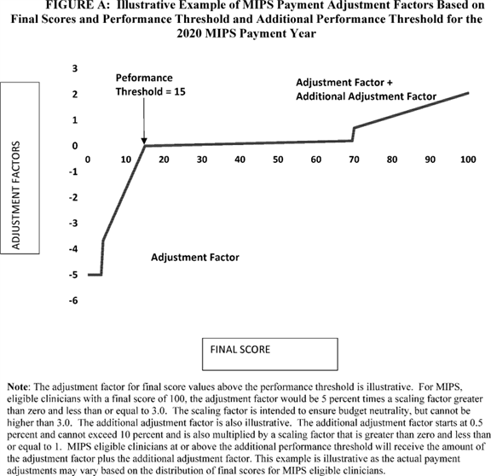

BILLING CODE 4120-01-C

The final MIPS payment adjustments will be determined by the distribution of final scores across MIPS eligible clinicians and the performance threshold. More MIPS eligible clinicians above the performance threshold means the scaling factors would decrease because more MIPS eligible clinicians receive a positive MIPS payment adjustment. More MIPS eligible clinicians below the performance threshold means the scaling factors would increase because more MIPS eligible clinicians would have negative MIPS payment adjustments and relatively fewer MIPS eligible clinicians would receive positive MIPS payment adjustments.

Table 32 illustrates the changes in payment adjustments from the transition year to the 2020 MIPS payment year based on the final policies, as well as the statutorily-required increase in the applicable percent as required by section 1848(q)(6)(B) of the Act.

| **Table 32--Illustration of Point System and Associated Adjustments Comparison** | | | |
| --- | --- | --- | --- |
| **Between Transition Year and the 2020 MIPS Payment Year** | | | |
|  |  |  |  |
| **Transition year** | | **2020 MIPS payment year** | |
|  |  |  |  |
| **Final score** | **MIPS adjustment** | **Final score** | **MIPS adjustment** |
| **points** |  | **points** |  |
| 0.0-0.75 | Negative 4 percent | 0.0-3.75 | Negative 5 |
|  |  |  | percent. |
| 0.76-2.99 | Negative MIPS | 3.76-14.99 | Negative MIPS |
|  | payment adjustment |  | payment adjustment |
|  | greater than |  | greater than |
|  | negative 4 percent |  | negative 5 percent |
|  | and less than 0 |  | and less than 0 |
|  | percent on a |  | percent on a |
|  | linear sliding |  | linear sliding |
|  | scale |  | scale. |
| 3.00 | 0 percent | 15.00 | 0 percent |
|  | adjustment |  | adjustment. |
| 3.01-69.99 | Positive MIPS | 15.01-69.99 | Positive MIPS |
|  | payment adjustment |  | payment adjustment |
|  | greater than 0 |  | greater than 0 |
|  | percent on a |  | percent on a |
|  | linear sliding |  | linear sliding |
|  | scale. The linear |  | scale. The linear |
|  | sliding scale |  | sliding scale |
|  | ranges from 0 to 4 |  | ranges from 0 to 5 |
|  | percent for scores |  | percent for scores |
|  | from 3.00 to |  | from 15.00 to |
|  | 100.00. This |  | 100.00. This |
|  | sliding scale is |  | sliding scale is |
|  | multiplied by a |  | multiplied by a |
|  | scaling factor |  | scaling factor |
|  | greater than zero |  | greater than zero |
|  | but not exceeding |  | but not exceeding |
|  | 3.0 to preserve |  | 3.0 to preserve |
|  | budget neutrality |  | budget neutrality. |
| 70.00-100 | Positive MIPS | 70.00-100 | Positive MIPS |
|  | payment adjustment |  | payment adjustment |
|  | greater than 0 |  | greater than 0 |
|  | percent on a |  | percent on a |
|  | linear sliding |  | linear sliding |
|  | scale. The linear |  | scale. The linear |
|  | sliding scale |  | sliding scale |
|  | ranges from 0 to 4 |  | ranges from 0 to 5 |
|  | percent for scores |  | percent for scores |
|  | from 3.00 to |  | from 15.00 to |
|  | 100.00. This |  | 100.00. This |
|  | sliding scale is |  | sliding scale is |
|  | multiplied by a |  | multiplied by a |
|  | scaling factor |  | scaling factor |
|  | greater than zero |  | greater than zero |
|  | but not exceeding |  | but not exceeding |
|  | 3.0 to preserve |  | 3.0 to preserve |
|  | budget neutrality; |  | budget neutrality; |
|  | PLUS |  | PLUS. |
|  | An additional MIPS |  | An additional MIPS |
|  | payment adjustment |  | payment adjustment |
|  | for exceptional |  | for exceptional |
|  | performance. The |  | performance. The |
|  | additional MIPS |  | additional MIPS |
|  | payment adjustment |  | payment adjustment |
|  | starts at 0.5 |  | starts at 0.5 |
|  | percent and |  | percent and |
|  | increases on a |  | increases on a |
|  | linear sliding |  | linear sliding |
|  | scale. The linear |  | scale. The linear |
|  | sliding scale |  | sliding scale |
|  | ranges from 0.5 to |  | ranges from 0.5 to |
|  | 10 percent for |  | 10 percent for |
|  | scores from 70.00 |  | scores from 70.00 |
|  | to 100.00. This |  | to 100.00. This |
|  | sliding scale is |  | sliding scale is |
|  | multiplied by a |  | multiplied by a |
|  | scaling factor not |  | scaling factor not |
|  | greater than 1.0 |  | greater than 1.0 |
|  | in order to |  | in order to |
|  | proportionately |  | proportionately |
|  | distribute the |  | distribute the |
|  | available funds |  | available funds |
|  | for exceptional |  | for exceptional |
|  | performance |  | performance. |

In the CY 2018 Quality Payment Program proposed rule, we provided a few examples for the 2020 MIPS payment year to demonstrate scenarios in which MIPS eligible clinicians can achieve a final score at or above the performance threshold of 15 points. We note a calculation error was included in Example 3. Because the MIPS eligible clinician did not submit advancing care information, the quality performance category should have been 85 percent to reflect reweighting, while the advancing care information performance category should have been zero percent. Earned points (column D) should have been 42.5 for quality to reflect reweighting and the final score should have been listed as 51.5.

We have provided updated examples below for the 2020 MIPS payment year to demonstrate scenarios in which MIPS eligible clinicians can achieve a final score at or above the performance threshold of 15 points based on our final policies.

Example 1: MIPS Eligible Clinician in Small Practice Submits 1 Quality Measure and 1 Improvement Activity

In the example illustrated in Table 32, a MIPS eligible clinician in a small practice reporting individually meets the performance threshold by reporting one quality measure one time via claims and one medium-weight improvement activity. The practice does not submit data for the advancing care information performance category, but does submit a significant hardship exception application which is approved; therefore, the weight for the advancing care information performance category is reweighted to the quality performance category due to final reweighting policies discussed in section II.C.7.b.(3) of this final rule with comment period [*(82 FR 30141*](https://advance.lexis.com/api/document?collection=administrative-codes&id=urn:contentItem:5NX6-6BS0-006W-83PD-00000-00&context=) through 30146). We also assumed the small practice has a cost performance category percent score of 50 percent. Finally, we assumed a complex patient bonus of 3 points which represents the average HCC risk score for the beneficiaries seen by the MIPS eligible clinician as well as the proportion of Medicare beneficiaries that are dual eligible. There are several special scoring rules which affect MIPS eligible clinicians in a small practice:

* 3 Measure achievement points for each quality measure even if the measure does not meet data completeness standards. We refer readers to section II.C.7.a.(2)(d) of this final rule with comment period for discussion of this policy. Therefore, a quality measure submitted one time would receive 3 points. Because the measure is submitted via claims, it does not qualify for the end-to-end electronic reporting bonus, nor would it qualify for the high-priority bonus because it is the only measure submitted. Because the MIPS eligible clinician does not meet full participation requirements, the MIPS eligible clinician does not qualify for improvement scoring. We refer readers to section II.C.7.a.(2)(i)(iii) of this final rule with comment period for a discussion on full participation requirements. Therefore, the quality performance category is (3 measure achievement points + zero measure bonus points)/60 total available measure points + zero improvement percent score which is 5 percent.

1. The advancing care information performance category weight is redistributed to the quality performance category so that the quality performance category score is worth 75 percent of the final score. We refer readers to section II.C.7.b.(3)(d) of this final rule with comment period for a discussion of this policy.
2. MIPS eligible clinicians in small practices qualify for special scoring for improvement activities so a medium weighted activity is worth 20 points out of a total 40 possible points for the improvement activities performance category. We refer readers to section II.C.6.e.(5) of this final rule with comment period for a discussion of this policy.
3. MIPS eligible clinicians in small practices qualify for the 5-point small practice bonus which is applied to the **[*53798]** final score. We refer readers to section II.C.7.b.(1)(c) of this final rule with comment period for a discussion of this policy.

This MIPS eligible clinician exceeds the performance threshold of 15 points (but does not exceed the additional performance threshold). This score is summarized in Table 33.

| **Table 33--Scoring Example 1, MIPS Eligible Clinician in a Small Practice** | | | |
| --- | --- | --- | --- |
|  |  |  |  |
| **Performance category** | **Performance score** | **Category weight** | **Earned** |
|  |  |  | **points** |
|  |  |  | **([B] \*** |
|  |  |  | **[C] \*** |
|  |  |  | **100)** |
| [A] | [B] | [C] | [D] |
| Quality | 5% | 75% | 3.75 |
| Cost | 50% | 10% | 5.0 |
| Improvement | 20 out of 40 | 15% | 7.5 |
| Activities | points--50% |  |  |
| Advancing Care | N/A | 0% (reweighted to | 0 |
| Information |  | quality) |  |
| Subtotal (Before |  |  | 16.25 |
| Bonuses) |  |  |  |
| Complex Patient Bonus |  |  | 3 |
| Small Practice Bonus |  |  | 5 |
| Final Score (not to |  |  | 24.25 |
| exceed 100) |  |  |  |

Example 2: Group Submission Not in a Small Practice

In the example illustrated in Table 34, a MIPS eligible clinician in a medium size practice participating in MIPS as a group receives performance category scores of 75 percent for the quality performance category, 50 percent for the cost performance category, and 100 percent for the advancing care information and improvement activities performance categories. There are many paths for a practice to receive a 75 percent score in the quality performance category, so for simplicity we are assuming the score has been calculated at this amount. The final score is calculated to be 85.5, and both the performance threshold of 15 and the additional performance threshold of 70 are exceeded. Again, for simplicity, we assume a complex patient bonus of 3 points. In this example, the group practice does not qualify for any special scoring, yet is able to exceed the additional performance threshold and will receive the additional MIPS payment adjustment.

| **Table 34--Scoring Example 2, MIPS Eligible Clinician in a Medium Practice** | | | |
| --- | --- | --- | --- |
|  |  |  |  |
| **Performance category** | **Performance score** | **Category weight** | **Earned** |
|  |  |  | **points** |
|  |  |  | **([B] \*** |
|  |  |  | **[C] \*** |
|  |  |  | **100)** |
| [A] | [B] | [C] | [D] |
| Quality | 75% | 50% | 37.5 |
| Cost | 50% | 10% | 5 |
| Improvement | 40 out of 40 points | 15% | 15 |
| Activities | 100% |  |  |
| Advancing Care | 100% | 25% | 25 |
| Information |  |  |  |
| Subtotal (Before |  |  | 82.5 |
| Bonuses) |  |  |  |
| Complex Patient Bonus |  |  | 3 |
| Small Practice Bonus |  |  | 0 |
| Final Score (not to |  |  | 85.5 |
| exceed 100) |  |  |  |

Example 3: Non-Patient Facing MIPS Eligible Clinician

In the example illustrated in Table 35, an individual MIPS eligible clinician that is non-patient facing and not in a small practice receives performance category scores of 50 percent for the quality performance category, 50 percent for the cost performance category, and 50 percent for 1 medium-weighted improvement activity. Again, there are many paths for a practice to receive a 50 percent score in the quality performance category, so for simplicity we are assuming the score has been calculated. Because the MIPS eligible clinician is non-patient facing, they qualify for special scoring for improvement activities and receive 20 points (out of 40 possible points) for the medium weighted activity. Also, this individual did not submit advancing care information measures and qualifies for the automatic reweighting of the advancing care information performance category to the quality performance category. Again, for simplicity, we assume a complex patient bonus of 3 points. The MIPS eligible clinician is not in a small practice so does not qualify for the small practice bonus.

In this example, the final score is 53 and the performance threshold of 15 is exceeded while the additional performance threshold of 70 is not.

| **Table 35--Scoring Example 3, Non-Patient Facing MIPS Eligible Clinician** | | | |
| --- | --- | --- | --- |
|  |  |  |  |
| **Performance category** | **Performance score** | **Category weight** | **Earned** |
|  |  |  | **points** |
| [A] | [B] | [C] | ([B] * |
|  |  |  | [C] * |
|  |  |  | 100) = |
|  |  |  | [D] |
| Quality | 50% | 75% | 37.5 |
| Cost | 50% | 10% | 5 |
| Improvement | 20 out of 40 points | 15% | 7.5 |
| Activities | for 1 medium weight |  |  |
|  | activity |  |  |
|  | 50% |  |  |
| Advancing Care | 0% | 0% (reweighted to | 0 |
| Information |  | quality) |  |
| Subtotal (Before |  |  | 50 |
| Bonuses) |  |  |  |
| Complex Patient Bonus |  |  | 3 |
| Small Practice Bonus |  |  | 0 |
| Final Score (not to |  |  | 53 |
| exceed 100) |  |  |  |

We note that these examples are not intended to be exhaustive of the types of participants nor the opportunities for reaching and exceeding the performance threshold.

9. Review and Correction of MIPS Final Score

a. Feedback and Information To Improve Performance

(1) Performance Feedback

As we have stated previously in the CY 2017 Quality Payment Program final rule [*(81 FR 77345),*](https://advance.lexis.com/api/document?collection=administrative-codes&id=urn:contentItem:5M3D-MP10-006W-80MT-00000-00&context=) we will continue to engage in user research with front-line clinicians to ensure we are providing the performance feedback data in a user-friendly format, and that we are including the data most relevant to clinicians. Any suggestions from user research would be considered as we develop the systems needed for performance feedback, which would occur outside of the rulemaking process.

Over the past year, we have conducted numerous user research sessions to determine what the community most needs in performance feedback. In summary, we have found the users want the following:

(1) To know as soon as possible how I am performing based on my submitted data so that I have confidence that I performed the way I thought I would.

(2) To be able to quickly understand how and why my payments will be adjusted so that I can understand how my business will be impacted.

(3) To be able to quickly understand how I can improve my performance so that I can increase my payment in future program years.

(4) To know how I am performing over time so I can improve the care I am providing patients in my practice.

(5) To know how my performance compares to my peers.

Based on that research, we have already begun development of real-time feedback on data submission and scoring where technically feasible (some scoring requires all clinician data be submitted, and therefore, cannot occur until the end of the submission period). By "real-time" feedback, we mean instantaneous receipt recognition; for example, when a clinician submits their data via our Web site or a third party submits data via our Application Program Interface (API), they will know immediately if their submission was successful.

We will continue to provide information for stakeholders who wish to participate in user research via our education and communication channels. Suggestions can also be sent via the "Contact Us" information on *qpp.cms.gov*. However, we noted that suggestions provided through this channel would not be considered as comments on the proposed rule.

(a) MIPS Eligible Clinicians

Under section 1848(q)(12)(A)(i) of the Act, we are at a minimum required to provide MIPS eligible clinicians with timely (such as quarterly) confidential feedback on their performance under the quality and cost performance categories beginning July 1, 2017, and we have discretion to provide such feedback regarding the improvement activities and advancing care information performance categories.

We proposed to provide, beginning July 1, 2018, performance feedback to MIPS eligible clinicians and groups for the quality and cost performance categories for the 2017 performance period, and if technically feasible, for the improvement activities and advancing care information performance categories. We proposed to provide this performance feedback at least annually, and as, technically feasible, we would provide it more frequently, such as quarterly. If we are able to provide it more frequently, we would communicate the expected frequency to our stakeholders via our education and outreach communication channels.

Based on public comments summarized and responded to in the CY 2017 Quality Payment Program final rule [*(81 FR 77347),*](https://advance.lexis.com/api/document?collection=administrative-codes&id=urn:contentItem:5M3D-MP10-006W-80MT-00000-00&context=) we also proposed that the measures and activities specified for the CY 2017 performance period (for all four MIPS performance categories), along with the final score, would be included in the performance feedback provided on or about July 1, 2018.

For cost measures, since we can measure performance using any 12-month period of prior claims data, we requested comment on whether it would be helpful to provide more frequent feedback on the cost performance category using rolling 12-month periods or quarterly snapshots of the most recent 12-month period; how frequent that feedback should be; and the format in which we should make it available to clinicians and groups. In addition, as described in sections II.C.6.b. and II.C.6.d. of the proposed rule, we stated in the proposed rule our intent to provide cost performance feedback in the fall of 2017 and the summer of 2018 on new episode-based cost measures that are currently under development by CMS. With regard to the format of feedback on cost measures, we noted how we are considering utilizing the parts of the Quality and Resource Use Reports (QRURs) that user testing has revealed beneficial while making the overall look and feel usable to clinicians. We requested comment on whether that format is appropriate or if other formats or revisions to that format should be used to provide performance feedback on cost measures.

The following is a summary of the public comments received on the "MIPS Eligible Clinicians" proposals and our responses:

*Comment:* Many commenters asked for more timely feedback. Some commenters expressed concern that the data in existing reports may be more than 2 or more years out of date and that more recent feedback is needed to improve quality and change behaviors. Several commenters noted the need for real time feedback in order to be actionable. Many commenters noted feedback reports should be available quarterly, semi-annually, or more frequently than annually. A few commenters noted receiving feedback in mid-2018 would be too late to make the necessary adjustments to ensure success in the following MIPS performance period and requested mid-year performance reports for the start of the performance period. One commenter stated that CMS should hold itself accountable for annual reports to be **[*53800]** available no later than the following August, but CMS should aim for having them available no later than July. Half-year performance should be available no later than the following March, but CMS should aim for January. The commenter stated that if CMS is unable to provide timely reports, then clinicians should be exempt from MIPS.

One commenter noted that it is important that CMS reduce the amount of time between the performance period and performance feedback from CMS to allow practices time to make necessary adjustments before the next reporting period begins. The commenter also requested that feedback to clinicians should be delivered by CMS to clinicians beginning no later than April 1, 2019. A few commenters requested technology and system upgrades, so that CMS could improve the way performance information is disseminated to physicians and practices, such as dashboards or reports on demand. One commenter requested quarterly information to ensure the accuracy of the information, especially as CMS has proposed posting MIPS performance scores on the Physician Compare Web site.

Another commenter encouraged CMS to release the reports as early as possible, at minimum following the MACRA recommendation that data be available on a quarterly basis, so that clinicians are not well into the next reporting cycle before they learn of their MIPS results and performance and can institute workflow changes to ensure success under MIPS. One commenter expressed that measure-based feedback is helpful as eligible clinicians determine performance improvement plans and select measures for future performance periods. One commenter believes that patient-level data is helpful to eligible clinicians as they determine areas in which additional resources can be allocated.

*Response:* Under section 1848(q)(12)(A)(i) of the Act, we are at a minimum required to provide MIPS eligible clinicians with timely (such as quarterly) confidential feedback on their performance under the quality and cost performance categories beginning July 1, 2017, and we have discretion to provide such feedback regarding the improvement activities and advancing care information performance categories. We are finalizing our policy as proposed to provide performance feedback annually on the quality and cost performance categories, and as technically feasible the improvement activities and advancing care information performance categories. As we have indicated previously, our goal is to provide even more timely feedback under MIPS as the program evolves, and we are continuing to work with stakeholders as we build performance feedback to incorporate technology to improve the usability of performance feedback. We do note that there are a number of challenges with providing feedback more frequently than annually, namely that for the MIPS performance period, we can only provide feedback on performance as often as data are reported to us; for MIPS, this will be an annual basis for all quality submission mechanisms except for claims and administrative claims. As soon as the data are available on a more frequent basis we can continue exploring the path to provide performance feedback on a more frequent basis, such as quarterly. The inability to provide more frequent feedback, other than annually, is not a reason to be exempted from the Quality Payment Program, and by statute there is no authority to create such exemptions. For eligible clinicians and groups who use a third party intermediary to report data, we expect those intermediaries to provide additional performance feedback on top of what CMS is providing through the annual performance feedback. Lastly, we are working with stakeholders on an API alpha where registries, and other third party intermediaries as technically feasible, are currently testing real-time feedback capabilities with the intermediary directly sharing the feedback with the eligible clinician or group. Lastly, we refer readers to section II.C.5. of this final rule with comment period for more information on the MIPS performance period.

*Comment:* One commenter requested CMS include the advancing care information and improvement activities categories in the report as well in order for eligible clinicians to familiarize themselves with the program and scoring and to enable them to make decisions to support their success under MIPS.

*Response:* We agree that all four performance categories are beneficial to include in performance feedback, and are working to incorporate these data into the July 1, 2018 performance feedback, as technically feasible. We will continue to work with stakeholders on the best way to include all four performance categories in performance feedback.

*Comment:* One commenter suggested that one person should be able to obtain feedback for an entire TIN or even group of TINs at once because seeking out a report on each NPI is not sustainable for larger organizations.

*Response:* We are continuing to evaluate ways to make the data in performance feedback more easily accessible to practice managers who manage large numbers of clinicians (TINs).

*Comment:* One commenter noted that cost category elements could be submitted to other entities using APIs.

*Response:* We note that the cost category measures for MIPS require no submission, and are entirely claims based. Therefore, identifying additional submission mechanisms for cost category data appears unnecessary.

*Comment:* Several commenters suggested feedback on cost measures and cost performance category as it relates to performance feedback. Some commenters agreed it would be helpful to provide more frequent and actionable feedback on the cost performance category using rolling 12-month periods or quarterly snapshots of the most recent 12-month period. One commenter asked for the agency to do this in a transparent manner. A few commenters asked for information on cost performance to include cost metrics related to episodes of care and comparative data.

Another commenter expressed concerns that there is limited experience in episode grouper and urged CMS to test and evaluate its episode grouper methodology and ensure that their application will not result in unintended consequences, such as stinting on needed care as a way to ensure that costs within the defined episode are contained. Another commenter noted that issues such as identifying the correct length of the episode window and assigning services to the episode (like rehabilitation therapy or imaging, etc.) each take hours to resolve and asked that CMS think critically about the MIPS timeline needed to build out every episode of care in the Medicare population. That commenter further requested that CMS provide stakeholders with a time-table for developing Medicare Cost measure episodes as well as a list of future episodes under consideration and that once developed, the proposed details of the new episode-based cost measures should be subject to notice and comment rulemaking in a future proposed rule. Finally, the commenter noted that while this performance category relies solely on administrative claims data, critical resource use related questions like attribution and risk adjustment for medically complex patients still need solutions that can only be answered with additional time and through CMS collaboration with the relevant professions. **[*53801]**

*Response:* We will take this into consideration as we continue to build the mechanisms and formats for performance feedback for the Quality Payment Program. Additionally, we are actively developing new episode-based cost measures, which includes field testing the measures that will share such information with clinicians. We will continue to engage in user research with front-line clinicians and other stakeholders to ensure we are providing the performance feedback data in a user-friendly format, and that we are including the data most relevant to clinicians. In particular, we have held a Technical Expert Panel focused on risk adjustment for episode-based cost measures, which has informed the development of potential new episode-based cost measures. Any new cost measures would be proposed through rulemaking. In terms of clinician involvement, the cost measure development contractor has brought together nearly 150 clinicians affiliated with nearly 100 specialty societies to both recommend which new cost measures to build first and to review and make recommendations for every step of cost measure development including which claims to include and risk adjustment.

*Comment:* One commenter suggested including the following information in standardized feedback reports as fields: (1) Indications for individual or group classification for non-patient facing, small group practice, and rural area and health professional shortage area; (2) indications for performance category reweighting and special scoring considerations; (3) for the quality performance category, including the title of the quality measure submitted, measure type, the total points that can be achieved based on the benchmark, whether data completeness has been met for the quality measure, decile level achieved, measure achievement points, bonus points awarded, and performance score; and (4) for the improvement activities category, including the title of the improvement activity submitted, weighting of the improvement activity, total points that can be earned, special scoring applied; and points earned for the measure performance score. Another commenter recommended including the following information in standardized feedback reports: (1) Eligibility status for both eligible clinicians and group practices; (2) for a group practice especially, a defined and updated list of NPIs for which the group is responsible when reporting at group TIN level; (3) submission status tracking files submitted and whether or not the submission was successful; and (4) scoring feedback on claim-based universal population quality measures and cost measures which is often not available to eligible clinicians and groups until after the performance period.

*Response:* We agree with commenters about continually improving the usability of performance feedback, and will continue doing stakeholder outreach with the goal that the template for performance feedback will be available in a usable and user-friendly format. We intend to consider different options--including all the comments submitted on the proposed rule--before the performance feedback is displayed in a web-based application to MIPS eligible clinicians.

*Final Action:* As a result of the public comments, we are finalizing these policies as proposed. Specficially, on an annual basis, beginning July 1, 2018, performance feedback will be provided to MIPS eligible clinicians and groups for the quality and cost performance categories for the 2017 performance period, and if technically feasible, for the improvement activities and advancing care information performance categories.

We also solicited comment only on how often cost data should be provided in performance feedback under the Quality Payment Program, as well as, which data fields in the QRUR that would be useful to include in the Quality Payment Program performance feedback.

We received a number of comments on this item and appreciate the input received. As this was a request for comment only, we will take the feedback provided into consideration for the future as we continue to build performance feedback.

(b) MIPS APMs

We proposed that MIPS eligible clinicians who participate in MIPS APMs would receive performance feedback in 2018 and future years of the Quality Payment Program, as technically feasible. We referred readers to section II.C.6.g.(5) of the proposed rule for additional information related to the proposal. A summary of comments on those proposals can be found in section II.C.6.g.(5) of this final rule with comment period.

(c) Voluntary Clinician and Group Reporting

As noted in the CY 2017 Quality Payment Program final rule [*(81 FR 77071),*](https://advance.lexis.com/api/document?collection=administrative-codes&id=urn:contentItem:5M3D-MP10-006W-80MT-00000-00&context=) eligible clinicians who are not included in the definition of a MIPS eligible clinician during the first 2 years of MIPS (or any subsequent year) may voluntarily report on measures and activities under MIPS, but will not be subject to the payment adjustment. In the CY 2017 Quality Payment Program final rule [*(81 FR 77346),*](https://advance.lexis.com/api/document?collection=administrative-codes&id=urn:contentItem:5M3D-MP10-006W-80MT-00000-00&context=) we summarized public comments requesting that eligible clinicians who are not required, but who voluntarily report on measures and activities under MIPS, should receive the same access to performance feedback as MIPS eligible clinicians; there, we indicated that we would take the comments into consideration in the future development of performance feedback. We proposed to furnish performance feedback to eligible clinicians and groups that do not meet the definition of a MIPS eligible clinician but voluntarily report on measures and activities under MIPS. We proposed that this would begin with data collected in performance period 2017, and would be available beginning July 1, 2018. Based on user and market research, we believe that making this information available would provide value in numerous ways. First, it would help clinicians who are excluded from MIPS in the 2017 performance period, but who may be considered MIPS eligible clinicians in future years, to prepare for participation in the Quality Payment Program when there are payment consequences associated with participation. Second, it would give all clinicians equal access to the CMS claims and benchmarking data available in performance feedback. And third, it would allow clinicians who may be interested in participating in an APM to make a more informed decision.

The following is a summary of the public comments received on the "Voluntary Clinician and Group Reporting" proposals and our responses:

*Comment:* A few commenters supported providing feedback reports to clinicians who do not meet the definition of MIPS eligible clinician, but voluntarily report measures and activities to MIPS, beginning July 1, 2018, and containing information on data submitted in the 2017 performance period, because MIPS provides a valuable introduction to value-based payment for clinicians that may not have previously encountered it, which will help them better understand the program and prepare for successful participation in the future if they become MIPS eligible.

*Response:* We agree this data will be useful and are finalizing this proposal.

*Final Action:* As a result of the public comments, we are finalizing this policy as proposed. Specifically, starting with data collected in the performance period 2017 that would be available beginning **[*53802]** July 1, 2018, we will furnish performance feedback to eligible clinicians and groups that do not meet the definition of a MIPS eligible clinician but voluntarily report on measures and activities under MIPS.

(2) Mechanisms

Under section 1848(q)(12)(A)(ii) of the Act, the Secretary may use one or more mechanisms to make performance feedback available, which may include use of a web-based portal or other mechanisms determined appropriate by the Secretary. For the quality performance category, described in section 1848(q)(2)(A)(i) of the Act, the feedback shall, to the extent an eligible clinician chooses to participate in a data registry for purposes of MIPS (including registries under sections 1848(k) and (m) of the Act), be provided based on performance on quality measures reported through the use of such registries. For any other performance category (that is, cost, improvement activities, or advancing care information), the Secretary shall encourage provision of feedback through qualified clinical data registries (QCDRs) as described in section 1848(m)(3)(E) of the Act.

As previously stated in the CY 2017 Quality Payment Program final rule [*(81 FR 77347*](https://advance.lexis.com/api/document?collection=administrative-codes&id=urn:contentItem:5M3D-MP10-006W-80MT-00000-00&context=) through 77349), we will use a CMS-designated system as the mechanism for making performance feedback available, which we expect will be a web-based application. We expect to use a new and improved format for the next performance feedback, anticipated to be released around July 1, 2018. It will be provided via the Quality Payment Program Web site (*qpp.cms.gov*), and we intend to leverage additional mechanisms, such as health IT vendors, registries, and QCDRs to help disseminate data and information contained in the performance feedback to eligible clinicians, where applicable.

We also sought comment on how health IT, either in the form of an EHR or as a supplemental module, could better support the feedback related to participation in the Quality Payment Program and quality improvement in general. Specifically--

* Are there specific health IT functionalities that could contribute significantly to quality improvement?

1. Are there specific health IT functionalities that could be part of a certified EHR technology or made available as optional health IT modules in order to support the feedback loop related to Quality Payment Program participation or participation in other HHS reporting programs?
2. In what other ways can health IT support clinicians seeking to leverage quality data reports to inform clinical improvement efforts? For example, are there existing or emerging tools or resources that could leverage an API to provide timely feedback on quality improvement activities?
3. Are there opportunities to expand existing tracking and reporting for use by clinicians, for example expanding the feedback loop for patient engagement tools to support remote monitoring of patient status and access to education materials?

We welcomed public comment on these questions.

We also noted in the proposed rule that we intend to continue to leverage third party intermediaries as a mechanism to provider performance feedback [*(82 FR 30155*](https://advance.lexis.com/api/document?collection=administrative-codes&id=urn:contentItem:5NX6-6BS0-006W-83PD-00000-00&context=) through 30156). In the CY 2017 Quality Payment Program final rule [*(81 FR 77367*](https://advance.lexis.com/api/document?collection=administrative-codes&id=urn:contentItem:5M3D-MP10-006W-80MT-00000-00&context=) through 77386) we finalized that at least 4 times per year, qualified registries and QCDRs will provide feedback on all of the MIPS performance categories that the qualified registry or QCDR reports to us (improvement activities, advancing care information, and/or quality performance category). The feedback should be given to the individual MIPS eligible clinician or group (if participating as a group) at the individual participant level or group level, as applicable, for which the qualified registry or QCDR reports. The qualified registry or QCDR is only required to provide feedback based on the MIPS eligible clinician's data that is available at the time the performance feedback is generated. In regard to third party intermediaries, we also noted we would look to propose "real time" feedback as soon as it is technically feasible.

We also noted in the proposed rule [*(82 FR 30156)*](https://advance.lexis.com/api/document?collection=administrative-codes&id=urn:contentItem:5NX6-6BS0-006W-83PD-00000-00&context=) that, per the policies finalized in the CY 2017 Quality Payment Program final rule [*(81 FR 77367*](https://advance.lexis.com/api/document?collection=administrative-codes&id=urn:contentItem:5M3D-MP10-006W-80MT-00000-00&context=) through 77386), we require qualified registries and QCDRs, as well as encourage other third party intermediaries (such as health IT vendors that submit data to us on behalf of a MIPS eligible clinician or group), to provide performance feedback to individual MIPS eligible clinicians and groups via the third party intermediary with which they are already working. We also noted that we understand that performance feedback is valuable to individual clinicians and groups, and seek feedback from third party intermediaries on when "real-time" feedback could be provided.

As discussed in the proposed rule (see [*82 FR 30156),*](https://advance.lexis.com/api/document?collection=administrative-codes&id=urn:contentItem:5NX6-6BS0-006W-83PD-00000-00&context=) we plan to continue to work with third party intermediaries as we continue to develop the mechanisms for performance feedback, to see where we may be able to develop and implement efficiencies for the Quality Payment Program. We are exploring options with an API, which could allow authenticated third party intermediaries to access the same data that we use to provide confidential feedback to the individual clinicians and groups on whose behalf the third party intermediary reports for purposes of MIPS, in accordance with applicable law, including, but not limited to, the HIPAA Privacy and Security Rules. Our goal is to enable individual clinicians and groups to more easily access their feedback via the mechanisms and relationships they already have established. We referred readers to section II.C.10. of the proposed rule for additional information on Third Party Data Submission.

We solicited comment only on mechanisms used for performance feedback but did not propose any specific policy.

We received a number of comments on this item and appreciate the input received. As this was a request for comment only, we will take the feedback provided into consideration for the future as we continue to build performance feedback.

(3) Receipt of Information

Section 1848(q)(12)(A)(v) of the Act, states that the Secretary may use the mechanisms established under section 1848(q)(12)(A)(ii) of the Act to receive information from professionals. This allows for expanded use of the feedback mechanism to not only provide feedback on performance to MIPS eligible clinicians, but to also receive information from professionals.

In the CY 2017 Quality Payment Program final rule [*(81 FR 77350),*](https://advance.lexis.com/api/document?collection=administrative-codes&id=urn:contentItem:5M3D-MP10-006W-80MT-00000-00&context=) we discussed that we intended to explore the possibility of adding this feature to the CMS-designated system, such as a portal, in future years under MIPS. Although we did not make any specific proposals at this time, we sought comment on the features that could be developed for the expanded use of the feedback mechanism. This could be a feature where eligible clinicians and groups can send their feedback (for example, if they are experiencing issues accessing their data, technical questions about their data, etc.) to us through the Quality Payment Program Service Center or the Quality Payment Program Web site. We noted that we appreciate that eligible clinicians and groups may have questions regarding the Quality Payment Program information contained in their performance feedback. To assist **[*53803]** eligible clinicians and groups, we intend to utilize existing resources, such as a helpdesk or offer technical assistance, to help address questions with the goal of linking these resource features to the Quality Payment Program Web site and Service Center.

We solicited comment only on the receipt of information on features that could be developed for the expanded use of the feedback mechanism but did not propose any specific policy.

We received a number of comments on this item and appreciate the input received. As this was a request for comment only, we will take the feedback provided into consideration for the future as we continue to build performance feedback. As a reminder, we have already established a single helpdesk to address all questions related to the Quality Payment Program. Please visit our Web site at *qpp.cms.gov* for more information.

(4) Additional Information--Type of Information

Section 1848(q)(12)(B)(i) of the Act states that beginning July 1, 2018, the Secretary shall make available to MIPS eligible clinicians information about the items and services for which payment is made under Title 18 that are furnished to individuals who are patients of MIPS eligible clinicians by other suppliers and providers of services. This information may be made available through mechanisms determined appropriate by the Secretary, such as the CMS-designated system that would also provide performance feedback. Section 1848(q)(12)(B)(ii) of the Act specifies that the type of information provided may include the name of such providers, the types of items and services furnished, and the dates that items and services were furnished. Historical data regarding the total, and components of, allowed charges (and other figures as determined appropriate by the Secretary) may also be provided.

We proposed, beginning with the performance feedback provided around July 1, 2018, to make available to MIPS eligible clinicians and eligible clinicians information about the items and services for which payment is made under Title 18 that are furnished to individuals who are patients of MIPS eligible clinicians and eligible clinicians by other suppliers and providers of services. We proposed to include as many of the following data elements as technically feasible: The name of such suppliers and providers of services; the types of items and services furnished and received; the dollar amount of services provided and received; and the dates that items and services were furnished. We proposed that the additional information would include historical data regarding the total, and components of, allowed charges (and other figures as determined appropriate). We proposed that this information be provided on the aggregate level; with the exception of data on items and services, as we could consider providing this data at the patient level, if clinicians find that level of data to be useful, although we noted it may contain personally identifiable information and protected health information. We proposed the date range for making this information available would be based on what is most helpful to clinicians, which could include the most recent data we have available, which as technically feasible would be from the previous 3 to 12-month period. We proposed to make this information available via the Quality Payment Program Web site, and as technically feasible, as part of the performance feedback. Finally, because data on items and services furnished is generally kept confidential, we proposed that access would be provided only after secure credentials are obtained.

The following is a summary of the public comments received on the "Additional Information--Type of Information" proposals and our responses:

*Comment:* One commenter supported providing additional information about the items and services for which payment is made under Title XVIII. The commenter urged CMS to make the information more robust by identifying alternatives to the items or services provided that would have been more cost effective to the patient while still delivering the same quality of care.

Two commenters provided recommendations for the type of additional information to include in performance feedback. One commenter recommended that CMS create machine-readable APIs for the feedback mechanism so that vendors could then interpret "raw data," thereby enabling them to develop visualization and processing tools to better understand this data. The commenter believes that providing all data and allowing community tools to filter out irrelevant data would provide more useful insights to MIPS eligible clinicians. Another commenter suggested inclusion of information about which patients are attributed to particular clinicians, which other clinicians have partnered in that care, and the care directly attributed to the clinician. The commenter believes that inclusion of this information would better balance the power between CMS to audit and potentially recover money with the opportunity for an eligible clinician to seek an informal review. Furthermore, the commenter observed that current feedback reports lack key details for understanding the methodologies used to arrive at the benchmarks and other calculations and encouraged CMS to generate a summary report of all measures across the MIPS domains per specialty and TIN size, including the "success" of each measure assessed.

*Response:* We appreciate the feedback provided and will consider these ideas as we continue to build performance feedback. We are continuing to work with registries, QCDRs, and health IT vendors to test new APIs and plan to continue to develop new APIs as the Quality Payment Program progresses. We also continue to evaluate what additional information and type of information as required by section 1848(q)(12)(B)(i) of the Act would be useful to clinicians and groups, and are currently working with stakeholders to establish what to include in performance feedback.

*Final Action:* As a result of the public comments, we are finalizing these policies as proposed. Section 1848(q)(12)(B)(i) of the Act states that beginning July 1, 2018, the Secretary shall make available to MIPS eligible clinicians information about the items and services for which payment is made under Title 18 that are furnished to individuals who are patients of MIPS eligible clinicians by other suppliers and providers of services.

(5) Performance Feedback Template

In the proposed rule, we noted our intent [*(82 FR 30157),*](https://advance.lexis.com/api/document?collection=administrative-codes&id=urn:contentItem:5NX6-6BS0-006W-83PD-00000-00&context=) to do as much as we can of the development of the template for performance feedback by working with the stakeholder community in a transparent manner. We stated our belief that this will encourage stakeholder commentary and make sure the result is the best possible format(s) for feedback.

To continue with our collaborative goal of working with the stakeholder community, we sought comment on the structure, format, content (for example, detailed goals, data fields, and elements) that would be useful for MIPS eligible clinicians and groups to include in performance feedback, including the data on items and services furnished, as discussed above. Additionally, we understand the term "performance feedback" may not be a meaningful phrase to communicate to clinicians or groups the scope of the data. Therefore, we sought comment on a more suitable term than "performance feedback." User **[*53804]** testing to date has provided some considerations for a name in the Quality Payment Program, such as Progress Notes, Reports, Feedback, Performance Feedback, or Performance Reports.

Any suggestions on the template to be used for performance feedback or what to call "performance feedback" can be submitted to the Quality Payment Program Web site at *qpp.cms.gov*.

We received a number of comments on this item and appreciate the input received. As this was a request for comment only and we did nto make a proposal, we will take the feedback provided into consideration for the future as we continue to build performance feedback. We intend to do as much as we can of the development of the template for performance feedback by working with the stakeholder community in a transparent manner. We invite clinicians and groups that may have ideas they want to share, or if they would like to participate in user testing to email [*partnership@cms.hhs.gov*](mailto:partnership@cms.hhs.gov). We think this will both encourage stakeholder commentary and make sure we end up with the best possible format(s) for feedback. We intend for this performance feedback to be available in the new format on the 2017 performance period by summer 2018, after the 2017 reporting closes.

b. Targeted Review

In the CY 2017 Quality Payment Program final rule [*(81 FR 77546),*](https://advance.lexis.com/api/document?collection=administrative-codes&id=urn:contentItem:5M3D-MP10-006W-80MT-00000-00&context=) we finalized at § 414.1385 that MIPS eligible clinicians or groups may request a targeted review of the calculation of the MIPS payment adjustment factor under section 1848(q)(6)(A) of the Act and, as applicable, the calculation of the additional MIPS payment adjustment factor under section 1848(q)(6)(C) of the Act applicable to such MIPS eligible clinician or group for a year. We noted MIPS eligible clinicians who are scored under the APM scoring standard described in section II.C.6.g. of the proposed rule may request this targeted review. Although we did not propose any changes to the targeted review process, we provided information on the process that was finalized in the CY 2017 Quality Payment Program final rule [*(81 FR 77353*](https://advance.lexis.com/api/document?collection=administrative-codes&id=urn:contentItem:5M3D-MP10-006W-80MT-00000-00&context=) through 77358).

(1) MIPS eligible clinicians and groups have a 60-day period to submit a request for targeted review, which begins on the day we make available the MIPS payment adjustment factor, and if applicable the additional MIPS payment adjustment factor, for the MIPS payment year and ends on September 30 of the year prior to the MIPS payment year or a later date specified by us.

(2) We will respond to each request for targeted review timely submitted and determine whether a targeted review is warranted. Examples under which a MIPS eligible clinician or group may wish to request a targeted review include, but are not limited to:

* The MIPS eligible clinician or group believes that measures or activities submitted to us during the submission period and used in the calculations of the final score and determination of the adjustment factors have calculation errors or data quality issues. These submissions could be with or without the assistance of a third party intermediary; or

1. The MIPS eligible clinician or group believes that there are certain errors made by us, such as performance category scores were wrongly assigned to the MIPS eligible clinician or group (for example, the MIPS eligible clinician or group should have been subject to the low-volume threshold exclusion, or a MIPS eligible clinician should not have received a performance category score).

(3) The MIPS eligible clinician or group may include additional information in support of their request for targeted review at the time the request is submitted. If we request additional information from the MIPS eligible clinician or group, it must be provided and received by us within 30 days of the request. Non-responsiveness to the request for additional information may result in the closure of the targeted review request, although the MIPS eligible clinician or group may submit another request for targeted review before the deadline.

(4) Decisions based on the targeted review are final, and there is no further review or appeal.

c. Data Validation and Auditing

In the CY 2017 Quality Payment Program final rule [*(81 FR 77546*](https://advance.lexis.com/api/document?collection=administrative-codes&id=urn:contentItem:5M3D-MP10-006W-80MT-00000-00&context=) through 77547), we finalized at § 414.1390(a) that we will selectively audit MIPS eligible clinicians and groups on a yearly basis. If a MIPS eligible clinician or group is selected for audit, the MIPS eligible clinician or group will be required to do the following in accordance with applicable law and timelines we establish:

(1) Comply with data sharing requests, providing all data as requested by us or our designated entity. All data must be shared with us or our designated entity within 45 days of the data sharing request, or an alternate timeframe that is agreed to by us and the MIPS eligible clinician or group. Data will be submitted via email, facsimile, or an electronic method via a secure Web site maintained by us.

(2) Provide substantive, primary source documents as requested. These documents may include: Copies of claims, medical records for applicable patients, or other resources used in the data calculations for MIPS measures, objectives, and activities. Primary source documentation also may include verification of records for Medicare and non-Medicare beneficiaries where applicable. We did not propose any changes to the requirements in section § 414.1390(a).

We indicated in the CY 2017 Quality Payment Program final rule that all MIPS eligible clinicians and groups that submit data to us electronically must attest to the best of their knowledge that the data submitted to us is accurate and complete [*(81 FR 77362).*](https://advance.lexis.com/api/document?collection=administrative-codes&id=urn:contentItem:5M3D-MP10-006W-80MT-00000-00&context=) We also indicated in the final rule that attestation requirements would be part of the submission process [*(81 FR 77360).*](https://advance.lexis.com/api/document?collection=administrative-codes&id=urn:contentItem:5M3D-MP10-006W-80MT-00000-00&context=) We neglected to codify this requirement in ***regulation*** text of the CY 2017 Quality Payment Program final rule. Additionally, after further consideration since the final rule, the requirement is more in the nature of a certification, rather than an attestation. Thus, we proposed to revise § 414.1390 to add a new paragraph (b) that requires all MIPS eligible clinicians and groups that submit data and information to CMS for purposes of MIPS to certify to the best of their knowledge that the data submitted to CMS is true, accurate, and complete. We also proposed that the certification by the MIPS eligible clinician or group must accompany the submission.

We also indicated in the CY 2017 Quality Payment Program final rule that if a MIPS eligible clinician or group is found to have submitted inaccurate data for MIPS, we would reopen and revise the determination in accordance with the rules set forth at §§ 405.980 through 405.984 [*(81 FR 77362).*](https://advance.lexis.com/api/document?collection=administrative-codes&id=urn:contentItem:5M3D-MP10-006W-80MT-00000-00&context=) We neglected to codify this policy in ***regulation*** text of the CY 2017 Quality Payment Program final rule and further, we did not include § 405.986, which is also an applicable rule in our reopening policy. We also finalized our approach to recoup incorrect payments from the MIPS eligible clinician by the amount of any debts owed to us by the MIPS eligible clinician and likewise, we would recoup any payments from the group by the amount of any debts owed to us by the group. Thus, we proposed to revise § 414.1390 to add a new paragraph (c) that states we may reopen and revise a MIPS payment determination in accordance with the rules set forth at §§ 405.980 through 405.986. **[*53805]**

In the CY 2017 Quality Payment Program final rule, we also indicated that MIPS eligible clinicians and groups should retain copies of medical records, charts, reports and any electronic data utilized for reporting under MIPS for up to 10 years after the conclusion of the performance period [*(81 FR 77360).*](https://advance.lexis.com/api/document?collection=administrative-codes&id=urn:contentItem:5M3D-MP10-006W-80MT-00000-00&context=) We neglected to codify this policy in ***regulation*** text of the CY 2017 Quality Payment Program final rule. Thus, we proposed to revise § 414.1390 to add a new paragraph (d) that states that all MIPS eligible clinicians or groups that submit data and information to CMS for purposes of MIPS must retain such data and information for a period of 10 years from the end the MIPS Performance Period.

Finally, we indicated in the CY 2017 Quality Payment Program final rule, that, in addition to recouping any incorrect payments, we intend to use data validation and audits as an educational opportunity for MIPS eligible clinicians and groups and we note that this process will continue to include education and support for MIPS eligible clinicians and groups selected for an audit.

The following is a summary of the public comments received on the "Data Validation And Auditing" proposals and our responses:

*Comment:* One commenter supported CMS' proposals regarding data validation and auditing requirements.

*Response:* We thank the commenter for their support.

*Comment:* Several commenters expressed concern regarding CMS's proposal to codify the requirement that eligible clinicians and groups must retain data utilized for reporting under MIPS for a period of 10 years from the end of the MIPS performance period. A few commenters noted the 10-year retention requirement is excessive, and will create undue financial and time burden for eligible clinicians associated with managing, storing, and retrieving data for audit. Some of these commenters also noted the 10-year retention requirement is inconsistent with data retention requirements for other CMS programs, such as the EHR Incentive Program, the record retention requirements for non-Quality Payment Program Part B payments, the rules governing CMS's Recovery Audit Contractors, and state laws on medical records retention. As a result, using a 10-year retention period would create multiple disparate data retention requirements for eligible clinicians participating in MIPS. A few commenters also asserted using the outer limit of False Claims Act liability as the data retention requirement for MIPS is inappropriate because the False Claims Act relates to instances where a party knowingly files a false claim for payment, and therefore, is an unduly burdensome and inappropriate baseline for data retention policies in a quality program. A few commenters therefore recommended CMS reduce the record retention policy to 3 years, as the commenters stated it is comparable to rules for CMS' Recovery Audit Contractors and it would allow eligible clinicians to retain the performance year data that would be used for payment adjustments. Whereas other commenters recommended using a 6-year retention period, stating that it would be similar to the requirements under the EHR Incentive Program. Two commenters specifically recommended adopting a 5-year retention period, with one commenter noting state law record retention rules which use a 5 to 7-year record retention time period.

*Response:* We appreciate the commenters' concerns and suggestions to reduce the record retention period. We understand concerns regarding the financial and time burdens associated with retaining data and information. Therefore, we are modifying our proposed record retention policy at § 414.1390(d) to require all MIPS eligible clinicians and groups that submit data and information to CMS for purposes of MIPS to retain such data and information for a period of 6 years from the end of the performance period. We believe our final 6-year record retention requirement reduces burden and cost on MIPS eligible clinicians and groups and, is consistent with HIPAA record retention requirements and other Medicare program requirements.

*Comment:* Several commenters requested additional guidance regarding the specific data eligible clinicians and groups must retain for auditing purposes and who should be responsible for retaining this data. A few commenters urged CMS to further specify the data retention required for auditing purposes prior to the beginning of the performance period so eligible clinicians and groups have adequate notice of what is expected of and required from them. One commenter specifically requested additional information regarding what evidence an eligible clinician should retain to support attestations, and encouraged CMS to provide eligible clinicians additional education regarding their data retention responsibilities. Another commenter requested clarification on whether the data retention requirements apply to third-party entities who submit data to CMS on behalf of eligible clinicians.

*Response:* MIPS eligible clinicians and groups are responsible for retaining data. Please note, in the CY 2017 Quality Payment Program final rule, we required at § 414.1390(a)(1) that MIPS eligible clinicians and groups must provide all data as requested by CMS or its designated entity, and at § 414.1390(a)(2) that MIPS eligible clinicians and groups must provide substantive, primary source documents as requested. Such documents may include: Copies of claims, medical records for applicable patients, or other resources used in the data calculations for MIPS measures, objectives, and activities; and verification of records for Medicare and non-Medicare beneficiaries where applicable. We will continue providing clarification through subregulatory guidance. We also encourage MIPS eligible clinicians and groups to review the current guidance available on the Quality Payment Program Web site at [*https://qpp.cms.gov/docs/QPP_MIPS_Data_Validation_Criteria.zip*](https://qpp.cms.gov/docs/QPP_MIPS_Data_Validation_Criteria.zip).

Additionally, we note that the certification policy we finalized in the CY 2017 Quality Payment Program final rule [*(81 FR 77362)*](https://advance.lexis.com/api/document?collection=administrative-codes&id=urn:contentItem:5M3D-MP10-006W-80MT-00000-00&context=) and proposed to codify at § 414.1390(b) in the CY 2017 Quality Payment Program proposed rule [*(82 FR 30254),*](https://advance.lexis.com/api/document?collection=administrative-codes&id=urn:contentItem:5NX6-6BS0-006W-83PD-00000-00&context=) requires MIPS eligible clinicians and groups to certify to the best of their knowledge that the data submitted to CMS is true, accurate, and complete. Thus, the evidence needed to support such an assertion would be the types of data and information we would request under § 414.1390. Finally, we refer readers to section II.C.10.g. of this final rule with comment period where we discuss the record retention policy for third party intermediaries. This policy is found at § 414.1400(j)(2), which we proposed to update in the CY 2018 Quality Payment Program proposed rule [*(82 FR 30255).*](https://advance.lexis.com/api/document?collection=administrative-codes&id=urn:contentItem:5NX6-6BS0-006W-83PD-00000-00&context=)

*Comment:* A few commenters provided specific recommendations regarding CMS' auditing process for MIPS data, focusing on the need for a process that is not excessively burdensome for eligible clinicians and provides sufficient time to respond to auditing requests in light of eligible clinicians' patient care obligations and resource availability. One commenter specifically recommended CMS establish an ombudsman for the sole purpose of monitoring and responding to eligible clinicians' complaints and concerns regarding the burden associated with audits. Another commenter recommended CMS develop a process to protect eligible clinicians' rights and offer recourse for eligible clinicians in instances where there are **[*53806]** issues with third-party intermediaries retaining data on their behalf. A third commenter requested CMS establish a fair and transparent auditing process with clear documentation requirements and data validation criteria for each MIPS category in order to lower the likelihood of misinterpretation by eligible clinicians and groups.

*Response:* We believe the audit process established is reasonable and is no more burdensome than other existing Medicare audit processes, which similarly require providers and suppliers to furnish documentation to support the accuracy of previous statements made to CMS. We do not believe an ombudsman is necessary, but we will closely monitor concerns from MIPS eligible clinicians and groups regarding audit burdens and third-party intermediary issues. We believe that MIPS eligible clinicians and groups should incorporate appropriate protections into their agreements with third party intermediaries. Additionally, in regards to establishing a fair and transparent auditing process, we refer readers to our response above and reiterate that we believe § 414.1390(a) sets forth what must be retained for purposes of an audit. We will continue providing clarification through subregulatory guidance.

*Final Action:* After consideration of the public comments, we are finalizing our proposal as proposed to add a new paragraph (b) to § 414.1390 that requires all MIPS eligible clinicians and groups that submit data and information to CMS for purposes of MIPS to certify to the best of their knowledge that the data submitted to CMS is true, accurate, and complete. Further, we finalize that the certification by the MIPS eligible clinician or group must accompany the submission and be made at the time of the submission. We are also finalizing with clarification our proposal to revise § 414.1390 to add a new paragraph (c). Specifically, we are clarifying that we may reopen and revise a MIPS payment adjustment rather than a payment determination. Thus, we are finalizing our proposal to add a new paragraph (c) at § 414.1390 that states we may reopen and revise a MIPS payment adjustment in accordance with the rules set forth at §§ 405.980 through 405.986. Finally, we are finalizing our proposal with modification to revise § 414.1390 to add a new paragraph (d) stating that all MIPS eligible clinicians and groups that submit data and information to CMS for purposes of MIPS must retain such data and information for 6 years from the end of the MIPS performance period.

10. Third Party Data Submission

a. Generally

Flexible reporting options will provide eligible clinicians with options to accommodate different practices and make measurement meaningful. We believe that allowing eligible clinicians to participate in MIPS through the use of third party intermediaries that will collect or submit data on their behalf, will help us accomplish our goal of implementing a flexible program. We strongly encourage all third party intermediaries to work with their MIPS eligible clinicians to ensure the data submitted are representative of the individual MIPS eligible clinician's or group's overall performance for that measure or activity.

We use the term third party to refer to a qualified registry, QCDR, a health IT vendor, or other third party that obtains data from a MIPS eligible clinician's Certified Electronic Health Record Technology, or a CMS approved survey vendor. We refer readers to the CY 2017 Quality Payment Program final rule [*(81 FR 77363)*](https://advance.lexis.com/api/document?collection=administrative-codes&id=urn:contentItem:5M3D-MP10-006W-80MT-00000-00&context=) and § 414.1400 of the CFR for our previously established policies regarding third party intermediaries.

(1) Expansion to Virtual Groups

In the CY 2018 Quality Payment Program proposed rule [*(82 FR 30158),*](https://advance.lexis.com/api/document?collection=administrative-codes&id=urn:contentItem:5NX6-6BS0-006W-83PD-00000-00&context=) we proposed to allow third party intermediaries to also submit on behalf of virtual groups. We proposed to revise § 414.1400(a)(1) to state that MIPS data may be submitted by third party intermediaries on behalf of an individual MIPS eligible clinician, group, or virtual group. We also refer readers to section II.C.4. of this final rule with comment period for a detailed discussion about virtual groups.

(2) Certification

Additionally, we believe it is important that the MIPS data submitted by third party intermediaries is true, accurate, and complete. To that end, in the CY 2018 Quality Payment Program proposed rule [*(82 FR 30158),*](https://advance.lexis.com/api/document?collection=administrative-codes&id=urn:contentItem:5NX6-6BS0-006W-83PD-00000-00&context=) we proposed to add a requirement at § 414.1400(a)(5) stating that all data submitted to CMS by a third party intermediary on behalf of a MIPS eligible clinician, group or virtual group must be certified by the third party intermediary to the best of its knowledge as true, accurate, and complete. We also proposed that this certification accompany the submission and be made at the time of the submission. We solicited comments on these proposals.

Below is a summary of the public comments received on our proposals to: (1) Allow third party intermediaries to also submit on behalf of virtual groups; (2) require that all data submitted to us by a third party intermediary on behalf of a MIPS eligible clinician, group, or virtual group must be certified by the third party intermediary to the best of its knowledge as true, accurate, and complete; and (3) require that this certification occur at the time of the submission and accompany the submission.

*Comment:* One commenter supported the proposal to permit third-party intermediaries to submit data on behalf of not only individual eligible clinicians and groups, but also on behalf of virtual groups.

*Response:* We thank the commenter for their support.

*Comment:* One commenter supported the proposal that third-party intermediaries submitting data on behalf of a MIPS eligible clinician, group, or virtual group must certify and attest that the data are true, accurate, and complete at the time of submission but recommended that CMS define "true, accurate, and complete." One commenter expressed concern that the term "true, accurate, and complete" is too vague, particularly the "complete" element; that because the third parties act as an intermediary and are not the original source of data means it is not reasonable to request that they certify to that criteria; and that because MIPS eligible clinicians themselves are the source of some of the information, data being attested to would be burdensome to verify. The commenter recommended studying data quality, possibly through a task force made up of all stakeholders engaged in this process because they suspect that standard checks of the quality of information retention from source to intermediary could be devised, but it should be done in a deliberative manner that leaves all constituents comfortable with the recommended process and requirements. One commenter also recommended that the certification requirement occur not with each individual submission, but rather on a registry level; and that individual practices or registries should not be punished if the attestation is found to be incorrect.

*Response:* We appreciate the commenter's recommendations. The "true, accurate, and complete" standard is used throughout the Medicare program and is commonly used in Medicare certifications. We do not believe that it is ambigious or vague. Additionally, we understand that third **[*53807]** party intermediaries may not always be the original source of data. In the CY 2017 Quality Payment Program final rule with comment period [*(81 FR 77388),*](https://advance.lexis.com/api/document?collection=administrative-codes&id=urn:contentItem:5M3D-MP10-006W-80MT-00000-00&context=) we clarified that MIPS eligible clinicians are ultimately responsible for the data that is submitted by their third party intermediary and expect that MIPS eligible clinicians and groups should ultimately hold their third party intermediary accountable for accurate reporting. However, we also expect third party intermediaries to develop processes to ensure that the data and information they submit to us on behalf of MIPS eligible clinicians, groups, and virtual groups is true, accurate, and complete. We rely on the third party intermediaries to address these issues in its arrangements and agreements with other entities, including MIPS eligible clinicians, groups, and virtual groups. We thank the commenter for their recommendation to develop a task force and will take this into consideration as we develop future policy. Additionally, we thank the commenter for their recommendation that the certification requirement be at the registry level. However, we are clarifying that the third party intermediary must certify each submission and that the certification must be for each MIPS eligible clinician, group, and virtual group on whose behalf it is submitting data to us. Finally, a third party intermediary that knowingly submits false data to the government, whether the third party intermediary was the original source of the data or not, would be subject to penalty under federal law.

*Comment:* One commenter did not support the proposal that all data must be certified by the third party intermediary because the commenter believed the current ***regulations*** and attestations are adequate and broadening the attestation without providing guidance to third party intermediaries on how they can confidently make such an expansive assertion is not reasonable.

*Response:* This certification requirement is not duplicative of current requirements nor is it an expansive assertion. Rather, it is a change for consistency across the program, that all data submissions are certified by the one who submitted it. We do not believe the certification requirement at § 414.1400(a)(5) is an expansive assertion because the third party intermediary is certifying to the best of their knowledge that the data it submits is true, accurate, and complete. The certification we are requiring at § 414.1400(a)(5) is imposed upon a third party intermediary and the data it submits to CMS on behalf of an individual MIPS eligible clinician, group, or virtual groups, while the certification requirement we finalized in the CY 2017 QPP Final Rule [*(81 FR 77362)*](https://advance.lexis.com/api/document?collection=administrative-codes&id=urn:contentItem:5M3D-MP10-006W-80MT-00000-00&context=) is imposed upon MIPS eligible clinicians and groups that submit data and information to CMS for purposes of MIPS. We believe it is important that all MIPS data submitted to CMS, whether it is submitted by MIPS eligible clinicians, groups, virtual groups, or a third party intermediary on behalf of MIPS eligible clinicians, groups, or virtual groups, be certified as true, accurate, and complete. Thus, we believe both certifications are necessary. Moreover, we do not believe additional guidance is needed, we believe that this requirement provides sufficent guidance for third party intermediaries to execute this certification requirement in a manner that is feasible in their business operations while remaining compliant with requirements of the policy. We also refer readers to our response to the previous comment for additional discussion.

*Final Action:* After consideration of the public comments received, we are finalizing our proposals, as proposed: (1) To revise § 414.1400(a)(1) to include virtual groups; and (2) that we will require at § 414.1400(a)(5) that all data submitted to CMS by a third party intermediary on behalf of a MIPS eligible clinician, group or virtual group must be certified by the third party intermediary to the best of its knowledge as true, accurate, and complete; and require that this certification occur at the time of the submission and accompany the submission.

b. Qualified Clinical Data Registries (QCDRs)

In the CY 2017 Quality Payment Program final rule [*(81 FR 77364),*](https://advance.lexis.com/api/document?collection=administrative-codes&id=urn:contentItem:5M3D-MP10-006W-80MT-00000-00&context=) we finalized the definition and capabilities of a QCDR. We finalized to require other information (described below) of QCDRs at the time of self-nomination. As previously established, if an entity becomes qualified as a QCDR, they will need to sign a statement confirming this information is correct prior to listing it on our Web site [*(81 FR 77363).*](https://advance.lexis.com/api/document?collection=administrative-codes&id=urn:contentItem:5M3D-MP10-006W-80MT-00000-00&context=) Once we post the QCDR on our Web site, including the services offered by the QCDR, we will require the QCDR to support these services and measures for its clients as a condition of the entity's participation as a QCDR in MIPS [*(81 FR 77366).*](https://advance.lexis.com/api/document?collection=administrative-codes&id=urn:contentItem:5M3D-MP10-006W-80MT-00000-00&context=) Failure to do so will preclude the QCDR from participation in MIPS in the subsequent year [*(81 FR 77366).*](https://advance.lexis.com/api/document?collection=administrative-codes&id=urn:contentItem:5M3D-MP10-006W-80MT-00000-00&context=) In the CY 2018 Quality Payment Program proposed rule [*(82 FR 30159),*](https://advance.lexis.com/api/document?collection=administrative-codes&id=urn:contentItem:5NX6-6BS0-006W-83PD-00000-00&context=) we did not propose any changes to the definition or the capabilities of a QCDR. However, we did propose changes to the self-nomination process and the QCDR measure nomenclature. Additionally, we proposed a policy in which a QCDR may support an existing QCDR measure that is owned by another QCDR. The details of these proposals are discussed in more detail below.

(1) Establishment of an Entity Seeking To Qualify as a QCDR

In the CY 2017 Quality Payment Program final rule [*(81 FR 77365),*](https://advance.lexis.com/api/document?collection=administrative-codes&id=urn:contentItem:5M3D-MP10-006W-80MT-00000-00&context=) we finalized the criteria to establish an entity seeking to qualify as a QCDR. In the CY 2018 Quality Payment Program proposed rule [*(82 FR 30159),*](https://advance.lexis.com/api/document?collection=administrative-codes&id=urn:contentItem:5NX6-6BS0-006W-83PD-00000-00&context=) we did not propose any changes to the criteria and refer readers to the CY 2017 Quality Payment Program final rule for the criteria to qualify as a QCDR.

(2) Self-Nomination Process

(a) Generally

In the CY 2017 Quality Payment Program final rule [*(81 FR 77365*](https://advance.lexis.com/api/document?collection=administrative-codes&id=urn:contentItem:5M3D-MP10-006W-80MT-00000-00&context=) through 77366), we finalized procedures and requirements for QCDRs to self-nominate. Additional details regarding self-nomination requirements for both the self-nomination form and the QCDR measure specification criteria and requirements can be found in the QCDR fact sheet and the self-nomination user guide, that are posted in the resource library of the Quality Payment Program Web site at [*https://qpp.cms.gov/about/resource-library*](https://qpp.cms.gov/about/resource-library).

In the CY 2017 Quality Payment Program final rule [*(81 FR 77365*](https://advance.lexis.com/api/document?collection=administrative-codes&id=urn:contentItem:5M3D-MP10-006W-80MT-00000-00&context=) through 77366), we finalized the self-nomination period for the 2017 performance period to begin on November 15, 2016, and end on January 15, 2017. We also finalized for future years of the program, beginning with the 2018 performance period, for the self-nomination period to begin on September 1 of the year prior to the applicable performance period until November 1 of the same year. As an example, the self-nomination period for the 2018 performance period will begin on September 1, 2017, and will end on November 1, 2017. We believe an annual self-nomination process is the best process to ensure accurate information is conveyed to MIPS individual eligible clinicians and groups and accurate data is submitted for MIPS. Having qualified as a QCDR in a prior year does not automatically qualify the entity to participate in MIPS as a QCDR in subsequent performance periods [*(82 FR 30159).*](https://advance.lexis.com/api/document?collection=administrative-codes&id=urn:contentItem:5NX6-6BS0-006W-83PD-00000-00&context=) As discussed in the CY 2017 Quality Payment Program final rule [*(81 FR 77365),*](https://advance.lexis.com/api/document?collection=administrative-codes&id=urn:contentItem:5M3D-MP10-006W-80MT-00000-00&context=) a QCDR may chose not to continue participation in the program in **[*53808]** future years, or may be precluded from participation in a future year due to multiple data or submission errors. QCDRs may also want to update or change the measures, services or performance categories they intend to support [*(82 FR 30159).*](https://advance.lexis.com/api/document?collection=administrative-codes&id=urn:contentItem:5NX6-6BS0-006W-83PD-00000-00&context=) Thus, we require that QCDRs must self-nominate each year, and note that the prior performance of the QCDR (when applicable) is taken into consideration in approval of their self-nomination for subsequent years [*(82 FR 30159).*](https://advance.lexis.com/api/document?collection=administrative-codes&id=urn:contentItem:5NX6-6BS0-006W-83PD-00000-00&context=) In this final rule, we are establishing a simplified self-nomination process for existing QCDRs in good standing, beginning with the CY 2019 performance period.

(b) Simplified Self-Nomination Process for Existing QCDRs in MIPS, That Are in Good Standing

We do understand that some QCDRs may not have any changes to the measure and/or activity inventory they offer to their clients, and intend to participate in the MIPS for many years. In the CY 2018 Quality Payment Program proposed rule [*(82 FR 30159),*](https://advance.lexis.com/api/document?collection=administrative-codes&id=urn:contentItem:5NX6-6BS0-006W-83PD-00000-00&context=) we proposed beginning with the 2019 performance period, a simplified self-nomination process, to reduce the burden of self-nomination for those existing QCDRs that have previously participated in MIPS and are in good standing (not on probation or disqualified, as described below), and to allow for sufficient time for us to review data submissions and make determinations. Our proposals to simplify the process for QCDRs in good standing with no changes, minimal changes, and those with substantive changes are discussed below.

(i) Existing QCDRs in Good Standing With No Changes

In the CY 2018 Quality Payment Program proposed rule [*(82 FR 30159),*](https://advance.lexis.com/api/document?collection=administrative-codes&id=urn:contentItem:5NX6-6BS0-006W-83PD-00000-00&context=) we proposed, beginning with the 2019 performance period, a simplified process for which existing QCDRs in good standing may continue their participation in MIPS, by attesting that the QCDR's previously approved: Data validation plan, services offered, cost associated with using the QCDR, measures, activities, and performance categories supported in the previous year's performance period of MIPS have no changes and will be used for the upcoming performance period. Specifically, existing QCDRs in good standing with no changes may attest during the self-nomination period, between September 1 and November 1, that they have no changes to their approved self-nomination application from the previous year of MIPS. By attesting that all aspects of their approved application from the previous year have not changed, these existing QCDRs in good standing would be spending less time completing the entire self-nomination form, as was previously required on a yearly basis.

(ii) Existing QCDRs in Good Standing With Minimal Changes

Beginning with the 2019 performance period, existing QCDRs in good standing that would like to make minimal changes to their previously approved self-nomination application from the previous year, may submit these changes, and attest to no other changes from their previously approved QCDR application, for CMS review during the self-nomination period, from September 1 to November 1. In the CY 2018 Quality Payment Program proposed rule [*(82 FR 30159),*](https://advance.lexis.com/api/document?collection=administrative-codes&id=urn:contentItem:5NX6-6BS0-006W-83PD-00000-00&context=) we proposed that minimal changes include: Limited changes to their performance categories, adding or removing MIPS quality measures, and adding or updating existing services offered, and/or the cost associated with using the QCDR.

(iii) Existing QCDRs in Good Standing With Substantive Changes

In the CY 2018 Quality Payment Program proposed rule [*(82 FR 30159)*](https://advance.lexis.com/api/document?collection=administrative-codes&id=urn:contentItem:5NX6-6BS0-006W-83PD-00000-00&context=) we stated that existing QCDRs in good standing, may also submit for CMS review and approval, substantive changes to measure specifications for existing QCDR measures that were approved the previous year, or submit new QCDR measures for CMS review and approval without having to complete the entire self-nomination application process, which is required to be completed by a new QCDR. By attesting that certain aspects of their approved application from the previous year have not changed, existing QCDRs in good standing would be spending less time completing the entire self-nomination form, as was previously required on a yearly basis. We are proposing such a simplified process to reduce the burden of self-nomination for those existing QCDRs who have previously participated in MIPS, and are in good standing (not on probation or disqualified, as described later in this section) and to allow for sufficient time for us to review data submissions and to make determinations on the standing of the QCDRs. We note that substantive changes to existing QCDR measure specifications or any new QCDR measures would have to be submitted for CMS review and approval by the close of the self-nomination period. This proposed process will allow existing QCDRs in good standing to avoid completing the entire application annually, as is required in the existing process, and in alignment with the existing timeline. We requested comments on this proposal.

*(A) Multi-Year Approval of QCDRs*

In the development of the above policy, we had also reviewed the possibility of offering a multi-year approval, in which QCDRs would be approved for a continuous 2-year increment of time. However, we are concerned that utilizing a multi-year approval process would restrict QCDRs by having them support the same fixed services they had for the first year, and would not provide QCDRs with the flexibility to add or remove services, measures, and/or activities based on their QCDR capabilities for the upcoming program year. Furthermore, under a multi-year approval process, QCDRs would not be able to make changes to their organizational structure (as described above) and would also create complications in our process for placing QCDRs who perform poorly (during the first year) on probation or disqualifying them (as described below). Moreover, a multi-year approval process would not take into consideration potential changes in criteria or requirements of participation for QCDRs, that may occur as the MIPS program develops through future program years. For the reasons stated above, we believe an annual self-nomination period is appropriate. We understand that stakeholders are interested in a multi-year approval process, for that reason we intend to revisit the topic once we have gained additional experience with the self-nomination process under MIPS. We seek comment from stakeholders as to how they believe our aforementioned concerns with multi-year approvals of QCDRs can be resolved.

*(B) Web-Based Submission of Self-Nomination Forms*

In the CY 2018 Quality Payment Program proposed rule [*(82 FR 30159),*](https://advance.lexis.com/api/document?collection=administrative-codes&id=urn:contentItem:5NX6-6BS0-006W-83PD-00000-00&context=) for the 2018 performance period and beyond, we proposed that self-nomination information must be submitted via a web-based tool, and to eliminate the submission method of email. We noted that we will provide further information about the web-based tool at [*www.qpp.cms.gov*](http://www.qpp.cms.gov).

Below is a summary of the public comments received on the following proposals: (1) A simplified self-nomination process for existing QCDRs in good standing; and (2) To eliminate the self-nomination submission method of email. **[*53809]**

*Comment:* Many commenters supported the proposal allowing a simplified self-nomination process for QCDRs in good standing to continue their participation in MIPS by attesting to certain information, for reasons including: It would require less time to complete the self-nomination application; it would minimize confusion and miscommunication with CMS; it should enable CMS to dedicate more time to the review of the QCDR measures; it would help reduce reporting burden for QCDRs; it will encourage the use and development of QCDR; it will allow for more time to be spent developing new measures; and decreasing application burden will enhance their ability to assist clients with quality improvement and data submission and may create efficiency by encouraging registries to make many measure changes at one time versus submitting small changes annually.

*Response:* We thank commenters for their support with regards to a simplified self-nomination process for existing QCDRs in good standing beginning with the 2019 performance period.

*Comment:* One commenter recommended simplifying the QCDR self-nomination process by de-coupling the QCDR self-nomination and measure selection processes. One commenter recommended that CMS make exception to this proposal to allow a QCDR to replace a measure if deems necessary. One commenter recommended that the self-nomination could be used if QCDR measures changes because they believed that QCDR measure changes should be considered independent of the self-nomination process. One commenter recommended that CMS consider self-populating self-nomination forms based on the previous application. One commenter recommended that CMS consider a system under which QCDRs only need to reapply if they make substantial organizational or operational changes.

*Response:* We recognize that the existing process and our proposals could use additional clarification. The existing process for QCDR self-nomination and QCDR measure approval is a two-part process. The QCDR self-nomination form requires contact information, services, costs associated with using the QCDR, performance categories supported, MIPS quality measures, and data validation plan to be considered for the next performance period [*(82 FR 30159).*](https://advance.lexis.com/api/document?collection=administrative-codes&id=urn:contentItem:5NX6-6BS0-006W-83PD-00000-00&context=) Currently, QCDRs may also submit for consideration QCDR measures (previously referred to as non-MIPS measures [*(81 FR 77375)*](https://advance.lexis.com/api/document?collection=administrative-codes&id=urn:contentItem:5M3D-MP10-006W-80MT-00000-00&context=) and separate from MIPS quality measures) as a part of their self-nomination, which are reviewed and approved or rejected separately from the self-nomination form. MIPS quality measures have gone through extensive review prior to rulemaking and are approved or rejected for inclusion in the program through the rule-making cycle as discussed in the CY 2018 Quality Payment Program proposed rule [*(82 FR 30043-30045).*](https://advance.lexis.com/api/document?collection=administrative-codes&id=urn:contentItem:5NX6-6BS0-006W-83PD-00000-00&context=) QCDR measures, on the other hand, are reviewed for consideration under a different timeline and must be reviewed to the extent needed to determine whether they are appropriate for inclusion in the program, and align within the goals of the MIPS program and provide meaningful measurement to eligible clinicians and groups [*(82 FR 30160*](https://advance.lexis.com/api/document?collection=administrative-codes&id=urn:contentItem:5NX6-6BS0-006W-83PD-00000-00&context=) through 30161). Details regarding self-nomination requirements for both the self-nomination form and the QCDR measure specification criteria and requirements can be found in the QCDR fact sheet and the self-nomination user guide, that are posted in the resource library of the Quality Payment Program Web site at [*https://qpp.cms.gov/about/resource-library*](https://qpp.cms.gov/about/resource-library).

Under our proposals, we are clarifying that beginning with the 2019 performance period, we are clarifying that any previously approved QCDR in good standing (meaning, those that are not on probation or disqualified) that wishes to self nominate using the simplified process can attest, in whole or in part, that their previously approved form is still accurate and applicable. Specifically, under this process, QCDRs with no changes can attest that their previously submitted QCDR self-nomination form in its entirety remains the same. Similarly, previously approved QCDRs in good standing that wish to self nominate using the simplified process and have minimal changes can attest to aspects of their previously submitted form that remain the same, but would additionally be required to update the self-nomination form to reflect any minimal changes for CMS review. As stated in our proposal above, minimal changes include, but are not limited to: Limited changes to performance categories, adding or removing MIPS quality measures, and adding or updating existing services and/or cost information.

Furthermore, under our proposal, we are also clarifying that any previously approved QCDR in good standing that wishes to self nominate using the simplified process and has substantive changes may submit those substantive changes while attesting that the remainder of their application remains the same from the previous year. We are clarifying here that substantive changes include, but are not limited to: Updates to existing (approved) QCDR measure specifications, new QCDR measures for consideration, changes in the QCDR's data validation plan, or changes in the QCDR's organizational structure (for example, if a regional health collaborative or specialty society wishes to partner with a different data submission platform vendor that would support the submission aspect of the QCDR). This process mirrors that for minimal changes. For example, if a previously approved QCDR in good standing would like to submit changes only to it's QCDR measures, the QCDR can attest that there are no changes to their self-nomination form, and provide the updated QCDR measures specifications for CMS review and approval. We are also clarifying that the information required to be submitted for any changes would be the same as that required under the normal self-nomination process. We refer reader to the CY 2017 Quality Payment Program final rule [*(81 FR 77366*](https://advance.lexis.com/api/document?collection=administrative-codes&id=urn:contentItem:5M3D-MP10-006W-80MT-00000-00&context=) through 77367), as well as [*(81 FR 77374*](https://advance.lexis.com/api/document?collection=administrative-codes&id=urn:contentItem:5M3D-MP10-006W-80MT-00000-00&context=) through 77375) and § 414.1400(f). For example, if a QCDR would like to include one new QCDR measure, it would be required to submit: Descriptions and narrative specifications for each measure, the name or title of the QCDR measure, NQF number (if NQF endorsed), descriptions of the denominator, numerator, denominator exceptions (when applicable), denominator exclusions (when applicable), risk adjustment variables (when applicable), and risk adjustment algorithms. We expect that the measure will address a gap in care, and prefer outcome or high priority measures. Documentation or "check box" measures are discouraged. Measures that have a very high performance rate already, or extremely rare gaps in care will unlikely be approved for inclusion [*(81 FR 77374*](https://advance.lexis.com/api/document?collection=administrative-codes&id=urn:contentItem:5M3D-MP10-006W-80MT-00000-00&context=) through 77375).

We disagree with the recommendation that QCDRs only need to reapply if they make substantial organization or operational changes. This would not take into consideration potential changes in criteria or requirements of participation for QCDRs, as the MIPS program develops through future program years. Furthermore, we believe self-nomination should occur on an annual basis to account for QCDRs that may perform poorly and thereby need to be placed on probation or precluded from participation the following year. We thank the commenter for their **[*53810]** suggestion of automatically self-nomination forms based off of the previous year's application; we are looking into the technical capabilities of the system, and will make any potential updates based on the feasibility of the system for future self-nomination form updates.

*Comment:* One commenter recommended that in light of Congressional intent to encourage the use of QCDRs, CMS should not only simplify the process for re-approval of QCDRs, but should also consider substantially streamlining and simplifying the process for approval of new QCDRs. The commenter suggests including a revision or elimination of any requirement that the Scientific Registry for Transplant Recipients (SRTR) must report quality performance on an individual level in order to be approved as a QCDR.

*Response:* As indicated in the CY 2017 Quality Payment Program final rule [*(81 FR 77363)*](https://advance.lexis.com/api/document?collection=administrative-codes&id=urn:contentItem:5M3D-MP10-006W-80MT-00000-00&context=) the Secretary encourages the use of QCDRs in carrying out MIPS. We believe the current self-nomination application for new QCDRs is comprehensive and collects information needed to make a determination as to whether the entity has or has not met the requirements and criteria of participation as a QCDR under MIPS. We believe that this simplified self-nomination policy will help us streamline the existing self-nomination process. As a requirement, QCDRs must support reporting under the quality performance category at the individual and/or group level [*(81 FR 77368).*](https://advance.lexis.com/api/document?collection=administrative-codes&id=urn:contentItem:5M3D-MP10-006W-80MT-00000-00&context=)

*Comment:* A few commenters expressed concern with the current QCDR self-nomination process for reasons including inconsistent feedback, impractical timelines, and a lack of rationale for rejected measures. A few commenters recommended that QCDR self-nomination application and materials should be updated to outline all of the information needed to determine QCDR status to avoid delays and misunderstandings. A few commenters recommended that CMS develop a standardized process for reviewing QCDR measures, including structured timeframes for an initial review period, an appeals process, and a final review. One commenter also recommended mechanisms to ensure transparency and predictability, assigning a coordinator for each QCDR and creating an official database containing decisions on measures to ensure there are no conflicting messages.

*Response:* We refer readers to our previous response in this final rule with comment period, in which we clarify that the existing process for QCDR self-nomination and QCDR measure approval is a two-part process. To reiterate, the QCDR self-nomination form requires contact information, services, costs associated with using the QCDR, performance categories supported, MIPS quality measures, and data validation plan to be considered for the next performance period [*(82 FR 30159).*](https://advance.lexis.com/api/document?collection=administrative-codes&id=urn:contentItem:5NX6-6BS0-006W-83PD-00000-00&context=) Currently, QCDRs may also submit for consideration QCDR measures (previously referred to as non-MIPS measures [*(81 FR 77375)*](https://advance.lexis.com/api/document?collection=administrative-codes&id=urn:contentItem:5M3D-MP10-006W-80MT-00000-00&context=) and separate from MIPS quality measures) as a part of their self-nomination, which are reviewed and approved or rejected separately from the self-nomination form. MIPS quality measures have gone through extensive review prior to rulemaking and are approved or rejected for inclusion in the program through the rulemaking cycle as discussed in the CY 2018 Quality Payment Program proposed rule [*(82 FR 30043-30045).*](https://advance.lexis.com/api/document?collection=administrative-codes&id=urn:contentItem:5NX6-6BS0-006W-83PD-00000-00&context=) QCDR measures, on the other hand, are reviewed for consideration under a different timeline and must be reviewed to the extent needed to determine whether they are appropriate for inclusion in the program, and align within the goals of the MIPS program and provide meaningful measurement to eligible clinicians and groups [*(82 FR 30160*](https://advance.lexis.com/api/document?collection=administrative-codes&id=urn:contentItem:5NX6-6BS0-006W-83PD-00000-00&context=) through 30161). Details regarding self-nomination requirements for both the self-nomination form and the QCDR measure specification criteria and requirements can be found in the QCDR fact sheet and the self-nomination user guide, that are posted in the resource library of the Quality Payment Program Web site at [*https://qpp.cms.gov/about/resource-library*](https://qpp.cms.gov/about/resource-library).

We understand the commenters concerns, but would like to note we have been working to implement process improvements and develop additional standardization for the 2018 performance period self-nomination and QCDR measure review, in which consistent feedback is communicated to vendors, additional time is given to vendors to respond to requests for information, and more detailed rationales are provided for rejected QCDR measures. Furthermore, through our review, we intend to communicate the timeframe in which a decision re-examination can be requested should we reject QCDR measures. In order to improve predictability and avoid delays or misunderstandings, we have made updates to the self-nomination form to outline all of the information needed during the review process. We refer readers to: [*https://www.cms.gov/Medicare/Quality-Initiatives-Patient-Assessment-Instruments/Value-Based-Programs/MACRA-MIPS-and-APMs/MACRA-MIPS-and-APMs.html*](https://www.cms.gov/Medicare/Quality-Initiatives-Patient-Assessment-Instruments/Value-Based-Programs/MACRA-MIPS-and-APMs/MACRA-MIPS-and-APMs.html) where additional self-nomination guidance can be found. Furthermore, we intend to assign specific personnel to communicate self-nomination and QCDR decisions as appropriate and will continue to use our internal decision tracker to track all decisions made on QCDRs and their QCDR measures, as we did during the review of 2017 self-nominations and QCDR measures. We appreciate that commenters provided recommendations to standardize a process and timeframe for self-nomination review and will take them into consideration for future policies. We are currently working through such efforts to standardize the process and timelines to the best of our ability.

*Comment:* One commenter appreciated the adjusted timeline that ends on November 1, but expressed concern about the feasibility of this timeline because the commenter believed QCDRs will have less than a full year's worth of data to evaluate when making decisions about whether to retire or modify existing measures for the upcoming year. The commenter requested that CMS adopt a multi-year measure approval process, such as 5 years, to allow QCDRs to adjust or retire a QCDR measure from year-to-year, as long as they request such changes by CMS's self-nomination deadline so QCDRs would not be expected to invest time and resources on defending their measures from year to year and could instead shift their focus to more meaningful analytics to help improve patient care. A few commenters that supported the simplified process also expressed concerns about the timelines for the self-nomination process and ability to update or change information given that they will not have a full year of data by the deadline.

*Response:* We appreciate the commenters support regarding the change in the self-nomination period timeline. We understand that that there is concern around the timeline as QCDRs believe they will have less than a full year's worth of data to evaluate prior to making decisions about whether to retire or modify an existing QCDR measure before the next self-nomination period. We acknowledge that the timeframe may, in some instances, limit the QCDR's ability to make a determination about changing or retiring their QCDR measure, however we heard overwhelmingly from stakeholders in the CY 2017 Quality Payment Program final rule, that having the ability to make their quality measure selections **[*53811]** prior to the beginning of the performance period is critical. CMS will review the measure, data submissions and performance data (as available) to ensure that the measure is appropriate for inclusion. We will also take into consideration whether or not the measure is topped out, reflects current clinical guidelines and is not considered standard of care prior to making a final determination on the QCDR measure. We refer readers to § 414.1400(f) for additional information. Furthermore, as stated in our proposal, we are concerned that utilizing a multi-year approval process would restrict QCDRs by having them support the same fixed services they had for the first year, and would not provide QCDRs with the flexibility to add or remove services, measures, and/or activities based on their QCDR capabilities for the upcoming program year. Moreover, a multi-year approval process would not take into consideration potential changes in criteria or requirements of participation for QCDRs. Furthermore, our concerns with multi-year approval of QCDR measures stem from the possibility of clinical guidance changes, that may include the addition, removal, or update to a new class of medications, procedures, diagnosis codes (for example, ICD-10 code updates), or treatment methodology. Thus, at this time, we believe an annual self-nomination and QCDR measure approval process is most appropriate. We will however take such recommendations into consideration, for future years as we gain further experience with QCDRs and QCDR measures under MIPS.

*Comment:* One commenter supported the registry self-nomination period deadline of November 1, 2017, because they believed with this deadline, CMS will be able to better accommodate registries, other third-party intermediaries, and eligible clinicians and groups as they implement and prepare for MIPS reporting each year. The commenter recommended that CMS approve 2018 QCDR measure specifications by December 1, 2017, to allow for adequate time to prepare for the 2018 performance year.

*Response:* We interpret the comment to refer to QCDRs and thank the commenter for its support. We intend to have QCDR measure specification approvals and/or rejections completed by early December.

*Comment:* A few commenters supported CMS's proposal that beginning with the 2018 performance period, self-nomination information must be submitted via a web-based tool, rather than email, because they noted it will simplify the process, reduce the time to complete self-nomination applications, and would minimize confusion and miscommunication with CMS.

*Response:* We thank the commenters for their support and believe the web-based tool will help reduce burden and confusion.

*Comment:* A few commenters recommended revising the application process to eliminate the duplication when applying as both a QCDR and qualified registry. One commenter also recommended eliminating duplicate applications for Qualified Registries and QCDRs because they believed a majority of the qualified registry questions were also on the QCDR application, and therefore, the application could be duplicated within the web portal.

*Response:* We believe having distinct applications for QCDRs and Qualified Registries is important because each specifies specific measures, performance categories, and services offered by the entity. Though we understand that application questions are the same under the QCDR and Qualified Registries self-nomination applications, we note that QCDRs have additional capabilities as compared to Qualified Registries. QCDRs have the capability to develop and submit for consideration up to 30 QCDR measures for CMS review and approval. Furthermore, as defined in the CY 2017 Quality Payment Program final rule [*(81 FR 77366)*](https://advance.lexis.com/api/document?collection=administrative-codes&id=urn:contentItem:5M3D-MP10-006W-80MT-00000-00&context=) for QCDR measures, if the measure is risk adjusted, the QCDR is required to provide us with details on their risk adjustment methodology (risk adjustment variables, and applicable calculation formula) at the time of self-nomination. However, we will take these comments into consideration as we develop future policy.

*Final Action:* After consideration of the public comments received, we are finalizing our proposals with clarification. Specifically at § 414.1400(b) we are finalizing our proposal, beginning with the 2019 performance period, that previously approved QCDRs in good standing (that are not on probation or disqualified) that wish to self nominate using the simplified process can attest, in whole or in part, that their previously approved form is still accurate and applicable. We are clarifying our proposals by elaborating on what would be required for previously approved QCDRs in good standing that wish to self-nominate and have minimal or substantive changes. For abundant clarity, we are restating our finalized proposals with clarifications here:

Beginning with the 2019 performance period, previously approved QCDRs in good standing (meaning, those that are not on probation or disqualified) that wishes to self nominate using the simplified process can attest, in whole or in part, that their previously approved form is still accurate and applicable. Specifically, under this process, QCDRs with no changes can attest that their previously submitted QCDR self-nomination form in its entirety remains the same. Similarly, previously approved QCDRs in good standing that wish to self nominate using the simplified process and have minimal changes can attest to aspects of their previously submitted form that remain the same, but would additionally be required to outline any minimal changes for CMS review and approval. Minimal changes include, but are not limited to: Limited changes to performance categories, adding or removing MIPS quality measures, and adding or updating existing services and/or cost information. Furthermore, a previously approved QCDRs in good standing that wishes to self nominate using the simplified process and has substantive changes may submit those substantive changes while attesting that the remainder of their application remains the same from the previous year. Substantive changes include, but are not limited to: Updates to existing (approved) QCDR measure specifications, new QCDR measures for consideration, changes in the QCDR's data validation plan, or changes in the QCDR's organizational structure (for example, if a regional health collaborative or speciality society wishes to partner with a different data submission platform vendor that would support the submission aspect of the QCDR). We are also clarifying that the information required to be submitted for any changes would be the same as that required under the normal self-nomination process as discussed previously in this final rule with comment period.

Furthermore, we are finalizing our proposal, as proposed, that beginning with the 2018 performance period, that self-nomination applications must be submitted via a web-based tool, and that the email method of submission will be eliminated.

For the 2018 performance period and future performance periods, we are finalizing the following proposal: That self-nomination submissions will occur via a web-based tool rather than email; and for the 2019 performance period and future performance periods, we are finalizing the availability of a simplified **[*53812]** self-nomination process for existing QCDRs in good standing.

(3) Information Required at the Time of Self-Nomination

In the CY 2017 Quality Payment Program final rule [*(81 FR 77366*](https://advance.lexis.com/api/document?collection=administrative-codes&id=urn:contentItem:5M3D-MP10-006W-80MT-00000-00&context=) through 77367), we finalized the information a QCDR must provide to us at the time of self-nomination. In the CY 2018 Quality Payment Program proposed rule [*(82 FR 30159*](https://advance.lexis.com/api/document?collection=administrative-codes&id=urn:contentItem:5NX6-6BS0-006W-83PD-00000-00&context=) through 30160), we proposed to replace the term "non-MIPS measures" with "QCDR measures" for future program years, beginning with the 2018 performance period. We noted that although we proposed a change in the term referring to such measures, we did not propose any other changes to the information a QCDR must provide to us at the time of self-nomination under the process finalized in the CY 2017 Quality Payment Program final rule. We referred readers to the CY 2017 Quality Payment Program final rule for specific information requirements. However, we refer readers to section II.C,10,a,(5)(b) of this final rule with comment period, where we are modifying our proposal that as a part of the self-nomination review process for 2018 and future years, we will assign QCDR measure IDs to approved QCDR measures, and the same measure ID must be used by any other QCDRs that have received permission to also report the measure. We also note that information required under the newly finalized simplified process is discussed in the previous section of this final rule with comment period. Additionally, as finalized in section II.C.10.b.(2)(b)(iii) of this final rule with comment period, we will only accept self-nomination applications through the web-based tool and will provide additional guidance as to what information needs to be submitted for QCDR measure specifications through the 2018 Self-Nomination User Guide that will be posted on our Web site.

The following is a summary of the public comments received on the "Information Required at the Time of Self-Nomination" proposal and our response:

*Comment:* A few commenters supported the proposal that the term "QCDR measures" replace the term "non-MIPS measures" for reasons including a belief that the term "non-MIPS" has caused confusion and created the impression that the measures are not eligible to be reported under the MIPS program when in fact they are.

*Response:* We thank the commenters for their support.

*Comment:* One commenter did not support the proposal to replace the term "non-MIPS measure" with "QCDR measure" noting that there is likely to be greater understanding and familiarity with the current terminology of "non-MIPS measures." The commenter recommended that, instead, these measures could be referred to as "non-MIPS (QCDR defined, specialty-specific) measures," "non-MIPS (QCDR-specific) measures," or "non-MIPS (QCDR-defined) measures" to promote clarity for clinicians.

*Response:* Although we understand the commenters perspective, that there is greater familiarity with the current terminology of "non-MIPS measures", we believe that the term may lead clinicians and groups new to MIPS to believe that the measures are not in the MIPS program and they may then chose not to report on measures developed by QCDRs. "QCDR measures" will clearly construe that the measure is owned by a QCDR and avoid any misinterpretation that the measures are not reportable under MIPS. The term "QCDR measure", previously referred to as "non-MIPS measure" is used to identify measures that are developed by QCDRs. The term is used to distinguish them from the quality measures that are in the MIPS program that have been reviewed and approved through the rule making cycle. The term is used in the QCDR self-nomination form and in the QCDR qualified posting to identify which QCDR developed measures have been approved for use in the upcoming performance period.

*Final Action:* After consideration of the public comments, we are finalizing as proposed, our proposal to replace the term "non-MIPS measures" with "QCDR measures" for future program years, beginning with the 2018 performance period. We have also updated the ***regulation*** text to reflect this change, and refer readers to § 414.1400(e) for the updated language.

For the 2018 performance period and future performance periods, we are finalizing the following proposal: That the term "QCDR measures" will replace the term "non-MIPS measures".

(4) QCDR Criteria for Data Submission

In the CY 2017 Quality Payment Program final rule [*(81 FR 77367*](https://advance.lexis.com/api/document?collection=administrative-codes&id=urn:contentItem:5M3D-MP10-006W-80MT-00000-00&context=) through 77374), we finalized that a QCDR must perform specific functions to meet the criteria for data submission. While we did not propose any changes to the criteria for data submission in the CY 2018 Quality Payment Program proposed rule [*(82 FR 30160),*](https://advance.lexis.com/api/document?collection=administrative-codes&id=urn:contentItem:5NX6-6BS0-006W-83PD-00000-00&context=) we clarified the criteria for QCDR data submission. For data submissions, QCDRs:

* Must have in place mechanisms for transparency of data elements and specifications, risk models and measures. That is, we expect that the QCDR measures, and their data elements (that is, specifications) comprising these measures be listed on the QCDR's Web site unless the measure is a MIPS measure, in which case the specifications will be posted by us. QCDR measure specifications should be provided at a level of detail that is comparable to what is posted by us on the CMS Web site for MIPS quality measure specifications.

1. Approved QCDRs may post the MIPS quality measure specifications on their Web site, if they so choose. If the MIPS quality measure specifications are posted by the QCDRs, they must be replicated exactly the same as the MIPS quality measure specifications as posted on the CMS Web site.
2. Enter into and maintain with its participating MIPS eligible clinicians, an appropriate Business Associate Agreement that complies with the HIPAA Privacy and Security Rules. Ensure that Business Associate Agreement provides for the QCDR's receipt of patient-specific data from an individual MIPS eligible clinician or group, as well as the QCDR's disclosure of quality measure results and numerator and denominator data or patient specific data on Medicare and non-Medicare beneficiaries on behalf of MIPS eligible clinicians and groups.
3. Must provide timely feedback at least 4 times a year, on all of the MIPS performance categories that the QCDR will report to us. We refer readers to section II.C.9.a. of the CY 2018 Quality Payment Program proposed rule for additional information on third party intermediaries and performance feedback.
4. For purposes of distributing performance feedback to MIPS eligible clinicians, we encourage QCDRs to assists MIPS eligible clinicians in the update of their email addresses in CMS systems--including PECOS and the Identity and Access System--so that they have access to feedback as it becomes available on [*www.qpp.cms.gov*](http://www.qpp.cms.gov) and have documentation from the MIPS eligible clinician authorizing the release of his or her email address.

As noted in the CY 2017 Quality Payment Program final rule [*(81 FR 77370),*](https://advance.lexis.com/api/document?collection=administrative-codes&id=urn:contentItem:5M3D-MP10-006W-80MT-00000-00&context=) we will on a case-by-case basis allow QCDRs and qualified registries to request review and approval for additional MIPS measures throughout the performance period. In the CY 2018 Quality Payment Program proposed rule [*(82 FR 30160),*](https://advance.lexis.com/api/document?collection=administrative-codes&id=urn:contentItem:5NX6-6BS0-006W-83PD-00000-00&context=) we clarified and explained that this flexibility would **[*53813]** only apply for MIPS measures; QCDRs will not be able to request additions of any new QCDR measures throughout the performance period. Furthermore, QCDRs will not be able to retire any measures they are approved for during the performance period [*(82 FR 30160).*](https://advance.lexis.com/api/document?collection=administrative-codes&id=urn:contentItem:5NX6-6BS0-006W-83PD-00000-00&context=) Should a QCDR encounter an issue regarding the safety or change in evidence for a measure during the performance period, it must inform CMS by email of said issue and indicate whether it will or will not be reporting on the measure; we will review measure issues on a case-by-case basis [*(82 FR 30160).*](https://advance.lexis.com/api/document?collection=administrative-codes&id=urn:contentItem:5NX6-6BS0-006W-83PD-00000-00&context=) Any measures QCDRs wish to retire would need to be retained until the next annual self-nomination process and applicable performance period [*(82 FR 30160).*](https://advance.lexis.com/api/document?collection=administrative-codes&id=urn:contentItem:5NX6-6BS0-006W-83PD-00000-00&context=)

(5) QCDR Measure Specifications Criteria

In the CY 2017 Quality Payment Program final rule [*(81 FR 77374*](https://advance.lexis.com/api/document?collection=administrative-codes&id=urn:contentItem:5M3D-MP10-006W-80MT-00000-00&context=) through 77375), we specified at § 414.1400(f) that the QCDR must provide specific QCDR measures specifications criteria. We generally intend to apply a process similar to the one used for MIPS measures to QCDR measures that have been identified as topped out. In the CY 2018 Quality Payment Program proposed rule [*(82 FR 30160),*](https://advance.lexis.com/api/document?collection=administrative-codes&id=urn:contentItem:5NX6-6BS0-006W-83PD-00000-00&context=) we did not propose any changes to the QCDR measure specifications criteria and refer readers to the CY 2017 Quality Payment Program final rule [*(81 FR 77374*](https://advance.lexis.com/api/document?collection=administrative-codes&id=urn:contentItem:5M3D-MP10-006W-80MT-00000-00&context=) through 77375) for the specification requirements a QCDR must submit for each measure, activity, or objective the QCDR intends to submit to CMS. Though we did not make proposals around the QCDR measure specifications themselves, in the CY 2018 Quality Payment Program proposed rule, [*(82 FR 30160)*](https://advance.lexis.com/api/document?collection=administrative-codes&id=urn:contentItem:5NX6-6BS0-006W-83PD-00000-00&context=) we did make a number of clarifications around alignment with the measures development plan, previously retired measures, and the public posting of the QCDR measure specifications. Additionally, we proposed to allow QCDR vendors to seek permission from another QCDR to use an existing approved QCDR measure. Lastly, we sought comment from stakeholders around requiring QCDRs to fully develop and test their QCDR measures by the time of self-nomination. These are discussed in more detail below.

(a) Clarifications to Previously Established Policies

In the CY 2017 Quality Payment Program final rule [*(81 FR 77375),*](https://advance.lexis.com/api/document?collection=administrative-codes&id=urn:contentItem:5M3D-MP10-006W-80MT-00000-00&context=) we finalized that we will consider all QCDR (non-MIPS) measures submitted by the QCDR, but that the measures must address a gap in care and outcome or other high priority measures are preferred. In the CY 2018 Quality Payment Program proposed rule [*(82 FR 30160),*](https://advance.lexis.com/api/document?collection=administrative-codes&id=urn:contentItem:5NX6-6BS0-006W-83PD-00000-00&context=) we clarified that we encourage alignment with our Measures Development Plan. n13

n13 The CMS Quality Measures Development Plan: Supporting the Transition to The Quality Payment Program 2017 Annual Report, available at [*https://www.cms.gov/Medicare/Quality-Initiatives-Patient-Assessment-Instruments/Value-Based-Programs/MACRA-MIPS-and-APMs/2017-CMS-MDP-Annual-Report.pdf*](https://www.cms.gov/Medicare/Quality-Initiatives-Patient-Assessment-Instruments/Value-Based-Programs/MACRA-MIPS-and-APMs/2017-CMS-MDP-Annual-Report.pdf).

In the CY 2017 Quality Payment Program final rule [*(81 FR 77375),*](https://advance.lexis.com/api/document?collection=administrative-codes&id=urn:contentItem:5M3D-MP10-006W-80MT-00000-00&context=) we finalized that measures that have very high performance rates already or address extremely rare gaps in care (thereby allowing for little or no quality distinction between MIPS eligible clinicians) are also unlikely to be approved for inclusion. In the CY 2018 Quality Payment Program proposed rule [*(82 FR 30160),*](https://advance.lexis.com/api/document?collection=administrative-codes&id=urn:contentItem:5NX6-6BS0-006W-83PD-00000-00&context=) we also clarified that we will likely not approve retired measures that were previously in one of CMS's quality programs, such as the Physician Quality Reporting System (PQRS) program, if proposed as QCDR measures. This includes measures that were retired due to being topped out, as defined in section II.C.6.c.(2) of the CY 2018 Quality Payment Program proposed rule, due to high-performance or measures retired due to a change in the evidence supporting the use of the measure.

Lastly, in the CY 2017 Quality Payment Program final rule [*(81 FR 77375),*](https://advance.lexis.com/api/document?collection=administrative-codes&id=urn:contentItem:5M3D-MP10-006W-80MT-00000-00&context=) we finalized that the QCDR must publicly post the measure specifications (no later than 15 days following our approval of these measure specifications) for each QCDR measure it intends to submit for MIPS. In the CY 2018 Quality Payment Program proposed rule [*(82 FR 30160),*](https://advance.lexis.com/api/document?collection=administrative-codes&id=urn:contentItem:5NX6-6BS0-006W-83PD-00000-00&context=) we clarified that 15 days refers to 15 calendar days, not business days. The QCDR must publicly post the measure specifications no later than 15 calendar days following our approval of these measures specifications for each QCDR measure it intends to submit for MIPS. It is important for QCDRs to post their QCDR measure specifications on their Web site in a timely manner, so that the specifications are readily available for MIPS eligible clinicians and groups to access and review in determining which QCDR measures they intend to report on for the performance period.

(b) QCDRs Seeking Permission From Another QCDR To Use an Existing, Approved QCDR Measure

In the CY 2018 Quality Payment Program proposed rule [*(82 FR 30160),*](https://advance.lexis.com/api/document?collection=administrative-codes&id=urn:contentItem:5NX6-6BS0-006W-83PD-00000-00&context=) beginning with the 2018 performance period and for future program years, we proposed that QCDR vendors may seek permission from another QCDR to use an existing measure that is owned by the other QCDR. If a QCDR would like report on an existing QCDR measure that is owned by another QCDR, they must have permission from the QCDR that owns the measure that they can use the measure for the performance period. Permission must be granted at the time of self-nomination, so that the QCDR that is using the measure can include the proof of permission for CMS review and approval for the measure to be used in the performance period. The QCDR measure owner (QCDR vendor) would still own and maintain the QCDR measure, but would allow other approved QCDRs to utilize their QCDR measure with proper notification. We noted that the proposal would help to harmonize clinically similar measures and limit the use of measures that only slightly differ from another. We invited comments on this proposal.

(c) Full Development and Testing of QCDR Measures by Self-Nomination

In the CY 2018 Quality Payment Program proposed rule [*(82 FR 30160),*](https://advance.lexis.com/api/document?collection=administrative-codes&id=urn:contentItem:5NX6-6BS0-006W-83PD-00000-00&context=) we sought comment for future rulemaking, on requiring QCDRs that develop and report on QCDR measures, to fully develop and test (that is, conduct reliability and validity testing) their QCDR measures, by the time of submission of the new measure during the self-nomination process. We received a number of comments on this item and appreciate the input received. As this was a request for comment only, we will take the feedback provided into consideration for possible inclusion in future rulemaking.

The following is a summary of the public comments received on the "QCDR Measure Specifications Criteria" proposals and our responses:

*Comment:* Several commenters supported the proposal to allow QCDRs to seek permission to use another vendor's QCDR's measures for reasons including that developing and testing measures is a costly process; the measure steward has the resources and clinical guidance to ensure appropriate use for consistency that will assist with reporting; it is intended to harmonize measures; it could allow similar types of clinicians to report the same measure regardless of their TIN structure; allowing the same measures to be collected by the QCDR registries for different specialties at the same time would give CMS and the physician community a more complete picture regarding the quality of care being **[*53814]** provided to Medicare beneficiaries; and it will reduce the proliferation of similar measures that may be duplicative. One commenter also sought clarity as to the mechanism the Agency will use to identify "shared" measures and recommended that CMS do the following to increase clarity, harmonization, and transparency including: (1) Require that if the specifications are not identical to the original QCDR's measure(s), the borrowing QCDR must identify, provide a rationale, and make public any changes made to the measure specifications; (2) require the original measure steward/owner be identified in the borrowing QCDR's list of measures; and (3) establish some system of identification (that is, tags or numbers similar to MIPS measures) so it is clear when one measure is used in multiple QCDRs.

*Response:* We thank the commenters for their recommendations. Similar to how we identify the stewards of MIPS quality measures, we agree that it is important to identify when QCDR measures are owned by another QCDR. In response, we are modifying our proposal, such that as a part of the self-nomination review process for the 2018 performance period and future years, we will assign QCDR measure IDs once the QCDR measure has been approved, and the same measure ID must be used by any other QCDRs that have received permission to also report the measure. If a QCDR measure has been assigned a measure ID from a previous performance period, the secondary QCDR must use the previously assigned measure ID and identify the QCDR that the measure belongs to as a part of their self-nomination application. As stated in our proposal above, permission must be granted at the time of self-nomination, so that the borrowing QCDR using the measure can include proof of permission in their application. Additionally, as finalized in section II.C.10.b.(2)(b)(iii) of this final rule with comment period, we will only accept self-nomination applications through the Web-based tool and will provide additional guidance as to what information needs to be submitted for QCDR measure specifications through the 2018 Self-Nomination User Guide that will be posted on our Web site. To be clear, if a QCDR is requesting permission to use another QCDR's measure, the borrowing QCDR must use the exact measure specification as provided by the QCDR measure owner. We expect that if a QCDR measure owner implements a change to their QCDR measure, and the change is approved by us during the QCDR measure review process (as outlined previously in this final rule with comment period), secondary QCDRs borrowing the QCDR measure must use the updated specifications.

*Comment:* One commenter requested that CMS clarify what form proof of permission must take to satisfy the requirements of the self-nomination application process. Another commenter recommended that CMS reconsider the proposal to require that a QCDR must, by the time of self-nomination, have permission from the QCDR that owns the measure that they can use the measure for the performance period and rather provide the ability to add reportable measures throughout the year.

*Response:* As a clarification to the proposal, for the 2018 self-nomination period and for future performance periods, the self-nomination form that is available through the Web-based tool, will include two additional fields: One that questions whether the QCDR measure is owned by another QCDR, and another that questions the secondary QCDR to attest that it has received written permission to use another QCDR's measure. We leave these agreements and their details to QCDRs to determine. We may request that the secondary QCDR provide proof that permission was received in instances where we seek further verification. As stated in our proposal, permission must be established by the QCDR at the time of self-nomination.

*Final Action:* After consideration of the public comments received, we are finalizing, with modification that beginning with the 2018 performance period and for future program years, QCDRs can report on an existing QCDR measure that is owned by another QCDR. In response to comments, we are modifying our proposal to also include that we will assign QCDR measure IDs after the QCDR measure has been approved, and the same measure ID must be used by other QCDRs that have received permission to also report the measure. Furthermore, the self-nomination form that is available via the Web-based tool will be modified to include a field that will request QCDR measure IDs if the measure has been previously approved and assigned a MIPS QCDR measure ID.

We are also clarifying and updating at § 414.1400(f)(3) that the QCDR must publicly post the measure specifications no later than 15 calendar days, not business days, following our approval of these measures specifications for each approved QCDR measure.

For the 2018 performance period and future performance periods, we are finalizing the following proposal: That QCDRs may report on QCDR measures owned by another QCDR with the appropriate permissions; and we clarify that QCDRs must publicly post QCDR measure specifications no later than 15 calendar days following our approval of the measures specifications.

(6) Identifying QCDR Quality Measures

In the CY 2017 Quality Payment Program final rule [*(81 FR 77375*](https://advance.lexis.com/api/document?collection=administrative-codes&id=urn:contentItem:5M3D-MP10-006W-80MT-00000-00&context=) through 77377), we finalized the definition and types of QCDR quality measures for purposes of QCDRs submitting data for the MIPS quality performance category. In the CY 2018 Quality Payment Program proposed rule [*(82 FR 30160),*](https://advance.lexis.com/api/document?collection=administrative-codes&id=urn:contentItem:5NX6-6BS0-006W-83PD-00000-00&context=) we did not propose any changes to the criteria on how to identify QCDR quality measures. However, in the proposed rule, we clarified that QCDRs are not limited to reporting on QCDR measures, and may also report on MIPS measures as indicated in section II.C.10.b.(4) of this final rule with comment period, the QCDR data submission criteria section.

As the MIPS program progresses in its implementation, we are interested in elevating the standards for which QCDR measures are selected and approved for use. We are interested in further aligning our QCDR measure criteria with that used under the Call for Quality Measures process, as is described in the CY 2017 Quality Payment Program final rule [*(81 FR 77151).*](https://advance.lexis.com/api/document?collection=administrative-codes&id=urn:contentItem:5M3D-MP10-006W-80MT-00000-00&context=) We seek comment in this final rule with comment period, on whether the standards used for selecting and approving QCDR measures should align more closely with the standards used for the Call for Quality Measures process for consideration in future rule making.

(7) Collaboration of Entities To Become a QCDR

In the CY 2017 Quality Payment Program final rule [*(81 FR 77377),*](https://advance.lexis.com/api/document?collection=administrative-codes&id=urn:contentItem:5M3D-MP10-006W-80MT-00000-00&context=) we finalized policy on the collaboration of entities to become a QCDR. In the CY 2018 Quality Payment Program proposed rule [*(82 FR 30161),*](https://advance.lexis.com/api/document?collection=administrative-codes&id=urn:contentItem:5NX6-6BS0-006W-83PD-00000-00&context=) we did not propose any changes to this policy.

c. Health IT Vendors That Obtain Data From MIPS Eligible Clinicians' Certified EHR Technology (CEHRT)

In the CY 2017 Quality Payment Program final rule [*(81 FR 77382),*](https://advance.lexis.com/api/document?collection=administrative-codes&id=urn:contentItem:5M3D-MP10-006W-80MT-00000-00&context=) we finalized definitions and criteria around health IT vendors that obtain data from MIPS eligible clinicians CEHRT. We note that, a health IT vendor that serves as a third party intermediary to collect or submit data on behalf MIPS eligible clinicians may or may not also be a **[*53815]** "health IT developer." We refer readers to the CY 2018 Quality Payment Program proposed rule [*(82 FR 30161)*](https://advance.lexis.com/api/document?collection=administrative-codes&id=urn:contentItem:5NX6-6BS0-006W-83PD-00000-00&context=) for additional information regarding health IT vendors. Throughout this rule, we used the term "health IT vendor" to refer to entities that support the health IT requirements of a clinician participating in the Quality Payment Program.

In the CY 2018 Quality Payment Program proposed rule [*(82 FR 30161),*](https://advance.lexis.com/api/document?collection=administrative-codes&id=urn:contentItem:5NX6-6BS0-006W-83PD-00000-00&context=) we did not propose any changes to this policy in the proposed rule. However, we sought comment for future rulemaking regarding the potential shift to seeking alternatives which might fully replace the QRDA III format in the Quality Payment Program in future program years. We received a number of comments on this item and appreciate the input received. As this was a request for comment only, we will take the feedback provided into consideration for possible inclusion in future rulemaking.

d. Qualified Registries

In the CY 2017 Quality Payment Program final rule [*(81 FR 77382*](https://advance.lexis.com/api/document?collection=administrative-codes&id=urn:contentItem:5M3D-MP10-006W-80MT-00000-00&context=) through 77386), we finalized the definition and capability of qualified registries. As previously established, if an entity becomes qualified as a qualified registry, they will need to sign a statement confirming that this information is currect prior to listing it on our Web site [*(81 FR 77383).*](https://advance.lexis.com/api/document?collection=administrative-codes&id=urn:contentItem:5M3D-MP10-006W-80MT-00000-00&context=) Once we post the qualified registry on our Web site, including the services offered by the qualified registry, we will require the qualified registry to support these services and measures for its clients as a condition of the entity's participation as a qualified registry in MIPS [*(81 FR 77383).*](https://advance.lexis.com/api/document?collection=administrative-codes&id=urn:contentItem:5M3D-MP10-006W-80MT-00000-00&context=) Failure to do so will preclude the qualified registry from participation in MIPS in the subsequent year [*(81 FR 77383).*](https://advance.lexis.com/api/document?collection=administrative-codes&id=urn:contentItem:5M3D-MP10-006W-80MT-00000-00&context=) In the CY 2018 Quality Payment Program proposed rule [*(82 FR 30161),*](https://advance.lexis.com/api/document?collection=administrative-codes&id=urn:contentItem:5NX6-6BS0-006W-83PD-00000-00&context=) we did not propose any changes to the definition or the capabilities of qualified registries. However, we did propose changes to the self-nomination process for the 2019 performance period. This is discussed in detail below.

(1) Establishment of an Entity Seeking To Qualify as a Registry

In the CY 2017 Quality Payment Program final rule [*(81 FR 77383),*](https://advance.lexis.com/api/document?collection=administrative-codes&id=urn:contentItem:5M3D-MP10-006W-80MT-00000-00&context=) we finalized the requirements for the establishment of an entity seeking to qualify as a registry. In the CY 2018 Quality Payment Program proposed rule [*(82 FR 30161),*](https://advance.lexis.com/api/document?collection=administrative-codes&id=urn:contentItem:5NX6-6BS0-006W-83PD-00000-00&context=) we did not propose any changes to the criteria regarding the establishment of an entity seeking to qualify as a registry criteria.

(2) Self-Nomination Process

(a) Generally

In the CY 2017 Quality Payment Program final rule [*(81 FR 77383*](https://advance.lexis.com/api/document?collection=administrative-codes&id=urn:contentItem:5M3D-MP10-006W-80MT-00000-00&context=) through 77384), we finalized procedures and requirements for qualified registries to self-nominate. Additional details regarding self-nomination requirements for the self-nomination form can be found in the qualified registry fact sheet and the self-nomination user guide, that are posted in the resource library of the Quality Payment Program Web site at [*https://qpp.cms.gov/about/resource-library*](https://qpp.cms.gov/about/resource-library).

For the 2018 performance period, and for future years of the program, we finalized in the CY 2017 Quality Payment Program final rule [*(81 FR 77383)*](https://advance.lexis.com/api/document?collection=administrative-codes&id=urn:contentItem:5M3D-MP10-006W-80MT-00000-00&context=) and § 414.1400(g) a self-nomination period for qualified registries from September 1 of the year prior to the applicable performance period, until November 1 of the same year. For example, for the 2018 performance period, the self-nomination period would begin on September 1, 2017, and end on November 01, 2017. Entities that desire to qualify as a qualified registry for purposes of MIPS for a given performance period will need to provide all requested information to us at the time of self-nomination and would need to self-nominate for that performance period [*(81 FR 77383).*](https://advance.lexis.com/api/document?collection=administrative-codes&id=urn:contentItem:5M3D-MP10-006W-80MT-00000-00&context=) Having previously qualified as a qualified registry does not automatically qualify the entity to participate in subsequent MIPS performance periods [*(81 FR 77383).*](https://advance.lexis.com/api/document?collection=administrative-codes&id=urn:contentItem:5M3D-MP10-006W-80MT-00000-00&context=) Furthermore, prior performance of the qualified registry (when applicable) will be taken into consideration in approval of their self-nomination. For example, a qualified registry may choose not to continue participation in the program in future years, or the qualified registry may be precluded from participation in a future year, due to multiple data or submission errors as noted in section II.C.10.f. of this final rule with comment period. As such, we believe an annual self-nomination process is the best process to ensure accurate information is conveyed to MIPS eligible clinicians and accurate data is submitted to MIPS. In this final rule with comment period, we are establishing a simplified process for existing qualified registries in good standing.

(b) Simplified Self-Nomination Process for Existing Qualified Registries in MIPS, That Are in Good Standing

We do understand that some qualified registries may not have any changes to the measures and/or activity inventory they offer to their clients and intend to participate in MIPS for many years. In the CY 2018 Quality Payment Program proposed rule [*(82 FR 30161),*](https://advance.lexis.com/api/document?collection=administrative-codes&id=urn:contentItem:5NX6-6BS0-006W-83PD-00000-00&context=) we proposed, beginning with the 2019 performance period, a simplified process, to reduce the burden of self-nomination for those existing qualified registries that have previously participated in MIPS and are in good standing (not on probation or disqualified, as described below), and to allow for sufficient time for us to review data submissions and make determinations. Our proposals to simplify the process for existing qualified registries in good standing with no changes, minimal changes, and those with substantive changes are discussed below.

(i) Existing Qualified Registries in Good Standing, With No Changes

In the CY 2018 Quality Payment Program proposed rule [*(82 FR 30161),*](https://advance.lexis.com/api/document?collection=administrative-codes&id=urn:contentItem:5NX6-6BS0-006W-83PD-00000-00&context=) we proposed, beginning with the 2019 performance period, a simplified process for which existing qualified registries in good standing may continue their participation in MIPS, by attesting that the qualified registry's previously approved: Data validation plan, cost to use the qualified registry, measures, activities, services, and performance categories used in the previous year's performance period of MIPS have no changes and will be used for the upcoming performance period. Specifically, existing qualified registries in good standing with no changes may attest during the self-nomination period, between September 1 and November 1, that they have no changes to their approved self-nomination application from the previous year from the previous year of MIPS. By attesting that all aspects of their approved application from the previous year have not changed, these existing qualified registries in good standing would be spending less time completing the entire self-nomination form, as was previously required on a yearly basis.

(ii) Existing Qualified Registries in Good Standing With Minimal Changes

Beginning with the 2019 performance period, existing qualified registries in good standing that would like to make minimal changes to their previously approved self-nomination application from the previous year, may submit these changes, and attest to no other changes from their previously approved qualified registry application, for CMS review during the self-nomination period, from September 1 to November 1. In the CY 2018 Quality Payment Program proposed rule [*(82 FR 30161),*](https://advance.lexis.com/api/document?collection=administrative-codes&id=urn:contentItem:5NX6-6BS0-006W-83PD-00000-00&context=) we proposed that minimal changes **[*53816]** include: Limited changes to their supported performance categories, adding or removing MIPS quality measures, adding or updating existing services and/or the costs to use the registry.

(iii) Existing Qualified Registries in Good Standing With Substantive Changes

In the CY 2018 Quality Payment Program proposed rule [*(82 FR 30161),*](https://advance.lexis.com/api/document?collection=administrative-codes&id=urn:contentItem:5NX6-6BS0-006W-83PD-00000-00&context=) we inadvertently left out language in the preamble that explained our proposed updates to § 414.1400(g), which were included in the proposed amendments to 42 CFR chapter IV at [*82 FR 30255,*](https://advance.lexis.com/api/document?collection=administrative-codes&id=urn:contentItem:5NX6-6BS0-006W-83PD-00000-00&context=) and stated that:

For the 2018 performance period and future years of the program, the qualified registry must self-nominate from September 1 of the prior year until November 1 of the prior year. Entities that desire to qualify as a qualified registry for a given performance period must self-nominate and provide all information requested by CMS at the time of self-nomination. Having qualified as a qualified registry does not automatically qualify the entity to participate in subsequent MIPS performance periods. Beginning with the 2019 performance period, existing qualified registries that are in good standing may attest that certain aspects of their previous year's approved self-nomination have not changed and will be used for the upcoming performance period. CMS may allow existing qualified registries in good standing to submit minimal or substantive changes to their previously approved self-nomination form from the previous year, during the annual self-nomination period, for CMS review and approval without having to complete the entire qualified registry self-nomination application process.

This language mirrors that proposed for QCDRs [*(82 FR 30255)*](https://advance.lexis.com/api/document?collection=administrative-codes&id=urn:contentItem:5NX6-6BS0-006W-83PD-00000-00&context=) and finalized above in section II.C.10.b. of this final rule with comment period. Our intention was to parallel the simplified self-nomination process available to QCDRs in good standing beginning with the 2019 performance period, including for substantive changes, such that Qualified Registries could do the same. The update to § 414.1400(g), as included in the proposed rule, allows a qualified registry to also submit substantive changes, in addition to minor changes, through the simplified self-nomination process. Therefore, we are clarifying here in this final rule with comment period that beginning with the 2019 performance period, CMS may allow existing qualified registries in good standing to submit substantive changes, in addition to minimal changes as discussed in the section above, to their previously approved self-nomination form from the previous year, during the annual self-nomination period. We are also clarifying that substantive changes may include, but are not limited to: Updates to a qualified registry's data validation plan, or a change in the qualified registry's organization structure that would impact any aspect of the qualified registry. We are also clarifying that the information required to be submitted for any changes would be the same as that required under the normal self-nomination process as previously finalized. We refer readers to the CY 2017 Quality Payment Program final rule [*(81 FR 77383*](https://advance.lexis.com/api/document?collection=administrative-codes&id=urn:contentItem:5M3D-MP10-006W-80MT-00000-00&context=) through 77384), where we finalized the information a qualified registry must provide to us at the time of self-nomination as well as [*(82 FR 30162)*](https://advance.lexis.com/api/document?collection=administrative-codes&id=urn:contentItem:5NX6-6BS0-006W-83PD-00000-00&context=) and § 414.1400(g).

(c) Multi-Year Approval of Qualified Registries

In the development of the above proposal, we had also reviewed the possibility of offering a multi-year approval, in which qualified registries would be approved for a 2-year increment of time. However, we are concerned that utilizing a multi-year approval process would restrict qualified registries by having them support the same fixed services they had for the first year, and would not provide qualified registries with the flexibility to add or remove services, measures, and/or activities based on their qualified registry's capabilities for the upcoming year. Furthermore, under a multi-year approval process, qualified registries would not be able to make changes to their organizational structure (as noted above) and would also create complications in our process for placing qualified registries who perform poorly (during the first year) on probation or disqualifying them (as described below). Moreover, a multi-year approval process would not take into consideration potential changes in criteria or requirements of participation for qualified registries, that may occur as the MIPS program develops through future program years. For the reasons stated above, we believe an annual self-nomination period is appropriate. We understand that stakeholders are interested in a multi-year approval process, for that reason we intend to revisit the topic once we have gained additional experience with the self-nomination process under MIPS. We seek comment from stakeholders as to how they believe our aforementioned concerns with multi-year approvals of qualified registries can be resolved.

(d) Web-Based Submission of Self-Nomination Forms

In the CY 2018 Quality Payment Program proposed rule [*(82 FR 30162),*](https://advance.lexis.com/api/document?collection=administrative-codes&id=urn:contentItem:5NX6-6BS0-006W-83PD-00000-00&context=) for the 2018 performance period and beyond, we proposed that self-nomination information must be submitted via a Web-based tool, and to eliminate the submission method of email. We noted that we will provide further information about the web-based tool at [*www.qpp.cms.gov*](http://www.qpp.cms.gov).

We invited public comment on: (1) Our proposals regarding a simplified self-nomination process beginning with the 2019 performance period for previously approved qualified registries in good standing; (2) multi-year approvals; and (3) our proposal to submit self-nomination information via a web-based tool. The following is a summary of the public comments received on the "Self-Nomination Period" proposals and our responses:

*Comment:* A few commenters supported the proposal to allow a simplified self-nomination process for qualified registries in good standing for reasons including a belief it would be more efficient.

*Response:* We thank the commenters for their support.

*Comment:* A few commenters supported the proposal that beginning with the 2018 performance period self-nomination information for a qualified registry must be submitted via a Web-based tool, rather than email, because they believed it will simplify the process.

*Response:* We thank the commenters for their support.

*Comment:* One commenter requested clarification on the proposal for simplification of the self-nomination process for qualified registries, specifically to confirm: (1) For 2018, the only proposed change from 2017 is that the self-nomination submission process will be via a web-based tool rather than email; and (2) it is not until 2019 that the self-nomination submission process will be replaced with the attestation for existing qualified registries.

*Response:* For the 2018 performance period, the only change proposed is that self-nomination submission will occur via a web-based tool rather than email. The simplified self-nomination process would be available for qualified registries in good standing beginning with the 2019 performance period. In addition, in order to align with the QCDR process finalized above, we are providing clarification here. We recognize that the existing process and our proposals could use additional clarification. The qualified registry self- **[*53817]** nomination form requires: contact information, services, costs associated with using the qualified registry, performance categories supported, MIPS quality measures, and data validation plan to be considered for the next performance period [*(81 FR 77383*](https://advance.lexis.com/api/document?collection=administrative-codes&id=urn:contentItem:5M3D-MP10-006W-80MT-00000-00&context=) through 77384). Details regarding self-nomination requirements can be found in the qualified registry fact sheet and the self-nomination user guide, that are posted in the resource library of the Quality Payment Program Web site at [*https://qpp.cms.gov/about/resource-library*](https://qpp.cms.gov/about/resource-library).

Under our proposals, we are clarifying that beginning with the 2019 performance period, any previously approved qualified registry in good standing (meaning, those that are not on probation or disqualified) that wishes to self nominate using the simplified process can attest, in whole or in part, that their previously approved form is still accurate and applicable. Specifically, under this process, qualified registries with no changes can attest that their previously submitted qualified registry self-nomination form in its entirety remains the same. Similarly, previously approved qualified registries in good standing that wish to self nominate using the simplified process and have minimal changes can attest to aspects of their previously submitted form that remain the same, but would additionally be required to outline any minimal changes for our review and approval through the self-nomination review process. Additional instructions regarding the completion of this simplified self-nomination form will be available on our Web site prior to the start of the self-nomination process for the 2019 performance period. As stated in our proposal above, minimal changes include, but are not limited to: Limited changes to performance categories, adding or removing MIPS quality measures, and adding or updating existing services and/or cost information.

Furthermore, we are also clarifying that any previously approved qualified registry in good standing that wishes to self nominate using the simplified process can submit substantive changes while attesting that the remainder of their application remains the same from the previous year. Substantive changes include, but are not limited to: Updates to the qualified registry's data validation plan, or a change in the qualified registry's organization structure that would impact any aspect of the qualified registry. For example, if a previously approved qualified registry in good standing would like to submit changes only to it's MIPS quality measures, the qualified registry can attest that there are no changes to their self-nomination form, and provide updated MIPS quality measures information for CMS review and approval. We are also clarifying that the information required to be submitted for any changes would be the same as that required under the normal self-nomination process. We refer readers to the CY 2017 Quality Payment Program final rule [*(81 FR 77383*](https://advance.lexis.com/api/document?collection=administrative-codes&id=urn:contentItem:5M3D-MP10-006W-80MT-00000-00&context=) through 77384), where we finalized the information a qualified registry must provide to us at the time of self-nomination as well as [*(82 FR 30162)*](https://advance.lexis.com/api/document?collection=administrative-codes&id=urn:contentItem:5NX6-6BS0-006W-83PD-00000-00&context=) and § 414.1400(g).

*Comment:* One commenter supported the simplified self-nomination process available for QCDRs and qualified registries. Specifically that existing QCDRs and qualified registries in good standing may also make substantive or minimal changes to their approved self-nomination application from the previous year of MIPS that would be submitted during the self-nomination period for CMS review and approval.

*Response:* We thank the commenter for their support. As clarified above, in the CY 2018 Quality Payment Program proposed rule, we inadvertently left out language in the preamble that explained our proposed updates to § 414.1400(g), which were included in the proposed rule at [*82 FR 30255.*](https://advance.lexis.com/api/document?collection=administrative-codes&id=urn:contentItem:5NX6-6BS0-006W-83PD-00000-00&context=) The update to § 414.1400(g) would allow a qualified registry to also submit substantive changes, in addition to minor changes, through the simplified self-nomination process. We refer readers to our clarification for existing Qualified Registries in good standing with substantive changes as discussed above.

*Comment:* One commenter recommended that CMS allow qualified registries to report existing QCDR measures, using the same approval process that QCDRs would use.

*Response:* Currently, qualified registries are limited to reporting MIPS quality measures that currently exist in the program, as described in the CY 2017 Quality Payment Program final rule [*(81 FR 77384).*](https://advance.lexis.com/api/document?collection=administrative-codes&id=urn:contentItem:5M3D-MP10-006W-80MT-00000-00&context=) Should an entity wish to report on existing, approved QCDR measures they should consider self-nominating as a QCDR. However, we will take the commenter's feedback into consideration as we develop future policies.

*Final Action:* After consideration of the public comments received, we are finalizing our proposals with clarifications. Specifically at § 414.1400 (5)(g), we are finalizing our proposal, beginning with the 2019 performance period, that previously approved qualified registries in good standing (that are not on probation or disqualified) that wish to self nominate using the simplified process can attest, in whole or in part, that their previously approved form is still accurate and applicable. We are clarifying our proposals by elaborating on what would be required for previously approved qualified registries in good standing that wish to self-nominate and have changes. For abundant clarity, we are restating our finalized proposals with clarifications here:

Beginning with the 2019 performance period, any previously approved qualified registry in good standing (meaning, those that are not on probation or disqualified) that wishes to self nominate using the simplified process can attest, in whole or in part, that their previously approved form is still accurate and applicable. Specifically, under this process, qualified registries with no changes can attest that their previously submitted qualified registry self-nomination form in its entirety remains the same. Similarly, previously approved qualified registries in good standing that wish to self nominate using the simplified process and have minimal changes can attest to aspects of their previously submitted form that remain the same, but would additionally be required to update and describe any minimal changes in their self-nomination application for our review and approval. Minimal changes include, but are not limited to: limited changes to performance categories, adding or removing MIPS quality measures, and adding or updating existing services and/or cost information.

We are also clarifying that any previously approved qualified registry in good standing that wishes to self nominate using the simplified process and has substantive changes may submit those substantive changes while attesting that the remainder of their application remains the same from the previous year. Substantive changes include, but are not limited to: Changes in the qualified registry's data validation plan, or changes in the qualified registry's organizational change in the qualified registry's organization structure that would impact any aspect of the qualified registry. We are clarifying that the information required to be submitted for any changes would be the same as that required under the normal self-nomination process as previously finalized. Therefore, we are finalizing at § 414.1400(g) the following: for the 2018 performance period and future years of the program, the qualified registry must self-nominate from September 1 of the prior year until **[*53818]** November 1 of the prior year. Entities that desire to qualify as a qualified registry for a given performance period must self-nominate and provide all information requested by us at the time of self-nomination. Having qualified as a qualified registry does not automatically qualify the entity to participate in subsequent MIPS performance periods. Beginning with the 2019 performance period, existing qualified registries that are in good standing may attest that certain aspects of their previous year's approved self-nomination have not changed and will be used for the upcoming performance period. We may allow existing qualified registries in good standing to submit minimal or substantive changes to their previously approved self-nomination form from the previous year, during the annual self-nomination period, for our review and approval without having to complete the entire qualified registry self-nomination application process.

We are also finalizing, as proposed, that for the 2018 performance period and beyond: (1) Self-nomination information must be submitted via a web-based tool, and (2) we are eliminating the submission method of email. We will provide further information on the web-based tool at [*www.qpp.cms.gov*](http://www.qpp.cms.gov).

(3) Information Required at the Time of Self-Nomination

We finalized in the CY 2017 Quality Payment Program final rule [*(81 FR 77384)*](https://advance.lexis.com/api/document?collection=administrative-codes&id=urn:contentItem:5M3D-MP10-006W-80MT-00000-00&context=) that a qualified registry must provide specific information to us at the time of self-nomination. In the CY 2018 Quality Payment Program proposed rule [*(82 FR 30162),*](https://advance.lexis.com/api/document?collection=administrative-codes&id=urn:contentItem:5NX6-6BS0-006W-83PD-00000-00&context=) we did not propose any changes to this policy.

(4) Qualified Registry Criteria for Data Submission

In the CY 2017 Quality Payment Program final rule [*(81 FR 77386),*](https://advance.lexis.com/api/document?collection=administrative-codes&id=urn:contentItem:5M3D-MP10-006W-80MT-00000-00&context=) we finalized the criteria for qualified registry data submission. In the CY 2018 Quality Payment Program proposed rule [*(82 FR 30162),*](https://advance.lexis.com/api/document?collection=administrative-codes&id=urn:contentItem:5NX6-6BS0-006W-83PD-00000-00&context=) we did not propose any changes to this policy. Although no changes were proposed, however we made two clarifications to the existing criteria:

* In the CY 2017 Quality Payment Program final rule [*(81 FR 77385),*](https://advance.lexis.com/api/document?collection=administrative-codes&id=urn:contentItem:5M3D-MP10-006W-80MT-00000-00&context=) we specify that qualified registries must enter into and maintain with its participating MIPS eligible clinicians an appropriate MIPS eligible clinicians an appropriate Business Associate agreement. The Business Associate agreement should provide for the qualified registry's receipt of patient-specific data from an individual MIPS eligible clinician or group; as well as the qualified registry's disclosure of quality measure results and numerator and denominator data or patient specific data on Medicare and non-Medicare beneficiaries on behalf of individual MIPS eligible clinicians and groups. As stated in the CY 2018 Quality Payment Program proposed rule [*(82 FR 30162),*](https://advance.lexis.com/api/document?collection=administrative-codes&id=urn:contentItem:5NX6-6BS0-006W-83PD-00000-00&context=) we are clarifying that the Business Associate agreement must comply with the HIPAA Privacy and Security Rules.

1. We had finalized in the CY 2017 Quality Payment Program final rule [*(81 FR 77384)*](https://advance.lexis.com/api/document?collection=administrative-codes&id=urn:contentItem:5M3D-MP10-006W-80MT-00000-00&context=) that timely feedback be provided at least four times a year, on all of the MIPS performance catgeories that the qualified registry will report to us. We are clarifying that readers should refer to section II.C.9.a. of this rule for additional information on third party intermediaries and performance feedback.

We refer readers to the CY 2017 Quality Payment Program final rule [*(81 FR 77370)*](https://advance.lexis.com/api/document?collection=administrative-codes&id=urn:contentItem:5M3D-MP10-006W-80MT-00000-00&context=) for additional information on allowing qualified registries ability to request CMS approval to support additional MIPS quality measures.

e. CMS-Approved Survey Vendors

In the CY 2017 Quality Payment Program final rule [*(81 FR 77386),*](https://advance.lexis.com/api/document?collection=administrative-codes&id=urn:contentItem:5M3D-MP10-006W-80MT-00000-00&context=) we finalized the definition, criteria, required forms, and vendor business requirements needed to participate in MIPS as a survey vendor. In the CY 2018 QPP proposed rule [*(82 FR 30162),*](https://advance.lexis.com/api/document?collection=administrative-codes&id=urn:contentItem:5NX6-6BS0-006W-83PD-00000-00&context=) we did not propose changes to those policies. However, in the CY 2016 PFS rule [*(80 FR 71143)*](https://advance.lexis.com/api/document?collection=administrative-codes&id=urn:contentItem:5HCY-PC70-006W-831M-00000-00&context=) we heard from some groups that it would be useful to have a final list of CMS-approved survey vendors to inform their decision on whether or not to participate in the CAHPS for MIPS survey. Therefore, in the proposed rule, we proposed to change the survey vendor application deadline in order to timely display a final list of CMS-approved survey vendors. This is discussed in more detail below.

(1) Updated Survey Vendor Application Deadline

In the CY 2017 Quality Payment Program final rule [*(81 FR 77386),*](https://advance.lexis.com/api/document?collection=administrative-codes&id=urn:contentItem:5M3D-MP10-006W-80MT-00000-00&context=) we finalized a survey vendor application deadline of April 30th of the performance period. We also finalized that survey vendors would be required to undergo training, to meet our standards on how to administer the survey, and submit a quality assurance plan [*(81 FR 77386).*](https://advance.lexis.com/api/document?collection=administrative-codes&id=urn:contentItem:5M3D-MP10-006W-80MT-00000-00&context=) In the CY 2018 Quality Payment Program proposed rule [*(82 FR 30162-30163),*](https://advance.lexis.com/api/document?collection=administrative-codes&id=urn:contentItem:5NX6-6BS0-006W-83PD-00000-00&context=) we noted that the current CAHPS for MIPS survey timeframe from the 2017 performance period conflicts with the timeframe in which groups can elect to participate in the CAHPS for MIPS survey. We would like to clarify that the current CAHPS for MIPS survey vendor application deadline from the 2017 performance period of April 30th conflicts with the timeframe in which groups can elect to participate in the CAHPS for MIPS survey, of April 1st to June 30th. In order to provide a final list of CMS-approved survey vendors earlier in the timeframe during which groups can elect to participate in the CAHPS for MIPS survey, an earlier vendor application deadline would be necessary. This could be accomplished by having a rolling application period, where vendors would be able to submit an application by the end of the first quarter. The rolling application period that would end by the first quarter would allow us to adjust the application deadline beyond January 31st on a year to year basis, based on program needs. However, in addition to submitting a vendor application, vendors must also complete vendor training and submit a Quality Assurance Plan and we need to allow sufficient time for these requirements as well.

Therefore, in the CY 2018 Quality Payment Program proposed rule [*(82 FR 30162*](https://advance.lexis.com/api/document?collection=administrative-codes&id=urn:contentItem:5NX6-6BS0-006W-83PD-00000-00&context=) through 30163), we proposed for the 2018 performance period of the Quality Payment Program and future years that the vendor application deadline would be January 31st of the applicable performance year or a later date specified by CMS. The proposal would allow us to adjust the application deadline beyond January 31st on a year to year basis, based on program needs. We would notify vendors of the application deadline to become a CMS-approved survey vendor through additional communications and postings on the Quality Payment Program Web site, *qpp.cms.gov*. We requested comments on this proposal and other alternatives that would allow us to provide a final list of CMS-approved survey vendors early in the timeframe during which groups can elect to participate in the CAHPS for MIPS survey.

We did not receive any comments related to this proposal.

*Final Action:* We are finalizing our policy, as proposed, therefore beginning with the 2018 performance period and for future years, the vendor application deadline will be January 31st of the applicable performance year or a later date specified by CMS as discussed in this final rule with comment period. Therefore, we are finalizing at § 414.1400(i), the following: Vendors are required to undergo the CMS approval **[*53819]** process for each year in which the survey vendor seeks to transmit survey measures data to CMS. Applicants must adhere to any deadlines specified by CMS.

f. Probation and Disqualification of a Third Party Intermediary

At § 414.1400(k), we finalized the process for placing third party intermediaries on probation and for disqualifying such entities for failure to meet certain standards established by us [*(81 FR 77386).*](https://advance.lexis.com/api/document?collection=administrative-codes&id=urn:contentItem:5M3D-MP10-006W-80MT-00000-00&context=) Specifically, we proposed that if at any time we determine that a third party intermediary (that is, a QCDR, health IT vendor, qualified registry, or CMS-approved survey vendor) has not met all of the applicable criteria for qualification, we may place the third party intermediary on probation for the current performance period or the following performance period, as applicable [*(81 FR 77389).*](https://advance.lexis.com/api/document?collection=administrative-codes&id=urn:contentItem:5M3D-MP10-006W-80MT-00000-00&context=) We refer readers to the CY 2018 Quality Payment Program proposed rule [*(81 FR 30163)*](https://advance.lexis.com/api/document?collection=administrative-codes&id=urn:contentItem:5JSR-M100-006W-81VT-00000-00&context=) for additional information regarding the probation and disqualification process.

In the CY 2017 Quality Payment Program final rule with comment [*(81 FR 77388),*](https://advance.lexis.com/api/document?collection=administrative-codes&id=urn:contentItem:5M3D-MP10-006W-80MT-00000-00&context=) we stated that MIPS eligible clinicians are ultimately responsible for the data that are submitted by their third party intermediaries and expect that MIPS eligible clinicians and groups should ultimately hold their third party intermediaries accountable for accurate reporting. We also stated that we would consider from the MIPS eligible clinicians and groups perspective, cases of vendors leaving the marketplace [*(81 FR 77388)*](https://advance.lexis.com/api/document?collection=administrative-codes&id=urn:contentItem:5M3D-MP10-006W-80MT-00000-00&context=) during the performance period on a case by case basis, but that we will not consider cases prior to the performance period. Furthermore, we stated that we would need proof that the MIPS eligible clinician had an agreement in place with the vendor at the time of their withdrawal from the marketplace.

While we did not propose any changes to the process of probation and disqualification of a third party intermediary in the CY 2018 Quality Payment Program proposed rule [*(82 FR 30163),*](https://advance.lexis.com/api/document?collection=administrative-codes&id=urn:contentItem:5NX6-6BS0-006W-83PD-00000-00&context=) we received a number of comments on this item and appreciate the input received.

g. Auditing of Third Party Intermediaries Submitting MIPS Data

In the CY 2017 Quality Payment Program final rule [*(81 FR 77389),*](https://advance.lexis.com/api/document?collection=administrative-codes&id=urn:contentItem:5M3D-MP10-006W-80MT-00000-00&context=) we finalized at § 414.1400(j) that any third party intermediary (that is, a QCDR, health IT vendor, qualified registry, or CMS-approved survey vendor) must comply with the following procedures as a condition of their qualification and approval to participate in MIPS as a third party intermediary:

(1) The entity must make available to us the contact information of each MIPS eligible clinician or group on behalf of whom it submits data. The contact information will include, at a minimum, the MIPS eligible clinician or group's practice phone number, address, and if available, email;

(2) The entity must retain all data submitted to us for MIPS for a minimum of 10 years; and

(3) For the purposes of auditing, we may request any records or data retained for the purposes of MIPS for up to 6 years and 3 months.

In the CY 2018 Quality Payment Program proposed rule [*(82 FR 30163),*](https://advance.lexis.com/api/document?collection=administrative-codes&id=urn:contentItem:5NX6-6BS0-006W-83PD-00000-00&context=) we proposed to update § 414.1400(j)(2) from stating that the entity must retain all data submitted to us for MIPS for a minimum of 10 years to state that the entity must retain all data submitted to us for purposes of MIPS for a minimum of 10 years from the end of the MIPS performance period.

We invited public comment on our proposal, but did not receive any.

*Final Action:* We are finalizing our proposal with modification. We are modifying the record retention provision at § 414.1400(j)(2) to align with the record retention provisions elsewhere in this final rule with comment period. We refer readers to section II.C.9.c. of this final rule with comment period where we discuss and respond to public comments we received on our proposal to add a new paragraph (d) at § 414.1390, codifying our record retention policy for MIPS eligible clinicians and groups. Based on comments we received on the 10 year record retention period at § 414.1390(d) regarding time and financial burden in managing, storing, and retrieving data and information, and our interest in reducing financial and time burdens under this program and having consistent policies across this program, we are modifying our proposed 10-year retention requirement at § 414.1400(j)(2) to a 6-year retention requirement.

Similarly, we finalized in the CY 2017 Quality Payment Program final rule [*(81 FR 77389-77390)*](https://advance.lexis.com/api/document?collection=administrative-codes&id=urn:contentItem:5M3D-MP10-006W-80MT-00000-00&context=) at § 414.1400(j)(3) that for the purposes of auditing, we may request any records or data retained for the purposes of MIPS for up to 6 years and 3 months. While we did not propose any changes or updates to this policy in the CY 2018 QPP proposed rule, based on our modifications to § 414.1390(d) and § 414.1400(j)(2), as discussed previously in this final rule with comment period, we are also updating § 414.1400(j)(3) to reflect these same changes and allow us to request any records or data retained for the purposes of MIPS for up to 6 years from the end of the MIPS performance period. We believe this change will promote consistent and cohesive policies across this program.

11. Public Reporting on Physician Compare

This section contains the approach for public reporting on Physician Compare for year 2 of the Quality Payment Program (2018 data available for public reporting in late 2019) and future years, including MIPS, APMs, and other information as required by the MACRA and building on the MACRA public reporting policies previously finalized [*(81 FR 77390*](https://advance.lexis.com/api/document?collection=administrative-codes&id=urn:contentItem:5M3D-MP10-006W-80MT-00000-00&context=) through 77399).

Physician Compare draws its operating authority from section 10331(a)(1) of the Affordable Care Act. As required by section 10331(a)(1) of the Affordable Care Act, by January 1, 2011, we developed a Physician Compare Internet Web site with information on physicians enrolled in the Medicare program under section 1866(j) of the Act, as well as information on other EPs who participate in the PQRS under section 1848 of the Act. More information about Physician Compare can be accessed on the Physician Compare Initiative Web site at [*https://www.cms.gov/medicare/quality-initiatives-patient-assessment-instruments/physician-compare-initiative/*](https://www.cms.gov/medicare/quality-initiatives-patient-assessment-instruments/physician-compare-initiative/).

The first phase of Physician Compare was launched on December 30, 2010 ([*http://www.medicare.gov/physiciancompare*](http://www.medicare.gov/physiciancompare)). Since the initial launch, Physician Compare has been continually improved, and more information has been added. In December 2016, the site underwent a complete user-informed, evidenced-based redesign to further enhance usability and functionality on both desktop computers and mobile devices and to begin to prepare the site for the inclusion of more data as required by the MACRA.

Consistent with section 10331(a)(2) of the Affordable Care Act, Physician Compare initiated a phased approach to public reporting performance scores that provide comparable information on quality and patient experience measures for reporting periods beginning January 1, 2012. The first set of quality measures were publicly reported on Physician Compare in February 2014. A complete history of public reporting on Physician Compare is detailed in the CY 2016 PFS final rule [*(80 FR 71117*](https://advance.lexis.com/api/document?collection=administrative-codes&id=urn:contentItem:5HCY-PC70-006W-831M-00000-00&context=) through 71122). The Physician Compare Initiative Web site at [*https://www.cms.gov/medicare/*](https://www.cms.gov/medicare/)***[*53820]*** *quality-initiatives-patient-assessment-instruments/physician-compare-initiative/* is regularly updated to provide information about what is currently available on the Web site.

As finalized in the CY 2015 and CY 2016 PFS final rules *(79 FR 67547* and [*80 FR 70885,*](https://advance.lexis.com/api/document?collection=administrative-codes&id=urn:contentItem:5HCY-PC70-006W-831K-00000-00&context=) respectively), Physician Compare will continue to expand public reporting. This expansion includes publicly reporting both individual eligible professional (now referred to as eligible clinician) and group-level QCDR measures starting with 2016 data available for public reporting in late 2017, as well as the inclusion of a 5-star rating based on a benchmark in late 2017 based on 2016 data [*(80 FR 71125 and 71129),*](https://advance.lexis.com/api/document?collection=administrative-codes&id=urn:contentItem:5HCY-PC70-006W-831M-00000-00&context=) among other additions.

This expansion will continue under the MACRA. Sections 1848(q)(9)(A) and (D) of the Act facilitate the continuation of our phased approach to public reporting by requiring the Secretary to make available on the Physician Compare Web site, in an easily understandable format, individual MIPS eligible clinician and group performance information, including:

* The MIPS eligible clinician's final score;

1. The MIPS eligible clinician's performance under each MIPS performance category (quality, cost, improvement activities, and advancing care information);
2. Names of eligible clinicians in Advanced APMs and, to the extent feasible, the names of such Advanced APMs and the performance of such models; and,
3. Aggregate information on the MIPS, posted periodically, including the range of final scores for all MIPS eligible clinicians and the range of the performance of all MIPS eligible clinicians for each performance category.

Initial plans to publicly report this performance information on Physician Compare were finalized in the CY 2017 Quality Payment Program final rule [*(81 FR 77390).*](https://advance.lexis.com/api/document?collection=administrative-codes&id=urn:contentItem:5M3D-MP10-006W-80MT-00000-00&context=) The proposals related to each of these requirements for year 2 of the Quality Payment Program are summarized below in this section.

Section 1848(q)(9)(B) of the Act also requires that this information indicate, where appropriate, that publicized information may not be representative of the eligible clinician's entire patient population, the variety of services furnished by the eligible clinician, or the health conditions of individuals treated. The information mandated for Physician Compare under section 1848(q)(9) of the Act will generally be publicly reported consistent with sections 10331(a)(2) and 10331(b) of the Affordable Care Act, and like all measure data included on Physician Compare, will be comparable. In addition, section 10331(b) of the Affordable Care Act requires that we include, to the extent practicable, processes to ensure that data made public are statistically valid, reliable, and accurate, including risk adjustment mechanisms used by the Secretary. In addition to the public reporting standards identified in the Affordable Care Act, we have established a policy that, as determined through user testing, the data we disclose generally should resonate with and be accurately interpreted by Web site users to be included on Physician Compare profile pages. Together, we refer to these conditions as the Physician Compare public reporting standards [*(80 FR 71118*](https://advance.lexis.com/api/document?collection=administrative-codes&id=urn:contentItem:5HCY-PC70-006W-831M-00000-00&context=) through 71120). Section 10331(d) of the Affordable Care Act also requires us to consider input from multi-stakeholder groups, consistent with sections 1890(b)(7) and 1890A of the Act. We continue to receive general input from stakeholders on Physician Compare through a variety of means, including rulemaking and different forms of stakeholder outreach (for example, Town Hall meetings, Open Door Forums, webinars, education and outreach, the Technical Expert Panel convened by our Physician Compare support team contractor, etc.).

In addition, section 1848(q)(9)(C) of the Act requires the Secretary to provide an opportunity for eligible clinicians to review the information that will be publicly reported prior to such information being made public. This is generally consistent with section 10331(a)(2) of the Affordable Care Act, under which we have established a 30-day preview period for all measurement performance data that allows physicians and other eligible clinicians to view their data as it will appear on the Web site in advance of publication on Physician Compare *(80 FR 77392).* Section 1848(q)(9)(C) of the Act also requires that eligible clinicians be able to submit corrections for the information to be made public with respect to the eligible clinician. We finalized a policy to continue the current Physician Compare 30-day preview period for MIPS eligible clinicians starting with data from the 2017 MIPS performance period, which will be available for public reporting in late 2018. Therefore, we finalized a 30-day preview period in advance of the publication of data on Physician Compare [*(81 FR 77392).*](https://advance.lexis.com/api/document?collection=administrative-codes&id=urn:contentItem:5M3D-MP10-006W-80MT-00000-00&context=)

We will coordinate data review and any relevant data resubmission or correction between Physician Compare and the four performance categories of MIPS. All data available for public reporting--measure rates, scores, and attestations, etc.--are available for review and correction during the targeted review process, which will begin at least 30 days in advance of the publication of new data. Data under review is not publicly reported until the review is complete. All corrected measure rates, scores, and attestations submitted as part of this process are available for public reporting. The technical details of the process are communicated directly to affected eligible clinicians and groups and detailed outside of rulemaking with specifics made public on the Physician Compare Initiative page on [*www.cms.gov*](http://www.cms.gov) and communicated through Physician Compare and other CMS listservs [*(81 FR 77391).*](https://advance.lexis.com/api/document?collection=administrative-codes&id=urn:contentItem:5M3D-MP10-006W-80MT-00000-00&context=)

In addition, section 1848(q)(9)(D) of the Act requires that aggregate information on the MIPS be periodically posted on the Physician Compare Web site, including the range of final scores for all MIPS eligible clinicians and the range of performance for all MIPS eligible clinicians for each performance category.

Lastly, section 104(e) of the MACRA requires the Secretary to make publicly available, on an annual basis, in an easily understandable format, information for physicians and, as appropriate, other eligible clinicians related to items and services furnished to people with Medicare, and to include, at a minimum:

* Information on the number of services furnished by the physician or other eligible clinician under Part B, which may include information on the most frequent services furnished or groupings of services;

1. Information on submitted charges and payments for Part B services; and,
2. A unique identifier for the physician or other eligible clinician that is available to the public, such as an NPI.

The information is further required to be made searchable by at least specialty or type of physician or other eligible clinician; characteristics of the services furnished (such as volume or groupings of services); and the location of the physician or other eligible clinician.

In accordance with section 104(e) of the MACRA, we finalized a policy in the CY 2016 PFS final rule [*(80 FR 71130)*](https://advance.lexis.com/api/document?collection=administrative-codes&id=urn:contentItem:5HCY-PC70-006W-831M-00000-00&context=) to add utilization data to the Physician Compare downloadable database. Utilization data is currently available at [*http://www.cms.gov/Research-Statistics-Data-and-Systems/Statistics-Trends-and-Reports/Medicare-Provider-Charge-Data/Physician-and-Other-*](http://www.cms.gov/Research-Statistics-Data-and-Systems/Statistics-Trends-and-Reports/Medicare-Provider-Charge-Data/Physician-and-Other-)***[*53821]*** *Supplier.html*. This information is integrated on the Physician Compare Web site via the downloadable database each year using the most current data, starting with the 2016 data, targeted for initial release in late 2017 [*(80 FR 71130).*](https://advance.lexis.com/api/document?collection=administrative-codes&id=urn:contentItem:5HCY-PC70-006W-831M-00000-00&context=) Not all available data will be included. The specific HCPCS codes included are to be determined based on analysis of the available data, focusing on the most used codes. Additional details about the specific HCPCS codes that are included in the downloadable database will be provided to the public in advance of data publication. All data available for public reporting--on the public-facing Web site pages or in the downloadable database--are available for review during the 30-day preview period.

We proposed to revise the public reporting ***regulation*** at § 414.1395(a) to more completely and accurately reference the data available for public reporting on Physician Compare and to remove from the heading and text references to "MIPS" and "public Web site" and instead reference "Quality Payment Program" and "Physician Compare". Specifically, we proposed to modify § 414.1395(a) to read as follows: "Public reporting of eligible clinician and group Quality Payment Program information. For each program year, CMS posts on Physician Compare, in an easily understandable format, information regarding the performance of eligible clinicians or groups under the Quality Payment Program." We also proposed to add paragraphs (b), (c), and (d) at § 414.1395, to capture previously established policies for Physician Compare relating to the public reporting standards, first year measures, and the 30-day preview period. Specifically, at § 414.1395(b), we proposed that, with the exception of data that must be mandatorily reported on Physician Compare, for each program year, we rely on the established public reporting standards to guide the information available for inclusion on Physician Compare. The public reporting standards require data included on Physician Compare to be statistically valid, reliable, and accurate; be comparable across submission mechanisms; and, meet the reliability threshold. And, to be included on the public facing profile pages, the data must also resonate with Web site users, as determined by CMS. At § 414.1395(c), we proposed to codify our policy regarding first year measures to state that for each program year, CMS does not publicly report any first year measure, meaning any measure in its first year of use in the quality and cost performance categories. After the first year, CMS reevaluates measures to determine when and if they are suitable for public reporting. At § 414.1395(d), we proposed to specify the 30-day preview period to state that for each program year, CMS provides a 30-day preview period for any clinician or group with Quality Payment Program data before the data are publicly reported on Physician Compare.

The following is a summary of the public comments received on the proposed changes and additions to the ***regulation*** text at § 414.1395(a) through § 414.1395(d) and our responses:

*Comment:* No specific comments were received regarding our proposal at § 414.1395(a) of the ***regulation*** text. Multiple commenters supported our proposal at § 414.1395(b) to only include information on Physician Compare that meets our established public reporting standards. One commenter questioned how CMS would determine which measures meet these criteria. All commenters supported our proposal at § 414.1395(c) not to publicly report first year quality and cost measures. Several commenters requested that CMS not report quality or cost measures for the first 3 years a measure is in use. Commenters specifically requested that CMS add data to Physician Compare gradually, specifically new data such as cost information. Finally, multiple commenters supported our proposal at § 414.1395(d) to provide a30-day preview period for data prior to publication on Physician Compare. However, many commenters requested that the preview period be extended. Specifically, commenters requested an extension to 45 days, 60 days, and 90 days. Commenters explained this would provide more time to review data, identify possible errors, and provide the needed documentation to CMS for consideration. Some commenters noted a longer preview period would be consistent with the Open Payments Program.

*Response:* As indicated in the proposed rule [*(82 FR 30164),*](https://advance.lexis.com/api/document?collection=administrative-codes&id=urn:contentItem:5NX6-6BS0-006W-83PD-00000-00&context=) substantial statistical testing and user testing with patients and caregivers is conducted to determine which measures meet these criteria. Additional information about this testing and our findings will be shared on the Physician Compare Initiative page on [*www.cms.gov*](http://www.cms.gov).

Concerning the commenters support for not including first year quality and cost measures, we understand the request to further delay measures, but as we discuss in more detail later in this final rule with comment period, we do not find added value in waiting to provide the public with potentially valuable information after clinicians and groups have had a chance to review and understand the initial results and the measure is deemed to meet all public reporting criteria. We believe the benefit of releasing the data in a timely manner is significant, especially for the more established quality data. We will carefully evaluate the cost measure data after the first year, understanding this is new and complex information. With the exception of data that must be mandatorily reported on Physician Compare, if certain cost measure data is determined under our established public reporting standards not to be suitable for public reporting, it will not be reported. Also, as discussed in greater detail in this final rule with comment period, we will proceed with our phased approach to public reporting, addressing requests to move forward with public reporting gradually.

Concerning the support for our 30-day preview period, we do understand the concerns raised about having ample time to review and contest data, if needed, but we do not believe a longer preview period is necessary. Historically, clinicians and groups have not initiated the preview process until near the end of the process, so we do not think that extending the preview period will provide additional value. We are actively working to ensure the preview process is more streamlined and user-friendly under the Quality Payment Program, which should also facilitate more easily obtaining the information needed to assist with previewing data. In addition, we are actively working to provide more information about the preview timeline and process each year through stakeholder outreach and the Physician Compare listserv. In light of these efforts, we believe the 30-day preview period is sufficient.

*Final Action:* After consideration of the public comments, we are finalizing our proposed changes and additions to the ***regulation*** text at § 414.1395(a) through § 414.1395(d).

We believe section 10331 of the Affordable Care Act supports the overarching goals of the MACRA by providing the public with quality information that will help them make informed decisions about their health care, while encouraging clinicians to improve the quality of care they provide to their patients. In accordance with section 10331 of the Affordable Care Act, section 1848(q)(9) of the Act, and section 104(e) of the MACRA, we plan to continue to publicly report performance information on Physician Compare. As such, we proposed the **[*53822]** inclusion of the following information on Physician Compare.

a. Final Score, Performance Categories, and Aggregate Information

Sections 1848(q)(9)(A) and (D) of the Act require that we publicly report on Physician Compare the final score for each MIPS eligible clinician and the performance of each MIPS eligible clinician for each performance category, and that we periodically post aggregate information on the MIPS, including the range of final scores for all MIPS eligible clinicians and the range of performance of all the MIPS eligible clinicians for each performance category. We finalized such data for public reporting on Physician Compare for the transition year [*(81 FR 77393),*](https://advance.lexis.com/api/document?collection=administrative-codes&id=urn:contentItem:5M3D-MP10-006W-80MT-00000-00&context=) and we proposed to add these data each year to Physician Compare for each MIPS eligible clinician or group, either on the profile pages or in the downloadable database, as technically feasible [*(82 FR 30165*](https://advance.lexis.com/api/document?collection=administrative-codes&id=urn:contentItem:5NX6-6BS0-006W-83PD-00000-00&context=) through 30166). We will use statistical testing and user testing, as well as consultation with the Physician Compare Technical Expert Panel convened by the Physician Compare support team contractor, to determine how and where these data are best reported on Physician Compare. As the MACRA requires that this information be available for public reporting on Physician Compare, we proposed to include it each year moving forward, as technically feasible. We requested comment on this proposal to publicly report on Physician Compare the final score for each MIPS eligible clinician or group and the performance of each MIPS eligible clinician or group for each performance category, and to periodically post aggregate information on the MIPS, including the range of final scores for and the range of performance of all the MIPS eligible clinicians or groups for each performance category, as technically feasible.

The following is a summary of the public comments received on the "Final Score, Performance Categories, and Aggregate Information" proposals and our responses:

*Comment:* Many commenters supported the inclusion of final score and other aggregate information on the Web site, appreciating that public reporting is statutorily-mandated. However, multiple commenters opposed reporting these data, citing concerns regarding whether the data reflect clinicians' true performance, as well as concerns regarding whether patients can appropriately use the data to make health care decisions. Alternatively, some commenters suggested that CMS wait to publish composite or aggregate information until further testing is completed, though some of these commenters supported the inclusion of as much information as possible in the downloadable database. Commenters noted concern that the "Pick Your Pace" option of participation in the early years of MIPS could make final score and aggregate information non-comparable and thus recommended against reporting it.

*Response:* We appreciate both the support for this proposal and the concern raised regarding additional testing. Analysis and user testing of the final score and aggregate information, as with all data available for public reporting, will be ongoing, and we will actively work to share the results of this testing with stakeholders through outreach and via the Physician Compare Initiative page on *cms.gov*. User testing will also address the concern as to whether these data help patients and caregivers make health care decisions. We are taking steps to address concerns around the comparability of data and the "Pick Your Pace" options. With the exception of data that must be mandatorily reported on Physician Compare, all data considered for public reporting must meet our established public reporting standards. These include ensuring the data are comparable. Therefore, analyses will be done to ensure the chosen participation approach does not lead to non-comparable data on Physician Compare.

*Comment:* Many commenters supported publicly reporting all MIPS measures, activities, and objectives across the four performance categories as proposed. One commenter specifically requested that CMS release all data, not subsets of data. If subsets are reported, the commenter requested that more information be made public about what was not released so it is clear what was and was not being provided to the public. Multiple commenters raised concerns about how missing data or a lack of data would be interpreted by Web site users. In general, commenters who supported our proposals to publicly report the MIPS data cited the importance of transparency and the benefit for patients and caregivers to have access to these data when making health care decisions.

*Response:* We agree that reporting these data facilitates transparency and provides useful information to patients and caregivers. We also understand the desire to have full transparency, but as we begin the Quality Payment Program, we believe we should employ the same phased approach used at the start of public reporting under the legacy PQRS program to ensure the data made public most accurately represents clinical performance and is best understood by Web site users. Regarding concerns raised about the interpretation of missing data or a lack of data, this is a concept that has been tested with users under the legacy PQRS program. To date, we have found that users understand there are many reasons a clinician or group may not have data on the Web site, and they understand this is just the start of the public reporting process. We will actively work to ensure that the language on the Web site and the additional education and outreach conducted for patients and caregivers continues to make this message clear.

*Comment:* Three commenters did not support publicly reporting individual measures, and noted that more testing of these measures was needed prior to public reporting. Another commenter supported including all data in the downloadable database, but not including the data on profile pages until more patient testing was done. This commenter also suggested that CMS obtain feedback on specific measures being considered for inclusion on profile pages. Another commenter cautioned that data included in the downloadable database could be misinterpreted by third-party users and used to mislead the public.

*Response:* We have started the process of testing the data available under the Quality Payment Program with patients and caregivers. All data considered for inclusion on Physician Compare profile pages must be tested with patients and caregivers prior to being included on the Web site. We conduct extensive one-on-one testing to review all performance information under consideration for inclusion on the profile pages with both patients and caregivers around the country to ensure they understand the information, accurately interpret it, and find it useful in decision-making. Again, all data that are considered for public reporting on Physician Compare profile pages must meet our public reporting standards, and this includes that the data be accurately interpreted by patients and caregivers. We do understand concerns around the use of the downloadable database by third-party users and will take these into account when considering the data to be included. As noted, final decisions on which data are included will be determined based on statistical and user testing. In order for data to be reported in as timely a manner as possible, we will not provide the specific subset of measures targeted for public reporting for review and comment once testing is complete. All data are available for **[*53823]** preview for 30 days prior to publication, however.

*Comment:* Several commenters supported our phased approach to public reporting MIPS data, but some commenters requested the information not be reported immediately. One commenter specifically suggested MIPS reporting be delayed until clinicians could review and improve on their data. Other commenters cautioned against reporting data in the transition years of the MIPS program when the program and information collected was new.

*Response:* We understand the desire to delay reporting but note that, as discussed below in more detail, for the transition year (2017 data available for public reporting in late 2018), no first year measures, activities, or objectives will be publicly reported on Physician Compare because we do appreciate that these are new data and would like clinicians and groups to have the opportunity to learn from the first year of reporting. However, as part of our phased approach, as we move into year 2 of the program (2018 data available for public reporting in late 2019), additional information will become available for public reporting in an effort to continue to advance the program, ensure increasing transparency and value to patients and caregivers, and help drive improvement.

*Comment:* Some commenters requested that CMS make statistical analysis and user testing results public prior to publicly reporting any data on Physician Compare. Many commenters noted that it is important that the data included on Physician Compare be accurately understood by patients and caregivers.

*Response:* We agree that accurate interpretation is of utmost importance, which is why one of our public reporting criteria states that all data must resonate with users to be included on the Web site, as determined by CMS through user testing. We also understand that more actively and frequently sharing the results of statistical testing and user testing can help continue our ongoing conversation with our stakeholders about the future of public reporting and Physician Compare. As a result, as noted, we will actively work to share the results of this testing with stakeholders through outreach and via the Physician Compare Initiative page on *cms.gov* prior to reporting the data each year.

*Final Action:* After consideration of the public comments, we are finalizing our proposal for year 2 of the Quality Payment Program (2018 data available for public reporting in late 2019) and future years, to publicly report on Physician Compare, either on profile pages or in the downloadable database, the final score for each MIPS eligible clinician and the performance of each MIPS eligible clinician for each performance category, and to periodically post aggregate information on the MIPS, including the range of final scores for all MIPS eligible clinicians and the range of performance of all the MIPS eligible clinicians for each performance category, as technically feasible. We will use statistical testing and user testing, as well as consultation with the Physician Compare Technical Expert Panel convened by our contractor, to determine how and where these data are best reported on Physician Compare.

A summary of the proposals related to each performance category of MIPS data follows.

b. Quality

(1) Generally

As detailed in the CY 2017 Quality Payment Program final rule [*(81 FR 77395),*](https://advance.lexis.com/api/document?collection=administrative-codes&id=urn:contentItem:5M3D-MP10-006W-80MT-00000-00&context=) and consistent with the existing policy making all current PQRS measures available for public reporting, we finalized a decision to make all measures under the MIPS quality performance category available for public reporting on Physician Compare in the transition year of the Quality Payment Program, as technically feasible. This included all available measures reported via all available submission methods, and applied to both MIPS eligible clinicians and groups.

Also consistent with current policy, although all measures will be available for public reporting, not all measures will be made available on the public-facing Web site profile pages. As explained in the CY 2017 Quality Payment Program final rule [*(81 FR 77394),*](https://advance.lexis.com/api/document?collection=administrative-codes&id=urn:contentItem:5M3D-MP10-006W-80MT-00000-00&context=) providing too much information can overwhelm Web site users and lead to poor decision making. Therefore, consistent with section 1848(q)(9)(A)(i)(II) of the Act, all measures in the quality performance category that meet the statistical public reporting standards will be included in the downloadable database, as technically feasible. We also finalized a policy that a subset of these measures will be publicly reported on the Web site's profile pages, as technically feasible, based on Web site user testing. We will use statistical testing and user testing to determine how and where measures are reported on Physician Compare. In addition, we adopted our existing policy of not publicly reporting first year measures, meaning new measures that have been in use for less than 1 year, regardless of submission method used, for the MIPS quality performance category. After a measure's first year in use, we will evaluate the measure to see if and when the measure is suitable for public reporting [*(81 FR 77395).*](https://advance.lexis.com/api/document?collection=administrative-codes&id=urn:contentItem:5M3D-MP10-006W-80MT-00000-00&context=)

Currently, there is a minimum sample size requirement of 20 patients for performance data to be included on Physician Compare. In the CY 2017 Quality Payment Program final rule, we finalized instituting a minimum reliability threshold for public reporting data on Physician Compare starting with 2017 data available for public report in late 2018 and each year moving forward [*(81 FR 77395).*](https://advance.lexis.com/api/document?collection=administrative-codes&id=urn:contentItem:5M3D-MP10-006W-80MT-00000-00&context=)

We will conduct analyses to determine the reliability of the data collected and use this to calculate the minimum reliability threshold for the data. Once an appropriate minimum reliability threshold is determined, we will only publicly report those performance rates for any given measure that meet the minimum reliability threshold. We note that reliability standards for public reporting and reliability for scoring need not align; reliability for public reporting is unique because, for example, public reporting requires ensuring additional protections to maintain confidentiality. In addition, because publicly reported measures can be compared across clinicians and across groups, it is particularly important for the most stringent reliability standards to be in place to ensure differences in performance scores reflect true differences in quality of care to promote accurate comparisons by the public. For further information on reliability as it relates to scoring of cost measures see section II.C.7.a.(3) of this final rule with comment period.

In the CY 2017 Quality Payment Program final rule, we established that we will include the total number of patients reported on each measure in the downloadable database to facilitate transparency and more accurate understanding and use of the data [*(81 FR 77395).*](https://advance.lexis.com/api/document?collection=administrative-codes&id=urn:contentItem:5M3D-MP10-006W-80MT-00000-00&context=) We will begin publishing the total number of patients reported on each measure in the downloadable database with 2017 data available for public reporting in late 2018 and for each year moving forward.

Understanding that we will continue our policies to not publicly report first year quality measures, that we will only report those measures that meet the reliability threshold and meet the public reporting standards, and include the total number of patients reported on for each measure in the downloadable database, we again proposed to make all **[*53824]** measures under the MIPS quality performance category available for public reporting on Physician Compare, as technically feasible [*(82 FR 30166).*](https://advance.lexis.com/api/document?collection=administrative-codes&id=urn:contentItem:5NX6-6BS0-006W-83PD-00000-00&context=) This would include all available measures reported via all available submission methods for both MIPS eligible clinicians and groups, for 2018 data available for public reporting in late 2019, and for each year moving forward. Continuing to publicly report these data ensures continued transparency and provides people with Medicare and their caregivers valuable information they can use to make informed health care decisions. We requested comment on this proposal.

The following is a summary of the public comments received on the "Quality" proposals and our responses:

*Comment:* Many commenters supported publicly reporting quality performance category data at the measure level, with one commenter noting that performance data helps patients select clinicians. One commenter encouraged user testing prior to public reporting to ensure that patients accurately understand the measures. Another commenter requested that CMS obtain multi-stakeholder feedback on the display of data prior to publication. Multiple commenters supported not publicly reporting first year quality measures. Several commenters requested that CMS not report quality measures for the first 3 years a measure is in use. One commenter requested additional time for rural and small practice clinicians to gain more experience with documentation improvement prior to having their quality data publicly reported.

*Response:* We reiterate that all data available for public reporting on Physician Compare will be tested with users to ensure it meets our public reporting criteria and is accurately understood prior to being considered for publication. We agree that publicly reporting performance data helps patients select clinicians. Regarding the request for stakeholder input on measure display, we will continue to conduct outreach to provide opportunities for all stakeholders to provide input on the Web site outside of rulemaking, as appropriate. We encourage all stakeholders to contact the Physician Compare support team at [*PhysicianCompare@Westat.com*](mailto:PhysicianCompare@Westat.com) with any suggestions and feedback on Web site display. In addition, although we appreciate the desire to delay use of new measures beyond the first year, we also appreciate the need to provide Medicare patients and their caregivers useful information to make informed decisions. Withholding new measure data beyond the first year if all public reporting criteria are met prevents us from considering valuable new data for inclusion on the Web site in a timely manner. And, withholding data for rural and small practices would also prevent us from providing this useful information to the patients they serve. It is important to remember, however, that our public reporting standards do ensure data comparability, and our phased approach to public reporting ensures a gradual approach to reporting. Our reporting standards, and gradual approach to public reporting, will help ensure rural and small practices are accurately and appropriately represented.

*Final Action:* After consideration of the public comments, we are finalizing our proposal to make all measures under the MIPS quality performance category available for public reporting on Physician Compare, either on profile pages or in the downloadable database, as technically feasible. This includes all available measures reported via all available submission methods for both MIPS eligible clinicians and groups, for year 2 of the Quality Payment Program (2018 data available for public reporting in late 2019) and future years. We will use statistical testing and user testing to determine how and where measures are reported on Physician Compare. We will also continue our policies to not publicly report first year quality measures, to only report those measures that meet the reliability threshold and meet the public reporting standards, and to include the total number of patients reported on for each measure in the downloadable database.

(2) Request for Comment on Patient Experience Narrative Data

We sought comment on expanding the patient experience data available for public reporting on Physician Compare. Currently, the CAHPS for MIPS survey is available for groups to report under the MIPS. This patient experience survey data is highly valued by patients and their caregivers as they evaluate their health care options. However, in testing with patient and caregivers, they regularly ask for more information from patients like them in their own words. Patients regularly request that we include narrative reviews of clinicians and groups on the Web site. The Agency for Healthcare Research and Quality (AHRQ) is fielding a beta version of the CAHPS Patient Narrative Elicitation Protocol ([*https://www.ahrq.gov/cahps/surveys-guidance/item-sets/elicitation/index.html*](https://www.ahrq.gov/cahps/surveys-guidance/item-sets/elicitation/index.html)). This includes five open-ended questions designed to be added to the Clinician & Groups CAHPS survey, on which CAHPS for MIPS is modeled. These five questions have been developed and tested to work to capture patient narratives in a scientifically grounded and rigorous way, setting it apart from other patient narratives collected by various health systems and patient rating sites. More scientifically rigorous patient narrative data would not only greatly benefit patients, but it would also greatly aid clinicians and groups as they work to assess how their patients experience care. We also sought comment on potentially reporting these five open-ended questions for the CAHPS for MIPS survey on Physician Compare for consideration in future rulemaking. We direct readers to the Quality Performance Criteria in section II.C.6.b.(3)(a) of this final rule with comment period for additional information related to seeking comment on adding these questions to the CAHPS for MIPS survey.

We received a number of comments on this item and appreciate the input received. As this was a request for comment only, we will take the feedback provided into consideration for possible inclusion in future rulemaking.

c. Cost

Consistent with section 1848(q)(9)(A)(i)(II) of the Act, we finalized in the CY 2017 Quality Payment Program final rule a decision to make all measures under the MIPS cost performance category available for public reporting on Physician Compare [*(81 FR 77396).*](https://advance.lexis.com/api/document?collection=administrative-codes&id=urn:contentItem:5M3D-MP10-006W-80MT-00000-00&context=) This included all available measures reported via all available submission methods, and applied to both MIPS eligible clinicians and groups. However, as noted in the final rule, we may not have data available for public reporting in the transition year of the Quality Payment Program for the cost performance category (2017 data available for public reporting in late 2018).

As discussed in the final rule [*(81 FR 77395),*](https://advance.lexis.com/api/document?collection=administrative-codes&id=urn:contentItem:5M3D-MP10-006W-80MT-00000-00&context=) cost data are difficult for patients to understand, and, as a result, publicly reporting these measures could lead to significant misinterpretation and misunderstanding. For this reason, we again proposed to include on Physician Compare a subset of cost measures that meet the public reporting standards, either on profile pages or in the downloadable database, if technically feasible, for 2018 data available for public reporting in late 2019, and for each year moving forward [*(82 FR 30167).*](https://advance.lexis.com/api/document?collection=administrative-codes&id=urn:contentItem:5NX6-6BS0-006W-83PD-00000-00&context=)

These data are required by the MACRA to be available for public **[*53825]** reporting on Physician Compare, but we want to ensure we only share those cost measures on profile pages that can help patients and caregivers make informed health care decisions. For transparency purposes, the cost measures that meet all other public reporting standards would be included in the downloadable database. We would use statistical testing and Web site user testing to determine how and where measures are reported on Physician Compare to minimize passing the complexity of these measures on to patients and to ensure those measures included are accurately understood and correctly interpreted. Under this proposal, we noted that the policies we previously mentioned regarding first year measures, the minimum reliability threshold, and all public reporting standards would apply. The proposal applied to all available measures reported via all available submission methods, and to both MIPS eligible clinicians and groups. We requested comment on this proposal.

The following is a summary of the public comments received on the "Cost" proposal and our responses:

*Comment:* Two commenters supported publicly reporting cost performance category data. These commenters supported user testing to ensure the cost data are accurately interpreted and of value to patients in their health care decision making. Multiple commenters did not support reporting cost performance category data, indicating concern that patients and caregivers cannot accurately interpret these data, and suggested caution especially in years when the cost performance category will be weighted at zero percent for MIPS scoring. If reported, multiple commenters supported not publicly reporting first year cost measures. Three commenters requested that CMS not report cost measures for the first 3 years a measure is in use. One commenter suggested that CMS provide the specific subset of cost measures under consideration for public reporting for public comment. Other commenters suggested that cost measures be linked to quality measures to better demonstrate value.

*Response:* We understand the commenters' concerns that patients and caregivers cannot accurately interpret these data. As noted, we appreciate that these data can be difficult to interpret, and therefore, extensive user testing is planned to ensure that any cost measure considered for public reporting meets all public reporting standards, including resonating with Web site users.

We agree it is best to continue to not report first year cost measures, but as with quality measures, we believe that delaying consideration for inclusion if all public reporting criteria are met beyond the first year could unnecessarily prevent us from including valuable, timely information on the Web site. Through the rulemaking process, which provides an opportunity to comment on the universe of cost measures available for public reporting, and through stakeholder outreach and the 30-day preview period, we will provide ample opportunity for stakeholders to review the available data and provide feedback.

We will take the recommendation to link quality and cost data under consideration and evaluate feasibility for including this in future rulemaking.

*Final Action:* After consideration of the public comments, we are finalizing our proposal to include on Physician Compare a subset of cost measures that meet the public reporting standards, either on profile pages or in the downloadable database, if technically feasible, for year 2 of the Quality Payment Program (2018 data available for public reporting in late 2019) and future years. We will use statistical testing and Web site user testing to determine how and where measures are reported on Physician Compare. We will continue our policies to not publicly report first year quality measures, and we will only report those measures that meet the reliability threshold and meet the public reporting standards. This includes all available measures reported via all available submission methods, and applies to both MIPS eligible clinicians and groups.

d. Improvement Activities

Consistent with section 1848(q)(9)(A)(i)(II) of the Act, we finalized a decision to make all activities under the MIPS improvement activities performance category available for public reporting on Physician Compare [*(81 FR 77396).*](https://advance.lexis.com/api/document?collection=administrative-codes&id=urn:contentItem:5M3D-MP10-006W-80MT-00000-00&context=) This included all available improvement activities reported via all available submission methods, and applied to both MIPS eligible clinicians and groups.

Consistent with the policy finalized for the transition year, we again proposed to include a subset of improvement activities data on Physician Compare that meet the public reporting standards, either on the profile pages or in the downloadable database, if technically feasible, for 2018 data available for public reporting in late 2019, and for each year moving forward [*(82 FR 30167).*](https://advance.lexis.com/api/document?collection=administrative-codes&id=urn:contentItem:5NX6-6BS0-006W-83PD-00000-00&context=) This again includes all available activities reported via all available submission methods, and applies to both MIPS eligible clinicians and groups. For those eligible clinicians or groups that successfully meet the improvement activities performance category requirements, this information will be posted on Physician Compare as an indicator. This information is required by the MACRA to be available for public reporting on Physician Compare, but the improvement activities performance category is a new field of data for Physician Compare, so concept and Web site user testing is still needed to ensure these data are understood by stakeholders. Therefore, we again proposed that we would use statistical testing and user testing to determine how and where improvement activities are reported on Physician Compare, as appropriate.

For the transition year, we excluded first year activities from public reporting [*(81 FR 77396).*](https://advance.lexis.com/api/document?collection=administrative-codes&id=urn:contentItem:5M3D-MP10-006W-80MT-00000-00&context=) First year activities are any improvement activities in their first year of use. Starting with year 2 (2018 data available for public reporting in late 2019), we proposed publicly reporting first year activities if all other public reporting criteria are satisfied. This evolution in our Quality Payment Program public reporting plan provides an opportunity to make more valuable information public given that completion of or participation in first year activities is different from reporting first year quality or cost measures. Clinicians and groups can learn from the first year of quality and cost data, understand why their performance rate is what it is, and take time to improve. A waiting period for indicating completion or participation in an improvement activity is unlikely to produce the same benefit. We requested comments on these proposals.

The following is a summary of the public comments received on the "Improvement Activities" proposals and our responses:

*Comment:* Some commenters supported reporting improvement activity information, including first year activities. However, several commenters did not support reporting improvement activity information. Multiple commenters noted CMS should add new data, such as improvement activities, to Physician Compare gradually. One commenter noted that improvement activity information should be withheld from public reporting until statistical and user testing could be completed to confirm accuracy. Other commenters noted that CMS should gain more experience with improvement activity information before publicly reporting it. **[*53826]**

*Response:* The primary concerns raised regarding publicly reporting improvement activities information focused on the need for statistical and user testing and concern regarding whether patients and caregivers would accurately understand this information. We have already started testing this data with Web site users and have found that this data is not only easily understood but believed to be of great value to Web site users. Many of the activities included in the program resonate with users and provide them with valuable information in their decision making process. In addition, as noted, because we are just indicating if an activity was completed and not also reporting performance on the activity, we do not find added benefit in waiting beyond year 2 of the Quality Payment Program to report first year activities. As with all data under consideration for inclusion on Physician Compare, we are looking to include data per our phased approach recognizing the need to add new data gradually.

*Final Action:* After consideration of the public comments, we are finalizing our proposal to include a subset of improvement activities data on Physician Compare that meet the public reporting standards, either on the profile pages or in the downloadable database, if technically feasible, for year 2 of the Quality Payment Program (2018 data available for public reporting in late 2019 and future years. This includes all available activities reported via all available submission methods, and applies to both MIPS eligible clinicians and groups. For those eligible clinicians or groups that successfully meet the improvement activities performance category requirements, this information will be posted on Physician Compare as an indicator. We are also finalizing our proposal that we will use statistical testing and user testing to determine how and where improvement activities are reported on Physician Compare, as appropriate.

We are also finalizing our proposal, for year 2 of the Quality Payment Program (2018 data available for public reporting in late 2019) and future years, to publicly reporting first year activities if all other public reporting criteria are satisfied.

e. Advancing Care Information

Since the beginning of the EHR Incentive Programs in 2011, participant performance data has been publicly available in the form of public use files on the CMS Web site. In the 2015 EHR Incentive Programs final rule [*(80 FR 62901),*](https://advance.lexis.com/api/document?collection=administrative-codes&id=urn:contentItem:5H5B-72Y0-006W-851V-00000-00&context=) we addressed comments requesting that we not only continue this practice but also include a wider range of information on participation and performance. In that rule, we stated our intent to publish the performance and participation data on Stage 3 objectives and measures of meaningful use in alignment with quality programs which utilize publicly available performance data such as Physician Compare. At this time there is only an indicator on Physician Compare profile pages to show that an eligible clinician successfully participated in the current Medicare EHR Incentive Program.

As MIPS will include advancing care information as one of the four MIPS performance categories, we decided, consistent with section 1848(q)(9)(i)(II) of the Act, to include more information on an eligible clinician's or group's performance on the objectives and measures of meaningful use on Physician Compare for the transition year [*(81 FR 77387).*](https://advance.lexis.com/api/document?collection=administrative-codes&id=urn:contentItem:5M3D-MP10-006W-80MT-00000-00&context=) An important consideration was that to meet the public reporting standards, the data added to Physician Compare must resonate with Medicare patients and their caregivers. Testing to date has shown that people with Medicare value the use of certified EHR technology and see EHR use as something that if used well can improve the quality of their care. In addition, we believe the inclusion of indicators for clinicians and groups who achieve high performance in key care coordination and patient engagement activities provide significant value for patients and their caregivers as they make health care decisions.

Consistent with our transition year final policy, and understanding the value of this information to Web site users, we again proposed to include an indicator on Physician Compare for any eligible clinician or group who successfully meets the advancing care information performance category, as technically feasible [*(82 FR 30168).*](https://advance.lexis.com/api/document?collection=administrative-codes&id=urn:contentItem:5NX6-6BS0-006W-83PD-00000-00&context=) Also, as technically feasible, we proposed to include additional indicators, including but not limited to, objectives, activities, or measures specified in section II.C.6.f. of the proposed rule (see [*82 FR 30057*](https://advance.lexis.com/api/document?collection=administrative-codes&id=urn:contentItem:5NX6-6BS0-006W-83PD-00000-00&context=) through 30080), such as identifying if the eligible clinician or group scores high performance in patient access, care coordination and patient engagement, or health information exchange. The proposals applied to 2018 data available for public reporting in late 2019, and for each year moving forward, as this information is required by the MACRA to be available for public reporting on Physician Compare. We also proposed that any advancing care information objectives, activities, or measures would need to meet the public reporting standards applicable to data posted on Physician Compare, either on the profile pages or in the downloadable database. This would include all available objectives, activities, or measures reported via all available submission methods, and would apply to both MIPS eligible clinicians and groups. We would use statistical testing and Web site user testing to determine how and where objectives and measures are reported on Physician Compare.

As with improvement activities, we also proposed to allow first year advancing care information objectives, activities, and measures to be available for public reporting starting in year 2 (2018 data available for public reporting in late 2019). Again, especially if we are including an indicator over a performance rate, the benefits of waiting 1 year are not the same and thus, we believe it is more important to make more information available for public reporting as the Quality Payment Program matures. We requested comment on these proposals.

The following is a summary of the public comments received on the "Advancing Care Information" proposals and our responses:

*Comment:* Several commenters supported including advancing care information as proposed and noted that including advancing care information as indicators rather than performance rates will aid accurate interpretation of the information. Other commenters requested clarification regarding what would constitute "high" and "low" performance or "successful completion" of the advancing care information performance category. One commenter did not support reporting an indicator for "low" performance. If "successful completion" was defined as attaining the base score, one commenter supported its inclusion as an indicator. This commenter did not, however, support reporting an indicator for "high" performance. Another commenter requested clarification as to whether Physician Compare would indicate whether 2014 or 2015 CEHRT was used to meet "successful completion."

*Response:* We appreciate the support for including advancing care information as indicators on Physician Compare as we know patients and caregivers find value in this information. We also appreciate concerns around indicating "low" performance in the early years of the Quality Payment Program. To clarify, "successful completion" of this performance category will be defined as obtaining the base score of 50 percent, as supported by commenters. "High" **[*53827]** performance will be defined as obtaining a score of 100 percent. Because the information is technically complex and of less value to the average patient and caregiver, we will not indicate the version of CEHRT used on Physician Compare, but we will evaluate this further to see if there is value in adding it to the documentation for the clinicians and groups reporting the data and/or third parties using the data.

*Final Action:* After consideration of the public comments, we are finalizing our proposal, for year 2 of the Quality Payment Program (2018 data available for public reporting in 2019) and future years, to include an indicator on Physician Compare for any eligible clinician or group who successfully meets the advancing care information performance category, as technically feasible. We are also finalizing our proposal to include, as technically feasible, additional information, including but not limited to, objectives, activities, or measures specified in section II.C.6.f. of this final rule with comment period. We are finalizing that we will indicate "high" performance, as technically feasible and appropriate, but we will not indicate "low" performance in year 2 of the Quality Payment Program (2018 data available for public reporting in late 2019). We will revisit the value of indicating "low" performance for possible consideration in future rulemaking.

We are also finalizing our proposal that any advancing care information objectives, activities, or measures will need to meet the public reporting standards applicable to data posted on Physician Compare, either on the profile pages or in the downloadable database. This will include all available objectives, activities, or measures reported via all available submission methods, and will apply to both MIPS eligible clinicians and groups. We will use statistical testing and Web site user testing to determine how and where objectives, activities, and measures are reported on Physician Compare.

In addition, we are finalizing our proposal to allow first year advancing care information objectives, activities, and measures to be available for public reporting for year 2 of the Quality Payment Program (2018 data available for public reporting in late 2019) and future years, as appropriate.

f. Achievable Benchmark of Care (ABC(TM))

Benchmarks are important to ensuring that the quality data published on Physician Compare are accurately understood. A benchmark allows Web site users to more easily evaluate the information published by providing a point of comparison between groups and between clinicians. In the CY 2016 PFS final rule [*(80 FR 71129),*](https://advance.lexis.com/api/document?collection=administrative-codes&id=urn:contentItem:5HCY-PC70-006W-831M-00000-00&context=) we finalized a decision to publicly report on Physician Compare an item, or measure-level, benchmark by submission mechanism, using the Achievable Benchmark of Care (ABC(TM)) n14 methodology annually based on the PQRS performance rates most recently available by submission mechanism. As a result, in late 2017, we expect to publicly report a benchmark based on the 2016 PQRS performance rates for each measure by each available submission mechanism for a subset of measures that meet the necessary public reporting standards and the added reliability testing necessary to determine the benchmark and the resulting star rating cut-offs. The specific measures for which the benchmark will be calculated will be determined once the data are available and analyzed.

n14 Kiefe CI, Weissman NW, Allison JJ, Farmer R, Weaver M, Williams OD. Identifying achievable benchmarks of care: concepts and methodology. International Journal of Quality Health Care. 1998 Oct; 10(5):443-7.

We believe ABC(TM) is a well-tested, data-driven methodology that allows us to account for all of the data collected for a quality measure, evaluate who the top performers are, and then use that to set a point of comparison for all of those clinicians or groups who report the measure. ABC(TM) starts with the pared-mean, which is the mean of the best performers on a given measure for at least 10 percent of the patient population--not the population of reporters. To find the pared-mean, we will rank order clinicians or groups (as appropriate per the measure being evaluated) in order from highest to lowest performance score. We will then subset the list by taking the best performers moving down from best to worst until we have selected enough reporters to represent 10 percent of all patients in the denominator across all reporters for that measure.

We finalized that the benchmark would be derived by calculating the total number of patients in the highest scoring subset receiving the intervention or the desired level of care, or achieving the desired outcome, and dividing this number by the total number of patients that were measured by the top performing doctors. This would produce a benchmark that represents the best care provided to the top 10 percent of patients by measure, by submission mechanism.

*An Example:* A clinician reports on how many patients with diabetes she has given foot exams. There are four steps to establishing the benchmark for this measure.

(1) We look at the total number of patients with diabetes for all clinicians who reported this diabetes measure.

(2) We rank clinicians that reported this diabetes measure from highest performance score to lowest performance score to identify the set of top clinicians who treated at least 10 percent of the total number of patients with diabetes.

(3) We count how many of the patients with diabetes who were treated by the top clinicians also got a foot exam.

(4) This number is divided by the total number of patients with diabetes who were treated by the top clinicians, producing the ABC(TM) benchmark.

To account for low denominators, ABC(TM) suggests the calculation of an adjusted performance fraction (AFP) using a Bayesian Estimator or use of another statistical methodology. After analysis, we have determined that the use of a beta binomial model adjustment is most appropriate for the type of data we are working with. The beta binomial method moves extreme values toward the average for a given measure, while the Bayesian Estimator moves extreme values toward 50 percent. Using the beta binomial method is a more methodologically sophisticated approach to address the issue of extreme values based on small sample sizes. This ensures that all clinicians are accounted for and appropriately figured in to the benchmark.

The benchmarks for Physician Compare developed using the ABC(TM) methodology will be based on the current year's data, so the benchmark will be appropriate regardless of the unique circumstances of data collection or the measures available in a given reporting year. We also finalized [*(80 FR 71129)*](https://advance.lexis.com/api/document?collection=administrative-codes&id=urn:contentItem:5HCY-PC70-006W-831M-00000-00&context=) a decision to use the ABC(TM) methodology to generate a benchmark which will be used to systematically assign stars for the Physician Compare 5-star rating. We conducted outreach with stakeholders, and consulted CMS programs, measure experts, and the Physician Compare Technical Expert Panel convened by our contractor to determine the best method for determining the 5-star categories based on the benchmark. This consultation in combination with extensive analysis led us to a decision to use the equal ranges method.

During outreach, stakeholders expressed the importance of assigning star ratings in a way that is understandable to Web site users. The equal ranges method is intuitive to **[*53828]** interpret, and has tested well with patients and caregivers. We also repeatedly heard from stakeholders that we should choose a method of assigning stars that reflects true performance on the measure rather than forcing a distribution. Our testing has shown that the equal ranges method best reflects true performance on the measure. Our analyses also show that the equal ranges method generates more stable star rating cut-offs than the other methods we evaluated. Additionally, we expect star rating assignments based on the equal ranges method to be more stable across years allowing the ability to better assess year-to-year performance. The equal ranges method also provides a more reliable and meaningful classification than other methods evaluated. In this way, using equal ranges ensures that a 4-star performance is statistically better than and distinct from a 3-star performance on a measure and so forth.

After we determine the benchmark using the ABC(TM) methodology for a given measure, and determine that the benchmark meets our public reporting standards, we move on to assigning star ratings. Any clinicians or groups who meet or exceed the benchmark by measure, by mechanism, will be assigned 5-stars for the measure. Next, we use the equal ranges method to assign 1 to 4 stars. The equal ranges method is based on the difference between the benchmark and the lowest performance score for a given measure and uses that range to assign 1 to 4 stars.

Clinicians or groups who meet or exceed the established benchmark for a measure will be assigned 5-stars. To determine the 4-star cut-off using the equal ranges method, we subtract the lowest performance score from the benchmark to get the range of performance scores, and then divide by 4 to get quarters. The 4-star cut-off is one quarter of the distance between the ABC(TM) benchmark and the lowest performance score. Clinicians or groups who score at or above the 4-star cut-off, but below the benchmark will be assigned 4 stars. The 3-star cut-off is two quarters of the distance between the benchmark and lowest performance score. Clinicians or groups who score at or above the 3-star cut-off but below the 4-star cut-off are assigned 3 stars. We follow the same method to get the 2-star cut-off, which is 3 quarters of the distance between the benchmark and the lowest performance score. Finally, any scores that are greater than three quarters of the distance between the benchmark and the lowest performance score are assigned 1 star.

More information about this star attribution method can also be found on the Physician Compare Initiative page on cms.gov. As part of our phased approach to public reporting, we expect to publicly report the benchmark and 5-star rating for the first time on Physician Compare in late 2017 using the 2016 PQRS performance scores for a subset of available group-level measures.

As a result of stakeholder feedback asking that we consider one consistent approach for benchmarking and parsing the data based on the benchmark across the Quality Payment Program, we did consider an alternative approach. We reviewed the benchmark and decile breaks being used to assign points and determine payment under MIPS (see [*82 FR 30168*](https://advance.lexis.com/api/document?collection=administrative-codes&id=urn:contentItem:5NX6-6BS0-006W-83PD-00000-00&context=) through 30169). This approach was not considered ideal for public reporting for several reasons. A primary concern was that the decile approach when used for public reporting would force a star rating distribution inconsistent with the raw distribution of scores on a given measure. If applied to star ratings, there would need to be an equal distribution of clinicians in each of the star rating categories.

Using the ABC(TM) methodology for the benchmark sets the 5-star rating at the performance rate that is the best achievable rate in the current clinical climate based on the current set of measures and the current universe of reporters. The star ratings are then derived from there consistent with the raw score distribution. In this way, if the majority of clinicians performed well on a measure, the majority would receive a high star rating. If we used the decile approach some clinicians would be reported as having a "low" star rating despite their relative performance on the measure.

It is not always ideal to use the same methodology across the program as scoring for payment purposes may be designed in a somewhat different way that may incorporate factors that are not necessarily as applicable for public reporting, while the key consideration for public reporting is that the methodology used best helps patients and caregivers easily interpret the data accurately. Testing with Web site users has shown that the star rating based on the ABC(TM) benchmark helps patients and caregivers interpret the data accurately.

ABC(TM) has been historically well received by the clinicians and entities it is measuring because the benchmark represents quality while being both realistic and achievable; it encourages continuous quality improvement; and, it is shown to lead to improved quality of care. n15 n16 n17 Appreciating this and the support this methodology received in previous rulemaking and throughout our outreach process to date, we again proposed to use the ABC(TM) methodology to determine a benchmark for the quality, cost, improvement activities, and advancing care information data, as feasible and appropriate, by measure and by submission mechanism for each year of the Quality Payment Program, starting with the transition year data (2017 data available for public reporting in late 2018) [*(82 FR 30169).*](https://advance.lexis.com/api/document?collection=administrative-codes&id=urn:contentItem:5NX6-6BS0-006W-83PD-00000-00&context=) We also proposed to use this benchmark to determine a 5-star rating for each MIPS measure, as feasible and appropriate. As previously finalized, only those measures that meet the public reporting standards would be considered, and the benchmark would be based on the most recently available data.

n15 Kiefe CI, Weissman NW, Allison JJ, Farmer R, Weaver M, Williams OD. Identifying achievable benchmarks of care: concepts and methodology. International Journal of Quality Health Care. 1998 Oct; 10(5):443-7.

n16 Kiefe CI, Allison JJ, Williams O, Person SD, Weaver MT, Weissman NW. Improving Quality Improvement Using Achievable Benchmarks For Physician Feedback: A Randomized Controlled Trial. JAMA. 2001;285(22):2871-2879.

n17 Wessell AM, Liszka HA, Nietert PJ, Jenkins RG, Nemeth LS, Ornstein S. Achievable benchmarks of care for primary care quality indicators in a practice-based research network. American Journal of Medical Quality 2008 Jan-Feb;23(1):39-46.

We believe that displaying the appropriate and relevant MIPS data in this user-friendly format provides more opportunities to present these data to people with Medicare in a way that is most likely to be accurately understood and interpreted. We requested comment on these proposals.

The following is a summary of the public comments received on the "Achievable Benchmark of Care (ABC(TM))" proposals and our responses:

*Comment:* Many commenters supported the proposals with caveats. Commenters requested a phased approach to publicly reporting the star ratings based on the ABC(TM) benchmark. Also, commenters asked that we share additional information about the equal ranges method, the use of the beta binomial, and more data to understand the overall approach, specifically as it relates to measures that do not have much variation in performance rates. Commenters also stressed the importance of deriving the benchmark by measure and submission mechanism. In addition, commenters indicated the importance of ample Web site user testing to ensure the resulting star rating was fully understood by patients and caregivers. Multiple commenters also **[*53829]** supported using the ABC(TM) methodology instead of the decile approach for purposes of MIPS scoring. Three commenters raised concerns that not having clinicians broken out by subspecialty or not having more subspecialty specific measures meant that some comparisons may not be appropriate. Specifically, concerns were raised in relation to emergency department doctors, retina specialists, and psychiatrists.

*Response:* We appreciate that many commenters would like to move forward with the ABC(TM) benchmark and resulting star rating via a phased approach. Just as we started the process of public reporting with a phased approach, we intend to reset and apply the same phased approach to public reporting measures as star ratings. Understanding the additional information requested about the equal ranges method, the use of the beta binomial, and more data to understand the overall approach, specifically as it relates to measures that do not have much variation in performance rates, resources have been added to the Physician Compare Initiative page that cover these topics and explain the benchmark methodology and the star rating attribution process using the equal ranges method. Also, consistent with our position to actively share additional information on analysis and user testing and our overall approach to implementing star ratings based on the ABC(TM) benchmark, more information about the analysis conducted in preparation for the release of the first star ratings is being made available to stakeholders via the Physician Compare Initiative page on *cms.gov*. User testing results will also be made available to address concerns about the need for sufficient user testing prior to reporting star ratings. As previously finalized and as proposed [*(82 FR 30169),*](https://advance.lexis.com/api/document?collection=administrative-codes&id=urn:contentItem:5NX6-6BS0-006W-83PD-00000-00&context=) the benchmark is being derived by measure and by submission mechanism, which is consistent with commenters' requests.

We also appreciate the commenters' support for using the ABC(TM) methodology instead of the decile approach for purposes of MIPS scoring. We will take this recommendation into consideration for the future. However, we do reiterate that it is not always ideal or necessary to use the same methodology for scoring and public reporting given the unique considerations and goals of each. Testing with Web site users has shown that the star rating based on the ABC(TM) benchmark helps patients and caregivers interpret the data accurately, which is the main goal of public reporting.

Regarding the commenters' concerns that not having clinicians broken out by subspecialty or not having more subspecialty specific measures means that some comparisons may not be appropriate with respect to certain subspecialties, we note that all searches on Physician Compare are by specialty and location. Therefore, there is some level of stratification by specialty for Web site users. We do appreciate the desire for more detailed specialty-level information. However, at this time, this level of detailed information--subspecialty information--is not available through the Provider Enrollment, Chain, and Ownership System (PECOS), the sole source of specialty information available to Physician Compare, and thus not available for use on Physician Compare. We will, however, continue to evaluate options for providing more sub-specialty level information for future consideration, as feasible.

*Final Action:* After consideration of the public comments, we are finalizing our proposal to use the ABC(TM) methodology to determine a benchmark for the quality, cost, improvement activities, and advancing care information data, as feasible and appropriate, by measure and by submission mechanism for each year of the Quality Payment Program, starting with the transition year (2017 data available for public reporting in late 2018) and each year forward. We are also finalizing our proposal to use this benchmark as the basis of a 5-star rating for each available measure, as feasible and appropriate. Only those measures that meet the public reporting standards will be considered for benchmarking and star ratings, and the benchmark will be based on the most recently available data each year.

g. Voluntary Reporting

In CY 2017 Quality Payment Program proposed rule [*(81 FR 28291),*](https://advance.lexis.com/api/document?collection=administrative-codes&id=urn:contentItem:5JR6-TD50-006W-8163-00000-00&context=) we solicited comment on the advisability and technical feasibility of including on Physician Compare data voluntarily reported by eligible clinicians and groups that are not subject to MIPS payment adjustments, such as excluded clinician types, to be addressed through separate notice-and-comment rulemaking.

As indicated in the CY 2017 Quality Payment Program final rule [*(81 FR 77394),*](https://advance.lexis.com/api/document?collection=administrative-codes&id=urn:contentItem:5M3D-MP10-006W-80MT-00000-00&context=) comments received were favorable overall. Stakeholders generally support clinicians and groups being permitted to have data available for public reporting when submitting these data voluntarily under MIPS. As a result, we proposed starting with year 2 of the Quality Payment Program (2018 data available for public reporting in 2019) and for each year moving forward, to make available for public reporting all data submitted voluntarily across all MIPS performance categories, regardless of submission method, by eligible clinicians and groups that are not subject to the MIPS payment adjustments, as technically feasible [*(82 FR 30169).*](https://advance.lexis.com/api/document?collection=administrative-codes&id=urn:contentItem:5NX6-6BS0-006W-83PD-00000-00&context=)

If an eligible clinician or group that is not subject to the MIPS payment adjustments chooses to submit quality, cost (if applicable), improvement activity, or advancing care information, these data would become available for public reporting. However, because these data would be submitted voluntarily, we proposed that during the 30-day preview period, these eligible clinicians and groups would have the option to opt out of having their data publicly reported on Physician Compare. If eligible clinicians and groups do not take the action to opt out at this time, their data would be available for inclusion on Physician Compare if the data meet all previously stated public reporting standards and the minimum reliability threshold. As eligible clinicians and groups that are not required to report under MIPS, particularly in the first years of the Quality Payment Program, are taking additional steps to show their commitment to quality care, we want to ensure they have the opportunity to report their data and have it included on Physician Compare. We requested comment on the proposal.

The following is a summary of the public comments received on the "Voluntary Reporting" proposals and our responses:

*Comment:* Many commenters supported this proposal to allow voluntarily reported data to be included on Physician Compare. However, some commenters supported an "opt in" versus an "opt out" approach during the 30-day preview period. One commenter recommended that CMS only publicly report the information for which it is legally mandated and that posting too much information could be confusing for patients.

*Response:* We do understand the support for an "opt in" versus an "opt out" approach during the 30-day preview period. However, we also appreciate that voluntary reporters (that is, eligible clinicians and groups that are not subject to the MIPS payment adjustments) are already taking additional steps to provide their data to CMS and believe it is reasonable to presume based on previously received comments and feedback that such **[*53830]** reporters want to have their data included on Physician Compare. Given the additional burden an "opt in" approach would impose and the value these data provide to users, we will move forward with the "opt out" approach as proposed. As with all data considering for inclusion on Physician Compare, we will conduct user testing to ensure that any additional data considered for the Web site are clear and add value to the user's Web site experience.

*Final Action:* After consideration of the public comments, we are finalizing our proposal for year 2 of the Quality Payment Program (2018 data available for public reporting in 2019) and future years, to make available for public reporting all data submitted voluntarily across all MIPS performance categories, regardless of submission method, by eligible clinicians and groups that are not subject to the MIPS payment adjustments, as technically feasible. If an eligible clinician or group that is not subject to the MIPS payment adjustments chooses to submit quality, cost (if applicable), improvement activity, or advancing care information, these data will become available for public reporting. We are also finalizing our proposal that during the 30-day preview period, these eligible clinicians and groups will have the option to opt out of having their data publicly reported on Physician Compare. If eligible clinicians and groups do not actively take the action to opt out at this time, their data will be available for inclusion on Physician Compare if the data meet all public reporting standards and the minimum reliability threshold.

h. APM Data

Section 1848(q)(9)(A)(ii) of the Act requires us to publicly report names of eligible clinicians in Advanced APMs and, to the extent feasible, the names and performance of Advanced APMs. We see this as an opportunity to continue to build on the ACO reporting we are now doing on Physician Compare. At this time, if a clinician or group submitted quality data as part of an ACO, there is an indicator on the clinician's or group's profile page indicating this. In this way, it is known which clinicians and groups participated in an ACO. Also, currently, all ACOs have a dedicated page on the Physician Compare Web site to showcase their data. For the transition year of the Quality Payment Program, we decided to use this model as a guide as we add APM data to Physician Compare. Specifically, we finalized a policy to indicate on eligible clinician and group profile pages of Physician Compare when the eligible clinician or group is participating in an APM [*(81 FR 77398).*](https://advance.lexis.com/api/document?collection=administrative-codes&id=urn:contentItem:5M3D-MP10-006W-80MT-00000-00&context=) We also finalized a decision to link eligible clinicians and groups to their APM's data, as technically feasible, through Physician Compare. The finalized policy provides the opportunity to publicly report data for both Advanced APMs and APMs that are not considered Advanced APMs for the transition year, as technically feasible.

At the outset, APMs will be very new concepts for Medicare patients and their caregivers. In these early years, indicating who participated in APMs and testing language to accurately explain that to Web site users provides useful and valuable information as we continue to evolve Physician Compare. As we come to understand how to best explain this concept to patients and their caregivers, we can continue to assess how to most fully integrate these data on the Web site. Understanding this and understanding the value of adding APM data to Physician Compare, we again proposed to publicly report names of eligible clinicians in Advanced APMs and the names and performance of Advanced APMs and APMs that are not considered Advanced APMs related to the Quality Payment Program starting with year 2 (2018 data available for public reporting in late 2019), and for each year moving forward, as technically feasible [*(82 FR 30170).*](https://advance.lexis.com/api/document?collection=administrative-codes&id=urn:contentItem:5NX6-6BS0-006W-83PD-00000-00&context=) In addition, we again proposed to continue to find ways to more clearly link clinicians and groups and the APMs they participate in on Physician Compare, as technically feasible. We requested comment on the proposals.

The following is a summary of the public comments received on the "APM Data" proposals and our responses:

*Comment:* Two commenters expressed support for CMS' thoughtful and measured approach to reporting APM data and continuing to find ways to more clearly explain the intricacies of APMs to patients and caregivers. Another commenter requested clarification whether CMS will publish, for Advanced APM participants and participants of APMs that are not considered Advanced APMs, a total performance score or only performance scores at the measure-level.

*Response:* We appreciate the support of our efforts to continue publishing APM performance information on Physician Compare in a way that will be meaningful for patients and caregivers. Regarding whether we will publish, for Advanced APMs and APMs that are not considered Advanced APMs, a total performance score or only performance scores at the measure-level, with the exception of data that must be mandatorily reported on Physician Compare, this will be determined based on statistical and user testing, and in consultation with the Physician Compare Technical Expert Panel convened by our contractor. As noted above, section 1848(q)(9)(A)(i)(I) of the Act requires that we publicly report on Physician Compare each MIPS eligible clinician's final score and performance category scores. As with all data considered for inclusion on Physician Compare, these data must also meet our public reporting standards to be publicly reported.

*Final Action:* After consideration of the public comments, we are finalizing our proposal to publicly report names of eligible clinicians in Advanced APMs and the names and performance of Advanced APMs and APMs that are not considered Advanced APMs related to the Quality Payment Program for year 2 of the Quality Payment Program (2018 data available for public reporting in late 2019) and future years, as technically feasible. We are also finalizing our proposal to continue to find ways to more clearly link clinicians and groups and the APMs they participate in on Physician Compare, as technically feasible.

i. Stratification by Social Risk Factors

We understand that social risk factors such as income, education, race and ethnicity, employment, disability, community resources, and social support play a major role in health. One of our core objectives is to improve the outcomes of people with Medicare, and we want to ensure that complex patients, as well as those with social risk factors receive excellent care. In addition, we seek to ensure that all clinicians are treated as fairly as possible within all CMS programs. In the CY 2017 Quality Payment Program final rule [*(81 FR 77395),*](https://advance.lexis.com/api/document?collection=administrative-codes&id=urn:contentItem:5M3D-MP10-006W-80MT-00000-00&context=) we noted that we would review the first of several reports by the Office of the Assistant Secretary for Planning and Evaluation (ASPE) n18 . In addition, we have been reviewing the report of the National Academies of Sciences, Engineering, and Medicine on the issue of accounting for social risk factors in CMS programs. n19 ASPE's first report, as required by the Improving Medicare **[*53831]** Post-Acute Care Treatment (IMPACT) Act, was released on December 21, 2016, and analyzed the effects of social risk factors of people with Medicare on clinician performance under nine Medicare value-based purchasing programs. A second report due in October 2019 will expand on these initial analyses, supplemented with non-Medicare datasets to measure social risk factors. The National Academies of Sciences, Engineers, and Medicine released its fifth and final report on January 10, 2017, and provided various potential methods for accounting for social risk factors, including stratified public reporting, as well as recommended next steps.

n18 ASPE, "Report to Congress: Social Risk Factors and Performance Under Medicare's Value-Based Purchasing Programs." 21 Dec 2016. Available at [*https://aspe.hhs.gov/pdf-report/report-congress-social-risk-factors-and-performance-under-medicares-value-based-purchasing-programs*](https://aspe.hhs.gov/pdf-report/report-congress-social-risk-factors-and-performance-under-medicares-value-based-purchasing-programs).

n19 National Academies of Sciences, Engineering, and Medicine. 2017. Accounting for social risk factors in Medicare payment. Washington, DC: The National Academies Press.

As we continue to consider the analyses and recommendations from these and any future reports, we look forward to working with stakeholders in this process. Therefore, we sought comment only on accounting for social risk factors through public reporting on Physician Compare [*(82 FR 30170).*](https://advance.lexis.com/api/document?collection=administrative-codes&id=urn:contentItem:5NX6-6BS0-006W-83PD-00000-00&context=) Specifically, we sought comment on stratified public reporting by risk factors and ask for feedback on which social risk factors or indicators should be used and from what sources. Examples of social risk factor indicators include but are not limited to dual eligibility/low-income subsidy, race and ethnicity, social support, and geographic area of residence. We also sought comment on the process for accessing or receiving the necessary data to facilitate stratified reporting. Finally, we sought comment on whether strategies such as confidential reporting of stratified rates using social risk factor indicators should be considered in the initial years of the Quality Payment Program in lieu of publicly reporting stratified performance rates for quality and cost measures under the MIPS on Physician Compare. We sought comment only on these items for possible consideration in future rulemaking.

The following is a summary of the public comments received on the "Stratification by Social Risk Factors" request for comment:

We received a number of comments on this item and appreciate the input received. As this was a request for comment only, we will take the feedback provided into consideration for possible inclusion in future rulemaking.

j. Board Certification

Finally, we proposed adding additional Board Certification information to the Physician Compare Web site [*(82 FR 30170).*](https://advance.lexis.com/api/document?collection=administrative-codes&id=urn:contentItem:5NX6-6BS0-006W-83PD-00000-00&context=) Board Certification is the process of reviewing and certifying the qualifications of a physician or other clinician by a board of specialists in the relevant field. We currently include American Board of Medical Specialties (ABMS), American Osteopathic Association (AOA), and American Board of Optometry (ABO) data as part of clinician profiles on Physician Compare. We appreciate that there are additional, well respected boards that are not included in the ABMS, AOA, and ABO data currently available on Physician Compare that represent clinicians and specialties included on the Web site. Such board certification information is of interest to users as it provides additional information to use to evaluate and distinguish between clinicians on the Web site, which can help in making an informed health care decision. The more data of immediate interest that is included on Physician Compare, the more users will come to the Web site and find data that can help them make informed decisions. Please note we are not endorsing any particular boards.

Another board, the American Board of Wound Medicine and Surgery (ABWMS), has shown interest in being added to Physician Compare and have demonstrated that they have the data to facilitate inclusion of this information on the Web site. We believe this board fills a gap for a specialty that is not currently covered by the ABMS, so we proposed to add ABWMS Board Certification information to Physician Compare.

Additionally, for all years moving forward, for any board that would like to be considered for addition to the Physician Compare Web site, we proposed to establish a process for reviewing interest from these boards as it is brought to our attention on a case-by-case basis, and selecting boards as possible sources of additional board certification information for Physician Compare. We further proposed that, for purposes of CMS's selection, the board would need to demonstrate that it: fills a gap in currently available board certification information listed on Physician Compare, can make the necessary data available, and, if appropriate, can make arrangements and enter into agreements to share the needed information for inclusion on Physician Compare. We proposed that boards contact the Physician Compare support team at [*PhysicianCompare@Westat.com*](mailto:PhysicianCompare@Westat.com) to indicate interest and initiate the review and discussion process. Once decisions are made, they will be communicated via the *CMS.gov* Physician Compare initiative Web page and via the Physician Compare listserv. We requested comments on these proposals.

The following is a summary of the public comments received on the "Board Certification" proposals and our responses:

*Comment:* Several commenters supported these proposals. A couple of commenters encouraged CMS to establish very clear criteria for what constitutes a suitable board for inclusion, in line with the criteria used by ABMS, which are reviewed and accepted through a multi-stakeholder process. One commenter requested that CRNA board certification be posted on Physician Compare as well.

*Response:* We understand that Web site users value this information, and we look forward to the opportunity to be able to include valid and reliable information in a timely manner. We proposed that, for purposes of CMS's selection, the board would need to demonstrate that it: Fills a gap in currently available board certification information listed on Physician Compare, can make the necessary data available, and, if appropriate, can make arrangements and enter into agreements to share the needed information for inclusion on Physician Compare. We also proposed that boards contact the Physician Compare support team at [*PhysicianCompare@Westat.com*](mailto:PhysicianCompare@Westat.com) to indicate interest and initiate the review and discussion process. We will provide more technical information on the finalized process and selection criteria, as well as any boards selected for inclusion, on the Physician Compare Initiative page on *cms.gov*. We also appreciate the suggestion to post board certification information for CRNAs on Physician Compare and encourage the relevant board(s) to contact the Physician Compare support team to initiate the process.

*Final Action:* After consideration of the public comments, we are finalizing our proposal to add additional Board Certification information to the Physician Compare Web site. Specifically, we are finalizing our proposal to add ABWMS Board Certification information to Physician Compare. We are also finalizing our proposal to establish a process for reviewing interest from these boards as it is brought to our attention on a case-by-case basis, and selecting boards as possible sources of additional board certification information for Physician Compare. We are also finalizing our proposal that, for purposes of CMS's selection, the board would need to demonstrate that it: Fills a gap in currently available board certification information listed on Physician Compare, can make the necessary data available, and, if appropriate, can make **[*53832]** arrangements and enter into agreements to share the needed information for inclusion on Physician Compare. We are also finalizing our proposal that boards contact the Physician Compare support team at [*PhysicianCompare@Westat.com*](mailto:PhysicianCompare@Westat.com) to indicate interest and initiate the review and discussion process. Once decisions are made, they will be communicated via the *CMS.gov* Physician Compare initiative Web page and via the Physician Compare listserv.

*D. Overview of the APM Incentive*

1. Overview

Section 1833(z) of the Act requires that an incentive payment be made to QPs for participation in Advanced APMs. In the CY 2017 Quality Payment Program final rule [*(81 FR 77399*](https://advance.lexis.com/api/document?collection=administrative-codes&id=urn:contentItem:5M3D-MP10-006W-80MT-00000-00&context=) through 77491), we finalized policies relating to the following topics:

* Beginning in 2019, if an eligible clinician participated sufficiently in an Advanced APM during the QP Performance Period, that eligible clinician may become a QP for the year. Eligible clinicians who are QPs are excluded from the MIPS reporting requirements for the performance year and payment adjustment for the payment year.

1. For years from 2019 through 2024, QPs receive a lump sum incentive payment equal to 5 percent of their prior year's payments for Part B covered professional services. Beginning in 2026, QPs receive a higher update under the PFS for the year than non-QPs.
2. For 2019 and 2020, eligible clinicians may become QPs only through participation in Advanced APMs.
3. For 2021 and later, eligible clinicians may become QPs through a combination of participation in Advanced APMs and Other Payer Advanced APMs (which we refer to as the All-Payer Combination Option).

In the CY 2018 Quality Payment Program proposed rule, we proposed clarifications and modifications to some of the policies that we previously finalized and provided additional details and proposals regarding the All-Payer Combination Option [*(82 FR 30170-30207).*](https://advance.lexis.com/api/document?collection=administrative-codes&id=urn:contentItem:5NX6-6BS0-006W-83PD-00000-00&context=) In this CY 2018 Quality Payment Program final rule with comment period, we respond to public comments on those proposals and announce our final policies.

2. Terms and Definitions

In the CY 2018 Quality Payment Program proposed rule, we explained that as we continue to develop the Quality Payment Program, we identified the need to propose additions, deletions, and changes to some of the definitions previously finalized in our ***regulations*** at § 414.1305 [*(82 FR 30171).*](https://advance.lexis.com/api/document?collection=administrative-codes&id=urn:contentItem:5NX6-6BS0-006W-83PD-00000-00&context=)

In the CY 2018 Quality Payment Program proposed rule, we proposed to change the timeframe of the QP Performance Period under the All-Payer Combination Option so that it would begin on January 1 and end on June 30 of the calendar year that is 2 years prior to the payment year. We proposed to add the definition of All-Payer QP Performance Period using this timeframe. We also proposed to add the definition of Medicare QP Performance Period, which would begin on January 1 and end on August 31 of the calendar year that is 2 years prior to the payment year. We would replace the single definition we established in the CY 2017 Quality Payment Program final rule for QP Performance Period with the definitions of All-Payer QP Performance Period and Medicare QP Performance Period. To update the ***regulation*** to incorporate this proposal, we also proposed to remove "QP Performance Period" each time it occurs in our ***regulations*** and replace it with either "All-Payer QP Performance Period" or "Medicare QP Performance Period" as relevant [*(82 FR 30171).*](https://advance.lexis.com/api/document?collection=administrative-codes&id=urn:contentItem:5NX6-6BS0-006W-83PD-00000-00&context=)

We sought comment on these proposals. The following is a summary of the public comments received on these proposals and our responses:

*Comment:* Three commenters supported our proposals to distinguish between the Medicare QP Performance Period and the All-Payer QP Performance Period in light of our proposal to make each last a different period of time.

*Response:* We appreciate the commenters' support of these proposals.

*Final Action:* We are not finalizing these proposals. As we discuss in section II.D.6.d.(3)(a) through (b) of this final rule with comment period, we are not finalizing our proposal to create a separate All-Payer QP Performance Period. The QP Performance Period will begin on January 1 and end on August 31 of the calendar year that is 2 years prior to the payment year for both the Medicare Option and the All-Payer Combination Option. Therefore, we will continue to use the term "QP Performance Period" to refer to the performance period under both the Medicare Option and the All-Payer Combination Option, and the separate terms "All-Payer QP Performance Period" and "Medicare QP Performance Period" and the corresponding revisions to our ***regulations*** are no longer necessary.

As we discussed in the CY 2018 Quality Payment Program proposed rule, in connection with our proposals to calculate Threshold Scores for QP determinations under the All-Payer Combination Option, we did not anticipate having or receiving information about attributed beneficiaries as we do under the Medicare Option. This is because under the All-Payer Combination Option, APM Entities or eligible clinicians would only submit aggregate payment and patient data. We would not have anything similar to a Participation List or an Affiliated Practitioner List for Other Payer Advanced APMs. Therefore, we proposed to change the definition of attributed beneficiary so that it only applies to Advanced APMs, not to Other Payer Advanced APMs [*(82 FR 30171).*](https://advance.lexis.com/api/document?collection=administrative-codes&id=urn:contentItem:5NX6-6BS0-006W-83PD-00000-00&context=)

We sought comment on this proposal. The following is a summary of the public comments received on these proposals and our responses:

*Comment:* One commenter supported our proposal.

*Response:* We appreciate the commenter's support of our proposal.

*Comment:* One commenter noted that this proposal is designed to facilitate making QP determinations at the individual eligible clinician level under the All-Payer Combination Option. The commenter suggested that not all Other Payer Advanced APMs will use attribution and also suggested that we create an alternate term to reflect Other Payer Advanced APMs where the beneficiary may or may not be attributed.

*Response:* We appreciate the comment. Because we are collecting aggregate patient and payment data for the Other Payer Advanced APM part of QP determinations under the All-Payer Combination Option, we do not need to collect information about how an Other Payer Advanced APM establishes or conducts attribution.

*Final Action:* After considering public comments, we are finalizing the policy as proposed at § 414.1305 to modify the definition of attributed beneficiary so that it only applies to Advanced APMs.

We sought comment on these terms, including how we have defined the terms, the relationship between terms, any additional terms that we should formally define to clarify the explanation and implementation of this program, and potential conflicts with other terms we use in similar contexts. We also sought comment on the naming of the terms and whether there are ways to name or describe their relationships to one another that make the definitions more distinct and easier to understand. For instance, we would consider options for a framework of definitions **[*53833]** that might more intuitively distinguish between APMs and Other Payer Advanced APMs and between APMs and Advanced APMs.

The comments we received in response to this comment solicitation are discussed throughout this section as they are responsive to specific proposals regarding defined terms. We note that we may consider the creation of additional terms or revision of existing terms in future rulemaking.

3. ***Regulation*** Text Changes

a. Clarifications and Corrections

In the CY 2018 Quality Payment Program proposed rule, we proposed to revise the definition of APM Entity in the ***regulation*** at § 414.1305 to clarify that a "payment arrangement with a non-Medicare payer" is an other payer arrangement as defined in § 414.1305. We proposed to make technical changes to the definition of Medicaid APM in § 414.1305 to clarify that these arrangements must meet the Other Payer Advanced APM criteria set forth in § 414.1420, and not just the criteria under § 414.1420(a) as provided under the definition finalized in the CY 2017 Quality Payment Program final rule.

To consolidate our ***regulations*** and avoid unnecessarily defining a term, we proposed to remove the defined term for Advanced APM Entity in § 414.1305 and to replace "Advanced APM Entity" where it appears throughout the ***regulations*** with "APM Entity." We also proposed to make this substitution in the definitions of Affiliated Practitioner and Attributed Beneficiary in § 414.1305. Similarly, we proposed to replace "Advanced APM Entity group" with "APM Entity group" where it appears throughout our ***regulations***. We noted that these proposed changes are technical and would not have a substantive effect on our policies.

We sought comment on these proposals. The following is a summary of the public comments received on these proposals and our responses:

*Comment:* A few commenters encouraged us not to delete the defined term "Advanced APM Entity" as proposed. Two of these commenters stated that if we delete the term "Advanced APM Entity," we must revise the definition of APM Entity to explicitly include Advanced APMs.

*Response:* We appreciate the comment. One of our goals in designing the Quality Payment Program is to minimize complexity and confusion. We believe that deleting the term Advanced APM Entity supports that goal. We do not believe that revising the definition of APM Entity is necessary. An APM Entity can participate in an APM that is, or is not, an Advanced APM.

*Comment:* One commenter agreed that Medicaid APMs should be classified as Other Payer Advanced APMs, and one commenter supported our proposed technical changes generally.

*Response:* We appreciate the commenter's support of our proposed technical changes in general. Regarding the proposed technical changes to the definition of Medicaid APM in § 414.1305, we believe these changes clarify that these arrangements must meet the Other Payer Advanced APM criteria set forth in § 414.1420, and not just the criteria under § 414.1420(a).

*Final Action:* After considering public comments, we are finalizing these technical changes as proposed.

We proposed technical changes to correct the references in the first sentence of the ***regulation*** at § 414.1415 to refer to the financial risk standard under paragraph (c)(1) or (2) and the nominal amount standard under paragraph (c)(3) or (4). Due to typographical errors, the ***regulation*** finalized in the CY 2017 Quality Payment Program final rule refers to paragraphs (d)(1) through (4), and there is no paragraph (d) in this section. We also proposed to correct typographical errors in § 414.1420(a)(3)(i), (a)(3)(ii), (d) and (d)(1). In § 414.1420(d), we proposed to correct the reference to the "nominal risk standard" to instead refer to the "nominal amount standard." We proposed technical, non-substantive clarifications in §§ 414.1425(a)(1) through (3), and (b)(2); and § 414.1435(d). We also proposed to correct a typographical error in § 414.1460(b) to refer to participation "during a QP Performance Period" instead of "during the QP Performance Periods."

We sought comment on these proposals. We received no comments in response to these proposals.

*Final Action:* We are finalizing these technical revisions to our ***regulations*** as proposed.

b. Changes to § 414.1460

In the CY 2018 Quality Payment Program proposed rule, we proposed to reorganize and revise the monitoring and program integrity provisions at § 414.1460. We proposed changes to paragraphs (a), (b), and (d) in this section of the proposed rule as these policies apply to both the Medicare Option and the All-Payer Combination Option. We explained that we addressed the changes we proposed to paragraphs (c) and (e) of § 414.1460 in our discussion of the All-Payer Combination Option [*(82 FR 30195).*](https://advance.lexis.com/api/document?collection=administrative-codes&id=urn:contentItem:5NX6-6BS0-006W-83PD-00000-00&context=)

We finalized in the CY 2017 Quality Payment Program final rule at § 414.1460(d) that for any QPs who are terminated from an Advanced APM or found to be in violation of any Federal, State, or tribal statute, ***regulation***, or binding guidance during the QP Performance Period or Incentive Payment Base Period or terminated after these periods as a result of a violation occurring during either period, we may rescind such eligible clinician's QP determinations and, if necessary, recoup part or all of any such eligible clinician's APM Incentive Payment or deduct such amount from future payments to such individuals. We also finalized that we may reopen and recoup any payments that were made in error [*(81 FR 77555).*](https://advance.lexis.com/api/document?collection=administrative-codes&id=urn:contentItem:5M3D-MP10-006W-80MT-00000-00&context=)

In the CY 2018 Quality Payment Program proposed rule, we acknowledged that rescinding QP determinations and reopening and recouping APM Incentive Payments are separate policies. For this reason, we proposed to reorganize § 414.1460 so that paragraph (b) sets forth our policy on rescinding QP determinations and paragraph (d) sets forth our policy on reopening and recouping APM Incentive Payments. We proposed to revise § 414.1460(b) to specify when we may rescind a QP determination. In addition, we proposed to remove the last sentence of § 414.1460(d), which provides that an APM Incentive Payment would be recouped if an audit reveals a lack of support for attested statements provided by eligible clinicians and APM Entities. We explained that we believe that this provision is duplicative of the immediately preceding sentence, which permits us to reopen and recoup any erroneous payments in accordance with existing procedures set forth at §§ 405.980 through 405.986 and §§ 405.370 through 405.379. We proposed to codify our recoupment policy at § 414.1460(d)(2), which provides that we may reopen, revise, and recoup an APM Incentive Payment that was made in error in accordance with procedures similar to those set forth at §§ 405.980 through 405.986 and §§ 405.370 through 405.379 or as established under the relevant APM.

In the CY 2017 Quality Payment Program final rule, we indicated at § 414.1460(b) that we may reduce or deny an APM Incentive Payment to eligible clinicians who are terminated by APMs or whose APM Entities are terminated by APMs for non-compliance with Medicare conditions of participation or the terms of the relevant Advanced APMs in which they **[*53834]** participate during the QP Performance Period. We also finalized at § 414.1460(a) that for QPs who we determines are not in compliance with all Medicare conditions of participation and the terms of the relevant Advanced APMs in which they participate during the QP Performance Period, there may be a reduction or denial of the APM Incentive Payment. In the CY 2018 Quality Payment Program proposed rule, we proposed to consolidate our policy on reducing and denying APM Incentive Payments and redesignate it to § 414.1460(d)(1). Thus, we proposed to remove provisions regarding reducing and denying APM Incentive Payments from paragraphs (a) and (b) of § 414.1460, and revise paragraph (d) to discuss when CMS may reduce or deny an APM Incentive Payment to an eligible clinician. We sought comment on these proposals.

The following is a summary of the public comments received on these proposed changes to § 414.1460 and our responses:

*Comment:* Two commenters supported our proposals to revise the monitoring and program integrity provisions in order to separate rescinding QP determinations from recouping APM incentive payments and to consolidate APM incentive payment reduction and denial policies.

*Response:* We appreciate the feedback and support for our proposals.

*Comment:* One commenter suggested that we reconsider having an unlimited time to reopen, revise, and recoup Advanced APM payments "made in error."

*Response:* It appears that the commenter misunderstood the proposals we made in the CY 2018 Quality Payment Program proposed rule. We proposed that we may reopen, revise, and recoup an APM Incentive Payment that was made in error in accordance with procedures similar to those set forth at §§ 405.980 through 405.986 and §§ 405.370 through 405.379 of this chapter or as established under the relevant APM. The procedures we referenced in the proposal apply broadly to providers and suppliers paid under Medicare Part A and B and impose reasonable time limits on reopenings and recoupments.

*Comment:* One commenter sought clarification regarding the rescinding of a QP determination for a violation of "any Federal, State, or tribal statute or ***regulation***." This commenter was concerned that this provision is too broad and could be interpreted to include a violation of a law or ***regulation*** that has no impact on a QP determination or the provision of health care items and services. The commenter was especially concerned because no judicial or administrative review is available for a QP determination, and thus asserted that an eligible clinician could be determined not to be a QP for irrelevant reasons with no recourse to appeal. The commenter suggested that the ***regulation*** could instead say "any *relevant* Federal, State, or tribal statute or ***regulation***."

*Response:* We appreciate and agree with the commenter's concern. Our intent is to rescind QP determinations based on violations of Federal, State, or tribal statutes or ***regulations*** that are relevant to the Quality Payment Program, including our interest in maintaining the integrity of the Quality Payment Program. Therefore, we are modifying § 414.1460(b)(3) so that we may rescind a QP determination if a QP is found to be in violation of the terms of the relevant Advanced APM or any relevant Federal, State, or tribal statute or ***regulation***.

*Final Action:* After considering public comments, we are finalizing our proposal to reorganize and revise § 414.1460 with one modification. Specifically, we are finalizing with modification § 414.1460(b)(3) so that we may rescind a QP determination if a QP is found to be in violation of the terms of the relevant Advanced APM or any relevant Federal, State, or tribal statute or ***regulation***.

4. Advanced APMs

a. Overview

In the CY 2017 Quality Payment Program final rule, we finalized the criteria that define an Advanced APM based on the requirements set forth in sections 1833(z)(3)(C) and (D) of the Act [*(81 FR 77408).*](https://advance.lexis.com/api/document?collection=administrative-codes&id=urn:contentItem:5M3D-MP10-006W-80MT-00000-00&context=) An Advanced APM is an APM that:

* Requires its participants to use certified EHR technology (CEHRT) [*(81 FR 77409-44414);*](https://advance.lexis.com/api/document?collection=administrative-codes&id=urn:contentItem:5M3D-MP10-006W-80MT-00000-00&context=)

1. Provides for payment for covered professional services based on quality measures comparable to measures under the quality performance category under MIPS [*(81 FR 77414-77418);*](https://advance.lexis.com/api/document?collection=administrative-codes&id=urn:contentItem:5M3D-MP10-006W-80MT-00000-00&context=) and
2. Either requires its participating APM Entities to bear financial risk for monetary losses that are in excess of a nominal amount, or the APM is a Medical Home Model expanded under section 1115A(c) of the Act [*(81 FR 77418-77431).*](https://advance.lexis.com/api/document?collection=administrative-codes&id=urn:contentItem:5M3D-MP10-006W-80MT-00000-00&context=) We refer to this criterion as the financial risk criterion.

b. Summary of Proposals

We proposed the following changes and modifications to aspects of the financial risk criterion in the CY 2018 Quality Payment Program proposed rule:

* We proposed to amend § 414.1415(c)(2) to exempt any APM Entities in Round 1 of the Comprehensive Primary Care Plus (CPC+) Model as of January 1, 2017 from the requirement that, beginning in the 2018 QP Performance Period, the Medical Home Model financial risk standard applies only to an APM Entity that is participating in a Medical Home Model if it has fewer than 50 eligible clinicians in its parent organization [*(82 FR 30172-30173).*](https://advance.lexis.com/api/document?collection=administrative-codes&id=urn:contentItem:5NX6-6BS0-006W-83PD-00000-00&context=)

1. We proposed to amend § 414.1415(c)(3)(i)(A) and (c)(4)(i)(A) through (D) to more clearly define the generally applicable revenue-based nominal amount standard and the Medical Home Model revenue-based nominal amount standard as a percentage of the average estimated total Medicare Parts A and B revenue of all providers and suppliers in participating APM Entities [*(82 FR 30173).*](https://advance.lexis.com/api/document?collection=administrative-codes&id=urn:contentItem:5NX6-6BS0-006W-83PD-00000-00&context=)
2. We proposed to amend § 414.1415(c)(3)(i)(A) to state that the generally applicable revenue-based nominal amount standard remains at 8 percent of the average estimated total Medicare Parts A and B revenue of providers and suppliers in participating APM Entities for the 2019 and 2020 QP Performance Periods, and to address the standard for QP Performance Periods after 2020 through subsequent rulemaking [*(82 FR 30173-30174).*](https://advance.lexis.com/api/document?collection=administrative-codes&id=urn:contentItem:5NX6-6BS0-006W-83PD-00000-00&context=)
3. We proposed to amend § 414.1415(c)(4)(i)(A) through (D) to provide that, to be an Advanced APM, a Medical Home Model must require that the total annual amount that an APM Entity potentially owes us or foregoes under the Medical Home Model be at least the following amounts:

++ For QP Performance Period 2018, 2 percent of the average estimated total Medicare Parts A and B revenue of all providers and suppliers in participating APM Entities.

++ For QP Performance Period 2019, 3 percent of the average estimated total Medicare Parts A and B revenue of all providers and suppliers in participating APM Entities.

++ For QP Performance Period 2020, 4 percent of the average estimated total Medicare Parts A and B revenue of all providers and suppliers in participating APM Entities.

++ For QP Performance Periods 2021 and later, 5 percent of the average estimated total Medicare Parts A and B revenue of all providers and suppliers in participating APM Entities [*(82 FR 30174).*](https://advance.lexis.com/api/document?collection=administrative-codes&id=urn:contentItem:5NX6-6BS0-006W-83PD-00000-00&context=) **[*53835]**

c. Bearing Financial Risk for Monetary Losses

(1) Medical Home Model Eligible Clinician Limit

In the CY 2017 Quality Payment Program final rule, we finalized that beginning in the 2018 QP Performance Period, the Medical Home Model financial risk and nominal amount standards would only apply to APM Entities that participate in Medical Home Models and that have fewer than 50 eligible clinicians in the organization through which the APM Entity is owned and operated [*(81 FR 77430).*](https://advance.lexis.com/api/document?collection=administrative-codes&id=urn:contentItem:5M3D-MP10-006W-80MT-00000-00&context=) We refer to this policy throughout this final rule with comment period as the 50 eligible clinician limit. Under this policy, the Medical Home Model financial risk and nominal amount standards would be applicable only for those APM Entities owned and operated by organizations with fewer than 50 eligible clinicians. We note this policy does not apply to Medical Home Models expanded under section 1115A of the Act.

In the CY 2018 Quality Payment Program proposed rule, we stated that we finalized the 50 eligible clinician limit after practices applied and signed agreements with CMS to participate in Round 1 of the CPC+ Model. As such, practices applying to participate in Round 1 of the CPC+ Model were not necessarily aware of the eligible clinician limit policy and, by the beginning of 2018, will have already participated in the CPC+ Model for one year without this requirement applying to them. Thus, to permit continued and uninterrupted testing of the CPC+ Model in existing regions, we stated that we believe it is necessary to exempt practices participating in Round 1 of the CPC+ Model from this requirement. Additionally, we noted that because in the future all APM Entities would know about this requirement prior to their enrollment, and in order to ensure that large APM Entities that are able to bear more risk enroll in models with higher levels of risk, we proposed that CPC+ Model participants who enroll in the future (for example, in Round 2 of the CPC+ Model) would not be exempt from this requirement [*(82 FR 30172-30173).*](https://advance.lexis.com/api/document?collection=administrative-codes&id=urn:contentItem:5NX6-6BS0-006W-83PD-00000-00&context=)

Therefore, we proposed to amend § 414.1415(c)(2) to exempt any APM Entity participating in Round 1 of the CPC+ Model from the requirement that beginning in the 2018 QP Performance Period, the Medical Home Model financial risk standard applies only to an APM Entity that is participating in a Medical Home Model if it has fewer than 50 eligible clinicians in its parent organization. We sought comment on this proposal.

The following is a summary of the public comments received on this proposal and our responses:

*Comment:* Several commenters supported our proposal.

*Response:* We thank commenters for their support our proposal.

*Comment:* The majority of commenters on this issue supported CMS's proposal to exempt participants in Round 1 of the CPC+ Model from the 50 eligible clinician limit, but also requested that we go further. Some commenters stated that all CPC+ Model participants should be exempted from the 50 eligible clinician limit and stated that applying the 50 eligible clinician limit to other CPC+ Model participants would discourage them from participating or continuing to participate in the CPC+ Model. Some of these commenters were concerned that future rounds of CPC+ Model participants would likely not become QPs, but they would instead be subject to MIPS under the APM scoring standard because they would not meet the generally applicable financial risk and nominal amount standards for an Advanced APM through participation in the CPC+ Model. A few commenters suggested that CMS exempt risk-bearing State models that would be Medical Home Models from the 50 eligible clinician limit. These commenters suggested that CMS apply this exemption in the same way as for Round 1 of the CPC+ Model and stated that the 50 eligible clinician limit could deter participation in, and negatively impact the overall efficacy of such models.

Many commenters requested that CMS remove the 50 eligible clinician limit for all Medical Home Models, not just exempt those practices in Round 1 of the CPC+ Model. These commenters suggested that the 50 eligible clinician limit is arbitrary and expressed concern that it may exclude clinicians and practices who could benefit most from the Medical Home Model financial risk and nominal amount standards. Some of these commenters also expressed concern that the 50 eligible clinician limit could discourage larger group or multispecialty practices from participating in in Medical Home Models, which could limit access for beneficiaries to primary care medical home services. The commenters noted that many health care providers associated with large group or multispecialty practices are well positioned to deliver primary care medical home services, but they might be discouraged from participating because they would exceed the 50 eligible clinician limit. Some of the commenters who opposed applying the 50 eligible clinician limit to any Medical Home Model expressed concern that the limit could distort market dynamics and have unintended consequences. These commenters also suggested the 50 eligible clinician limit reflects a preference for larger practices to participate in ACOs instead of Medical Home Models, which the commenters disagreed with.

*Response:* We established the 50 eligible clinician limit because we believe larger group practices, and particularly those that are a part of larger parent organizations, have the capacity to assume levels of risk that meet the generally applicable financial risk and nominal amount standards. We appreciate the commenters' concerns, but we believe that the 50 eligible clinician limit is a reasonable way to distinguish larger organizations more capable of bearing risk from smaller organizations for which the generally applicable financial risk and nominal amount standards would represent a substantial, genuine barrier to participation in Advanced APMs.

As we discussed in the CY 2017 Quality Payment Program final rule, the 50 eligible clinician limit was intended to encourage larger organizations to move into Advanced APMs with greater levels of risk. We did not intend to imply that participation in Medical Home Models is necessarily inappropriate for larger organizations; and we recognize that Medical Home Models differ from other APMs, such as ACO initiatives, in that Medical Home Models focus on improving primary care through much more targeted interventions than those commonly found in other APMs. We encourage organizations that can effectively participate in Medical Home Models to do so, regardless of whether that participation results in the participating eligible clinicians in the APM Entity becoming QPs in a given year [*(81 FR 77429).*](https://advance.lexis.com/api/document?collection=administrative-codes&id=urn:contentItem:5M3D-MP10-006W-80MT-00000-00&context=) However, we believe it is appropriate for larger organizations that exceed the 50 eligible clinician limit to assume risk that meets the generally applicable financial risk and nominal amount standards, commensurate with their capability, in order for their participation in a Medical Home Model to be treated as participation in an Advanced APM for purposes of QP determinations.

*Comment:* Some commenters suggested alternative approaches to limiting the application of the Medical Home Model financial risk and nominal amount standards such as applying the 50 eligible clinician limit at the APM Entity level, using patient panel size **[*53836]** attributed to the APM Entity, or applying the Medical Home Model financial risk and nominal amount standards based on each APM Entity's demonstrated ability to assume financial risk.

*Response:* We appreciate the commenters' suggestions. We disagree that it would be appropriate to apply the 50 eligible clinician limit to the number of eligible clinicians in the APM Entity. We believe an organization's ability to bear risk is more likely to be correlated with its overall size in terms of eligible clinicians in the entire organization, rather than with the number of eligible clinicians that participate in a given APM Entity. Establishing the limit based on the size of the APM Entity could also incentivize APM Entities to artificially limit the number of clinicians who participate in each APM Entity. We believe that using patient panel size would share some of the drawbacks associated with basing the limit on APM Entity size, and would also add considerable variability and complexity to the implementation of the Medical Home Model standard. Lastly, we do not have any standardized or consistent way of assessing individual APM Entities' ability to assume financial risk, thus we do not believe that implementing such a standard would be feasible.

*Comment:* One commenter expressed concern that it is operationally difficult to identify the parent organization of a billing entity and even more so to decipher the relationships between multiple parent and subsidiary entities. This commenter also noted that the application of different financial risk and nominal amount standards for organizations of different sizes would require complex rules governing how the APM entities are treated after acquisition by, merger with, or separation from, another organization with 50 or more eligible clinicians. This commenter also urged CMS to recognize that many medium size organizations may fluctuate in their size at or near the 50 eligible clinician limit, potentially deterring these organizations from participating in a Medical Home Model.

*Response:* We agree that it may be operationally difficult to identify the parent organizations of APM Entities, as well as the relationships to, and between, multiple subsidiary entities. That said, we believe that we will be able to do so. We intend to rely primarily on information submitted by the APM Entities themselves, who should be most familiar with their own corporate structures, to implement this policy.

*Final Action:* After considering public comments, we are finalizing our proposal to exempt any entities in Round 1 of the CPC+ Model as of January 1, 2017 from the requirement that, beginning in the 2018 QP Performance Period, the Medical Home Model financial risk standard applies only to an APM Entity that is participating in a Medical Home Model if it has fewer than 50 eligible clinicians in its parent organization by amending § 414.1415(c)(2) and adding § 414.1415(c)(7).

We are also making accompanying edits to our discussion of the 50 eligible clinician limit for Medicaid Medical Home Models by amending §§ 414.1420(d)(2) and § 414.1415(d)(4) and adding § 414.1420(d)(8).

(2) Nominal Amount of Risk

(a) Generally Applicable Revenue-Based Nominal Amount Standard

In the CY 2017 Quality Payment Program final rule, we finalized two generally applicable standards for defining what is a nominal amount of risk--a benchmark-based standard and a revenue-based standard. We also finalized an alternative nominal amount standard applicable only to Medical Home Models. Both the generally applicable revenue-based nominal amount standard and the Medical Home Model revenue-based nominal amount standards state the standard in terms of average estimated total Medicare Parts A and B revenue of participating APM Entities [*(81 FR 77424).*](https://advance.lexis.com/api/document?collection=administrative-codes&id=urn:contentItem:5M3D-MP10-006W-80MT-00000-00&context=)

In the CY 2018 Quality Payment Program proposed rule, we acknowledged that this language may be ambiguous as to whether it is intended to include payments to all providers and suppliers in an APM Entity or only payments directly to the APM Entity itself. To eliminate this potential ambiguity, we proposed to amend §§ 414.1415(c)(3)(i)(A) and (c)(4)(i)(A) through (D) to more clearly define the generally applicable revenue-based nominal amount standard and the Medical Home Model revenue-based nominal amount standard as a percentage of the average estimated total Medicare Parts A and B revenue of providers and suppliers in participating APM Entities. Under the proposed policy, when assessing whether an APM meets the generally applicable revenue-based nominal amount standard, where total risk under the model is not expressly defined in terms of revenue, we would calculate the estimated total Medicare Parts A and B revenue of providers and suppliers that are at risk for each APM Entity. We would then calculate an average of all the estimated total Medicare Parts A and B revenue of providers and suppliers that are at risk for each APM Entity, and if that average estimated total Medicare Part A and B revenue that is at risk for all APM Entities was equal to or greater than 8 percent, the APM would satisfy the generally applicable revenue-based nominal amount standard [*(82 FR 30173).*](https://advance.lexis.com/api/document?collection=administrative-codes&id=urn:contentItem:5NX6-6BS0-006W-83PD-00000-00&context=) The same approach would be taken for assessing whether a Medical Home Model meets the Medical Home Model nominal amount standard.

We requested comment on this proposal.

The following is a summary of the public comments received on this proposal and our responses:

*Comment:* Two commenters supported CMS's proposal. One commenter stated that it would be easier for eligible clinicians and practices to understand.

*Response:* We appreciate the commenter's support of our proposal.

*Comment:* Several commenters suggested that the revenue-based nominal amount standards should be based on the revenues of the individual APM Entities participating in the APM that would responsible for repayment of any losses. These commenters expressed concern with CMS's proposal, assuming that the risk for smaller APM Entities to participate in the APM would effectively be higher than 8 percent if there was also participation by large APM entities. These commenters stated that if the calculation was made at the individual APM entity level, smaller APM entities would be protected from being at risk for more than 8 percent of their revenues. These commenters stated that CMS's proposal would create barriers to Advanced APM participation for smaller APM Entities and cause such APM entities to not participate in Advanced APMs, eventually only allowing for larger APM Entities capable of bearing such risk to participate. Several commenters suggested that the proposed clarification would lead to a lack of predictability in terms of financial risk that could disadvantage smaller APM Entities, as participants would not know whether an APM met the risk standard or what the risk to any individual APM Entity would be until after the end of each year, when all of the participating entities and their revenues were known.

*Response:* We disagree that our proposal to clarify the way we evaluate the generally applicable nominal amount standard would disadvantage smaller APM Entities. We emphasize that we make Advanced APM determinations at the APM level. The inquiry we make is whether the APM itself requires participating APM **[*53837]** Entities to bear risk that meets the relevant risk standard. It appears that the commenter may not have understood that only APMs, and not APM Entities, can be Advanced APMs as defined in our ***regulations***. As such, we would calculate the average estimated total Medicare Parts A and B revenue of providers and suppliers in APM Entities that are participating in an APM, which pertains to an entire APM, not to individual APM Entities. The Advanced APM determination that is based in part on this calculation would apply to all APM Entities participating in that APM (except in the case of an APM Entity that exceeds the 50 eligible clinician limit and participates in a Medical Home Model). In particular, large APM Entities would not be treated any differently than smaller APM Entities, as their individual revenues would have no impact on their QP status. We also disagree that our proposed clarification would introduce unpredictability, as we would make this calculation prior to the relevant performance period of the APM.

We also note that, for APMs that expressly limit total risk in terms of revenue, we do not assess whether an APM meets the generally applicable revenue-based nominal amount standard based on the percentage of average estimated total Medicare Parts A and B revenue of providers and suppliers in participating APM Entities. For example, the Medicare ACO Track 1+ Model expressly caps risk for certain ACOs in terms of participant revenue). For these APMs, if the amount of total risk, in terms of revenue, required under the terms of the APM is equal to or greater than 8 percent, then the APM would meet the revenue-based nominal amount standard.

*Comment:* Several commenters suggested that CMS modify the revenue-based nominal amount standards to exclude Part A revenues as many APMs do not include hospitals and therefore, should not accept risk for Part A revenues. These commenters suggested that including Part A revenues in the risk calculation encourages health care providers, including eligible clinicians, to not partner with hospitals in an APM and may further fragment markets by discouraging collaboration between hospitals, physician groups, and other health care providers, in turn making participation in risk bearing models more difficult. These commenters also expressed concern that the proposed clarification would discriminate against physician practices and health systems that are owned or affiliated with hospitals, because they would have no choice but to include Part A revenues, essentially requiring the assumption of more risk by these entities. These commenters suggested that CMS finalize a revenue-based nominal amount standard that only includes Part B revenues.

*Response:* We reiterate that we did not propose to make changes to the types of revenue are included in the generally applicable revenue-based nominal amount standard. Rather, we proposed to clarify that we would include revenues of all providers and suppliers in an APM Entity (as opposed to only the revenues of the APM Entity itself.) We disagree that the generally applicable revenue-based nominal amount standard should only include Part B revenues, as many APM Entities participating in current Advanced APMs include hospitals and other types of institutional providers or suppliers that may receive both Part A and B revenues and APM Entities that could potentially participate in future Advanced APMs may also receive both Part A and B revenues. We note that the generally applicable revenue-based nominal amount standard is inclusive only of the Medicare Part A and B revenues of providers and suppliers in participating APM Entities; therefore, if the providers and suppliers in a given APM Entity have only Medicare Part B revenues, only such revenues will be considered.

We also disagree that including Part A revenues would discourage collaboration between physicians and hospitals. While APM Entities that include both physicians and hospitals may, depending on an individual APM's design, be exposed to greater risk, they would also presumably have greater capacity to assume this risk and may also have greater capacity to manage their beneficiaries across the spectrum of care.

*Comment:* Several commenters expressed confusion regarding CMS's proposed clarification and requested that CMS provide additional clarity on what CMS intends to calculate as the average estimated revenues of the participants in the APM entity when making a determination as to whether an APM meets the financial risk criterion. Many of these commenters believe that the generally applicable revenue-based nominal amount standard meant that an individual APM Entity's losses could be limited to 8 percent of that individual entity's revenues. As such, many of these commenters suggested that CMS modify the ***regulation*** to clearly state that APM Entities meet the nominal risk standard if the total amount that each individual APM Entity potentially owes CMS or foregoes under an APM is equal to 8 percent of the estimated average total Medicare Part A and B revenues.

*Response:* We reiterate that the financial risk criterion is applied for the purpose of making Advanced APM determinations with respect to an APM as a whole, and as such, is assessed at the APM level. Specifically, an APM meets the generally applicable revenue-based nominal amount standard either because the design of the APM mandates that participating APM Entities assume total risk of at least 8 percent of Medicare Parts A and B revenues, or because we calculate that under the terms of the APM the average estimated amount of total risk, across all participating APM Entities, is greater than 8 percent of the estimated average total Part A and B revenues. We further clarify that the generally applicable revenue-based nominal amount standard does not limit or cap an individual APM Entity's losses at 8 percent of that individual APM Entity's revenues, but rather represents a minimum amount of risk the average participating APM Entity must be exposed to in order for the APM to be an Advanced APM. The total amount of risk an individual APM Entity is exposed to may be higher than 8 percent of the total combined Medicare Part A and B revenues for the eligible clinicians and any other providers and suppliers that make up the APM Entity.

*Comment:* Many commenters suggested that CMS expand the definition of financial risk to include the investment and business risk assumed by providers and suppliers who comprise APM Entities that participate in APMs. These commenters disagreed with CMS's contention in the CY 2017 Quality Payment Program final rule that CMS could not accurately assess business risk without exceptional administrative burden on both the agency and APM Entities in order to quantify and verify such expenditures. These commenters stated that CMS could design standards for business risk and required documentation and attestation from APM Entities. These commenters also disagreed with CMS's statements in the CY 2017 Quality Payment Program final rule that investment and business risk are not analogous to performance risk.

*Response:* We recognize the substantial investments that many APM Entities make in order to become successful APM participants. Nonetheless, as we discussed in the CY 2017 Quality Payment Program final rule, we continue to believe that there would be significant complexity involved in creating an objective and **[*53838]** enforceable standard for determining whether an entity's business risk exceeds a nominal amount, and that the statutory framework for the APM Incentive Payment recognizes that not all alternative payment arrangements will meet the criteria to be considered for purposes of the QP determination. We also reiterate that business risk is generally a cost that is unrelated to performance-based payment under an APM. No matter how well or poorly an APM Entity performs, those costs are not reduced or increased correspondingly. Therefore, we maintain the position that business risk is not analogous to performance risk in the APM context because those activities and investments are costs that are not incorporated into the financial calculations of an APM [*(81 FR 77420).*](https://advance.lexis.com/api/document?collection=administrative-codes&id=urn:contentItem:5M3D-MP10-006W-80MT-00000-00&context=)

*Final Action:* After considering public comments, we are finalizing amendments to §§ 414.1415(c)(3)(i)(A) and (c)(4)(i)(A) through (E) to clarify that the revenue-based nominal amount standards are based on a percentage of the average estimated total Medicare Part A and B revenue of providers and suppliers in the participating APM Entities.

In the CY 2017 Quality Payment Program final rule, we finalized the amount of the generally applicable revenue-based nominal amount standard at 8 percent for the first two QP Performance Periods only, and we sought comment on what the revenue-based nominal amount standard should be for the third and subsequent QP Performance Periods. Specifically, we sought comment on: (1) setting the revenue-based standard for 2019 and later at up to 15 percent of revenue; or (2) setting the revenue-based standard at 10 percent so long as risk is at least equal to 1.5 percent of expected expenditures for which an APM Entity is responsible under an APM [*(81 FR 77427).*](https://advance.lexis.com/api/document?collection=administrative-codes&id=urn:contentItem:5M3D-MP10-006W-80MT-00000-00&context=)

After considering public comments submitted on the potential options for increasing the generally applicable revenue-based nominal amount standard for 2019 QP Performance Period and later, in the CY 2018 Quality Payment Program proposed rule, we proposed to maintain the current generally applicable revenue-based nominal amount standard at 8 percent of the average estimated total Medicare Part A and B revenue of all providers and suppliers in participating APM Entities for the 2019 and 2020 QP Performance Periods, and to address the standard for QP Performance Periods after 2020 through subsequent rulemaking [*(82 FR 30173).*](https://advance.lexis.com/api/document?collection=administrative-codes&id=urn:contentItem:5NX6-6BS0-006W-83PD-00000-00&context=)

We sought comment on this proposal.

The following is a summary of the public comments received on this proposal and our responses:

*Comment:* Many commenters supported CMS's proposal. Some of these commenters suggested that CMS maintain the 8 percent generally applicable revenue-based nominal amount standard for the 2021 QP Performance Period and later. Several commenters also suggested that until CMS can determine how the current generally applicable revenue-based nominal amount standard affects APM Entities and eligible clinicians, CMS should not consider increases or decreases in the generally applicable revenue-based nominal amount standard.

*Response:* We appreciate commenters' support of our proposal. We agree that additional time is needed for us to assess how the current generally applicable revenue-based nominal amount standard is affecting participation in Advanced APMs before we propose to change the generally applicable revenue-based nominal amount standard.

*Comment:* Many commenters suggested that CMS not increase the generally applicable revenue-based nominal amount standard beyond 8 percent. Some commenters suggested that CMS reduce the amount of revenue-based financial risk an APM Entity must bear under the terms of an APM to meet the requirements for an APM to qualify as an Advanced APM. Some of these commenters also recommended that we phase in the revenue-based nominal amount standard at 4 percent for the 2018 QP Performance Period, 6 percent for the 2019 and 2020 QP Performance Periods, and 8 percent beginning for the 2021 QP Performance Period and beyond. These commenters suggested that APM Entities in Advanced APMs will be facing de facto higher levels of risk as QP payment amount and patient count thresholds increase in future years, and stated that 8 percent represents a level or risk that is already more than nominal.

One commenter stated that in the CY 2017 Quality Payment Program final rule, CMS used discretionary authority to establish a different Medical Home Model financial risk standard and lower level of risk in the Medical Home Model nominal amount standard. This commenter suggested that CMS use the same discretionary authority to establish a more gradual progression of financial risk for Advanced APMs in general.

*Response:* We continue to believe that 8 percent of Medicare Part A and B revenues generally represents an appropriate standard for more than nominal financial risk. We established a gradual progression of financial risk within the Medical Home Model nominal amount standard in recognition of the fact that few APM Entities in Medical Home Models have had experience assuming financial risk and because the MACRA statute specifically makes medical homes an instrumental piece of the law [*(81 FR 77403).*](https://advance.lexis.com/api/document?collection=administrative-codes&id=urn:contentItem:5M3D-MP10-006W-80MT-00000-00&context=) We believe that most APM Entities in Advanced APMs that are not Medical Home Models generally have some previous experience in assuming financial risk.

We also note that establishing a more gradual progression of financial risk required for purposes of deciding whether an APM to be considered is an Advanced APM would not reduce the level of risk under any particular APM, nor would it likely change the list of Advanced APMs in 2018.

*Final Action:* After considering public comments, we are finalizing our proposal to maintain the current revenue-based nominal amount standard at 8 percent of the average estimated total Medicare Parts A and B revenue of all providers and suppliers in participating APM Entities for the 2019 and 2020 QP Performance Periods at § 414.1415(c)(3)(i)(A). We will address the standard for QP Performance Periods after 2020 in future rulemaking.

We also sought comment on whether we should consider either a lower or higher revenue-based nominal amount standard for the 2019 and 2020 QP Performance Periods, and we sought comment on the amount and structure of the revenue-based nominal amount standard for QP Performance Periods 2021 and later. In particular, we sought comment on whether we should consider a different, potentially lower, revenue-based nominal amount standard only for small practices and those in rural areas [*(82 FR 30173-30174).*](https://advance.lexis.com/api/document?collection=administrative-codes&id=urn:contentItem:5NX6-6BS0-006W-83PD-00000-00&context=)

The following is a summary of the public comments received in response to our request for comment and our responses:

*Comment:* Many commenters supported CMS establishing a lower nominal amount standard for small and rural practices participating in Advanced APMs. Some of these commenters stated that a lower revenue-based nominal amount standard for small practices and those in rural areas should apply to both practices that are separate participants in Advanced APMs as well as those that join larger APM Entities to participate in Advanced APMs. Several commenters suggested that CMS extend the Medical Home **[*53839]** Nominal financial risk and nominal amount standards to small and rural practices participating in all Advanced APMs. These commenters also suggested that CMS use the same definitions for small and rural practices currently used for MIPS. A few commenters did not support the notion of creating a lower revenue-based nominal amount standard for small or rural practices. These commenters suggested the CMS avoid creating unnecessary distinctions in the application of the generally applicable revenue-based nominal amount standard. These commenters noted that establishing a lower revenue-based nominal amount standard for small or rural practices creates an unnecessary division and possibly ***competition*** where affected practices may terminate their participation in an ACO or other APM Entity to benefit from lower risk thresholds available to them on their own, creating division among providers based on practice size and geography. These commenters also urged CMS to explore alternative methods to address the issue of resource adequacy rather than just lowering the nominal amount standards for small and rural practices.

*Response:* We appreciate this feedback from commenters. We may address the topic of a different, potentially lower revenue-based nominal amount standard for small or rural practices in future rulemaking. We welcome further public comment on this issue.

*Final Action:* We are not taking any action at this time.

(b) Medical Home Model Nominal Amount Standard

In the CY 2017 Quality Payment Program final rule, we finalized that for a Medical Home Model to be an Advanced APM, the total annual amount that an APM Entity potentially owes CMS or foregoes must be at least:

* For QP Performance Period 2017, 2.5 percent of the estimated average total Medicare Parts A and B revenues of participating APM entities.

1. For QP Performance Period 2018, 3 percent of the estimated average total Medicare Parts A and B revenues of participating APM entities.
2. For QP Performance Period 2019, 4 percent of the estimated average total Medicare Parts A and B revenues of participating APM entities.
3. For QP Performance Period 2020 and later, 5 percent of the estimated average total Medicare Parts A and B revenues of participating APM entities [*(81 FR 77428).*](https://advance.lexis.com/api/document?collection=administrative-codes&id=urn:contentItem:5M3D-MP10-006W-80MT-00000-00&context=)

In the CY 2018 Quality Payment Program proposed rule, we reconsidered this schedule for incremental annual increases in the nominal amount standard that we finalized for Medical Home Models. We acknowledged that establishing an even more gradual increase in risk for Medical Home Models with a lower risk floor for the 2018 QP Performance Period may be better suited to the circumstances of many APM Entities in Medical Home Models that have little experience with risk. We also reiterated, as we noted for the generally applicable nominal amount standard, that the terms and conditions in the particular APM govern the actual risk that participants experience; the nominal amount standard merely sets a floor on the level of risk required for the APM to be considered an Advanced APM. To that end, we noted that we believe a small reduction of risk in the Medical Home Model nominal amount standard beginning in the 2018 QP Performance Period, along with a more gradual progression toward a 5 percent nominal amount standard, would allow for greater flexibility at the APM level in setting financial risk thresholds that would encourage more participation in Medical Home Models and be more sustainable for the type of APM Entities that would potentially participate in Medical Home Models [*(82 FR 30174).*](https://advance.lexis.com/api/document?collection=administrative-codes&id=urn:contentItem:5NX6-6BS0-006W-83PD-00000-00&context=)

Therefore, we proposed that to be an Advanced APM, a Medical Home Model must require that the total annual amount that an APM Entity potentially owes CMS or foregoes under the Medical Home Model be at least the following:

* For QP Performance Period 2018, 2 percent of the average estimated total Medicare Parts A and B revenue of all providers and suppliers in participating APM Entities.

1. For QP Performance Period 2019, 3 percent of the average estimated total Medicare Parts A and B revenue of all providers and suppliers in participating APM Entities.
2. For QP Performance Period 2020, 4 percent of the average estimated total Medicare Parts A and B revenue of all providers and suppliers in participating APM Entities.
3. For QP Performance Periods 2021 and later, 5 percent of the average estimated total Medicare Parts A and B revenue of all providers and suppliers in participating APM Entities.

We sought comment on this proposal.

The following is a summary of the public comments received on this proposal and our responses:

*Comment:* Many commenters expressed support for a more gradual increase in the Medical Home Model nominal amount standard. Some of these commenters also noted that a more gradual increase would enable greater flexibility in setting financial risk thresholds, encourage greater participation in Medical Home Models, reinforcing the overall sustainability of Medical Home Models.

*Response:* We appreciate these commenters' support of this proposal. We agree that the proposed change to a more gradual increase in the Medical Home Model nominal amount standard will allow for greater participation in current and future Medical Home Models.

*Comment:* Some commenters, while supporting the proposal, expressed concern that increasing the standard to 5 percent of average estimated total Medicare Parts A and B revenue by 2021 might represent too much risk for Medical Home Model participants. These commenters cited the upfront costs of establishing the infrastructure required to deliver services within Medical Home Models and the limited ability of most primary care practices to take on any downside risk as reasons to cap the Medical Home Model nominal amount standard at 2 or 2.5 percent and maintain the standard at that level until it is determined that a sufficient number participants in Medical Home Models have demonstrated the ability to succeed.

*Response:* We do not agree that increasing the standard to 5 percent of average estimated total Medicare Parts A and B revenue by 2021 represents too much risk for Medical Home Model participants. As we stated in the CY 2017 Quality Payment Program final rule, we continue to believe that setting the standard at 5 percent of Parts A and B revenue strikes the appropriate balance to reflect the meaning of "nominal" in the Medical Home Model context [*(81 FR 77428).*](https://advance.lexis.com/api/document?collection=administrative-codes&id=urn:contentItem:5M3D-MP10-006W-80MT-00000-00&context=)

*Comment:* Several commenters disagreed with the proposed change to the Medical Home Model nominal amount standard and to the Medical Home Model nominal amount standard more generally. These commenters expressed concern that CMS has not complied with Congressional intent that Medical Home Models should be able to qualify as Advanced APMs without being required to bear more than nominal risk. Some of these commenters suggested it would be more appropriate for primary care clinicians in Medical Home Models to accept investment or business risk, and not financial risk, arguing that investment or business risk reflects Congressional intent regarding the qualification of Medical Home Models as Advanced APMs. One commenter strongly recommended that **[*53840]** CMS remove the Medical Home Model standard in its entirety and stated that medical homes should not be subject to any financial risk.

*Response:* We disagree with these commenters, and we believe that the Medical Home Model financial risk and nominal amount standard is reflective of Congressional intent as expressed in section 1833(z)(3)(D) of the Act. We continue to believe that the application of this standard is appropriate for Medical Home Models, especially since the statute expressly calls out medical homes for special consideration in certain situations. We believe it is appropriate to exercise our discretion to separately set financial risk and nominal amount standards for Medical Home Models that are below an amount we consider to be a "more than nominal" amount in the context of other types of APMs [*(81 FR 77427).*](https://advance.lexis.com/api/document?collection=administrative-codes&id=urn:contentItem:5M3D-MP10-006W-80MT-00000-00&context=) The generally applicable and Medical Home Model financial risk and nominal amount standards represent our interpretation of the statutory requirement for Advanced APMs to bear more than a nominal amount of financial risk, and we believe those standards, including the modifications we proposed to the Medical Home Model nominal amount standard, are appropriate for the QP Performance Periods in which they apply.

We also reiterate that, as described in the CY 2017 Quality Payment Program final rule, a Medical Home Model that has been expanded under section 1115A(c) of the Act would meet the expanded Medical Home Model criterion under section 1833(z)(3)(D)(ii)(II) of the Act, and thus would not need to meet the financial risk criterion under section 1833(z)(3)(D)(ii)(I) of the Act in order to be an Advanced APM. Under this policy, an APM would have to be both determined to be a Medical Home Model and in fact be expanded using the authority under section 1115A(c) of the Act in order to be an Advanced APM without considering the financial risk and nominal amount standards [*(81 FR 77431).*](https://advance.lexis.com/api/document?collection=administrative-codes&id=urn:contentItem:5M3D-MP10-006W-80MT-00000-00&context=)

Lastly, we disagree with commenters that costs not encompassed by an APM's financial risk arrangements should be considered when assessing financial risk under the APM. For a more extensive discussion of this issue, we refer readers to the CY 2017 Quality Payment Program final rule [*(81 FR 77420;*](https://advance.lexis.com/api/document?collection=administrative-codes&id=urn:contentItem:5M3D-MP10-006W-80MT-00000-00&context=) [*81 FR 77467).*](https://advance.lexis.com/api/document?collection=administrative-codes&id=urn:contentItem:5M3D-MP10-006W-80MT-00000-00&context=)

*Comment:* One commenter expressed concern that CMS's proposed change to the Medical Home Model nominal amount standard further reduces the risk required for Medical Home Models to qualify as Advanced APMs, which is substantially lower than the risk required to participate as an ACO in other Advanced APMs. The commenter expressed that the difference in nominal amount standards creates a disparity that may lead health care providers to join a Medical Home Model over an ACO model because of the lower risk thresholds.

*Response:* We thank this commenter for their feedback. While we understand the concern that the separate Medical Home Model financial risk and nominal amount standards set a lower bar to be an Advanced APM than the generally applicable financial risk and nominal amount standards, in most cases we do not believe that this difference will encourage providers or practices to join Medical Home Models rather than Advanced APMs that have ACOs as the APM Entities or other types of Advanced APMs. We note that an APM only qualifies as a Medical Home Model if it meets the criteria specified in the definition at § 414.1305, including that it has a primary care focus with participants that primarily include primary care practices or multispecialty practices that include primary care physicians and practitioners and offer primary care services. Therefore, participation in Medical Home Models is generally unavailable to eligible clinicians who in APM Entities that do not principally provide primary care services.

In addition, many APMs that have ACOs as the APM Entities use beneficiary attribution or alignment methodologies that rely on determining where a beneficiary received the plurality of evaluation and management services, which are often furnished by primary care practitioners. This creates an incentive for larger organizations such as health systems and multi-specialty group practices that join to form ACOs to include primary care providers in the ACO in order to maintain adequate patient attribution.

*Final Action:* After considering public comments, we are finalizing our proposal with one modification. Upon further consideration, we do not believe it would be appropriate to lower the Medical Home Model nominal amount standard to 2 percent for the 2018 QP Performance Period after the standard has been set at 2.5 percent for the 2017 QP Performance Period. Instead, we believe it would be more judicious to maintain the Medical Home Model nominal amount standard at 2.5 percent for the 2018 QP Performance Period as well. We believe finalizing this level of risk for the 2018 QP Performance Period is consistent with our goal of establishing an even more gradual increase in risk for Medical Home Models, while also avoiding the counterintuitive situation where the minimum risk level is lower in the 2018 QP Performance Period than it was in the 2017 QP Performance Period. We also note that this policy will also allow for a smaller increase in the standard from the 2018 QP Performance Period (2.5 percent) to the 2019 Performance Period (3 percent). We are finalizing our more gradual ramp-up between the 2019 and 2021 QP Performance Periods as proposed.

We are finalizing in § 414.1415(c)(4)(i)(B) through (E) that to be an Advanced APM, a Medical Home Model must require that the total annual amount that an APM Entity potentially owes us or foregoes under the Medical Home Model be at least the following:

* For QP Performance Period 2018, 2.5 percent of the average estimated total Medicare Parts A and B revenue of all providers and suppliers in participating APM Entities.

1. For QP Performance Period 2019, 3 percent of the average estimated total Medicare Parts A and B revenue of all providers and suppliers in participating APM Entities.
2. For QP Performance Period 2020, 4 percent of the average estimated total Medicare Parts A and B revenue of all providers and suppliers in participating APM Entities.
3. For QP Performance Periods 2021 and later, 5 percent of the average estimated total Medicare Parts A and B revenue of all providers and suppliers in participating APM Entities.

d. Summary of Final Policies

In summary, we are finalizing the following policies:

* We are finalizing our proposal to exempt any APM Entities in Round 1 of the Comprehensive Primary Care Plus (CPC+) Model, which is a Medical Home Model as of January 1, 2017 from the requirement that, beginning in the 2018 QP Performance Period, the Medical Home Model financial risk standard applies only to an APM Entity that is participating in a Medical Home Model if it has fewer than 50 eligible clinicians in its parent organization by amending § 414.1415(c)(2) and adding § 414.1415(c)(7). We are also making accompanying edits to our discussion of the 50 eligible clinician limit in Medicaid Medical Home Models at § 414.1420(d)(2), § 414.1415(d)(4), and adding § 414.1420(d)(8).

1. We are amending § 414.1415(c)(3)(i)(A) and (c)(4)(i)(A) through (E) as proposed to more clearly define the generally applicable revenue- **[*53841]** based nominal amount standard and the Medical Home Model revenue-based nominal amount standard as a percentage of the average estimated total Medicare Parts A and B revenue of all providers and suppliers in participating APM Entities.
2. We are amending § 414.1415(c)(3)(i)(A) to state that the generally applicable revenue-based nominal amount standard remains at 8 percent of the average estimated total Medicare Parts A and B revenue of providers and suppliers in participating APM Entities for the 2019 and 2020 QP Performance Periods. We will address the standard for QP Performance Periods after 2020 through subsequent rulemaking.
3. We are amending § 414.1415(c)(4)(i)(B) through (E) to provide that, to be an Advanced APM, a Medical Home Model must require that the total annual amount that an APM Entity potentially owes CMS or foregoes under the Medical Home Model be at least the following amounts:

++ For QP Performance Period 2018, 2.5 percent of the average estimated total Medicare Parts A and B revenue of all providers and suppliers in participating APM Entities.

++ For QP Performance Period 2019, 3 percent of the average estimated total Medicare Parts A and B revenue of all providers and suppliers in participating APM Entities.

++ For QP Performance Period 2020, 4 percent of the average estimated total Medicare Parts A and B revenue of all providers and suppliers in participating APM Entities.

++ For QP Performance Period 2021 and later, 5 percent of the average estimated total Medicare Parts A and B revenue of all providers and suppliers in participating APM Entities.

5. Qualifying APM Participant (QP) and Partial QP Determinations

a. Overview

We finalized policies relating to QP and Partial QP determinations in the CY 2017 Quality Payment Program final rule [*(81 FR 77433-77450).*](https://advance.lexis.com/api/document?collection=administrative-codes&id=urn:contentItem:5M3D-MP10-006W-80MT-00000-00&context=) We finalized that the QP Performance Period will run from January 1 through August 31 of the calendar year that is 2 years prior to the payment year [*(81 FR 77446).*](https://advance.lexis.com/api/document?collection=administrative-codes&id=urn:contentItem:5M3D-MP10-006W-80MT-00000-00&context=) In the CY 2018 Quality Payment Program proposed rule, we proposed to refer to this time period for the Medicare Option as the Medicare QP Performance Period [*(82 FR 30171).*](https://advance.lexis.com/api/document?collection=administrative-codes&id=urn:contentItem:5NX6-6BS0-006W-83PD-00000-00&context=) As we discuss in sections II.D.6.d.(3)(a) and II.D.6.d.(3)(b) of this final rule with comment period, we are not finalizing the term Medicare QP Performance Period.

b. Summary of Proposals

Because some Advanced APMs may start or end during a QP Performance Period, we proposed the following in the CY 2018 Quality Payment Program proposed rule:

* We proposed to calculate QP Threshold Scores for APM Entities in Advanced APMs that are actively tested continuously for a minimum of 60 days during the QP Performance Period and start or end during the QP Performance Period using only the dates that APM Entities were able to participate in active testing in the Advanced APM per the terms of the Advanced APM, not the full QP Performance Period. We proposed to add this policy to § 414.1425(c)(6) [*(82 FR 30175).*](https://advance.lexis.com/api/document?collection=administrative-codes&id=urn:contentItem:5NX6-6BS0-006W-83PD-00000-00&context=)

1. We proposed to make QP determinations under § 414.1425(c)(4), for eligible clinicians participating in multiple Advanced APMs using the full QP Performance Period even if the eligible clinician participates in one or more Advanced APMs that start or end during the QP Performance Period [*(82 FR 30175*](https://advance.lexis.com/api/document?collection=administrative-codes&id=urn:contentItem:5NX6-6BS0-006W-83PD-00000-00&context=) through 30176).
2. We proposed to amend our ***regulations*** to make clear that under § 414.1425(c)(4), if an eligible clinician is determined to be a QP based on participation in multiple Advanced APMs, but any of the APM Entities in which the eligible clinician participates voluntarily or involuntarily terminates from the Advanced APM before the end of the QP Performance Period, the eligible clinician is not a QP [*(82 FR 30176).*](https://advance.lexis.com/api/document?collection=administrative-codes&id=urn:contentItem:5NX6-6BS0-006W-83PD-00000-00&context=)

c. Advanced APMs Starting or Ending During a QP Performance Period

We acknowledged in the CY 2018 Quality Payment Program proposed rule that there may be Advanced APMs that start after January 1 of the QP Performance Period for a year and that there may also be Advanced APMs that end prior to the August 31 end of the QP Performance Period for a year [*(82 FR 30175).*](https://advance.lexis.com/api/document?collection=administrative-codes&id=urn:contentItem:5NX6-6BS0-006W-83PD-00000-00&context=) By "start" and "end," in this context, we explained that we mean that the period of active testing of the model starts or ends such that there is no opportunity for any APM Entity to participate in the Advanced APM before it starts or to participate in it after it ends. We explained that we consider the active testing period to mean the dates within the performance period specific to the model, which is also the time period for which we consider payment amounts or patient counts through the Advanced APM when we make QP determinations. We explained that an Advanced APM is in active testing if APM Entities are furnishing services to beneficiaries and those services will count toward the APM Entity's performance in the Advanced APM. We proposed to modify our policies regarding the timeframe(s) for which payment amount and patient count data are included in the QP payment amount and patient count threshold calculations for Advanced APMs that start after January 1 or end before August 31 in a given QP Performance Period [*(82 FR 30175).*](https://advance.lexis.com/api/document?collection=administrative-codes&id=urn:contentItem:5NX6-6BS0-006W-83PD-00000-00&context=) In these situations, we would calculate QP Threshold Scores using only data in the numerator and denominator for the dates that APM Entities were able to participate in active testing of the Advanced APM, per the terms of the Advanced APM, so long as APM Entities were able to participate in the Advanced APM for 60 or more continuous days during the QP Performance Period. We proposed to add this policy to § 414.1425(c)(6) [*(82 FR 30175).*](https://advance.lexis.com/api/document?collection=administrative-codes&id=urn:contentItem:5NX6-6BS0-006W-83PD-00000-00&context=) The QP Threshold Score would be calculated at the APM Entity level or the Affiliated Practitioner level as set forth in § 414.1425(b); this change would not affect our established policy as to which list of eligible clinicians, the Participation List or Affiliated Practitioner List, would be used.

We sought comment on these proposals.

The following is a summary of the public comments received on these proposals and our responses:

*Comment:* The majority of commenters supported our proposals. These commenters agreed with CMS's view that in situations where active testing of the Advanced APM begins after January 1 or ended prior to August 31 of the QP Performance Period, using the full QP Performance Period data in the denominator of the QP threshold calculation could be unfair to eligible clinicians. These commenters suggested that making QP determinations based on dates on which APM Entities participated in active testing of the Advanced APM would prevent those APM Entities and eligible clinicians from being unfairly disadvantaged in QP determinations. These commenters supported our proposal to require at least 60 continuous days of active testing of and Advanced APM during the QP Performance Period, stating that 60 days is an acceptable minimum length of time for APM Entities to be participating in the active testing of an Advanced APM.

*Response:* We appreciate the commenters' support of our proposals.

*Comment:* Some commenters stated that CMS should calculate QP Threshold Scores for APM entities in Advanced APMs that are actively tested continuously for a minimum of 90 **[*53842]** rather than 60 days. These commenters noted that while 60 days is the shortest period between two snapshot dates (June 30 through August 31), 90 days is currently the shortest possible length of time we would use to make QP determinations (January 1 through March 31). These commenters also stated that a 90 day active testing period is also more appropriate as it provides additional time for the participating APM entities to be able to meet the relevant QP threshold.

*Response:* We appreciate the commenters' feedback. Although 90 days is currently the shortest period of time we use to make QP determinations (January 1-March 31) we believe that calculating QP threshold scores for Advanced APMs that are actively tested continuously for a minimum of 60 days rather than 90 days will allow more eligible clinicians the opportunity to attain QP status. While 90 days may provide more time to meet the relevant QP thresholds, we believe 60 days provides sufficient time to measure the participation of APM entities and eligible clinicians in Advanced APMs. We also note that some eligible clinicians may attain QP status based on 60 days of participation, and we believe that it is appropriate to make that opportunity available in circumstances where active testing of the Advanced APM begins after January 1 or ended prior to August 31 of the QP Performance Period.

*Comment:* One commenter suggested that CMS should apply this proposed policy to all QP determinations, including those made under the All-Payer Combination Option. The commenter suggested that doing so would benefit APM Entities and eligible clinicians who participate in multiple Advanced APMs and Other Payer Advanced APMs.

*Response:* We note that we did not propose a similar policy for the All-Payer Combination Option. While we generally seek to align the policies in the Medicare Option and the All-Payer Combination Option, we do not believe that a similar policy is appropriate for the All-Payer Combination Option. We believe that doing so could be burdensome to payers, APM Entities, and eligible clinicians because it may require the submission of additional information. Moreover, in order for an eligible clinicians to become a QP through the All Payer Combination Option, the eligible clinician must participate in at least one Advanced APM and at least one Other Payer Advanced APM. It is unlikely that these two (or more) payment arrangements would have the same start and end dates. As such, it would be unclear which time period should be used when making the QP threshold calculations especially as we will make QP determinations under both the Medicare Option and All-Payer Combination Option based on one period of time (*e.g.,* January 1-March 31; January 1-June 30; January 1-August 31).

*Comment:* One commenter that supported CMS's proposal was under the impression that CMS proposed to change the QP Performance Period to run from January 1 through June 30.

*Response:* We clarify that we did not propose to change the Medicare QP Performance Period to begin from January 1 and end on June 30. We did not propose to revise the Medicare QP Performance Period that runs from January 1 and ends on August 31 of the calendar year that is 2 years prior to the payment year. We proposed to modify the All-Payer QP Performance Period from January 1 through August 31 to instead establish a performance period from January 1 through June 30 of the calendar year that is 2 years prior to the payment year [*(82 FR 30171).*](https://advance.lexis.com/api/document?collection=administrative-codes&id=urn:contentItem:5NX6-6BS0-006W-83PD-00000-00&context=) As we discuss further in sections II.D.6.d.(3)(a) and (b) of this final rule with comment period, we note that we are not finalizing separate Medicare and All-Payer QP Performance Periods as proposed. The term QP Performance Period will be used for both the Medicare and All-Payer Combination Option, and the QP Performance Period will begin on January 1 and end on August 31 of the calendar year that is 2 years prior to the payment year.

*Final Action:* After considering public comments, we are finalizing our proposal to calculate QP Threshold Scores using only data in the numerator and denominator for the dates that APM Entities were able to participate in active testing of the Advanced APM, per the terms of the Advanced APM, so long as APM Entities were able to participate in the Advanced APM for 60 or more continuous days during the QP Performance Period. We clarify that we are adding this policy to § 414.1425(c)(7)(i).

We also proposed to make QP and Partial QP determinations for eligible clinicians who participate in multiple Advanced APMs as set forth by §§ 414.1425(c)(4) and 414.1425(d)(2) of our ***regulation*** using the full QP Performance Period even if the eligible clinician participates in one or more Advanced APMs that start or end during the QP Performance Period [*(82 FR 30175-30176).*](https://advance.lexis.com/api/document?collection=administrative-codes&id=urn:contentItem:5NX6-6BS0-006W-83PD-00000-00&context=)

We sought comment on this proposal.

The following is a summary of the public comments received on this proposal and our responses:

*Comment:* Two commenters supported CMS's proposal, suggesting that for eligible clinicians participating in multiple Advanced APMs, using the full QP Performance Period to make QP determinations is appropriate even if the eligible clinician participates in one or more Advanced APMs that start or end during the Medicare QP Performance Period.

*Response:* We thank commenters for their support of our proposal.

*Final Action:* After considering public comments, we are finalizing our proposal to make QP and Partial QP determinations for eligible clinicians who participate in multiple Advanced APMs as set forth by §§ 414.1425(c)(4) and 414.1425(d)(2) using the full QP Performance Period even if the eligible clinician participates in one or more Advanced APMs that start or end during the QP Performance Period. We are codifying this policy at § 414.1425(c)(7)(ii).

With the exception of QP determinations for individual eligible clinicians who participate in multiple Advanced APMs, we believe it is appropriate to require that an Advanced APM must be actively tested for a minimum of 60 continuous days during the QP Performance Period in order for the payment amount or patient count data to be considered for purposes of QP determinations for the year because it is important that the QP determination be based on a measure of meaningful participation in an Advanced APM.

Accordingly, we proposed to make QP determinations for all QP determination snapshot dates that fall after the Advanced APM meets the minimum time requirement of 60 continuous days whether the Advanced APM starts or ends during the QP Performance Period. We would not make a QP or Partial QP determination for participants in Advanced APMs that are not actively tested for a period of at least 60 continuous days during the Medicare QP Performance Period [*(82 FR 30176).*](https://advance.lexis.com/api/document?collection=administrative-codes&id=urn:contentItem:5NX6-6BS0-006W-83PD-00000-00&context=)

We sought comment on this proposal. We received no comments in response to this proposal.

*Final Action:* We are finalizing our proposal to make QP determinations for all QP determination snapshot dates that fall after the Advanced APM meets the minimum time requirement of 60 continuous days whether the Advanced APM starts or ends during the QP Performance Period. **[*53843]**

d. Participation in Multiple Advanced APMs

In the CY 2018 Quality Payment Program proposed rule, we proposed to amend §§ 414.1425(c)(4) and (d)(4) to better reflect our intended policy for QP determinations and Partial QP determinations for eligible clinicians who are included in more than one APM Entity group and none of the APM Entity groups in which the eligible clinician is included meets the corresponding QP or Partial QP threshold, or those who are Affiliated Practitioners [*(82 FR 30176).*](https://advance.lexis.com/api/document?collection=administrative-codes&id=urn:contentItem:5NX6-6BS0-006W-83PD-00000-00&context=) As we explained in the CY 2017 Quality Payment Program final rule, eligible clinicians may become QPs through any of the assessments conducted for the three snapshot dates: March 31, June 30, and August 31 [*(81 FR 77446-77447).*](https://advance.lexis.com/api/document?collection=administrative-codes&id=urn:contentItem:5M3D-MP10-006W-80MT-00000-00&context=) If the APM Entity group meets the QP threshold under this first assessment, then all eligible clinicians in the APM Entity group will be QPs unless the APM Entity's participation in the Advanced APM is voluntarily or involuntarily terminated before the end of the QP Performance Period, or in the event of a program integrity violation by eligible clinician or APM as set forth in § 414.1460. We stated these same procedures apply to the QP determination made for individual eligible clinicians on an APM Entity's Affiliated Practitioner List or individual eligible clinicians in multiple Advanced APMs whose APM Entity groups did not meet the QP threshold.

We also proposed to amend our ***regulations*** to make clear that under § 414.1425(c)(4), if an eligible clinician is determined to be a QP based on participation in multiple Advanced APMs, but any of the APM Entities in which the eligible clinician participates voluntarily or involuntarily terminates from the Advanced APM before the end of the QP Performance Period, the eligible clinician is not a QP. We proposed to make the same clarification for Partial QP determinations under § 414.1425(d)(4). These clarifying edits specify that this policy applies only within the context of QP and Partial QP determinations based on participation in multiple Advanced APMs, not for all QP determinations. Accordingly, for example, if an eligible clinician is a QP through participation in each of two Advanced APMs under § 414.1425(b)(1), and one APM Entity voluntarily or involuntarily terminates from one of those Advanced APMs, the eligible clinician is still a QP. However, if the eligible clinician is a QP through participation in multiple Advanced APMs under § 414.1425(c)(4), and any APM Entity that eligible clinician participates in that counts towards the QP determination voluntarily or involuntarily terminates from the Advanced APM before the end of the QP Performance Period, the eligible clinician is no longer a QP.

We sought comment on these proposals.

The following is a summary of the public comments received on these proposals and our responses:

*Comment:* Three commenters expressed concern that CMS's polices are different for individuals than they are for APM Entities. One commenter questioned why this policy would be different for individuals than for APM Entities. Specifically, the commenter noted that when an eligible clinician participates in multiple Advanced APMs, but neither APM Entity through which they participate obtain QP status, the eligible clinician's data are then used to make an individual QP threshold calculation, including data from the entire QP Performance Period regardless of any of their Advanced APM start or end dates. One of these commenters believes that this policy is contradictory to the proposal that an eligible clinician reaching QP status through an individual calculation will lose QP status if any of the APM Entities through which they participated terminates from its Advanced APM before the end of the Medicare QP Performance Period.

*Response:* We clarify that it is necessary to include data from the entire QP Performance Period, regardless of any Advanced APM start or end dates, to make an individual QP threshold calculation when an eligible clinician participates in multiple Advanced APMs to ensure that the period of assessment for calculating their QP threshold score is consistent across the Advanced APMs in which the eligible clinician participates. We further clarify that our policy for rescinding an eligible clinician's QP status upon the voluntary or involuntary termination of an APM Entity from an Advanced APM before the end of the QP Performance Period is consistent, whether the eligible clinician initially achieved QP status through a determination at the APM Entity level or as an individual. In both scenarios, if the APM Entity through which the eligible clinician participated in the Advanced APM terminates from the Advanced APM before the end of the QP Performance Period, the eligible clinician participating as part of that APM Entity will lose QP status.

*Comment:* One commenter supported CMS's proposal that if one or more of the APM Entities in which the eligible clinician participates meets the QP threshold, the eligible clinician becomes a QP.

*Response:* We appreciate the commenter's support.

*Comment:* Two commenters supported CMS's proposal to clarify that if an eligible clinician is determined to be a QP or Partial QP based on his or her combined participation in multiple Advanced APMs, if any APM entity that is included for purposes of the QP determination voluntarily or involuntarily terminates from the Advanced APM before the end of the QP Performance Period, the eligible clinician is no longer a QP.

*Response:* We thank commenters for their support of this proposal.

*Comment:* Three commenters did not support CMS's proposal that eligible clinicians who participate in multiple Advanced APMs will lose QP status if any of the APM Entities through which they participated in the Advanced APM terminate their participation from the Advanced APM before the end of the QP Performance Period. These commenters believe this policy would unfairly penalize eligible clinicians that may otherwise have obtained QP status and qualified for the APM incentive payment. These commenters noted that eligible clinicians are only assessed individually using their participation in multiple Advanced APMs if none of the APM Entities through which they participated meet the QP thresholds. These commenters expressed concern that as the QP thresholds increase in later years of the Quality Payment Program, this situation will be more common. These commenters recommended that CMS remove the APM Entity that terminates from the QP threshold calculation, but still calculate the QP thresholds for the eligible clinicians in these circumstances using their participation in APM Entities that did not terminate.

*Response:* These public comments have led us to consider a situation which an individual eligible clinician is in more than two APM Entities and Advanced APMs. We acknowledge that there could be a situation where one of those APM Entities through which the eligible clinician participates in an Advanced APM terminates prior to the end of the QP Performance Period, but the individual eligible clinician is in multiple other APM Entities, through which the eligible clinician is in other Advanced APMs, and those APM Entities have not terminated their participation in an Advanced APM prior to the end of the QP Performance Period. Because it would be possible for **[*53844]** such a eligible clinician to attain QP or Partial QP status based solely on performance in remaining APM Entities that did not terminate prior to the end of the QP Performance Period, in this scenario, we will evaluate whether the individual eligible clinician's participation in the remaining Advanced APMs would meet the relevant QP or Partial QP Threshold.

*Comment:* One commenter questioned how CMS will identify the services furnished by the eligible clinician through the APM Entity that terminated and to exclude other services performed by the eligible clinician when these calculations are made at the individual level, but also supported our intent to ensure that services are not double-counted.

*Response:* As we discussed in the CY 2017 Quality Payment Program final rule, because we will make QP determinations using claims analyses, which enables us to connect services for beneficiaries to an eligible clinician's NPI, we would only need to add the numerator and denominator values together and adjust for any duplication in the numerator or denominator. The formulas would be the same as if calculated for the group but based on the individual eligible clinician's activity at the NPI level [*(81 FR 77443).*](https://advance.lexis.com/api/document?collection=administrative-codes&id=urn:contentItem:5M3D-MP10-006W-80MT-00000-00&context=) We did not propose any changes to this approach.

*Final Action:* After considering public comments, we are amending §§ 414.1425(c)(6) and (d)(4) to reflect our policy for the situation where an eligible clinician is in multiple APM Entities participating in multiple Advanced APMs, and it would be possible for this eligible clinician to attain QP or Partial QP status based solely on performance in non-terminating APM Entities when one of the APM Entities terminates prior to the end of the QP Performance Period. In this situation, we will evaluate whether the individual eligible clinician's participation in the remaining Advanced APMs would meet the relevant QP or Partial QP Threshold.

e. Summary of Final Policies

In summary, we are finalizing the following policies:

* We are finalizing that we will calculate QP Threshold Scores for participants in Advanced APMs that are actively tested continuously for a minimum of 60 days during the QP Performance Period and start or end during the QP Performance Period based on data only for the dates that APM Entities were able to participate in the Advanced APM per the terms of the Advanced APM, not for the full QP Performance Period. We are codifying this policy at § 414.1425(c)(7)(i).

1. We are finalizing that we will make QP determinations under § 414.1425(c)(4) for eligible clinicians participating in multiple Advanced APMs using the full QP Performance Period even if the eligible clinician participates in one or more Advanced APMs that start or end during the QP Performance Period. We are codifying this policy at § 414.1425(c)(7)(ii).
2. We are finalizing amendments to §§ 414.1425(c)(6) and (d)(4) to reflect our policy for the situation where an eligible clinician is in multiple APM Entities participating in multiple Advanced APMs, and it would be possible for this eligible clinician to attain QP or Partial QP status based solely on performance in non-terminating APM Entities when one of the APM Entities terminates prior to the end of the QP Performance Period. We will evaluate whether the individual eligible clinician's participation in the remaining Advanced APMs would meet the relevant QP or Partial QP Threshold.

6. All-Payer Combination Option

a. Overview

Section 1833(z)(2)(B)(ii) of the Act requires that beginning in payment year 2021, in addition to the Medicare Option, eligible clinicians may become QPs through the Combination All-Payer and Medicare Payment Threshold Option, which we refer to as the All-Payer Combination Option. In the CY 2017 Quality Payment Program final rule, we finalized our overall approach to the All-Payer Combination Option [*(81 FR 77459).*](https://advance.lexis.com/api/document?collection=administrative-codes&id=urn:contentItem:5M3D-MP10-006W-80MT-00000-00&context=) The Medicare Option focuses on participation in Advanced APMs, and we make determinations under this option based on Medicare Part B covered professional services attributable to services furnished through an APM Entity. The All-Payer Combination Option does not replace or supersede the Medicare Option; instead, it will allow eligible clinicians to become QPs by meeting the QP thresholds through a pair of calculations that assess Medicare Part B covered professional services furnished through Advanced APMs, and a combination of both Medicare Part B covered professional services furnished through Advanced APMs and services furnished through Other Payer Advanced APMs. We finalized that beginning in payment year 2021, we will conduct QP determinations sequentially so that the Medicare Option is applied before the All-Payer Combination Option [*(81 FR 77438).*](https://advance.lexis.com/api/document?collection=administrative-codes&id=urn:contentItem:5M3D-MP10-006W-80MT-00000-00&context=) The All-Payer Combination Option encourages eligible clinicians to participate in payment arrangements with payers other than Medicare that have payment designs that satisfy the Other Payer Advanced APM criteria. It also encourages sustained participation in Advanced APMs across multiple payers.

We finalized that the QP determinations under the All-Payer Combination Option are based on payment amounts or patient counts as illustrated in Tables 36 and 37, and Figures 1 and 2 [*(81 FR 77460-77461).*](https://advance.lexis.com/api/document?collection=administrative-codes&id=urn:contentItem:5M3D-MP10-006W-80MT-00000-00&context=) We also finalized that, in making QP determinations, we will use the Threshold Score that is most advantageous to the eligible clinician toward achieving QP status for the year, or if QP status is not achieved, Partial QP status for the year [*(81 FR 77475).*](https://advance.lexis.com/api/document?collection=administrative-codes&id=urn:contentItem:5M3D-MP10-006W-80MT-00000-00&context=) **[*53845]**

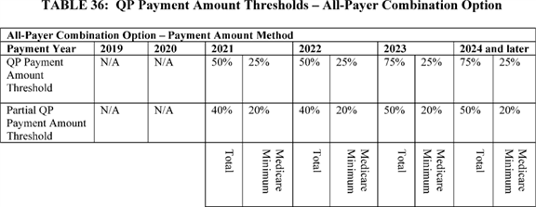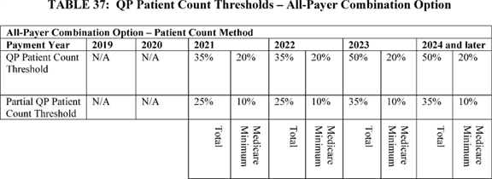

BILLING CODE 4120-01-P **[*53846]**

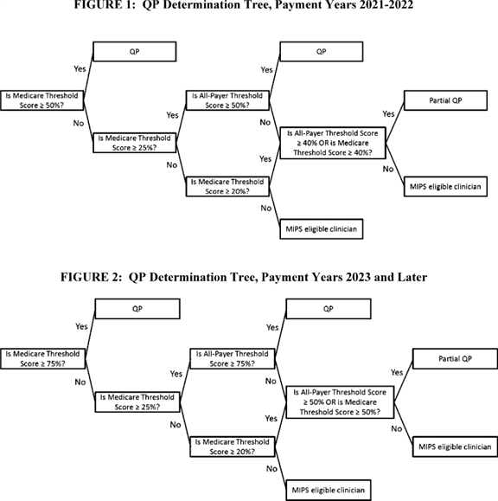

BILLING CODE 4120-01-C

Unlike the Medicare Option, where we have access to all of the information necessary to determine whether an APM meets the criteria to be an Advanced APM, we cannot determine whether an other payer arrangement meets the criteria to be an Other Payer Advanced APM without receiving the required information from an external source. Similarly, we do not have the necessary payment amount and patient count information to determine under the All-Payer Combination Option whether an eligible clinician meets the payment amount or patient count threshold to be a QP without receiving the required information from an external source.

We finalized the process that eligible clinicians can use to seek a QP determination under the All-Payer Combination Option [*(81 FR 77478-77480):*](https://advance.lexis.com/api/document?collection=administrative-codes&id=urn:contentItem:5M3D-MP10-006W-80MT-00000-00&context=)

* The eligible clinician submits to CMS sufficient information on all relevant payment arrangements with other payers;

1. Based upon that information CMS determines that at least one of those payment arrangements is an Other Payer Advanced APM; and
2. The eligible clinician meets the relevant QP thresholds by having sufficient payments or patients attributed to a combination of participation in Other Payer Advanced APMs and Advanced APMs.

In the CY 2018 Quality Payment Program proposed rule, we proposed additional details around our plans for implementing the All Payer Combination Option and we also proposed certain modifications to our previously finalized policies [*(82 FR 30177*](https://advance.lexis.com/api/document?collection=administrative-codes&id=urn:contentItem:5NX6-6BS0-006W-83PD-00000-00&context=) through 30207).

We address the following topics in this section of this final rule with comment period: (1) Other Payer Advanced APM Criteria; (2) Determination of Other Payer Advanced APMs; and (3) Calculation of All-Payer Combination Option Threshold Scores and QP Determinations. **[*53847]**

b. Other Payer Advanced APM Criteria

(1) In General

Our goal is to align the Advanced APM criteria under the Medicare Option and the Other Payer Advanced APM criteria under the All-Payer Combination Option as permitted by statute and as feasible and appropriate. We believe this alignment will help simplify the Quality Payment Program and encourage participation in Other Payer Advanced APMs.

In the CY 2017 Quality Payment Program final rule, we finalized that in general, an other payer arrangement with any payer other than traditional Medicare, including Medicare Health Plans, which include Medicare Advantage, Medicaid-Medicaid Plans, 1876 Cost Plans, and Programs of All Inclusive Care for the Elderly (PACE) plans, will be an Other Payer Advanced APM if it meets all three of the following criteria:

* The other payer arrangement requires at least 50 percent of participating eligible clinicians in each participating APM Entity, or each hospital if hospitals are the APM Entities, to use CEHRT to document and communicate clinical care [*(81 FR 77464-77465);*](https://advance.lexis.com/api/document?collection=administrative-codes&id=urn:contentItem:5M3D-MP10-006W-80MT-00000-00&context=)

1. The other payer arrangement requires that quality measures comparable to measures under the MIPS quality performance category apply, which means measures that are evidence-based, reliable and valid; and, if available, at least one measure must be an outcome measure [*(81 FR 77466);*](https://advance.lexis.com/api/document?collection=administrative-codes&id=urn:contentItem:5M3D-MP10-006W-80MT-00000-00&context=) and
2. The other payer arrangement either: (1) Requires APM Entities to bear more than nominal financial risk if actual aggregate expenditures exceed expected aggregate expenditures (under either the generally applicable or Medicaid Medical Home Model standards for nominal amount of financial risk, as applicable); or (2) is a Medicaid Medical Home Model that meets criteria comparable to Medical Home Models expanded under section 1115A(c) of the Act [*(81 FR 77466-77467).*](https://advance.lexis.com/api/document?collection=administrative-codes&id=urn:contentItem:5M3D-MP10-006W-80MT-00000-00&context=)

(2) Summary of Proposals

In the CY 2018 Quality Payment Program proposed rule, we proposed the following:

* We proposed that an other payer arrangement would be considered to meet the nominal amount standard if, under the terms of the other payer arrangement, the total amount that an APM Entity potentially owes the payer or foregoes is equal to at least: for the 2019 and 2020 QP Performance Periods, 8 percent of the total combined revenues from the payer of providers and suppliers in participating APM Entities.

1. We proposed that to be an Other Payer Advanced APM, a Medicaid Medical Home Model must require that the total annual amount that an APM Entity potentially owes or foregoes under the Medicaid Medical Home Model must be at least:

++ For QP Performance Period 2019, 3 percent of the APM Entity's total revenue under the payer.

++ For QP Performance Period 2020, 4 percent of the APM Entity's total revenue under the payer.

++ For QP Performance Period 2021 and later, 5 percent of the APM Entity's total revenue under the payer.

(3) Other Payer Medical Home Models

In the CY 2017 Quality Payment Program final rule, we finalized definitions of Medical Home Model and Medicaid Medical Home Model at § 414.1305. The statute does not define "medical homes," but sections 1848(q)(5)(C)(i), 1833(z)(2)(B)(iii)(II)(cc)(BB), 1833(z)(2)(C)(iii)(II)(cc)(BB), and 1833(z)(3)(D)(ii)(II) of the Act make medical homes an instrumental piece of the Quality Payment Program.

We recognize that there may be medical homes that are operated by other payers that may be appropriately considered medical home models under the All-Payer Combination Option. Examples of these arrangements may include those aligned with the Comprehensive Primary Care Plus (CPC+) Model. Therefore, in the CY 2018 Quality Payment Program proposed rule, we sought comment on whether we should define the term Other Payer Medical Home Model as an other payer arrangement that is determined by us to have the following characteristics:

* The other payer arrangement has a primary care focus with participants that primarily include primary care practices or multispecialty practices that include primary care physicians and practitioners and offer primary care services. For the purposes of this provision, primary care focus means the inclusion of specific design elements related to eligible clinicians practicing under one more of the following Physician Specialty Codes: 01 General Practice; 08 Family Medicine; 11 Internal Medicine; 16 Obstetrics and Gynecology; 37 Pediatric Medicine; 38 Geriatric Medicine; 50 Nurse Practitioner; 89 Clinical Nurse Specialist; and 97 Physician Assistant;

1. Empanelment of each patient to a primary clinician; and
2. At least four of the following:

++ Planned coordination of chronic and preventive care.

++ Patient access and continuity of care.

++ Risk-stratified care management.

++ Coordination of care across the medical neighborhood.

++ Patient and caregiver engagement.

++ Shared decision-making.

++ Payment arrangements in addition to, or substituting for, fee-for-service payments (for example, shared savings or population-based payments).

We also explained that similar to Medical Home Models and Medicaid Medical Home Models, we believe that Other Payer Medical Home Models could be considered unique types of other payer arrangements for purposes of the Quality Payment Program. We anticipate that participants in these arrangements may generally be more limited in their ability to bear financial risk than other entities because they may be smaller and predominantly include primary care practitioners, whose revenues are a smaller fraction of the patients' total cost of care than those of other eligible clinicians. Because of these factors, we explained that we believe it may be appropriate to determine whether an Other Payer Medical Home Model satisfies the financial risk criterion by using special Other Payer Medical Home Model financial risk and nominal amount standards, which could be different from the generally applicable Other Payer Advanced APM standards and would be identical to the Medicaid Medical Home Model financial risk and nominal amount standards [*(82 FR 30180).*](https://advance.lexis.com/api/document?collection=administrative-codes&id=urn:contentItem:5NX6-6BS0-006W-83PD-00000-00&context=)

We noted a particular interest in, and sought comment on, whether there are payment arrangements that currently exist that would meet this definition. We encouraged commenters to suggest whether such payment arrangements would meet the existing generally applicable Other Payer Advanced APM financial risk and nominal amount standards. We also requested comments on any special considerations that might be relevant when establishing a definition for a medical home model standard for payers with payment arrangements that would not fit under the Medical Home Model or Medicaid Medical Home Model definitions, including how the 50 clinician cap we finalized in the CY 2017 Quality Payment Program final rule [*(81 FR 77428-77429)*](https://advance.lexis.com/api/document?collection=administrative-codes&id=urn:contentItem:5M3D-MP10-006W-80MT-00000-00&context=) Medical Home Model nominal amount standard would apply.

The following is a summary of the public comments received in response **[*53848]** to our request for comment and our responses:

*Comment:* Several commenters supported CMS creating an Other Payer Medical Home Model definition. One commenter stated that there is no reason to allow for a Medical Home Model standard under both Medicare and Medicaid but not for other payers. Some of these commenters also suggested that we align the Other Payer Medical Home Model definition with the Medical Home Model and Medicaid Medical Home Model definitions.

*Response:* We appreciate the support from these commenters. Given that we still have limited knowledge about payment arrangements between private payers and eligible clinicians, we believe that it is appropriate for us to continue to evaluate whether an Other Payer Medical Home Model definition is appropriate. We note that throughout the APM incentive portions of the Quality Payment Program, one of our goals is to align policies between the Medicare Option and the All-Payer Combination Option to the extent feasible and appropriate.

*Comment:* Some commenters suggested that CMS consider making some changes to the suggested Other Payer Medical Home Model definition. A few commenters suggested that specialty-focused medical homes should be included in the Other Payer Medical Home Model definition. A few commenters also suggested that CMS do not include the 50 eligible clinician limit in the Other Payer Medical Home Model definition.

*Response:* One of our goals is to align policies between the Medicare Option and the All-Payer Combination Option to the extent possible. In the CY 2017 Quality Payment Program final rule, in our discussion of the Medical Home Model and Medicaid Medical Home Model definitions, we noted that we believe an APM cannot be a Medical Home Model unless it has a primary care focus with an explicit relationship between patients and practitioners [*(81 FR 77403).*](https://advance.lexis.com/api/document?collection=administrative-codes&id=urn:contentItem:5M3D-MP10-006W-80MT-00000-00&context=) If we propose this definition or a similar definition in the future, we will consider at that time whether a 50 eligible clinician limit or other similar limit would be appropriate.

*Final Action:* We are not establishing a definition of Other Payer Medical Home Model. However, we may consider creating such a definition in future rulemaking. We welcome further public comment on this topic.

(4) Financial Risk for Monetary Losses

In the CY 2017 Quality Payment Program final rule, we finalized policies to assess whether an other payer arrangement requires participating APM Entities to bear more than nominal financial risk if aggregate expenditures exceed expected aggregated expenditures. This Other Payer Advanced APM criterion has two components: A financial risk standard and a nominal amount standard. The financial risk standard defines what it means for an APM Entity to bear financial risk if actual aggregate expenditures exceed expected aggregate expenditures under an other payer arrangement. We finalized a generally applicable financial risk standard and a Medicaid Medical Home Model financial risk standard for Other Payer Advanced APMs. [*(81 FR 77466*](https://advance.lexis.com/api/document?collection=administrative-codes&id=urn:contentItem:5M3D-MP10-006W-80MT-00000-00&context=) through 77474).

We finalized that for an other payer arrangement to meet the generally applicable financial risk standard for Other Payer Advanced APMs, if an APM Entity's actual aggregate expenditures exceed expected aggregate expenditures during a specified performance period, the payer must:

* Withhold payment of services to the APM Entity and/or the APM Entity's eligible clinicians;

1. Reduce payment rates to APM Entity and/or the APM Entity's eligible clinicians; or
2. Require direct payments by the APM Entity to the payer [*(81 FR 77467).*](https://advance.lexis.com/api/document?collection=administrative-codes&id=urn:contentItem:5M3D-MP10-006W-80MT-00000-00&context=)

We also finalized that for a Medicaid Medical Home Model to be an Other Payer Advanced APM, if the APM Entity's actual aggregate expenditures exceed expected aggregate expenditures during a specified performance period, the Medicaid Medical Home Model must:

* Withhold payment of services to the APM Entity and/or the APM Entity's eligible clinicians;

1. Reduce payment rates to APM Entity and/or the APM Entity's eligible clinicians;
2. Require direct payments by the APM Entity to the payer; or
3. Require the APM Entity to lose the right to all or part of an otherwise guaranteed payment or payments [*(81 FR 77468-77469).*](https://advance.lexis.com/api/document?collection=administrative-codes&id=urn:contentItem:5M3D-MP10-006W-80MT-00000-00&context=)

(a) Generally Applicable Nominal Amount Standard

(i) Marginal Risk and Minimum Loss Rate

The generally applicable nominal amount standard that we finalized in the CY 2017 Quality Payment Program final rule for Other Payer Advanced APMs differs from the generally applicable nominal amount standard for Advanced APMs in two ways [*(81 FR 77471).*](https://advance.lexis.com/api/document?collection=administrative-codes&id=urn:contentItem:5M3D-MP10-006W-80MT-00000-00&context=)

First, the finalized generally applicable nominal amount standard for Advanced APMs only requires an APM to meet one measure of risk--total risk [*(81 FR 77424).*](https://advance.lexis.com/api/document?collection=administrative-codes&id=urn:contentItem:5M3D-MP10-006W-80MT-00000-00&context=) The finalized generally applicable nominal amount standard for Other Payer Advanced APMs involves assessment of the following three measures of risk:

* Marginal risk--the percentage of the amount by which actual expenditures exceed expected expenditures for which an APM Entity would be liable under the payment arrangement.

1. Minimum loss rate--a percentage by which actual expenditures may exceed expected expenditures without triggering financial risk.
2. Total risk--the maximum potential payment for which an APM Entity could be liable under a payment arrangement.

We reiterate that as we described in the CY 2017 Quality Payment Program final rule, although we did not formally adopt marginal risk or minimum loss rate criteria for Advanced APMs, we pointed out that all current Advanced APMs would meet these standards, and that we intend that all future Advanced APMs would meet the three measures of risk as well [*(81 FR 77426).*](https://advance.lexis.com/api/document?collection=administrative-codes&id=urn:contentItem:5M3D-MP10-006W-80MT-00000-00&context=) Therefore, we do not expect the application of the different criteria between Advanced APMs and Other Payer Advanced APMs to produce meaningfully different results in terms of actual risk faced by participants.

Second, the finalized generally applicable Advanced APM nominal amount standard allows for total risk to be defined in one of two ways, based on expected expenditures (the benchmark-based standard) or based on revenue (the revenue-based standard) [*(81 FR 77427).*](https://advance.lexis.com/api/document?collection=administrative-codes&id=urn:contentItem:5M3D-MP10-006W-80MT-00000-00&context=) In contrast, the finalized Other Payer Advanced APM generally applicable nominal amount standard is only based on expected expenditures [*(81 FR 77471).*](https://advance.lexis.com/api/document?collection=administrative-codes&id=urn:contentItem:5M3D-MP10-006W-80MT-00000-00&context=)

In the CY 2017 Quality Payment program final rule, we sought comments on using the expected expenditures approach for the generally applicable Other Payer Advanced APM nominal amount standard.

In the CY 2018 Quality Payment Program proposed rule, we did not propose to modify the marginal risk and minimum loss rates as finalized in the 2017 Quality Payment Program final rule as part of the generally applicable nominal amount standard for Other Payer Advanced APMs. We noted that we continue to believe that using these measures of risk will ensure that payment arrangements involving other payers and APM Entities or eligible clinicians cannot be engineered in such a way as to provide eligible clinicians **[*53849]** an avenue to QP status through an Other Payer Advanced APM that technically meets the financial risk criterion but carries a very low risk of losses based on performance. Because we do not have direct control over the design of Other Payer Advanced APMs, we noted that we believe the use of a multi-factor nominal amount standard to assess financial risk provides greater assurance that Other Payer Advanced APMs will involve true financial risk in accordance with statutory requirements. We stated that including marginal risk and minimal loss rate requirements as components of the nominal amount standard assures that the payment arrangements that we could determine are Other Payer Advanced APMs and could contribute to the attainment of QP status are similarly rigorous to Advanced APMs. We requested additional comments on this approach, and on whether there are potential alternative approaches to achieving these goals [*(82 FR 30181).*](https://advance.lexis.com/api/document?collection=administrative-codes&id=urn:contentItem:5NX6-6BS0-006W-83PD-00000-00&context=)

The following is a summary of the public comments received in response to this request for comment and our responses:

*Comment:* Many commenters supported consistency between the nominal amount standards in the Medicare Option and the All-Payer Combination Option. Several commenters expressed support for removing the marginal risk and minimum loss rate requirements from the Other Payer Advanced APM generally applicable nominal amount standard, while two commenters supported maintaining the current Other Payer Advanced APM generally applicable nominal amount standard.

*Response:* We agree with these commenters that creating alignment between the Medicare Option and the All-Payer Combination Option is generally desirable, wherever possible. We also recognize that including marginal risk and minimum loss rate requirements adds significant complexity and may make it more challenging for both payers and eligible clinicians to participate in the All Payer Combination Option. That said, we continue to believe that the use of a multi-factor nominal amount standard to assess financial risk provides us with an important guardrail to ensure that Other Payer Advanced APMs will involve true financial risk.

*Final Action:* We are not making any changes to this policy at this time. We welcome additional comment on this approach. We note that we are looking to explore ways to reduce burden within the All-Payer Combination Option, and may consider additional changes in future rulemaking, as we gain more experience in implementing the All Payer Combination Option. We request additional comment on whether we should continue to require the marginal risk and minimum loss rate requirements, and also on whether there are alternative approaches to achieving our goals.

(ii) Generally Applicable Revenue-Based Nominal Amount Standard

In the CY 2018 Quality Payment Program proposed rule, we proposed to add a revenue-based nominal amount standard to the generally applicable nominal amount standard for Other Payer Advanced APMs that is parallel to the generally applicable revenue-based nominal amount standard for Advanced APMs. Specifically, we proposed that an other payer arrangement would meet the total risk component of the proposed nominal risk standard if, under the terms of the other payer arrangement, the total amount that an APM Entity potentially owes the payer or foregoes is equal to at least: For the 2019 and 2020 QP Performance Periods, 8 percent of the total combined revenues from the payer of providers and suppliers in participating APM Entities. This standard would be in addition to the previously finalized expenditure-based standard. We explained that a payment arrangement would only need to meet one of the two standards. We would use this standard only for other payer arrangements where financial risk is expressly defined in terms of revenue in the payment arrangement. We sought comment on this proposal.

The following is a summary of the public comments received on this proposal and our responses:

*Comment:* Many commenters supported CMS's proposal. One commenter requested that this 8 percent generally applicable revenue-based nominal amount standard be maintained beyond the 2019 and 2020 QP Performance Periods.

*Response:* We appreciate commenters' support of this proposal. We will establish this standard for QP Performance Periods 2019 and 2020 as proposed, and we anticipate adopting a generally applicable revenue-based nominal amount standard for QP Performance Periods after 2020 through future rulemaking.

*Comment:* One commenter suggested that the revenue-based nominal amount standard should only include physician revenue.

*Response:* We do not believe that it would be appropriate to limit the revenue-based nominal amount standard to only take physician revenue into account, as doing so may not capture the wide variety of potential payment arrangements and types of entities in those arrangements.

*Comment:* One commenter stated that it was still unclear how the nominal amount standard under the Medicare Option aligns with the nominal amount standard under the All-Payer Combination Option.

*Response:* Where possible, we aim to align the Medicare Option and the All-Payer Combination Option. We believe that this proposal, by creating a revenue-based standard that requires the same percentage of revenue be at risk for Other Payer Advanced APMs as is required for Advanced APMs and defines revenue in a comparable way, advances that goal.

*Final Action:* After considering public comments, we are finalizing our proposal with one clarification. As we clarified in section II.D.4.c.(2)(a) of this final rule with comment period regarding the generally applicable revenue-based nominal amount standard for Advanced APMs, we will look at the average estimated total Medicare Parts A and B revenue of providers and other entities participating in APM Entities. Similarly, for the generally applicable revenue-based nominal amount standard under the All-Payer Combination Option, we will look at the total combined revenues of the providers or other entities under the payment arrangement to determine that an other payer arrangement would meet the total risk component of the nominal standard if, under the terms of the other payer arrangement, the total amount that an APM Entity potentially owes the payer or foregoes is equal to at least: For the 2019 and 2020 QP Performance Periods, 8 percent of the total combined revenues from the payer to providers and other entities under the payment arrangement by revising § 414.1420(d)(3)(i).

For Advanced APMs, we may determine that an APM still meets the generally applicable revenue-based nominal amount standard, even if risk is not explicitly defined in terms of revenue, by comparing model downside risk to the estimated average Medicare revenue of model participants. Because we have direct access to Medicare claims data, we can estimate such an average. For other payers, we do not have similar direct access to claims data. As such, there are significant operational challenges to identifying whether an other payer arrangement would satisfy the revenue-based nominal amount standard when the other payer arrangement does not define risk explicitly in terms of revenue. **[*53850]** Because we do not have direct access to other payer revenue data, we could not do this calculation without significant assistance from the relevant payer. For this reason, we proposed that the revenue-based nominal amount standard would only be applied to other payer arrangements in which risk is explicitly defined in terms of revenue, as specified in an agreement covering the other payer arrangement.

We sought comment on this proposal. We did not receive any comments in response to this proposal.

*Final Action:* We are finalizing our proposal that the revenue-based standard would only be applied to other payer arrangements in which risk is explicitly defined in terms of revenue, as specified in an agreement covering the other payer arrangement. We are codifying this policy by revising § 414.1420(d)(3)(i).

In the CY 2018 Quality Payment Program proposed rule, we proposed that under the generally applicable nominal amount standard for Other Payer Advanced APMs, an other payer arrangement would need to meet either the benchmark-based nominal amount standard or the revenue-based nominal amount standard and need not meet both. We noted that we believe the proposed approach to the nominal amount standard would expand the opportunities for other payer arrangements to meet the generally applicable nominal amount standard, and would allow closer alignment between Medicare and other payers as new payment arrangements are introduced and evolve.

We sought comment on this proposal. We received no comments in response to this proposal.

*Final Action:* We are finalizing our proposal that under the generally applicable nominal amount standard for Other Payer Advanced APMs, an other payer arrangement would need to meet either the benchmark-based nominal amount standard or the revenue-based nominal amount standard and need not meet both.

We also sought comment on whether we should consider a different, potentially lower, revenue-based nominal amount standard only for small practices and those in rural areas that are not participating in a Medicaid Medical Home Model for the 2019 and 2020 QP Performance Periods [*(82 FR 30182).*](https://advance.lexis.com/api/document?collection=administrative-codes&id=urn:contentItem:5NX6-6BS0-006W-83PD-00000-00&context=) We noted we would use the definition of small practices and rural areas that is in § 414.1305. We noted that we believe that a different, potentially lower, revenue-based nominal amount standard for the 2019 and 2020 QP Performance Periods specifically for small and rural organizations may allow for increased participation in Other Payer Advanced APMs, which may help increase the quality and coordination of care beneficiaries receive as a result. Specifically, we sought comment on whether such a standard should apply only to small and, or, rural practices that are participants in an Other Payer Advanced APM, or also to small and/or rural practices that join larger APM Entities to participate in APMs. We also sought comment on how we should decide where a practice is located to determine whether it is operating in a rural area is defined in § 414.1305.

The following is a summary of the public comments received in response to this request for comments and our responses:

*Comment:* Some commenters supported a different, lower revenue-based nominal amount standard for small and rural practices. One commenter urged CMS to further assess rural communities to determine how much risk they can handle and the most appropriate kinds of risk--symmetric, asymmetric, or another alternative. Another commenter stated that creating a different, lower revenue-based nominal amount standard would give us the opportunity to engage new practices that would not otherwise participate in higher risk models, or those that tried the existing higher risk models found the risk levels unworkable and would no longer participate anyway.

*Response:* We appreciate the comments submitted, and we will continue to assess the need for a different revenue-based nominal amount standard for small or rural practices or organizations.

*Final Action:* We are not creating a different revenue-based nominal amount standard for either small practices or rural areas at this time. We may address this topic in future rulemaking.

(b) Medicaid Medical Home Model Nominal Amount Standard

In the CY 2017 Quality Payment Program final rule, in addition to the financial risk standard for Medicaid Medical Home Models, we finalized that to be an Other Payer Advanced APM, a Medicaid Medical Home Model must require that the total annual amount that an APM Entity potentially owes or foregoes be at least the following amounts in a given performance year:

* In 2019, 4 percent of the APM Entity's total revenues under the payer.

1. In 2020 and later, 5 percent of the APM Entity's total revenues under the payer [*(81 FR 77472).*](https://advance.lexis.com/api/document?collection=administrative-codes&id=urn:contentItem:5M3D-MP10-006W-80MT-00000-00&context=)

In the CY 2018 Quality Payment Program proposed rule, we reconsidered the incremental annual increases we had established for the Medicaid Medical Home Model nominal amount standard to take effect over several years. Our policy finalized in the CY 2017 Quality Payment Program final rule set forth what we envisioned was a gradually increasing but achievable amount of risk that would apply over time. In general, we still believe this to be true, but recognize that establishing an even more gradual increase in risk for Medicaid Medical Home Models may better suit many APM Entities in Medicaid Medical Home Models that have little experience with risk. To that end, we explained that we believe a small reduction of risk in the Medicaid Medical Home Model nominal amount standard beginning in the 2019 QP Performance Period may allow for greater flexibility in setting financial risk thresholds that would encourage more participation in Medicaid Medical Home Models and be more sustainable for the type of APM Entities that would potentially participate in Medicaid Medical Home Models.

Therefore, in the CY 2018 Quality Payment Program proposed rule, we proposed that to be an Other Payer Advanced APM, a Medicaid Medical Home Model must require that the total annual amount that an APM Entity potentially owes or foregoes under the Medicaid Medical Home Model must be at least:

* For QP Performance Period 2019, 3 percent of the APM Entity's total revenue under the payer.

1. For QP Performance Period 2020, 4 percent of the APM Entity's total revenue under the payer.
2. For QP Performance Period 2021 and later, 5 percent of the APM Entity's total revenue under the payer [*(82 FR 30182*](https://advance.lexis.com/api/document?collection=administrative-codes&id=urn:contentItem:5NX6-6BS0-006W-83PD-00000-00&context=) through 30183).

We sought comment on this proposal.

The following is a summary of the public comments received on this proposal and our responses:

*Comment:* Several commenters expressed support for this proposal.

*Response:* We appreciate the commenters' support for this proposal.

*Comment:* Some commenters suggested that the proposed total levels of revenue at risk are too high for Medicaid clinicians and should be lowered. One of these commenters recommended that ultimately 2.5 percent of the APM Entity's total revenue under the payer should be at risk, not 5 percent as we have proposed. Another commenter suggested that states should have the ability and flexibility to set nominal risk levels. **[*53851]**

*Response:* We believe that we have taken into account the circumstances that eligible clinicians with a significant Medicaid practice face, particularly the potential that they may have limited experience with bearing financial risk, in the development of the Medicaid Medical Home Model nominal amount standard. We continue to believe that a gradual ramp-up to a 5 percent Medicaid Medical Home Model nominal amount standard is appropriate as eligible clinicians with a significant Medicaid practice may not have much experience in assuming risk. We also do not believe that this more gradual ramp-up will constrain state flexibility or discourage eligible clinicians from participating arrangements that we may determine are Medicaid Medical Home Models.

*Comment:* One commenter stated that Medicaid Medical Home Models participating in a State Innovation Model (SIM) initiative should be exempt from the Medicaid Medical Home Model nominal amount standard.

*Response:* Our determination of whether an other payer arrangement meets the Other Payer Advanced APM criteria, including the Medicaid Medical Home Model nominal amount standard, is based on whether the terms of the other payer arrangement itself meet the Other Payer Advanced APM criteria. While we appreciate and encourage continued and further participation in the State Innovation Model (SIM) initiative, that participation has no bearing on whether an other payer arrangement would be considered a Medicaid Medical Home Model.

*Final Action:* After considering public comments, we are finalizing our proposal with one clarification. As we clarified in section II.D.4.c.(2)(a) of this final rule with comment period regarding the generally applicable revenue-based nominal amount standard, and as we state in the Medical Home Model nominal amount standard, we will look at the average estimated total Medicare Parts A and B revenue of providers and other entities participating in APM Entities. Similarly, for the Medicaid Medical Home Model nominal amount standard, we will look at the total revenues of the participating providers or other entities under the payment arrangement to determine whether an other payer arrangement meets the Medicaid Medical Home Model nominal amount standard.

Therefore, we are amending § 414.1420(d)(4)(i) and (iii) to state that meet the Medicaid Medical Home Model nominal amount standard, a Medicaid Medical Home Model must require that the total annual amount that an APM Entity potentially owes a payer or foregoes under the Medicaid Medical Home Model must be at least:

* For QP Performance Period 2019, 3 percent of the average estimated total revenue of the participating providers or other entities under the payer.

1. For QP Performance Period 2020, 4 percent of the average estimated total revenue of the participating providers or other entities under the payer.
2. For QP Performance Period 2021 and later, 5 percent of the average estimated total revenue of the participating providers or other entities under the payer.

(5) Summary of Final Policies

In summary, we are finalizing the following policies:

* We are finalizing that an other payer arrangement would meet the generally applicable revenue-based nominal amount standard we are finalizing if, under the terms of the other payer arrangement, the total amount that an APM Entity potentially owes the payer or foregoes is equal to at least: For the 2019 and 2020 QP Performance Periods, 8 percent of the total combined revenues from the payer to providers and other entities in the payment arrangement only for arrangements that are expressly defined in terms of revenue. We are codifying this policy by revising § 414.1420(d)(3)(i).

1. We are finalizing at § 414.1420(d)(4)(i) and (iii) that a Medicaid Medical Home Model would meet the benchmark-based Medicaid Home Model nominal amount standard if, under the terms of the other payer arrangement, the total annual amount that an APM Entity potentially owes or foregoes under the Medicaid Medical Home Model must be at least:

++ For QP Performance Period 2019, 3 percent of the average estimated total revenue of the participating providers or other entities under the payer.

++ For QP Performance Period 2020, 4 percent of the average estimated total revenue of the participating providers or other entities under the payer.

++ For QP Performance Period 2021 and later, 5 percent of the average estimated total revenue of the participating providers or other entities under the payer.

c. Determination of Other Payer Advanced APMs

(1) Overview

For other payer arrangements, in the CY 2017 Quality Payment Program final rule, we specified that an APM Entity or eligible clinician must submit, by a date and in a manner determined by us, information necessary to identify whether a given payment arrangement satisfies the Other Payer Advanced APM criteria [*(81 FR 77480).*](https://advance.lexis.com/api/document?collection=administrative-codes&id=urn:contentItem:5M3D-MP10-006W-80MT-00000-00&context=) We finalized that we will identify Medicaid APMs and Medicaid Medical Home Models that meet the Other Payer Advanced APM criteria before the beginning of the QP Performance Period [*(81 FR 77478-77480).*](https://advance.lexis.com/api/document?collection=administrative-codes&id=urn:contentItem:5M3D-MP10-006W-80MT-00000-00&context=) We also sought comment on the overall process for reviewing payment arrangements to determine whether they are Other Payer Advanced APMs, and we also sought comment on whether we should create a separate pathway to identify whether other payer arrangements with Medicaid as a payer meet the Other Payer Advanced APM criteria [*(81 FR 77463).*](https://advance.lexis.com/api/document?collection=administrative-codes&id=urn:contentItem:5M3D-MP10-006W-80MT-00000-00&context=)

We note that in the CY 2017 Quality Payment Program final rule, we codified some of our final policies pertaining to the Determination of Other Payer Advanced APMs at § 414.1410(b)(2). In this CY 2018 Quality Payment Program final rule with comment period, we are removing § 414.1410(b)(2) and are codifying policies pertaining to Other Payer Advanced APM determinations at § 414.144.

(a) Summary of Proposals

In the CY 2018 Quality Payment Program proposed rule, we proposed the following:

Payer Initiated Process

* We proposed to allow certain other payers, including payers with payment arrangements authorized under Title XIX, Medicare Health Plan payment arrangements, and payers with payment arrangements aligned with a CMS Multi-Payer Model to request that we determine whether their other payer arrangements are Other Payer Advanced APMs starting prior to the 2019 QP Performance Period and each year thereafter. We proposed to allow remaining other payers, including commercial and other private payers, to request that we determine whether other payer arrangements are Other Payer Advanced APMs starting in 2019 prior to the 2020 QP Performance Period, and annually each year thereafter. We proposed to generally refer to this process as the Payer Initiated Other Payer Advanced APM Determination Process (Payer Initiated Process), and we proposed that the Payer Initiated Process would generally involve the same steps for each payer type for each QP Performance Period. We proposed that these Other Payer Advanced APM determinations would be in effect for only one year at a time. We proposed **[*53852]** that the Payer Initiated Process would be voluntary for all payers.

1. We proposed that payers would be required to use the Payer Initiated Submission Form to request that we make an Other Payer Advanced APM determination. We proposed that the Submission Period opening date and Submission Deadline would vary by payer type to align with existing CMS processes for payment arrangements authorized under Title XIX, Medicare Health Plan payment arrangements, and payers with payment arrangements aligned with a CMS Multi-Payer Model to the extent possible and appropriate.
2. We proposed that if we determine that the payer has submitted incomplete or inadequate information, we would inform the payer and allow the payer to submit additional information no later than 10 business days from the date we inform the payer. For each other payer arrangement for which the payer does not submit sufficient information, we would not make a determination in response to that request submitted via the Payer Initiated Submission Form.
3. We proposed that if a payer uses the same other payer arrangement in other commercial lines of business that the payer has submitted for determination as a Title XIX, Medicare Health Plan, or CMS Multi-Payer Model payment arrangement, we will allow the payer to concurrently request that we determine whether those other payer arrangements are Other Payer Advanced APMs as well.
4. *Title XIX (Medicaid):* We proposed that any states and territories ("states") that have in place a state plan under Title XIX may request that we determine prior to the QP Performance Period whether other payer arrangements authorized under Title XIX are Other Payer Advanced APMs under the Payer Initiated Process beginning in the year prior to the first QP Performance Period under the All-Payer Combination Option. We proposed to allow states to request determinations for both Medicaid fee-for-service and Medicaid managed care plan payment arrangements. We proposed that the Submission Period for the Payer Initiated Process would open on January 1 of the calendar year prior to the relevant QP Performance Period. We proposed that the Submission Deadline for these submissions is April 1 of the year prior to the QP Performance Period for which we would make the determination.
5. *CMS Multi-Payer Models:* We proposed that payers with other payer arrangements aligned with a CMS Multi-Payer Model may request that we determine whether their aligned other payer arrangements are Other Payer Advanced APMs. We proposed that payers with other payer arrangements aligned with a CMS Multi-Payer Model may request that we determine prior to the QP Performance Period whether those other payer arrangements are Other Payer Advanced APMs. We proposed that payers that want to request that we determine whether those arrangements are Other Payer Advanced APMs would use the processes specified for payment arrangements authorized under Title XIX and Medicare Health Plan payment arrangements. We proposed that the Submission Period would open on January 1 of the calendar year prior to the relevant QP Performance Period. We also proposed that the Submission Period would close on June 30 of the calendar year prior to the relevant QP Performance Period. We proposed that, in CMS Multi-Payer Models where a state prescribes uniform payment arrangements across all payers statewide, the state would submit on behalf of payers in the Payer Initiated Process for Other Payer Advanced APMs. We would seek information for the determination from the state, rather than individual payers. The same Payer Initiated Process and timeline described that applies for CMS Multi-Payer Models would apply.
6. *Medicare Health Plans:* We proposed that the Submission Period would begin and end at the same time as the annual Medicare Advantage bid timeframe. We proposed the Submission Period would begin when the bid packages are sent out to plans in April of the year prior to the relevant QP Performance Period. We also proposed that the Submission Deadline would be the annual bid deadline, which would be the first Monday in June in the year prior to the relevant QP Performance Period.
7. *Remaining Other Payers:* We proposed to allow the remaining other payers not specifically addressed in other proposals above, including commercial and other private payers that are not states, Medicare Health Plans, or payers with arrangements that are aligned with a CMS Multi-Payer Model, to request that we determine whether their other payer arrangements are Other Payer Advanced APMs starting prior to the QP Performance Period for 2020 and annually each year thereafter.
8. We proposed that, for each other payer arrangement for which a payer requests us to determine whether it is an Other Payer Advanced APM, the payer must complete and submit the Payer Initiated Submission Form by the relevant Submission Deadline.

Eligible Clinician Initiated Process

* We proposed that through the Eligible Clinician Initiated Process, APM Entities and eligible clinicians participating in other payer arrangements would have an opportunity to request that we determine for the relevant QP Performance Period whether those other payer arrangements are Other Payer Advanced APMs. The Eligible Clinician Initiated Process could also be used to request determinations before the beginning of a QP Performance Period for other payer arrangements authorized under Title XIX.

1. We proposed that APM Entities or eligible clinicians would be required to use the Eligible Clinician Initiated Submission Form to request that we make an Other Payer Advanced APM determination.
2. We proposed that if we determine that an APM Entity or eligible clinician has submitted incomplete or inadequate information, we would inform the payer and allow the payer to submit additional information no later than 10 business days from the date we inform the APM Entity or eligible clinician. For each other payer arrangement for which the APM Entity or eligible clinician does not submit sufficient information, we would not make a determination in response to that request submitted via the Eligible Clinician Initiated Submission Form.
3. *Title XIX (Medicaid):* We proposed that beginning in the first QP Performance Period under the All-Payer Combination Option, APM Entities and eligible clinicians may submit information on payment arrangements authorized under Title XIX to request that we determine whether those arrangements that are not already determined to be Other Payer Advanced APMs through the Payer Initiated Process are Medicaid APMs or Medicaid Medical Home Models that meet the Other Payer Advanced APM criteria prior to the QP Performance Period. We proposed that APM Entities or eligible clinicians may submit Eligible Clinician Initiated Submission Forms for payment arrangements authorized under Title XIX beginning on September 1 of the calendar year prior to the QP Performance Period. We also proposed that the Submission Deadline is November 1 of the calendar year prior to the QP Performance Period.
4. *CMS Multi-Payer Models:* We proposed that through the Eligible Clinician Initiated Process, APM Entities and eligible clinicians **[*53853]** participating in other payer arrangements in CMS Multi-Payer Models may request that we determine whether those other payer arrangements that are not already determined to be Other Payer Advanced APMs through the Payer Initiated Process are Other Payer Advanced APMs. We proposed that APM Entities or eligible clinicians may request Other Payer Advanced APM determinations beginning on August 1 of the same year as the relevant QP Performance Period. We proposed that the Submission Deadline for requesting Other Payer Advanced APM determinations, as well as to request QP determinations under the All-Payer Combination Option, is December 1 of the same year as the relevant QP Performance Period.
5. *Medicare Health Plans:* We proposed that through the Eligible Clinician Initiated Process, APM Entities and eligible clinicians participating in other payer arrangements in Medicare Health Plans would have an opportunity to request that we determine whether those other payer arrangements that are not already determined to be Other Payer Advanced APMs through the Payer Initiated Process are Other Payer Advanced APMs. We proposed that APM Entities or eligible clinicians may request Other Payer Advanced APM determinations beginning on August 1 of the same year as the relevant QP Performance Period. We proposed that the Submission Deadline for requesting Other Payer Advanced APM determinations, as well as to request QP determinations under the All-Payer Combination Option, is December 1 of the same year as the relevant QP Performance Period.
6. *Remaining Other Payers:* We proposed that, through the Eligible Clinician Initiated Process, APM Entities and eligible clinicians participating in other payer arrangements through a remaining other payer may request that we determine whether or not the payment arrangement is an Other Payer Advanced APM. We proposed that APM Entities or eligible clinicians may request Other Payer Advanced APM determinations beginning on August 1 of the same year as the relevant QP Performance Period. We proposed that the Submission Deadline for requesting Other Payer Advanced APM determinations, as well as to request QP determinations under the All-Payer Combination Option, is December 1 of the same year as the relevant QP Performance Period.

Submission of Information for Other Payer Advanced APM Determinations

* We proposed that, for each other payer arrangement for which a payer requests us to determine whether it is an Other Payer Advanced APM, all payers must complete and submit the Payer Initiated Submission Form by the relevant Submission Deadline. We proposed that the Payer Initiated Submission Form would allow payers to include descriptive language for each of the required information elements. We proposed to require the name and description of the arrangement, nature of the arrangement, QP Performance Period for which the arrangement is available, participant eligibility criteria, and location(s) where the arrangement will be available so that we can verify whether eligible clinicians who may tell us that they participate in such arrangements are eligible to do so. We proposed to require that payers submit documentation that supports the information they provided in the Payer Initiated Submission Form and that is sufficient to enable us to determine whether the other payer arrangement is an Other Payer Advanced APM.

1. We proposed that, for each other payer arrangement for which an APM Entity or eligible clinician requests us to determine whether it is an Other Payer Advanced APM, all eligible clinicians must complete and submit the Eligible Clinician Initiated Submission Form by the relevant Submission Deadline. We proposed that the Eligible Clinician Initiated Submission Form would allow APM Entities or eligible clinicians to include descriptive language for each of the required information elements. We proposed to require the name and description of the arrangement, nature of the arrangement, QP Performance Period for which the arrangement is available, participant eligibility criteria, and location(s) where the arrangement will be available so that we can verify whether eligible clinicians who may tell us that they participate in such arrangements are eligible to do so. We proposed to require that APM Entities or eligible clinicians submit documentation that supports the information they provided in the Eligible Clinician Initiated Submission Form and that is sufficient to enable us to determine whether the other payer arrangement is an Other Payer Advanced APM.
2. We proposed that, for each other payer arrangement for which an APM Entity or eligible clinician requests us to determine whether it is an Other Payer Advanced APM, the APM Entity or eligible clinician must complete and submit the Eligible Clinician Initiated Submission Form by the relevant Submission Deadline.
3. We proposed to add a new requirement at § 414.1445(d) stating that a payer that submits information pursuant to § 414.1445(c) must certify to the best of its knowledge that the information submitted to us through the Payer Initiated Process is true, accurate, and complete. Additionally, we proposed that this certification must accompany the Payer Initiated Submission Form and any supporting documentation that payers submit to us through the Payer Initiated Process.
4. We also proposed to revise the monitoring and program integrity provisions at § 414.1460 to ensure the integrity of the Payer Initiated Process. Specifically, we proposed to require payers that choose to submit information through the Payer Initiated Process to maintain such books, contracts, records, documents, and other evidence as necessary to audit an Other Payer Advanced APM determination, and that such information and supporting documentation must be maintained for 10 years after submission and must be provided to CMS upon request. We also proposed to specify that information submitted by payers for purposes of the All-Payer Combination Option may be subject to audit by CMS.
5. We proposed to remove the requirement at § 414.1445(b)(3) that payers must attest to the accuracy of information submitted by eligible clinicians. We also proposed to remove the attestation requirement at § 414.1460(c) and add a requirement at § 414.1445(d) that an APM Entity or eligible clinician that submits information pursuant to § 414.1445(c) must certify to the best of its knowledge that the information it submitted to us is true, accurate, and complete. We also proposed that this certification must accompany the submission.
6. We proposed to remove the record retention requirement at § 414.1445(c) and only address the record retention issue at § 414.1460(e) stating that APM Entities and eligible clinicians must maintain such books, contracts, records, documents, and other evidence as necessary to enable the audit of an Other Payer Advanced APM determination, QP determination, and the accuracy of an APM Incentive Payment.
7. We proposed that, with the exception of the specific information we proposed to make publicly available as stated above, the information a payer submits to us through the Payer Initiated Process and the information an APM Entity or eligible clinician submits **[*53854]** to us through the Eligible Clinician Initiated Process would be kept confidential to the extent permitted by federal law, in order to avoid dissemination of potentially sensitive contractual information or trade secrets.
8. We proposed that we would presume that an other payer arrangement would satisfy the 50 percent CEHRT use criterion if we receive information and documentation from the APM Entity or eligible clinician through the Eligible Clinician Initiated Process showing that the other payer arrangement requires the requesting eligible clinician(s) to use CEHRT to document and communicate clinical information.

(b) Payer Initiated Other Payer Advanced APM Determination Process (Payer Initiated Process)

In the CY 2018 Quality Payment Program proposed rule, we proposed to allow certain other payers, including payers with payment arrangements authorized under Title XIX, Medicare Health Plan payment arrangements, and payers with payment arrangements aligned with a CMS Multi-Payer Model to request that we determine whether their other payer arrangements are Other Payer Advanced APMs starting prior to the 2019 QP Performance Period and each year thereafter. We proposed to generally refer to this process as the Payer Initiated Other Payer Advanced APM Determination Process (Payer Initiated Process) [*(82 FR 30183).*](https://advance.lexis.com/api/document?collection=administrative-codes&id=urn:contentItem:5NX6-6BS0-006W-83PD-00000-00&context=)

The following is a summary of the public comments received on these proposals and our responses:

*Comment:* Several commenters supported CMS's proposed general approach for Other Payer Advanced APM determinations, and many commenters supported our proposed general approach to the Payer Initiated Process.

*Response:* We appreciate the support for our proposed general approach for Other Payer Advanced APM determinations and the Payer Initiated Process.

*Comment:* Some commenters stated that CMS's general proposed approach is overly complicated and requested that CMS simplify how it makes Other Payer Advanced APM determinations.

*Response:* One of our goals is to minimize the burden on payers, APM Entities, and eligible clinicians to the extent possible while collecting the information that we need in order to make Other Payer Advanced APM determinations. As we continue to implement the All-Payer Combination Option, we will continue to evaluate and adjust policies if there are additional opportunities to reduce burden that we can incorporate into how we determine whether other payer arrangements meet the Other Payer Advanced APM criteria.

*Comment:* Two commenters opposed the proposed Payer Initiated Process. These commenters stated that group practices and eligible clinicians should be responsible for submitting payment arrangement information, not payers. One commenter stated that this process is confusing.

*Response:* We note that the Payer Initiated Process is voluntary. Payers who do not wish to submit information through the Payer Initiated Process are not required to do so. APM Entities and eligible clinicians can choose to submit payment information on those same other payer arrangements through the Eligible Clinician Initiated Process. We believe that offering payers the option to submit payment arrangement information can help with the implementation of the All-Payer Combination Option, including by reducing some of the burden for APM Entities and eligible clinicians. We reiterate that one of our goals is to reduce burden and complexity, and we will continue to look for opportunities to further streamline this process.

*Comment:* One commenter supported the overall approach of the Payer Initiated Process, but the commenter suggested that CMS consider simplifying the process significantly by requiring payers to submit their arrangements to us at the group (TIN) level.

*Response:* We will rely on payers to tell us how the payment arrangement is designed and who is eligible to participate, and we believe we have allowed for significant flexibility in this decision, which we think is particularly important given the likely variation in the structure of payment arrangements for which payers may request Other Payer Advanced APM determinations.

*Final Action:* After considering public comments, we are finalizing our proposals to allow certain other payers, including payers with payment arrangements authorized under Title XIX, Medicare Health Plan payment arrangements, and payers with payment arrangements aligned with a CMS Multi-Payer Model to request that we determine whether their other payer arrangements are Other Payer Advanced APMs starting prior to the 2019 QP Performance Period and each year thereafter. We will generally refer to this process as the Payer Initiated Other Payer Advanced APM Determination Process (Payer Initiated Process). We are codifying these policies at §§ 414.1445(a) and 414.1445(b)(1).

In the CY 2018 Quality Payment Program proposed rule, if a payer requests that we determine whether a payment arrangement authorized under Title XIX, a Medicare Health Plan payment arrangement, or a payment arrangement in a CMS Multi-Payer Model is an Other Payer Advanced APM, and the payer uses the same other payer arrangement in other commercial lines of business, we proposed to allow the payer to concurrently request that we determine whether those other payer arrangements are Other Payer Advanced APMs as well. We proposed to make Other Payer Advanced APM determinations for each individual payment arrangement [*(82 FR 30183).*](https://advance.lexis.com/api/document?collection=administrative-codes&id=urn:contentItem:5NX6-6BS0-006W-83PD-00000-00&context=) We sought comment on this proposal. The following is a summary of the public comments received on this proposal and our responses:

*Comment:* One commenter suggested that if a payer has the same payment arrangement in place across multiple plans, that payer should be allowed to submit one form for a determination that would apply to all of those plans.

*Response:* We appreciate the suggestion. We will continue to identify ways where we can simplify the Payer Initiated Process, and we will provide further detailed instructions and guidance on how to complete the Payer Initiated Submission Form. It is our intent that if a payer has the same payment arrangement in place across multiple plans, or multiple payer types, that payer should be allowed to submit one Payer Initiated Submission Form for a determination that will apply to all of those plans or payer types.

*Final Action:* After considering public comments, we are finalizing this policy as proposed with one modification. We are finalizing that we will allow payers with payment arrangements under Title XIX or aligned with a CMS Multi-Payer Model to submit a single submission form when the same payment arrangement is in place with other plans. However, we are not currently extending this policy to Medicare Health Plans as we continue to address the feasibility of operational changes to the Health Plan Management System (HPMS) that would be necessary to implement this policy.

In the CY 2018 Quality Payment Program proposed rule, we proposed that these Other Payer Advanced APM determinations would be in effect for only one year at a time [*(82 FR 30183).*](https://advance.lexis.com/api/document?collection=administrative-codes&id=urn:contentItem:5NX6-6BS0-006W-83PD-00000-00&context=)

We sought comment on this proposal. The following is a summary of the public comments received on this proposal and our responses: **[*53855]**

*Comment:* Many commenters expressed concern with an annual determination process and generally preferred a policy where Other Payer Advanced APM determinations would be in effect for multiple years. Some of these commenters requested a multi-year policy specifically for Medicaid payment arrangements. Some commenters stated that some of these arrangements take years to develop and that they last for more than one year, and some commenters recommended that we renew Other Payer Advanced APM determinations automatically if either the payer or eligible clinician attests that the key characteristics of the Other Payer Advanced APM are not changing from year to year. Some commenters were concerned that an annual determination process would introduce an unnecessary element of uncertainty to eligible clinicians, particularly those in Other Payer Advanced APMs that have an agreement term of more than one year. Several commenters suggested that CMS establish a multi-year process, such as a 3 or 5 year process, so that an Other Payer Advanced APM determination would remain valid throughout that period and that payers only need to report changes as they occur. These commenters suggested that these alternatives would reduce burden and also encourage the development of multi-year Other Payer Advanced APMs.

*Response:* We will start out for the first year of Other Payer Advanced APM determinations with an annual submission and determination process, and then evaluate whether there is an appropriate, less burdensome, and administratively feasible way to extend determinations for subsequent years. We believe it is necessary to obtain more information on the characteristics of, and more experience with, other payer arrangements and the determination process before we change our approach. We are also interested in what impact multiple year determinations might have on payers, for example, would it encourage payers to develop multi-year payment arrangements.

*Final Action:* After considering public comments, we are finalizing this policy as proposed. We seek comment regarding the current duration of the contracts governing such arrangements and whether creating some multi-year determination would encourage the creation of more multi-year payment arrangements as opposed to payment arrangements that are one year. We also seek comment on what kind of information should be submitted annually to update an Other Payer Advanced APM determination. We will consider in future rulemaking whether to introduce an option where Other Payer Advanced APM determinations could be extended for more than one year a time in future rulemaking.

We also proposed to allow remaining other payers, including commercial and other private payers, to request that we determine whether other payer arrangements are Other Payer Advanced APMs starting in 2019 prior to the 2020 QP Performance Period and annually each year thereafter. In the CY 2018 Quality Payment Program proposed rule, we stated that we believe that phasing in the Payer Initiated Process would allow us to gain experience with the determination process on a limited basis with payers where we have the strongest relationships and existing processes that we believe can help facilitate submitting this information, and that we anticipated making improvements and refinements to this process, which we believe will help us facilitate receiving this information from the remaining other payers [*(82 FR 30183).*](https://advance.lexis.com/api/document?collection=administrative-codes&id=urn:contentItem:5NX6-6BS0-006W-83PD-00000-00&context=) We refer readers to section II.D.6.c.(5)(a) of this final rule with comment period for a discussion of these policies.

We proposed that the Payer Initiated Process would be voluntary for all payers.

We sought comment on this proposal. We did not receive any comments in response to this proposal.

*Final Action:* We are finalizing that the Payer Initiated Process will be voluntary for all payers.

In the CY 2018 Quality Payment Program proposed rule, we proposed that the Payer Initiated Process would generally involve the same steps for each payer type as listed below for each QP Performance Period, and we elaborated on details within this framework that are specific to payer type [*(82 FR 30183*](https://advance.lexis.com/api/document?collection=administrative-codes&id=urn:contentItem:5NX6-6BS0-006W-83PD-00000-00&context=) through 30184). We discuss our final policies below.

*Guidance and Submission Form:* We noted that we intend to make guidance available regarding the Payer Initiated Process for each payer type prior to the first Submission Period, which would occur during 2018. We also noted that we intend to develop a submission form (which we refer to as the Payer Initiated Submission Form) that would be used by payers to request Other Payer Advanced APM determinations, and that we intend to make this Payer Initiated Submission Form available to payers prior to the first Submission Period. We proposed that payers would be required to use the Payer Initiated Submission Form to request that we make an Other Payer Advanced APM determination. We stated that we intend for the Payer Initiated Submission Form to include questions that are applicable to all payment arrangements and some that are specific to a particular type of payment arrangement, and we intend for it to include a way for payers to attach supporting documentation. We proposed that payers may submit requests for review of multiple other payer arrangements through the Payer Initiated Process, though we would make separate determinations as to each other payer arrangement and a payer would be required to use a separate Payer Initiated Submission Form for each other payer arrangement. Payers may submit other payer arrangements with different tracks within that arrangement as one request along with information specific to each track.

The following is a summary of the public comments received on these proposals and our responses:

*Comment:* Several commenters requested that submission forms and guidance be made available for payers and eligible clinicians as soon as possible, potentially earlier than the beginning of calendar year or in the case of Medicare Health Plans, before the bid process. These commenters stated that making the forms and guidance available earlier would give payers more lead time to prepare and submit the necessary information.

*Response:* We agree that it is important to make the Payer Initiated Submission Form and related guidance available as soon as possible so that payers have time to prepare and submit the information and we intend to do so. We note that the Payer Initiated Submission Form is subject to the Paperwork Reduction Act (PRA) approval process, which includes an opportunity for public comment. We refer readers to section IV.O. of this final rule with comment period for more information about that process. After the first year, if any updates or amendments are necessary, we also intend to make those available as soon as possible.

*Comment:* One commenter suggested that CMS should use the Quality Reporting Document Architecture (QRDA) III as the submission content standard because it is already an industry standard, and the commenter also suggested that CMS should align their work with industry standards to avoid increasing physician burden by introducing proprietary formats that differ from what is used for submission to other payers or state Medicaid programs. The commenter also noted that HHS has already required industry-wide investment in QRDA III through their ONC certification program, so **[*53856]** using QRDA III would facilitate implementation.

*Response:* We appreciate the suggestion and will consider these ideas as we continue to develop and refine the Submission Form.

*Final Action:* After considering public comments, we are finalizing our proposal that payers with payment arrangements authorized under Title XIX, Medicare Health Plan payment arrangements, and payment arrangements aligned with a CMS Multi-Payer Model will be required to use the Payer Initiated Submission Form in order to request that we make an Other Payer Advanced APM determination. We are also finalizing our proposal that payers may submit requests for review of multiple other payer arrangements through the Payer Initiated Process, though we will make separate determinations as to each other payer arrangement, and a payer will be required to use a separate Payer Initiated Submission Form for each other payer arrangement.

*Submission Period:* We proposed that the Submission Period opening date and Submission Deadline would vary by payer type to align with existing CMS processes for payment arrangements authorized under Title XIX, Medicare Health Plan payment arrangements, and payers with payment arrangements aligned with a CMS Multi-Payer Model to the extent possible and appropriate.

We sought comment on this proposal. The following is a summary of the comments received on this proposal and our responses:

*Comment:* A few commenters supported CMS's proposed general approach and efforts to align with existing programs.

*Response:* We appreciate the commenters' support of our proposed general approach.

*Comment:* Some commenters requested that CMS create a rolling determination process where Payer Initiated Submission Forms could be submitted at any time.

*Response:* We believe that it is important for both payers and us, particularly in the first year of implementing the Payer Initiated Process, to have a clear structure for the Payer Initiated Process that can be easily understood. We reiterate that our goal is to align with existing CMS processes and deadlines to the extent possible. We also believe that the deadlines are important so that we can timely generate and publish the list of Other Payer Advanced APMs on the CMS Web site. We may consider making changes to our overall approach to the Submission Periods when we have more experience in operating the Payer Initiated Process.

*Comment:* One commenter suggested that payers submitting information for Other Payer Advanced APM determinations should be required to notify their APM Entities and eligible clinicians that they are submitting information, which would help reduce burden on APM Entities and eligible clinicians and avoid duplicate submissions.

*Response:* While we would generally encourage this type of communication, we do not believe that we should set requirements for how payers interact with APM Entities and eligible clinicians in their payment arrangements, and we note that payers can choose to notify their participating APM Entities and eligible clinicians either that they submitted information to request an Other Payer Advanced APM determination, as well as the determination that the payers receive. We also note that the public posting of Other Payer Advanced APMs on the CMS Web site may reduce duplicative submissions by APM Entities or eligible clinicians.

*Comment:* One commenter suggested that CMS make public all other payer arrangements that are under review prior to the determination of whether they are Other Payer Advanced APMs, so that APM Entities and eligible clinicians are aware the review is taking place.

*Response:* While we appreciate the suggestion, we believe that making this information public would do more to confuse APM Entities and eligible clinicians, especially as we already intend to post a list of Other Payer Advanced APMs on the CMS Web site. Also, we anticipate that all determinations under the Payer Initiated Process will be made prior to the relevant QP Performance Period. We reiterate that the Eligible Clinician Initiated Process takes place after the conclusion of the QP Performance Period. For this reason, we believe that there would be limited, if any, utility to posting a list of other payer arrangements for which there are pending Other Payer Advanced APM determinations because we will have already posted a list of the payment arrangements determined to be Other Payer Advanced APMs on the CMS Web site prior to the start of the relevant QP Performance Period.

*Final Action:* After considering public comments, we are finalizing our proposal that the Submission Period opening date and Submission Deadline would vary by payer type to align with existing CMS processes for payment arrangements authorized under Title XIX, Medicare Health Plan payment arrangements, and payers with payment arrangements aligned with a CMS Multi-Payer Model to the extent possible and appropriate. We discuss the specific Submission Period for each payer type in sections II.D.6.c.(2)(a), II.D.6.c.(3)(a), and II.D.6.c.(4)(a) of this final rule with comment period.

*CMS Determination:* Upon the timely receipt of a Payer Initiated Submission Form, we would use the information submitted to determine whether the other payer arrangement meets the Other Payer Advanced APM criteria. We proposed that if we find that the payer has submitted incomplete or inadequate information, we would inform the payer and allow the payer to submit additional information no later than 10 business days from the date we inform the payer. For each other payer arrangement for which the payer does not submit sufficient information in a timely fashion, we would not make a determination in response to that request submitted via the Payer Initiated Submission Form. As a result, the other payer arrangement would not be considered an Other Payer Advanced APM for the year. These determinations are final and not subject to reconsideration.

We sought comment on this proposal. The following is a summary of the public comments received on this proposal and our responses:

*Comment:* Several commenters opposed the 10 business day limit for responding to a request for additional information, noting that 10 business days is too short a timeframe to adequately address such requests.

*Response:* We believe that responding to requests for additional information will generally be a straightforward process, and that the process and timeline for these requests will allow us to verify information while making determinations in an expeditious manner. At the same time, we recognize that payers may need some additional time to respond to requests.

*Comment:* Some commenters objected that determinations are final and not subject to reconsideration. Some commenters were concerned that there may be instances where we do not appropriately consider the information submitted. These commenters requested that determinations be reconsidered at least once and that a formal appeals process be installed, and one of these commenters suggested that CMS should allow such appeals to be submitted within 30 days of the determination.

*Response:* We appreciate the comment. We continue to believe that it **[*53857]** is appropriate for us to make final Other Payer Advanced APM determinations. We are considering whether it would be beneficial to provide for an informal review process, and we may address this issue in future rulemaking.

*Comment:* A few commenters requested that CMS to commit to specific timeframes for making Other Payer Advanced APM determinations.

*Response:* We are trying to provide as much certainty and notice in the Payer Initiated Process as possible especially because this coming year will be the first year where we implement the Payer Initiated Process. We note that we are committed to making Other Payer Advanced APM determinations as soon as practicable.

*Final Action:* After considering public comments, we are finalizing a modified version of the proposed policy. We will extend the required timeframe for responding to a request for additional information from 10 days to 15 business days in order to provide payers more time to respond while still allowing for Other Payer Advanced APM determinations to be made expeditiously. We are finalizing this policy for the determination process for payment arrangements authorized under Title XIX, Medicare Health Plan payment arrangements, and payment arrangements aligned with a CMS Multi-Payer Model.

*CMS Notification:* We noted that we intend to notify payers of our determination for each request as soon as practicable after the relevant Submission Deadline. APM Entities or eligible clinicians may submit information regarding an other payer arrangement for a subsequent QP Performance Period even if we have determined that the other payer arrangement is not an Other Payer Advanced APM for a prior year.

The following is a summary of the public comments received on this topic and our responses:

*Comment:* One commenter sought clarification regarding when we would notify payers of the results of Other Payer Advanced APM determinations.

*Response:* We reiterate that we intend to notify payers of the results as soon as practicable and clarify that this notification to payers is independent of posting the list of Other Payer Advanced APMs on the CMS Web site.

*Final Action:* After considering public comments, we reiterate that we intend to notify payers of our determination for each request under the Payer Initiated Process as soon as practicable after the relevant Submission Deadline. We codify this policy at § 414.1445(f).

*CMS Posting of Other Payer Advanced APMs:* We noted that we intend to post on the CMS Web site a list (which we refer to as the Other Payer Advanced APM List) of all other payer arrangements that we determine to be Other Payer Advanced APMs. Prior to the start of the relevant QP Performance Period, we intend to post the Other Payer Advanced APMs that we determine through the Payer Initiated Process and Other Payer Advanced APMs under Title XIX that we determine through the Eligible Clinician Initiated Process. After the QP Performance Period, we would update this list to include Other Payer Advanced APMs that we determine based on other requests through the Eligible Clinician Initiated Process.

We still intend to post this list prior to the start of the relevant QP Performance Period and then update it to include Other Payer Advanced APMs that we determine based on requests received through the Eligible Clinician Initiated Process.

(c) APM Entity or Eligible Clinician Initiated Other Payer Advanced APM Determination Process (Eligible Clinician Initiated Process)

In the CY 2018 Quality Payment Program proposed rule, we proposed that through the Eligible Clinician Initiated Process, APM Entities and eligible clinicians participating in other payer arrangements would have an opportunity to request that we determine for the year whether those other payer arrangements are Other Payer Advanced APMs. The Eligible Clinician Initiated Process could also be used to request determinations before the beginning of a QP Performance Period for other payer arrangements authorized under Title XIX. The Eligible Clinician Initiated Process would not be necessary for, or applicable to, other payer arrangements that are already determined to be Other Payer Advanced APMs through the Payer Initiated Process [*(82 FR 30184).*](https://advance.lexis.com/api/document?collection=administrative-codes&id=urn:contentItem:5NX6-6BS0-006W-83PD-00000-00&context=)

The following is a summary of the public comments received on this proposal and our responses:

*Comment:* Some commenters expressed support for our proposed general approach to the Eligible Clinician Initiated Process.

*Response:* We appreciate commenters' support of this proposed general approach to the Eligible Clinician Initiated Process.

*Comment:* One commenter stated that the proposed Eligible Clinician Initiated Process presents operational challenges to eligible clinicians, particularly that reporting the information would be time consuming and burdensome. Another commenter stated that ultimately the onus for submitting information on payment arrangements should be with payers as they have all the relevant information and relying on eligible clinicians to submit information would result in duplication.

*Response:* We do not have the authority to require payers to submit information regarding their payment arrangements. Therefore, we believe it is important for an option to be available for eligible clinicians or APM Entities to submit such information. If an eligible clinician requests a QP determination under the All-Payer Combination Option, the eligible clinician or APM Entity has the opportunity to submit information to allow us to determine whether an other payer arrangement is an Other Payer Advanced APM. Our goal is to minimize the burden associated with the Eligible Clinician Initiated Process. We also note that payers may voluntarily submit other payer arrangement information through the Payer Initiated Process so that we can determine whether those arrangements are Other Payer Advanced APMs, which may reduce or eliminate the need for some APM Entities or eligible clinicians to submit information through the Eligible Clinician Initiated Process.

*Comment:* One commenter suggested that Other Payer Advanced APM determinations made through the Eligible Clinician Initiated Process be made for multiple years if the contracts involved are for multiple years.

*Response:* As we stated regarding the Payer Initiated Process above, we will start out for the first year with an annual submission and determination process and then evaluate next year whether there is an appropriate, less burdensome, and administratively feasible way to extend determinations for subsequent years. We believe it is necessary to get more information on the characteristics of, and more experience with, other payer arrangements and the determination process before we change our approach.

*Final Action:* After considering public comments, we are finalizing our proposal that through the Eligible Clinician Initiated Process, APM Entities and eligible clinicians participating in other payer arrangements would have an opportunity to request that we determine for the year whether those other payer arrangements are Other Payer Advanced APMs. We seek additional comment regarding the current duration of payment arrangements and whether creating a **[*53858]** multi-year determination process would encourage the creation of more multi-year payment arrangements as opposed to payment arrangements that are one year. We also seek comment on what kind of information should be submitted annually after the first year to update an Other Payer Advanced APM determination. We will consider in future rulemaking whether to introduce an option where Other Payer Advanced APM determinations could be last for more than one year a time.

*Guidance and Submission Form:* We intend to make guidance available regarding the Eligible Clinician Initiated Process for each payer type prior to the first Submission Period for arrangements authorized under Title XIX, which would occur during 2018. We intend to develop a submission form (which we refer to as the Eligible Clinician Initiated Submission Form) that will be used by APM Entities or eligible clinicians to request Other Payer Advanced APM determinations, and we intend to make this Eligible Clinician Initiated Submission Form available to APM Entities and eligible clinicians prior to the first Submission Period. We proposed that APM Entities and eligible clinicians would be required to use the Eligible Clinician Initiated Submission Form to request that we make an Other Payer Advanced APM determination. We intend for the Eligible Clinician Initiated Submission Form to include questions that are applicable to all other payer arrangements and some that are specific to a particular type of other payer arrangements, and we intend for it to include a way for APM Entities or eligible clinicians to attach supporting documentation. We proposed that APM Entities or eligible clinicians may submit requests for review of multiple other payer arrangements through the Eligible Clinician Initiated Process, though we would make separate determinations as to each other payer arrangement, and an APM Entity or eligible clinician would be required to use a separate Eligible Clinician Initiated Submission Form for each other payer arrangement. APM Entities or eligible clinicians may submit other payer arrangements with different tracks within that arrangement as one request along with information specific to each track.

The following is a summary of the public comments received on these proposals and our responses:

*Comment:* One commenter suggested that CMS clarify that only APM Entities or eligible clinicians that hold contracts with an other payer should submit an Eligible Clinician Initiated Submission Form for an Other Payer Advanced APM determination.

*Response:* We agree with this commenter and we clarify here that only APM Entities or eligible clinicians that hold contracts to participate in an payment arrangement with an other payer can submit an Eligible Clinician Initiated Submission Form for an Other Payer Advanced APM determination. We will make this limitation clear in guidance and instructions for the Eligible Clinician Initiated Submission Form.

*Final Action:* After considering public comments, we are finalizing our proposal that APM Entities and eligible clinicians would be required to use the Eligible Clinician Initiated Submission Form to request that we make an Other Payer Advanced APM determination. We are also finalizing our proposal that APM Entities or eligible clinicians may submit requests for review of multiple other payer arrangements through the Eligible Clinician Initiated Process, though we will make separate determinations as to each other payer arrangement, and an APM Entity or eligible clinician will be required to use a separate Eligible Clinician Initiated Submission Form for each other payer arrangement. We are finalizing this policy for all of the Eligible Clinician Initiated Process regardless of the type of payment arrangement being submitted.

*Submission Period:* In general, we proposed that APM Entities or eligible clinicians may request Other Payer Advanced APM determinations beginning on August 1 of the same year as the relevant QP Performance Period. We proposed that the Submission Deadline for requesting Other Payer Advanced APM determinations, as well as to request QP determinations under the All-Payer Combination Option, is December 1 of the same year as the relevant QP Performance Period.

The following is a summary of the public comments received on these proposals and our responses:

*Comment:* A few commenters were concerned that having a Submission Deadline would be burdensome to APM Entities and eligible clinicians, and they suggested that CMS institute a rolling process without a set deadline would provide additional flexibility.

*Response:* We believe that it is important for eligible clinicians, APM Entities, and us, particularly in the first year of implementing the Eligible Clinician Initiated Process, to have a clear structure for the Eligible Clinician Initiated Process that can be easily understood. We may consider making changes to the overall approach to Submission Periods when we have more information and experience with the Eligible Clinician Initiated Process. We are also concerned that a rolling process where we receive requests to make Other Payer Advanced APM determinations after December 1 could delay QP determinations; and timely QP determinations are important so that eligible clinicians can make other important and time sensitive decisions if necessary, such as preparing for MIPS reporting.

*Comment:* One commenter requested clarification regarding why some eligible clinicians are required to submit information prior to the QP Performance Period and others are allowed to submit information after the QP Performance Period.

*Response:* We clarify that the only category of payment arrangements where APM Entities or eligible clinicians must submit information prior to the QP Performance Period is for Medicaid payment arrangements, and as we discuss in section II.D.6.c.(2)(a) of this final rule with comment period, we allow this early submission so that we can carry out the required exclusion of Title XIX payments and patients from the other payer portion of certain QP determination calculations under the All-Payer Combination Option. For other payer arrangements for which Medicaid is not the payer, APM Entities or eligible clinicians can submit requests for determinations of Other Payer Advanced APMs after the QP Performance Period. We note that the distinction is based on the type of payment arrangement, not the type of APM Entity or eligible clinician. An APM Entity could be in a Medicaid payment arrangement and also a payment arrangement with a commercial payer, and the APM Entity may request Other Payer Advanced APM determinations for both arrangements. To request an Other Payer Advanced APM determination for the Medicaid payment arrangement, the APM Entity would submit the Eligible Clinician Initiated Submission Form prior to the QP Performance Period. That same APM Entity would submit the Eligible Clinician Initiated Submission Form after the QP Performance Period, but before December 1, for the arrangement with the commercial payer.

*Final Action:* After considering public comments, we are finalizing our proposal that APM Entities or eligible clinicians may request Other Payer Advanced APM determinations beginning on August 1 of the same year as the relevant QP Performance Period **[*53859]** for payment arrangements authorized under Title XIX. We note that eligible clinicians may request Other Payer Advanced APM determinations for payment arrangements authorized under Title XIX prior to the relevant QP Performance Period, beginning in 2018. We are also finalizing our proposal that the Submission Deadline for requesting Other Payer Advanced APM determinations, as well as to request QP determinations under the All-Payer Combination Option, is December 1 of the same year as the relevant QP Performance Period.

*CMS Determination:* Upon timely receipt of an Eligible Clinician Initiated Submission Form, we would use the information submitted to determine whether the other payer arrangement meets the Other Payer Advanced APM criteria. We proposed that, if we determine that the APM Entity or eligible clinician has submitted incomplete or inadequate information, we would inform the APM Entity or eligible clinician and allow the APM Entity or eligible clinician to submit additional information no later than 10 business days from the date we inform the APM Entity or eligible clinician. For each other payer arrangement for which the APM Entity or eligible clinician does not submit sufficient information, we would not make a determination in response to that request submitted via the Eligible Clinician Initiated Submission Form. As a result, the other payer arrangement would not be considered an Other Payer Advanced APM for the year. These determinations are final and not subject to reconsideration.

The following is a summary of the public comments received on these proposals and our responses:

*Comment:* A few commenters expressed concern with the requirement that additional information be submitted within 10 business days, and one commenter suggested that 30 days would be a better timeframe.

*Response:* We believe that responding to requests for additional information will generally be a straightforward process, and that the process and timeline for responding to these requests will allow us to verify information while making determinations in an expeditious manner. That said, we also recognize that APM Entities and eligible clinicians may need some additional time to respond to requests.

*Comment:* One commenter suggested that CMS send both an electronic and hard copy of the request for additional information to ensure rapid response from the eligible clinician. In addition, the commenter stated that eligible clinicians should be allowed to respond via fax, email or other electronic methods as necessary.

*Response:* We are implementing an electronic method to facilitate the rapid exchange of information between us and APM Entities or eligible clinicians. We believe that routinely providing both electronic and hard copy documents would create additional burden and unnecessary cost to CMS with very little benefit.

*Final Action:* After considering public comments, we are finalizing our proposal that, if we determine that the APM Entity or eligible clinician has submitted incomplete or inadequate information, we would inform the APM Entity or eligible clinician. We are finalizing a modification to our proposal, which is that we will allow the APM Entity or eligible clinician to submit additional information no later than 15 business days from the date we inform the APM Entity or eligible clinician that the submission contains incomplete or inadequate information. For each other payer arrangement for which the APM Entity or eligible clinician does not submit sufficient information, we would not make a determination in response to that request submitted via the Eligible Clinician Initiated Submission Form. As a result, the other payer arrangement would not be considered an Other Payer Advanced APM for the year. These determinations are final and not subject to reconsideration. We are finalizing this policy for all of the Eligible Clinician Initiated Process, regardless of the type of payment arrangement being submitted.

*CMS Notification:* We proposed to notify APM Entities and eligible clinicians of our determinations for each other payer arrangement for which a determination was requested as soon as practicable after the Submission Deadline.

In the CY 2018 Quality Payment Program proposed rule, we noted that APM Entities and eligible clinicians who submit complete Eligible Clinician Initiated Submission Forms by September 1 of the same calendar year as the relevant QP Performance Period may allow for us to make Other Payer Advanced APM determinations and inform APM Entities or eligible clinicians of those determinations prior to the December 1 QP Determination Submission Deadline. If we determine that an other payer arrangement is not an Other Payer Advanced APM, notifying APM Entities or eligible clinicians of such a determination may help them avoid the burden of submitting payment amount and patient count information for that payment arrangement. We intend to make these early notifications to the extent possible. We proposed that APM Entities or eligible clinicians may submit information regarding an other payer arrangement for a subsequent QP Performance Period even if we have determined that the other payer arrangement is not an Other Payer Advanced APM for a prior year [*(82 FR 30185).*](https://advance.lexis.com/api/document?collection=administrative-codes&id=urn:contentItem:5NX6-6BS0-006W-83PD-00000-00&context=)

The following is a summary of the public comments received on these proposals and our responses:

*Comment:* Two commenters stated that for eligible clinicians who submit their information after December 1, CMS should commit to make a determination within 30 calendar days of when the applicable information is submitted. Two other commenters stated that CMS should establish a firm deadline for notifying eligible clinicians the results of Other Payer Advanced APM determinations.

*Response:* We are trying to provide as much certainty and notice in the Eligible Clinician Initiated Process as possible especially because this coming year will be the first year where we implement the Eligible Clinician Initiated Process. We note that we are committed to making Other Payer Advanced APM determinations as soon as practicable.

*Final Action:* After considering public comments, we are finalizing our proposal to notify APM Entities and eligible clinicians of our determinations for each other payer arrangement for which a determination was requested as soon as practicable after the Submission Deadline. We are finalizing this proposal for all of the Eligible Clinician Initiated Process, regardless of the type of payment arrangement being submitted. We codify this policy at § 414.1445(f).

*CMS Posting of Other Payer Advanced APMs:* We noted that we intend to post on the CMS Web site a list (which we refer to as the Other Payer Advanced APM List) of all of the other payer arrangements that we determine to be Other Payer Advanced APMs. Prior to the start of the relevant QP Performance Period, we intend to post the Other Payer Advanced APMs that we determine through the Payer Initiated Process and Other Payer Advanced APMs under Title XIX that we determine through the Eligible Clinician Initiated Process. After the QP Performance Period, we would update this list to include Other Payer Advanced APMs that we determine **[*53860]** based on other requests through the Eligible Clinician Initiated Process.

We still intend to post this list prior to the start of the relevant QP Performance Period and update it to include Other Payer Advanced APMs that we determine based on requests received through the Eligible Clinician Initiated Process.

(2) Medicaid APMs and Medicaid Medical Home Models

In the CY 2018 Quality Payment Program proposed rule, we noted that payers, APM Entities, and eligible clinicians may request that we determine whether payment arrangements authorized under Title XIX of the Act are Medicaid APMs or Medicaid Medical Home Models that meet the Other Payer Advanced APM criteria. We explained that there are some differences between the determination process for other payer arrangements where Medicaid is the payer and the process for other payer arrangements with other types of payers. These differences stem in part from the requirements specified in sections 1833(z)(2)(B)(ii)(bb) and 1833(z)(2)(C)(ii)(bb) of the Act for QP determinations under the All-Payer Combination Option. We noted that we interpret those statutory provisions to direct us, when making QP determinations under the All-Payer Combination Option, to exclude from the calculation of "all other payments" any payments made (or patients under the patient count method) under Title XIX in a state in which there is no available Medicaid APM (which by definition at § 414.1305 meets the Other Payer Advanced APM criteria) or Medicaid Medical Home Model that meets the Other Payer Advanced APM criteria [*(82 FR 30185).*](https://advance.lexis.com/api/document?collection=administrative-codes&id=urn:contentItem:5NX6-6BS0-006W-83PD-00000-00&context=)

To implement this requirement, we explained in the CY 2018 Quality Payment Program proposed rule that we need to determine which states have no available Medicaid APMs or Medicaid Medical Home Models that meet the Other Payer Advanced APM criteria during a given QP Performance Period. We noted that we believe that it is important for us to make this determination prior to the QP Performance Period, and to announce the Medicaid APMs and Medicaid Medical Home Models that meet the Other Payer Advanced APM criteria and the locations where they are available, so that eligible clinicians can assess whether their Title XIX payments and patients would be excluded under the All-Payer Combination Option for that particular performance year. If, for a given state, we receive no requests to make determinations for other payer arrangements that could be Medicaid APMs or Medicaid Medical Home Models that are Other Payer Advanced APMs for the year through either the Payer Initiated Process or the Eligible Clinician Initiated Process, we would assume that there are no Medicaid APMs or Medicaid Medical Home Models that meet the Other Payer Advanced APM criteria in that state for the relevant QP Performance Period. Accordingly, we would exclude Title XIX payments and patients from the All-Payer Combination Option calculations for eligible clinicians in that state [*(82 FR 30185).*](https://advance.lexis.com/api/document?collection=administrative-codes&id=urn:contentItem:5NX6-6BS0-006W-83PD-00000-00&context=)

(a) Payer Initiated Process

In the CY 2018 Quality Payment Program proposed rule, we proposed that any states and territories (which we refer to as states) that have in place a state plan under Title XIX may request that we determine prior to the QP Performance Period whether other payer arrangements authorized under Title XIX are Medicaid APMs or Medicaid Medical Home Models that meet the Other Payer Advanced APM criteria, in other words, are Other Payer Advanced APMs, under the Payer Initiated Process. States include the 50 states, the District of Columbia, the Commonwealth of Puerto Rico, the Virgin Islands, Guam, American Samoa, and the Northern Mariana Islands.

We proposed to allow states to request determinations for both Medicaid fee-for-service and Medicaid managed care plan payment arrangements. We explained that states often use managed care plan contracts to implement payment arrangements, and a substantial portion of the Medicaid beneficiary population receives their health care services through Medicaid managed care plans. We noted that we expect that states would work closely with their managed care plans to identify and collect relevant information. However, we proposed to accept requests regarding payment arrangements authorized under Title XIX under the Payer Initiated Process only from the state, not from a Medicaid managed care plan, as states are responsible ultimately for the administration of their Medicaid programs [*(82 FR 30186).*](https://advance.lexis.com/api/document?collection=administrative-codes&id=urn:contentItem:5NX6-6BS0-006W-83PD-00000-00&context=)

The following is a summary of the public comments received on these proposals and our responses:

*Comment:* One commenter supported CMS's proposal that, under the Payer Initiated Process, states alone are responsible for submission of information on payment arrangements authorized under Title XIX.

*Response:* We appreciate the commenter's support for our proposal.

*Comment:* Some commenters requested Medicaid managed care plans be allowed to submit their payment arrangement information directly to us. These commenters stated that it would be a burden for state agencies to submit all of the Medicaid payment arrangements within the state as we proposed. These commenters also pointed out that some Medicaid managed care organizations operate Medicaid payments across multiple states and the proposed process would create an additional burden on the Medicaid managed care organizations. Alternatively, a few commenters suggested that states be given the option of either submitting all information regarding Medicaid payment arrangements in their state, or delegating the submission of Medicaid managed care plan payment arrangement to the plans.

*Response:* We believe that our proposal allows for states to prepare the Payer Initiated Submission Form for Medicaid payment arrangements and provides a uniform process for all states to follow. We believe that this approach would create one source of information from each state on Medicaid APMs and Medicaid Medical Home Models that could be determined to be Other Payer Advanced APMs, which will allow us to properly carry out the statutory Medicaid exclusion. We note that if Medicaid managed care plans were to submit information on payment arrangements directly, states might not be aware of all of the Medicaid payment arrangements submitted from Medicaid managed care plans in their state. This may require additional follow-up inquiries with states to confirm the existence and characteristics of certain Medicaid managed care payment arrangements. Similarly, if states were given the option of either submitting the information regarding all Medicaid payment arrangements in their state, or delegating the submission of Medicaid managed care plans, an additional up-front survey of states regarding which option they will be pursuing would be needed. We do not think such a survey is feasible, given other program deadlines. We also believe that having multiple standards across different states is likely to add to the complexity of the process, and may be confusing to stakeholders.

*Comment:* One commenter suggested that states be allowed to submit information on payment arrangements across other public payers, such as public employee benefit programs. **[*53861]**

*Response:* For the first year, we will limit the types of payment arrangements for which states can submit information. As we discuss in section II.D.6.c.(3)(a) of this final rule with comment period, if a payment arrangement with a public payer is aligned with a payment arrangement authorized under Title XIX, a state may also submit that payment arrangement for an Other Payer Advanced APM determination. We note that APM Entities or eligible clinicians may submit payment arrangement information for a payment arrangement with a public payer that is not authorized under Title XIX after the QP Performance Period beginning in the first year. We expect that states will be able to directly submit information about these arrangements, even if they are not aligned with a payment arrangement authorized under Title XIX, when we allow for all payer types to submit payment arrangement information in 2019, prior to performance year 2020.

*Final Action:* After considering public comments, we are finalizing our proposal that states that have in place a payment arrangement authorized under Title XIX may request that we determine prior to the QP Performance Period whether other payer arrangements authorized under Title XIX are Medicaid APMs or Medicaid Medical Home Models that meet the Other Payer Advanced APM criteria, in other words, are Other Payer Advanced APMs, under the Payer Initiated Process. We are also finalizing our proposal to allow states to request determinations for both Medicaid fee-for-service and Medicaid managed care plan payment arrangements, and we are finalizing our proposal to accept requests regarding payment arrangements authorized under Title XIX under the Payer Initiated Process only from the state, not from a Medicaid managed care plan.

Below we discuss our final policies for the Payer Initiated Process for payment arrangements authorized under Title XIX.

*Guidance and Submission Form:* We discuss our final policies pertaining to the Guidance and Submission Form in section II.D.6.c.(1)(b) of this final rule with comment period as to all payer types in the Payer Initiated Process, including payment arrangements authorized under Title XIX.

We intend to work with states as they prepare and submit Payer Initiated Submission Forms for our review. In completing the Payer Initiated Submission Form, states could refer to information they have already submitted to us regarding their payment arrangements to support their request for a determination. This information could include, for example, submissions that states typically make to us to obtain authorization to modify their Medicaid payment arrangements, such as a State Plan Amendment or an 1115 demonstration's waiver application, Special Terms and Conditions document, implementation protocol document, or other document describing the 1115 demonstration arrangements approved by CMS.

*Submission Period:* We proposed that the Submission Period for the Payer Initiated Process for use by states to request Other Payer Advanced APM determinations for other payer arrangements authorized under Title XIX will open on January 1 of the calendar year prior to the relevant QP Performance Period for which we would make Other Payer Advanced APM determinations. We proposed that the Submission Deadline is April 1 of the year prior to the QP Performance Period for which we would make the determination.

The following is a summary of the public comments received on these proposals and our responses:

*Comment:* One commenter suggested that states should be allowed to submit information on Medicaid payment arrangements on a rolling basis rather than following a set schedule.

*Response:* We believe that it is important for both payers and us, particularly in the first year of implementing the Payer Initiated Process, to have a clear structure for the Eligible Clinician Initiated Process that can be easily understood. We may consider making changes to the overall approach to the Submission Period for payment arrangements authorized under Title XIX when we have more information and experience in operating the Payer Initiated Process. We are also concerned that if we have a rolling process, especially because we need the information to implement the Medicaid exclusion prior to the QP Performance Period, accepting requests for Other Payer Advanced APMs on a rolling basis may prevent us from having a complete list of Medicaid APMs and Medicaid Medical Home Models that are Other Payer Advanced APMs prior to the relevant QP Performance Period.

*Final Action:* After considering public comments, we are finalizing our proposals that the Submission Period for the Payer Initiated Process for use by states to request Other Payer Advanced APM determinations for other payer arrangements authorized under Title XIX will open on January 1 of the calendar year prior to the relevant QP Performance Period for which we would make the determination for a Medicaid APM or a Medicaid Medical Home Model that is an Other Payer Advanced APM and that the Submission Deadline is April 1 of the year prior to the QP Performance Period for which we would make the determination.

*CMS Determination:* Upon the timely receipt of a Payer Initiated Submission Form, we would use the information submitted to determine whether the other payer arrangement meets the Other Payer Advanced APM criteria. We proposed that, if we determine that the state has submitted incomplete or inadequate information, we would inform the state and allow the state to submit additional information no later than 10 business days from the date we inform the state. For each other payer arrangement for which the state does not submit sufficient information, we would not make a determination in response to that request submitted via the Payer Initiated Submission Form. As a result, the other payer arrangement would not be considered an Other Payer Advanced APM for the year. These determinations are final and not subject to reconsideration.

The following is a summary of the public comments received on this proposal and our responses:

*Comment:* One commenter stated that certain Medicaid programs, such as the New York Delivery System Reform Incentive Program (DSRIP), should be deemed Other Payer Advanced APMs because participants in such programs that accept two-sided risk are likely to meet the Other Payer Advanced APM criteria.

*Response:* While any Medicaid payment arrangement may meet the Other Payer Advanced APM criteria, such determinations are made through the Other Payer Advanced APM determination process as described in this final rule with comment period. For example, New York State can choose to submit information about this program to us through the Payer Initiated Process and we can make that determination. Alternatively, APM Entities or eligible clinicians can submit information about this program to us through the Eligible Clinician Initiated Process. We will work with states as they develop innovative Medicaid models and assist then in designing payment arrangements that meet the criteria to be Other Payer Advanced APMs.

*Final Action:* We discuss our final policies pertaining to the CMS Determination in section II.D.6.c.(1)(b) of this final rule with comment period as to all payer types in the Payer Initiated Process, including payment **[*53862]** arrangements authorized under Title XIX.

*CMS Notification:* We proposed to notify states of our determinations for each request as soon as practicable after the relevant Submission Deadline. We proposed that states may submit information regarding an other payer arrangement for a subsequent QP Performance Period even if we have determined that the other payer arrangement is not an Other Payer Advanced APM for a prior year.

The following is a summary of the public comments received on these proposals and our responses:

*Comment:* One commenter expressed concern about the timeline, stating that because CMS may make Other Payer Advanced APM determinations as late as the September preceding the QP Performance Period, there may be insufficient time for the Medicaid agency, Medicaid managed care organizations, and contracted health care providers to negotiate and update contracts.

*Response:* We appreciate the concern. We note that we will notify states of Other Payer Advanced APM determinations as soon as they are completed after the April 1 Submission Deadline.

*Final Action:* We discuss our final policies pertaining to the CMS Notification in section II.D.6.c.(1)(b) of this final rule with comment period as to all payer types in the Payer Initiated Process, including payment arrangements authorized under Title XIX.

*CMS Posting of Other Payer Advanced APMs:* We explained our policy in section II.D.6.c.(1)(b) of this final rule with comment period.

We intend to provide ongoing assistance through existing conversations or negotiations as states design and develop new payment arrangements that may be identified as Other Payer Advanced APMs. As states begin discussions with us regarding the development of other payer arrangements through the different legal authorities available under Title XIX or Title XI of the Act, we would help states consider and address the Other Payer Advanced APM criteria.

(b) Eligible Clinician Initiated Process

In the CY 2018 Quality Payment Program proposed rule, we proposed that APM Entities and eligible clinicians may request determinations for any Medicaid payment arrangements in which they are participating at an earlier point, prior to the QP Performance Period. This would allow all clinicians in a given state or county to know before the beginning of the QP Performance Period whether their Title XIX payments and patients would be excluded from the all-payer calculations that are used for QP determinations for the year under the All-Payer Combination Option.

We sought comment on this proposal. The following is a summary of the public comments received on this proposal and our responses:

*Comment:* One commenter supported CMS's proposed approach for obtaining information from eligible clinicians participating in Medicaid payment arrangements and doing so prior to the QP Performance Period.

*Response:* We appreciate the support of our proposed approach.

*Final Action:* After considering public comments, we are finalizing our proposal that APM Entities and eligible clinicians may request determinations for any Medicaid payment arrangements in which they are participating prior to the relevant QP Performance Period.

Below we discuss our policies for the Eligible Clinician Initiated Process for payment arrangements authorized under Title XIX.

*Guidance and Submission Form:* We discuss our final policies pertaining to the Guidance and Submission Form in section II.D.6.c.(1)(c) of this final rule with comment period for all of the Eligible Clinician Initiated Process, including for requests that are payment arrangements authorized under Title XIX.

*Submission Period:* We proposed that APM Entities or eligible clinicians may submit Eligible Clinician Initiated Forms for payment arrangements authorized under Title XIX beginning on September 1 of the calendar year prior to the QP Performance Period. We also proposed that the Submission Deadline is November 1 of the calendar year prior to the QP Performance Period.

We sought comment on this proposal. We received no comments in response to this proposal.

*Final Action:* We are finalizing this policy as proposed.

*CMS Determination:* We discuss our final policies pertaining to the CMS Determination in section II.D.6.c.(1)(c) of this final rule with comment period for all of the Eligible Clinician Initiated Process, including for requests that are payment arrangements authorized under Title XIX.

*CMS Notification:* We discuss our final policies pertaining to the CMS Notification in section II.D.6.c.(1)(c) of this final rule with comment period for all of the Eligible Clinician Initiated Process, including for requests that are payment arrangements authorized under Title XIX.

*CMS Posting of Other Payer Advanced APMs:* We explained our policy in section II.D.6.c.(1)(c) of this final rule with comment period.

(c) Final Timeline

The final timelines for both the Payer Initiated and Eligible Clinician Initiated Other Payer Advanced APM Determination Processes for payment arrangements authorized under Title XIX are summarized in Table 38.

| **Table 38--Other Payer Advanced APM Determination Process for Payment** | | | | |
| --- | --- | --- | --- | --- |
| **Arrangements Authorized Under Title XIX for QP Performance Period 2019** | | | | |
|  |  |  |  |  |
|  | **Payer initiated** | **Date** | **Eligible clinician** | **Date** |
|  | **process** |  | **(EC) initiated** |  |
|  |  |  | **process \*** |  |
| Medicaid | Guidance sent to | Jan. 2018 | Guidance made | Sept. |
|  | states, then |  | available to ECs, | 2018. |
|  | Submission Period |  | then Submission |  |
|  | Opens |  | Period Opens |  |
|  | Submission Period | April | Submission Period | Nov. |
|  | Closes | 2018 | Closes | 2018. |
|  | CMS contacts states | Sept. | CMS contacts ECs and | Dec. |
|  | and posts Other | 2018 | states and posts | 2018. |
|  | Payer Advanced APM |  | Other Payer Advanced |  |
|  | List |  | APM List |  |

* Note that APM Entities or eligible clinicians may use the Eligible Clinician Initiated Process.

(3) CMS Multi-Payer Models

For purposes of carrying out the Quality Payment Program, we proposed to define the term CMS Multi-Payer Model at § 414.1305 as an Advanced APM that CMS determines, per the terms of the Advanced APM, has at least one other payer arrangement that is designed to align with the terms of that Advanced APM. Examples of CMS Multi-Payer Models include the Comprehensive Primary Care Plus **[*53863]** (CPC+) Model, the Oncology Care Model (OCM) (2-sided risk arrangement), and beginning in 2019, the Vermont All-Payer ACO Model. n20

n20 Vermont ACOs will be participating in an Advanced APM during 2018 through a modified version of the Next Generation ACO Model. The Vermont Medicare ACO Initiative will be an Advanced APM beginning in 2019.

We sought comment on this proposal. We received no comments in response to this proposal.

*Final Action:* We are finalizing our proposal to define the term CMS Multi-Payer Model as an Advanced APM that CMS determines, per the terms of the Advanced APM, has at least one other payer arrangement that is designed to align with the terms of that Advanced APM at § 414.1305.

Other payer arrangements that are aligned with a CMS Multi-Payer Model, by definition, are not APMs, and thus, cannot be Advanced APMs under the Medicare Option. We recognize, though, that these other payer arrangements could be Other Payer Advanced APMs. We therefore proposed that beginning in the first QP Performance Period under the All-Payer Combination Option, payers with other payer arrangements aligned with a CMS Multi-Payer Model may request that we determine whether those aligned other payer arrangements are Other Payer Advanced APMs. Because there may be differences between the other payer arrangements that are aligned with an Advanced APM in a CMS Multi-Payer Model, we proposed to make separate determinations about each of those other payer arrangements on an individual basis. In other words, an other payer arrangement aligned with an Advanced APM in a CMS Multi-Payer Model is not automatically an Other Payer Advanced APM by virtue of its alignment.

The following is a summary of the public comments received on these proposals and our responses:

*Comment:* A few commenters suggested that CMS streamline the determination process for a payment arrangement aligned with a CMS Multi-Payer Model by using information that CMS has already collected for other purposes. One commenter also suggested that CMS automatically determine whether a payment arrangement aligned with a CMS Multi-Payer Model are Other Payer Advanced APMs, and the commenter stated that this automatic determination would be an opportunity for us to reduce administrative burden on payers and eligible clinicians.

*Response:* We have, or will have, some information regarding these other payment arrangement by virtue of their alignment with a CMS Multi-Payer Model. Where feasible, we will use information that we already have to help streamline the process to make Other Payer Advanced APM determinations. Payers with payment arrangements aligned with a CMS Multi-Payer Model will only be required to submit any additional information needed to make a determination, which would be identified in communications between the payer and CMS. We do not believe it would be appropriate, however, for other payment arrangements to automatically be determined to be Other Payer Advanced APMs. The payment arrangements offered by non-Medicare payers aligned with a Multi-Payer Model are not necessarily required to align completely with the Advanced APM components of the model. In addition, the criteria for determining Advanced APMs and Other Payer Advanced APMs, while similar, are not identical. As such, simply being aligned as part of a Multi-Payer Model is not in itself sufficient evidence that a payment arrangement meets the criteria to be an Other Payer Advanced APM.

*Final Action:* After considering public comments, we are finalizing our proposal that beginning in the first QP Performance Period under the All-Payer Combination Option, payers with a payment arrangement aligned with a CMS Multi-Payer Model may request that we determine whether that aligned payment arrangement is an Other Payer Advanced APM. We are also finalizing our proposal to make separate determinations about each of those other payer arrangements on an individual basis.

In the CY 2018 Quality Payment Program proposed rule, we stated that because there can be payment arrangements authorized under Title XIX or Medicare Health Plan payment arrangements that are aligned with a CMS Multi-Payer Model, we proposed that payers, APM Entities, or eligible clinicians who want to request that we determine whether those arrangements are Other Payer Advanced APMs would use the processes specified for payment arrangements authorized under Title XIX and Medicare Health Plan payment arrangements [*(82 FR 30188).*](https://advance.lexis.com/api/document?collection=administrative-codes&id=urn:contentItem:5NX6-6BS0-006W-83PD-00000-00&context=)

We sought comment on this proposal. We received no comments in response to this proposal.

*Final Action:* We are finalizing our proposal that payers, APM Entities, or eligible clinicians who want to request that we determine whether those arrangements are Other Payer Advanced APMs would use the processes specified for payment arrangements authorized under Title XIX and Medicare Health Plan payment arrangements.

(a) Payer Initiated Process

Below we discuss our policies for the Payer Initiated Process for payment arrangements aligned with a CMS Multi-Payer Model.

*Guidance and Submission Form:* We discuss our final policies pertaining to the Guidance and Submission Form in section II.D.6.c.(1)(b) of this final rule with comment period as to all payer types in the Payer Initiated Process, including payment arrangements that are aligned with a CMS Multi-Payer Model.

*Submission Period:* We proposed that the Submission Period would open on January 1 of the calendar year prior to the relevant QP Performance Period. We also proposed that the Submission Period would close on June 1 of the calendar year prior to the relevant QP Performance Period.

We sought comment on this proposal. We received no comments in response to this proposal.

*Final Action:* We are finalizing this policy as proposed with one modification. Due to technical error, we inadvertently stated that June 30 is the deadline for this Submission Period. We are finalizing that the Submission Period will close on June 1 of the calendar year prior to the relevant QP Performance Period.

*CMS Determination:* We discuss our final policies pertaining to the CMS Determination in section II.D.6.c.(1)(b) of this final rule with comment period as to all payer types in the Payer Initiated Process, including payment arrangements that are aligned with a CMS Multi-Payer Model.

*CMS Notification:* We discuss our final policies pertaining to the CMS Determination in section II.D.6.c.(1)(b) of this final rule with comment period as to all payer types in the Payer Initiated Process, including payment arrangements that are aligned with a CMS Multi-Payer Model.

*CMS Posting of Other Payer Advanced APMs:* We explained our policy in section II.D.6.c.(1)(b) of this final rule with comment period as to all payer types in the Payer Initiated Process, including payment arrangements that are aligned with a CMS Multi-Payer Model.

(b) Eligible Clinician Initiated Process

Below we discuss our policies for the Eligible Clinician Initiated Process for payment arrangements aligned with a CMS Multi-Payer Model. **[*53864]**

*Guidance and Submission Form:* We discuss our final policies pertaining to the Guidance and Submission Form in II.D.6.c.(1)(c) of this final rule with comment period for all of the Eligible Clinician Initiated Process, including payment arrangements that are aligned with a CMS Multi-Payer Model.

*Submission Period:* We proposed that APM Entities or eligible clinicians may request Other Payer Advanced APM determinations beginning on August 1 of the same year as the relevant QP Performance Period. We proposed that the Submission Deadline for requesting Other Payer Advanced APM determinations, as well as to request QP determinations under the All-Payer Combination Option, is December 1 of the same year as the relevant QP Performance Period.

We sought comment on this proposal. We received no comments in response to this proposal.

*Final Action:* We are finalizing our proposals that the Submission Period will open on August 1 of the same year as the relevant QP Performance Period and close on December 1 of the same year as the relevant QP Performance Period.

*CMS Determination:* We discuss our final policies pertaining to the CMS Determination in section II.D.6.c.(1)(c) of this final rule with comment period for all of the Eligible Clinician Initiated Process, including payment arrangements that are aligned with a CMS Multi-Payer Model.

*CMS Notification:* We discuss our final policies pertaining to the CMS Notification in section II.D.6.c.(1)(c) of this final rule with comment period for all of the Eligible Clinician Initiated Process, including payment arrangements that are aligned with a CMS Multi-Payer Model.

*CMS Posting of Other Payer Advanced APMs:* We explained our policy in section II.D.6.c.(1)(c) of this final rule with comment period for all of the Eligible Clinician Initiated Process, including payment arrangements that are aligned with a CMS Multi-Payer Model.

(c) State All-Payer Models

Some CMS Multi-Payer Models involve an agreement with a state to test an APM and one or more associated other payer arrangements in that state where the state prescribes uniform payment arrangements across state-based payers. As such, we believe it may be appropriate and efficient for states, rather than any other payer, to submit information to us on these payment arrangements for purposes of requesting an Other Payer Advanced APM determination.

We proposed that, in CMS Multi-Payer Models where a state prescribes uniform payment arrangements across all payers statewide, the state would submit on behalf of payers in the Payer Initiated Process for Other Payer Advanced APMs; we would seek information for the determination from the state, rather than individual payers. The same Payer Initiated Process and timeline described above for CMS Multi-Payer Models would apply. We sought comment on this proposal. Additionally, we sought comment regarding the effectiveness of taking a similar approach in cases where the state does not require uniform payment arrangements across payers.

We sought comment on this proposal. We received no comments in response to our proposal.

*Final Action:* We are finalizing our proposal that where a state prescribes uniform payment arrangements across all payers statewide, the state would use the Payer Initiated Process to submit information on behalf of payers to support Other Payer Advanced APM determination(s); we would seek information for the determination from the state, rather than individual payers.

(d) Final Timeline

The final timelines for both the Payer Initiated and Eligible Clinician Initiated Other Payer Advanced APM Determination Processes for payment arrangements aligned with a CMS Multi-Payer Model are summarized in Table 39.

| **Table 39--Other Payer Advanced APM Determination Process for CMS Multi-Payer** | | | | |
| --- | --- | --- | --- | --- |
| **Models for QP Performance Period 2019** | | | | |
|  |  |  |  |  |
|  | **Payer initiated** | **Date** | **Eligible** | **Date** |
|  | **process** |  | **clinician (EC) \*** |  |
|  |  |  | **initiated process** |  |
| CMS Multi- | Guidance made | Jan. 2018 | Guidance made | Aug. 2019. |
| Payer Models | available to |  | available to |  |
|  | payers-- |  | ECs--Submission |  |
|  | Submission Period |  | Period Opens |  |
|  | Opens |  |  |  |
|  | Submission Period | June 2018 | Submission Period | Dec. 2019. |
|  | Closes |  | Closes |  |
|  | CMS contacts | Sept. 2018 | CMS contacts ECs | Dec. 2019. |
|  | payers and Posts |  | and Posts Other |  |
|  | Other Payer |  | Payer Advanced |  |
|  | Advanced APM |  | APM List |  |
|  | Lists |  |  |  |

* Note that APM Entities or eligible clinicians may use the Eligible Clinician Initiated Process.

(4) Medicare Health Plans

In the CY 2018 Quality Payment Program proposed rule, we noted that the Medicare Option for QP determinations under sections 1833(z)(2)(A), (2)(B)(i), and (2)(C)(i) of the Act, is based only on the percentage of Part B payments for covered professional services, or patients, that is attributable to payments through an Advanced APM. As such, payment amounts or patient counts under Medicare Health Plans, including Medicare Advantage, Medicare-Medicaid Plans, 1876 Cost Plans, and Programs of All Inclusive Care for the Elderly (PACE) plans, cannot be included in the QP determination calculations under the Medicare Option [*(81 FR 77473-77474).*](https://advance.lexis.com/api/document?collection=administrative-codes&id=urn:contentItem:5M3D-MP10-006W-80MT-00000-00&context=) Instead, eligible clinicians who participate in Other Payer Advanced APMs, including those with Medicare Advantage as a payer, could become QPs based on that participation during the 2019 QP Performance Period in payment year 2021 [*(82 FR 30190).*](https://advance.lexis.com/api/document?collection=administrative-codes&id=urn:contentItem:5NX6-6BS0-006W-83PD-00000-00&context=) However, eligible clinicians who participate in Other Payer Advanced APMs with Medicare Advantage as the payer can only achieve QP status if they also participate in an Advanced APM with Medicare fee-for-service.

In light of these statutory limitations, as noted in the CY 2018 Quality Payment Program proposed rule, we received feedback in support of the idea of also incentivizing eligible clinician participation in alternative payment arrangements under Medicare Advantage by providing credit for that participation in QP determinations under the Medicare Option. We noted in the CY 2018 Quality Payment Program proposed rule that we were considering opportunities to address this issue, and we sought comment on such opportunities, including potential models and uses of our waiver and demonstration authorities. Under the **[*53865]** All-Payer Combination Option, eligible clinicians can become QPs based in part on payment amounts or patient counts associated with other payer arrangements through Medicare Health Plans, provided that such arrangements meet the criteria to be Other Payer Advanced APMs. We note that the financial relationship between the Medicare Health Plan and CMS is not relevant to determination of whether a plan is an Other Payer Advanced APM. We note that under our approach to making Other Payer Advanced APM determinations, because QP determinations are made for eligible clinicians, only the payment arrangement between a Medicare Health Plan and an eligible clinician is relevant when determining whether a payment arrangement is an Other Payer Advanced APM.

The following is a summary of the public comments received in response to our request for comment and our responses:

*Comment:* Many commenters supported CMS's exploring ways, perhaps through a demonstration project testing the effects of doing so, that eligible clinician participation in alternative Medicare Advantage payment arrangements could be counted in the QP determinations under the Medicare Option. Many of these commenters suggested potential models and ways to use CMS waiver and demonstration authorities. One commenter urged CMS to proceed cautiously in undertaking a demonstration to include Medicare Advantage under the Medicare Option, suggesting that the MACRA statute does not provide credit for such participation under the Medicare Option. Another commenter stated that Medicare Advantage plans currently have a large degree of flexibility and should not be given special consideration within the Quality Payment Program beyond that already provided for in the statute.

*Response:* We appreciate the comments, and agree that there is merit in testing the effects of incentives for eligible clinicians to participate in alternative payment arrangements with Medicare Advantage, especially in the case of eligible clinicians who would not receive credit for such participation under the regular APM incentive rules. We are pursuing this idea, and we are considering potential demonstration project designs that would do so.

*Final Action:* While we are not taking any formal action with respect to commenters' suggestions in this final rule with comment period, we intend to develop a demonstration project to test the effects of expanding incentives for eligible clinicians to participate in innovative alternative payment arrangements under Medicare Advantage that qualify as Advanced APMs, by allowing credit for participation in such Medicare Advantage arrangements prior to 2019 and incentivizing participation in such arrangements in 2018 through 2024, which we believe is especially important for eligible clinicians who do not participate in Advanced APMs with Medicare fee-for-service. We expect that this will give us an opportunity to test whether giving clinicians incentives for participation in Advanced APMs with Medicare Advantage alone (without having to concurrently participate in an Advanced APM with Medicare fee-for-service) encourages more clinicians to move to the Advanced APM path under the Quality Payment Program. Unless there are significant methodological or other obstacles, we plan to proceed with providing an option along these lines.

(a) Payer Initiated Process

In the CY 2018 Quality Payment Program proposed rule, we proposed that Medicare Health Plans may request that we determine whether their payment arrangements are Other Payer Advanced APMs prior to the QP Performance Period by submitting information contemporaneously with the annual bidding process for Medicare Advantage contracts (that is, submitted by the first Monday in June of the year prior to the payment and coverage year) [*(82 FR 30190).*](https://advance.lexis.com/api/document?collection=administrative-codes&id=urn:contentItem:5NX6-6BS0-006W-83PD-00000-00&context=)

The following is a summary of the public comments received on this proposal and our responses:

*Comment:* Some commenters expressed support for our proposal.

*Response:* We appreciate the commenters' support of our proposal.

*Comment:* One commenter requested that CMS clarify that provider-sponsored Medicare Advantage payment arrangements could qualify as Other Payer Advanced APMs.

*Response:* We clarify that all Medicare Advantage payment arrangements may be submitted to us for Other Payer Advanced APM determinations.

*Comment:* Another commenter suggested that the process for Medicare Advantage is too complex and should be simplified.

*Response:* We proposed that Medicare Health Plans may request that we determine whether their payment arrangements are Other Payer Advanced APMs prior to the QP Performance Period by submitting information contemporaneously with the annual bidding process for Medicare Advantage contracts. We continue to believe that this is the least complex and burdensome option available for Medicare Health Plans. As we gain experience with the All-Payer Combination Option, we will continue to explore additional opportunities to minimize the burden associated with completing the Payer Initiated Submission Form.

*Final Action:* After considering public comments, we are finalizing our proposal to allow Medicare Health Plans to request that we determine whether their payment arrangements are Other Payer Advanced APMs in the year prior to the QP Performance Period by submitting information contemporaneously with the annual bidding process for Medicare Advantage contracts.

Below we discuss our policies for the Payer Initiated Process for Medicare Health Plan payment arrangements.

*Guidance and Submission Form:* We discuss our final policies pertaining to the Guidance and Submission Form in section II.D.6.c.(1)(b) of this final rule with comment period as to all payer types in the Payer Initiated Process, including Medicare Health Plans. We note that for Medicare Health Plans, the Payer Initiated Submission Form will be incorporated into the Health Plan Management System (HPMS).

*Submission Period:* We proposed that the Submission Period would begin and end at the same time as the annual Medicare Advantage bid timeframe. We proposed the Submission Period would begin when the bid packages are sent out to plans in April of the year prior to the relevant QP Performance Period. We also proposed that the Submission Deadline would be the annual bid deadline, which would be the first Monday in June in the year prior to the relevant QP Performance Period.

We sought comment on this proposal. We received no comments in response to this proposal.

*Final Action:* We are finalizing our proposal that the Submission Period would begin and end at the same time as the annual Medicare Advantage bid timeframe.

*CMS Determination:* The following is a summary of the public comments received on this proposal and our responses:

*Comment:* One commenter suggested that CMS should assume that qualified risk contracts between payers and eligible clinicians in Medicare Advantage are Other Payer Advanced APMs.

*Response:* We do not believe that it would be appropriate for us to presume that a payment arrangement meets the Other Payer Advanced APM criteria **[*53866]** without conducting an Other Payer Advanced APM determination. While some qualified risk contracts may meet the Other Payer Advanced APM criteria, others may not.

*Final Action:* We discuss our final policies pertaining to the CMS Determination in section II.D.6.c.(1)(b) of this final rule with comment period as to all payer types in the Payer Initiated Process, including Medicare Health Plan payment arrangements.

*CMS Notification:* We discuss our final policies pertaining to the CMS Notification in section II.D.6.c.(1)(b) of this final rule with comment period as to all payer types in the Payer Initiated Process, including Medicare Health Plan payment arrangements.

*CMS Posting of Other Payer Advanced APMs:* We explained our policy in section II.D.6.c.(1)(b) of this final rule with comment period as to all payer types in the Payer Initiated Process, including Medicare Health Plan payment arrangements.

(b) Eligible Clinician Initiated Process

We discuss policies for the Eligible Clinician Initiated Process for Medicare Health Plan payment arrangements below.

*Guidance and Submission Form:* We discuss our final policies pertaining to the Guidance and Submission Form in section II.D.6.c.(1)(c) of this final rule with comment period for all of the Eligible Clinician Initiated Process, including Medicare Health Plan payment arrangements.

*Submission Period:* We proposed that APM Entities or eligible clinicians may request Other Payer Advanced APM determinations beginning on August 1 of the same year as the relevant QP Performance Period. We proposed that the Submission Deadline for requesting Other Payer Advanced APM determinations, as well as to request QP determinations under the All-Payer Combination Option, is December 1 of the same year as the relevant QP Performance Period.

We sought comment on this proposal. We received no comments in response to this proposal.

*Final Action:* We are finalizing our proposal that APM Entities or eligible clinicians may request Other Payer Advanced APM determinations beginning on August 1 of the same year as the relevant QP Performance Period, and we are finalizing our proposal that the Submission Deadline is December 1 of the same year as the relevant QP Performance Period.

*CMS Determination:* We discuss our final policies pertaining to the CMS Determination in section II.D.6.c.(1)(c) of this final rule with comment period for all of the Eligible Clinician Initiated Process, including Medicare Health Plan payment arrangements.

*CMS Notification:* We discuss our final policies pertaining to the CMS Notification in section II.D.6.c.(1)(c) of this final rule with comment period for all of the Eligible Clinician Initiated Process, including Medicare Health Plan payment arrangements.

*CMS Posting of Other Payer Advanced APMs:* We explained our policy on this topic for all eligible clinicians, regardless of payer type, including Medicare Health Plan payment arrangements, in section II.D.6.c.(1)(c) of this final rule with comment period.

(c) Final Timeline

The final timelines for both the Payer Initiated and Eligible Clinician Initiated Other Payer Advanced APM Determination Processes for Medicare Health Plan payment arrangements are summarized in Table 40.

| **Table 40--Other Payer Advanced APM Determination Process for Medicare Health** | | | | |
| --- | --- | --- | --- | --- |
| **Plan Payment Arrangements for QP Performance Period 2019** | | | | |
|  |  |  |  |  |
|  | **Payer initiated** | **Date** | **Eligible clinician** | **Date** |
|  | **process** |  | **(EC) \*** |  |
|  |  |  | **initiated process** |  |
| Medicare | Guidance sent to | April | Guidance made | Aug. |
| Health | Medicare Health | 2018 | available to | 2019. |
| Plans | Plans--Submission |  | ECs--Submission |  |
|  | Period Opens |  | Period Opens |  |
|  | Submission Period | June 2018 | Submission Period | Dec. |
|  | Closes |  | Closes | 2019. |
|  | CMS contacts | Sept. | CMS contacts ECs and | Dec. |
|  | Medicare Health | 2018 | Posts Other Payer | 2019. |
|  | Plans and Posts |  | Advanced APM List |  |
|  | Other Payer Advanced |  |  |  |
|  | APM List |  |  |  |

* Note that APM Entities or eligible clinicians may use the Eligible Clinician Initiated Process.

(5) Remaining Other Payers

(a) Payer Initiated Process

In the CY 2018 Quality Payment Program proposed rule, we proposed to allow the remaining other payers not specifically addressed in proposals, including commercial and other private payers that are not states, Medicare Health Plans or payers with arrangements that are aligned with a CMS Multi-Payer Model, to request that we determine whether other payer arrangements are Other Payer Advanced APMs starting prior to the 2020 QP Performance Period and each year thereafter. We sought comment on this proposal, and we also sought comment on potential challenges to these other payers submitting information to us for Other Payer Advanced APM determinations. We noted that we intend to discuss the Payer Initiated Process for remaining other payers in more detail in future rulemaking [*(82 FR 30192).*](https://advance.lexis.com/api/document?collection=administrative-codes&id=urn:contentItem:5NX6-6BS0-006W-83PD-00000-00&context=)

The following is a summary of the public comments received on this proposal and our responses:

*Comment:* Many commenters opposed our proposal. These commenters stated that not allowing remaining other payers to submit payment arrangements for the 2019 QP Performance Period would limit eligible clinicians' ability to become QPs and believes that this approach is arbitrary. These commenters urged CMS to allow remaining other payers to submit payment arrangement information for Other Payer Advanced APM determinations prior to the 2019 QP Performance Period.

*Response:* We appreciate the comments and the interest in remaining other payers' ability to request Other Payer Advanced APM determinations. We believe that limiting the payer types for the first year of implementation to those with which we already have a relationship is necessary for orderly initial implementation of the Payer Initiated Process. The payers for whom we have proposed to make the Payer Initiated Process available in 2019 have significant and long-standing pre-existing relationships with us, which we believe will significantly ease the burden of collecting the required information. We also note that we believe there is value in gradually implementing the Payer Initiated Process, as it requires us to collect categories of information with which we have little experience and may involve **[*53867]** unanticipated challenges. We look forward to using our experience during the first year of implementation as a basis for developing the capacity to make this process available to remaining other payers prior to the 2020 QP Performance Period, which we believe will include collecting information about the identity and type of such payers.

We also note that APM Entities and eligible clinicians will be able to submit information about payment arrangements with remaining other payers through the Eligible Clinician Initiated Process for the 2019 QP Performance Period. Therefore, our proposal does not in any way prevent eligible clinicians from receiving credit for participation in such payment arrangements and thereby becoming QPs for the 2019 QP Performance Period.

*Final Action:* After considering public comments, we are finalizing our proposal that the remaining other payers, including commercial and other private payers, may request that we determine whether other payer arrangements are Other Payer Advanced APMs starting prior to the 2020 QP Performance Period and each year thereafter.

(b) Eligible Clinician Initiated Process

In the CY 2018 Quality Payment Program proposed rule, we proposed that APM Entities and eligible clinicians may request that we determine whether an other payer arrangement with one of these other payers is an Other Payer Advanced APM beginning in the 2019 QP Performance Period [*(82 FR 30192).*](https://advance.lexis.com/api/document?collection=administrative-codes&id=urn:contentItem:5NX6-6BS0-006W-83PD-00000-00&context=)

We sought comment on this proposal. We received no comments in response to this proposal.

*Final Action:* We are finalizing our proposal that APM Entities and eligible clinicians may request that we determine whether an other payer arrangement with one of these other payers is an Other Payer Advanced APM beginning in the 2019 QP Performance Period.

Below we discuss our final policies for the Eligible Clinician Initiated Process.

*Guidance and Submission Form:* We discuss our final policies pertaining to the Guidance and Submission Form in section II.D.6.c.(1)(c) of this final rule with comment period for all of the Eligible Clinician Initiated Process, including payment arrangements with remaining other payers.

*Submission Period:* We proposed that APM Entities or eligible clinicians may request Other Payer Advanced APM determinations beginning on August 1 of the same year as the relevant QP Performance Period. We proposed that the Submission Deadline for requesting Other Payer Advanced APM determinations, as well as to request QP determinations under the All-Payer Combination Option, is December 1 of the same year as the relevant QP Performance Period.

We sought comment on this proposal. We received no comments in response to this proposal.

*Final Action:* We are finalizing our proposal that APM Entities or eligible clinicians may request Other Payer Advanced APM determinations beginning on August 1 of the same year as the relevant QP Performance Period, and we are finalizing our proposal that the Submission Deadline for these requests is December 1 of the same year as the relevant QP Performance Period.

*CMS Determination:* We discuss our final policies pertaining to the CMS Determination in section II.D.6.c.(1)(c) of this final rule with comment period for all of the Eligible Clinician Initiated Process, including payment arrangements with remaining other payers.

*CMS Notification:* We discuss our final policies pertaining to the CMS Notification in section II.D.6.c.(1)(c) of this final rule with comment period for all of the Eligible Clinician Initiated Process, including payment arrangements with remaining other payers.

*CMS Posting of Other Payer Advanced APMs:* We explained our policy for this topic in section II.D.6.c.(1)(c) of this final rule with comment period, including for requests that are payment arrangements with remaining other payers.

(c) Final Timeline

The final timelines for both the Payer Initiated and Eligible Clinician Initiated Other Payer Advanced APM Determination Processes for payment arrangements for remaining other payers are summarized in Table 41.

| **Table 41--Other Payer Advanced APM Determination Process for Remaining Other** | | |
| --- | --- | --- |
| **Payer Payment Arrangements for QP Performance Period 2019** | | |
|  |  |  |
|  | **Eligible clinician (EC) initiated** | **Date** |
|  | **process \*** |  |
| Remaining Other | Guidance made available to | Aug. 2019. |
| Payers | ECs--Submission Period Opens |  |
|  | Submission Period Closes | Dec. 2019. |
|  | CMS contacts ECs and Posts Other Payer | Dec. 2019. |
|  | Advanced APM List |  |

* Note that APM Entities or eligible clinicians may use the Eligible Clinician Initiated Process.

(6) Final Timeline for the Other Payer Advanced APM Determination Processes

The final timeline for both the Payer Initiated and Eligible Clinician Initiated Other Payer Advanced APM Determination Processes for all payer types is presented in Table 42. **[*53868]**

| **Table 42--Timeline for Other Payer Advanced APM Determination Process for the** | | | | | |
| --- | --- | --- | --- | --- | --- |
| **2019 QP Performance Period by Payer Type \*** | | | | | |
|  |  |  |  |  |  |
| **Year** | **Date** | **Payment** | **Payment** | **Medicare** | **Remaining** |
|  |  | **arrangements** | **arrangements** | **health plan** | **other payer** |
|  |  | **authorized** | **aligned with a** | **payment** | **payment** |
|  |  | **under** | **CMS multi-** | **arrangements** | **arrangements** |
|  |  | **Title XIX** | **payer model** |  |  |
| 2018 | January | Guidance sent | Guidance made |  |  |
|  |  | to states-- | available to |  |  |
|  |  | Submission | payers-- |  |  |
|  |  | Period Opens | Submission |  |  |
|  |  |  | Period Opens |  |  |
|  | April | Submission |  | Guidance sent |  |
|  |  | Period Closes |  | to Medicare |  |
|  |  | for states |  | Health Plans-- |  |
|  |  |  |  | Submission |  |
|  |  |  |  | Period Opens |  |
|  | June |  | Submission | Submission |  |
|  |  |  | Period Closes | Period Closes |  |
|  |  |  | for payers | for Medicare |  |
|  |  |  |  | Health Plans |  |
|  | July- | CMS makes | CMS makes | CMS makes |  |
|  | August | Other Payer | Other Payer | Other Payer |  |
|  |  | Advanced APM | Advanced APM | Advanced APM |  |
|  |  | Determinations | Determinations | Determinations |  |
|  |  | for states | for payers | for Medicare |  |
|  |  |  |  | Health Plans |  |
|  | September | CMS posts | CMS posts | CMS posts |  |
|  |  | Other Payer | Other Payer | Other Payer |  |
|  |  | Advanced APM | Advanced APM | Advanced APM |  |
|  |  | List | List | List |  |
|  |  | Guidance made |  |  |  |
|  |  | available to |  |  |  |
|  |  | ECs-- |  |  |  |
|  |  | Submission |  |  |  |
|  |  | Period Opens |  |  |  |
|  |  | for ECs |  |  |  |
|  | November | Submission |  |  |  |
|  |  | Period Closes |  |  |  |
|  |  | for ECs |  |  |  |
|  | December | CMS posts |  |  |  |
|  |  | Other Payer |  |  |  |
|  |  | Advanced APM |  |  |  |
|  |  | List |  |  |  |
| 2019 | August |  | Submission | Submission | Submission |
|  |  |  | Period Opens | Period Opens | Period Opens |
|  |  |  | for ECs | for ECs | for ECs. |
|  | September | Submission | Latest time | Latest time | Latest time |
|  |  | Period for QP | where ECs can | where ECs can | where ECs can |
|  |  | determination | request Other | request Other | request Other |
|  |  | data opens | Payer Advanced | Payer Advanced | Payer Advanced |
|  |  |  | APM | APM | APM |
|  |  |  | determinations | determinations | determinations |
|  |  |  | to get | to get | to get |
|  |  |  | notification | notification | notification |
|  |  |  | prior to close | prior to close | prior to close |
|  |  |  | of data | of data | of data |
|  |  |  | submission | submission | submission |
|  |  |  | period | period | period. |
|  |  |  | Submission | Submission | Submission |
|  |  |  | Period for QP | Period for QP | Period for QP |
|  |  |  | determination | determination | determination |
|  |  |  | data opens | data opens | data opens. |
|  | December |  | Submission | Submission | Submission |
|  |  |  | Period Closes | Period Closes | Period Closes |
|  |  |  | for EC | for EC | for EC |
|  |  |  | requests for | requests for | requests for |
|  |  |  | Other Payer | Other Payer | Other Payer |
|  |  |  | Advanced APM | Advanced APM | Advanced APM |
|  |  |  | determinations | determinations | determinations |
|  |  |  | and QP | and QP | and QP |
|  |  |  | determination | determination | determination |
|  |  |  | data | data | data. |
|  |  |  | CMS makes | CMS posts | CMS makes |
|  |  |  | Other Payer | Other Payer | Other Payer |
|  |  |  | Advanced APM | Advanced APM | Advanced APM |
|  |  |  | Determinations | List | Determinations |
|  |  |  | for ECs |  | for ECs. |
|  |  |  | CMS posts | CMS makes | CMS posts |
|  |  |  | Other Payer | Other Payer | Other Payer |
|  |  |  | Advanced APM | Advanced APM | Advanced APM |
|  |  |  | List | Determinations | List. |
|  |  |  |  | for ECs |  |

* The process repeats beginning in 2019 for the 2020 QP Performance Period.

The timeline for Other Payer Advanced APM Determination Process for the 2019 QP Performance Period by Payer Type table included in the CY 2018 Quality Payment Program proposed rule had one typographical error [*(82 FR 30193).*](https://advance.lexis.com/api/document?collection=administrative-codes&id=urn:contentItem:5NX6-6BS0-006W-83PD-00000-00&context=) We correct and clarify in Table 42 in this final rule with comment period that guidance will be made to eligible clinicians, and submission will open, for payments authorized under Title XIX in September 2018, not June 2018.

The following is a summary of the public comments received on the overall timeline and our responses:

*Comment:* One commenter expressed support for the overall timeline for Other Payer Advanced APM determinations.

*Response:* We appreciate the support for the overall timeline for Other Payer Advanced APM determinations.

*Final Action:* After considering public comments, we are finalizing the overall timeline for Other Payer Advanced APM determinations as proposed. **[*53869]**

(7) Submission of Information for Other Payer Advanced APM Determinations

In the CY 2017 Quality Payment Program final rule, we finalized that to be assessed under the All-Payer Combination Option, APM Entities or eligible clinicians must submit, in a manner and by a date that we specify, payment arrangement information necessary to assess whether the other payer arrangement meets the Other Payer Advanced APM criteria [*(81 FR 77480).*](https://advance.lexis.com/api/document?collection=administrative-codes&id=urn:contentItem:5M3D-MP10-006W-80MT-00000-00&context=) We are codifying the final policies pertaining to submission of information for Other Payer Advanced APM determinations in this section at § 414.1445(c).

(a) Required Information

(i) Payer Initiated Process

In the CY 2018 Quality Payment Program proposed rule, we noted that we intend to create a Payer Initiated Submission Form that would allow payers to submit the information necessary for us to determine whether a payment arrangement is an Other Payer Advanced APM. We proposed that, for each other payer arrangement for which a payer requests that we determine whether it is an Other Payer Advanced APM, the payer must complete and submit the Payer Initiated Submission Form by the relevant Submission Deadline [*(82 FR 30194).*](https://advance.lexis.com/api/document?collection=administrative-codes&id=urn:contentItem:5NX6-6BS0-006W-83PD-00000-00&context=) We finalized these proposals in section II.D.6.c.(1)(b) of this final rule with comment period.

For us to make these determinations, in the CY 2018 Quality Payment Program proposed rule, we proposed to require that payers submit the following information for each other payer arrangement on the Payer Initiated Submission Form:

* Arrangement name;

1. Brief description of the nature of the arrangement;
2. QP Performance Period for which the arrangement is available;
3. Participant eligibility criteria;
4. Locations (nationwide, state, or county) where this other payer arrangement will be available;
5. Evidence that the CEHRT criterion set forth in § 414.1420(b) is satisfied;
6. Evidence that the quality measure criterion set forth in § 414.1420(c) is satisfied, including an outcome measure;
7. Evidence that the financial risk criterion set forth in § 414.1420(d) is satisfied; and
8. Other documentation as may be necessary for us to determine that the other payer arrangement is an Other Payer Advanced APM [*(82 FR 30194).*](https://advance.lexis.com/api/document?collection=administrative-codes&id=urn:contentItem:5NX6-6BS0-006W-83PD-00000-00&context=)

We proposed that the Payer Initiated Submission Form would allow payers to include descriptive language for each of the required information elements. We proposed to require the name and description of the arrangement, nature of the arrangement, QP Performance Period for which the arrangement is available, participant eligibility criteria, and location(s) where the arrangement will be available so that we can verify whether eligible clinicians who may tell us that they participate in such arrangements are eligible to do so. We proposed that a submission for an Other Payer Advanced APM determination submitted by the payer is complete only if all of these information elements are submitted to us.

We proposed to require that payers submit documentation that supports the information they provided in the Payer Initiated Submission Form and that is sufficient to enable us to determine whether the other payer arrangement is an Other Payer Advanced APM. Examples of such documentation would include contracts and other relevant documents that govern the other payer arrangement that verify each required information element, copies of their full contracts governing the arrangement, or some other documents that detail and govern the payment arrangement.

The following is a summary of the public comments received on these proposals and our responses:

*Comment:* A few commenters stated that while it is difficult to tell without the official form available, they expressed concerned that this level of documentation will be burdensome for both payers and eligible clinicians. One of these commenters also stated that it was unclear what evidence or other potentially necessary documentation would be needed short of providing the actual contract.

*Response:* One of our goals in developing the processes for determining Other Payer Advanced APMs is to reduce burden to the extent possible. We plan to issue guidance to provide clarity on what supporting documentation is required. We clarify that we will accept redacted contracts or portions of contracts if the information submitted will allow us to make an Other Payer Advanced APM determination.

*Comment:* Some commenters recommended that the Payer Initiated Process be simplified to require only the submission of an attestation that the payment arrangement is an Other Payer Advanced APM.

*Response:* We continue to believe that when information on a payment arrangement is first submitted for the Payer Initiated Process, it is necessary that documentation be provided to support the responses in the Payer Initiated Submission Form. We believe that more than a simple attestation is necessary to ensure the integrity of the Payer Initiated Process. The Payer Initiated Submission Form and guidance will provide clarity on what information is needed and what supporting documentation is required. We note that for a payment arrangement that we have determined is Other Payer Advanced APM for a particular year, we may consider in future rulemaking methods to extend Other Payer Advanced APM determinations for a period longer than a single year, especially in cases where we can verify that the design and structure of the arrangement have not changed since we made our determination.

*Comment:* One commenter stated that it would be administratively burdensome and, particularly in the case of states, could potentially impede the state's goals if we were to require the submission of information each year in order to consider whether to extend the determination that the arrangement is an Other Payer Advanced APM. This commenter recommended that CMS allow for multi-year determinations for Medicaid APMs when such determinations would align with the state's overall delivery system and payment reform strategies, or at minimum, CMS should create a streamlined redetermination process for Other Payer Advanced APMs that do not change from year to year.

*Response:* In section II.D.6.c.(1)(b) of this final rule with comment period, we finalized that Other Payer Advanced APM determinations are only effective for one year at a time. As we mentioned above, we believe that is important to establish regular review of payment arrangements to ensure the criteria for Other Payer Advanced APMs are being met. In addition, we believe that annual review of Medicaid payment arrangements will facilitate the implementation of the Medicaid exclusion. We also note that some payment arrangements may change from one year to the next. We also recognize, however, that some payment arrangements may not change from year to year. Once a payment arrangement has been determined to be an Other Payer Advanced APM, we may consider in future rulemaking whether we should establish a process to extend Other Payer Advanced APM determinations for a period longer than a single year if we can verify that the design and structure of the arrangement have not changed since our previous determination. **[*53870]**

*Final Action:* After considering public comments, we are finalizing the policy as proposed. We seek additional comment regarding the duration of the agreements for other payer arrangements that may be submitted for Other Payer Advanced APM determinations and how frequently portions of those arrangements that are relevant to Other Payer Advanced APM determinations may change. We seek comment on whether we should allow for determinations that would be for multiple years, and if so, what kind of information, if any, should be submitted annually to allow us to determine that there have been no changes to an other payer arrangement that would affect our previous determination that the arrangement is an Other Payer Advanced APM.

(ii) Eligible Clinician Initiated Process

In the CY 2018 Quality Payment Program proposed rule, we explained that we intend to create an Eligible Clinician Initiated Submission Form that would allow for APM Entities or eligible clinicians to submit the information necessary for us to determine whether a payment arrangement is an Other Payer Advanced APM. We proposed that, for each other payer arrangement an APM Entity or eligible clinician requests us to determine whether it is an Other Payer Advanced APM, the APM Entity or eligible clinician must complete and submit the Eligible Clinician Initiated Submission Form by the relevant Submission Deadline [*(82 FR 30194*](https://advance.lexis.com/api/document?collection=administrative-codes&id=urn:contentItem:5NX6-6BS0-006W-83PD-00000-00&context=) through 30195). We are finalizing these policies in section II.D. 6.c.(1)(c) of this final rule with comment period.

For us to make these determinations, we proposed to require that the APM Entity or eligible clinician submit the following information for each other payer arrangement:

* Arrangement name;

1. Brief description of the nature of the arrangement;
2. QP Performance Period for which the arrangement is available;
3. Locations (nationwide, state, or county) where this other payer arrangement will be available;
4. Evidence that the CEHRT criterion set forth in § 414.1420(b) is satisfied;
5. Evidence that the quality measure criterion set forth in § 414.1420(c) is satisfied, including an outcome measure;
6. Evidence that the financial risk criterion set forth in § 414.1420(d) is satisfied; and
7. Other documentation as may be necessary for us to determine whether the other payer arrangement is an Other Payer Advanced APM.

We proposed that the Eligible Clinician Initiated Submission Form would allow APM Entities and eligible clinicians to include descriptive language for each of the required information elements. We proposed to require the name and description of the arrangement, nature of the arrangement, QP Performance Period for which the arrangement is available, participant eligibility criteria, and, in the case of Title XIX arrangements only, location(s) where the arrangement will be available. We proposed to require evidence that all of the Other Payer Advanced APM criteria are met in order for us to determine that the arrangement is an Other Payer Advanced APM. We proposed that a submission for an Other Payer Advanced APM determination submitted by the APM Entity or eligible clinician is complete only if all of these information elements are submitted to us.

We proposed to require that APM Entities or eligible clinicians submit documentation that supports the information they provided in the Eligible Clinician Initiated Submission Form and that is sufficient to enable us to determine whether the other payer arrangement is an Other Payer Advanced APM. Examples of such documentation would include contracts and other relevant documents that govern the other payer arrangement that verify each required information element, copies of their full contracts governing the arrangement, or some other documents that detail and govern the payment arrangement. In addition to requesting that we determine whether one or more other payer arrangements are Other Payer Advanced APMs for the year, APM Entities or eligible clinicians may also inform us that they are participating in an other payer arrangement that we determine to be an Other Payer Advanced APM for the year. To do so, we proposed that an APM Entity or eligible clinician would indicate, upon submission of Other Payer Advanced APM participation data for purposes of QP determinations, which Other Payer Advanced APMs they participated in during the QP Performance Period, and include copies of participation agreements or similar contracts (or relevant portions of them) to document their participation in those payment arrangements.

We acknowledged that there is some burden associated with requesting Other Payer Advanced APM determinations. We sought comment on ways to reduce burden on states, payers, APM Entities, and eligible clinicians while still allowing us to receive the information necessary to make such determinations.

We received no comments in response to these proposals.

*Final Action:* We are finalizing these policies as proposed.

(b) Certification and Program Integrity

(i) Payer Initiated Process

In the CY 2018 Quality Payment Program proposed rule, we believe that it is important that the information submitted by payers through the Payer Initiated Process is true, accurate, and complete. To that end, we proposed to add a new requirement at § 414.1445(d) stating that a payer that submits information pursuant to § 414.1445(c) must certify to the best of its knowledge that the information it submitted to us through the Payer Initiated Process is true, accurate, and complete. Additionally, we proposed that this certification must accompany the Payer Initiated Submission Form and any supporting documentation that payers submit to us through the Payer Initiated Process [*(82 FR 30195).*](https://advance.lexis.com/api/document?collection=administrative-codes&id=urn:contentItem:5NX6-6BS0-006W-83PD-00000-00&context=)

We proposed to revise and clarify the monitoring and program integrity provisions at § 414.1460. First, we proposed to modify § 414.1460(c) to specify that information submitted by payers for purposes of the All-Payer Combination Option may be subject to audit by us. We anticipate that the purpose of any such audit would be to verify the accuracy of an Other Payer Advanced APM determination. We sought comment on how this might be done with minimal burden to payers. Second, we proposed at § 414.1460(e)(1) to require payers who choose to submit information through the Payer Initiated Process to maintain such books, contracts, records, documents, and other evidence as necessary to audit an Other Payer Advanced APM determination. We proposed that such information must be maintained for 10 years after submission. We also proposed at § 414.1460(e)(3) that such information and supporting documentation must be provided to us upon request. We requested comments on this proposal, including comment on the length of time payers typically maintain such information. We also sought comment on how this might be done with minimal burden to payers.

The following is a summary of the public comments received on these proposals and our responses:

*Comment:* One commenter supported CMS's proposal.

*Response:* We appreciate the commenter's support of our proposal.

*Comment:* Some commenters stated that 10 years is too long for payers to **[*53871]** maintain information submitted for the Other Payer Advanced APM determinations. One commenter recommended 5 years, and this commenter suggested that 5 years is standard business practice in the health insurance industry. Another commenter encouraged CMS to contemplate the statutes of limitation in enforcement, standards set by accreditation organizations, and state law record retention rules that require providers to retain records for 5 to 7 years. One commenter suggested a 6 year record retention period as an alternative, and the commenter stated that 6-year record retention period would be more consistent with existing requirements including the statute of limitations under the False Claims Act and Civil Monetary Penalty authorities. One commenter noted that the Health Insurance Portability and Accountability Act (HIPAA) also requires a covered entity, to retain required documentation for 6 years. The commenter also stated that in 2016, we proposed a 10 year record retention period for the recovery of overpayments, but we ultimately concluded that a 6 year record retention period was the most appropriate because it addressed many of the concerns about burden and costs to providers.

*Response:* We appreciate the commenters' concerns and suggestions to reduce the record retention period for the Payer Initiated Process. We understand concerns regarding the burden associated with maintaining the required information for a program in which payers do not participate. We do not wish to lengthen existing record retention requirements for parties that do not participate in Medicare. Therefore, we are modifying our proposed record retention policy to require payers who choose to submit information through the Payer Initiated Process to maintain such books, contracts, records, documents, and other evidence as necessary to audit an Other Payer Advanced APM determination for 6 years after submission. We believe that our final 6 year record retention requirement reduces the burden on payers in a manner that is consistent with industry standards and adequately protects the integrity of Other Payer Advanced APM determinations.

*Final Action:* After considering public comments, we are finalizing our proposed changes to § 414.1445. We are finalizing our proposed changes to § 414.1460(e)(1) as proposed, except that we are finalizing a 6 year record retention requirement for payers that choose to submit information through the Payer Initiated Process.

(ii) Eligible Clinician Initiated Process

In the CY 2017 Quality Payment Program final rule, we finalized a requirement at § 414.1445(b)(3) that payers must attest to the accuracy of information submitted by eligible clinicians [*(81 FR 77480).*](https://advance.lexis.com/api/document?collection=administrative-codes&id=urn:contentItem:5M3D-MP10-006W-80MT-00000-00&context=) After publication of the CY 2017 Quality Payment Program final rule, we received comments from stakeholders opposing this requirement. Commenters suggested that payers may not have any existing relationship with us, that payers do not have any direct stake in the QP status of eligible clinicians, and that there may be operational and legal barriers to payers attesting to this information. In consideration of these comments, in the CY 2018 Quality Payment Program proposed rule, we proposed to eliminate the requirement at § 414.1445(b)(3) that payers attest that the information submitted by eligible clinicians is accurate. Instead, we proposed that payers must certify the truth, accuracy, and completeness of only the information they submit directly to us [*(82 FR 30195).*](https://advance.lexis.com/api/document?collection=administrative-codes&id=urn:contentItem:5NX6-6BS0-006W-83PD-00000-00&context=)

In the CY 2017 Quality Payment Program final rule, we finalized a requirement at § 414.1460(c) that eligible clinicians and APM Entities must attest to the accuracy and completeness of data submitted to meet the requirements under the All-Payer Combination Option. We believe this requirement would be more appropriately placed in the regulatory provisions that discuss the submission of information related to requests for Other Payer Advanced APM determinations. Accordingly, we proposed to remove this requirement at § 414.1460(c) and proposed at § 414.1445(d) that an APM Entity or eligible clinician that submits information under § 414.1445(c) must certify to the best of its knowledge that the information it submitted to us is true, accurate, and complete. In the case of information submitted by the APM Entity, we proposed that the certification be made by a person with the authority to bind the APM Entity. We also proposed that this certification accompany the Eligible Clinician Initiated Submission Form and any supporting documentation that eligible clinicians submit to us through this process. We noted that under § 414.1460(c), APM Entities or eligible clinicians may be subject to audit of the information and supporting documentation provided under the certification. We also proposed to add a similar certification requirement at § 414.1440(f)(2) for QP determinations. We noted that we proposed to remove the last sentence of § 414.1460(c) regarding record retention and address the record retention issue only in the maintenance of records provision at § 414.1460(e).

Finally, we proposed to clarify the nature of the information subject to the record retention requirements at § 414.1460(e). Specifically, we proposed that an APM Entity or eligible clinician must maintain such books, contracts, records, documents, and other evidence as necessary to enable the audit of an Other Payer Advanced APM determination, QP determination, and the accuracy of an APM Incentive Payment.

The following is a summary of the public comments received on these proposals and our responses:

*Comment:* One commenter stated that requiring APM entities and eligible clinicians to maintain all data submitted for a period of 10 years poses liability, storage, and cost issues, and places a significant burden on eligible clinicians, particularly those in small practices. The commenter was also concerned that this requirement would place eligible clinicians and APM Entities at greater risk of exposing health and other information and encouraged us to contemplate the statutes of limitation in enforcement, standards set by accreditation organizations, and state law record retention rules that require providers to retain records for 5 to 7 years. The commenter recommended that CMS reduce the record retention policy to 5 years. Another commenter stated that 10 years is excessive and asserted that 7 years is a sufficient amount of time that would benefit APM Entities and eligible clinicians in terms of administrative burden in the storage and retrieval of records.

*Response:* We appreciate the commenters' concerns and suggestions to reduce the record retention period. We understand the commenters' concerns with the liability, cost, and storage burdens associated with maintaining data and information. Therefore, we are modifying our proposed record retention policy at § 414.1460(e)(2) to set forth a 6 year record retention requirement. Specifically, this final rule with comment period requires an APM Entity or eligible clinician that submits information to us under § 414.1445 for assessment under the All-Payer Combination Option to maintain such books, contracts, records, documents, and other evidence as necessary to enable the audit of an Other Payer Advanced APM determination for a period of 6 years from the end of the QP Performance Period or from the date of **[*53872]** completion of any audit, evaluation, or inspection, whichever is later. We believe that our final 6 year record retention requirement reduces the burden on APM Entities and eligible clinicians and is more consistent with HIPAA record retention requirements and other Medicare program requirements. In addition, we note that we are also reducing the record retention burden by revising § 414.1460(e)(2) to remove the requirements to retain records for an additional period of time under certain circumstances. Specifically, for a special need, as determined by us, or for an additional 6 years from the date of any final resolution of a termination, dispute, or allegation of fraud or similar fault against an APM Entity or eligible clinician.

*Final Action:* After considering public comments, we are finalizing the proposed changes to §§ 414.1445(b)(3), 414.1460(c), 414.1445(d), 414.1440(f)(2), 414.1460(c), and 414.1460(e). We note that the record retention requirements set forth in § 414.1460(e)(2) are reduced. Specifically, the policies at § 414.1460(e)(2) in this final rule with comment period provide that an APM Entity or eligible clinician that submits information to us under § 414.1445 for assessment under the All-Payer Combination Option must maintain such books, contracts, records, documents, and other evidence as necessary to enable the audit of an Other Payer Advanced APM determination for a period of 6 years from the end of the QP Performance Period or from the date of completion of any audit, evaluation, or inspection, whichever is later. Additionally, § 414.1460(e)(2) no longer require an APM Entity or eligible clinician to retain records for a longer period of time due to a special need, as determined by CMS, or for an additional 6 years from the date of any final resolution of a termination, dispute, or allegation of fraud or similar fault against an APM Entity or eligible clinician. We are revising the regulatory text at § 414.1445(d)(2) to ensure that whoever signs the certification is capable of binding the party. Therefore, when a payer or APM Entity submits information to request an Other Payer Advanced APM determination, the certification must be made by an individual with the authority to bind the payer or APM Entity.

(iii) Outcome Measure

In the CY 2017 Quality Payment Program final rule, we finalized at § 414.1420(c)(3) that to meet the quality measure use criterion to be an Other Payer Advanced APM, the other payer arrangement must use an outcome measure if there is an applicable outcome measure on the MIPS quality measure list; but if there is no outcome measure available for use in the other payer arrangement, the APM Entity must attest that there is no applicable measure on the MIPS quality measure list. While we did not propose substantive changes to this policy in the CY 2018 Quality Payment Program proposed rule, we did propose technical revisions to our ***regulations*** to codify this policy at § 414.1445(c)(3) and we clarify that a payer, APM entity, or eligible clinician must certify that there is no applicable measure on the MIPS quality measure list if the payment arrangement does not use an outcome measure.

The following is a summary of the public comments received on this proposal and our responses:

*Comment:* One commenter supported CMS's proposal.

*Response:* We appreciate the commenter's support of our proposal.

*Final Action:* After considering public comments, we are finalizing this policy as proposed at § 414.1445(c)(3).

(c) Use of Information Submitted

In the CY 2018 Quality Payment Program proposed rule, we noted that we intend to post, on the CMS Web site, only the following information about other payer arrangements that we determine are Other Payer Advanced APMs: The names of payers with Other Payer Advanced APMs as specified in either the Payer Initiated or Eligible Clinician Initiated Submission Form, the location(s) in which the Other Payer Advanced APMs are available whether at the nationwide, state, or county level, and the names of the specific Other Payer Advanced APMs [*(82 FR 30196).*](https://advance.lexis.com/api/document?collection=administrative-codes&id=urn:contentItem:5NX6-6BS0-006W-83PD-00000-00&context=)

We explained that we believe that making this information publicly available is particularly important for Medicaid APMs and Medicaid Medical Home Models determined to meet the Other Payer Advanced APM criteria so that eligible clinicians can assess whether their Medicaid payments and patients would be excluded in calculations under the All-Payer Combination Option. More generally, we believe that making this information publicly available would help eligible clinicians to identify which of their other payer arrangements are Other Payer Advanced APMs so they can include information on those Other Payer Advanced APMs in their requests for QP determinations; and to learn about, and potentially join, Other Payer Advanced APMs that may be available to them. We sought comment on whether posting this information would be helpful to APM Entities or eligible clinicians.

In the CY 2017 Quality Payment Program final rule, we finalized that, to the extent permitted by federal law, we would maintain confidentiality of certain information that APM Entities or eligible clinicians submit for purposes of Other Payer Advanced APM determinations to avoid dissemination of potentially sensitive contractual information or trade secrets [*(81 FR 77478-77480).*](https://advance.lexis.com/api/document?collection=administrative-codes&id=urn:contentItem:5M3D-MP10-006W-80MT-00000-00&context=)

In the CY 2018 Quality Payment Program proposed rule, we proposed that, with the exception of the specific information we proposed to make publicly available as stated above, the information a payer submits to us through the Payer Initiated Process and the information an APM Entity or eligible clinician submits to us through the Eligible Clinician Initiated Process would be kept confidential to the extent permitted by federal law, in order to avoid dissemination of potentially sensitive contractual information or trade secrets.

We sought comment on this proposal.

The following is a summary of the public comments received on this proposal and our responses:

*Comment:* Several commenters expressed concern about the submission of potentially proprietary or commercially sensitive information. Some of these commenters urged CMS to develop procedures to ensure that any proprietary or commercially sensitive information remains confidential, short of fraud and abuse reviews or other enforcement proceedings. One commenter requested that CMS provide examples of when our disclosure of such information would be lawful in this final rule. A couple of commenters urged CMS to provide assurance that the limited information to be posted on the CMS Web site will not be expanded without further rulemaking.

Some commenters requested that CMS clarify whether any of the information that is required to be submitted would be subject to disclosure under the Freedom of Information Act (FOIA), and several commenters requested that CMS clarify that this information would be predesignated as falling under a FOIA exemption, either under Exemption 4 or Exemption 5 of FOIA.

*Response:* We appreciate the commenters' concerns. As we stated in the CY 2018 quality payment program proposed rule, we reiterate that we will keep confidential information submitted **[*53873]** to us for Other Payer Advanced APM determinations to the extent permitted by federal law.

Additionally, we note that records that a submitter marks as confidential will be protected from disclosure to the extent permitted by federal law. Specifically, Exemption 4 of the Freedom of Information Act (FOIA) authorizes us to withhold trade secrets and commercial or financial information obtained from a person and privileged or confidential. ([*45 CFR 5.31(d)*](https://advance.lexis.com/api/document?collection=administrative-codes&id=urn:contentItem:5M3C-5810-008H-03VN-00000-00&context=)). A person who submits records to the government may designate part or all of the information in such records that they may consider to be exempt from disclosure under Exemption 4 of the FOIA. The person may make this designation either at the time the records are submitted to the government or within a reasonable time thereafter. The designation must be in writing. Any such designation will expire 10 years after the records were submitted to the government. ([*45 CFR 5.41*](https://advance.lexis.com/api/document?collection=administrative-codes&id=urn:contentItem:5M3C-5810-008H-03VV-00000-00&context=)). If records provided by a submitter become the subject of a FOIA request, the agency will engage the submitter in the pre-disclosure notification process, unless the agency determines that the information should be withheld, or the designation of "confidential" appears obviously frivolous. The pre-disclosure notification process can be found at [*45 CFR 5.42*](https://advance.lexis.com/api/document?collection=administrative-codes&id=urn:contentItem:5M3C-5810-008H-03VW-00000-00&context=).

*Comment:* One commenter recommended that payers should have the opportunity, but not an obligation, to review their Other Payer Advanced APM information before it is posted publicly.

*Response:* We appreciate the suggestion. We may take this suggestion into consideration in future rulemaking as we gain experience with the Payer Initiated and Eligible Clinician Initiated Determination Processes.

*Comment:* One commenter suggested that cybersecurity is a significant consideration in both the Payer Initiated Process and Eligible Clinician Initiated Process. The commenter requested that CMS reconsider the amount and types of information required for these processes. The commenter also recommended strong protections in these processes and to make these processes public. A commenter also urged CMS to conduct periodic testing of database confidentiality and report the results to plans and health care providers.

*Response:* We appreciate these concerns. We are committed to preventing, mitigating, and responding to cyber incidents to the extent possible and we will develop safeguards to protect the information submitted to us for purposes of the All-Payer Combination Option and the Quality Payment Program more generally.

*Comment:* Two commenters urged CMS to ensure that public descriptions of Other Payer Advanced APMs do not include commercially sensitive information. Some commenters stated that it was unclear whether posting the location of Other Payer Advanced APMs will be helpful, suggesting that it may be more helpful to include a short descriptor of the model where eligible clinicians would know based on communication with their payer which model was applicable to their situation, but the public would not be able to determine any of the specific details of the model. Another commenter recommended that CMS redact individual plan identities or aggregate data before releasing the information publicly.

*Response:* We believe that it is appropriate to limit the information we share about Other Payer Advanced APMs to the categories of information we proposed, particularly to help avoid the disclosure of commercially sensitive information. We believe that the limited categories of information that we will post on the CMS Web site will help avoid the disclosure of commercially sensitive information without the need for any redaction of information that we post on the CMS Web site. We also believe that posting the location of Other Payer Advanced APMs can help APM Entities and eligible clinicians see where Other Payer Advanced APMs are operating and find potential Other Payer Advanced APMs to join.

*Final Action:* After considering public comments, we are finalizing our proposal that, with the exception of the specific information we proposed to make publicly available as stated above, the information a payer submits to us through the Payer Initiated Process and the information an APM Entity or eligible clinician submits to us through the Eligible Clinician Initiated Process would be kept confidential to the extent permitted by federal law.

(d) Use of Certified EHR Technology (CEHRT)

In the CY 2017 Quality Payment Program final rule, we finalized that to be an Other Payer Advanced APM, the other payer arrangement must require at least 50 percent of participating eligible clinicians in each APM Entity to use CEHRT to document and communicate clinical care [*(81 FR 77465).*](https://advance.lexis.com/api/document?collection=administrative-codes&id=urn:contentItem:5M3D-MP10-006W-80MT-00000-00&context=)

In the CY 2018 Quality Payment Program proposed rule, we stated that we believe that some other payer arrangements, particularly those for which eligible clinicians may request determinations as Other Payer Advanced APMs, may only require CEHRT use at the individual eligible clinician level in the contract the eligible clinician has with the payer. We also believe that it may be challenging for eligible clinicians to submit information sufficient for us to determine that at least 50 percent of eligible clinicians under the other payer arrangement are required to use CEHRT to document and communicate clinical care [*(82 FR 30196).*](https://advance.lexis.com/api/document?collection=administrative-codes&id=urn:contentItem:5NX6-6BS0-006W-83PD-00000-00&context=)

To address this issue, we proposed that we would presume that an other payer arrangement would satisfy the 50 percent CEHRT use criterion if we receive information and documentation from the eligible clinician through the Eligible Clinician Initiated Process showing that the other payer arrangement requires the requesting eligible clinician(s) to use CEHRT to document and communicate clinician information. We sought comment on this proposal. We also sought comment on what kind of requirements for CEHRT currently exist in other payer arrangements, particularly if they are written to apply at the eligible clinician level.

The following is a summary of the public comments received on this proposal and our responses:

*Comment:* Two commenters supported CMS's proposal. Four commenters suggested that because contracts between payers and APMs may not use precise language identifying the use of CEHRT and clinicians have little control over the exact language used in these contracts, we should give deference to common synonyms, such as Electronic Health Records (EHR) and Electronic Medical Records (EMR). Two commenters also suggested that if CMS is not able to be more flexible in accepting varying contract terminology, CMS should accept the EHR vendor's Certified Health IT Product List (CHPL) identification number as verification of the use of CEHRT.

*Response:* We appreciate the support of our proposal. While we recognize that the use of the terms EHR and EMR could amount to use of CEHRT in certain circumstances and will attempt to identify and appropriately credit instances where this is the case, we cannot give deference to the terms EHR or EMR alone as those terms do not categorically meet the definition of CEHRT in § 414.1305. While a CHPL identification number may be evidence that CEHRT is being used, it is not evidence that CEHRT use is required **[*53874]** through a particular payment arrangement.

*Comment:* A few commenters stated that the CERHT requirements would require 50 percent of participating eligible clinicians in each APM Entity to use CEHRT. The commenter stated that operationalizing this standard would be challenging, and the commenter opposed setting such a threshold for Other Payer Advanced APMs. The commenter also stated that this ***regulation*** is a more stringent requirement than what is in the statute. One commenter stated concern that the requirement that Other Payer Advanced APMs must include at least 50 percent of eligible clinicians to use CEHRT may limit Medicaid APM participation. The commenter recommended that CMS develop a pathway for states to develop their own EHR adoption thresholds for Medicaid APM participation. Two commenters recommended that CMS gradually phase in the CEHRT use requirement for Medicaid arrangements. One commenter recommended that CMS allow for flexibility with respect to this requirement.

*Response:* We note that this requirement aligns with the CEHRT Advanced APM criterion in the Medicare Option, and we aim to align the Medicare Option and the All-Payer Combination Option to the extent possible. While it may be initially difficult to operationalize, we continue to believe that aligning this requirement between the two options is appropriate. We seek comment on this issue and whether in future years we should consider revising the 50 percent CEHRT use requirement and instead use some other standard to identify other payer arrangements that meet the criterion to require CEHRT use. We intend to monitor this requirement and may reconsider this topic in future rulemaking.

*Comment:* One commenter stated that CMS should not require payers to collect, or clinicians to provide, documentation on each provider group's CEHRT use. The commenter stated that CMS should determine that an other payer arrangement meets the CEHRT use criterion if the contract between the payer and the provider requires use of CEHRT.

*Response:* We clarify that our policy is to use the contract between the payer and the eligible clinician, and the requirements it specifies for CEHRT use, to determine whether an other payer arrangement meets this criterion to be an Other Payer Advanced APM. We do not require documentation for an individual or group's use of CEHRT.

*Final Action:* After considering public comments, we are finalizing our proposal to presume that an other payer arrangement meets the 50 percent CEHRT use criterion if we receive information and documentation from the eligible clinician through the Eligible Clinician Initiated Process showing that the other payer arrangement requires the requesting eligible clinician to use CEHRT to document and communicate clinician information at § 414.1445(c)(2). We seek comment on whether we should consider revising the 50 percent CEHRT use requirement in future years, and if so what standard we should use in its place.

(8) Summary of Final Policies

In summary, we are finalizing the following policies:

Payer Initiated Process

* We are finalizing our proposal to allow certain other payers, including payers with payment arrangements authorized under Title XIX, Medicare Health Plan payment arrangements, and payers with payment arrangements aligned with a CMS Multi-Payer Model to request that we determine whether their other payer arrangements are Other Payer Advanced APMs starting prior to the 2019 QP Performance Period and each year thereafter. We are finalizing our proposal to allow remaining other payers, including commercial and other private payers, to request that we determine whether other payer arrangements are Other Payer Advanced APMs starting in 2019 prior to the 2020 QP Performance Period, and annually each year thereafter. We will generally refer to this process as the Payer Initiated Other Payer Advanced APM Determination Process (Payer Initiated Process), and we are finalizing our proposal that the Payer Initiated Process would generally involve the same steps for each payer type for each QP Performance Period. If a payer uses the same other payer arrangement in other commercial lines of business, we are finalizing our proposal to allow the payer to concurrently request that we determine whether those other payer arrangements are Other Payer Advanced APMs as well. We are codifying these policies at §§ 414.1445(a) and 414.1445(b)(1).

1. We are finalizing our proposal that Other Payer Advanced APM determinations would be in effect for only one year at a time.
2. We are finalizing our proposal that the Payer Initiated Process would be voluntary for all payers.
3. We are finalizing our proposal that payers would be required to use the Payer Initiated Submission Form to request that we make an Other Payer Advanced APM determination. We are finalizing our proposal that the Submission Period opening date and Submission Deadline would vary by payer type to align with existing CMS processes for payment arrangements authorized under Title XIX, Medicare Health Plan payment arrangements, and payers with payment arrangements aligned with a CMS Multi-Payer Model to the extent possible and appropriate.
4. We are finalizing that, if we determine that the payer has submitted incomplete or inadequate information, we would inform the payer and allow the payer to submit additional information no later than 15 business days from the date we inform the payer. For each other payer arrangement for which the payer does not submit sufficient information, we would not make a determination in response to that request submitted via the Payer Initiated Submission Form.
5. *Title XIX (Medicaid):* We are finalizing that states that have in place a state plan under Title XIX may request that we determine prior to the QP Performance Period whether other payer arrangements authorized under Title XIX are Other Payer Advanced APMs under the Payer Initiated Process. We are finalizing our proposal to allow states to request determinations for both Medicaid fee-for-service and Medicaid managed care plan payment arrangements. We are finalizing our proposal that the Submission Period for the Payer Initiated Process for use by states to request Other Payer Advanced APM determinations for other payer arrangements authorized under Title XIX will open on January 1 of the calendar year prior to the relevant QP Performance Period for which we would make Other Payer Advanced APM determinations. We are finalizing our proposal that the Submission Deadline for these submissions is April 1 of the year prior to the QP Performance Period for which we would make the determination.
6. *CMS Multi-Payer Models:* We are finalizing our proposal that payers with other payer arrangements aligned with a CMS Multi-Payer Model may request that we determine whether their aligned other payer arrangements are Other Payer Advanced APMs. We are finalizing our proposal that payers with other payer arrangements in a CMS Multi-Payer Model may request that we determine prior to the QP Performance Period whether those other payer arrangements are Other Payer Advanced **[*53875]** APMs. We are finalizing our proposal that payers that want to request that we determine whether those arrangements are Other Payer Advanced APMs would use the processes specified for payment arrangements authorized under Title XIX and Medicare Health Plan payment arrangements. We are finalizing our proposal that the Submission Period would open on January 1 of the calendar year prior to the relevant QP Performance Period. We are also finalizing our proposal that the Submission Period would close on June 1 of the calendar year prior to the relevant QP Performance Period. We are finalizing our proposal that, in CMS Multi-Payer Models where a state prescribes uniform payment arrangements across all payers statewide, the state would submit on behalf of payers in the Payer Initiated Process for Other Payer Advanced APMs; we would seek information for the determination from the state, rather than individual payers. The same Payer Initiated Process and timeline described above for CMS Multi-Payer Models would apply.
7. *Medicare Health Plans:* We are finalizing our proposal that the Submission Period would begin and end at the same time as the annual Medicare Advantage bid timeframe. We are finalizing our proposal the Submission Period would begin when the bid packages are sent out to plans in April of the year prior to the relevant QP Performance Period. We are also finalizing our proposal that the Submission Deadline would be the annual bid deadline, which would be the first Monday in June in the year prior to the relevant QP Performance Period.
8. *Remaining Other Payers:* We are finalizing our proposal that we will allow the remaining other payers not specifically addressed in proposals above, including commercial and other private payers that are not states, Medicare Health Plans, or payers with arrangements that are aligned with a CMS Multi-Payer Model, to request that we determine whether their other payer arrangements are Other Payer Advanced APMs starting prior to the 2020 QP Performance Period and each year thereafter.

Eligible Clinician Initiated Process

* We are finalizing our proposal that through the Eligible Clinician Initiated Process, APM Entities and eligible clinicians participating in other payer arrangements would have an opportunity to request that we determine for the year whether those other payer arrangements are Other Payer Advanced APMs. We are finalizing our proposal that through the Eligible Clinician Initiated Process, APM Entities and eligible clinicians participating in other payer arrangements would have an opportunity to request that we determine for the year whether those other payer arrangements are Other Payer Advanced APMs. The Eligible Clinician Initiated Process could be used to request determinations before the beginning of an QP Performance Period for other payer arrangements authorized under Title XIX. We are codifying these policies at §§ 414.1445(a) and 414.1445(b)(2).

1. We are finalizing our proposal that APM Entities or eligible clinicians would be required to use the Eligible Clinician Initiated Submission Form to request that we make an Other Payer Advanced APM determination.
2. We are finalizing our proposal that if we determine that the APM Entity or eligible clinician has submitted incomplete or inadequate information, we would inform the payer and allow the payer to submit additional information no later than 15 business days from the date we inform the APM Entity or eligible clinician. For each other payer arrangement for which the APM Entity or eligible clinician does not submit sufficient information, we would not make a determination in response to that request submitted via the Eligible Clinician Initiated Submission Form.
3. *Title XIX (Medicaid):* We are finalizing our proposal that for the first QP Performance Period under the All-Payer Combination Option, APM Entities and eligible clinicians may submit information on payment arrangements authorized under Title XIX to request that we determine whether those arrangements are Medicaid APMs or Medicaid Medical Home Models that meet the Other Payer Advanced APM criteria prior to the QP Performance Period. We are finalizing our proposal that APM Entities or eligible clinicians may submit an Eligible Clinician Initiated Submission Form for payment arrangements authorized under Title XIX beginning on September 1 of the calendar year prior to the QP Performance Period. We are also finalizing our proposal that the Submission Deadline is November 1 of the calendar year prior to the QP Performance Period.
4. *CMS Multi-Payer Models:* We are finalizing our proposal that through the Eligible Clinician Initiated Process, APM Entities and eligible clinicians participating in other payer arrangements aligned with a CMS Multi-Payer Model may request that we determine whether those other payer arrangements are Other Payer Advanced APMs. We are finalizing our proposal that APM Entities or eligible clinicians may request Other Payer Advanced APM determinations beginning on August 1 of the same year as the relevant QP Performance Period. We are finalizing that the Submission Deadline for requesting Other Payer Advanced APM determinations, as well as to request QP determinations under the All-Payer Combination Option, is December 1 of the same year as the relevant QP Performance Period.
5. *Medicare Health Plans:* We are finalizing our proposal that through the Eligible Clinician Initiated Process, APM Entities and eligible clinicians participating in other payer arrangements in Medicare Health Plans would have an opportunity to request that we determine whether those other payer arrangements that are not already determined to be Other Payer Advanced APMs through the Payer Initiated Process are Other Payer Advanced APMs. We are finalizing that APM Entities or eligible clinicians may request Other Payer Advanced APM determinations beginning on August 1 of the same year as the relevant QP Performance Period. We are finalizing our proposal that the Submission Deadline for requesting Other Payer Advanced APM determinations, as well as to request QP determinations under the All-Payer Combination Option, is December 1 of the same year as the relevant QP Performance Period.
6. *Remaining Other Payers:* We are finalizing our proposal that through the Eligible Clinician Initiated Process APM Entities and eligible clinicians participating in other payer arrangements through one of these other payers is an Other Payer Advanced APM. We are finalizing that APM Entities or eligible clinicians may request Other Payer Advanced APM determinations beginning on August 1 of the same year as the relevant QP Performance Period. We are finalizing that the Submission Deadline for requesting Other Payer Advanced APM determinations, as well as to request QP determinations under the All-Payer Combination Option, is December 1 of the same year as the relevant QP Performance Period.

Submission of Information for Other Payer Advanced APM Determinations

* We are finalizing that, for each other payer arrangement for which a payer requests that we make an Other Payer Advanced APM determination, all payers must complete and submit the **[*53876]** Payer Initiated Submission Form by the relevant Submission Deadline. We are finalizing that the Payer Initiated Submission Form would allow payers to include descriptive language for each of the required information elements. We are finalizing our proposal to require the name and description of the arrangement, nature of the arrangement, QP Performance Period for which the arrangement is available, participant eligibility criteria, and location(s) where the arrangement will be available so that we can verify whether eligible clinicians who may tell us that they participate in such arrangements are eligible to do so. We are finalizing the requirement that payers submit documentation that supports the information they provided in the Payer Initiated Submission Form and that is sufficient to enable us to determine whether the other payer arrangement is an Other Payer Advanced APM.

1. We are finalizing our proposal that, for each other payer arrangement an APM Entity or eligible clinician requests us to determine whether it is an Other Payer Advanced APM, all APM Entities or eligible clinicians must complete and submit the Eligible Clinician Initiated Submission Form by the relevant Submission Deadline. We are finalizing that the Eligible Clinician Initiated Submission Form would allow APM Entities or eligible clinicians to include descriptive language for each of the required information elements. We are finalizing our proposal to require the name and description of the arrangement, nature of the arrangement, QP Performance Period for which the arrangement is available, participant eligibility criteria, and location(s) where the arrangement will be available so that we can verify whether eligible clinicians who may tell us that they participate in such arrangements are eligible to do so. We are finalizing our proposal to require that APM Entities or eligible clinicians submit documentation that supports the information they provided in the Eligible Clinician Initiated Submission Form and that is sufficient to enable us to determine whether the other payer arrangement is an Other Payer Advanced APM.
2. We are finalizing our proposal that, for each other payer arrangement a payer requests us to determine whether it is an Other Payer Advanced APM, the payer must complete and submit the Payer Initiated Submission Form by the relevant Submission Deadline.
3. We are finalizing our proposal that, for each other payer arrangement an APM Entity or eligible clinician requests us to determine whether it is an Other Payer Advanced APM, the APM Entity or eligible clinician must complete and submit the Eligible Clinician Initiated Submission Form by the relevant Submission Deadline.
4. We are finalizing our proposal to add a new requirement at § 414.1445(d) stating that a payer that submits information pursuant to § 414.1445(c) must certify to the best of its knowledge that the information submitted to us through the Payer Initiated Process is true, accurate, and complete. Additionally, we are finalizing that this certification must accompany the Payer Initiated Submission Form and any supporting documentation that payers submit to us through this process.
5. We are finalizing our proposed revisions to the monitoring and program integrity provisions at § 414.1460 to ensure the integrity of the Payer Initiated Process. Specifically, we are requiring payers that choose to submit information through the Payer Initiated Process to maintain such books, contracts, records, documents, and other evidence as necessary to enable the audit of an Other Payer Advanced APM determination and that such information and supporting documentation must be maintained for a period of 6 years after submission and must be provided to CMS upon request. We are also finalizing our proposal to specify that information submitted by payers for purposes of the All-Payer Combination Option may be subject to audit by CMS.
6. We are removing the requirement at § 414.1445(b)(3) that payers must attest to the accuracy of information submitted by eligible clinicians, and we are also removing the attestation requirement at § 414.1460(c). Instead, we are finalizing our proposal to add a requirement at § 414.1445(d) that an APM Entity or eligible clinician that submits information pursuant to § 414.1445(c) must certify to the best of its knowledge that the information it submitted to us is true, accurate, and complete. We are also finalizing that this certification must accompany the submission, and in the case of information submitted by an APM Entity, the certification must be made by an individual with the authority to bind the APM Entity.
7. We are removing the record retention requirement at § 414.1445(c) and in this final rule with comment period, we only address the record retention requirements for Other Payer Advanced APM determinations at § 414.1460(e)(1). We are finalizing that an APM Entity and eligible clinician that submits information to us under § 414.1445 for assessment under the All-Payer Combination Option must maintain such books, contracts, records, documents, and other evidence as necessary to enable the audit of an Other Payer Advanced APM determination for a period of 6 years from the end of the QP Performance Period or from the date of completion of any audit, evaluation, or inspection, whichever is later.
8. We are finalizing that, with the exception of the specific information we propose to make publicly available as stated above, the information a payer submits to us through the Payer Initiated Process and the information an APM Entity or eligible clinician submits to us through the Eligible Clinician Initiated Process would be kept confidential to the extent permitted by federal law.
9. We are finalizing our proposal to presume that an other payer arrangement would satisfy the 50 percent CEHRT use criterion if we receive information and documentation from the APM Entity or eligible clinician through the Eligible Clinician Initiated Process showing that the other payer arrangement requires the requesting eligible clinician or those in the requesting APM Entity to use CEHRT to document and communicate clinical information.

d. Calculation of All-Payer Combination Option Threshold Scores and QP Determinations

(1) Overview

In the CY 2017 Quality Payment Program final rule, we finalized our overall approach to the All-Payer Combination Option [*(81 FR 77463).*](https://advance.lexis.com/api/document?collection=administrative-codes&id=urn:contentItem:5M3D-MP10-006W-80MT-00000-00&context=) Beginning in 2021, in addition to the Medicare Option, an eligible clinician may alternatively become a QP through the All-Payer Combination Option, and an eligible clinician need only meet the QP threshold under one of the two options to be a QP for the payment year [*(81 FR 77459).*](https://advance.lexis.com/api/document?collection=administrative-codes&id=urn:contentItem:5M3D-MP10-006W-80MT-00000-00&context=) We finalized that we will conduct the QP determination sequentially so that the Medicare Option is applied before the All-Payer Combination Option [*(81 FR 77439).*](https://advance.lexis.com/api/document?collection=administrative-codes&id=urn:contentItem:5M3D-MP10-006W-80MT-00000-00&context=)

We finalized that we will calculate Threshold Scores under the Medicare Option through both the payment amount and patient count methods, compare each Threshold Score to the relevant QP and Partial QP Thresholds, and use the most advantageous score to make QP determinations [*(81 FR 77457).*](https://advance.lexis.com/api/document?collection=administrative-codes&id=urn:contentItem:5M3D-MP10-006W-80MT-00000-00&context=) We finalized the same approach for the All-Payer Combination Option [*(81 FR 77475).*](https://advance.lexis.com/api/document?collection=administrative-codes&id=urn:contentItem:5M3D-MP10-006W-80MT-00000-00&context=) **[*53877]**

(2) Summary of Proposals

In the CY 2018 Quality Payment Program proposed rule, we proposed the following policies:

* We proposed to establish the All-Payer QP Performance Period, which would begin on January 1 and end on June 30 of the calendar year that is 2 years prior to the payment year. We proposed to add the term All-Payer QP Performance Period to § 414.1305.

1. We proposed to make QP determinations based on individual eligible clinicians' participation in Advanced APMs and Other Payer Advanced APMs for 2 time periods: Between January 1 through March 31 and between January 1 through June 30 of the All-Payer QP Performance Period under the All-Payer Combination Option. We proposed to use data for the same time periods for Medicare payments or patients and that of other payers. We also proposed that in order for us to make a QP determination for an individual eligible clinician under the All-Payer Combination Option, the individual eligible clinician must request it and must submit payment amount and patient count data from other payers to support the QP determination.
2. We proposed to notify eligible clinicians of their QP status under the All-Payer Combination Option as soon as practicable after the proposed QP Determination Submission Deadline.
3. We proposed to make QP determinations under the All-Payer Combination Option at the individual eligible clinician level only.
4. We proposed to use the individual eligible clinician payment amounts and patient counts for Medicare in the All-Payer Combination Option. We proposed that when an individual eligible clinician's Medicare Threshold Score calculated at the individual eligible clinician level would be a lower percentage than the one that is calculated at the APM Entity group level, we would apply a weighting methodology.
5. We proposed that we will determine whether a state operates a Medicaid APM or a Medicaid Medical Home Model that has been determined to be an Other Payer Advanced APM at a sub-state level. We proposed that we will use the county level to determine whether a state operates a Medicaid APM or a Medicaid Medical Home Model that meets the Other Payer Advanced APM at a sub-state level.
6. We proposed that in a state where we determine there are one or more Medicaid APMs or Medicaid Medical Home Models that are Other Payer Advanced APMs in operation, but only in certain counties, or only for eligible clinicians in certain specialties, we would further evaluate whether those Medicaid APMs or Medicaid Medical Home Models were available to each eligible clinician for whom we make a QP determination under the All-Payer Combination Option. We would identify the county in which the eligible clinician practices by having the individual eligible clinician submit information so we can identify the county where an individual eligible clinician saw the most patients during the relevant QP Performance Period when they request a QP determination. We also proposed that if the eligible clinician's practice is in a county or in a specialty in which there is no Medicaid APM or Medicaid Medical Home Model in operation, all of that eligible clinician's Medicaid payments and patients would be excluded from the numerator and denominator of the calculations under the payment amount or patient count method, respectively.
7. We proposed to first make a calculation under the Medicare Option using all Medicare payments for the APM Entity for the payment amount method. If the minimum threshold score for the Medicare Option were met, we would make calculations under the All-Payer Combination Option. Because we proposed to make QP determinations at the individual eligible clinician level only, we proposed that under the All-Payer Combination Option the numerator would be the aggregate of all payments from all payers, except those excluded, that are made or attributable to the eligible clinician, under the terms of all Advanced APMs and Other Payer Advanced APMs. We also proposed that the denominator would be the aggregate of all payments from all payers, except those excluded, that are made or attributed to the eligible clinician.
8. Because we proposed to make QP determinations at the individual eligible clinician level only, we proposed to count each unique patient one time in the numerator and one time in the denominator across all payers to align with our finalized policy for patient counts at the eligible clinician level for the patient count method under the All-Payer Combination Option. We proposed that the numerator would be the number of unique patients the eligible clinician furnishes services to under the terms of all of their Advanced APMs or Other Payer Advanced APMs. We proposed that the denominator would be the number of unique patients the eligible clinician furnishes services to under all payers, except those excluded.
9. We proposed to collect the necessary payment amount and patient count information for QP determinations under the All-Payer Combination Option aggregated for the two proposed snapshot timeframes: From January 1 through March 31 and from January 1 through June 30. We proposed that APM Entities may submit this information on behalf of any of the eligible clinicians in the APM Entity group at the individual eligible clinician level. If an APM Entity or eligible clinician submits sufficient information for either the payment amount or patient count method, but not for both, we proposed to make a QP determination based on the one method for which we receive sufficient information.
10. We proposed that APM Entities or eligible clinicians must submit all of the required information about the other payer arrangements in which they participate, including those for which there is a pending request for an Other Payer Advanced APM determination, as well as the payment amount and patient count information sufficient for us to make QP determinations by December 1 of the calendar year that is 2 years to prior to the payment year, which we refer to as the QP Determination Submission Deadline.
11. We proposed that an APM Entity or eligible clinician who submits information to request a QP determination under the All-Payer Combination Option must certify to the best of their knowledge that the information submitted is true, accurate and complete. When this information is submitted by an APM Entity, we proposed that the certification be made by an individual with the authority to bind the APM Entity. We also proposed that this certification must accompany the form that APM Entities or eligible clinicians submit to us when requesting that we make QP determinations under the All-Payer Combination Option.
12. We proposed that APM Entities and eligible clinicians who submit information to us under § 414.1445 for assessment under the All-Payer Combination Option or § 414.1440 for QP determinations under the All-Payer Combination Option must maintain such books, contracts, records, documents, and other evidence as necessary to enable the audit of an Other Payer Advanced APM determination, QP determinations, and the accuracy of APM Incentive Payments for a period of 10 years from the end of the QP Performance Period or from the date of completion of any audit, evaluation, or inspection, whichever is later. **[*53878]**
13. We proposed that APM Entities and eligible clinicians who submit information to us under § 414.1445 or § 414.1440 must provide such information and supporting documentation to us upon our request.
14. We proposed that, to the extent permitted by federal law, we will maintain confidentiality of the information that APM Entities or eligible clinicians submit to us for purposes of QP determinations under the All-Payer Combination Option, to avoid dissemination of potentially sensitive contractual information or trade secrets.
15. We proposed that eligible clinicians who are Partial QPs for the year under the All-Payer Combination Option would make the election whether to report to MIPS.

(3) Timing of QP Determinations Under the All-Payer Combination Option

(a) All-Payer QP Performance Period and Medicare QP Performance Period

In the CY 2018 Quality Payment Program proposed rule, we proposed to establish a separate QP Performance Period for the All-Payer Combination Option, which would begin on January 1 and end on June 30 of the calendar year that is 2 years prior to the payment year. We proposed to define this term in § 414.1305 as the All-Payer QP Performance Period. We also proposed that the QP Performance Period for the Medicare Option would remain the same as previously finalized, so it would begin on January 1 and end on August 31 of the calendar year that is 2 years to the payment year. We proposed to define this term in § 414.1305 as the Medicare QP Performance Period [*(82 FR 30171).*](https://advance.lexis.com/api/document?collection=administrative-codes&id=urn:contentItem:5NX6-6BS0-006W-83PD-00000-00&context=)

We explained that we proposed to establish the All-Payer QP Performance Period because, to make QP determinations under the All-Payer Combination Option, we first need to collect information on eligible clinicians' payments and patients with all other payers. And, in order to provide eligible clinicians with timely QP determinations that would enable them to make their own timely decisions for purposes of MIPS based on their QP status for the year, we need to collect this information by December 1 of the QP performance year. We expressed concern that eligible clinicians would not be able to submit the necessary payment and patient information from all of their other payers for the period from January 1 through August 31 before the December 1 QP Determination Submission Deadline. For the Medicare Option, we allow for a 90-day claims run out period before gathering the necessary payment amount and patient count information. We stated that we believe the same claims run out timeframe should be adopted for other payers, and that if we were to maintain the current QP Performance Period through August 31, eligible clinicians would be required to submit their other payer payment and patient information to us on or very near the end of the 90 day claims run out period, leaving them with little or no time to prepare the submission. We also stated that we believe that an additional 60 days after the claims run out is a reasonable amount of time for the eligible clinician to collect and submit the payment and patient data. We sought comment on this proposal, specifically as to an appropriate claims run out standard for other payers.

We noted that if we retained the current QP Performance Period and instead delayed the QP Determination Submission Deadline to allow eligible clinicians time comparable to the time provided under the Medicare Option to fully collect and submit this information, QP determinations under the All-Payer Combination Option would likely not be complete before the end of the MIPS reporting period, which would undermine our goal of giving eligible clinicians information about their QP status prior to the end of the MIPS reporting period.

Alternatively, we considered whether to establish the All-Payer QP Performance Period from January 1 through March 31 of the calendar year that is 2 years prior to the payment year. We sought comment on this alternative.

(b) Alignment of Time Periods Assessed Under the Medicare Option and the All-Payer Combination Option

In the CY 2018 Quality Payment Program proposed rule, consistent with our proposal to make the All-Payer QP Performance Period from January 1 through June 30 of the calendar year that is 2 years prior to the payment year, we proposed to make QP determinations based on eligible clinicians' participation in Advanced APMs and Other Payer Advanced APMs between January 1 through March 31 and January 1 through June 30 under the All-Payer Combination Option. We also proposed that an eligible clinician would need to meet the relevant QP or Partial QP Threshold under the All-Payer Combination Option, and we would use data for the same time periods for Medicare payments or patients and that of other payers. We also proposed to align the time period assessed for the Medicare and other payer portions of the calculations under the All-Payer Combination Option because we believe that would support the principle that QP determinations should be based on an eligible clinician's performance over a single period of time [*(82 FR 30199*](https://advance.lexis.com/api/document?collection=administrative-codes&id=urn:contentItem:5NX6-6BS0-006W-83PD-00000-00&context=) through 30200).

We sought comment on our proposal to create the All-Payer QP Performance Period and our proposals regarding alignment between time periods assessed under the Medicare Option and the All-Payer Combination Option. The following is a summary of the public comments received on these proposals and our responses:

*Comment:* Several commenters supported CMS's proposal to create an All-Payer QP Performance Period. One commenter observed that this proposal would allow additional time for data to be analyzed and reviewed. One commenter also preferred a 6 month All-Payer QP Performance Period to a 3 month All-Payer QP Performance Period.

*Response:* We appreciate the commenters' support of our proposal.

*Comment:* Several commenters stated that introducing a different QP Performance Period for the Medicare Option and All-Payer Combination Option would be confusing, and these commenters recommended that CMS keep the QP Performance Periods for both the Medicare Option and the All-Payer Combination Option the same. One commenter suggested that aligning the two QP Performance Periods would make it easier for APM Entities to predict whether their eligible clinicians would become QPs. One commenter preferred alignment between the Medicare Option and All-Payer Combination Option, but in the event that CMS finalized a different timeframe, stated that January 1 through June 30 was preferable to January 1 through March 31.

*Response:* We appreciate these comments, and we agree that aligning the QP Performance Periods for the Medicare Option and All-Payer Combination Option would help reduce confusion among APM Entities and eligible clinicians. In general, it is our goal to align the policies under the Medicare Option and the All-Payer Combination Option to the extent feasible and appropriate. We also recognize that APM Entities and eligible clinicians may want a longer QP Performance Period so that more payments or patients could be included in the numerator and help them achieve QP status. While we remain concerned about whether APM Entities and eligible clinicians will be able to submit data from January 1 through August 31 by **[*53879]** December 1, if sufficient data is submitted by December 1, we believe that we will be able to notify eligible clinicians of their QP status before the MIPS reporting deadline.

*Comment:* One commenter stated that CMS's proposal would not provide sufficient time to prepare and submit the information needed for a request for a QP determination under the All-Payer Combination Option and receive notification of whether the eligible clinician is a QP before that eligible clinician could have to begin submitting data in order to comply with MIPS. Another commenter noted that to be truly sufficient, notice of whether an eligible clinician is a QP would have to occur prior to the performance year, particularly if MIPS eventually requires reporting of quality data for the full year.

*Response:* We are committed to making QP determinations and notifying eligible clinicians of their QP status as expeditiously as possible so the eligible clinicians can make appropriate decisions as necessary. We cannot notify an eligible clinician of QP status for a performance year in advance of the performance year, as we must rely on data from that performance year to make QP determinations. We also note that, in order to potentially achieve QP status through the All-Payer Combination Option, an eligible clinician must first achieve sufficient participation in an Advanced APM. We also anticipate that in many instances eligible clinicians who do not become QPs or Partial QPs under the All-Payer Combination Option would have already been required to submit information that would be used for MIPS scoring, particularly if the eligible clinician is in an Advanced APM that is also a MIPS APM, because the majority of information that would be required for MIPS would already be required under the terms of such an Advanced APM.

*Comment:* Two commenters urged CMS to finalize a policy for Other Payer Advanced APMs under the All-Payer Combination Option similar to the policy CMS proposed for the Medicare Option to address the situation for Advanced APMs that start after or end before the QP Performance Period. In this circumstance, as discussed in section D.5.c. of this final rule with comment period, CMS proposed to only count claims from the date that the Advanced APM was in active testing if it was in active testing for at least 60 consecutive days in the QP Performance Period.

*Response:* While we generally seek to align the policies in the Medicare Option and the All-Payer Combination Option, we do not currently believe that a similar policy is appropriate for the All-Payer Combination Option. We believe that doing so would be burdensome to payers, APM Entities, and eligible clinicians because it would require the submission of additional information. Moreover, in order for an eligible clinician to become a QP through the All Payer Combination Option, the eligible clinician must participate in at least one Advanced APM and at least one Other Payer Advanced APM. It is unlikely that these two (or more) payment arrangements would have the same start and end dates, and therefore, it would be unclear which time period should be used when making the threshold calculations, especially as we make QP determinations under both the Medicare Option and All-Payer Combination Option based on one period of time (for example, January 1-March 31).

*Comment:* One commenter suggested that a 3 month All-Payer QP Performance Period would be too short given non-clinical drivers of variation in performance, such as seasonality, and urged us to use an All-Payer QP Performance Period of at least 12 months in length to ensure eligible clinicians are assessed fairly. One commenter requested that CMS clarify how the snapshots would be used to make QP determinations.

*Response:* We clarify that, while an eligible clinician may be able to attain QP status based on a 3 month period, eligible clinicians also have the opportunity to be assessed based on longer periods based on subsequent snapshots. For example, an eligible clinician could meet the relevant QP threshold based on performance between January 1 and March 31. Alternatively, an eligible clinician can attain QP status based on performance between January 1 and June 30. We believe that establishing a QP Performance Period of 12 months would leave us unable to make QP determinations and notify certain eligible clinicians of their QP status in advance of the MIPS reporting deadline. We also note that our snapshots are for the purposes of determining QP status only. The snapshots do not affect the terms of any specific payment arrangement. In most cases, we expect that model specific assessments and incentives will occur over a longer period of time, such as the entire calendar year.

*Final Action:* After considering public comments, we are not finalizing the proposal to create a separate All-Payer QP Performance Period. We will continue to align the QP Performance Period for the All-Payer Combination Option with the Medicare Option, so that the QP Performance Period for both options will begin on January 1 and end on August 31 of the calendar year that is 2 years prior to the payment year. We are finalizing this approach to reduce complexity and, as several commenters expressed support for, promote alignment between the Medicare Option and the All-Payer Combination Option. As we discuss in section II.D.6.d.(3)(b). of this final rule with comment period, we are not finalizing our proposal to create the terms and All-Payer QP Performance Period and Medicare QP Performance Period and we will instead continue to use the term QP Performance Period as finalized in the CY 2017 Quality Payment Program final rule in § 414.1305.

As we do for the Medicare Option, we will make QP determinations based on three snapshot dates: March 31, June 30, and August 31. We are finalizing our proposal that an eligible clinician would need to meet the relevant QP or Partial QP threshold under the All-Payer Combination Option as of one of these three dates, and to use data for the same time periods for Medicare and other payer payments or patients in making QP determinations. We recognize that it may be challenging for some eligible clinicians to submit data for the third snapshot, and in the event that an eligible clinician or APM Entity submits only information for either of the first two snapshots, we will make QP determinations on that basis. We are codifying this policy at § 414.1440(e)(3).

(c) Notification of QP Determinations Under the All-Payer Combination Option

In the CY 2018 Quality Payment Program proposed rule, we explained that we believe it is important to provide eligible clinicians as much information as possible about their QP status under the Medicare Option prior to the proposed QP Determination Submission Deadline.

We also believe that it is important to give eligible clinicians as much time as possible to prepare for MIPS reporting if necessary. We therefore proposed to inform eligible clinicians of their QP status under the All-Payer Combination Option as soon as practicable after the proposed QP Determination Submission Deadline [*(82 FR 30200).*](https://advance.lexis.com/api/document?collection=administrative-codes&id=urn:contentItem:5NX6-6BS0-006W-83PD-00000-00&context=)

We sought comment on this proposal. We received no comments in response to this proposal.

*Final Action:* We are finalizing this policy as proposed. We are codifying this policy at § 414.1440(g). **[*53880]**

(4) QP Determinations Under the All-Payer Combination Option

(a) QP Determinations at the Individual Eligible Clinician Level or APM Entity Level

In the CY 2017 Quality Payment Program final rule, we finalized that, similar to the Medicare Option, we will calculate the Threshold Scores used to make QP determinations under the All-Payer Combination Option at the APM Entity group level unless certain exceptions apply [*(81 FR 77478).*](https://advance.lexis.com/api/document?collection=administrative-codes&id=urn:contentItem:5M3D-MP10-006W-80MT-00000-00&context=)

In the CY 2018 Quality Payment Program proposed rule, we proposed to modify this policy and make QP determinations under the All-Payer Combination Option at the individual eligible clinician level only. We stated that we believe that there would be significant challenges associated with making QP determinations under the All-Payer Combination Option at the APM Entity group level as we finalized in the CY 2017 Quality Payment Program final rule [*(82 FR 30200).*](https://advance.lexis.com/api/document?collection=administrative-codes&id=urn:contentItem:5NX6-6BS0-006W-83PD-00000-00&context=)

As we explained in the CY 2017 Quality Payment Program final rule, an APM Entity generally faces the risks and rewards of participation in an Advanced APM as a single unit and is responsible for performance metrics that are aggregated to the APM Entity group level as determined by the Advanced APM. We note that there are certain exceptions for QP determinations, specified in § 414.1425(b)(1), for eligible clinicians on Affiliated Practitioner Lists. In light of these exceptions, we noted that we believe it is generally preferable to make QP determinations at the APM Entity level unless we are making QP determinations for eligible clinicians identified on Affiliated Practitioner Lists as specified at § 414.1425(b)(1); or we are making QP determinations for eligible clinicians participating in multiple APM Entities, none of which reach the QP Threshold as a group as specified at § 414.1425(c)(4) [*(81 FR 77439).*](https://advance.lexis.com/api/document?collection=administrative-codes&id=urn:contentItem:5M3D-MP10-006W-80MT-00000-00&context=)

However, under the All-Payer Combination Option, in the CY 2018 Quality Payment Program proposed rule, we explained that we believe in many instances that the eligible clinicians in the APM Entity group we would identify and use to make QP determinations under the Medicare Option would likely have little, if any, common APM Entity group level participation in Other Payer Advanced APMs. The eligible clinicians in the same APM Entity group would not necessarily have agreed to share risks and rewards for Other Payer Advanced APM participation as an APM Entity group, particularly when eligible clinicians may participate in Other Payer Advanced APMs at different rates within an APM Entity group (or not at all).

We also discussed our concern that eligible clinicians may participate in Other Payer Advanced APMs whose participants do not completely overlap, or do not overlap at all, with the APM Entity the eligible clinician is part of. Therefore, we noted that we believe that looking at participation in Other Payer Advanced APMs at the individual eligible clinician level may be a more meaningful way to assess their participation across multiple payers. In addition, those risks and rewards associated with participation in Other Payer Advanced APMs may vary significantly among eligible clinicians depending on the Other Payer Advanced APMs in which they participate. Specifically, we expressed concern that if we were to make All-Payer Combination Option QP determinations at the APM Entity level, the denominator in QP threshold calculations could include all other payments and patients from eligible clinicians who had no, or limited, Other Payer Advanced APM participation, thereby disadvantaging those eligible clinicians who did have significant Other Payer Advanced APM participation. By contrast, this scenario is unlikely to occur when making QP determinations at the APM Entity level under the Medicare Option because all eligible clinicians in the APM Entity group would be contributing to the APM Entity's performance under the Advanced APM. For these reasons, we stated that we believe it would be most appropriate to make all QP determinations under the All-Payer Combination Option at the individual eligible clinician level [*(82 FR 30200).*](https://advance.lexis.com/api/document?collection=administrative-codes&id=urn:contentItem:5NX6-6BS0-006W-83PD-00000-00&context=)

We sought comment on this proposal, specifically on the possible extent to which APM Entity groups in Advanced APMs could agree to be assessed collectively for performance in Other Payer Advanced APMs. We also sought comment on whether there is variation, and the extent of that variation, among eligible clinicians within an APM Entity group in their participation in other payer arrangements that we may determine to be Other Payer Advanced APMs. We sought comment on whether there are circumstances in which QP determinations should be made at the APM Entity group level under the All-Payer Combination Option.

We also sought comment on whether APM Entities in Other Payer Advanced APMs could report this information at the APM Entity group level to facilitate our ability to make QP determinations at the APM Entity group level.

The following is a summary of the public comments received on our proposal and our responses:

*Comment:* Some commenters supported our proposal.

*Response:* We appreciate the commenters' support of our proposal.

*Comment:* Many commenters disagreed with CMS's proposal. One commenter expressed concerned that CMS's proposal runs counter to the idea that CMS would hold APM Entities collectively accountable for performance and risk. Another commenter disagreed with CMS's contention that making QP determinations at the APM Entity level made sense for the Medicare Option but not the All-Payer Combination Option. Some commenters suggested that CMS make QP determinations under the All-Payer Combination Option at either the APM Entity or the TIN level. Some commenters suggested that CMS allow the APM Entity to decide whether QP determinations under the All-Payer Combination Option are made at the APM Entity or eligible clinician level. Some commenters urged CMS to offer a flexible approach that that allows CMS to make QP determinations at the APM Entity level when possible, in order to accommodate varying organizational structures.

*Response:* We continue to believe that there will likely be operational challenges in making QP determinations at the APM Entity level in some circumstances. We also understand that making QP determinations at the individual eligible clinician level may be burdensome to APM Entities and eligible clinicians, and that there may be instances where making calculations at the APM Entity level is logical. As such, we are finalizing a flexible policy that takes into account the potential diversity in organizational structures while also trying to keep program implementation as simple and minimally burdensome as possible. Specifically, we are finalizing that an eligible clinician may request a QP determination at the individual eligible clinician level, and that the APM Entity may request a QP determination at the APM Entity level.

*Final Action:* After considering public comments, and in order to provide eligible clinicians with the most opportunities to attain QP status that take into account their diverse organizational structures and practice patterns, we are finalizing a modified version of our proposal. We are finalizing that an eligible clinician may request a QP determination at the **[*53881]** eligible clinician level, and that an APM Entity may request a QP determination at the APM Entity level. We expect that this final policy will balance the concerns raised by commenters and the concerns that we expressed in the CY 2018 Quality Payment Program proposed rule. In cases where QP determinations are requested at the APM Entity level, we expect that the composition of the APM Entity will be generally consistent across the Advanced APM(s) and Other Payer Advanced APM(s). Eligible clinicians may also request QP determinations at the individual eligible clinician level, and we expect that this may occur in situations where the composition of the APM Entity is not consistent across the Advanced APM(s) and Other Payer Advanced APM(s).

In the event that we receive a request for QP determination from an individual eligible clinician and also separately receive a QP determination request from that individual eligible clinician's APM Entity, we would make a determination at both levels. The eligible clinician could become a QP on the basis of either of the two determinations.

We are also requesting comments on whether in future rulemaking we should also add a third alternative to allow QP determinations at the TIN level when all clinicians who have reassigned billing to the TIN are included in a single APM Entity. In particular, we are interested in whether submitting information to request QP determinations under the All-Payer Combination Option at the TIN level would more closely align with eligible clinicians' existing recordkeeping practices, and thereby be less burdensome.

In the CY 2018 Quality Payment Program proposed rule, we noted that when an Affiliated Practitioner List defines the eligible clinicians to be assessed for QP determination in the Advanced APM, we make QP determinations under the Medicare Option at the individual level only. As such, we proposed that even if we did not finalize our proposal to conduct assessments under the All-Payer Combination Option at the individual eligible clinician level only, and instead adopted a mechanism to make QP determinations under the All-Payer Combination Option at the APM Entity group level, we would nonetheless assess eligible clinicians who meet the criteria to be assessed individually under the Medicare Option at the individual level only under the All-Payer Combination Option [*(82 FR 30201).*](https://advance.lexis.com/api/document?collection=administrative-codes&id=urn:contentItem:5NX6-6BS0-006W-83PD-00000-00&context=)

We sought comment on this proposal. We received no comments in response to this proposal.

*Final Action:* We are finalizing this policy as proposed at § 414.1440(d)(2). Eligible clinicians who are assessed individually under the Medicare Option will be assessed only individually under the All Payer Combination Option.

(b) Use of Individual or APM Entity Group Information for Medicare Payment Amount and Patient Count Calculations Under the All-Payer Combination Option

In the CY 2018 Quality Payment Program proposed rule, we explained that because we proposed to make QP determinations at the individual eligible clinician level only, we proposed to use the individual eligible clinician payment amounts and patient counts for the Medicare calculations in the All-Payer Combination Option. We noted that we believe that matching the information we use at the same level for all payment amounts and patient counts for both the Medicare and other payer portions of the calculations under the All-Payer Combination Option is most consistent with sections 1833(z)(2)(B)(ii) and (C)(ii) of the Act because these provisions require calculations that add together the payments or patients from Medicare and all other payers (except those excluded).

We noted, however, that we would use the APM Entity group level payment amounts and patient counts for all Medicare Option Threshold Scores, unless we are making QP determinations for Affiliated Practitioner Lists as specified at § 414.1425(b)(1) or we are making QP determinations for eligible clinicians participating in multiple APM Entities, none of which reach the QP Threshold as a group as specified at § 414.1425(c)(4) [*(82 FR 30201).*](https://advance.lexis.com/api/document?collection=administrative-codes&id=urn:contentItem:5NX6-6BS0-006W-83PD-00000-00&context=)

We sought comment on this proposal. We received no comments in response to this proposal.

*Final Action:* Because we are finalizing a modified version of our proposal regarding the level at which we make QP determinations, we are finalizing a modified version of this proposal. When we make QP determinations at the individual eligible clinician level, we will use the individual eligible clinician level payment amounts and patient counts for the Medicare calculations in QP determinations under the All-Payer Combination Option. When we make QP determinations at the APM Entity level, we will use APM Entity level payment amounts and patient counts for the Medicare calculations in QP determinations under the All-Payer Combination Option. Eligible clinicians assessed at the individual eligible clinician level under the Medicare Option at § 414.1425(b)(2) will be assessed at the individual eligible clinician level only under the All-Payer Combination Option. We codify these policies at § 414.1440(d)(2).

In the CY 2018 Quality Payment Program proposed rule, we explained that we recognize that in many cases an individual eligible clinician's Medicare Threshold Scores would likely differ from the corresponding Threshold Scores calculated at the APM Entity group level, which would benefit those eligible clinicians whose individual Threshold Scores would be higher than the group Threshold Scores and disadvantage those eligible clinicians whose individual Threshold Scores are equal to or lower than the group Threshold Scores. In situations where eligible clinicians are assessed under the Medicare Option as an APM Entity group, and receive a Medicare Threshold Score at the group level, we believe that the Medicare portion of their All-Payer Combination Option should not be lower than the Medicare Threshold Score that they received by participating in an APM Entity group [*(82 FR 30201).*](https://advance.lexis.com/api/document?collection=administrative-codes&id=urn:contentItem:5NX6-6BS0-006W-83PD-00000-00&context=)

To accomplish this outcome, we proposed a modified methodology. We proposed that when the eligible clinician's Medicare Threshold Score calculated at the individual level would be a lower percentage than the one that is calculated at the APM Entity group level we would apply a weighting methodology. This methodology would allow us to apply the APM Entity group level Medicare Threshold Score (if higher than the individual eligible clinician level Medicare Threshold Score), to the eligible clinician, under either the payment amount or patient count method, but weighted to reflect the individual eligible clinician's Medicare volume.

We would multiply the eligible clinician's APM Entity group Medicare Threshold Score by the total Medicare payments or patients made to that eligible clinician as follows: **[*53882]**



As an example of how this weighting methodology would apply under the payment amount method for payment year 2021, consider the following APM Entity group with two clinicians, one of whom participates in Other Payer Advanced APMs and one who does not.

| **Table 43--Weighting Methodology Example--Payment Amount Method** | | | | |
| --- | --- | --- | --- | --- |
|  |  |  |  |  |
|  | **Medicare--** | **Medicare--** | **Other payer--** | **Other payer--** |
|  | **advanced APM** | **total payments** | **advanced APM** | **total payments** |
|  | **payments** |  | **payments** |  |
| Clinician A | $ 150 | $ 200 | $ 0 | $ 500 |
| Clinician B | 150 | 800 | 760 | 1,200 |
| APM Entity | 300 | 1,000 |  |  |

In this example, the APM Entity group Medicare Threshold Score is $ 300/$ 1000, or 30 percent. Eligible Clinicians A and B would not be QPs under the Medicare Option, but Clinician B could request that we make a QP determination at the individual eligible clinician level under the All-Payer Combination Option since the APM Entity group Threshold Score exceeded the 25 percent minimum Medicare payment amount QP Threshold under the Medicare Option.

When we calculate Clinician B's payments individually, we would calculate the Threshold Score as follows:

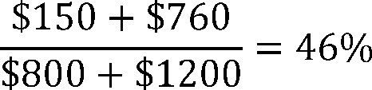

Because Clinician B's Threshold Score is less than the 50 percent QP Payment Amount Threshold, Clinician B would not be a QP based on this result. However, if we apply the weighting methodology, we would calculate the Threshold Score as follows:

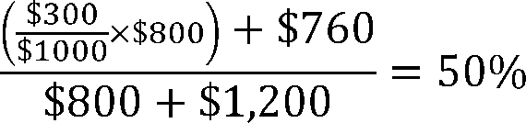

Based upon this Threshold Score, Clinician B would be a QP under the All-Payer Combination Option for the year.

We would calculate the eligible clinician's Threshold Scores both individually and with this weighting methodology, and then use the more advantageous score when making a QP determination. We noted that we believe that this approach promotes consistency between the Medicare Option and the All-Payer Combination Option to the extent possible. We sought comment on this proposal.

The following is a summary of the public comments received on this proposal and our responses:

*Comment:* A few commenters supported our proposal.

*Response:* We appreciate the support for our proposal.

*Comment:* One commenter opposed this proposal. The commenter stated that it could lead to consequences such as QP status changing within a year. The commenter expressed concern that unless we make QP determinations based on participation volume from the prior year, as payment changes, the QP status of eligible clinicians may also change during the year.

*Response:* We will make QP determinations under the All-Payer Combination Option based on performance through several intervals of time, at the three snapshot dates. This weighting methodology is designed to give an eligible clinician the more advantageous score when conducting QP determinations at the individual eligible clinician level under the All-Payer Combination Option. We emphasize that there is no situation in which our application of this weighting methodology would prevent an eligible clinician from attaining QP status. Nor would it ever result in QP status for an eligible clinician changing during the course of a year.

*Final Action:* After considering public comments, we are finalizing this policy as proposed with one modification at § 414.1440(d)(3). Because of our modified policy regarding the level at which we will calculate QP determinations under the All-Payer Combination Option, we clarify that we would only use this weighting methodology when QP determinations are made at the individual eligible clinician level and when the individual Threshold Scores under the Medicare Option are lower than the corresponding APM Entity group Threshold Scores under the Medicare Option.

(c) Title XIX Excluded Payments and Patients

Sections 1833(z)(2)(B)(ii)(I)(bb) and 1833(z)(2)(C)(ii)(I)(bb) of the Act direct us to exclude payments made under Title XIX in a state where no Medicaid Medical Home Model or Medicaid APM is available under that state program. To carry out this exclusion, in the CY 2017 Quality Payment Final Rule, we finalized that for both the payment amount and patient count methods, Title XIX payments or patients will be excluded from the numerator and denominator for the QP determination unless:

(1) A state has in operation at least one Medicaid APM or Medicaid Medical Home Model that is determined to be an Other Payer Advanced APM; and

(2) The relevant APM Entity is eligible to participate in at least one of such Other Payer Advanced APMs during the QP Performance Period, regardless of whether the APM Entity actually participates in such Other Payer Advanced APMs [*(81 FR 77475).*](https://advance.lexis.com/api/document?collection=administrative-codes&id=urn:contentItem:5M3D-MP10-006W-80MT-00000-00&context=)

For purposes of the discussion below on the exclusion of Title XIX payments and patients in QP determinations, we note that when we refer to Medicaid Medical Home Models, we are referring to those that are Other Payer Advanced APMs. We also discussed that if a state operates such an Other Payer Advanced APM at a sub-state level such that eligible clinicians who do not practice in the area are not eligible to participate, Medicaid payments or patients should not be included in those eligible clinicians' QP calculations because no Medicaid Medical Home Model or Medicaid APM was available for their participation [*(81 FR 77475).*](https://advance.lexis.com/api/document?collection=administrative-codes&id=urn:contentItem:5M3D-MP10-006W-80MT-00000-00&context=) **[*53883]**

In the CY 2018 Quality Payment Program proposed rule, we proposed that we will use the county level to determine whether a state operates a Medicaid APM or a Medicaid Medical Home Model at a sub-state level. We noted that we believe that the county level is appropriate as in our experience, the county level is the most common geographic unit used by states when creating payment arrangements under Title XIX at the sub-state level. We explained that we believe that applying this exclusion at the county level would allow us to carry out this exclusion in accordance with the statute in a way that would not penalize eligible clinicians who have no Medicaid APMs or Medicaid Medical Home Models available to them [*(82 FR 30202).*](https://advance.lexis.com/api/document?collection=administrative-codes&id=urn:contentItem:5NX6-6BS0-006W-83PD-00000-00&context=) We sought comment on this proposal.

The following is a summary of the public comments received on this proposal and our responses:

*Comment:* Two commenters supported this proposal.

*Response:* We appreciate the support for this proposal.

*Final Action:* After considering public comments, we are finalizing this policy as proposed at § 414.1440(a).

In the CY 2018 Quality Payment Program proposed rule, we also proposed that, in states where a Medicaid APM or Medicaid Medical Home Model only exists in certain counties, we would exclude Title XIX data from an eligible clinician's QP calculations unless the county where the eligible clinician saw the most patients during the relevant QP Performance Period was a county where a Medicaid APM or Medicaid Medical Home Model was available. We would require eligible clinicians to identify and certify the county where they saw the most patients during the relevant QP Performance Period. If that county is not in a county where a Medicaid APM or Medicaid Medical Home Model was available during the Performance Period, then Title XIX payments would be excluded from the eligible clinician's QP calculations. We proposed this approach to ensure that, before including Title XIX payment or patient count information in calculating QP determinations, eligible clinicians have a meaningful opportunity to participate in a Medicaid APM or Medicaid Medical Home Model in a manner that would allow for both positive and negative contributions to their QP threshold score under the All-Payer Combination Option [*(82 FR 30202).*](https://advance.lexis.com/api/document?collection=administrative-codes&id=urn:contentItem:5NX6-6BS0-006W-83PD-00000-00&context=) We sought comment on this proposal.

The following is a summary of the public comments received on this proposal and our responses:

*Comment:* One commenter was concerned about the burden that our proposal would place on eligible clinicians.

*Response:* We appreciate that we are requesting eligible clinicians to submit more information to us, but we continue to believe that our proposal is the least burdensome way for us to obtain information necessary to determine how to apply the Medicaid exclusion at the county level.

*Final Action:* After considering public comments, we are finalizing the policy as proposed.

In addition to excluding payments based on county-level geography, we proposed to exclude Title XIX payments and patients from the QP determination calculation when the only Medicaid APMs and Medicaid Medical Home Models available in a given county are not available to the eligible clinician in question based on their specialty. We noted that we believe that this proposal is consistent with the statutory requirement to exclude Title XIX payment and patients from the calculations when no Medicaid APM or Medicaid Medical Home Model is available. In cases where participation in such a model is limited to eligible clinicians in certain specialties, we do not believe the Medicaid APM or Medicaid Medical Home Model would effectively be available to eligible clinicians who are not in those specialties. We therefore believe it would be inappropriate and inequitable to include Title XIX payments and patients in such eligible clinicians' QP determination calculations. We proposed to identify Medicaid APM or Medicaid Medical Home Models that are only open to certain specialties through questions requested of states in the Payer Initiated Process and of APM Entities and eligible clinicians in the Eligible Clinician Initiated Process. We would exclude Title XIX data from an eligible clinician's QP calculations unless the eligible clinician practiced under one of the specialty codes eligible to participate in a Medicaid APM or Medicaid Medical Home Model that was available in the county where the eligible clinician saw the most patients. We would use the method generally used in the Quality Payment Program to identify an eligible clinician's specialty or specialties [*(82 FR 30202*](https://advance.lexis.com/api/document?collection=administrative-codes&id=urn:contentItem:5NX6-6BS0-006W-83PD-00000-00&context=) through 30203). We sought comment on these proposals.

The following is a summary of the public comments received on these proposals and our responses:

*Comment:* One commenter expressed support for excluding Title XIX payments when the only Medicaid APMs and Medicaid Medical Home models available in a given county are not available to the eligible clinician in question based on their specialty.

*Response:* We appreciate the support for these proposals.

*Final Action:* After considering public comments, we are finalizing these policies as proposed at § 414.1440(a)(2).

(d) Payment Amount Method

In the CY 2017 Quality Payment Program final rule, we finalized that we will calculate an All-Payer Combination Option Threshold Score for eligible clinicians in an APM Entity using the payment amount method [*(81 FR 77476-77477).*](https://advance.lexis.com/api/document?collection=administrative-codes&id=urn:contentItem:5M3D-MP10-006W-80MT-00000-00&context=) We finalized that the numerator will be the aggregate of all payments from all payers, except those excluded, to the APM Entity's eligible clinicians, or the eligible clinician in the event of an individual eligible clinician assessment, under the terms of all Other Payer Advanced APMs during the QP Performance Period. We finalized that the denominator will be the aggregate of all payments from all payers, except excluded payments, to the APM Entity's eligible clinicians, or the eligible clinician in the event of an individual eligible clinician assessment during the QP Performance Period.

We finalized that we will calculate the Threshold Score by dividing the numerator value by the denominator value, which will result in a percent value Threshold Score. We will compare that Threshold Score to the relevant QP Payment Amount Threshold and the relevant Partial QP Payment Amount Threshold and determine the QP status of the eligible clinicians for the payment year [*(81 FR 77475).*](https://advance.lexis.com/api/document?collection=administrative-codes&id=urn:contentItem:5M3D-MP10-006W-80MT-00000-00&context=)

In the CY 2018 Quality Payment Program proposed rule, we proposed to maintain the policies we finalized for the payment amount method as finalized, with some proposed modifications. We proposed these changes to facilitate the implementation of the payment amount method while providing eligible clinicians with some flexibility in choosing the timeframe for making QP determinations. To implement our proposal to make QP determinations at the eligible clinician level only, we proposed that the numerator would be the aggregate of all payments from all payers, except those excluded, attributable to the eligible clinician only, under the terms of all Advanced APMs and Other Payer Advanced APMs from either January 1 through March 31 or January 1 through **[*53884]** June 30 of the QP Performance Period. We also proposed that the denominator would be the aggregate of all payments from all payers, except excluded payments, to the eligible clinician from either January 1 through March 31, or January 1 through June 30 of the QP Performance Period [*(82 FR 30203).*](https://advance.lexis.com/api/document?collection=administrative-codes&id=urn:contentItem:5NX6-6BS0-006W-83PD-00000-00&context=) We sought comment on these proposals.

The following is a summary of the public comments received on these proposals our responses:

*Comment:* One commenter stated support for these proposals.

*Response:* We appreciate the support for these proposals.

*Final Action:* After considering public comments, we are finalizing the policy as proposed with one modification. Because we are retaining the January 1 through August 31 QP Performance Period for the All-Payer Combination Option, we will also have an August 31 snapshot date and thereby also make calculations based on the January 1 through August 31 time period. We are codifying our payment amount method policy at § 414.1440(b).

(e) Patient Count Method

In the CY 2017 Quality Payment Program final rule, we finalized that the Threshold Score calculation for the patient count method would include patients for whom the eligible clinicians in an APM Entity furnish services and receive payment under the terms of an Other Payer Advanced APM, except for those excluded. We finalized that the numerator would be the number of unique patients to whom eligible clinicians in the APM Entity furnish services that are included in the aggregate expenditures used under the terms of all their Other Payer Advanced APMs during the QP Performance Period plus the patient count numerator for Advanced APMs. We finalized that the denominator would be the number of unique patients to whom eligible clinicians in the APM Entity furnish services under all payers, except those excluded. We finalized that we will calculate the Threshold Score by dividing the numerator value by the denominator value, which will result in a percent value Threshold Score. We will compare that Threshold Score to the finalized QP Patient Count Threshold and the Partial QP Patient Count Threshold and determine the QP status of the eligible clinicians for the payment year. We finalized that we would count each unique patient one time in the numerator and one time in the denominator [*(81 FR 77477-77478).*](https://advance.lexis.com/api/document?collection=administrative-codes&id=urn:contentItem:5M3D-MP10-006W-80MT-00000-00&context=)

In the CY 2018 Quality Payment Program proposed rule, we explained that we intend to carry out QP determinations using the patient count method as finalized with some proposed modifications. We proposed these changes to facilitate the implementation of the patient count method while providing eligible clinicians with some flexibility in choosing the timeframe for making QP determinations. To implement the proposal to make QP determinations at the eligible clinician level only, we proposed to count each unique patient one time in the numerator and one time in the denominator across all payers to align with our finalized policy for patient counts at the eligible clinician level. We proposed that the numerator would be the number of unique patients the eligible clinician furnishes services to under the terms of all of their Advanced APMs or Other Payer Advanced APMs from either January 1 through March 31 or January 1 through June 30 of the QP Performance Period. We proposed that the denominator would be the number of unique patients the eligible clinician furnishes services to under all payers, except those excluded from either January 1 through March 31 or January 1 through June 30 of the QP Performance Period [*(82 FR 30203).*](https://advance.lexis.com/api/document?collection=administrative-codes&id=urn:contentItem:5NX6-6BS0-006W-83PD-00000-00&context=) We sought comment on these proposals.

The following is a summary of the public comments received on these proposals and our responses:

*Comment:* One commenter supported our proposals.

*Response:* We appreciate the commenter's support of our proposals.

*Comment:* A few commenters expressed concern that the patient count approach could include Medicare Advantage patients in the denominator without commensurate addition to the numerator, which would dilute the patient count threshold for affected eligible clinicians. One commenter specifically recommended that CMS would first carry out the patient count method with Medicare fee-for-service alone and only add Medicare Advantage patient data if the eligible clinician fails to become a QP with just fee-for-service.

*Response:* We clarify that, as we explained in the CY 2017 Quality Payment Program final rule, QP determinations are done sequentially, meaning that calculations under the Medicare Option are conducted prior to calculations under the All-Payer Combination Option. The All-Payer Combination Option is only available to eligible clinicians who have a sufficient amount of Advanced APM participation to qualify, but who do not become QPs under, the Medicare Option.

We acknowledge that some eligible clinicians may have a significant number of Medicare Advantage patients but furnish care to very few of them through an Other Payer Advanced APM with Medicare Advantage as a payer. In that case, the numerator may be significantly smaller than the denominator, and those eligible clinicians may not meet a QP Threshold. However, we do not believe there is any basis for making any special adjustment for this situation generally, nor do we believe it would be appropriate to treat Medicare Advantage differently from any other payer in this situation.

*Final Action:* After considering public comments, and in light of operational challenges that our proposal would pose for eligible clinicians or APM Entities, who would have to develop a process for ensuring that a single patient is not reported under two separate payers we are not finalizing these policies as proposed.

We are retaining the policies as they were finalized in the CY 2017 Quality Payment Program final rule [*(81 FR 77477-77478).*](https://advance.lexis.com/api/document?collection=administrative-codes&id=urn:contentItem:5M3D-MP10-006W-80MT-00000-00&context=) Specifically, for each APM Entity, we would count each unique patient one time in the numerator and one time in the denominator. However, the same patient could be counted separately in the numerator and denominator of two separate payers (for example, Medicare and Medicaid for a dual eligible). Also, because we are retaining the January 1 through August 31 QP Performance Period for the All-Payer Combination Option, we will also have an August 31 snapshot date and thereby also make calculations based on the January 1 through August 31 time period. We are codifying our patient count method policy at § 414.1440(c).

(5) Submission of Information for QP Determinations Under the All-Payer Combination Option

In the CY 2017 Quality Payment Program final rule, we finalized that either APM Entities or individual eligible clinicians must submit by a date and in a manner determined by us: (1) Payment arrangement information necessary to assess whether each other payer arrangement is an Other Payer Advanced APM, including information on financial risk arrangements, use of CEHRT, and payment tied to quality measures; (2) for each payment arrangement, the amounts of payments for services furnished through the arrangement, the total payments from the payer, the numbers of patients furnished any service through the arrangement (that is, patients for whom the eligible clinician is at risk if actual expenditures exceed expected expenditures), and (3) the total number **[*53885]** of patients furnished any service through the arrangement [*(81 FR 77480).*](https://advance.lexis.com/api/document?collection=administrative-codes&id=urn:contentItem:5M3D-MP10-006W-80MT-00000-00&context=) We also finalized that if we do not receive sufficient information to complete our evaluation of an other payer arrangement and to make QP determinations, we would not assess the eligible clinicians under the All-Payer Combination Option [*(81 FR 77480).*](https://advance.lexis.com/api/document?collection=administrative-codes&id=urn:contentItem:5M3D-MP10-006W-80MT-00000-00&context=)

(a) Required Information

In the CY 2018 Quality Payment Program proposed rule, we explained that in order for us to make QP determinations under the All-Payer Combination Option using either the payment amount or patient count method, we would need to receive all of the payment amount and patient count information: (1) Attributable to the eligible clinician through every Other Payer Advanced APM; and (2) for all other payments or patients, except from excluded payers, made or attributed to the eligible clinician during the QP Performance Period. We clarified that eligible clinicians will not need to submit Medicare payment or patient information for QP determinations under the All-Payer Combination Option.

In the CY 2018 Quality Payment Program proposed rule, we also noted that we will need this payment amount and patient count information from January 1 through June 30 of the calendar year 2 years prior to the payment year. We noted will need this payment amount and patient count information submitted in a way that allows us to distinguish information from January 1 through March 31 and from January 1 through June 30 so that we can make QP determinations based on the two proposed snapshot dates [*(82 FR 30203*](https://advance.lexis.com/api/document?collection=administrative-codes&id=urn:contentItem:5NX6-6BS0-006W-83PD-00000-00&context=) through 30204).

We explained that to meet the need for information in a way that we believe minimizes reporting burden, we proposed to collect this payment amount and patient count information aggregated for the two proposed snapshot time frames: from January 1 through March 31 and from January 1 through June 30. We sought comment on this approach, particularly as to the feasibility of submitting information in this way and suggestions on how to further minimize reporting burden. We also explained that alternatively, if we finalized an All-Payer QP Performance Period of January 1 through March 31, we would need payment amount and patient count information only from January 1 through March 31. We noted that if we were to retain the current finalized QP Performance Period, we would need information aggregated for three snapshot timeframes: from January 1 through March 31, January 1 through June 30, and January 1 through August 31.

The following is a summary of the public comments received on this proposal and our responses:

*Comment:* One commenter expressed confusion about the timing of QP determinations under the All-Payer Combination Option. The commenter suggested that there may be a misalignment between the timing of the snapshots and the time period for submitting requests for Other Payer Advanced APM determinations.

*Response:* We clarify that eligible clinicians or APM Entities may request Other Payer Advanced APM determinations of other payer arrangements that they participate in during a QP Performance Period after the QP Performance Period, and that to request a QP determination, the eligible clinician or APM Entity will need to include payment and patient data for the snapshots of that same year. We acknowledge that it is possible that an eligible clinician or APM Entity may submit information about a payment arrangement that we do not determine is an Other Payer Advanced APM, and we encourage eligible clinicians or APM Entities to submit this information on other payer arrangements earlier so that we can tell them the status of the payment arrangement in advance of submitting payment and patient data to avoid an unnecessary submission.

*Comment:* One commenter suggested that CMS utilize enough snapshot dates to cover the entire year for both the Medicare Option and the All-Payer Combination Option.

*Response:* We are finalizing that there will be three snapshot dates for both the Medicare Option and the All-Payer Combination Option, which are March 31, June 30, and August 31. As we discussed in the CY 2017 Quality Payment Program final rule, we continue to believe that this policy of using snapshots on March 31, June 30, and August 31 accommodates the variety of policies in different models and initiatives regarding the addition and removal of APM participants so that we capture the eligible clinicians who have meaningfully participated in an APM Entity in an Advanced APM during the QP Performance Period [*(81 FR 77444).*](https://advance.lexis.com/api/document?collection=administrative-codes&id=urn:contentItem:5M3D-MP10-006W-80MT-00000-00&context=) We continue to believe that this policy, and a parallel policy for the All-Payer Combination Option, allows for more certainty at an earlier point in time of an eligible clinician's status.

Additionally, for the All-Payer Combination Option, we are concerned that adding a December 31 snapshot date will leave us unable to notify eligible clinicians of their QP status prior to the end of the MIPS reporting period, particularly because we would also need to move the QP Determination Submission Deadline to some time period after December 1.

*Final Action:* After considering public comments, we are finalizing the policy as proposed with a modification to reflect our final policy for the QP Performance Period in § 414.1440(e). Because the length of the QP Performance Period for the All-Payer Combination Option is from January 1 through August 31 of the calendar year that is 2 years prior to the payment year, we will need to receive payment and patient information for the periods January 1 through March 31, January 1 through June 30, and January 1 through August 31. As we discuss in section II.D.6.d.(3)(b) of this final rule with comment period, we recognize that the timing may be challenging for APM Entities or eligible clinicians to submit information for the August 31 snapshot date. If we receive information for either the March 31 or June 30 snapshots, but not the August 31 snapshot, we will use that information to make QP determinations under the All-Payer Combination Option.

In the CY 2018 Quality Payment Program proposed rule, we proposed that all of this payment and patient information must be submitted at the eligible clinician level, and not at the APM Entity group level as we finalized in rulemaking last year.

We sought comment on this proposal. We received no comments in response to this proposal.

*Final Action:* Because we are finalizing a policy where we may make QP determinations at either the individual eligible clinician level or the APM Entity level, we are finalizing a policy that payment and patient information must be submitted at either the individual or APM Entity level in order to request a QP determination. Specifically, if an individual eligible clinician requests a QP determination under the All-Payer Combination Option, payment and patient information must be submitted at the individual eligible clinician level. If an APM Entity requests a QP determination under the All-Payer Combination Option, payment and patient information must be submitted at the APM Entity level. We are codifying this policy at § 414.1440(e).

In the CY 2018 Quality Payment Program proposed rule, to minimize reporting burden on individual eligible clinicians and to allow eligible clinicians to submit information to us as efficiently as possible, we proposed to **[*53886]** allow eligible clinicians to have APM Entities submit information for them at the individual eligible clinician level on behalf of any of the eligible clinicians in the APM Entity group. We sought comments on these proposals, particularly regarding the feasibility of APM Entities reporting this information for some or all of the eligible clinicians in the APM Entity group. Additionally, we proposed that if an APM Entity or eligible clinician submits sufficient information only for the payment amount or patient count method, but not for both, we will make a QP determination based on the one method for which we receive sufficient information [*(82 FR 30204).*](https://advance.lexis.com/api/document?collection=administrative-codes&id=urn:contentItem:5NX6-6BS0-006W-83PD-00000-00&context=) We noted that we believe that the proposal was consistent with our overall approach, particularly because we finalized in the CY 2017 Quality Payment Program final rule that we will use the more advantageous of the Threshold Scores to make QP determinations [*(81 FR 77475).*](https://advance.lexis.com/api/document?collection=administrative-codes&id=urn:contentItem:5M3D-MP10-006W-80MT-00000-00&context=) We clarified that APM Entities or eligible clinicians can submit information to allow us to use both the payment amount and patient count methods.

To facilitate and ease burden for information submissions, we also proposed to create a form that APM Entities or eligible clinicians would be able to use to submit this payment amount and patient count information. APM Entities and eligible clinicians would be required to use this form for submitting the payment and patient information.

We sought comment on these proposals.

The following is a summary of comments we received on these proposals and our responses:

*Comment:* One commenter supported CMS's proposal to allow for APM Entities to report on behalf of eligible clinicians, and one commenter requested that any reporting requirements minimize burden on eligible clinicians.

*Response:* We appreciate the commenter's support of our proposal. One of our goals is to reduce burden to the extent possible.

*Comment:* One commenter stated that CMS should make the forms to collect this information available well in advance and that they should be subject to public comment to allow payers to clarify terminology and definitions and help ensure that information submitted to us is appropriate. A few commenters requested that CMS release subregulatory guidance so that APM entities and eligible clinicians will know what to collect and submit in order for CMS to make a QP determination under the All-Payer Combination Option. The commenter requested that CMS provide guidance on the format and the submission mechanism and estimated expense and time for clinicians to compile payment and patient count information.

*Response:* We appreciate the comments. We intend to create a form that will be available for public comment through the Paperwork Reduction Act (PRA) process and to release subregulatory guidance to facilitate the submission of this information.

*Comment:* One commenter suggested that the onus on submitting relevant payment information should be on the payer, especially as eligible clinicians are already overburdened and that payers have a better understanding of what information CMS would need and would be in a better position to provide that information than eligible clinicians.

*Response:* We encourage payers to assist APM Entities and eligible clinicians in compiling and submitting data, but we have no clear basis for compelling payers to submit, or holding payers accountable to the accuracy of, the necessary information. We also note that no single payer is likely to have all of the necessary information for any given clinician, as such information will typically involve payment and patient counts across multiple payers.

*Final Action:* After considering public comments, we are finalizing our proposal to allow eligible clinicians to have APM Entities submit information for them at the individual eligible clinician level on behalf of any of the eligible clinicians in the APM Entity group.

We are also finalizing our proposal that if an APM Entity or eligible clinician submits sufficient information only for the payment amount or patient count method, but not for both, we will make a QP determination based on the one method for which we receive sufficient information. We are also finalizing our proposal to create a form that APM Entities or eligible clinicians would be able to use to submit this payment amount and patient count information.

(b) QP Determination Submission Deadline

In the CY 2018 Quality Payment Program proposed rule, we proposed that APM Entities or eligible clinicians must submit all of the required information about the Other Payer Advanced APMs in which they participate, including those for which there is a pending request for an Other Payer Advanced APM determination, as well as the payment amount and patient count information sufficient for us to make QP determinations by December 1 of the calendar year that is 2 years to prior to the payment year, which we refer to as the QP Determination Submission Deadline [*(82 FR 30204).*](https://advance.lexis.com/api/document?collection=administrative-codes&id=urn:contentItem:5NX6-6BS0-006W-83PD-00000-00&context=)

In the CY 2017 Quality Payment Program final rule, we finalized that without sufficient information we will not make QP determinations under the All-Payer Combination Option [*(81 FR 77480).*](https://advance.lexis.com/api/document?collection=administrative-codes&id=urn:contentItem:5M3D-MP10-006W-80MT-00000-00&context=) As such, we will not make QP determinations for an eligible clinician under the All-Payer Combination Option if we do not receive information sufficient to make a QP determination under either the payment amount or patient count method by the QP Determination Submission Deadline.

We sought comment on this proposal.

The following is a summary of the public comments received on this proposal and our responses:

*Comment:* One commenter supported CMS's proposal and encouraged CMS to finalize it so that QP determinations could be made in time to notify eligible clinicians of their QP status prior to the MIPS reporting deadline.

*Response:* We appreciate the support of our proposal, and we agree that it is important for us to develop this timeline in a way that allows for QP determinations to be made and notifications to be sent prior to the MIPS reporting deadline.

*Comment:* Two commenters expressed concern that CMS seemed to be requesting that the requests for determination must be submitted by September 1 in order to be notified of their QP status prior to the MIPS reporting deadline.

*Response:* We clarify that September 1 is the deadline for an APM Entity or eligible clinician to choose to submit information regarding any payment arrangements they participate in so that they can receive Other Payer Advanced APM determinations for those arrangements prior to submitting payment and patient data. If eligible clinicians and APM Entities are made aware in advance that certain arrangements are not Other Payer Advanced APMs, they will know with more specificity what payment or patient information to submit. The deadline for submitting payment amount and patient count data so that a QP determination can be made under the All-Payer Combination Option is December 1.

*Comment:* One commenter was concerned that this timeline would place APM entities and eligible clinicians in an awkward position of not knowing until the very end of the **[*53887]** performance year, or even later, whether they need to report to MIPS. They suggested that CMS consider either some form of deemed status from one year to another. For example, data from 2017 could be used to establish QP status for 2018 or CMS could adopt some earlier deadline for part-year data submission such as first 6 months of the year, reportable starting July 1 of that year.

*Response:* We appreciate the comments. We acknowledge that the timeframe between QP determinations and MIPS reporting is narrow, and we have designed this timeline to try to provide as much advance notice to eligible clinicians as possible. We will monitor how this timeline develops and may consider changes in future rulemaking.

*Final Action:* After considering public comments, we are finalizing our proposal that APM Entities or eligible clinicians must submit all of the required information about the Other Payer Advanced APMs in which they participate, including those for which there is a pending request for an Other Payer Advanced APM determination, as well as the payment amount and patient count information sufficient for us to make QP determinations by December 1 of the calendar year that is 2 years to prior to the payment year, which we refer to as the QP Determination Submission Deadline. We are codifying this policy at § 414.1440(e)(4).

(c) Certification and Program Integrity

In the CY 2018 Quality Payment Program proposed rule, we proposed that a new requirement be added at § 414.1440(f)(2) stating that the APM Entity or eligible clinician that submits information to request a QP determination under the All-Payer Combination Option must certify to the best of its knowledge that the information that they submitted to us is true, accurate, and complete. If the information is submitted by an APM Entity, we proposed that the certification must be made by an individual with the authority to legally bind the APM Entity. This certification would accompany the Eligible Clinician Initiated Submission Form, which both eligible clinicians and APM Entities use for the Eligible Clinician Initiated Process [*(82 FR 30204).*](https://advance.lexis.com/api/document?collection=administrative-codes&id=urn:contentItem:5NX6-6BS0-006W-83PD-00000-00&context=) We sought comment on these proposals.

We proposed to revise the monitoring and program integrity provisions at § 414.1460 to further promote the integrity of the All-Payer Combination Option. In the CY 2017 Quality Payment Program final rule, we finalized at § 414.1460(e) that an APM Entity or eligible clinician that submits information to us under § 414.1445 for assessment under the All-Payer Combination Option must maintain such books contracts records, documents, and other evidence for a period of 10 years from the final date of the QP Performance Period or from the date of completion of any audit, evaluation, or inspection, whichever is later [*(81 FR 77555).*](https://advance.lexis.com/api/document?collection=administrative-codes&id=urn:contentItem:5M3D-MP10-006W-80MT-00000-00&context=) We also finalized at § 414.1460(c) that eligible clinicians and APM Entities must maintain copies of any supporting documentation related to the All-Payer Combination Option for at least 10 years [*(81 FR 77555).*](https://advance.lexis.com/api/document?collection=administrative-codes&id=urn:contentItem:5M3D-MP10-006W-80MT-00000-00&context=) We propose to revise § 414.1460(e) to apply to information submitted to us under § 414.1440 for QP determinations. We also proposed to add paragraph (3) to § 414.1460(e) stating that an APM Entity or eligible clinician who submits information to us under § 414.1445 or § 414.1440 must provide such information and supporting documentation to us upon our request. We sought comments on these proposals.

The following is a summary of the public comments received on these proposals and our responses:

*Comment:* One commenter stated that the 10-year record retention period is overly burdensome on eligible clinicians. This commenter also stated that the 10-year record retention period is based on the outer limit of the False Claims Act, and the commenter suggested that our proposed timeframe is unreasonable. The commenter encouraged CMS to use either a 3 or 6 year period.

*Response:* We appreciate the commenters' concerns and suggestions to reduce the record retention period. For the reasons set forth in section II.D.6.c.(7)(b) of this final rule with comment period, we are finalizing a 6 year record retention requirement. In addition, we have modified the ***regulation*** text to remove language that would require parties to retain records for a longer period of time in certain circumstances.

*Final Action:* After considering public comments, we are finalizing the proposed changes to § 414.1440(f)(2) and § 414.1460(e) without modification, except that the record retention requirements set forth in § 414.1460(e)(2) are reduced. Specifically, the policies at § 414.1460(e)(2) in this final rule provide that an APM Entity or eligible clinician that submits information to us under § 414.1440 for QP determinations must maintain such books, contracts, records, documents, and other evidence as necessary to enable the audit of an QP determinations and the accuracy of APM Incentive Payments for a period of 6 years from the end of the QP Performance Period or from the date of completion of any audit, evaluation, or inspection, whichever is later. Additionally, § 414.1460(e)(2) no longer require an APM Entity or eligible clinician to retain records for a longer period of time based on a special need, as determined by us, or for an additional 6 years from the date of any final resolution of a termination, dispute, or allegation of fraud or similar fault against an APM Entity or eligible clinician.

(d) Use of Information

In the CY 2017 Quality Payment Program final rule, we finalized that, to the extent permitted by federal law, we will maintain confidentiality of the information and data that APM Entities and eligible clinicians submit to support Other Payer Advanced APM determinations in order to avoid dissemination of potentially sensitive contractual information or trade secrets [*(81 FR 77479-77480).*](https://advance.lexis.com/api/document?collection=administrative-codes&id=urn:contentItem:5M3D-MP10-006W-80MT-00000-00&context=)

We believe that it is similarly appropriate for us to maintain the confidentiality of information submitted to us for the purposes of QP determinations to the extent permitted by federal law. Therefore, we proposed that, to the extent permitted by federal law, we will maintain confidentiality of the information that APM Entities or eligible clinicians submit to us for purposes of QP determinations under the All-Payer Combination Option.

The following is a summary of the public comments we received on this proposal and our responses:

*Comment:* One commenter urged us to keep commercially sensitive information confidential.

*Response:* We reiterate that we will maintain confidentiality of the information that APM Entities or eligible clinicians submit to us for purposes of QP determinations under the All-Payer Combination Option to the full extent permitted by federal law.

Additionally, we also note that records that a submitter marks as confidential will be protected from disclosure to the extent permitted by federal law. Specifically, Exemption 4 of the Freedom of Information Act (FOIA) authorizes our agency to withhold trade secrets and commercial or financial information obtained from a person and privileged or confidential. ([*45 CFR 5.31(d)*](https://advance.lexis.com/api/document?collection=administrative-codes&id=urn:contentItem:5M3C-5810-008H-03VN-00000-00&context=)). A person who submits records to the government may designate part or all of the information in such records that they may consider to be exempt from disclosure under Exemption 4 of **[*53888]** the FOIA. The person may make this designation either at the time the records are submitted to the government or within a reasonable time thereafter. The designation must be in writing. Any such designation will expire 10 years after the records were submitted to the government ([*45 CFR 5.41*](https://advance.lexis.com/api/document?collection=administrative-codes&id=urn:contentItem:5M3C-5810-008H-03VV-00000-00&context=)). If records provided by a submitter become the subject of a FOIA request, the agency will engage the submitter in the pre-disclosure notification process, unless the agency determines that the information should be withheld, or the designation of "confidential" appears obviously frivolous. The pre-disclosure notification process can be found at [*45 CFR 5.42*](https://advance.lexis.com/api/document?collection=administrative-codes&id=urn:contentItem:5M3C-5810-008H-03VW-00000-00&context=).

*Final Action:* After considering public comments, we are finalizing the policy as proposed.

(6) Examples

In the CY 2018 Quality Payment Program proposed rule, to illustrate how we would conduct QP determinations under the All-Payer Combination Option, we provided examples where an eligible clinician is in a Medicare ACO Model that we have determined to be an Advanced APM, a commercial ACO arrangement, and a Medicaid APM from January 1 through June 30, 2019 [*(82 FR 30205*](https://advance.lexis.com/api/document?collection=administrative-codes&id=urn:contentItem:5NX6-6BS0-006W-83PD-00000-00&context=) through 30206). Because we are finalizing that one of the ways in which we will make QP determinations is at the individual eligible clinical level, this example illustrates how we will make individual eligible clinician level QP determinations.

In this example, we would use the information below to determine that eligible clinician's QP status for payment year 2021. We would calculate the Threshold Scores for the APM Entity group in the Advanced APM under the Medicare Option. For the payment amount method, as we show in Table 44 below, the APM Entity group would not attain QP status under the Medicare Option, which for payment year 2021 requires a QP payment amount Threshold Score of 50 percent. The APM Entity group would also fail to attain Partial QP status under the Medicare Option, which for payment year 2021 requires a Partial QP payment amount Threshold Score of 40 percent. For the patient count method, as we show in Table 45, the APM Entity group would not attain QP status under the Medicare Option, which for payment year 2021 requires a QP patient count Threshold Score of 35 percent. The APM Entity group would not attain Partial QP status under the Medicare Option, which for payment year 2021 requires a Partial QP patient count Threshold Score of 25 percent.

| **Table 44--All-Payer Combination Option Example--Payment Amount Method for** | | | | |
| --- | --- | --- | --- | --- |
| **Eligible Clinicians** | | | | |
|  |  |  |  |  |
| **Payer** | **Level** | **Payments to** | **Total** | **Threshold** |
|  |  | **group/eligible** | **payments to** | **score** |
|  |  | **clinician** | **group/eligible** | **(percentage)** |
|  |  | **by payer** | **clinician by** |  |
|  |  | **(in dollars)** | **payer** |  |
|  |  |  | **(in dollars)** |  |
| Medicare Option | | | | |
|  |  |  |  |  |
| Advanced APM | APM Entity | 300,000 | 1,000,000 | 30 |
| (Medicare) | Group |  |  |  |
| All-Payer Combination Option | | | | |
|  |  |  |  |  |
| Advanced APM | Eligible | 20,000 | 50,000 |  |
| (Medicare) | Clinician |  |  |  |
| Other Payer | Eligible | 20,000 | 50,000 |  |
| Advanced APM | Clinician |  |  |  |
| (Commercial) |  |  |  |  |
| Medicaid APM | Eligible | 80,000 | 100,000 |  |
|  | Clinician |  |  |  |
| Totals for | Eligible | 120,000 | 200,000 | 60 |
| All-Payer | Clinician |  |  |  |
| Combination |  |  |  |  |
| Option |  |  |  |  |

| **Table 45--All-Payer Combination Option Example--Patient Count Method for** | | | | |
| --- | --- | --- | --- | --- |
| **Eligible Clinicians** | | | | |
|  |  |  |  |  |
| **Payer** | **Level** | **Patients of** | **Total** | **Threshold** |
|  |  | **group/eligible** | **patients of** | **score** |
|  |  | **clinician by** | **group/eligible** | **(percentage)** |
|  |  | **payer** | **clinician by** |  |
|  |  |  | **payer** |  |
| Medicare Option | | | | |
|  |  |  |  |  |
| Advanced APM | APM Entity | 2,200 | 10,000 | 22 |
| (Medicare) | Group |  |  |  |
| All-Payer Combination Option | | | | |
|  |  |  |  |  |
| Advanced APM | Eligible | 200 | 1,000 |  |
| (Medicare) | Clinician |  |  |  |
| Other Payer | Eligible | 100 | 500 |  |
| Advanced APM | Clinician |  |  |  |
| (Commercial) |  |  |  |  |
| Medicaid APM | Eligible | 500 | 1,000 |  |
|  | Clinician |  |  |  |
| Totals for | Eligible | 800 | 2,500 | 32 |
| All-Payer | Clinician |  |  |  |
| Combination |  |  |  |  |
| Option |  |  |  |  |

The APM Entity group did not attain QP or Partial QP status under either the payment amount or patient count method under the Medicare Option. However, because under both methods of calculation, the APM Entity group meets or exceeds the required Medicare threshold for the year under the All-Payer Combination Option of 25 percent and 20 percent, respectively, eligible clinicians within the APM Entity group would be eligible to obtain QP status through the All-Payer Combination Option. The eligible clinicians in the APM Entity group would have been **[*53889]** notified of this result as we share information on a regular basis on their QP status under each snapshot. For payment year 2021, the eligible clinicians in this APM Entity group would submit their payment amount or patient count data from all payers to calculate their Threshold Score under the All-Payer Combination Option.

In this example above where we make the calculation at the individual eligible clinician level, the eligible clinician score exceeds the QP payment amount Threshold under the All-Payer Combination Option, which for payment year 2021 is 50 percent, but the eligible clinician only exceeds the Partial QP patient count Threshold under the All-Payer Combination Option, which for payment year 2021 is 25 percent. We would use the more advantageous score, so the eligible clinician would be a QP for payment year 2021.

Alternatively, if we were to use the APM Entity weighting methodology for calculation of a Threshold Score using the payment amount method as described in the proposed rule, we would apply the weighted methodology as follows:

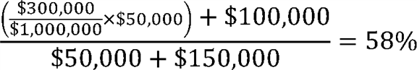

The eligible clinician would obtain a Threshold Score of 58 percent. This would be slightly below the Threshold Score obtained from the individual eligible clinician payment count calculation, but it would still exceed the QP payment amount threshold of 50 percent under the All-Payer Combination Option. Based upon this Threshold Score, the eligible clinician would be a QP under the All-Payer Combination Option.

Because we are finalizing that we will in certain circumstances make QP determinations under the All-Payer Combination Option at the APM Entity level, we provide an example below of how we will make QP determinations at the APM Entity group level under the All-Payer Combination Option based on information shown in Tables 46 and 47. The APM Entity group score exceeds the QP payment amount Threshold under the All-Payer Combination Option, or 50 percent, but the APM Entity group only exceeds the Partial QP patent count Threshold under the All-Payer Combination Option, which for payment year 2021 is 25 percent. Again, we would use the more advantageous score, so the eligible clinician would be a QP for the payment year 2021.

| **Table 46--All-Payer Combination Option Example--Payment Amount Method for APM** | | | | |
| --- | --- | --- | --- | --- |
| **Entity** | | | | |
|  |  |  |  |  |
| **Payer** | **Level** | **Payments to** | **Total** | **Threshold** |
|  |  | **group by** | **payments to** | **score** |
|  |  | **payer** | **group by** | **(percentage)** |
|  |  | **(in dollars)** | **payer** |  |
|  |  |  | **(in dollars)** |  |
| Medicare Option | | | | |
|  |  |  |  |  |
| Advanced APM | APM Entity | 300,000 | 1,000,000 | 30 |
| (Medicare) | Group |  |  |  |
| All-Payer Combination Option | | | | |
|  |  |  |  |  |
| Advanced APM | APM Entity | 300,000 | 1,000,000 |  |
| (Medicare) | Group |  |  |  |
| Other Payer | APM Entity | 200,000 | 500,000 |  |
| Advanced APM | Group |  |  |  |
| (Commercial) |  |  |  |  |
| Medicaid APM | APM Entity | 800,000 | 1,000,000 |  |
|  | Group |  |  |  |
| Totals for | APM Entity | 1,300,000 | 2,500,000 | 52 |
| All-Payer | Group |  |  |  |
| Combination |  |  |  |  |
| Option |  |  |  |  |

| **Table 47--All-Payer Combination Option Example--Patient Count Method for APM** | | | | |
| --- | --- | --- | --- | --- |
| **Entity** | | | | |
|  |  |  |  |  |
| **Payer** | **Level** | **Patients of** | **Total patients** | **Threshold** |
|  |  | **group by** | **of group** | **score** |
|  |  | **payer** | **by payer** | **(percentage)** |
| Medicare Option | | | | |
|  |  |  |  |  |
| Advanced APM | APM Entity | 2,200 | 10,000 | 22 |
| (Medicare) | Group |  |  |  |
| All-Payer Combination Option | | | | |
|  |  |  |  |  |
| Advanced APM | APM Entity | 2,200 | 10,000 |  |
| (Medicare) | Group |  |  |  |
| Other Payer | APM Entity | 1,000 | 5,000 |  |
| Advanced APM | Group |  |  |  |
| (Commercial) |  |  |  |  |
| Medicaid APM | APM Entity | 5,000 | 10,000 |  |
|  | Group |  |  |  |
| Totals for | APM Entity | 8,200 | 25,000 | 33 |
| All-Payer | Group |  |  |  |
| Combination |  |  |  |  |
| Option |  |  |  |  |

**[*53890]**

(7) Partial QP Election to Report to MIPS

In the 2017 Quality Payment Program final rule, we finalized under the Medicare Option that, in the cases where the QP determination is made at the individual eligible clinician level, if the eligible clinician is determined to be a Partial QP, the eligible clinician will make the election whether to report to MIPS and then be subject to MIPS reporting requirements and payment adjustments [*(81 FR 77449).*](https://advance.lexis.com/api/document?collection=administrative-codes&id=urn:contentItem:5M3D-MP10-006W-80MT-00000-00&context=) To promote alignment with the Medicare Option and to simplify requirements when possible, we proposed that eligible clinicians who are Partial QPs for the year under the All-Payer Combination Option would make the election whether to report to MIPS and therefore be subject to MIPS reporting requirements and payment adjustments. We sought comment on this proposal. We received no comments in response to this proposal.

*Final Action:* We are finalizing this policy as proposed.

(8) Summary of Final Policies

In summary, we are finalizing the following policies:

* We are finalizing at § 414.1305 that the QP Performance Period begins on January 1 and ends on August 31 of the calendar year that is 2 years prior to the payment year applies to the All-Payer Combination Option. We are not finalizing the terms All-Payer QP Performance Period and Medicare QP Performance Period.

1. We are finalizing that we will make QP determinations based on eligible clinicians' participation in Advanced APMs and Other Payer Advanced APMs for 3 time periods: between January 1 through March 31, between January 1 through June 30, and between January 1 through August 31 of the QP Performance Period under the All-Payer Combination Option. We are finalizing that we will use data for the same time periods for Medicare payments or patients and that of other payers. We are codifying this policy at § 414.1440(d)(1).
2. We are finalizing that we will notify eligible clinicians of their QP status under the All-Payer Combination Option as soon as practicable after the QP Determination Submission Deadline. We are codifying this policy at § 414.1440(g).
3. We are finalizing that eligible clinicians may request that we make QP determinations at the individual eligible clinician level and that APM Entities may request that we make QP determinations at the APM Entity level. We are codifying this policy at § 414.1440(e).
4. We are finalizing that we will use either individual eligible clinician level or APM Entity level payment amounts and patient counts for Medicare in the All-Payer Combination Option, depending on which level the request for QP determination is made. We are finalizing that when the eligible clinician's Medicare Threshold Score calculated at the individual eligible clinician level would be a lower percentage than the one that is calculated at the APM Entity level, and the eligible clinician requested that we make QP determinations at the individual eligible clinician level, we would apply the weighting methodology. We are codifying this policy at § 414.1440(d)(3).
5. We are finalizing that we will determine whether a state operates a Medicaid APM or a Medicaid Medical Home Model that has been determined to be an Other Payer Advanced APM at a sub-state level. We are finalizing that we will use the county level to determine whether a state operates a Medicaid APM or a Medicaid Medical Home Model that meets the Other Payer Advanced APM at a sub-state level. We are codifying our policies pertaining to Title XIX excluded payments and patients at § 414.1440(a).
6. We are finalizing that in a state where we determine there are one or more Medicaid APMs or Medicaid Medical Home Models that are Other Payer Advanced APMs in operation, but only in certain counties, or only for eligible clinicians in certain specialties, we would further evaluate whether those Medicaid APMs or Medicaid Medical Home Models were available to each eligible clinician for whom we make a QP determination under the All-Payer Combination Option. We will identify the county in which the eligible clinician practices by having the eligible clinician submit that information to identify the county where they saw the most patients during the relevant QP Performance Period when they request a QP determination. We are also finalizing that if the eligible clinician's practice is in a county, or in a specialty, in which there is no Medicaid APM or Medicaid Medical Home Model in operation, all of that eligible clinician's Medicaid payments and patients would be excluded from the numerator and denominator of the calculations under the payment amount or patient count method, respectively. We are also finalizing that we will identify Medicaid APMs or Medicaid Medical Home Models that are only open to certain specialties through questions requested of states in the Payer Initiated Process and of eligible clinicians in the Eligible Clinician Initiated Process. We would use the method generally used in the Quality Payment Program to identify an eligible clinician's specialty or specialties. We are codifying our policies pertaining to Title XIX excluded payments and patients at § 414.1440(a).
7. For the payment amount method, we are finalizing that we would first make a calculation under the Medicare Option. If the minimum threshold score for the Medicare Option were met so that the eligible clinician could become a QP under the All-Payer Combination Option, and did not become a QP under the Medicare Option, we would make calculations under the All-Payer Combination Option. We are finalizing that under the All-Payer Combination Option the numerator would be the aggregate of all payments from all payers, except those excluded, that are made or attributable to the eligible clinician, under the terms of all Advanced APMs and Other Payer Advanced APMs. We are also finalizing that the denominator would be the aggregate of all payments from all payers, except those excluded, that are made or attributed to the eligible clinician. We are codifying our payment amount method policy at § 414.1440(b).
8. For the patient count method under the All-Payer Combination Option, we are not finalizing our proposal and we are maintaining the policy that we finalized in the CY 2017 Quality Payment Program final rule. Specifically, for each APM Entity, we would count each unique patient one time in the numerator and one time in the denominator. However, the same patient could be counted separately in the numerator and denominator of two separate payers (for example, Medicare and Medicaid). We are codifying our patient count policy at § 414.1440(c).
9. We are finalizing that we will require APM Entities or eligible clinicians to submit the necessary payment amount and patient count information for QP determinations under the All-Payer Combination Option aggregated for the two proposed snapshot timeframes: From January 1 through March 31, from January 1 through June 30, and from January 1 through August 31. We are finalizing that APM Entities may submit this information on behalf of any of the eligible clinicians in the APM Entity group at the individual eligible clinician level. If we receive information for some, but not all of the snapshots dates, we will use that information to make QP determinations under the All-Payer Combination Option. We are codifying this policy at § 414.1440(e). **[*53891]**
10. We are finalizing that if an APM Entity or eligible clinician submits sufficient information for either the payment amount or patient count method, but not for both, we will make a QP determination based on the one method for which we receive sufficient information. We are codifying this policy at §§ 414.1440(e)(3) and 414.1440(f)(1).
11. We are finalizing that APM Entities or eligible clinicians must submit all of the required information about the Other Payer Advanced APMs in which they participate, including those for which there is a pending request for an Other Payer Advanced APM determination, as well as the payment amount and patient count information sufficient for us to make QP determinations by December 1 of the calendar year that is 2 years to prior to the payment year, which we refer to as the QP Determination Submission Deadline. We are codifying this policy at § 414.1440(e)(4).
12. We are finalizing that an APM Entity or eligible clinician that submits information to request a QP determination under the All-Payer Combination Option must certify to the best of its knowledge that the information submitted is true, accurate and complete. In the case of information submitted by the APM Entity, we are finalizing that the certification needs to be made by an individual with the authority to bind the APM Entity. We are also finalizing that this certification must accompany the form that APM Entities or eligible clinicians submit to us when requesting that we make QP determinations under the All-Payer Combination Option. We are codifying this policy at § 414.1440(f)(2).
13. We are finalizing that an APM Entity or eligible clinician that submits information to us under § 414.1440 for QP determinations must maintain such books, contracts, records, documents, and other evidence as necessary to enable the audit of QP determinations and the accuracy of APM Incentive Payments for a period of 6 years from the end of the QP Performance Period or from the date of completion of any audit, evaluation, or inspection, whichever is later.
14. We are finalizing that APM Entities and eligible clinicians that submit information to us under § 414.1440 must provide such information and supporting documentation to us upon request. We are codifying this policy at § 414.1460(e)(3).
15. We are finalizing that to the extent permitted by federal law, we will maintain confidentiality of the information that an APM Entity or eligible clinician submits to us for purposes of QP determinations under the All-Payer Combination Option.
16. We are finalizing that eligible clinicians who are Partial QPs for the year under the All-Payer Combination Option would make the election whether to report to MIPS and then be subject to MIPS reporting requirements and payment adjustments.

7. Physician-Focused Payment Models (PFPMs)

a. Overview

Section 1868(c) of the Act established an innovative process for individuals and stakeholder entities (stakeholders) to propose physician-focused payment models (PFPMs) to the Physician-Focused Payment Model Technical Advisory Committee (PTAC). The PTAC, established under section 1868(c)(1)(A) of the Act, is a federal advisory committee comprised of 11 members that provides advice to the Secretary. A copy of the PTAC's charter, established on January 5, 2016, is available at [*https://aspe.hhs.gov/charter-physician-focused-payment-model-technical-advisory-committee*](https://aspe.hhs.gov/charter-physician-focused-payment-model-technical-advisory-committee).

Section 1868(c)(2)(C) of the Act requires the PTAC to review stakeholders' proposed PFPMs, prepare comments and recommendations regarding whether such proposed PFPMs meet the PFPM criteria established by the Secretary, and submit those comments and recommendations to the Secretary. Section 1868(c)(2)(D) of the Act requires the Secretary to review the PTAC's comments and recommendations on proposed PFPMs and to post "a detailed response" to those comments and recommendations on the CMS Web site.

b. Definition of PFPM

Definition of PFPM

In the CY 2017 Quality Payment Program final rule [*(81 FR 77555),*](https://advance.lexis.com/api/document?collection=administrative-codes&id=urn:contentItem:5M3D-MP10-006W-80MT-00000-00&context=) we defined PFPM at § 414.1465 as an Alternative Payment Model (APM) in which: Medicare is a payer; in which eligible clinicians that are eligible professionals as defined in section 1848(k)(3)(B) of the Act are participants and play a core role in implementing the APM's payment methodology; and which targets the quality and costs of services that eligible clinicians participating in the APM provide, order, or can significantly influence. We stated that a PFPM could include other payers in addition to Medicare, but that other payer arrangements and Other Payer Advanced APMs are not PFPMs. Therefore, PFPM proposals would need to include Medicare as a payer.

In the CY 2018 Quality Payment Program proposed rule, we sought comment on whether to broaden the definition of PFPM to include payment arrangements that involve Medicaid or the Children's Health Insurance Program (CHIP) as a payer, even if Medicare is not included as a payer. A PFPM would then include Medicaid, CHIP, or Medicare (or some combination of these) as a payer. A PFPM might still include other payers in addition to Medicaid, CHIP, or Medicare; however, another payer arrangement or Other Payer Advanced APM that includes only private payers, including a Medicare Advantage (MA) plan, would not be a PFPM. As we indicated in the proposed rule, MA and other private plans paid to act as insurers on the Medicare program's behalf are considered to be private payers [*(82 FR 30208).*](https://advance.lexis.com/api/document?collection=administrative-codes&id=urn:contentItem:5NX6-6BS0-006W-83PD-00000-00&context=)

We sought comment on whether broadening the definition of PFPM would be inclusive of potential PFPMs that could focus on areas not generally applicable to the Medicare population, such as pediatric issues or maternal health, and whether changing the definition of PFPM may engage more stakeholders in designing PFPMs that include more populations beyond Medicare FFS beneficiaries. We sought comment on how the PFPM criteria could be applied to these payment arrangements. We sought comment on whether including more issues and populations fits within the PTAC's charge and whether stakeholders are interested in the opportunity to allow the PTAC to apply its expertise to a broader range of proposals for PFPMs [*(82 FR 30208).*](https://advance.lexis.com/api/document?collection=administrative-codes&id=urn:contentItem:5NX6-6BS0-006W-83PD-00000-00&context=)

The current definition of PFPM specifies that a PFPM is an APM. In the CY 2017 Quality Payment Program final rule [*(81 FR 77406),*](https://advance.lexis.com/api/document?collection=administrative-codes&id=urn:contentItem:5M3D-MP10-006W-80MT-00000-00&context=) we noted that APM is defined under section 1833(z)(3)(C) of the Act as any of the following: (1) A model under section 1115A of the Act (other than a health care innovation award); (2) the Shared Savings Program under section 1899 of the Act; (3) a demonstration under section 1866C of the Act; or (4) a demonstration required by federal law. If a payment arrangement is a PFPM it must also be an APM. Under our current ***regulation***, a model that does not meet the definition of APM is not a PFPM. However, a payment arrangement with Medicaid or CHIP as the payer, but not Medicare, would not necessarily meet the definition of APM. Therefore, we sought comment on whether we should, in conjunction with potentially broadening the scope of PFPMs to include payment arrangements with **[*53892]** Medicaid and CHIP, require that a PFPM be an APM or a payment arrangement operated under legal authority for Medicaid or CHIP payment arrangements [*(82 FR 30208).*](https://advance.lexis.com/api/document?collection=administrative-codes&id=urn:contentItem:5NX6-6BS0-006W-83PD-00000-00&context=)

We also sought comment on whether states and stakeholders see value in having the definition of PFPM broadened to include payment arrangements with Medicaid or CHIP but not Medicare as a payer, and whether they see value in having proposals for PFPMs with Medicaid or CHIP but not Medicare as a payer go through the PTAC's review process [*(82 FR 30209).*](https://advance.lexis.com/api/document?collection=administrative-codes&id=urn:contentItem:5NX6-6BS0-006W-83PD-00000-00&context=)

The following is a summary of the public comments received on the areas where we sought comment related to the definition of PFPM and our responses:

*Comment:* Many commenters were in favor of changing the definition of PFPM to include payment arrangements with Medicaid or CHIP, even if Medicare is not a payer. A few commenters suggested that the definition of PFPM be broadened to include Medicaid and CHIP and a combination of public and private payers, noting how coordination among such payers is critical for aligning incentives across payers and populations. Some commenters suggested that if the PFPM definition is changed to include payment arrangements with Medicaid or CHIP, then the PTAC should prioritize proposals that include Medicare. A few commenters were in favor of broadening the definition of PFPM to include Medicaid and CHIP payment arrangements under legal authorities other than those included in the definition of APM.

*Response:* We thank commenters for their feedback. We did not propose changes to the PFPM definition in this rulemaking and are not making such changes at this time, but we will carefully consider all comments for future rulemaking.

*Comment:* One commenter was concerned that broadening the definition of PFPM to include Medicaid and CHIP as payers (with or without Medicare as a payer) goes beyond statutory intent of the PTAC.

*Response:* While we did not propose changes to the definition of PFPM in this rulemaking, we do not believe the statutory language limits the scope of proposals under the PTAC review process exclusively to those in which Medicare is a payer. We also note the Secretary has authority to update the criteria for PFPMs under section 1868(c)(2)(A)(iii) of the Act.

*Comment:* Some commenters recommended CMS broaden the definition of PFPM to include payment arrangements with MA or other private payers, but not Medicare, as a payer.

*Response:* We thank commenters for their feedback. We appreciate the role that private payment arrangements could have in PFPMs. The current definition of PFPM requires that Medicare be a payer, but includes PFPMs that also include additional payers, such as MA or other private payers. However, we do not believe proposed PFPMs with only private payers are within the scope of models where the Secretary can effectuate or contribute to an outcome.

*Comment:* One commenter requested that if the PFPM definition is expanded, Medicaid Managed Care and MA plan proposals should not seek review and approval by the PTAC and should be able to self-certify that their programs meet the criteria.

*Response:* The PTAC's charge is to review submitted proposals for PFPMs and provide comments and recommendations to the Secretary as to whether such proposals meet the PFPM criteria established by the Secretary. The Secretary is required to review and post on the CMS Web site a detailed response to the PTAC's comments and recommendations.

*Comment:* Many commenters emphasized the importance of including clinicians other than physicians in PFPMs. Many commenters suggested the PTAC consider payment models for ancillary services, such as long-term care, durable medical equipment, and laboratories.

*Response:* The definition of PFPM allows for proposals in which eligible clinicians who are eligible professionals as defined in section 1848(k)(3)(B) of the Act are participants and play a core role in implementing the APM's payment methodology. Under section 1848(k)(3)(B) of the Act, eligible professionals are defined as: Physicians; practitioners described in section 1842(b)(18)(C) of the Act, such as nurse practitioners and physician assistants; physical or occupational therapists or qualified speech-language pathologists, and qualified audiologists.

*Final Action:* We did not propose changes and we are not making changes at this time to the current definition of PFPM, which is an APM in which Medicare FFS is a payer, and thus does not include an APM in which Medicaid or CHIP is the only payer. Compared to APMs in which Medicare FFS is a payer, the PTAC's assessment of proposed PFPMs with only Medicaid or CHIP as a payer would be highly dependent on the role of states in the proposed PFPM. Given the uncertainties this could create during the PTAC's review, we believe it would be premature to expand the definition of PFPM at this point. Rather, we believe the PTAC can have the greatest impact by focusing on those proposed models where the Secretary has the greatest authority to directly advance or contribute to the implementation of the proposed model--that is, those that include Medicare FFS as a payer. However, we may seek further comment or propose a change of this nature in subsequent rulemaking.

(2) Relationship Between PFPMs and Advanced APMs

In the CY 2018 Quality Payment Program proposed rule, we noted that section 1868(c) of the Act does not require PFPMs to meet the criteria to be an Advanced APM, and we did not define PFPMs solely as Advanced APMs. Stakeholders may therefore propose as PFPMs either Advanced APMs or Medical Home Models, or other APMs. We also noted that if we were to broaden the definition to include payment arrangements with Medicaid or CHIP but not Medicare as a payer, stakeholders could propose as PFPMs Medicaid APMs, Medicaid Medical Home Models, or other payer arrangements involving Medicaid or CHIP as a payer.

*Comment:* Some commenters questioned whether the PFPM proposals that have been submitted to the PTAC will be Advanced APMs. Some commenters recommended alternative pathways for PFPMs to be considered Advanced APMs. A few commenters requested that PFPM proposals recommended by the PTAC and tested by CMS automatically be Advanced APMs or MIPS APMs, even if they do not meet criteria associated with those types of APMs.

*Response:* We appreciate that there is continued interest in the opportunities available for eligible clinicians to participate in Advanced APMs and MIPS APMs. We did not propose changes to the definition of PFPM in this rulemaking. As stated above, to be a PFPM, a model must meet the definition of APM under section 1833(z)(3)(C) of the Act. If a PFPM is recommended by the PTAC and tested by CMS, and if it meets the criteria for an Advanced APM under section 1833(z)(3)(D) of the Act and as finalized in § 414.1415 of our ***regulations***, it will be an Advanced APM. We do not believe there is a reason that PFPMs, as a type of APM, should not be subject to the same criteria as other APMs in order to be considered Advanced APMs. To ensure consistency with our ability to **[*53893]** determine when a PFPM meets the criteria for an Advanced APM, we intend to keep PFPMs defined as a type of APM. Similarly, classification as a MIPS APM requires that a model meets the criteria finalized in § 414.1370 of our ***regulations***. The financial risk and other characteristics of a PFPM may help inform a recommendation by the PTAC, but a PTAC recommendation does not necessarily mean that the PFPM meets the criteria to be an Advanced APM or a MIPS APM. These determinations will be made if the proposed PFPM is tested by CMS.

*Final Action:* We did not propose changes and we are not making changes at this time to the definition of PFPM. Stakeholders may propose PFPMs and if selected for testing, CMS will determine the appropriate APM status of PFPMs.

c. PTAC Review Process of PFPM Proposals With Medicaid or CHIP as a Payer

In the CY 2017 Quality Payment Program final rule [*(81 FR 77491-92),*](https://advance.lexis.com/api/document?collection=administrative-codes&id=urn:contentItem:5M3D-MP10-006W-80MT-00000-00&context=) we described the roles of the Secretary, the PTAC, and CMS as they relate to PFPMs and the PTAC's review process. We provided additional information about the level of consideration the Secretary will give proposed PFPMs recommended by the PTAC and why we decline committing to specific timeframes for testing PFPMs. Although we believe that proposed PFPMs that meet all of the PFPM criteria and are recommended by the PTAC may need less time to go through the development process, we cannot guarantee that the development process would be shortened or estimate by how much it would be shortened. In the CY 2018 Quality Payment Program proposed rule, we reiterated these points and also included a discussion of how these principles might be applied were we to expand the definition of PFPM to include payment arrangements with Medicaid or CHIP, but not Medicare, as a payer [*(82 FR 30209).*](https://advance.lexis.com/api/document?collection=administrative-codes&id=urn:contentItem:5NX6-6BS0-006W-83PD-00000-00&context=)

The following is a summary of the public comments received on the areas where we sought comment related to the PTAC review process of PFPM proposals with Medicaid or CHIP as a payer and our responses:

*Comment:* One commenter was in favor of us retaining the authority to determine whether to test proposed models recommended by the PTAC but suggested that we should be transparent in why CMS will or will not test a PFPM proposal and allow interested parties to seek more information about the decision-making process.

*Response:* We agree with the commenter. The Secretary's response to the PTAC's comments and recommendations regarding proposed PFPMs will be made available on the CMS Web site, after the Secretary's review of the PTAC's comments and recommendations, at [*https://innovation.cms.gov/initiatives/pfpms/*](https://innovation.cms.gov/initiatives/pfpms/).

*Comment:* One commenter requested that we encourage the PTAC to establish a timeline for PFPM proposal review.

*Response:* The PTAC has described a proposal review process and timeline in a document entitled "Proposal Submission Instructions", available at [*https://aspe.hhs.gov/system/files/pdf/255906/ProposalSubmissionInstructions.pdf*](https://aspe.hhs.gov/system/files/pdf/255906/ProposalSubmissionInstructions.pdf).

*Comment:* A few commenters requested that we test all PFPM proposals recommended by the PTAC, that there be a rebuttable presumption that any PFPM proposal recommended will be tested, or that we prioritize testing PFPM proposals recommended by the PTAC.

*Response:* We intend to continue to give serious consideration to proposed PFPMs recommended by the PTAC. However, section 1868(c) of the Act does not require CMS to test proposals that are recommended by the PTAC, and, as we discussed in the CY 2017 Quality Payment Program final rule, we are unable to commit to testing every PFPM proposal recommended by the PTAC given that we are unable to predict the volume, quality, or appropriateness of the proposed PFPMs on which the PTAC will make comments and recommendations [*(81 FR 77491).*](https://advance.lexis.com/api/document?collection=administrative-codes&id=urn:contentItem:5M3D-MP10-006W-80MT-00000-00&context=)

*Comment:* Many commenters requested a deadline for the Secretary's response to comments and recommendations from the PTAC, such as 60 or 90 days. Some commenters requested more information about the process for testing proposed PFPMs recommended by the PTAC, including requests that we make public a specific process. A few commenters requested that we expedite approval of and begin testing PFPM proposals recommended by the PTAC within an established timeframe. One commenter requested the public comment timeframe for PFPM proposals be extended.

*Response:* As discussed in the CY 2017 Quality Payment Program final rule, setting a deadline for the Secretary's response would be difficult given that there may be variation in the number and frequency of proposals [*(81 FR 77492).*](https://advance.lexis.com/api/document?collection=administrative-codes&id=urn:contentItem:5M3D-MP10-006W-80MT-00000-00&context=) The Secretary would need varying lengths of time to review, comment on, and respond to PFPM proposals depending on the volume and nature of each proposal. With respect to processes for testing proposed PFPMs, the processes for testing proposed PFPMs depend on the nature of the PFPM's design, among other factors. An attempt to impose a deadline on them would diminish our ability to tailor review and development to the needs of the PFPM proposal. However, we are mindful of stakeholders' interest in a timely process and are committed to reviewing (and where appropriate, implementing) PFPM proposals, with or without Medicaid or CHIP as a payer, as quickly as possible [*(81 FR 77492).*](https://advance.lexis.com/api/document?collection=administrative-codes&id=urn:contentItem:5M3D-MP10-006W-80MT-00000-00&context=) We did not seek comments on the public comment timeframe for PFPM proposals, but the PTAC determines the process for reviewing proposed PFPMs. Currently, the PTAC generally allows three weeks for public comments.

*Comment:* Some commenters requested specific representation of certain types of clinicians or experts on the PTAC.

*Response:* While we appreciate the comments, they are outside of the scope of CMS authority in that section 1868(c)(1)(B)(i) of the Act authorizes the Comptroller General of the United States (GAO) to appoint members of the PTAC, not CMS.

*Final Action:* We did not propose and are not making any additions or changes to the process or timeline for review of proposed PFPMs. In order to preserve flexibility in considering diverse proposals of varying scope and features, we continue to believe it would not be appropriate to establish through rulemaking a single process or timeline for the PTAC's review or for implementation of proposed models recommended by the PTAC. Section 1868(c)(2)(D) of the Act requires the Secretary to review the PTAC's comments and recommendations on proposed PFPMs and to post a "detailed response" to those comments and recommendations on the CMS Web site. Therefore, the Secretary has a responsibility to review comments and recommendations from the PTAC on PFPM proposals and a responsibility to respond. However, we appreciate that commenters seek additional information from us on our process. We are mindful of stakeholders' interest in a timely process and are committed to reviewing (and where appropriate, implementing) PFPM proposals as quickly as possible.

d. PFPM Criteria

In the CY 2017 Quality Payment Program final rule [*(81 FR 77555),*](https://advance.lexis.com/api/document?collection=administrative-codes&id=urn:contentItem:5M3D-MP10-006W-80MT-00000-00&context=) we finalized the Secretary's criteria for PFPMs as required by section 1868(c)(2)(A)(i) of the Act (PFPM criteria). The PFPM criteria are for the PTAC's use in discharging its duties under section 1868(c)(2)(C) of the Act to **[*53894]** make comments and recommendations to the Secretary on proposed PFPMs.

In the CY 2018 Quality Payment Program proposed rule, we sought comment on the PFPM criteria, including, but not limited to, whether the criteria are appropriate for evaluating PFPM proposals and are clearly articulated. In addition, we sought comment on stakeholders' needs in developing PFPM proposals that meet the Secretary's criteria. In particular, we want to know whether stakeholders believe there is sufficient guidance available on what constitutes a PFPM, the relationship between PFPMs, APMs, and Advanced APMs; and on how to access data, or how to gather supporting evidence for a PFPM proposal [*(82 FR 30209).*](https://advance.lexis.com/api/document?collection=administrative-codes&id=urn:contentItem:5NX6-6BS0-006W-83PD-00000-00&context=)

The following is a summary of the public comments received on the areas where we sought comment related to the PFPM criteria and our responses:

*Comment:* One commenter requested that we provide actionable information for clinicians to develop and propose meaningful PFPMs, including publication of relevant, objective benchmarks that the PTAC will use to recommend proposed models and for us to test proposed PFPMs.

*Response:* To help inform the development of APMs, PFPMs, and Advanced APMs, including design, evaluation, and APM elements, CMS developed an APM Design Toolkit, available at [*https://qpp.cms.gov/docs/QPP_APM_Design_Toolkit.pdf*](https://qpp.cms.gov/docs/QPP_APM_Design_Toolkit.pdf). Additionally, the PTAC provides resources to guide proposal development and submission, and they are available at [*https://aspe.hhs.gov/resources-public-comment-physician-focused-payment-model-technical-advisory-committee*](https://aspe.hhs.gov/resources-public-comment-physician-focused-payment-model-technical-advisory-committee). The PFPM criteria were designed to promote payment incentives for higher-value care, including paying for value over volume and providing resources and flexibility necessary for practitioners to deliver high-quality health care. The PTAC uses the PFPM criteria established by the Secretary to frame its comments and recommendations. It is the PTAC's responsibility to assess if and how each proposal meets every criterion.

*Comment:* One commenter requested that in evaluating PFPM proposals, the PTAC focus on and prioritize results and outcomes, as opposed to the methods and means.

*Response:* When considering whether and how to test PFPMs, along with the implications of distinct model designs, there are a number of operational and administrative factors we must consider, including those that the Innovation Center currently uses to determine which models to test, as described in the document available at [*https://innovation.cms.gov/files/x/rfi-websitepreamble.pdf*](https://innovation.cms.gov/files/x/rfi-websitepreamble.pdf).

*Comment:* A few commenters recommended additional criteria for PFPMs, including a patient-centered approach and having the model place the physician as the hub of care delivery and coordination.

*Response:* While we are not proposing changes to the criteria, we believe these considerations fall within the existing criteria for PFPM proposals, specifically the Integration and Care Coordination and Patient Choice criteria.

*Comment:* One commenter requested that the criteria be revised to elevate the value and importance of specialists in PFPMs. Another commenter suggested proposal submitters be required to consult participating and affected specialties prior to submission to the PTAC. One commenter suggested that we consider expanding the PFPM Payment Methodology criterion to include consideration of whether episodes of care defined in the proposed PFPM have undergone stakeholder vetting. One commenter recommended that the PTAC request submission of a list of clinical experts either with the PFPM letter of intent or with the PFPM completed application.

*Response:* While we appreciate the comments, they are outside of the scope of CMS rulemaking in that the PTAC establishes guidance for PFPM proposal submissions, not CMS. It is the PTAC's responsibility to assess if and how the design of a proposed PFPM meets the PFPM criteria. We believe considerations related to an intervention's relationship to specialty care fall within the existing Scope, Flexibility, and Integration and Care Coordination PFPM criteria. We note that section 1868(c) of the Act does not require as part of the definition of a PFPM or within the PFPM criteria that a particular specialty or category of clinician be addressed.

*Comment:* One commenter suggested that we amend the existing Flexibility criterion from "provide the flexibility needed for practitioners to deliver high-quality health care" to "provide the flexibility needed for practitioners to deliver high-quality health care, including adapting to account for new technologies."

*Response:* While we are not proposing changes to the Flexibility criterion, we do recognize practitioners have varying capacities to adapt to and adopt new technologies.

*Comment:* One commenter requested that the PTAC welcome all ideas and proposals regardless of the existence of other payment models within the CMS portfolio.

*Response:* We appreciate the comment. The PTAC reviews all PFPM proposals that are complete based on the requirements outlined in "PTAC's Physician-Focused Payment Models: PTAC Proposal Submission Instructions", available at [*https://aspe.hhs.gov/system/files/pdf/255906/ProposalSubmissionInstructions.pdf*](https://aspe.hhs.gov/system/files/pdf/255906/ProposalSubmissionInstructions.pdf). However, all complete proposals will be subject to the PTAC's analysis of the Scope criterion which reflects a desire to maximize the diversity of CMS' APM portfolio by offering opportunities to propose PFPMs in areas not addressed under existing APMs, including Advanced APMs.

*Comment:* One commenter recommended that the Secretary's Payment Methodology criterion require a neutral party determine and disseminate payments to participants to avoid financial conflict of interest, particularly in proposals involving multiple specialties.

*Response:* The PTAC assesses each PFPM proposal against the PFPM criteria. If a PFPM proposal is recommended for implementation, and CMS decides to test the proposed PFPM, then CMS would work to address any concerns related to the payment methodology, including conflicts of interest, and if necessary make changes to the PFPM design prior to implementation.

*Comment:* One commenter recommended that we assign high priority to the Patient Safety criterion to ensure access to necessary services is not compromised for the sake of establishing new models.

*Response:* The PTAC reviews each PFPM proposal against the PFPM criteria, and has designated three of those criteria as High Priority: Scope; Quality and Cost; and Payment Methodology. The Secretary reviews the PTAC's comments related to all PFPM criteria, including Patient Safety. If patient access is a concern within a proposed PFPM, then we would expect the PTAC's comments on the Patient Safety and Patient Choice criteria to address access issues. The PTAC's Physician-Focused Payment Models: PTAC Proposal Submission Instructions direct individuals and organizations submitting PFPM proposals to include certain supporting information specific to each of the PFPM criteria, which the PTAC will use to evaluate the extent to which submitted PFPM proposals meet the PFPM criteria. For the Patient Safety criterion, the PTAC recommends that proposals explain how patients would be protected from potential disruption **[*53895]** in health care delivery brought about by the changes in payment methodology and provider incentives. The Patient Choice criterion encourages greater attention to the health of the population served while also supporting the unique needs and preferences of individual patients. We believe these criteria and supplemental information allow the PTAC to analyze potential adverse impact to access to necessary services.

*Comment:* One commenter urged PTAC to guard against proposals that could create a chilling effect against innovation in techniques and treatment modalities.

*Response:* We believe the PFPM criteria, the PTAC's analysis of PFPM proposals using PFPM criteria, and the Secretary's response to the PTAC's recommendations are all intended to safeguard against any chilling effects against innovation in techniques and treatment modalities.

*Comment:* Many commenters requested that the Department provide "technical assistance" to stakeholders developing and submitting PFPM proposals. One commenter recommended that CMS develop clear guidance documents, tools, and efforts separate from the release of rulemaking for the Quality Payment Program to better stimulate development of robust proposals. Many commenters requested that CMS make as much data available as possible to assist stakeholders in developing PFPMs.

*Response:* We are committed to continuing to explore and consider ways to be responsive to stakeholders in developing PFPM proposals. To that end, we have developed a resource to help inform the development of APMs, PFPMs, and Advanced APMs. This resource, the APM Design Toolkit, is available at [*https://qpp.cms.gov/docs/QPP_APM_Design_Toolkit.pdf*](https://qpp.cms.gov/docs/QPP_APM_Design_Toolkit.pdf). Additionally, the PTAC provides resources to guide proposal development and submission, and they are available at [*https://aspe.hhs.gov/resources-public-comment-physician-focused-payment-model-technical-advisory-committee*](https://aspe.hhs.gov/resources-public-comment-physician-focused-payment-model-technical-advisory-committee). We have made available a Model Design Factors document, available at [*https://innovation.cms.gov/files/x/rfi-Websitepreamble.pdf*](https://innovation.cms.gov/files/x/rfi-websitepreamble.pdf)*, describing the operational and administrative factors that the Innovation Center currently uses to determine which models to test. These factors are similarly important to consider for PFPMs.* We hope these resources are helpful. CMS is currently focused on developing additional APMs, including PFPMs. We encourage stakeholders to continue to submit proposals to the PTAC.

*Comment:* Some commenters specifically requested that CMS also interpret or assist stakeholders in analyzing and interpreting data.

*Response:* We recognize the value of data analysis in developing PFPM proposals. We will continue to consider ways we may be able to support data needs related to PFPM proposal development.

*Comment:* One commenter suggested that for proposals the PTAC recommends for testing, CMS should accept a qualitative description of the payment with quantitative data in lieu of a payment methodology with payment amount(s).

*Response:* We recognize that proposal submitters may not have the resources required to fully design a payment methodology similar to that of models currently being tested. For proposed PFPMs that the PTAC recommends and CMS selects for testing, CMS will undertake a robust analysis of the proposed payment methodology as appropriate prior to testing.

*Final Action:* We did not propose and are not making changes to the definition of PFPM at this time. We similarly did not propose and are not making changes to the PFPM criteria at this time. We will consider the feedback on the PFPM definition and PFPM criteria received from commenters as we continue to assess including APMs with Medicaid and CHIP as payers in the PFPM definition and explore ways to provide additional guidance and information related to PFPMs. We will also consider comments on whether there is sufficient guidance on what constitutes a PFPM; the relationship between PFPMs, APMs, and Advanced APMs; and on how to access data, or how to gather supporting evidence for a PFPM proposal. We will continue to consider how to provide additional types of guidance in addition to the resources already available to those developing PFPM proposals.

e. Summary

In this final rule with comment period, we are not proposing or making changes to the existing definition of PFPM or the PFPM criteria. We will consider the comments received on the adequacy of guidance available on PFPM criteria and, within the scope of CMS authority, follow the guidance of the Secretary in the Secretary's responses to the PTAC comments and recommendations.

**III. Quality Payment Program: Extreme and Uncontrollable Circumstance Policy for the Transition Year Interim Final Rule With Comment Period**

*A. Background*

1. Significant Hardship and Extreme and Uncontrollable Circumstances in the MIPS Program

This interim final rule with comment period is being issued in conjunction with the final rule with comment period and its provisions discussed in sections II.C.6.f.(7) and II.C.7.b.(3)(c) pertaining to the policies that apply to MIPS eligible clinicians who are subject to extreme and uncontrollable circumstances. As we discussed in section II.C.6.f.(7) of the final rule with comment period, we established a policy to assign a weight of zero percent to the advancing care information performance category in the final score for MIPS eligible clinicians who demonstrate a significant hardship through an application process, and we are relying on section 1848(o)(2)(D) of the Act as the authority for that policy. We recognized that one type of significant hardship a clinician might experience would be extreme and uncontrollable circumstances, such as a natural disaster in which an EHR or practice building are destroyed [*(81 FR 77241).*](https://advance.lexis.com/api/document?collection=administrative-codes&id=urn:contentItem:5M3D-MP10-006W-80MT-00000-00&context=) This policy for the advancing care information performance category applies beginning with the transition year of MIPS (2017 performance period/2019 MIPS payment year) [*(81 FR 77240*](https://advance.lexis.com/api/document?collection=administrative-codes&id=urn:contentItem:5M3D-MP10-006W-80MT-00000-00&context=) through 77243). As we discussed in section II.C.6.f.(7) of the final rule with comment period, to be considered for reweighting of the advancing care information performance category in the final score for the transition year based on extreme and uncontrollable circumstances, a MIPS eligible clinician must submit an application by December 31, 2017. A MIPS eligible clinician who is eligible for reweighting but chooses to report (as an individual, group, or virtual group) for the advancing care information performance category will be scored on the performance category like all other MIPS eligible clinicians, and the performance category will be given the weighting prescribed by section 1848(q)(5)(E) of the Act regardless of their advancing care information performance category score.

In addition, as we discussed in section II.C.7.b.(3)(c) of the final rule with comment period, we are establishing a similar policy for the quality, cost, and improvement activities performance categories beginning with the second year of MIPS **[*53896]** (2018 performance period/2020 MIPS payment year). For these performance categories, we define "extreme and uncontrollable circumstances" as rare (that is, highly unlikely to occur in a given year) events entirely outside the control of the clinician and of the facility in which the clinician practices that cause the MIPS eligible clinician to be unable to collect information that the clinician would submit for a performance category or to submit information that would be used to score a performance category for an extended period of time (for example, 3 months with respect to data collection for the quality performance category). We provided the example of a tornado or fire destroying the only facility where a clinician practices as a likely extreme and uncontrollable circumstance. We are establishing this policy under the authority of section 1848(q)(5)(F) of the Act and refer readers to section II.C.7.b.(3)(c) of the final rule with comment period for a discussion of how extreme and uncontrollable circumstances, such as natural disasters, could affect whether there are sufficient measures and activities applicable and available to MIPS eligible clinicians. Under the policy, MIPS eligible clinicians who are affected by extreme and uncontrollable circumstances may submit a request for reweighting of the quality, cost, and/or improvement activities performance categories for the second year of MIPS by the deadline of December 31, 2018. The policy does not apply to APM Entities under the APM scoring standard.

2. Extraordinary Circumstances Exceptions in Other CMS Quality Programs

For many of our quality reporting and value-based purchasing programs for hospitals and other types of facilities, we have adopted extraordinary circumstances exceptions (ECE) policies. In the FY 2018 IPPS/LTCH PPS final rule [*(82 FR 38410)*](https://advance.lexis.com/api/document?collection=administrative-codes&id=urn:contentItem:5P7S-BTF0-006W-82GN-00000-00&context=) and CY 2018 OPPS/ASC proposed rule [*(82 FR 33683),*](https://advance.lexis.com/api/document?collection=administrative-codes&id=urn:contentItem:5P2F-1C40-006W-807V-00000-00&context=) we worked to align common processes for our ECE policies across many of our quality programs including the Hospital IQR Program, Hospital OQR Program, IPFQR Program, ASCQR Program, and PCHQR Program, as well as the Hospital VBP Program, HAC Reduction Program, and the Hospital Readmissions Reduction Program. Using the Hospital IQR Program as an example, generally, CMS may grant an exception with respect to quality data reporting requirements in the event of extraordinary circumstances beyond the control of the hospital ([*42 CFR 412*](https://advance.lexis.com/api/document?collection=administrative-codes&id=urn:contentItem:5T08-KTT0-008H-0530-00000-00&context=).140(c)(2)). Specific requirements for submission of a request for an exception are available on *QualityNet.org.* As part of this ECE policy, CMS may grant an exception to one or more hospitals that have not requested an exception if: CMS determines that a systemic problem with CMS data collection systems directly affected the ability of the hospital to submit data; or if CMS determines that an extraordinary circumstance, such as an act of nature (for example, hurricane), has affected an entire region or locale (§ 412.140(c)(2) and [*76 FR 51651).*](https://advance.lexis.com/api/document?collection=administrative-codes&id=urn:contentItem:53K6-7D30-006W-80K9-00000-00&context=) We stated that if we make the determination to grant an ECE to hospitals in a region or locale, we would communicate this decision through routine communication channels [*(76 FR 51652*](https://advance.lexis.com/api/document?collection=administrative-codes&id=urn:contentItem:53K6-7D30-006W-80K9-00000-00&context=) and [*82 FR 38410).*](https://advance.lexis.com/api/document?collection=administrative-codes&id=urn:contentItem:5P7S-BTF0-006W-82GN-00000-00&context=)

3. Hurricanes Occurring in 2017

The events of Hurricanes Harvey, Irma, and Maria impacted large regions of the United States in August and September of 2017. These events occurred over a period of several days and led to widespread destruction of infrastructure within impacted regions which impacted residents' ability to carry on normal functions in the months following the events. Hurricane Harvey made landfall in Texas as a category 4 hurricane on August 25, 2017, and produced rainfall totals of 45 to 50 inches (depending on county) over a 5-day period. The rainfall caused catastrophic drainage issues and made rivers rise greatly. After moving offshore, Harvey made a third landfall just west of Cameron, Louisiana on the morning of August 30th and brought more heavy rainfall to the Northern Gulf States. n21 Hurricane Irma was a Category 5 hurricane with peak sustained winds of 185 miles per hour and gusts in the 200s. Hurricane Irma inflicted devastating damage on the northernmost Leeward Islands, and U.S./British Virgin Islands. The storm made landfall in Florida as a category 4 hurricane on September 10th producing wind gusts of 120 to 142 miles per hour. Tropical rains and gusty winds then arrived to a larger portion of the Southeastern United States. n22 Hurricane Maria brought maximum sustained winds of 145 miles per hour to 230 miles per hour. n23 Hurricane Maria hit Puerto Rico on September 20th as a category 4 hurricane causing widespread power outages and damage to infrastructure throughout the territory.<24> n25 We have recently granted ECEs from reporting requirements for CMS programs (including value-based purchasing programs for skilled nursing facilities, hospices, and inpatient rehabilitation facilities) as a result of Hurricanes Harvey, Irma, and Maria. n26 Following these events, we released communication indicating the areas impacted, as well as the scope and duration of the exceptions provided. For example, CMS granted an ECE for certain requirements under the Hospital IQR Program for subsection (d) hospitals impacted by Hurricane Irma, including the HCAHPS Survey and chart-abstracted measures for discharges occurring in the 2nd and 3rd quarters of 2017. However, for the Hospital Value-Based Purchasing (VBP) Program, Hospital-Acquired Condition (HAC) Reduction Program, and Hospital Readmissions Reduction Program, we requested that providers or facilities directly impacted by hurricane or resulting flood damage submit individual ECE Requests. n27 We refer readers to the posting at [*https://www.cms.gov/About-CMS/Agency-Information/Emergency/Downloads/Memo-Requirements-Facilities-Irma.pdf*](https://www.cms.gov/About-CMS/Agency-Information/Emergency/Downloads/Memo-Requirements-Facilities-Irma.pdf) for more information on the ECE for Hurricane Irma.

n21 National Weather Service. Hurricane Harvey Info. Available at [*http://www.weather.gov/hgx/hurricaneharvey*](http://www.weather.gov/hgx/hurricaneharvey).

n22 National Weather Service. Impacts from Irma- September 2017. Available at [*http://www.weather.gov/bmx/event_irma2017*](http://www.weather.gov/bmx/event_irma2017).

n23 National Hurricane Center. Hurricane Maria Update Statement. [*http://www.nhc.noaa.gov/text/MIATCUAT5.shtml*](http://www.nhc.noaa.gov/text/MIATCUAT5.shtml).

n24 More information can be found at [*https://www.cms.gov/About-CMS/Agency-Information/Emergency/Downloads/Memo-Requirements-Facilities-Maria.pdf*](https://www.cms.gov/About-CMS/Agency-Information/Emergency/Downloads/Memo-Requirements-Facilities-Maria.pdf).

n25 National Hurricane Center. Hurricane Maria Discussion Number 18. Available at [*http://www.nhc.noaa.gov/archive/2017/al15/al152017.discus.018.shtml*](http://www.nhc.noaa.gov/archive/2017/al15/al152017.discus.018.shtml).

n26 CMS communication regarding these ECEs can be found at the following links:

Irma: [*https://www.cms.gov/About-CMS/Agency-Information/Emergency/Downloads/Memo-Requirements-Facilities-Irma.pdf*](https://www.cms.gov/About-CMS/Agency-Information/Emergency/Downloads/Memo-Requirements-Facilities-Irma.pdf).

Harvey: [*https://www.cms.gov/About-CMS/Agency-Information/Emergency/Downloads/2017-121-IP-Quality-Program-Exemptions-for-FEMA-Texas-Louisiana-Providerpdf.pdf*](https://www.cms.gov/About-CMS/Agency-Information/Emergency/Downloads/2017-121-IP-Quality-Program-Exemptions-for-FEMA-Texas-Louisiana-Providerpdf.pdf).

Maria: [*https://www.cms.gov/About-CMS/Agency-Information/Emergency/Downloads/Memo-Requirements-Facilities-Maria.pdf*](https://www.cms.gov/About-CMS/Agency-Information/Emergency/Downloads/Memo-Requirements-Facilities-Maria.pdf).

n27 See [*https://www.cms.gov/About-CMS/Agency-Information/Emergency/Downloads/Memo-Requirements-Facilities-Irma.pdf*](https://www.cms.gov/About-CMS/Agency-Information/Emergency/Downloads/Memo-Requirements-Facilities-Irma.pdf).

*B. Changes to the Extreme and Uncontrollable Circumstances Policies for the MIPS Transition Year*

1. Automatic Extreme and Uncontrollable Circumstance Policy for the 2017 MIPS Performance Period

Due to Hurricanes Harvey, Irma, and Maria, which occurred during the 2017 MIPS performance period, we believe that changes to our policies for extreme and uncontrollable circumstances are **[*53897]** warranted for the transition year for individual MIPS eligible clinicians. We do not currently have an extreme and uncontrollable circumstance policy for the transition year for the quality, cost, and improvement activities performance categories. As discussed above, the final policy we adopted in section II.C.7.b.(3)(c) of the final rule with comment period applies beginning with the 2018 performance period/2020 MIPS payment year. In addition, our existing extreme and uncontrollable circumstance policy for the advancing care information performance category requires MIPS eligible clinicians to submit a request for reweighting to us by December 31, 2017.

Given the broad impact of these three hurricanes, in this interim final rule with comment period, we are establishing a policy for the 2017 MIPS performance period under which we would apply the extreme and uncontrollable circumstance policies for the MIPS performance categories as described in sections II.C.6.f.(7) and II.C.7.b.(3)(c) of the final rule with comment period without requiring a MIPS eligible clinician to submit an application when we determine a triggering event, as described in section III.B.1.a. of this interim final rule with comment period, has occurred and the clinician is in an affected area. We refer to this policy as the "automatic extreme and uncontrollable circumstance policy." We believe the automatic extreme and uncontrollable circumstance policy will reduce burden for clinicians who have been affected by these catastrophes and will also align with existing Medicare policies in other programs such as the Hospital IQR Program. Further, we believe it is necessary to adopt the automatic extreme and uncontrollable circumstance policy in an interim final rule with comment period due to the urgency of providing relief for MIPS eligible clinicians impacted by the recent hurricane events during the 2017 MIPS performance period. In particular, we are concerned about individual MIPS eligible clinicians receiving a negative MIPS payment adjustment for failure to submit information on the MIPS measures and activities when events outside of their control, such as the hurricanes, would likely constitute a significant hardship for clinicians and affect whether sufficient measures and activities are applicable and available to them. As discussed in section III.B.1. of this interim final rule with comment period, although this policy includes individual MIPS eligible clinicians who practice in impacted areas and are part of a group practice, the policy does not apply to groups for the transition year, although we may address its application to groups in future rulemaking. We believe there is less urgency to establish a policy for groups given the low performance threshold (three points) for the transition year, and the fact that groups are only scored as groups if they submit information to MIPS as a group. For these reasons, we believe virtually all groups (including those in the impacted areas) would not receive final scores below the performance threshold, and thus the MIPS eligible clinicians in those groups would not be subject to a negative payment adjustment.

We invite public comment on our automatic extreme and uncontrollable circumstance policy for individual MIPS eligible clinicians for the 2017 MIPS performance period.

a. Triggering Events for the Automatic Extreme and Uncontrollable Circumstance Policy

Under the automatic extreme and uncontrollable circumstance policy, we will have discretion not to require MIPS eligible clinicians to submit an application for reweighting the performance categories in cases where an extreme and uncontrollable circumstance, such as an act of nature (for example, hurricane), affects an entire region or locale. Generally, we anticipate the types of events that could trigger this policy would be events designated a Federal Emergency Management Agency (FEMA) major disasters or a public health emergency declared by the Secretary, although we will review each situation on a case-by-case basis. We also generally intend to align the automatic extreme and uncontrollable circumstance policy with the ECE policies for other Medicare programs such that events that trigger ECE policies would also trigger the automatic extreme and uncontrollable circumstance policy.

We believe that Hurricanes Harvey, Irma, and Maria are such triggering events and have provided details about the affected regions in section III.B.1.d. of this interim final rule with comment period. Should additional extreme and uncontrollable circumstances arise for the 2017 MIPS performance period that trigger the automatic extreme and uncontrollable circumstance policy, then we would communicate that information through routine communication channels, including but not limited to issuing memos, emails, and notices on the QPP Web site, *qpp.cms.gov*.

We invite comments on applying the automatic extreme and uncontrollable circumstance policy based on triggering events that affect an entire region or locale, on a case-by-case basis.

b. Scoring Considerations for Performance Categories Under the Automatic Extreme and Uncontrollable Circumstance Policy

If we determine that an event should trigger the automatic extreme and uncontrollable circumstance policy, then we will assume that MIPS eligible clinicians in the affected areas do not have sufficient measures and activities available and applicable to them for the quality and improvement activities performance categories. Similarly, we will assume that MIPS eligible clinicians in the affected areas are experiencing a significant hardship as a result of the triggering event and would qualify for a significant hardship exception for the advancing care information performance category. We will not require MIPS eligible clinicians in the affected areas to submit an application to CMS (as described in sections II.C.6.f.(7) and II.C.7.b.(3)(c) of the final rule with comment period) requesting that the performance categories be reweighted. We believe requiring an application could be overly burdensome to these MIPS eligible clinicians who have been affected by extreme events, such as hurricanes and other natural disasters, and who may have been displaced from their homes or practice locations as a result of such events. Because the cost performance category has a zero percent weight for the 2017 MIPS performance period, we are not including the cost performance category in the automatic extreme and uncontrollable circumstances policy for the transition year.

For MIPS eligible clinicians who practice in the affected areas, if they do not submit data for the quality, advancing care information, and/or improvement activities performance categories, then each category for which they do not submit data will not be scored and will be assigned a weight of zero percent in the final score. Because we believe the final score should be a composite score, we adopted a policy in section II.C.7.b.(2) of the final rule with comment period that a MIPS eligible clinician with fewer than two performance category scores will receive a final score equal to the performance threshold, and we would apply this policy for the transition year as well as 2018 and subsequent years.

It is possible that some MIPS eligible clinicians in the affected areas may not be significantly impacted by the extreme and uncontrollable circumstance. These clinicians might not experience a **[*53898]** significant hardship as a result of the extreme and uncontrollable circumstance, and thus, would not need an exception for the advancing care information performance category, and they might have sufficient MIPS measures and activities available and applicable to them for the quality or improvement activities performance categories such that they would be able to report on those categories. We believe it is important to ensure these clinicians who are not significantly affected by the extreme and uncontrollable circumstance can participate in MIPS. Therefore, under the policy we are adopting, if a MIPS eligible clinician in an affected area submits data for any of the MIPS performance categories by the applicable submission deadline for the 2017 performance period, they will be scored on each performance category for which they submit data, and the performance category will not be reweighted to zero percent in the final score.

For the 2017 MIPS performance period, it is possible we may receive data from MIPS eligible clinicians in affected areas that does not represent the entire performance period. In those cases, we will score the submitted data, even if does not represent the entire performance period. For example, for the claims submission mechanism for the quality performance category, measures are submitted by adding quality data codes to a claim. It is possible that a MIPS eligible clinician in an affected area could have submitted some data prior to the triggering event for the automatic extreme and uncontrollable circumstance policy. However, due to the policy we adopted in section II.C.7.b.(2) of the final rule with comment period that a MIPS eligible clinician with fewer than two performance category scores will receive a final score equal to the performance threshold, the clinician would also have to submit data for the improvement activities or the advancing care information performance categories in order to receive a final score higher than the performance threshold.

For measures which we derive from administrative claims data, such as the all-cause hospital readmission measure and the cost measures, clinicians do not submit data other than claims. However, for the 2017 MIPS performance period/2019 MIPS payment period, cost measures are not used to determine the MIPS final score and the only administrative claims quality measure used to determine the MIPS final score is the readmission measure, which is only applied to groups (which are excluded from our automatic extreme and uncontrollable circumstance policy); therefore, administrative claims measures are not included in our automatic extreme and uncontrollable circumstance policy for this interim final rule with comment period.

We invite public comments on these policies related to scoring the performance categories.

d. Identifying MIPS Eligible Clinicians in Affected Areas

We will determine if an individual MIPS eligible clinician is in an impacted area based on the practice location address listed in the Provider Enrollment, Chain and Ownership System (PECOS). As discussed above, the individual MIPS eligible clinician will receive a final score equal to the performance threshold for the 2017 MIPS performance period if they do not submit any data or submit data on only one performance category by the applicable submission deadline for the 2017 performance period. If the individual MIPS eligible clinician submits data on 2 or more performance categories, then the clinician will be scored on their data submissions under the policies that apply to all other MIPS eligible clinicians who are not in affected areas.

As discussed above, groups are not included in the automatic extreme and uncontrollable circumstance policy in this interim final rule with comment period. We would consider expanding this policy to include groups in future years, but we believe there are some policy questions that need to be addressed through rulemaking first. For example:

* How should we determine whether a group, which may have multiple practice sites, should qualify for the automatic extreme and uncontrollable circumstance policy?

1. Should it be based on whether a certain percentage of the clinicians in the group are located in an affected area?

As we explained above, we believe it is less urgent to establish a policy for groups for the transition year. If an individual MIPS eligible clinician's practice location address as listed in PECOS is in an affected area, and the clinician is part of a group practice that reports as a group for MIPS for the 2017 performance period and receives a final score below the performance threshold (as explained above, we believe this will be unlikely given the low performance threshold of 3 points), that clinician still will receive a final score equal to the performance threshold under our policy. We seek comment on our policy to determine which MIPS eligible clinicians are in affected areas based on practice location addresses listed in PECOS, and how we should apply the automatic extreme and uncontrollable circumstance policies for groups and virtual groups in future years.

e. Regions Impacted by Harvey, Irma, and Maria

We believe the recent Hurricanes Harvey, Irma, and Maria are triggering events for the automatic extreme and uncontrollable circumstance policy we are adopting in this interim final rule with comment period. The regions impacted by these events are defined as a major disaster county, municipal (municipio in Spanish), or county-equivalent by the Federal Emergency Management Agency (FEMA) and are:

* All 67 counties in Florida.

1. All 159 counties in Georgia.
2. The following parishes of Louisiana: Acadia; Allen; Assumption; Beauregard; Calcasieu; Cameron; De Soto; Iberia; Jefferson Davis; Lafayette; Lafourche; Natchitoches; Plaquemines; Rapides; Red River; Sabine; St. Charles; St. Mary; Vermilion; and Vernon.
3. All 78 municipios in Puerto Rico.
4. The following counties of South Carolina: Allendale; Anderson; Bamberg; Barnwell; Beaufort; Berkeley; Charleston; Colleton; Dorchester; Edgefield; Georgetown; Hampton; Jasper; McCormick; Oconee; and Pickens.
5. The following counties in Texas: Aransas; Austin; Bastrop; Bee; Bexar; Brazoria; Burleson; Caldwell; Calhoun; Chambers; Colorado; Comal; Dallas; Dewitt; Fayette; Fort Bend; Galveston; Goliad; Gonzales; Grimes; Guadalupe; Hardin; Harris; Jackson; Jasper; Jefferson; Jim Wells; Karnes; Kleberg; Lavaca; Lee; Liberty; Madison; Matagorda; Milam; Montgomery; Newton; Nueces; Orange; Polk; Refugio; Sabine; San Augustine; San Jacinto; San Patricio; Tarrant; Travis; Tyler; Victoria; Walker; Waller; Washington; and Wharton.
6. All of the U.S. Virgin Islands.

These lists may continue to be updated. The most current list of impacted areas can be found at [*https://www.cms.gov/About-CMS/Agency-Information/Emergency/index.html?redirect=/emergency*](https://www.cms.gov/About-CMS/Agency-Information/Emergency/index.html?redirect=/emergency).

*C. Changes to the Final Score and Policies for Redistributing the Performance Category Weights for the Transition Year*

As discussed above, we adopted a policy in section II.C.7.b.(2) of the final rule with comment period that a MIPS eligible clinician with fewer than two performance category scores will receive **[*53899]** a final score equal to the performance threshold, and this policy will apply in 2017 for MIPS eligible clinicians under the automatic extreme and uncontrollable circumstance policy.

In the CY 2017 Quality Payment Program final rule [*(81 FR 77325*](https://advance.lexis.com/api/document?collection=administrative-codes&id=urn:contentItem:5M3D-MP10-006W-80MT-00000-00&context=) through 77329), we adopted a policy for redistributing the weights of the performance categories in the final score for the 2017 performance period/2019 MIPS payment year. We stated that we envisioned that all MIPS eligible clinicians would have sufficient improvement activities applicable and available to them [*(81 FR 77323),*](https://advance.lexis.com/api/document?collection=administrative-codes&id=urn:contentItem:5M3D-MP10-006W-80MT-00000-00&context=) and our policy did not include a scenario where a MIPS eligible clinician would not receive an improvement activities performance category score for 2017. With the addition of the automatic extreme and uncontrollable circumstance policy in this interim final rule with comment period, it is possible for a MIPS eligible clinician not to receive a score for the improvement activities performance category and for the category to be reweighted to zero percent in the final score; therefore, we need to modify our existing policy for redistributing the performance category weights for 2017 to account for this situation.

In the CY 2018 Quality Payment Program proposed rule [*(82 FR 30144-30146),*](https://advance.lexis.com/api/document?collection=administrative-codes&id=urn:contentItem:5NX6-6BS0-006W-83PD-00000-00&context=) we proposed a policy for redistributing the performance category weights for the 2018 performance period/2020 MIPS payment year based on our proposal to weight the cost performance category at zero percent of the final score. Although we are not finalizing these proposals, as explained in section II.C.7.b.(2) of the final rule with comment period, we will adopt this redistribution policy (reflected in Table 48) for the 2017 performance period/2019 MIPS payment year. This policy is the same as our existing policy for the transition year, but also accounts for the scenario where a MIPS eligible clinician has a score for the quality and advancing care information performance categories, but not an improvement activities performance category score; in this case we would redistribute the weight of the improvement activities performance category to the quality performance category.

| **Table 48--Performance Category Redistribution Policies for CY 2017 MIPS** | | | | |
| --- | --- | --- | --- | --- |
| **Performance Period** | | | | |
|  |  |  |  |  |
| **Performance** | **Weighting** | **Reweight** | **Reweight** | **Reweight** |
| **category** | **for the 2019** | **scenario if** | **scenario** | **scenario** |
|  | **MIPS payment** | **no advancing** | **if no** | **if no** |
|  | **year** | **care** | **quality** | **improvement** |
|  | **(%)** | **information** | **performance** | **activities** |
|  |  | **performance** | **category** | **performance** |
|  |  | **category score** | **percent score** | **category score** |
|  |  | **(%)** | **(%)** | **(%)** |
| Quality | 60 | 85 | 0 | 75 |
| Cost | 0 | 0 | 0 | 0 |
| Improvement | 15 | 15 | 50 | 0 |
| Activities |  |  |  |  |
| Advancing Care | 25 | 0 | 50 | 25 |
| Information |  |  |  |  |

*D. APM Scoring Standard for MIPS Eligible Clinicians in MIPS APMs for the Transition Year*

In the CY 2017 Quality Payment Program final rule [*(81 FR 77246*](https://advance.lexis.com/api/document?collection=administrative-codes&id=urn:contentItem:5M3D-MP10-006W-80MT-00000-00&context=) through 77269, 77543), we finalized the APM scoring standard, which is designed to reduce reporting burden for participants in certain APMs by minimizing the need for them to make duplicative data submissions for both MIPS and their respective APMs.

We are not modifying the APM scoring standard policies that apply in 2017 for MIPS eligible clinicians who have been affected by extreme and uncontrollable circumstances. The cost performance category has been waived under the APM scoring standard [*(81 FR 77258, 77262, and 77266).*](https://advance.lexis.com/api/document?collection=administrative-codes&id=urn:contentItem:5M3D-MP10-006W-80MT-00000-00&context=) We will continue to apply the quality performance category scoring methodology described in section II.C.7.a.(2) of the final rule with comment period. The improvement activities performance category will continue to be automatically scored [*(81 FR 77266).*](https://advance.lexis.com/api/document?collection=administrative-codes&id=urn:contentItem:5M3D-MP10-006W-80MT-00000-00&context=) The advancing care information performance category will be scored according to the policies described in section II.C.6.g.(3)(d) of the final rule with comment period for APM Entities scored under the APM scoring standard, which would include MIPS eligible clinicians in affected areas who qualify for a zero percent weighting of the advancing care information performance category under the automatic extreme and uncontrollable circumstance policy adopted in this interim final rule with comment period.

*E. Waiver of Proposed Rulemaking for Provisions Related to Extreme and Uncontrollable Circumstances*

Under *5 U.S.C. 553(b)* of the Administrative Procedure Act (APA), the agency is required to publish a notice of the proposed rule in the **Federal Register** before the provisions of a rule take effect. Similarly, section 1871(b)(1) of the Act requires the Secretary to provide for notice of the proposed rule in the **Federal Register** and provide a period of not less than 60 days for public comment. Section 553(b)(B) of the APA provides for exceptions from the notice and comment requirements; in cases in which these exceptions apply, section 1871(b)(2)(C) of the Act provides for exceptions from the notice and 60-day comment period requirements of the Act as well. Section 553(b)(B) of the APA and section 1871(b)(2)(C) of the Act authorize an agency to dispense with normal rulemaking requirements for good cause if the agency makes a finding that the notice and comment process is impracticable, unnecessary, or contrary to the public interest.

We find that there is good cause to waive the notice and comment requirements under sections 553(b)(B) of the APA and section 1871(b)(2)(C) due to the impact of Hurricanes Harvey, Irma, and Maria as described in section III.A.3. of this interim final rule with comment period. Based on the size and scale of the destruction and displacement caused by these natural disasters in the regions identified in section III.A.3. of this interim final rule with comment period, we believe it is likely that some MIPS eligible clinicians have been significantly adversely affected by these events. It is possible that some MIPS eligible clinicians may have had to temporarily close their practice locations, or may lack access to their EHR technology or other data they would need to submit for MIPS for the 2017 performance period. We believe it is in the public interest to adopt these interim final policies to provide relief to impacted individual MIPS eligible **[*53900]** clinicians to assist them while they direct their resources toward caring for their patients and repairing structural damages to facilities.

We find that it would be impracticable and contrary to the public interest to undergo notice and comment procedures before finalizing, on an interim basis with an opportunity for public comment, the policies described herein for individual MIPS eligible clinicians who have been affected by extreme and uncontrollable events that impact an entire region or locale. Therefore, we find good cause to waive the notice of proposed rulemaking as provided under section 1871(b)(2)(C) of the Act and section 553(b)(B) of the APA and to issue this interim final rule with an opportunity for public comment. We are providing a 60-day public comment period as specified in the **DATES** section of this document.

**IV. Collection of Information Requirements**

Under the Paperwork Reduction Act of 1995 (PRA), we are required to publish a 60-day notice in the **Federal Register** and solicit public comment before a collection of information requirement is submitted to the Office of Management and Budget (OMB) for review and approval. To fairly evaluate whether an information collection should be approved by OMB, section 3506(c)(2)(A) of the PRA requires that we solicit comment on the following issues:

* The need for the information collection and its usefulness in carrying out the proper functions of our agency.

1. The accuracy of our burden estimates.
2. The quality, utility, and clarity of the information to be collected.
3. Our effort to minimize the information collection burden on the affected public, including the use of automated collection techniques.

We solicited public comment in the CY 2018 Quality Payment Program proposed rule on each of the required issues under section 3506(c)(2)(A) of the PRA for the following information collection requirements (ICRs) [*(82 FR 30213*](https://advance.lexis.com/api/document?collection=administrative-codes&id=urn:contentItem:5NX6-6BS0-006W-83PD-00000-00&context=) through 30230).

*Summary and Overview*

In the CY 2017 Quality Payment Program final rule, we estimated a reduction of burden costs of $ 7.4 million relative to the legacy programs (PQRS and EHR Incentive Program for Eligible Professionals) it replaced [*(81 FR 77513).*](https://advance.lexis.com/api/document?collection=administrative-codes&id=urn:contentItem:5M3D-MP10-006W-80MT-00000-00&context=) The streamlining and simplification of data submission structures in the transition year resulted in a reduction in burden relative to the approved information collections for the legacy programs. We estimate that the policies finalized in this final rule with comment period would result in further reduction of approximately 171,264 burden hours and a further reduction in burden cost of approximately $ 13.9 million relative to a $ 708 million baseline of continuing the policies in the CY 2017 Quality Payment Program final rule.

For our CY 2018 Quality Payment Program final rule with comment period burden estimates, we used several data sources. We used the 2017 MIPS eligibility file and the initial QP determination file for the 2017 Quality Payment Program performance year to account for which clinicians or groups would be excluded from or ineligible for MIPS, and which clinicians and groups would be exempt from the advancing care information performance category. We also used 2016 PQRS data and 2015 and 2016 Medicare and Medicaid EHR Incentive Program data to estimate the number of participants (or respondents) for the performance categories.

The Quality Payment Program Year 2 reduction in burden based on this final rule with comment period reflects our decision to finalize several proposed policies from the CY 2018 Quality Payment Program proposed rule, including our proposal for significant hardship or other type of exception, including a new significant hardship exception for small practices for the advancing care information performance category; our proposal to use a shorter version of the CAHPS for MIPS survey; and our proposal to allow MIPS eligible clinicians to form virtual groups which would create efficiencies in data submission. We chose to finalize the following proposals beginning with the CY 2019 performance period rather than the CY 2018 performance period as proposed: Implementing facility based measurement [*(82 FR 30125)*](https://advance.lexis.com/api/document?collection=administrative-codes&id=urn:contentItem:5NX6-6BS0-006W-83PD-00000-00&context=) and allowing MIPS eligible clinicians [*(82 FR 30035*](https://advance.lexis.com/api/document?collection=administrative-codes&id=urn:contentItem:5NX6-6BS0-006W-83PD-00000-00&context=) through 30035) to submit data via multiple submission mechanisms for a single performance category and these changes are reflected in our burden estimates.

In addition to the decline in burden due to the policies proposed in this rule, we anticipate further reduction in burden because of policies set forth in the CY 2017 Quality Payment Program final rule, including greater clinician familiarity with the measures and data submission methods set in their second year of participation, operational improvements streamlining registration and data submission.

We also see a decline in burden compared to the CY 2017 Quality Payment Program final rule based on the initial QP determination file, which we used to identify 100,649 QPs that would have otherwise reported as part of a group or as an individual clinician that will be excluded from MIPS in 2017 based on policies established in the CY 2017 Quality Payment Program final rule. Our estimates assume clinicians who participated in the 2016 PQRS and who are not QPs in Advanced APMs in the 2017 Quality Payment Program performance period will continue to submit quality data as either MIPS eligible clinicians or voluntary reporters in the 2018 Quality Payment Program performance period. Our participation estimates are reflected in Table 54 for the quality performance category, Table 65 for the advancing information performance category, and Table 67 for the improvement activities performance category. We estimate that 35 percent of the estimated 825,673 clinicians (288,986 clinicians) that are not subject to a MIPS payment adjustment in CY 2018, will report voluntarily and are included in our CY 2018 burden estimates because they reported previously under PQRS. We expect them to continue to submit because (a) the collection and submission of quality data has been integrated into their clinician practice; and (b) the clinician types that were ineligible from MIPS in the Quality Payment Program Years 1 and 2 may potentially become eligible in the future.

We also assume that previous PQRS participants who are not QPs will also submit under the improvement activities performance category, and will submit under the advancing care information performance category unless they receive a significant hardship or other type of exception, including a new significant hardship exception for small practices or are automatically assigned a weighting of zero percent for the advancing care information performance category.

Due to data limitations, these burden estimates may overstate the total burden for data submission under the quality, advancing care information, and improvement activities performance categories. Because of the total expected growth in Advanced APM participation, the estimated number of QPs excluded from our burden estimates based on data from the 2017 Quality Payment Program performance period (100,649) is lower than the summary level projection for the 2018 Quality Payment Program performance period based on the total expected growth in APM participation **[*53901]** (185,000 to 250,000). n28 We use the QP determination file for the transition year because the performance year 2018 summary estimate was not available at the TIN/NPI level. The 185,000 to 250,000 eligible clinicians represent the projected range of QPs for the performance year 2018. We made our estimate of 100,649 using the TIN/NPIs of clinicians in the initial QP determination file for the transition year. Because we excluded QPs based on 2017 data, our burden estimates may be overestimating the number of clinicians that will submit MIPS data.

n28 70,732 QPs were excluded from our analysis who did not meet any of the other MIPS exclusion or ineligibility criteria; in other words, they were eligible clinician types and exceeded the low-volume threshold. An additional 29,917 QPs were excluded from our burden estimates who also met other MIPS exclusion or ineligibility criteria--that is they were not eligible clinician types or did not exceed the low-volume threshold.

This total expected growth in Advanced APM participation is due in part to the addition of new participants in the CPC+ and Next Generation ACO models for 2018, and the start of the Medicare ACO Track 1+ Model which is projected to have a large number of participants, with a large majority reaching QP status. Hence, our model may overestimate the numbers of clinicians and groups that will report data under the quality, advancing care information, and improvement activities performance categories.

Our burden estimates assume that 35 percent of the 825,673 clinicians who do not exceed the low-volume threshold or are not eligible clinician types (288,986) will voluntarily submit quality data under MIPS because they submitted quality data under the PQRS. Hence, the finalized changes in low-volume threshold will increase our estimate of the proportion of clinicians who will submit data voluntarily, but will not affect our overall burden estimate. As discussed in section II.C.2.c. of this final rule with comment period, we are finalizing at § 414.1305 that clinicians or groups who have Medicare Part B allowed charges less than or equal to $ 90,000 or provide care for 200 or fewer Part B-enrolled Medicare beneficiaries are excluded from MIPS. The CY 2017 Quality Payment Program final rule established a low-volume threshold of less than or equal to $ 30,000 in allowed Medicare Part B charges or less than or equal to 100 Medicare patients [*(81 FR 77069).*](https://advance.lexis.com/api/document?collection=administrative-codes&id=urn:contentItem:5M3D-MP10-006W-80MT-00000-00&context=)

The revised MIPS requirements and burden estimates for all ICRs listed below (except for CAHPS for MIPS and virtual groups election) were submitted as a request for revision of OMB control number 0938-1314. The CAHPS for MIPS ICR was submitted as a request for revision of OMB control number 0938-1222. Due to the statutory requirement for the virtual group election process to take place prior to the start of the 2018 MIPS performance period, the information collection request for the virtual group election process was submitted for OMB review and approval separately from this rulemaking process and is assigned to OMB control number 0938-1343. Please note that the 60-day **Federal Register** notice was published on June 14, 2017 [*(82 FR 27257)*](https://advance.lexis.com/api/document?collection=administrative-codes&id=urn:contentItem:5NSR-V2P0-006W-81RY-00000-00&context=) and the related comment period ended on August 14, 2017. The 30-day **Federal Register** notice [*(82 FR 39440)*](https://advance.lexis.com/api/document?collection=administrative-codes&id=urn:contentItem:5P8M-94R0-006W-82Y8-00000-00&context=) was published August 18, 2017 announcing that we were formally submitting the information collection request to OMB and informing the public on its additional opportunity to review the information collection request and submit comments by September 18, 2017. OMB approved the ICR on September 27, 2017.

The following is a summary of general public comments received regarding our request for information on our information collections and our responses. We received several general comments regarding the burden of data collection.

*Comment:* Several commenters supported CMS's efforts to reduce burden, including CMS's efforts to reduce burden for small practices or practices in rural areas, as well as the ability to form virtual groups. One commenter applauded CMS's efforts thus far, and urged CMS to go further to alleviate the burden placed on MIPS eligible clinicians participating in the Quality Payment Program.

*Response:* We thank commenters for their support and will continue to work to reduce burden for MIPS eligible clinicians. To reduce burden, we are raising the low-volume threshold so that fewer clinicians in small practices are required to participate in the MIPS starting with the 2018 MIPS performance period; including bonus points for clinicians in small practices; adding a new significant hardship exception for the advancing care information performance category for MIPS eligible clinicians in small practices; implementing virtual groups, and extending the ability of MIPS eligible clinicians and groups to use 2014 Edition CEHRT while providing bonus points for the use of the 2015 Edition of CEHRT.

*Comment:* Many commenters expressed concern that the Quality Payment Program is too burdensome and complex, and interferes with their ability to practice medicine. One commenter stated that burden estimates remain low by a factor of at least 10, and that the CY 2018 Quality Payment Program proposed rule added more nuances and complications for clinicians and organizations. While this commenter did not specifically explain why they believe burden estimates are low by a factor of at least 10, they did explain that there are nuances involved with tracking and reporting multiple TINs and NPIs as groups or individuals which are specific to larger organizations and are not recognized as burdensome. Similarly, one commenter stated that the proposed requirements for the 2018 MIPS performance period are significantly more rigorous and burdensome than those in place for the 2017 MIPS performance period. Several commenters cited the costly burden of documentation and paperwork to comply with requirements. One commenter shared concerns that the Quality Payment Program has evolved into a program that includes even more requirements, which continues to incentivize box-checking instead of actions that improve patient care.

*Response:* In general, we believe that the changes in this final rule with comment period will improve the quality and value of care provided to Medicare beneficiaries. More broadly, we expect that, over time, clinician engagement in the Quality Payment Program may result in improved quality of patient care, resulting in lower morbidity and mortality. We believe the policies finalized in the CY 2017 Quality Payment Program final rule, as well as policies in this final rule with comment period will lead to additional growth in the participation of both MIPS APMS and Advanced APMs. APMs promote seamless integration by way of their payment methodology and design that incentivize such care coordination. We acknowledge clinician concerns with reporting burden and have tried to reduce burden where possible, while meeting the intent of the Act, including our obligations to improve patient outcomes.

Further, absent specific information from the commenter as to why the commenter believes our burden estimates are low, we cannot specifically address commenter's burden concerns because no particular reference was made to any of the burden hours or costs provided across our burden estimate tables. Generally, we believe that our burden estimates provide a reasonable and appropriate assessment of burden on clinicians in the Quality Payment Program. Our estimates are grounded in reliable data **[*53902]** sources, our assumptions are based in past program methodologies including that of PQRS, and our analysis and justifications are detailed in this section of the final rule with comment period. In future program years, we anticipate that the burden will be reduced as eligible clinicians become more familiar with the requirements of the Quality Payment Program. Consistent with the requirements of the PRA, the burden estimates in this section of the final rule with comment period only include the costs of data submission and related record keeping. The Regulatory Impact Analysis section of this rule also includes estimates of the costs of reviewing this final rule with comment period. Therefore, we will not make any changes to the burden estimates as a result of these comments.

*Comment:* A few commenters shared concerns regarding the complexity and burden of the CY 2018 Quality Payment Program proposed rule, citing implementation costs and concerns regarding the amount of effort needed to avoid Quality Payment Program negative payment adjustments. A few commenters cited a Medical Group Management Association (MGMA) report that summarized data from 750 group practices that volunteered to respond to a survey about the costs of complying with federal ***regulations***. n29 Among the 750 group practices responding to the survey, 82 percent rated Quality Payment Program as extremely or very burdensome. Further, study respondents were concerned with overall implementation costs related to their participation in MIPS. One commenter shared concerns that the Quality Payment Program positive payment adjustments available for the commenter's specialty do not cover the costs of compliance with MIPS quality reporting requirements. Another commenter noted that if the CY 2018 Quality Payment Program proposed rule is finalized as proposed, MIPS eligible clinicians will face even more rigorous and burdensome program requirements since MIPS eligible clinicians will need to report either complete data for at least 5 quality measures, fulfill all necessary improvement activities or report on all required advancing care information performance category measures, and score an additional 10 performance points (or a combination of these activities) to avoid negative payment adjustments.

n29 Medical Group Management Association. MGMA Regulatory Burden Survey, August 2016. [*https://www.mgma.com/getattachment/Government-Affairs/Advocacy/Advocacy-*](https://www.mgma.com/getattachment/Government-Affairs/Advocacy/Advocacy-)*(1)/MGMA-2017-Regulatory-Relief-Survey/MGMA-Regulatory-Relief-Survey-Results.pdf*.

*Response:* We have made an effort to focus on policies that remove as much administrative burden as possible from MIPS eligible clinicians and their practices while still providing meaningful incentives for high-quality, efficient care. We established special policies for the first year of the Quality Payment Program, which enabled a ramp-up and gradual transition with less financial risk for clinicians in the transition year. We called this approach "pick your pace" and allowed clinicians and groups to participate in MIPS through flexible means while avoiding a negative payment adjustment. In this final rule with comment period, we continue the slow ramp-up of the Quality Payment Program by establishing special policies for Quality Payment Program Year 2 aimed at encouraging successful participation in the program while reducing burden, and preparing clinicians for compliance with the 2019 performance period (2021 payment year) statutory requirements.

We are also finalizing that we will compare MIPS eligible clinicians' final scores against a MIPS performance threshold of 15 points, which can be achieved via multiple pathways and continues the gradual transition into MIPS. While we acknowledge commenters' concerns that these more rigorous requirements for Quality Payment Program Year 2 may lead to increased data submission burden, we clarify that our burden estimates in the CY 2017 Quality Payment Program final rule accounted for MIPS eligible clinicians choosing the full year participation option in MIPS with complete data submission (as opposed to reporting only the minimum 90 days of data required by the rule) for the 2017 performance period and, therefore, we did not adjust these estimates for this final rule with comment period. Further, we anticipate that the burden will be reduced as eligible clinicians become more familiar with the requirements of the Quality Payment Program.

Because eligible clinicians will need to become familiar with the new requirements of this final rule with comment period, we will use our extensive outreach efforts to improve clinician understanding to the greatest extent possible. Additionally, in keeping with the objectives to provide education about the Quality Payment Program and maximize participation, and as authorized by section 1848(q)(11) of the Act, during a period of 5 years, $ 100 million in funding was provided for technical assistance to be available to provide guidance and assistance to MIPS eligible clinicians in small practices through contracts with regional health collaboratives, and others. Finally, the Regulatory Impact Analysis includes a general discussion of the potential costs to clinicians of meeting MIPS requirements, including implementation costs and the costs of reviewing this final rule with comment period. Consistent with the PRA, this section of the final rule with comment period only estimates the costs for submitting data (including reviewing measure specifications) and associated record keeping.

After consideration of the public comments, we are not making any changes to our burden estimate methodology, but we are making changes to the burden to reflect the decisions to finalize the following proposals beginning with the CY 2019 performance period rather than the CY 2018 performance period as proposed: Implementing facility based measurement [*(82 FR 30125)*](https://advance.lexis.com/api/document?collection=administrative-codes&id=urn:contentItem:5NX6-6BS0-006W-83PD-00000-00&context=) and allowing MIPS eligible clinicians [*(82 FR 30035*](https://advance.lexis.com/api/document?collection=administrative-codes&id=urn:contentItem:5NX6-6BS0-006W-83PD-00000-00&context=) through 30035) to submit data via multiple submission mechanisms for a single performance category.

We note that we are also adopting policies in an interim final rule with comment period that address extreme and uncontrollable circumstances MIPS eligible clinicians may face as a result of widespread catastrophic events affecting a region or locale in CY 2017, such as Hurricanes Irma, Harvey and Maria. We refer readers to section IV.P of this document for the collection of information requirements related to the interim final rule with comment period.

*A. Wage Estimates*

To derive wage estimates, we used data from the U.S. Bureau of Labor Statistics' (BLS) May 2016 National Occupational Employment and Wage Estimates for all salary estimates ([*http://www.bls.gov/oes/current/oes_nat.htm*](http://www.bls.gov/oes/current/oes_nat.htm)). Table 49 in this final rule with comment period presents the mean hourly wage (calculated at 100 percent of salary), the cost of fringe benefits and overhead, and the adjusted hourly wage.

As indicated, we are adjusting our employee hourly wage estimates by a factor of 100 percent. This is necessarily a rough adjustment, both because fringe benefits and overhead costs vary significantly from employer to employer, and because methods of estimating these costs vary widely from study to study. Nonetheless, there is no practical alternative, and we believe that doubling the hourly wage to estimate total cost is a reasonably accurate estimation method. We have selected **[*53903]** the occupations in Table 49 based on a study (Casalino et al., 2016) that collected data on the staff in physician's practices involved in the quality data submission process. n30

n30 Lawrence P. Casalino et al., "US Physician Practices Spend More than $ 15.4 Billion Annually to Report Quality Measures," Health Affairs, 35, no. 3 (2016): 401-406.

In addition, to calculate time costs for beneficiaries who elect to complete the CAHPS for MIPS survey, we have used wage estimates for Civilian, All Occupations, using the same BLS data discussed in the proposed rule [*(82 FR 30010).*](https://advance.lexis.com/api/document?collection=administrative-codes&id=urn:contentItem:5NX6-6BS0-006W-83PD-00000-00&context=) We have not adjusted these costs for fringe benefits and overhead because direct wage costs represent the "opportunity cost" to beneficiaries themselves for time spent completing the survey. To calculate time costs for virtual groups to prepare their written formal agreements, we have used wage estimates for Legal Support Workers, All Others.

| **Table 49--Adjusted Hourly Wages Used in Burden Estimates** | | | | |
| --- | --- | --- | --- | --- |
|  |  |  |  |  |
| **Occupation** | **Occupational** | **Mean hourly** | **Fringe** | **Adjusted** |
| **title** | **code** | **wage** | **benefits and** | **hourly wage** |
|  |  | **($/hr.)** | **overhead** | **($/hr.)** |
|  |  |  | **($/hr.)** |  |
| Billing and | 43-3021 | $ 18.06 | $ 18.06 | $ 36.12 |
| Posting Clerks |  |  |  |  |
| Computer | 15-1121 | 44.05 | 44.05 | 88.10 |
| Systems |  |  |  |  |
| Analysts |  |  |  |  |
| Physicians | 29-1060 | 101.04 | 101.04 | 202.08 |
| Practice | 11-9111 | 52.58 | 52.58 | 105.16 |
| Administrator |  |  |  |  |
| (Medical and |  |  |  |  |
| Health |  |  |  |  |
| Services |  |  |  |  |
| Managers) |  |  |  |  |
| Licensed | 29-2061 | 21.56 | 21.56 | 43.12 |
| Practical |  |  |  |  |
| Nurse (LPN) |  |  |  |  |
| Legal Support | 23-2099 | 31.81 | 31.81 | 63.62 |
| Workers, All |  |  |  |  |
| Other |  |  |  |  |
| Civilian, All | Not applicable | 23.86 | N/A | 23.86 |
| Occupations |  |  |  |  |

Source: Occupational Employment and Wage Estimates May 2016, U.S. Department of Labor, Bureau of Labor Statistics. [*https://www.bls.gov/oes/current/oes_nat.htm*](https://www.bls.gov/oes/current/oes_nat.htm).

*B. Framework for Understanding the Burden of MIPS Data Submission*

Because of the wide range of information collection requirements under MIPS, Table 50 presents a framework for understanding how the organizations permitted or required to submit data on behalf of clinicians varies across the types of data, and whether the clinician is a MIPS eligible clinician, MIPS APM participant, or an Advanced APM participant. As shown in the first row of Table 50, MIPS eligible clinicians that are not in MIPS APMs and other clinicians voluntarily submitting data will submit data either as individuals, groups, or virtual groups, as applicable, to the quality, advancing care information, and improvement activities performance categories. Because the cost performance category relies on administrative claims data, MIPS eligible clinicians are not requested to provide any additional information and therefore claims data is not represented in Table 50.

For MIPS APMs, the organizations submitting data on behalf of participating MIPS eligible clinicians will vary across categories of data, and in some instances across APMs. For the 2018 MIPS performance period, the quality data submitted by Shared Savings Program ACOs, Next Generation ACOs, and APM Entities in Other MIPS APMs on behalf of their participant MIPS eligible clinicians will fulfill any MIPS submission requirements for the quality performance category.

For the advancing care information performance category, billing TINs will submit data on behalf of participants who are MIPS eligible clinicians. For the improvement activities performance category, we will assume no reporting burden for MIPS APM participants. In the CY 2017 Quality Payment Program final rule, we describe how we determine MIPS APM scores [*(81 FR 77185).*](https://advance.lexis.com/api/document?collection=administrative-codes&id=urn:contentItem:5M3D-MP10-006W-80MT-00000-00&context=) We compare the requirements of the specific MIPS APM with the list of activities in the Improvement Activities Inventory and score those activities in the same manner that they are otherwise scored for MIPS eligible clinicians. If, by our assessment, the MIPS APM does not receive the maximum improvement activities performance category score then the APM Entity can submit additional improvement activities. We assume that MIPS APMs available for the CY 2018 MIPS performance period will receive the maximum improvement activities performance category score, and therefore, will not require the APM Entity to submit additional improvement activities. Advanced APM participants who are determined to be Partial QPs may incur additional burden if they elect to participate in MIPS, which is discussed in more detail in section II.D.5. of this final rule with comment period. **[*53904]**

| **Table 50--Clinicians or Organizations Submitting MIPS Data on Behalf of** | | | | |
| --- | --- | --- | --- | --- |
| **Clinicians, by Type of Data and Category of Clinician \*** | | | | |
|  |  |  |  |  |
| **Category of** | **Quality** | **Advancing care** | **Improvement** | **Other data** |
| **clinician** | **performance** | **information** | **activities** | **submitted on** |
|  | **category** | **performance** | **performance** | **behalf of MIPS** |
|  |  | **category** | **category** | **eligible** |
|  |  |  |  | **clinicians** |
| Type of Data Submitted | | | | |
|  |  |  |  |  |
| MIPS Eligible | As group, | As group, | As group, | Groups |
| Clinicians | virtual | virtual | virtual | electing to |
| (not in MIPS | groups, or | groups, or | groups, or | use a |
| APMs) and | individual | individuals. | individual | CMS-approved |
| Other | clinicians | Clinicians who | clinicians | survey vendor |
| Clinicians |  | practice |  | to administer |
| Voluntarily |  | primarily in a |  | CAHPS must |
| Submitting |  | hospital, |  | register. |
| Data fn31 |  | ambulatory |  | Groups |
|  |  | surgical |  | electing to |
|  |  | center based |  | submit via CMS |
|  |  | clinicians, |  | Web Interface |
|  |  | non-patient |  | for the first |
|  |  | facing |  | time must |
|  |  | clinicians, |  | register. |
|  |  | PAs, NPs, CNSs |  | Virtual groups |
|  |  | and CRNAs are |  | must register |
|  |  | automatically |  | via email. |
|  |  | eligible for a |  |  |
|  |  | zero percent |  |  |
|  |  | weighting for |  |  |
|  |  | the advancing |  |  |
|  |  | care |  |  |
|  |  | information |  |  |
|  |  | performance |  |  |
|  |  | category. |  |  |
|  |  | Clinicians |  |  |
|  |  | approved for |  |  |
|  |  | significant |  |  |
|  |  | hardship |  |  |
|  |  | exceptions are |  |  |
|  |  | also eligible |  |  |
|  |  | for a zero |  |  |
|  |  | percent |  |  |
|  |  | weighting |  |  |
| Eligible | ACOs submit to | Each group TIN | CMS will | Advanced APM |
| Clinicians | the CMS Web | in the APM | assign the | Entities will |
| participating | Interface and | Entity reports | improvement | make election |
| in the Shared | CAHPS for ACOs | advancing care | activities | for |
| Savings | on behalf of | information to | performance | participating |
| Program or | their | MIPS. fn33 | category score | MIPS eligible |
| Next | participating |  | to each APM | clinicians. |
| Generation ACO | MIPS eligible |  | Entity group |  |
| Model (both | clinicians. |  | based on the |  |
| MIPS APMs) | [Not included |  | activities |  |
|  | in burden |  | involved in |  |
|  | estimate |  | participation |  |
|  | because |  | in the Shared |  |
|  | quality data |  | Savings |  |
|  | submission to |  | Program. fn34 |  |
|  | fulfill |  | [The burden |  |
|  | requirements |  | estimates |  |
|  | of the Shared |  | assume no |  |
|  | Savings |  | improvement |  |
|  | Program and |  | activity |  |
|  | Next |  | reporting |  |
|  | Generation ACO |  | burden for APM |  |
|  | models are not |  | participants |  |
|  | subject to the |  | because we |  |
|  | PRA]. fn32 |  | assume the |  |
|  |  |  | MIPS APM model |  |
|  |  |  | provides a |  |
|  |  |  | maximum |  |
|  |  |  | improvement |  |
|  |  |  | activity |  |
|  |  |  | performance |  |
|  |  |  | category |  |
|  |  |  | score.] |  |
| Eligible | MIPS APM | Each MIPS | CMS will | Advanced APM |
| Clinicians | Entities | eligible | assign the | Entities will |
| participating | submit to MIPS | clinician in | same | make election |
| in Other MIPS | on behalf of | the APM Entity | improvement | for |
| APMs | their | reports | activities | participating |
|  | participating | advancing care | performance | eligible |
|  | MIPS eligible | information to | category score | clinicians. |
|  | clinicians | MIPS through | to each APM |  |
|  | [Not included | either group | Entity based |  |
|  | in burden | TIN or | on the |  |
|  | estimate | individual | activities |  |
|  | because | reporting. | involved in |  |
|  | quality data | [The burden | participation |  |
|  | submission to | estimates | in the MIPS |  |
|  | fulfill | assume group | APM. [The |  |
|  | requirements | TIN-level | burden |  |
|  | of Innovation | reporting] | estimates |  |
|  | Center models |  | assume no |  |
|  | are not |  | improvement |  |
|  | subject to the |  | activities |  |
|  | PRA.] |  | performance |  |
|  |  |  | category |  |
|  |  |  | reporting |  |
|  |  |  | burden for APM |  |
|  |  |  | participants |  |
|  |  |  | because we |  |
|  |  |  | assume the |  |
|  |  |  | MIPS APM model |  |
|  |  |  | provides a |  |
|  |  |  | maximum |  |
|  |  |  | improvement |  |
|  |  |  | activity |  |
|  |  |  | score.] |  |

* Because the cost performance category relies on administrative claims data, MIPS eligible clinicians are not requested to provide any additional information and therefore claims data is not represented in this table.

The policies finalized in the CY 2017 Quality Payment Program final rule and this final rule with comment period **[*53905]** create some additional data collection requirements not listed in Table 50. These additional data collections, some of which were previously approved by OMB under control numbers 0938-1314 and 0938-1222 are as follows:

n31 Virtual group participation is limited to MIPS eligible clinicians, specifically, solo practitioners and groups consisting of 10 eligible clinicians or fewer.

n32 Sections and 3021 and 3022 of the Affordable Care Act state the Shared Savings Program and testing, evaluation, and expansion of Innovation Center models are not subject to the PRA ([*42 U.S.C. 1395jjj*](https://advance.lexis.com/api/document?collection=statutes-legislation&id=urn:contentItem:4YWK-2031-NRF4-4001-00000-00&context=) and 42 U.S.C. 315a(d)(3), respectively).

n33 For MIPS APMs other than the Shared Savings Program, both group TIN and individual clinician advancing care information data will be accepted. If both group TIN and individual scores are submitted for the same MIPS APM Entity, CMS would take the higher score for each TIN/NPI. The TIN/NPI scores are then aggregated for the APM Entity score.

n34 APM Entities participating in MIPS APMs do not need to submit improvement activities data unless the CMS-assigned improvement activities scores are below the maximum improvement activities score.

* Self-nomination of new and returning QCDRs and registries (0938-1314).

1. CAHPS for MIPS survey completion by beneficiaries (0938-1222).
2. Approval process for new and returning CAHPS for MIPS survey vendors.
3. Call for new improvement activities (see section II.C.6.e.(7) of this final rule with comment period).
4. Call for new advancing care information measures.
5. Other Payer Advanced APM determinations: Payer Initiated Process.
6. Opt out of performance data display on Physician Compare for voluntary reporters under MIPS.

We did not receive comments specific to our framework for understanding the burden of MIPS data submission.

*C. ICR Regarding Burden for Virtual Group Election (§ 414.1315)*

As described in section II.C.4.b. of this final rule with comment period, virtual groups are defined by a combination of 2 or more TINs and must report as a virtual group on measures in all quality, improvement activities, and advancing care information performance categories as virtual groups. Virtual groups may submit data through any of the mechanisms available to groups. We refer to section II.C.4. of this final rule with comment period on additional requirements for virtual groups.

In section II.C.4.e. of this final rule with comment period, we are establishing an optional 2-stage process for enrollment. In stage 1, MIPS eligible clinicians have the option to request a determination of their eligibility to form a virtual group before they form a group and begin the stage 2 submission of an election to participate in a virtual group. For clinicians or groups that do not choose to participate in stage 1 of the election process, we will make an eligibility determination during stage 2 of the election process. We refer readers to section II.C.4.e. of this final rule with comment period for a discussion of the finalized virtual group election process.

As established in section II.C.4.e. of this final rule with comment period, the submission of a virtual group election must include, at a minimum, detailed information pertaining to each TIN and NPI associated with the virtual group and detailed information for the virtual group representative, as well as confirmation of a written formal agreement between members of the virtual group at the TIN level.

We assume that virtual group participation will be relatively low in the first year because we have heard from stakeholders that they need at least 3 to 6 months to form groups and establish agreements before signing up. We are not able to give them that much time in the first year, rather closer to 60 days. Because of this, we expect the number of virtual groups will be very small in the first year of virtual group implementation. Our assumptions for participation in a virtual group are shown in Table 51. We assume that only those eligible clinicians that reported historically will participate in virtual groups in the first year because of the limited lead time to create processes. Also, while virtual groups may use the same submission mechanisms as groups, we are estimating based on stakeholder feedback that the 16 virtual groups reflected in Table 51 will report by registry. Table 51 also shows that we estimate that approximately 765 MIPS eligible clinicians will decide to join 16 virtual groups for the 2018 MIPS performance period. We assumed each of the 16 virtual groups would consist of approximately 5 TINs (765 MIPS eligible clinicians / 48 eligible clinicians per virtual group) or 80 TINs total that will participate in virtual groups (16 virtual groups x 5 MIPS eligible clinicians per TIN).

We assume that the virtual election process will require 10 hours per virtual group, similar to the burden of the QCDR or registry self-nomination process finalized in § 414.1400. We assume that 8 hours of the 10 burden hours per virtual group will be computer systems analyst's time or the equivalent with an average labor cost of $ 88.10/hour, and an estimated cost of $ 704.80 per virtual group ($ 88.10/hour x 8 hours). We also assume that 2 hours of the 10 burden hours per virtual group will be legal support services professionals assisting in formulating the written virtual agreement with an average labor cost of $ 63.62/hour, with a cost of $ 127.24 per virtual group ($ 63.62/hour x 2 hours). Therefore, the total burden cost per virtual group associated with the election process is $ 832.04 ($ 704.80 + $ 127.24). We also assume that 16 new virtual groups will go through the election process leading to a total burden of $ 13,313 ($ 832.04 x 16 virtual groups). We estimate that the total annual burden hours will be 160 (16 virtual groups x 10 hours).

| **Table 51--Estimated Burden for Virtual Group Election Process** | |
| --- | --- |
|  |  |
|  | **Burden** |
|  | **estimate** |
| Total Estimated Number of MIPS eligible clinicians in TINs of 10 | 765 |
| eligible clinicians or fewer submitting data in MIPS (a) |  |
| Total Estimated Number of eligible TINs (10 eligible clinicians or | 80 |
| fewer) (b) |  |
| Estimated # of virtual groups (c) | 16 |
| Estimated Total Annual Burden Hours for virtual group to prepare | 2 |
| written formal agreement (d) |  |
| Estimated Total Annual Burden Hours for Virtual Group | 8 |
| Representative to submit application to form a virtual group (e) |  |
| Estimated Total Annual Burden Hours per virtual group (f) | 10 |
| Estimated Total Annual Burden Hours for virtual groups (g) = (c) * | 160 |
| (f) |  |
| Estimated Cost to prepare formal written agreement (@legal support | $ 127.24 |
| services professional's labor rate of $ 63.62) (h) |  |
| Estimated Cost to elect per virtual group (@computer systems | $ 704.80 |
| analyst's labor rate of $ 88.10/hr.) (i) |  |
| Estimated Total Annual Burden Cost per virtual group (j) | $ 832.04 |
| Estimated Total Annual Burden Cost (k) = (c) * (j) | $ 13,313 |

While the formation of virtual groups will result in a burden for virtual group registration, we also estimate that the formation of virtual groups will result in a decline in burden from other forms of data submission. Because we assume burden is the same for each organization (group, virtual group, or eligible clinician) submitting quality, improvement activities or advancing care information performance category data, virtual groups will reduce burden by reducing the time needed to prepare data for submission, review measure specifications, register or elect to submit data via a mechanism such as QCDR, registry, CMS Web Interface, or EHR. This reduction in burden is described in **[*53906]** each of the quality, improvement activities, and advancing care information performance category sections below. There is no burden represented for the cost performance category because administrative claims data is used to collect information on cost measures from MIPS eligible clinicians.

As stated earlier, the information collection request for the virtual group election process was reviewed and approved by OMB (0938-1343) separately from this rulemaking process. We announced the opportunity for the public to comment on the virtual group election process via a 60-day **Federal Register** notice published on June 14, 2017 [*(82 FR 27257)*](https://advance.lexis.com/api/document?collection=administrative-codes&id=urn:contentItem:5NSR-V2P0-006W-81RY-00000-00&context=) and a 30-day **Federal Register** notice published August 18, 2017 [*(82 FR 39440-39442).*](https://advance.lexis.com/api/document?collection=administrative-codes&id=urn:contentItem:5P8M-94R0-006W-82Y8-00000-00&context=)

The following is a summary of the public comments received regarding our request for on the 2018 Quality Payment Program proposed rule regarding our estimated burden for the virtual group election process.

*Comment:* One commenter believed that CMS underestimated the time and cost involved in making the decision to form and create a virtual group. The commenter noted that the estimated 10 burden hours per virtual group election included 8 hours for computer systems analysts and 2 hours for legal support but no allocation of costs for clinician time, which could be substantial since many clinicians own small practices and are closely involved with such business decisions. The commenter believed that the burden for a virtual group to comply with MIPS reporting requirements would be greater than the 10 estimated hours required for virtual group election and noted the potential added burden associated with a virtual group reporting as a group due to the potential heterogeneity within the groups involved.

*Response:* To clarify, we are assuming that the time to submit data via a virtual group would include the 10 burden hours per group to elect to become a virtual group, and then the additional time required to submit data for the quality, advancing care information, and improvement activities performance categories. The reduction in burden is due to the MIPS eligible clinicians, who are forming the virtual group, and then reporting at a more consolidated level. We understand that clinicians may need to spend time (1) becoming familiar with the requirements to form a virtual group and (2) making a decision about whether to form a virtual group. Further, they may incur costs as a result of those activities. However, we do not anticipate that the clinicians will be responsible for the activities that are included in our burden estimate for virtual group election--the drafting and submission of the virtual group application via email and any associated recordkeeping. We acknowledge that if practices of heterogeneous specialists form a virtual group, it may result in that virtual group reporting more than 6 measures. We anticipate that most virtual groups will involve only 1 specialty. Consistent with the PRA, costs associated with forming a virtual group as well as the time spent on day-to-day clinical practice activities and on coordination across virtual group members are not included in our burden estimates.

After considerations of public comments, we are making no changes to our virtual group election process burden estimates as a result of public comments received. The burden estimates have not been updated from the CY 2018 Quality Payment Program proposed rule [*(82 FR 2013).*](https://advance.lexis.com/api/document?collection=administrative-codes&id=urn:contentItem:5MJV-VX90-006W-825K-00000-00&context=)

*D. ICR Regarding Burden for Election of Facility-Based Measurement*

Because we are not finalizing the policy to allow facility-based measurement until the 2019 MIPS performance period, we have revised our burden estimates to include back into our quality performance category data submission burden estimates 17,943 eligible clinicians who practice primarily in the hospital that did not submit under the 2017 MIPS performance period that would have elected facility-based measurement as individuals in the 2018 MIPS performance period. We also revised our burden estimates to include back into our quality performance category data submission burden estimates 264 groups who practice primarily in the hospital that previously submitted as groups under the 2017 MIPS performance period that we projected would have elected facility-based measurement in the 2018 MIPS performance period. We also removed the burden estimate of 1 hour of a billing clerk's time at $ 36.12/hr. for each of these individuals or groups that would have otherwise elected facility-based measurement or a total annual burden cost of $ 657,637 (18,207 x $ 36.12) for the election process to participate in facility-based measurement.

*E. ICRs Regarding Burden for Third-Party Reporting (§ 414.1400)*

Under MIPS, quality, advancing care information, and improvement activities performance categories' data may be submitted via relevant third-party intermediaries, such as qualified registries, QCDRs and health IT vendors. The CAHPS for MIPS survey data, which counts as one quality performance category measure, can be submitted via CMS-approved survey vendors. The burdens associated with qualified registry and QCDR self-nomination and the CAHPS for MIPS survey vendor applications are discussed below.

1. Burden for Qualified Registry and QCDR Self-Nomination n35

n35 We do not anticipate any changes in the CEHRT process for health IT vendors as we transition to MIPS. Hence, health IT vendors are not included in the burden estimates for MIPS.

For the 2017 MIPS performance period, 120 qualified registries and 113 QCDRs were qualified to report quality measures data for purposes of the PQRS, an increase from 114 qualified registries and 69 QCDRs in CY 2016. n36 For purposes of the 2018 MIPS performance period, we estimate the same number of qualified registries and QCDRs, for a total of 233, although we believe that the number of QCDRs and qualified registries will continue to increase because: (1) Many MIPS eligible clinicians will be able to use the qualified registry and QCDR for all MIPS submissions (not just for quality submission), and (2) QCDRs will be able to provide innovative measures that address practice needs. Qualified registries or QCDRs interested in submitting quality measure results and numerator and denominator data on quality measures to us on their participants' behalf will need to complete a self-nomination process to be considered to be qualified to submit on behalf of MIPS eligible clinicians or groups.

n36 The full list of qualified registries for 2017 is available at [*https://qpp.cms.gov/docs/QPP_MIPS_2017_Qualified_Registries.pdf*](https://qpp.cms.gov/docs/QPP_MIPS_2017_Qualified_Registries.pdf) and the full list of QCDRs is available at [*https://qpp.cms.gov/docs/QPP_2017_CMS_Approved_QCDRs.pdf*](https://qpp.cms.gov/docs/QPP_2017_CMS_Approved_QCDRs.pdf).

In sections II.C.10.b.(2)(b) and II.C.10.d.(2)(b) of this final rule with comment period, we finalized our proposals with clarification that previously approved QCDRs and qualified registries in good standing (that are not on probation or disqualified) that wish to self nominate using the simplified process can attest, in whole or in part, that their previously approved form is still accurate and applicable . We clarified our proposals by elaborating on what would be required for previously approved entities in good standing that wish to self-nominate and have minimal or substantive changes. As we discussed in II.C.10.d.(2)(b)(i) and (ii) of this final rule with comment period, existing **[*53907]** QCDRs in good standing with no changes may attest during the self-nomination period, between September 1 and November 1, that they have no changes to their approved self-nomination application from the previous year of MIPS. Existing QCDRs in good standing that would like to make minimal changes to their previously approved self-nomination application from the previous year, may submit these changes, and attest to no other changes from their previously approved QCDR application, for CMS review during the self-nomination period, from September 1 to November 1. This simplified self-nomination process would begin for the 2019 MIPS performance period. For purposes of 2018 MIPS performance period, we assume all qualifying registries and QCDRs will go through the current process.

We estimate that the self-nomination process for qualified registries or QCDRs to submit on behalf of MIPS eligible clinicians or groups for MIPS will involve approximately 1 hour per qualified registry or QCDR to complete the online self-nomination process. The self-nomination form is submitted electronically using a web-based tool. We proposed to eliminate the option of submitting the self-nomination form via email that was available in the transition year.

In addition to completing a self-nomination statement, qualified registries and QCDRs will need to perform various other functions, such as meeting with CMS officials when additional information is needed. In addition, QCDRs calculate their measure results. QCDRs must possess benchmarking capability (for QCDR measures) that compares the quality of care a MIPS eligible clinician provides with other MIPS eligible clinicians performing the same quality measures. For QCDR measures the QCDR must provide to us, if available, data from years prior (for example, 2016 data for the 2018 MIPS performance period) before the start of the performance period. In addition, the QCDR must provide to us, if available, the entire distribution of the measure's performance broken down by deciles. As an alternative to supplying this information to us, the QCDR may post this information on their Web site prior to the start of the performance period, to the extent permitted by applicable privacy laws. The time it takes to perform these functions may vary depending on the sophistication of the entity, but we estimate that a qualified registry or QCDR will spend an additional 9 hours performing various other functions related to being a MIPS qualified registry or QCDR.

As shown in Table 52, we estimate that the staff involved in the qualified registry or QCDR self-nomination process will mainly be computer systems analysts or their equivalent, who have an average labor cost of $ 88.10/hour. Therefore, assuming the total burden hours per qualified registry or QCDR associated with the self-nomination process is 10 hours, the annual burden hours is 2,330 ((113 QCDRs + 120 qualified registries) x 10 hours). We estimate that the total cost to a qualified registry or QCDR associated with the self-nomination process will be approximately $ 881.00 ($ 88.10 per hour x 10 hours per qualified registry). We also estimate that 233 qualified registries or QCDRs will go through the full self-nomination process leading to a total burden of $ 205,273 ($ 881.00 x 233).

Qualified registries and QCDRs must comply with requirements on the submission of MIPS data to CMS. The burden associated with the qualified registry and QCDR submission requirements will be the time and effort associated with calculating quality measure results from the data submitted to the qualified registry or QCDR by its participants and submitting these results, the numerator and denominator data on quality measures, the advancing care information performance category, and improvement activities data to us on behalf of their participants. We expect that the time needed for a qualified registry to accomplish these tasks will vary along with the number of MIPS eligible clinicians submitting data to the qualified registry or QCDR and the number of applicable measures. However, we believe that qualified registries and QCDRs already perform many of these activities for their participants. We believe the estimate noted in this section represents the upper bound of QCDR burden, with the potential for less additional MIPS burden if the QCDR already provides similar data submission services.

Based on the assumptions previously discussed, we provide an estimate of total annual burden hours and total annual cost burden associated with a qualified registry or QCDR self-nominating to be considered "qualified" to submit quality measures results and numerator and denominator data on MIPS eligible clinicians.

| **Table 52--Estimated Burden for QCDR and Qualified Registry Self-Nomination** | |
| --- | --- |
|  |  |
|  | **Burden** |
|  | **estimate** |
| Estimated # of Qualified registries or QCDRs Self-Nominating (a) | 233 |
| Estimated Total Annual Burden Hours Per Qualified Registry or QCDR | 10 |
| (b) |  |
| Estimated Total Annual Burden Hours for Qualified Registries or | 2,330 |
| QCDRs (c) = (a) * (b) |  |
| Estimated Cost Per Qualified Registry or QCDR (@computer systems | $ 881.00 |
| analyst's labor rate of $ 88.10/hr.) (d) |  |
| Estimated Total Annual Burden Cost for Qualified registries or | $ 205,273 |
| QCDRs (e) = (a) * (d) |  |

The following is a summary of the public comments received on our estimated burden for QCDR and registry self-nomination.

*Comment:* One commenter shared concerns that the process of revising and changing measures during a QCDR-vendor application window is quite burdensome and costly, as are incorporating any changes within each practice and facility. The commenter stated that the estimate of 10 hours to complete and submit a QCDR-vendor application is significantly under-valued or incomplete, and it is unclear whether this estimate included the follow-up changes and discussions QCDRs must also undergo subsequent to the self-nomination's submission. This is a very labor-intensive process and the potential technological changes required to gain approval can be very costly to the QCDR vendor.

*Response:* We acknowledge the commenter's concern regarding burden and cost for QCDR measure revisions and the self-nomination process. Our burden estimates consider the time associated with submitting the application, but do not include direct financial costs such as those related to measure revisions and updates. Our burden estimates do incorporate time estimates regarding the self-nomination application and recordkeeping, **[*53908]** including follow-up changes and discussions QCDRs must also undergo subsequent to the self-nomination's submission.

We assume that many of the QCDRs that previously participated in the self-nomination process for the CY 2017 Quality Payment Program will do so again for the CY 2018 Quality Payment Program and will not need to have as many follow-up discussions as in the previous year. However, because the estimate is an average, we maintained our estimate of 10 hours which we included in our CY 2017 burden estimates even though we believe continuing QCDRs will need fewer hours. The burden estimates in this section addresses time costs of data collection, not direct financial costs such as those related to measure updating.

After consideration of public comments, no changes were made to our estimated burden for QCDR and registry self-nomination compared to those presented in the CY 2018 Quality Payment Program proposed rule [*(82 FR 30216).*](https://advance.lexis.com/api/document?collection=administrative-codes&id=urn:contentItem:5NX6-6BS0-006W-83PD-00000-00&context=)

*2. Burden for CMS-Approved Survey Vendors*

In the CY 2017 Quality Payment Program final rule [*(81 FR 77386),*](https://advance.lexis.com/api/document?collection=administrative-codes&id=urn:contentItem:5M3D-MP10-006W-80MT-00000-00&context=) we finalized the definition, criteria, required forms, and vendor business requirements needed to participate in MIPS as a survey vendor. For purposes of MIPS, we defined a CMS-approved survey vendor at § 414.1305 as a survey vendor that is approved by us for a particular performance period to administer the CAHPS for MIPS survey and transmit survey measures data to us [*(81 FR 77386).*](https://advance.lexis.com/api/document?collection=administrative-codes&id=urn:contentItem:5M3D-MP10-006W-80MT-00000-00&context=) At § 414.1400(i), we require that vendors undergo the CMS-approval process each year in which the survey vendor seeks to transmit survey measures data to us [*(81 FR 77386).*](https://advance.lexis.com/api/document?collection=administrative-codes&id=urn:contentItem:5M3D-MP10-006W-80MT-00000-00&context=) We finalized the criteria for a CMS-approved survey vendor for the CAHPS for MIPS survey [*(81 FR 77386).*](https://advance.lexis.com/api/document?collection=administrative-codes&id=urn:contentItem:5M3D-MP10-006W-80MT-00000-00&context=) In section II.C.10.e.(1) of this final rule with comment period, we finalized that beginning with the 2018 performance period and for future years, the vendor application deadline will be January 31st of the applicable performance year or a later date specified by CMS, which we do not anticipate would have any burden impact on the CMS-approved survey vendors.

We estimate that approximately 15 CMS-approved survey vendors will apply for the 2018 MIPS performance period. We estimate that it will take a survey vendor 10 hours to submit the information required for the CMS-approval process, including the completion of the Vendor Participation Form and compiling documentation, including the quality assurance plan, that demonstrates that they comply with Minimum Survey Vendor Business Requirements. This is comparable to the burden of the QCDR and qualified registry self-nomination process. As shown in Table 53, we assume that the survey vendor staff involved in collecting and submitting the information required for the CAHPS for MIPS certification will be computer systems analysts, who have an average labor cost of $ 88.10/hour. Therefore, assuming the total burden hours per CAHPS associated with the application process is 10 hours, the annual burden hours is 150 (15 survey vendors x 10 hours). We estimate that the total cost to each survey vendor associated with the application process will be approximately $ 881.00 ($ 88.10 per hour x 10 hours per survey vendor). We estimate that 15 survey vendors will go through the process leading to a total burden of $ 13,215 ($ 881.00 x 15 survey vendors).

Based on the assumptions previously discussed, we provide an estimated number of total annual burden hours and total annual cost burden associated with the survey vendor approval process in Table 53.

| **Table 53: Estimated Burden for CMS-Approved Survey Vendor Application** | |
| --- | --- |
|  |  |
|  | **Burden** |
|  | **estimate** |
| Estimated # of New Survey Vendors Applying (a) | 15 |
| Estimated # of Burden Hours Per Vendor to Apply (b) | 10 |
| Estimated Cost Per Vendor Reporting (@computer systems analyst's | $ 881.00 |
| labor rate of $ 88.10/hr.) (c) |  |
| Estimated Total Annual Burden Hours (d) = (a) * (b) | 150 |
| Estimated Total Annual Burden Cost for Survey Vendor Application | $ 13,215 |
| Process (e) = (a) * (c) |  |

We received no public comments related to the burden estimates for the CMS-approved survey vendor application. The burden estimates have not been updated from the CY 2018 Quality Payment Program proposed rule[*(82 FR 30216).*](https://advance.lexis.com/api/document?collection=administrative-codes&id=urn:contentItem:5NX6-6BS0-006W-83PD-00000-00&context=)

*F. ICRs Regarding the Quality Performance Category (§ 414.1330 and § 414.1335)*

Two groups of clinicians will submit quality data under MIPS: Those who submit as MIPS eligible clinicians and other eligible clinicians who opt to submit data voluntarily but will not be subject to MIPS payment adjustments.

Historically, the PQRS has never experienced 100 percent participation; the participation rate for 2015 was 69 percent. n37 For purposes of these analyses, we assume that a total of 892,992 clinicians who participated in the 2016 PQRS and who are not QPs in Advanced APMs in the 2017 Quality Payment Program performance period will continue to submit quality data as either MIPS eligible clinicians (604,006) or voluntary reporters (288,986) in the 2018 MIPS performance period. Based on 2016 data from the PQRS, and 2017 MIPS eligibility data and 2017 QP determination data, we estimate that a minimum of 90 percent of MIPS eligible clinicians not participating in MIPS APMs will submit quality performance category data including those participating as individual clinicians, groups, or virtual groups. We assume that 100 percent of APM Entities in MIPS APMs will submit quality data to CMS as required under their models. n38 We anticipate that the professionals submitting data voluntarily will include clinicians that are ineligible for the Quality Payment Program, clinicians that do not exceed the low-volume threshold, and newly enrolled Medicare clinicians. Based on those assumptions, using 2017 MIPS eligibility data file and data from the 2016 PQRS, we estimate that an additional 288,986 clinicians, or 35 percent of clinicians excluded from or ineligible from MIPS, will submit **[*53909]** MIPS quality data voluntarily. Because of the exclusion of QPs from our burden estimates, we are predicting a decline in the rate of voluntary quality data submission among clinicians excluded from or ineligible for MIPS relative to our estimated voluntary reporting rate of 44 percent in the CY 2017 Quality Payment Program final rule (81 FR77501). Historically, clinicians who are expected to be QPs in 2018 MIPS performance period were much more likely to have submitted quality data under the 2016 PQRS than other clinicians excluded from or ineligible from MIPS. Due to data limitations, our assumptions about quality performance category participation for the purposes of our burden estimates differs from our assumptions about quality performance category participation in the impact analysis. n39

n37 [*https://www.cms.gov/Medicare/Quality-Initiatives-Patient-Assessment-Instruments/PQRS/Downloads/2015_PQRS_Experience_Report.pdf*](https://www.cms.gov/Medicare/Quality-Initiatives-Patient-Assessment-Instruments/PQRS/Downloads/2015_PQRS_Experience_Report.pdf).

n38 We estimate that 100,649 clinicians that participated in the 2016 PQRS will be QPs who will not be not required to submit MIPS quality performance category data under MIPS, and are not included in the numerator or denominator of our participation rate.

n39 As noted, the COI section of this rule uses the actual overall average participation rate of 92 percent in quality data submission based on 2015 PQRS data. The RIA section of this rule uses the actual participation rate for practices with more than 15 clinicians and assumes a minimum 90 percent participation (standard assumption or 80 percent participation (alternative assumption) for practices with 1-15 clinicians.

Our burden estimates for data submission combine the burden for MIPS eligible clinicians and other clinicians submitting data voluntarily. Apart from clinicians that became QPs in the first QP performance period, we assume that clinicians will continue to submit quality data under the same submission mechanisms that they used under the 2016 PQRS. Further, as discussed in more detail in section IV.C. of this final rule with comment period when describing the burden for the virtual group application process, we assume that the approximately 80 TINs that elect to form the approximately 16 virtual groups will continue to use the same submission mechanism as they did when reporting under the 2016 PQRS, but the submission will be at the virtual group, rather than group level. Our burden estimates for the quality performance category do not include the burden for the quality data that APM Entities in MIPS APMs submit to fulfill the requirements of their models. Sections 3021 and 3022 of the Affordable Care Act state the Shared Savings Program and the testing, evaluation, and expansion of Innovation Center models are not subject to the PRA ([*42 U.S.C. 1395jjj*](https://advance.lexis.com/api/document?collection=statutes-legislation&id=urn:contentItem:4YWK-2031-NRF4-4001-00000-00&context=) and [*42 U.S.C. 1315a(d)(3)*](https://advance.lexis.com/api/document?collection=statutes-legislation&id=urn:contentItem:4YXM-7SK1-NRF4-4001-00000-00&context=), respectively). n40 Tables 54, 55, and 56 explain our revised estimates of the number of organizations (including groups, virtual groups, and individual MIPS eligible clinicians) submitting data on behalf of clinicians via each of the quality submission mechanisms.

n40 Our estimates do reflect the burden that MIPS APM participants of submitting advancing care information data, which is outside the requirements of their models.

Table 54 provides our estimated counts of clinicians that will submit quality performance category data as MIPS individual clinicians, groups, or virtual groups in the 2018 MIPS performance period. The first step was to estimate the number of clinicians to submit as an individual clinician or group via each mechanism during the 2017 MIPS performance period using 2016 PQRS data on individuals and groups submitting through various mechanisms and excluding clinicians identified as QPs using the initial QP determination file as described in the 2017 Quality Payment Program final rule [*(81 FR 77444).*](https://advance.lexis.com/api/document?collection=administrative-codes&id=urn:contentItem:5M3D-MP10-006W-80MT-00000-00&context=)

Based on these methods, Table 54 shows that in the 2018 MIPS performance period, an estimated 278,039 clinicians will submit as individuals via claims submission mechanisms; 255,228 clinicians will submit as individuals, or as part of groups or virtual groups via qualified registry or QCDR submission mechanisms; 131,133 clinicians will submit as individuals, or as part of groups or virtual groups via EHR submission mechanisms; and 93,867 clinicians will submit as part of groups via the CMS Web Interface.

Although we did not finalize multiple submission mechanisms within a performance category for the 2018 MIPS performance period, we are capturing the burden of any eligible clinician that may have historically submitted via multiple mechanisms, as we assume they would continue to submit via multiple mechanisms and that our MIPS scoring methodology would take the highest score. Hence, the estimated numbers of individual clinicians, groups, and virtual groups to submit via the various submission mechanisms are not mutually exclusive, and reflect the occurrence of individual clinicians or groups that submitted data via multiple mechanism under the 2016 PQRS.

| **Table 54--Estimated Number of Clinicians Submitting Quality Performance** | | | | |
| --- | --- | --- | --- | --- |
| **Category Data by Mechanism** | | | | |
|  |  |  |  |  |
|  | **Claims** | **QCDR/registry** | **EHR** | **CMS Web** |
|  |  |  |  | **interface** |
| Estimated | 278,039 | 255,228 | 131,133 | 93,867 |
| number of |  |  |  |  |
| clinicians to |  |  |  |  |
| submit via |  |  |  |  |
| mechanism (as |  |  |  |  |
| individual |  |  |  |  |
| clinicians, |  |  |  |  |
| groups, or |  |  |  |  |
| virtual |  |  |  |  |
| groups) in |  |  |  |  |
| Quality |  |  |  |  |
| Payment |  |  |  |  |
| Program Year 1 |  |  |  |  |
| (excludes QPs) |  |  |  |  |

Table 54 provides estimates of the number of clinicians to submit quality measures via each mechanism, regardless of whether they decide to submit as individual clinicians or as part of groups or virtual groups. Because our burden estimates for quality data submission assume that burden is reduced when clinicians elect to submit as part of a group or virtual group, we also separately estimate the expected number of clinicians to submit as individuals or part of groups or virtual groups.

Table 55 uses methods similar to those described for Table 54 to estimate the number of clinicians to submit as individual clinicians via each mechanism in Quality Payment Program Year 2. We estimate that approximately 278,039 clinicians will submit as individuals via claims submission mechanisms; approximately 104,281 clinicians will submit as individuals via qualified registry or QCDR submission mechanisms; and approximately 52,709 clinicians will submit as individuals via EHR submission mechanisms. Individual clinicians cannot elect to submit via CMS Web Interface. Consistent with the policy finalized in section II.C.7.a. of this final rule with comment period to score individual clinicians on quality measures independently for each submission mechanism submitted via multiple mechanisms, our columns in Table 55 are not mutually exclusive. **[*53910]**

| **Table 55--Estimated Number of Clinicians Submitting Quality Performance** | | | | |
| --- | --- | --- | --- | --- |
| **Category Data as Individuals** | | | | |
|  |  |  |  |  |
|  | **Claims** | **QCDR/registry** | **EHR** | **CMS Web** |
|  |  |  |  | **interface** |
| Estimated | 278,039 | 104,281 | 52,709 | 0 |
| number of |  |  |  |  |
| Clinicians to |  |  |  |  |
| submit data as |  |  |  |  |
| individuals in |  |  |  |  |
| Quality |  |  |  |  |
| Payment |  |  |  |  |
| Program Year 1 |  |  |  |  |
| (excludes QPs) |  |  |  |  |
| (a) |  |  |  |  |

Table 56 provides our estimated counts of groups or virtual groups to submit quality data on behalf of clinicians via each mechanism in the 2018 MIPS performance period and reflects our assumption that the formation of virtual groups will reduce burden. Except for groups comprised entirely of QPs, we assume that groups that submitted quality data as groups under the 2016 PQRS will continue to submit quality data either as groups or virtual groups via the same submission mechanisms as they did as a group or TIN within a virtual group for the 2018 MIPS performance period. The first step in estimating the numbers of groups or virtual groups to submit via each mechanism in the 2018 MIPS performance period was to estimate the number of groups to submit on behalf of clinicians via each mechanism in the 2017 MIPS performance period. We used 2016 PQRS data on groups submitting on behalf of clinicians via various mechanisms and excluded groups comprised entirely of QPs using the initial QP determination file as described in the 2017 Quality Payment Program final rule [*(81 FR 77444).*](https://advance.lexis.com/api/document?collection=administrative-codes&id=urn:contentItem:5M3D-MP10-006W-80MT-00000-00&context=) The second and third steps in Table 56 reflect our assumption that virtual groups will reduce the burden for quality data submission by reducing the number of organizations to submit quality data on behalf of clinicians. We assume that 40 groups that previously submitted on behalf of clinicians via QCDR or qualified registry submission mechanisms will elect to form 8 virtual groups that will submit via QCDR and qualified registry submission mechanisms. We assume that another 40 groups that previously submitted on behalf of clinicians via EHR submission mechanisms will elect to form another 8 virtual groups via EHR submission mechanisms. Hence, the third step in Table 56 is to subtract out the estimated number of groups under each submission mechanism that will elect to form virtual groups, and the fourth step in Table 56 is to add in the estimated number of virtual groups that will submit on behalf of clinicians via each submission mechanism.

Specifically, we assumed that 2,936 groups and virtual groups will submit data via QCDR/registry submission mechanisms on behalf of 150,957 clinicians; 1,509 groups and virtual groups will submit via EHR submission mechanisms on behalf of 78,424 eligible clinicians; and 296 groups will submit data via the CMS Web Interface on behalf of 93,867 clinicians. Groups cannot elect to submit via claims submission mechanism.

| **Table 56--Estimated Number of Groups and Virtual Groups Submitting Quality** | | | | |
| --- | --- | --- | --- | --- |
| **Performance Category Data by Mechanism on Behalf of Clinicians** | | | | |
|  |  |  |  |  |
|  | **Claims** | **QCDR/registry** | **EHR** | **CMS Web** |
|  |  |  |  | **interface** |
| Estimated | 0 | 2,968 | 1,541 | 296 |
| number of |  |  |  |  |
| groups to |  |  |  |  |
| submit via |  |  |  |  |
| mechanism (on |  |  |  |  |
| behalf of |  |  |  |  |
| clinicians) in |  |  |  |  |
| Quality |  |  |  |  |
| Payment |  |  |  |  |
| Program Year 1 |  |  |  |  |
| (excludes QPs) |  |  |  |  |
| (a) |  |  |  |  |
| Subtract out: | 0 | 40 | 40 | 0 |
| Estimated |  |  |  |  |
| number groups |  |  |  |  |
| to submit via |  |  |  |  |
| mechanism on |  |  |  |  |
| behalf of |  |  |  |  |
| clinicians in |  |  |  |  |
| Quality |  |  |  |  |
| Payment |  |  |  |  |
| Program Year 1 |  |  |  |  |
| that will |  |  |  |  |
| submit as |  |  |  |  |
| virtual groups |  |  |  |  |
| in Quality |  |  |  |  |
| Payment |  |  |  |  |
| Program Year 2 |  |  |  |  |
| (b) |  |  |  |  |
| Add in: | 0 | 8 | 8 | 0 |
| Estimated |  |  |  |  |
| number of |  |  |  |  |
| virtual groups |  |  |  |  |
| to submit via |  |  |  |  |
| mechanism on |  |  |  |  |
| behalf of |  |  |  |  |
| clinicians in |  |  |  |  |
| Quality |  |  |  |  |
| Payment |  |  |  |  |
| Program Year 2 |  |  |  |  |
| (c) |  |  |  |  |
| Estimated | 0 | 2,936 | 1,509 | 296 |
| number groups |  |  |  |  |
| to submit via |  |  |  |  |
| mechanism on |  |  |  |  |
| behalf of |  |  |  |  |
| clinicians in |  |  |  |  |
| Quality |  |  |  |  |
| Payment |  |  |  |  |
| Program Year 2 |  |  |  |  |
| (d) = (a)-(b) |  |  |  |  |
| + (c) |  |  |  |  |

These burden estimates have some limitations. We believe it is difficult to quantify the burden accurately because clinicians and groups may have different processes for integrating quality data submission into their practices' work flows. Moreover, the time needed for a clinician to review quality measures and other information, select measures applicable to their patients and the services they furnish, and incorporate the use of quality data codes into the practice workflows is expected to vary along with the number of measures that are potentially applicable to a given clinician's practice. Further, these burden estimates are based on historical rates of participation in the PQRS program, and the rate of participation in MIPS are expected to differ.

We believe the burden associated with submitting the quality measures will vary depending on the submission method selected by the clinician, group, or virtual group. As such, we break down the burden estimates by clinicians, groups, and virtual groups by the submission method used.

We anticipate that clinicians and groups using QCDR, qualified registry, and EHR submission mechanisms will have the same start-up costs related to reviewing measure specifications. As such, we estimate for clinicians, groups, and virtual groups using any of these three submission mechanisms a total of 6 staff hours needed to review the quality measures list, review the various submission options, select the most appropriate submission option, identify the applicable measures or specialty measure sets for which they can report the necessary information, review the measure specifications for the selected measures or measures group, and incorporate submission of the selected measures or specialty measure sets into the practice work flows. Building on data in a recent article, Casalino et al. (2016), we assume that a range of expertise is needed to review quality measure specifications: 2 hours of a practice administrator's time, 1 hour of a clinician's time, 1 hour of an LPN/medical assistant's time, 1 hour of a computer systems analyst's time, and 1 **[*53911]** hour of a billing clerk's time. n41 In the CY 2017 Quality Payment Program final rule we estimated 3 hours for a practice administrator's time for data submission. Because the new CMS API will be available for EHR, registry and QCDR, and CMS Web Interface submission mechanisms, we have reduced our estimate to 2 hours of a practice administrator's time for data submission for EHR and 2 hours using registry or QCDR. This CMS API will streamline the process of reviewing measure specifications and submitting measures for third-party submission mechanisms. We have also reduced our burden estimate for CMS Web Interface to reflect the new CMS API in a separate section below. n42

n41 Our burden estimates are based on prorated versions of the estimates for reviewing measure specifications in Lawrence P. Casalino et al., "US Physician Practices Spend More than $ 15.4 Billion Annually to Report Quality Measures," Health Affairs, 35, no. 3 (2016): 401-406. The estimates were annualized to 50 weeks per year, and then prorated to reflect that Medicare revenue is 30 percent of all revenue paid by insurers, and then adjusted to reflect that the decrease from 9 required quality measures under PQRS to 6 required measures under MIPS.

n42 CMS: New API Will Automate MACRA Quality Measure Data Sharing. [*http://healthitanalytics.com/news/cms-new-api-will-automate-macra-quality-measure-data-sharing*](http://healthitanalytics.com/news/cms-new-api-will-automate-macra-quality-measure-data-sharing).

For the claims submission mechanism, we estimate that the start-up cost for a MIPS eligible clinician's practice to review measure specifications is $ 684.90, including 3 hours of a practice administrator's time (3 hours x $ 105.16=$ 315.48), 1 hour of a computer systems analyst time (1 hour x $ 88.10/hou r= $ 88.10), 1 hour of an LPN/medical assistant's time (1 hour x $ 43.12), 1 hour of a billing clerk's time (1 hour x $ 36.12/hour = $ 36.12) and 1 hour of a clinician's time (1 hour x $ 202.08/hour = $ 202.08). These start-up costs pertain to the specific quality submission methods below, and hence appear in the burden estimate tables.

For the purposes of our burden estimates for the claims, qualified registry and QCDR, and EHR submission mechanisms, we also assume that, on average, each clinician, group, or virtual group will submit 6 quality measures.

Our estimated number of respondents for the QCDR/qualified registry and EHR submission mechanisms increased relative to the estimates in the CY 2017 Quality Payment Program final rule. Our estimated respondents for the claims submission mechanism has declined relative to the CY 2017 Quality Payment Program final rule in part because we have excluded QPs from our burden estimates; in the CY 2017 Quality Payment Program final rule, QPs were included in our burden estimates due to data limitations. The number of respondents for CMS Web Interface has declined relative to the estimates in the CY 2017 Quality Payment Program final rule because our estimates now exclude QPs and CMS Web Interface data submitted in 2016 by Shared Savings Program and Next Generation and Pioneer ACOs to fulfill the requirement of their models. As noted in this section of the CY 2018 Quality Payment Program final rule with comment period, information collections associated with the Shared Savings Program and the testing, evaluation, and expansion of CMS Innovation Center models are not subject to the PRA.

The following is a summary of the public comments received regarding our request for information on our general burden estimates regarding the quality performance category.

*Comment:* One commenter believed that the quality performance category costs were grossly underestimated because CMS assumes that all practices have a practice manager, IT support, LPN, and billing clerk to assist clinicians in carrying out reporting requirements; however, the commenter noted that, for many small practices, this work is done by the clinicians themselves, at a higher cost than CMS estimates.

*Response:* We acknowledge commenter's concerns regarding burden estimates for the quality performance category for small practices. We clarify, however, that time spent incorporating measures into practice workflow is not part of our time estimates given that time associated with day-to-day clinician practice is not included in the Collection of Information section, under the PRA, and therefore, not included in our burden estimates. Further, while our time estimates rely on assumptions, including a list of possible staff who may assist clinicians in carrying out reporting requirements, we highlight that these assumptions are focused on the staff for an average practice. However, we believe that are estimates are applicable to all practices because these estimates are grounded in reliable data sources, and past program methodologies including that of PQRS, and our analysis and justifications are detailed in this section of the final rule with comment period.

*Comment:* One commenter expressed concern about the lack of clinical relevance to patient care in the Quality Payment Program and time to spent reporting on quality measures, citing a 2016 Health Affairs study that CMS cited in the CY 2018 Quality Payment Program proposed rule [*(82 FR 30219),*](https://advance.lexis.com/api/document?collection=administrative-codes&id=urn:contentItem:5NX6-6BS0-006W-83PD-00000-00&context=) which found that practices in 4 common specialties spend, on average, 785 hours per physician and more than $ 15.4 billion on quality measure reporting programs that nearly three-quarters of practices stated were not clinically relevant.

*Response:* In general, we believe that the changes in this final rule with comment period will improve the quality and value of care provided to Medicare beneficiaries. We have provided clinicians the flexibility to identify and select quality measures that are clinically relevant for their patients and practice. As a result, we expect that, over time, clinician engagement in the Quality Payment Program may result in improved quality of patient care, resulting in lower morbidity and mortality. We appreciate clinician concerns with reporting burden and have tried to reduce burden where possible while meeting the intent of the Act, including our obligations to improve patient outcomes. In future program years, we anticipate that the burden will be reduced as MIPS eligible clinicians become more familiar with the quality measures and submission requirements.

Our estimated data submission burden for the Quality Payment Program, approximately $ 695 million, is significantly lower than the estimated $ 15.4 billion cost of quality reporting programs described in the Casalino et al. (2016). Our burden estimates are based on prorated versions of the estimates for reviewing measure specifications in Casalino et al., "US Physician Practices Spend More than $ 15.4 Billion Annually to Report Quality Measures," Health Affairs, 35, no. 3 (2016): 401-406. The estimates were annualized to 50 weeks per year, and then prorated to reflect that Medicare revenue is 30 percent of all revenue paid by insurers, and then adjusted to reflect that the decrease from 9 required quality measures under PQRS to 6 required measures under MIPS. We also refer to the CY 2017 Quality Payment Program final rule [*(81 FR 77502),*](https://advance.lexis.com/api/document?collection=administrative-codes&id=urn:contentItem:5M3D-MP10-006W-80MT-00000-00&context=) where we provided a footnote that describes the prorated assumptions which are also included in this final rule with comment period burden estimates.

After consideration of public comments, no changes were made to the quality performance category burden estimate in response to comments specific to that performance category. The burden estimates were updated from the CY 2018 Quality Payment Program proposed rule [*(82 FR 30218*](https://advance.lexis.com/api/document?collection=administrative-codes&id=urn:contentItem:5NX6-6BS0-006W-83PD-00000-00&context=) to 30219) to reflect updated data sources on the number of respondents, and to reflect that we are not finalizing the policy to allow facility-based **[*53912]** measurement until the 2019 MIPS performance period.

1. Burden for Quality Data Submission by Clinicians: Claims-Based Submission

As noted in Table 54, based on 2016 PQRS data and 2017 MIPS eligibility data, we assume that 278,039 individual clinicians will submit quality data via claims. We anticipate the claims submission process for MIPS will be operationally similar to the way the claims submission process functioned under the PQRS. Specifically, clinicians will need to gather the required information, select the appropriate quality data codes (QDCs), and include the appropriate QDCs on the claims they submit for payment. Clinicians will collect QDCs as additional (optional) line items on the CMS-1500 claim form or the electronic equivalent HIPAA transaction 837-P, approved by OMB under control number 0938-1197.

The total estimated burden of claims-based submission will vary along with the volume of claims on which the submission is based. Based on our experience with the PQRS, we estimate that the burden for submission of quality data will range from 0.22 hours to 10.8 hours per clinician. The wide range of estimates for the time required for a clinician to submit quality measures via claims reflects the wide variation in complexity of submission across different clinician quality measures. As shown in Table 57, we also estimate that the cost of quality data submission using claims will range from $ 19.38 (0.22 hours x $ 88.10) to $ 951.48 (10.8 hours x $ 88.10). The total estimated annual cost per clinician ranges from the minimum burden estimate of $ 704.28 to a maximum burden estimate of $ 1,636.38. The burden will involve becoming familiar with MIPS data submission requirements. As noted in Table 57, we believe that the start-up cost for a clinician's practice to review measure specifications totals 7 hours, which includes 3 hours of a practice administrator's time (3 hours x $ 105.16 = $ 315.48), 1 hour of a clinician's time (1 hour x $ 202.08/hour = $ 202.08), 1 hour of an LPN/medical assistant's time (1 hour x $ 43.12 = $ 43.12), 1 hour of a computer systems analyst's time (1 hour x $ 88.10 = $ 88.10), and 1 hour of a billing clerk's time (1 hour x $ 36.12/hour = $ 36.12).

Considering both data submission and start-up costs, the total estimated burden hours per clinician ranges from a minimum of 7.22 hours (0.22 + 3 + 1 + 1 + 1 + 1) to a maximum of 17.8 hours (10.8 + 3 + 1 + 1 + 1 + 1). The total estimated annual cost per clinician ranges from the minimum estimate of $ 704.28 ($ 19.38 + $ 315.48 + $ 88.10 + $ 43.12 + $ 36.12 + $ 202.08) to a maximum estimate of $ 1,636.38 ($ 951.48 + $ 315.48 + $ 88.10 + $ 43.12 + $ 36.12 + $ 202.08). Therefore, total annual burden cost is estimated to range from a minimum burden estimate of $ 195,817,307 (278,039 x $ 704.28) to a maximum burden estimate of $ 454,977,459 (278,039 x $ 1,636.38).

Based on the assumptions discussed in this section of this final rule with comment period, Table 57 summarizes the range of total annual burden associated with clinicians using the claims submission mechanism.

| **Table 57--Burden Estimate for Quality Performance Category: Clinicians Using** | | | |
| --- | --- | --- | --- |
| **the Claims Submission Mechanism** | | | |
|  |  |  |  |
|  | **Minimum** | **Median** | **Maximum** |
|  | **burden** | **burden** | **burden** |
|  |  |  | **estimate** |
| Estimated # of Clinicians (a) | 278,039 | 278,039 | 278,039 |
| Burden Hours per Clinician to | 0.22 | 1.58 | 10.8 |
| Submit Quality Data (b) |  |  |  |
| Estimated # of Hours Practice | 3 | 3 | 3 |
| Administrator Review Measure |  |  |  |
| Specifications (c) |  |  |  |
| Estimated # of Hours Computer | 1 | 1 | 1 |
| Systems Analyst Review Measure |  |  |  |
| Specifications (d) |  |  |  |
| Estimated # of Hours LPN Review | 1 | 1 | 1 |
| Measure Specifications (e) |  |  |  |
| Estimated # of Hours Billing Clerk | 1 | 1 | 1 |
| Review Measure Specifications (f) |  |  |  |
| Estimated # of Hours Clinician | 1 | 1 | 1 |
| Review Measure Specifications (g) |  |  |  |
| Estimated Annual Burden hours per | 7.22 | 8.58 | 17.8 |
| Clinician (h) = (b) + (c) + (d) + |  |  |  |
| (e) + (f) + (g) |  |  |  |
| Estimated Total Annual Burden Hours | 2,007,442 | 2,385,575 | 4,949,094 |
| (i) = (a) * (h) |  |  |  |
| Estimated Cost to Submit Quality | $ 19.38 | $ 139.20 | $ 951.48 |
| Data (@computer systems analyst's |  |  |  |
| labor rate of $ 88.10/hr.) (j) |  |  |  |
| Estimated Cost to Review Measure | $ 315.48 | $ 315.48 | $ 315.48 |
| Specifications (@practice |  |  |  |
| administrator's labor rate of |  |  |  |
| $ 105.16/hr.) (k) |  |  |  |
| Estimated Cost to Review Measure | $ 88.10 | $ 88.10 | 88.10 |
| Specifications (@computer systems |  |  |  |
| analyst's labor rate of |  |  |  |
| $ 88.10/hr.) (l) |  |  |  |
| Estimated Cost to Review Measure | $ 43.12 | $ 43.12 | $ 43.12 |
| Specifications (@LPN's labor rate |  |  |  |
| of $ 43.12/hr.) (m) |  |  |  |
| Estimated Cost to Review Measure | $ 36.12 | $ 36.12 | $ 36.12 |
| Specifications (@billing clerk's |  |  |  |
| labor rate of $ 36.12/hr.) (n) |  |  |  |
| Estimated Cost to Review Measure | $ 202.08 | $ 202.08 | $ 202.08 |
| Specifications (@physician's labor |  |  |  |
| rate of $ 202.08/hr.) (o) |  |  |  |
| Estimated Total Annual Cost per | $ 704.28 | $ 824.10 | $ 1,636.38 |
| Clinician (p) = (j) + (k) + (l) + |  |  |  |
| (m) + (n) + (o) |  |  |  |
| Estimated Total Annual Burden Cost | $ 195,817,307 | $ 229,131,940 | $ 454,977,459 |
| (q) = (a) * (p) |  |  |  |

We received no public comment specific to our burden estimates for the quality performance category claims submission mechanism. The burden estimates were updated from the CY 2018 Quality Payment Program proposed rule to reflect updated data sources on the number of respondents, and to reflect that we are not finalizing the policy to allow facility-based measurement until the 2019 MIPS performance period.

2. Burden for Quality Data Submission by Individuals, Groups, and Virtual Groups Using Qualified Registry and QCDR Submissions

As noted in Table 54 and based on the 2016 PQRS data and 2017 MIPS eligibility data, we assume that 255,228 clinicians will submit quality data as individuals, groups, or virtual groups via qualified registry or QCDR submissions. Of these, we expect 104,281 clinicians, as shown in Table 55, to submit as individuals and 2,936 groups, as shown in Table 56, are expected to submit on behalf of the remaining 150,947 clinicians. Given that the number of measures required is the **[*53913]** same for clinicians, groups, and virtual groups, we expect the burden to be the same for each respondent submitting data via qualified registry or QCDR, whether the clinician is participating in MIPS as an individual, group or virtual group.

We estimate that burdens associated with QCDR submissions are similar to the burdens associated with qualified registry submissions. Therefore, we discuss the burden for both data submissions together below. For qualified registry and QCDR submissions, we estimate an additional time burden for respondents (individual clinicians, groups, and virtual groups) to become familiar with MIPS submission requirements and, in some cases, specialty measure sets and QCDR measures. Therefore, we believe that the costs for an individual clinician or group to review measure specifications and submit quality data total $ 843.74. For review costs and data submission costs, this total includes 3 hours per respondent to submit quality data (3 hours x $ 88.10/hour = $ 264.00), 2 hours of a practice administrator's time (2 hours x $ 105.16/hour = $ 210.32), 1 hour of a computer systems analyst's time (1 hour x $ 88.10/hour = $ 88.10), 1 hour of an LPN/medical assistant's time, (1 hour x $ 43.12/hour = $ 43.12), 1 hour of a billing clerk's time (1 hour x $ 36.12/hour = $ 36.12) and 1 hour of a clinician's time (1 hour x $ 202.08). Clinicians, groups, and virtual groups will need to authorize or instruct the qualified registry or QCDR to submit quality measures' results and numerator and denominator data on quality measures to us on their behalf. We estimate that the time and effort associated with authorizing or instructing the quality registry or QCDR to submit this data will be approximately 5 minutes (0.083 hours) per clinician or group (respondent) for a total burden cost of $ 7.31, at a computer systems analyst's labor rate (.083 hours x $ 88.10/hour). Hence, we estimate 9.083 burden hours per respondent, with annual total burden hours of 973,852 (9.083 burden hours x 107,217 respondents). The total estimated annual cost per respondent is estimated to be approximately $ 851.05. Therefore, total annual burden cost is estimated to be $ 91,247,028 (107,217 x $ 851.05). Based on these assumptions, we have estimated in Table 58 the burden for these submissions.

| **Table 58--Burden Estimate for Quality Performance Category: Clinicians** | |
| --- | --- |
| **(Participating Individually or as Part of a Group or Virtual Group) Using the** | |
| **Qualified Registry/QCDR Submission** | |
|  |  |
|  | **Burden** |
|  | **estimate** |
| # of clinicians submitting as individuals (a) | 104,281 |
| # of groups or virtual groups submitting via QCDR or registry on | 2,936 |
| behalf of individual clinicians (b) |  |
| # of Respondents (groups and virtual groups plus clinicians | 107,217 |
| submitting as individuals) (c) = (a) + (b) |  |
| Estimated Burden Hours per Respondent to Report Quality Data (d) | 3 |
| Estimated # of Hours Practice Administrator Review Measure | 2 |
| Specifications (e) |  |
| Estimated # of Hours Computer Systems Analyst Review Measure | 1 |
| Specifications (f) |  |
| Estimated # of Hours LPN Review Measure Specifications (g) | 1 |
| Estimated # of Hours Billing Clerk Review Measure Specifications | 1 |
| (h) |  |
| Estimated # of Hours Clinician Review Measure Specifications (i) | 1 |
| Estimated # of Hours Per Respondent to Authorize Qualified | 0.083 |
| Registry to Report on Respondent's Behalf (j) |  |
| Estimated Annual Burden Hours Per Respondent (k) = (d) + (e) + | 9.083 |
| (f) + (g) + (h) + (i) + (j) |  |
| Estimated Total Annual Burden Hours (l) = (c) * (k) | 973,852 |
| Estimated Cost per Respondent to Submit Quality Data (@computer | $ 264.00 |
| systems analyst's labor rate of $ 88.10/hr.) (m) |  |
| Estimated Cost to Review Measure Specifications (@practice | $ 210.32 |
| administrator's labor rate of $ 105.16/hr.) (n) |  |
| Estimated Cost Computer System's Analyst Review Measure | $ 88.10 |
| Specifications (@computer systems analyst's labor rate of |  |
| $ 88.10/hr.) (o) |  |
| Estimated Cost LPN Review Measure Specifications (@LPN's labor | $ 43.12 |
| rate of $ 43.12/hr.) (p) |  |
| Estimated Cost Billing Clerk Review Measure Specifications | $ 36.12 |
| (@clerk's labor rate of $ 36.12/hr.) (q) |  |
| Estimated Cost Clinician Review Measure Specifications | $ 202.08 |
| (@physician's labor rate of $ 202.08/hr.) (r) |  |
| Estimated Burden for Submission Tool Registration etc. | $ 7.31 |
| (@computer systems analyst's labor rate of $ 88.1/hr.) (s) |  |
| Estimated Total Annual Cost Per Respondent (t) = (m) + (n) + (o) | $ 851.05 |
| + (p) + (q) + (r) + (s) |  |
| Estimated Total Annual Burden Cost (u) = (c) * (t) | $ 91,247,028 |

The following is a summary of the public comments received regarding our request for information on our qualified registry/QCDR burden estimates regarding the quality performance category.

*Comment:* One commenter believed that the quality performance category costs were grossly underestimated because CMS does not consider the direct cost of qualified registry/QCDR submission, which can be substantial, nor does CMS include the direct, often considerable, cost of data mapping and maintaining the interface with qualified registry/QCDR.

*Response:* We are unable to estimate the potential costs of fees paid to QCDRs and registries because this information will vary by QCDR or registry and we do not know which MIPS eligible clinician will use which QCDR or registry.

The burden estimates in this section address time costs, not direct financial costs for data submission to registries and QCDRs. The CY 2017 Quality Payment Program final rule established a policy to have QCDRs and registries publish fees [*(81 FR 77505).*](https://advance.lexis.com/api/document?collection=administrative-codes&id=urn:contentItem:5M3D-MP10-006W-80MT-00000-00&context=) The fees are published at [*https://qpp.cms.gov/docs/QPP_2017_Qualified_Registries.pdf*](https://qpp.cms.gov/docs/QPP_2017_Qualified_Registries.pdf).

*Comment:* One commenter expressed concern that multiple submission options may increase the likelihood of successful participation in MIPS but that it also drives up the costs of participation incurred by clinicians. In order to have a sufficient number of measures to report and file with CMS, clinicians will incur fees to a QCDR or registry (possibly several) followed by paying their staff or outside vendors and consultants to assemble, test, and submit their information. This may prove to be impractical financially for some clinicians. The commenter suggested that QCDR and registry vendors should explore innovative pricing options that help make MIPS participation more affordable.

*Response:* We acknowledge the commenter's concerns with QCDR and registry fees in order to have sufficient number of measures to report and file with CMS given the proposed multiple **[*53914]** submissions options policy. As mentioned in II.C.6.a.(1) of the final rule with comment period, we are finalizing the multiple submission mechanism policy beginning with the 2019 MIPS performance period to allow additional time to communicate how this policy intersects with our measure applicability policies.

Our burden estimates for clinicians submitting through multiple or single submission mechanism reflect the time costs, but not the direct financial costs of data submission. In the CY 2017 Quality Payment Program final rule [*(81 FR 77505)*](https://advance.lexis.com/api/document?collection=administrative-codes&id=urn:contentItem:5M3D-MP10-006W-80MT-00000-00&context=) we finalized a policy to post QCDR's self-reported costs for MIPS eligible clinicians or groups to use the QCDR on the CMS Web site alongside their organizational contact information and the services and measures offered. In summary, no changes were made to the quality performance category qualified registry/QCDR burden estimate in response to comments received. The burden estimates were updated from the CY 2018 Quality Payment Program proposed rule to reflect updated data sources on the number of respondents, and to reflect that we are not finalizing the policy to allow facility-based measurement until the 2019 MIPS performance period.

After consideration of public comments, we made no changes to our qualified registry/QCDR burden estimates. The burden estimates were updated from the CY 2018 Quality Payment Program proposed rule [*(82 FR 30222)*](https://advance.lexis.com/api/document?collection=administrative-codes&id=urn:contentItem:5NX6-6BS0-006W-83PD-00000-00&context=) to reflect updated data sources on the number of respondents, and to reflect that we are not finalizing the policy to allow facility-based measurement until the 2019 MIPS performance period.

3. Burden for Quality Data Submission by Clinicians, Groups, and Virtual Groups: EHR Submission

As noted in Tables 54, 55 and 56, based on 2016 PQRS data and 2017 MIPS eligibility data, we assume that 131,133 clinicians will submit quality data as individuals or groups via EHR submissions; 52,709 clinicians are expected to submit as individuals; and 1,509 groups are expected to submit on behalf of 78,424 clinicians. We expect the burden to be the same for each respondent submitting data via EHR, whether the clinician is participating in MIPS as an individual or group.

Under the EHR submission mechanism, the individual clinician or group may either submit the quality measures data directly to us from their EHR or utilize an EHR data submission vendor to submit the data to us on the clinician's or group's behalf.

To prepare for the EHR submission mechanism, the clinician or group must review the quality measures on which we will be accepting MIPS data extracted from EHRs, select the appropriate quality measures, extract the necessary clinical data from their EHR, and submit the necessary data to the CMS-designated clinical data warehouse or use a health IT vendor to submit the data on behalf of the clinician or group. We assume the burden for submission of quality measures data via EHR is similar for clinicians, groups, and virtual groups who submit their data directly to us from their CEHRT and clinicians, groups, and virtual groups who use an EHR data submission vendor to submit the data on their behalf. To submit data to us directly from their CEHRT, clinicians, groups, and virtual groups must have access to a CMS-specified identity management system which we believe takes less than 1 hour to obtain. Once a clinician or group has an account for this CMS-specified identity management system, they will need to extract the necessary clinical data from their EHR, and submit the necessary data to the CMS-designated clinical data warehouse.

We estimate that obtaining an account on a CMS-specified identity management system will require 1 hour per respondent for a cost of $ 88.10 (1 hour x $ 88.10/hour). For submitting the actual data file, we believe that this will take clinicians or groups no more than 2 hours per respondent for a cost of submission of $ 176.20 (2 hours x $ 88.10/hour). The burden will involve becoming familiar with MIPS submission. We believe that the start-up cost for a clinician or group to review measure specifications is a total of 6 hours which includes 2 hours of a practice administrator's time (2 hours x $ 105.16/hour = $ 210.32), 1 hour of a clinician's time (1 hour x $ 202.08/hour = $ 202.08), 1 hour of a computer systems analyst's time (1 hour x $ 88.10/hour = $ 88.10), 1 hour of an LPN/medical assistant's time (1 hour x $ 43.12/hour = $ 43.12), and 1 hour of a billing clerk's time (1 hour x $ 36.12/hour = $ 36.12). Hence, we estimated 9 total burden hours per respondent with annual total burden hours of 487,962 (9 burden hours x 54,218 respondents). The total estimated annual cost per respondent is estimated to be $ 844.04. Therefore, total annual burden cost is estimated to be $ 45,762,161 = (54,218 respondents x $ 844.04).

Based on the assumptions discussed in section II.C.6.a of this final rule with comment period, we have estimated the burden for the quality data submission using EHR submission mechanism in Table 59.

| **Table 59--Burden Estimate for Quality Performance Category: Clinicians** | |
| --- | --- |
| **(Submitting Individually or as Part of a Group or Virtual Group) Using the** | |
| **EHR Submission Mechanism** | |
|  |  |
|  | **Burden** |
|  | **estimate** |
| # of clinicians submitting as individuals (a) | 52,709 |
| # of Groups and virtual groups submitting via EHR on behalf of | 1,509 |
| individual clinicians (b) |  |
| # of Respondents (groups and virtual groups plus clinicians | 54,218 |
| submitting as individuals) (c) = (a) + (b) |  |
| Estimated Burden Hours Per Respondent to Obtain Account in | 1 |
| CMS-Specified Identity Management System (d) |  |
| Estimated Burden Hours Per Respondent to Submit MIPS Quality | 2 |
| Data File to CMS (e) |  |
| Estimated # of Hours Practice Administrator Review Measure | 2 |
| Specifications (f) |  |
| Estimated # of Hours Computer Systems Analyst Review Measure | 1 |
| Specifications (g) |  |
| Estimated # of Hours LPN Review Measure Specifications (h) | 1 |
| Estimated # of Hours Billing Clerk Review Measure Specifications | 1 |
| (i) |  |
| Estimated # of Hours Clinicians Review Measure Specifications | 1 |
| (j) |  |
| Estimated Annual Burden Hours Per Respondent (k) = (d) + (e) + | 9 |
| (f) + (g) + (h) + (i) + (j) |  |
| Estimated Total Annual Burden Hours (l) = (c) * (k) | 487,962 |
| Estimated Cost Per Respondent to Obtain Account in CMS-specified | $ 88.10 |
| identity management system (@computer systems analyst's labor |  |
| rate of $ 88.10/hr.) (m) |  |
| Estimated Cost Per Respondent to Submit Quality Data (@computer | $ 176.20 |
| systems analyst's labor rate of $ 88.10/hr.) (n) |  |
| Estimated Cost to Review Measure Specifications (@practice | $ 210.32 |
| administrator's labor rate of $ 105.16/hr.) (o) |  |
| Estimated Cost to Review Measure Specifications (@computer | $ 88.10 |
| systems analyst's labor rate of $ 88.10/hr.) (p) |  |
| Estimated Cost to Review Measure Specifications (@LPN's labor | $ 43.12 |
| rate of $ 43.12/hr.) (q) |  |
| Estimated Cost to Review Measure Specifications (@clerk's labor | $ 36.12 |
| rate of $ 36.12/hr.) (r) |  |
| Estimated Cost to D21Review Measure Specifications (@physician's | $ 202.08 |
| labor rate of $ 202.08/hr.) (s) |  |
| Estimated Total Annual Cost Per Respondent (t) = (m) + (n) + (o) | $ 844.04 |
| + (p) + (q) + (r) + (s) |  |
| Estimated Total Annual Burden Cost (u) = (c) * (t) | $ 45,762,161 |

The following is a summary of the public comments received regarding our request for information on our EHR submission mechanism burden estimates regarding the quality performance category.

*Comment:* One commenter did not support our quality performance category burden estimates because the commenter believed costs were grossly underestimated because CMS does not recognize time to train personnel in data capture, designing templates for data capture, documentation time, or time to review data submission reports and work with vendors to correct submissions. The commenter also noted that CMS also does not include IT consulting fees for small groups that lack internal IT departments and fails to consider direct fees from the EHR vendors submitting on behalf of clinicians (approximately $ 300/physician).

*Response:* We acknowledge commenter's concerns regarding our EHR submission mechanism burden estimates. We note that under the PRA, costs associated with training personnel is not included in the Collection of Information section, and, therefore, not included in our burden estimates. We note that costs and benefits are discussed in section VI.F. of this final rule with comment period. The burden estimates in this section address time costs, not direct financial costs.

After consideration of public comments, we made no changes to the quality performance category EHR submission mechanism burden estimate. The burden estimates were updated from the CY 2018 Quality Payment Program proposed rule [*(82 FR 30222)*](https://advance.lexis.com/api/document?collection=administrative-codes&id=urn:contentItem:5NX6-6BS0-006W-83PD-00000-00&context=) to reflect updated data sources on the number of respondents, and to reflect that we are not finalizing the policy to allow facility-based measurement until the 2019 MIPS performance period.

4. Burden for Quality Data Submission via CMS Web Interface

Based on 2016 PQRS data and as shown in Table 60, we assume that 296 groups will submit quality data via the CMS Web Interface in the 2018 MIPS performance period. We anticipate that approximately 93,867 clinicians will be represented.

The burden associated with the group submission requirements under the CMS Web Interface is the time and effort associated with submitting data on a sample of the organization's beneficiaries that is prepopulated in the CMS Web Interface. Based on experience with PQRS GPRO Web Interface submission mechanism, we estimate that, on average, it will take each group 74 hours of a computer systems analyst's time to submit quality measures data via the CMS Web Interface at a cost of $ 88.10 per hour, for a total cost of $ 6,519 (74 hours x $ 88.10/hour). Our estimate of 74 hours for submission includes the time needed for each group to populate data fields in the web interface with information on approximately 248 eligible assigned Medicare beneficiaries and then submit the data (we will partially pre-populate the CMS Web Interface with claims data from their Medicare Part A and B beneficiaries). The patient data either can be manually entered or uploaded into the CMS Web Interface via a standard file format, which can be populated by CEHRT. Because the CMS API will streamline the measure submission process for many groups, we have reduced our estimate of the computer system's analyst time needed for submission from 79 hours in the CY 2017 Quality Payment Program final rule to 74 hours. Because each group must provide data on 248 eligible assigned Medicare beneficiaries (or all eligible assigned Medicare beneficiaries if the pool of eligible assigned beneficiaries is less than 248) for each measure, we assume that entering or uploading data for one Medicare beneficiary across all the measures requires approximately 18 minutes of a computer systems analyst's time (74 hours / 248 patients for each measure).

The total annual burden hours are estimated to be 21,904 (296 groups x 74 annual hours), and the total annual burden cost is estimated to be $ 1,929,624 (296 groups x $ 6,519).

Based on the assumptions discussed in this section of the CY 2018 Quality Payment Program proposed rule, we have calculated in Table 60 the following burden estimate for groups submitting to MIPS with the CMS Web Interface.

| **Table 60--Burden Estimate for Quality Data Submission via the CMS Web** | |
| --- | --- |
| **Interface** | |
|  |  |
|  | **Burden** |
|  | **estimate** |
| Estimated # of Eligible Group Practices (a) | 296 |
| Estimated Total Annual Burden Hours Per Group to Submit (b) | 74 |
| Estimated Total Annual Burden Hours (c) = (a) * (b) | 21,904 |
| Estimated Cost Per Group to Report (@computer systems analyst's | $ 6,519 |
| labor rate of $ 88.10/hr.) (d) |  |
| Estimated Total Annual Cost Per Group (e) = (d) | $ 6,519 |
| Estimated Total Annual Burden Cost (f) = (a) * (e) | $ 1,929,624 |
|  | By Eligible |
|  | Clinician |
|  | or Group |
| Estimated # of Participating Eligible Professionals (g) | 252,808 |
| Average Burden Hours Per Eligible Professional (h) = (c) / (g) | 0.09 |
| Estimated Cost Per Eligible Professional to Report Quality Data | $ 7.63 |
| (i) = (f) / (g) |  |

The following is a summary of the public comments received regarding our request for information on our Web Interface submission mechanism burden estimates regarding the quality performance category.

*Comment:* One commenter believed that the quality performance category costs were grossly underestimated because the commenter believed that CMS incorrectly stated that each group reports on 248 beneficiaries. The commenter noted that instead, they report on 248 beneficiaries per measure x 15 measures. The commenter noted that while some patients may be represented in more than one measure, this is not the norm. Also, the commenter stated that CMS does not consider the time, in manual hours, needed to abstract data that is not readily available electronically, which the commenter noted can be a large cost. For the above reasons, the commenter shared concerns that the quality performance category costs were grossly underestimated.

*Response:* Thank you for your comment on the CMS Web Interface submission mechanism burden estimates. Our estimate of 74 hours is an average across all groups that submit via the CMS Web Interface based on historical data available updated for the efficiencies of using API. Our estimate takes into consideration the 15 measures and 248 beneficiaries selected for each measure. Users will have access to a redesigned CMS Web Interface and will no longer need to use an XML file to download and upload file. Instead users will be able to use an Excel template to upload and download files which we believe will help to streamline the data submission process.

After consideration of public comments, we made no changes to the quality performance category Web Interface submission mechanism burden estimate. The burden estimates were updated from the CY 2018 Quality Payment Program proposed rule [*(82 FR 30223)*](https://advance.lexis.com/api/document?collection=administrative-codes&id=urn:contentItem:5NX6-6BS0-006W-83PD-00000-00&context=) to reflect updated data sources on the number of respondents.

5. Burden for Beneficiary Responses to CAHPS for MIPS Survey

Under MIPS, groups of 2 or more clinicians can elect to contract with a CMS-approved survey vendor and use the CAHPS for MIPS survey as one of their 6 required quality measures. Beneficiaries that choose to respond to the CAHPS for MIPS survey will experience burden.

The usual practice in estimating the burden on public respondents to surveys such as CAHPS is to assume that respondent time is valued, on average, at civilian wage rates. As previously explained, the BLS data show the average hourly wage for civilians in all occupations to be $ 23.86. Although most Medicare beneficiaries are retired, we believe that their time value is unlikely to depart significantly from prior earnings expense, and we have used the average hourly wage to compute the dollar cost estimate for these burden hours.

Under the 2018 MIPS performance period, we assume that 461 groups will elect to report on the CAHPS for MIPS survey, which is equal to the number of groups reporting via CAHPS for the PQRS for reporting period 2016. n43 Table 61 shows the estimated annualized burden for beneficiaries to participate in the CAHPS for MIPS Survey. Based on historical information on the numbers of CAHPS for PQRS survey respondents, we assume that an average of 287 beneficiaries will respond per group. Therefore, the CAHPS for MIPS survey will be administered to approximately 132,307 beneficiaries per year (461 groups x an average of 287 beneficiaries per group responding).

n43 Because the CAHPS for PQRS survey was required for groups of 100 or more clinicians under the PQRS, we expect that group participation in CAHPS for MIPS survey, which is optional under MIPS, may be somewhat lower. Hence, we assume that the number of groups electing to use the CAHPS for MIPS survey will be equivalent to the second highest participation rate for CAHPS for PQRS survey, which occurred in year 2015 when 461 groups used the survey. The most popular year of the CAHPS for PQRS survey was reporting year 2016, when 514 groups used the survey.

In section II.C.6.b.(3)(1)(iii) of this final rule with comment period, we are establishing a policy to use a shorter version of the CAHPS for MIPS survey with 58 items, as compared to 81 items for the version that will be used in the transition year. The shorter survey is estimated to require an average administration time of 12.9 minutes (or 0.22 hours) in English (at a pace of 4.5 items per minute). We assume the Spanish survey would require 15.5 minutes (assuming 20 percent more words in the Spanish translation). Because less than 1 percent of surveys were administered in Spanish for reporting year 2016, our burden estimate reflects the length of the English survey. Our finalized policy will reduce beneficiary burden compared to the transition year; we estimate that the 81-item survey requires an average administration time of 18 minutes in English and 21.6 minutes in Spanish. Compared to the survey for reporting year 2016, this is a reduction of 5.1 minutes (18 minutes to 12.9 minutes) in administration time for the English version and a reduction of 6.1 (21.6 minutes--15.5 minutes) minutes in administration time for the Spanish version.

Given that we expect approximately 132,307 respondents per year, the annual total burden hours are estimated to be 29,108 hours (132,307 respondents x 0.22 burden hours per respondent). The estimated total burden annual burden cost is $ 694,612 (132,307 x $ 5.25).

| **Table 61--Burden Estimate for Beneficiary Participation in CAHPS for MIPS** | |
| --- | --- |
| **Survey** | |
|  |  |
|  | **Burden** |
|  | **estimate** |
| Estimated # of Eligible Group Practices Administering CAHPS for | 461 |
| Physician Quality Reporting Survey (a) |  |
| Estimated # of Beneficiaries Per Group Responding to Survey (b) | 287 |
| Estimated # of Total Beneficiary Respondents (c) = (a) * (b) | 132,307 |
| Estimated # of Burden Hours Per Beneficiary Respondent (d) | 0.22 |
| Estimated Cost Per Beneficiary (@labor rate of $ 23.86/hr.) (e) | $ 5.25 |
| Estimated Total Annual Burden Hours (f) = (c) * (d) | 29,108 |
| Estimated Total Annual Burden Cost for Beneficiaries Responding to | $ 694,612 |
| CAHPS MIPS (g) = (c) * (e) |  |

We received no public comments related to the burden estimates for beneficiary participation in the CAHPS for MIPS survey. The burden estimates have not been changed from the CY 2018 Quality Payment Program proposed rule [*(82 FR 30224).*](https://advance.lexis.com/api/document?collection=administrative-codes&id=urn:contentItem:5NX6-6BS0-006W-83PD-00000-00&context=)

6. Burden for Group Registration for CMS Web Interface

Groups interested in participating in MIPS using the CMS Web Interface for the first time must complete an on-line registration process. After first time registration, groups will only need to opt out if they are not going to continue to submit via the CMS Web Interface. In Table 62 we estimate that the registration process for groups under MIPS involves approximately 1 hour of administrative staff time per group. We assume that a billing clerk will be responsible for registering the group and that, therefore, this process has an average computer systems analyst labor cost of $ 88.10 per hour. Therefore, assuming the total burden hours per group associated with the group registration process is 1 hour, we estimate the total cost to a group associated with the group registration process to be approximately $ 88.10 ($ 88.10 per hour x 1 hour per group). We assume that approximately 10 groups will elect to use the CMS Web Interface submission mechanism in the 2018 MIPS performance period. The total annual burden hours are estimated to be 10 (10 groups x 1 annual hour), and the total annual burden cost is estimated to be $ 881.00 (10 groups x $ 88.10).

| **Table 62--Total Estimated Burden for Group Registration for CMS Web Interface** | |
| --- | --- |
|  |  |
|  | **Burden** |
|  | **estimate** |
| Estimated Number of New Groups Registering for CMS Web Interface | 10 |
| (a) |  |
| Estimated Annual Burden Hours Per Group (b) | 1 |
| Estimated Total Annual Burden Hours (c) = (a) * (b) | 10 |
| Estimated Cost per Group to Register for CMS Web Interface | $ 88.10 |
| @computer systems analyst's labor rate of $ 88.10/hr.) (d) |  |
| Estimated Total Annual Burden Cost for CMS Web Interface Group | $ 881 |
| Registration (e) = (a) * (d) |  |

We received no public comments related to the burden estimates for group registration for the CMS Web Interface. The burden estimates have not been updated from the CY 2018 Quality Payment Program proposed rule [*(82 FR 30224).*](https://advance.lexis.com/api/document?collection=administrative-codes&id=urn:contentItem:5NX6-6BS0-006W-83PD-00000-00&context=)

7. Burden for Group Registration for CAHPS for MIPS Survey

Under MIPS, the CAHPS for MIPS survey counts for 1 measure towards the MIPS quality performance category and, as a patient experience measure, also fulfills the requirement to submit at least one high priority measure in the absence of an applicable outcome measure. Groups that wish to administer the CAHPS for MIPS survey must register by June of the applicable 12-month performance period, and electronically notify CMS of which vendor they have selected to administer the survey on their behalf. In the 2018 MIPS performance period, we assume that 461 groups will enroll in the MIPS for CAHPS survey.

As shown in Table 63, we assume that the staff involved in the group registration for CAHPS for MIPS Survey will mainly be computer systems analysts or their equivalent, who have an average labor cost of $ 88.10/hour. We assume the CAHPS for MIPS Survey registration burden estimate includes the time to register for the survey as well as select the CAHPS for MIPS Survey vendor. Therefore, assuming the total burden hours per registration is 1 hour and 0.5 hours to select the CAHPS for MIPS Survey vendor that will be used and electronically notify CMS of their selection, the total burden hours for CAHPS for MIPS registration is 1.5. We estimate the total annual burden hours as 692 (461 groups x 1.5 hours). We estimate the cost per group for CAHPS for MIPS Survey registration is $ 132.15 ($ 88.10 x 1.5 hours). We estimate that the total cost associated with the registration process is $ 60,921 ($ 132.15 per hour x 461 hours per group).

| **Table 63--Burden Estimate for Group Registration for CAHPS for MIPS Survey** | |
| --- | --- |
|  |  |
|  | **Burden** |
|  | **estimate** |
| Estimated # of Groups Registering for CAHPS (a) | 461 |
| Estimated Total Annual Burden Hours for CAHPS Registration (b) | 1.5 |
| Estimated Total Annual Burden Hours for CAHPS Registration (c) = | 692 |
| (a) * (b) |  |
| Estimated Cost to Register for CAHPS@computer systems analyst's | $ 132.15 |
| labor rate of $ 88.10/hr.) (d) |  |
| Estimated Total Annual Burden Cost for CAHPS Registration (e) = (a) | $ 60,921 |
| * (d) |  |

**[*53918]**

The following is a summary of the public comments received regarding our estimated burden for the group registration for the CAHPS for MIPS survey.

*Comment:* One commenter shared concerns regarding our assumptions for the burden estimates regarding CAHPS registration costs. The commenter stated that CMS does not consider direct costs of group contracting with a CAHPS vendor.

*Response:* We are unable to estimate the cost of fees paid to CAHPS for MIPS survey vendors because this information is not available and we believe it may vary by vendor.

Because the burden estimates in this section addresses time costs, not direct financial costs, no changes were made to the burden estimate for group registration for CAHPS for MIPS survey as a result of this comment.

We received no public comments related to the burden estimates for group registration for the CAHPS for MIPS Survey. The burden estimates have not been updated from the CY 2018 Quality Payment Program proposed rule [*(82 FR 30225).*](https://advance.lexis.com/api/document?collection=administrative-codes&id=urn:contentItem:5NX6-6BS0-006W-83PD-00000-00&context=)

*G. ICRs Regarding Burden Estimate for Advancing Care Information Data (§ 414.1375)*

During the 2018 MIPS performance period, clinicians, groups, and virtual groups can submit advancing care information data through qualified registry, QCDR, EHR, CMS Web Interface, and attestation data submission methods. We have worked to further align the advancing care information performance category with other MIPS performance categories. We anticipate that most organizations will use the same data submission mechanism for the advancing care information and quality performance categories and that the clinicians, practice managers, and computer systems analysts involved in supporting the quality data submission will also support the advancing care information data submission process. Hence, the burden estimate for the submission of advancing care information data below shows only incremental hours required above and beyond the time already accounted for in the quality data submission process. While this analysis assesses burden by performance category and submission mechanism, we emphasize that MIPS is a consolidated program and submission analysis and decisions are expected to be made for the program as a whole.

1. Burden for Advancing Care Information Application

As stated in the CY 2017 Quality Payment Program final rule, some MIPS eligible clinicians may not have sufficient measures applicable and available to them for the advancing care information performance category, and as such, they may apply to have the advancing care information performance category re-weighted to zero in the following circumstances: insufficient internet connectivity, extreme and uncontrollable circumstances, lack of control over the availability of CEHRT [*(81 FR 77240*](https://advance.lexis.com/api/document?collection=administrative-codes&id=urn:contentItem:5M3D-MP10-006W-80MT-00000-00&context=) through 77243). As described in section II.C.6.f.(7) of this final rule with comment period, we are establishing a policy to allow MIPS eligible clinicians to apply to have their advancing care information performance category re-weighted to zero due to a significant hardship exception or exception for decertified EHR technology. We are also establishing a policy that MIPS eligible clinicians who are in small practices (15 or fewer clinicians) may, beginning with the 2018 MIPS performance period and 2020 MIPS payment year, request a reweighting to zero for the advancing care information performance category due to a significant hardship. We are finalizing our policy to rely on section 1848(o)(2)(D) of the Act, as amended by section 4002(b)(1)(B) of the 21st Century Cures Act, as our authority for the significant hardship exceptions.

Table 64 shows the estimated annualized burden for clinicians to apply for a reweighting to zero of their advancing care information performance category due to a significant hardship exception or as a result of a decertification of an EHR, as well as an application for significant hardship by small practices. Based on 2016 data from the Medicare EHR Incentive Program and the first 2019 payment year MIPS eligibility and special status file, we assume 40,645 respondents (eligible clinicians, groups, or virtual groups) will submit a request for reweighting to zero of their advancing care information performance category due to a significant hardship exception, decertification of an EHR or significant hardship for small practices through the Quality Payment Program. We estimate that 5,812 respondents (eligible clinicians, groups, or virtual groups) will submit a request for a reweighting to zero for the advancing care information performance category due to extreme and uncontrollable circumstances or as a result of a decertification of an EHR, and 34,833 respondents will submit a request for a reweighting to zero for the advancing care information performance category as a small practice. The application to request a reweighting to zero for the advancing care information performance category due to significant hardship is a short online form that requires identifying which type of hardship or if decertification of an EHR applies and a description of how the circumstances impair the ability to submit the advancing care information data, as well as some proof of circumstances beyond the submitter's control. The estimate to submit this application is 0.5 hours of a computer system analyst's time. Given that we expect 40,645 applications per year, the annual total burden hours are estimated to be 20,323 hours (40,645 respondents x 0.5 burden hours per respondent). The estimated total annual burden is $ 1,790,412 (40,645 x $ 44.05).

| **Table 64--Burden Estimate for Application for Advancing Care Information** | |
| --- | --- |
| **Hardship Applications** | |
|  |  |
|  | **Burden** |
|  | **estimate** |
| # of Eligible Clinicians, Groups, or Virtual Groups Applying Due | 5,812 |
| to Significant Hardship and Other Exceptions (a) |  |
| # of Eligible Clinicians, Groups, or Virtual Groups Applying Due | 34,833 |
| to Significant Hardship as Small Practice (b) |  |
| Total respondents Due to Hardships, Other Exceptions and | 40,645 |
| Hardships for Small Practices (c) |  |
| Estimated Burden Hours Per Applicant for Advancing Care | 0.5 |
| Information (d) |  |
| Estimated Total Annual Burden Hours (e) = (a) * (c) | 20,323 |
| Estimated Cost Per Applicant for Advancing Care Information | $ 44.05 |
| (@computer systems analyst's labor rate of $ 88.10/hr.) (f) |  |
| Estimated Total Annual Burden Cost (g) = (a) * (f) | $ 1,790,412 |

We received no public comments related to the burden estimates for application for reweighting for the advancing care information performance category. The burden estimates have not been updated from the CY 2018 Quality **[*53919]** Payment Program proposed rule [*(82 FR 30226).*](https://advance.lexis.com/api/document?collection=administrative-codes&id=urn:contentItem:5NX6-6BS0-006W-83PD-00000-00&context=)

2. Number of Organizations Submitting Advancing Care Information Data on Behalf of Eligible Clinicians

A variety of organizations will submit advancing care information data on behalf of clinicians. Clinicians not participating in a MIPS APM can submit as individuals or as part of a group or virtual group. Group TINs may submit advancing care information data on behalf of clinicians in MIPS APMs, or, except for participants in the Shared Savings Program, clinicians in MIPS APMs may submit advancing care information performance category data individually. Because group TINs in APM Entities will be submitting advancing care information data to fulfill the requirements of submitting to MIPS, we have included MIPS APMs in our burden estimate for the advancing care information performance category. Consistent with the list of APMs that are MIPS APMs on the Quality Payment Program Web site, n44 we assume that 3 MIPS APMs that do not also qualify as Advanced APMs will operate in the 2018 MIPS performance period: Track 1 of the Shared Savings Program, CEC (one-sided risk arrangement), and the OCM (one-sided risk arrangement). Further, we assume that group TINs will submit advancing care information data on behalf of partial QPs that elect to participate in MIPS.

n44 [*https://qpp.cms.gov/docs/QPP_Advanced_APMs_in_2017.pdf*](https://qpp.cms.gov/docs/QPP_Advanced_APMs_in_2017.pdf).

As shown in Table 65, based on data from the 2015 and 2016 Medicare and Medicaid EHR Incentive Programs, the 2016 PQRS data, and 2017 MIPS eligibility data, we estimate that 195,022 individual MIPS eligible clinicians and 668 groups or virtual groups, representing 101,873 MIPS eligible clinicians, will submit advancing care information data. These estimates reflect that under the policies finalized in CY 2017 Quality Payment Program final rule, certain MIPS eligible clinicians will be eligible for automatic reweighting of their advancing care information performance category score to zero, including MIPS eligible clinicians that practice primarily in the hospital, physician assistants, nurse practitioners, clinician nurse specialists, certified registered nurse anesthetists, and non-patient facing clinicians. These estimates also account for the significant hardships finalized in the CY 2017 Quality Payment Program final rule and the final policies adopted in this rule for significant hardship exceptions, including for MIPS eligible clinicians in small practices, as well as exceptions due to decertification of an EHR. Due to data limitations, our estimate of the number of clinicians to submit advancing care information data does not account for our policy finalized in this final rule with comment period to rely on section 1848(o)(2)(D) of the Act, as amended by section 4002(b)(1)(B) of the 21st Century Cures Act, to assign a scoring weight of zero percent for the advancing care information performance category for MIPS eligible clinicians who are determined to be based in ambulatory surgical centers (ASCs) (section II.C.6.f.(7)(a) of this final rule with comment period).

Further, we anticipate that the 480 Shared Savings Program ACOs will submit data at the ACO participant group TIN-level, for a total of 15,945 group TINs. We anticipate that the three APM Entities electing the one-sided track in the CEC model will submit data at the group TIN-level, for an estimated total of 100 group TINs submitting data. We anticipate that the 195 APM Entities in the OCM (one-sided risk arrangement) will submit data at APM Entity level, for an estimated total of 6,478 group TINs. Based on the initial QP determination file, we estimate 2 APM Entities in the CPC+ model will submit at the group TIN-level, for an estimated total of 2 group TINs submitting data. Based on the initial QP determination file, we assume that 1 CPC+ APM entity will submit data because one or more of its participants is a partial QP, and that 1 CPC+ APM Entity will submit data because some of its participants qualify as either as QPs or partial QPs. The total estimated number of respondents is estimated at 218,215.

| **Table 65--Estimated Number of Respondents to Submit Advancing Care** | | |
| --- | --- | --- |
| **Information Performance Data on Behalf of Clinicians** | | |
|  |  |  |
|  | **Estimated** | **Estimated** |
|  | **Number of** | **Number of** |
|  | **respondents** | **APM entities** |
| Number of individual | 195,022 |  |
| clinicians to submit |  |  |
| advancing care |  |  |
| information (a) |  |  |
| Number of groups or | 668 |  |
| virtual groups to submit |  |  |
| advancing care |  |  |
| information (b) |  |  |
| Shared Savings Program | 15,945 | 480 |
| ACO Group TINs (c) |  |  |
| CEC one-sided risk track | 100 | 3 |
| participants(45M) (d) |  |  |
| OCM one-sided risk | 6,478 | 195 |
| arrangement Group TINs |  |  |
| (e) |  |  |
| CPC+ TINs (f) | 2 | 2 |
| Total (g) = (a) + (b) + | 218,215 | 680 |
| (c) + (d) + (e) + (f) |  |  |

We received no public comments related to the burden estimates for submitting advancing care information performance data. The burden estimates have not been updated from the CY 2018 Quality Payment Program proposed rule [*82 FR 30227).*](https://advance.lexis.com/api/document?collection=administrative-codes&id=urn:contentItem:5NX6-6BS0-006W-83PD-00000-00&context=)

n45 The 3 CEC APM Entities reflected in the burden estimate are the non-large dialysis organizations participating in the one-sided risk track.

3. Burden for Submission of Advancing Care Information Data

In Table 66, we estimate that up to approximately 218,215 respondents will be submitting data under the advancing care information performance category, 195,022 clinicians, 668 groups or virtual groups, 15,945 group TINs within the Shared Savings Program ACOs, 100 group TINs within the APM Entity participating in CECs in the one-sided risk track, and 6,478 group TINs within the OCM (one-sided risk arrangement), and 2 CPC+ group TINs. We estimate this is a significant reduction in respondents from the 2017 MIPS performance period as a result of our **[*53920]** policy to provide significant hardship exceptions, including for MIPS eligible clinicians in small practices, as well as for situations due to decertification of an EHR, and our policy to allow eligible clinicians to participate as part of a virtual group.

In the CY 2017 Quality Payment Program final rule, our burden estimates assumed all clinicians who submitted quality data would also submit under the advancing care information performance category. For this final rule with comment period, MIPS special status eligibility data were available to model exceptions. The majority (267,065) of the difference in our estimated number of respondents is due to the availability of MIPS special status data to identify clinicians and groups that would also not need to report advancing care information data under transition year policies, including hospital-based eligible clinicians, clinician types eligible for automatic reweighting of their advancing care information performance category score, non-patient facing clinicians, and clinicians facing a significant hardship. The remaining decline in respondents is due to policies established in this final rule with comment period, including 42,951 respondents who would be excluded under the finalized significant hardship exception for small practices. We also do not include clinicians in ambulatory surgical centers.

Our burden estimates in the CY 2017 Quality Payment Program final rule assumed that during the transition year, 3 hours of clinician time would be required to collect and submit advancing care information performance category data. We anticipate that the year-over-year consistency of data submission processes, measures, and activities and the further alignment of the advancing care information performance category with other performance categories will reduce the clinician time needed under this performance category in the 2018 MIPS performance period. Further, for some practices the staff mix requirements in the 2018 MIPS performance period may be driven more by transition to 2015 CEHRT. Therefore, as shown in Table 66, the total burden hours for an organization to submit data on the specified Advancing Care Information Objectives and Measures is estimated to be 3 incremental hours of a computer analyst's time above and beyond the clinician, practice manager, and computer system's analyst time required to submit quality data. The total estimated burden hours are 654,645 (218,215 respondents x 3 hours). At a computer systems analyst's hourly rate, the total burden cost is $ 57,674,225 (218,215 x $ 264.30/hour).

| **Table 66--Estimated Burden for Advancing Care Information Performance** | |
| --- | --- |
| **Category Data Submission** | |
|  |  |
|  | **Burden** |
|  | **estimate** |
| # of respondents submitting advancing care information data on | 218,215 |
| behalf of clinicians (a) |  |
| Estimated Total Annual Burden Hours Per Respondent (b) | 3 |
| Estimated Total Annual Burden Hours (c) = (a) * (b) | 654,645 |
| Estimated Cost Per Respondent to Submit Advancing Care | $ 264.30 |
| Information data (@computer systems analyst's labor rate of |  |
| $ 88.10/hr.) (d) |  |
| Estimated Total Annual Burden Cost (e) = (a) * (d) | $ 57,674,225 |

The following is a summary of the public comments received regarding our request for information on our burden estimates regarding the advancing care information performance category.

*Comment:* Several commenters shared concerns regarding the complexity and burden of the advancing care information performance category.

*Response:* We acknowledge the commenters' concerns regarding the advancing care information performance category's complexity. We anticipate a reduction in the burden of reporting advancing care information performance category measures as eligible clinicians, and organizations reporting on their behalf, become more familiar with, and have adapted to, the measure specifications.

*Comment:* One commenter believed that CMS underestimated the amount of time and costs required to participate in the advancing care information performance category for its burden estimates because the objectives and measures require 3 incremental hours of a computer analyst's time in addition to the clinician's, practice manager's, and computer systems analyst's time required to submit quality data, at $ 88.10 per hour (wage) or $ 264.30. The commenter stated that, based on feedback from the commenter's members, the burden estimates (for both clinician times and staff) are significantly underestimated and urged CMS to review these estimates prior to increasing the reporting thresholds for the advancing care information performance category in the future.

*Response:* We acknowledge the commenter's concerns regarding our time and cost estimates. Our estimates are grounded in reliable data sources, our assumptions are based in past program methodologies, and our analysis and justifications are detailed in this section of the final rule with comment period. We anticipate that most organizations will use the same data submission mechanism for the advancing care information and quality performance categories and that the clinicians, practice managers, and computer systems analysts involved in supporting the quality data submission will also support the advancing care information data submission process. Hence, the burden estimate for the submission of advancing care information data below shows only incremental hours required above and beyond the time already accounted for in the quality data submission process. Therefore, no changes were made to our burden estimates as a result of this comment.

After consideration of public comments, no changes were made to the advancing care information performance category burden estimates from the CY 2018 Quality Payment proposed rules [*(82 FR 30227)*](https://advance.lexis.com/api/document?collection=administrative-codes&id=urn:contentItem:5NX6-6BS0-006W-83PD-00000-00&context=) as a result of comments specific to that performance category.

The burden estimates were updated from the PQRS 2016 data to reflect updated data sources on the number of respondents. Our decision not to finalize implementing facility-based measurement [*(82 FR 30125)*](https://advance.lexis.com/api/document?collection=administrative-codes&id=urn:contentItem:5NX6-6BS0-006W-83PD-00000-00&context=) until the beginning of the 2019 performance period does not affect these numbers because we had selected facility-based clinicians from a subset of clinicians that could qualify for automatic reweighting.

*H. ICR Regarding Burden for Improvement Activities Submission (§ 414.1355)*

Requirements for submitting improvement activities did not exist in the legacy programs replaced by MIPS, and we do not have historical data **[*53921]** which is directly relevant. In section II.C.6.e.(3) of this final rule with comment period, we finalize that (1) for purposes of the 2020 MIPS payment year and future years and future payment years, MIPS eligible clinicians or groups must submit data on MIPS improvement activities in one of the following manners: via qualified registries; EHR submission mechanisms; QCDR, CMS Web Interface; or attestation. For activities that are performed for at least a continuous 90 days during the performance period, MIPS eligible clinicians must submit a yes response for activities within the Improvement Activities Inventory. In sections II.C.6.e.(2)(a) and II.C.6.e.(3)(b) of this final rule with comment period, we finalized that the term "recognized" is accepted as equivalent to the term "certified" when referring to the requirements for a patient-centered medical home and would receive full credit for the improvement activities performance category. We also note that for the 2020 MIPS payment year and future years, to receive full credit as a certified or recognized patient-centered medical home or comparable specialty practice, at least 50 percent of the practice sites within the TIN must be recognized as a patient-centered medical home or comparable specialty practice. Finally, in the CY 2017 Quality Payment Program final rule, we describe how we determine MIPS APM scores [*(81 FR 77185).*](https://advance.lexis.com/api/document?collection=administrative-codes&id=urn:contentItem:5M3D-MP10-006W-80MT-00000-00&context=) We compare the requirements of the specific MIPS APM with the list of activities in the Improvement Activities Inventory and score those activities in the same manner that they are otherwise scored for MIPS eligible clinicians. If, by our assessment, the MIPS APM does not receive the maximum improvement activities performance category score, then the APM Entity can submit additional improvement activities, although, as we noted, we anticipate that MIPS APMs in the 2018 MIPS performance period will not need to submit additional improvement activities as the models will already meet the maximum improvement activities performance category score.

A variety of organizations and in some cases, individual clinicians, will submit improvement activity performance category data. For clinicians who are not part of APMs, we assume that clinicians submitting quality data as part of a group or virtual group through the QCDR and registry, EHR, and CMS Web Interface submission mechanisms will also submit improvement activities data. As finalized in the CY 2017 Quality Payment Program final rule [*(82 FR 77264),*](https://advance.lexis.com/api/document?collection=administrative-codes&id=urn:contentItem:5R90-7FM0-006W-80HS-00000-00&context=) APM Entities only need to report improvement activities data if the CMS-assigned improvement activities score is below the maximum improvement activities score. Our CY 2018 Quality Payment Program final rule burden estimates assume all ACOs will receive the maximum CMS-assigned improvement activities score.

In the CY 2018 Quality Payment Program proposed rule [*(82 FR 30228),*](https://advance.lexis.com/api/document?collection=administrative-codes&id=urn:contentItem:5NX6-6BS0-006W-83PD-00000-00&context=) we estimated 520,654 clinicians will submit improvement activities as individuals during the 2018 MIPS performance period, an estimated 3,818 groups to submit improvement activities on behalf of clinicians during the 2018 MIPS performance period, and an additional 16 virtual groups to submit improvement activities, resulting in 524,488 total respondents. However, the burden estimates have been updated from the CY 2018 Quality Payment Program proposed rule to reflect updated data sources on the number of respondents.

In this final rule with comment period, we are updating our estimates to reflect an additional 923 groups for a total of 4,741 based using the more recent 2016 PQRS data and 85,625 fewer clinicians reporting as individuals for the improvement activities performance category.

As represented in Table 67, we estimate 435,029 clinicians will submit improvement activities as individuals during the 2018 MIPS performance period, an estimated 4,741 groups to submit improvement activities on behalf of clinicians during the 2018 MIPS performance period, and an additional 16 virtual groups to submit improvement activities, resulting in 439,786 total respondents. The burden estimates assume there will be no improvement activities burden for MIPS APM participants. We will assign the improvement activities performance category score at the APM level. We assume that the MIPS APM models for the 2018 MIPS performance period would qualify for the maximum improvement activities performance category score and the APM Entities would not need to submit any additional improvement activities.

| **Table 67--Estimated Numbers of Organizations Submitting Improvement** | |
| --- | --- |
| **Activities Performance Category Data on Behalf of Clinicians** | |
|  |  |
|  | **Count** |
| Estimated # of clinicians to participate in improvement activities | 435,029 |
| data submission as individuals during the 2018 MIPS performance |  |
| period (a) |  |
| Estimated # of Groups to submit improvement activities on behalf of | 4,741 |
| clinicians during the 2018 MIPS performance period (b) |  |
| Estimated # of Virtual Groups to submit improvement activities on | 16 |
| behalf of clinicians during the 2018 MIPS performance period (c) |  |
| Total # of Respondents (Groups, Virtual Groups, and Individual | 439,786 |
| Clinicians) to submit improvement activities data on behalf of |  |
| clinicians during the 2018 MIPS performance period (d) = (a) + (b) |  |
| + (c) |  |

In Table 68, we estimate that approximately 439,786 respondents will be submitting data under the improvement activities performance category. Our burden estimates in the CY 2017 Quality Payment Program final rule assumed that during the transition year, 2 hours of clinician time would be required to submit data on the specified improvement activities. For this final rule with comment period, our burden estimate assumes that the total burden hours to submit data on the specified improvement activities will be 1 hour of computer system analyst time in addition to time spent on other performance categories. Our revised estimate is based on changes we made to include additional new high-weighted activities that were in response to comments from stakeholders [*(82 FR 30052).*](https://advance.lexis.com/api/document?collection=administrative-codes&id=urn:contentItem:5NX6-6BS0-006W-83PD-00000-00&context=) The addition of more high-weighted activities means that some clinicians will need to spend less time selecting activities because they may be able to select only two high-weighted activities instead of four medium-weighted activities.

Additionally, the same improvement activity may be reported across multiple performance periods so many MIPS eligible clinicians will not have any additional information to develop for the 2018 MIPS performance period. The total estimated burden hours are **[*53922]** 439,786 (439,786 responses X 1 hour). At a computer systems analyst's hourly rate, the total burden cost is $ 38,745,147 (439,786 x $ 88.10/hour). This is based on updated data from PQRS 2016.

| **Table 68--Estimated Burden for Improvement Activities Submission** | |
| --- | --- |
|  |  |
|  | **Burden** |
|  | **estimate** |
| Total # of Respondents (Groups, Virtual Groups, and Individual | 439,786 |
| Clinicians) to submit improvement activities data on behalf of |  |
| clinicians during the 2018 MIPS performance period (a) |  |
| Estimated Total Annual Burden Hours Per Respondent (b) | 1 |
| Estimated Total Annual Burden Hours (c) | 439,786 |
| Estimated Cost Per Respondent to submit improvement activities | $ 88.10 |
| (@computer systems analyst's labor rate of $ 88.10/hr.) (d) |  |
| Estimated Total Annual Burden Cost (e) = (a) * (d) | $ 38,745,147 |

The following is a summary of the public comments received regarding our burden estimates for submission of improvement activities.

*Comment:* One commenter did not dispute the time estimation (524,488 clinicians that are not part of APMs will submit improvement activities taking one hour each) but expressed concern that CMS is not considering the direct costs charged by vendors for submitting improvement activities via qualified registry and/or EHR, which can be substantial as reflected in the updated qualified registries and QCDR lists for the MIPS 2017 performance period.

*Response:* The costs and benefits are discussed in section VI.F. of this final rule with comment period. Since the burden estimates in this section address time costs, not direct financial costs, no changes were made to the burden estimate for direct costs charged by vendors for submitting improvement activities as a result of this comment.

After consideration of public comments, we made no changes to the improvement activities submission burden estimates from the CY 2018 Quality Payment Program proposed rule [*(82 FR 30228).*](https://advance.lexis.com/api/document?collection=administrative-codes&id=urn:contentItem:5NX6-6BS0-006W-83PD-00000-00&context=) The burden estimates were updated from the CY 2018 Quality Payment Program proposed rule to reflect updated data sources on the number of respondents.

*I. ICR Regarding Burden for Nomination of Improvement Activities § 414.1360)*

For the 2018 MIPS performance period, we finalizing to formalize to allow clinicians, groups, and other relevant stakeholders to nominate new improvement activities using a nomination form provided on the Quality Payment Program Web site at *qpp.cms.gov*, and to send their proposed new improvement activities to us via email. As shown in Table 69, based on a response to an informal call for new proposed improvement activities during the transition year, we estimate that approximately 150 organizations (clinicians, groups or other relevant stakeholders) will nominate new improvement activities. We estimate it will take an estimated 0.5 hours per organization to submit an activity to us, including an estimated 0.3 hours per practice for a practice administrator to make a strategic decision to nominate that activity and submit an activity to us via email at a rate of $ 105.16/hour for a total of $ 31.55 per activity and clinician review time of 0.2 hours at a rate of $ 202.08/hour for a total of $ 40.42 per activity. We estimate that the total annual burden cost is $ 10,796 (150 x $ 71.96).

| **Table 69--Estimated Burden for Nomination of Improvement Activities** | |
| --- | --- |
|  |  |
|  | **Burden** |
|  | **estimate** |
| # of Organizations Nominating New Improvement Activities (a) | 150 |
| Estimated # of Hours Per Practice Administrator to Identify and | 0.30 |
| Propose Activity (b) |  |
| Estimated # of Hours Per Clinician to Identify Activity (c) | 0.20 |
| Estimated Annual Burden Hours Per Respondent (d) = (b) + (c) | 0.50 |
| Estimated Total Annual Burden Hours (e) = (a) * (d) | 75.00 |
| Estimated Cost to Identify and Submit Activity (@practice | $ 31.55 |
| administrator's labor rate of $ 105.16/hr.) (f) |  |
| Estimated Cost to Identify Improvement Activity (@physician's labor | $ 40.42 |
| rate of $ 202.08/hr.) (g) |  |
| Estimated Total Annual Cost Per Respondent (h) = (f) + (g) | $ 71.97 |
| Estimated Total Annual Burden Cost (i) = (a) * (h) | $ 10,796 |

We did not receive comments specific to our burden estimates for nomination of improvement activities. The burden estimates have not been updated from the CY 2018 Quality Payment Program proposed rule [*(82 FR 30229).*](https://advance.lexis.com/api/document?collection=administrative-codes&id=urn:contentItem:5NX6-6BS0-006W-83PD-00000-00&context=)

*J. ICRs Regarding Burden for Cost (§ 414.1350)*

The cost performance category relies on administrative claims data. The Medicare Parts A and B claims submission process is used to collect data on cost measures from MIPS eligible clinicians. MIPS eligible clinicians are not requested to provide any documentation by CD or hardcopy. Therefore, under the cost performance category, we do not anticipate any new or additional submission requirements for MIPS eligible clinicians. We did not receive comments specific to cost performance category and no changes were made to this section.

*K. ICR Regarding Partial QP Elections (§ 414.1430)*

APM Entities may face a data submission burden under MIPS related to Partial QP elections. Advanced APM participants will be notified about their QP or Partial QP status before the end of the performance period. For Advanced APMs the burden of partial QP election would be incurred by a representative of the participating APM Entity. For the purposes of this burden estimate, we assume that all MIPS **[*53923]** eligible clinicians determined to be Partial QPs will participate in MIPS.

Based on our analyses of the initial QP determination file as described in the 2017 Quality Payment Program final rule [*(81 FR 77444),*](https://advance.lexis.com/api/document?collection=administrative-codes&id=urn:contentItem:5M3D-MP10-006W-80MT-00000-00&context=) we assume that approximately 17 APM Entities will face the data submission requirement in the 2018 performance period.

As shown in Table 70, we assume that 17 APM Entities will make the election to participate as a partial QP in MIPS. We estimate it will take the APM Entity representative 15 minutes to make this election. Using a computer systems analyst's hourly labor cost, we estimate a total burden cost of just $ 375 (17 participant x $ 22.03).

| **Table 70--Estimated Burden for Partial QP Election** | |
| --- | --- |
|  |  |
|  | **Burden** |
|  | **estimate** |
| # of APM Entities Electing Partial QP Status on behalf of their | 17 |
| Participants (a) |  |
| # of Organizations Electing Partial QP Status on Behalf of Advanced | 17 |
| APM Participants (c) = (a) + (b) |  |
| Estimated Burden Hours Per Respondent to Elect to Participate as | 0.25 |
| Partial QP (d) |  |
| Estimated Total Annual Burden Hours (e) = (c) * (d) | 4.25 |
| Estimated Cost Per Respondent to Elect to Participate as Partial QP | $ 22.03 |
| (@computer systems analyst's labor rate of $ 88.10/hr.) (f) |  |
| Estimated Total Annual Burden Cost (g) = (c) * (f) | $ 375 |

We did not receive comments specific to our burden estimates for partial QP elections. Our burden estimates for partial QP elections have not been changed from the CY 2018 Quality Payment Program proposed rule [*(82 FR 30229).*](https://advance.lexis.com/api/document?collection=administrative-codes&id=urn:contentItem:5NX6-6BS0-006W-83PD-00000-00&context=)

*L. ICRs Regarding Other Payer Advanced APM Determinations: Payer-Initiated Process (§ 414.1440) and Medicaid Specific Eligible Clinician Initiated Process (§ 414.1445)*

1. Payer Initiated Process

Beginning in Quality Payment Program Year 3, the All-Payer Combination Option will be an available pathway to QP status for eligible clinicians participating sufficiently in Advanced APMs and Other Payer Advanced APMs. The All-Payer Combination Option allows for eligible clinicians to achieve QP status through their participation in both Advanced APMs and Other Payer Advanced APMs. In order to include an eligible clinician's participation in Other Payer Advanced APMs in their QP threshold score, we will need to determine if certain payment arrangements with other payers meet the criteria to be Other Payer Advanced APMs. To provide eligible clinicians with advanced notice prior to the start of the 2019 performance period, and to allow other payers to be involved prospectively in the process, we finalized in section II.D.6.c.(1)(b) of this final rule with comment period a payer-initiated identification process for identifying payment arrangements that qualify as Other Payer Advanced APMs. This payer-initiated identification process of Other Payer Advanced APMs will begin in CY 2018, and determinations would be applicable for the Quality Payment Program Year 3.

As shown in Table 71, we estimate that 300 other payer arrangements will be submitted (50 Medicaid payers, 150 Medicare Advantage Organizations, and 100 Multi-payers) for identification as Other Payer Advanced APMs. The estimated burden to apply is 10 hours per payment arrangement, for a total annual burden hours of 3,000 (300 X 100). We estimate a total cost per payer of $ 881.00 using a computer system analyst's rate of $ 88.10/hour (10 X 81.10). The total annual burden cost for all other payers is $ 264,300 (300 X $ 881.00).

| **Table 71--Burden for Other Payer Advanced APM Identification Determinations:** | |
| --- | --- |
| **Payer-Initiated Process** | |
|  |  |
|  | **Burden** |
|  | **estimate** |
| Estimated # of other payer payment arrangements (50 Medicaid, 150 | 300 |
| Medicare Advantage Organizations, 100 Multi-payers) (a) |  |
| Estimated Total Annual Burden Hours Per other payer payment | 10 |
| arrangement (b) |  |
| Estimated Total Annual Burden Hours (c) = (a) * (b) | 3,000 |
| Estimated Cost Per Other Payer (@computer systems analyst's labor | $ 881.00 |
| rate of $ 88.10/hr.) (d) |  |
| Estimated Total Annual Burden Cost for Other Payer Advanced APM | $ 264,300 |
| determinations (e) = (a) * (d) |  |

The following is a summary of the public comments received regarding our request for information on our burden estimates for Other Payer Advanced APM identification: Payer-Initiated Process.

*Comment:* One commenter noted that in Table 84 of the CY 2018 Quality Payment Program proposed rule [*(82 FR 30230),*](https://advance.lexis.com/api/document?collection=administrative-codes&id=urn:contentItem:5NX6-6BS0-006W-83PD-00000-00&context=) CMS suggests that 300 organizations would request an Other Payer Advanced APM Identification: Payer Initiated Process and that the total hours to prepare such requests per organization would be 10 hours at a cost of $ 88.10. Given that it says Payer Initiated Process, the commenter noted that it is assumed this reflects the number of plans that will request model approval. The commenter requested clarification regarding why CMS does not include an estimate for the APM Entity Initiated process and inquired whether CMS does not believe any clinicians will endeavor to get models approved. It is also unclear why the process through which clinicians request an All-Payer Combination QP calculation does not appear to be accounted for in CMS's burden estimates. The commenter believed that clinicians will choose to do so, and that CMS should transparently acknowledge that it will be quite burdensome on these clinicians.

*Response:* In response to the public comment, we have added a burden estimate, which is included in Table 72, for the Medicaid specific Eligible Clinician Initiated Process where APM Entities and eligible clinicians can request to have Medicaid payment arrangements they are participating in assessed to determine if they are Other Payer Advanced APMs. For non-Medicare payers other than Medicaid, we did not include the burden estimate for the Eligible Clinician Initiated **[*53924]** process because in 2018, only the Payer Initiated Process through which other payers can request CMS make determinations prospectively as to whether payment arrangements qualify as Other Payer Advanced APMs is available. We will include the burden estimate for the Eligible Clinician Initiated process in the CY 2019 Quality Payment Program proposed rule.

After consideration of public comments, we made no changes to the Other Payer Advanced APM Identification: Payer-Initiated Process burden from the CY 2018 Quality Payment Program proposed rule [*(82 FR 30230),*](https://advance.lexis.com/api/document?collection=administrative-codes&id=urn:contentItem:5NX6-6BS0-006W-83PD-00000-00&context=) and have added the burden for the Medicaid specific Eligible Clinician Initiated Process in this section of the final rule with comment period.

2. Medicaid Specific Eligible Clinician Initiated Process (§ 414.1445)

Beginning in Quality Payment Program Year 3, the All-Payer Combination Option will be an available pathway to QP status for eligible clinicians participating sufficiently in Advanced APMs and Other Payer Advanced APMs. The All-Payer Combination Option allows for eligible clinicians to achieve QP status through their participation in both Advanced APMs and Other Payer Advanced APMs. In order to include an eligible clinician's participation in Other Payer Advanced APMs in their QP threshold score, we will need to determine if certain payment arrangements with other payers meet the criteria to be Other Payer Advanced APMs.

To provide eligible clinicians with advanced notice prior to the start of the 2019 performance period, and to allow other payers to be involved prospectively in the process, we finalized in section II.D.6.c.(1) of this final rule with comment period a payer-initiated identification process for identifying payment arrangements that qualify as Other Payer Advanced APMs. However, to appropriately implement the Title XIX exclusions, we determined it was not feasible to allow APM Entities and eligible clinicians to request determinations for Title XIX payment arrangements after the conclusion of the All-Payer QP. To do so would mean that a single clinician requesting a determination for a previously unknown Medicaid APM or Medicaid Medical Home Model that meets the Other Payer Advanced APM criteria could unexpectedly affect QP threshold calculations for every other clinician in that state (or county) as described in section II.D.6.c.(3)(b) of the proposed rule. Thus, we also finalized in section II.D.6.c.(3) of this final rule with comment period that APM Entities and eligible clinicians may request determinations for any Medicaid payment arrangements in which they are participating at an earlier point, prior to the start of the 2019 performance period. This would allow all clinicians in a given state or county to know before the beginning of the performance period whether their Title XIX payments and patients would be excluded from the all-payer calculations that are used for QP determinations for the year under the All-Payer Combination Option. This Medicaid specific eligible clinician-initiated determination process of Other Payer Advanced APMs will also begin in CY 2018, and determinations would be applicable for the Quality Payment Program Year 3.

As shown in Table 72, we estimate that 75 other payer arrangements will be submitted by APM Entities and eligible clinicians for identification as Other Payer Advanced APMs. The estimated burden to apply is 10 hours per payment arrangement, for a total annual burden hours of 1,500 (150 x 10). We estimate a total cost per payer of $ 881.00 using a computer system analyst's rate of $ 88.10/hour (10 x 81.10). The total annual burden cost for all other payers is $ 66,075 (75 x $ 881.00).

| **Table 72--Burden for Other Payer Advanced APM Determinations: Medicaid** | |
| --- | --- |
| **Specific Eligible Clinician Initiated Process** | |
|  |  |
|  | **Burden** |
|  | **estimate** |
| Estimated # of other payer payment arrangements from APM Entities | 75 |
| and eligible clinicians |  |
| Estimated Total Annual Burden Hours Per other payer payment | 10 |
| arrangement (b) |  |
| Estimated Total Annual Burden Hours (c) = (a) * (b) | 750 |
| Estimated Cost Per Other Payer (@computer systems analyst's labor | $ 881.00 |
| rate of $ 88.10/hr.) (d) |  |
| Estimated Total Annual Burden Cost for Other Payer Advanced APM | $ 66,075 |
| determinations (e) = (a) * (d) |  |

*M. ICRs Regarding Burden for Voluntary Participants to Elect Opt Out of Performance Data Display on Physician Compare (§ 414.1395)*

We estimate 22,400 clinicians and groups who will voluntarily participate in MIPS but also will elect not to participate in public reporting. Table 73 shows that for these voluntary participants, they may submit a request to opt out which is estimated at 0.25 hours of a computer system analyst's labor rate of $ 88.10. The total annual burden hours for opting out is estimated at 5,600 hours (22,400 x 0.25). The total annual burden cost for opting out for all requesters is estimated at $ 493,472 (22,400 x $ 22.03).

| **Table 73--Burden for Voluntary Participants To Elect Opt Out of Performance** | |
| --- | --- |
| **Data Display on Physician Compare** | |
|  |  |
|  | **Burden** |
|  | **estimate** |
| Estimated # of Voluntary Participants Opting Out of Physician | 22,400 |
| Compare (a) |  |
| Estimated Total Annual Burden Hours Per Opt-out Requester (b) | 0.25 |
| Estimated Total Annual Burden Hours for Opt-out Requester (c) = (a) | 5,600 |
| * (b) |  |
| Estimated Cost Per Physician Compare Opt-out Request@computer | $ 22.03 |
| systems analyst's labor rate of $ 88.10/hr.) (d) |  |
| Estimated Total Annual Burden Cost for Opt-out Requester (e) = (a) | $ 493,472 |
| * (d) |  |

**[*53925]**

We did not receive comments specific to our burden estimates for voluntary participants to elect opt out of performance data display on Physician Compare. The burden estimates are unchanged from the CY 2018 Quality Payment Program proposed rule [*(82 FR 30230).*](https://advance.lexis.com/api/document?collection=administrative-codes&id=urn:contentItem:5NX6-6BS0-006W-83PD-00000-00&context=)

*N. Summary of Annual Burden Estimates*

Table 74 includes our CY 2018 Quality Payment Program final rule with comment period burden estimates for annual recordkeeping and data submission of 7,589,445 hours with total labor cost of $ 694,183,802. In order to understand the burden implications of the policies finalized in this rule, we have also estimated a baseline burden of continuing the policies and information collections set forth in the CY 2017 Quality Payment Program final rule into the 2018 performance period. This estimated baseline burden of 7,760,708 hours and a total labor cost of $ 708,101,886 is lower than the burden approved for information collection related to the CY 2017 Quality Payment Program final rule n46 because we anticipate greater respondent familiarity with the measures and data submission methods in their second year of participation. Our baseline estimates are based on 2018 data, and therefore, do not exclude those individuals that were impacted by the hurricanes of 2017, Harvey, Irma and Maria that are referred to in the interim final rule with comment period pertaining to extreme and uncontrollable circumstances for the 2017 performance period. Further, our estimated baseline burden estimates reflect the recent availability of data sources to more accurately reflect the number of the organizations exempt from the advancing care information performance category and to more accurately reflect the exclusion of QPs from all MIPS performance categories.

n46 The burden estimate for the CY 2017 Quality Payment Program final rule was 10,940,417 hours for a total labor cost of $ 1,349,763,999. For comparability for the burden estimate in this CY 2018 Quality Payment Program proposed rule, the burden estimate for the CY 2017 Quality Payment Program final rule has been updated using 2016 wages.

We estimate that this final rule with comment period will decrease burden by 171,264 hours and $ 13.9 million in labor costs relative to the estimated baseline of continued transition year policies. The Quality Payment Program Year 2 reduction in burden based on policies established in this final rule reflects several finalized policies, including our finalized policy for a new significant hardship exception for small practices for the advancing care information performance category, reduced length of the CAHPS survey and the finalized policy to allow MIPS eligible clinicians to form virtual groups, which would create efficiencies in data submission.

| **Table 74--Annual Recordkeeping and Submission Requirements** | | | | | |
| --- | --- | --- | --- | --- | --- |
|  |  |  |  |  |  |
|  | **Respondents** | **Hours per** | **Total** | **Labor cost** | **Total** |
|  | **/responses** | **response** | **annual** | **of** | **annual** |
|  |  |  | **burden** | **submission** | **burden cost** |
|  |  |  | **hours** |  |  |
| Registration for | 16 | 10.0 | 160 | Varies (See | $ 13,313 |
| Virtual Groups |  |  |  | Table 51) |  |
| QCDR and | 233 | 10.0 | 2,330 | $ 88.10 | 439,786 |
| Registries self- |  |  |  |  |  |
| nomination |  |  |  |  |  |
| CAHPS Survey | 15 | 10.0 | 150 | $ 88.10 | 13,215 |
| Vendor |  |  |  |  |  |
| Application |  |  |  |  |  |
| (Quality | 278,039 | 17.8 | 4,949,094 | Varies (See | 454,977,459 |
| Performance |  |  |  | Table 57) |  |
| Category) Claims |  |  |  |  |  |
| Submission |  |  |  |  |  |
| Mechanism |  |  |  |  |  |
| (Quality | 107,217 | 9.1 | 973,852 | Varies (See | 91,247,028 |
| Performance |  |  |  | Table 58) |  |
| Category) |  |  |  |  |  |
| Qualified |  |  |  |  |  |
| Registry or QCDR |  |  |  |  |  |
| Submission |  |  |  |  |  |
| Mechanisms |  |  |  |  |  |
| (Quality | 54,218 | 9.0 | 487,962 | Varies (See | 45,762,161 |
| Performance |  |  |  | Table 59) |  |
| Category) EHR- |  |  |  |  |  |
| Submission |  |  |  |  |  |
| Mechanism |  |  |  |  |  |
| (Quality | 296 | 74.0 | 21,904 | $ 88.10 | 1,929,624 |
| Performance |  |  |  |  |  |
| Category) CMS Web |  |  |  |  |  |
| Interface |  |  |  |  |  |
| Submission |  |  |  |  |  |
| Mechanism |  |  |  |  |  |
| (Quality | 10 | 1.0 | 10 | $ 88.10 | 881 |
| Performance |  |  |  |  |  |
| Category) |  |  |  |  |  |
| Registration and |  |  |  |  |  |
| Enrollment for |  |  |  |  |  |
| CMS Web Interface |  |  |  |  |  |
| (CAHPS for MIPS | 132,307 | 0.22 | 29,108 | $ 23.86 | 694,612 |
| Survey) |  |  |  |  |  |
| Beneficiary |  |  |  |  |  |
| Participation |  |  |  |  |  |
| (CAHPS for MIPS | 461 | 1.5 | 692 | $ 88.10 | 60,921 |
| Survey) Group |  |  |  |  |  |
| Registration |  |  |  |  |  |
| § 414.1375 | 40,645 | 0.5 | 20,323 | $ 88.10 | 1,790,412 |
| (Advancing Care |  |  |  |  |  |
| Information) |  |  |  |  |  |
| Performance |  |  |  |  |  |
| Category |  |  |  |  |  |
| Significant |  |  |  |  |  |
| Hardships, |  |  |  |  |  |
| including for |  |  |  |  |  |
| small practices |  |  |  |  |  |
| and |  |  |  |  |  |
| decertification |  |  |  |  |  |
| of EHRs |  |  |  |  |  |
| (Advancing Care | 218,215 | 3.0 | 654,645 | $ 88.10 | 57,674,225 |
| Information |  |  |  |  |  |
| Performance |  |  |  |  |  |
| Category) Data |  |  |  |  |  |
| Submission |  |  |  |  |  |
| (Improvement | 439,786 | 1.00 | 439,786 | $ 88.10 | 38,745,147 |
| Activities |  |  |  |  |  |
| Performance |  |  |  |  |  |
| Category) Data |  |  |  |  |  |
| Submission |  |  |  |  |  |
| (Improvement | 150 | 0.5 | 75 | Varies (See | 10,796 |
| Activities |  |  |  | Table 69) |  |
| Performance |  |  |  |  |  |
| Category) Call |  |  |  |  |  |
| for Activities |  |  |  |  |  |
| (Partial | 17 | 0.3 | 4 | $ 88.10 | 375 |
| Qualifying APM |  |  |  |  |  |
| Participant (QP) |  |  |  |  |  |
| Election) |  |  |  |  |  |
| Other Payer | 300 | 10.0 | 3,000 | $ 88.10 | 264,300 |
| Advanced APM |  |  |  |  |  |
| Identification: |  |  |  |  |  |
| Other Payer |  |  |  |  |  |
| Initiated Process |  |  |  |  |  |
| Other Payer | 75 | 10.0 | 750 | $ 88.10 | 66,075 |
| Advanced APM |  |  |  |  |  |
| Identification: |  |  |  |  |  |
| Medicaid-Specific |  |  |  |  |  |
| Clinician |  |  |  |  |  |
| Initiated Process |  |  |  |  |  |
| (Physician | 22,400 | 0.3 | 5,600 | $ 88.10 | 493,472 |
| Compare) Opt Out |  |  |  |  |  |
| for Voluntary |  |  |  |  |  |
| Participants |  |  |  |  |  |
| Total | 1,294,400 |  | 7,589,445 |  | 694,183,802 |

**[*53926]**

We did not receive comments specific to our summary of annual burden estimates. We have updated the numbers to reflect updates based on 2016 data and to reflect new assumptions, but no other changes were made.

*O. Submission of PRA-Related Comments*

We have submitted a copy of this rule's information collection and recordkeeping requirements to OMB for review and approval. These requirements are not effective until they have been approved by the OMB.

To obtain copies of the supporting statement and any related forms for the proposed collections discussed above, please visit CMS's Web site at [*www.cms.hhs.gov/PaperworkReductionActof1995*](http://www.cms.hhs.gov/PaperworkReductionActof1995), or call the Reports Clearance Office at 410-786-1326.

We invite public comments on these potential information collection requirements. If you wish to comment, please identify the rule (CMS-5522-FC) and submit your comments to the OMB desk officer via one of the following transmissions: Mail: OMB, Office of Information and Regulatory Affairs, Attention: CMS Desk Officer, Fax Number: 202-395-5806 OR, Email: *OIRA@*[*submission@omb.eop.gov*](mailto:submission@omb.eop.gov). We will consider all ICR related comments we receive by the date and time specified in the **DATES** section of the preamble, and, when we proceed with a subsequent document, we will respond to the comments in the preamble to that document.

*P. Collection of Information Requirements for the Interim Final Rule With Comment Period: Medicare Program; Quality Payment Program: Extreme and Uncontrollable Circumstance Policy for the Transition Year*

This document does not impose information collection requirements, that is, reporting, recordkeeping, or third-party disclosure requirements. Consequently, there is no need for review by the Office of Management and Budget under the authority of the Paperwork Reduction Act of 1995 ([*44 U.S.C. 3501*](https://advance.lexis.com/api/document?collection=statutes-legislation&id=urn:contentItem:4YF7-GNM1-NRF4-408K-00000-00&context=) *et seq.*).

**V. Response to Comments**

Because of the large number of public comments, we normally receive on **Federal Register** documents, we are not able to acknowledge or respond to them individually. We will consider all comments we receive by the date and time specified in the **DATES** section of this preamble, and when we proceed with a subsequent document, we will respond to the comments in the preamble to that document.

**VI. Regulatory Impact Analysis**

*A. Statement of Need*

This final rule with comment period is necessary to make statutorily required policy changes and other policy updates to the Merit-based Incentive Payment System (MIPS) established under MACRA as well as the policies related to the Advanced APM provisions of MACRA, which together are referred to as the Quality Payment Program. As required by MACRA, MIPS consolidates several quality programs, including components of the Medicare Electronic Health Record Incentive Program, the Physician Quality Reporting System (PQRS), and the Physician Value-Based Payment Modifier (VM) and Physician Feedback Program. MACRA effectively ends these programs after CY 2018 and authorizes MIPS' operation beginning with payments under Part B for items and services furnished in CY 2019.

The Quality Payment Program is structured to improve care quality over time with input from clinicians, patients, and other stakeholders. We have sought and continue to seek feedback from the health care community through various public avenues such as listening sessions, request for information and rulemaking where we have received feedback that many clinical practices are still working towards implementing the Quality Payment Program. This final rule with comment period for Quality Payment Program Year 2 reflects this feedback and includes several policies that extend transition year policies finalized in the CY 2017 Quality Payment Program final rule with comment period; however, we also include policies to begin ramping up to full implementation, since the MIPS performance threshold must be the mean or median of the final scores for all MIPS eligible clinicians for a prior period starting in the 2019 MIPS performance period (2021 MIPS payment year). Additionally, we noted in the proposed rule that we address elements of MACRA that were not included in the first year of the program, including virtual groups, facility-based measurement, and improvement scoring [*(82 FR 30010).*](https://advance.lexis.com/api/document?collection=administrative-codes&id=urn:contentItem:5NX6-6BS0-006W-83PD-00000-00&context=) We also include policies to continue implementing elements of MACRA that do not take effect in the first or second year of the Quality Payment Program, including policies related to the All-Payer Combination Option for the APM incentive.

*B. Overall Impact*

We have examined the impact of this final rule with comment period as required by Executive Order 12866 on Regulatory Planning and Review (September 30, 1993), Executive Order 13563 on Improving ***Regulation*** and Regulatory Review (February 2, 2013), the Regulatory Flexibility Act ([*Pub. L. 96-354*](https://advance.lexis.com/api/document?collection=statutes-legislation&id=urn:contentItem:5CD7-HSK0-01XN-S228-00000-00&context=) enacted September 19, 1980) (RFA), section 1102(b) of the Act, section 202 of the Unfunded Mandates Reform Act of 1995 (Pub. L. 14-04 enacted March 22, 1995), Executive Order 13132 on Federalism (August 4, 1999), the Congressional Review Act ([*5 U.S.C. 804(2)*](https://advance.lexis.com/api/document?collection=statutes-legislation&id=urn:contentItem:4YF7-GTB1-NRF4-40PP-00000-00&context=)), and Executive Order 13771 on Reducing ***Regulation*** and Controlling Regulatory Costs (January 30, 2017).

Executive Orders 12866 and 13563 direct agencies to assess all costs and benefits of available regulatory alternatives and, if ***regulation*** is necessary, to select regulatory approaches that maximize net benefits (including potential economic, environmental, public health and safety effects, distributive impacts, and equity). A regulatory impact analysis (RIA) must be prepared for major rules with economically significant effects ($ 100 million or more in any 1 year). We estimate, as discussed below in this section, that the Medicare Part B provisions included in this final rule with comment period will redistribute more than $ 118 million in budget neutral payments in the second performance year. In addition, as specified by Section 101 of the MACRA this final rule with comment period will increase government outlays for the exceptional performance payment adjustments under MIPS ($ 500 million), and incentive payments to QPs (approximately $ 675 to $ 900 million). Overall, this rule will transfer more than $ 1 billion in payment adjustments for MIPS eligible clinicians and incentive payments to QPs. Therefore, we estimate that this rulemaking is "economically significant" as measured by the $ 100 million threshold, and hence also a major rule under the Congressional Review Act. Accordingly, we have prepared a RIA that, to the best of our ability, presents the costs and benefits of the rulemaking.

Executive Order 13771, titled Reducing ***Regulation*** and Controlling Regulatory Costs, was issued on January 30, 2017. This final rule is considered an EO 13771 deregulatory action. As shown in the discussion of Table 84 in the Collection of Information section of this final rule with comment period, we estimate that this final rule with **[*53927]** comment period would reduce the ICR burden by 171,264 hours and would result in a further reduction in burden costs of $ 13.9 million in the Quality Payment Program Year 2 relative to Quality Payment Program Year 1. As discussed in section VI.C.6 of this final rule with comment period, we are unable to quantify the compliance costs with the advancing care information and improvement activities performance category requirements. However, we believe this final rule with comment period has removed the performance category requirements for a large number of clinicians, and therefore, would overall be a reduction in the overall cost of compliance to clinicians relative to transition year policies. We believe that clinicians who complied with the requirements of the advancing care information performance category or improvement activities performance category in the transition year, there would be no additional costs of compliance for this final rule with comment period. For advancing care information performance category, clinicians can opt to use the same measures in the 2018 performance period as in the transition year. For the improvement activities performance category, we anticipate that for the vast majority of MIPS eligible clinicians, the activities needed to comply with the requirements of this final rule with comment period would be the same as the activities required to comply with transition year policies. As shown in the discussion of Regulatory Review Costs in section VI.E. of this final rule with comment period, we estimate that total regulatory review costs associated with the Quality Payment Program would be approximately $ 2.2 million.

The RFA requires agencies to prepare an Initial Regulatory Flexibility Analysis to describe and analyze the impact of the final rule on small entities unless the Secretary can certify that the ***regulation*** will not have a significant impact on a substantial number of small entities. The RFA requires agencies to analyze options for regulatory relief of small entities. Note that Small Business Administration (SBA) standards for small entities differ than the definition of a small practice under MIPS finalized in the CY 2017 Quality Payment Program final rule under § 414.1305. The SBA standard for a small business is $ 11 million in average receipts for an office of clinicians and $ 7.5 million in average annual receipts for an office of other health practitioners. (For details, see the SBA's Web site at [*http://www.sba.gov/content/table-small-business-size-standards*](http://www.sba.gov/content/table-small-business-size-standards) (refer to the 620000 series)).

Approximately 95 percent of practitioners, other providers, and suppliers are considered to be small entities either by nonprofit status or by having annual revenues that qualify for small business status under the SBA standards. There are over 1 million physicians, other practitioners, and medical suppliers that receive Medicare payment under the PFS. Because many of the affected entities are small entities, the analysis and discussion provided in this RIA section as well as elsewhere in this final rule with comment period is intended to comply with the requirement for a Final Regulatory Flexibility Analysis (FRFA).

As discussed below, approximately 622,000 MIPS eligible clinicians will be required to submit data under MIPS. This represents just over 50 percent of clinicians who meet the statutory requirements of being eligible clinician and not being newly enrolled (approximately 622,000 out of 1.2 million who are eligible and not newly enrolled.) As shown later in this analysis, however, potential reductions in Medicare Part B payment for MIPS eligible clinicians under the MIPS are a certain percentage of their total Medicare Part B paid charges--5 percent in the 2020 MIPS payment year--though rising to as high as 9 percent in subsequent years. On average, clinicians' Medicare billings are only approximately 23 percent of their total revenue, n47 so even those MIPS eligible clinicians that receive the maximum negative MIPS payment adjustment under MIPS would rarely face losses in excess of 3 percent of their total revenues, the HHS standard for determining whether an economic effect is "significant." (In order to determine whether a rule meets the RFA threshold of "significant" impact, HHS has, for many years, used as a standard adverse effects that exceed 3 percent of either revenues or costs.) However, because there are so many affected MIPS eligible clinicians, even if only a small proportion is significantly adversely affected, the number could be "substantial." Therefore, we are unable to conclude that an FRFA is not required. Accordingly, the analysis and discussion provided in this section, as well as elsewhere in this final rule with comment period, together meet the requirements for an FRFA. We note that whether or not a particular MIPS eligible clinician or other eligible clinician is adversely affected would depend in large part on the performance of that MIPS eligible clinician or other eligible clinician, and that CMS will offer significant technical assistance to MIPS eligible clinicians and other eligible clinicians in meeting the new standards.

n47 Based on National Health Expenditure Data, Physicians and Clinical Services Expenditures, [*https://www.cms.gov/Research-Statistics-Data-and-Systems/Statistics-Trends-and-Reports/NationalHealthExpendData/NationalHealthAccountsProjected.html*](https://www.cms.gov/Research-Statistics-Data-and-Systems/Statistics-Trends-and-Reports/NationalHealthExpendData/NationalHealthAccountsProjected.html).

For the 2018 MIPS performance period, this final rule with comment period has several key policies that will provide regulatory relief for clinicians and practices and help increase ways for successful participation. These include implementing virtual groups, raising the low volume threshold, continuing to allow the use of 2014 Edition CEHRT, and adding a new significant hardship exception for the advancing care information performance category for MIPS eligible clinicians who are in small practices, as summarized in section I.D.4 of this final rule with comment period.

In addition, section 1102(b) of the Act requires us to prepare an RIA if a rule may have a significant impact on the operations of a substantial number of small hospitals located in rural areas. This analysis must conform to the provisions of section 604 of the RFA. For purposes of section 1102(b) of the Act, we define a small hospital located in a rural area as a hospital that is located outside of a Metropolitan Statistical Area for Medicare payment ***regulations*** and has fewer than 100 beds. We are not preparing an analysis for section 1102(b) of the Act because we have determined, and the Secretary certifies, that this final rule with comment period would not have a significant impact on the operations of a substantial number of small hospitals located in rural areas.

Section 202 of the Unfunded Mandates Reform Act of 1995 (UMRA) also requires that agencies assess anticipated costs and benefits on state, local, or tribal governments or on the private sector before issuing any rule whose mandates require spending in any 1 year of $ 100 million in 1995 dollars, updated annually for inflation. In 2017, that threshold is approximately $ 148 million. This final rule with comment period imposes no mandates on state, local, or tribal governments or on the private sector because participation in Medicare is voluntary and because physicians and other clinicians have multiple options as to how they will participate under MIPS and discretion over their performance. Moreover, HHS interprets UMRA as applying only to unfunded mandates. We do not interpret Medicare payment **[*53928]** rules as being unfunded mandates, but simply as conditions for the receipt of payments from the federal government for providing services that meet federal standards. This interpretation applies whether the facilities or providers are private, state, local, or tribal.

Executive Order 13132 establishes certain requirements that an agency must meet when it issues a proposed rule (and subsequent final rule) that imposes substantial direct effects on state and local governments, preempts state law, or otherwise has Federalism implications. We have outlined in section II.D.6.b. of this final rule with comment period a payer-initiated identification process for identifying which payment arrangements qualify as Other Payer Advanced APMs. State Medicaid programs may elect to participate in the payer-initiated identification process. Beginning in Quality Payment Program Year 3, the All-Payer Combination Option will be an available pathway to QP status for eligible clinicians participating sufficiently in Advanced APMs and Other Payer Advanced APMs. The All-Payer Combination Option allows for eligible clinicians to achieve QP status through their participation in both Advanced APMs and Other Payer Advanced APMs. To include an eligible clinician's participation in Other Payer Advanced APMs in their QP threshold score, we will need to determine if certain payment arrangements with other payers meet the criteria to be Other Payer Advanced APMs (Medicaid Specific Eligible Clinician Initiated Process (§ 414.1445)). We do not believe any of these policies impose a substantial direct effect on the Medicaid program as participation in the Payer Initiated Determination Process is voluntary and use of the Eligible Clinician Initiated Determination Process is also voluntary.

We note that we are also adopting policies in an interim final rule with comment period that address extreme and uncontrollable circumstances MIPS eligible clinicians may face as a result of widespread catastrophic events affecting a region or locale in CY 2017, such as Hurricanes Irma, Harvey and Maria. We have prepared the following analysis, which together with the information provided in the rest of this final rule with comment period, meets all assessment requirements. The analysis explains the rationale for and purposes of this final rule with comment period; details the costs and benefits of the rule; analyzes alternatives; and presents the measures we would use to minimize the burden on small entities. As indicated elsewhere in this final rule with comment period, we are implementing a variety of changes to our ***regulations***, payments, or payment policies to implement statutory provisions. We provide information for each of the policy changes in the relevant sections of this final rule with comment period. We note that many of the MIPS policies from the CY 2017 Quality Payment Program final rule were only defined for the 2017 MIPS performance period and 2019 MIPS payment year (including the performance threshold, the performance category reweighting policies, and many scoring policies for the quality performance category) which precludes us from developing a baseline for the 2018 MIPS performance period and 2020 MIPS payment year if there were no new regulatory action. We are unaware of any relevant federal rules that duplicate, overlap, or conflict with this final rule with comment period. The relevant sections of this final rule with comment period contain a description of significant alternatives if applicable.

*C. Changes in Medicare Payments*

Section 101 of MACRA, (1) repeals the Sustainable Growth Rate (SGR) formula for physician payment updates in Medicare, and (2) requires that we establish MIPS for eligible clinicians under which the Secretary must use a MIPS eligible clinician's final score to determine and apply a MIPS payment adjustment factor to the clinician's Medicare Part B payments for items and services (which includes services under the Physician Fee Schedule, Part B drugs and other Part B payments) for a year.

The largest component of MACRA costs is its replacement of scheduled reductions in physician payments with payment rates first frozen at 2015 levels and then increasing at a rate of 0.5 percent a year during CYs 2016 through 2019. The estimates in this RIA take those legislated rates as the baseline for the estimates we make as to the costs, benefits, and transfer effects of this final ***regulation***, with some data submission provisions for the 2018 MIPS performance period taking effect in 2018 and 2019, and the corresponding positive and negative payment adjustments taking effect in the 2020 MIPS payment year.

As required by MACRA, overall payment rates for services for which payment is made under the PFS would remain at the 2019 level through 2025, but starting in 2019, the amounts paid to individual MIPS eligible clinicians and other eligible clinicians would be subject to adjustment through one of two mechanisms, depending on whether the clinician achieves the threshold for participation in Advanced APMs to be considered a QP or Partial QP, or is instead evaluated under MIPS.

1. Estimated Incentive Payments to QPs in Advanced APMs

From 2019 through 2024, eligible clinicians receiving a sufficient portion of Medicare Part B payments for covered professional services or seeing a sufficient number of Medicare patients through Advanced APMs as required to become QPs would receive a lump-sum APM Incentive Payment equal to 5 percent of their estimated aggregate payment amounts for Medicare covered professional services in the preceding year, as discussed in section II.D.5. of this final rule with comment period.

The APM Incentive Payment is separate from, and in addition to, the payment for covered professional services furnished by an eligible clinician during that year. Eligible clinicians who become QPs for a year would not need to report to MIPS and would not receive a MIPS payment adjustment to their Part B payments. Eligible clinicians who do not become QPs, but meet a slightly lower threshold to become Partial QPs for the year, may elect to report to MIPS and would then be scored under MIPS and receive a MIPS payment adjustment, but do not receive the APM Incentive Payment. For the 2018 Medicare QP Performance Period, we define Partial QPs to be eligible clinicians in Advanced APMs who have at least 20 percent, but less than 25 percent, of their payments for Part B covered professional services through an Advanced APM Entity, or furnish Part B covered professional services to at least 10 percent, but less than 20 percent, of their Medicare beneficiaries through an Advanced APM Entity. If the Partial QP elects to be scored under MIPS, they would be subject to all MIPS requirements and would receive a MIPS payment adjustment. This adjustment may be positive or negative. If an eligible clinician does not meet either the QP or Partial QP standards, the eligible clinician would be subject to MIPS, would report to MIPS, and would receive the corresponding MIPS payment adjustment.

Beginning in 2026, payment rates for services furnished by clinicians who achieve QP status for a year would be increased each year by 0.75 percent for the year, while payment rates for services furnished by clinicians who do not achieve QP status for the year would be increased by 0.25 percent. In addition, MIPS eligible clinicians would **[*53929]** receive positive, neutral, or negative MIPS payment adjustments to their Part B payments for items and services in a payment year based on performance during a prior performance period. Although MACRA amendments established overall payment rate and procedure parameters until 2026 and beyond, this impact analysis covers only the second payment year (2020) of the Quality Payment Program in detail. After 2020, while overall payment levels will be partially bounded, we have also acknowledged in the preamble that the Department will likely revise its quality and other payment measures and overall payment thresholds and other parameters as clinicians' behavior changes.

We estimate that between 185,000 and 250,000 eligible clinicians will become QPs, therefore be exempt from MIPS, and qualify for lump sum incentive payment based on 5 percent of their Part B allowable charges for covered professional services, which are estimated to be between approximately $ 13,500 million and $ 18,000 million in the 2018 Quality Payment Program performance year. We estimate that the aggregate total of the APM incentive payment of 5 percent of Part B allowed charges for QPs would be between approximately $ 675 and $ 900 million for the 2020 Quality Payment Program payment year. These estimates reflect longstanding HHS policy not to attempt to predict the effects of future rulemaking in order to maximize future Secretarial discretion over whether, and if so how, payment or other rules would be changed.

We project the number of eligible clinicians that will be excluded from MIPS as QPs using several sources of information. First, the projections are anchored in the most recently available public information on Advanced APMs. The projections reflect APMs that will be operating in 2018. This final rule with comment period indicates which APMs would be Advanced APMs under the finalized policies, including the Next Generation ACO Model, Comprehensive Primary Care Plus (CPC+) Model, Comprehensive ESRD Care (CEC) Model (Two-Sided Risk Arrangement), Vermont All-Payer ACO Model, n48 Comprehensive Care for Joint Replacement Payment Model (CEHRT Track), Oncology Care Model (Two-Sided Risk Arrangement), Medicare ACO Track 1+ Model, the Shared Savings Program Tracks 2 and 3. We also project Advanced APM participation based on applicant counts and estimated acceptance rates to Advanced APMs that had open application periods as of early 2017. We used the APM Participant Lists (see [*(81 FR 77444*](https://advance.lexis.com/api/document?collection=administrative-codes&id=urn:contentItem:5M3D-MP10-006W-80MT-00000-00&context=) through 77445 for information on the APM participant lists and QP determination) on the most recent MDM provider extract (March 31, 2017) for the Initial QP determination file for Performance Year 2017 to estimate QPs for 2018. We examine the extent to which Advanced APM participants would meet the QP thresholds of having at least 25 percent of their Part B covered professional services or at least 20 percent of their Medicare beneficiaries furnished Part B covered professional services through the Advanced APM Entity.

n48 Vermont ACOs will be participating in an Advanced APM during 2018 through a modified version of the Next Generation ACO Model. The Vermont Medicare ACO Initiative will be an Advanced APM beginning in 2019.

2. Estimated Numbers of Clinicians Eligible for MIPS

Certain clinicians may not be eligible to participate or may be excluded from participation in MIPS for various reasons. For example, MACRA requires us to limit eligibility for the 2019 and 2020 MIPS payment years to specified clinician types. Additionally, we exclude eligible clinicians with billings that do not exceed the low volume threshold as finalized in section II.C.2.c. of this final rule with comment period: Those with $ 90,000 or less in Part B allowed charges or 200 or fewer Medicare Part B patients as measured at the TIN/NPI level for individual reporting, the TIN level for group reporting, the APM Entity level for reporting under the APM scoring standard. We also exclude those who are newly enrolled to Medicare and those eligible clinicians who are QPs.

To estimate the number of clinicians that are not in MIPS due to an ineligible clinician type for CY 2018, our scoring model used the first 2019 Payment Year MIPS eligibility file as described in [*81 FR 77069*](https://advance.lexis.com/api/document?collection=administrative-codes&id=urn:contentItem:5M3D-MP10-006W-80MT-00000-00&context=) through 77070. The data file included 1.5 million clinicians who had Medicare Part B claims from September 1, 2015 to August 31, 2016 and included a 60-day claim run-out. We limited our analysis to those clinicians identified as MIPS eligible clinician types for the 2020 MIPS payment year: Doctors of medicine, doctors of osteopathy, chiropractors, dentists, optometrists, podiatrists, nurse practitioners, physician assistants, certified registered nurse anesthetists, and clinical nurse specialists.

We estimated the number of clinicians excluded for low volume by comparing the allowed Medicare Part B charges in the first 2019 MIPS payment year eligibility file to the finalized low volume threshold. We used 2016 PQRS reporting data to determine whether clinicians have historically reported as a group and whether to make the low-volume determination at the individual (TIN/NPI) or group (TIN) level. We assumed all 2016 ACO participants (including participants from Shared Savings Program or Pioneer or Next Generation ACO Models) would exceed the low volume threshold because the ACOs are required to have a minimum number of assigned beneficiaries.

Because of the lack of available data on which eligible clinicians would elect to participate as part of a virtual group under the policies finalized in section II.C.4. of this final rule with comment period, the scoring model does not reflect the finalized policies for scoring virtual groups.

We estimated the number of newly enrolled Medicare clinicians to be excluded from MIPS by assuming clinicians (NPIs) are newly enrolled if they have Part B charges in the eligibility file, but no Part B charges in 2015. Because of data limitations, this newly enrolled modeling methodology is different than the one that will be used under the policies finalized under §§ 414.1310 and 414.1315.

To exclude QPs from our scoring model and because the performance year 2018 summary was not available at the TIN/NPI level, we used the 2017 initial QP determination file. We assumed that all partial QPs would participate in MIPS and included them in our scoring model. Because of the expected growth in Advanced APM participation, the estimated number of QPs excluded from our model (an additional 70,732 clinicians after all other MIPS exclusions have been applied) based on data from the 2017 Quality Payment Program performance period is lower than the summary level projection for the 2018 Quality Payment Program performance period based on the expected growth in APM participation (to a total of 185,000-250,000). The 185,000 to 250,000 eligible clinicians represent the projected range of QPs for the performance year 2018. This expected growth is due in part to the entry of new participants in CPC+ and the Next Generation ACO Model for 2018, and the Medicare ACO Track 1+ Model which is projected to have a large number of participants, with a large majority reaching QP status. Hence, our model may overestimate the fraction of clinicians and allowed Medicare Part B charges that will remain subject to MIPS after the exclusions.

We have estimated the cumulative effects of these exclusions in Table 75. **[*53930]** We estimate that 66 percent of clinicians' $ 124,029 million in allowed Medicare Part B charges (physician fee schedule services, certain Part B drugs, and other non-physician fee schedule services) will be included in MIPS. Further, we estimate that approximately 40 percent of 1,548,022 Medicare clinicians billing to Part B will be included in MIPS.

Table 75 also shows the number of eligible clinicians remaining in the scoring model used for this RIA (604,006) is lower than the estimated number of eligible clinicians remaining after exclusions (621,700). The discrepancy is due to our scoring model excluding clinicians that submitted via measures groups under the 2016 PQRS, since that data submission mechanism was eliminated under MIPS.

| **Table 75--Projected Number of Clinicians Ineligible for or Excluded From MIPS** | | | | |
| --- | --- | --- | --- | --- |
| **in CY 2018, by Reason** | | | | |
|  |  |  |  |  |
| **Reason for** | **Count of** | **Part B allowed** | **Count of** | **Part B allowed** |
| **exclusion** | **Medicare** | **charges \*** | **Medicare** | **charges** |
|  | **clinicians** | **remaining** | **clinicians** | **excluded** |
|  | **(TIN/NPIs)** | **after** | **(TIN/NPIs)** | **($ in** |
|  | **remaining** | **exclusion** | **excluded** | **millions)** |
|  | **after** | **($ in** |  |  |
|  | **exclusion** | **millions)** |  |  |
| All Medicare | 1,548,022 | $ 124,029 |  |  |
| Clinicians |  |  |  |  |
| Billing Part B |  |  |  |  |
| Subset to | 1,314,733 | $ 101,733 | 233,289 | $ 22,296 |
| clinician |  |  |  |  |
| types that are |  |  |  |  |
| eligible for |  |  |  |  |
| 2020 MIPS |  |  |  |  |
| payment year |  |  |  |  |
| ** |  |  |  |  |
| Exclude Newly | 1,232,779 | $ 101,243 | 81,954 | $ 490 |
| Enrolled |  |  |  |  |
| Clinicians *** |  |  |  |  |
| Additionally, | 692,432 | $ 88,247 | 540,347 | $ 12,996 |
| Exclude Low |  |  |  |  |
| Volume |  |  |  |  |
| Clinicians |  |  |  |  |
| **** |  |  |  |  |
| Additionally, | 621,700 | $ 81,921 | 70,732 | $ 6,326 |
| Exclude |  |  |  |  |
| Qualifying APM |  |  |  |  |
| Participants |  |  |  |  |
| (QPs) ***** |  |  |  |  |
| Total | 621,700 | $ 81,921 |  |  |
| remaining in |  |  |  |  |
| MIPS after |  |  |  |  |
| exclusions |  |  |  |  |
| Percent | 40% | 66% |  |  |
| eligible |  |  |  |  |
| clinicians |  |  |  |  |
| remaining in |  |  |  |  |
| MIPS after |  |  |  |  |
| exclusions |  |  |  |  |
| Additional |  |  |  |  |
| exclusions for |  |  |  |  |
| scoring model: |  |  |  |  |
| Exclude | 604,006 | $ 73,352 | 17,694 | $ 8,569 |
| clinicians who |  |  |  |  |
| previously |  |  |  |  |
| submitted |  |  |  |  |
| measures |  |  |  |  |
| groups under |  |  |  |  |
| 2016 PQRS |  |  |  |  |
| Percent | 39% | 59% |  |  |
| eligible |  |  |  |  |
| clinicans |  |  |  |  |
| remaining in |  |  |  |  |
| scoring model |  |  |  |  |
| after |  |  |  |  |
| exclusions |  |  |  |  |

* Allowed Medicare Part B charges for covered items and services of the clinician under Part B (physician fee schedule services, certain Part B drugs, and other non-physician fee schedule services) from September 1, 2015 to August 31, 2016 data. Payments estimated using 2015 or 2016 dollars.

** Section 1848(q)(1)(C) of the Act defines a MIPS eligible clinician for payment years 1 and 2 as a physician, physician's assistant, nurse practitioner, or clinical nurse anesthetist, or a group that includes such clinicians.

*** Newly enrolled Medicare clinicians in our scoring model had positive Part B charges between September 1, 2015 and August 31, 2016 but had no Part B charges for CY2015.

**** Low-volume clinicians have less than or equal to $ 90,000 in allowed Medicare Part B charges or less than or equal to 200 Medicare patients.

***** QPs have at least 25 percent of their Medicare Part B covered professional services or least 20 percent of their Medicare beneficiaries furnished part B covered professional services through an Advanced APM. Because of the expected growth in Advanced APM participation, the estimated number of QPs excluded from our model (an additional 70,732 clinicians after all other MIPS exclusions have been applied) based on data from the 2017 Quality Payment Program performance period is lower than the summary level projection for the 2018 Quality Payment Program performance period based on the expected growth in APM participation (to a total of 185,000-250,000).

3. Estimated Impacts on Payments to MIPS Eligible Clinicians

Our scoring model includes eligible clinicians who will be required to submit MIPS data to us in the 2017 MIPS performance period. n49 They are eligible clinicians who (a) are not QPs participating in Advanced APMs, (b) exceeded the low volume threshold, and (c) enrolled as Medicare clinicians prior to the current performance year.

n49 Due to data limitations, our scoring model excluded the 17,694 MIPS eligible clinicians who submitted quality via the measures groups mechanism under the 2016 PQRS. The measures group submission mechanism is not available in MIPS.

Payment impacts in this final rule with comment period reflect averages by specialty and practice size based on Medicare utilization. The payment impact for a MIPS eligible clinician could vary from the average and would depend on the mix of services that the MIPS eligible clinician furnishes. The average percentage change in total revenues would be less than the impact displayed here because MIPS eligible clinicians generally furnish services to both Medicare and non-Medicare patients. In addition, MIPS eligible clinicians may receive Medicare revenues for services under other Medicare payment systems, such as the Medicare Federally Qualified Health Center Prospective Payment System or Medicare Advantage, that would not be affected by MIPS payment adjustment factors.

To estimate the impact of MIPS on clinicians required to report, we used the most recently available data, including 2015 and 2016 PQRS data, 2014 and 2015 CAHPS for PQRS data, 2014 and 2015 VM data, 2015 and 2016 Medicare and Medicaid EHR Incentive Program data, the data prepared to support the 2017 performance period initial determination of clinician and special status eligibility (available via the NPI lookup on *qpp.cms.gov*), the initial QP determination file for the transition year, the 2017 MIPS measure benchmarks, and other available data to model the scoring provisions described in this ***regulation***. First, we arithmetically calculated a hypothetical final score for each MIPS eligible clinician based on quality, cost, advancing care information, and improvement activities performance categories.

We estimated the quality performance category score using measures submitted to PQRS for the 2016 performance period. For quality measures submitted via the claims, EHR, qualified registry, QCDR, and CMS-approved survey vendor submission mechanisms, we applied the published benchmarks developed for the 2017 MIPS performance period. For quality measures submitted via Web Interface, we applied the published benchmarks developed for the 2016/2017 reporting years for the Shared Savings Program where available, and did not calculate scores for measures for which Shared Savings Program benchmarks did not exist. As mentioned in II.C.6.a.(1) of this final rule with comment period, we are finalizing the multiple submission mechanism policy beginning with year 3 to allow additional time to communicate how this policy intersects with our measure applicability policies. Also, given **[*53931]** stakeholder concerns regarding our multiple submissions mechanism policy, when this policy begins in year 3, we are not requiring that MIPS individual clinicians and groups submit via additional submission mechanisms, however through this policy the option would be available for those that have applicable measures or activities available to them. The requirements for the performance categories remain the same regardless of the number of submission mechanisms used. We are modifying our validation proposal to provide that we will validate the availability and applicability of quality measures only with respect to the data submission mechanism(s) that a MIPS eligible clinician utilizes for the quality performance category for a performance period. We will not apply the validation process to any data submission mechanism that the MIPS eligible clinician does not utilize for the quality performance category for the performance period. We refer readers to section II.C.9.c. of this final rule with comment period for additional discussion regarding the validation process.

Because we are not finalizing our proposal to allow multiple submission mechanisms within a performance category for the CY 2018 performance period, we scored the quality performance category score based on the measures within each submission mechanism and selected the submission mechanism with the highest score. In order to estimate the impact of improvement for the quality performance category, we estimated a quality performance category percent score using 2015 PQRS data, 2014 CAHPS for PQRS data, and 2014 VM data. Because we lack detailed information on which MIPS eligible clinicians would elect to submit as part of a virtual group, the finalized policy regarding virtual groups is not reflected in our scoring model. Our model applied the MIPS APM scoring standards in section II.C.6.g. of this final rule with comment period to quality data from MIPS eligible clinicians that participated in the Shared Savings Program, the Pioneer ACO model, and the Next Generation ACO model in 2016.

We estimated the cost performance category score using measures computed for the 2017 value modifier (VM) using data for calendar year 2015. We used the total per capita cost measure and the Medicare Spending Per Beneficiary (MSPB) measure. These VM measures are computed for the TIN, so each MIPS eligible clinician was assigned the cost performance category score for the applicable TIN. We developed benchmarks based on the VM data and assigned between 1 and 10 points per measure if the case minimum was met. We required a minimum of 20 eligible cases for using the total cost per capita score, and a minimum of 35 eligible cases for using the Medicare spending per beneficiary score. Due to limited data, we did not estimate an improvement score for the cost performance category. When the minimum case requirement was met for one of these two measures but not the other, we estimated the cost performance category score a as the value of the measure that had the required number of cases. When the minimum case requirement was not met for either measure then we did not estimate a score for the cost performance category, and the weight for the cost performance category was reassigned to the quality performance quality.

For the advancing care information performance category score, we used data from the CY 2015 and 2016 Medicare and Medicaid EHR Incentive Programs. Because the EHR Incentive Programs are based on attestation at the NPI level, the advancing care information performance category scores are assigned to clinicians by their individual NPI, regardless of whether the clinician was part of a group submission for PQRS. We assigned a score of 100 percent to MIPS eligible clinicians who attested in the 2015 Medicare EHR Incentive Program or received a 2015 incentive payment from the Medicaid EHR Incentive Program (after excluding incentive payments to adopt, implement, and upgrade). While we had attestation information for the Medicare EHR Incentive Program, we did not have detailed attestation information for the Medicaid EHR Incentive Program. Therefore, we used incentive payments (excluding the adopt implement and upgrade incentive payments) as a proxy for attestation in the Medicaid EHR Incentive Program. Our rationale for selecting a 100 percent performance score is that the requirements to achieve a base score of 50 percent in MIPS are lower than the EHR Incentive Program requirements to attest for meaningful use (which determined whether program requirements were met on an all or nothing basis). We anticipate clinicians who met EHR Incentive Program requirements for meaningful use will be able to achieve an advancing care information performance category score of 100 percent. Because the minimum requirements for meaningful use did not allow partial scoring, we believe the clinicians who met the minimum requirements would be able to achieve an advancing care information performance category score of 100 percent. For example, the minimum requirements to attest to Modified Stage 2 objectives and measures for the 2017 Medicare EHR Incentive Program (assuming no measure exceptions and an immunization registry is available) would translate into an advancing care information performance category score of 85 percent. Generally, we see that clinicians have performance greater than the minimum requirements, which is the reason we estimated an advancing care information performance category score of 100 percent.

For those clinicians who did not attest in either the 2015 Medicare or Medicaid EHR Incentive Program, we evaluated whether the MIPS eligible clinician could have their advancing care information performance category score reweighted. The advancing care information performance category weight is set equal to zero percent, and the weight is redistributed to the quality performance category for non-patient facing clinicians, hospital-based clinicians, ASC-based clinicians, NPs, PAs, CRNAs, or CNSs, or those who request and are approved for a significant hardship or other type of exception, including a new significant hardship exception for small practices, or clinicians who are granted an exception based on decertified EHR technology. We used the non-patient facing and hospital-based indicators and specialty and small practice indicators as calculated in the initial MIPS eligibility run. Due to data limitations, we were not able to reweight the advancing care information performance category scores of ASC-based clinicians in our scoring model. For significant hardship exceptions, we used the 2016 final approved significant hardship file from the Medicare EHR Incentive Program. If a MIPS eligible clinician did not attest and did not qualify for a reweighting of their advancing care information performance category, the advancing care information performance category score was set equal to zero percent. We modeled the improvement activities performance category score based on 2016 APM participation and historic participation in 2016 PQRS and 2016 Medicare and Medicaid EHR Incentive Programs. Our model identified 2016 participants in the Shared Savings Program, Next Generation ACO Model and the Pioneer ACO Model, and assigned them an improvement activity score of 100 **[*53932]** percent, consistent with our policy to assign a 100 percent improvement activities score to ACO participants who were not excluded due to being QPs. Due to limitations in 2016 data, our model was not able to include 2016 participants in APMs other than the Shared Savings Program, the Pioneer ACO Model, and the Next Generation ACO Model.

Clinicians and groups not participating in a MIPS APM were assigned an improvement activities score based on their performance in the quality and advancing care information performance categories. MIPS eligible clinicians whose 2016 PQRS data meets all the MIPS quality submission criteria (for example, submitting 6 measures with data completeness, including one outcome or high priority measures) and had an estimated advancing care information performance category score of 100 percent (if advancing care information is applicable to them) are assigned an improvement activities performance category score of 100 percent. MIPS eligible clinicians who did not participate in 2016 PQRS or the 2015 Medicare or Medicaid EHR Incentive Program (if it was applicable), earned an improvement activity performance category score of zero percent, with the rationale that these clinicians may be less likely to participate in MIPS if they have not previously participated in other programs.

For the remaining MIPS eligible clinicians not assigned an improvement activities performance category score of 0 or 100 percent in our model, we assigned a score that corresponds to submitting one medium-weighted improvement activity. The MIPS eligible clinicians assigned an improvement activity performance category score corresponding to a medium-weighted activity include (a) those who submitted some quality measures under the 2016 PQRS but did not meet the MIPS quality submission criteria or (b) those who did not submit any quality data under the 2016 PQRS who attested under the Medicare EHR Incentive program or received an incentive payment (excluding adopt implement and upgrade payments) from the Medicaid EHR Incentive Program. We assumed that these clinicians may be likely to partially, but not fully participate, in the improvement activities category. For non-patient facing clinicians, clinicians in a small practice (consisting of 15 or fewer professionals), clinicians in practices located in a rural area, clinicians in a geographic healthcare professional shortage area (HPSA) practice or any combination thereof, the medium weighted improvement activity was assigned one-half of the total possible improvement activities performance category score (20 out of a 40 possible points or 50 percent). The remaining MIPS eligible clinicians not assigned an improvement activities performance category score of 0, 50, or 100 percentage points were assigned a score corresponding to one medium-weighted activity (10 out of 40 possible points or 25 percent). Due to lack of available data, we were not able to identify MIPS eligible clinicians in patient-centered medical homes or comparable specialty societies in our scoring model. The policy finalized under § 414.1380(b)(3) states that a MIPS eligible clinician or group in a practice that is certified as a patient-centered medical home or comparable specialty practice, as determined by the Secretary, receives full credit for performance on the improvement activities performance category. In other words, MIPS eligible clinicians in a patient centered medical home or comparable specialty societies would qualify for an improvement activities performance category score of 100 percent.

Our model assigns a final score for each TIN/NPI by multiplying each performance category score by the corresponding performance category weight, adding the products together, and multiplying the sum by 100 points. For MIPS eligible clinicians that had their advancing care information performance category score reweighted due to a significant hardship exception or automatic reweighting, the weight for the advancing care information performance category was assigned to the quality performance category. For MIPS eligible clinicians whose TIN did not have a cost performance category score assigned the weight for the cost performance category was assigned to the quality performance category.

The scoring model reflects the finalized bonuses for complex patients and small practices in sections II.C.7.b.(1)(b) and II.C.7.b.(1)(c) of this final rule with comment period. Consistent with the policy to define complex patients as those with high medical risk or with dual eligibility, our scoring model calculated the bonus by using average Hierarchical Condition Category (HCC) risk score, as well as the MIPS eligible clinician's patients dual eligible proportion calculated for each NPI in the 2015 Physician and Other Supplier Public Use File. The dual eligible proportion for each MIPS eligible clinician was multiplied by 5. We also generated a group average HCC risk score by weighing the scores for individual clinicians in each group by the number of beneficiaries they have seen. We generated group dual eligible proportions using the weighted average dual eligible patient ratio for all MIPS eligible clinicians in the groups, which was then multiplied by 5. The complex patient bonus was calculated by adding together the average HCC risk score and the ratio of dual eligible patients multiplied by 5, with a 5 point cap. Our scoring model also adds 5 points to the final score for small practices that had a final score greater than 0 points. After adding any applicable bonus for complex patients and small practices, we set any final scores that exceeded 100 points to equal 100 points.

We then implemented an exchange function based on the provisions of this final rule with comment period to estimate the positive or negative MIPS payment adjustment based on the estimated final score and the Medicare Part B paid charges. We calculated the parameters of the exchange function distributions of MIPS payment adjustments that meet statutory requirements related to the linear sliding scale, budget neutrality and aggregate exceptional performance payment adjustment amounts (as finalized under § 414.1405). Our model used a 15-point performance threshold and a 70-point additional performance threshold.

With the extensive changes to policy and the flexibility that is allowed under MIPS, estimating impacts of this final rule with comment period using only historic 2016 PQRS participation assumptions would significantly overestimate the impact on clinicians, particularly on clinicians in practices with 1 to 15 clinicians, which have traditionally had lower participation rates. To assess the sensitivity of the impact to the participation rate, we have prepared two sets of analyses.

The first analysis, which we label as standard participation assumptions, relies on the assumption that a minimum 90 percent of MIPS eligible clinicians will participate in submitting quality performance category data to MIPS, regardless of practice size. Therefore, we assumed that, on average, the categories of practices with 1 to 15 clinicians would have 90 percent participation in the quality performance category. This assumption is an increase from existing historical data. PQRS participation rates have increased steadily since the program began; the 2015 PQRS Experience Report showed an increase in the participation rate from 15 percent in 2007 to 69 percent **[*53933]** in 2015. n50 In 2016, among those eligible for MIPS, 93.0 percent participated in the PQRS. In 2016, MIPS eligible practices of less than 1 to 15 clinicians participated in the PQRS at a rate of 70.4 percent. Because practices of 16-24 have a 92.6 percent participation rate based on historical data, and 25-99 clinicians have a 97.0 percent participation rate and practices of 100+ clinicians have a 99.4 percent participation rate, we assumed the average participation rates of those categories of clinicians would be the same as under the 2016 PQRS. Our assumption of 90 percent average participation for the categories of practices with 1 to 15 clinicians reflects our belief that small and solo practices will respond to the finalized policies and this final rule with comment period's flexibility, reduced data submission burden, financial incentives, and the support they will receive through technical assistance by participating at a rate close to that of other practice sizes, enhancing the existing upward trend in quality data submission rates. Therefore, we assume that the quality scores assigned to new participants reflect the distribution of MIPS quality scores. We also applied standard and alternative participation assumptions to the improvement activities performance category.

n50 2015 PQRS Experience Report, available at [*https://www.cms.gov/Medicare/Quality-Initiatives-Patient-Assessment-Instruments/PQRS/Downloads/2015_PQRS_Experience_Report.pdf*](https://www.cms.gov/Medicare/Quality-Initiatives-Patient-Assessment-Instruments/PQRS/Downloads/2015_PQRS_Experience_Report.pdf).

To simulate the impact of the standard model assumption, we randomly select a subset of non-participants. For each of these non-participants we substitute the quality score of a randomly selected participant, and recompute the improvement activity score to reflect the change in quality participation status. For example, for a previously non-participating clinician, we substitute the scores of a randomly selected MIPS eligible clinician with a quality score of 73 percent. The improvement activities performance category score is then computed using this randomly selected clinician's quality participation status. We did not apply the same participation assumptions to the advancing care information performance category because the category applies only to a subset of MIPS eligible clinicians, and, as noted above, would be weighted at zero percent for non-patient facing clinicians, hospital-based clinicians, ASC-based clinicians, NPs, PAs, CRNAs, or CNSs, and those who request and are approved for a significant hardship or other type of exception, including those in small practices. Further, we took into account that advancing care information performance category participation may be affected by the cost and time it may take to acquire and implement certified EHR technology needed to perform in that performance category. We did not apply the same participation assumptions to the cost performance category because the category uses claims data, so participation does not require any special action by MIPS eligible clinicians.

The second analysis, which we label as "alternative participation assumptions," assumes a minimum participation rate in the quality performance category of 80 percent. In the CY 2018 QPP proposed rule [*[82 FR 30237],*](https://advance.lexis.com/api/document?collection=administrative-codes&id=urn:contentItem:5NX6-6BS0-006W-83PD-00000-00&context=) we used 2015 PQRS data and in this final rule with comment period we updated it with 2016 PQRS data. Because both the 2015 and 2016 PQRS participation rates for practices of more than 15 clinicians are greater than 80 percent, this analysis assumes increased participation for practices of 1 to 15 clinicians only. Practices of more than 15 clinicians are included in the model at their historic participation rates.

Table 76 summarizes the impact on Part B paid amount (physician fee schedule services, certain Part B drugs, and other non-physician fee schedule services) of MIPS eligible clinicians by specialty for the standard participation assumptions.

Table 77 summarizes the impact on Part B paid amount (physician fee schedule services, certain Part B drugs, and other non-physician fee schedule services) of MIPS eligible clinicians by specialty under the alternative participation assumptions.

Tables 78 and 79 summarize the impact on Part B paid amount (physician fee schedule services, certain Part B drugs, and other non-physician fee schedule services) of MIPS eligible clinicians by practice size for the standard participation assumptions (Table 78) and the alternative participation assumptions (Table 79).

Tables 76 and 78 show that under our standard participation assumptions, the vast majority (97.1 percent) of MIPS eligible clinicians are anticipated to receive positive or neutral MIPS payment adjustments for the 2020 MIPS payment year, with only 2.9 percent receiving negative MIPS payment adjustments. Using the alternative participation assumptions, Tables 77 and 79 shows that 95.3 percent of MIPS eligible clinicians are expected to receive positive or neutral payment adjustments.

The projected distribution of funds reflects this final rule with comment period's emphasis on increasing more complete reporting of MIPS eligible clinicians for the Quality Payment Program Year 2, which continues the ramp to more robust participation in future MIPS performance years.

We chose not to finalize the proposals in the CY 2018 Quality Payment Program proposed rule to allow beginning with the 2019 MIPS performance period: Implementing facility based measurement [*(82 FR 30125)*](https://advance.lexis.com/api/document?collection=administrative-codes&id=urn:contentItem:5NX6-6BS0-006W-83PD-00000-00&context=) and allowing MIPS eligible clinicians to submit data via multiple submission mechanisms [*(82 FR 30035*](https://advance.lexis.com/api/document?collection=administrative-codes&id=urn:contentItem:5NX6-6BS0-006W-83PD-00000-00&context=) through 30036).

The following policy changes were made between the proposed and final rule with comment period that affected our model: The cost performance category is weighted at 10 percent not zero percent; the multiple submission mechanism policy was not finalized for the 2018 MIPS performance period; we increased the topped out scoring cap from 6 points to 7 points and the quality data completeness threshold for claims, EHR, QCDR and registry submission mechanisms increased from 50 percent to 60 percent; and we modified the complex patient bonus by increasing the bonus to 5 points and including both HCC risk and dual eligible ratio in the bonus. In addition to the policy changes, we updated the PQRS information for 2016 which affected the quality score and the number of clinicians we estimated participated in group reporting and the file used to estimate QP. **[*53934]**

**[*53935]**

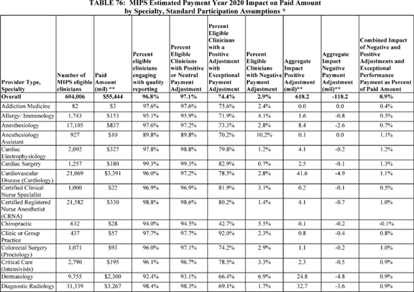

**[*53935]**



**[*53936]**

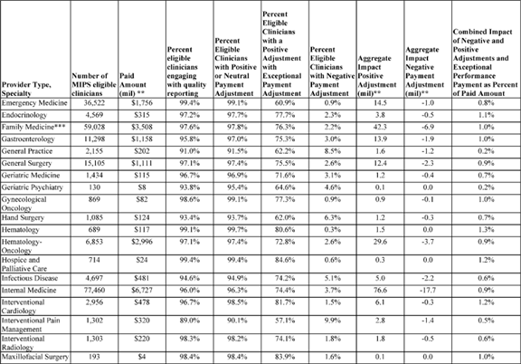

**[*53936]**



**[*53937]**

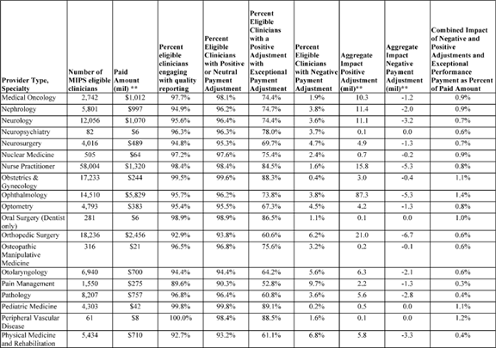

**[*53937]**



**[*53938]**

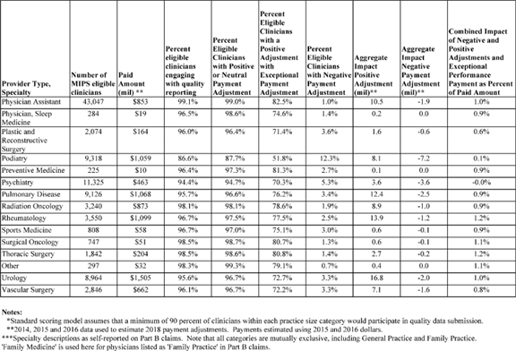

**[*53938]**



**[*53939]**

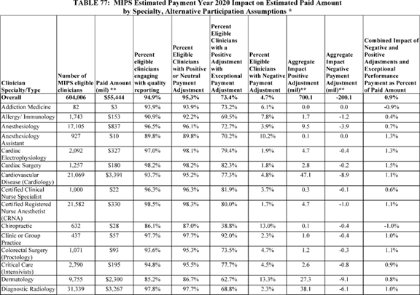

**[*53939]**



**[*53940]**

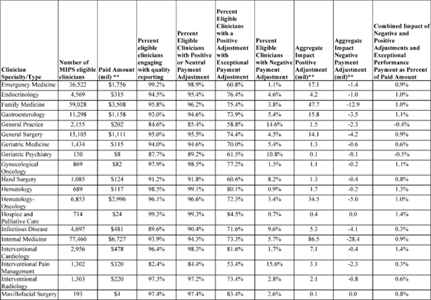

**[*53940]**



**[*53941]**

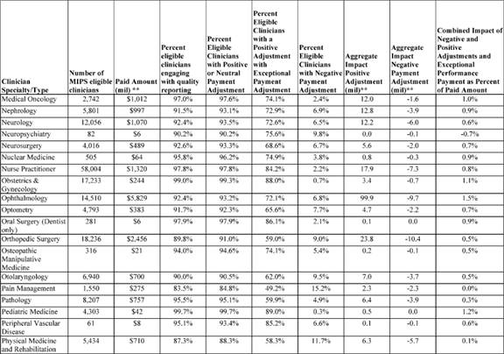

**[*53941]**



**[*53942]**

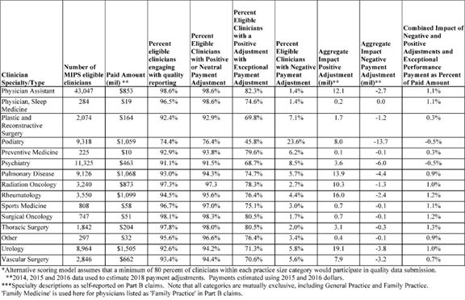

**[*53942]**



**[*53943]**

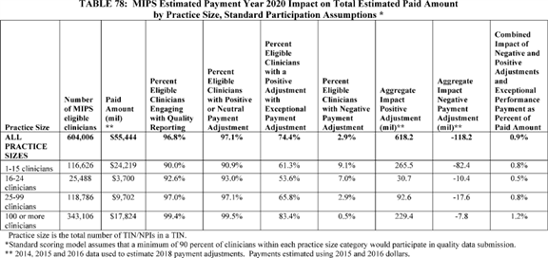

**[*53943]**



**[*53944]**

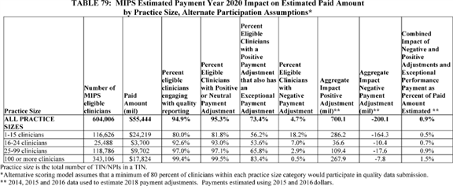

**[*53944]**



4. Potential Costs of Compliance With the Advancing Care Information and Improvement Activities Performance Categories for Eligible Clinicians

a. Potential Costs of Compliance With Advancing Care Information Performance Category

We believe that most MIPS eligible clinicians who can report the advancing care information performance category of MIPS have already adopted an EHR during Stage 1 and 2 of the Medicare or Medicaid EHR Incentive Programs, and will have limited additional operational expenses related to compliance with the advancing care information performance category requirements. Under the policies established in the CY 2017 Quality Payment Program final rule, MIPS eligible clinicians who did not participate in the Medicare and Medicaid EHR Incentive Programs could potentially have faced additional operational expenses for implementation and compliance with the advancing care information performance category requirements. We believe that clinicians who complied with the transition year requirements of the advancing care information performance category will incur no additional costs for compliance for this final rule with comment period. This final rule with comment period allows clinicians to continue to use EHR technology certified to the 2014 Edition CEHRT, which would allow them to use the same technology required in the transition year. (Clinicians may also choose to use the 2015 Edition CEHRT or a combination of the two.) Similarly, we believe that third parties who submit data on behalf of clinicians who prepared to submit data in the transition year will not incur additional costs as a result of this rule.

As a result of this final rule with comment period, some clinicians who were required to submit advancing care information performance category data under transition year policies will no longer be required to submit data.. As described in section II.C.2.c of this final rule with comment period, we found that increasing the low-volume threshold to exclude individual eligible clinicians or groups that have Medicare Part B allowed charges less than or equal to $ 90,000 or that provide care for 200 or fewer Part B-enrolled Medicare beneficiaries will exclude approximately 123,000 additional clinicians from MIPS from the approximately 744,000 clinicians that would have been eligible based on the low-volume threshold that was finalized in the CY 2017 Quality Payment Program final rule. Among the 123,000 additional clinicians excluded due to the increase in the low-volume threshold, we estimate that approximately 40,000 clinicians who had not previously participate in the EHR Incentive Program would have been required to submit advancing care information performance category data under the low-volume threshold finalized in the CY 2017 Quality Payment Program final rule.

In addition to changes to the low volume threshold, we have expanded the reasons a clinician can qualify for having the advancing care information category be weighted at zero percent of the final score. We will continue our policy that was finalized in the 2017 Quality Payment Program final rule at § 414.1375(a) to reweight the advancing care information performance category scores for certain MIPS eligible clinicians, including those who may have been exempt from the Medicare EHR Incentive Program such as hospital-based clinicians, non-patient facing clinicians, PAs, NPs, CNs and CRNAs [*(81 FR 77237*](https://advance.lexis.com/api/document?collection=administrative-codes&id=urn:contentItem:5M3D-MP10-006W-80MT-00000-00&context=) through 77245). Further, as described in section II.6.f.(7)(a)(iv) of this final rule with comment period, we rely on section 1848(o)(2)(D) of the Act, as amended by section 4002(b)(1)(B) of the 21st Century Cures Act, to assign a scoring weight of zero percent for the advancing care information performance category for MIPS eligible clinicians who are determined to be based in ambulatory surgical centers (ASCs). As described in section II.6.f.(7)(a)(i) of this final rule with comment period, we rely on section 1848(o)(2)(D) of the Act, as amended by section 4002(b)(1)(B) of the 21st Century Cures Act, to allow MIPS eligible clinicians to apply for a significant hardship exception and subsequently have their advancing care information performance category reweighted to zero when they are faced with a significant hardship. Relying on this same authority, we are finalizing a new significant hardship exception for the advancing care information performance category for MIPS eligible clinicians who are in small practices, as discussed in section II.6.f.7.(a)(ii) of this final rule with comment period, and finalizing an exception for MIPS eligible clinicians whose CEHRT has been decertified under ONC's Health IT Certification Program as discussed in section II.6.f.7.(a)(v) of this final rule with comment period. While we are unable to account for all of these exceptions in our model, we do estimate that approximately 60,000 MIPS eligible clinicians in small practices who had not previously reported under the EHR Incentive Program would not have to adopt an EHR to comply with the advancing care information performance category requirements.

As we have stated with respect to the Medicare EHR Incentive Program, we believe that future retrospective studies on the costs to implement an EHR and the return on investment (ROI) will demonstrate efficiency improvements that offset the actual costs incurred by MIPS eligible clinicians participating in MIPS and specifically in the advancing care information performance category, but we are unable to quantify those costs and benefits at this time. However, given that approximately 40,000 clinicians would no longer be eligible due to the low-volume threshold and approximately 60,000 MIPS eligible clinicians in small practices qualify for a significant hardship exception, we believe the overall cost of compliance would decrease as a result of this final rule with comment period.

At present, evidence on EHR benefits in either improving quality of care or reducing health care costs is mixed. This is not surprising since the adoption of EHR as a fully functioning part of medical practice is progressing, with numerous areas of adoption, use, and sophistication demonstrating need for improvement. Even physicians and hospitals that can meet Medicare EHR Incentive Program standards have not necessarily fully implemented all the functionality of their systems or fully exploited the diagnostic, prescribing, and coordination of care capabilities that these systems promise. Moreover, many of the most important benefits of EHR depend on interoperability among systems and this functionality is still lacking in many EHR systems.

A RAND report prepared for the ONC reviewed 236 recent studies that related the use of health IT to quality, safety, and efficacy in ambulatory and non-ambulatory care settings and found that--

"A majority of studies that evaluated the effects of health IT on healthcare quality, safety, and efficiency reported findings that were at least partially positive. These studies evaluated several forms of health IT: Metric of satisfaction, care process, and cost and health outcomes across many different care settings. Our findings agree with previous [research] suggesting that health IT, particularly those functionalities included in the Medicare EHR Incentive Program ***regulation***, can improve healthcare quality and safety. The relationship between health IT and [health care] efficiency is complex and remains poorly documented or understood, particularly in terms of **[*53945]** healthcare costs, which are highly dependent upon the care delivery and financial context in which the technology is implemented." n51 Other recent studies have not found definitive quantitative evidence of benefits. n52 Health IT vendors may face additional costs in Quality Payment Program Year 2 if they choose to develop additional capabilities in their systems to submit advancing care information and improvement activities performance category data on behalf of MIPS eligible clinicians.

n51 Paul G. Shekelle, et al. Health Information Technology: An Updated Systematic Review with a Focus on Meaningful Use Functionalities. RAND Corporation. 2014.

n52 See, for example, Saurabh Rahurkar, et al., "Despite the Spread of Health Information Exchange, There Is Little Information of Its Impact On Cost, Use, And Quality of Care," Health Affairs, March 2015; and Hemant K. Bharga and Abhay Nath Mishra, "Electronic Medical Records and Physician Productivity: Evidence from Panel Data Analysis," Management Science, July 2014.

We requested comments that provide information that would enable us to quantify the costs, costs savings, and benefits associated with implementation and compliance with the requirements of the advancing care information performance category.

The following is a summary of the public comments received regarding information that would enable us to quantify the costs, costs savings, and benefits associated with implementation and compliance with the requirements of the advancing care information performance category and our responses:

*Comment:* Several commenters indicated that CEHRT compliance, changing EHR systems, or switching from the 2014 CEHRT Edition to the 2015 CEHRT Edition remains costly for many small groups and individual clinicians. We received one comment that quantified the cost of compliance with the advancing care information performance category. One commenter mentioned they may be forced to change to another software, at a minimum cost of $ 90,000. The commenter noted risks of losing data in the process of conversion, and that none of the EHRs the commenter has tried has the same ease of use as the software they have been using for 11 years.

*Response:* Because we received only one comment that quantified the cost of compliance with the advancing care information performance category, we do not have sufficient information to draw robust conclusions about the cost of compliance for all types of practices, therefore we are not adding more quantified costs. As discussed in section II.C.6.f.(4), we are not requiring clinicians to upgrade to the 2015 Edition CEHRT for the 2018 MIPS performance period, but we continue to believe that 2015 Edition products have other benefits such as the ability to better support interoperability across the care continuum.

*Final Action:* After consideration of public comments, on the cost of compliance with the advancing care information category, we are not quantifying the costs, costs savings, and benefits associated with implementation and compliance with the requirements of the advancing care information performance category. However, given that approximately 40,000 clinicians would no longer be eligible due to the low-volume threshold and approximately 60,000 MIPS eligible clinicians in small practices qualify for a significant hardship exception, we believe the overall potential cost of compliance would decrease as a result of this final rule with comment period.

b. Potential Costs of Compliance With Improvement Activities Performance Category

Under the policies established in the CY 2017 Quality Payment Program final rule, the costs for complying with the improvement activities performance category requirements could have potentially led to higher expenses for MIPS eligible clinicians. Costs per full-time equivalent primary care clinician for improvement activities will vary across practices, including for some activities or certified patient-centered medical home practices, in incremental costs per encounter, and in estimated costs per (patient) member per month.

Costs for compliance with transition year policies may vary based on panel size (number of patients assigned to each care team) and location of practice among other variables. For example, Magill (2015) conducted a study of certified patient-centered medical home practices in two states. n53 That study found that costs associated with a full-time equivalent primary care clinician, who were associated with certified patient-centered medical home practices, varied across practices. Specifically, the study found an average cost of $ 7,691 per month in Utah practices, and an average of $ 9,658 in Colorado practices. Consequently, incremental costs per encounter were $ 32.71 for certified patient-centered medical home practices in Utah and $ 36.68 in Colorado (Magill, 2015). The study also found that the average estimated cost per patient member, per month, for an assumed panel of 2,000 patients was $ 3.85 in Utah and $ 4.83 in Colorado. However, given the lack of comprehensive historical data for improvement activities, we are unable to quantify those costs in detail at this time.

n53 Magill et al. "The Cost of Sustaining a Patient-Centered Medical Home: Experience from 2 States." Annals of Family Medicine, 2015; 13:429-435.

The following factors also contribute to the difficulty of identifying compliance costs for the improvement activities performance category. Some improvement activities, such as those related to expanded hours and access (for example, IA_EPA_1 "Provide 24/7 Access to Eligible Clinicians or Groups Who Have Real-time Access to Patient's Medical Record" as finalized in Table G of the appendices of this final rule with comment period), may be revenue neutral as MIPS eligible clinicians can receive payment for services provided during the expanded hours. Other improvement activities, such as IA_PSPA_2 "Participation in MOC Part IV" (as finalized in Table G of the appendices of this final rule with comment period), is connected to board certification, and we anticipate that there would be no additional compliance costs associated with this final rule with comment period above and beyond costs that clinicians already incur to maintain board certification. Some improvement activities have direct out-of-pocket costs, such as fees, while other improvement activities have no fees.

While we are unable to quantify the compliance costs of the improvement activities performance category, we do believe that because we are increasing the low volume threshold (as described in section II.C.2.c of this final rule with comment period), we will exclude approximately 123,000 additional clinicians from MIPS from the approximately 744,000 clinicians that would have been eligible based on the low-volume threshold that was finalized in the CY 2017 Quality Payment Program final rule. With this reduction in clinicians that are required to submit data to the improvement activities performance category, we believe the overall potential cost of compliance would decrease as a result of this final rule with comment period.

Further, we anticipate that the vast majority of clinicians submitting improvement activities data to comply with transition year policies could continue to submit the same activities under the policies established in this final year with comment period. Only 1 of the 92 improvement activities established in the transition year was removed from the inventory, while 20 additional activities were added (See **[*53946]** Tables F and G of the Appendices). Similarly, we believe that third parties who submit data on behalf of clinicians who prepared to submit data in the transition year will not incur additional costs as a result of this rule. We requested comments that provide information that would enable us to quantify the costs, costs savings, and benefits associated implementation of improvement activities.

The following is a summary of the public comments received and our responses:

*Comment:* A few commenters urged CMS to consider the regulatory impact on both clinicians and vendors in documenting and demonstrating successful performance of improvement activities. One commenter asked that CMS consider the direct costs charged by vendors for submitting improvement activities via qualified registry and/or EHR, which can be substantial as reflected in the updated qualified registries and QCDR lists for performance period 2017. One commenter suggested that CMS determine and publish the organizational costs (for both clinical organizations and vendors) to meet Quality Payment Program requirements to make the opportunity costs of the Quality Payment Program more apparent, because the commenter believed these costs displace discretionary spending on bona fide improvement activities in terms of money, time, and personnel.

*Response:* Improvement activities are an opportunity for clinicians to engage in activities that are most relevant to their practice and contribute toward improvements in health outcomes. As such, we believe the effort needed to demonstrate successful performance will be limited as the clinicians will be reporting on improvement activities that they are already performing because they recognize health outcome improvements. Additionally, activities may be continuing (that is, could have started prior to the performance period and are continuing) or be adopted in the performance period as long as an activity is being performed for at least 90 days. This means that clinicians may have already invested in implementing an improvement activity in CY 2017 and may be continuing with that activity in CY 2018 where they are not incurring any additional costs. For consideration of the direct costs charged by vendors, we believe the commenter is referring to the 2017 lists available at [*https://qpp.cms.gov/docs/QPP_2017_Qualified_Registries.pdf*](https://qpp.cms.gov/docs/QPP_2017_Qualified_Registries.pdf) and [*https://qpp.cms.gov/docs/QPP_2017_CMS_Approved_QCDRs.pdf*](https://qpp.cms.gov/docs/QPP_2017_CMS_Approved_QCDRs.pdf). While the costs vary on these lists, we note that we are unable to estimate the average costs per clinician. As stated in our description above, costs may vary based on panel size and location of practice among other variables. As such, we thank commenters for their input and will take them into consideration as we continue to evaluate how best to quantify the costs, costs savings, and benefits associated implementation of improvement activities.

*Final Action:* We will take into consideration of public comments received regarding the costs of implementation of improvement activities. We are not quantifying the costs, costs savings, and benefits associated with implementation and compliance with the requirements of the information activities performance category because we cannot systematically determine the amount associated with the ***regulation*** compliance at this time. However, with the reduction in clinicians that are required to submit data to the improvement activities performance category due to changes in the low-volume threshold, we believe the overall potential cost of compliance would decrease as a result of this final rule with comment period.

*D. Impact on Beneficiaries*

There were a number of changes in this final rule with comment period that will have an effect on beneficiaries. In general, we believe that the changes may have a positive impact and improve the quality and value of care provided to Medicare beneficiaries. More broadly, we expect that over time clinician engagement in the Quality Payment Program may result in improved quality of patient care, resulting in lower morbidity and mortality. We believe the policies finalized in the CY 2017 Quality Payment Program final rule, as well as policies in this rule will lead to additional growth in the participation of both MIPS APMS and Advanced APMs. APMs promote seamless integration by way of their payment methodology and design that incentivize such care coordination. The policies that are being finalized regarding the All-Payer Combination Option and identification of Other Payer Advanced APMs will help facilitate both the development and participation in alternative payment arrangements in the private and public sectors. Beginning in Quality Payment Program Year 3, the All-Payer Combination Option will be an available pathway to QP status for eligible clinicians participating sufficiently in Advanced APMs and Other Payer Advanced APMs. The All-Payer Combination Option allows for eligible clinicians to achieve QP status through their participation in both Advanced APMs and Other Payer Advanced APMs. Clinicians can focus their efforts around the care transformation in either Advanced APM or MIPS APM models and know that those efforts will be aligned with the Quality Payment Program, either through incentive payments for QPs or through MIPS scores calculated based on performance within the APM assessed at the APM Entity level.

Several Advanced APMs and MIPS APMS have shown evidence of improving the quality of care provided to beneficiaries and beneficiaries' experience of care. For example, in August of 2015, we issued quality and financial performance results for 2014 showing that ACOs continue to improve the quality of care for Medicare beneficiaries while generating net savings to the Medicare trust fund, if shared savings paid out to these ACOs are not included. n54 In 2014, the 20 ACOs in the Pioneer ACO Model and 333 Shared Shavings Program ACOs generated more than $ 411 million in total savings, which includes all ACOs' savings and losses but does not include shared savings payments to ACOs. The Pioneer ACO Model achieved net savings even after paying out shared savings payments to ACOs. Additionally, in their first years of implementation, both Pioneer and Shared Savings Program ACOs had higher quality care than Medicare FFS providers on measures for which comparable data were available. Beneficiaries with multiple chronic conditions and high predicted Medicare spending that were assigned to Shared Savings Program ACOs received better quality care than comparable FFS beneficiaries. n55 Between the first and fourth performance years of the Pioneer ACO Model, Pioneer ACOs improved their average quality score from 71 percent to 92 percent.

n54 [*https://www.cms.gov/Newsroom/MediaReleaseDatabase/Fact-sheets/2015-Factsheets-items/2015-08-25.html*](https://www.cms.gov/Newsroom/MediaReleaseDatabase/Fact-sheets/2015-Factsheets-items/2015-08-25.html).

n55 J.M. McWilliams et al., "Changes in Patients' Experiences in Medicare Accountable Care Organizations." New England Journal of Medicine 2014; 371:1715-1724, DOI: 10.1056/NEJMsa1406552.

The results from the third program year (January through December 2015) of the original CPC Initiative indicate that from 2013 to 2015 CPC practices transformed their care delivery--with the biggest improvements in risk-stratified care management, expanded access to care, and continuity of care. The independent evaluation also found **[*53947]** that CPC also improved patient experience slightly. Over the first 3 years, ED visits increased by 2 percent less for Medicare FFS beneficiaries in CPC practices relative to those in comparison practices.<56 57>

n56 Peikes, D., Taylor, E., Dale, S., et al. "Evaluation of the Comprehensive Primary Care Initiative: Second Annual Report." Princeton, NJ: Mathematica Policy Research, April 13, 2016, available at [*https://innovation.cms.gov/files/reports/cpci-evalrpt2.pdf*](https://innovation.cms.gov/files/reports/cpci-evalrpt2.pdf).

n57 For more detail see Peikes, D., Anglin, G., Taylor, E., et al. "Evaluation of the Comprehensive Primary Care Initiative: Third Annual Report." Princeton, NJ: Mathematica Policy Research, December 2016, available at [*https://innovation.cms.gov/Files/reports/cpci-evalrpt3.pdf*](https://innovation.cms.gov/Files/reports/cpci-evalrpt3.pdf).

As the early findings from the original CPC initiative and literature from other medical home models supported by payment suggest, we expect to see improvement in quality and patient experience of care.<58 59 60 61> Under CPC+, a higher proportion of the practice revenue is de-linked from FFS payment and there is thus more flexibility for practices to deliver care without a face-to-face encounter and instead in the modality that best meets patients' health care needs (that is, office visit, virtual visit, phone call, etc.). n62

n58 Reid, R.J., Fishman, P.A., Yu, O., Ross, T.R., Tufano, J.T., Soman, M.P, & Larson, E.B. (2009). Patient-centered medical home demonstration: A prospective, quasi-experimental, before and after evaluation. *AJMC, 15* (9), e71-e87.

n59 Maeng, D.D., Graham, J., Graf, T.R., Liberman, J.N., Dermes, N.B., Tomcavage, J., et al (2012). Reducing long-term cost by transforming primary care: Evidence from Geisinger's Medical Home Model. *AJMC, 18* (3), 149-155.

n60 Nelson, K.M., Helfrich, C., Sun, H., Hebert, P.L., Liu, C.F., Dolan, E., et al. (2014). Implementation of the patient-centered medical home in the Veterans Health Administration: Associations with patient satisfaction, quality of care, staff burnout, and hospital and emergency department use. *JAMA Intern Med, 174* (8), 1350-1358.

n61 DeVries, A., Li, C.H.W., Sridhar, G., Hummel, J.R., Breidbart, S., & Barron, J.J. (2012). Impact of medical homes on quality, Healthcare utilization, and costs. *AJMC, 18* (9), 534-544.

n62 Mechanic, R.E., Santos, P., Landon, B.E., & Chernew, M.E. (2011). Medical group responses to global payment: early lessons from the 'Alternative Quality Contract' in Massachusetts. *Health Aff (Millwood), 30* (9), 1734-42.

While maintaining coverage of Original Medicare services and beneficiary freedom to choose providers, ACOs could potentially enhance care management of the chronically ill aligned population through the adoption of leading-edge technologies, care coordination techniques, and evidence-based benefit enhancements that motivate providers and beneficiaries to optimize care. The evidence discussed here focuses on the benefit enhancements available under the Next Generation ACO Model, which include enhanced telehealth and home health care.

The transition from the inpatient setting to home is a critical period for patients, particularly elderly populations. Studies have examined a variety of interventions to help smooth care transitions. Interventions found in the literature include advance practice nurse-led comprehensive discharge planning and home visit follow-up protocols n63,64,65 and patient coaching accompanied by post-discharge home visits. n66 The Next Generation ACO Model is testing whether allowing participating ACOs to furnish and bill for types of post-discharge home visits not currently available under Original Medicare would improve outcomes for beneficiaries assigned to the ACO.

n63 Naylor MD, Brooten D, Campbell R, et al. Comprehensive Discharge Planning and Home Follow-up of Hospitalized Elders: A Randomized Clinical Trial. JAMA. 1999;281(7):613-620.

n64 Naylor, M. D., Brooten, D. A., Campbell, R. L., Maislin, G., McCauley, K. M. and Schwartz, J. S. (2004), Transitional Care of Older Adults Hospitalized with Heart Failure: A Randomized, Controlled Trial. Journal of the American Geriatrics Society, 52: 675-684.

n65 Stauffer BD, Fullerton C, Fleming N, et al. Effectiveness and Cost of a Transitional Care Program for Heart Failure: A Prospective Study with Concurrent Controls. Arch Intern Med. 2011;171(14):1238-1243.

n66 Voss R, Gardner R, Baier R, Butterfield K, Lehrman S, Gravenstein S. The Care Transitions Intervention: Translating From Efficacy to Effectiveness. Arch Intern Med. 2011;171(14):1232-1237.

The study of the potential value and efficacy of telehealth and remote patient monitoring has become more prevalent in recent years as technology has enabled greater utilization of these services. n67 Studies and case studies from health systems have shown value in using telehealth platforms for activities such as e-visits <68 69> and remote patient monitoring, n70 as well as for higher intensity care through real-time videoconferencing, n71 particularly to enable older adults to receive care more rapidly from their homes and with minimal burden. The Next Generation ACO Model allows ACOs flexibility in utilizing telehealth services to improve access to the most appropriate care for aligned beneficiaries.

n67 Joseph Kvedar, Molly Joel Coye and Wendy Everett, Connected Health: A Review Of Technologies and Strategies to Improve Patient Care with Telemedicine and Telehealth, Health Affairs, 33, no.2 (2014):194-199.

n68 Patrick T. Courneya, Kevin J. Palattao and Jason M. Gallagher. HealthPartners' Online Clinic For Simple Conditions Delivers Savings Of $ 88 Per Episode And High Patient Approval. Health Affairs, 32, no.2 (2013):385-392.

n69 Mehrotra A, Paone S, Martich G, Albert SM, Shevchik GJ. A Comparison of Care at E-visits and Physician Office Visits for Sinusitis and Urinary Tract Infection. JAMA Intern Med. 2013;173(1):72-74.

n70 UVA Health System, Tech Firm Collaborate to Reduce Hospital Readmission Rates. VHQC News. June 2014.

n71 Shah MN, Gillespie SM, et al. High-Intensity Telemedicine-Enhanced Acute Care for Older Adults: An Innovative Healthcare Delivery Model. Journal of the American Geriatrics Society. 2003; 61(11):2000-2007.

1. Impact on Other Health Care Programs and Providers

We estimate that the Quality Payment Program Year 2 will not have a significant economic effect on eligible clinicians and groups and believe that MIPS policies, along with increasing participation in APMs over time may succeed in improving quality and reducing costs. This may in turn result in beneficial effects on both patients and some clinicians, and we intend to continue focusing on clinician-driven, patient-centered care.

We will implement several policies for the Quality Payment Program Year 2 to reduce burden. These include raising the low-volume threshold with the effect that fewer clinicians in small practices are required to participate in the MIPS starting with the 2018 MIPS performance period; including bonus points for clinicians in small practices; adding a new significant hardship exception for the advancing care information performance category for MIPS eligible clinicians in small practices; implementing virtual groups; and extending the ability of MIPS eligible clinicians and groups to use 2014 CEHRT Edition while providing bonus points for the use of the 2015 Edition of CEHRT. Additionally, for vendors, we believe the flexibility to use EHR technology certified to either the 2014 Edition or the 2015 Edition for the Quality Payment Program Year 2 is beneficial as vendors will have additional time to deploy the updated software to their customers, which are the clinicians and other providers. Clinicians will likewise have additional time to upgrade and implement the new functionalities.

In summary, the Quality Payment Program policies are designed to promote the delivery of high-value care for individuals in all practices and areas with a focus on easing the burden for clinicians in small and solo practices. We believe each of these policies will further reduce burdens on clinicians and practices and help increase successful participation. Further, the policies throughout this final rule with comment period will focus the Quality Payment Program in its second year on encouraging more complete data submission and educating clinicians. The policies will continue a glide path, which began in the transition year, to more robust participation and performance in future years. The policy **[*53948]** changes are reflected in the RIA estimates, which show that the risk for negative MIPS payment adjustment is minimal for MIPS eligible clinicians, including small and solo practices that meet the data completeness requirements.

2. Alternatives Considered

This final rule with comment period contains a range of policies, including many related to specific statutory provisions. The preceding preamble provides descriptions of the statutory provisions that are addressed, identifies those policies where discretion has been exercised, presents our rationale for our policies and, where relevant, analyzes alternatives that we considered. We view the performance threshold as one of the most important factors affecting the distribution of payment adjustments under the Quality Payment Program, and the alternatives that we considered focus on that policy.

For example, as discussed in section II.C.8.c. of this final rule with comment period, we finalized a 15-point performance threshold and a 70-point additional performance threshold. As described earlier, we assumed a minimum 90 percent participation rate in each category of eligible clinicians and an alternative with a minimum 80 percent participation rate. We displayed the results of that modeling in Table 76 and 77 along with subsequent tables described in section VI.B.2 of this final rule with comment period.

In addition, as discussed in section II.C.2.c, we increased the low-volume threshold to exclude individual eligible clinicians or groups that have Medicare Part B allowed charges less than or equal to $ 90,000 or that provide care for 200 or fewer Part B-enrolled Medicare beneficiaries compared to the low-volume threshold that was finalized in the CY 2017 Quality Payment Program final rule which would exclude individual eligible clinicians or groups that have Medicare Part B allowed charges less than or equal to $ 30,000 or that provide care for 100 or fewer Part B-enrolled Medicare beneficiaries. Using our standard model assumptions described in section VI.C.3 of this final rule with comment period, the low volume threshold based on the transition year would have included approximately 744,000 MIPS eligible clinicians distribute approximately $ 139 million in payment adjustments on a budget-neutral basis, compared to our final policy which has 622,000 MIPS eligible clinicians and distributes approximately $ 118 million in payment adjustments on a budget-neutral basis.

3. Assumptions and Limitations

We would like to note several limitations to the analyses that estimated MIPS eligible clinicians' eligibility, negative MIPS payment adjustments, and positive payment adjustments for the 2020 MIPS payment year based on the data prepared to support the 2017 performance period initial determination of clinician and special status eligibility (available via the NPI lookup on *qpp.cms.gov*), participant lists using the initial QP determination file for the transition year, and 2014, 2015, and 2016 data from legacy programs, including the PQRS, CAHPS for PQRS, and the VM.

The scoring model cannot fully reflect MIPS eligible clinicians' behavioral responses to MIPS. The scoring model assumes higher participation in MIPS quality reporting than under the PQRS. Other potential behavioral responses are not addressed in our scoring model. The scoring model assumes that quality measures submitted and the distribution of scores on those measures would be similar under Quality Payment Program Payment in the 2020 MIPS payment year as they were under the 2016 PQRS program.

The scoring model does not reflect the growth in Advanced APM participation between 2017 and 2018 (Quality Payment Program Years 1 and 2). After applying the other MIPS exclusions, the scoring model excluded an additional 70,732 QPs using the initial QP determination file. n72 This estimate is much lower than the summary level projection for the 2018 Quality Payment Program performance period based on the total expected growth in APM participation (185,000 to 250,000) because the projected file does not have information at the TIN/NPI level which is needed for our model.

n72 70,732 QPs were excluded from our analysis who did not meet any of the other MIPS exclusion or ineligibility criteria; in other words, they were eligible clinician types and exceeded the low-volume threshold. An additional 29,917 QPs were excluded from our burden estimates who also met other MIPS exclusion or ineligibility criteria--that is they were not eligible clinician types or did not exceed the low-volume threshold.

There are additional limitations to our estimates. To the extent that there are year-to-year changes in the data submission, volume and mix of services provided by MIPS eligible clinicians, the actual impact on total Medicare revenues will be different from those shown in Tables 76 through 79. Due the limitations above, there is considerable uncertainty around our estimates that is difficult to quantify in detail.

*E. Regulatory Review Costs*

If ***regulations*** impose administrative costs on private entities, such as the time needed to read and interpret this final rule with comment period, we should estimate the cost associated with regulatory review. Due to the uncertainty involved with accurately quantifying the number of entities that will review this final rule with comment period, we assume that the total number of commenters on the CY 2018 Quality Payment Program published proposed rule will be the number of reviewers of this final rule with comment period (1300 commenters). We acknowledge that this assumption may understate or overstate the costs of reviewing this rule. It is possible that not all commenters reviewed the proposed in detail, and it is also possible that some reviewers chose not to comment on the CY 2018 Quality Payment Program proposed rule. For these reasons, we believe that the number of commenters for the CY 2018 Quality Payment Program proposed rule would be a fair estimate of the number of reviewers of this final rule with comment period.

We also recognize that different types of entities are in many cases affected by mutually exclusive sections of this final rule with comment period. Therefore, for the purposes of our estimate, we assume that each reviewer reads approximately 50 percent of the final rule with comment period.

Using the wage information from the BLS for practice administrators (medical and health service managers) (Code 11-9111), we estimate that the cost of reviewing the proposed rule is $ 105.16 per hour, including overhead and fringe benefits, which we assume are 100 percent of the hourly wage for a practice administrator ([*https://www.bls.gov/oes/2016/may/naics4_621100.htm*](https://www.bls.gov/oes/2016/may/naics4_621100.htm)). Assuming an average reading speed, we estimate that it would take approximately 16.4 hours for a practice administrator to review half of the proposed rule. For each commenter that reviews this final rule with comment period, the estimated cost is $ 1,724.62 (16.4 hours x $ 105.16). Therefore, we estimate that the total cost of reviewing this final rule with comment period is $ 2,242,011.20 ($ 1,724.62 x 1,300 reviewers).

We welcomed any public comments on the approach in estimating the number of entities that would review the regulatory text that we described in CY 2018 Quality Payment Program proposed rule [*(82 FR 30244).*](https://advance.lexis.com/api/document?collection=administrative-codes&id=urn:contentItem:5NX6-6BS0-006W-83PD-00000-00&context=) We did not receive any specific comments related to the number of readers of this proposed rule, or that each reviewer **[*53949]** reads approximately 50 percent of the information.

*F. Accounting Statement*

As required by OMB Circular A-4 (available at [*http://www.whitehouse.gov/omb/circulars/a004/a-4.pdf*](http://www.whitehouse.gov/omb/circulars/a004/a-4.pdf)), in Table 80 (Accounting Statement), we have prepared an accounting statement.

We have not attempted to quantify the benefits of this final rule with comment period because of the many uncertainties as to both clinician behaviors and resulting effects on patient health and cost reductions. For example, the applicable percentage for MIPS payment adjustments changes over time, increasing from 4 percent in 2019 to 9 percent in 2022 and subsequent years, and we are unable to estimate precisely how physicians will respond to the increasing payment adjustments. As noted above, in CY 2020, we estimate that we will distribute approximately $ 118 million in payment adjustments on a budget-neutral basis, which represents the applicable percent for 2020 required under section 1848(q)(6)(B)(i) of the Act and excludes $ 500 million in additional MIPS payment adjustments for exceptional performance.

Further, the addition of new Advanced APMs and growth in Advanced APM participation over time will affect the pool of MIPS eligible clinicians, and for those that are MIPS eligible clinicians, may change their relative performance. The $ 500 million available for exceptional performance and the 5 percent APM Incentive Payment for QPs are only available from 2019 through 2024. Beginning in 2026, Medicare PFS payment rates for services furnished by QPs will receive a higher update than for services furnished by non-QPs. However, we are unable to estimate the number of QPs in those years, as we cannot project the number or types of Advanced APMs that will be made available in those years through future CMS initiatives proposed and implemented in those years, nor the number of QPs for those future Advanced APMs.

The percentage of the final score attributable to each performance category will change over time and we will continue to refine our scoring rules. The improvement activities category represents a new category for measuring MIPS eligible clinicians' performance. We may also propose policy changes in future years as we continue implementing MIPS and as MIPS eligible clinicians accumulate experience with the new system. Moreover, there are interactions between the MIPS and APM incentive programs and other shared savings and incentive programs that we cannot model or project. Nonetheless, even if ultimate savings and health benefits represent only low fractions of current experience, benefits are likely to be substantial in overall magnitude.

Table 80 includes our estimate for MIPS payment adjustments ($ 118 million), the exceptional performance payment adjustments under MIPS ($ 500 million), and incentive payments to QPs (using the range described in the preceding analysis, approximately $ 675-$ 900 million). However, of these 3 elements, only the negative MIPS payment adjustments are shown as estimated decreases.

| **Table 80--Accounting Statement: Transfers** | |
| --- | --- |
|  |  |
| **Category** | **Transfers** |
| CY 2020 Annualized Monetized Transfers | Estimated increase of between $ 1,293 |
|  | and $ 1,518 million in payments for |
|  | higher performance under MIPS and to |
|  | QPs. fn73 |
| From Whom to Whom? | Increased Federal Government payments |
|  | to physicians, other practitioners and |
|  | suppliers who receive payment under |
|  | the Medicare Physician Fee Schedule. |
| Category | Transfers |
| CY 2020 Annualized Monetized Transfers | Estimated decrease of $ 118 million |
|  | for lower performance under MIPS. |
| From Whom to Whom? | Reduced Federal Government payments to |
|  | physicians, other practitioners and |
|  | suppliers who receive payment under |
|  | the Medicare Physician Fee Schedule. |

Note: These estimates are identical under both a 7 percent and 3 percent discount rate.

Based on National Health Expenditure data, n74 total Medicare expenditures for physician and clinical services in 2015 reached $ 144.3 billion. Expenditures for physician and clinical services from all sources reached $ 634.9 billion. Table 80 shows that the aggregate negative MIPS payment adjustment for all MIPS eligible clinicians under MIPS is estimated at $ 118 million, which represents approximately 0.08 percent of Medicare payments for physician and clinical services and approximately 0.02 percent of payments for physician and clinician services from all sources. Table 80 also shows that the aggregate positive payment adjustment for MIPS eligible clinicians under MIPS is estimated at $ 618 million (including additional MIPS payment adjustments for exceptional performance), which represents less than 0.5 percent of Medicare expenditures for physician and clinician services and 0.1 percent of Medicare expenditures from all sources for physician and clinical services.

n73 A range of estimates is provided due to uncertainty about the number of Advanced APM participants that will meet the QP threshold in 2016.

n74 Physicians and Clinical Services Expenditures, [*https://www.cms.gov/Research-Statistics-Data-and-Systems/Statistics-Trends-and-Reports/NationalHealthExpendData/NationalHealthAccountsHistorical.html*](https://www.cms.gov/Research-Statistics-Data-and-Systems/Statistics-Trends-and-Reports/NationalHealthExpendData/NationalHealthAccountsHistorical.html).

Table 81 summarizes the regulatory review costs discussed in section VI.E. of this final rule with comment period, and the collection of information burden costs calculated in section IV.N. of this final rule with comment period.

As noted above, we estimate the regulatory review costs of $ 2.2 million for this final rule with comment period. In Table 81, we have prepared our analysis of collection of information burden costs to be consistent with guidance in accordance with OMB's April 2017 guidance on EO13771. The Order's guidance directs agencies to measure certain costs, including costs associated with "Medicare quality performance tracking", using the estimates in the CY 2017 Quality Payment Program final rule as a baseline. The Order notes that regular updates to certain Medicare ***regulations*** make assessments of the incremental changes related to "performance tracking" included in a ***regulation*** much more useful than a comparison against **[*53950]** hypotheticals (such as a program's hypothetical discontinuation).

As shown in section IV.N. of this final rule with comment period, we estimate that this final rule with comment period will result in approximately $ 695 million in collection of information-related burden. However, we estimate that the incremental collection of information-related burden associated with this final rule with comment period is an approximately $ 13.9 million reduction relative to the baseline burden of continuing the policies and information collections set forth in the CY 2017 Quality Program final rule into CY 2018. Our burden estimates reflect several finalized policies that would reduce burden, including the reduction in the length of the CAHPS survey; and our proposal to allow MIPS eligible clinicians to form virtual groups, which would create efficiencies in data submission; and our proposal for significant hardship or other type of exception, including a new significant hardship exception for small practices for the advancing care information performance category.

| **Table 81--Additional Costs and Benefits** | |
| --- | --- |
|  |  |
| **Category of cost or benefits** | **Costs/benefits** |
| Regulatory Review Costs | $ 2.2 million. |
| Incremental Collection of | -$ 13.9 million. |
| Information/Paperwork Reduction Act |  |
| Burden Estimates |  |
| Costs of Newly Incentivized EHR and | Unquantified reduction due to a |
| Improvement Activities | reduction of clinicians required to |
|  | submit data, but potentially |
|  | anticipated. |
| Benefits of Expanded Advanced and MIPS | Improvements in quality, patient |
| APM Participation | experience of care, readmission rates, |
|  | access to appropriate care, and total |
|  | cost of care. |
| Benefits of MIPS | Improvements in quality, patient |
|  | experience of care, and readmission |
|  | rates. |

Note: These estimates are identical under both a 7 percent and 3 percent discount rate. Incremental information collection costs are total information collection costs associated with this final rule with comment period minus costs associated with CY 2017 Quality Payment Program final rule.

Table 81 also shows the expected benefits associated with this final rule with comment period. We note that these expected benefits are qualitative in nature. We expect that the Quality Payment Program will result in quality improvements and improvements to the patients' experience of care as MIPS eligible clinicians respond to the incentives for high-quality care provided by the Program and implement care quality improvements in their clinical practices. While we cannot quantify these effects specifically at this time because we cannot project eligible clinicians' behavioral responses to the incentives offered under the Quality Payment Program, we nevertheless believe that changes to clinical care will result in care quality improvements for Medicare beneficiaries and other patients treated by eligible clinicians.

*G. Regulatory Impact Statement for Interim Final Rule With Comment Period: Medicare Program; Quality Payment Program: Extreme and Uncontrollable Circumstance Policy for the Transition Year*

We estimate the implications of adopting the extreme and uncontrollable circumstance policy in this interim final rule with comment period for the transition year could reduce the amount redistributed in the 2019 MIPS payment year by approximately $ 19.9 million. We determined this estimate assessing the impact of this policy on the potential number of MIPS eligible clinicians and applying that to the regulatory impact described in the CY 2017 Quality Payment Program final rule. In the CY 2017 Quality Payment Program final rule, we estimated approximately $ 199 million in payment adjustments would be redistributed in MIPS on a budget neutral basis [*(81 FR 77535).*](https://advance.lexis.com/api/document?collection=administrative-codes&id=urn:contentItem:5M3D-MP10-006W-80MT-00000-00&context=) Additionally, up to $ 500 million would be distributed for the additional MIPS payment adjustment for exceptional performance [*(81 FR 77535).*](https://advance.lexis.com/api/document?collection=administrative-codes&id=urn:contentItem:5M3D-MP10-006W-80MT-00000-00&context=) We analyzed the MIPS eligibility file from the first eligibility run and estimated approximately 10 percent of MIPS eligible clinicians practiced in areas affected by the Hurricanes Harvey, Irma, and Maria. Based on this finding, we estimate approximately 10 percent of MIPS eligible clinicians with a negative payment adjustment may receive a neutral payment adjustment which represents approximately $ 19.9 million (10 percent of $ 199 million). We do not believe that this interim final rule with comment period would affect the overall distribution of the $ 500 million for exceptional performance.

***Regulations***

**List of Subjects**

*42 CFR Part 414*

Administrative practice and procedure, Biologics, Drugs, Health facilities, Health professions, Diseases, Medicare, Reporting and recordkeeping requirements.

For the reasons set forth in the preamble, the Centers for Medicare & Medicaid Services amends 42 CFR chapter IV as set forth below:

1. **MEDICAL AND OTHER HEALTH SERVICES**
2. The authority citation for part 414 continues to read as follows:

**Authority:** Secs. 1102, 1871, and 1881(b)(l) of the Social Security Act ([*42 U.S.C. 1302*](https://advance.lexis.com/api/document?collection=statutes-legislation&id=urn:contentItem:4YF7-GM31-NRF4-40JV-00000-00&context=), [*1395hh*](https://advance.lexis.com/api/document?collection=statutes-legislation&id=urn:contentItem:4YF7-GKD1-NRF4-453S-00000-00&context=), and [*1395rr(b)(l)*](https://advance.lexis.com/api/document?collection=statutes-legislation&id=urn:contentItem:4YF7-GPS1-NRF4-41KB-00000-00&context=)).

1. Section 414.1305 is amended by--
2. Removing the definition of "Advanced APM Entity";
3. Revising the definition of "Affiliated practitioner";
4. Adding in alphabetical order a definition for "Ambulatory Surgical Center (ASC)-based MIPS eligible clinician";
5. Revising the definitions of "APM Entity" and "Attributed beneficiary";
6. Amending the definition "Certified Electronic Health Record Technology (CEHRT)" by revising paragraphs (1) introductory text, (1)(iii), and (2) introductory text;
7. Adding in alphabetical order a definition for "CMS Multi-Payer Model";
8. Adding in alphabetical order a definition for "Facility-based MIPS eligible clinician";
9. Revising the definition of "Final score";
10. Adding in alphabetical order a definition for "Full TIN APM";
11. Revising the definition of "Hospital-based MIPS eligible clinician";
12. Adding in alphabetical order a definition for "Improvement scoring";
13. Revising the definitions of "Low-volume threshold", "Medicaid APM", **[*53951]** and "Non-patient facing MIPS eligible clinician";
14. Adding in alphabetical order a definition for "Other MIPS APM";
15. Revising the definition of "Other Payer Advanced APM";
16. Removing the definition of "Rural areas";
17. Adding in alphabetical order a definition for "Rural area";
18. Removing the definition of "Small practices"; and
19. Adding in alphabetical order definitions for "Small practice", "Solo practitioner", and "Virtual group".

The revisions and additions read as follows:

*    *    *    *    *

*Affiliated practitioner* means an eligible clinician identified by a unique APM participant identifier on a CMS-maintained list who has a contractual relationship with the APM Entity for the purposes of supporting the APM Entity's quality or cost goals under the Advanced APM.

   *    *    *    *    *

*Ambulatory Surgical Center (ASC)-based MIPS eligible clinician* means a MIPS eligible clinician who furnishes 75 percent or more of his or her covered professional services in sites of service identified by the Place of Service (POS) codes used in the HIPAA standard transaction as an ambulatory surgical center setting based on claims for a period prior to the performance period as specified by CMS.

*APM Entity* means an entity that participates in an APM or other payer arrangement through a direct agreement with CMS or an other payer or through Federal or State law or ***regulation***.

   *    *    *    *    *

*Attributed beneficiary* means a beneficiary attributed to the APM Entity under the terms of the Advanced APM as indicated on the most recent available list of attributed beneficiaries at the time of a QP determination.

   *    *    *    *    *

*Certified Electronic Health Record Technology (CEHRT)* * * *:

1. For any calendar year before 2019, EHR technology (which could include multiple technologies) certified under the ONC Health IT Certification Program that meets one of the following:

   *    *    *    *    *

1. The definition for 2019 and subsequent years specified in paragraph (2) of this definition.
2. For 2019 and subsequent years, EHR technology (which could include multiple technologies) certified under the ONC Health IT Certification Program that meets the 2015 Edition Base EHR definition (as defined at [*45 CFR 170*](https://advance.lexis.com/api/document?collection=administrative-codes&id=urn:contentItem:5GFW-1YM0-008H-00BG-00000-00&context=).102) and has been certified to the 2015 Edition health IT certification criteria--

   *    *    *    *    *

*CMS Multi-Payer Model* means an Advanced APM that CMS determines, per the terms of the Advanced APM, has at least one other payer arrangement that is designed to align with the terms of that Advanced APM.

   *    *    *    *    *

*Facility-based MIPS eligible clinician* means an individual MIPS eligible clinician who furnishes 75 percent or more of their covered professional services (as defined in section 1848(k)(3)(A) of the Act) in sites of service identified by the Place of Service (POS) codes used in the HIPAA standard transaction as an inpatient hospital, as identified by POS code 21, or an emergency room, as identified by POS code 23, based on claims during the facility-based determination period, and a group provided that more than 75 percent of the NPIs billing under the group's TIN meet the definition of a facility-based individual MIPS eligible clinician during the facility-based determination period.

*Final score* means a composite assessment (using a scoring scale of 0 to 100) for each MIPS eligible clinician for a performance period determined using the methodology for assessing the total performance of a MIPS eligible clinician according to performance standards for applicable measures and activities for each performance category.

*Full TIN APM* means an APM where participation is determined at the TIN level, and all eligible clinicians who have assigned their billing rights to a participating TIN are therefore participating in the APM.

   *    *    *    *    *

*Hospital-based MIPS eligible clinician* means a MIPS eligible clinician who furnishes 75 percent or more of his or her covered professional services in sites of service identified by the place of service codes used in the HIPAA standard transaction as an inpatient hospital, on-campus outpatient hospital, off campus-outpatient hospital, or emergency room setting based on claims for a period prior to the performance period as specified by CMS.

   *    *    *    *    *

*Improvement scoring* means an assessment measuring improvement for each MIPS eligible clinician or group for a performance period using a methodology that compares improvement from one performance period to another performance period.

   *    *    *    *    *

*Low-volume threshold* means:

1. For the 2019 MIPS payment year, the low-volume threshold that applies to an individual eligible clinician or group that, during the low-volume threshold determination period described in paragraph (3) of this definition, has Medicare Part B allowed charges less than or equal to $ 30,000 or provides care for 100 or fewer Part B-enrolled Medicare beneficiaries.
2. For the 2020 MIPS payment year and future years, the low-volume threshold that applies to an individual eligible clinician or group that, during the low-volume threshold determination period described in paragraph (3) of this definition, has Medicare Part B allowed charges less than or equal to $ 90,000 or provides care for 200 or fewer Part B-enrolled Medicare beneficiaries.
3. The low-volume threshold determination period is a 24-month assessment period consisting of:
4. An initial 12-month segment that spans from the last 4 months of the calendar year 2 years prior to the performance period through the first 8 months of the calendar year preceding the performance period; and
5. A second 12-month segment that spans from the last 4 months of the calendar year 1 year prior to the performance period through the first 8 months of the calendar year performance period. An individual eligible clinician or group that is identified as not exceeding the low-volume threshold during the initial 12-month segment will continue to be excluded under § 414.1310(b)(1)(iii) for the applicable year regardless of the results of the second 12-month segment analysis. For the 2019 MIPS payment year, each segment of the low-volume threshold determination period includes a 60-day claims run out. For the 2020 MIPS payment year and future years, each segment of the low-volume threshold determination period includes a 30-day claims run out.

   *    *    *    *    *

*Medicaid APM* means a payment arrangement authorized by a State Medicaid program that meets the Other Payer Advanced APM criteria set forth in § 414.1420.

   *    *    *    *    *

*Non-patient facing MIPS eligible clinician* means:

1. An individual MIPS eligible clinician who bills 100 or fewer patient-facing encounters (including Medicare telehealth services defined in section 1834(m) of the Act), as described in **[*53952]** paragraph (2) of this definition, during the non-patient facing determination period described in paragraph (3) of this definition, and a group or virtual group provided that more than 75 percent of the NPIs billing under the group's TIN or virtual group's TINs, as applicable, meet the definition of a non-patient facing individual MIPS eligible clinician during the non-patient facing determination period described in paragraph (3) of this definition.
2. For purposes of this definition, a patient-facing encounter is an instance in which the individual MIPS eligible clinician or group bills for items and services furnished such as general office visits, outpatient visits, and procedure codes under the PFS, as specified by CMS.
3. For purposes of this definition, the non-patient facing determination period is a 24-month assessment period consisting of:
4. An initial 12-month segment that spans from the last 4 months of the calendar year 2 years prior to the performance period through the first 8 months of the calendar year preceding the performance period; and
5. A second 12-month segment that spans from the last 4 months of the calendar year 1 year prior to the performance period through the first 8 months of the calendar year performance period. An individual eligible MIPS clinician, group, or virtual group that is identified as non-patient facing during the initial 12-month segment will continue to be considered non-patient facing for the applicable year regardless of the results of the second 12-month segment analysis. For the 2019 MIPS payment year, each segment of the non-patient facing determination period includes a 60-day claims run out. For the 2020 MIPS payment year and future years, each segment of the non-patient facing determination period includes a 30-day claims run out.

*Other MIPS APM* means a MIPS APM that does not require reporting through the CMS Web Interface.

*Other Payer Advanced APM* means an other payer arrangement that meets the Other Payer Advanced APM criteria set forth in § 414.1420.

   *    *    *    *    *

*Rural area* means a ZIP code designated as rural, using the most recent Health Resources and Services Administration (HRSA) Area Health Resource File data set available.

*Small practice* means a practice consisting of 15 or fewer eligible clinicians.

*Solo practitioner* means a practice consisting of 1 eligible clinician (who is also a MIPS eligible clinician).

   *    *    *    *    *

*Virtual group* means a combination of two or more TINs assigned to one or more solo practitioners or to one or more groups consisting of 10 or fewer eligible clinicians, or both, that elect to form a virtual group for a performance period for a year.

1. Section 414.1315 is added to read as follows:
2. A solo practitioner or a group of 10 or fewer eligible clinicians must make their election to participate in MIPS as a virtual group prior to the start of the applicable performance period and cannot change their election during the performance period. Virtual group participants may elect to be in no more than one virtual group for a performance period and, in the case of a group, the election applies to all MIPS eligible clinicians in the group. Except as provided under § 414.1370(f)(2), each MIPS eligible clinician in the virtual group will receive a MIPS payment adjustment based on the virtual group's combined performance assessment.
3. A virtual group representative must make an election, on behalf of the members of a virtual group, regarding the formation of a virtual group for an applicable performance period, by December 31 of the calendar year preceding the applicable performance period.
4. The two-stage virtual group election process for the 2018 and 2019 performance years is as follows:
5. ***gibility determination.***
6. Solo practitioners and groups with 10 or fewer eligible clinicians interested in forming or joining a virtual group have the option to contact their designated technical assistance representative, as applicable, in order to determine whether or not they are eligible to participate in MIPS as a virtual group.
7. [Reserved]
8. ***mation.***
9. TINs comprising a virtual group must establish a formal written agreement that satisfies paragraph (3) of this section prior to an election.
10. On behalf of a virtual group, the official designated virtual group representative must submit an election by December 31 of the calendar year prior to the start of the applicable performance period.
11. The submission of a virtual group election must include, at a minimum, information pertaining to each TIN and NPI associated with the virtual group and contact information for the virtual group representative.
12. Once an election is made, the virtual group representative must contact their designated CMS contact to update any election information that changed during a performance period at least one time prior to the start of an applicable submission period.
13. The virtual group arrangement must be set forth in a written agreement among each solo practitioner and group that composes a virtual group. The agreement must comply with the following requirements:
14. Identifies the parties to the agreement by name of party, TIN, and NPI, and includes as parties to the agreement only the groups and solo practitioners that compose the virtual group.
15. Is executed on behalf of each party by an individual who is authorized to bind the party.
16. Expressly requires each member of the virtual group (and each NPI under each TIN in the virtual group) to participate in the MIPS as a virtual group and comply with the requirements of the MIPS and all other applicable laws and ***regulations*** (including, but not limited to, federal criminal law, False Claims Act, anti-kickback statute, civil monetary penalties law, Health Insurance Portability and Accountability Act of 1996, and physician self-referral law).
17. Identifies each NPI under each TIN in the virtual group and requires each TIN within a virtual group to notify all NPIs associated with the TIN regarding their participation in the MIPS as a virtual group.
18. Sets forth the NPI's rights and obligations in, and representation by, the virtual group, including without limitation, the reporting requirements and how participation in the MIPS as a virtual group affects the ability of the NPI to participate in the MIPS outside of the virtual group.
19. Describes how the opportunity to receive payment adjustments will encourage each member of the virtual group (and each NPI under each TIN in the virtual group) to adhere to quality assurance and improvement.
20. Requires each party to the agreement to update its Medicare enrollment information, including the addition and deletion of NPIs billing through its TIN, on a timely basis in accordance with Medicare program requirements and to notify the virtual group of any such changes within 30 days after the change. **[*53953]**
21. Is for a term of at least one performance period as specified in the formal written agreement.
22. Requires completion of a close-out process upon termination or expiration of the agreement that requires each party to the virtual group agreement to furnish all data necessary in order for the virtual group to aggregate its data across the virtual group.
23. ***quirements:***For TINs participating in MIPS at the virtual group level--
24. Individual eligible clinicians and individual MIPS eligible clinicians who are part of a TIN participating in MIPS at the virtual group level will have their performance assessed as a virtual group.
25. Individual eligible clinicians and individual MIPS eligible clinicians who are part of a TIN participating in MIPS at the virtual group level must meet the definition of a virtual group at all times during the performance period for the MIPS payment year.
26. Individual eligible clinicians and individual MIPS eligible clinicians who are part of a TIN participating in MIPS at the virtual group level must aggregate their performance data across multiple TINs in order for their performance to be assessed as a virtual group.
27. MIPS eligible clinicians that elect to participate in MIPS at the virtual group level will have their performance assessed at the virtual group level across all four MIPS performance categories.
28. Virtual groups must adhere to an election process established and required by CMS.
29. Section 414.1320 is amended by adding paragraph (c) to read as follows:
30. **riod.**

*    *    *    *    *

1. For purposes of the 2021 MIPS payment year, the performance period for:
2. The quality and cost performance categories is CY 2019 (January 1, 2019 through December 31, 2019).
3. The advancing care information and improvement activities performance categories is a minimum of a continuous 90-day period within CY 2019, up to and including the full CY 2019 (January 1, 2019 through December 31, 2019).
4. Section 414.1325 is amended by revising paragraphs (c)(4) and (6) and (d) to read as follows:
5. **uirements.**

*    *    *    *    *

1. * * *
2. The CMS Web Interface (for groups consisting of 25 or more eligible clinicians) for the quality, improvement activities, and advancing care information performance categories.

   *    *    *    *    *

1. A CMS-approved survey vendor for groups that elect to include the CAHPS for MIPS survey as a quality measure. Groups that elect to include the CAHPS for MIPS survey as a quality measure must select at least one other data submission mechanism described in this section to submit their other quality information.
2. *Report measures and activities, as applicable, via multiple data submission mechanisms for the quality, improvement activities, or advancing care information performance categories.* Beginning with the 2021 MIPS payment year, MIPS eligible clinicians, groups, and virtual groups may elect to submit measures and activities, as available, via multiple data submission mechanisms for a single performance category (specifically, the quality, improvement activities, or advancing care information performance category); provided, however, that the MIPS eligible clinician, group, or virtual group uses the same identifier for all performance categories and all submissions.

   *    *    *    *    *

1. Section 414.1335 is amended by revising the paragraphs (a)(2) introductory text and (a)(2)(i) to read as follows:
2. **teria for the quality performance category.**
3. * * *
4. ***-for groups consisting of 25 or more eligible clinicians only.***
5. Report on all measures included in the CMS Web Interface. The group must report on the first 248 consecutively ranked beneficiaries in the sample for each measure or module.

   *    *    *    *    *

1. Section 414.1340 is amended by revising paragraphs (a)(1) and (2) and (b)(1) and (2) to read as follows:
2. **riteria for the quality performance category.**
3. * * *
4. At least 50 percent of the MIPS eligible clinician or group's patients that meet the measure's denominator criteria, regardless of payer for the MIPS payment years 2019.
5. At least 60 percent of the MIPS eligible clinician or group's patients that meet the measure's denominator criteria, regardless of payer for the MIPS payment years 2020 and 2021.
6. * * *
7. At least 50 percent of the applicable Medicare Part B patients seen during the performance period to which the measure applies for MIPS payment years 2019.
8. At least 60 percent of the applicable Medicare Part B patients seen during the performance period to which the measure applies for MIPS payment years 2020 and 2021.

   *    *    *    *    *

1. Section 414.1360 is amended by revising paragraphs (a) introductory text and (a)(1) introductory text to read as follows:
2. **teria for the improvement activities performance category.**
3. For purposes of the transition year of MIPS and future years, MIPS eligible clinicians or groups must submit data on MIPS improvement activities in one of the following manners:
4. Via qualified registries; EHR submission mechanisms; QCDR, CMS Web Interface; or attestation. For activities that are performed for at least a continuous 90-days during the performance period, MIPS eligible clinicians must--

   *    *    *    *    *

1. Section 414.1370 is amended by--
2. Revising paragraphs (e) and (f);
3. Revising paragraph (g)(1)(i);
4. Adding paragraph (g)(1)(ii);
5. Revising paragraphs (g)(2), (g)(3)(i), (g)(4)(i), and (g)(4)(ii) introductory text;
6. Adding paragraph (g)(4)(iii);
7. Revising paragraph (h) introductory text, (h)(1)(i) and (ii), (h)(3)(i) and (ii), and (h)(4)(i) and (ii);
8. Adding paragraph (h)(5); and
9. Adding paragraph (i).

The revisions and additions read as follows:

1. **d under MIPS.**

*    *    *    *    *

1. ***tion.***For the APM scoring standard, the APM Entity group is determined in the manner prescribed in § 414.1425(b)(1).
2. In addition to the dates set forth in § 414.1425(b)(1), the APM Entity group includes an eligible clinician who is on a Participation List in a Full TIN APM on December 31 of the MIPS performance period.
3. [Reserved]
4. ***nder the APM scoring standard.***The MIPS final score calculated for the APM Entity is applied to each MIPS eligible clinician in the APM Entity group. The MIPS payment adjustment is applied at the TIN/NPI level for each of the MIPS eligible clinicians in the APM Entity group.
5. If a Shared Savings Program ACO does not report data on quality measures **[*53954]** as required by the Shared Savings Program under § 425.508 of this chapter, each ACO participant TIN will be treated as a unique APM Entity for purposes of the APM scoring standard and the ACO participant TINs may report data for the MIPS quality performance category according to the MIPS submission and reporting requirements.
6. MIPS eligible clinicians who have elected to participate in a virtual group and who are also on a MIPS APM Participation List will be included in the assessment under MIPS for purposes of producing a virtual group score and under the APM scoring standard for purposes of producing an APM Entity score. The MIPS payment adjustment for these eligible clinicians is based solely on their APM Entity score.
7. * * *
8. * * *
9. ***Entities to submit quality data using the CMS Web Interface.***
10. ***ry Score.***The quality performance category score for a MIPS performance period is calculated for the APM Entity using the data submitted by the APM Entity according to the terms of the MIPS APM, including data on measures submitted through the CMS Web Interface and other measures specified by CMS through notice and comment rulemaking for the APM scoring standard.
11. Beginning in 2018, for an APM Entity for which CMS calculated a total quality performance category score for one or more participants in the APM Entity for the previous MIPS performance period, CMS calculates a quality improvement score for the APM Entity group as specified in § 414.1380(b)(1)(xvi).
12. ***Category Score.***Beginning in 2018, the total quality performance category score is the sum of the quality performance category score, all applicable bonus points provided for by § 414.1380(b), and the quality improvement score.
13. ***ry Score.***The MIPS quality performance category score for a MIPS performance period is calculated for the APM Entity using the data submitted by the APM Entity based on measures specified by CMS through notice and comment rulemaking for each Other MIPS APM from among those used under the terms of the Other MIPS APM, and which are:
14. Tied to payment;
15. Available for scoring;
16. Have a minimum of 20 cases available for reporting; and
17. Have an available benchmark.
18. Beginning in 2019, for an APM Entity for which CMS calculated a total quality performance category score for the previous MIPS performance period, CMS calculates a quality improvement score for the APM Entity group, as specified in § 414.1380(b)(1)(xvi).
19. ***Category Score.***Beginning in 2018, the total quality performance category score is the sum of the quality performance category score, all applicable bonus points provided by § 414.1380(b), and the quality improvement score.
20. The cost performance category weight is zero percent for APM Entities in MIPS APMs.
21. * * *
22. CMS assigns an improvement activities score for each MIPS APM for a MIPS performance period based on the requirements of the MIPS APM. The assigned improvement activities score applies to each APM Entity group for the MIPS performance period. In the event that the assigned score does not represent the maximum improvement activities score, an APM Entity may report additional activities.

   *    *    *    *    *

1. * * *
2. Each Shared Savings Program ACO participant TIN must report data on the Advancing Care Information (ACI) performance category separately from the ACO, as specified in § 414.1375(b)(2). The ACO participant TIN scores are weighted according to the number of MIPS eligible clinicians in each TIN as a proportion of the total number of MIPS eligible clinicians in the APM Entity group, and then aggregated to determine an APM Entity score for the ACI performance category.
3. For APM Entities in MIPS APMs other than the Shared Savings Program, CMS uses one score for each MIPS eligible clinician in the APM Entity group to derive a single average APM Entity score for the ACI performance category. The score for each MIPS eligible clinician is the higher of either:

   *    *    *    *    *

1. In the event that a participant TIN in the Shared Savings Program or individual MIPS eligible clinician participating in a MIPS APM besides the Shared Savings Program receives an exception under section 1848(o)(2)(D) of the Act from the advancing care information performance category reporting requirements, such participant TIN or eligible clinician will be assigned a null score when CMS calculates the APM Entity's advancing care information performance category score under the APM scoring standard.
2. If all participant TINs or MIPS eligible clinicians in an APM Entity have been excepted from reporting the advancing care information performance category, the performance category weight will be reweighted to zero for the APM Entity for that MIPS performance period.
3. [Reserved]
4. ***rmance category weights.***The performance category weights used to calculate the MIPS final score for an APM Entity group for the APM scoring standard performance period are:
5. * * *
6. For MIPS APMs that require use of the CMS Web Interface: 50 percent.
7. For Other MIPS APMs, 0 percent for 2017, 50 percent beginning in 2018.

   *    *    *    *    *

1. * * *
2. For MIPS APMs that require use of the CMS Web Interface: 20 percent.
3. For Other MIPS APMs, 25 percent for 2017, 20 percent beginning in 2018.
4. * * *
5. For MIPS APMs that require use of the CMS Web Interface: 30 percent.
6. For Other MIPS APMs, 25 percent for 2017, 30 percent beginning in 2018.
7. ***rmance categories for the APM scoring standard.***If CMS determines there are not sufficient measures or activities applicable and available to MIPS eligible clinicians, CMS will assign weights as follows:
8. If CMS reweights the quality performance category to 0 percent:
9. In 2017, the improvement activities performance category is reweighted to 25 percent and the advancing care information performance category is reweighted to 75 percent; and
10. Beginning in 2018, the advancing care information performance category is reweighted to 80 percent and the improvement activities performance category will remain at 20 percent.
11. If CMS reweights the advancing care information performance category to 0 percent:
12. In 2017, the quality performance category is reweighted to 75 percent and the improvement activities performance category will remain at 25 percent.
13. Beginning in 2018, the quality performance category is reweighted to 80 percent and the improvement activities performance category will remain at 20 percent.
14. CMS scores each performance category and then multiplies each performance category score by the applicable performance category weight. CMS then **[*53955]** calculates the sum of each weighted performance category score and then applies all applicable adjustments. APM Entities will receive MIPS bonuses applied to the final score as set forth in § 414.1380(b).
15. Section 414.1375 is amended by revising paragraphs (a) and (b)(2)(ii) to read as follows:
16. **rmation performance category.**

*    *    *    *    *

1. The advancing care information performance category comprises 25 percent of a MIPS eligible clinician's final score for the 2019 MIPS payment year and each MIPS payment year thereafter, unless a different scoring weight is assigned by CMS.
2. * * *
3. * * *
4. May claim an exclusion for each measure that includes an option for an exclusion.

   *    *    *    *    *

1. Section 414.1380 is revised to read as follows:
2. MIPS eligible clinicians are scored under MIPS based on their performance on measures and activities in four performance categories. MIPS eligible clinicians are scored against performance standards for each performance category and receive a final score, composed of their scores on individual measures and activities, and calculated according to the final score methodology.
3. ***the four performance categories are scored against performance standards.***
4. For the quality performance category, measures are scored between zero and 10 points. Performance is measured against benchmarks. Bonus points are available for both submitting specific types of measures and submitting measures using end-to-end electronic reporting. Starting with the 2020 MIPS payment year, improvement scoring is available in the quality performance category.
5. For the cost performance category, measures are scored between 1 and 10 points. Performance is measured against a benchmark. Starting with the 2020 MIPS payment year, improvement scoring is available in the cost performance category.
6. For the improvement activities performance category, each improvement activity is worth a certain number of points. The points for each reported activity are summed and scored against a total potential performance category score of 40 points.
7. For the advancing care information performance category, the performance category score is the sum of a base score, performance score, and bonus score.
8. [Reserved]
9. MIPS eligible clinicians are scored under MIPS in four performance categories.
10. ***ry.***For the 2019 and 2020 MIPS payment years, MIPS eligible clinicians receive between 3 and 10 measure achievement points for each submitted measure that can be reliably scored against a benchmark, which requires meeting the case minimum and data completeness requirements. A quality measure must have a measure benchmark to be scored based on performance. Quality measures that do not have a benchmark will not be scored based on performance. For the 2019 and 2020 MIPS payment years, MIPS eligible clinicians will receive 3 points for measures that are submitted but do not meet the required case minimum or do not have a benchmark. For the 2020 MIPS payment year, MIPS eligible clinicians will receive 1 point for measures that do not meet data completeness criteria, with an exception for measures submitted by small practices, which will receive 3 points, in accordance with paragraph (b)(1)(vii) of this section.
11. Measure benchmarks are based on historical performance for the measure based on a baseline period. Each benchmark must have a minimum of 20 individual clinicians or groups who reported the measure meeting the data completeness requirement and minimum case size criteria and performance greater than zero. Benchmark data are separated into decile categories based on a percentile distribution. We will restrict the benchmarks to data from MIPS eligible clinicians and comparable APM data, including data from QPs and Partial QPs.
12. As an exception, if there is no comparable data from the baseline period, CMS would use information from the performance period to create measure benchmarks, as described in paragraph (b)(1)(i) of this section, which would not be published until after the performance period. For the 2019 MIPS payment year, CMS would use information from CY 2017 during which MIPS eligible clinicians may report for a minimum of any continuous 90-day period.
13. CMS Web Interface submission uses benchmarks from the corresponding reporting year of the Shared Savings Program.
14. [Reserved]
15. Separate benchmarks are used for the following submission mechanisms:
16. EHR submission options;
17. QCDR and qualified registry submission options;
18. Claims submission options;
19. CMS Web Interface submission options;
20. CMS-approved survey vendor for CAHPS for MIPS submission options; and
21. Administrative claims submission options.
22. Minimum case requirements for quality measures are 20 cases, unless a measure is subject to an exception.
23. As an exception, the minimum case requirements for the all-cause hospital readmission measure is 200 cases.
24. MIPS eligible clinicians failing to report a measure required under this category receive zero points for that measure.
25. Subject to paragraph (b)(1)(viii) of this section, MIPS eligible clinicians do not receive zero points if the expected measure is submitted but is unable to be scored because it does not meet the required case minimum or if the measure does not have a measure benchmark for MIPS payment years 2019 and 2020. Instead, these measures receive a score of 3 points in MIPS payment years 2019 and 2020. MIPS eligible clinicians do not receive zero points if the expected measure is submitted but is unable to be scored because it is below the data completeness requirement. Instead, these measures receive a score of 3 points in the 2019 MIPS payment year and a score of 1 point in the 2020 MIPS payment year, except if the measure is submitted by a small practice. Measures below the data completeness requirement submitted by a small practice receive a score of 3 points in the 2020 MIPS payment year.
26. As an exception, the administrative claims-based measures and CMS Web Interface measures will not be scored if these measures do not meet the required case minimum. For CMS Web Interface measures, we will recognize the measure was submitted but exclude the measure from being scored. For CMS Web Interface measures: Measures that do not have a measure benchmark and measures that have a measure benchmark but are redesignated as pay for reporting for all Shared Savings Program accountable care organizations by the Shared Savings Program, CMS will recognize the measure was submitted but exclude the measure from being scored as long as the data completeness requirement is met. CMS Web Interface measures that **[*53956]** are below the data completeness requirement will be scored and receive 0 points.
27. Measures submitted by MIPS eligible clinicians are scored against measure benchmarks using a percentile distribution, separated by decile categories.
28. For each set of benchmarks, CMS calculates the decile breaks for measure performance and assigns points based on which benchmark decile range the MIPS eligible clinician's measure rate is between.
29. CMS assigns partial points based on the percentile distribution.
30. MIPS eligible clinicians are required to submit measures consistent with § 414.1335.
31. MIPS eligible clinicians that submit measures via claims, qualified registry, EHR, or QCDR submission mechanisms, and submit more than the required number of measures are scored on the required measures with the highest measure achievement points. Beginning in the 2021 MIPS payment year, MIPS eligible clinicians that report a measure via more than one submission mechanism can be scored on only one submission mechanism for that measure, which will be the submission mechanism with the highest measure achievement points. Groups that submit via these submission options may also submit and be scored on CMS-approved survey vendor for CAHPS for MIPS submission mechanisms.
32. Groups that submit measures via the CMS Web Interface may also submit and be scored on CMS-approved survey vendor for CAHPS for MIPS submission mechanisms.
33. CMS will identify topped out measures in the benchmarks published for each Quality Payment Program year.
34. For the 2020 MIPS payment year, selected topped out measures identified by CMS will receive no more than 7 measure achievement points, provided that the measure benchmarks for the applicable submission mechanisms are identified as topped out in the benchmarks published for the 2018 MIPS performance period.
35. Beginning with the 2021 MIPS payment year, a measure, except for measures in the CMS Web Interface, whose benchmark is identified as topped out for 2 or more consecutive years will receive no more than 7 measure achievement points in the second consecutive year it is identified as topped out, and beyond.
36. Measure bonus points are available for measures determined to be high priority measures when two or more high priority measures are reported.
37. Measure bonus points are not available for the first reported high priority measure which is required to be reported. To qualify for measure bonus points, each measure must be reported with sufficient case volume to meet the required case minimum, meet the required data completeness criteria, and not have a zero percent performance rate. Measure bonus points may be included in the calculation of the quality performance category percent score regardless of whether the measure is included in the calculation of the total measure achievement points.
38. Outcome and patient experience measures receive two measure bonus points.
39. Other high priority measures receive one measure bonus point.
40. Measure bonus points for high priority measures cannot exceed 10 percent of the total available measure achievement points for the 2019 and 2020 MIPS payment years.
41. If the same high priority measure is submitted via two or more submission mechanisms, the measure will receive high priority measure bonus points only once for the measure beginning in the 2021 MIPS payment year.
42. One measure bonus point is also available for each measure submitted with end-to-end electronic reporting for a quality measure under certain criteria determined by the Secretary. Bonus points cannot exceed 10 percent of the total available measure achievement points for the 2019 and 2020 MIPS payment years. If the same measure is submitted via 2 or more submission mechanisms, the measure will receive measure bonus points only once for the measure beginning in the 2021 MIPS payment year.
43. Improvement scoring is available to MIPS eligible clinicians that demonstrate improvement in performance in the current MIPS performance period compared to performance in the performance period immediately prior to the current MIPS performance period based on measure achievement points.
44. Improvement scoring is available when the data sufficiency standard is met, which means when data are available and a MIPS eligible clinician has a quality performance category achievement percent score for the previous performance period and the current performance period.
45. Data must be comparable to meet the requirement of data sufficiency which means that the quality performance category achievement percent score is available for the current performance period and the previous performance period and quality performance category achievement percent scores can be compared.
46. Quality performance category achievement percent scores are comparable when submissions are received from the same identifier for two consecutive performance periods.
47. If the identifier is not the same for 2 consecutive performance periods, then for individual submissions, the comparable quality performance category achievement percent score is the highest available quality performance category achievement percent score associated with the final score from the prior performance period that will be used for payment for the individual. For group, virtual group, and APM Entity submissions, the comparable quality performance category achievement percent score is the average of the quality performance category achievement percent score associated with the final score from the prior performance period that will be used for payment for each of the individuals in the group.
48. The improvement percent score may not total more than 10 percentage points.
49. The improvement percent score is assessed at the performance category level for the quality performance category and included in the calculation of the quality performance category percent score as described in paragraph (b)(1)(xvii) of this section.
50. The improvement percent score is awarded based on the rate of increase in the quality performance category achievement percent score of MIPS eligible clinicians from the previous performance period to the current performance period.
51. An improvement percent score is calculated by dividing the increase in the quality performance category achievement percent score from the prior performance period to the current performance period by the prior performance period quality performance category achievement percent score multiplied by 10 percent.
52. An improvement percent score cannot be lower than zero percentage points.
53. For the 2020 MIPS payment year, if a MIPS eligible clinician has a previous year quality performance category achievement percent score less than or equal to 30 percent, then the 2018 performance will be compared to an assumed 2017 quality performance category achievement percent score of 30 percent.
54. The improvement percent score is zero if the MIPS eligible clinician did not fully participate in the quality **[*53957]** performance category for the current performance period.
55. For the purpose of improvement scoring methodology, the term "quality performance category achievement percent score" means the total measure achievement points divided by the total available measure achievement points, without consideration of measure bonus points or improvement percent score.
56. For the purpose of improvement scoring methodology, the term "improvement percent score" means the score that represents improvement for the purposes of calculating the quality performance category percent score as described in paragraph (b)(1)(xvii) of this section.
57. For the purpose of improvement scoring methodology, the term "fully participate" means the MIPS eligible clinician met all requirements in §§ 414.1330 and 414.1340.
58. A MIPS eligible clinician's quality performance category percent score is the sum of all the measure achievement points assigned for the measures required for the quality performance category criteria plus the measure bonus points in paragraph (b)(1)(xiv) of this section and measure bonus points in paragraph (b)(1)(xv) of this section. The sum is divided by the sum of total available measure achievement points. The improvement percent score in paragraph (b)(1)(xvi) of this section is added to that result. The quality performance category percent score cannot exceed 100 percentage points.
59. Beginning with the 2018 MIPS performance period, measures significantly impacted by ICD-10 updates, as determined by CMS, will be assessed based only on the first 9 months of the 12-month performance period. For purposes of this paragraph, CMS will make a determination as to whether a measure is significantly impacted by ICD-10 coding changes during the performance period. CMS will publish on the CMS Web site which measures require a 9-month assessment process by October 1st of the performance period if technically feasible, but by no later than the beginning of the data submission period at § 414.1325(f)(1).
60. A MIPS eligible clinician receives one to ten achievement points for each cost measure attributed to the MIPS eligible clinician based on the MIPS eligible clinician's performance compared to the measure benchmark.
61. Cost measure benchmarks are based on the performance period. Cost measures must have a benchmark to be scored.
62. A MIPS eligible clinician must meet the minimum case volume specified by CMS to be scored on a cost measure.
63. A MIPS eligible clinician cost performance category percent score is the sum of the following, not to exceed 100 percent:
64. The total number of achievement points earned by the MIPS eligible clinician divided by the total number of available achievement points; and
65. The cost improvement score, as determined under paragraph (b)(2)(iv) of this section.
66. Cost improvement scoring is available to MIPS eligible clinicians that demonstrate improvement in performance in the current MIPS performance period compared to their performance in the immediately preceding MIPS performance period.
67. The cost improvement score is determined at the measure level for the cost performance category.
68. The cost improvement score is calculated only when data sufficient to measure improvement is available. Sufficient data is available when a MIPS eligible clinician or group participates in MIPS using the same identifier in 2 consecutive performance periods and is scored on the same cost measure(s) for 2 consecutive performance periods. If the cost improvement score cannot be calculated because sufficient data is not available, then the cost improvement score is zero.
69. The cost improvement score is determined by comparing the number of measures with a statistically significant change (improvement or decline) in performance; a change is determined to be significant based on application of a t-test. The number of cost measures with a significant decline is subtracted from the number of cost measures with a significant improvement, with the result divided by the number of cost measures for which the MIPS eligible clinician or group was scored for two consecutive performance periods. The resulting fraction is then multiplied by the maximum improvement score.
70. The cost improvement score cannot be lower than zero percentage points.
71. The maximum cost improvement score for the 2020 MIPS payment year is 1 percentage point.
72. A cost performance category percent score is not calculated if a MIPS eligible clinician is not attributed any cost measures because the clinician or group has not met the case minimum requirements for any of the cost measures or a benchmark has not been created for any of the cost measures that would otherwise be attributed to the clinician or group.
73. ***formance category.***MIPS eligible clinicians and groups receive points for improvement activities based on patient-centered medical home or comparable specialty practice participation, APM participation, and improvement activities reported by the MIPS eligible clinician in comparison to the highest potential score (40 points) for a given MIPS year. For purposes of this paragraph, "full credit" means that the MIPS eligible clinician or group has met the highest potential score for the improvement activities performance category.
74. CMS assigns credit for the total possible category score for each reported improvement activity based on two weights: Medium-weighted and high-weighted activities.
75. Improvement activities with a high weighting receive credit for 20 points, toward the total possible category score.
76. Improvement activities with a medium weighting receive credit for 10 points toward the total possible category score.
77. A MIPS eligible clinician or group in a practice that is certified or recognized as a patient-centered medical home or comparable specialty practice, as determined by the Secretary, receives full credit for performance on the improvement activities performance category. A practice is certified or recognized as a patient-centered medical home if it meets any of the following criteria:
78. The practice has received accreditation from one of four accreditation organizations that are nationally recognized;
79. The Accreditation Association for Ambulatory Health Care;
80. The National Committee for Quality Assurance (NCQA);
81. The Joint Commission; or
82. The Utilization Review Accreditation Commission (URAC).
83. The practice is participating in a Medicaid Medical Home Model or Medical Home Model.
84. The practice is a comparable specialty practice that has received the NCQA Patient-Centered Specialty Recognition.
85. The practice has received accreditation from other certifying bodies that have certified a large number of medical organizations and meet national guidelines, as determined by the Secretary. The Secretary must determine that these certifying bodies must have 500 or more certified member **[*53958]** practices, and require practices to include the following:
86. Have a personal physician/clinician in a team-based practice.
87. Have a whole-person orientation.
88. Provide coordination or integrated care.
89. Focus on quality and safety.
90. Provide enhanced access.
91. CMS compares the points associated with the reported activities against the highest potential category score of 40 points.
92. A MIPS eligible clinician or group's improvement activities category score is the sum of points for all of their reported activities, which is capped at 40 points, divided by the highest potential category score of 40 points.
93. Non-patient facing MIPS eligible clinicians and groups, small practices, and practices located in rural areas and geographic HPSAs receive full credit for improvement activities by selecting one high-weighted improvement activity or two medium-weighted improvement activities. Non-patient facing MIPS eligible clinicians and groups, small practices, and practices located in rural areas and geographic HPSAs receive half credit for improvement activities by selecting one medium-weighted improvement activity.
94. For the transition year, to receive full credit as a certified or recognized patient-centered medical home or comparable specialty a TIN that is reporting must include at least one practice site which is a certified patient-centered medical home or comparable specialty practice.
95. MIPS eligible clinicians participating in APMs that are not patient-centered medical homes for a performance period shall earn a minimum score of one-half of the highest potential score for the improvement activities performance category.
96. For the 2020 MIPS payment year and future years, to receive full credit as a certified or recognized patient-centered medical home or comparable specialty practice, at least 50 percent of the practice sites within the TIN must be recognized as a patient-centered medical home or comparable specialty practice.
97. ***performance category.***
98. A MIPS eligible clinician's advancing care information performance category score equals the sum of the base score, performance score, and any applicable bonus scores. A MIPS eligible clinician cannot earn the performance score or base score until they have fulfilled the base score. The advancing care information performance category score will not exceed 100 percentage points.
99. A MIPS eligible clinician earns a base score by reporting the numerator (of at least one) and denominator or a yes/no statement or an exclusion; as applicable, for each required measure.
100. A MIPS eligible clinician earns a performance score by reporting on certain measures specified by CMS. MIPS eligible clinicians may earn up to 10 or 20 percentage points as specified by CMS for each measure reported for the performance score.
101. A MIPS eligible clinician may earn the following bonus scores:
102. A bonus score of 5 percentage points for reporting to one or more additional public health agencies or clinical data registries.
103. A bonus score of 10 percentage points for attesting to completing one or more improvement activities specified by CMS using CEHRT.
104. For the 2020 MIPS payment year, a bonus score of 10 percentage points for submitting data for the measures for the base score and the performance score generated solely from 2015 Edition CEHRT.
105. Each MIPS eligible clinician receives a final score of 0 to 100 points for a performance period for a MIPS payment year calculated as follows:

Final score = [(quality performance category percent score x quality performance category weight) + (cost performance category percent score x cost performance category weight) + (improvement activities performance category score x improvement activities performance category weight) + (advancing care information performance category score x advancing care information performance category weight)] x 100 + [the complex patient bonus + the small practice bonus], not to exceed 100 points.

If a MIPS eligible clinician is scored on fewer than 2 performance categories, he or she receives a final score equal to the performance threshold.

1. ***ts.***The weights of the performance categories in the final score are as follows, unless a different scoring weight is assigned under paragraph (c)(2) of this section:
2. Quality performance category weight is defined under § 414.1330(b).
3. Cost performance category weight is defined under § 414.1350(b).
4. Improvement activities performance category weight is defined under § 414.1355(b).
5. Advancing care information performance category weight is defined under § 414.1375(a).
6. ***e categories.***A scoring weight different from the weights specified in paragraph (c)(1) of this section will be assigned to a performance category, and its weight as specified in paragraph (c)(1) of this section will be redistributed to another performance category or categories, in the following circumstances:
7. CMS determines there are not sufficient measures and activities applicable and available to MIPS eligible clinicians pursuant to section 1848(q)(5)(F) of the Act.
8. CMS estimates that the proportion of eligible professionals who are meaningful EHR users is 75 percent or greater pursuant to section 1848(q)(5)(E)(ii) of the Act.
9. A significant hardship exception or other type of exception is granted to a MIPS eligible clinician for the advancing care information performance category pursuant to section 1848(o)(2)(D) of the Act.
10. Provided that the MIPS eligible clinician, group, virtual group or APM entity submits data for at least one MIPS performance category during the 2018 MIPS performance period, a complex patient bonus will be added to the final score for the 2020 MIPS payment year, as follows:
11. For MIPS eligible clinicians and groups, the complex patient bonus is calculated as follows: [The average HCC risk score assigned to beneficiaries (pursuant to the HCC risk adjustment model established by CMS pursuant to section 1853(a)(1) of the Act) seen by the MIPS eligible clinician or seen by clinicians in a group] + [the dual eligible ratio x 5].
12. For APM entities and virtual groups, the complex patient bonus is calculated as follows: [The beneficiary weighted average HCC risk score for all MIPS eligible clinicians, and if technically feasible, TINs for models and virtual groups which rely on complete TIN participation within the APM entity or virtual group, respectively] + [the average dual eligible ratio for all MIPS eligible clinicians, and if technically feasible, TINs for models and virtual groups which rely on complete TIN participation, within the APM entity or virtual group, respectively, x 5].
13. The complex patient bonus cannot exceed 5.0.
14. A small practice bonus of 5 points will be added to the final score for the 2020 MIPS payment year for MIPS eligible clinicians, groups, virtual groups, and APM Entities that meet the definition of a small practice as defined at § 414.1305 **[*53959]** and participate in MIPS by submitting data on at least one performance category in the 2018 MIPS performance period.
15. MIPS eligible clinicians in APM Entities that are subject to the APM scoring standard are scored using the methodology under § 414.1370.
16. ***measurement.***For the payment in 2021 MIPS payment year and subsequent years, a MIPS eligible clinician or group may elect to be scored under the quality and cost performance categories using facility-based measures under the methodology described in this paragraph.
17. The facility-based measurement scoring standard is the MIPS scoring methodology applicable for MIPS eligible clinicians identified as meeting the requirements in paragraphs (e)(2) and (3) of this section.
18. ***ased measurement.***MIPS eligible clinicians are eligible for facility-based measurement for a MIPS payment year if they are determined to be facility-based as an individual clinician or as part of a group, as follows:
19. ***determination.***A MIPS eligible clinician furnishes 75 percent or more of his or her covered professional services in sites of service identified by the place of service codes used in the HIPAA standard transaction as an inpatient hospital or emergency room setting based on claims for a period prior to the performance period as specified by CMS.
20. ***rmination.***A facility-based group is a group in which 75 percent or more of its eligible clinician NPIs billing under the group's TIN meet the requirements under paragraph (e)(2)(i) of this section.
21. [Reserved].
22. ***ty-based measurement.***There are no data submission requirements for clinicians that elect facility-based measurement.
23. ***e facility score.***A facility-based clinician or group receives a score under the facility-based measurement scoring standard derived from the value-based purchasing score for the facility at which the clinician or group provided services to the most Medicare beneficiaries during the year the claims are drawn from in paragraph (e)(2) of this section. If there is an equal number of Medicare beneficiaries treated at more than one facility, the value-based purchasing score for the highest scoring facility is used.
24. ***scoring under the facility-based measurement scoring standard --***
25. The quality and cost measures are those adopted under the value-based purchasing program of the facility for the year specified.
26. The benchmarks are those adopted under the value-based purchasing program of the facility program for the year specified.
27. The performance period for facility-based measurement is the performance period for the measures adopted under the value-based purchasing program of the facility program for the year specified.
28. The quality performance category percent score is established by determining the percentile performance of the facility in the value-based purchasing program for the specified year as described in paragraph (e)(5) of this section and awarding a score associated with that same percentile performance in the MIPS quality performance category percent score for those MIPS-eligible clinicians who are not scored using facility-based measurement for the MIPS payment year.
29. The cost performance category percent score is established by determining the percentile performance of the facility in the value-based purchasing program for the specified year as described in paragraph (e)(5) of this section and awarding a score associated with that same percentile performance in the MIPS cost performance category percent score [for those MIPS eligible clinicians who are not scored using facility-based measurement] for the MIPS payment year.
30. MIPS eligible clinicians who elect facility-based measurement are not scored on cost measures described in paragraph (b)(2) of this section.
31. [Reserved].
32. Section 414.1390 is amended by adding paragraphs (b) through (d) to read as follows:
33. **auditing.**

*    *    *    *    *

1. All MIPS eligible clinicians and groups that submit data and information to CMS for purposes of MIPS must certify to the best of their knowledge that the data submitted to CMS is true, accurate, and complete. Such certification must accompany the submission and be made at the time of submission.
2. CMS may reopen and revise a MIPS payment adjustment in accordance with the rules set forth at §§ 405.980 through 405.986 of this chapter.
3. All MIPS eligible clinicians and groups that submit data and information to CMS for purposes of MIPS must retain such data and information for 6 years from the end of the MIPS performance period.
4. Section 414.1395 is revised to read as follows:
5. ***le clinician and group Quality Payment Program information.***For each program year, CMS posts on Physician Compare, in an easily understandable format, information regarding the performance of eligible clinicians or groups under the Quality Payment Program.
6. ***eporting standards.***With the exception of data that must be mandatorily reported on Physician Compare, for each program year, CMS relies on established public reporting standards to guide the information available for inclusion on Physician Compare. The public reporting standards require data included on Physician Compare to be statistically valid, reliable, and accurate; comparable across submission mechanisms; and meet the reliability threshold. And, to be included on the public facing profile pages, the data must also resonate with Web site users, as determined by CMS.
7. For each program year, CMS does not publicly report any first year measure, meaning any measure in its first year of use in the quality and cost performance categories. After the first year, CMS reevaluates measures to determine when and if they are suitable for public reporting.
8. For each program year, CMS provides a 30-day preview period for any clinician or group with Quality Payment Program data before the data are publicly reported on Physician Compare.
9. Section 414.1400 is amended by--
10. Revising paragraph (a)(1) introductory text;
11. Adding paragraph (a)(5);
12. Revising paragraphs (b), (e) introductory text, (e)(3), (f), (g), (i), and (j)(2) and (3).

The revisions and addition read as follows:

1. **bmission.**
2. * * *
3. MIPS data may be submitted by third party intermediaries on behalf of a MIPS eligible clinician, group or virtual group by:

   *    *    *    *    * **[*53960]**

1. All data submitted to CMS by a third party intermediary on behalf of a MIPS eligible clinician, group or virtual group must be certified by the third party intermediary to the best of its knowledge as true, accurate, and complete. Such certification must accompany the submission and be made at the time of the submission.
2. ***ria.***For the 2018 performance period and future years of the program, QCDRs must self-nominate from September 1 of the prior year until November 1 of the prior year. Entities that desire to qualify as a QCDR for the purposes of MIPS for a given performance period will need to self-nominate for that performance period and provide all information requested by CMS at the time of self-nomination. Having qualified as a QCDR does not automatically qualify the entity to participate in subsequent MIPS performance periods. Beginning with the 2019 performance period existing QCDRs that are in good standing may attest that certain aspects of their previous year's approved self-nomination have not changed and will be used for the upcoming performance period. CMS may allow existing QCDRs in good standing to submit minimal or substantial changes to their previously approved self-nomination form, from the previous year, during the annual self-nomination period, for CMS review and approval without having to complete the entire QCDR self-nomination application process.

   *    *    *    *    *

1. ***easures.***Beginning with the 2018 performance period and for future program years, the term "non-MIPS measures" will be replaced with the term "QCDR measures". For purposes of QCDRs submitting data for the MIPS quality performance category, CMS considers the following types of quality measures to be QCDR quality measures:

   *    *    *    *    *

1. CAHPS for MIPS survey. Although the CAHPS for MIPS survey is included in the MIPS measure set, we consider the changes that need to be made to the CAHPS for MIPS survey for reporting by individual MIPS eligible clinicians (and not as a part of a group) significant enough as to treat the CAHPS for MIPS survey as a QCDR quality measure for purposes of individual MIPS eligible clinicians reporting the CAHPS for MIPS survey via a QCDR.
2. ***s criteria.***A QCDR must provide specifications for each measure, activity, or objective the QCDR intends to submit to CMS. The QCDR must provide CMS descriptions and narrative specifications for each measure, activity, or objective no later than November 1 of the applicable performance period for which the QCDR wishes to submit quality measures or other performance category (improvement activities and advancing care information) data starting with the 2018 performance period and in future program years.
3. For QCDR quality measures, the quality measure specifications must include the following for each measure: Name/title of measures, NQF number (if NQF-endorsed), descriptions of the denominator, numerator, and when applicable, denominator exceptions, denominator exclusions, risk adjustment variables, and risk adjustment algorithms. The narrative specifications provided must be similar to the narrative specifications we provide in our measures list.
4. For MIPS quality measures, the QCDR only needs to submit the MIPS measure numbers or specialty-specific measure sets (if applicable). CMS expects that QCDRs reporting on MIPS measures, retain and use the MIPS measure specifications as they exist under the program year.
5. The QCDR must publicly post the measure specifications no later than 15 calendar days following CMS approval of the measure specifications for each QCDR measure it intends to submit for MIPS. The QCDR may use any public format it prefers. Immediately following the posting of the measure specification, the QCDR must provide CMS with the link to where this information is posted.
6. ***mination criteria.***For the 2018 performance period and future years of the program, the qualified registry must self-nominate from September 1 of the prior year until November 1 of the prior year. Entities that desire to qualify as a qualified registry for a given performance period must self-nominate and provide all information requested by CMS at the time of self-nomination. Having qualified as a qualified registry does not automatically qualify the entity to participate in subsequent MIPS performance periods. Beginning with the 2019 performance period, existing qualified registries that are in good standing may attest that certain aspects of their previous year's approved self-nomination have not changed and will be used for the upcoming performance period. CMS may allow existing qualified registries in good standing to submit minimal or substantive changes to their previously approved self-nomination form from the previous year, during the annual self-nomination period, for CMS review and approval without having to complete the entire qualified registry self-nomination application process.

   *    *    *    *    *

1. ***application criteria.***Vendors are required to undergo the CMS approval process for each year in which the survey vendor seeks to transmit survey measures data to CMS. Applicants must adhere to any deadlines specified by CMS.
2. * * *
3. The entity must retain all data submitted to CMS for purposes of MIPS for 6 years from the end of the MIPS performance period.
4. For the purposes of auditing, CMS may request any records or data retained for the purposes of MIPS for up to 6 years from the end of the MIPS performance period.

   *    *    *    *    *

1. Section 414.1405 is amended by adding paragraphs (b)(4) and (5) and (d)(3) and (4) to read as follows:

*    *    *    *    *

1. * * *
2. The performance threshold for the 2019 MIPS payment year is 3 points.
3. The performance threshold for the 2020 MIPS payment year is 15 points.

   *    *    *    *    *

1. * * *
2. The additional performance threshold for the 2019 MIPS payment year is 70 points.
3. The additional performance threshold for the 2020 MIPS payment year is 70 points.

   *    *    *    *    *

1. Section 414.1410 is amended by revising the paragraph (b) introductory text and removing and reserving paragraph (b)(2).

The revision reads as follows:

1. **ination.**

*    *    *    *    *

1. ***process.***CMS determines Advanced APMs in the following manner:

   *    *    *    *    *

1. Section 414.1415 is amended by--
2. Revising paragraphs (c) introductory text, (c)(2) introductory text, (c)(3)(i)(A), and (c)(4); and
3. Adding paragraph (c)(7).

The revisions and addition read as follows:

1. **ia.**

*    *    *    *    *

1. To be an Advanced APM, an APM must either meet the financial risk standard under paragraph **[*53961]** (c)(1) or (2) of this section and the nominal amount standard under paragraph (c)(3) or (4) of this section or be an expanded Medical Home Model under Section 1115A(c) of the Act.

   *    *    *    *    *

1. ***al risk standard.***The APM Entity participates in a Medical Home Model that, based on the APM Entity's failure to meet or exceed one or more specified performance standards, which may include expected expenditures, does one or more of the following:

   *    *    *    *    *

1. * * *
2. * * *
3. For QP Performance Periods 2017, 2018, 2019, and 2020, 8 percent of the average estimated total Medicare Parts A and B revenue of all providers and suppliers in participating APM Entities; or

   *    *    *    *    *

1. ***amount standard.***
2. For a Medical Home Model to meet the Medical Home Model nominal amount standard, the total annual amount that an APM Entity potentially owes CMS or foregoes must be at least the following amounts:
3. For QP Performance Period 2017, 2.5 percent of the average estimated total Medicare Parts A and B revenue of all providers and suppliers in participating APM Entities.
4. For QP Performance Period 2018, 2.5 percent of the average estimated total Medicare Parts A and B revenue of all providers and suppliers in participating APM Entities.
5. For QP Performance Period 2019, 3 percent of the average estimated total Medicare Parts A and B revenue of all providers and suppliers in participating APM Entities.
6. For QP Performance Period 2020, 4 percent of the average estimated total Medicare Parts A and B revenue of all providers and suppliers in participating APM Entities.
7. For QP Performance Periods 2021 and later, 5 percent of the average estimated total Medicare Parts A and B revenue of all providers and suppliers in participating APM Entities.
8. [Reserved]

   *    *    *    *    *

1. ***ible clinician limit.***Notwithstanding paragraphs (c)(2) and (4) of this section, beginning in the 2018 QP Performance Period, if an APM Entity participating in a Medical Home Model other than Round 1 of the Comprehensive Primary Care Plus (CPC+) Model is owned and operated by an organization with 50 or more eligible clinicians whose Medicare billing rights have been reassigned to the TIN(s) of the organization(s) or any of the organization's subsidiary entities, the requirements of paragraphs (c)(1) and (c)(3) of this section apply.
2. Section 414.1420 is amended by--
3. Revising the section heading and paragraphs (a)(3)(i) and (ii), the paragraph (c) subject heading, paragraphs (c)(2) introductory text, (c)(3), (d) introductory text, (d)(1) introductory text, (d)(2) introductory text, (d)(3) introductory text, (d)(3)(i), and (d)(4); and
4. Adding paragraph (d)(8).

The revisions and addition read as follows:

1. **d APM criteria.**
2. * * *
3. * * *
4. Requires APM Entities to bear more than nominal financial risk if actual aggregate expenditures exceed expected aggregate expenditures as described in paragraph (d) of this section; or
5. Is a Medicaid Medical Home Model that meets criteria comparable to Medical Home Models expanded under section 1115A(c) of the Act as described in paragraph (d) of this section.

   *    *    *    *    *

1. *    *    *    *    *
2. At least one of the quality measures used in the payment arrangement must have an evidence-based focus, be reliable and valid, and meet at least one of the following criteria:

   *    *    *    *    *

1. To meet the quality measure use criterion, a payment arrangement must use an outcome measure if there is an applicable outcome measure on the MIPS quality measure list.
2. To be an Other Payer Advanced APM, a payment arrangement must meet either the financial risk standard under paragraph (d)(1) or (2) of this section and the nominal amount standard under paragraph (d)(3) or (4) of this section, make payment using a full capitation arrangement under paragraph (d)(6) of this section, or be a Medicaid Medical Home Model with criteria comparable to an expanded Medical Home Model under section 1115A(c) of the Act.
3. ***cial risk standard.***Except for APM Entities to which paragraph (d)(2) of this section applies, to be an Other Payer Advanced APM, an APM Entity must, based on whether an APM Entity's actual expenditures for which the APM Entity is responsible under the payment arrangement exceed expected expenditures during a specified period of performance do one or more of the following:

   *    *    *    *    *

1. ***l financial risk standard.***The APM Entity participates in a Medicaid Medical Home Model that, based on the APM Entity's failure to meet or exceed one or more specified performance standards, does one or more of the following:

   *    *    *    *    *

1. ***al amount standard.***Except for payment arrangements described in paragraph (d)(2) of this section, the total amount an APM Entity potentially owes a payer or foregoes under a payment arrangement must be at least:
2. For the 2019 and 2020 QP Performance Periods, 8 percent of the total combined revenues from the payer to providers and other entities under the payment arrangement if financial risk is expressly defined in terms of revenue; or

   *    *    *    *    *

1. ***l nominal amount standard.***For a Medicaid Medical Home Model to meet the Medicaid Medical Home Model nominal amount standard, the total annual amount that an APM Entity potentially owes a payer or foregoes must be at least the following amounts:
2. For QP Performance Period 2019, 3 percent of the average estimated total revenue of the participating providers or other entities under the payer.
3. For QP Performance Period 2020, 4 percent of the average estimated total revenue of the participating providers or other entities under the payer.
4. For QP Performance Periods 2021 and later, 5 percent of the average estimated total revenue of the participating providers or other entities under the payer.

   *    *    *    *    *

1. ***l 50 eligible clinician limit.***Notwithstanding paragraphs (d)(2) and (4) of this section, beginning in the 2019 QP Performance Period, if an APM Entity participating in a Medicaid Medical Home Model is owned and operated by an organization with 50 or more eligible clinicians whose Medicare billing rights have been reassigned to the TIN(s) of the organization(s) or any of the organization's subsidiary entities, the requirements of paragraphs (d)(1) and (3) of this section apply.
2. Section 414.1425 is amended by--
3. Revising paragraphs (a), (b), (c)(3), (c)(4)(i), and (c)(6);
4. Adding paragraph (c)(7); and **[*53962]**
5. Revising paragraphs (d)(1) and (4).

The revisions and addition read as follows:

1. **icipant determination: In general.**
2. ***tion.***
3. For Advanced APMs in which all APM Entities may include eligible clinicians on a Participation List, the Participation List is used to identify the APM Entity group for purposes of QP determinations, regardless of whether the APM Entity may also include eligible clinicians on an Affiliated Practitioner List.
4. For Advanced APMs in which APM Entities do not include eligible clinicians on a Participation List but do include eligible clinicians on an Affiliated Practitioner List, the Affiliated Practitioner List is used to identify the eligible clinicians for purposes of QP determinations.
5. For Advanced APMs in which some APM Entities may include eligible clinicians on a Participation List and other APM Entities may only include eligible clinicians on an Affiliated Practitioner List depending on the type of APM Entity, paragraph (a)(1) of this section applies to APM Entities that may include eligible clinicians on a Participation List, and paragraph (a)(2) of this section applies to APM Entities that may only include eligible clinicians on an Affiliated Practitioner List.
6. ***ination under the Medicare Option. (1) APM Entity group determination.***Except for paragraphs (b)(2) and (3) of this section and as set forth in § 414.1440, for purposes of the QP determinations for a year, eligible clinicians are grouped and assessed through their collective participation in an APM Entity group that is in an Advanced APM. To be included in the APM Entity group for purposes of the QP determination, an eligible clinician's APM participant identifier must be present on a Participation List of an APM Entity group on one of the dates: March 31, June 30, or August 31 of the QP Performance Period. An eligible clinician included on a Participation List on any one of these dates is included in the APM Entity group even if that eligible clinician is not included on that Participation List at one of the prior or later listed dates. CMS performs QP determinations for the eligible clinicians in an APM entity group three times during the QP Performance Period using claims data for services furnished from January 1 through each of the respective QP determination dates: March 31, June 30, and August 31. An eligible clinician can only be determined to be a QP if the eligible clinician appears on the Participation List on a date (March 31, June 30, or August 31) CMS uses to determine the APM Entity group and to make QP determinations collectively for the APM Entity group based on participation in the Advanced APM.
7. ***dividual determination under the Medicare Option.***For Advanced APMs to which paragraph (a)(2) of this section applies, QP determinations are made individually for each eligible clinician. To be assessed as an Affiliated Practitioner, an eligible clinician must be identified on an Affiliated Practitioner List on one of the dates: March 31, June 30, or August 31 of the QP Performance Period. An eligible clinician included on an Affiliated Practitioner List on any one of these dates is assessed as an Affiliated Practitioner even if that eligible clinician is not included on the Affiliated Practitioner List at one of the prior or later listed dates. For such eligible clinicians, CMS performs QP determinations during the QP Performance Period using claims data for services furnished from January 1 through each of the respective QP determination dates that the eligible clinician is on the Affiliated Practitioner List: March 31, June 30, and August 31.
8. * * *
9. An eligible clinician is a QP for a year under the Medicare Option if the eligible clinician is in an APM Entity group that achieves a Threshold Score that meets or exceeds the corresponding QP payment amount threshold or QP patient count threshold for that QP Performance Period as described in § 414.1430(a)(1) and (3). An eligible clinician is a QP for the year under the All-Payer Combination Option if the eligible clinician individually, or as part of an APM Entity group, achieves a Threshold Score that meets or exceeds the corresponding QP payment amount threshold or QP patient count threshold for that QP Performance Period as described in § 414.1430(b)(1) and (3).
10. * * *
11. The eligible clinician is included in more than one APM Entity group and none of the APM Entity groups in which the eligible clinician is included meets the QP payment amount threshold or the QP patient count threshold, or the eligible clinician is an Affiliated Practitioner; and

   *    *    *    *    *

1. Notwithstanding paragraph (c)(4) of this section, an eligible clinician is not a QP for a year if one or more of the APM Entities in which the eligible clinician participates voluntarily or involuntarily terminates from the Advanced APM before the end of the QP Performance Period, and the eligible clinician does not individually achieve a Threshold Score that meets or exceeds the QP payment amount threshold or QP patient count threshold based on participation in the remaining non-terminating APM Entities.
2. Advanced APMs that start or end during the QP Performance Period:
3. Notwithstanding paragraph (a) of this section and §§ 414.1435 and 414.1440, CMS makes QP determinations and Partial QP determinations for the APM Entity group or individual eligible clinician under § 414.1425(b) for Advanced APMs that start or end during the QP Performance Period and that are actively tested for 60 or more continuous days during the QP Performance Period using claims data for services furnished during those dates on which the Advanced APM is actively tested. For Advanced APMs that start active testing during the QP Performance Period, CMS performs QP and Partial QP determinations during the QP Performance Period using claims data for services furnished from the start of active testing of the Advanced APM through each of the QP determination dates that occur on or after the Advanced APM has been actively tested for 60 or more continuous days: March 31, June 30, and August 31. For Advanced APMs that end active testing during the QP Performance Period, CMS performs QP and Partial QP determinations using claims data for services furnished from January 1 or the start of active testing, whichever occurs later, through the final day of active testing of the Advanced APM for each of the QP determination dates that occur on or after the Advanced APM has been actively tested for 60 or more continuous days during that QP Performance Period: March 31, June 30, and August 31.
4. For QP determinations specified under paragraph (c)(4) of this section and Partial QP determinations under paragraph (d)(2) of this section, QP determinations are made using claims data for the full QP Performance Period even if the eligible clinician participates in one or more Advanced APMs that start or end during the QP Performance Period.
5. * * *
6. An eligible clinician is a Partial QP for a year under the Medicare Option if the eligible clinician is in an APM Entity group that achieves Threshold Score that meets or exceeds the corresponding Partial QP payment **[*53963]** amount threshold or Partial QP patient count threshold for that QP Performance Period as described in § 414.1430(a)(2) and (4). An eligible clinician is a Partial QP for the year under the All-Payer Combination Option if the eligible clinician achieves individually, or as part of an APM Entity group, a Threshold Score that meets or exceeds the corresponding Partial QP payment amount threshold or Partial QP patient count threshold for that QP Performance Period as described in § 414.1430(b)(2) and (4).

   *    *    *    *    *

1. Notwithstanding paragraph (d)(2) of this section, an eligible clinician is not a Partial QP for a year if one or more of the APM Entities in which the eligible clinician participates voluntarily or involuntarily terminates from the Advanced APM before the end of the QP Performance Period, and the eligible clinician does not individually achieve a Threshold Score that meets or exceeds the Partial QP payment amount threshold or Partial QP patient count threshold based on participation in the remaining non-terminating APM Entities.

   *    *    *    *    *

1. Section 414.1435 is amended by revising paragraphs (a) introductory text, (a)(1) and (2), (b)(1), (b)(3) and (4), and (d) to read as follows:
2. **icipant determination: Medicare option.**
3. The Threshold Score for an APM Entity or eligible clinician is calculated as a percent by dividing the value described under paragraph (a)(1) of this section by the value described under paragraph (a)(2) of this section.
4. The aggregate of payments for Medicare Part B covered professional services furnished by the APM Entity group to attributed beneficiaries during the QP Performance Period.
5. The aggregate of payments for Medicare Part B covered professional services furnished by the APM Entity group to all attribution-eligible beneficiaries during the QP Performance Period.

   *    *    *    *    *

1. * * *
2. The number of attributed beneficiaries to whom the APM Entity group furnishes Medicare Part B covered professional services or services by a Rural Health Clinic (RHC) or Federally-Qualified Health Center (FQHC) during the QP Performance Period.

   *    *    *    *    *

1. For each APM Entity group, a unique Medicare beneficiary is counted no more than one time for the numerator and no more than one time for the denominator.
2. ***le times.***Based on attribution under the terms of an Advanced APM, a single Medicare beneficiary may be counted in the numerator or denominator for multiple different APM Entity groups.

   *    *    *    *    *

1. CMS calculates Threshold Scores for an APM Entity or eligible clinician as provided by § 414.1425(b) under both the payment amount and patient count methods for each QP Performance Period. CMS then assigns to the eligible clinicians included in the APM Entity group or to the eligible clinician the score that results in the greater QP status. QP status is greater than Partial QP status, and Partial QP status is greater than no QP status.
2. Section 414.1440 is amended by revising paragraphs (a)(1)(iii), (a)(2), (b), (c), and (d) and adding paragraphs (e) through (g) to read as follows:
3. **icipant determination: All-payer combination option.**
4. * * *
5. * * *
6. Under Title XIX in a State in which no Medicaid APM or Medicaid Medical Home Model that is an Other Payer Advanced APM is available.
7. Payments and associated patient counts under paragraph (a)(1)(iii) of this section are included in the numerator and denominator as specified in paragraphs (b)(2) and (3) and paragraphs (c)(2) and (3) of this section for an eligible clinician if CMS determines that there is at least one Medicaid APM or Medicaid Medical Home Model that is an Other Payer Advanced APM available in the county where the eligible clinician sees the most patients during the QP Performance Period, and that the eligible clinician is not ineligible to participate in the Other Payer Advanced APM based on their specialty.
8. The Threshold Score for either an APM Entity group or eligible clinician will be calculated by dividing the value described under the numerator by the value described under the denominator as specified in paragraphs (b)(2) and (3) of this section.
9. The aggregate amount of all payments from all payers, except those excluded under paragraph (a) of this section, attributable to the eligible clinician or to the APM Entity group under the terms of all Advanced APMs and Other Payer Advanced APMs during the QP Performance Period.
10. The aggregate amount of all payments from all payers, except those excluded under paragraph (a) of this section, made to the eligible clinician or to the APM Entity group during the QP Performance Period.
11. The Threshold Score for either an APM Entity group or eligible clinician is calculated by dividing the value described under the numerator by the value described under the denominator as specified in paragraphs (c)(2) and (3) of this section.
12. The number of unique patients to whom an APM Entity group or eligible clinician furnishes services that are included in the measures of aggregate expenditures used under the terms of all Advanced APMs and Other Payer Advanced APMs during the QP Performance Period.
13. The number of unique patients to whom the APM Entity group or eligible clinician furnishes services under all non-excluded payers during the QP Performance Period.
14. CMS may count a single patient in the numerator and/or denominator for multiple different payers.
15. ***e All-Payer Combination Option.***
16. CMS performs QP determinations following the QP Performance Period using payment amount and/or patient count information submitted from January 1 through each of the respective QP determination dates: March 31, June 30, and August 31. CMS will use data for the same time periods for the Medicare and other payer portions of Threshold Score calculations under the All-Payer Combination Option.
17. An APM Entity may request that CMS make QP determinations at the APM Entity level, and an eligible clinician may request that CMS make QP determinations at the eligible clinician level. CMS makes QP determinations at either the APM Entity or eligible clinician level. Eligible clinicians assessed at the eligible clinician level under the Medicare Option at § 414.1425(b)(2) will be assessed at the eligible clinician level only under the All-Payer Combination Option.
18. CMS uses data at the same level for the Medicare and other payer portions of Threshold Score calculations under the All-Payer Combination Option. When QP determinations are made at the eligible clinician level, and if the Medicare Threshold Score for the **[*53964]** APM Entity group is higher than when calculated for the eligible clinician, CMS makes QP determinations using a weighted Medicare Threshold Score that are factored into an All-Payer Combination Option Threshold Score.
19. ***ate Threshold Scores under the All-Payer Combination Option.***
20. An APM Entity or eligible clinician may request as set forth in § 414.1445(b)(2) that CMS determine whether a payment arrangement in which they participate meets the Other Payer Advanced APM criteria and may demonstrate participation in an Other Payer Advanced APM determined as a result of a request made in § 414.1445(a)(1) or (b)(1) in a form and manner specified by CMS.
21. To request a QP determination under the All-Payer Combination Option, for each payment arrangement submitted as set forth in paragraph (e)(1) of this section, the APM Entity or eligible clinician must include the amount of revenue for services furnished through the payment arrangement, the total revenue received from all payers except those excluded as provided in paragraph (a)(2) of this section, the number of patients furnished any service through the arrangement, and the total number of patients furnished any services, except those excluded as provided in paragraph (a)(2) of this section.
22. An APM Entity or eligible clinician must submit the information specified in paragraph (e)(2) of this section in a form and manner specified by CMS. An APM Entity or eligible clinician may submit the information specified in paragraph (e)(2) of this section for the following periods of time in the relevant QP Performance Period: January 1 through March 31, January 1 through June 30, and January 1 through August 31.
23. To request a QP determination under the All-Payer Combination Option, an APM Entity or eligible clinician must submit this information to CMS no later than the QP Determination Submission Deadline, which is December 1 of the calendar year that is 2 years prior to the payment year.
24. ***icient information --***
25. CMS makes a QP determination with respect to the eligible clinician under the All-Payer Combination Option only if the APM Entity or eligible clinician submits the information required under paragraph (e) of this section sufficient for CMS to assess the eligible clinician under either the payment amount or patient count as described in paragraphs (b) and (c) of this section.
26. The APM Entity or eligible clinician who submits information to request a QP determination under the All-Payer Combination Option must certify that the information submitted to CMS is true, accurate, and complete. Such certification must accompany the submission and be made at the time of submission. In the case of information submitted by an APM Entity, the certification must be made by an individual with the authority to bind the APM Entity.
27. ***nation.***CMS notifies eligible clinicians determined to be QPs or Partial QPs for a year as soon as practicable after QP calculations are conducted.
28. Section 414.1445 is revised to read as follows:
29. **her payer advanced APMs.**
30. ***APMs.***Beginning in 2018, and each year thereafter, at a time determined by CMS, a state, APM Entity, or eligible clinician may request, in a form and manner specified by CMS, that CMS determine whether a payment arrangement authorized under Title XIX is either a Medicaid APM or a Medicaid Medical Home Model that meets the Other Payer Advanced APM criteria as set forth in § 414.1420. A state must submit its request by April 1 of the year prior to the relevant QP Performance Period, and an APM Entity or eligible clinician must submit its request by November 1 of the year prior to the relevant QP Performance Period. CMS will not determine that a payment arrangement is a Medicaid APM or Medicaid Medical Home Model that meets the Other Payer Advanced APM criteria as set forth in § 414.1420 for a year after the relevant QP Performance Period.
31. ***er Advanced APMs --***
32. ***r Advanced APM Determination Process.***Beginning in 2018, and each year thereafter, at a time determined by CMS, a payer with a Medicare Health Plan payment arrangement or a payment arrangement aligned with a CMS Multi-Payer Model may request, in a form and manner specified by CMS, that CMS determine whether a Medicare Health Plan payment arrangement or a payment arrangement aligned with a CMS Multi-Payer Model meets the Other Payer Advanced APM criteria as set forth in § 414.1420. A payer with a Medicare Health Plan payment arrangement must submit its requests by the annual Medicare Advantage bid deadline of the year prior to the relevant QP Performance Period. A payer with an arrangement aligned with a CMS Multi-Payer Model must submit its requests by June 30 of the year prior to the relevant QP Performance Period.
33. ***ed Other Payer Advanced APM determination process.***Except as provided by paragraph (a) of this section, at a time specified by CMS, an APM Entity or eligible clinician may request that CMS determine whether a payment arrangement meets the Other Payer Advanced APM criteria as set forth in § 414.1420 in a form and manner specified by CMS. An APM Entity or eligible clinician must submit requests by December 1 of the calendar year of the relevant QP Performance Period.
34. ***ther Payer Advanced APM determinations.***
35. In order to make an Other Payer Advanced APM determination as set forth in paragraphs (a) and (b) of this section, a payer, APM Entity, or eligible clinician must submit the information specified by CMS in a form and manner specified by CMS. If a payer, APM Entity, or eligible clinician fails to submit the information required, CMS will not make a determination as to whether a payment arrangement meets the Other Payer Advanced APM criteria as set forth in § 414.1420.
36. If an eligible clinician submits information showing that a payment arrangement requires that the eligible clinician must use CEHRT as defined in § 414.1305 to document and communicate clinical care, CMS will presume that the CEHRT criterion in § 414.1420(b) is satisfied for that payment arrangement.
37. If a payment arrangement has no outcome measure, the payer, APM Entity, or eligible clinician requesting a determination of whether a payment arrangement meets the Other Payer Advanced APM criteria must certify that there is no available or applicable outcome measure on the MIPS measure list.
38. A payer, APM Entity, or eligible clinician that submits information pursuant to paragraph (c) of this section must certify that the information it submitted to CMS is true, accurate, and complete. Such certification must accompany the submission and be made at the time of submission. In the case of information submitted by a payer or an APM Entity, the certification must be made by an individual with the authority to bind the payer or the APM Entity.
39. ***nced APM determinations.***CMS makes Other **[*53965]** Payer Advanced APM determinations prior to making QP determinations under § 414.1440.
40. ***r Advanced APM determinations.***CMS makes Other Payer Advanced APM determinations and notifies the requesting payer, APM Entity, or eligible clinician of such determinations as soon as practicable following the relevant submission deadline.
41. Section 414.1460 is amended by revising paragraphs (a) through (e) to read as follows:
42. **ram integrity.**
43. ***s.***Prior to payment of the APM Incentive Payment, CMS determines if eligible clinicians were in compliance with all Medicare conditions of participation and the terms of the relevant Advanced APMs in which they participated during the QP Performance Period. A determination under this provision is not binding for other purposes.
44. ***ns.***CMS may rescind a QP determination if:
45. Any of the information CMS relied on in making the QP determination was inaccurate or misleading.
46. The QP is terminated from an Advanced APM or Other Payer Advanced APM during the QP Performance Period or Incentive Payment Base Period; or
47. The QP is found to be in violation of the terms of the relevant Advanced APM or any relevant Federal, State, or tribal statute or ***regulation*** during the QP Performance Period or Incentive Payment Base Period.
48. ***All-Payer Combination Option.***Information submitted by payers, APM Entities, or eligible clinicians for purposes of the All-Payer Combination Option may be subject to audit by CMS.
49. ***ouping of APM Incentive Payments.***
50. CMS may reduce or deny an APM Incentive Payment to an eligible clinician.
51. Who CMS determines is not in compliance with all Medicare conditions of participation and the terms of the relevant Advanced APM in which they participate during the QP Performance Period or Incentive Payment Base Period;
52. Who is terminated by an APM or Advanced APM during the QP Performance Period or Incentive Payment Base Period; or
53. Whose APM Entity is terminated by an APM or Advanced APM for non-compliance with any Medicare condition of participation or the terms of the relevant Advanced APM in which they participate during the QP Performance Period or Incentive Payment Base Period.
54. CMS may reopen, revise, and recoup an APM Incentive Payment that was made in error in accordance with procedures similar to those set forth at §§ 405.980 through § 405.986 and §§ 405.370 through 405.379 of this chapter or as established under the relevant APM.
55. A payer that submits information to CMS under § 414.1445 for assessment under the All-Payer Combination Option must maintain such books, contracts, records, documents, and other evidence as necessary to enable the audit of an Other Payer Advanced APM determination. Such information and supporting documentation must be maintained for a period of 6 years after submission.
56. An APM Entity or eligible clinician that submits information to CMS under § 414.1445 for assessment under the All-Payer Combination Option or § 414.1440 for QP determinations must maintain such books, contracts, records, documents, and other evidence as necessary to enable the audit of an Other Payer Advanced APM determination, QP determinations, and the accuracy of APM Incentive Payments for a period of 6 years from the end of the QP Performance Period or from the date of completion of any audit, evaluation, or inspection, whichever is later.
57. A payer, APM Entity or eligible clinician that submits information to CMS under §§ 414.1440 or 414.1445 must provide such information and supporting documentation to CMS upon request.

   *    *    *    *    *

Dated: October 23, 2017.

**Seema Verma,**

*Administrator, Centers for Medicare & Medicaid Services.*

Dated: October 24, 2017.

**Eric D. Hargan,**

*Acting Secretary, Department of Health and Human Services.*

BILLING CODE 4120-01-P

In the CY 2018 Quality Payment Program proposed rule [*(82 FR 30010),*](https://advance.lexis.com/api/document?collection=administrative-codes&id=urn:contentItem:5NX6-6BS0-006W-83PD-00000-00&context=) we proposed to include these additional improvement activities in the Improvement Activities Inventory for the Quality Payment Program Year 2 and future years based on guidelines discussed in the CY 2017 Quality Payment Program final rule at [*(81 FR 77190)*](https://advance.lexis.com/api/document?collection=administrative-codes&id=urn:contentItem:5M3D-MP10-006W-80MT-00000-00&context=) and finalized in section II.C.6.e.(7)(b) of this final rule with comment period. These may include one or more of the following criteria:

* Relevance to an existing improvement activities subcategory (or a proposed new subcategory);

1. Importance of an activity toward achieving improved beneficiary health outcome;
2. Importance of an activity that could lead to improvement in practice to reduce health care disparities;
3. Aligned with patient-centered medical homes;
4. Activities that may be considered for an advancing care information bonus;
5. Representative of activities that multiple individual MIPS eligible clinicians or groups could perform (for example, primary care, specialty care);
6. Feasible to implement, recognizing importance in minimizing burden, especially for small practices, practices in rural areas, or in areas designated as geographic HPSAs by HRSA;
7. CMS is able to validate the activity; or
8. Evidence supports that an activity has a high probability of contributing to improved beneficiary health outcomes.

BILLING CODE 4120-01-P **[*54195]**

**[*54196]**

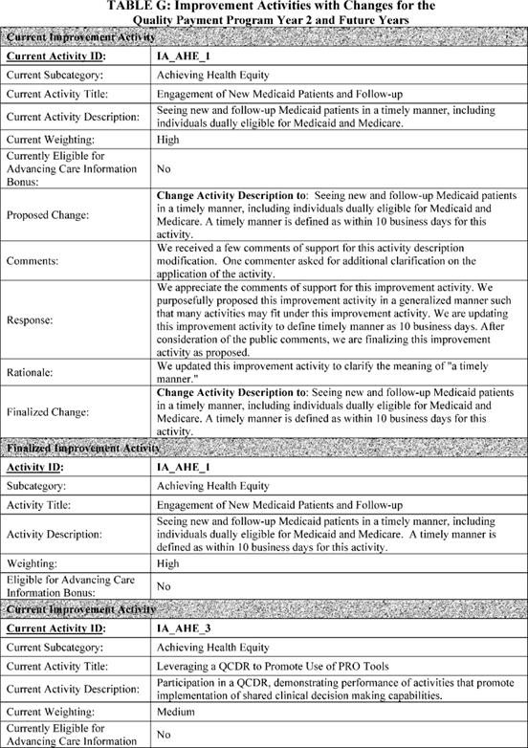

**[*54196]**



**[*54197]**

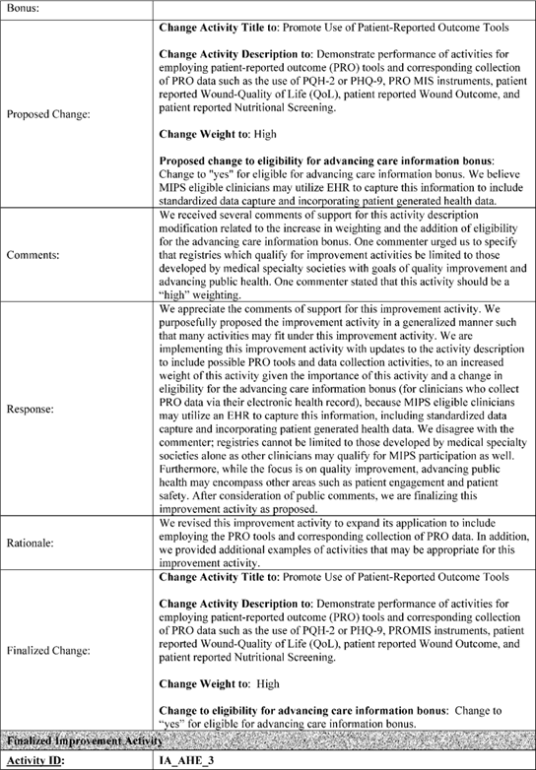

**[*54197]**



**[*54198]**

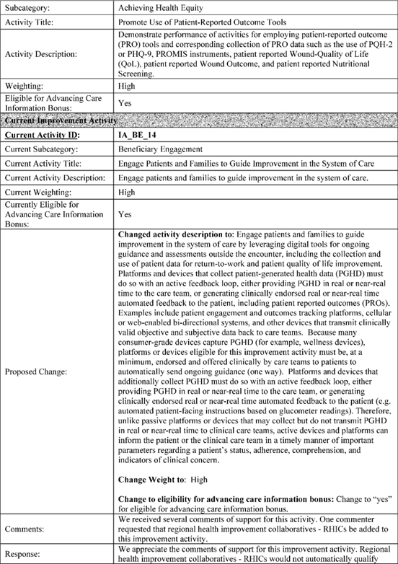

**[*54198]**



**[*54199]**

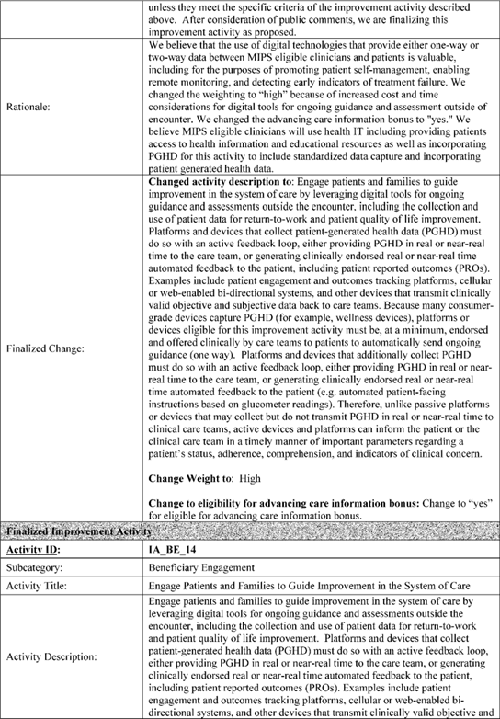

**[*54199]**



**[*54200]**

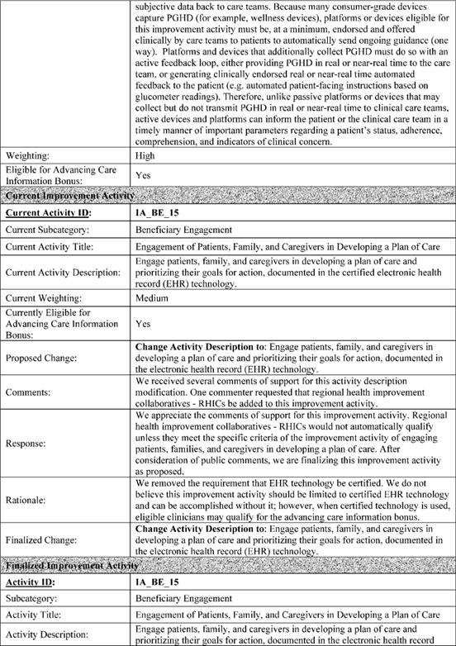

**[*54200]**



**[*54201]**

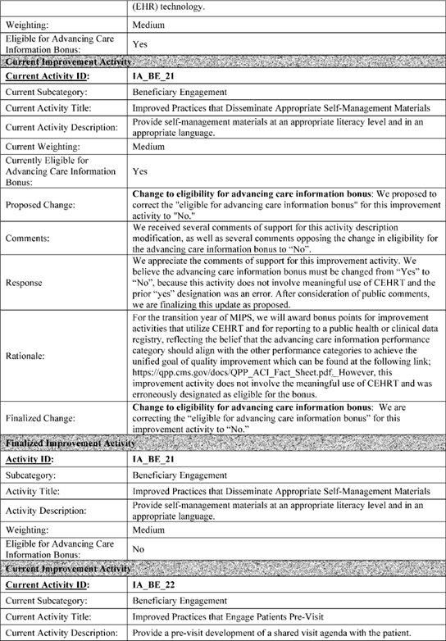

**[*54201]**



**[*54202]**

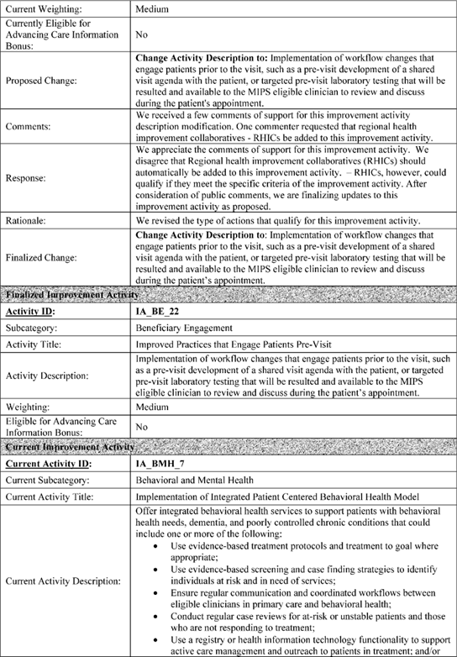

**[*54202]**



**[*54203]**

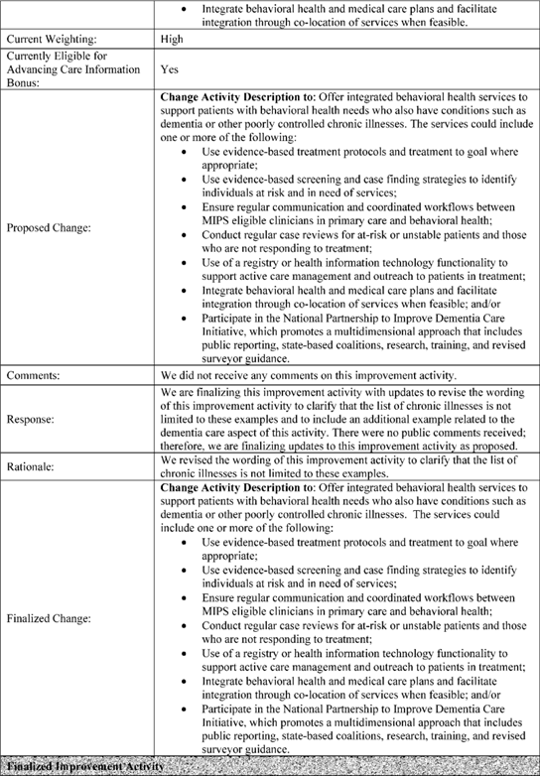

**[*54203]**



**[*54204]**

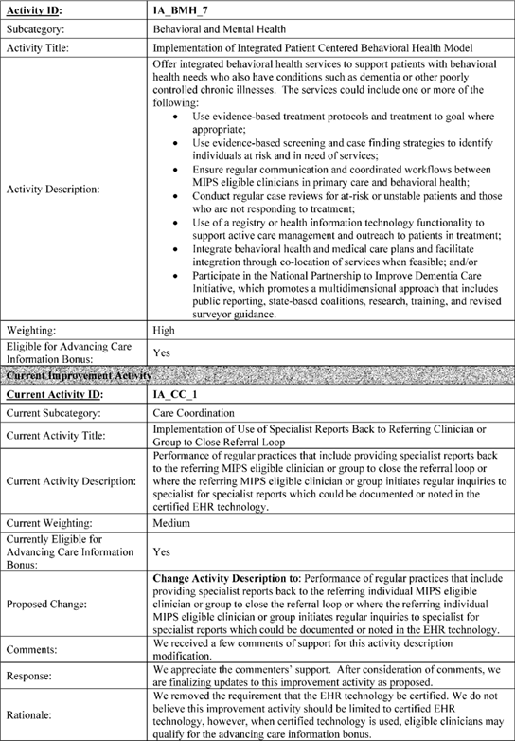

**[*54204]**



**[*54205]**

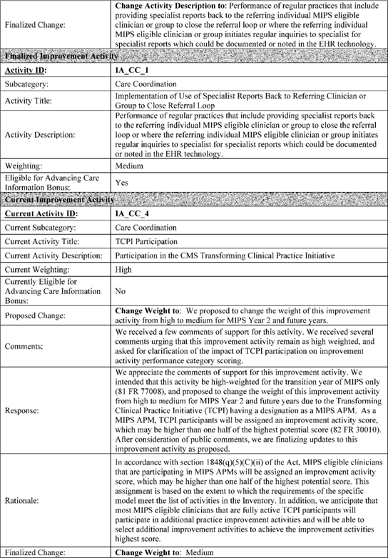

**[*54205]**



**[*54206]**

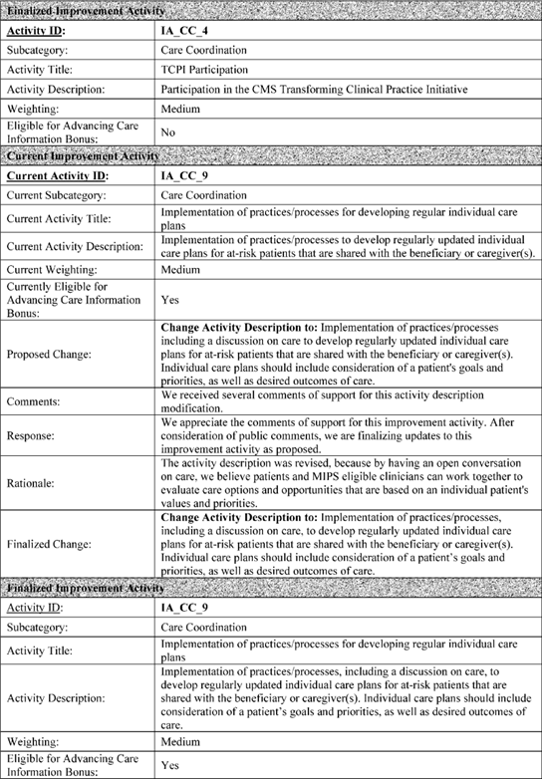

**[*54206]**



**[*54207]**

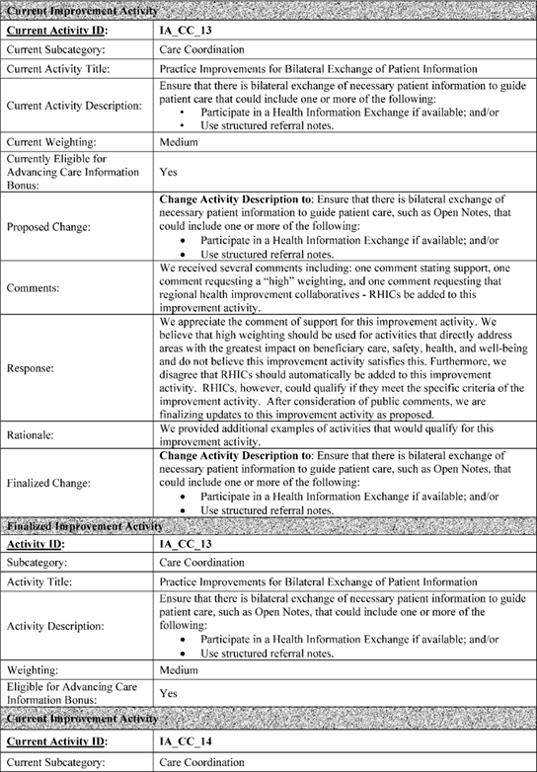

**[*54207]**



**[*54208]**

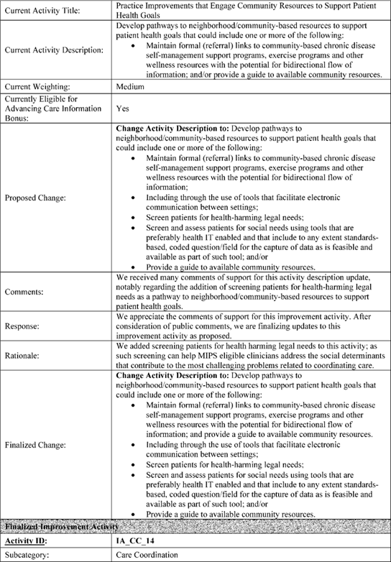

**[*54208]**



**[*54209]**

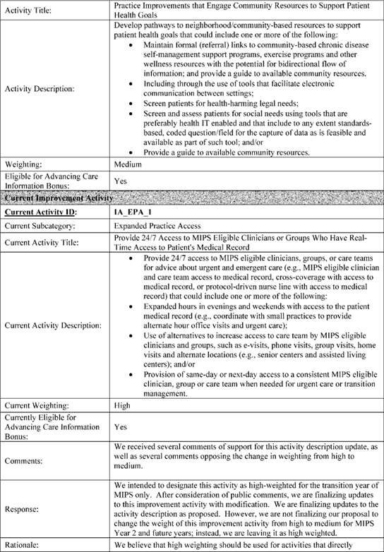

**[*54209]**



**[*54210]**

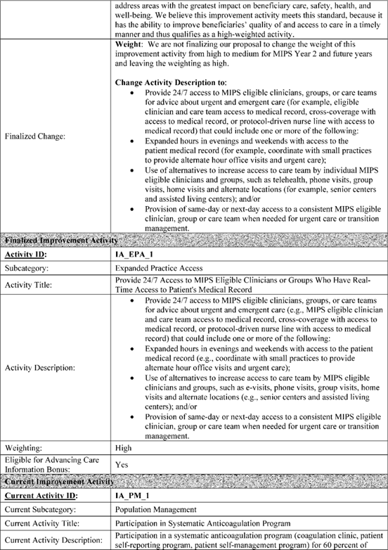

**[*54210]**



**[*54211]**

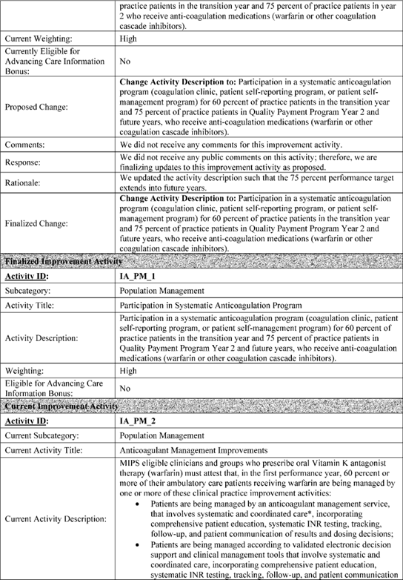

**[*54211]**



**[*54212]**

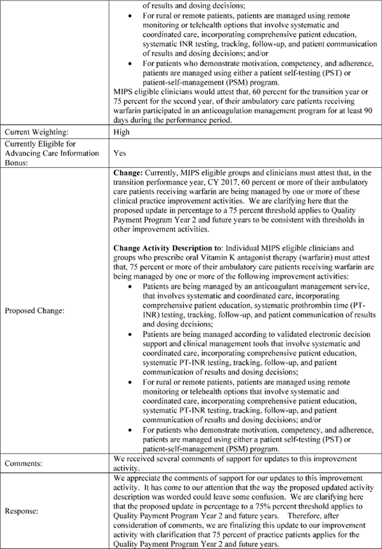

**[*54212]**



**[*54213]**

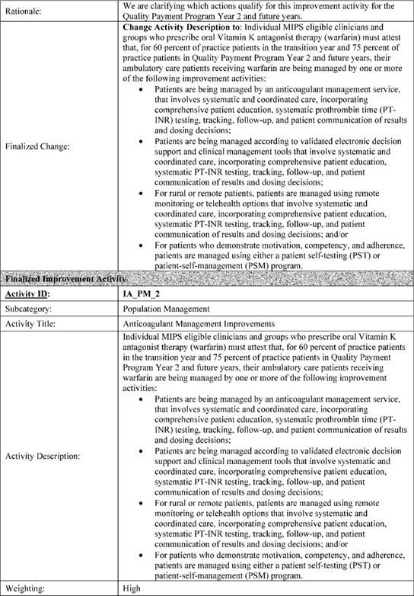

**[*54213]**



**[*54214]**

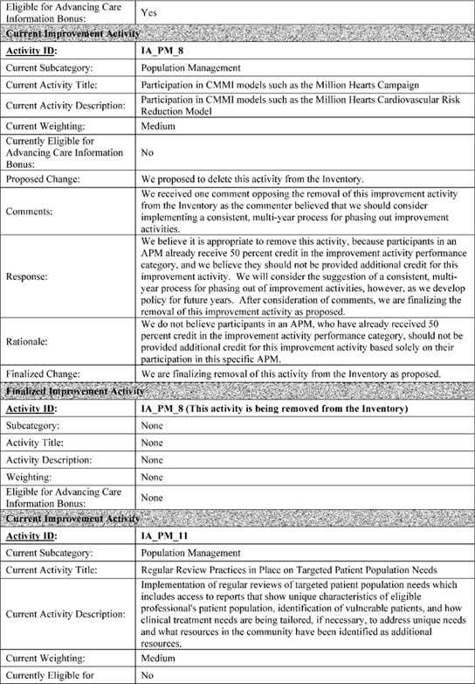

**[*54214]**



**[*54215]**

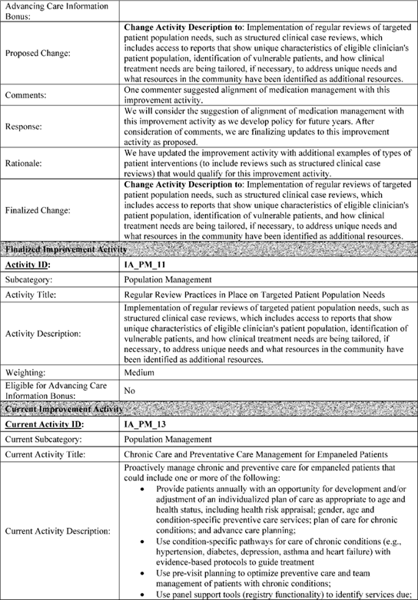

**[*54215]**



**[*54216]**

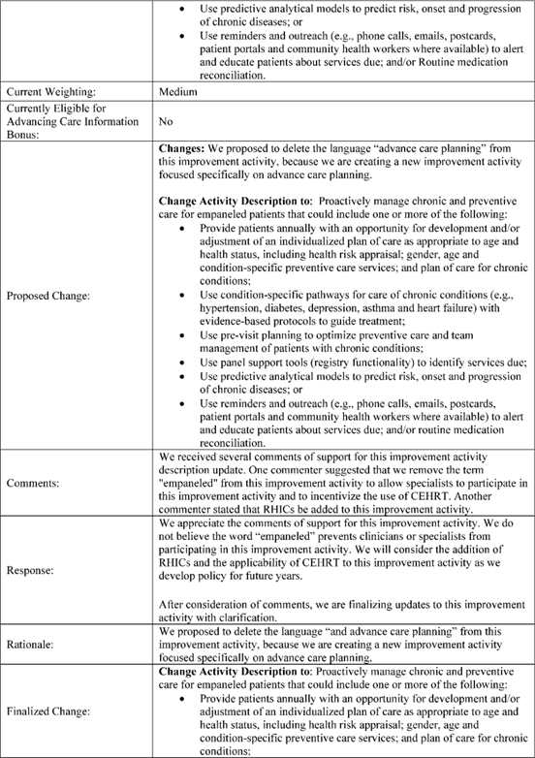

**[*54216]**



**[*54217]**

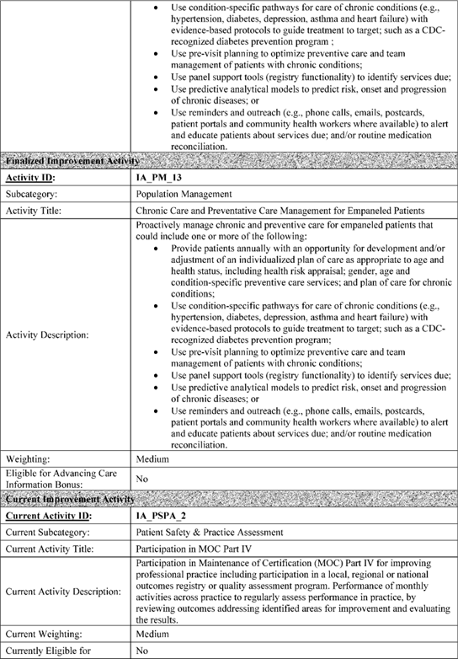

**[*54217]**



**[*54218]**

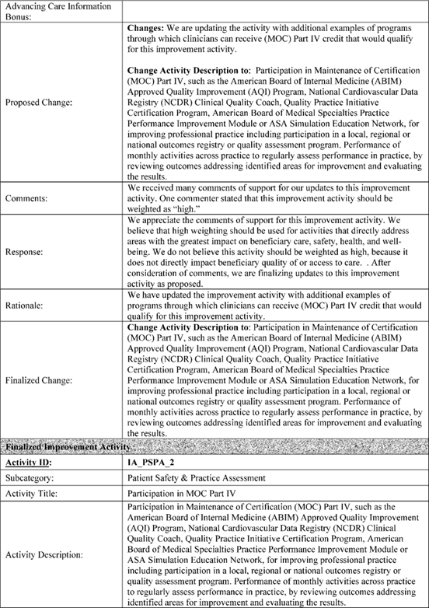

**[*54218]**



**[*54219]**

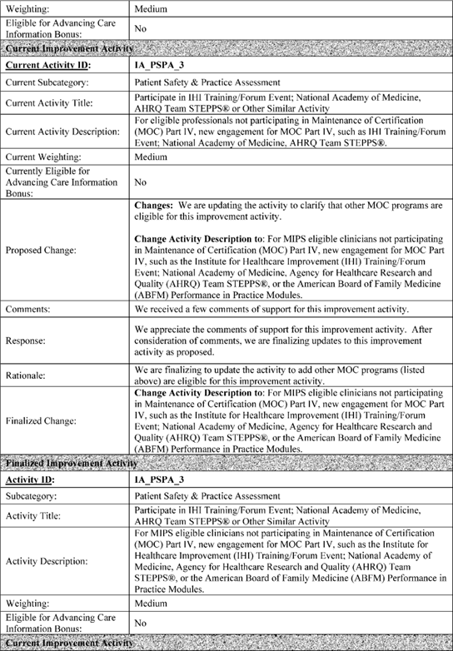

**[*54219]**



**[*54220]**

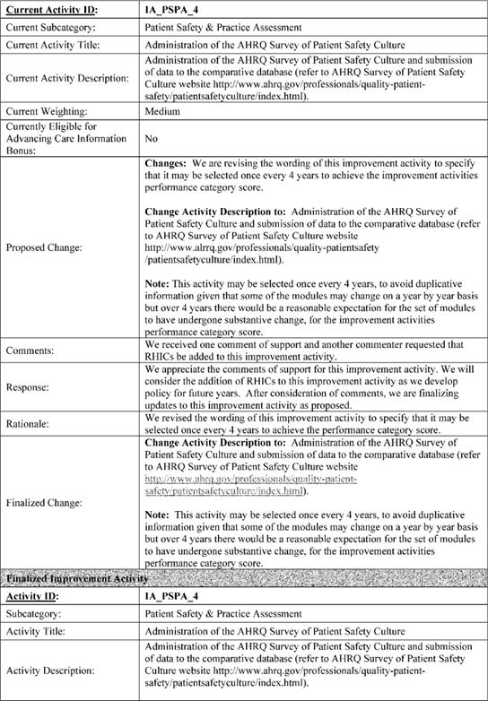

**[*54220]**



**[*54221]**

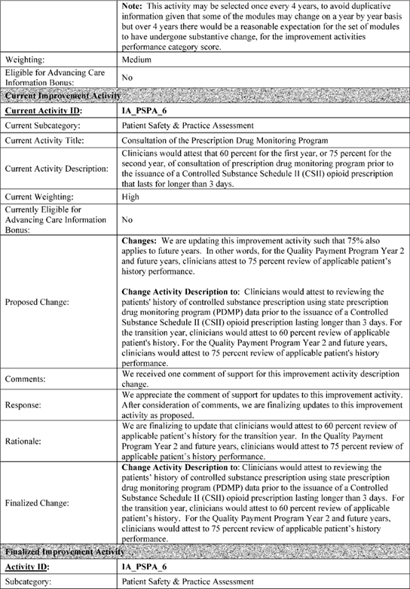

**[*54221]**



**[*54222]**

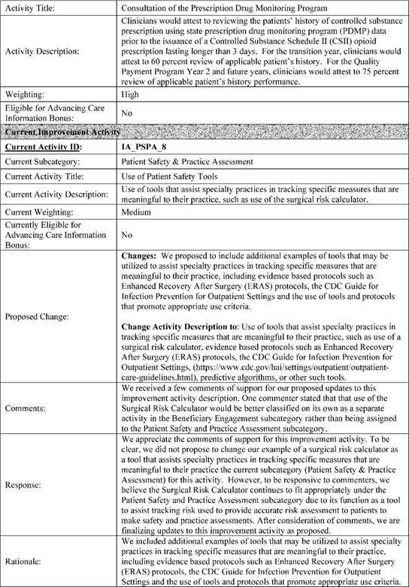

**[*54222]**



**[*54223]**

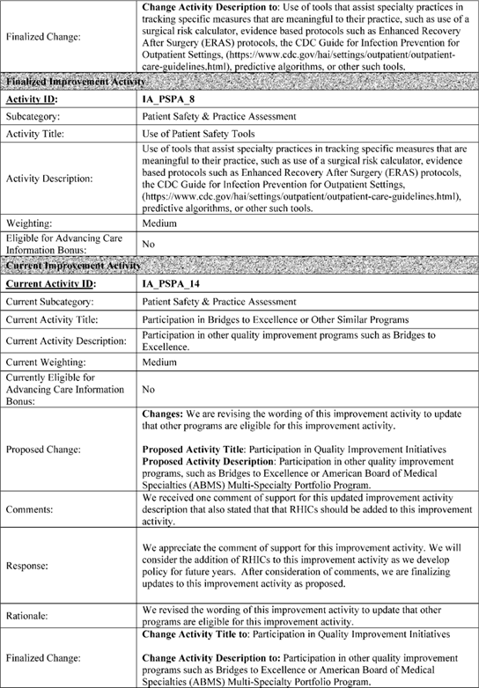

**[*54223]**



**[*54224]**

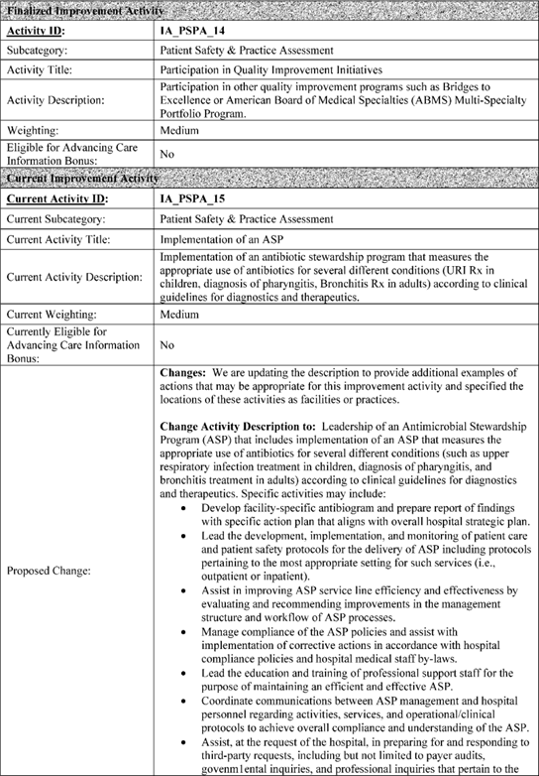

**[*54224]**



**[*54225]**

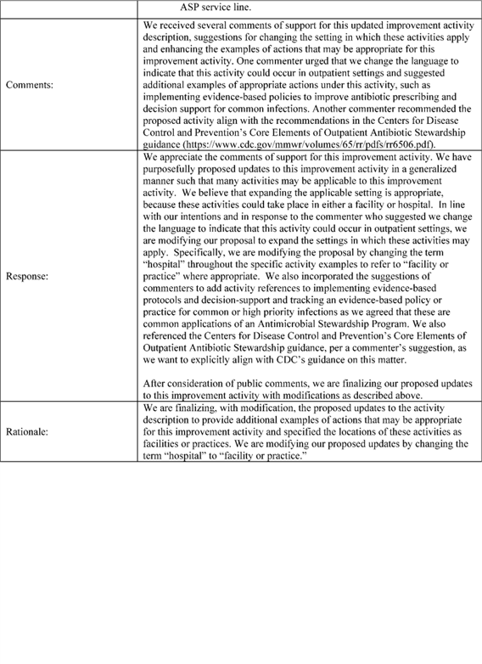

**[*54225]**



**[*54226]**

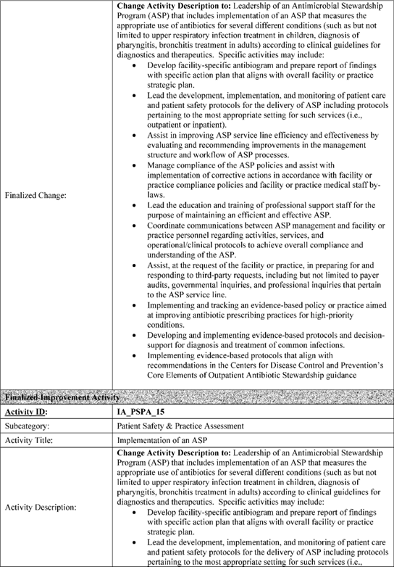

**[*54226]**



**[*54227]**

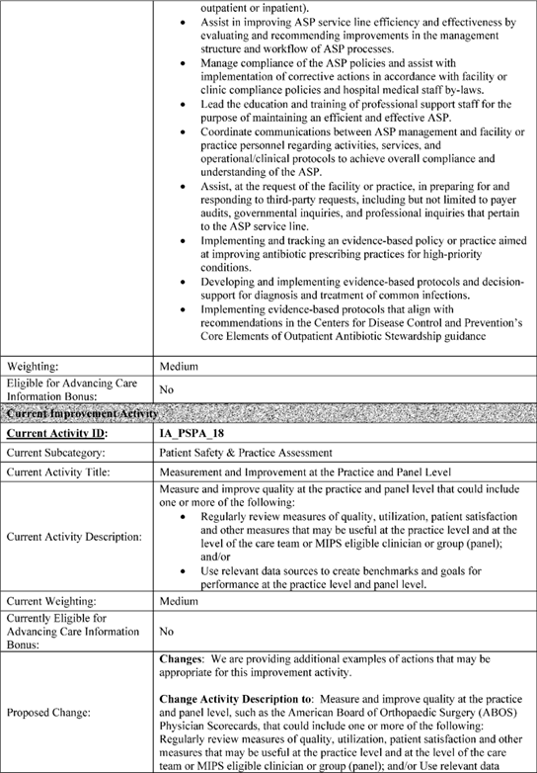

**[*54227]**



**[*54228]**

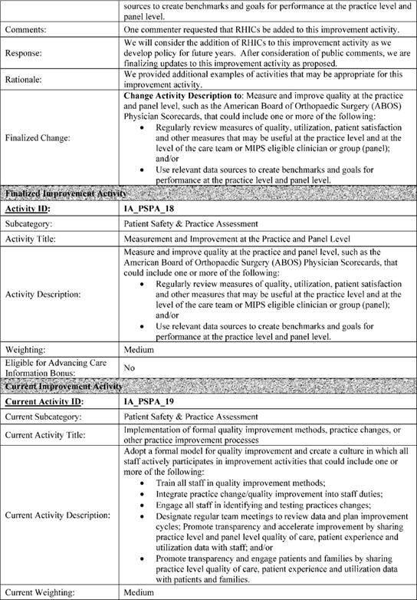

**[*54228]**



**[*54229]**

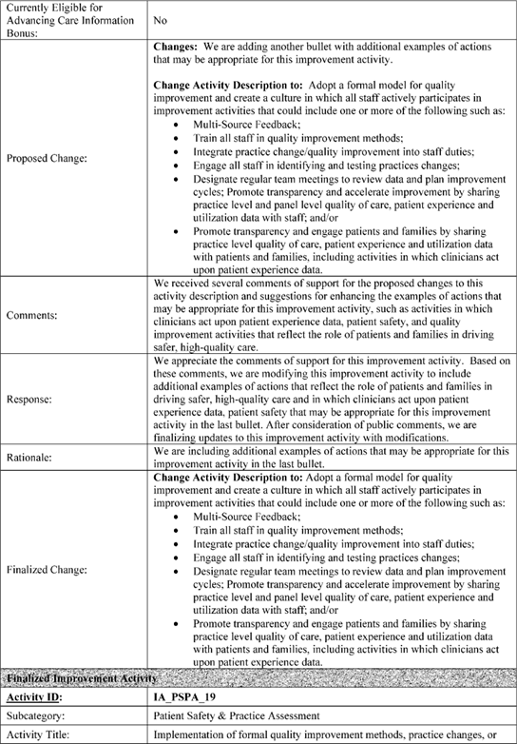

**[*54229]**

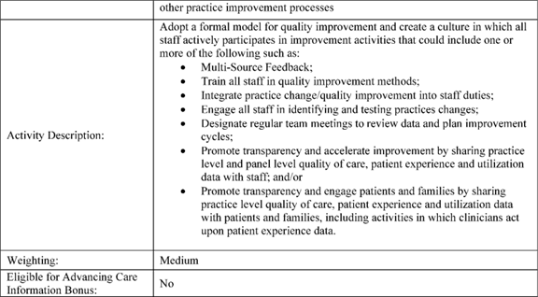

[FR Doc. 2017-24067 Filed 11-2-17; 4:15 pm]

BILLING CODE 4120-01-C

**Dates**

**DATES:**

*Effective date:* These provisions of this final rule with comment period and interim final rule with comment period are effective on January 1, 2018.

*Comment date:* To be assured consideration, comments must be received at one of the addresses provided below, no later than 5 p.m. on January 1, 2018.

**Contacts**

**ADDRESSES:** In commenting, please refer to file code CMS-5522-FC when commenting on issues in the final rule with comment period, and CMS-5522-IFC when commenting on issues in the interim final rule with comment period. Because of staff and resource limitations, we cannot accept comments by facsimile (FAX) transmission. You may submit comments in one of four ways (please choose only one of the ways listed):

1. *Electronically.* You may submit electronic comments on this ***regulation*** to [*http://www.****regulations****.gov*](http://www.regulations.gov). Follow the "Submit a comment" instructions.

2. *By regular mail.* You may mail written comments to the following address ONLY: Centers for Medicare & Medicaid Services, Department of Health and Human Services, Attention: CMS-5522-FC or CMS-5522-IFC (as appropriate), P.O. Box 8016, Baltimore, MD 21244-8016.

Please allow sufficient time for mailed comments to be received before the close of the comment period.

3. *By express or overnight mail.* You may send written comments to the following address ONLY: Centers for Medicare & Medicaid Services, Department of Health and Human Services, Attention: CMS-5522-FC or CMS-5522-IFC (as appropriate), Mail Stop C4-26-05, 7500 Security Boulevard, Baltimore, MD 21244-1850.

4. *By hand or courier.* Alternatively, you may deliver (by hand or courier) your written comments ONLY to the following addresses prior to the close of the comment period:

a. For delivery in Washington, DC-- Centers for Medicare & Medicaid Services, Department of Health and Human Services, Room 445-G, Hubert H. Humphrey Building, 200 Independence Avenue SW., Washington, DC 20201.

(Because access to the interior of the Hubert H. Humphrey Building is not readily available to persons without Federal government identification, commenters are encouraged to leave their comments in the CMS drop slots located in the main lobby of the building. A stamp-in clock is available for persons wishing to retain a proof of filing by stamping in and retaining an extra copy of the comments being filed.)

b. For delivery in Baltimore, MD-- Centers for Medicare & Medicaid Services, Department of Health and Human Services, 7500 Security Boulevard, Baltimore, MD 21244-1850.

If you intend to deliver your comments to the Baltimore address, call telephone number (410) 786-7195 in advance to schedule your arrival with one of our staff members. Comments erroneously mailed to the addresses indicated as appropriate for hand or courier delivery may be delayed and received after the comment period.

For information on viewing public comments, see the beginning of the **SUPPLEMENTARY INFORMATION** section.

**FOR FURTHER INFORMATION CONTACT:** Molly MacHarris, (410) 786-4461, for inquiries related to MIPS.

Benjamin Chin, (410) 786-0679, for inquiries related to APMs.

FEDERAL REGISTER

**End of Document**